47th Annual Review of Progress
in Quantitative Nondestructive Evaluation
QNDE2020
July 26-30, 2020, Minneapolis, MN, USA

QNDE2020-1234

Delamination depth imaging for Quasi-static and fatigue load testing using passive thermography

Joseph N. Zalameda and William P. Winfree
NASA Langley Research Center
Hampton, VA

Abstract
Passive thermography is used to monitor small increases in temperature resulting from delamination damage formation in composite hat-stiffened panels during both quasi-static and fatigue loading. It has been observed that rapid damage formation produces heating. This is composed of two heat generation components. The first component is an instantaneous response due to an irreversible thermoelastic strain release. The second component is mechanical heating, at the interface of failure, due to fracture damage. This produces a transient rise in temperature as the heat diffuses to the surface. The first component defines the thermal start time for the transient response. A one-dimensional thermal model is fitted to the data pixel by pixel, to produce imagery of the damage depth. The results are compared to ultrasonic and X-ray CT data.
Keywords: Passive thermography, quasi-static and fatigue loading, delamination damage depth
Nomenclature
T(t) Surface temperature response
T_{F} Final temperature
l Damage depth
$α$ Thermal diffusivity
t Time

- INTRODUCTION
Both fatigue and quasi-static load testing are performed on composite hat stiffened panels. These tests are necessary to validate structural designs and damage prediction models [1]. During load testing, it is important to monitor the composite and to determine damage initiation and growth. Growing the damage incrementally allows for detailed through-the-thickness damage characterization using X-ray computed tomography (CT) or ultrasound. A key aspect of testing is to implement real time nondestructive evaluation (NDE) to determine when loading is stopped due to incremental damage detection. Passive thermography has been proven to be an effective inspection technique for real time NDE of composite structures during load testing [2-4]. In this work, quasi-static and fatigue loads are
applied to a single stringer stiffened composite panel. It has been observed that sudden damage or rapid growth damage produces detectable heating in both periodic and non-periodic loading. The rapid growth temperature rise at the surface is composed of two thermal responses. The first response is instantaneous and conforms to the shape of the damage. This instantaneous temperature rise is due to the irreversible thermoelastic release of energy when the sample fails over the area of failure [3,4]. The second response is a transient increase in temperature due to mechanical heating at the interface of failure. This second component produces a transient rise in temperature that is a function of the damage depth and thermal diffusivity. The first component defines the thermal start time for the transient response. A one-dimensional thermal model is used to determine the damage depth for a given known thermal diffusivity. The results are compared to ultrasound and X-ray CT data.

- MATERIALS AND METHODS
2.1 Composite Panels Tested
The stiffened composite panel skin is 12 plies with a thickness of 0.22 cm, the stiffener flange is 12 plies thick with a thickness of 0.24 cm. The stiffener hat top is 16 plies with a thickness of 0.32 cm. The stiffener is a woven composite. Figures 1a, 1b, and 1c show the stiffened composite panel stringer side, a painted specimen, and a cross sectional view respectively. The overall panel dimensions are 25.4 x 25.4 cm. This panel is used for the quasi-static loading. The applied quasi-static loads are up to 1,000 pounds. The single stringer panel, used for fatigue loading, has the same geometry and thickness. Figures 1d and 1e show the stiffened composite panel skin side and stiffener side respectively. The dimensions of the panel are width 21.6 cm and length 51.3 cm. The maximum applied cyclic fatigue loads are approximately 25,000 pounds for the single stringer panel. The frequency of the loading is 2 Hertz.

2.2 Test Setup
The test setups shown in Figures 2a and 2b are the quasi-static and fatigue loading configurations respectively. The basic
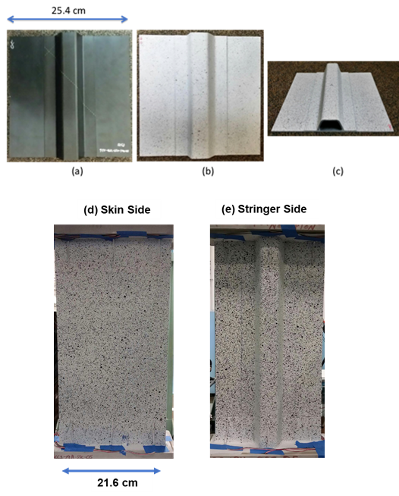

FIGURE 1: SINGLE STRINGER COMPOSITE PANELS.

system consists of an IR camera operating in the 3–5 micrometer IR band and an image data acquisition computer. The IR camera is configured with 25 mm germanium optics. The focal plane

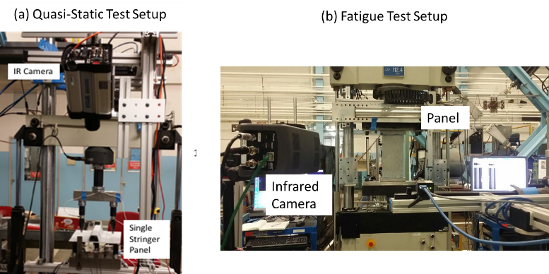

FIGURE 2: TEST SETUP FOR QUASI-STATIC (a) AND FATIGUE LOADING (b).

array size of the camera is 640x512. The passive inspection captured the thermal variations during the loading. The setup required a Plexiglas® shield to filter out spurious IR background sources (not shown in Figure 2). The camera frame rate is externally triggered and operated at 80 Hz. The load signal is also acquired using a USB based 12-bit data acquisition module. For each infrared camera frame, a load value is acquired. Furthermore, real time averaging, a delayed image subtraction, and real time contrast adjustment are used to enhance detection of the small thermal transient signatures due to the damage [4]. Without this processing, the faint thermal signatures that indicate damage would be difficult to detect in real time.

2.3 Model Fit to Data
The heat flux, originating at the interface of failure, is created due to the mechanical failure when the two surfaces separate. The separation is instantaneous and is modeled as an impulse heat flux that creates heating within the separated inner layers. Since the two layers are not in contact after failure, a simple two sided or through-transmission heat flow model is used. The depth of the damage is determined by the heat transfer from the inside to the outer surface. This temperature response will be a function of the damage depth and thermal diffusivity. A simple one-dimensional two-sided thermal measurement model can be used to estimate the damage depth if the thermal diffusivity is known.
The analytic solution derived by Winfree [5] is shown in equation (1). This equation is commonly used for a two-sided thermal measurement and is computationally efficient as compared to an infinite series solution.

$T\left(t\right)= 2 T_{f}\sqrt{\frac{l^{2}}{α π t}} \left( {\exp{ }}^{\frac{-l^{2}}{4 α t}} + {\exp{ }}^{\frac{-9 l^{2}}{4 α t}} \right) for t<0.4 \frac{l^{2}}{α} and T\left(t\right)= T_{f}\left(1- 2 {\exp{ }}^{\frac{- α π^{2} t}{l^{2}}} \right) for t≥0.4 \frac{l^{2}}{α}$ (1)
T(t) is the surface temperature response, T_{F} is the final temperature, $α$is the thermal diffusivity, $l$ is the layer thickness, and t is time. The equation assumes no convection losses and the heat flux generated is considered instantaneous. The equation also does not take into account the instantaneous heating response; however, the start time is determined from the instantaneous response. The instantaneous response is shown in the top right plot of Figure 3 where a single pixel point of the instantaneous thermal image is plotted as a function of time. The instantaneous heating image is shown to have the same overall size as the ultrasonic inspection shown in the bottom right figure of Figure 3. For a known thermal diffusivity, equation (1) is used to determine the damage depth, pixel by pixel, by minimizing the squared difference between the model and the data. Shown in bottom plot of Figure 3 is an example model fit to the thermal data for a single pixel point (located in the damage center) for the delamination damage. The data used for the model fit was truncated (0.9 to 7.5 seconds) to remove the early times which is dominated by the instantaneous heating response.

- RESULTS AND DISCUSSION
By fitting the thermal model to the data pixel by pixel, the thermal data can be reduced to a thickness image revealing the damage depth. This is shown in Figure 4 for the quasi-static loaded panel. The depth image is blurry due to the early times omitted from the fitting. The thermally measured depth appears uniform in depth at around 0.2 cm over the damaged area. This is confirmed from X-ray CT measurements (results will be shown in final paper). Also note the thermally measured thickness values away from the damage gives erroneous values due to the lack of a thermal response. Shown in Figure 5 is the instantaneous heating thermal image from fatigue loading. This heating results from rapid damage growth. This image is obtained by removing the thermoelastic thermal response using a simple notch filter. The damage depth image is obtained by pixel by pixel curve fit of equation (1). The damage depth image reveals damage at different depths from 0.20 to 0.40 cm. This indicates the damage detected is at multiple ply levels.

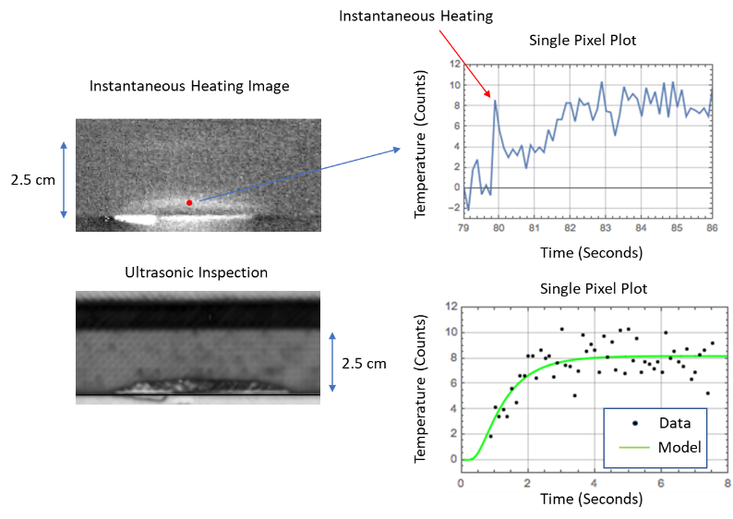
FIGURE 3: INSTANTANEOUS THERMAL IMAGE WITH ULTRASONIC COMPARISON AND SINGLE PIXEL PLOT WITH CURVE FIT.

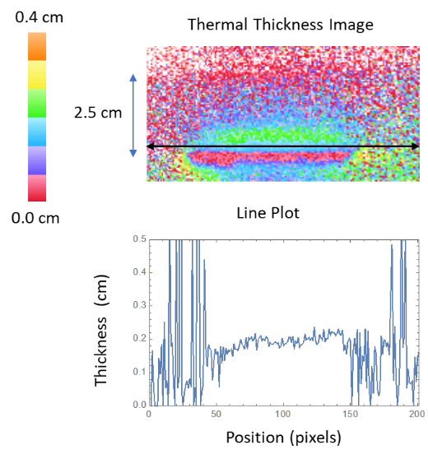
FIGURE 4: THERMAL DAMAGE DEPTH IMAGE FROM STATIC LOADING WITH LINE PLOT.

CONCLUSION
Passive thermography has been shown to be an effective real time NDE inspection technique to track damage onset and growth in composite single stringer panels during both quasi-static and fatigue loading. The thermal data is processed for damage depth using both the instantaneous temperature rise which is due to an irreversible thermoelastic release of energy when the sample fails and the transient increase in temperature due to the buried heat generated at the interface of failure. Using these two components, the damage depth can be imaged thermally. This can potentially help test engineers by providing damage location, size and depth during composites load testing.

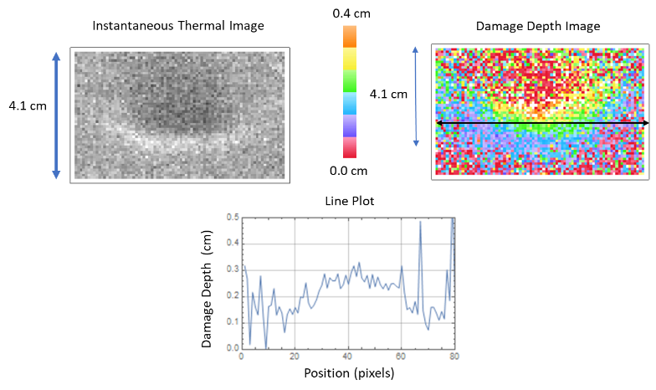

FIGURE 5: INSTANTANEOUS THERMAL IMAGE FROM FATIGUE LOADING AND DAMAGE DEPTH IMAGE WITH LINE PLOT.

ACKNOWLEDGEMENTS
This work was performed under NASA’s Advanced Composites Project.
REFERENCES
- Rose, C.A.; Dávila, C.G.; Leone, F.A. Analysis Methods for Progressive Damage of Composite Structures; NASA/TM-2013-218024; NASA Langley Research Center: Hampton, VA, USA, 2013.
- Roche, J.-M.; Balageas, D.; Lamboul, B.; Bai, G.; Passilly, F.; Mavel, A.; Grail, G. Passive and active thermography for in situ damage monitoring in woven composites during mechanical testing. In Proceedings of the 39th Annual Review of Progress in Quantitative Nondestructive Evaluation, Baltimore, MD, USA, 21–26 July 2013; pp. 555–562.
- Winfree, W. P., Zalameda, J. N., and Michael R. Horne, “Simulations of Thermal Signatures of Damage Measured during Quasi-Static Loading of a Single Stringer Panel”, AIP Conference Proceedings 2102, 120007 (2019); https://doi.org/10.1063/1.5099849, Published Online: 08 May 2019.
- Zalameda, J.N., Jackson, W.C., and Rose, C.A., Estimation of Delamination Crack Depth using Passive Thermography. Proc. SPIE 2019, 11004, doi:10.1117/12.2520390.
- Winfree, W.P., Heath, D.M. Thermal diffusivity imaging of aerospace materials and structures. In Proceedings of the Aerospace/Defense Sensing and Controls, Orlando, FL, USA, 13–17 April 1998; pp. 282–290.

Contact author: joseph.n.zalameda@nasa.gov

