Crashworthiness of a Lift plus Cruise eVTOL Vehicle Design within Dynamic Loading Environments

Jacob Putnam
Jacob.B.Putnam@nasa.gov
Research Aerospace Engineer
NASA Langley Research Center
Hampton VA, 23681

Justin Littell
Justin.D.Littell@nasa.gov
Research Aerospace Engineer
NASA Langley Research Center
Hampton VA, 23681

ABSTRACT
To aid in the development of electric Vertical Take-off and Landing (eVTOL) technology, the National Aeronautics and Space Administration has undertaken research initiatives to evaluate and optimize design features of eVTOL aircraft. One such initiative has been to develop energy attenuating design mechanisms to improve eVTOL vehicle crashworthiness. In this study, crashworthiness design mechanisms, implemented within a six-passenger lift plus cruise (LPC) eVTOL concept vehicle, were evaluated under multi-axis dynamic loading conditions. This work builds upon crashworthiness design concepts previously optimized within a simplified vehicle-loading environment. The results of this study found the effectiveness of energy attenuating design mechanisms to be dependent on the complexity of load environment in which they were employed. An increase in off-axis loading resulted in a decrease in occupant protective capability. These results indicate the necessity for evaluating vehicle design across the range of possible dynamic impact conditions to characterize crashworthiness. This work provides preliminary methodology for implementing energy attenuating design mechanisms and evaluating crashworthiness for future UAM markets.

Introduction
The ever expanding and densifying urban environment has resulted in increased transit demand coupled with larger transit distances. Conventional transit systems are under constant strain with increased commute times and increased public frustration. The need for new transit avenues within the urban environment has led to a boom in urban air transportation development. This emerging transit field has been termed “Urban Air Mobility” (UAM).
The strong market demand for UAM capability has inspired a wide field of both traditional and startup vehicle manufacturers (OEMs) to invest in UAM development. Primarily OEMs are looking to compete in this market with electric Vertical Take-off and Landing (eVTOL) vehicles. These vehicles have the unique ability to operate within the urban environment. Both eVTOL technology and the UAM market are emerging fields, thus the design paradigms and the certification requirements have yet to be defined.
The public places high value on transportation safety, as made apparent in the creation of regulating bodies such has the National Highway Safety Administration (NHTSA) for the automotive industry and the Federal Aviation Administration (FAA) for aviation. Currently official regulations for UAM vehicle safety design have not been set, but it can be assumed vehicle designers will have to maintain a level of occupant safety at or above that which the public has come to expect in conventional transportation. As eVTOL vehicles are developed for the UAM market, regulations may spur the requirement of having the vehicle adequately protect the occupant in a crash event.
To demonstrate vehicle crashworthiness, Anthropomorphic Test Devices (ATDs) have been developed to predict human injury risk within the dynamic loading environment of a crash [1]. ATDs - more commonly referred to as crash test dummies - provide a tool with which to convert standardized kinematic and load measurements to quantified risk of human injury. The use of these tools in vehicle crash testing has led to the development of safety designs and mechanisms now standard across transportation fields. Such safety features, which are now taken for granted in vehicle design, include seatbelts, airbags, and vehicle crumple zones.
Crash testing of vehicles with ATDs has proven an effective means for improving vehicle crashworthiness. Unfortunately, crash tests are costly and time intensive. Additionally, testing within the aerospace domain requires specialized facilities capable of inducing vertical and/or combined horizontal and vertical crash loads on the vehicle. Lastly, crash testing a vehicle requires a completed design for prototyping, meaning limited design optimization capabilities exist post-test. To overcome these limitations, Finite Element Analysis (FEA) is used to perform preliminary crashworthiness evaluations and optimizations prior to testing.
In an effort to improve aerospace transportation safety the National Aeronautics and Space Administration (NASA) has been working to develop and improve FEA tools used to perform vehicle crashworthiness evaluation [2-4]. This had resulted in the development of a library of composite and traditional aerospace material and component models verified within the aerospace crash-loading environment. This study leverages these tools to present an approach for evaluating and improving eVTOL vehicle crashworthiness through FEA.
NASA has developed a cadre of concept vehicles to perform preliminary design research [5,6]. The focus of this research is to both prepare for and aid the burgeoning UAM market. These concept vehicles cover a range of sizes and propulsive designs from a single passenger quadrotor to a fifteen-passenger tilt-wing. Previously the single passenger quadrotor concept was evaluated for crashworthiness capabilities under simplified crash impact conditions [7]. This study expands upon that work by evaluating the six-passenger Lift Plus Cruise (LPC) concept vehicle under more complex loading. A variety of impact conditions are selected to represent feasible certification requirements for UAM flight. Simulations of these conditions are performed and potential approaches to meet vehicle safety demands through implementation of crashworthy design concepts are explored.

Methods

Vehicle FEM Development
To perform dynamic structural analysis of the NASA LPC concept vehicle a finite element model (FEM) was developed (Figure 1). Computer aided design (CAD) of the vehicle, previously used to perform aero- dynamic and acoustic design studies within Open-VSP, was used to define the vehicle geometry [5]. All non-structural components were removed from the CAD and replaced with representative point masses. The CAD essentially contained the outer mold line (OML) of the LPC vehicle and did not include internal structural components. This internal structure, which included the aircraft frame sections, ribs, spars, and bulkheads was added to develop a semi-monoccoque vehicle structure. The developed geometry was meshed using 2x2-in quadrilateral shell elements within Hypermesh® 14.0 [8]. The non-structural components, represented by point masses, were re-attached to the airframe using constrained nodal rigid bodies (CNRB’s). The developed NASA LPC concept vehicle FEM consisted of: 37,675 nodes, 60,138 shell elements, 15 parts, and 15 concentrated masses.
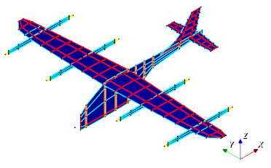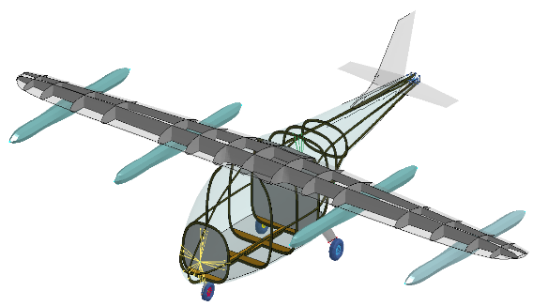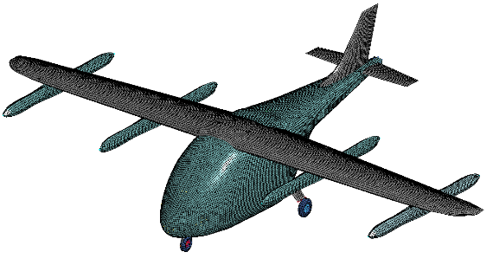
Figure 1. NASA six-passenger LPC vehicle design CAD (top) and FEM (bottom)
The material type and thickness of each vehicle component was assigned based on preliminary design specifications and previous eVTOL vehicle FEM development [5,7]. The fuselage, firewall, wings, and landing legs were assigned a carbon fiber plain weave designated as C/C, with shell wall thicknesses of 0.05 in, 0.05 in, 0.1 in, and 0.25 in respectively. The material model definitions for all materials used are provided in the Appendix - Material Model Definitions. The base interior structure and booms were defined as aluminum. The shell wall thickness of the wing reinforcing structure and booms was set to 0.125 in. The shell wall thickness of the fuselage frames and floor was 0.063 in. The landing gear wheels were assigned a rubber material with a thickness of 0.25 in. The total weight of the baseline vehicle FEM was 6,864 lb., which was 137 lb. lighter than the estimated design weight of 7,001 lb.
The vehicle cabin included seating for six passengers. The seats were represented by carbon fiber racing seats [9] made up of 0.24-in thick C/C composite. Connections between each seat and floor were assumed rigid and made up of CNRB’s assigned between the two components. As the seat substructure and connection to vehicle floor is currently undefined, these rigid connections provided a conservative baseline to assess component additions against. Compliant seat structure and connections to the floor would be expected to reduce energy transferred to the occupant under dynamic impact loading. A mid-size male occupant was modeled within the cabin using the Humanetics FAA Hybrid III 50th FEM version 1.2.3 [10]. The ATD was arranged within the second seat along the port side of the vehicle (Figure 2 ). Point masses were rigidly fixed to the remaining seats using CNRBs to represent a full cabin configuration. Each point mass was assigned 170 lb., representative of a mid-size male occupant mass. The positioning of the FAA Hybrid III 50th FEM was performed using the LS-Prepost® ATD positioning tool. The ATD was positioned in a neutral upright posture, which consisted of a 90° knee – 90° hip angle with hands on knees. Seat height above the floor was defined based on the location of the ATD feet once positioned within the seat.
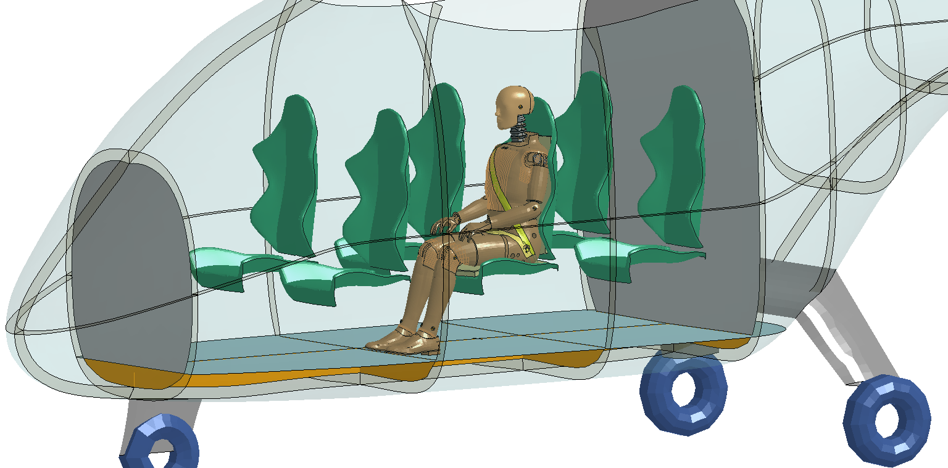
Figure 2. Vehicle Cabin and Occupant Model
A seat cushion model was added to the seat that contained the ATD (Figure 3). This cushion included both a seat pan and seat back component. The seat pan consisted of a 0.2-in thick polyurethane upper layer and 1.0-in thick polyethylene lower layer. The seat back was made up of 0.6 in of polyethylene. This seat foam setup is consistent with commercial aircraft seat cushions [11]. Although this component was previously found to have little effect on occupant response in the dynamic loading environment [7], it was included within analysis as final vehicle designs will likely incorporate some form of seat foam to provide occupant comfort.
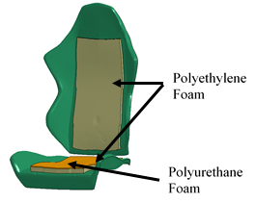
Figure 3. Seat and Foam Model
Three belt configurations were modeled to evaluate the effects of restraint type within the multi-directional crash environment. A two-, three-, and five-point restraint was modeled (Figure 4). Each restraint model was made up of combination of 1D and 2D elements created using the seatbelt fitting tool within LS-Prepost®. The fabric in contact with the ATD was modeled as shell elements while the spooling component was modeled as 1-D seatbelt elements. Each belt attachment location contained a pretensioner and retractor element used to tension the belts in the pre-load phase of simulation. Seatbelt material definitions were applied from a previously developed and verified aerospace restraint FEM [12].
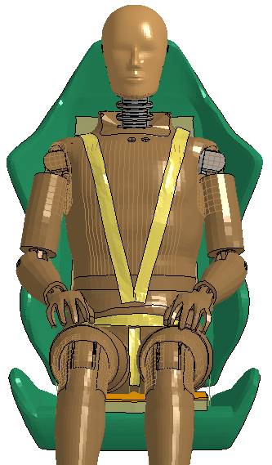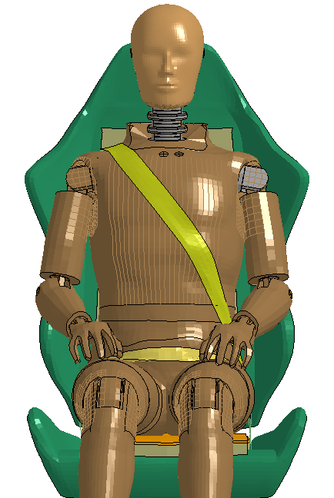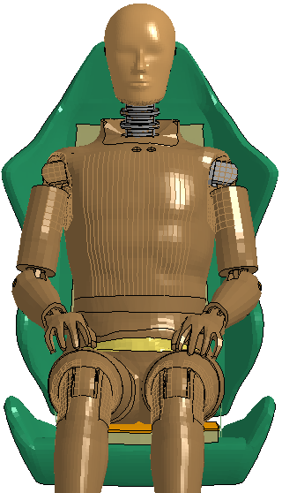
Figure 4. Belt Configurations: 5-Point (left), 3-Point (middle), 2-Point (Right)
The interior cabin model including seats, ATD, restraints, and representative occupant masses contained a total of 198,200 nodes, 294,417 elements, and 417 parts. The weight of the interior cabin model was 987 lb., 222 lb. lighter than the design weight of 1209 lb. Differences in weight can be attributed to lack of defined seat support structure within the vehicle FEM as well as variations in occupant sizes not accounted for in this study.

Energy Attenuating Designs
A second vehicle configuration was developed which incorporated added energy attenuating design components. Added components included a crushable subfloor and a crush tube design implemented between the seat and floor. A previous study of crashworthiness design modifications on an eVTOL vehicle, found use of these components significantly improved vehicle crashworthiness in the vertical loading environment [7]. Both components were made of a carbon-aramid composite designated C/A [13].
The crushable subfloor design was implemented within the LPC concept model by adjusting the material definition of the baseline subfloor (Figure 5). The baseline aluminum subfloor model was replaced with a 0.05-in thick C/A material definition, and did not directly replace the aluminum frames upon which the subfloor was attached. Implementation of this design had a minimal effect on vehicle weight, reducing it by 1.0 lb.
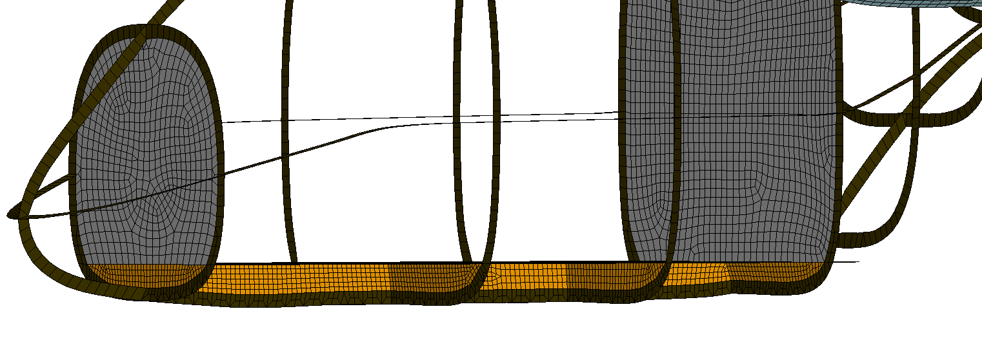
Figure 5. Subfloor Component Model
The seat level C/A crush tube was implemented between the seat and the floor below (Figure 6). To represent the approximate stability the seat substructure would provide during impact, a translational joint was defined between the seat, crush tube, and floor. This joint enforced an axial load path between the seat and crush tube, minimizing bending moment and shear forces on the crush tube were not evaluated due to the enforced load path. The crush tube had a diameter of 3.0 in. and height of 6.8 in. A five 0.0124-in ply layup in an accordion shape was used for the crush tube design. This shape and layup specification was developed through a crush tube shape optimization procedure used to improve crush tube performance in the dynamic loading environment. Implementation of the crush tube added 1.0 lb. to the vehicle weight.
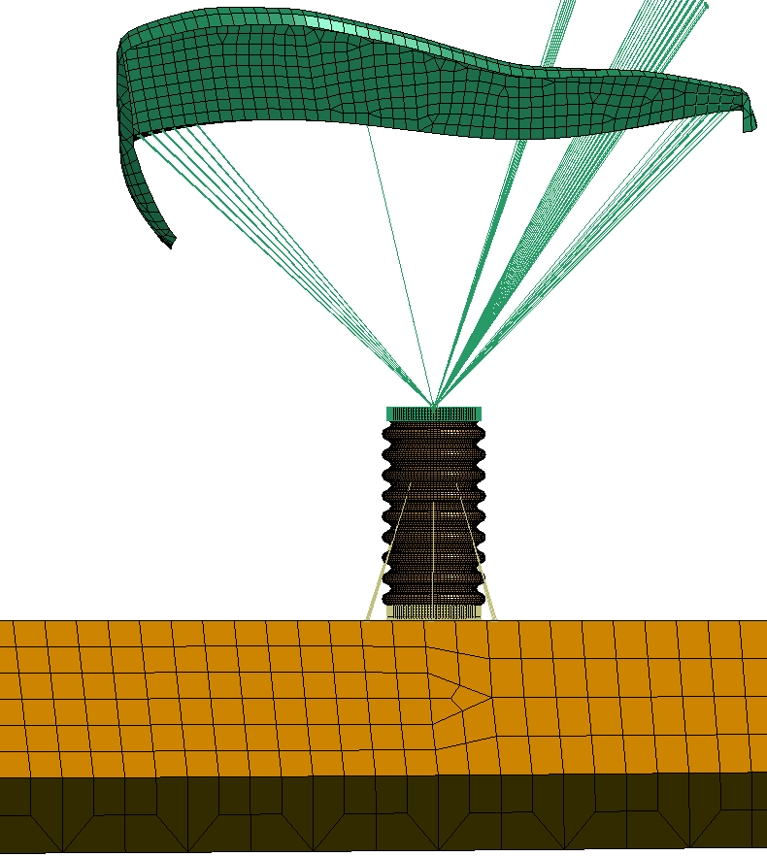
Figure 6. Seat Level Crush Tube Model
To evaluate the capability of energy attenuating mechanisms to extend the occupant protective capabilities of current eVTOL design beyond conventional aircraft dynamic loading requirements, a third mechanism positioned externally on the fuselage was implemented within the design for higher dynamic loading conditions. A deployable energy absorber (DEA) made of Kevlar®-129 honeycomb was implemented into the vehicle design (Figure 7). The DEA concept and representative model had previously been developed and evaluated in a drop test of a composite airframe fuselage section [14]. This DEA design, implemented within the NASA LPC vehicle model, was fixed under the fuselage and arranged across the cabin area. DEA length was adjusted to maximize crush volume while not interfering with normal landing operations in the event of inadvertent deployment. The DEA concept was only implemented in the higher velocity (35 ft/s) impact simulations.
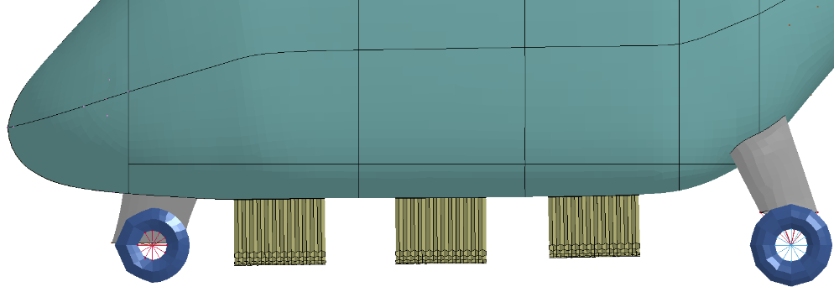
Figure 7. DEA Component Model

Energy Absorbing Crush Tube Optimization
To improve crush tube performance, a design optimization study was undertaken. This optimization study looked to improve the crush response of the tube through variations in shape as well as the shell thickness. The study was performed using HyperMesh® interfaced with LS-Dyna® using LS-Opt®[15].
Shape perturbations of the tube curvature were defined using the Hypermorph feature within Hypermesh®. A symmetric domain was applied to the inner and outer curve across the length of the tube. A minimum and maximum shape definition was then set by increasing and decreasing the curve ratio of this domain by 20% (Figure 8). These shapes were exported for use within LS-Opt® to define the bounds for automated morphing of tube curvature.
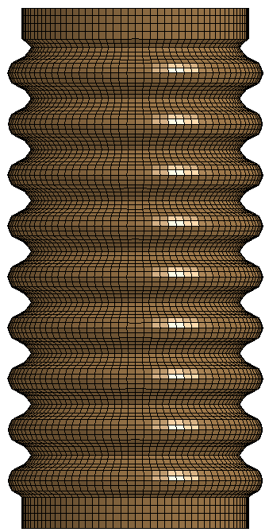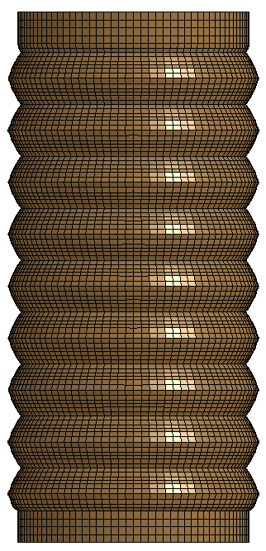
Figure 8. Crush Tube Shape Variation: Minimum Curvature (Left) and Maximum Curvature (Right)
A metamodel-based Monte Carlo analysis was developed within LS-Opt® to explore the effect of curvature changes and tube thickness on crush response (Figure 9). Curvature change was defined as a single variable, which ranged from -1.5 to 1.5. This corresponded with 1.5 times the 20% change in curve ratio and resulting in scaling of the tube shape boundaries previously defined. Negative value for the shape variable resulted in increased curvature, and thus greater difference in inner and outer tube radius. The number of C/A plies used in the layup could not easily be parameterized within LS-Opt so, as an approximation, the ply thickness was varied between the baseline of 0.0124 in and a maximum of 0.025 in. A total of 15 design cases were evaluated to characterize the effects of these variables on crush tube response.
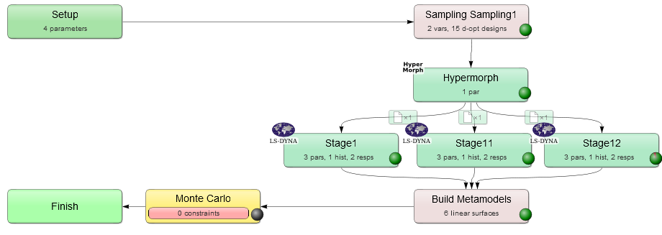
Figure 9. Schematic of Crush Tube Optimization Procedure
Three LS-Dyna simulations were performed for each design case. In each simulation, the base of the tube was rigidly constrained while the top was impacted with a block mass at 18.5 ft/s (Figure 10). This impact velocity was used to approximate peak seat-to-vehicle velocity differential at impact, as measured during preliminary vehicle impact simulations. To evaluate the sensitivity of crush response to occupant mass the block mass was varied across the three simulations. Masses of 100 lb., 170 lb., and 225 lb. representative of a small female, mid-size male, and large male occupant respectively were used across the three simulations. Peak acceleration of the block measured in simulation was used to quantify the energy attenuating capability of the crush tube designs evaluated.

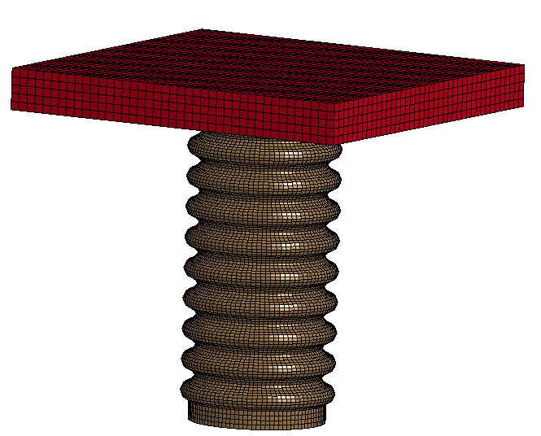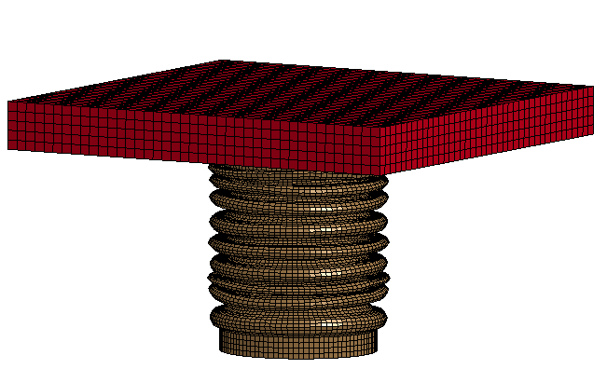
Figure 10. Crush Tube Optimization Simulation: Initial State (Left) and Crushed State (Right)
Increased curvature was found to reduce peak acceleration across the three simulation conditions (Figure 11). An increase in shell wall thickness increased peak acceleration at the lower mass condition but decreased peak acceleration in the medium and large mass conditions. Although increasing shell thickness increased initial acceleration in all cases, it prevented the tube from bottoming out under the larger masses. Based on the results of this analysis an optimized tube design incorporating a 20% curvature increase from baseline and 5 ply of 0.0124-in thick C/A material was selected for integration within the NASA LPC concept vehicle design.
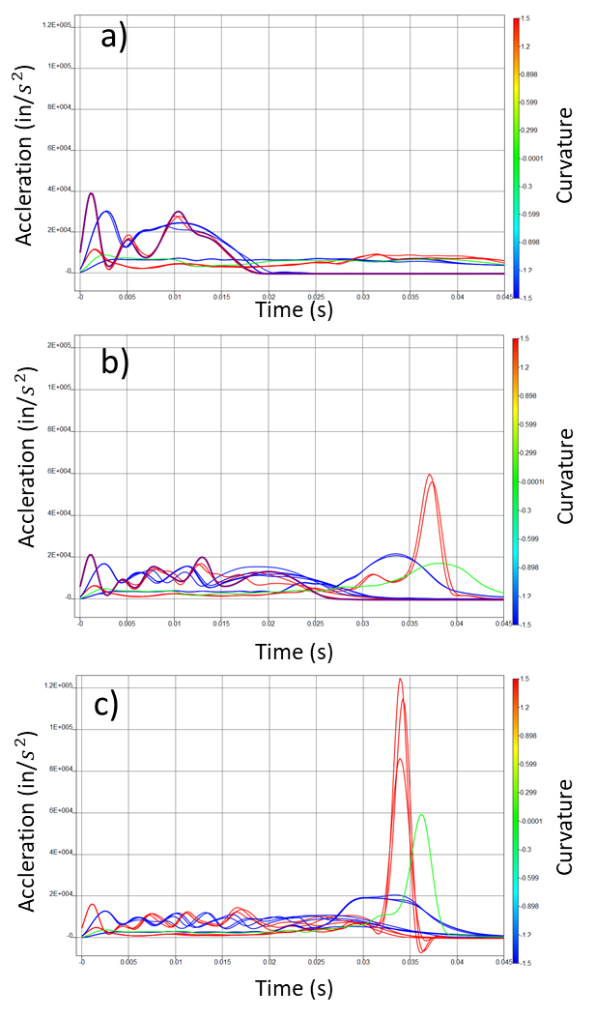
Figure 11. Crush Tube Optimization Results: a) small female, b) mid-size male, c) large male occupant mass

Simulation Methodology
To evaluate the crashworthiness capabilities of the NASA LPC concept vehicle, three unique dynamic impact conditions were simulated. These conditions included pure vertical, combined 60°/30° vertical/horizontal, and 60°/30° with 10° yaw impact. These conditions were approximated from the emergency landing dynamic conditions specified for general aviation and rotorcraft [16-18]. A Root Sum Squared(RSS) impact velocity of 30 ft/s was used for all impact conditions. In addition, a fourth case using a higher velocity impact case of 35 ft/s was simulated in the pure vertical direction to evaluate the potential for additional external crashworthiness mechanism implementation to expand the design envelope for impact capabilities
The vehicle model was impacted against a concrete landing strip (176-in. length, 96-in. width, 8-in. depth) with an initial velocity definition, dependent on design case, applied to all vehicle and occupant components. Prior to simulating the vehicle impact, the ATD was pre-loaded within the seat environment under gravity. This pre-load simulation was run for 200 ms and allowed the ATD and seat foam contact force to reach a steady state under gravitational load. A second pre-load was then run for 100 ms within the impact simulation to tighten the belts to a steady load of 5 lb. and initialize the 1-g forces within the ATD and vehicle. The vehicle was constrained during this time in the rotor region.
Simulations were performed using LS-DYNA SMP Version R10.1.0 single precision. Simulations were run using 4-8 processors on a Linux computer cluster. Simulations were executed to 0.3 s, with CPU run times ranging between 80 and 120 hrs depending on vehicle configuration.

Injury Metrics
To quantify occupant injury risk in each landing scenario and vehicle configuration, the ATD injury metric peak compressive lumbar load was used. Peak compressive lumbar load is the standard ATD injury metric criteria used by the FAA to certify aircraft seats [18]. This metric quantifies risk of vertebral fracture within the lumbar spine. The FAA limit for seat certification is 1,500 lb. of compressive load measured in the lumbar spine load cell of a straight spine Hybrid II or FAA Hybrid III 50th male ATD. The ATD upper neck injury criteria (Nij), was used to evaluate differences in response due to belt configuration within the combined 60°/30° vertical/horizontal impact loading condition. Nij is used by NHTSA in the certification of automotive vehicles [19] and predicts risk of injury to the upper cervical spine. Nij is calculated as a combination of axial loading and bending moment measured in the upper neck load cell. NASA has adopted both of these metrics for occupant protection analysis [21].

Results

Combined Vertical/Horizontal Impact Condition
The three belted configurations evaluated within the combined 60°/30° vertical/horizontal impact loading condition exhibited similar neck injury risk values (Figure 12-a). Although multi-axial, the peak Nij values calculated in this impact condition were dominated by the compression load predicted within the neck. The application of a 2-, 3-, or 5- point restraint had little effect on this compressive force as it occurs on initial impact before the ATD torso flailed forward. As the simulation progressed, the ATD within the 3- and 5-point restraints exhibited similar kinematics while the ATD simulated with the 2-point restraint exhibited greater forward flexion (Figure 12-b in blue seat). Although the flexion exhibited by the 2-point restrained ATD offloads the neck compressive force, reducing Nij values later in simulation, it presents a greater risk for flail-induced injuries. Based on these results the 3-point belt was down selected for vehicle concept design.
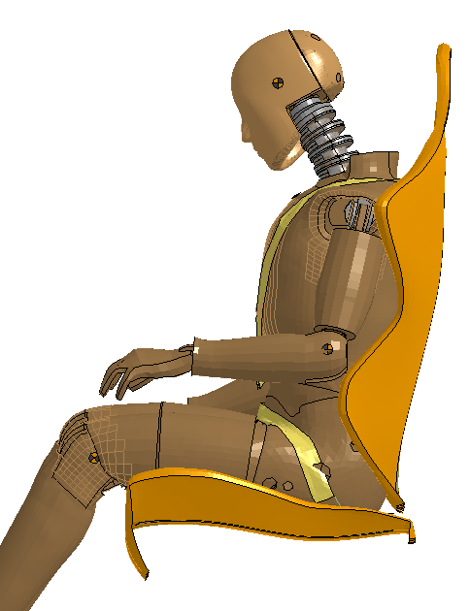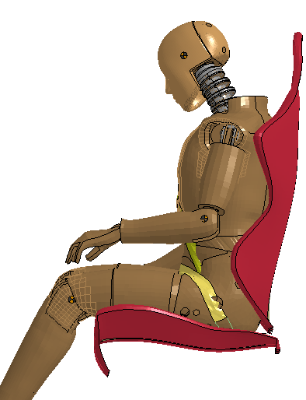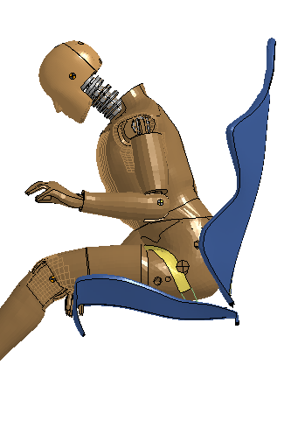
a)
b)
2-Point Restraint
3-Point Restraint
5-Point Restraint
Figure 12. Effect of Belt Configuration on Predicted ATD Response: Nij (Top) and Kinematics (Bottom)
The employed crashworthiness design features are shown to reduce lumbar injury risk in the combined 60°/30° vertical/horizontal impact loading condition (Figure 13). The baseline vehicle design drives a load of over 3,000 lb., over twice the injury metric limit, into the occupant. The lumbar load predicted within the crashworthy design peaks at the limit of 1,500 lb.. The difference between the aluminum (baseline design) and C/A (crashworthy design) subfloors can be observed over the first 75 ms of impact. The lumbar response shape between the two designs is similar but the more compliant C/A material reduces the onset rate of the loading by absorbing more of the impact energy and reducing overall load transferred into the occupant. After the floor bottoms out, the lumbar load in the baseline design spikes to its peak well above the injury limit. The load within the crashworthy design levels out over this period due to the energy absorption of the seat crush tube. The crush tube is loaded up to its crush initiation stress at approximately 0.09 s; it then crushes limiting the force transferred into the occupant. Lumbar load rises again as the tube folds and compacts, but its response remains below the injury metric threshold of 1,500 lb.
Figure 13. Predicted Lumbar Spine Response in Combined 60°/30° Vertical/Horizontal Loading Condition

Combined Vertical/Horizontal w/ Yaw Impact Condition
The addition of a 10° yaw component within the 60°/30° vertical/horizontal impact loading condition was found to reduce predicted injury risk within the baseline vehicle design (Figure 14). In comparison with the no yaw condition, the effectiveness of implemented crashworthy mechanisms was found to diminish with off-axis loading. The lumbar load predicted within the crashworthy design peaked at 1,600 lb. This was 39% reduction over the baseline design. The crashworthy design within the 60°/30 no yaw condition was able to reduce lumbar load by 52%.
Figure 14. Predicted Lumbar Spine Response in Combined 60°/30° Vertical/Horizontal Loading Condition with 10° Yaw

Uniaxial Vertical Impact Condition
The pure vertical landing condition resulted in the highest lumbar predicted within the baseline vehicle design, over 3,500 lb. (Figure 15). Under uniaxial loading, impact energy was transmitted directly through the vehicle and into lumbar spine compressive force. The implemented crashworthy design features exhibited the greatest effectiveness in reducing occupant injury risk within this uniaxial vertical loading environment. Peak lumbar load was reduced by 60% within the crashworthy vehicle design and remained below the 1,500-lb. injury metric limit.
Figure 15. Predicted Lumbar Spine Response in the Baseline Vertical Loading Condition

Uniaxial Vertical Landing Condition w/ higher energy
When simulated within the 35 ft/s vertical impact condition, the crashworthy vehicle design without employing the DEA feature produced significant loading into the occupant (Figure 16). Although the crush tubes were able to reduce lumbar load below 1,500 lb. at the initiation of crush, it quickly bottomed out in this condition. After the crush tube bottomed out the predicted lumbar load spiked up over 2,500 lb. The addition of the DEA component to this design was able to flatten the load curve . The impact of the DEA with the ground caused the cabin compartment to begin decelerating earlier in simulation, exhibited by the earlier rise in lumbar load compression. The additional energy absorption provided by this mechanism reduced the lumbar load imparted during initiation of the crush tube and prevented this component from bottoming out. This resulted in an effective use of all three mechanisms to reduce occupant injury risk within the more severe loading environment. Although the addition of the DEA within the crashworthy design was able to reduce occupant loads below the lumbar load injury metric limit, additional occupant safety concerns were observed in this simulation. The increased impact energy was found to result in significant damage to the vehicle structure. The large overhead mass of the wings and rotors penetrated the airframe (Figure 17). This reduced the survivable volume of the cabin and exhibited potential sources of penetration-induced occupant injury. However, the DEA and vehicle structure were developed for a different set of conditions, and therefore not optimized to this environment. Further work would be required to facilitate the vehicle structure, DEA, subfloor, and seat tubes to work together as a unified system.
Figure 16. Predicted Lumbar Spine Response in the 35-ft/s Vertical Loading Condition
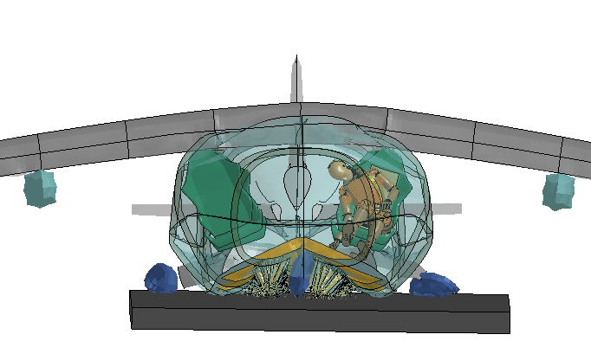
Figure 17. Vehicle Deformation in the 35-ft/s Vertical Loading Condition

Conclusions
The analysis performed in this study provides insight into the use of crashworthiness design concepts to improve UAM occupant safety under multi-axis dynamic loading. As the UAM design space has not been fully characterized nor dynamic impact standards for certification specified, the NASA LPC concept vehicle was simulated in impact conditions approximating current dynamic impact standards for rotorcraft and airplanes. This included a pure vertical impact and a combined loading impact of 60°/30° vertical/horizontal. To induce loading across all three planes a hybrid impact condition was simulated in which the aircraft was yawed 10° within the 60°/30° vertical/horizontal impact condition. Each condition was simulated with the vehicle in its baseline configuration as well as with the addition of crashworthy mechanisms implemented within its design. These features had previously been evaluated within the uniaxial loading environment and this study provided a means for evaluating the effectiveness of their implementation under multi-axial loading.
In all simulated conditions, the vertical component of the impact load was found to drive occupant injury risk as defined by peak lumbar load. Within the baseline vehicle, the largest lumbar load was measured in the pure vertical impact while the lowest load was measured under the combined 3-axis loading impact in which the component vertical load was the lowest. This is to be somewhat expected as the lumbar load metric considers only the vertical compression load within the lumbar spine. When evaluating neck injury risk (Nij), which combines moment, shear, and vertical force within the neck, a similar effect was found. The predicted Nij values for the three restraint conditions evaluated in the 60°/30° vertical/horizontal impact loading condition were all dominated by the initial vertical load imparted on impact. This peak value was unaffected by the horizontal restraint configuration. Although ATD kinematics differed in the 2-point restraint, it had little effect on the overall injury risk assessment.
The effectiveness of the energy attenuating mechanisms implemented within the crashworthy design configuration did exhibit dependency on the directional complexity of the impact condition. The crashworthy design reduced lumbar loads below the injury metric threshold only in the pure vertical impact condition. This can be attributed to reduced performance of the seat level crush tube under multi-axis loading. While lumbar load in the baseline vehicle design decreased with impact direction complexity, the lumbar load measured prior to the crush initiation within the crush tube increased as off-axis load increased. The effectiveness of this component was previously evaluated under pure vertical loading. The optimization work performed on its design was performed under similar uniaxial loading conditions. The reduction in effectiveness of this mechanism within the more complex loading environment indicate the need for full-system evaluation of occupant protective mechanisms across the range of dynamic impact conditions in which they may be subjected. This finding is particularly important for UAM vehicles where omnidirectional impact conditions are more likely than traditional aircraft due to their design and flight environment.
The simulation of the higher energy impact condition, 35 ft/s vertical, demonstrated potential for expanding the crash landing envelope for UAM vehicles through implementation of occupant protective mechanisms while also highlighting some of the difficulties associated with it. Lumbar load measured within the crashworthy vehicle design within the 30 ft/s impact condition peaked at 1,450 lb., the 5 ft/s increase in impact velocity nearly doubled that value bringing it to 2,800 lb. Although the crushable subfloor and crush tube design could likely be tuned to improve performance in this higher energy impact condition it would likely be at the cost of reduced performance within the 30 ft/s condition. The implementation of additional energy attenuating design features to improve capability is more realistic. The DEA concept was found to successfully reduce occupant loads below the injury metric threshold when used in conjunction with the other energy attenuating systems implemented within the crashworthy design. Though DEAs may not be standard for all UAM design, they may provide solution for vehicles requiring certification within a larger dynamic impact envelope. For example, occupant protective mechanisms such as DEAs may be added to vehicle designs in which parachute or other emergency velocity reducing systems are unable to reliably meet impact velocities defined for future dynamic impact certification requirements of UAM vehicles.
To meet public expectations for transportation safety, the UAM community will need to demonstrate crashworthiness within new vehicle designs. The approach to designing and certifying for crashworthiness will likely incorporate a combination of testing and FEA. This study demonstrates a methodology for evaluating and optimizing vehicle crashworthiness within the multi-directional loading environment using FEA. As the UAM design space and certification requirements become better defined, this methodology can be used to guide eVTOL vehicle development and testing to improve occupant safety.

AUTHOR CONTACT
Jacob Putnam - Jacob.b.putnam@nasa.gov
Justin Littell - justin.d.littell@nasa.gov

REFERENCES
- Backaitis, S.H. and Mertz. H.J. (eds), "Hybrid III: The first human-like crash test dummy." Society of Automotive Engineers, PT-44, Warrendale, PA, 1994.

- Jackson, Karen E., and Edwin L. Fasanella. "NASA Langley Research Center Impact Dynamics Research Facility Research Survey." Journal of aircraft 41.3 (2004): 511-522.

- Polanco, M. A., and J. D. Littell. "Vertical Drop Testing and Simulation of Anthropomorphic Test Devices” Proceedings from the 67th Annual Forum and Technology Display. Virginia Beach, VA, May 3-5, 2011.

- Jackson, K.E., Fasanella, E.L., and Littell, J.D. “Development of a Continuum Damage Mechanics Material Model of a Graphite-Kevlar ® Hybrid Fabric for Simulation the Impact Response of Energy Absorbing Subfloor Concepts.” Proceedings from the 73rd Annual American Helicopter Society Annual Forum and Technology Display. Fort Worth, TX. May 9-11, 2017.

- Johnson, W., Silva, C., and Solis, E. “Concept Vehicles for VTOL Air Taxi Operations.” Proceedings from the AHS Technical Conference on Aeromechanics Design for Transformative Vehicle Flight. San Francisco, CA. January 16-19, 2018.

- Silva, C., Johnson, W., Antcliff, K.R., Patterson, M.D., “VTOL Urban Air Mobility Concept Vehicles for Technology Development”. Proceedings from the 2018 Aviation Technology, Integration, and Operations Conference. Atlanta, GA, June-25-29, 2018.

- Putnam, J. and Littell, J., “Evaluation of Impact Energy Attenuators and Composite Material Designs of a UAM VTOL Concept Vehicle” Proceedings from the 75th American Helicopter Society Annual Forum and Technology Display. Philadelphia, PA. May 13-16, 2019.

- Altair. “Hyperworks 14.0 Manual”, Altair Engineering Inc., Troy, MI, 2018

- Maruzza, H. (2016, February 26). Racing Seat Evo. [Online] Available: https://grabcad.com/library/racing-seat-evo

- Humanetics (2018). “User’s Manual FAA Hybrid III 50th Male Dummy LS-DYNA Model Version 1.2.3.” Humanetics Innovative Solutions, Plymouth, MI.

- Jackson, Karen E., et al. "Finite Element Simulations of Two Vertical Drop Tests of F-28 Fuselage Sections." NASA/TM-2018-219807, 2018.

- Putnam, J. B., Somers, J.T., Wells, J.A., Perry, C. E., & Untaroiu, C.D.. "Development and evaluation of a finite element model of the THOR for occupant protection of spaceflight crewmembers." Accident Analysis & Prevention 82 (2015): 244-256.

- Littell, J. and Putnam, J., “The Evaluation of Composite Energy Absorbers for use in UAM VTOL Vehicle Impact Attenuation”. Proceedings from the 75th American Helicopter Society Annual Forum and Technology Display. Philadelphia, PA. May 13-16, 2019.

- Kellas, S., and Jackson, K.E., “Deployable System for Crash-Load Attenuation,” Proceedings of the 63rd AHS Annual Forum, Virginia Beach, VA, May 1-3, 2007.

- LSTC. “LS-DYNA Theory Manual”. Livermore Software Technology Company, Livermore, CA. July 2017.

- Code of Federal Regulations, Title 14 – CFR Part 23. “Airworthiness Standards: Normal, Utility, Acrobatic, and Commuter Category Airplanes”, Federal Aviation Administration, Washington, DC, 2011.

- Code of Federal Regulations, Title 14 – CFR Part 27. “Airworthiness Standards: Normal Category Rotorcraft”, Federal Aviation Administration, Washington, DC, 2011.

- Federal Register. “Special Conditions: Airbus A350-900 Airplane; Crashworthiness, Emergency Landing Conditions.” Vol 79. No. 43. Friday July 25, 2014.

- Code of Federal Regulations, Title 14 – CFR Part 25. “Airworthiness Standards: Transport Category Airplanes”, Federal Aviation Administration, Washington, DC, 2018.

- M. Kleinberger, E. Sun, R. Eppinger, S. Kuppa, and R. Saul, "Development of Improved Injury Criteria for the Assessment of Advanced Automotive Restraint Systems," National Highway Traffic Safety Administration, Washington, DC, 1998.

- Somers, Jeffrey T., Dustin Gohmert, and James W. Brinkley. "Application of the Brinkley dynamic response criterion to spacecraft transient dynamic events." NASA/TM-2013-217380-REV1, 2017.

- Jackson, K. E., et al. (2020). "Development of a Full-Scale Finite Element Model of the Fokker F28 Fellowship Aircraft and Crash Simulation Predictions." Proceedings of the 2020 ASCE Earth and Space Conference, Seattle, WA.

AppendiX

Material Model Definitions
The aluminum material model used to characterize the aircraft structural components was defined as *MAT_003 within LS-DYNA®. The material parameter definitions are provided in Table 1. This material model was previously developed and verified against a series of component and full–scale aircraft dynamic impact tests [8,21]. A single point integration element formulation (Hughes-Liu) is used in conjunction with this material model.
Table 1. Defined Material Properties of Aluminum
RO  lb.-s²/in.² | E  psi | PR | SIGY  psi | ETAN  psi | FS
1.29E-4 | 1.04E+7 | 0.33 | 6.09E+4 | 1.90E+5 | 0.05
The foam material models used to characterize the seat cushion were previously developed through a series of static coupon compression tests and dynamic impactor tests [8]. The combined foam model was verified against in-situ testing of ATD’s dynamically loading into the seat within the crash environment. The polyurethane foam was defined using *MAT_001 and the polyethylene foam was defined using *MAT_057 within LS-DYNA®. The material parameter definitions for each material is provided in Table 2. Both foams are modeled using constant stress solid elements.
Table 2. Defined Material Properties for Seat Cushion Foam
Polyurethane Foam
RO  lb.-s²/in.² | E  psi | PR
2.0E-5 | 2E+3 | 0.4
Polyethylene
RO  lb.-s²/in.² | E  psi | TC  psi | KCON  psi
3.85E-6 | 500 | 1.0E+3 | 0.5
The composite material models defined in this vehicle model are representative of carbon composite compositions currently being studied at NASA LaRC for aerospace design application [4,13]. These studies have included the characterization, calibration, verification of the material models used to represent them in this study. The carbon fiber plain weave (C/C) is made up of 3k-sized carbon tows in both the warp and fill directions. The carbon aramid composite (C/A) is made up of 3k-sized carbon tows in the warp and 3k-sized aramid fibers in the fill direction. Both materials were characterized within LS-Dyna using *MAT_058. Number of weave layers and orientation was defined using *PART_COMPOSITE. All composite components were defined using a 45° weave orientation. A single point integration (Hughes-Liu) with viscous hourglass control was used to define element formulation of all composite materials. The material parameters used to define each material model is provided in Table 3.
Table 3. Defined Material Properties of Carbon Composites Models
 | C/C Material | C/A Material
RO, lb.-s²/in.² | 1.29E-4 | 1.29E-4
EA, psi | 6.5E+6 | 6.3E+6
EB, psi | 6.5E+6 | 2.76E+6
PRBA | 0.1095 | 0.1095
TAU1, psi | 7.94E+3 | 4.50E+3
GAMMA1, in/in | 0.0246 | 0.0246
GAB, psi | 3.0E+5 | 3.0E+5
SLIMT1 | 0.8 | 0.8
SLIMC1 | 1.0 | 1.0
SLIMT2 | 0.8 | 0.8
SLIMC2 | 1.0 | 1.0
SLIMS | 1.0 | 1.0
AOPT | N/A* | N/A*
ERODS | 0.5 | 0.5
FS | -1 | -1
A1,A2,A3 | N/A* | N/A*
D1,D2,D3 | N/A* | N/A*
E11C, in/in | 0.011 | 0.013
E11T, in/in | 0.0143 | 0.0143
E22C, in/in | 0.011 | 0.025
E22T, in/in | 0.0143 | 0.025
GMS, in/in | 0.142 | 0.142
XC, psi | 7.00E+4 | 7.00E+4
XT, psi | 8.90E+4 | 8.90E+4
YX, psi | 7.00E+4 | 5.00E+4
YT, psi | 8.90E+4 | 5.40E+4
SC, psi | 7.10E+3 | 7.10E+3
*AOPT parameter not used as ply direction defined in PART_COMPOSITE.
The Kevlar® material model used to characterize the DEA honeycomb was defined within LS-Dyna using *MAT_058. The parameters used to define this model are provided in Table 4. Fully integrated Belytschko-Tsay elements were used in conjunction with this material model. An element thickness of 0.01 in was used to define the elements within this component.
Table 4. Defined Material Properties Kevlar ® Models
 | Kevlar® Material
RO, lb.-s²/in.² | 1.29E-4
EA, psi | 1.3E+6
EB, psi | 1.3E+6
PRBA | 0.3
TAU1, psi | 0
GAMMA1, in/in | 0
GAB, psi | 1.53E+5
SLIMT1 | 0.8
SLIMC1 | 1.0
SLIMT2 | 0.8
SLIMC2 | 1.0
SLIMS | 1.0
AOPT | 0
ERODS | 10
FS | 1
A1,A2,A3 | 0
D1,D2,D3 | 0
E11C, in/in | 0.02
E11T, in/in | 0.05
E22C, in/in | 0.02
E22T, in/in | 0.05
GMS, in/in | 0.02
XC, psi | 1.00E+4
XT, psi | 8.00E+4
YX, psi | 1.00E+4
YT, psi | 8.00E+4
SC, psi | 5.0E+3

Presented at the Vertical Flight Society’s 76th Annual Forum & Technology Display, Montreal, Quebec, Canada, May 19-21, 2020. This is a work of the U.S. Government and is not subject to copyright protection in the U.S.

