The Lunar Geophysical Network Mission
R. C. Weber¹, C. Neal², B. Banerdt³, C. Beghein⁴, P. Chi⁴, D. Currie⁵, S. Dell’Agnello⁶, R. Garcia⁷, I. Garrick-Bethell⁸, R. Grimm⁹, M. Grott¹⁰, H. Haviland², T. Kawamura¹¹, S. Kedar³, P. Lognonné¹¹, S. Nagihara¹², Y. Nakamura¹³, C. Nunn³, L. Ostrach¹⁴, M. Panning³, N. Petro¹⁵, N. Schmerr⁵, M. Siegler¹⁶, T. Watters¹⁷, M. Wieczorek¹⁸, and K. Zacny¹⁹. ¹NASA MSFC; ²Univ. of Notre Dame; ³NASA JPL; ⁴UCLA; ⁵Univ. of Maryland; ⁶Laboratori Nazionali di Frascati dell’INFN; ⁷ISAE-SUPAERO, Univ. de Toulouse, France; ⁸UC Santa Cruz; ⁹SwRI; ¹⁰DLR; ¹¹IPGP; ¹²Texas Tech Univ.; ¹³UT Austin; ¹⁴USGS Flagstaff; ¹⁵NASA GSFC; ¹⁶PSI; ¹⁷Smithsonian Institution; ¹⁸Observatoire de la Côte d’Azur; ¹⁹Honeybee Robotics.

Summary

The National Academy’s current Planetary Decadal Survey (NRC, 2011) prioritizes a future Lunar Geophysical Network (LGN) mission to gather new information that will permit us to better determine how the overall composition and structure of the Moon inform us about the initial differentiation and subsequent evolution of terrestrial planets.

Introduction

The Moon has been the cornerstone of our understanding of terrestrial planet formation and initial evolution since the Apollo surface investigations 50 years ago. Geophysical instruments deployed by astronauts as part of the Apollo Lunar Surface Experiment Package (ALSEP) contributed key information that advanced our knowledge of the lunar interior. Still, significant questions regarding the nature of the Moon’s global structure remain unanswered, including: the nature of the extinct lunar dynamo; the origin of the Moon’s crustal magnetic anomalies; unambiguous observations of a mid-mantle discontinuity, a partial melt layer, or an inner core; whether and how surface hemispherical dichotomies propagate into the interior; and the origin of shallow moonquakes.

Terrestrial planets all share a common structural framework (crust, mantle, core) which is developed very shortly after formation and which determines subsequent evolution. While much of Earth’s early structural evidence has been destroyed by plate tectonics, the so-called “ancient” planets, including the Moon, retain more information about their early interior structure, and are ideal bodies to explore to advance our understanding of all terrestrial planetary formation and evolution. The heat engine that drove differentiation of the Moon waned after the first ~1.5 b.y. of lunar history as the volume of magmatism decreased dramatically. Therefore, the Moon represents an end member in terrestrial planet evolution as it potentially preserves the initial differentiation stage through a magma ocean.

The structure and composition of the lunar interior therefore provides fundamental information on the initial evolution of any differentiated terrestrial planetary body (Neal et al., 2020).

Robotic vs. crewed

Currently in formulation for response to the anticipated NASA New Frontiers 5 Announcement of Opportunity, LGN consists of a globally distributed network of robotic landers, each of which deploys an identical suite of geophysical instruments: a seismometer, a heat flow probe, a laser retroreflector, and a magnetotelluric sounder (Fig. 1). To maximize science return, the landers should operate continuously for a minimum of 6 years (with a goal of 10 years), and at least one lander should be located on the lunar far side (NASA, 2009).
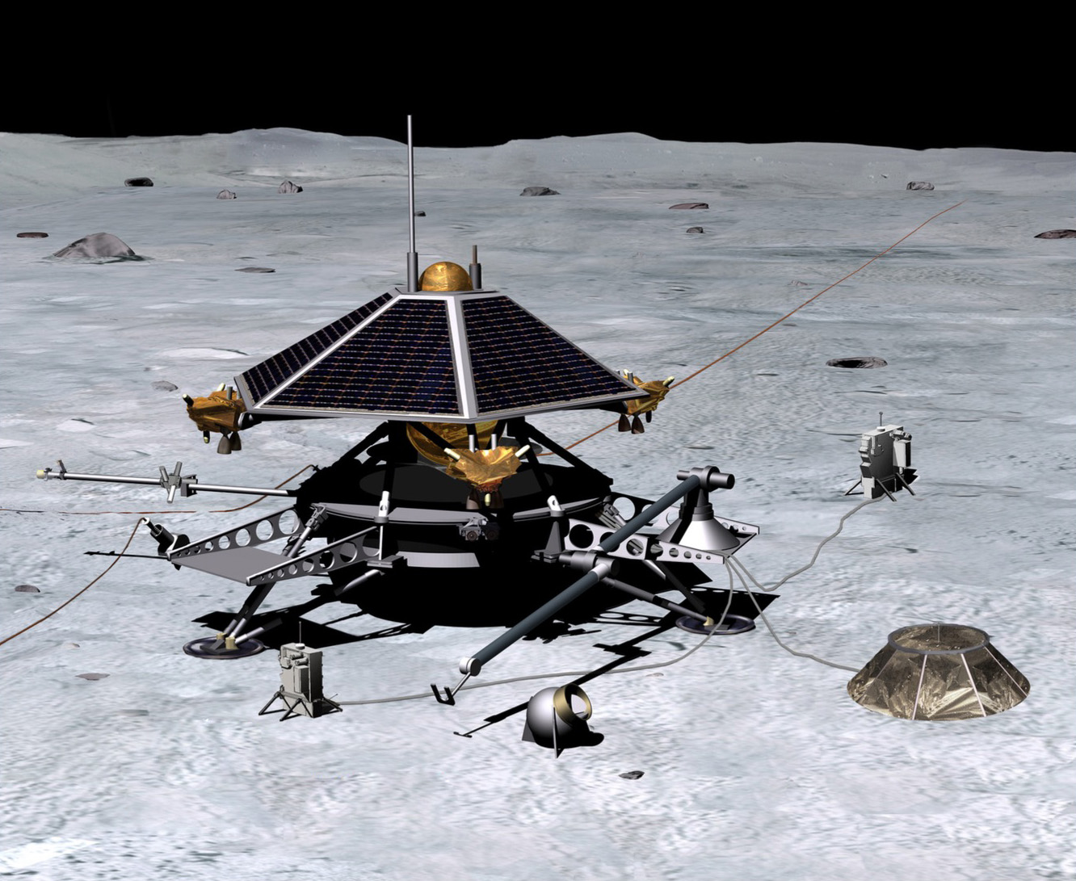

Figure 1: The LUNETTE mission concept (Neal et al., 2010), showing instruments robotically deployed to the surface.

Terrestrial geophysical survey instruments are traditionally deployed by humans in situ. Seismometers, heat flow probes, and magnetotelluric sounders require good ground coupling and on Earth are almost universally buried, isolating them from atmospheric and anthropogenic noise, as well as diurnal temperature variations. They can require leveling and orientation with respect to geographic coordinates and sun angle.
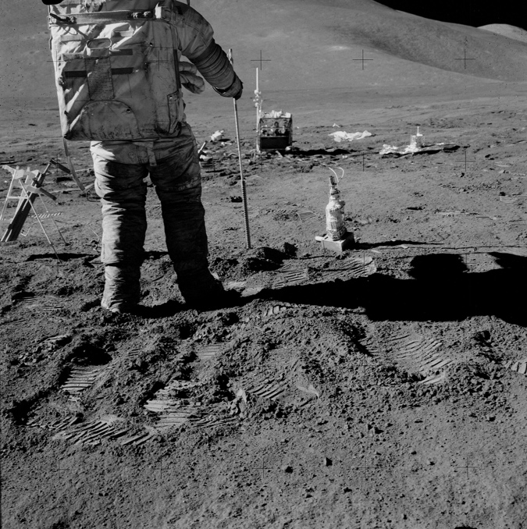

Figure 2: Manual deployment of an Apollo 15 heat flow probe into a predrilled borehole. The drill is shown next to the bore stem.

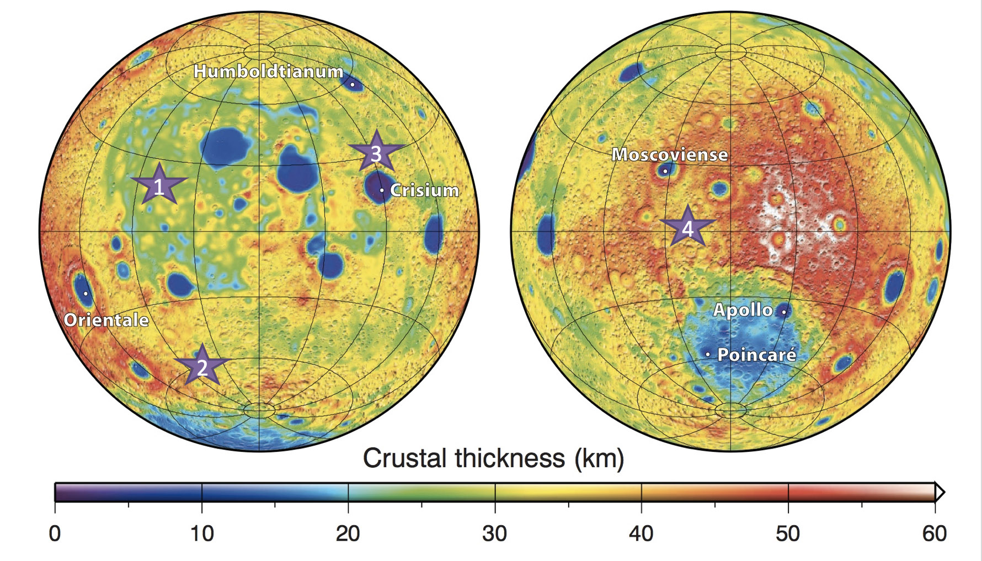
Figure 3: LGN candidate landing sites. 1: PKT. 2: Schickard (antipode to A33 deep moonquake source). 3: In or near Crisium. 4: Far side (antipode to A1 deep moonquake source). For further discussion see Jawin et al. (2019).
Completing these tasks robotically poses a technological challenge (and risk) to landed missions. While atmospheric noise is not an issue on the Moon, the extreme temperature variations are problematic and instruments still ideally need to operate in direct contact with the ground. Deployment mechanisms introduce cost and complexity to robotic missions, and are often not robust to unanticipated obstacles. The Mars InSight mission’s heat flow probe, for example, has not been able to penetrate to its intended depth despite repeated attempts (NASA, 2020), and deployment would have been greatly facilitated by an astronaut, as was done during the Apollo missions (Fig. 2).

Artemis enables LGN

Many of the instruments in development for LGN will soon fly to the Moon under NASA’s Commercial Lunar Payload Services (CLPS) program (UMD, 2019; Nagihara et al., 2019; Grimm et al., 2019). Others are in work under NASA’s Development and Advancement of Lunar Instrumentation (DALI) program (Weber et al., 2019; Yu et al., 2018). Our goal is to have all LGN primary payloads at TRL 6 (or higher) in time to be responsive to an anticipated AO in 2022.

Humans will land at the south pole of the Moon in 2024, during LGN’s Phase B. A human-deployed station at the south pole would enable an evaluation of seismic risk to a future lunar outpost, and be a fantastic addition to a robotically deployed LGN. Multiple human landings, likely spread across several years, and located at a geographically diverse set of landing sites (Fig. 3), would be required to establish an Artemis geophysical network. For comparison, the Apollo network of long-lived instruments was deployed over a period of 2.5 years (Apollo 12 to Apollo 16). All four stations only operated concurrently for an additional five years.

Artemis can reduce risk for LGN through a variety of means: 1) by raising the TRL of instruments; 2) by crew testing candidate deployment mechanisms; 3) by crew establishing the first node of a long-lived network which LGN can later augment. LGN likewise enables future long-term lunar exploration via monitoring of seismic and impact hazards. Artemis and LGN jointly provide a unique opportunity to open a new era of lunar planetary geophysical exploration.

Conclusions

In the past decade, lunar science has made multiple advancements in our understanding of the Moon’s interior. In 2018, NASA chartered the Lunar Exploration Analysis Group to form a Special Action Team, Advancing Science of the Moon, which was tasked with re-evaluating the 2007 National Academy Of Science report on the Scientific Context For The Exploration Of The Moon.

The recent Gravity Recovery and Interior Laboratory (GRAIL) mission drastically improved the lunar gravity field and revealed features of the lunar crust in unprecedented detail, including fractures and other tectonic structures, mascons, lava tubes and other volcanic landforms, impact basin rings, and the shape and size of complex to peak-ring lunar craters.

GRAIL analysis produced a family of core models consistent with geodetic parameters (including constraints from LLR), but gravity data alone have not yet definitively identified the presence of an inner core. Laser ranging data suggest the lunar core is liquid, although combining gravity, topography and laser ranging data to model the deep interior of the Moon produces a solid inner core and total core size akin to the core modeled using Apollo seismic data. Additional laser ranging stations would provide significant scientific return.

The presence of Th in the Moon’s nearside heat-producing crustal terrane (the Procellarum KREEP Terrane, or PKT) would lead to asymmetric mantle temperatures and cause a giant “mantle plume” below the PKT; the influence of ilmenite on mantle overturn may have also permitted a single upwelling plume. GRAIL data revealed a dyke system surrounding the PKT, calling into question the long-standing theory that the PKT is an ancient impact basin. Rather this work suggests it may be a magmatic-tectonic feature overlying the nearside “magma plumbing system” that supplied the mare with their basaltic infills. A thermal asymmetry that extended into the mantle may have produced true polar wander. Continued modeling efforts help define new hypotheses for heat-producing element distribution and updated landing site considerations.

Paleomagnetic studies of Apollo samples have demonstrated that the Moon had surface magnetic fields of ~30–100 μT between at least 4.2 and 3.56 Ga. The widely accepted theory for the generation of this field is an ancient core dynamo. While large surface impacts can also generate transient magnetic fields, recent analyses of Apollo samples require a slow cooling timescale that excludes impact field origins. Sample studies continue to make surprising discoveries about the lunar dynamo, but need the global context of an LGN type mission.

When taking into account advancements from the GRAIL mission, from improved analysis and modeling techniques, and from paleomagnetic sample analyses, it’s clear that a more nuanced view of the lunar interior drives new questions to be answered by LGN.

REFERENCE CHANGE: Reference lists will not be included in the expanded abstract, but should be prepared separately and entered during the submission process in the online form.

Grimm, R. E. et al., 2019, Lunar Magnetotelluric Sounder. Lunar Exploration Analysis Group annual meeting, Abstract #5026.

Jawin, E. R. et al., 2019, Lunar Science for Landed Missions Workshop Findings Report. Earth & Space Sci. 6, 2–40.

Nagihara, S. et al., 2019, Heat flow probe for short-duration lunar missions on small landers. Lunar and Planetary Science Conference Abstract #1557.

NASA, Science Definition Team for the ILN Anchor Nodes, 2009, International Lunar Network Final Report.

NASA InSight Mission News, Feb. 21, 2020, Common Questions About InSight’s ‘Mole.’
https://mars.nasa.gov/news/8444/common-questions-about-insights-mole/?site=insight

National Research Council, 2011. Vision and Voyages for Planetary Science in the Decade 2013-2022. Washington, DC: The National Academies Press. https://doi.org/10.17226/13117.

Neal, C. et al., 2010, LUNETTE: Establishing a Lunar Geophysical Network via a Discovery-class mission. Ground-based Geophysics on the Moon Workshop, Abstract #3036.

Neal, C. et al., 2020, The Lunar Geophysical Network (LGN) is critical for solar system science and human exploration. Lunar and Planetary Science Conference, Abstract #2355.

Univ. of Maryland News Release, July 11, 2019, UMD Physicist for Apollo Experiment Gets Chance to Send Next Gen Version to Moon.
https://umdrightnow.umd.edu/news/umd-physicist-apollo-experiment-gets-chance-send-next-gen-version-moon

Weber, R. C. et al., 2019, Seismometer for Lunar Network. American Geophysical Union Fall Meeting, Abstract #P33D-07.

Yu, N. et al., 2018, Lunar Super Low-Frequency Atomic Seismometer. NASA Development of Advanced Lunar Instrumentation selection abstracts (p.11).
https://nspires.nasaprs.com/external/viewrepositorydocument/cmdocumentid=659252/solicitationId=%7B07F905CA-C287-12CB-B7E5-AEF4EDBD3FC4%7D/viewSolicitationDocument=1/DALI18%20Abstracts.pdf

