Central Valley Water Resources
Improving California Groundwater Assessments using GRACE and InSAR Datasets for Water Resource Management

Technical Report
Final Draft – April 2nd, 2020

Forrest Corcoran (Project Lead)
Marissa Dudek
James Kitchens
Patrick Saylor

Zhen Liu, Ph.D., NASA Jet Propulsion Laboratory, California Institute of Technology (Science Advisor)
Kyra Kim, Ph.D., NASA Jet Propulsion Laboratory, California Institute of Technology (Science Advisor)
John T. Reager, Ph.D., NASA Jet Propulsion Laboratory, California Institute of Technology (Science Advisor)

1. Abstract
California’s Central Valley is one of the most productive agricultural areas in the world, producing approximately $20 billion in crops annually. The recent California droughts of 2007-2010 and 2012-2019 resulted in increased groundwater pumping in the Central Valley to adequately irrigate farmland. Overdrafting of the Central Valley aquifer results in groundwater depletion, land subsidence, and permanent loss of groundwater storage. In 2014, depletion of groundwater led the state of California to enact the Sustainable Groundwater Management Act (SGMA), requiring critically overdrafted, high, and medium priority sub-basins to reach sustainable levels of groundwater pumping and recharge by 2042. SGMA allows local Groundwater Sustainability Agencies (GSAs) the authority to create Groundwater Sustainability Plans (GSPs) at the sub-basin level. To assist California’s Department of Water Resources (DWR), this project quantified groundwater change and land subsidence in Central Valley sub-basins with sparse or unreliable well and Geographic Positioning Systems (GPS) data. This was done using NASA’s Gravity Recovery and Climate Experiment (GRACE), GRACE Follow-On (GRACE-FO), and interferograms derived from Sentinel-1 C-band Synthetic Aperture Radar (C-SAR) and Advanced Land Observing Satellite 2 (ALOS-2) Phased Array L-band Synthetic Aperture Radar 2 (PALSAR-2). Time series of the GRACE and InSAR data were compared with well and GPS data in data-dense sub-basins to determine the feasibility of these datasets for groundwater storage and subsidence monitoring. We found that GRACE and InSAR data are effective tools for determining groundwater change and land subsidence and can be used on their own to monitor sub-basins in the absence of well and GPS data.

Keywords
remote sensing, groundwater, subsidence, GRACE, InSAR, time series

2. Introduction
2.1 Background Information
The Central Valley is an approximately 20,000 square mile region of California (Faunt, 2009) that serves as one of the most productive agricultural regions in the world. The Central Valley produces approximately $20 billion worth of crops annually (Faunt, 2016), including over 250 different crops. The region accounts for 17% of all U.S. irrigated land (Faunt, 2009), and produces nearly half of the nation’s nuts, fruits, and vegetable supply (USGS, 2020). Taking up only 11% of California’s total land area, the Central Valley aquifer provides roughly 65% of the state’s water supply and provides 20% of the nation’s demand for groundwater, making it the second-most-pumped-aquifer in the U.S. (USGS, 2020). The Central Valley also supports a rapidly growing residential population, which has more than tripled in size from two million residents to 6.5 million since 1980 (Faunt, 2009). The California Department of Water Resources (DWR) has classified three basins within the Central Valley: the Lower Sacramento River, San Joaquin River, and the Tulare Lake Basin. These three hydrologic basins of the region are further divided into 39 sub-basins.

This project used downscaled Gravity Recovery and Climate Experiment (GRACE) and GRACE Follow-On (GRACE-FO) data to create maps of water storage change in the Central Valley. The work was coupled with previously processed Interferometric Synthetic Aperture Radar (InSAR) data processed by NASA’s Jet Propulsion Laboratory (JPL) to map surface elevation subsidence at the millimeter scale. California DWR will be able to use the GRACE and InSAR data to confirm the validity of groundwater assessments and groundwater sustainability plans. The remotely sensed GRACE and InSAR data, coupled with in-situ groundwater and elevation data, will help build the capacity of the DWR to apply these methods in the future.

2.1.1 Geologic and Hydrologic Setting
The Central Valley is a sediment-filled structural trough located between the Coast Ranges to the west and the Sierra Nevada mountains to the east. The consolidated crystalline rocks of the mountains surrounding the Central Valley act as a bowl, collecting and storing water in underground aquifers made up of unconsolidated marine, deltaic, and clastic sediment. Due to the western dip of the Sierra Nevada block, the sediment thickness ranges from zero meters on the eastern edge to more than fifteen kilometers on the western edge (Faunt, 2009). The Central Valley aquifer system is made up of confined, unconfined, and semi-confined aquifers. The Corcoran Clay, extending throughout the southern and central area of the Central Valley, makes up approximately half of the sediment fill within the valley. See Figure 1 for an overview of the study area, including the extent of the study area.

Aquifers of the Central Valley are naturally recharged from precipitation, stream seepage, snowmelt, and channel runoff from the surrounding mountains, with the majority of recharge taking place at the margins of the valley as water flows towards lower elevation. Natural discharge of the aquifers flows into lakes, marshes, and rivers near the central axis of the valley (Faunt, 2009). Unnatural discharge of the aquifer is due to human-induced pumping for public and agricultural use. Land surface subsidence in the Central Valley occurs when subsurface pore pressure is exceeded by the pressure of overlying material, often as a result of groundwater depletion. This loss in surface elevation can be recovered during elastic subsidence, while the loss of surface elevation is permanent during inelastic subsidence. Inelastic subsidence permanently reduces the total volume of water that can be stored within an aquifer. Over extended periods of time, as large volumes of water are pumped out for public and agricultural use, the Central Valley experiences greater subsidence more quickly than would naturally occur. To ensure the health and longevity of the Central Valley water resources, groundwater storage and surface subsidence are monitored by in-situ water surface elevation from well data, ground surface elevation from GPS data, and remote sensing Earth observations of gravitational anomalies and elevation.

2.1.2 Community Concerns
Over the past two decades, the Central Valley has been acutely affected by the widespread California droughts (Faunt et al., 2016). The most recent drought was one of the most intense in California’s history, lasting 376 weeks, from December 27, 2011 to March 5, 2019. As a result of these droughts, as well as the agricultural and residential reliance on groundwater, the Central Valley aquifer was pumped at levels exceeding the rate of recharge from precipitation and runoff. This overdrafting has led to substantial drops in head pressure for many wells across the valley as well as land subsidence (Liu et al., 2019).

In 2014, California Governor Jerry Brown signed the Sustainable Groundwater Management Act (SGMA) into law. With the threat of decreasing water levels, governments and water agencies of high and medium priority sub-basins are required by law to have a Groundwater Sustainability Plan (GSP) in place by 2024 and to bring groundwater storage into balanced levels of pumping and recharge by 2042. Critically overdrafted basins have goals to reach sustainable levels by the year 2040. Within each sub-basin, Groundwater Sustainability Agencies (GSAs) are responsible for enforcing local GSPs. See Figure 1 for each GSA’s SGMA groundwater sustainability priority level. Unfortunately, most California groundwater basins are unmanaged and pumping from basins is unmeasured to this day (Dickinson & Pavley, 2014).

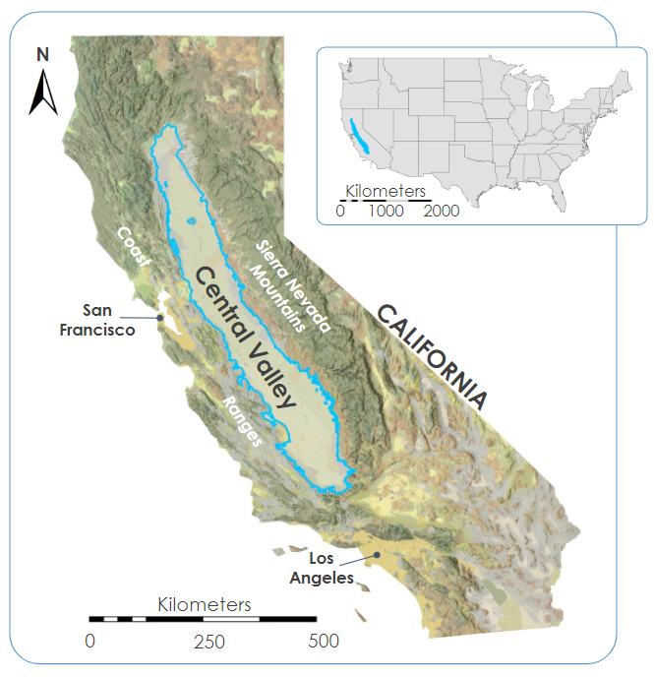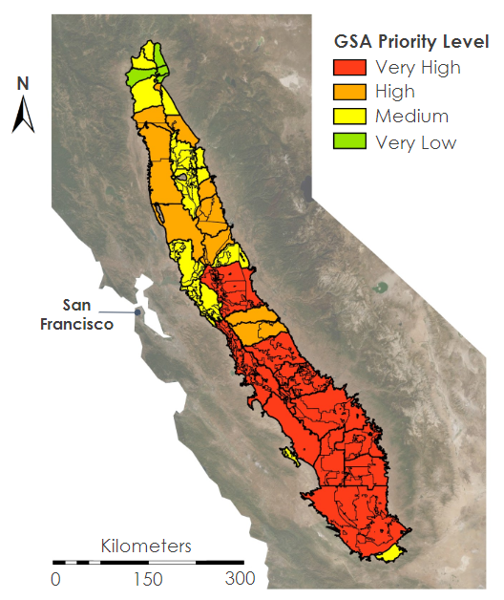
Figure 1. Left: Map of the study area showing the location of the Central Valley within the context of the state of California, and a submap showing the Central Valley within the context of the continental United States. Right: Map of the DWR hydrologic sub-basins. Colors indicate each Groundwater Sustainability Agency’s (GSA) groundwater sustainability priority level. Very high priority sub-basins have been classified as critically overdrafted.
2.2 Project Partners & Objectives
This project partnered with the DWR, as well as collaborators from California State University, Los Angeles (CSU-LA), to determine the feasibility of using Earth observations to monitor groundwater storage change and land surface subsidence. See Table 1 for more information on project partners and collaborators.

The California DWR has established 39 sub-basins and 188 GSAs in the Central Valley. Within sub-basins, local level GSAs are responsible for enacting and enforcing sustainable groundwater practices, with the ultimate goal of reaching sustainable levels in accordance with SGMA (Dickinson & Pavley, 2014). The objective of this project was to assist California DWR’s South Central Region Office (SRCO), Southern Region Office (SRO), and North Central Region Office (NCRO) by providing remotely sensed estimates of terrestrial water storage and surface elevation change in the Central Valley region of California. The SCRO, SRO, and NCRO provide GSAs with in-situ groundwater and elevation data in populated areas; however, in-situ data is sparse in rural areas.

Table 1
Partners involved in the project

Partner Organization | Point of Contact | Partner Role
California, Department of Water Resources, Southern Region Office | Timothy Ross, Ph.D., Senior Engineering Geologist, SRO Section Lead; Jack Tung, Engineering Geologist | End User
California, Department of Water Resources, North Central Region Office | Bill Brewster, Senior Engineering Geologist, NCRO Section Lead | End User
California, Department of Water Resources, South Central Region Office | Mike McKenzie, Senior Engineering Geologist, SCRO Section Lead | End User
California State University, Los Angeles | Charles Hays, Ph.D., Lecturer; Jingjing Li, Ph.D., Assistant Professor | Collaborator

2.3 Study Period
This study focused on the period between January 2003 - December 2019. This period was chosen due to the availability of GRACE/GRACE-FO data, which was launched in 2003. While in-situ well station data dates back several decades, data before 2003 were found to be spatially sparse, sporadically measured, and unreliable. As one of the main objectives of this project was to present DWR with groundwater depletion and land subsidence data with respect to individual GSAs since the implementation of SGMA, we chose a study period which paralleled those of sub-basin GSPs. Within the study period, dates leading up to, during, and following heavy drought seasons were of particular interest to study the groundwater storage susceptibility and resilience to overdrafting of the Central Valley aquifer. See Figure 2 for a timeline of the study period including time spans of droughts, SGMA, and data sets used in this study.

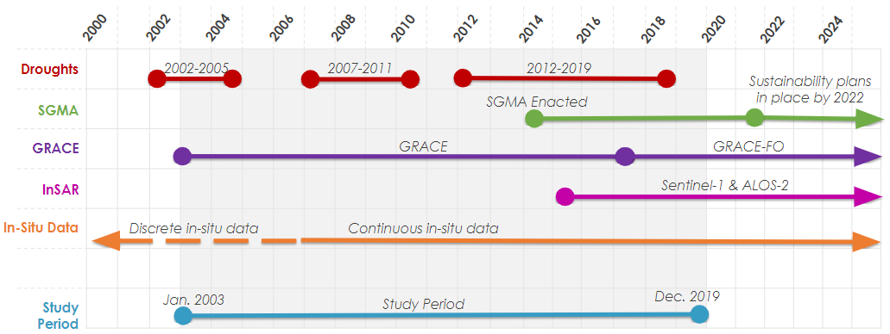

Figure 2. Timeline of the study period. Droughts: Timespan of major droughts in California. SGMA: SGMA enacted in 2014 requires all GSAs to have GSPs in place by 2022. GRACE: Timespan of GRACE and GRACE-FO data. InSAR: Timespan of Sentinel-1 & ALOS-2 InSAR data. In-Situ Data: In-situ well water surface elevation and GPS surface elevation data. Study Period: Timespan of data collected in this project. Shaded: All data included within the study period.

3. Methodology
3.1 Data Acquisition
A shapefile containing basins, sub-basins, and GSAs within the Central Valley was acquired through the California DWR Bulletin 118 and associated Open Data Portal. The team located in-situ well and GPS station measurements from the DWR and Nevada Geodetic Laboratory (NGL) databases, respectively. Within the California Statewide Groundwater Elevation Monitoring Program (CASGEM) Open Data Portal, the team found three datasets containing well measurements over the time period of our study: continuous, monthly, and periodic. For this study, the team used a combination of DWR and USGS datasets in order to provide the most consistent spatial and temporal coverage across the Central Valley. The well and GPS measurements include periodic measurements of water surface elevation (WSE) and ground surface elevation, respectively, over the study period and area.

The team acquired downscaled GRACE data from NASA’s Goddard Space Flight Center. Originally collected by NASA’s GRACE and GRACE Follow-On (GRACE-FO) missions, NASA’s Goddard Space Flight Center downscaled the satellite data to a spatial resolution of approximately 12.5 km per pixel using NASA’s North American Land Data Assimilation System (NLDAS) Version 2. The team obtained processed interferograms of Sentinel-1 C-band Synthetic Aperture Radar (C-SAR) and Advanced Land Observing Satellite 2 (ALOS-2) Phased Array L-Band Synthetic Aperture Radar 2 (PALSAR-2) data from Dr. Zhen Liu at NASA’s Jet Propulsion Laboratory (JPL). These InSAR datasets were collected by the European Space Agency’s (ESA) Sentinel-1 C-SAR and Japanese Aerospace Exploration Agency’s (JAXA) ALOS-2 PALSAR-2 before being processed to produce rasterized data of land surface elevation change over time.

3.2 Data Processing
3.2.1 In-situ groundwater well data
Many in-situ groundwater observation databases exist for the state of California. However, well identification codes, data formatting and individual wells catalogued in each database are inconsistent. This creates a challenge in generating a holistic assessment of groundwater in the state of California. Here, the team integrated and merged selected wells across five in-situ groundwater well datasets obtained from the USGS and DWR. Two databases were obtained from DWR: Continuous Well Monitoring Data and Periodic Well Monitoring Data. Three additional databases were accessed from the USGS: the groundwater level (GWL) database from the National Water Information System (NWIS), a subset of USGS wells documented in Liu et al. 2019, and the National Groundwater Monitoring Network, a product of Federal Advisory Committee on Water Information (ACWI NGWMN). See Table 2 for the total number of stations and observations per dataset.

Table 2
Groundwater well input datasets.
Dataset | Number of Stations | Number of Observations
DWR continuous daily | 407 | 1158739
DWR periodic | 16279 | 640274
USGS GWL | 4003 | 30000
[USGS] Liu et al. 2019 | 9 | 540
USGS-ACWI-NGWMN | 60 | 26383

Processing and cleaning of each database was conducted primarily based on quality assurance and quality control (QA/QC) codes provided with each database. Due to the large volume of data ingested, and the unique nature of each dataset, each dataset was quality controlled individually. Across all databases, only data passing quality control as designated by the collecting agency was included in this study (if QC were provided). Further cleaning was conducted to ensure internally consistent nomenclature. Missing data and erroneous recordings were removed to ensure uniformity in each database. Finally, data were selected from January 1 2003 – December 31, 2019 for evaluation in this study. Each dataset was then brought to a standard format and merged into a master database. However, it should be noted that USGS data and DWR do not have a shared groundwater identification nomenclature. Further, individual wells cannot be matched up or uniquely identified by location, as the GPS coordinates provided in each database do not provide sufficient resolution to avoid overlap. As a result, to identify a unique and consistent database for analysis that integrates all data sources, a gridding and scoring system was implemented to select the highest quality, unique data.

An approximately 1 km grid system (1/100th decimal degree) was established for California. At each grid location, the master well database was queried to identify all wells at that location. A scoring system was then implemented to select a representative well based on the following criteria: number of observations, number of months in the study window with observations, and mean observations per month. Criteria were normalized across the available wells and uniformly weighted. See Figure 3 for a visualization of the data aggregation and data selection with the scorecard method. The highest-ranking well was then selected as the groundwater observation representative of that grid cell. Through this method, we avoided duplication of well data across databases and maintained uniformity and consistency in spatial sampling. The criteria were selected to balance both quantity and temporal spread available data at each location. Final well station locations used in this project are shown in Figure 4, with a qualitative look at the relative station density per sub-basin and the number of observations per station, and Table 3 for well station statistics.
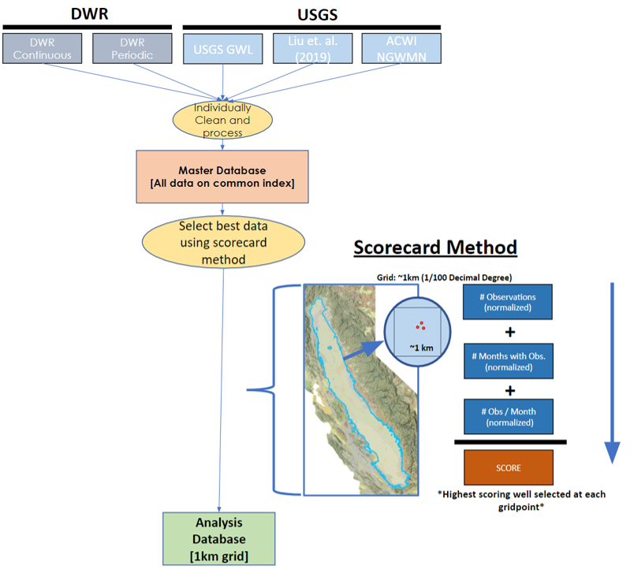
Figure 3. Flow chart showing the datasets that were individually cleaned and processed and aggregated into a master database with a common index. Then a grid and scorecard method was applied to select the most appropriate well for analysis within each 1km² cell. Highest scoring wells were then added to the analysis database.

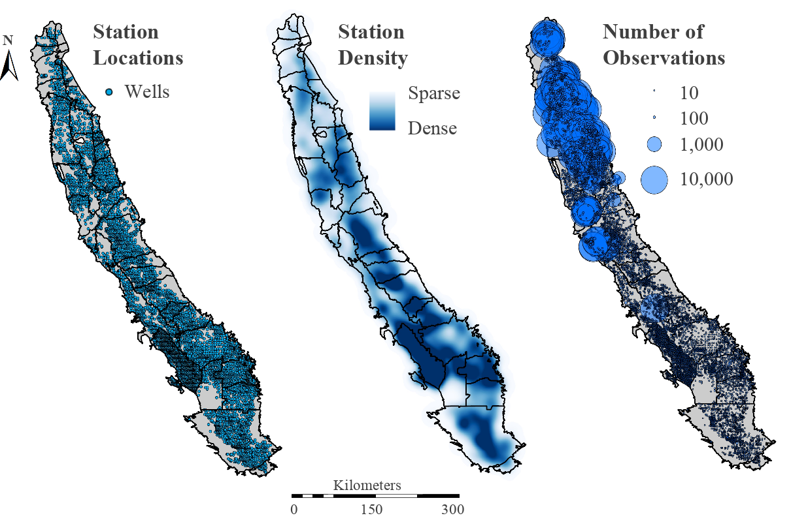
Figure 4. Maps of well station locations used in this project (left), relative station density with dark areas representing a high density (middle), and number of total observations within the study period at each station with the size of the circle representing the number of observations (right).

Table 3
Statistics of well station and observations used in this study after data cleaning
Number of Well Stations | Number of Observations (total) | Number of Observations (per stations)
 |  | Max. | Mean | Median | Min. | St. Dev.
7,706 | 642,736 | 13,949 | 83.4 | 11 | 1 | 501.06

3.2.2 In-situ GPS Data
GPS ground stations from the NGL were accessed to serve as in-situ measurements of ground surface elevation change (Blewitt et al., 2018), with the 2014 International Global Navigation Satellite System (GNSS) Service reference frame (IGS14). Daily IGS14 easting, northing, and vertical readings from a total of 125 GPS stations were collected within the study area. The vertical component of station movement was isolated for analysis, as horizontal translation is assumed to be a negligible contribution to the evaluation of surface subsidence. In order to compare the GPS and InSAR measurements, the vertical component of the GPS data was converted to Line of Sight (LOS) for Sentinel-1, as shown in Figure 5. This was done using Equation 1, where $θ$ was assumed to be 37 degrees for all GPS stations in the Central Valley. GPS station locations used in this project are shown in Figure 6, with a qualitative look at the relative station density per sub-basin and the number of observations per station. Across the 125 stations, a total of 359,800 observations were analyzed, with a mean number of observations of 2,878 per station. See Table 4 for quantitative information on the number of well stations and WSE observations per station.

$LOS= Z/{cos⁡(θ)}$ (1)
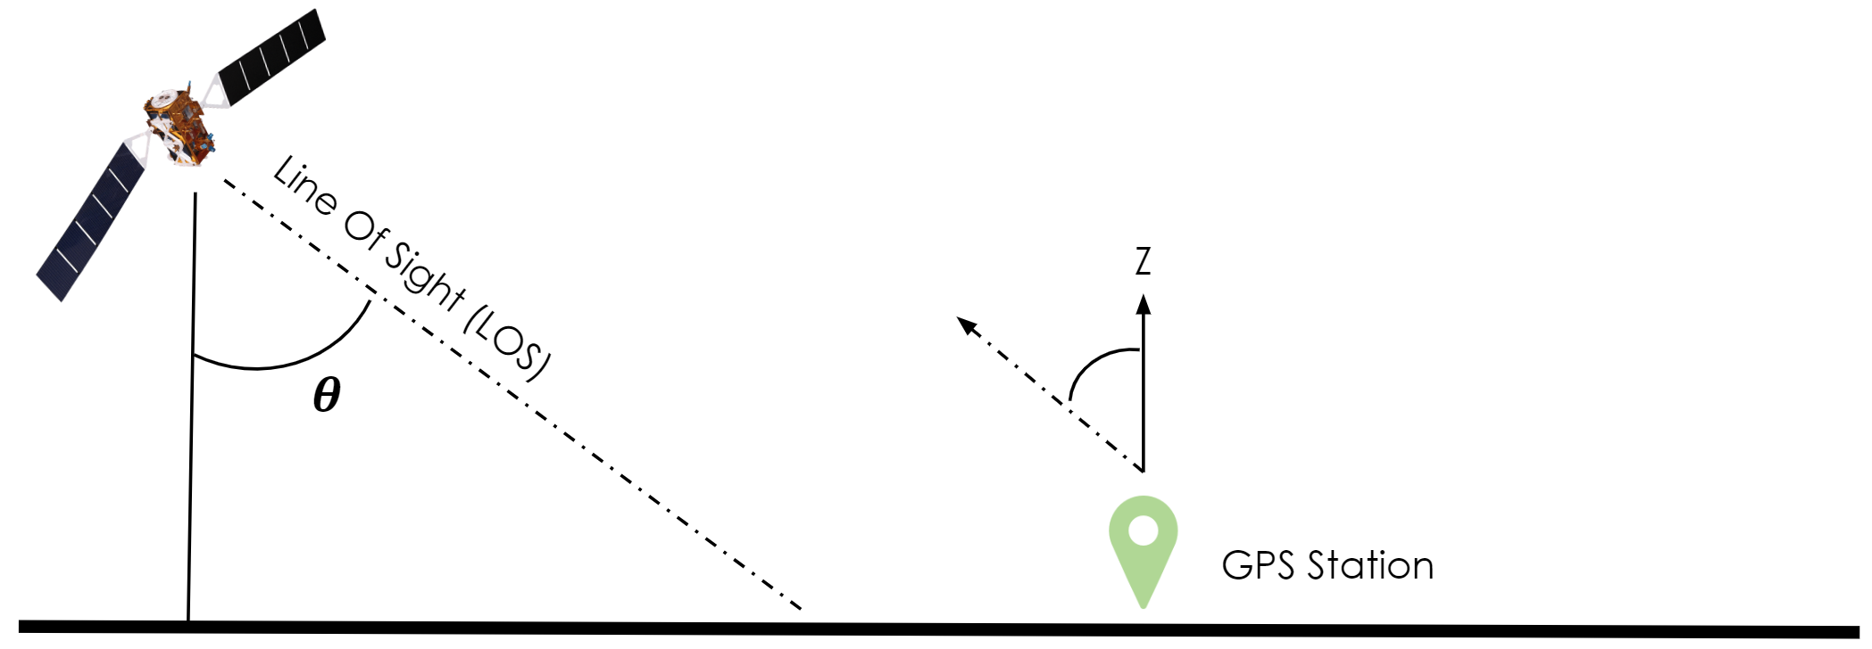
Figure 5. GPS measurements evaluating the displacement of the sensor in three dimensions were isolated to evaluate only the vertical component as horizontal changes were assumed negligible in contributing to subsidence. InSAR data collected from Sentinel-1 is measured from an oblique angle, known as a Line of Sight (LOS) swath measurement. Therefore, in order to compare GPS ground stations with LOS measurements, all vertical GPS measurements were converted to LOS (Equation 1).

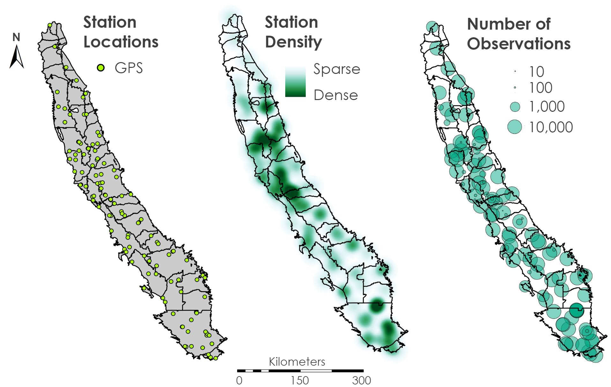
Figure 6. Maps of GPS station locations used in this project (left), relative station density with dark areas representing a high density (middle), and number of total observations within the study period at each station with the size of the circle representing the number of observations (right).

Table 4
Statistics of GPS station and observations used in this study
Number of GPS Stations | Number of Observations (total) | Number of Observations (per stations)
 |  | Max. | Mean | Median | Min. | St. Dev.
125 | 359,800 | 7,619 | 2,878.4 | 2,784 | 1 | 2,126.51

3.2.3 In-situ well vs. GRACE
Each well site had an associated reference coordinate (longitude/latitude) which the team used to isolate the stations within the study area and group them based on sub-basin and GSA. Each well station location was then queried with respect to rasterized GRACE data to find the groundwater thickness (mm) at each well station location. The remotely sensed data were merged with the in-situ well measurements to create a table that stored a time series of groundwater capacity at each location over time (see Figure 7).

3.2.4 In-situ GPS vs. InSAR
The team applied a similar process as the well data to clean the measurements from GPS stations. The GPS dataset did not include QA/QC codes, so filtering was based on the date of collection within the study period. Each GPS station had an associated reference coordinate (longitude/latitude) taken at the time of installation, which the team used to isolate the stations within the study area and group them based on sub-basin and GSA. Each GPS station location was then queried with respect to the rasterized InSAR data to find the surface elevation (mm) at each location. The remotely sensed data were merged with the in-situ GPS measurements to create a table that stored a time series of surface elevation at each location over time (see Figure 7).

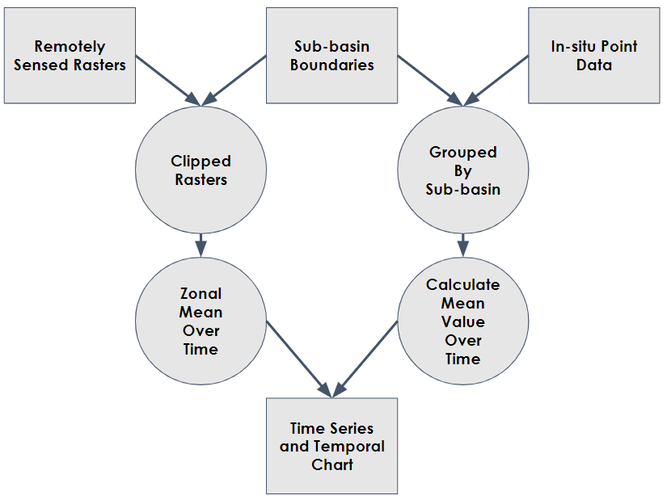
Figure 7. Workflow of data analysis process. Zonal statistics were compared across remotely sensed and in-situ point datasets using time series plots and Pearson correlations

3.3 Data Analysis
In order to compare the various data sources and evaluate their efficacy for measuring groundwater storage loss and land surface subsidence in the context of the SGMA legislation, the team performed a zonal analysis of the InSAR, GRACE, well, and GPS data at the sub-basin level. Sub-basins were chosen as the zones for this zonal analysis as opposed to GSAs because GSAs are not always spatially contiguous. Additionally, GSAs organize at the sub-basin level to form the GSPs that apply to all GSAs within that sub-basin. This makes zonal analysis of sub-basins a more representative method of monitoring progress in the context of the SGMA legislation. The Delta-Mendota sub-basin was chosen to test the feasibility of this analysis because it has the highest density of well and GPS station data, while also being fully covered by InSAR and GRACE datasets, making it the ideal test case.

At each time step in the data and for each sub-basin in the Central Valley, the team aggregated the data points located within the sub-basin. The team then took the mean value for each dataset at each time step, creating four time series (GRACE, InSAR, wells, and GPS) for each sub-basin. Each time series represents the average value spatially across the sub-basin and temporally over the study period.

In order to compare the time series data of each sub-basin independent of measurement units, the team took the average value of each time series over time and subtracted it from each entry, then divided this value by the standard deviation of the time series, generating a z-score for each measurement. This normalization process converted the time series to a common unit of standard deviations (z-score), making the various data sources comparable across time. The team then plotted the data on a common axis to compare the time series.

4. Results & Discussion
4.1 Analysis of Results
By plotting these datasets on a common axis, the team was able to clearly see the pattern between the datasets. In particular, the GRACE and well data show remarkably similar patterns of seasonality over time. Although the shape of the well data does diverge from the GRACE data at some time steps, this can likely be attributed to the more infrequent sampling in the well data, as demonstrated by the more jagged shape of the well time series (see Figure 8). The team also hypothesized that well measurements were taken selectively after episodes of either high precipitation or drought, thereby increasing the variance in the well data. The team performed a Pearson correlation between the different datasets within the Delta-Mendota sub-basin and found significant but relatively weak correlations between GRACE and well datasets between 2003 and 2020 (Table A1). When performed across the Central Valley as a whole, we found a much stronger correlation between the datasets (Table A2).

In addition to the match between the well and GRACE data, these two datasets also correspond with the timing of natural phenomena. The period between 2012 and 2017, overlapping one of the most intense droughts in California history, shows a depression in average groundwater storage across the sub-basin. In 2018, while the well data does show a moderate increase in groundwater storage across the sub-basin, the GRACE data shows a much more pronounced signal, indicating the end of the drought (see Figure 8). This suggests that GRACE data may be a more appropriate indicator of groundwater storage response to natural phenomena than localized well station observations.

The Sentinel-1 data show a distinctly similar pattern of seasonality corresponding with the GRACE and well data, lending further evidence to the link between overdrafting of the Central Valley aquifer and local land subsidence. Although ALOS data were processed in the same manner, these data do not show similar trends to Sentinel-1. Further investigation into the root cause of these differences is necessary but beyond the scope of this project. GPS measurements show a consistent downward trend across the entire time period, without exceptional gain during the drought period. The Sentinel-1 trend shows that the majority of land subsidence is recovered after each major seasonal drop, but there is a smaller fraction of elevation that is not recovered. This fraction represents the inelastic subsidence. Additionally, it is important to note the steep drop in surface elevation between 2015 and 2016. This loss in elevation, which occurs during one of the most intense drought periods, is never fully recovered throughout the time series.

Zonal Analysis Results: Delta-Mendota Sub-Basin
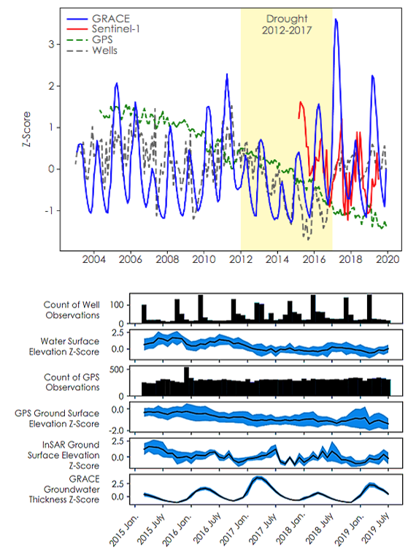

Figure 8. Zonal analysis time series of the Delta-Mendota sub-basin. (Top) Time series from 2003-2020 with GRACE groundwater thickness in blue, Sentinel-1 surface elevation in red, GPS surface elevation in dashed green, and well WSE in dashed grey. (Bottom) Size panel time series of normalized well, GPS, InSAR, and GRACE groundwater thickness. The time series represent the spatial and temporal average across the sub-basin per month in black, with the blue band representing one standard deviation from the mean.

4.2 Future Work
Although zonal analysis produced invaluable results for understanding groundwater storage and land subsidence responses to overdrafting in the context of SGMA, the team believes other analyses could be performed to generate a more holistic understanding of groundwater storage and land subsidence regimes throughout the Central Valley. One such analysis the team identified is a point analysis. In this analysis, remotely sensed data would be compared to in-situ data taken at corresponding times, much like the zonal analysis. However, the datasets would not be aggregated over different regions to calculate mean values but would instead be analyzed at the point where the in-situ measurements were taken. This analysis would produce time series similar to Figure 8, but allow the team to draw conclusions at a scale local to the in-situ measurement, as opposed to regional. This technique would maintain information lost during the aggregation step of zonal analysis. However, this is also a much more computationally intensive process.

Additionally, the team would like to see future work expand on the use of InSAR data across the Central Valley. Currently, InSAR coverage of the valley only extends across the southern region due to prioritization of regions with greater subsidence. Increased InSAR coverage of the Central Valley would allow for a more comprehensive look at the natural factors affecting subsidence as well as the ground elevation response to overdrafting. The team hoped to utilize the Japanese Aerospace Exploration Agency’s (JAXA) Advanced Land Observing Satellite 2 (ALOS-2) Phased Array L-band Synthetic Aperture Radar 2 (PALSAR-2) as another potential data source for InSAR during the course of this project, but due to time limitations, only preliminary processing and analysis was feasible at this time. Incorporating measurements produced from this satellite would improve temporal resolution of the area with respect to land subsidence.

Finally, the team is currently undergoing efforts to produce a software tool, named the Visualization of In-situ and Remotely sensed Observations (VIRGO), that will allow researchers and water resource managers, such as our partners at the California DWR, to reproduce the work described in this study. The purpose of this tool is to increase the DWR’s capacity to monitor groundwater storage and land subsidence in the context of SGMA and ensure that GSAs meet their stated sustainability goals.

5. Conclusions
This study showed that GRACE and InSAR are reliable substitutes for monitoring groundwater storage and land subsidence in the context of the SGMA legislation, particularly in regions where in-situ well and GPS data are sparse, unreliable, or unavailable. The GRACE downscaled data provided by NASA’s Goddard Space Flight Center are an especially good substitute for well data, and may in fact be a preferable method for accurate assessment of groundwater storage over sub-basin scale regions. This is primarily due to the distinct similarities in the time series of the two datasets, with GRACE data showing a smoother shape with less variation over sub-seasonal time periods. Both the GRACE and well data accurately captured the drought period between 2012-2017. However, GRACE showed a much more dramatic response to the end of the drought, making it a better indicator of sub-basin scale hydrologic phenomena.

Likewise, this study showed that InSAR data can be used to assess land subsidence in regions of the Central Valley where in-situ data may be unavailable. The InSAR data used in this study demonstrated that land subsidence does correspond to decreases in groundwater storage and that decreases in elevation can be recovered to a certain extent, but that there is a fraction of unrecoverable loss in surface elevation corresponding with a loss in subsurface groundwater storage at each seasonal fluctuation. Most notably, a large episode of subsidence between 2015 and 2016 is never fully recovered over the course of the study period.

The team hopes that future work can be conducted to produce a more holistic understanding of the groundwater storage and land subsidence regimes across the study period, ideally using point analysis. The team has also identified areas of improvement, particularly with regards to InSAR coverage and data sources, that may be of use in further building out the results of this study. Finally, the team hopes to release a Visualization of In-situ and Remotely sensed Observations (VIRGO) software tool by the 2020 GSA annual report in order to provide actionable information to California’s DWR on groundwater sustainability.

6. Acknowledgments
We thank everyone at the California – JPL node for their support and guidance during this term and for providing the Earth observation data required for this project.

Dr. Kyra Kim (NASA Jet Propulsion Laboratory, California Institute of Technology)
Dr. Zhen Liu (NASA Jet Propulsion Laboratory, California Institute of Technology)
Dr. John T. Reager (NASA Jet Propulsion Laboratory, California Institute of Technology)
Ben Holt (NASA Jet Propulsion Laboratory, California Institute of Technology)
Cecil Byles (NASA DEVELOP National Program, Lead/Fellow)

A special thanks to our Project Partners who provided us with in-situ data and their expertise throughout this project.

Dr. Timothy Ross (California Department of Water Resources, Southern Region Office)
Jack Tung (California Department of Water Resources, Southern Region Office)
Bill Brewster (California Department of Water Resources, North Central Region Office)
Mike McKenzie (California, Department of Water Resources, South Central Region Office)
Dr. Charles Hayes (California State University, Los Angeles)
Dr. Jingjing Li (California State University, Los Angeles)

Any opinions, findings, and conclusions or recommendations expressed in this material are those of the author(s) and do not necessarily reflect the views of the National Aeronautics and Space Administration.

This material is based upon work supported by NASA through contract NNL16AA05C.

This material contains modified Copernicus Sentinel data (2015-2020), processed by ESA and Z. Liu (NASA Jet Propulsion Lab - Earth Surface and Interior).

7. Glossary
Aquifer - Underground layers of water-bearing permeable rock, unconsolidated materials, or void spaces
Basin - Area of land where water collects and drains off into a common outlet
CASGEM - California Statewide Groundwater Elevation Monitoring Program
DWR - Department of Water Resources
Earth observations – Satellites and sensors that collect information about the Earth’s physical, chemical, and biological systems over space and time
ESA - European Space Agency
GNSS - Global Navigation Satellite System
GPS - Global Positioning System
GRACE - Gravity Recovery and Climate Experiment
GRACE-FO - Gravity Recovery and Climate Experiment Follow-On
GSA - Groundwater Sustainability Agency
GSP - Groundwater Sustainability Plan
IGS14 - International Global Navigation Satellite System Service 2014 reference frame
InSAR - Interferometric Synthetic Aperture Radar
In-situ - On site, at an original location
LOS - Line-of-Sight
Pore pressure - Pressure of groundwater held between particles within a soil or rock
NGL - Nevada Geodetic Laboratory
QA - Quality Assurance
QC - Quality Control
Raster - A rectangular pattern of pixels, with each pixel representing a given value
SGMA - Sustainable Groundwater Management Act
Subsidence - Gradual sinking of an area or land surface
TWS - Total Water Storage
USGS - United States Geological Survey
UNAVCO - University NAVSTAR Consortium
WSE - Water Surface Elevation

8. References
Blewitt et al. (2018). Harnessing the GPS data explosion for interdisciplinary science, Eos, 99, https://doi.org/10.1029/2018EO104623.

Booth, N.L., Brodaric, B., Lucido, J.M., Kuo, I.-L., Boisvert, E., & Cunningham, W.L., (2011). Development of an Interoperable Groundwater Data Exchange Network between the United States and Canada. GeoHydro 2011 Conference Proceedings. https://acwi.gov/sogw/pubs/tr/pilot_results/Booth_etal_GeoHydro2011.pdfBooth

California Department of Water Resources, Continuous Groundwater Level Measurements. Accessed [Feb 02 2020]. https://data.cnra.ca.gov/dataset/continuous-groundwater-level-measurements

California Department of Water Resources, Periodic Groundwater Level Measurements. Accessed [Feb 02 2020]. https://data.cnra.ca.gov/dataset/periodic-groundwater-level-measurements.

California Department of Water Resources. (June 18 2018). NASA JPL InSAR Subsidence Data [Data file]. Retrieved from https://data.cnra.ca.gov/dataset/nasa-jpl-insar-subsidence.

Copernicus Sentinel-1 C-SAR data [2017-2019]. Retrieved from ASF DAAC, processed by ESA.

Faunt, C. (2009). Groundwater Availability of the Central Valley, California (US Geological Survey Professional Paper No. 1766). US Geological Survey. Available at https://pubs.usgs.gov/pp/1766/

Faunt, C. C., Sneed, M., Traum, J., & Brandt, J. T. (2016). Water availability and land subsidence in the Central Valley, California, USA. Hydrogeology Journal, 24(3), 675–684. https://doi.org/10.1007/s10040-015-1339-x

Liu, Z., Liu, P.-W., Massoud, E., Farr, T. G., Lundgren, P., & Famiglietti, J. S. (2019). Monitoring Groundwater Change in California’s Central Valley Using Sentinel-1 and GRACE Observations. Geosciences, 9(10), 436. https://doi.org/10.3390/geosciences9100436.x

Sustainable Groundwater Management Act (2014). SB-1168 Groundwater (Pavely), AB-1739 Groundwater management (Dickinson), SB-1319 Groundwater (Pavely), State of California. Available at https://water.ca.gov/Programs/Groundwater-Management/SGMA-Groundwater-Management

U.S. Geological Survey, 2016, National Water Information System. (USGS Water Data for the Nation), accessed [Feb 10. 2020]. http://waterdata.usgs.gov/nwis/. doi: http://dx.doi.org/10.5066/F7P55KJN

USGS (2020). California Water Science Center. California's Central Valley. United States Geological Survey California Water Science Center. U.S. Department of Interior. Available at https://ca.water.usgs.gov/projects/central-valley/about-central-valley.html

9. Appendices
Appendix A.
Table A1
Pearson Correlation table between mean monthly values from various datasets available for the Delta-Mendota Sub-basin. Correlation values range from -1 to 1.
Delta-Mendota Sub-Basin | Well mean | GRACE mean | Sentinel-1 mean | ALOS mean
Well mean | 1.00 | 0.33 | -0.35 | 0.31
GRACE mean | 0.33 | 1.00 | 0.08 | 0.39
Sentinel-1 mean | -0.35 | 0.08 | 1.00 | -0.28
ALOS mean | 0.31 | 0.39 | -0.28 | 1.00

Table A2
Pearson Correlation table between mean monthly values from various datasets available for the entire Central Valley. Correlation values range from -1 to 1.
Central Valley | Well mean | GRACE mean | Sentinel-1 mean | ALOS mean
Well mean | 1.00 | 0.73 | -0.32 | 0.11
GRACE mean | 0.73 | 1.00 | 0.07 | 0.38
Sentinel-1 mean | -0.32 | 0.07 | 1.00 | 0.08
ALOS mean | 0.11 | 0.38 | 0.08 | 1.00

