Lower Omo Food Security & Agriculture
Mapping Land Cover Change in Unprotected and Protected Areas in the Lower Omo River Valley, Ethiopia

Technical Report
Final Draft – April 2nd, 2020

Chiara Phillips (Project Lead)
Stacy Armbruster
Lauren Lad
Matison Lakstigala

Dr. Paul Evangelista, Colorado State University, Natural Resource Ecology Laboratory (Science Advisor)
Dr. Catherine Jarnevich, United States Geological Survey, Fort Collins Science Center (Science Advisor)
Nicholas Young, Colorado State University, Natural Resource Ecology Laboratory (Science Advisor)
Peder Engelstad, Colorado State University, Natural Resource Ecology Laboratory (Science Advisor)
Tony Vorster, Colorado State University, Natural Resource Ecology Laboratory (Science Advisor)

1. Abstract
Ethiopia is home to unique wildlife, biodiversity, and ecosystem services and, like much of the world, is undergoing population growth, development, and land use change. As a result, some biodiverse regions may be at risk of being urbanized, cultivated as agricultural plots, or losing access to water bodies that are essential for maintaining both terrestrial and aquatic life. The DEVELOP team partnered with the Ethiopian Wildlife Conservation Authority to quantify the land cover change between the years 1994, 2010, and 2018. The team utilized Ethiopia’s dry season (January to May) for training point development which was crucial in differentiating the level of greenness between the four land cover classes: water, natural vegetation, cultivated land, and bare ground. The study area covered 62,000 km² of the Lower Omo River Valley and includes eight protected areas. Data from Landsat 5 Thematic Mapper, Landsat 7 Enhanced Thematic Mapper Plus, Landsat 8 Operational Land Imager, and Shuttle Radar Topography Mission were used to employ a Random Forest classifier and identify the four classes within Google Earth Engine. For each of the supervised classifications, overall model accuracy was between 83% (2018) and 89% (1994). Between 1994 and 2018, the Lower Omo Valley experienced an overall increase of 258% (919 km²) in water and 291% (7,188 km²) in cultivated areas, while experiencing a 9% (2,761 km²) decrease in natural vegetation and 19% (5,346 km²) bare ground. There was an increase in water and cultivated land and a decrease in natural vegetation and bare ground in unprotected areas and all protected areas. However, protected areas maintained natural vegetation better than unprotected areas and only experienced a 1% (59 km²) loss compared to a 10% (2,701 km²) loss in unprotected areas.

Keywords
remote sensing, Landsat, Normalized Difference Vegetation Index, Tasseled Cap, Random Forest, land cover classification

2. Introduction
  - Lower Omo River Valley Background
The Lower Omo River Valley is a semi-arid region of southwestern Ethiopia with extraordinary biodiversity and a large number of distinct, indigenous agro-pastoral and fishing communities (Avery, 2013). It is inhabited by over 300 species of birds and 75 species of mammals such as eland, cheetah, elephant, black rhino, and leopard (Enawgaw, Deksios, & Timer, 2011). The valley contains a UNESCO World Heritage site, multiple protected areas, and is home to approximately 200,000 agro-pastoralists (Oakland Institute, 2013). However, within the past two decades, the Lower Omo River Valley has been experiencing expansions in agriculture, infrastructure such as the Gibe III dam, and human settlements (International Rivers, 2011).

While protected areas aim to conserve biodiversity and large-scale natural ecosystems, the protected areas in the Lower Omo Valley are increasingly facing a number of challenges associated with land cover change, endangering the future of this unique landscape (Enawgaw, Deksios, & Timer, 2011). Chiefly, agricultural expansion, livestock grazing, human settlements, and infrastructure development have become problematic for managing these protected areas (Hansilo & Tiki, 2017), often resulting in the loss of natural habitat critical for ecosystem services. Although there have been considerable changes to the region, no clear quantitative assessment on the impact of human encroachment on this region and the protected areas therein has been performed. These threats to the valley’s biodiversity prompt the urgency for sustainable land use planning and possible mitigation measures by way of enhanced remote sensing-based image analysis techniques that can identify areas of land use change only possible with long term satellite imagery.

Previous studies have established the utility of open-source data from space-borne sensors as a cost-effective, streamlined way to accurately examine land cover change (Kennedy, Yang & Warren, 2010; Lunetta, Knight, Ediriwickrema, Lyon, & Worthy, 2006; Rawat & Kumar, 2015; Zhu, Liu, Wu, Tang, & Meng, 2019). While Moderate Resolution Imaging Spectroradiometer (MODIS) imagery has been successfully used in land cover change research when daily imagery is needed, its coarse resolution (250-1000 m) has been a limitation in classifying land cover on scales smaller than 250 meters (Lunetta et al., 2006). Alternatively, the Landsat suite offers a finer resolution of 30 meters but has the limitation of a 16-day temporal resolution. Despite this limitation, many land cover change studies have successfully employed Landsat imagery (Kennedy et al., 2010; Rawat & Kumar, 2015; Zhu et al., 2019). Sentinel-2A offers an even finer spatial resolution, ranging from 10 meters to 30 meters, and a high revisit frequency but is limited to study periods after its launch in 2015 (Drusch et al., 2012).
Land cover change studies that employ remotely sensed data utilize a variety of predictor variables to differentiate between land cover classes. Vegetation indices such as Normalized Difference Vegetation Index (NDVI), fraction of Photosynthetically Active Radiation (fPAR) and Leaf Area Index (LAI) were effective in determining land cover classes using multi-temporal MODIS data (Lunetta et al., 2006). Additionally, to detect land use/cover between 1990 and 2010, previous research successfully utilized Landsat Thematic Mapper bands within a maximum likelihood algorithm (Rawat & Kumar, 2015). Another study used NDVI and Enhanced Vegetation Index (EVI) in the Landsat-based Detection of Trends in Disturbance and Recovery (LandTrendr) algorithm (Kennedy et al., 2010) with Google Earth Engine (GEE; Zhu et al., 2019) to effectively detect long-term land cover change. Compared to other change detection algorithms, LandTrendr in GEE offers the advantage of cloud computing which allows for faster computation speeds in data collection and processing (Zhu et al., 2019). The use of remotely sensed satellite data provides the opportunity to efficiently research long term land cover change at low costs to aid decision-makers and land managers globally.

  - Project Partners & Objectives
The Ethiopian Wildlife Conservation Authority (EWCA) is the governing agency for all protected lands and wildlife in Ethiopia. The EWCA makes decisions related to protected area enforcement and regulations and provides recommendations to policy makers at the national level. Throughout their decision making process, they assess the status of wildlife species and evaluate the current condition of protected areas. The EWCA is interested in understanding the extent of land cover change to help inform future land management and policy decisions. While they have maps of protected areas and other GIS-based features, they primarily rely on in-field surveys for analysis. The products from this research will improve the effectiveness and efficiency of their conservation work by mapping land cover change across large spatial extents, which would not be feasible without using NASA Earth observations and other remote sensing data.

To enhance the project partners’ knowledge of local land cover, the primary objective of this study was to identify and quantify the land cover changes that have taken place over the last thirty years in the Lower Omo River Valley. To achieve the primary objective, the team provided project partners with three accurate and comprehensive land cover classification maps covering the Lower Omo River Valley. These products helped describe the temporal and spatial scale of land cover and land use change within the region. The secondary objective was to quantify the area of land cover change in both unprotected and protected areas. To complete the secondary objective, the team analyzed the class changes that took place and isolated them into smaller regions of interest. Through the completion of this project, the team provided the EWCA with new data resources that can be passed on to policy makers.

3. Methodology
3.1 Study Area & Period
The team chose a 62,000 km² area within the Lower Omo River Valley (Figure 1) that includes all the major protected and EWCA primary concern areas (Omo, Mago, Tama, Murulle, Chelbi, Maze, Welshet Sala, and Chebera Churchura). This region has a semi-arid to arid climate, with the mean annual temperature in the basin varying from 17°C in the west highlands to 29°C in the south lowlands (Chaemiso, Abebe, & Pingale, 2016). The elevation of the basin ranges from 719 to 3,086 meters and is characterized by steep slopes and a volcanic plain (Beirne, 2014). 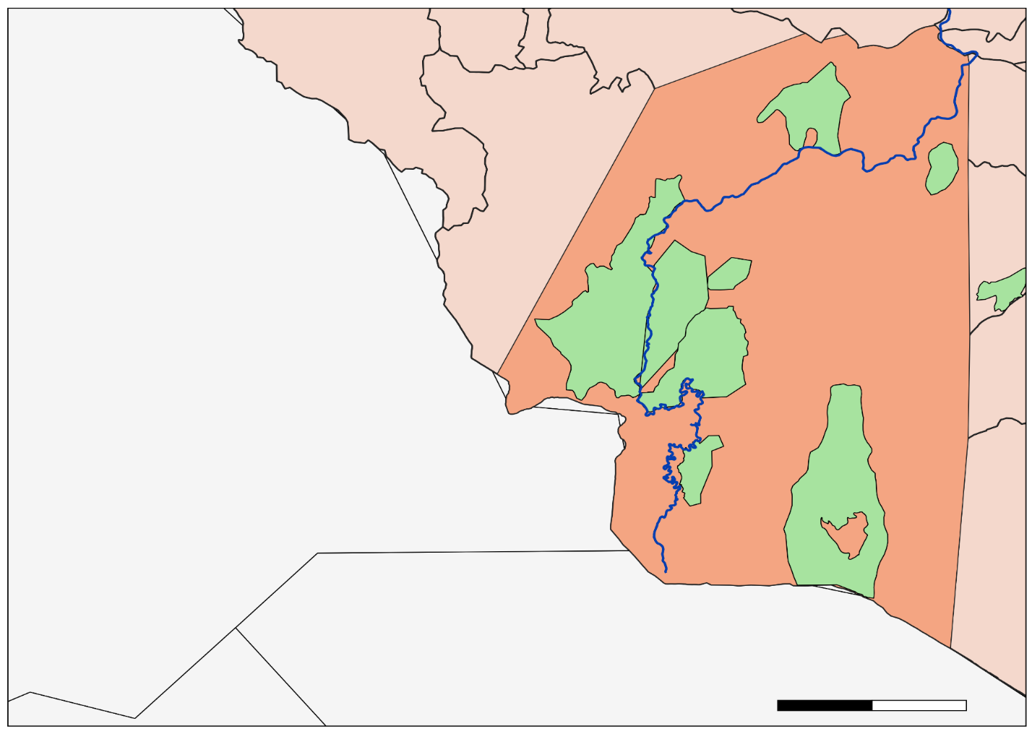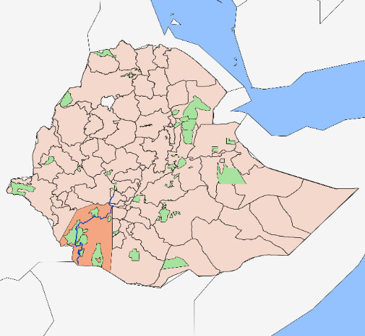

0
50
100
Omo
Tama
Mago
W. Sala
Murulle
Chelbi
Maze
Lower Omo Study Area
Omo River
Protected Areas
Study Area
Ethiopian Administrative Zones
km
C. Churchura
Figure 1. The study area comprises 62,000 square kilometers in the Lower Omo River Valley, Ethiopia.
Vegetation in the immediate vicinity of the Omo Riverbanks varies between large forest trees and shrub grassland (Figure 2). Further out from the banks, the vegetation transitions to a dense belt of woody plants or ‘brushland thicket,’ which then gives way to an open wooded grassland (Gil-Romera, Lamb, Thurton, Sevilla-Callejo, & Umer, 2010). The study period focused on the months of January through May from 1994 to 2018. December to February are winter months and a predominately dry season, and during the March to May transition to spring the valley receives minor amounts of precipitation (Jillo, Demisse, Viglione, Asfaw, & Sivapalan, 2017). Collectively, these are the driest months of the year when water, bare ground, natural vegetation, and cultivated vegetation are readily/easily identified in remotely sensed imagery.
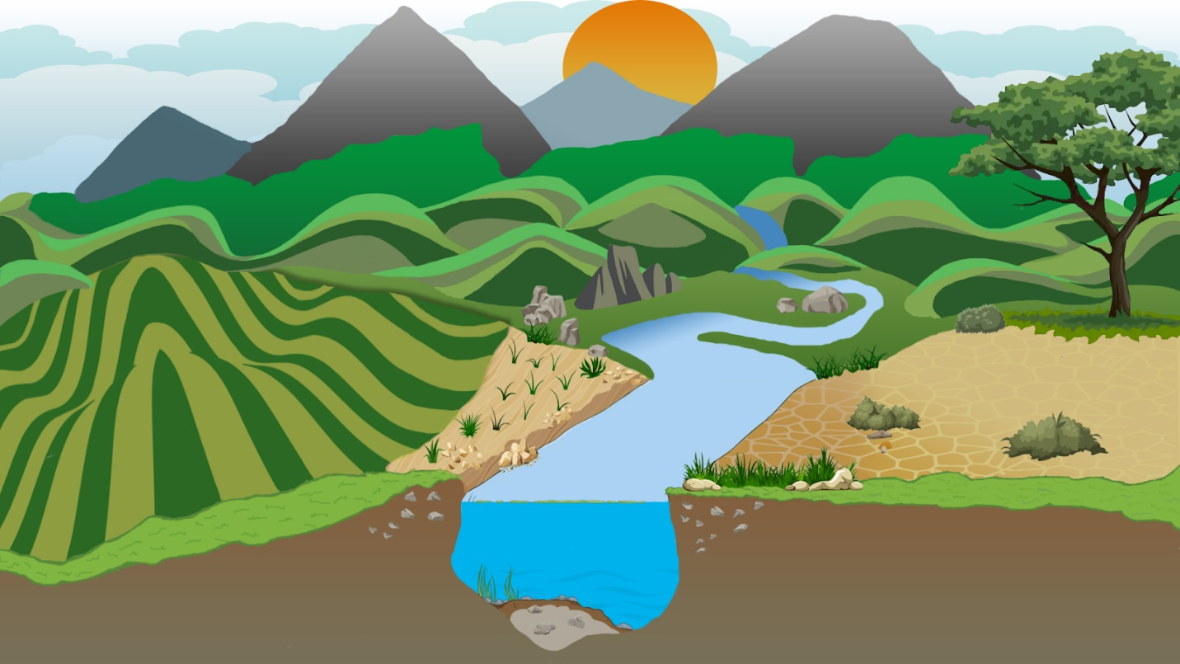
Flood Stage
Spring/Fall
Dry Season
Cultivated
Water
Bare
Natural Vegetation
Figure 2. The Lower Omo Valley features mountains, the Omo River, and diverse vegetation and wildlife. This project classified the valley’s land cover into four classes: water, native vegetation, cultivated land, and bare ground.
3.2 Data Acquisition
3.2.1 Earth Observation Data
The team employed the cloud computing power of GEE to access satellite data, run the LandTrendr algorithm, and calculate a Random Forest supervised classification. The LandTrendr algorithm was utilized because it harmonizes data across multiple Landsat sensors at a 30 m resolution. Harmonizing is essential for comparing land cover change through time, as it normalizes data for identifying trends. LandTrendr in Google Earth Engine imports Landsat Tier 1 surface reflectance imagery from the entire Landsat series (Table 1). While the study period was from January 1 to May 1 from 1994 to 2018, LandTrendr has better calibration when using the entire duration of the Landsat time series. As such, the team filtered the LandTrendr results down from 1984 to 2019 to the study period of 1994 to 2018. The collection parameters for LandTrendr were set to run between January 1st and May 1st to capture the dry season. By using the dry season for the training point collection, the team was able to capture when cultivated areas and natural vegetation were most spectrally distinct, as bare ground and water were easier to distinguish and establish ground truth points. Vegetation gain and loss were examined using the LandTrendr raster outputs that describe the magnitude of change and year of detection. The year of detection raster assigns each pixel with the year that the pixel experienced the greatest amount of change above the defined magnitude parameter. If a pixel does not change at a rate equal or greater to the magnitude parameter, it is assigned a value of zero. Because the year of detection raster only showcases these two values, rasters were then further processed for analysis of the extent and locations of change (See section 3.3.).

Table 1
NASA Earth Observations data used in this project.
Platform & Sensor | Image Dates
Landsat 5 Thematic Mapper (TM) Tier 1 Surface Reflectance | 1994, 2000-2002, 2009-2013
Landsat 7 Enhanced Thematic Mapper (ETM+) Tier 1 Surface Reflectance | 2003-2008, 2013
Landsat 8 Operational Land Imager (OLI) Tier 1 Surface Reflectance | 2014-2018
Shuttle Radar Topography Mission (SRTM) | 2000

3.2.2 Ancillary Data
Ancillary datasets validated LandTrendr outputs and acted as vector inputs for outlining the desired study area. Shapefiles of Ethiopia’s protected areas were downloaded from the Colorado State University Natural Resource Ecology Laboratory. These were used to analyze the location of land cover change and to understand the differences in land cover change between protected and unprotected areas. Additionally, to provide the classification algorithm with training data, training points for each land cover class were collected by the team through ocular sampling (Table 2). Training data were collected using ocular sampling to drop points in areas where the team could identify water, natural vegetation, cultivated land, and bare ground using false color and true color satellite imagery. To distinguish between cultivated land and natural vegetation, the team analyzed Landsat false color imagery to isolate areas with plantation fields. These locations were used as training for cultivated land, while all other vegetative land cover was used for training the natural vegetation class.

Table 2
The number of training points for each of the classification outputs.
Classification Year | Total Training Points | Water Training Points | Natural Vegetation Training Points | Cultivated Land Training Points | Bare Ground Training Points
1994 | 645 | 235 | 197 | 38 | 175
2010 | 689 | 224 | 210 | 39 | 216
2018 | 200 | 200 | 200 | 200 | 800

3.3 Data Processing
LandTrendr was utilized in GEE to identify years within the study period that had the greatest amount of change for land cover classification. The team chose NDVI as the primary index because within the dry season cultivated lands and natural vegetation receive different amounts of water, as cultivated lands are irrigated while areas with natural vegetation only receive rainfall. This would be evident in their spectral reflectance and NDVI values. Lastly, the team masked out clouds and shadows from the imagery. A majority of the LandTrendr parameters were kept at their default values, but maxSegments were decreased and the spikeThreshold was increased to identify land cover changes from year to year (Appendix A).

LandTrendr output rasters for vegetation gain and loss were used to isolate the three greatest years of change for both loss and gain. The raster calculator tool in ArcMap was used to isolate the pixels detected for each year into separate layers. Then, the separate year of change rasters were multiplied by the LandTrendr magnitude raster in order to depict the magnitudes of change during specific years. Using the semi-automatic classification plug-in in QGIS, the team then examined the LandTrendr outputs of greatest years of vegetation gain and loss. The plug-in outputs the pixel change, percentage change, and area of change for each year of detection raster. Using this table, as well as an assessment of cloud cover, the team was able to isolate the most significant years of vegetation change and use these as a basis for choosing classification years.

A Random Forest algorithm was used to conduct a supervised classification for three cloud-free years: 1994, 2010, and 2018. The team chose 1994 to conduct the first classification because it had the least cloud cover of any of the years in the 1990s. 2018 would provide the most recent classification within the study period. For a middle date, the team decided to focus on 2010 as it was roughly half-way between both classifications and required very little cloud masking. The use of 2010 for the third classification provided additional context of the land cover changes taking place over the long study period.
For each of the three classification models, the team created a cloud-masked surface reflectance composite from imagery taken from January 1st to May 1st. Final predictor variables (Table 3) were derived by band calculations on these composites as well as the bands themselves. Final predictors included elevation, NDVI, NDWI, NBR, and the tasseled cap variables to aid the model in distinguishing between the four distinct classes. Vegetation and moisture indices trained the model to identify the differences between the classes. Bare ground has little or no vegetation and low NDVI values. Native vegetation has a lower moisture content and less greenness during the dry season. Cultivated land has a high NDVI and greenness as it is more likely to be irrigated than the native vegetation. NDWI and the tasseled cap variables were utilized for similar reasons as NDVI, to distinguish between native vegetation and cultivated land during the dry season.

Table 3
Final predictor variables used in land cover classifications.
Predictor Variables | Description | Source
Elevation | SRTM Digital Elevation Model | GEE
NDVI | Normalized Difference Vegetation Index  ((NIR-Red Band)/(NIR+Red Band)) | N/A
NDWI | Normalized Difference Water Index  ((Green Band-NIR)/(Green Band+NIR)) | (Ahmed & Akter, 2017)
NBR | Normalized Burn Ratio  ((NIR-SWIR 2)/(NIR+SWIR 2)) | N/A
Tasseled Cap Brightness | A measurement value for the ground | (Baig et al., 2014)
Tasseled Cap Greenness | A measured value for vegetation health | (Baig et al., 2014)
Tasseled Cap Wetness | A measured value for interactions between soil and vegetation moisture | (Baig et al., 2014)
Red Band | Useful for differentiating vegetation slopes | GEE
Green Band | Useful for emphasizing peak vegetation to assess plant health | GEE
Blue Band | Useful for distinguishing soil from vegetation | GEE
Short-Wave Infrared Band 1 (SWIR 1) | Useful for differentiating moisture content of soil and vegetation | GEE
Short-Wave Infrared Band 2 (SWIR 2) | Improvement upon SWIR 1 | GEE
Near Infrared Band (NIR) | Useful for emphasizing biomass content | GEE

3.4 Data Analysis
To analyze the Random Forest classification results, the team split the reference points into groups of 70 and 30 percent for training and testing, respectively. The team calculated confusion matrices, class accuracy, and percent of overall accuracy for both the training and test data groups. The raster calculator tool was used in each of the three classifications to create separate binary rasters for each class. Once each class was in a separate raster, each of the four binary class rasters for each classification were multiplied by the next classification year’s binary rasters to identify which pixels were converting to other classes. The same methods were repeated for rasters between 1994 and 2018 for an overall trend of where and when different land cover types have changed. To analyze land cover change within protected areas, the team repeated these same methods using the 1994, 2010, and 2018 classification rasters clipped to the protected areas shapefile. Unprotected area change was calculated by subtracting the protected area change from the overall change per class.

4. Results & Discussion
4.1 Analysis of Results
Prior to the development of classification models, the LandTrendr results were used to isolate the best years for analysis. For the greatest loss year of detection raster, the years of greatest vegetation loss were 2003, 2001, and 2005 (Table 4). These three years experienced vegetation losses of 0.0019%, 0.0016%, and 0.00027%, respectively. For the greatest gain year of detection raster, the biggest years for vegetation gain were 2001, 2003, and 2012 (Table 4). These three years experienced vegetation gains of 0.0020%, 0.0013%, and 0.00089%, respectively. Using the vegetation loss and gain data, as well as a cloud cover percentage assessment from 1990 through 2018, the team narrowed the classification dates to 1994, 2010, and 2018.

Table 4
The percentage change for vegetation loss and gain. These data were derived from the LandTrendr year of detection rasters.
Vegetation Loss |  | Vegetation Gain
Class | Percent Change | Class | Percent Change
0 | 99.99 | 0 | 99.99
2003 | 0.0019 | 2001 | 0.0020
2001 | 0.0016 | 2003 | 0.0013
2005 | 0.00027 | 2012 | 0.00089
2012 | 0.00011 | 2005 | 0.00020
2016 | > 0.0001 | 2016 | 0.00019
2010 | > 0.0001 | 2017 | > 0.0001
2014 | > 0.0001 | 2002 | > 0.0001
2002 | > 0.0001 | 2014 | > 0.0001
2007 | > 0.0001 | 2018 | > 0.0001
To evaluate the accuracy of the classification models, the DEVELOP team assessed the overall accuracy, the user’s accuracy, and the producer’s accuracy. Using the Random Forest model, overall accuracies were at least 83% for all three classifications. The 1994 classification had the highest overall accuracy (89%) but was trained with fewer cultivated class training points (Table 2, Appendix B). The 2010 classification had an overall accuracy of 84% (Appendix C). While the 2018 classification had the lowest overall accuracy of 83%, it utilized the most training points (Table 2, Appendix D). This was due to more visually distinguishable agricultural areas in 2018. For individual class accuracies (Table 5), water was classified at an accuracy greater or equal to 93% for all three classifications. Cultivated land had the lowest accuracies in the 1994 and 2010 classifications, but also had fewer points and less overall visible cultivated areas during those years.

Table 5
The user and producer accuracy metrics for the classification outputs.
Land use/cover categories | 1994 Accuracy (%) |  | 2010 Accuracy (%) |  | 2018 Accuracy (%)
 | User | Producer | User | Producer | User | Producer
Water | 97.4 | 97.4 | 94.8 | 100.0 | 98.6 | 93.4
Natural Vegetation | 80.0 | 85.7 | 77.8 | 83.1 | 77.8 | 76.1
Cultivated Land | 55.6 | 45.5 | 35.7 | 31.5 | 81.5 | 74.6
Bare Ground | 93.4 | 90.5 | 91.8 | 81.8 | 73.8 | 88.9

Within the entire study area in 1994, there were 355 km² classified as water, 30,971 km² classified as natural vegetation, 2,468 km² classified as cultivated land, and 28,492 km² classified as bare ground (Table 6). According to the classification models, from 1994 to 2010, water increased by 1,163%, natural vegetation increased by 10%, cultivated lands decreased by 12%, and bare ground decreased by 24% in the study area. From 2010 to 2018, water decreased by 72%, natural vegetation decreased by 17%, cultivated land increased by 344%, and bare ground increased by 8%. Overall, from 1994 to 2018, water increased by 259%, natural vegetation decreased by 9%, cultivated lands increased by 291%, and bare ground decreased by 19% in the study area (Table 7).

Table 6
The total area and percent cover of each class within the entire study area by each year.
Land use/cover categories | 1994 |  | 2010 |  | 2018
 | km² | % | km² | % | km² | %
Water | 355 | 1 | 4,487 | 7 | 1,274 | 2
Natural Vegetation | 30,971 | 50 | 34,102 | 55 | 28,211 | 45
Cultivated Land | 2,468 | 4 | 2,177 | 4 | 9,656 | 16
Bare Ground | 28,492 | 46 | 21,521 | 35 | 23,147 | 37

Table 7
The change in total area and percent cover of each class within the entire study area between years.
Land use/cover categories | 1994 to 2010 |  | 2010 to 2018 |  | 1994 to 2018
 | km² | % | km² | % | km² | %
Water | +4,132 | +1,163 | -3,213 | -72 | +919 | +259
Natural Vegetation | +3,130 | +10 | -5,891 | -17 | -2,761 | -9
Cultivated Land | -291 | -12 | +7,479 | +344 | +7,188 | +291
Bare Ground | -6,971 | -24 | +1,626 | +8 | -5,346 | -19

Within the eight protected areas, in 1994, there were 92 km² classified as water, 5,928 km² classified as natural vegetation, 252 km² classified as cultivated land, and 7,637 km² classified as bare ground (Table 8). By 2018, according to the team’s models, water increased by 135%, natural vegetation decreased by 1%, cultivated land increased by 767%, and bare ground decreased by 26% (Table 9). Of the four classes, for all protected areas, cultivated land increased the most within the study period (Appendix D). Tama Community Conservation Area had the largest percent increase in cultivated land at a 17,272% increase. Omo National Park and Welshet Sala hunting area had the two next largest percent increases in cultivated land at a 5,127% increase and 2,518% increase, respectively. Of the eight protected areas, Chelbi Wildlife Reserve, Mago National Park, Maze National Park, and Tama Community Conservation Area saw the largest class percent decrease in bare ground. Chebera Churchura National Park, Omo National Park, and Welshet Sala hunting area saw the largest percent decrease in natural vegetation. Murelle hunting area was the only protected area to have water as the class with the largest percent decrease. In terms of area increase in cultivated land, Omo National Park had the greatest change at an additional 621 km² of cultivated land from 1994 to 2018, followed by Chelbi Wildlife Reserve at 600 km² gain and Mago National Park at 259 km² gain. Of all of the classes, cultivated land was the only class to increase from both 1994 to 2010 and 2010 to 2018. According to the three-date models, this increase is happening at an increasing rate as well. Bare ground was the only class to decrease from both 1994 to 2010 and 2010 to 2018. This decrease is happening at a decreasing rate.

Table 8
The total area and percent cover of each class within protected areas by each year.
Land use/cover categories | 1994 |  | 2010 |  | 2018
 | km² | % | km² | % | km² | %
Water | 92 | 1 | 509 | 4 | 217 | 2
Natural Vegetation | 5,928 | 43 | 6,877 | 49 | 5,869 | 42
Cultivated Land | 252 | 2 | 624 | 4 | 2,188 | 16
Bare Ground | 7,637 | 55 | 5,899 | 42 | 5,636 | 41

Table 9
The change in total area and percent cover of each class within protected areas between years.
Land use/cover categories | 1994 to 2010 |  | 2010 to 2018 |  | 1994 to 2018
 | km² | % | km² | % | km² | %
Water | +417 | +452 | -292 | -57 | +125 | +135
Natural Vegetation | +949 | +16 | -1,008 | -15 | -59 | -1
Cultivated Land | +371 | +147 | +1,565 | +251 | +1,936 | +767
Bare Ground | -1,737 | -23 | -264 | -4 | -2,001 | -26

In unprotected areas in 1994, 262 km² were classified as water, 25,043 km² were classified as natural vegetation, 2,216 km² were classified as cultivated land, and 20,855 km² were classified as bare ground (Table 10). In unprotected areas, water had the greatest percent increase of 302% from 1994 to 2018. Cultivated land was the second-largest increase class in unprotected areas, with an increase of 237% from 1994 to 2018. Bare ground had the largest percent decrease of 16% with natural vegetation close behind at an 11% decrease within the study period (Table 11).

Table 10
The total area and percent cover of each class within unprotected areas each year.
Land use/cover categories | 1994 |  | 2010 |  | 2018
 | km² | % | km² | % | km² | %
Water | 262 | 1 | 3,978 | 8 | 1,057 | 2
Natural Vegetation | 25,043 | 52 | 27,224 | 56 | 22,341 | 46
Cultivated Land | 2,216 | 5 | 1,553 | 3 | 7,467 | 15
Bare Ground | 20,855 | 43 | 15,621 | 32 | 17,511 | 36

Table 11
The change in total area and percent cover of each class within unprotected areas between years.
Land use/cover categories | 1994 to 2010 |  | 2010 to 2018 |  | 1994 to 2018
 | km² | % | km² | % | km² | %
Water | 3,715 | +14 | 2,921 | -73 | 794 | +302
Natural Vegetation | 2,181 | +9 | 4,883 | -18 | 2,701 | -11
Cultivated Land | 662 | -30 | 5,914 | +381 | 5,252 | +237
Bare Ground | 5,234 | -25 | 1,890 | +12 | 3,344 | -16

4.2 Discussion
The main objective of this research was to quantify the area and rate of land cover change between 1994 and 2018 within protected and unprotected areas in the Lower Omo Valley. Across all land cover types, the study area saw a total change of 16,214 km² between 1994 and 2018. For the entire study area, cultivated land and bare ground experienced the largest area changes with an increase of around 7,000 km² and a decrease of around 5,000 km², respectively. In unprotected areas, water saw the largest increase, while in protected areas, cultivated land saw the largest increase. In both protected and unprotected areas, natural vegetation and bare ground underwent losses in area. Natural vegetation experienced the lowest percent change when compared to the other three classes, likely due to it having the largest area initially. Overall, both protected areas and unprotected areas experienced the largest percentage of changes in water and cultivated land.

As development occurs, transitions in the location and extent of land cover often follow. Furthermore, increases in cultivation and a loss of natural vegetation, typically in the form of deforestation, are often tied to economic development (Culas, 2007). All eight of the protected areas in the study area experienced an increase in cultivated land and five experienced a loss of natural vegetation. In the Lower Omo Valley, protected areas are experiencing significantly more land cover change to cultivated land when compared to unprotected areas. Between 1994 and 2018, cultivated land rose by 237% in unprotected areas, while increasing 768% in protected areas. If the increase in cultivated land was happening proportionally, it would be expected that the area of unprotected land would be 2.8 times lower than that of protected areas. However, the area of unprotected land within the study area was over 48,380 km², while the protected areas only covered around 13,900 km². When taking a closer look, six (Chelbi Wildlife Reserve, Mago National Park, Maze National Park, Omo National Park, Tama Community Conservation Area, and Welshet Sala Controlled Hunting Area) of the eight protected areas in the study area experienced a higher increase in cultivated land than the unprotected areas. While the area of non-cultivated land converted to cultivated land was higher in the unprotected areas, the high percentage of land being converted to cultivated land in protected areas is concerning for the preservation of these biodiverse regions.

To understand the rate and location of these land use/cover conversions on a smaller scale, the team examined land cover in Omo National Park more closely. Omo National Park is dominated by bare ground and native vegetation, with each class having over 1,800 km² of land in 1994. Between 1994 and 2018, Omo National Park saw an increase in water, bare ground, and cultivated land, but a decrease in natural vegetation. Omo National Park underwent the largest decrease in natural vegetation of all protected areas, with a loss of 703 km². Since annual precipitation has remained consistent between 1994 and 2018, the driving factor behind the increase in water, both in Omo and the larger study area, is uncertain. However, Omo National Park contains a downstream section of the Omo River where the Gibe III Dam and other manmade infrastructural developments were completed in 2016. These developments may have altered the river’s flow or adjusted the location or classification of water and natural vegetation. However, the team was unable to attribute land cover change to any single factor, so a classification model that incorporates an urban class would help contextualize the land cover changes that were uncovered by this study. In Omo National Park, the unprotected areas, and the larger study area, water and cultivated land classes advanced at an increasing rate.

4.3 Limitations & Future Work
There were several limitations to this study. First, the project was limited by satellite imagery availability. Over the study area, Landsat 5 TM had missing satellite imagery from 2003 to 2009 and 2011 to 2013 in Google Earth Engine. Although Landsat 7 ETM+ had available imagery throughout the entire study period, it was not used for classifications due to the scan-line error within the sensor. Landsat 8 OLI did not have any errors or missing data, but it did not have any available imagery until 2014. In addition to satellite imagery availability, ocular sampling of training data from the satellite imagery could have introduced error into the models. Ideally, the team would have access to a ground-truthed dataset but, due to the large spatial extent of the study area and several sections of mountainous terrain within the region, this was not feasible for this project. Lastly, when the team visually compared the cloud-masked composites for 1994, 2010, and 2018 with the classification models, it was clear that the models were over-predicting cultivation and water across all models. For example, much of the natural vegetation was classified as irrigated cultivated land and very dark-colored bare ground was classified as water. This could be due to fewer areas of visible cultivated land and therefore subsequent fewer training points in the 1994 and 2010 classifications. This could have introduced additional error into the models and could make comparisons between land cover models less reliable. These errors could have also been driven by classes that were not spectrally different enough to sufficiently train the models.

Because the scope of this research was limited to examining land cover changes from 1994 to 2018, it may be necessary to continue monitoring this area and repeat similar methods in the future. Ideally, having in situ ground truth points would allow for additional classes (such as man-made structures or urban class), that could not be distinguished through ocular sampling methods. Future work could also utilize Sentinel-2A imagery to create a classification on a finer scale of 10 meters as opposed to the 30-meter scale classifications the team created with Landsat imagery. In terms of the LandTrendr outputs, research moving forward could try using different indices such as the three tasseled cap components or the normalized difference moisture index to increase classification accuracy. Additionally, having additional years of land cover classification may better illustrate the rate of change by class than the three-year comparison done in this study. Future research could also investigate the reasons behind land cover change on a local scale. Specifically, examining the reasons behind the disproportionate development of cultivated land in protected areas over unprotected areas would give more context to this work. Moving forward, continued land cover research will aid land managers in conservation work in the Lower Omo Valley.

5. Conclusions
While there have been significant increases in cultivated land and water throughout the study area from 1994 to 2018, protected areas are disproportionately experiencing land cover change to cultivated land at an increasing rate. In particular, the Tama Community Conservation Area, Omo National Park, and Welshet Sala controlled hunting area had the largest percent increase in cultivated land throughout the study period of 17,272%, 5,127%, and 2,518% respectively. In terms of area of cultivated land increase, Omo National Park, Chelbi Wildlife Reserve, and Mago National Park had the largest gains of 621, 600, and 259 km². In terms of area of natural vegetation decrease, Chebera Churchura National Park, Maze National Park, and Omo National Park had the largest losses of 209, 577, and 703 km². These results will support the Ethiopian Wildlife Conservation Authority in future land management decisions. Land cover change research in the Lower Omo Valley should be pursued moving forward to continue monitoring wildlife and biodiversity in this unique landscape.

6. Acknowledgments
The Lower Omo Food Security & Agriculture team would like to thank the mentors and partners who dedicated their time and assistance to this project. Without them, this project would not have been possible.

We appreciate the cooperation and help from our partners at the Ethiopian Wildlife Conservation Authority:
- Dr. Fanuel Kebede, Wildlife Research and Monitoring Directorate Director

Mentors/Science Advisors:
- Dr. Paul Evangelista, Colorado State University, Natural Resource Ecology Laboratory
- Dr. Catherine Jarnevich, USGS, Fort Collins Science Center
- Nicholas Young, Colorado State University, Natural Resource Ecology Laboratory
- Peder Engelstad, Colorado State University, Natural Resource Ecology Laboratory
- Tony Vorster, Colorado State University, Natural Resource Ecology Laboratory
- Kristen Dennis, NASA DEVELOP

Any opinions, findings, and conclusions or recommendations expressed in this material are those of the author(s) and do not necessarily reflect the views of the National Aeronautics and Space Administration.

This material is based upon work supported by NASA through contract NNL16AA05C.

7. Glossary
Earth observations – Satellites and sensors that collect information about the Earth’s physical, chemical, and biological systems over space and time
ERDAS – Earth Resources Data Analysis System, an image processing software package that allows users to process geospatial imagery and vector data
EVI – Enhanced Vegetation Index, an index measuring vegetation health
EWCA – Ethiopian Wildlife Conservation Authority, a governmental organization under the Ministry of Culture and Tourism given the authority to undertake conservation and sustainable utilization of wildlife in Ethiopia
fPar – Fraction of Photosynthetically Active Radiation, an index measuring vegetation health
GEE – Google Earth Engine, a cloud-based geospatial processing platform
LAI – Leaf Area Index, an index that characterizes plant canopies
Landsat – Jointly managed earth-observing NASA/USGS satellite mission
LandTrendr – Landsat-based Detection of Trends in Disturbance and Recovery, a package of algorithms to extract information from Landsat time-series imagery
MODIS – MODerate resolution Imaging Spectroradiometer
NBR – Normalized Burn Ratio, an index highlighting burned areas
NDVI – Normalized Difference Vegetation Index, an index measuring vegetation health
NDWI – Normalized Difference Water Index, an index measuring vegetation water content

NIR – Near Infrared, energy frequency used in calculating indices

Overall Accuracy – Model evaluation metric defined as the proportion of total training points mapped correctly across all classes

Producer’s Accuracy – Model evaluation metric defined how often the training points of a given class are correctly shown on the classified map

Sentinel – Earth-observing European Space Agency satellite mission

User’s Accuracy – Model evaluation metric defined as how often a given class on the classified map is present in the training points

8. References
Ahmed, K. R., & Akter, S. (2017). Analysis of land cover change in Southwest Bengal delta due to floods by NDVI, NDWI and K-means cluster with Landsat multispectral surface reflectance satellite data. Remote Sensing Applications, 8, 168-181. https://doi.org/10.1016/j.rsase.2017.08.010
Avery, S. (2013). What future for Lake Turkana and its wildlife? The impact of hydropower and irrigation development on the worlds largest desert lake. African Studies Centre: University of Oxford.

Baig, M. H. A., Zhang, L., Shuai, T., & Tong, Q. (2014). Derivation of a tasselled cap transformation based on Landsat 8 at-satellite reflectance. Remote Sensing Letters, 5(5), 423–431. https://doi.org/10.1080/2150704X.2014.915434
Beirne, J. (2014). Gilgel Gibe III: Dam-induced displacement in Ethiopia and Kenya. In F. Gemenne, P. Brucker, & D. Lonesco (Eds.), The state of environmental migration 2014: A review of 2013 (pp. 215-234). International Organization for Migration. Retrieved from: http://labos.ulg.ac.be/hugo/wp-content/uploads/sites/38/2017/11/The-State-of-Environmental-Migration-2014-215-234.pdf
Chaemiso, S.E., Abebe, A. & Pingale, S.M. (2016). Assessment of the impact of climate change on surface hydrological processes using SWAT: A case study of Omo-Gibe river basin, Ethiopia. Modeling Earth Systems and Environment, 2, 1–15. https://doi.org/10.1007/s40808-016-0257-9
Culas, R. J. (2007). Deforestation and the environmental Kuznet’s curve: An institutional perspective. Ecologial Economics, 61, 2-3:429-437. https://doi.org/10.1016/j.ecolecon.2006.03.014
Enawgaw, C., Deksios, D., & Timer, G. (2011). Existing challenges: Plantation development versus wildlife conservation in the Omo-Tama-Mago complex. Ethiopian Wildlife Conservation Authority. Retrieved from: http://internationalrivers.org/sites/default/files/attached-files/ewca_report_2012.pdf
Drusch, M., Bello, U. D., Carlier, S., Colin, O., Fernandez, V., Gascon, F., Hoersch, B., Isola, C., Laberinti, P., Martimort, P., Meygret, A., Spoto, F., Sy, O., Marchese, F., & Bargellini, P. (2012). Sentinel-2: ESA’s optical high-resolution mission for GMES operational services. Remote Sensing of Environment, 120, 25-36. https://doi.org/10.1016/j.rse.2011.11.026
Gil-Romera, G., Lamb, H., Turton, D., Sevilla-Callejo, M., & Umer, M. (2010). Long term resilience, bush encroachment patterns and local knowledge in a Northeast African savanna. Global Environmental Change, 20(4), 612-626. https://doi.org/10.1016/j.gloenvcha.2010.04.008
Hansilo, D. D. & Tiki, L. (2017). Challenges of human settlement on wildlife in Bale Mountains National Park, Southeast Ethiopia. International Journal of Biodiversity and Conservation, 9(4), 107-114. https://doi.org/10.5897/IJBC2015.1056
International Rivers (2011). Ethiopia’s Gibe III Dam: Sowing hunger and conflict. Retrieved from: https://www.internationalrivers.org/sites/default/files/attached-files/gibe3factsheet2011.pdf
Jillo, A.Y., Demissie, S.S, Viglione A., Asfaw D.H. & Sivapalan M. (2017). Characterization of regional variability of seasonal water balance within Omo-Ghibe River Basin. Hydrological Sciences Journal, 62(8), 1200-1215. https://doi.org/10.1080/02626667.2017.1313419
Kennedy, R. E., Yang, Z., Gorelick, N., Braaten, J., Cavalcante, L., Cohen, W. B., & Healey, S. (2018). Implementation of the LandTrendr algorithm on Google Earth Engine. Remote Sensing, 10(5), 691. https://doi.org/10.3390/rs10050691
Kennedy, R. E., Yang, Z., & Warren, C. B. (2010). Detecting trends in forest disturbance and recovery using yearly Landsat time series: 1. LandTrendr - temporal segmentation algorithms. Remote Sensing of Environment, 114(12), 2897-2910. https://doi.org/10.1016/j.rse.2010.07.008.
Lunetta, R. S., Knight, J. F., Ediriwickrema, J., Lyon, J. G., & Worthy, L. D. (2006). Land-cover change detection using multi-temporal MODIS NDVI data. Remote Sensing of the Environment, 105(2), 142-154. https://doi.org/10.1016/j.rse.2006.06.018
NASA Jet Propulsion Laboratory (JPL). (2013-2017). NASA Shuttle Radar Topography Mission Global 1 arc second [Data set]. https://doi.org/10.5067/MEaSUREs/SRTM/SRTMGL1.003.

Oakland Institute. (2013) Omo: Local Tribes Under Threat. Retrieved from: https://www.oaklandinstitute.org/sites/oaklandinstitute.org/files/OI_Report_Omo_Ethiopia.pdf

Rawat, J. S., & Kumar, M. (2015). Monitoring land use/cover change using remote sensing and GIS techniques: a case study of Hawalbagh block, district Almora, Uttarakhand, India. The Egyptian Journal of Remote Sensing and Space Science, 18(1), 77-84. https://doi.org/10.1016/j.ejrs.2015.02.002
Ethiopia Average Precipitation 1901-2015 Data: 2019-2020 Forecast: Historical. (n.d.). Retrieved March 16, 2020, from https://tradingeconomics.com/ethiopia/precipitation
US Geological Survey Earth Resources Observation and Science Center. (2017). Landsat 8 OLI/TIRS Level-2 Data Products – Surface Reflectance. US Geological Survey, accessed 20 Feb, 2020. https://doi.org/10.5066/F78S4MZJ
US Geological Survey Earth Resources Observation and Science Center. (2017). Landsat 7 ETM+ Level-2 Data Products – Surface Reflectance. US Geological Survey, accessed 20 Feb, 2020. https://doi.org/10.5066/F7Q52MNK
US Geological Survey Earth Resources Observation and Science Center. (2017). Landsat 5 TM Level-2 Data Products – Surface Reflectance. US Geological Survey, accessed 20 Feb, 2020. https://doi.org/10.5066/F7KD1VZ9
Zhu, L., Liu, X., Wu, L., Tang, Y., & Meng, Y. (2019, May 24). Long-term monitoring of cropland change near Dongting Lake, China, using LandTrendr algorithm with Landsat imagery. Remote Sensing, 11(10), 1234-1249. https://doi.org/10.3390/rs11101234

9. Appendices
Appendix A. The Final LandTrendr Parameters Used
LandTrendr Parameters | Parameter Definition (Kennedy et al., 2018) | Values
startYear | The minimum year in the desired range of annual collection | 1984
endYear | The maximum year in the desired range of annual collection | 2019
startDay | The minimum date in the desired seasonal range over which to generate annual composite | 01-01
endDay | The maximum date in the desired seasonal range over which to generate annual composite | 05-01
index | The index from the list in the Spectral index codes section used to generate LandTrendr outputs | Normalized Difference Vegetation Index
maskThese | A list of CSFMASK mask classes to include as masked pixels. Classes include: ‘cloud’, ‘shadow’, ‘snow’ and ‘water’ | cloud, shadow
delta | A parameter to define what segments to return information about. Either ‘all’ segments, only vegetation ‘loss’ segments, or only vegetation ‘gain’ segments | ‘loss’, ‘gain’
sort | The type of change to identify if there are more than one change event in a pixel time series. It can be ‘greatest’, ‘least’, ‘newest’, ‘oldest’, ‘fastest’, ‘slowest’ | greatest
mag | Options for filtering change events by magnitude | >200 (Default)
dur | Options for filtering change events by duration | <4 (Default)
preval | Options for filtering change events by pre-change spectral value | >300 (Default)
mmu | Options for filtering change events by minimum patch size. Patches are defined by change event pixels matching the above filtering criteria, having the same year of detection and adjacent to other pixels by the 8 neighbor rule | 11 (Default)
maxSegments | Maximum number of segments to be fitted on the time series | 9
spikeThreshold | Threshold for dampening the spikes (1.0 means no dampening) | 0.7 (Default is 0.9)
vertexCountOvershoot | The initial model can overshoot the maxSegments +1 vertices by this amount. Later it will be pruned down to maxSegments +1 | 3 (Default)
preventOneYearRecovery | Prevent segments that represent one year recoveries | False (Default)
recoveryThreshold | If a segment has a recovery rate faster than 1/recoveryThreshold (in years), then the segment is disallowed | 0.25 (Default)
pvalThreshold | If the p-value of the fitted model exceeds this threshold, then the current model is discarded and another one is fitted using the Levenberg-Marquardt optimizer | 0.1 (Default)
bestModelProportion | Takes the model with the most vertices that has a p-value that is at most this proportion away from | 1.25 (Default)
minObservationsNeeded | Minimum observations needed to perform output fitting | 6 (Default)
Appendix B. 1994 Land Cover Classification
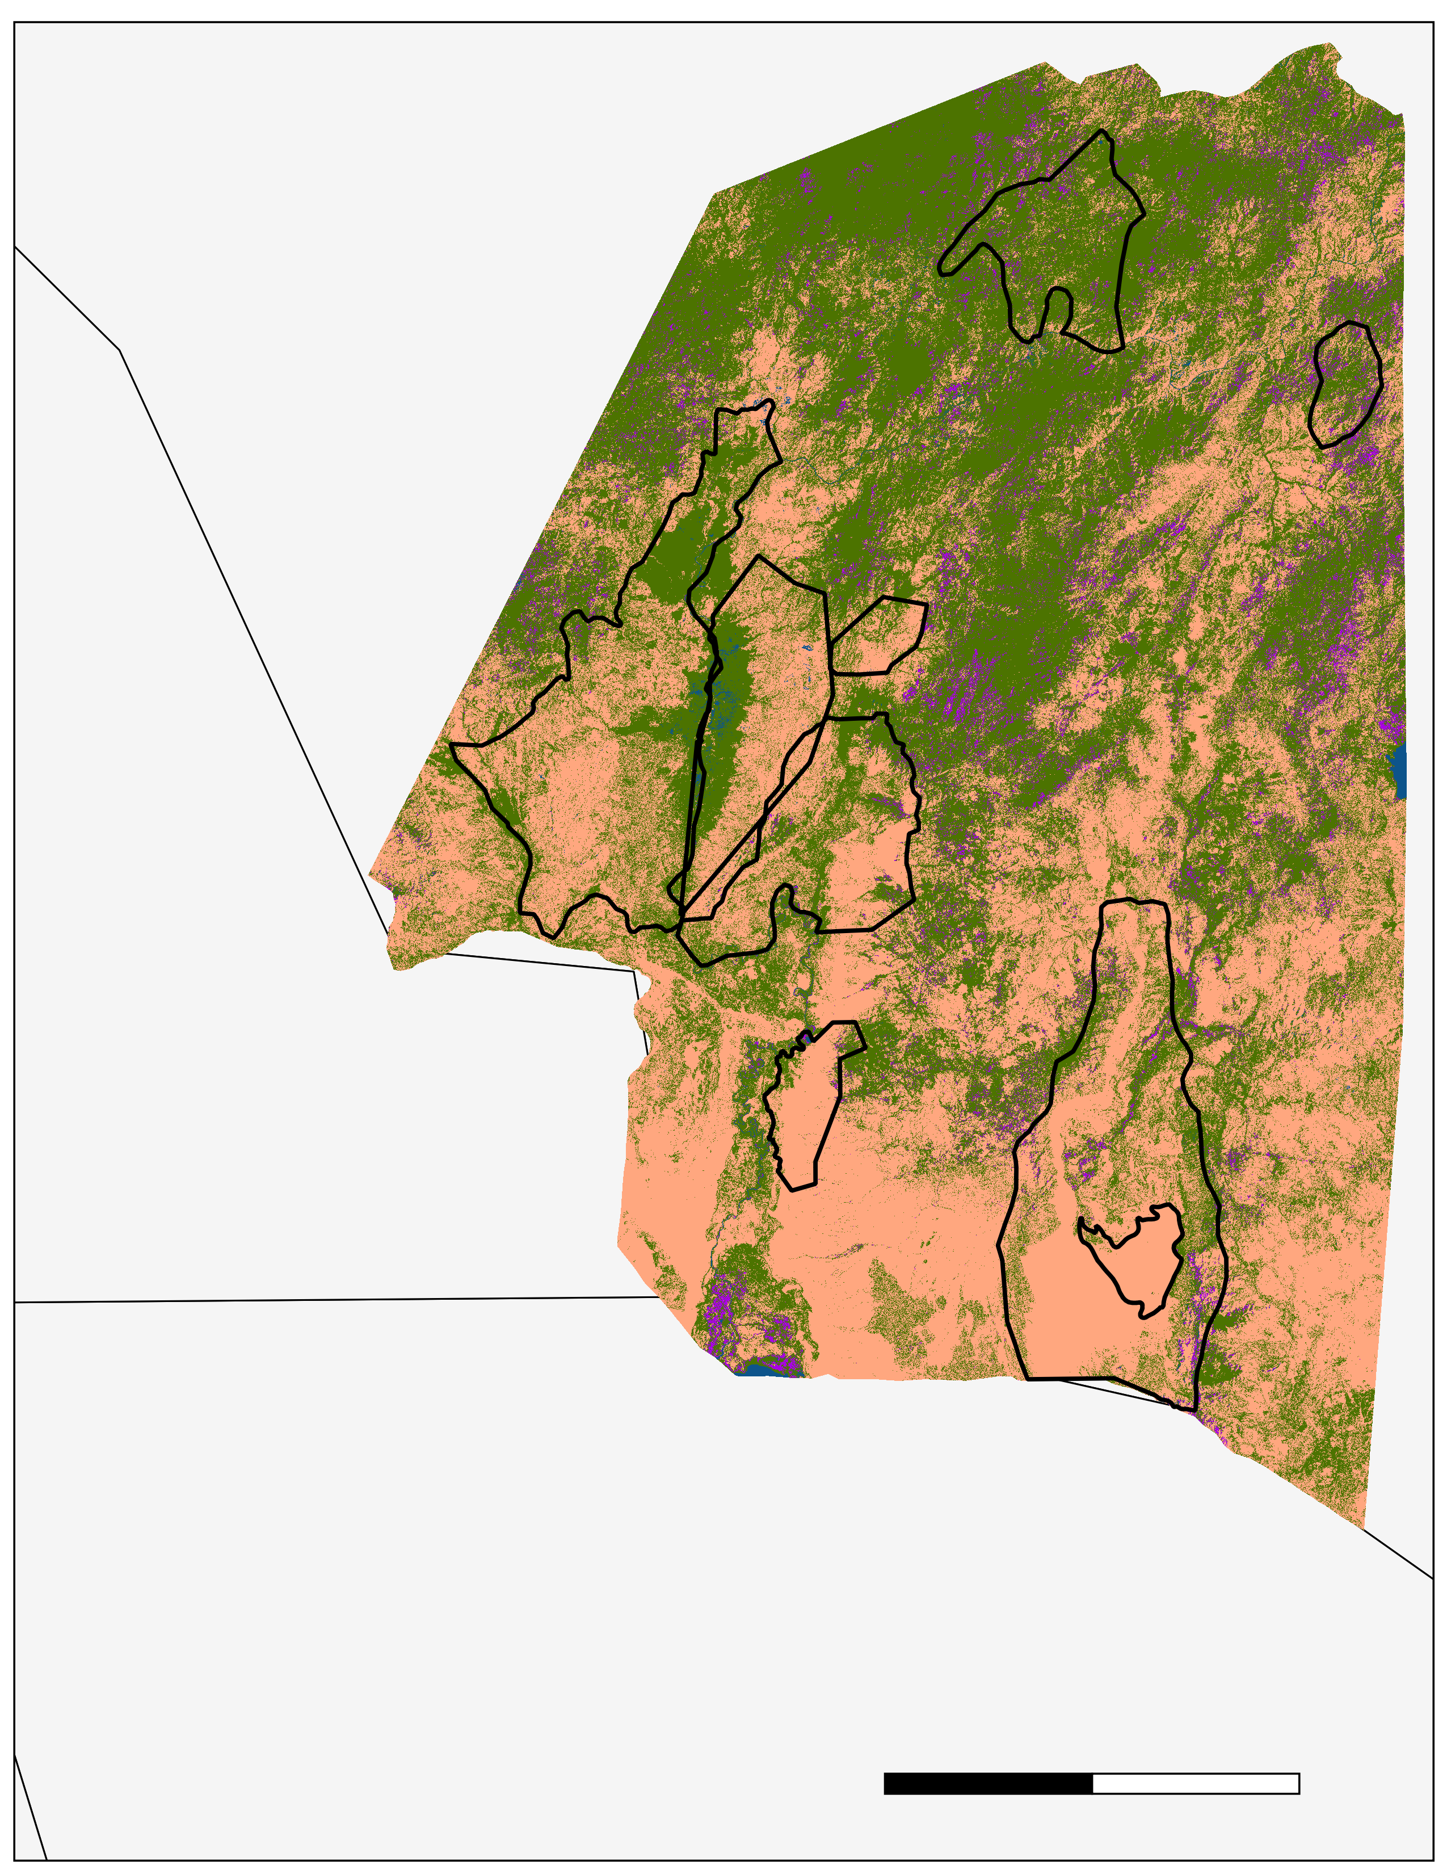
Water
Natural Vegetation
Cultivated Lands
Bare Ground
Land Cover Classes
km
100
50
0
W. Sala
Murulle
Chelbi
Maze
Tama
Mago
Omo
C. Churchura
Appendix C. 2010 Land Cover Classification
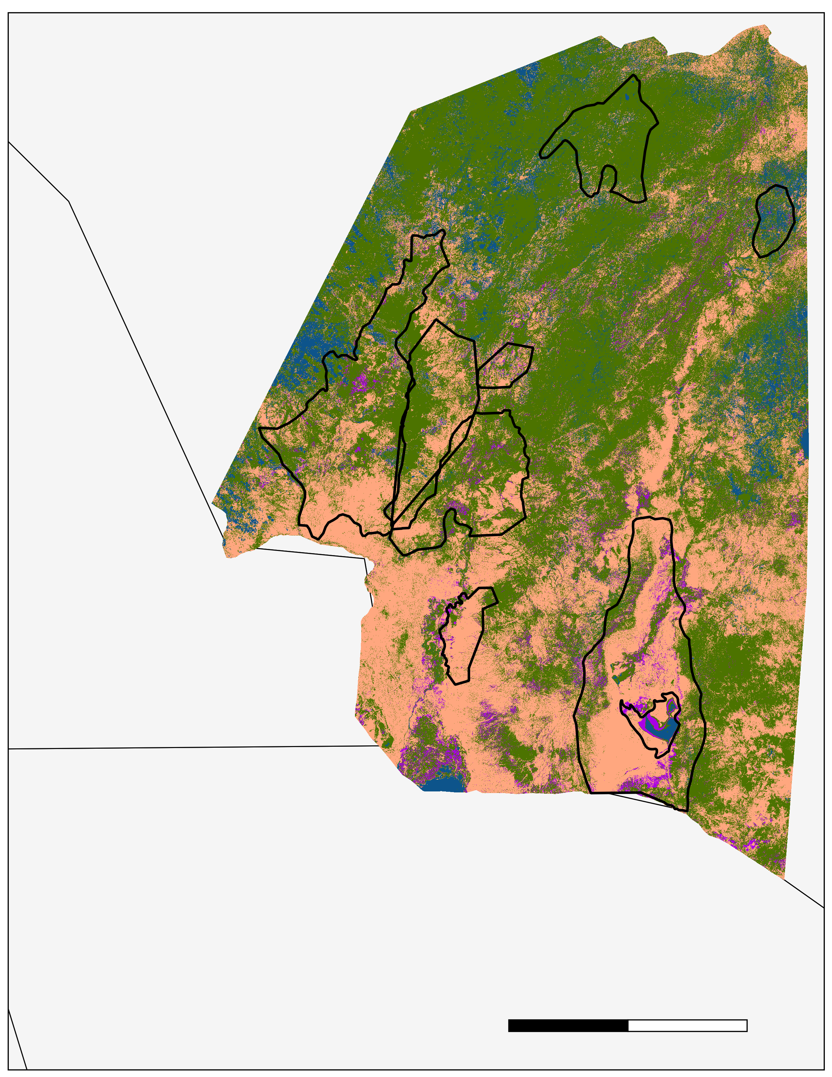
Water
Natural Vegetation
Cultivated Lands
Bare Ground
Land Cover Classes
km
50
100
0
Murulle
Chelbi
W. Sala
Mago
Omo
Tama
Maze
C. Churchura
Appendix D. 2018 Land Cover Classification
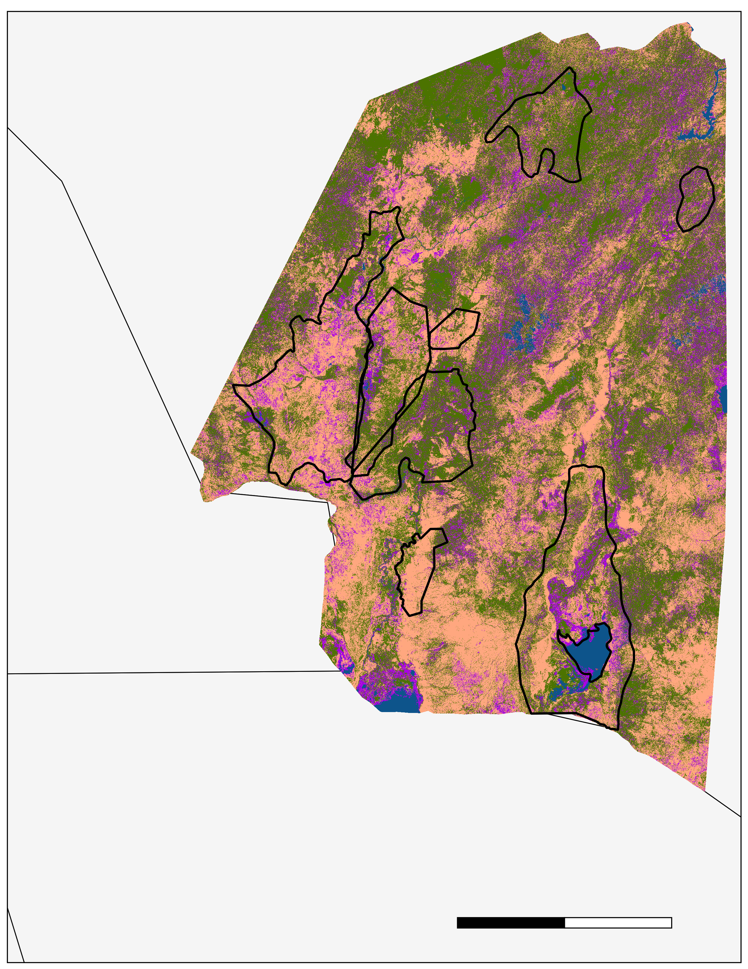
Maze
C. Churchura
Water
Natural Vegetation
Cultivated Lands
Bare Ground
Land Cover Classes
km
100
50
0
Murulle
Chelbi
W. Sala
Mago
Omo
Tama
Appendix E. Class Percent Change from 1994 to 2018 of all Protected Areas
17,900
15,900
13,900
11,900
9,900
7,900
5,900
3,900
1,900
-100
C. Churchura
Chelbi
Mago
Maze
Murulle
Omo
Tama
W. Sala
Protected Areas
Percent Change

Bare Ground
Cultivated Lands
Water
Natural Vegetation
Appendix F. Class Change in Area from 1994 to 2018 of all Protected Areas
8,800
Kilometers ²
2,800
4,800
6,800
800
-1200
Water
Natural Vegetation
Cultivated Lands
Bare Ground
C. Churchura
Chelbi
Mago
Maze
Murulle
Omo
Tama
W. Sala
Protected Areas

