Massachusetts Water Resources
Assessing Flood Events Resulting from North American Beaver Reintroduction with NASA Earth Observations to Inform Biodiversity and Infrastructure Management


Technical Report
Final Draft – April 2nd, 2020

Ahmed Baqai (Project Lead)
Rebecca Composto
Adelaide Gonzalez
Liana Stachowicz

Dr. Cedric Fichot, Boston University (Science Adviser)
Dr. Valerie Pasquarella, Boston University (Science Adviser)

1. Abstract
North American beavers (Castor canadensis) are returning to Massachusetts after overhunting decimated their populations in the 1700s. Current regulations have allowed this species to recolonize, resulting in increasingly prevalent human-beaver conflicts. These ecosystem engineers can quickly change their environment through the creation of dams, leading to floods that can adversely affect human infrastructures, such as basements, roads, or septic systems. Conversely, beaver dams can positively influence their environment, modifying the physical and chemical properties of streams and providing crucial habitats to a variety of wildlife. The 2020 Spring Boston NASA DEVELOP team collaborated with the Massachusetts Audubon Society to support their efforts in monitoring beaver impacts and managing human-beaver conflicts. The project-utilized data from Landsat 5 Thematic Mapper, Landsat 7 Enhanced Thematic Mapper Plus, and Landsat 8 Operational Land Imager to map the spectral signature created from beaver-induced flooding. The team created a tool called Beaver-Flood Event Detector (B-FED) in Google Earth Engine using imagery from 1985 to 2019. Ancillary datasets were incorporated into B-FED that allow the tool to highlight flood events in wetland areas and in situ observations of beaver presence. Beaver observations in or near flooded areas indicated likelihood that the flood was beaver induced. Time series and animations were also produced to display key regions of landscape change across Massachusetts. B-FED will allow the partner to identify and assess potential ecosystem changes and infrastructural impacts from beavers across Massachusetts and inform future management practices.

Keywords:
Landsat, remote sensing, Castor canadensis, beaver, Google Earth Engine, flooding, citizen science

2. Introduction
  - Background Information & Objectives
Over two hundred years after their population was decimated from overhunting and habitat loss, the American beaver (Castor canadensis) is making a rapid comeback to the landscape of Massachusetts. A lack of natural predators, limitations on hunting and trapping, and abundant habitat have facilitated their quick return to the conterminous United States (Pasquarella, 2016). They are continental-scale agents of change, able to create dam and pond networks large enough to be seen from space (Butler, 2002). Beavers are generalists and can easily adapt to a variety of food sources and environments (St-Pierre et al., 2017). This has allowed beavers to inhabit expansive territories, leading to prevalent human-beaver conflicts. While some residents appreciate their beaver neighbors, they are often regarded as pests; their dams cause floods, which can contaminate septic systems, wells, cropland, and damage human infrastructure (Jackson & Decker, 2004).

Much like humans, beavers are skilled engineers. They create dams out of massive complexes of wood, debris, and mud. Dams slow the flow of streams, leading to a beaver pond, which drowns out flood-intolerant vegetation. Over time, flood resistant species persist and ponds transition into wetlands. The introduction of a dam increases available nutrients, cools water temperatures, and increases sediment storage (Butler & Malanson, 1995; Martin et al., 2015). These altered landscapes create habitat for fish, amphibians, and other riparian and wetland species, allowing ecosystems to support a greater diversity of flora and fauna (Cunningham et al., 2006; Dittbrenner et al., 2018; Hood & Bayley, 2008; Jackson & Decker, 2004). Research suggests that beaver activity alleviates the effects of climate change by decreasing regional flood stress and increasing wetland area (Dittbrenner, 2018; Johnston, 2014). Nevertheless, beaver alterations can remain part of the landscape for centuries (Naiman et al., 1988) and can pose long-term infrastructure problems that require action. Therefore, understanding the spatial and temporal response of their activity is of great interest from both a scientific and land management perspective.

Despite the extent of beaver repopulation in the United States, studies of their activity have remained highly localized. Previous studies have relied on expert interpretation of high-resolution aerial photographs to track beaver related wetland formation (Cunningham et al., 2006; Johnston & Naiman, 1990; Morrison et al., 2014​). These studies do not account for the high variability of wetland dynamics and are limited in their scale of analysis (Pasquarella, 2016). Some studies have found that the use of satellite analyses can improve the efficiency and spatial extent of data collection. Previous studies have demonstrated that Landsat can be used to measure changes in vegetation dynamics over time (Czerwinski, King, & Mitchell, 2014). Finn & Howard (1981) determined that Landsat imagery is able to detect beaver ponds, while other studies were able to use satellite imagery to map changes in beaver pond areas (Townsend et al., 1995; Townsend & Butler, 1996). While there is support for the use of satellite imagery to map beaver related flooding, there is no current procedure or tool for large-scale beaver-flood mapping.

The goals of this project were to create an accessible method of monitoring past flooding events that were likely caused by beavers. To detect these flood events, the team created the Beaver-Flood Event Detector (B-FED). The second objective was to correlate beaver-induced flooding events to direct beaver observations. This acted as validation for the tool, using in situ beaver observations collected by citizen scientists and project partners. Finally, the team created a flood extent time series, maps, and animations to illustrate the impact of beaver flooding on Massachusetts’ landscape, both spatially and temporally.

  - Study Area & Project Partners
As a location of extensive human and beaver development, the team selected Massachusetts as the study area for the project (Figure 1). Data from January 1985 to December 2019 were analyzed. Additionally, the team selected three wildlife sanctuaries to act as case study locations, which contained ground-truthed beaver data. These case study areas, Broadmoor Wildlife Sanctuary (Broadmoor), Wachusett Meadow Wildlife Sanctuary (Wachusett), and Ipswich River Wildlife Sanctuary (Ipswich), allowed our team to observe changes over time at a finer scale (Figure 1).

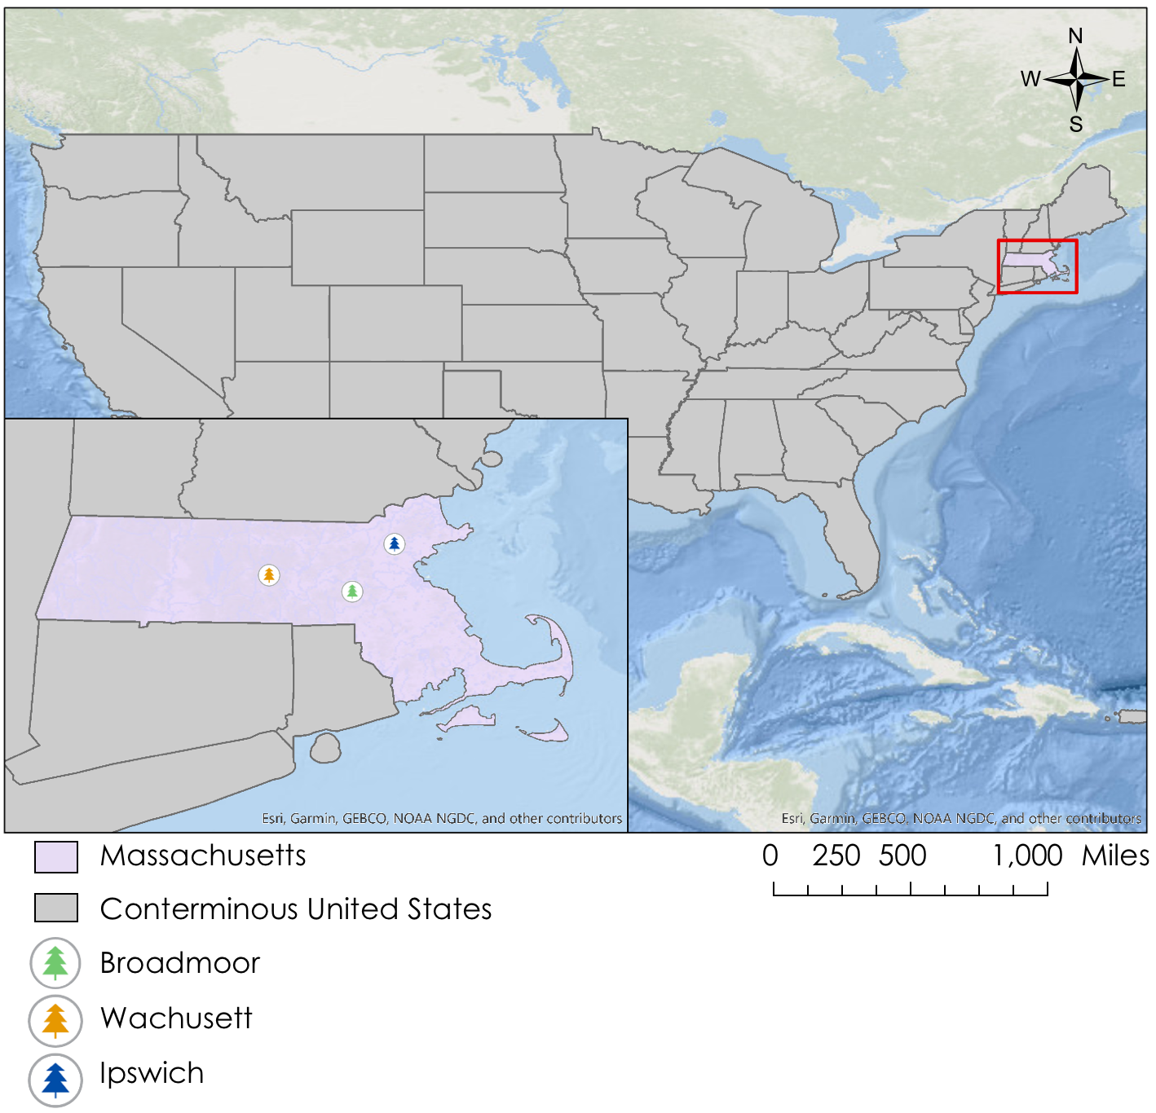
Figure 1. Shown above is a map of Massachusetts, with case study locations highlighted.

For this project, the Spring 2020 DEVELOP Massachusetts team partnered with the Massachusetts Audubon Society (Mass Audubon). The partner organization expressed a need for finding efficient ways to detect beaver-related floods and visualize wetland patch creation. Mass Audubon recognizes the importance of beavers in the modern landscape and wanted to use DEVELOP’s end products to create more effective management strategies and minimize human-beaver conflict. Their organization stresses the importance of conserving wildlife sanctuaries and manages over 38,000 acres of wildlife habitat in Massachusetts (Mass Audubon, n.d). NASA DEVELOP science advisor Dr. Valerie Pasquarella of Boston University has worked with Mass Audubon to study local beavers for over ten years. Her previous work (Pasquarella, 2016) served as the foundation for B-FED.

3. Methodology
3.1 Data Acquisition
The team utilized Landsat 5 Thematic Mapper (TM), Landsat 7 Enhanced Thematic Mapper Plus (ETM+), and Landsat 8 Operational Land Imager (OLI) imagery. All data used from these sensors are level 2 products with a spatial resolution of 30 m and a temporal resolution of 16 days. The team accessed the imagery using Google Earth Engine (GEE), a free, open-source, cloud-based geospatial data analysis platform. The team used data from the longest available date range, 1985 to 2019, to create a time series of flooding across Massachusetts (Table 1). In order to account for prolonged flooding events and wetland variability, the team specified an annual time step.

Table 1
Shown below is a list of Earth observations with sensors and data products utilized to generate B-FED.
Platform & Sensor | Data Product | Parameters | Dates | Acquisition Platform
Landsat 5 TM | LANDSAT/LT05/C01/T1_SR/  16 Day Global 30 M | Surface Reflectance | Jan 1, 1985 - Oct 31, 2011 | Google Earth Engine
Landsat 7 ETM+ | LANDSAT/LE07/C01/T1_SR/  16 Day Global 30 M | Surface Reflectance | Nov 1, 2011 - April 10, 2013 | Google Earth Engine
Landsat 8 OLI | LANDSAT/LC08/C01/T1_SR/  16 Day Global 30 M | Surface Reflectance | April 11, 2013 - Dec 31, 2020 | Google Earth Engine

Our team utilized in situ observations of beaver activities to validate B-FED’s results and differentiate between beaver-induced flooding and other flooding events. The in situ data consisted of citizen science observations obtained through the Global Biodiversity Information Facility (GBIF). The observations included the uploaded date, location, and reports of beaver sightings or evidence (GBIF, 2020). Considering beavers are nocturnal and are difficult to spot during the day (Baker & Hill, 2003), photos of beaver activity were accepted as an indicator of their presence. The team obtained GBIF data through iNaturalist, a free online platform that allows citizen scientists to share biodiversity data. The observations are verified by the iNaturalist community and then further authenticated to the degree of “Research Grade observations” in GBIF. This study obtained 6,207 observations from GBIF of global North American beaver activity from 1986 to 2020. The team then filtered the global sightings to Massachusetts, from 1999 to 2020.

Mass Audubon provided additional in situ data in the form of ecological management records that catalog beaver activity for the Broadmoor, Ipswich, and Wachusett wildlife sanctuaries. When possible, the sanctuary staff confirmed beaver sightings in their records. The three sanctuaries have varying landscape types as well as management styles, making them ideal for visualizing changes in the landscape at a finer scale using B-FED.
3.2 Data Processing
The study constrained available Landsat imagery analyses to Massachusetts with a 5,000 meter buffer around the state. The buffer ensured that if flooding events spilled across state lines, they would still be detected. Data preprocessing included orthorectifying, radiometrically calibrating, and atmospherically correcting the Landsat imagery, in addition to correcting for both clouds and the effects of snow and ice. Landsat 5 TM, 7 ETM+, and 8 OLI data were then preprocessed with Fmask QA, removing pixels with clouds, ice, or snow. Team members then calculated an image-based CloudScore for the data based on brightness and temperature. Images with a score greater than 80% were utilized in the study. The team did not use the GEE simpleCloudScore because it can only be applied to Landsat Top of Atmosphere images, not reflectance imagery. The resulting data were clear and prepared to be analyzed for flood detection.

Tasseled Cap (TC) transformations involve the application of pre-defined coefficients to radiance data, allowing scientists to maximize the difference in spectral variance for analysis. There are three TC components: Tasseled Cap Brightness (TCB), Tasseled Cap Greenness (TCG), and Tasseled Cap Wetness (TCW). TCB, TCG, and TCW look at the reflective characteristics of soils, vegetation, and soil moisture, respectively (Crist, 1985). TC components measure spectral development on a temporal scale, and TCB and TCG are both sensitive to topographic variation (Cohen, Warren, & Goward, 2004). This sensitivity makes these TC components the ideal input into the team’s B-FED tool. Additionally, TCB and TCG provide a reliable metric for disturbance monitoring (Senf, Pflugmacher, Wulder, & Hostert, 2015) and are known accurate portrayals of brightness and greenness (Cohen & Spies, 1992). The team did not select TCW as an input to B-FED because a previous study found that it had a wider range of spectral-temporal patterns in response to flooding events, making it more difficult to characterize (Pasquarella, 2016). The six-reflectance bands of Landsat 5 TM, 7 ETM+, and 8 OLI were transformed into TCB and TCG using Crist (1985) coefficients (Cohen & Spies, 1992) (Table 2). NDVI, another popular vegetation analysis, was not utilized in this study, as it contains only two bands, in comparison to Tasseled Cap’s six bands, making it a far less robust indicator of landscape change (Cohen, Warren, & Goward, 2004).

Table 2
Coefficients for the Tasseled Cap components, Brightness and Greenness, used in the beaver flood detection tool.
Tasseled Cap Component | Coefficients for the bands of Landsat imagery to convert 6 bands into 1 Tasseled Cap component
 | Blue | Green | Red | NIR | SWIR1 | SWIR2
Brightness | 0.2043 | 0.4158 | 0.5524 | 0.5741 | 0.3124 | 0.2303
Greenness | -0.1603 | -0.2819 | -0.4934 | 0.7940 | -0.0002 | -0.1446

3.3 Data Analysis
B-FED contains an algorithm to detect flooding at an annual time step with the input of processed TC components. These components are cumulative mean TCB (TCB_{cumsum}) and range TCG (TCG_{range}). The TCB_{cumsum} captures the annual differences compared to the starting year of the study, 1985. When there was a persistent decrease in TCB, less than -0.05, it was indicative that the water level had increased, as water appears dark (Pasquarella, 2016). The project used TCG_{range} as an indicator of vegetation, with smaller values in range indicating decreased vegetation beyond the seasonal vegetation cycle. After a flooding event, it is expected that TCG_{range} would decrease by more than 70% from TCG_{range} values in 1985 as flood intolerant vegetation would die soon afterward.

B-FED’s algorithm is a conditional evaluation that determines if a flooding event has occurred for a given year (Table 3). The tool checks for long-term (cumulative) changes in TCB and a decrease in the seasonal range of TCG. If TCB_{cumsum} has a change < -0.05 and TCG_{range} < 70% for a given year, then the pixel is considered flooded. The thresholds for the statements, -0.05 for TCB_{cumsum} and 70% for TCG range, were selected after experimenting with a range of parameters and looking at other literary sources (Pasquarella, 2016). There are 5 components within the B-FED tool: (1) Finding the Area of Interest, (2) Calculating TC Components, (3) Masking TC Components, (4) Inputting In-situ data, and (5) Constructing Time Series.

Table 3
Tasseled Cap components that were used for the beaver flood detection tool, B-FED.
Algorithm Inputs | Represents | Response to Flooding | Threshold
TCB_{cumsum} | Tasseled Cap Brightness cumulative sum of differences in means year to year | Persistent or abrupt decrease across multiple years due to higher water table after flooding event | -0.05
TCG_{range} | Tasseled Cap Greenness range | Decreases due to flood-intolerant vegetation dying after flooding event | 70%

In addition to flood detection, B-FED contains parameters to differentiate beaver flooding from other flood events. Visual analysis was conducted to connect GBIF citizen science beaver observations to local flooding (Figure 2). Additional analysis was conducted for case study locations, where flood detection data and time series were compared to historical beaver records provided by Mass Audubon. This study assumes that beavers are more likely to build dams in their preferred habitat, wetlands, before establishing themselves elsewhere. Therefore, this project included a wetland polygon layer in the GEE code. This wetland layer was obtained from the MassGIS database and was created in 2005 to provide medium-scale representation of wetlands in Massachusetts (MassGIS, 2019). This allows B-FED users to constrain flooding to these wetland polygons, allowing for a decreased rate of commission and an increased ability to monitor wetland patch changes that are the signature of beaver habitat change. Finally, to increase ease-of-accessibility for the results, a user interface (UI) was created within B-FED that would allow users to view flooding throughout Massachusetts over time. This UI allows users to access both flooding options, confined or unconfined to wetlands as well as turn on and off beaver citizen science observations.
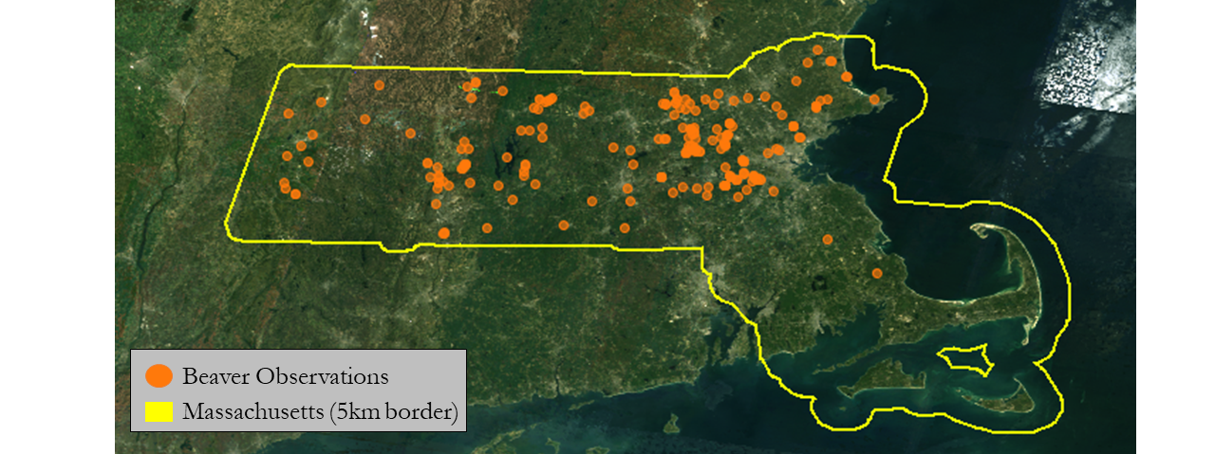
Figure 2. GBIF “Research grade” beaver activity observations in Massachusetts from 1999 to 2020 with Landsat 5 TM background imagery from 1995. Citizen science beaver observations are shown in orange, with the study area outlined in yellow.

4. Results & Discussion
4.1 Analysis of Results
Upon visual analysis, flooding showed no distinct, state-wide spatiotemporal patterns (Figure 3). Each case study location was evaluated by constructing a time series of the TC components for the flooded areas within the sanctuaries. Subsections of a few pixels of detected flooding areas in the case study locations were selected to graphically represent TC greenness and TC brightness (Figure 4A, Figure 4B, and Figure 4C). These subsections were picked subjectively to demonstrate how flooding events appear spectrally. Each case study location was also evaluated with visualizations through time. The background imagery for these visualizations is a median composite of Landsat 5 TM imagery from 1995. This imagery was selected as a background for visualizations because beavers began re-inhabiting Mass Audubon sanctuaries around this time period. The complete thumbnails for each year’s visualization at the three case study locations can be viewed in the Appendices (Figure A1, Figure B1, and Figure C1). It is worth noting that in all sanctuary locations, fluctuations in wetland patches are subject to patterns of rainfall and drought as well as water usage by residents, as baseflow year to year plays important roles in wetland signatures.

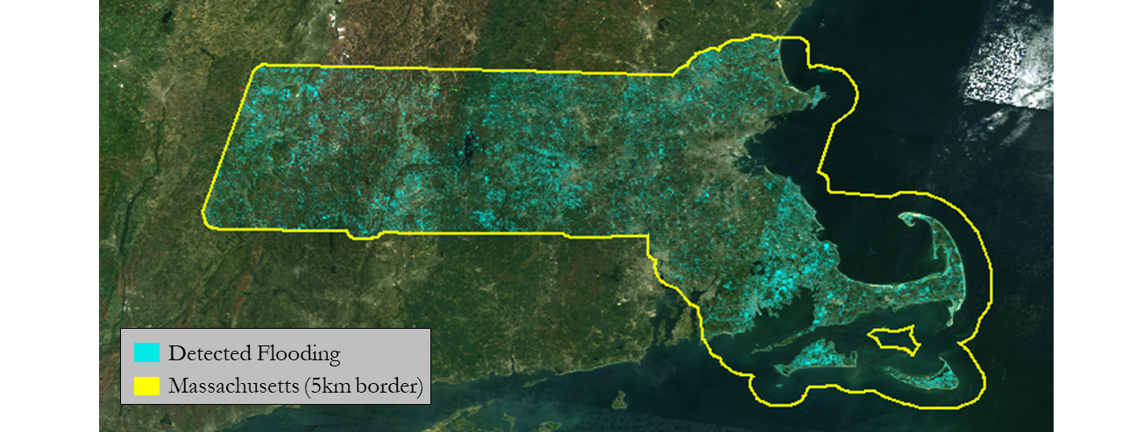
Figure 3. Flooding detected in B-FED from 1986 to 2019 in wetland ecosystems with Landsat 5 TM background imagery from 1995. Detected flooding is highlighted in light blue, with the study area outlined in yellow.

4A)
Broadmoor Wildlife Sanctuary
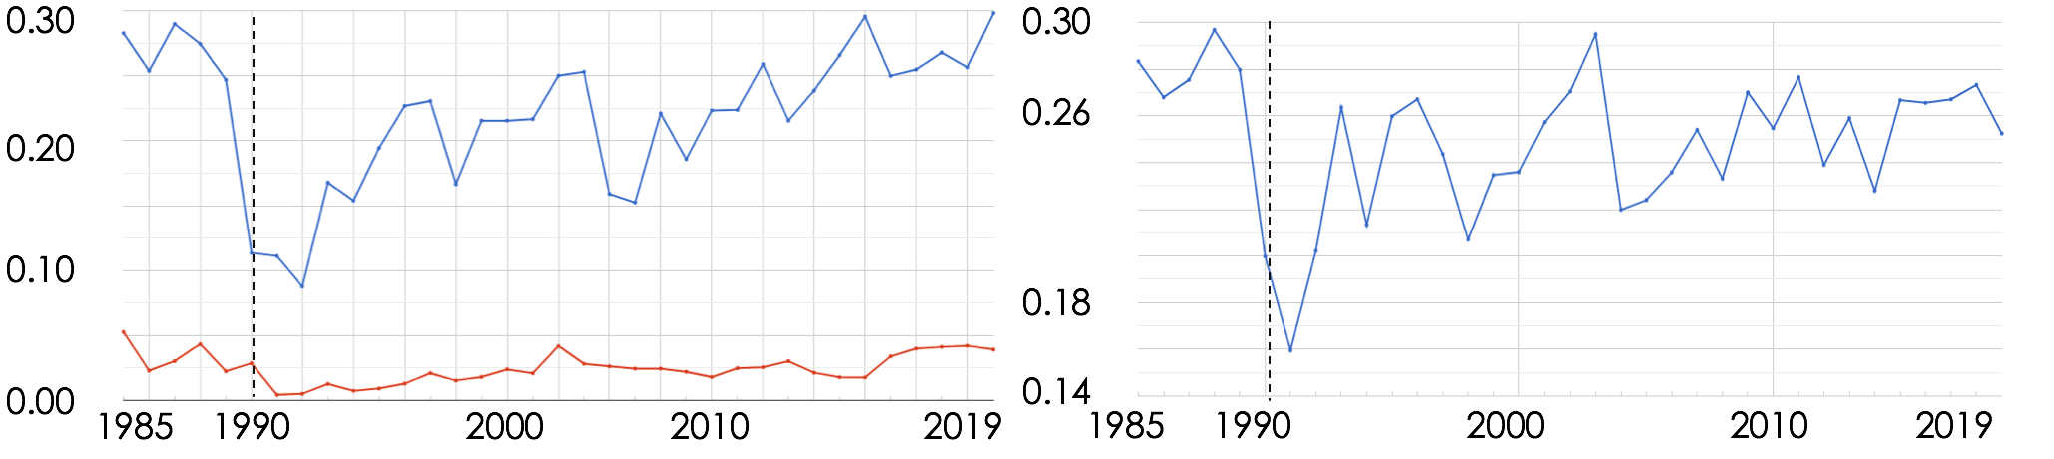
4B)
Ipswich River Wildlife Sanctuary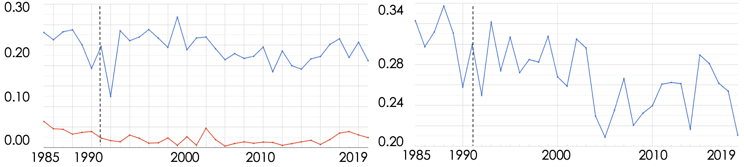

4C)
Wachusett Meadow Wildlife Sanctuary
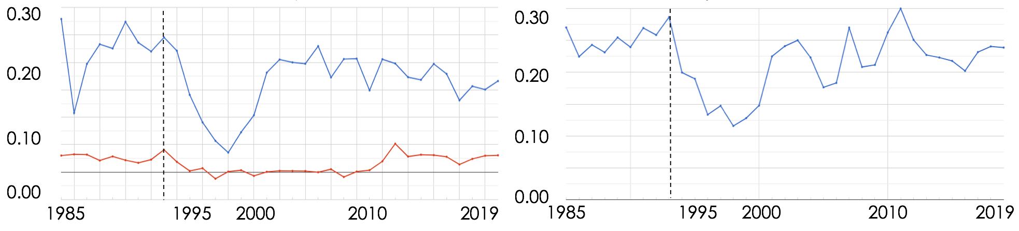

Figures 4A, 4B, & 4C. Shown above are TCG minimum and maximum time series (left) and TCB mean time series (right) for all three case study Wildlife Sanctuaries: A) Broadmoor, B) Ipswich River, and C) Wachusett Meadow. A steep drop in TCG range and a steep or steady drop in mean TCB together indicate flooding for a given year. The dotted line in each graph denotes the year that beavers were reintroduced to each sanctuary according to management records. For each case study location, B-FED’s time series successfully confirmed historical management records and identified beaver-induced flooding.

Analysis of Broadmoor Wildlife Sanctuary (Figure 4A) data indicated a distinct decrease in range of greenness and mean brightness in 1990, fulfilling the flooding parameters. This flooding coincides with noted beaver reintroduction in 1990, as confirmed by sanctuary staff (Wagner, 2011). In addition, flooding appears to occur in a wetland patch, allowing for visualization of wetland land change (Figure 5A). When analyzing wetland fluctuation over 6 years (Figure 5A), the tool indicates that the wetland patch grows after beaver reintroduction and fluctuates over time, diminishing in 1993 and returning in 1994. Fluctuations in detected wetland patch change (Figure 5A) can be attributed to revegetation, which is supported in increased greenness in years following flooding (Figure 4A). Additionally, management records indicate that beavers in the sanctuary establish dams and then relocated to surrounding areas, which may explain fluctuations in flooding, as dams break down from lack of repair. Since beaver reintroduction, sanctuary staff have not interfered in beaver activity and have installed no flow devices to lessen flooding. The confirmed beaver observations near and inside the sanctuary boundaries suggest that the tagged flooding is likely beaver induced (Figure 5A).

At the Ipswich River Wildlife Sanctuary, beavers constructed their first dam in May 1991. Data indicates a decrease in range of greenness and mean brightness following 1991 (Figure 4B), suggesting that beavers caused flood events in this area. However, B-FED visualizations of flooding across the time series do not show clear flood events following beaver reintroduction in 1991 (Figure 5B). Throughout the time series, flooding appears to follow fluvial boundaries in lowland areas, indicating that the tool is successfully visualizing flood events (Figure 5B). Lack of clear flooding after beaver introduction may be due to multiple flow devices installed across 4 locations by sanctuary staff, in order to lessen damage to trail infrastructure and nearby housing developments (Wagner, 2010). The confirmed beaver observations near and inside the sanctuary boundaries suggest that the tagged flooding is likely beaver induced (Figure 5B).
According to sanctuary staff, beavers returned to Wachusett Meadow Wildlife Sanctuary in 1993; however, there are currently no citizen science-based beaver observations for the sanctuary. Based on management records beavers built a dam across a culvert on the southern end of the sanctuary in 1993. After damming the culvert, water levels slowly filled the basin between topographic highs in the eastern and western portions of the sanctuary, covering the sanctuary boardwalk. When analyzing the flooding time series for Wachusett, the team identified a noticeable drop in TCG range and TCB mean around 1995, about two years after beaver introduction (Figure 4C). When looking at the yearly visualizations, flooding appears to fill the basin area starting in 1995, with fluctuations in flooding suggesting that the flood detection tool is successfully visualizing wetland patch change, but does not detect beaver flooding until two years after the introduction (Figure 5C). Slow flooding associated with culvert damming (Pasquarella, 2016) may have contributed to the delay in flood detection. The delay may also be attributed to the type of vegetation located at Wachusett. For decades before beaver reintroduction, the Wachusett southern basin was largely a red maple swamp and upon flooding (Lautzenheiser, 2013), already resistant vegetation could have resisted die off until 1995, when flooding was detected. Management reports suggest that the beaver dam was likely abandoned and broken down in 2008 (Lautzenheiser, 2013) were confirmed by decreased basin flooding (Figure 5C) following the mid to late ’90s. Largely, Wachusett staff did not interfere with beaver dams or activity, but they have sought funding to reinforce existing beaver dams, in order to prevent flooding downstream (Lautzenheiser, 2013).
5A)
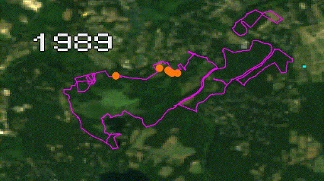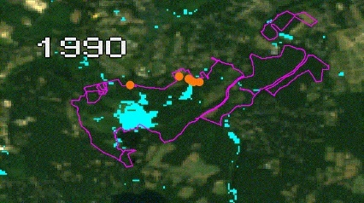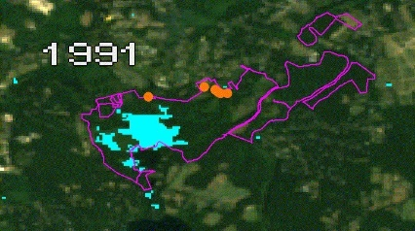
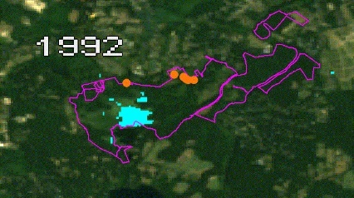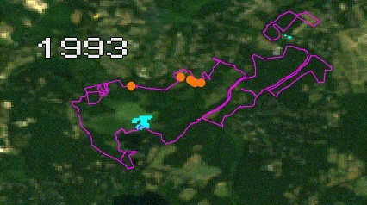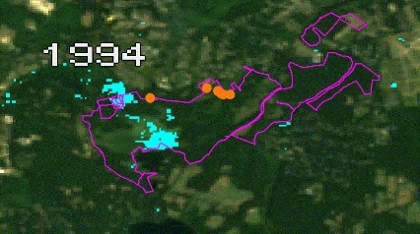

5B)
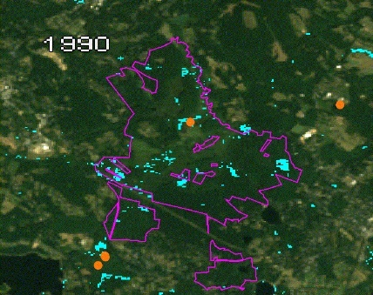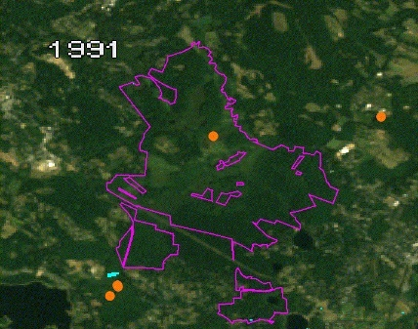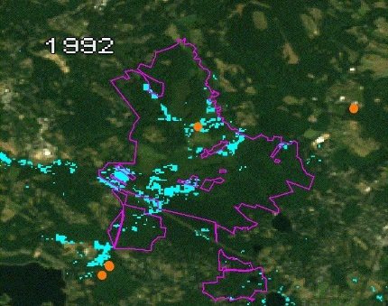
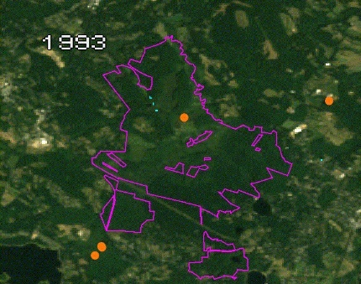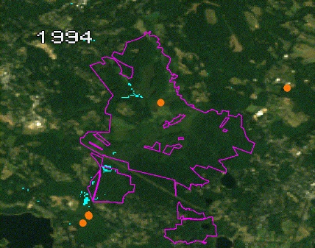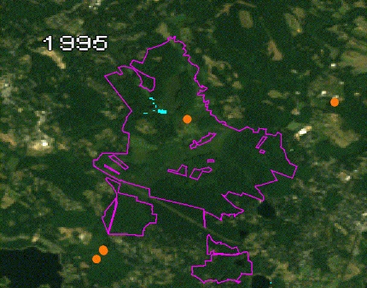
5C)
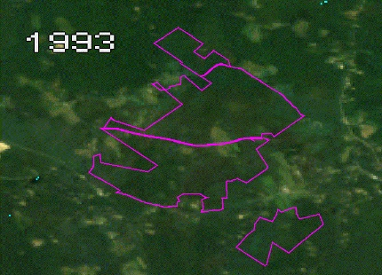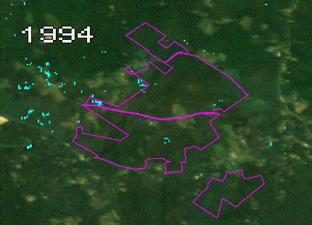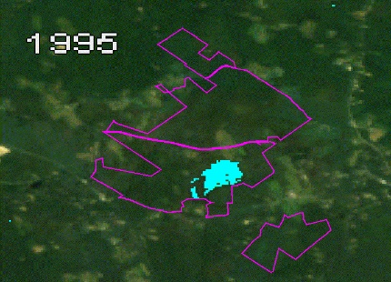
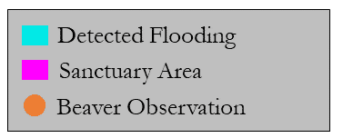
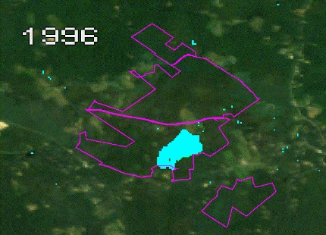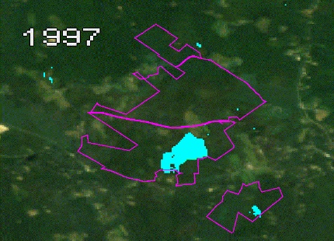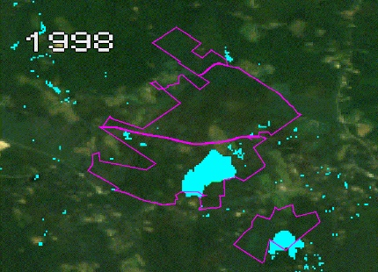

Figures 5A, 5B, & 5C. Shown above are yearly visualizations for flood detection in each case study location. Each sanctuary area is outlined in purple. Detected flooding in wetland areas is shown in blue and citizen science beaver observations are shown in orange. Landsat 5 TM imagery from 1995 is used in the background. (A) Shown are yearly B-FED detected flooding events from 1989 to 1994 for Broadmoor. Management records show that beavers were reintroduced in 1990, which is captured by B-FED’s analysis. Beaver observations from 1999 to 2019 are included. (B) Displayed are detected flooding events from 1990 to 1995 in the Ipswich River Wildlife Sanctuary. Management records show that beavers were introduced in 1991, but that is not shown in the yearly visualizations, likely due to installed flow devices. Beaver observations from 2016 to 2019 are included. (C) This shows yearly B-FED detected flooding events in Wachusett Meadow Wildlife Sanctuary from 1993 to 1998. Beavers were reintroduced in 1993, but this is not identified in the tool until 1995. This may be due to the prominence of flood resistant vegetation in the Wachusett area delaying the spectral pattern.

4.2 Errors and Uncertainties
Many of the errors and uncertainties of the tool may stem from B-FED’s flood parameters, which are calibrated specifically for Massachusetts. B-FED’s flood parameters, using a 70% reduction in TCG range and also -0.5 decrease in cumulative mean brightness, are based on previous research by Pasquarella in 2016. It is uncertain if these parameters are sufficient in detecting all beaver induced flooding, particularly across varied landscapes. As a result, it is likely that B-FED does not detect all flooded areas and, conversely, may detect some areas as flooded that are not actually flood regions. Additionally, the project included a wetland layer to reduce commission of non-beaver related flooding. However, this parameter may omit beaver floods outside of wetland polygons, particularly because the wetland layer is sourced from 2005 data, which does not reflect all current or past wetlands. Therefore, there is a margin of error when analyzing results. Due to time constraints, the tool has not yet undergone formal accuracy assessment, which entails a degree of uncertainty when determining the statistical significance of the tool.

4.3 Future Work
Further research could evaluate the statistical efficacy of the B-FED tool and algorithm by conducting an accuracy assessment of the tagged pixels. Due to time constraints, B-FED has not yet undergone statistical analysis to assess the preciseness of the tool. Further studies could complete an accuracy assessment to better understand and improve beaver flood detection. The movement of beavers and the spatial and temporal patterns of the flooding they cause could be further investigated on a statewide level. Citizen scientists can also improve B-FED by contributing additional beaver observations, especially in locations where flooding has been detected, but is not tied to any local beaver observations, such as Wachusett Meadow Wildlife Sanctuary. As the team was working with observations from 1999 to 2020, we did not correlate beaver observations to flood year. Further work could connect beaver observations and flood events from the same year. This could allow for verifying if a beaver observation and tagged flooding event are correlated. In addition, the team designed B-FED parameters to be adjustable in both spatial and temporal extent as well as for different environments, making B-FED useful for other beaver inhabited areas. A future comparative study of detected flood areas against detected flood areas filtered for wetlands could help explain if adjusting for particular environments makes B-FED more accurate. Furthermore, Sentinel data could be added to improve the spatial and temporal resolution for later years. Another avenue of research could be looking at the ability of beavers to ameliorate climate stress (Dittbrenner, 2018; Johnston, 2014). Future research could utilize B-FED in analyzing the role of the beaver in drought-prone landscapes like, for example, California.

5. Conclusions
Through the successful combination of Tasseled Cap component analysis and citizen science data, our project created a yearly time series of beaver flooding across Massachusetts. At all three case study locations of Broadmoor, Ipswich, and Wachusett, B-FED confirmed historical data, showing flooding in the years following beaver reintroduction and dam building. The detected flood patterns at Ipswich were hypothesized to not be as clear due to human influence with flow devices. Broadmoor and Ipswich have confirmed citizen science beaver observations, which strengthens the idea that flooding displayed in these sanctuaries is likely beaver induced. Citizen scientist data across the state can be used to connect beavers to local flooding and citizens are encouraged to contribute to the project with additional beaver observations, particularly in areas where flooding occurs, but is not confirmed. The tool’s ability to clip for wetland regions provides a valuable resource in wetland monitoring and in characterizing patch creation and conversion across all of Massachusetts. Yearly flood animations created using the tool can be used to visualize patch creation by beavers and monitor landscape change in the years following damming. The adaptability of the tool will allow for further research in new landscapes and different time periods. Information provided by B-FED can be used in evaluating the role of beavers in the modern landscape, particularly in regions where beavers may be useful in mitigating climate stress. B-FED is a tool that can aid organizations such as Mass Audubon in understanding beaver flooding from a spatial and temporal perspective and help in making land management decisions in regards to habitat change as well as areas that might have human-beaver conflicts.

6. Acknowledgments
The Spring 2020 Massachusetts Water Resources team is grateful for the technical support and feedback from Dr. Valerie Pasquarella and Dr. Cedric Fichot, our science advisors from Boston University. We also wanted to thank Joshua Rapp, Cameron Piper, Elissa Landre, and Jeff Collins, our project partners from the Massachusetts Audubon Society, for providing field data, management plans and their expertise throughout the project. A special thanks to Celeste Gambino, the NASA DEVELOP Massachusetts – Boston Fellow, for her oversight and guidance. Lastly, many thanks to the Earth & Environment Department at Boston University for hosting the team and allowing us to use their facilities.

Any opinions, findings, and conclusions or recommendations expressed in this material are those of the author(s) and do not necessarily reflect the views of the National Aeronautics and Space Administration.

This material is based upon work supported by NASA through contract NNL16AA05C.

7. Glossary

Beaver-Flood Event Detector (B-FED) – Tool created in GEE to detect flooding events likely caused by beavers

Broadmoor Wildlife Sanctuary (Broadmoor) – A wildlife sanctuary managed by Mass Audubon in Worcester, MA

Buffer – A zone around a map feature measured by distance or time

Global Biodiversity Information Facility (GBIF) – A free, online database of research-grade biodiversity data

Flow Device – common, cost-effective device, usually a pipe and chicken wire, used to allow flow of water through dams, usually used to mitigate the effects of beaver dams

Google Earth Engine (GEE) – A free, open-source, online platform for cloud-based geospatial analysis

iNaturalist – A free online platform that allows citizen scientists to share biodiversity data

Ipswich River Wildlife Sanctuary (Ipswich) – A wildlife sanctuary managed by Mass Audubon in Topsfield, MA

Landsat – Satellite operated by NASA and USGS that collects remotely sensed images of the planet

Massachusetts Audubon Society (Mass Audubon) – A non-profit that manages thousands of acres with the mission of protecting the nature of Massachusetts for people and wildlife

Pixel – The smallest measurable unit of an image that corresponds to a category or value; a combination of pixels forms an image

Sentinel 1 C-SAR – Satellite operated by the European Space Agency that that collects remotely sensed images of the planet

Tasseled Cap Brightness (TCB) – A Tasseled Cap component that reflects the background soil signal

Tasseled Cap components (TC) – Multidimensional indices derived from 6 bands that are robust indicators of change in the landscape

Tasseled Cap Greenness (TCG) – A Tasseled Cap component that reflects green vigor
User Interface (UI) – software that allows users to interact with code without viewing the code
Wachusett Meadow Wildlife Sanctuary (Wachusett) – A wildlife sanctuary managed by Mass Audubon in Princeton, MA

8. References
Baker, B. W., & Hill, E. P. (2003). Beaver (Castor canadensis). In Wild Mammals of North America: Biology, Management, and Conservation. (2nd ed., pp. 288–310). Baltimore, Maryland: The Johns Hopkins University Press

Butler, D. R. (2002). Visualizing animal impacts on the landscape: Remote sensing in the geography classroom. Geocarto International, 17(4), 69-76. https://doi.org/10.1080/10106040208542255

Butler, D. R., & Malanson, G. P. (1995). Sedimentation rates and patterns in beaver ponds in a mountain environment. Geomorphology, 13(1-4), 255-269. https://doi.org/10.1016/0169-555X(95)00031-Y

Cohen, W. B., Spies, T. A., & Fiorella, M. (1995). Estimating the age and structure of forests in a multi-ownership landscape of western Oregon, USA. International Journal of Remote Sensing, 16(4), 721-746. https://doi.org/10.1080/01431169508954436

Cohen, W. B., and Goward, S. N. (2004). Landsat's role in ecological applications of remote sensing. Bioscience, 54(6),535-54. https://doi.org/10.1641/00063568(2004)054[0535:LRIEAO]2.0.CO;2

Crist, E.P. (1985). A TM tasseled cap equivalent transformation for reflectance factor data. Remote Sensing of Environment, 17(3), 301-306. https://doi.org/10.1016/0034-4257(85)90102-6

Czerwinski, C. J., King, D. J., & Mitchell, S. W. (2014). Mapping forest growth and decline in a temperate mixed forest using temporal trend analysis of Landsat imagery, 1987–2010. Remote Sensing of Environment, 141, 188-200. http://doi.org/10.1016/j.rse.2013.11.0006

Cunningham, J. M., Calhoun, A. J., & Glanz, W. E. (2006). Patterns of beaver colonization and wetland change in Acadia National Park. Northeastern Naturalist, 13(4), 583-596. https://doi.org/10.1656/1092-6194(2006)13[583:POBCAW]2.0.CO;6

Dittbrenner, B. J., Pollock, M. M., Schilling, J. W., Olden, J. D., Lawler, J. J., & Torgersen, C. E. (2018). Modeling intrinsic potential for beaver (Castor canadensis) habitat to inform restoration and climate change adaptation. PloS one, 13(2). https://doi.org/10.1371/journal.pone.0192538

Finn, J. T., & Howard, R. (1981). Modeling a beaver population on the Prescott Peninsula, Massachusetts: Feasibility of LANDSAT as an input. ​NASA. Goddard Space Flight Center Eastern Reg. Remote Sensing Appl. Conf.; p 155-162

GBIF. 2020. GBIF Occurrence Download. Website https://www.gbif.org accessed [12 February 2020] https://doi.org/10.15468/dl.679ogt

Hood, G. A., & Bayley, S. E. (2008). Beaver (Castor canadensis) mitigate the effects of climate on the area of open water in boreal wetlands in western Canada. Biological Conservation, 141(2), 556-567. https://doi.org/10.1016/j.biocon.2007.12.002

iNaturalist. 2019. iNaturalist [online]. Website https://www.inaturalist.org accessed [14 February 2019].

Jackson, S. D., & Decker, T. (2004). Beavers in Massachusetts: Natural history, benefits, and ways to resolve conflicts between people and beavers. University of Massachusetts Extension; Massachusetts Division of Fisheries and Wildlife.

Johnston, C. A. (2014). Beaver pond effects on carbon storage in soils. Geoderma, 213, 371-378.

Johnston, C. A., & Naiman, R. J. (1990). Aquatic patch creation in relation to beaver population trends. Ecology, 71(4), 1617-1621. https://doi.org/10.2307/1938297

Lautzenheiser, Tom (2013). Wachusett Meadow Wildlife Sanctuary Rapid Ecological Assessment. Retrieved from the Massachusetts Audubon Society.

Mass Audubon. (n.d). Our Impact. Mass Audubon. https://www.massaudubon.org/about-us/our-impact

MassGIS. (2019). MassGIS Data: MassDEP Wetlands (2005) [ArcGIS LYRs]. Retrieved March, 2020, from https://docs.digital.mass.gov/dataset/massgis-data-massdep-wetlands-2005

Martin, S. L., Jasinski, B. L., Kendall, A. D., Dahl, T. A., & Hyndman, D. W. (2015). Quantifying beaver dam dynamics and sediment retention using aerial imagery, habitat characteristics, and economic drivers. Landscape Ecology, 30(6), 1129-1144. https://doi.org/10.1007/s10980-015-0165-9

Morrison et al. (2014). Distribution of Canadian Rocky Mountain wetlands impacted by beaver. Wetlands, 35, 95. https://doi.org/10.1007/s13157-014-0595-1

Naiman, R., Johnston, C., & Kelley, J. (1988). Alteration of North American Streams by Beaver. BioScience, 38(11), 753-762. https://doi.org/10.2307/1310784

Pasquarella, V. J. (2016). A conceptual and methodological approach to characterize beaver-related wetland disturbance using Landsat time series. In Utilizing the Landsat spectral-temporal domain for improved mapping and monitoring of ecosystem state and dynamics. [Doctoral dissertation, Boston University]. OpenBU

Senf, C., Pflugmacher, D., Wulder, M. A., & Hostert, P. (2015). Characterizing spectral–temporal patterns of defoliator and bark beetle disturbances using Landsat time series. Remote Sensing of Environment, 170, 166-177. http://dx.doi.org/10.1016/j.rse.2015.09.019

St-Pierre, M. L., Labbé, J., Darveau, M., Imbeau, L., & Mazerolle, M. J. (2017). Factors affecting abundance of beaver dams in forested landscapes. Wetlands, 37(5), 941-949. https://doi.org/10.1007/s13157017-0929-x

Townsend, P. A., Walsh, S. J., & Butler, D. R. (1995). Beaver pond identification through a satellite-based ecological habitat classification. In ​Proc., American Society for Photogrammetry and Remote Sensing and the American Congress on Survey and Mapping Annual Meeting, Charlotte, NC​(pp. 102-111).

Townsend, P. A., & Butler, D. R. (1996). Patterns of landscape use by beaver on the lower Roanoke River floodplain, North Carolina. ​Physical Geography​, ​17​(3), 253-269.

U.S. Geological Survey (2014). Provisional Landsat 8 OLI Surface Reflectance 16 Day Global 30m. U.S. Geological Survey Earth Resources Observation And Science Center. https://doi.org/10.5066/F78S4MZJ

U.S. Geological Survey Earth Resources Observation and Science Center. (2017). Landsat 7 ETM+ 16 Day Global 30m. U.S. Geological Survey Earth Resources Observation And Science Center. https://doi.org/10.5066/F7Q52MNK

U.S. Geological Survey (2012). Provisional Landsat 5 TM Surface Reflectance 16 Day Global 30m. U.S. Geological Survey Earth Resources Observation And Science Center. https://doi.org/10.5066/F7KD1Vz9

Wagner, Lou, Decker, Carol (2010). Ipswich River Wildlife Sanctuary 2010 Ecological Management Plan Update. Retrieved from the Massachusetts Audubon Society.

Wagner, Lou, Landre, Elissa (2011). Broadmoor Wildlife Sanctuary 2011 Ecological Management Plan Update. Retrieved from the Massachusetts Audubon Society.

9. Appendices
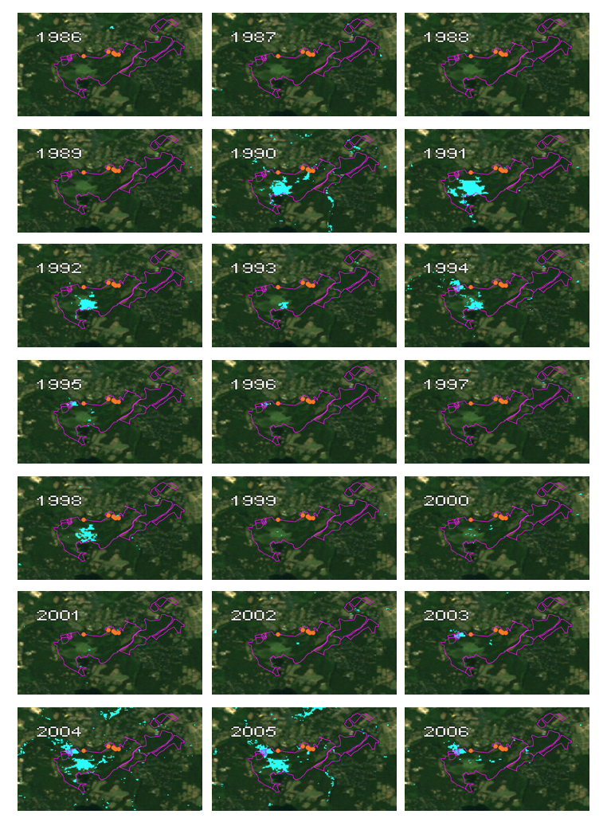
Appendix A

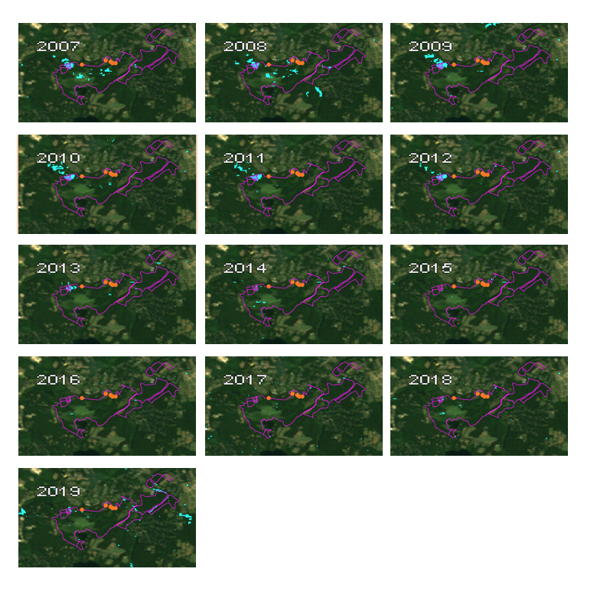
Figure A1. Yearly B-FED detected flooding events in wetland areas in Broadmoor Wildlife Sanctuary with GBIF beaver observations from 2006 – 2019 and Landsat 5 TM background imagery from 1995.

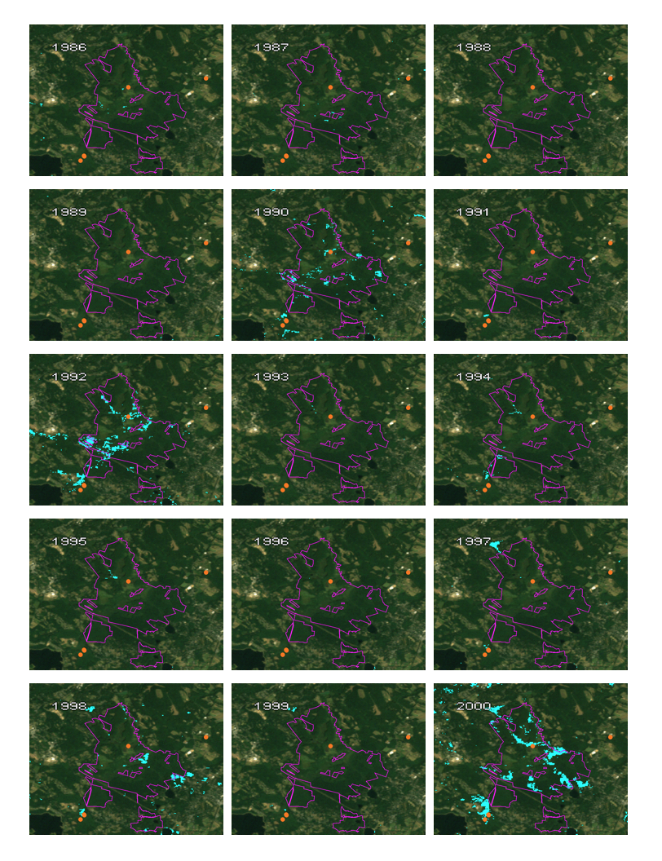
Appendix B 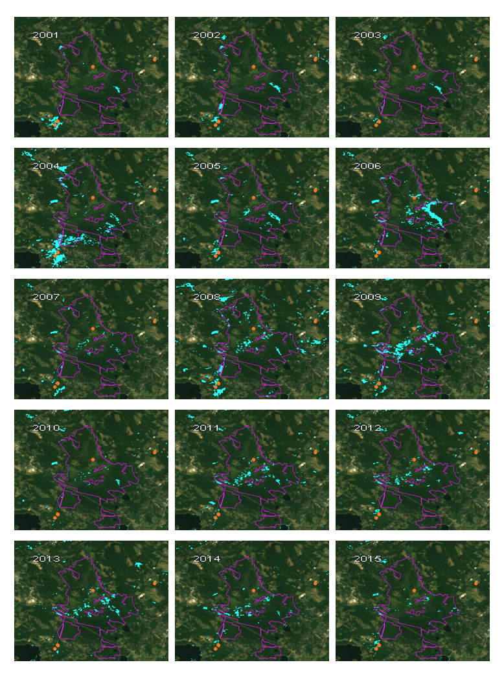 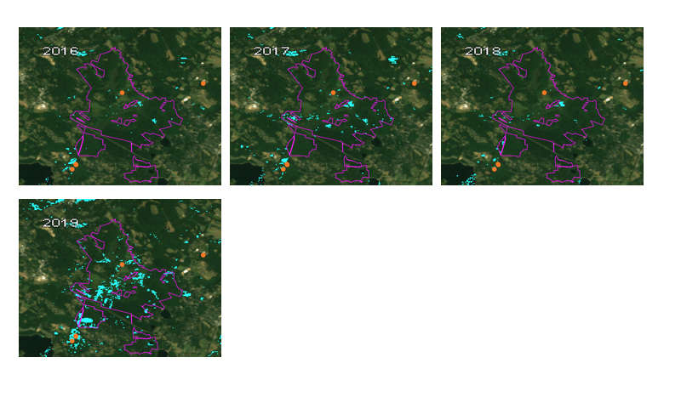
Figure B1. Yearly B-FED detected flooding events in wetland areas in Ipswich River Wildlife Sanctuary with GBIF beaver observations from 2016 – 2019 and Landsat 5 TM background imagery from 1995.
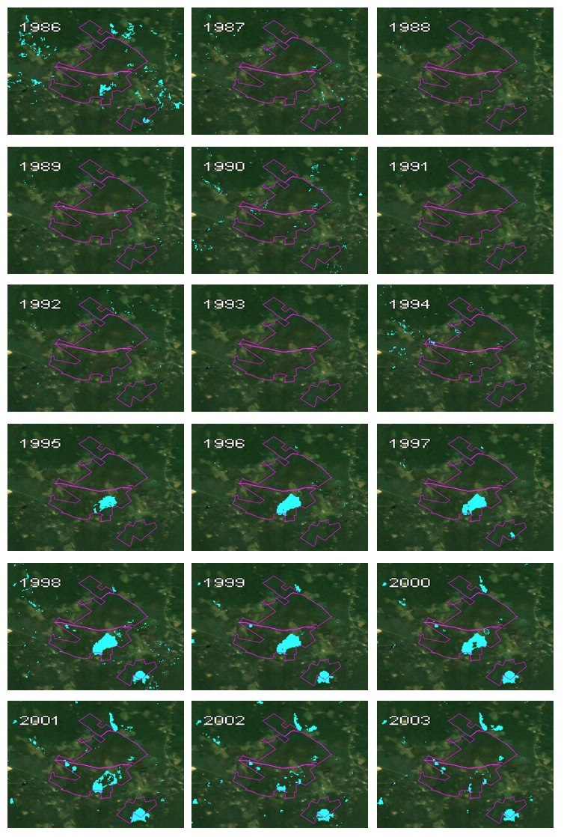
Appendix C
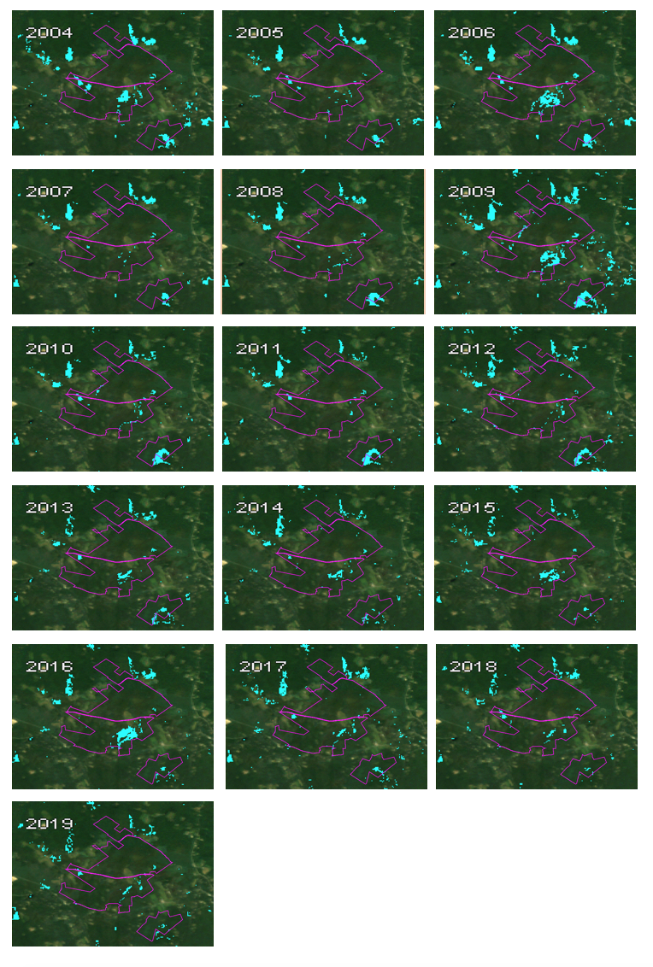
Figure C1. Yearly B-FED detected flooding events in wetland areas in Wachusett Wildlife Sanctuary with Landsat 5 TM background imagery from 1995.

