Colorado & New Mexico Water Resources
Mapping Wetland and Riparian Areas to Support Rio Grande Cutthroat Trout Habitat Restoration


Technical Report
Final Draft – April 2nd, 2020

Byron Schuldt (Project Lead)
Abby Eurich
Kat Tafoya
Toryn Walton

Dr. Paul Evangelista, Colorado State University, Natural Resource Ecology Laboratory (Science Advisor)
Dr. Catherine Jarnevich, United States Geological Survey, Fort Collins Science Center (Science Advisor)
Tony Vorster, Colorado State University, Natural Resource Ecology Laboratory (Science Advisor)
Nicholas Young, Colorado State University, Natural Resource Ecology Laboratory (Science Advisor)
Peder Engelstad, Colorado State University, Natural Resource Ecology Laboratory (Science Advisor)

1. Abstract
Over the last century, the Rio Grande cutthroat trout (Oncorhynchus clarki virginalis; RGCT) population has declined significantly due to habitat loss, competition, and hybridization with non-native trout species; the species currently occupies roughly 11% of its historic habitat. Conservation efforts led by governmental and private actors have succeeded in increasing RGCT populations since the early 2000s. Vermejo Park Ranch, a privately owned 560,000-acre property, partnered with US Fish and Wildlife Service and Colorado Parks and Wildlife (CPW) to begin the largest native trout restoration initiative in North America. Since 2002, these efforts have included wetland and riparian area restoration and RGCT reintroduction. Current restoration efforts focus on restoring the Costilla Creek Watershed to provide cool water temperatures, improve water quality, and create the necessary habitat requirements for the trout species. To guide these restoration efforts, the Colorado – Fort Collins NASA DEVELOP team produced maps to locate and characterize wetland and riparian areas in the Costilla Creek watershed. The team utilized NASA data from Landsat 8 Operational Land Imager (OLI), as well as Sentinel-2 MultiSpectral Instrument (MSI), Sentinel-1 Synthetic Aperture Radar (SAR), and additional ancillary data for May 2016 to October 2019. In order to produce probability maps of wetland presence, the team used the Software for Assisted Habitat Modeling (SAHM) incorporating predictor variables generated from topographic indices, spectral indices, and radar. The resulting maps allowed Vermejo Ranch and CPW to determine the extent of possible RGCT habitat and identify where habitat restoration efforts may be needed.

Keywords
remote sensing, wetlands, classification, Landsat, Sentinel, Tasseled Cap, NDVI

2. Introduction

  - Background Information
The Rio Grande cutthroat trout (Oncorhynchus clarkii virginalis; RGCT) holds high ecological importance to the southwestern United States as it serves as an indicator species for healthy riparian habitat and water quality (Amy, Cook, Rickel, & Triepke, 2012). The current habitat extent of the RGCT has been reduced to 10-12% of its historic range (Bakevich, Paggen, & Felt, 2016) and is expected to continue shrinking as anthropogenic and natural-caused hydrologic changes in the area exacerbate many environmental threats (Figure 1; US Fish and Wildlife Service, n.d.). Ongoing threats to the RGCT include hybridization and competition with non-native trout species, recreational fishing, habitat fragmentation, extended drought, and the effects of ash and debris flows following more frequent wildfires, which can wipe out fish populations from a stream (Pritchard & Cowley, 2006). Since populations are now more isolated from each other, once a population is extirpated from a stream, it cannot recolonize naturally (RGCT Conservation Team, 2013).

These environmental and anthropogenic threats have affected the RGCT for decades, but conservation efforts have consistently kept the species from federal listing. A petition was submitted to the US Fish and Wildlife Service in 1998 to list the RGCT under the Endangered Species Act, but the agency concluded that the listing was not warranted. This decision withstood an appeal with new information as well as a petition for Review of Agency Action. However, the RGCT is now considered a species of special concern in both Colorado and New Mexico. Current management and conservation practices, including reintroductions and protection of extant populations, have led to a stable distribution of the subspecies (US Forest Service, 2015). Conservation efforts led by the RGCT Conservation Team, including federal, state, tribal, non-governmental, and private organizations, have successfully restored 53 miles of river habitat and increased lake habitat by 37% for genetically pure RGCT since 2006 (Bakevich, Paggen, & Felt, 2016).

Like many subspecies of cutthroat trout, RGCT prefers clear, cold stream habitat but may also be found in small lakes or reservoirs (RGCT Conservation Team, 2013). Ideal stream temperatures for the subspecies are less than 59°F (New Mexico Game and Fish, n.d.); increasing stream temperatures have therefore reduced the elevation range of streams with appropriate temperatures for the RGCT. Although the historic RGCT habitat occupied elevations as low as 6,000 ft, most are now found in headwater streams from 8,000 - 10,000 ft in elevation (FSE Documents, n.d.; Machtinger & Boyer, 2007; New Mexico Game and Fish, n.d.; RGCT Conservation Team, 2013). For species survival, the RGCT requires four types of habitat for each part of the lifecycle: spawning habitat, nursery or rearing habitat, adult habitat, and refugium (RGCT Conservation Team, 2013). Spawning begins with the streamflow recession following snowmelt, after high streamflows increase oxygenation throughout the stream corridor (FSE Documents, n.d.; RGCT Conservation Team, 2013; United States Fish and Wildlife Service, 2013). For spawning, the fish require pools (0.5-11.8 inches in depth), mid- to high- velocity flow (0.6-6.0 in/s), and gravel substrate (0.24-1.6 inches in diameter) free of fine sediment such as sand (FSE Documents, n.d.; Machtinger & Boyer, 2007). Nursery and rearing habitat occur within stream margins with lower water velocity and slightly warmer water temperatures (above 46 °F in July) as well as abundant in-stream cover and well-vegetated stream banks (FSE Documents, n.d.). When RGCT reach adulthood, pools offer adults covered habitat and riffles provide them with ideal foraging for aquatic invertebrates (FSE Documents, n.d.; RGCT Conservation Team, 2013; Machtinger & Boyer, 2007). For survival through low flow seasons, trout rely on refugium’s which are usually deep, well-shaded pools that persist during both freezing temperatures and drought (FSE Documents, n.d.). Surrounding vegetation and abiotic structural diversity are essential to the survival and recruitment of RGCT. Tree canopy and overhanging vegetation help stabilize the streambank, maintain cooler temperatures, and provide wood and leaf material to the stream; large boulders and in-stream wood provide hiding cover for survival (Machtinger & Boyer, 2007). Therefore, restoration efforts around wetlands and riparian areas are critical to ensuring the success of re-established populations.
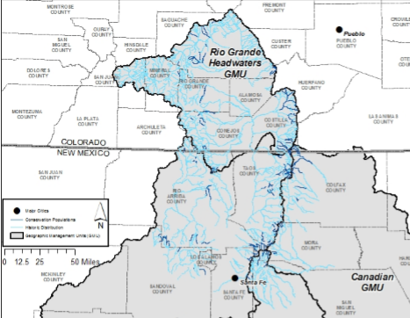

Figure 1. Historic range (light blue) and current populations (dark blue) of Rio Grande cutthroat trout. Map courtesy of New Mexico Department of Game and Fish and US Fish and Wildlife Service (RGCT Conservation Team, 2013).

Given the potential for RGCT to live in diverse and remote wetland habitats, utilizing remotely sensed imagery and topographic indices to identify these locations is promising. Several studies have successfully identified wetlands using remote sensing as new technologies become available. Chignell et al. (2017) and Wright and Gallant (2007) used Landsat imagery and topographic variables derived from a Digital Elevation Model (DEM) to distinguish wetlands in the western United States. However, Landsat imagery’s moderate resolution is a limiting factor in detecting smaller wetlands and streams where trout may live. Sentinel 2-MSI was launched in 2016 and collects spectral information at a resolution of 10 m (Blue, Green, Red, NIR bands), which provides a distinct advantage in this regard. In addition, Sentinel-1 C-band Synthetic Aperture Radar (C-SAR) instrument is potentially useful for wetlands detection—radar signals tend to scatter uniformly away from the sensor of origin over smooth surfaces such as water. Since both Sentinel-1 and Sentinel-2 have been launched recently, their use in wetland mapping is still being explored (European Space Agency, 2000; Mahdianpari et al., 2018; Whyte, Ferentinos, & Petropoulos, 2018). Previous work used remote sensing to locate and classify wetlands and riparian areas for the New Mexico side of Vermejo Park Ranch; however, the Colorado side of the ranch has not been mapped. Field observations are the only data source for the type and range of RGCT habitat in the unmapped area.

  - Project Partners & Objectives
We partnered with Colorado Parks and Wildlife (CPW) and Vermejo Park Ranch. Vermejo Park Ranch is a Ted Turner reserve known for its recreation opportunities and conservation efforts including wildlife reintroduction, bison herd management, and invasive species removal (Vermejo Conservation and Wildlife, 2020). In 2002, Vermejo Park Ranch partnered with CPW to begin RGCT reintroduction and habitat restoration. This effort became the largest restoration project of RGCT in North America, adding approximately 18 - 30 miles of riparian RGCT habitat. The project restocked genetically pure RGCT throughout the region on several tributaries to the Rio Grande, including the Costilla Creek watershed. The project partners are interested in information about the location and type of potential trout habitat in these watersheds to target future restoration efforts for restocking native RGCT and improving critical vegetative shading to current and future viable habitat.

Our project used a combination of Landsat and Sentinel imagery from 2016 to 2019, DEM topography data, ancillary and field data, and various model types to identify wetlands for RGCT habitat restoration. The primary project objective was to delineate wetland locations across the study area using remote sensing techniques. The team derived spectral and topographic indices, image texture, as well as radar polarizations from satellite datasets and used a point layer of known wetland locations to train models for wetland presence. To validate the model, the team reviewed accuracy metrics and conducted an ocular assessment of the map output. The partners will be able to use the maps to support their conservation goals by better understanding the distribution of wetland habitat and locations that may already contain RGCT, locating viable habitat for reintroductions, as well as identifying areas in need of habitat restoration. This product may also save the end user time and money associated with field observation collections.

3. Methodology

3.1 Study Area
The study area stretches across southern Colorado and northern New Mexico capturing the headwaters of the Upper Rio Grande watershed and Alamosa-Trinchera watershed. The elevation ranges from 2,543 m to 3,945 m, with the highest point near the southern boundary of the study area in the Culebra Mountain Range (Figure 2). Agriculture dominates the landscape to the northwest of the study area, at the base of the Willow Creek watershed. A large ridge spans from north to south through the study area, with its peak above the tree line and little to no vegetation (Figure 2). The greater part of the study area lies within the boundaries of the 550,000+ acres of Vermejo Park Ranch. Like much of the southwestern US, the climate is semi-arid and precipitation contribution to the streams is dominated by snowmelt runoff in the spring (Stewart, Cayan, & Dettinger, 2004). An investigation into the data from Snow Telemetry (SNOTEL) station 665, located within the study area, revealed that mean temperatures range from about 29℃ in the winter months (October to March) to 55℃ in the summer months (July/August). Precipitation totals about 20 mm per year with the majority falling as snow between November and February. Precipitation as rain occurs mostly in the spring, with fewer but more intense rainstorms in the summer and fall. Large annual variations in the temperature and precipitation can occur. Across the years of SNOTEL data studied, the maximum snow water equivalent varied between 0.7 mm (2018) and 11.4 mm (2019). This variability leads to a similar variation in wetland behavior; during wet years the extent of wetlands across the study area will be much greater than during dry years.

The Costilla Creek watershed, located within the Upper Rio Grande watershed, includes the East and West forks of Costilla Creek, which runs North to South through the east side of the study area and meet at the Colorado-New Mexico border, before running south into the Costilla Reservoir (Figure 2). These small first order streams are characterized by extensive riffle areas, moderate gradient, and gravel and cobble substrate (Vigil, 2018). Both streams were historical habitat for the RGCT and as a result of reintroduction, both currently sustain stable RGCT populations which are classified as Core Conservation Populations (Vigil, 2018). These streams are both characterized by floodplains with both riverine and palustrine wetlands along them. The Alamosa-Trinchera watershed also includes Willow Creek, a small first order stream, originating in New Mexico and spanning approximately 7 miles to its junction with Ventero Creek (Vigil, 2018). Willow Creek is a steeper and more forested watershed than Costilla Creek. Wetlands cover less area in Willow Creek and those that do exist are mostly palustrine emergent wetlands. Areas in both Costilla Creek and Willow Creek watersheds have been affected by livestock grazing which can degrade the quality of riparian vegetation; however, both watersheds offer excellent riparian habitat, especially in the upper regions, referred to as the headwaters (Vigil, 2018). In addition, there are sections of Willow Creek that dry up before the stream meets Ventero Creek, as a result of irrigation practices and the availability of water in dry years (Vigil, 2018).

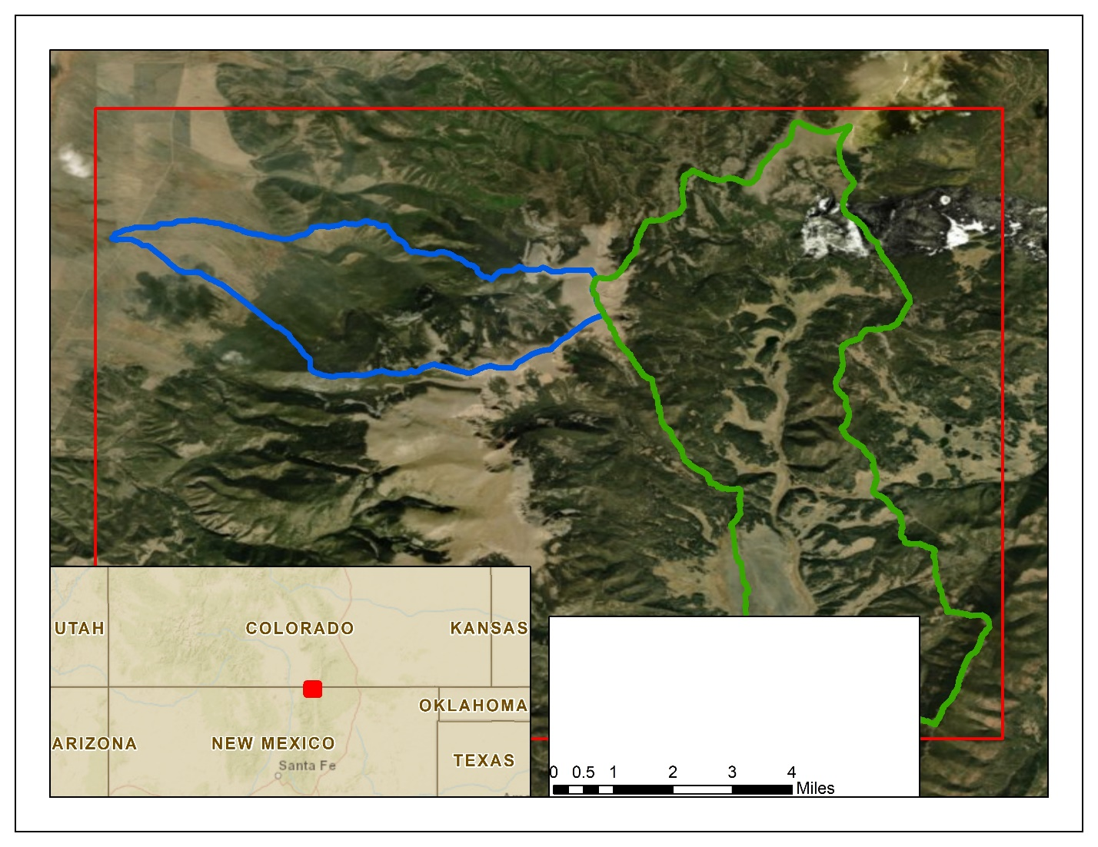
Study Area
Willow Creek Watershed
Costilla Creek Watershed
Figure 2. The study area spans both Colorado and New Mexico and includes the Costilla Creek and Willow Creek watersheds.

3.2 Data Acquisition
The GeoSpatial Services Program at Saint Mary’s University of Minnesota mapped wetlands as polygons and polylines in the New Mexico portion of the study area as part of the Canadian River Basin (CRB) dataset (Robertson et al., 2015). Project partners provided the CRB dataset for use in this project, as well as point data of wetland and stream locations and RGCT sampling locations in the upper Costilla Creek watershed. The team downloaded shapefiles representing wetland and stream extents from the National Wetlands Inventory (NWI) and the National Hydrography Dataset (NHDPlusV2) as well as the USGS National Elevation Dataset (NED) digital elevation model (DEM) at ⅓ arc-second resolution. Finally, SNOTEL readings for station 665, located in the study area, were accessed using the RNRCS package in R statistical software (Lee & Roberti, 2018).

The team utilized Google Earth Engine to export Landsat 8 Operational Land Imager (OLI) Level 2 surface reflectance scenes for the months of June through October from 2016 to 2019; this limited images to snow-free months and captured interannual hydrologic variability (Figure 6). To enhance spatial resolution for appropriate capture of small streams and wetlands, the team also used Sentinel-2 Multispectral Instrument (MSI) Level 2A surface reflectance imagery for the months of June through October for just 2019 because this is currently the only year of Sentinel-2 surface reflectance imagery available. Surface reflectance products were chosen over top-of-atmosphere so the team could compare images across multiple dates without the confounding influence of atmospheric conditions (Young et al., 2017). The Vertical-Vertical (VV) and Vertical-Horizontal (VH) polarizations from Sentinel-1 C-SAR for 5 randomly selected dates in snow-free months of 2019 were also exported from Google Earth Engine. Lastly, high-resolution National Agricultural Imagery Program (NAIP) imagery was downloaded from the USDA Geospatial Gateway for 2017 and 2018 for use in ocular assessment. High-resolution historical imagery spanning from 1997 to 2020 was also used for ocular assessment in Google Earth Pro.

Table 1
The table below showcases the satellite data used in this project. All data were accessed and processed in Google Earth Engine.
Platform and Sensor | Data Product | Dates
Landsat 8 OLI | Surface Reflectance Tier 1 | June-Oct, 2016-2019
Sentinel-2 MSI | Surface Reflectance Level 2A | June-Oct, 2019
Sentinel-1 C-SAR | C-Band Synthetic Aperture Radar Ground Range Detected | May-Oct, 2019

3.3 Data Processing
Training points for wetland presence were derived from the NWI database, St. Mary’s University Canadian River Basin (CRB) dataset, RGCT sampling coordinates provided by CPW, and wetland location coordinates provided by Vermejo Ranch (Figure 3, Figure 4). After testing a 5 m, 10 m, 15 m, and 20 m inward buffer, the 10 m inward buffer was selected to use on the NWI palustrine and lacustrine polygons, according to buffer methods utilized by Chignell et al. (2017). This reduced the palustrine and lacustrine wetland polygon area by 429.5 hectares. This buffer was used to limit geo-registration error from NWI data collected in 1975, 1983, and 1985, while retaining small areas of wetland polygons at high elevations. After applying the buffer, 1025.4 hectares of lacustrine and palustrine wetland polygons were available from which to derive training data (Figure 3). The random point generator tool in QGIS was used to create training points within the NWI and CRB wetland polygons at a minimum distance of 180 m (Figure 4). The NWI data (n = 325), CRB data (n = 5), and field-verified data from CPW (n = 2) and Vermejo Ranch (n = 7) were included as presences to create a total of 339 presence points (Figure 4). Non-wetland areas were created by erasing from the area of interest the original wetland extent polygons with an additional 30 m outward buffer. Within the non-wetland area, absence points were generated using the random point generator tool in QGIS (n=338). When the absence points were used in Software for Assisted Habitat Modeling (SAHM), model accuracy increased (Table C1). A randomized ocular QA/QC was performed on 100% of presence points and 40% of the absence points using high-resolution historical NAIP imagery from 1997 to 2020 in Google Earth Pro (Figure 5). Each presence point was assessed by proximity to forest and flooded areas, and absence points were removed when found in flooded areas. This quality check was limited to less than 100% of absence points by available project time. From the QA/QC, 1.3% of surveyed presence points were deemed incorrect and 0% of surveyed absence points were within or too close to a wetland and thus removed from the training data.
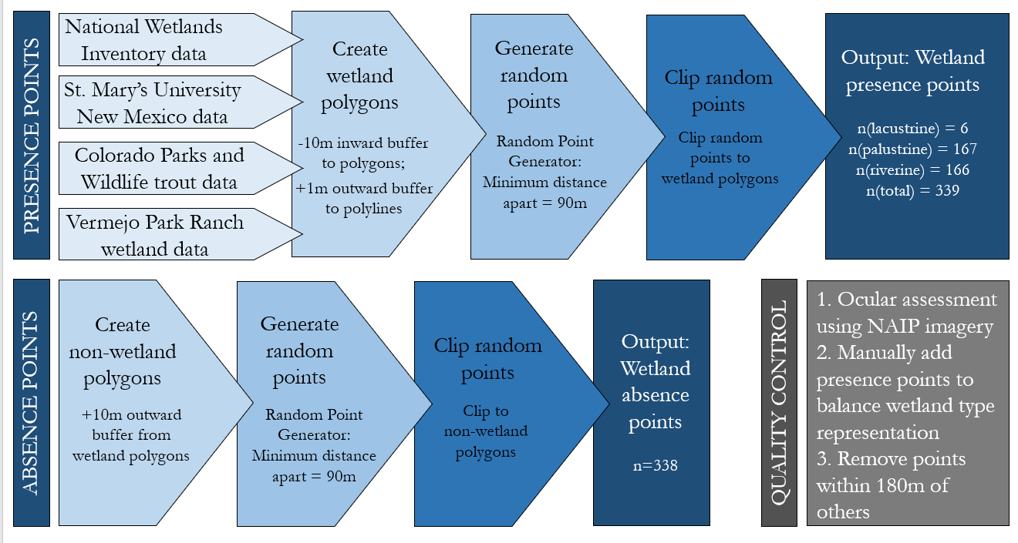
Figure 3. Methods used in QGIS and ArcMap to generate presence points, absence points, and conduct data quality control.

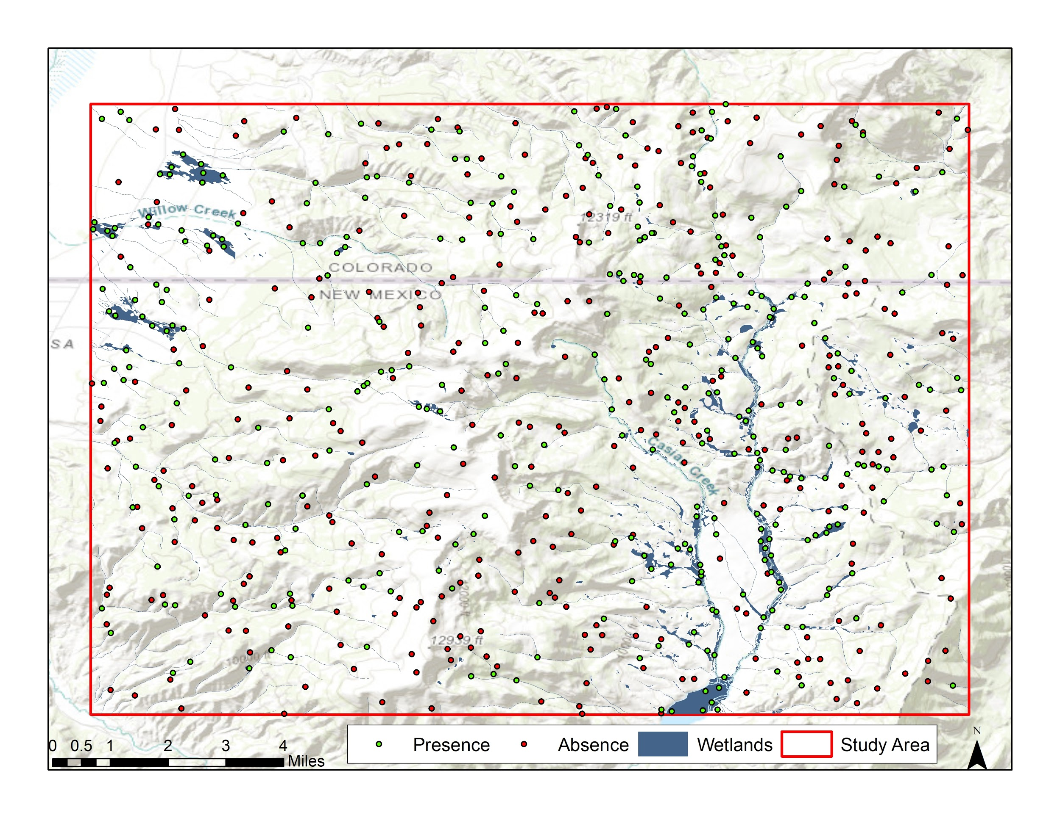
Figure 4. Training data (red = absence; green = presence) and wetland polygons (blue) throughout the study area.
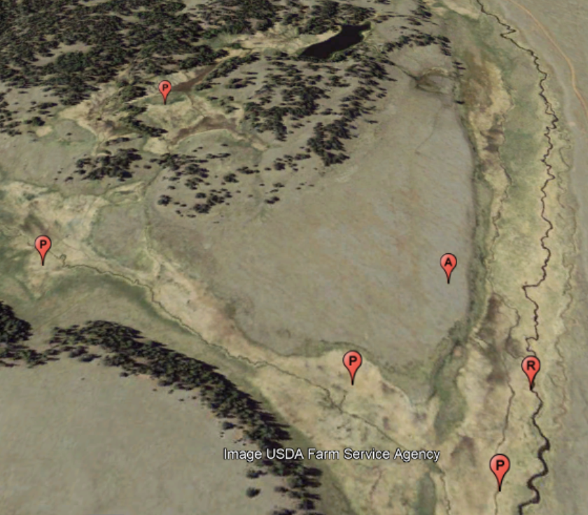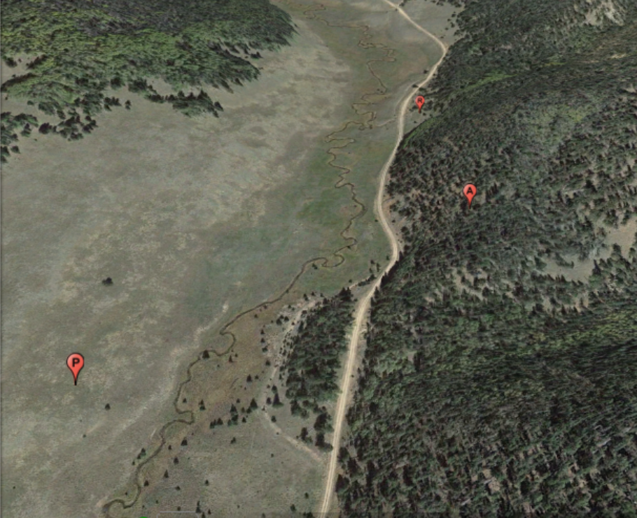
Figure 5. Examples of ocular assessment imagery from Google Earth Pro, where “P”, “R”, and “A” points represent palustrine presence, riverine presence, and absence points respectively.

The team utilized precipitation data to identify recent years of generally dry and wet conditions and inform imagery collection. SNOTEL precipitation data for the study area were totaled over each season from 2011 to 2019 (Figure 6). In the semi-arid climate of northern New Mexico and southern Colorado, hydrology is driven by the spring peak flows following snowmelt (Stewart et al., 2004). Therefore, winter precipitation is important for determining the amount of water available to the system for the year. High-intensity summer thunderstorms also play a large role in the hydrology of the system, often causing secondary streamflow peaks that are smaller than snowmelt runoff but still overtop channels into wetlands and floodplains. Over the nine-year timeframe, 2019 has the highest winter precipitation and 2017 has the third-highest winter precipitation, with the highest summer precipitation (Figure 6). The team deemed these years as generally wet within the current climatological context. Meanwhile, 2018 was relatively dry, with the lowest precipitation for all four seasons (Figure 6).

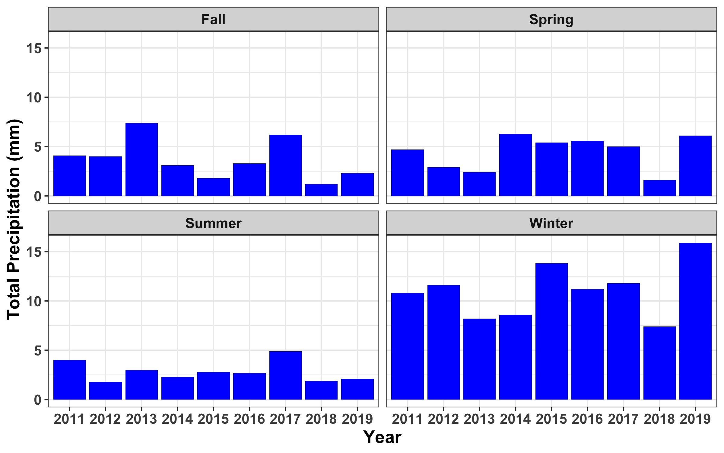
Figure 6. Total precipitation recorded at SNOTEL station 665, located in the study area, during Fall (Aug-Sept), Spring (April-May), Summer (June-July), and Winter (Nov-March).

The team primarily used Google Earth Engine for image processing. First, the Landsat 8 and Sentinel-2 datasets were filtered to (1) the study area, (2) June to October, and (3) 2016 to 2019. The resulting images were then assessed for cloud and snow cover. Images with <10% cloud or snow cover were used to calculate several spectral indices (Equations 1-6; Landsat Surface Reflectance-Derived Spectral Indices, n.d.). There were 19 images from Landsat 8 (2016: 5; 2017: 6; 2018: 4; 2019: 4) and 10 images from Sentinel-2 for 2019 that fit within these cloud and snow-cover specifications. The indices calculated were chosen based on a literature review of wetland mapping. Indices that proved useful in previous studies included Tasseled Cap Greenness, Brightness, and Wetness (Chignell et al., 2017; Townsend & Walsh, 2001; Wright & Gallant, 2007), Normalized Difference Vegetation Index (NDVI; Townsend & Walsh, 2001), Soil-adjusted Vegetation Index (SAVI), and Image Texture (Wright & Gallant, 2007). The team decided to also try Enhanced Vegetation Index (EVI), Multiband Normalized Difference Wetness Index (MNDWI), and Normalized Multiband Drought Index (NMBDI) as predictor indices in case they were useful in picking up wetland vegetation or moisture differences from upland areas, even though we did not find a direct reference to them in the literature. The Tasseled Cap (TC) indices were computed using a linear combination of bands and empirical coefficients (Baig et al., 2014; Nedkov, 2017), which were calculated using Principal Component Analysis (PCA), to highlight brightness, greenness, and wetness of the landscape (Table A1, Table A2). Image texture as variance was calculated using the glcmTexture tool in Google Earth Engine on the TC Greenness, Brightness, and Wetness bands as well as Red and NIR bands in a 3x3, 5x5, and 7x7 window for each of the five images, three Sentinel-2 dates and two Landsat-8 dates chosen for their lack of clouds and late-season wetland visibility (Wright & Gallant, 2007). Last, aggregations of images were created in an attempt to highlight the seasonal variability in spectral signatures for wetlands versus upland areas (Figure 7, Table 2, Table B1; Wright & Gallant, 2007). Spectral plots were created in Google Earth Engine for each of the indices over all the 2019 images used (e.g. Figure 7). From these plots, the unique spectral characteristics of the wetland polygons were determined, such as a higher peak in NDVI and TC Greenness and a more pronounced difference between early and late season for these indices as well. Table B1 in Appendix B lists all the aggregated images the team created and used in model runs. After computing each index, the resulting images were exported as a GeoTIFF in the WGS84 coordinate reference system.

(Normalized Difference Vegetation Index) $\text{NDVI = }\frac{\text{NIR - Red}}{\text{NIR + Red}}$ (1)

(Enhanced Vegetation Index) $\text{EVI = }\frac{\text{NIR - Red}}{\text{((}\text{NIR + 6)(Red} \text{-} \text{7.5)(Blue} \text{+} \text{1))}}$ (2)

(Normalized Difference Moisture Index) $\text{NDMI = }\frac{\text{SWIR1 - NIR}}{\text{SWIR1 + NIR}}$ (3)

(Multiband Normalized Difference Wetness Index) $\text{MNDWI} \text{= }\frac{\text{Green - SWIR1}}{\text{Green + SWIR1}}$ (4)

(Normalized Multiband Drought Index) $\text{NMBDI }\text{= }\frac{\text{NIR - }\text{(}\text{SWIR1}\text{ - SWIR2)}}{\text{NIR}\text{ + }\text{(}\text{SWIR1}\text{ - SWIR2)}}$ (5)

(Soil Adjusted Vegetation Index) $\text{SAVI }\text{= }\text{1.5 *}\frac{\text{NIR - }\text{Red}}{\text{NIR}\text{ + }\text{Green + 0.5}}$ (6)

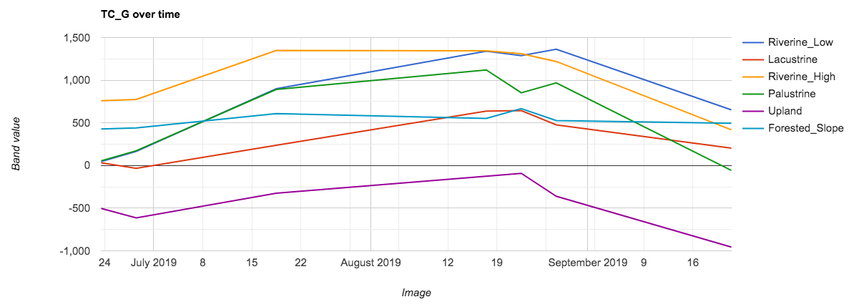
Figure 7. Spectral plot for TC Greenness over the Sentinel-2 images from 2019. Categories were created by drawing polygons manually in Google Earth Engine over high resolution NAIP imagery to capture the different types of landscape and wetlands in the study area.

Topographic data were also used as predictor variables and improved model accuracy in identifying wetland and riparian areas. Topography plays a large role in the movement of water through a landscape and where the water is likely to collect. The ArcGIS Spatial Analyst and Hydrology toolboxes were used to calculate slope, flow accumulation, flow direction, and sinks (Table B2). The Geomorphometry and Gradients Metrics toolbox (Evans et al., 2014) was used to calculate roughness, dissection, compound topographic index, and integrated moisture index (Table B2; Chignell et al., 2017). These predictors are useful because wetlands, especially if forested, can be difficult to identify by satellite imagery and spectral indices alone (Chignell et al., 2017; Wright & Gallant, 2007). All predictor variables calculated and used in the model runs are listed in Table 2.

Table 2
Predictor variables used for model runs.
Predictor Class | Variable
Topographic  From 10m DEM | Dissection | Integrated Moisture Index | Flow Direction
Topographic  From 10m DEM | Roughness | Slope | Sink
Topographic  From 10m DEM | Compound Topographic Index | Flow Accumulation
Radar  Sentinel - 1 | Linear Vertical:Vertical* | Linear Vertical:Horizontal* | Circular: Right-handed*
Spectral  Landsat 8, 30m  Sentinel - 2, 10m | Tasseled Cap | Vegetation | Moisture/Drought
Spectral  Landsat 8, 30m  Sentinel - 2, 10m | Greenness* | NDVI* | NDMI
Spectral  Landsat 8, 30m  Sentinel - 2, 10m | Brightness | EVI* | MNDWI*
Spectral  Landsat 8, 30m  Sentinel - 2, 10m | Wetness | SAVI | NMBDI*
Image Texture  5m x 5m | Near Infrared | Tasseled Cap Greenness | Tasseled Cap Wetness
Image Texture  5m x 5m | Red | Tasseled Cap Brightness
The “*” indicates an aggregate image was used for this variable as well, see Table B1

3.3 Data Analysis
The Software for Assisted Habitat Modeling (SAHM) was used to model wetland presence and absence (Morisette et al., 2013). This software allows the user to run four types of models simultaneously: Random Forest (RF), Boosted Regression Tree (BRT), Multivariate Adaptive Regression Spline (MARS), and Generalized Linear Model (GLM). Inputs to the model included training data, predictor variables, and a base layer to define the spatial resolution of the final model. For each model run, all possible predictor variables (Table 2) were used as inputs. From all the necessary inputs, SAHM determined the best set of predictor variables to differentiate the training data presence pixels from absence pixels. The software then produced a correlation matrix of the best variables for the model. For each pair of predictor variables with a correlation greater than 0.7, the variable with the higher percent deviance explained was kept and the other was removed from the model. Each model run produced a probability map with each pixel value representing the probability of wetland presence (0-100%).

To determine the best way to accurately map the wetlands in the watersheds of interest, the team ran 20 different models. We tried using different areas of interest (AOI’s) to subset the high elevation headwater areas that were most important to project partners and ensure that the low elevation open areas in the AOI were not biasing the model. Ultimately, we decided that the smaller AOI with just high elevation was leading to an overfit model that was also overpredicting wetlands; therefore, we selected the AOI described above in Section 3.1. We also tried different sets of training data to include just riverine, just palustrine and lacustrine, or riverine, palustrine, and lacustrine wetlands together. Initially, we hypothesized that riverine wetlands warranted a separate modeling process from palustrine and lacustrine wetlands due to assumed differences in spectral and topographic signatures. While modeling palustrine and lacustrine separate from riverine did improve accuracy for the former two classes without confusion with riverine wetlands, modeling riverine separately resulted in wide predictions in palustrine wetlands. We finally determined that modeling all three wetland types were best to identify all three types in one model and forego issues related to combining separate models into one map. Initially, we incorporated presence-only training data in SAHM and generated background points in the software instead of absence points. However, we later created absence points equal in number to total presence points and found that adding these to the training data improved model results (Figure 3, Table C1). Last, we tested different sets of predictor variables using Landsat 8 with a 30 m base layer and using Sentinel-1 & Sentinel-2 with a 10 m base layer (Table 2, Table C1). The Landsat 8 data offered a better temporal resolution, with images spanning four years of variable climate and precipitation; however, ultimately the finer spatial resolution of the Sentinel-1&2 images proved more useful for mapping the variable mountain habitat.

Models were evaluated based on accuracy metrics output from SAHM as well as a critical visual assessment of the output probability maps using high resolution imagery and the team’s growing knowledge of wetlands and the study area. The confusion matrix, receiver operating characteristic (ROC) plot, and calibration plot are all outputs from SAHM that were used to critically assess each model and ultimately choose the final model (Figure 9). The confusion matrices show the number of true positives in the top left corner and the number of true negatives in the bottom right corner. The top right corner is then the number of false positives and the bottom left corner is the number of false negatives. The goal with these plots is to have low numbers, relative to the total, of false positives and negatives, and high numbers, relative to the total, of true positives and negatives. This plot also offers statistics for total percent correctly classified, sensitivity, specificity, true skills stat, and Cohen’s kappa. In the ROC plot, the true positive rate (sensitivity) is plotted against the false positive rate (1 − specificity); therefore, ideally, the curve will rise steeply initially and then level off at a value close to the maximum of 1 (Freeman & Moisen, 2008). If this is the case, the model has achieved a high true positive rate while the false positive rate is still relatively small. The area under the ROC curve (AUC), with a maximum of 1, is a good measure of overall model performance. When the training split, the AUC and cross-validation AUC are similar, this indicates a well-fit model because it is not overfit to the training data split. Last, the calibration plot illustrates the accuracy of the model in predicting wetland presence, relative to the true probability of wetland presence. If the data points lie along the 1:1 line, it indicates a well-calibrated model because the predicted probability of presence equals the true probability of presence. Other metrics used to evaluate which model most accurately characterized wetland presence were the percent overlap with NWI polygons and an ocular assessment of the model for specific sampling areas with known wetland presence and absence. Using a combination of these metrics, visual assessments, and study area knowledge, and not necessarily just focusing on the model with the highest statistics, allowed the team to discern the best model from a full picture of statistical validation and real-world meaning to pass on useful maps to the partners for their conservation efforts.

From the probability map (Figure 8), we created a binary presence/absence map by assigning pixels with a probability value greater than the threshold a value of 1 indicating presence, and other pixels a 0, indicating absence (Figure 10). This was done in Google Earth Engine with the gt() function. For each of the three final models, three thresholds were chosen which can each be used for different purposes. With a lower threshold, a larger extent of wetlands is maintained in the map; however, the probability of wetland presence at those locations is reduced. In contrast, the highest threshold for each model offers the highest probability of wetland presence and also the smallest extent of wetlands across the study area. The threshold offered by the ROC plot is at the point where sensitivity equals specificity. This is ideal for many research objectives when the goal is to balance the true positives and the false positives of the model. However, for this project, the goal of the project partners was mostly to have high confidence in known wetland locations. This required that the group increase the threshold slightly from the SAHM output offering. With a baseline of the threshold in the ROC plots from the SAHM output, the thresholds were ultimately chosen based on an ocular assessment of the models over high-resolution NAIP imagery in Google Earth Engine to maintain a reasonable wetland extent, while minimizing false positives.

Four maps for each of the three final models were delivered to the project partners. These maps included the following:
1) full probability map; scale 0-100% probability of wetland presence;
2) low threshold map; scale binary (0: absence, 1: presence);
3) middle threshold map; scale binary (0: absence, 1: presence);
4) high threshold map; scale binary (0: absence, 1: presence).
A threshold ensemble map was also delivered to the project partners. This map is a combined map of all three models. Using the middle threshold for each model, the team added the three binary rasters together, resulting in a raster map with a scale of 0-3 and indicating the number of maps with that pixel classified as wetland presence. This map gave the partners a good idea of the overall classification of each pixel, from our three best model results.

The last valuable map to be delivered to the project partners was a vectorized version of the middle threshold Palustrine map, with useful characteristics of each wetland polygon added to the attribute table. After thresholding was complete, we turned the binary (0, 1) raster into vector polygons representing wetland locations using ArcMap (Figure 12). Using the wetland vector data, we classified the wetland types with the zonal statistics as a table tool to determine the mean slope, elevation, and vegetation characteristics for each wetland polygon. To capture vegetation characteristics, the mean and standard deviation values were calculated across each wetland polygon from an aggregated maximum NDVI raster. This maximum NDVI raster was created in Google Earth Engine and is made up of the maximum NDVI value for each pixel across July, August, and September 2019. These months were chosen because they tend to be the months with the highest values for NDVI in wetlands. This is a start for characterizing the amount of vegetation in a given wetland area; however, it should be considered with the following caveats. Different types of vegetation may have different NDVI signatures and so comparing values across wetlands does not necessarily translate to a direct comparison of vegetation amount across wetlands. Also, the timing of the peak NDVI is lost in this analysis because we combine the values across the growing season to identify the maximum value for the year. Within the 33,321.3-hectare study area, there are 2,256.5 hectares of wetlands. This polygon layer offered a bit more context and information on the wetlands in the study area that will be helpful to partners when they begin to further investigate these wetlands for their restoration and RGCT reintroduction efforts.

4. Results & Discussion

4.1 Analysis of Results
This study demonstrates the feasibility of using satellite imagery to identify wetlands in a high-elevation semi-arid study area. Even though the 10 m resolution Sentinel-2 imagery offered only one year of imagery to the analyses, it was more useful than multiple years of the 30 m resolution Landsat 8 imagery in identifying the diversity of wetlands in the study area. We determined that topographic predictors are quite useful and important for modeling wetlands in this area. The variables of the highest importance were Tasseled Cap Greenness and Dissection, r=16 (Table 3, Table B2, Figure C1). Creating aggregated images to capture seasonal nuances between the wetlands and surrounding landscape proved useful, as three of the predictors in the final Palustrine model were image aggregations. Furthermore, we found that emphasizing an even geographic distribution of training points and a balanced proportion of wetland types were important contributing factors to developing accurate models.

4.1.1 Model Output
Modeling wetlands in this high elevation semi-arid landscape was an iterative process using many combinations of predictor variables and training data; therefore, the final results are quite robust. We tested 20 model iterations in SAHM and selected three final models to hand off to the partners (Table 3, Figure 9, Figure 10). Together, the three models provide valuable information about potential locations of palustrine, lacustrine, and riverine wetlands and are meant to work together. For palustrine and lacustrine wetlands, we determined that the most accurate model was the Palustrine model. This model utilized a random forest approach and incorporated training data for palustrine, lacustrine, and wetland absence locations but excluded riverine training data. The two other final models incorporated training data for all three wetland types in addition to a balanced number of wetland absence locations. These models are named the Stream and Wetland Connectivity model, which effectively identified riverine corridors and potential smaller drainages across the landscape, and the High Sensitivity model, which provided additional predicted palustrine wetland locations beyond those predicted by the Palustrine model. The Stream and Wetland Connectivity model was produced using a Generalized Linear model and the High Sensitivity model was produced using the Boosted Regression Tree method.

The map outputs produced by the three models all illustrate the clustering of wetlands near the perennial streams in the southeastern corner of the study area (Figure 10). These are the vega (or meadow/valley) areas, rather than forested slopes. There is a small cluster of wetlands in the northeast corner of the study area; this area includes the headwaters of the Costilla Creek watershed which is of high importance to the project partners for potential restoration work. Additionally, there is a cluster of wetlands in the Upper Willow Creek watershed, which is a potential location for future restoration efforts. However, there are some differences in the maps from the three different models. The Palustrine model is the most conservative in its wetland predictions, while the High Sensitivity model is least conservative. By design, the Palustrine model does not identify riverine wetlands well but predicts discrete palustrine wetlands locations with high probability. The Stream and Wetland Connectivity model predicts a significantly larger extent of wetlands than the Palustrine model, but highlights streams and potential drainages well, which can serve as useful visual reference points for finding trout habitat. The High Sensitivity model predicts the largest extent of wetlands across the study area. This model does not distinguish minor streams and drainages like the Stream and Wetland Connectivity model but predicts palustrine wetlands in distinct new areas with high probability. However, both the High Sensitivity model and the Stream and Wetland Connectivity model predict the presence of wetlands on some forested slopes, dry uplands, and in very limited areas along the tops of ridges, indicating that these models have more trouble distinguishing these landscape features from wetlands than the Palustrine model.

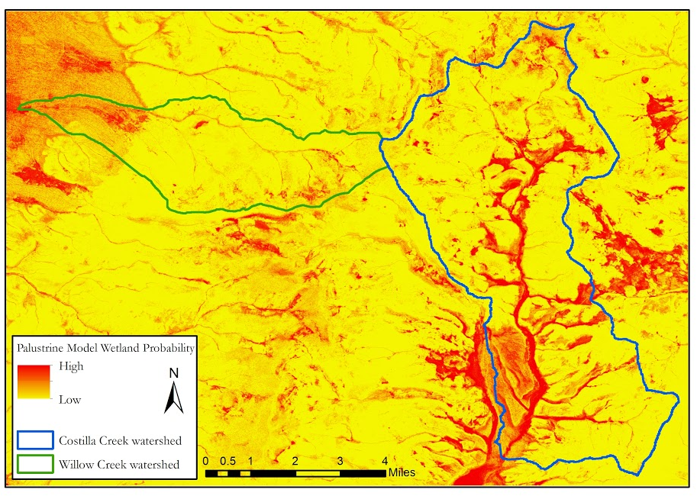
Figure 8. Probability map model output from the Palustrine model. Dark red indicates higher likelihood of wetland presence and yellow indicates lower likelihood of wetland presence.

Each model used a different set of predictor variables, with some commonalities. Topographic variables were especially important in all three models, according to the metric of change in AUC when that predictor is removed. Topographic dissection using a 16-pixel radius was the most important predictor in both the Stream and Wetland Connectivity model and the High Sensitivity model while it was the fourth most important in the Palustrine model (Table 3). Additionally, both the Palustrine model and the Stream and Wetland Connectivity model utilized the same three topographic variables (Table 3). Tasseled Cap Greenness for August 17, 2019, was important in all three models, illustrating the distinct spectral separation between wetlands and other areas later in the summer season. Lastly, radar-derived variables were important in the Palustrine model and the Stream and Wetland Connectivity model (Table 3), possibly due to the unique way radar interacts with flooded surfaces or the vegetation unique to wetlands.

Table 3
Final models with associated predictor variables in order of variable importance in the model (see Figure C1 for more info), training points information, and accuracy metrics.
 | Palustrine Model | Stream and Wetland Connectivity Model | High Sensitivity Model
Model Type | Random Forest | Generalized Linear Model | Boosted Regression Tree
Variables Used (in order of importance)  Topographic  Sentinel-1  Sentinel-2 | Tasseled Cap Greenness (08/17/19)  Mean VV  Slope  Dissection (r=16)  Difference NMBDI (Sept & Oct)  VH (05/11/19)  Tasseled Cap Wetness (09/21/19)  Tasseled Cap Brightness (08/17/19)  Median CR  Compound Topographic Index | Dissection (r=16)  Tasseled Cap Greenness (08/17/19)  Compound Topographic Index  Median CR  Slope  5x5 NIR (Texture; 08/17/19)  Mean VV | Dissection (r=16)  Tasseled Cap Greenness (08/17/19)
AUC | Training Split: 0.978 | Training Split: 0.929 | Training Split: 0.908
AUC | Cross Validation: 0.975 | Cross Validation: 0.885 | Cross Validation: 0.852
Training Points | Presence (195) = Absence (447)  Riverine = 0  Palustrine = 177  Lacustrine = 8 | Presence = Absence (338)  Riverine = 166  Palustrine = 166  Lacustrine = 6 | Presence = Absence (338)  Riverine = 166  Palustrine = 166  Lacustrine = 6
General Notes | Predicts a narrower spread of wetlands with high probability. Precise predictions of high probability in core palustrine wetland areas. Also includes the main riverine vega areas of lower Costilla Creek and Casias Creek. | Picks up stream connectivity well, high probability in riverine areas as well as high elevation palustrine wetlands. | Predicts high probability in novel palustrine wetlands that were not predicted in the Palustrine Model or Stream and Wetland Connectivity Model. Also does will with stream connectivity.

Figure 9 contains plots describing the accuracy of the three final models. Overall, the Palustrine model is more accurate than the other two, with a higher percentage of points correctly classified for both the training and cross validation data. The confusion matrices reveal the superior ability of the Palustrine model to correctly identify locations of wetland absence, whereas the other two models produced a higher rate of false positives. The ROC plot for the Palustrine model also shows that the model is more accurate at different probability thresholds than the other models because the curve steeply increases toward the value of (0,1) (Figure 9). The calibration plots show that the Palustrine model tends to overpredict wetland presence at low probability values and underpredict at high probability values. Both the Stream and Wetland Connectivity model and the High Sensitivity model underpredict wetland presence at low probabilities and tend to overpredict for most other probabilities (Figure 9).

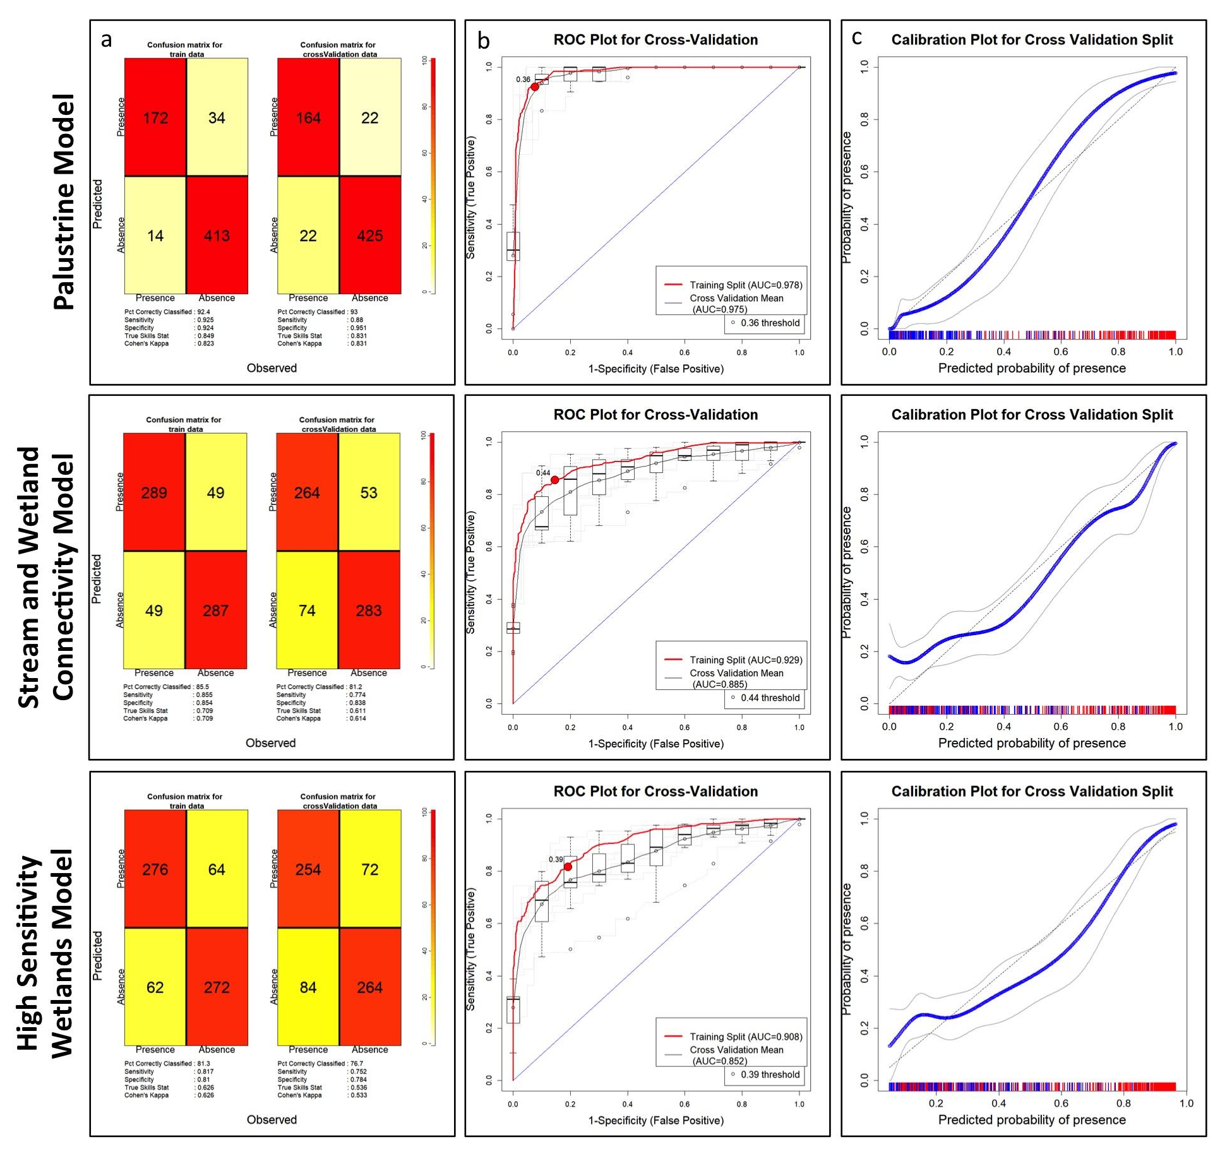
Figure 9. Confusion Matrix (a), ROC Plot (b), and Calibration Plot (c) for each of the three final models.

Threshold maps were created at three threshold levels for each of the final models, the process for which is detailed in section 3.3. For the Palustrine model, the low threshold is 0.4/40%, the middle threshold is 0.6/60%, and the high threshold is 0.8/80% (Figure 10). For both the Stream and Wetland Connectivity model and the High Sensitivity model, the low threshold is 0.6/60%, the middle threshold is 0.8/80%, and the high threshold is 0.9/90%. The Palustrine model probability predictions were more conservative, to begin with, because this model was restricted to just Palustrine and Lacustrine wetlands. Therefore, the thresholds chosen were slightly lower so that we did not lose useful wetland extent in this map. A low threshold map is helpful if the user is seeking to find new wetlands by exploring a wide range of potential locations, while a high threshold map is most useful when the user wants to be confident that a wetland will be found at a specific location.

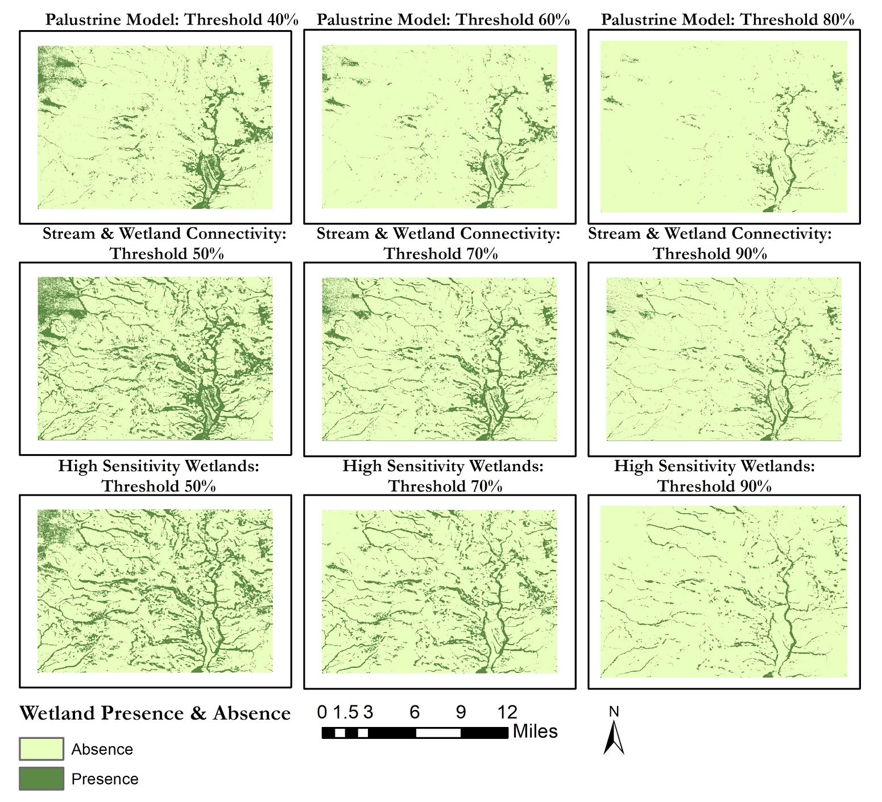

Figure 10. Threshold maps for the Palustrine, Stream and Wetland Connectivity, and High Sensitivity models. These are binary maps of wetland presence and absence when the probability threshold is set at different levels for each model.

From these threshold maps, the middle threshold map for each of the three final models was combined into the threshold ensemble map described in section 3.3 (Figure 11). The middle threshold for each model was chosen to create this map because the team determined that the resulting threshold maps were most realistic in their visual representation of wetland presence, whereas the low and high thresholds represent the extremes. Figure 11 shows the highest agreement between the three models for wetlands near and south of the convergence of East and West Fork Costilla Creek as well as Casias Creek, which also flows into the Costilla Reservoir. For wetlands north of the junction of the East and West Forks Costilla Creek, there is a small section with a high agreement between the models near the headwaters of East Fork Costilla Creek (Figure 11). This area of high probability wetlands can also be seen in the very top section of the Costilla Creek watershed in Figure 8 and is promising for potential partner restoration efforts in this area. Areas where all three models predict wetlands tend to be characterized by green vegetation and sparse tree cover, and areas where only one model predicts a wetland tend to exhibit forest cover or senesced vegetation when compared to high-resolution fall aerial imagery. This is likely because the open, vega areas, as described above, are easier to distinguish using spectral signatures of wetlands but the forested or covered areas are more difficult to pick out. The models that rely more heavily on the topographic variables tend to pick up those covered areas with a higher probability of wetlands in those locations (Table 3, Figure 10).

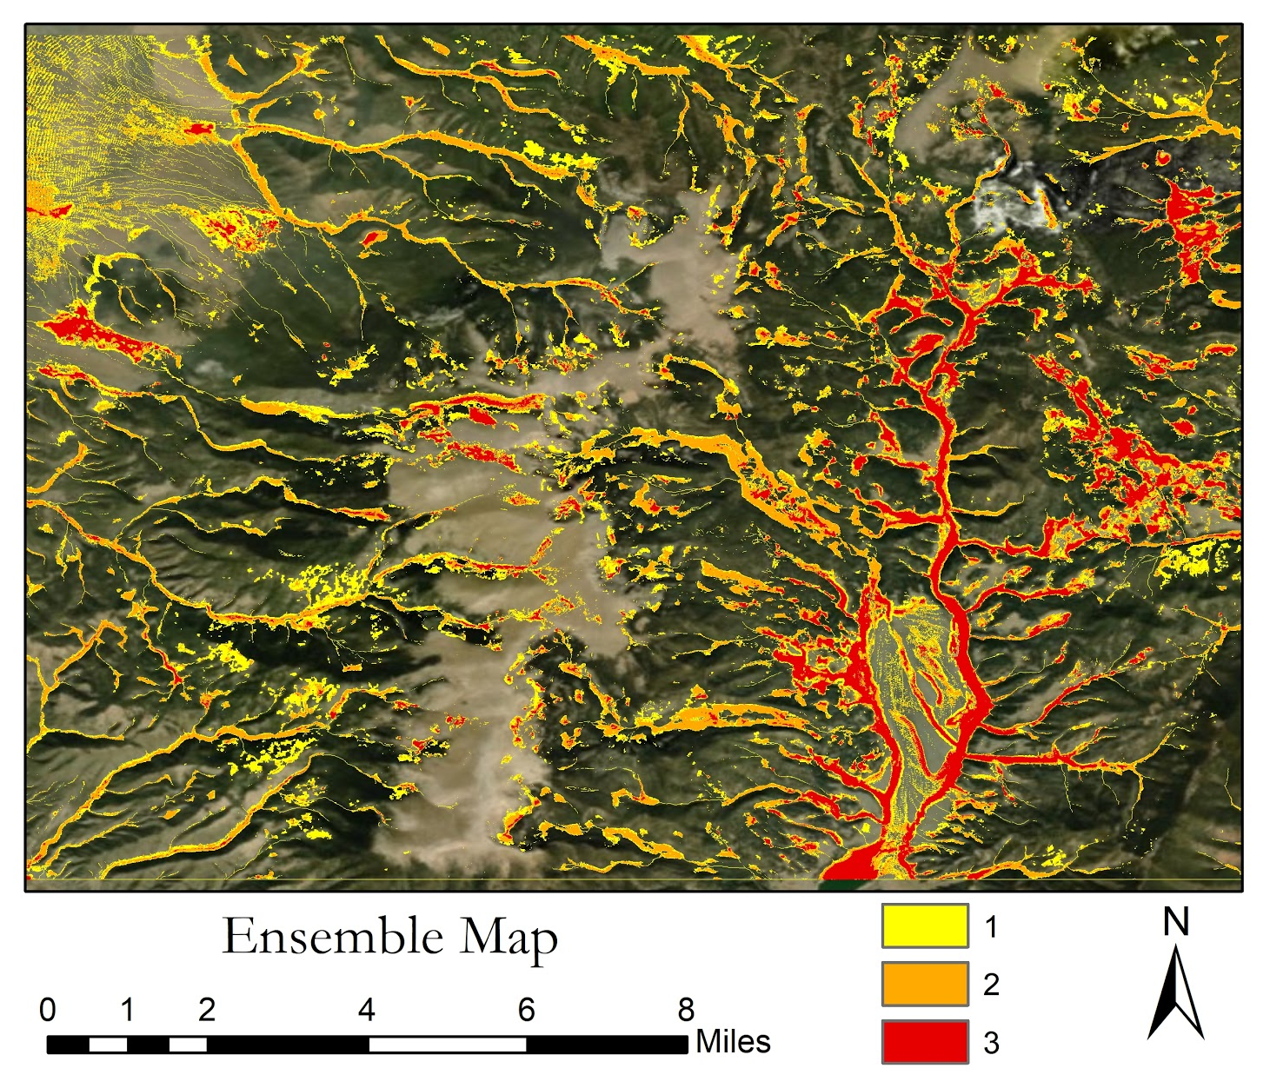
Figure 11. Aggregated values across three threshold maps (Palustrine Model 60%, Stream and Wetland Connectivity Model 70%, High Sensitivity Model 70%). Areas of presence in all three maps have a value of 3 and appear in red in this ensemble map. Areas of presence in only 1 or 2 of the individual threshold maps have a value of 1 or 2, respectively, in this ensemble map.

Finally, the team created a polygon layer of probable wetlands for the partners (Figure 12). These polygons were created following the methods described in section 3.3. The team was able to classify some polygons by wetland type based on intersecting NWI or St. Mary’s data, but many polygons in the Colorado portion of the study area, especially near the headwaters of the East Fork Costilla Creek, are unclassified. These unclassified polygons represent new potential areas where wetlands may exist beyond those locations identified in the pre-existing datasets. For the Colorado side of the study area, this polygon layer can serve mainly as an estimate of palustrine wetland locations but may be supplemented by any of the other maps discussed above for the three unique models to visualize other potential wetland locations, including additional riverine wetlands that do not appear in the Palustrine model. As described in section 3.3, these polygons also offer an attribute table of wetland characteristics, which may prove useful for project partners when they are investigating the potential areas for future restoration or RGCT reintroduction work.

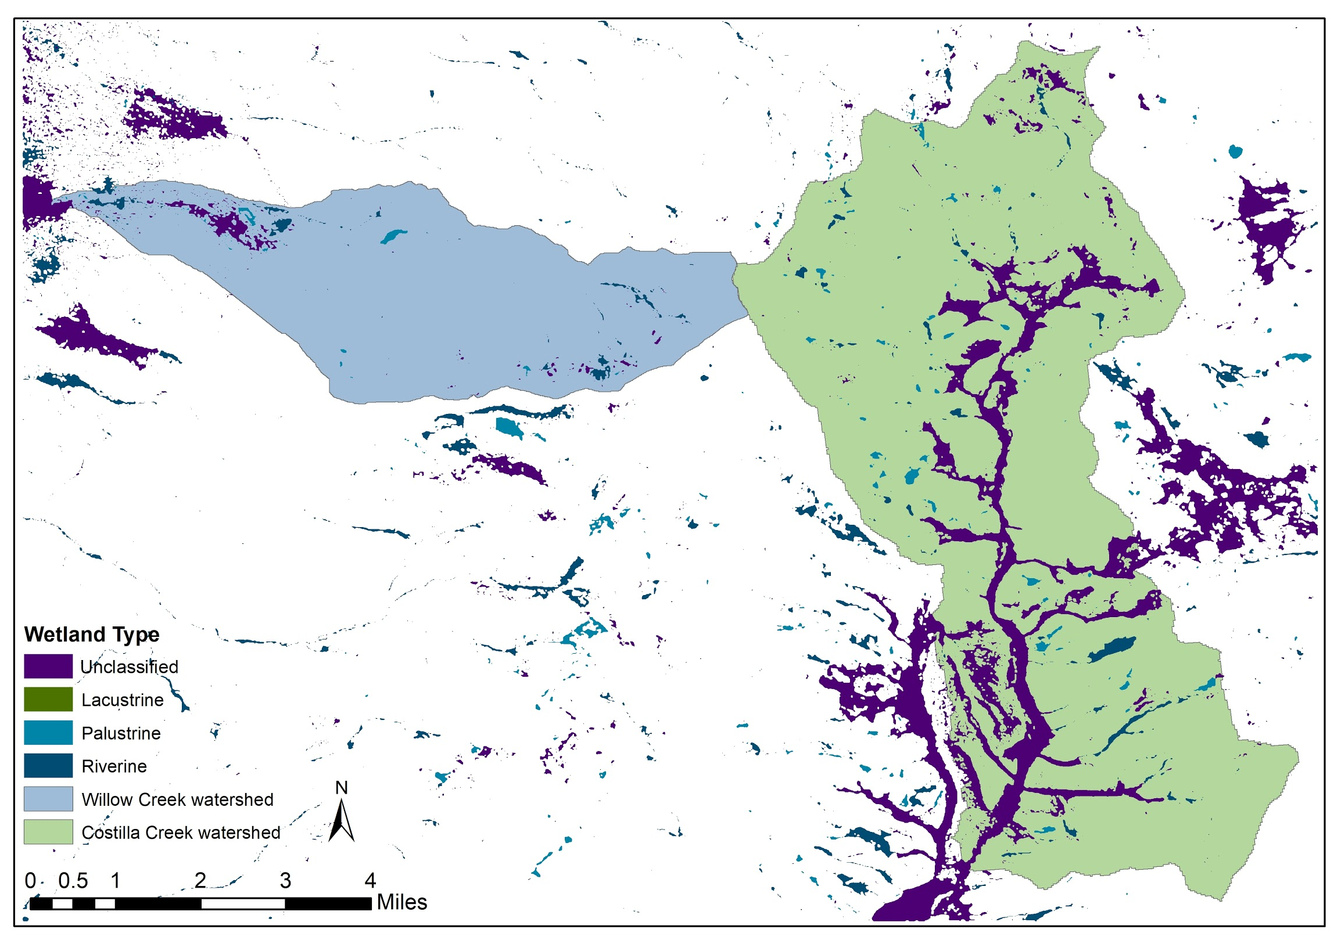
Figure 12. Wetland polygons derived from the Palustrine model probability map and their attributes, derived from intersecting NWI data.

4.1.2 Limitations
A major limitation of this study was the lack of representative training data in high elevation areas. These areas were the priority to the partners because there is less known about these watersheds at the headwaters and the high elevation sections are difficult to access by foot. Therefore, there were few training points for the model in the areas the team wanted to map most. The team could not access the area in order to ground-truth either the existing training points or the model itself. Due to the resolution of imagery available (10 m), it was difficult to map smaller wetlands using the spectral indices. The team also had difficulty mapping wetlands that are covered by vegetation year-round. Most riverine training points fell in forested areas where the spectral signature is similar to other forested areas without wetlands. The topographic indices aided with mapping riverine wetlands; however, finer resolution spectral indices would allow for more precise mapping of all wetland types. In addition, the availability of a larger temporal range of spectral data would allow for increased precision in our models. The Sentinel-2 surface reflectance data were available for only 2019. The Landsat 8 surface reflectance data were available for 2016 to 2019, but its utility was limited by the lower spatial resolution of 30 m. With more years of data from Sentinel-2, the team would be able to better define wetland types with regards to the hydrologic variability within and between years.

4.1.3 Future Work
Future analyses should focus on including further classification of wetlands and quantifying different characteristics of those wetlands. Wetland classification by type, habitat suitability, or surrounding vegetation and shading would be very useful for the partners, but were not feasible to complete during this project. Additionally, characterizing the interannual variability of the wetlands would be useful to understand the extent and suitability of RGCT habitat, even in dry years.

5. Conclusions
Our results produced high probability predictions of wetland locations in areas of the Costilla Creek and Willow Creek watersheds that had not been previously mapped. By shedding light on previously unknown wetland locations in the upper headwaters of these watersheds, this project may add new areas to the list of potential restoration efforts by partners. This may ultimately aid in the conservation of the RGCT and add habitat miles for the subspecies in this important conservation area.

Through this project, the team discovered some important techniques to accurately map wetlands from remotely sensed imagery. The variables of the highest importance in wetland modeling for this location were consistently Tasseled Cap Greenness from Sentinel-2 imagery in August 2019 and the topographic dissection variable with a circular radius of 16. This indicates that topography plays an important role in the locations of wetlands and should be well represented in predictor variables for future studies. Also, the unique green-up of wetlands in the late summer months is a useful spectral signature for mapping wetlands. Lastly, it was determined that it is very important to spend time creating well-thought-out training points to improve model results; the training point distribution should be spread evenly across the study area, with a balance of both presence and absence points.

The team was able to deliver multiple maps from three unique wetland models to the project partners. The models include a Palustrine model that offers a high probability of wetland presence, focused on the Palustrine type wetlands; a Stream and Wetland Connectivity model that offers a view of smaller drainages across the study area that may contain riverine wetlands, in addition to the spread of Palustrine wetlands; and a High Sensitivity model which focuses on high probability areas of both Palustrine wetlands not included in the other models as well as offering some stream connectivity and riverine wetland areas. Each of these maps had set thresholds at different levels, which may be useful to the project partners at different steps in their field investigations. Lastly, an ensemble map of all three models combined may prove especially useful to the project partners because it allows for an overall understanding of the wetlands in the study area, by highlighting the strengths of all three models. These products will support partners in identifying, protecting, and restoring viable trout habitat in these areas more efficiently.

6. Acknowledgments

This research would not have been possible without our science advisors, Tony Vorster, Peder Engelstad, Dr. Paul Evangelista, and Nicholas Young from Colorado State University (NREL). We also thank Dr. Catherine Jarnevich from USGS for her expertise in modeling with SAHM, and we thank Kristen Dennis from NASA DEVELOP for her support and guidance throughout this research. We are grateful to have collaborated with our project partners Sara Holm, Trey Chancellor, and Les Dhaseleer from Vermejo Park Ranch, and Estevan Vigil from CPW.

This material contains modified Copernicus Sentinel data (2019), processed by ESA.

Any opinions, findings, and conclusions or recommendations expressed in this material are those of the author(s) and do not necessarily reflect the views of the National Aeronautics and Space Administration.

This material is based upon work supported by NASA through contract NNL16AA05C.

7. Glossary

Arc-second – A measure of distance of latitude or longitude along the earth; at the equator, an arc-second of longitude approximately equals an arc-second of latitude, which is 1/60th of a nautical mile (or 101.27 feet or 30.87 meters).
Earth observations – Satellites and sensors that collect information about the Earth’s physical, chemical, and biological systems over space and time.
Riffles – A flow structure in a stream as water moves over a shallow portion.

8. References
Amy, W., Cook, C., Rickel, B., & Triepke, J. (2012). Santa Fe National Forest management indicator species assessment. United States Forest Service.
Anthropology Analytical Cartography Lab. (2011, December 17). Compound Topographic Index. Retrieved March 5, 2020, from https://wikispaces.psu.edu/display/AnthSpace/Compound Topographic Index
Baig, M. H. A., Zhang, L., Shuai, T., & Tong, Q. (2014). Derivation of a tasselled cap transformation based on Landsat 8 at-satellite reflectance. Remote Sensing Letters, 5(5), 423–431. https://doi.org/10.1080/2150704X.2014.915434
Bakevich, B., Paggen, R., & Felt, B. (2016). Range-Wide Status of Rio Grande Cutthroat Trout (Oncorhynchus clarkii virginalis): 2016. Colorado Parks & Wildlife.
Chignell, S. M., Luizza, M. W., Skach, S., Young, N. E., & Evangelista, P. H. (2017). An integrative modeling approach to mapping wetlands and riparian areas in a heterogeneous Rocky Mountain watershed. Remote Sensing in Ecology and Conservation, 4(2), 150–165. doi: 10.1002/rse2.63
Evans, J., Oakleaf J., Cushman, S., & Theobald, D. (2014). An ArcGIS Toolbox for Surface Gradient and Geomorphometric Modeling, version 2.0-0. Accessed 3 February 3, 2020 from http://eva nsmurphy.wix.com/evansspatial.
European Space Agency. (2000) Sentinel Online. Retrieved February 18, 2020, from https://sentinel.esa.int/web/sentinel/user-guides
Freeman, E.A. & Moisen, G. (2008). A comparison of the performance of threshold criteria for binary classification in terms of predicted prevalence and kappa. Ecological Modeling, 217, 48-58.
FSE Documents. (n.d.). Retrieved January 30, 2020, from https://www.fs.usda.gov/Internet/FSE_DOCUMENTS/fseprd534344.pdf
Iverson, L. R., & Prasad, A. M. (2003). A GIS-Derived Integrated Moisture Index. Characteristics of Mixed-Oak Forest Ecosystems in Southern Ohio Prior to the Reintroduction of Fire -- GTR NE-299, 29–41. doi: 10.2737/NE-GTR-299
Lee, R. & Roberti, J. (2018). RNRCS: Download NRCS Data. R package version 0.2.5. https://CRAN.R-project.org/package=RNRCS
Machtinger, E.T., & Boyer, K. (2007). Cutthroat trout (Oncorhynchus clarki) Fish and wildlife habitat management leaflet. Washington, DC: Natural Resources Conservation Service and Wildlife Habitat Council. Retrieved from https://www.nrcs.usda.gov/Internet/FSE_DOCUMENTS/nrcs143_010039.pdf
Mahdianpari, M., Salehi, B., Mohammadimanesh, F., Homayouni, S., & Gill, E. (2018). The first wetland inventory map of Newfoundland at a spatial resolution of 10 m using Sentinel-1 and Sentinel-2 data on the Google Earth Engine cloud computing platform. Remote Sensing, 11(43), 1–27. doi: 10.3390/rs11010043
Morisette, J. T., Jarnevich, C. S., Holcombe, T. R., Talbert, C. B., Ignizio, D., Talbert, M. K., Silva, C., Koop, D., Swanson, A., & Young, N. E. (2013). VisTrails SAHM: Visualization and workflow management for species habitat modeling. Ecography, 36(2), 129–135. https://doi.org/10.1111/j.1600-0587.2012.07815.x
Nedkov, R. (2017). Orthogonal transformation of segmented images from the satellite Sentinel-2. Comptes Rendus de l’Academie Bulgare des Sciences: Sciences Mathematiques et Naturelles, 70(5), 687-692
Netmap. (2014). Topographic Roughness. Retrieved March 5, 2020, from http://www.netmaptools.org/Pages/NetMapHelp/topographic_roughness.htm
New Mexico Game and Fish. (n.d.). Wildlife notes - Rio Grande Cutthroat Trout. Wildlife Notes - Rio Grande Cutthroat Trout. Retrieved from http://www.wildlife.state.nm.us/download/education/conservation/wildlife-notes/aquatic/Rio-Grande-cutthroat-trout.pdf
Pritchard, V. L., & Cowley, D. E. (2006). Rio Grande cutthroat trout (Oncorhynchus clarki virginalis): A technical conservation assessment. USDA Forest Service: Rocky Mountain Region.
Rio Grande Cutthroat Trout Conservation Team (2013). Rio Grande cutthroat trout (Oncorhynchus clarkii virginalis) conservation strategy. Colorado Parks and Wildlife: Denver, CO. Retrieved from https://cpw.state.co.us/Documents/Research/Aquatic/CutthroatTrout/2013RGCTConservationStrategy.pdf
Robertson, A. G., Stark, K.J., Anderson, J. C., Maffitt, B. L., Rokus, D. D., & Hutchins, H.H. (2015). Mapping and classification for wetlands protection: Northeastern New Mexico Highlands and Plains. Saint Mary’s University of Minnesota: Winona, Minnesota.
Stewart, I., Cayan, D., & Dettinger, M. (2004). Changes in snowmelt runoff timing in western North America under a ‘business as usual’ climate change scenario. Climatic Change, 1, 8–9.
Townsend, A., & Walsh, Stephen J. (2001). Remote sensing of forested wetlands: Application of multitemporal and multispectral satellite imagery to determine plant community composition and structure in southeastern USA. Plant Ecology, 157, 129-149.
United States Fish & Wildlife Service. (2013, June) Candidate conservation agreement with assurances for the Rio Grande Cutthroat (Oncorhynchus clarki virginalis). Candidate Conservation agreement with Assurances.
United States Fish and Wildlife Service. (n.d.). National Wetlands Inventory website. U.S. Department of the Interior, Fish and Wildlife Service, Washington, D.C. http://www.fws.gov/wetlands/
United States Geologic Survey. (n.d). Landsat Surface Reflectance-Derived Spectral Indices. Retrieved March 5, 2020, from https://www.usgs.gov/land-resources/nli/landsat/landsat-surface-reflectance-derived-spectral-indices?qt-science_support_page_related_con=0#qt-science_support_page_related_con
Vermejo Conservation and Wildlife. (2020, January 23). Retrieved February 19, 2020, from https://tedturnerreserves.com/vermejo/
Vigil, Estevan (2018). 2018 Fisheries Inventory Report, Rio Grande Basin. Colorado Parks and Wildlife: Monte Vista, CO.
Whyte, A., Ferentinos, K. P., & Petropoulos, G. P. (2018). A new synergistic approach for monitoring wetlands using Sentinels -1 and 2 data with object-based machine learning algorithms. Environmental Modelling & Software, 104, 40–54. doi: 10.1016/j.envsoft.2018.01.023
Wright, C., & Gallant, A. (2007). Improved wetland remote sensing in Yellowstone National Park using classification trees to combine TM imagery and ancillary environmental data. Remote Sensing of Environment, 107(4), 582–605. doi: 10.1016/j.rse.2006.10.019
Young, N., Anderson, R., Chignell, S., Vorster, A., Lawrence, R., & Evangelista, P. (2017). A survival guide to Landsat preprocessing. Ecology, 98(4), 920-932.

9. Appendices
Appendix A:
Tasseled Cap Coefficients for Landsat 8 and Sentinel 2 Surface Reflectance Imagery
Table A1
The Landsat 8 Tasseled Cap Band coefficients are used in the linear transformation of the bands to the tasseled cap indices (Baig et al., 2014).
Landsat 8 Tasseled Cap Surface Reflectance Band Coefficients
Component | Band 1 | Band 2 | Band 3 | Band 4 | Band 5 | Band 7
Brightness | 0.3037 | 0.2793 | 0.4343 | 0.5585 | 0.5082 | 0.1863
Greenness | -0.2848 | -0.2435 | -0.5436 | 0.7243 | 0.0840 | -0.1800
Wetness | 0.1509 | 0.1793 | 0.3299 | 0.3406 | -0.7112 | -0.4572

Table A2
The Sentinel-2 MSI Tasseled Cap Band coefficients are used in the linear transformation of the bands to the tasseled cap indices (Nedkov, 2017).
Sentinel-2 MSI Tasseled Cap Surface Reflectance Band Coefficients
Component | B2 | B3 | B4 | B5 | B6 | B7 | B8 | B8A | B11 | B12
Brightness | 0.0822 | 0.1360 | 0.2611 | 0.2964 | 0.3338 | 0.3877 | 0.3895 | 0.4750 | 0.3882 | 0.1366
Greenness | -0.1128 | -0.1680 | -0.3480 | -0.3303 | 0.0852 | 0.3302 | 0.3165 | 0.3625 | -0.4578 | -0.4064
Wetness | 0.1363 | 0.2802 | 0.3072 | 0.5288 | 0.1379 | -0.0001 | -0.0807 | -0.1389 | -0.4064 | -0.5602

Appendix B: Additional predictor variable information

Table B1
The aggregated images created to highlight seasonal variability in wetland versus upland spectral signatures.
Satellite | Aggregate Statistics | Images used
Sentinel-1 | VV median, mean | All images
Sentinel-1 | VH median, mean | All images
Sentinel-1 | CR median | All images
Sentinel-2 | Maximum: TC Greenness, NDVI, EVI | August/Sept
Sentinel-2 | Difference: NMBDI, MNDWI, EVI | September minus October

Table B2
The ArcGIS toolboxes used to calculate unique topographic indices for wetland modeling, and the meaning of each variable.
Toolbox | Tool | Definition
Spatial Analyst | Slope | Identify the gradient of each raster cell
Hydrology | Flow Accumulation | Accumulated flows in each raster cell, based on all cells flowing into that cell
Hydrology | Flow Direction | Flow direction in relation to downslope neighbor
Hydrology | Sink | Identify areas of pooling or small landscape depressions
Geomorphometry and Gradients Metrics (Evans et al., 2014) | Roughness | Determine terrain complexity by assigning a cell the average elevation of neighboring cells (Topographic Roughness, 2014 and Chignell et al. 2018)
Geomorphometry and Gradients Metrics (Evans et al., 2014) | Dissection | Elevation of a cell in relation to all cells within the window radius; shows ridges and depressions (Chignell et al. 2018)
Geomorphometry and Gradients Metrics (Evans et al., 2014) | Compound Topographic Index | Uses upslope area, slope, and aspect to represent the sizes of catchments and gradients of slopes (Compound Topographic Index 2011)
Geomorphometry and Gradients Metrics (Evans et al., 2014) | Integrated Moisture Index | Uses slope, aspect, downslope flow, and landscape curvature to estimate soil moisture (Iverson & Prasad, 2003)

Appendix C: Model Trials Information and Variable Importance

Table C1
Model Trials Table; useful information regarding the modeling process. Includes notes on training points used, inclusion of Riverine, Palustrine, and/or Lacustrine Wetlands (RPL), and notes on each model run*.
ID | Training Points | RPL | Study Area | AUC Metrics | Notes
008 | TrainingPts_v4 | PL | CO NM | RF Model  Training Split: 0.977  Cross Validation: 0.981 | Best calibration plots so far. This was the first use of absence points rather than SAHM generated background points.
009 | TrainingPts_v4 | PL | AOI_NHiE_84 | MARS Model  Training Split: 0.99  Cross Validation: 0.955 | Study area has all of Colorado and some of New Mexico. Excludes Costilla Reservoir and the far northeast corner of willow creek. The purpose was to get more of the upper elevations to see if it worked better for wetland prediction on Colorado side. Seemed to overfit the model; calibration plots very funky, even though the AUC metrics are high.
010 | TrainingPts_v5 | PL | AOI_MHiE_84 | BRT Model  Training Split: 0.998  Cross Validation: 0.972  RF Model  Training Split: 0.981  Cross Validation: 0.977 | Interpretation of calibration plots MARS- good if you are interested in low values. GLM- good if you are interested in the high values, however, the AUC is unrealistic. RF-bad; calibration plot very funky. BRT-good medium between high and low values.
011 | TrainingPts_v5 | PL | CO NM | BRT Model  Training Split: 0.982  Cross Validation: 0.964  RF Model  Training Split: 0.974  Cross Validation: 0.975 | Purpose of this model is to directly compare study area size with 010; used same predictor variables. Full CO NM study area seems to work better because we lose a lot of training data with smaller study area.
012 | TrainingPts_v5 | PL | CO NM | RF Model  Training Split: 0.978  Cross Validation: 0.975 | Threw in all covariates, excluding LS8 (low resolution). Different covariates from 011 and 010. First time that TC G, B, and W all made it. Balanced training points help with model calibration and visualization.
017 | TrainingPts_v5 | RPL | CO NM | RF Model  Training Split: 0.902  Cross Validation: 0.905 | Lower AUC than 012 but looks pretty good! Added Riverine training points.
018 | TrainingPts_v4_R | R | CO NM | GLM Model  Training Split: 0.901  Cross Validation: 0.897  RF Model  Training Split: 0.888  Cross Validation: 0.884 | This model is just using Riverine training points, rather than all 3 wetland types.  Selected spatial split for the Cross validation in SAHM. Did not seem to improve upon 017.
020 | TraininPts_v7_QC | RPL | CO NM | GLM Model  Training Split: 0.929  Cross Validation: 0.885  BRT Model  Training Split: 0.908  Cross Validation: 0.852 | Seems to be an improvement on 017, 018, and 019. This is a new version of training points which is balanced between Riverine/Palustrine, as well as Presence/Absence. It is also 100% QA/QC checked.
*Not all model runs are included here, only the runs that helped shape the final model.

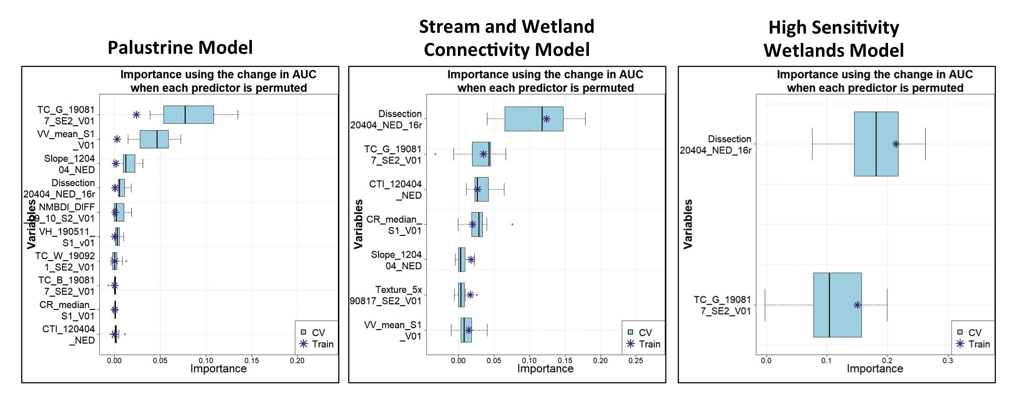
Figure C1. Variable importance plots for the three final models, output from SAHM. Variables are listed in order of importance in Table 3.

