The human forest:
Volatile chemical products enhance urban ozone

Authors: M.M. Coggon^{1,2,*}, G.I. Gkatzelis^{1,2}, B.C. McDonald², J.B. Gilman², N. Abuhassan³, K.C. Aikin^{1,2}, M. Arend ^{4,5}, T. Berkoff ⁶, T. Campos⁷, G. Gronoff ⁶, J. Hurley⁸, G. Isaacman-VanWertz⁸, A.R. Koss⁹, M. Li^{1,2}, S. McKeen^{1,2}, F. Moshary^{4,5}, J. Peischl^{1,2}, V. Pospisilova⁹, Y. Wu ^{4,5}, M. Trainer², C. Warneke^{1,2}

Affiliations:
1. Cooperative Institute for Research in Environmental Sciences, University of Colorado Boulder, Boulder, CO, USA
2. NOAA Chemical Sciences Laboratory, Boulder, CO, USA
3. Joint Center for Earth Systems Technology, University of Maryland Baltimore County, Baltimore, MD, USA
4. NOAA Cooperative Science Center for Earth System Sciences and Remote Sensing Technologies, The City College of New York.
5. Department of Electrical Engineering, The City College of New York, New York, NY, USA
6. Langley Research Center, National Space and Aeronautical Administration, Hampton, VA, USA.
7. Atmospheric Chemistry Observations and Modeling Laboratory, National Center for Atmospheric Research, Boulder, CO, USA
8. Department of Civil and Environmental Engineering, Virginia Polytechnic Institute and State University, Blacksburg, VA, USA
9. Tofwerk AG, Thun, Switzerland

*Correspondence: matthew.m.coggon@noaa.gov

Summary Paragraph: After decades of improving air quality through regulation of motor vehicles, volatile chemical products (VCPs) are now responsible for half of the petrochemical volatile organic compounds (VOCs) emitted in major urban areas. We show that VCP emissions are ubiquitous in US and European cities and scale with urban population density. We report significant VCP emissions for New York City (NYC), including an anthropogenic monoterpene flux (520–860 mg/person/day) from fragranced VCPs comparable to that of a summertime forest. During an extreme heat event, VCPs were responsible for more than 30% of the ozone produced downwind of NYC from anthropogenic sources. Ethanol and fragrances account for over 25% of the VCP-associated ozone. Ozone production was VOC-sensitive within 40 km of NYC, and reductions in anthropogenic VOC emissions would significantly reduce local ozone exceedances. NYC is a proxy for developed megacities, and the impacts of VCPs on ozone pollution may be similar for other major urban regions in the US or Europe.

Main Text:

Regulations of motor vehicle emissions have resulted in decades of declining mixing ratios of nitrogen oxides (NO_{x})^{1,2} and volatile organic compounds (VOCs) ³ in US urban areas, which has significantly reduced tropospheric ozone pollution. Despite revisions to US National Ambient Air Quality Standards (NAAQS) and continued efforts to decrease NO_{x} and VOC emissions from motor vehicles, reductions in ozone pollution have slowed in recent years. This slowdown has been partially attributed to changes in the distribution of urban emissions, which has shifted away from the dominance of combustion sources towards a pollution mixture that includes non-combustion sources^{2,4}.

Recent work in Los Angeles, CA has shown that emissions from consumer and industrial products (collectively “volatile chemical products”, VCPs) now contribute as much as 50% to total petrochemical VOC emissions, which includes fossil fuels ⁴. In smaller cities, consumer product usage has been shown to be a significant source of urban VOCs, as evidenced by emissions of the personal care product tracer decamethylcyclopentasiloxane (D5-siloxane)⁵. We show that VCP emissions are ubiquitous in urban environments and that associated VOC emission fluxes can outweigh biogenic and fossil fuel sources, depending on urban population density. We show that VCPs contribute substantially to urban ozone formation, and that anthropogenic VOC reduction along with NO_{x} controls may be a complementary strategy to further improve air quality.

VCP emissions are observed in cities across the US and Europe and depend on population density

Most human activity, including VCP consumption, scales with population density ⁶. Transportation emissions also increase with population ⁷, but are expected to plateau in large cities due to roadway restrictions on vehicle volume ⁸. Consequently, VCP emissions are expected to increase relative to traffic emissions in more densely populated regions. To evaluate the relationship between VCPs, traffic emissions, and urban population, we measured VOCs from a mobile laboratory in US and European cities (see Methods for details) using proton-transfer-reaction mass spectrometers (PTR-ToF-MS) and a whole air sampling system. We also measured VOCs in New York City (NYC) from a ground site located at the City College of New York (CCNY) during winter (March 5–28, 2018) and summer (July 5–24, 2018) to quantify VCP impacts on the air quality of the most densely populated region of the US.

Figure 1A shows the spatial distribution of D5-siloxane across the US and Europe. D5-siloxane is primarily emitted to the atmosphere from antiperspirants and hair care products ^{5,9} and is used as a tracer for emissions from personal care products. D5-siloxane is ubiquitous throughout urban areas, highest in populated regions, and generally correlates with population density (e.g. NYC, R² = 0.7, Fig. 2). In Fig. 1B, we show urban enhancement ratios of D5-siloxane relative to benzene, a marker for traffic emissions. We calculate urban enhancement ratios (ER) for cities sampled during morning hours (dark blue, Fig. 1A) when the emissions of D5-siloxane are expected to be highest ⁵ (see Methods for more details). The ERs for D5-siloxane strongly correlate with population density, which supports the inference that VCP emissions will increase relative to traffic in densely populated regions. Other VOCs also exhibited this behavior, including ethanol and monoterpenes. Ethanol was the most abundant VOC measured in urban regions (e.g. 15 ppb in NYC) and was strongly correlated with population density (R² = 0.80). Ethanol was previously considered a traffic emission¹⁰ and was only recently linked to emissions from VCPs⁴. Monoterpenes are predominantly emitted from biogenic sources during summer months ¹¹; however, in the following sections, we show that emissions from fragranced VCPs are a major source of monoterpenes in urban areas. In contrast to the species described above, aromatic compounds that are co-emitted with benzene from gasoline correlated poorly with population density (R² < 0.11, Fig. S31).

Figure 1 demonstrates that VCP emissions impact the VOC burden of cities across the US and Europe, but are most prevalent in dense megacities such as NYC. In the following section, we quantify VOC fluxes in NYC, with a focus on understanding emissions of anthropogenic monoterpenes.

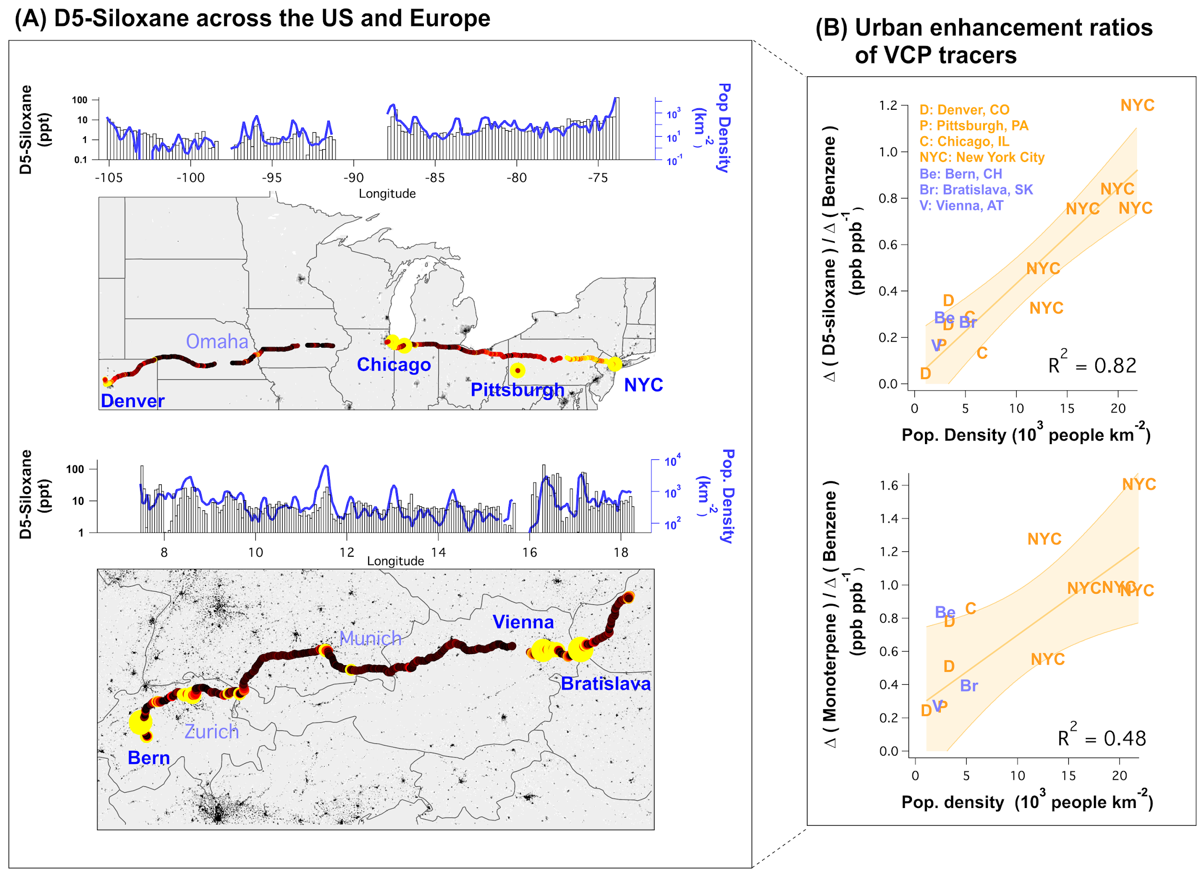
Fig. 1. (A) Drive track colored by D5-siloxane measured across the US and Europe. The distributions above each map show the median mixing ratios of D5-siloxane over longitudinal bins together with the population density within 5 km of the mobile laboratory. (B) Relationship between D5-siloxane and monoterpene enhancement ratios to benzene (gasoline tracer) with population density for US (orange) and European (blue) cities. The cities presented were sampled during morning hours in densely populated urban centers. For NYC, the data were separated into areas of high, low, and medium population density (see Methods section). Error bands represent the 95% confidence interval.

High anthropogenic monoterpene emissions in New York City indicate significant VCP use

A wide variety of VOCs are emitted from VCP sources. Fragranced VCPs have been studied for their air quality impacts on ozone and secondary organic aerosol (SOA) formation ¹²⁻¹⁵. Measurements of indoor air and consumer product headspaces have shown that monoterpenes, especially limonene, are ubiquitous in fragranced VCPs ^{13,15}. Anthropogenic monoterpenes have been observed previously in urban air, but were attributed to residential wood burning or vehicle exhaust ¹⁶. Anthropogenic monoterpenes from VCP emissions have not been reported in outdoor air and no studies have compared the speciation of ambient anthropogenic monoterpenes with those observed from fragranced VCPs.

To evaluate the source of anthropogenic monoterpenes in NYC, we compared spatial profiles of fossil fuel and combustion tracers (benzene and CO) and VCP tracers (D5-siloxane) to the profiles observed for urban monoterpenes. Mobile laboratory measurements in greater metropolitan NYC show that motor vehicle and combustion emissions are ubiquitous throughout the region (Fig. S30). Figure 2A shows that D5-siloxane is primarily enhanced in densely populated areas around Manhattan, and is well-correlated with population density (R² > 0.7). The elevated D5-siloxane mixing ratios and correlation to population density indicate significant use of VCPs.

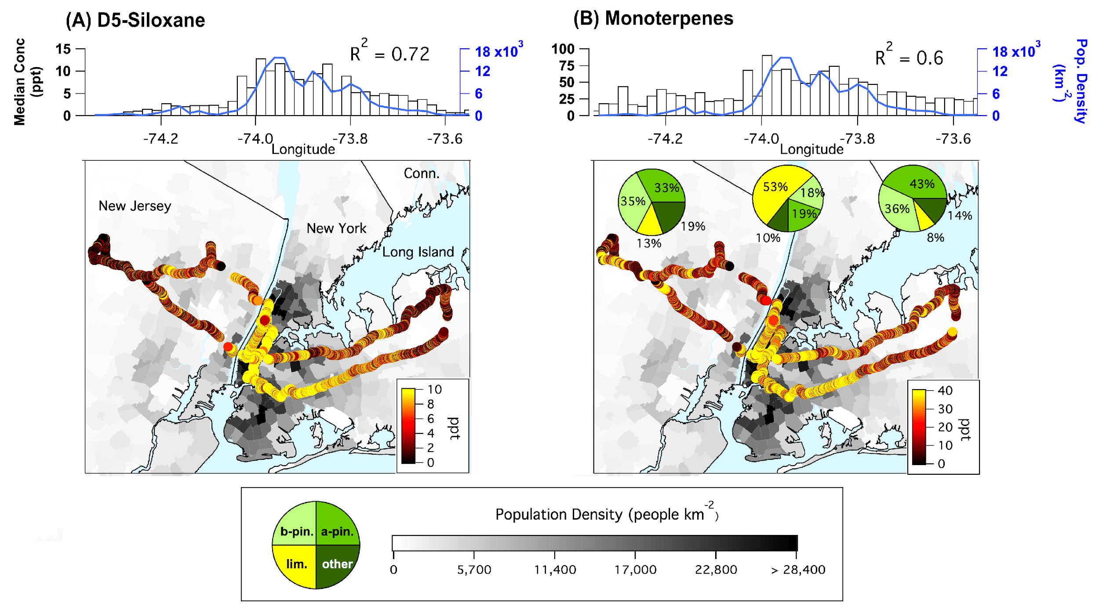
Fig. 2. March 2018 drive tracks colored by (A) D5-siloxane (personal care product tracer) and (B) sum of monoterpenes (biogenic + fragrances) measured by PTR-ToF-MS in winter 2018. Drive tracks overlay a population density map of the NYC region. Pie charts show the composition of monoterpenes measured in (left-to-right) New Jersey, Manhattan, and Long Island. The distributions above each map show longitudinally-binned median mixing ratios of D5-siloxane and monoterpenes, and population density.

Significant monoterpene mixing ratios were observed in populated regions of NYC during wintertime sampling (Fig. 2B) when biogenic monoterpene emissions are expected to be lowest ¹¹. Monoterpenes were highest in downtown NYC and coincident with enhancements in D5-siloxane. Measurements by gas chromatography-mass spectrometry (GC-MS) show that limonene was the dominant monoterpene isomer measured in Manhattan, which is consistent with measurements of consumer product headspaces (Fig. S26) and indoor environments (Fig. S27). In contrast, α- and β-pinene were the dominant isomers in forested areas, consistent with pine species common to northern New Jersey¹⁷ (Fig. S28).

In winter, monoterpenes were correlated with CO during air pollution episodes (R² = 0.7, Fig. S5), which is likely explained by the mixing of VCPs and combustion source emissions over coincident spatial and temporal scales ⁵. We use this correlation and a validated CO emissions inventory for Manhattan to estimate that monoterpenes were emitted a rate of 520–860 mg person⁻¹ d⁻¹ (details in Supplementary Methods). We also estimate an inventory of anthropogenic monoterpene emissions from first principles, and consider emissions from VCPs, cooking spices, citrus consumption, and building materials (see Supplementary Discussion). The two largest sources of monoterpenes are VCPs (~220 mg person⁻¹ d⁻¹) and building materials (~240 mg person⁻¹ d⁻¹) with smaller contributions from spices (< 10 mg person⁻¹ d⁻¹) and citrus consumption (~60 mg person⁻¹ d⁻¹). VCPs are the main source of limonene while building materials are likely the main source of α- and β-pinene in the city center.

The monoterpene emission rate estimated for Manhattan is significant when compared to biogenic monoterpene emissions expected for a typical US forest. For example, summertime monoterpene emissions in a dense southeast US forest are 0.40–0.68 kg hr⁻¹ km⁻², or 580–980 kg d⁻¹ when distributed over an area the size of Manhattan ¹¹. Anthropogenic monoterpene fluxes for Manhattan, 884–1462 kg d⁻¹, are comparable to this natural source.

The significant flux of anthropogenic monoterpenes emphasizes the emissions strength of VCPs in NYC. To quantify other VOC fluxes, we estimate total petrochemical emissions from VCPs, motor vehicles, and other fossil fuel sources following McDonald et al. ⁴ (see Supplementary Methods for details). The speciated VOC emissions are divided by CO emissions (Fig. S9) and verified with ambient VOC/CO ground site measurements from PTR-ToF-MS and GC-MS (Fig. S10). The inventory used for NYC, termed FIVE-VCP, broadly explains observations of VOCs emitted from both fossil fuel and VCP sources, and demonstrates that VCP emissions represent ~60% of the petrochemical VOCs emitted in NYC.

Modeling VCP produced ozone during an exceedance in NYC

During summer 2018, NYC endured a series of heatwave events that led to numerous ozone exceedances (Fig. S10). To evaluate the extent to which VCPs contribute to these exceedances, air quality is simulated for 5 weeks (6/27 to 7/31) for the continental US, and with a nested higher-resolution simulation over the Eastern US (Fig. S12) using the Weather Research Forecasting with Chemistry (WRF-Chem) model (see Methods section for details). With WRF-Chem, we account for the impacts of anthropogenic and biogenic emissions on the spatial, temporal, and vertical variability of ground-level ozone in NYC. WRF-Chem results are shown in Fig. 3 for July 2, 2018, which was the highest ozone exceedance observed throughout the NYC area in summer 2018. We note that WRF-Chem predictions have been extensively compared to field measurements of key chemical species (isoprene, formaldehyde, NO₂, and ozone) and meteorological parameters (planetary boundary layer height, horizontal wind speed and direction, and vertical ozone structure) and describe field observations to within 10%. Details describing this analysis are provided in the Supplementary Methods.

Both the surface monitors (8-hr max = 115 ppb) and WRF-Chem model (Fig. 2C, 8-hr max = 118 ppb) show that peak ozone formed downwind of NYC reached “very unhealthy” levels according to the US air quality index (AQI). At the surface, 32 of the 39 air quality monitors located between Philadelphia, NYC, and coastal Connecticut exceeded the 70 ppb National Ambient Air Quality Standard (NAAQS) for ozone (denoted by white circles in Fig. 2C), which was also predicted by the model (36 of 39 sites). Approximately 25 of 27 million people in the region were exposed to “unhealthy” air, according to the AQI.

On July 2, ozone formed from NO_{x} + BVOCs primarily contributed to NAAQS exceedances (Fig. 2A and D). These results are consistent with previous observations that NO_{x} emissions along with BVOCs are an important contributor to regional ozone formation in the Northeast US ⁴. Regional backgrounds outside of the NYC plume result from ozone transported to NYC, which was likely produced from the chemistry of NO_{x} sources upwind of NYC. At the ozone maximum north of NYC, NO_{x} from the NYC plume reacted alongside BVOCs to enhance ozone above the regional background to 97 ppb (Fig. 2D).

When mobile source VOCs are included, ozone at this location is enhanced to 114 ppb (an increase of 17 ppb). The addition of VCP emissions pushes this exceedance further to 123 ppb (an additional increase of 9 ppb). Between NYC and the ozone maximum to the north, half of the photochemically produced ozone is attributable to the chemistry of anthropogenic VOCs (AVOCs), of which approximately one-third is due to VCP emissions. Figure 3 shows that while isoprene from natural vegetation is expected to be a dominant precursor for ozone pollution in the Eastern US ^{18,19}, AVOCs significantly contributed to the ozone exceedances downwind of NYC during the July 2 heatwave.

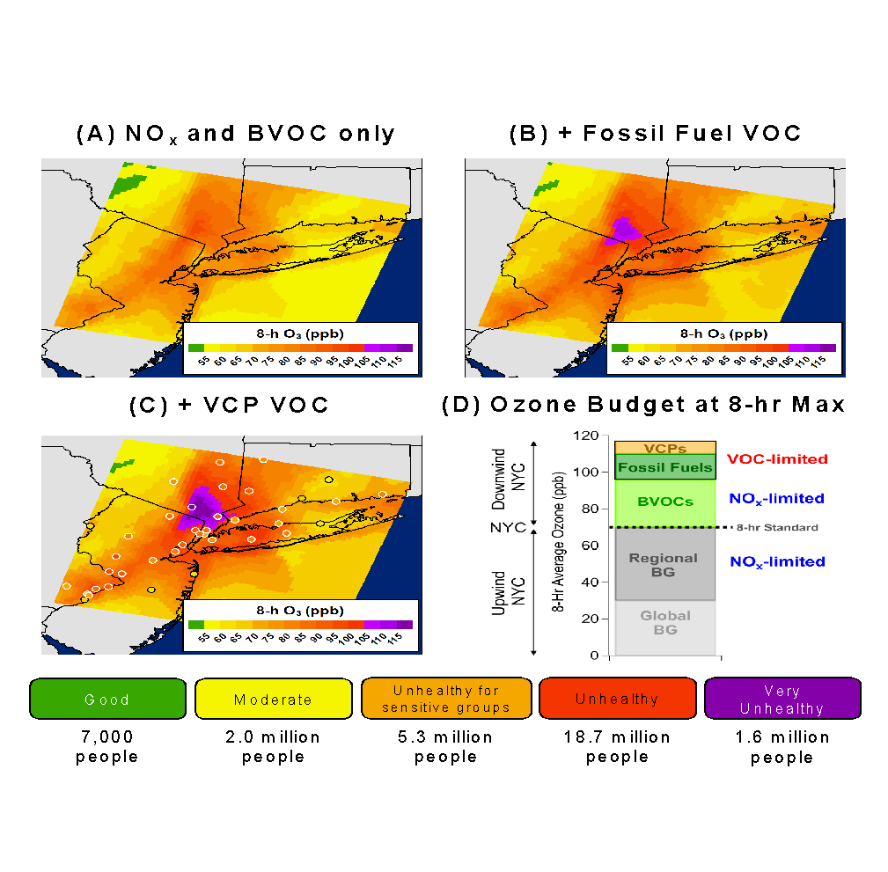

Fig. 3. WRF-Chem simulations of ozone during the July 2, 2018 pollution episode. Shown are simulations for (A) regional ozone background + NO_{x}+ BVOCs, (B) results from (A) with mobile source VOCs included, and (C) results from (B) with VOCs from VCPs added. Circles show ozone mixing ratios measured at monitoring stations in the NYC area; those bolded in white exceeded US NAAQS. The US air quality index, and the populations impacted within each index, are shown for reference. (D) Bar chart summary of ozone produced at the 8-hr ozone maximum north of NYC. Shown are the chemical regimes (NO_{X}- and VOC-limited) that dominated the ozone production for each category based on box model simulations (Fig. 5).

Attribution of ozone produced from VCPs

To complement the WRF-Chem modeling, we constructed a Lagrangian box model to further evaluate the chemical processes contributing to ozone formation downwind of NYC. The box model uses the same chemical mechanism as the WRF-Chem model, and is initialized with the emissions estimated for Manhattan. A full description of the box model and comparison to WRF-Chem simulations is provided in the Supplementary Methods. The box model predictions of total ozone and the attribution of ozone to biogenic and anthropogenic sources agree with WRF-Chem simulations to within 10%.

We evaluate the contributions of different VCP sectors to total VCP-produced ozone by conducting VOC sensitivity analyses for each of the ~1500 species in the FIVE-VCP inventory. Figure 4 shows the breakdown of total VCP-produced ozone at the 8-hr ozone maximum by VCP sector (pie chart) and chemical classification (bar chart). Personal care products (31%), adhesives (26%), coatings (22%), and cleaning products (15%) are the dominant sources of ozone associated with VCP emissions. Among all VCP emissions, monoterpenes + ethanol from personal care and cleaning products constitute the largest components of VCP-produced ozone (25%). Oxygenates, such as glycols and common solvents (acetone + MEK, the primary components of the oxygenates category), represent ~ one-third of VCP-produced ozone. The remaining fraction is attributable to aromatics, alkanes, and alkenes.

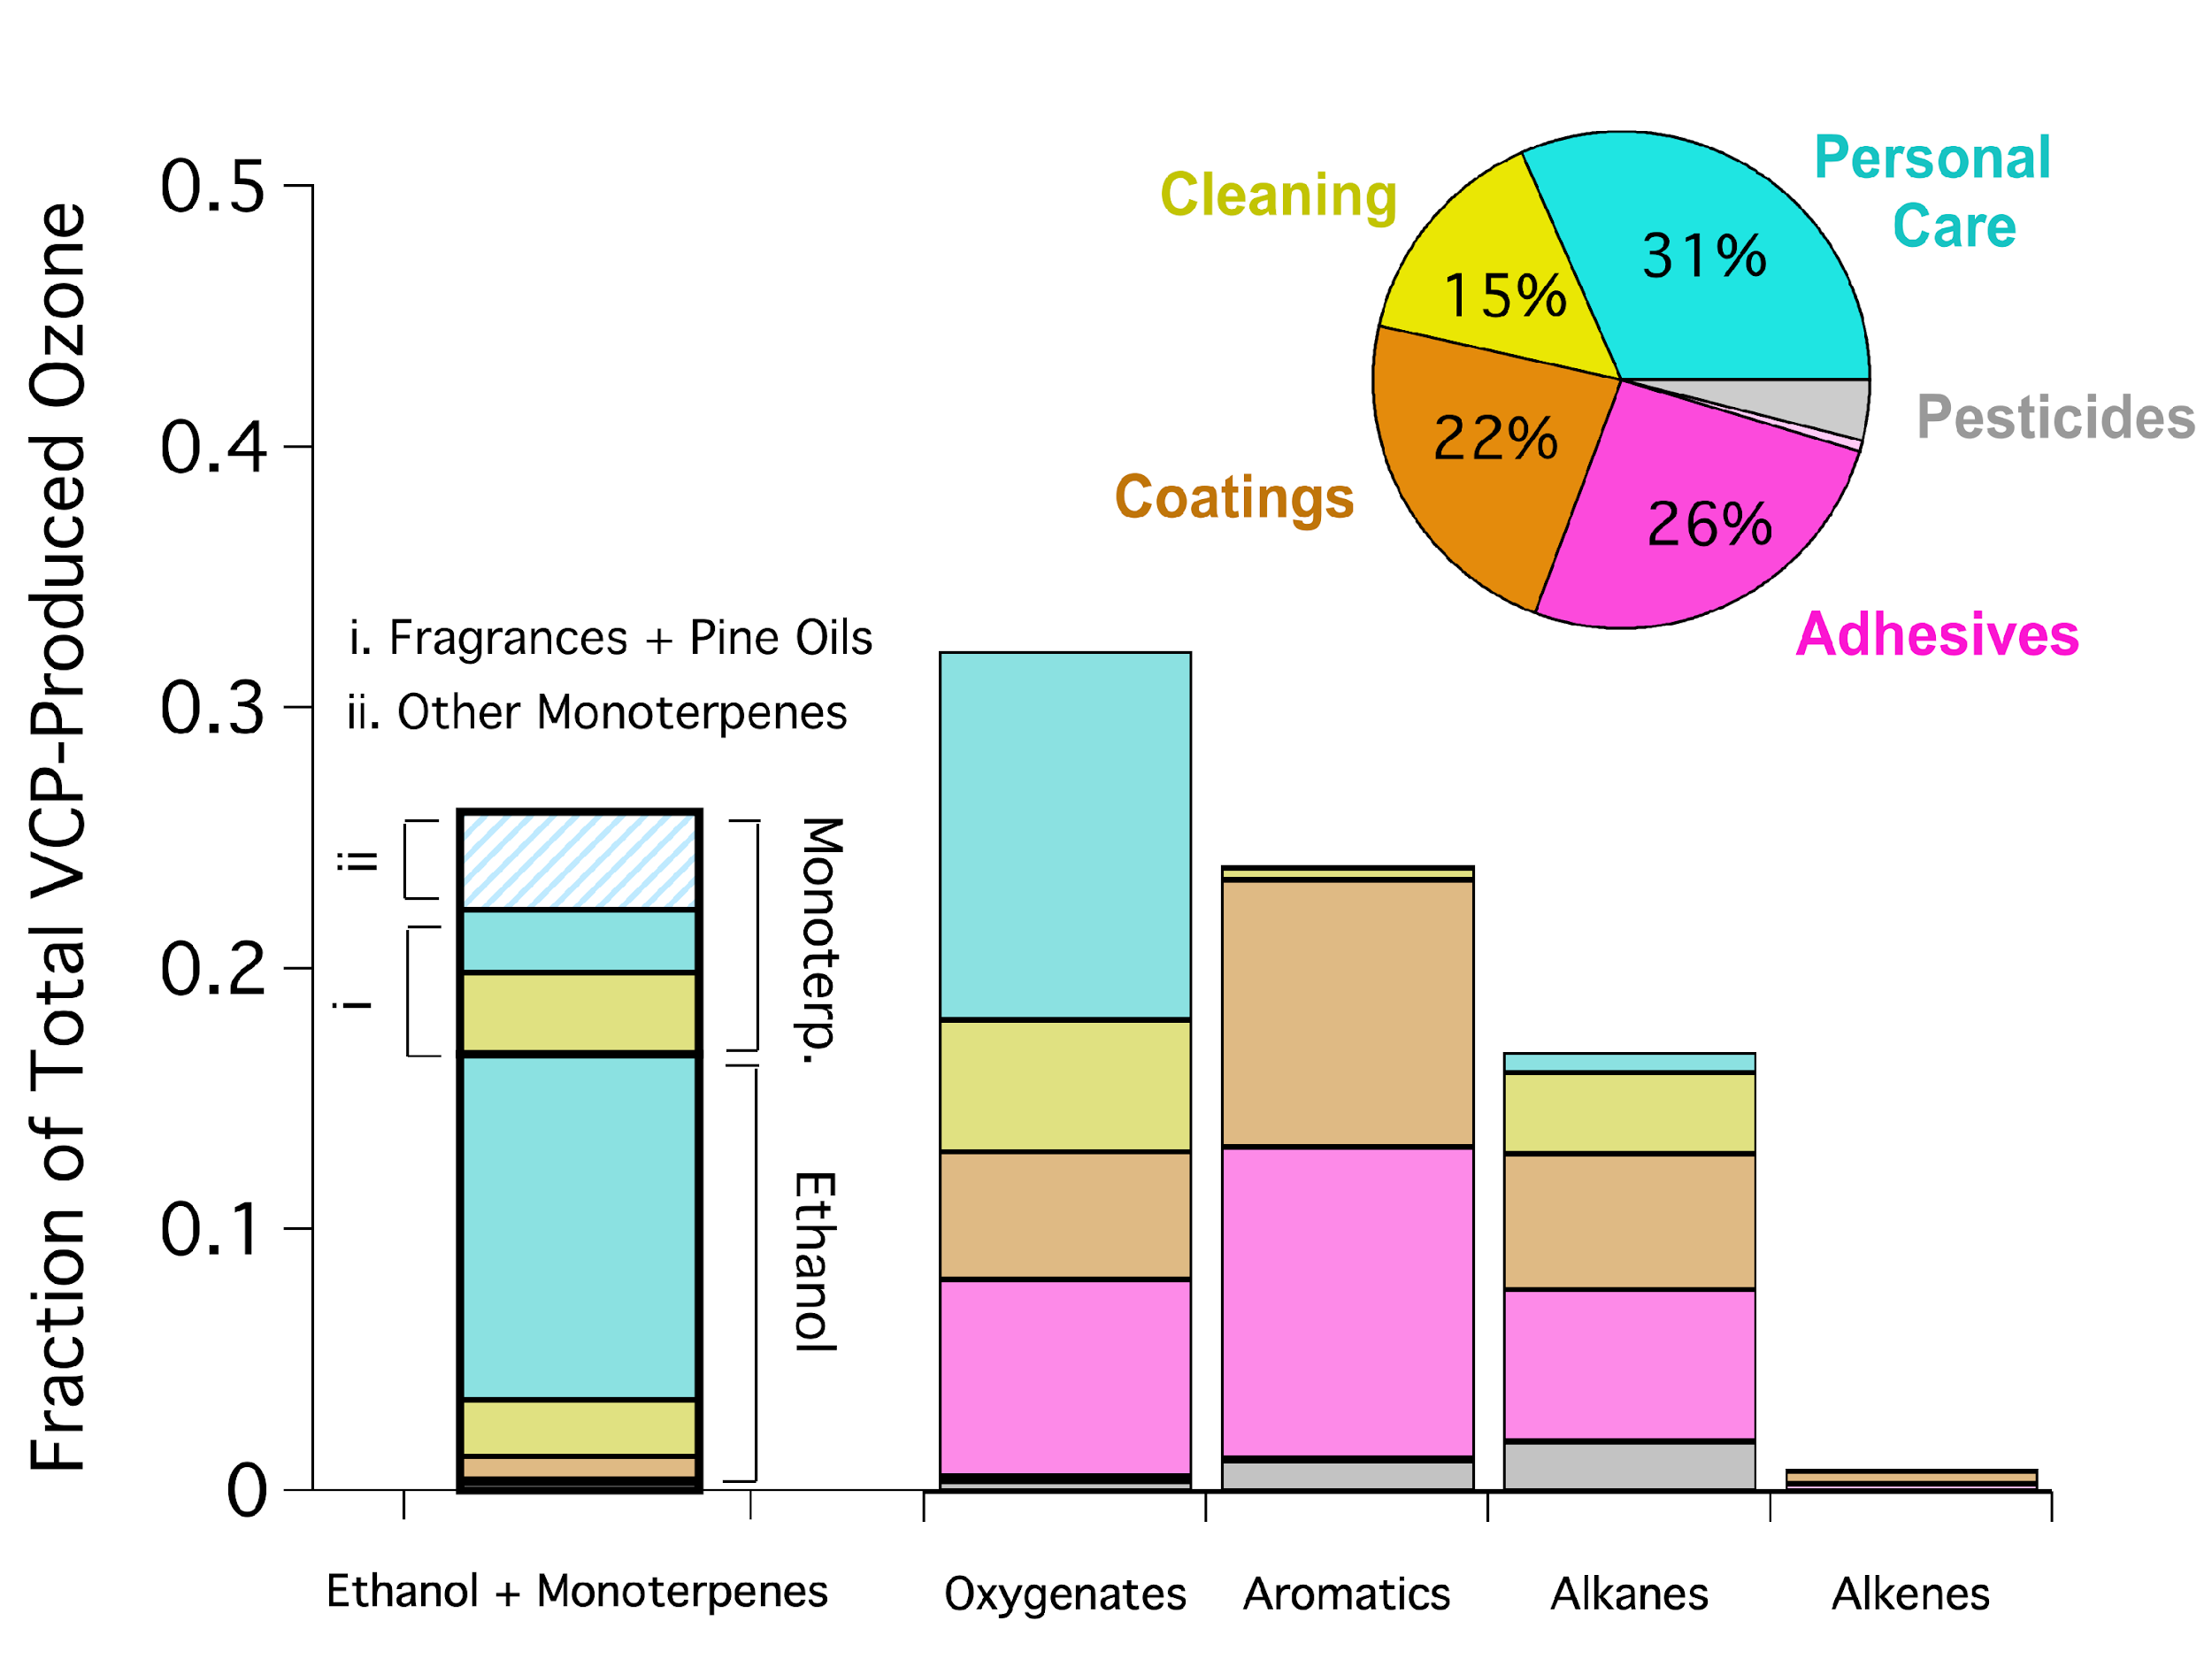
Fig. 4. Breakdown of VCP-produced ozone at the 8-hr ozone maximum by VCP sector (pie chart) and VOC chemical classification (bar chart). Anthropogenic monoterpenes are split to show the fraction attributable to VCPs (fragrances + pine oils) and other sources (building materials, citrus, etc).

Ethanol and anthropogenic monoterpenes account for one-fourth of VCP-produced ozone. While ethanol is slow to react with OH (k_{OH} = 3.2x10⁻¹² cm³ molec⁻¹ s⁻¹), it is one of the most abundant VOCs emitted from VCPs and mobile sources (Fig. S10). Limonene is the dominant monoterpene in urban environments (Fig. 2) and ethanol is the single largest contributor to VCP ozone (Fig. 4), yet neither VOC is routinely monitored in urban regions. Measuring limonene and ethanol may help to constrain the role of VCPs on anthropogenic ozone production.

Ozone sensitivity to VOC and NO_{x} reductions

Ozone mitigation strategies in urban regions often emphasize NO_{X} regulations, though VCPs are regulated for their impacts on ozone ²⁰. Based on WRF-Chem simulations, ozone formation downwind of NYC was partly sensitive to AVOC emissions. Figure 5 shows changes in ozone when box model emissions of NO_{X} and AVOCs are reduced by 50%. Model output is shown along the NYC plume trajectory (shown here as distance from Central Park) and the background colors indicate when ozone production transitions from VOC to NO_{x}-sensitive chemistry. A 50% decrease in AVOCs had the greatest impact on ozone formation within 40 km of Manhattan where ozone production was largely VOC-sensitive. In contrast, a 50% decrease in NO_{x} resulted in lower ozone formation on a regional scale (> 40km from Central Park) following a transition to NO_{x}-sensitive ozone production. The population density along the plume trajectory shows that on July 2, most people exposed to the ozone exceedance resided in regions likely to be sensitive to local AVOC reductions.

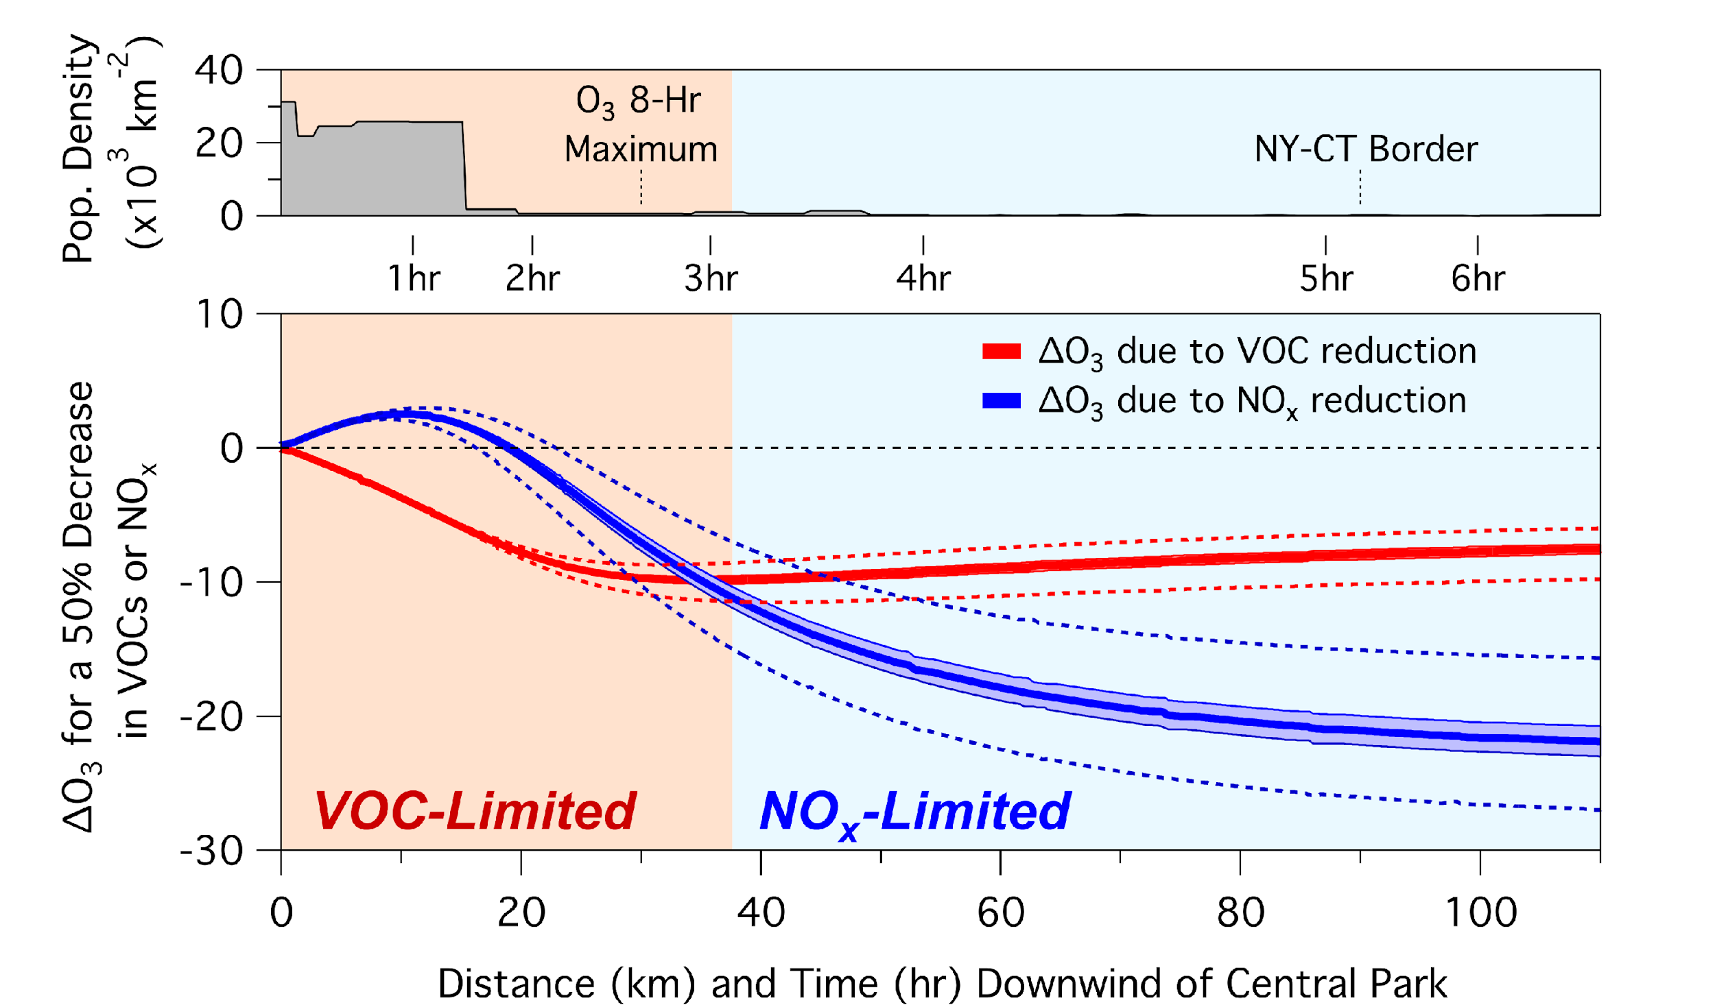

Fig. 5. Calculated change in ozone downwind of NYC assuming a 50% decrease in NO_{x} or VOCs. The population density along the plume transit is shown to highlight urban areas impacted by VOC and NO_{x}-limited ozone formation. Shaded regions delineate where the ozone isopleth transitions from VOC-limited ($\frac{dO_{3}}{d{NO}_{x}}<0$) to NO_{x}-limited ($\frac{dO_{3}}{d{NO}_{x}}>0$). Error bands in both panels show model results assuming 10 and 50% changes to the isoprene constraint (1 ppb).

It is expected that continued NO_{x} reductions will result in reduced plume-averaged ozone pollution for cities across the US ²¹. The results presented in Fig. 5 supports these conclusions for ozone production at regional scales; however, Figures 3 and 5 also demonstrate that a large fraction of the NYC population was exposed to elevated ozone mixing ratios that were produced under VOC-limited conditions. While the July 2 exceedance represents a case study of ozone formed during a heatwave, it is expected that similar events will become more frequent in a warming climate ²². Such events already contribute significantly to the number of ozone exceedances observed in urban areas, especially in the Eastern US ^{22,23}. Ozone mitigation strategies may benefit from considering the combined impacts of NO_{x} and VOC reductions on local and regional scales, as well as how these changes impact ozone production during extreme heat events. We note that VCP emissions are expected to be important precursors to urban SOA formation, and additional work is needed to assess how PM2.5 responds to changes in VCP and mobile source emissions.
Finally, it is notable that local ozone production in New York City is VOC-limited even though biogenic emissions are significant. VOC-sensitive ozone production may play a role in other megacities, especially those where biogenic emissions are lower. VCP emissions represent a mitigation lever that is decoupled from NO_{x} since VCPs are non-combustion sources, and these emissions may impact the air quality of other regions facing significant ozone pollution.

References

1 Pollack, I. B. et al. Trends in ozone, its precursors, and related secondary oxidation products in Los Angeles, California: A synthesis of measurements from 1960 to 2010. J Geophys Res-Atmos 118, 5893-5911, doi:10.1002/jgrd.50472 (2013).
2 Jiang, Z. et al. Unexpected slowdown of US pollutant emission reduction in the past decade. Proc. Natl. Acad. Sci. U.S.A. 115, 5099-5104, doi:10.1073/pnas.1801191115 (2018).
3 Warneke, C. et al. Multiyear trends in volatile organic compounds in Los Angeles, California: Five decades of decreasing emissions. J. Geophs. Res. 117, doi:10.1029/2012jd017899 (2012).
4 McDonald, B. C. et al. Volatile chemical products emerging as largest petrochemical source of urban organic emissions. Science 359, 760-764, doi:10.1126/science.aaq0524 (2018).
5 Coggon, M. M. et al. Diurnal Variability and Emission Pattern of Decamethylcyclopentasiloxane (D5) from the Application of Personal Care Products in Two North American Cities. Environ. Sci. Technol. 52, 5610-5618, doi:10.1021/acs.est.8b00506 (2018).
6 Bettencourt, L. M., Lobo, J., Helbing, D., Kuhnert, C. & West, G. B. Growth, innovation, scaling, and the pace of life in cities. Proc. Natl. Acad. Sci. U.S.A. 104, 7301-7306, doi:10.1073/pnas.0610172104 (2007).
7 Gately, C. K., Hutyra, L. R. & Sue Wing, I. Cities, traffic, and CO2: A multidecadal assessment of trends, drivers, and scaling relationships. Proc. Natl. Acad. Sci. U.S.A. 112, 4999-5004, doi:10.1073/pnas.1421723112 (2015).
8 Lamsal, L. N., Martin, R. V., Parrish, D. D. & Krotkov, N. A. Scaling relationship for NO2 pollution and urban population size: a satellite perspective. Environ. Sci. Technol. 47, 7855-7861, doi:10.1021/es400744g (2013).
9 Mackay, D. et al. Decamethylcyclopentasiloxane (D5) environmental sources, fate, transport, and routes of exposure. Environ. Toxicol. Chem. 34, 2689-2702, doi:10.1002/etc.2941 (2015).
10 de Gouw, J. A. et al. Increasing atmospheric burden of ethanol in the United States. Geophys. Res. Lett. 39, doi:10.1029/2012gl052109 (2012).
11 Warneke, C. et al. Biogenic emission measurement and inventories determination of biogenic emissions in the eastern United States and Texas and comparison with biogenic emission inventories. J. Geophys. Res. 115, doi:10.1029/2009jd012445 (2010).
12 CARB. 2016 Fragrance Formulator Survey. (California Air Resources Board, 2018).
13 Logue, J. M., McKone, T. E., Sherman, M. H. & Singer, B. C. Hazard assessment of chemical air contaminants measured in residences. Indoor Air 21, 92-109, doi:10.1111/j.1600-0668.2010.00683.x (2011).
14 Steinemann, A. Volatile emissions from common consumer products. Air Qual. Atmos. Hlth. 8, 273-281, doi:10.1007/s11869-015-0327-6 (2015).
15 Steinemann, A. C. et al. Fragranced consumer products: Chemicals emitted, ingredients unlisted. Environ. Impact. Asses. 31, 328-333, doi:10.1016/j.eiar.2010.08.002 (2011).
16 Hellén, H., Tykkä, T. & Hakola, H. Importance of monoterpenes and isoprene in urban air in northern Europe. Atmos. Environ. 59, 59-66, doi:10.1016/j.atmosenv.2012.04.049 (2012).
17 Geron, C., Rasmussen, R., R. Arnts, R. & Guenther, A. A review and synthesis of monoterpene speciation from forests in the United States. Atmos. Environ. 34, 1761-1781, doi:10.1016/s1352-2310(99)00364-7 (2000).
18 Chameides, W. L., Lindsay, R. W., Richardson, J. & Kiang, C. S. The role of biogenic hydrocarbons in urban photochemical smog: Atlanta as a case-study. Science 241, 1473-1475 (1988).
19 Trainer, M. et al. Models and observations of the impact of natural hydrocarbons on rural ozone. Nature 392, 705-707 (1987).
20 EPA. Study of volatile organic compound emissions from consumer and commercial products. (U.S. Environmental Protection Agency, 1995).
21 Laughner, J. L. & Cohen, R. C. Direct observation of changing NOx lifetime in North American cities. Science, 723-727 (2019).
22 Jacob, D. J. & Winner, D. A. Effect of climate change on air quality. Atmos. Environ. 43, 51-63, doi:10.1016/j.atmosenv.2008.09.051 (2009).
23 Shen, L., Mickley, L. J. & Gilleland, E. Impact of increasing heat waves on U.S. ozone episodes in the 2050s: Results from a multimodel analysis using extreme value theory. Geophys. Res. Lett. 43, 4017-4025, doi:10.1002/ 2016GL068432. (2016).
24 Coggon, M. M. et al. Emissions of nitrogen-containing organic compounds from the burning of herbaceous and arboraceous biomass: Fuel composition dependence and the variability of commonly used nitrile tracers. Geophys. Res. Lett. 43, 9903-9912, doi:10.1002/2016gl070562 (2016).
25 Yuan, B. et al. Emissions of volatile organic compounds (VOCs) from concentrated animal feeding operations (CAFOs): chemical compositions and separation of sources. Atmos Chem Phys 17, 4945-4956, doi:10.5194/acp-17-4945-2017 (2017).
26 Lerner, B. M. et al. An improved, automated whole air sampler and gas chromatography mass spectrometry analysis system for volatile organic compounds in the atmosphere. Atmos. Meas. Tech. 10, 291-313, doi:10.5194/amt-10-291-2017 (2017).
27 Yuan, B. et al. A high-resolution time-of-flight chemical ionization mass spectrometer utilizing hydronium ions (H3O+ToF-CIMS) for measurements of volatile organic compounds in the atmosphere. Atmos. Meas. Tech. 9, 2735-2752, doi:10.5194/amt-9-2735-2016 (2016).
28 Stark, H. et al. Methods to extract molecular and bulk chemical information from series of complex mass spectra with limited mass resolution. Int. J. Mass. Spectrom. 389, 26-38, doi:10.1016/j.ijms.2015.08.011 (2015).
29 Grell, G. A. et al. Fully coupled “online” chemistry within the WRF model. Atmos. Environ. 39, 6957-6975, doi:10.1016/j.atmosenv.2005.04.027 (2005).
30 Kim, S. W. et al. NO2 columns in the western United States observed from space and simulated by a regional chemistry model and their implications for NOx emissions. J. Geophys. Res. 114, doi:10.1029/2008jd011343 (2009).
31 Guenther, A. et al. Estimates of global terrestrial isoprene emissions using MEGAN (Model of Emissions of Gases and Aerosols from Nature). Atmos Chem Phys 6, 3181-3210 (2006).
32 Wolfe, G. M., Marvin, M. R., Roberts, S. J., Travis, K. R. & Liao, J. The Framework for 0-D Atmospheric Modeling (F0AM) v3.1. Geosci. Model Dev. 9, 3309-3319, doi:10.5194/gmd-9-3309-2016 (2016).

Acknowledgements: The authors thank Andrew Whitehill for useful comments to the manuscript and permission to use formaldehyde data collected during LISTOS. The authors thank Lukas Valin, James Szykman, and David Williams for insightful discussions and permission to use the Pandora data collected during LISTOS. The authors thank the NASA Pandora Project team for logistical and calibration support (led by R. Swap, L. Shalaby, A. Dimov, A. Suliman, A. Kotsakis, F. Santos) and the Luftblick Pandonia team for calibration and data processing support (led by A. Cede, M. Tiefengraber, M. Mueller and M. Gebetsberger). We thank Albert Presto and Rishabh Shah for ground support during measurements in Pittsburgh, PA. Funding: MMC, GIG, JVG, BCM, and CW acknowledge the CIRES Innovative Research Program. FM acknowledges the NOAA Cooperative Science Center for Earth System Sciences and Remote Sensing Technologies under the Cooperative Agreement Grant #: NA16SEC4810008, and Northeast States for Coordinated Air Use Management Project #2411. TB and GG acknowledge supplemental funding from the NASA Tropospheric Composition Program. Author Contributions: CW, BCM, MMC, JBG, and GIG formulated the field measurements; CW and MT supervised the research; MMC and GIG conducted PTR-ToF-MS measurements; JBG conducted GC-MS measurements; JP conducted CO measurements; AK and VP conducted Tofwerk mobile laboratory measurements. FM, MA, and WU conducted wind lidar and ceilometer measurements; TB and GG conducted ozone lidar measurements; TC conducted WINTER-2015 measurements; JH and GIVW characterized fragrance formulations; KA provided data support and software development; GIG evaluated VCP population density relationships. BCM developed the FIVE-VOC inventory; ML developed the NO_{x} inventory; BCM and SM conducted WRF-Chem modeling; MMC conducted box modeling; MMC, BCM, GIG, and CW prepared the manuscript with contributions from all authors. Competing Interests: The authors declare no competing interests. Data and Materials Availability: Data for LISTOS and PANDORA spectrometers can be accessed through the NASA data archive (https://www-air.larc.nasa.gov/missions/listos/index.html). Data for the NOAA mobile laboratory, NY-ICE, and LISTOS measurement campaigns can be found at https://www.esrl.noaa.gov /csd/groups/csd7/measurements/2018nyice/

Methods:

Ground site measurements and LISTOS 2018 campaign description

The New York Investigation of Consumer Emissions (NY-ICE) was a two-month field campaign conducted in winter (March 5 – 28, 2018) and summer (July 5 – 24, 2018) to measure the emission profile and strength of volatile organic compounds (VOCs) emitted from volatile chemical products (VCPs). The sampling periods were chosen in order to study VCP emissions during periods with both low biogenic activity (winter) and high potential for ozone pollution (summer). Measurements conducted in the summer were performed as part of the 2018 Long Island Sound Tropospheric Ozone Study (LISTOS 2018, https://www.nescaum.org/ documents/listos#about), which was a multi-agency field initiative aimed at understanding the influence of New York City (NYC) emissions on ozone formation and transport along the New England coast.

VOC and carbon monoxide (CO) mixing ratios were measured from an engineering building located at the City College of New York (CCNY). During winter, instruments were placed in a basement and sampled air at the top of a roof through a 10 m Teflon inlet. The total flow through the inlet was 15 L min⁻¹ and line losses for species reported here were negligible. In summer, the instruments were staged at the top of the building and sampled air through a 1 m Teflon inlet. Measurements were conducted for at least two weeks to characterize VOC temporal profiles and VOC/CO enhancement ratios.

Instrumentation

VOC mixing ratios were measured using a proton-transfer-reaction time-of-flight mass spectrometer (PTR-ToF-MS, Tofwerk Inc.) and a custom-built whole air canister system (WAS) analyzed by gas chromatography (WAS-GC-MS) ^{26,27}. The PTR-ToF-MS is sensitive to a broad range of VOCs, including aromatics, alkenes, biogenic species, and oxygenates. Reported here are measurements of benzene, the sum of monoterpenes, and decamethylpentasiloxane (D5-siloxane), as well as a suite of other VOCs representative of biogenic and anthropogenic sources. The WAS-GC-MS provides information about VOC isomers, which cannot be resolved by PTR-ToF-MS. WAS-GC-MS measurements are primarily used to evaluate monoterpene distributions, determine mixing ratios of alkane hydrocarbons, and verify compound-specific identities attributed to the masses measured by PTR-TOF-MS.

During ground site sampling, PTR-ToF-MS backgrounds were determined in situ every 2 hr by passing air through a platinum catalyst heated to 350°C. During drives, instrument backgrounds were determined every 15 minutes. Data were processed following the recommendations of Stark et al. ²⁸ using the Tofware package in Igor Pro (WaveMetrics).

The WAS sampling system consists of a stainless-steel bellow compressor, 12 to 24 canisters in series, a pneumatics system, and computer control (2). Each 2.7L electropolished stainless steel canister is initially cleaned, evacuated, and filled to 10 Torr of water vapor before shipping to the field (2). Canister samples were automatically collected every 2 hours during ground site measurements and manually triggered during mobile drives. During sampling, each evacuated canister is opened electronically by pneumatically-actuated stainless-steel bellows valves on each canister. The compressor is upstream of the samplers and is used to pressurize each canister to approximately 45 psig. The compressor was intentionally throttled down so that the average fill time was over 5 minutes in order to reduce the impacts of local, intermittent plumes. For winter 2018, 126 mobile and 207 stationary canisters were collected. During summer 2018, 37 mobile and 141 stationary samples were collected. The canisters were shipped back to Boulder, CO and analyzed by GC-MS within four days of collection to minimize sampling artifacts. Sampling artifacts due to VOC canister storage have been characterized previously and are expected to be negligible for the species reported here ²⁶. WAS-GC-MS instrument backgrounds were characterized by filling cleaned canisters with ultrapure nitrogen (Matheson, Inc.) and analyzing on the GC-MS.

Each canister sample is analyzed on a custom, two-channel GC-MS with a duty cycle of 20 minutes per sample. Two separate 240 mL aliquots are collected from each canister sample simultaneously and analyzed in series using a single quadrupole mass spectrometer (Agilent 5975C) operated in SIM/SCAN mode. Channel 1 consists of a CO₂ trap (Ascarite II, Thomas Scientific), water trap at -55 °C, and a sample pre-concentration trap at -165 °C coupled to a Al₂O₃-KCL PLOT column (Restek RT-Alumina BOND/KCl; 30 m length x 0.25 mm ID, 4 µm film thickness) designed to separate the C2-C6 hydrocarbons and select halocarbons. Channel 2 consists of a water trap at -55C and a sample pre-concentration trap at -155 °C coupled to a DB-624 column (Restek MXT-624; 30 m length x, 0.25 mmID, 1.4 µm film thickness) designed to separate the C5-C12 hydrocarbons and select oxygen-, halogen-, and nitrogen-containing VOCs.

VOC mixing ratios in Europe were measured using a Vocus S PTR-TOF MS (Towerk AG). Ambient air was sampled at a flow rate of 5 L min⁻¹ through a 2m long, 1/8” ID PFA inlet mounted above the engine. Instrument background was determined at the beginning of the drive and thereafter for select compounds by a 30-second zero performed every 20 minutes by passing air through an activated charcoal filter. Single-point calibrations were performed approximately every two hours.

The NOAA PTR-ToF-MS and WAS-GC-MS were calibrated using multiple gravimetrically-prepared gas standards and by liquid calibration methods as described by Coggon et al. ⁵. The Tofwerk PTR-TOF-MS was calibrated using an on-board gravimetrically-prepared gas standard. Instrument sensitivities and data intercomparisons are provided in the Supplementary Methods

CO was measured from the NYC ground site and onboard the NOAA mobile laboratory by integrated cavity output spectroscopy (Los Gatos Research, Inc.). The CO monitor was calibrated using certified CO-in-air standards (Scott-Marrin, Inc), which in turn were calibrated before and after the project to standards on the WMO CO_X2014A scale. Other instruments deployed during LISTOS 2018 are described in the Supplementary Methods.

Mobile measurements and urban enhancement ratio calculations

Mobile measurements were conducted in NYC and other US cities onboard the NOAA mobile laboratory ^{24,25} to characterize the spatial distribution of VCP emissions. In NYC, the mobile laboratory was driven through the NYC metropolitan area, including Long Island and northeastern New Jersey (Fig. S1, Supplemental Information). The drive paths were designed to sample regions of high and low population density to compare differences in VCP emissions. The mobile laboratory was also driven through forested regions of New Jersey and Long Island in order to contrast natural monoterpene emissions with those of fragranced VCPs.

At the beginning and end of each deployment, the mobile laboratory was driven across the US to sample urban emissions from other cities, as well as to characterize rural emissions of isoprene. Detailed mobile sampling was conducted for Denver, CO, Chicago, IL, and Pittsburgh, PA. For each city, urban emissions were characterized by sampling VOCs along surface roads and in densely populated regions, such as city centers. Urban emissions were contrasted with measurements in suburban and rural regions upwind and downwind of each city. Here, we focus on morning measurements (8:00 AM - 12:00 PM local time) when VCP emissions are expected to be highest.

VOC measurements in Europe were conducted onboard the Tofwerk mobile laboratory using a PTR-ToF-MS. Drives were conducted September 24-25, 2019, from Thun, Switzerland past Bratislava, Slovakia. In contrast to the US sampling strategy, measurements in Europe were performed exclusively on highway. Urban emissions were sampled in close proximity to multiple cities (Fig. S2); however, only Bratislava, Bern, and Vienna were sampled through dense population centers during morning hours. These cities are analyzed in detail to compare to US-based observations.

In this study, we evaluate VOC/benzene enhancement ratios (ERs) in US and European cities in order to compare VCP and traffic emissions across urban regions with different population densities. The equation used to derive urban enhancement ratios (ERs) is described by Equation 1.

$ER= \frac{{[VOC]}_{median in city}- {[VOC]}_{median out of city}}{{[Benzene]}_{median in city}- {[Benzene]}_{median out of city}}$ (1)

Morning-hour median mixing ratios were calculated from measurements conducted in the population center of each city and from upwind measurements where VCP and traffic emissions were expected to be low. NYC has large differences in population density across the five boroughs; consequently, NYC measurements are separated based on measurements conducted in areas of high (19,000 - 23,000 people km⁻²), medium (14,000-19,000 people km⁻²), and low (9,000-14,000 people km⁻²) population densities.

WRF-Chem and Box Modeling

In this study, we utilize a three-dimensional chemical transport model to quantify ozone observed during the 2018 ozone season, and a complementary Lagrangian box model to assess the influence of anthropogenic VOC emissions on ozone exceedances in the Long Island Sound region. The 3D model employs the Weather Research and Forecasting with Chemistry (WRF-Chem) model, where chemistry is fully coupled with meteorology ²⁹. The box model employs the same chemical mechanism and emissions inventory as WRF-Chem, but is parameterized to use simplified meteorology in order to facilitate solver efficiency.

A full description of the WRF-Chem and box model, and comparison to instrumentation deployed during LISTOS 2018, is provided in the Supplementary Methods. Briefly, we use WRF-Chem version 4.1 to simulate the Continental US at 12 km x 12 km horizontal resolution with 50 vertical levels (up to 50 hPa). The continental run provides initial and boundary conditions for the nested Eastern US domain at 4 km x 4 km horizontal resolution. We make the nested domain sufficiently large to reduce potential effects of complex terrain, due to the Appalachian Mountains, on our nested meteorological simulations. Air quality is simulated from 6/25/18 to 7/31/18 to assess the highest ozone exceedances observed during summer 2018, as well as to overlap with LISTOS 2018 measurements.

We initialize meteorology with the North American Mesoscale (NAM) model and utilize the Noah Land Surface Model and Mellor-Yamada Nakanishi and Niino (MYNN) planetary boundary layer scheme. We represent the atmospheric chemistry of NO_{x}, VOCs, and ozone using the RACM_ESRL chemical mechanism described by Kim et al. ³⁰ and the Madronich Photolysis (TUV) scheme. Biogenic VOC emissions are based on Model of Emissions of Gases and Aerosols from Nature (MEGAN) model, version 2.1 ³¹, with adjusted isoprene emissions based on mobile van measurements (further described in the Supplementary Methods).
Finally, anthropogenic VOC emissions are initialized based on an emissions inventory developed for NYC. The emissions inventory was developed following the methods described by McDonald et al. ⁴. The emissions inventory is compared to VOC/CO ratios measured at the CCNY ground site during summer and winter. A full description of the inventory, as well as a comparison to the ground site measurements, is provided in the Supplementary Methods.
The box model is constructed using the Framework for 0-D Atmospheric Modeling (F0AM) ³². The model is set up to treat the outflow from NYC as a Lagrangian plume in order to assess the impacts of NYC pollution on downwind ozone formation. We focus the box model analysis on July 2, 2018, which was the highest ozone exceedance observed during summer 2018 (8-hr ozone exceeded 100 ppb in Manhattan, and over 120 ppb downwind). Emissions from WRF-Chem are used to initialize VOC concentrations. The volume of the box is assumed to be equivalent to the area of Manhattan (~60 km²) and the height of the planetary boundary layer (~1.2 km). The box model is run between 11:00 AM and 5:00 PM when the height of the planetary boundary layer has stabilized, as measured by LIDAR from the CCNY ground site.

The output from the box model is compared to trajectory output from WRF-Chem during the July 2, 2018 ozone episode. The temporal evolution of chemical species between the two models agree to within 10%. A full description of this comparison is provided in the Supplementary Methods.

Supplementary Materials:
Supplementary Methods
Supplementary Discussion
Figures S1-S31
Tables S1-S7
References 1-94

