

Novel High Barrier Films for Packaging Food and Medicine

Final Report of Intern Jynette Tigner
Mentor: Sheila Ann Thibeault
Co-Mentor: Jin Ho Kang

National Aeronautics and Space Administration
Langley Research Center
Hampton, Virginia
April 20th, 2020

Table of Contents
Abstract 2
Introduction 3
Literature Review 6
Product Specifications 9
Product Design 10
Project Plan and Procedure 11
Results and Discussions 14
Future Work 23
Business, Social, and Ethical Considerations 24
Summary and Conclusions 25
References 26
Appendix: Data 28
Appendix: Operating Procedures 32

Abstract
Long manned missions require food packaging to maintain food safety, nutrition, and acceptability for the length of 3-5 years^{1,2} while the shelf life assigned by NASA for current provisions is 18-24 months¹. The focus of this design project was to make a polymer film specifically to function as a high oxygen barrier to later be included in an improved multi-layer packaging system of other specialized polymers with capabilities to allow for a 5-year shelf-life.
To qualify as a high oxygen barrier film and to be a successful design for the future packaging, the resulting film is required to have an oxygen transmission rate (OTR) less than 0.06 cc/ m²/24 hr/atm, the standard for the current packaging³. This new film was designed to have a decreased permeability by increasing the “tortuous path” a gas molecule travels to permeate through a film. The increase in the “tortuous path” of a gas molecule is accomplished by introducing a 2D material additive. The additive chosen for this project was hexagonal boron nitride (h-BN) which exfoliates into boron nitride nanosheets (BNNs). Nylon 6 was chosen as the candidate for the matrix.
This project is required to determine the best methods to synthesize the sample film and then to test the OTR of the film to determine if this design was successful. This project examined methods for pulverizing polymer resin pellets, h-BN exfoliation, and film fabrication using a hot press.
This report includes the exfoliation and analysis of h-BN, procedural preparations for films, and a modeling study of estimated OTR of the h-BN/Nylon. The work in this report did not yield a high barrier composite film because of the laboratory closure in response to COVID -19 guidance but provides a concise method of the additive preparation and film synthesis. This gives a good starting point for future research in high barrier films by 2D additive composites.

Introduction
Space is the next frontier for exploration. This step forward for humankind promises to spur a great amount of innovation that will allow humans to go farther than they have before while providing technology that improves the human condition on Earth. Long manned space missions, in particular, demand technological innovation based on the number of requirements needed to support human life for an extended period of time in an environment that is restricted by weight and an inability to be resupplied. Nutrition is a basic need for the human body; food packaging takes up a large amount of the weight, volume, and waste allocation for a space mission but is essential in maintaining food safety, nutrition, and acceptability¹.
Better packaging material for perishable items is needed. The current shelf life assigned to most space food provisions by NASA is 18-24 months¹. The shelf life requirement is specific per mission: shuttle flights must qualify for 9 months, International Space Station stock must qualify for a 1 year, and foods for future planetary expeditions must have a 5 year shelf life^{1,2,4}.
The current packaging for food used in space applications, retort packages, are made with layering polymers and aluminum foil together^{3,5}. Retort packaging is most utilized for space food because it rates the highest for the requirements and shows the greatest potential to achieve the shelf life of 3-5 years^{1,2}. Descriptions of the essential requirements that retort packaging fulfill are as listed:
- Food acceptability
The general appearance and taste of the food to astronauts. Shelf life is defined by the evident development of off-flavor and off-color traits of the food². The taste and monotony of the food contributes to the psychology of the crew. A variety of food options need to be considered as mental health is a major concern for long duration missions in the way it affects physical health and mission directives⁶.
- Nutrition and food safety
Ability to preserve vitamins in food that decrease over time and an absence of microorganisms that are dangerous for ingestion. Vitamin losses have been recorded in excess of 40% for naturally occurring vitamin C, folic acid, and pantothenic acid in most tested food items¹. The success of a space mission is reliant on a healthy crew.
The proposed design for this project is to utilize the preexisting retort packaging design while altering the materials used, improving the effectiveness of the single layers, which increases the capabilities of the packaging overall. The specific goal addressed in this engineering design project is the development and characterization of oxygen-barrier polymer film for the new packaging system.
Successful packaging protects food from foreign material, microorganisms, oxygen, light, and moisture. Among these methods of degradation, oxygen ingress can result in oxidation which decreases the food quality and nutrition, violating the requirements previously mentioned¹.
High-barrier oxygen films currently exist in industry and are defined as films with an oxygen transmission rate (OTR) less than 1 cc/100 in²/24 hr (15.5 cc/m²/24 hr)⁷. Among the options are films of higher OTRs being layered with aluminum⁸ or another metallized coating, blister packaging⁹, design changes that add sturdier hermetic seals¹⁰, coated films, and composite films.
The current commercial options lined with aluminum or other metallization have very low OTRs but aren’t compatible with incineration and processing procedures to optimize the resource utilization, such as recycling the used packaging¹.
Blister packaging and sturdier hermetic seals are undesired choices because blister packaging is inflexible in nature, limiting the packing capability, and extra hermetic seals to packaging designs increases the bulk and mass of the packaging¹.
Films coextruded with a coating like Ethylene–vinyl alcohol copolymers (EVOHs) show promise. Unfortunately, EVOHs are sensitive to water and lack sources, driving up cost. Composite films, in contrast, are not water sensitive or cost prohibitive.
Composite films use exfoliated particles, mostly clays, as an additive to the polymer itself. The accepted concept is that adding plate-like particles increases the tortuous path of gas molecules traveling through a film by requiring the molecule to diffuse around the additive, decreasing permeability. The larger the aspect ratio of the particles the more tortuous the path^{11–13}.
This project will be making a composite film as a high oxygen barrier utilizing 2D materials in the place of clay particles. 2D nanomaterials, like graphene, molybdenum disulfide, tungsten disulfide, niobium selenide , and hexagonal boron nitride (h-BN), have been of interest in current research because of the varied useful attributes they exhibit as additives¹¹. The 2D nanomaterial attributes of interest are thermal properties¹⁴, electrical properties^{11,15}, strength¹⁵, and now in barrier technologies^{11,12}.
2D materials have a much larger aspect ratio than organoclay particles and have been listed as requiring much less additive for a greater amount of decrease in OTR, as much as a 70% permeability reduction is seen in polyethylene terephthalate with a boron nitride nanosheet level of 3 vol%¹¹. These findings demonstrate the potential for a more efficient and effective film.

Literature Review
For long manned missions food packaging is required to maintain food safety, nutrition, and acceptability for the length of 3-5 years^{1,2} while the shelf life assigned by NASA for current provisions is 18-24 months¹. The restrictions of weight and ability to recycle the packaging limits the physical designs of packaging but leaves room for the innovation of better materials to replace the ones that are currently used.
The goal of this project is to synthesize a polymer film that is classified as a high barrier film, a film with an oxygen transmission rate (OTR) less than 1 cc/100 in²/24 hr (15.5 cc/m²/24 hr)⁷, to be used in conjunction with other polymer films that have separate capabilities to allow for a 5-year shelf-life. Ideally, as will be covered in the product specifications, the definition of success for the synthesized film will be to have a lower OTR than the current packaging used which is 0.06 cc/ m²/24 hr/atm³.
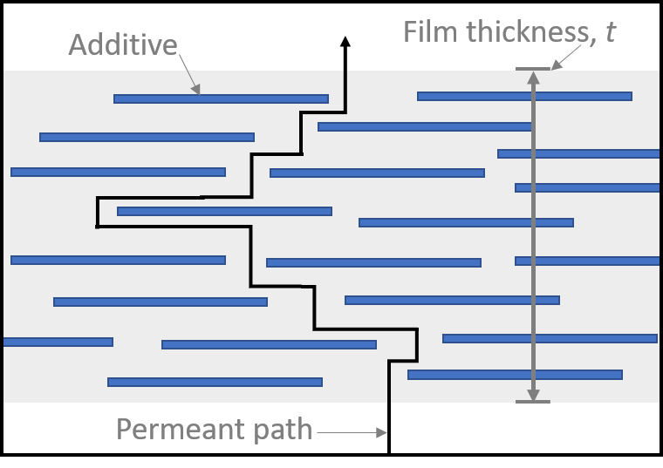
Tortuous Path and Gas Permeability of Polymers
The method in literature for reducing gas permeability in polymers is to increase the “tortuous path” a gas molecule travels to permeate through a film. There are several mathematical models that use the concept of tortuosity of path to predict the decrease in film permeability based on the volume fraction and geometric features of the additive.
The most cited model used in the literature surveyed was the Nielson model¹¹. The Nielson model treats the additive particles as infinitely long but with a known width and thickness, attributes that are referred to being “ribbon-like”. This model uses the permeability of the neat polymer, the volume fraction of the additive, and the aspect ratio of the additive which is the ratio of width to thickness^{16,17}. This model makes the following assumptions about the additive: that it is a consistent size, uniformly dispersed in the matrix, parallel to the surface, and impermeable. The Nielson model also assumes that the matrix properties are not affected by the presence of the filler¹⁷. The Nielson model is considered a simple but effective model to use at low concentrations before additives start to overlap or aggregate¹².
Figure 1 Lengthening the pathlength a gas molecule travels by increasing the tortuosity of the path increases the diffusion time of permeant.
The second model, referred to as the random model in this project, assumes the additive as being the same ribbon-like shape as the Nielson but treats the additive as having a random orientation¹⁸. The third model considered, referred to as the hexagonal model, treats the additive as randomly misaligned hexagonal flakes instead of ribbons¹⁹. All of the models surveyed for the purpose of this project see an increase to the degree of tortuosity, resulting in less permeability, by the increase of the calculated aspect ratio of the additive^{11,12}.
2D Materials vs Clay:
Nanoclays, like montmorillonite, are already used but do not exfoliate well and have lower aspect ratios in comparison to h-BN^{11,12} this results in more additive being necessary to have the same observed permeability reduction. In numbers, 5 wt% of nanoclay in polyethylene terephthalate (PET) to get a gas permeability reduction of 40%, in comparison to a permeability reduction of 42% from just 0.017 vol% of nanosheets¹¹.
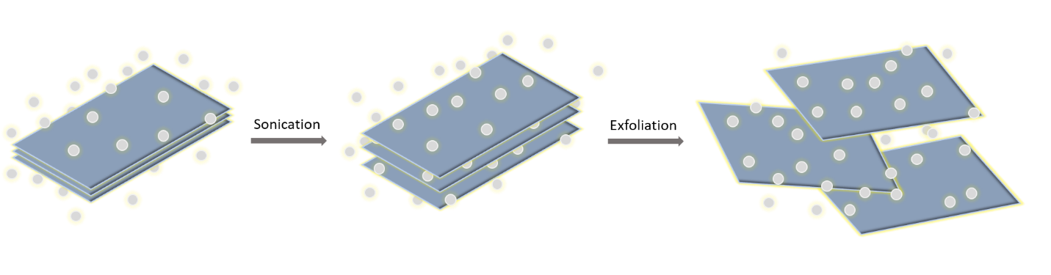
Exfoliating 2D Hexagonal Boron Nitride:
The chosen additive for this project is hexagonal-boron nitride h-BN. H-BN, like other 2D materials, is strongly covalently bounded in-plane but the planes are connected by weak van der Waals. Exfoliation shears these weaker bonds in the layered crystal to make boron nitride nanosheets (BNNs)¹¹.
Figure 2 Solvent aided exfoliation separates sheets and keeps them separated.
Liquid phase exfoliation (LPE) uses sonication in solvent to intercalate the solvent molecules between the crystal planes; creating “quasi-stable” states through electrostatic interactions, reducing interlayer binding to exfoliate the layers. Polar solvents are the ideal choice for this method. Simulations indicate that the best solvents are dimethyl sulfoxide (DMSO), isopropyl alcohol (IPA), and water²⁰. LPE is cheap and has been reported to produce high-quality defect-free 2D nanomaterials in large quantities¹¹.
Though LPE has been reported to be capable of producing BNNs in large quantities, LPE is restricted in a research setting because the BNNs will only suspend in the supernatant at low concentrations, typically a concentration below 2 mg/ml⁻¹ ¹⁵, when separating the product from the non-exfoliated particles. This would require batch sizes of LPE to be quite large in order to get a usable amount of BNNs additive.
Ball milling in urea is a suggested method for high disperse concentrations, up to 30 mg/ml⁻¹. Ball milling in urea is a mechano-chemical process where the urea molecules intercalate in the h-BN structure, decompose, and bond NH₂ group to few-layer BN exfoliating in a way to prevent re-stacking¹⁵. This method requires washing the additive to remove urea but limits the amount of waste liquids in comparison to LPE.
Film Synthesis:
The most common way of mixing the polymer with additives throughout the literature was to use a hot mixer since that is the method that is most analogous with commercial production. This process is environmentally benign because of the lack of solvents and uses shear to mix the molten polymer with the additives^{11,21}.
Making films from polymer powder or pellets can be done using a hot press or solvent casting. Hot pressed films have a higher level of crystallization making these films apt for permeability testing²² compared to solvent casting which are more permeable from solvent drying inconsistencies^{11,22}.
Areas of Research for Investigation:
While there was literature available for PET-BNNs composite films¹¹ there was no literature found using nylon 6 in combination with BNNs composite films in relation to the film permeability.

Product Specifications
The end use of this product is to be a layer in a multilayer retort packaging design. This is the layer that will serve as an oxygen barrier to prevent oxygen ingress. As this product is only a part of the design, the important attributes that are specific to this products function are what will be considered when determining the overall success or failure of this design.
The accepted standards that will determine the success of this product will be the Meal, Ready-to-Eat (MRE) retort packaging standards³. The oxygen transmission rate (OTR) required is less or equal to 0.06 cc/m²/24hrs/atm which is given by ASTM D3985 at 73°F and 50% relative humidity³. The materials for ASTM D3985 were not available for this project so the OTR will be determined by ASTM D1434-82 for Determining Gas Permeability Characteristics of Plastic Film and Sheeting because the correct apparatus was available.
Table 1 This table is to be filled out once the data on the properties is obtained to define the success of the film
Design Requirements of Oxygen Barrier Film
Property | Test Method | Definition of Success | Success / Fail
Oxygen Transmission Rate | ASTM D1434-82²³ | Permeability less than or equal to 0.00686 ((𝑐𝑚³∗𝑐𝑚)/(𝑐𝑚∗𝑠∗𝑃𝑎)) x10¹³
Food Safe | NA | Non-toxic materials were used
Visibility | Spring Session: Determine by sight, Future Testing: UV-Vis | Films are a level of transparency that allows for content observation

Product Design
The product of this design project would be a polymer film made specifically to function as a high oxygen barrier to later be included in an improved multi-layer packaging system. The current designs for retort packaging for food have the following layers beginning with the food contact layer and moving outwards: polyolefin (76.2 - 101.6 µm), aluminum foil (8.89 – 17.78 µm), nylon 6 (15.24 µm), and polyester (12.7 µm)³.
The aluminum foil works as an oxygen barrier, but the inclusion makes the packaging difficult to incinerate or recycle¹. A small change in the current retort design would be to swap the aluminum foil layer for a polymer composite film that acts as an oxygen barrier, but the final design would be to substitute all the layers with revised materials. Based on the permeabilities and thermal properties of the polymers supplied for this project, nylon 6 was determined to be good separate candidates for the composite film.
Table 2 Permeabilities from the polymer supplies available for this project to compare to the required permeability of less than or equal to 0.00686 ((𝑐𝑚³∗𝑐𝑚)/(𝑐𝑚∗𝑠∗𝑃𝑎)) x10¹³
Material | Density g/cm³ | Permeant | Permeability  ((𝑐𝑚³∗𝑐𝑚)/(𝑐𝑚∗𝑠∗𝑃𝑎)) x10¹³
High Density Polyethylene (HDPE) | 0.964 | O₂ | 0.3
Low density Polyethylene (LDPE) | 0.914 | O₂ | 2.2
Polypropylene (PP)
Crystallinity of 50% | 0.907 | O₂ | 1.7
Polyethylene terephthalate (PET)
Amorphous |  | O₂ | 0.0444
Crystallinity of 40% |  | O₂ | 0.0257
Mylar A |  | O₂ | 0.030
Nylon 6 | 1.084 | O₂ | 0.0285
*Data provided by the Polymer Handbook 3rd Edition²⁴
Metallized PET²⁵ | NA | O₂ | 0.1371

Project Plan and Procedure
The process to develop a polymer film is multi-step and involves solving the design challenges presented by each step by trial-and-error. These steps, as shown in figure 3, are the preparation of the materials for the films, the mixing of materials, and the actual making of the film.
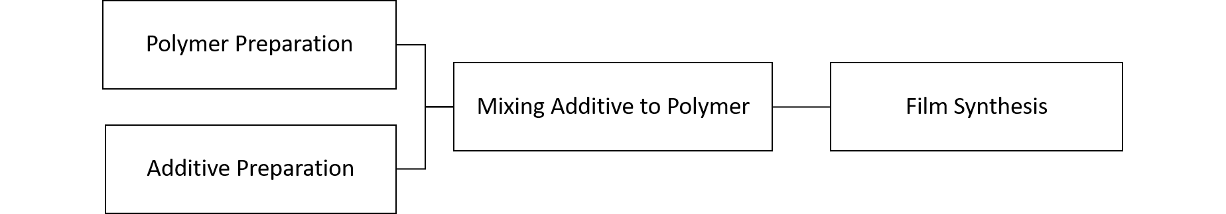
Figure 3 Film synthesis is a sum of processes that have design challenges within each one
The material preparation stage involves producing polymer particles from as received pellets and obtaining exfoliated BNNs from h-BN. The exfoliation step is unaffected by how the end film is synthesized while the mixing step is dependent on the polymer preparation and film synthesis. The composite films that will be made/ tested will have an additive load of 0.1%, 0.5%, 1%, and 5% vol%. Specifics on each process are included in the appendix.
Preparation of Additive: Exfoliating Hexagonal Boron Nitride
Two methods of exfoliating h-BN to make BNNs will be covered in this project to determine the best method of use. Both liquid phase exfoliation (LPE) and ball milling exfoliation (BME) have produced promising results for BNNs in literature. Each processed was sampled and recorded using a holey carbon grid dipped in an isopropyl alcohol suspension and scanning electron microscope (SEM, Hitachi S-5200). The SEM images were analyzed using ImageJ to take measurements.
Liquid Phase Exfoliation
An ultrasonic processor was used to exfoliate h-BN in isopropyl alcohol at a concentration of 50 mg/mL. The sonicated mixture was then centrifuged until the unexfoliated h-BN settled to the bottom. The suspended BNNs are expected to be see through. The transparent supernatant, including the BNNs, was decanted and dried to get mass yield from process.

Ball Milling Exfoliation
A mixture of a 1:20 weight ratio of h-BN : urea powder was prepared and solid-state ball milled at approximately 160 rpm. Samples were collected after ball milling for 1 day, 2 days, 3 days, and 5 days. This process was done for two different starting sizes of h-BN, approximately 70 nm and 7 µm, referred to as nano BN and micron BN throughout the process. The different starting sizes used were to determine if larger few layer BNNs would result from a larger h-BN crystal.
Polymer Preparation, Film Synthesis, and Mixing Materials
To get a consistent mix of polymer and additive, the as supplied polymer pellets needed to be made into a powder to be used in a hot press.
Solvent Method
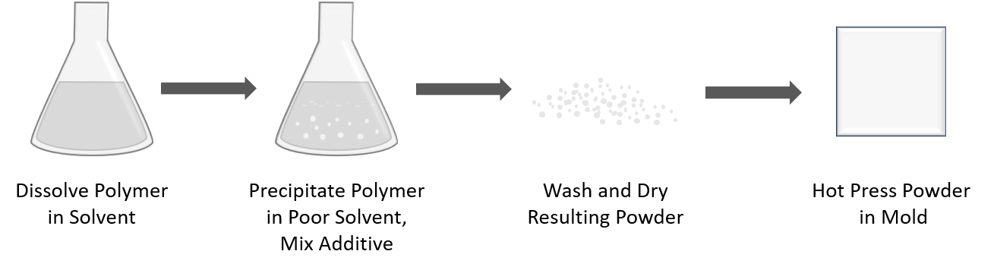
Figure 4 Using a solvent system to precipitate polymer particles and get a thorough mixture of polymer and additive
Dissolving the polymer to reprecipitate it in a poor solvent was determined to be a method that would allow for a consistent end-product. Nylon 6 dissolves in a mixture of calcium chloride and methanol. Calcium chloride and methanol are both readily available and do not require additional heat to dissolve the polymer.

Cryogenic Grinding Method
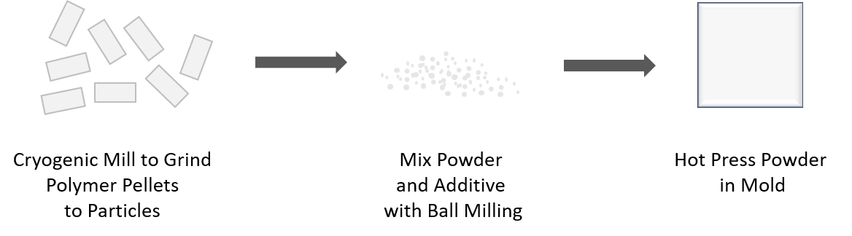
Figure 5 Using cryogenic mill reduces polymer to particles without use of solvent
Another method to get a powder from the nylon pellets is using a cryogenic mill. The Ultra Centrifugal Mill ZM 200 size reduction function utilizes the impact and shearing effects between the rotor and the fixed ring sieve. To mill cryogenically the pellets are mixed with at least double the amount of dry ice to polymer to run at a temperature of -78 °C²⁶.
Hot Press
A 3” x 3” stainless steel mold is used to press the polymers in a heated press with an approximately 100 µm thick frame. The plates of the hot press were set to 20°C higher than the literature value melting point of the pressed polymer. The pressure applied was approximately 1 MPa for a time of 10 minutes using a hot press (Carver 12-12H (4122) Press). Later developments led to a waiting period of 15 minutes before applying pressure after the mold reached the target temperature. This waiting period allows for the mold and plates to be completely heated through to the target temperature.

Results and Discussions
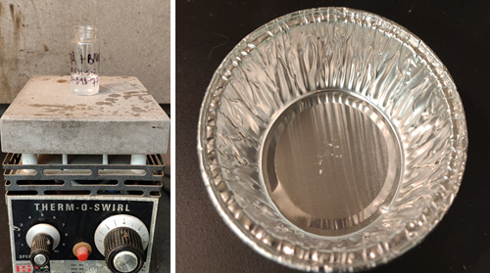
Exfoliation Results
Liquid Phase Exfoliation (LPE)
The trial run of the LPE did not result in a measurable mass yield from the dried dispersion of BNNs (figure 6), but a formation of few layer BNNs (figure 7) was found by scanning electron microscopy (SEM) in the sampling taken. It was determined that the extremely low concentration of the dispersed sheets would not produce a usable amount of additive needed for this project.
Figure 7 Good quality few layer BNNs from LPE but this formation was unique to the rest of the sample. Left: SEM, right: TEM
Figure 6 The amount of BNNs yielded from LPE was too small to measure using scale programmed to milligrams
Ball Milling Exfoliation (BME)
The samples collected for the 70 nm boron nitride (nano BN) and 7 µm boron nitride (micron BN) were measured manually using the software ImageJ. Three measurements, two length and one area, were taken per particle and included in a histogram to compare the measurements of different days.
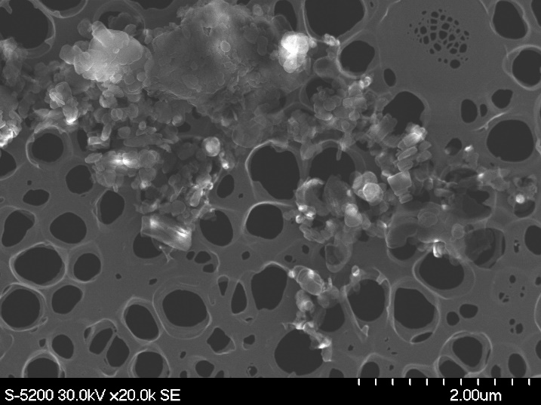
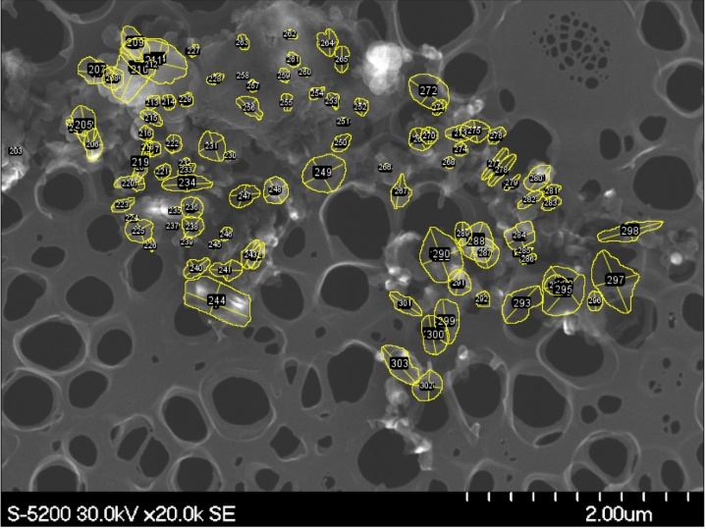
Figure 8 ImageJ allows for manual on screen length and area measurements sample shown is nano BN after LPE
Table 3 The statistical data from the size measurements taken after each day of ball milling
Length Data |  |  |  |  | Area Data
Data Set | Average (µm) | Standard Deviation (µm) | Max (µm) | Min (µm) | Data Set | Average (µm²) | Standard Deviation (µm²) | Max (µm²) | Min (µm²)
BN Nano Day 1 | 0.244 | 0.161 | 0.885 | 0.041 | BN Nano Day 1 | 0.0543 | 0.0695 | 0.5440 | 0.0040
BN Nano Day 2 | 0.157 | 0.090 | 0.642 | 0.030 | BN Nano Day 2 | 0.0260 | 0.0368 | 0.2850 | 0.0020
BN Nano Day 3 | 0.159 | 0.092 | 0.724 | 0.026 | BN Nano Day 3 | 0.0263 | 0.0336 | 0.2410 | 0.0020
BN Nano Day 5 | 0.198 | 0.099 | 0.629 | 0.037 | BN Nano Day 5 | 0.0356 | 0.0312 | 0.1590 | 0.0060
BN Micron Day 0 | 3.042 | 1.846 | 9.683 | 0.219 | BN Micron Day 0 | 7.7393 | 7.1817 | 36.3340 | 0.4700
BN Micron Day 1 | 2.208 | 1.812 | 9.776 | 0.225 | BN Micron Day 1 | 5.7835 | 8.3366 | 38.0380 | 0.0800
BN Micron Day 2 | 0.780 | 0.553 | 3.449 | 0.096 | BN Micron Day 2 | 0.6615 | 1.1038 | 8.4990 | 0.0360
BN Micron Day 3 | 0.513 | 0.402 | 2.523 | 0.000 | BN Micron Day 3 | 0.3334 | 0.6666 | 4.8610 | 0.0090
BN Micron Day 5 | 0.185 | 0.153 | 1.112 | 0.015 | BN Micron Day 5 | 0.0362 | 0.0785 | 0.5360 | 0.0009
As the measurements were done manually, as shown in figure 8, there are expected to be some inconsistencies, such as: which particles were measured, where the particles overlap, and the number of particles measured per day. To negate this there was an effort to have a large number of particles measured of each sampling, but there was a limitation to the number of particles captured on a SEM image. This limitation resulted in 80-100 particles being measured per sampling in comparison to the target amount of 200. The measurements taken are not exact but will be used to get a general estimate of the best process that yields the desired look and size of BNNs.

Figure 9 The span of all the area measurements
Figure 10 Area measurements from 0 to 1 µm² to give a closer look at the smaller measurements
Figure 11 The span of all the length measurements
Figure 12 Length measurements from 0 to 1 µm to give a closer look at the smaller measurements
When looking at the area measurements, figures 9-10, and length measurements, figures 11-12, both the nano BN and micron BN have the area peak frequency decreasing in size and the distribution of length measurements the longer the sample is ball milled. The micron BN sample ball milled for 5 days has an area peak frequency similar to the nano BN ball milled for 1 day while the length measurements also moved in the same range as the nano BN.
In general, there was an observed decrease in area and length measurements for both nano BN and micron BN the longer ball milling was performed as seen in the graphs. SEM analysis could not provide a thickness measurement for the flake-like particles so the decision of which ball milling time and particle starting size will be made with the assistance of qualitative observation of the SEM images, included in the appendix.
Since ball milling can result in the micron BN sample as having a similar size range as nano BN, while showing thinner, sheet-like particles, the micron BN was determined to be the better starting size for this process. From the SEM images of the micron BN samples, Day 3 has the most sheet like appearance and desired size.
Figure 13 SEM image of Micron BN after 3 days of ball milling which show sheet-like formations
Hot Press Film Results
Nylon 6, was pressed in 3” x 3” molds with heated presses set to 20°C higher than the literature value melting point of the polymer, 220°C for nylon 6. The target pressure for the pressing of the film was 1 MPa.

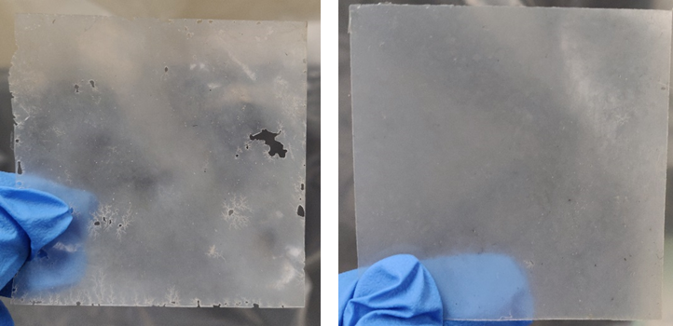
The nylon films pressed with 200% the calculated mass, the calculated mass being the expected mass required for a 100 µm thick film with a density of 1.084 g/mL, had some holes in the beginning; but after implementing a “pre-heating” step the films only had pin sized holes. This step involved keeping the temperature at the target temperature for 15 minutes before applying pressure to ensure that the mold was heated thoroughly. The next adaptation to get rid of the pin holes would be to press from a polymer powder instead of the polymer pellets. To get a polymer powder from the supplied pellets a size reduction method, such as milling, needs to be used.
Figure 15 Left: nylon film with no "pre-heating" step, Right: nylon film with “pre-heating” step
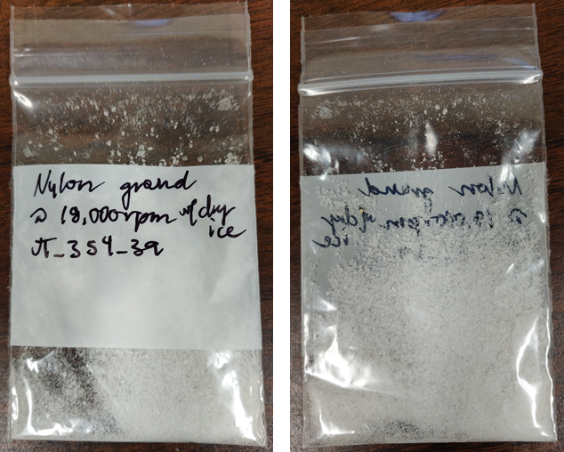
Cryogenic Milling
Cryogenic milling was used to mill polymer resin pellets. A crystalline nylon powder was produced by mixing the nylon pellets in a 2:1 ratio of dry ice to nylon and feeding the mixture into the Ultra Centrifugal Mill ZM 200 at 18,000 rpm at a rate of 1 g/min. The particle size has been visually confirmed to be what this project needs and should produce films when pressed with no defects in comparison to the films pressed from the pellets.
Figure 16 Milled polymer powder to use in hot press
Unfortunately, there were never any films made from the powdered nylon because NASA Langley Research Center was closed because of the COVID-19 crisis. All laboratory work was suspended, and no composite films were made. When evaluating the design requirements fulfilled with the lack of a finished film, as seen in Table 4, the requirement met was the use of non-toxic materials.
Table 4 The design requirements show the definition of success for the project
Design Requirements of Oxygen Barrier Film
Property | Test Method | Definition of Success | Success / Fail
Oxygen Transmission Rate | ASTM D1434-82²³ | Permeability less than or equal to 0.00686 ((𝑐𝑚³∗𝑐𝑚)/(𝑐𝑚∗𝑠∗𝑃𝑎)) x10¹³ | NA
Food Safe | NA | Non-toxic materials were used | Success
Visibility | Spring Session: Determine by sight, Future Testing: UV-Vis | Films are a level of transparency that allows for content observation | NA

Prediction of Oxygen Transition Rate (OTR)
Since the samples could not be made and tested, we can compare predictive models for when this project is continued at a later date. Comparing the models to the experimental data can inform us about the attributes of the additive. A popular model to use to give an estimate of the permeability of the composite film is the Nielson model²⁷:
$$\frac{P}{Po}=\frac{(1-φ)}{(1+\frac{φα}{2})}$$
P = permeability of composite
Po= Permeability of neat polymer
Φ = Volume fraction of the filler
α = Aspect ratio of filler particles α = w/t

The Nielson model treats the additive particles as being “ribbon-like” and assumes that the additive is a consistent size, uniformly dispersed in the matrix, parallel to the surface, and impermeable. Two other models were also implemented in this review are like the Nielson model but have important differences.
The second model, referred to as the random model, assumes the additive as being the same ribbon-like shape as the Nielson but does not assume that the additive is oriented parallel to the film. Rather, this model treats the additive as having a random orientation¹⁸.
$$\frac{P}{Po}=\frac{(1-φ)}{{\left(1+\frac{φα}{3}\right)}^{2}}$$
P = permeability of composite
Po= Permeability of neat polymer
Φ = Volume fraction of the filler
α = Aspect ratio of filler particles α = w/t

The third model looked at for this project, referred to as the hexagonal model, treats the additive as randomly misaligned hexagonal flakes¹⁹.$$\frac{P}{Po}=\frac{(1-φ)}{(1+\frac{μ}{4}(\frac{φ^{2}α^{2}}{1-φ}))}$$
µ=2/27
P = permeability of composite
Po= Permeability of neat polymer
Φ = Volume fraction of the filler
α = Aspect ratio of filler particles α = w/t

If we use the average length measurement of micron BN after 3 days of ball milling, 513 nm, and assume a thickness of at most 5 nm, based on what measurements could be taken from the flakes on SEM images, the aspect ratio is 102.6. Using these assumed values, figure 17 shows how the different models would predict the permeability decrease for the volume fraction added. When the aspect ratio is increased, say if we assume the thickness is 1 nm, the drop in permeability is more drastic. The most drastic difference in permeability is seen if the aspect ratio approaches 1000, by the 5 vol% mark of the additive the permeability of all the models become similar. With all the aspect ratios graphed the random model consistently shows the greatest decrease in permeability.
It should be mentioned that while the models show relative fidelity when being compared to clay additive experiment data²⁷ they haven’t been shown to be as predictable when using 2D materials. Current literature utilizing 2D materials with polyethylene terephthalate (PET)¹¹ and thermoplastic polyurethane (TPU)¹² compare predictive models to experiment data to find a departure from the predicted permeability around the 0.2 vol% mark. It is unclear why this happens at high aspect ratios, like in 2D materials, but it is hypothesized that it is at that point the additive begins to agglomerate.
Figure 17 Predicted permeability to volume fraction of additive with an assumed layer thickness of 5 nm
to a length of 513 nm
Figure 18 Predicted permeability to volume fraction of additive with an assumed layer thickness of 1 nm
to a length of 513 nm

Figure 19 Predicted permeability to volume fraction of additive if the aspect ratio is increased to 1000 the permeability drops to a point where the models are all very similar at the 5 vol% mark

Future Work
This project developed methods to make the composite films. The future work would be to make the films using the hot press from nylon particles mixed with the additive concentration. After sample preparation, the most crucial test is the permeability test to get the oxygen transmission rate, ASTM D1434-82. Once experimental data is obtained from the ASTM D1434-82 tests they can be plotted with the predictive models seen in the Results & Discussion portion of this paper. By comparing the results to the different models, conclusions can be made as to the behavior of the additive.
To get a measured aspect ratio of the additive, BNNs, the thickness of the sheets needs to be obtained. It is suggested to use an atomic force microscope to measure sheet thickness.
Once films are made, then the samples can be characterized to get other useful technical properties, such as: thermal properties (DSC, TGA) , degree of crystallinity (XRD), and mechanical properties (Instron). The final stage to show success would be to do a demonstration study of the film in action with the spoilage of a perishable.

Business, Social, and Ethical Considerations
The considerations for this product are mainly, first, the synthesis of the product, second, the use of the product, and third, the end-life of the product.
In creating this product there was a concerted effort to choose processes and materials that result in the least amount of hazardous by-products as a tenant of green chemistry²⁸. This is reflected by the choice of solvents in the initial solvent-based processes and later the transition to cryogenic milling of the polymer. Isopropyl alcohol was planned as the liquid for the exfoliation and washing processes and is classified as having a green circle safer choice by the EPA.
The importance for the use of the product is mainly in health safety and reliability. All supplies for the end product, nylon 6 and boron nitride, are considered either commonly used in industry or health safe²⁹. Since the purpose for this design would be to keep supplies viable in conditions where restocking is not an option, reliability is the highest requirement ethically.
The end-life of the product was taken into consideration and would be able to be incinerated, unlike metallized films it would be replacing, but factors like reliability were in the end more important than making the material completely recyclable.

Summary and Conclusions
In conclusion, this report has yielded results that have allowed processing details of film fabrication to be determined. Composite film fabrication includes the preparation of the additive and polymers separately and the method of film fabrication by hot press.
The best method of exfoliation of the additive, BNNs, from hexagonal boron nitride was determined to be to ball mill the larger-particle variation of BN with urea for three days. This is shown by qualitative observations of SEM images and how the size measurements begin to approach the smaller-particle variety of the BN. Improvements can be made to this process, such as increasing rpm of the ball mill or the amount of urea used for this process.
The simplest method determined for polymer particle size reduction was cryogenic milling as it alleviates the need of solvent handling and fume hoods. This powder form of nylon can be solid-state ball milled with the additive to thoroughly mix the powders before pressing it into a film in the hot press. To get the most consistent film, allow the hot press to wait until fifteen minutes after reaching the target temperature before pressing.
The work in this report did not yield a high barrier composite film because of the laboratory closure but can provide a concise method of the additive preparation and film synthesis. This falls short of the objectives set out at the beginning of the project, the requirements of a new design, but does give a good jumping-off point for future research in high barrier films by 2D additive composites.
The models addressed in the discussion section give different predicted permeabilities based on the dispersion and geometric factors of the additive. These models reinforce the importance of a large aspect ratio, which is only possible with 2D materials, for the additive as it is the factor that changes the resulting permeability the most.

References
(1) Cooper, M.; Douglas, G.; Perchonok, M. Developing the NASA Food System for Long‐duration Missions. J. Food Sci. 2011, 76 (2), R40–R48.
(2) Catauro, P. M.; Perchonok, M. H. Assessment of the Long‐term Stability of Retort Pouch Foods to Support Extended Duration Spaceflight. J. Food Sci. 2012, 77 (1), S29–S39.
(3) Meal, R.-T.-E. M. Technical Data Package.
(4) Trimarchi, M. How the NASA Space Food Research Lab Works https://science.howstuffworks.com/nasa-space-food-research-lab3.htm (accessed Mar 19, 2020).
(5) Bourland, C.; Fohey, M.; Rapp, R.; Sauer, R. Space Shuttle Food Processing and Packaging. J. Food Prot. 1981, 44 (4), 313–319.
(6) Shafiee, M. Space Food Technology: Production and Recent Developments. Int. J. Adv. Res. Technol. 2017, 6 (2), 120–129.
(7) Helmke, R. Oxygen-Barrier Packaging: How to Prevent Food Spoilage. Plastic Ingenuity, 2017.
(8) Schirmer, H. Oxygen-Barrier Retort Pouch. US4928474A, May 29, 1990.
(9) Bekele, S. High barrier polyvinylidene chloride composition and film. CA2463740C, May 15, 2003.
(10) Donovan, K.; Kong, D.-C.; Liu, L.; Sexton, D.; Tien-Kuei, S. Multi-Layer Hermetically Sealable Film and Method of Making Same. US5888648A, March 30, 1999.
(11) Xie, S.; Istrate, O. M.; May, P.; Barwich, S.; Bell, A. P.; Khan, U.; Coleman, J. N. Boron Nitride Nanosheets as Barrier Enhancing Fillers in Melt Processed Composites. Nanoscale 2015, 7 (10), 4443–4450.
(12) Azeem, M.; Jan, R.; Farrukh, S.; Hussain, A. Improving Gas Barrier Properties with Boron Nitride Nanosheets in Polymer-Composites. Results Phys. 2019, 12, 1535–1541.
(13) Hassanajili, S.; Khademi, M.; Keshavarz, P. Influence of Various Types of Silica Nanoparticles on Permeation Properties of Polyurethane/Silica Mixed Matrix Membranes. J. Membr. Sci. 2014, 453, 369–383.
(14) Ma, J.; Luo, N.; Xie, Z.; Chen, F.; Fu, Q. Preparation of Modified Hexagonal Boron Nitride by Ball-Milling and Enhanced Thermal Conductivity of Epoxy Resin. Mater. Res. Express 2019, 6 (10), 1050d8.
(15) Lei, W.; Mochalin, V. N.; Liu, D.; Qin, S.; Gogotsi, Y.; Chen, Y. Boron Nitride Colloidal Solutions, Ultralight Aerogels and Freestanding Membranes through One-Step Exfoliation and Functionalization. Nat. Commun. 2015, 6 (1), 1–8.
(16) Nielsen, L. E. Models for the Permeability of Filled Polymer Systems. J. Macromol. Sci. Part - Chem. 1967, 1 (5), 929–942. https://doi.org/10.1080/10601326708053745.
(17) Thomas, S.; Joseph, K.; Malhotra, S. K.; Goda, K.; Sreekala, M. S. Polymer Composites, Nanocomposites; Polymer Composites; Wiley, 2013.
(18) Lape, N. K.; Nuxoll, E. E.; Cussler, E. L. Polydisperse Flakes in Barrier Films. J. Membr. Sci. 2004, 236 (1–2), 29–37. https://doi.org/10.1016/j.memsci.2003.12.026.
(19) Moggridge, G. D.; Lape, N. K.; Yang, C.; Cussler, E. L. Barrier Films Using Flakes and Reactive Additives. Prog. Org. Coat. 2003, 46 (4), 231–240. https://doi.org/10.1016/S0300-9440(02)00180-7.
(20) Mukhopadhyay, T. K.; Datta, A. Deciphering the Role of Solvents in the Liquid Phase Exfoliation of Hexagonal Boron Nitride: A Molecular Dynamics Simulation Study. J. Phys. Chem. C 2016, 121 (1), 811–822.
(21) Dadfar, S. A.; Alemzadeh, I.; Dadfar, S. R.; Vosoughi, M. Studies on the Oxygen Barrier and Mechanical Properties of Low Density Polyethylene/Organoclay Nanocomposite Films in the Presence of Ethylene Vinyl Acetate Copolymer as a New Type of Compatibilizer. Mater. Des. 2011, 32 (4), 1806–1813.
(22) Moazeni, N.; Mohamad, Z.; Dehbari, N. Effects of the Processing Methods on the Gas Permeability of PLA/Sepiolite Thin Films: Solution Casting versus Thermo Compression; Trans Tech Publ, 2015; Vol. 695, pp 187–190.
(23) F02 Committee. Test Method for Determining Gas Permeability Characteristics of Plastic Film and Sheeting; ASTM International. https://doi.org/10.1520/D1434-82R15E01.
(24) Dechant, J. Polymer Handbook. 3rd Edition. J. BRANDRUP and E. H. IMMERGUT (Editors). ISBN 0-471-81244-7. New York/Chichester/Brisbane/Toronto/Singapore: John Wiley & Sons 1989. Cloth Bond, ca. 1850 Pages, £ 115.00, $175.00. Acta Polym. 1990, 41 (6), 361–362. https://doi.org/10.1002/actp.1990.010410614.
(25) Hanlon, J. F. Handbook of Package Engineering, 2nd ed.; Technomic Pub. Co: Lancaster, Pa, 1992.
(26) Ultra Centrifugal Mill ZM 200 https://www.retsch.com/products/milling/rotor-mills/zm-200/function-features/ (accessed Mar 11, 2020).
(27) Picard, E.; Vermogen, A.; Gérard, J.-F.; Espuche, E. Barrier Properties of Nylon 6-Montmorillonite Nanocomposite Membranes Prepared by Melt Blending: Influence of the Clay Content and Dispersion State: Consequences on Modelling. J. Membr. Sci. 2007, 292 (1–2), 133–144.
(28) Basics of Green Chemistry https://www.epa.gov/greenchemistry/basics-green-chemistry#twelve (accessed Mar 30, 2020).
(29) Fiume, M. M.; Bergfeld, W. F.; Belsito, D. V.; Hill, R. A.; Klaassen, C. D.; Liebler, D. C.; Marks Jr, J. G.; Shank, R. C.; Slaga, T. J.; Snyder, P. W. Safety Assessment of Boron Nitride as Used in Cosmetics. Int. J. Toxicol. 2015, 34 (3_suppl), 53S-60S.

Appendix: Data
Ball Mill Data
This section gives a more comprehensive look at the data obtained from ball milling boron nitride and urea as a method of exfoliation.
Table A1 Scanning electron microscope images of boron nitride ball milled with urea sampled at different milling times. The images are to provide a qualitative judgement on the appearance of the prepared additive.
 | Nano BN (x20k) Pristine | Micron BN (x20k) Pristine
 | Nano BN (x50k) | Micron BN (x10k)
Day 0
Day 1
Day 2
Day 3
Day 5
Table A2 Numerical data on the distribution of measurements for different ball milling days
Length Data |  |  |  |  | Area Data
Data Set | Average (µm) | Standard Deviation (µm) | Max (µm) | Min (µm) | Data Set | Average (µm²) | Standard Deviation (µm²) | Max (µm²) | Min (µm²)
BN Nano Day 1 | 0.244 | 0.161 | 0.885 | 0.041 | BN Nano Day 1 | 0.0543 | 0.0695 | 0.5440 | 0.0040
BN Nano Day 2 | 0.157 | 0.090 | 0.642 | 0.030 | BN Nano Day 2 | 0.0260 | 0.0368 | 0.2850 | 0.0020
BN Nano Day 3 | 0.159 | 0.092 | 0.724 | 0.026 | BN Nano Day 3 | 0.0263 | 0.0336 | 0.2410 | 0.0020
BN Nano Day 5 | 0.198 | 0.099 | 0.629 | 0.037 | BN Nano Day 5 | 0.0356 | 0.0312 | 0.1590 | 0.0060
BN Micron Day 0 | 3.042 | 1.846 | 9.683 | 0.219 | BN Micron Day 0 | 7.7393 | 7.1817 | 36.3340 | 0.4700
BN Micron Day 1 | 2.208 | 1.812 | 9.776 | 0.225 | BN Micron Day 1 | 5.7835 | 8.3366 | 38.0380 | 0.0800
BN Micron Day 2 | 0.780 | 0.553 | 3.449 | 0.096 | BN Micron Day 2 | 0.6615 | 1.1038 | 8.4990 | 0.0360
BN Micron Day 3 | 0.513 | 0.402 | 2.523 | 0.000 | BN Micron Day 3 | 0.3334 | 0.6666 | 4.8610 | 0.0090
BN Micron Day 5 | 0.185 | 0.153 | 1.112 | 0.015 | BN Micron Day 5 | 0.0362 | 0.0785 | 0.5360 | 0.0009

Figure A1 The span of all the area measurements
Figure A2 The span of all the length measurements

Figure A4 The micron BN ball milled for 5 days has a similar peak measurement occurrence as the nano BN that was ball milled for 1 day
Figure A3 The micron BN ball milled for 5 days has a similar peak measurement frequency as the nano size powder

Appendix: Operating Procedures
Sampling with Conductive Carbon Grid
- Suspend a small amount of powder sample in isopropyl alcohol (IPA)
  - Mixture should be at a very low concentration
  - Mix with vortex until no large particles remain (1-2 minutes)
- Dip conductive carbon grid into solution
  - Handle grid with tweezers, gripping grid by the edge to keep from punching holes into scanning area
  - Either side can be considered right-side up but for this process the carbon side was designated as right side up
- Dry grid sample
  - Use filter paper to dab sample after dipping to remove excess IPA
  - Place sample in vacuum oven (60°C) overnight

Liquid Phase Exfoliation
- Sonicate hexagonal boron nitride (h-BN) with isopropyl alcohol (IPA)
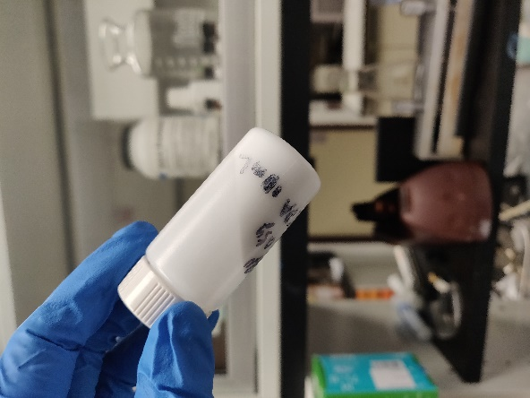
  - Agitate together h-BN and isopropyl alcohol (50 mg/mL concentration) with a wrist shaker
Figure A5 After sonication of liquid
  - Use ultrasonic processor to exfoliate by sonicating for a set amount of time that is listed in lab notebook JT_354
- Separate the BNNs and unexfoliated h-BN
  - The sonicated mixture was then centrifuged to settle the unexfoliated h-BN to the bottom
  - Decant supernatant, this includes transparent BNNs
- Dry supernatant in pre-weighed container to get powder form of BNNS

Ball Milling Exfoliation
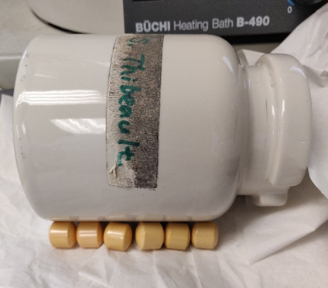
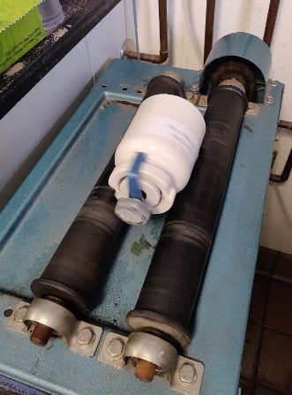
- Prepare ball milling container with a 1:20 weight ratio of hexagonal boron nitride (h-BN): urea powder
Figure A7 Step 2
  - The amount of media in the ball milling container should be the height of the container if placed on its side
Figure A6 Step 1.1 determining the amount of media to include
- Solid-state ball mill the powders together
  - Place container on ball mill running at approximately 160 rpm
  - Run ball mill at a constant speed for the time determined

Particle Size Analysis
Figure A8 The before and after particle size analysis
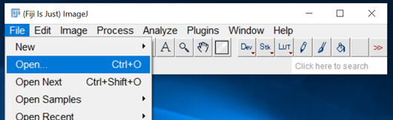
- Open ImageJ program
- Open SEM image for analysis
  - File > Open
- Set scale of photo
  - Select “line” tool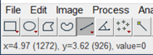
Figure A9 Step 2.1
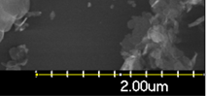
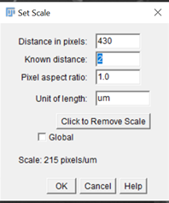
  - Click + Shift to draw straight line on the scale portion of the SEM image
  - Analyze > Set Scale
  - Set “Known distance” and “Unit of length”
  - Upper left of image should read the correct units now
- Save image as separate from original SEM
  - “Save As” > tiff, png, or jpeg> ImageName_ImageJ
Figure A10 Step 3.5
- Take length measurement
  - Select “line” tool
  - Click + drag line over particle requiring length measurement
  - Type “M” on keyboard to take measurement
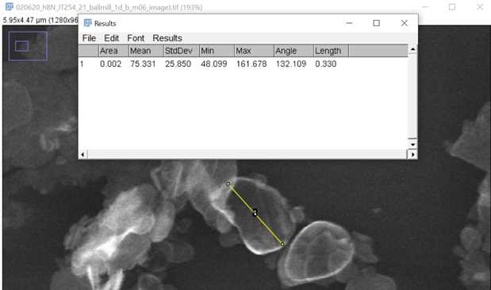
  - If the Results dialog box doesn’t list the measurements desired go to
Analyze > Set Measurements to check the boxes of the desired measurements
  - Select measurements in dialog box when finished with the length measurements and copy/paste into excel
- Take Area measurement
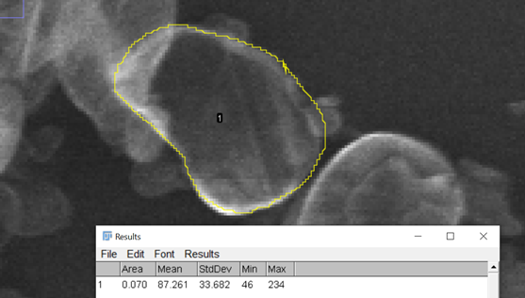
  - Select “freehand selections” tool
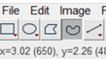
  - Trace around object being measured
  - Type “M” on keyboard to take measurement
  - Select measurements in dialog box when finished with the length measurements and copy/paste into excel
Figure A11 Particle area measurement
Cryogenic Mill Particle Size Reduction
- Place polymer pellets in dry ice
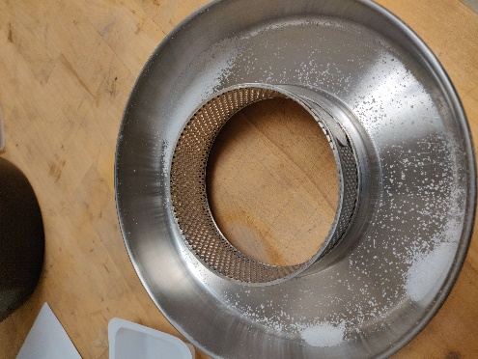
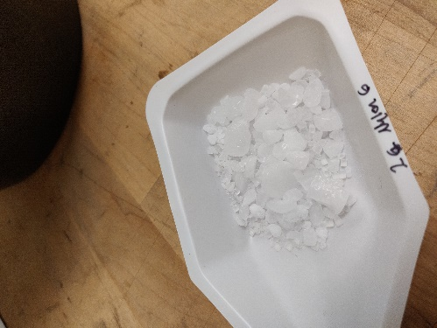
  - The mixture should be approximately a 2:1 ratio of dry ice: polymer
Figure A13 After Step 3
Figure A14 Step 1.1
- Prepare Ultra Centrifugal Mill ZM 200
  - Assemble mill parts according to the manual
  - Turn on mill
  - Set speed to 18,000 rpm
- Feed dry ice polymer mixture into the Ultra Centrifugal Mill ZM 200 at a rate of approximately 1 gram per minute

Hot Press
- Prepare mold and buffer pieces
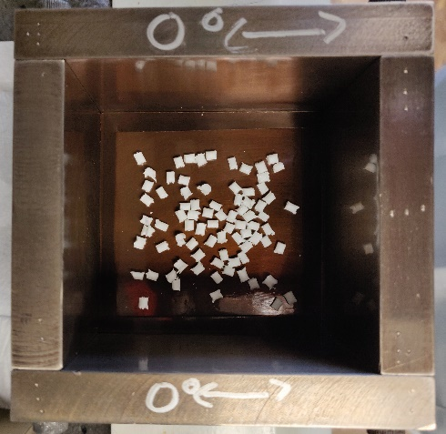
  - Buffer pieces are two polyimide sheets between the bottom and top mold piece and one frame with a .25” border to help with the thickness of the film
  - Spray all parts with mold release and allow to dry
  - Assemble mold and polymer with buffer pieces and frame
- Heat up the hot press
  - Target temperature is 20°C greater than the literature values
  - Attach thermocouple to mold and place mold in hot press with plates below and above
  - Surround mold with insulation
Figure A15 Step 1.3
  - Press might need to be set up to 20°C hotter than target depending on how much insulation is used and the thickness of the mold
- Press polymer
  - After thermocouple reaches target temperature, wait for 15 minutes
  - Press with 1 MPa of pressure and hold for 10 minutes
  - After the 10 minutes, slowly release most of the pressure and turn off the heat
  - When temperature drops below the glass transition temperature of the polymer the rest of the pressure can be released and insulation can be removed
  - Allow mold to cool completely before removing from hot press

