Title
Thermally altered subsurface material of asteroid 162173 Ryugu

Authors
K. Kitazato^{1*}, R. E. Milliken², T. Iwata^{3,4}, M. Abe^{3,4}, M. Ohtake¹, S. Matsuura⁵, Y. Takagi⁶, T. Nakamura⁷, T. Hiroi², M. Matsuoka³, L. Riu³, Y. Nakauchi³, K. Tsumura⁸, T. Arai⁹, H. Senshu¹⁰, N. Hirata¹, M. A. Barucci¹¹, R. Brunetto¹², C. Pilorget¹², F. Poulet¹², J.-P. Bibring¹², D. L. Domingue¹³, F. Vilas¹³, D. Takir¹⁴, E. Palomba¹⁵, A. Galiano¹⁵, D. Perna^{16,11}, T. Osawa¹⁷, M. Komatsu⁴, A. Nakato³, T. Arai¹⁰, N. Takato¹⁸, T. Matsunaga¹⁹, M. Arakawa²⁰, T. Saiki³, K. Wada¹⁰, T. Kadono²¹, H. Imamura³, H. Yano^{3,4}, K. Shirai^{20,3}, M. Hayakawa³, C. Okamoto^{20†}, H. Sawada³, K. Ogawa^{22,20}, Y. Iijima^{3†}, S. Sugita^{23,10}, R. Honda²⁴, T. Morota²³, S. Kameda²⁵, E. Tatsumi^{26,23}, Y. Cho²³, K. Yoshioka²³, Y. Yokota^{3,24}, N. Sakatani²⁵, M. Yamada¹⁰, T. Kouyama²⁷, H. Suzuki²⁸, C. Honda¹, N. Namiki^{18,4}, T. Mizuno^{3,4}, K. Matsumoto¹⁸, H. Noda¹⁸, Y. Ishihara¹⁹, R. Yamada¹, K. Yamamoto¹⁸, F. Yoshida¹⁸, S. Abe²⁹, A. Higuchi¹⁸, Y. Yamamoto^{3,4}, T. Okada^{3,23}, Y. Shimaki³, R. Noguchi³, A. Miura^{3,4}, N. Hirata²⁰, S. Tachibana^{23,3}, H. Yabuta^{30,3}, M. Ishiguro³¹, H. Ikeda³, H. Takeuchi^{3,4}, T. Shimada³, O. Mori³, S. Hosoda³, R. Tsukizaki³, S. Soldini³², M. Ozaki^{3,4}, F. Terui³, N. Ogawa³, Y. Mimasu³, G. Ono³³, K. Yoshikawa³³, C. Hirose³³, A. Fujii³, T. Takahashi³⁴, S. Kikuchi³, Y. Takei^{33,3}, T. Yamaguchi³⁵, S. Nakazawa³, S. Tanaka^{3,4}, M. Yoshikawa^{3,4}, S. Watanabe^{36,3} and Y. Tsuda^{3,4}

Affiliations
¹The University of Aizu, Fukushima, Japan.
²Brown University, Providence, RI, USA.
³Institute of Space and Astronautical Science (ISAS), Japan Aerospace Exploration Agency (JAXA), Sagamihara, Japan.
⁴The Graduate University for Advanced Studies (SOKENDAI), Kanagawa, Japan.
⁵Kwansei Gakuin University, Hyogo, Japan.
⁶Aichi Toho University, Nagoya, Japan.
⁷Tohoku University, Sendai, Japan.
⁸Tokyo City University, Tokyo, Japan.
⁹Ashikaga University, Tochigi, Japan.
¹⁰Chiba Institute of Technology, Chiba, Japan.
¹¹Laboratoire d’Etudes Spatiales et d’Instrumentation en Astrophysique (LESIA), Observatoire de Paris, Meudon, France.
¹²Institut d’Astrophysique Spatial, Université Paris-Sud, Orsay, France.
¹³Planetary Science Institute, Tucson, AZ, USA.
¹⁴Astromaterials Research and Exploration Science, NASA Johnson Space Center, Houston, TX, USA.
¹⁵Istituto di Astrofisica e Planetologia Spaziali, Istituto Nazionale di Astrofisica (INAF), Roma, Italy.
¹⁶Osservatorio Astronomico di Roma, INAF, Monte Porzio Catone, Italy.
¹⁷Japan Atomic Energy Agency, Ibaraki, Japan.
¹⁸National Astronomical Observatory of Japan, Tokyo, Japan.
¹⁹National Institute for Environmental Studies, Ibaraki, Japan.
²⁰Kobe University, Kobe, Japan.
²¹University of Occupational and Environmental Health, Fukuoka, Japan.
²²JAXA Space Exploration Center, JAXA, Sagamihara, Japan.
²³The University of Tokyo, Tokyo, Japan.
²⁴Kochi University, Kochi, Japan.
²⁵Rikkyo University, Tokyo, Japan.
²⁶Instituto de Astrofísica de Canarias, University of La Laguna, Tenerife, Spain.
²⁷National Institute of Advanced Industrial Science and Technology, Tokyo, Japan.
²⁸Meiji University, Tokyo, Japan.
²⁹Nihon University, Chiba, Japan.
³⁰Hiroshima University, Hiroshima, Japan.
³¹Seoul National University, Seoul, Korea.
³²University of Liverpool, Liverpool, UK.
³³Research and Development Directorate, JAXA, Sagamihara, Japan.
³⁴NEC Corporation, Tokyo, Japan.
³⁵Mitsubishi Electric Corporation, Kanagawa, Japan.
³⁶Nagoya University, Nagoya, Japan.
*Correspondence to: kitazato@u-aizu.ac.jp
†Deceased

Introductory paragraph
Studies of meteorite analysis and theoretical modeling have indicated the possibility that some carbonaceous near-Earth asteroids are thermally altered due to radiative heating during close approaches to the Sun in addition to parent body processes (Nakamura, 2005; Marchi et al., 2009; Chaumard et al., 2012). In April 2019, the Hayabusa2 mission successfully completed an artificial impact experiment on the carbonaceous near-Earth asteroid 162173 Ryugu (Arakawa et al., 2020), which provided an opportunity to investigate the effects of radiative heating through the exposed subsurface material. Here we report observations of the Ryugu’s subsurface material by the Near-Infrared Spectrometer (NIRS3) on the Hayabusa2 spacecraft. Spectra of the subsurface material exhibit a slightly stronger and peak-shifted hydroxyl absorption feature compared to that observed for the surface, indicating that space weathering and/or radiative heating caused a subtle change in the spectrum of Ryugu surface. However, the shape of the absorption feature still suggests that the subsurface material experienced heating above 300 ˚C similar to the surface. In contrast, our thermal modeling shows that radiative heating does not increase the subsurface temperature at 1 m depth above 200 ˚C even if the semimajor axis is reduced down to 0.344 au. This supports that the Ryugu material would have been preferentially altered due to radiogenic and/or impact heating on the parent body rather than radiative heating.

Main text
JAXA’s Hayabusa2 spacecraft had visited the carbonaceous near-Earth asteroid 162173 Ryugu from June 2018 through November 2019. The initial survey using the onboard instruments revealed that Ryugu is a rubble-pile object as indicated by its low bulk density and boulder-rich surface appearance (Watanabe et al., 2019) and that phyllosilicates are present on its surface (Kitazato et al., 2019). These findings indicate that Ryugu would have been generated from impact fragments of an aqueously altered parent body. Meanwhile, NASA’s OSIRIS-REx spacecraft, which reached the carbonaceous near-Earth asteroid 101955 Bennu in December 2018, also revealed a rubble-pile nature and the presence of phyllosilicates for that body (Lauretta et al., 2019; Hamilton et al., 2019). Although these two asteroids have some similarities, they are apparently distinct in terms of the degree of alteration. The visible and near-infrared reflectance spectrum of Bennu shows a good agreement with those of aqueously altered carbonaceous chondrites (Hamilton et al., 2019), while that of Ryugu is most similar to those of thermally- and/or shock-metamorphosed carbonaceous chondrites (Kitazato et al., 2019). This indicates that Ryugu possibly experienced a different evolutionary pathway with more heating than Bennu. As the cause of this heating, two possibilities can be considered: (1) parent body processes including heating by the decay of short-lived radionuclides and impact heating (Sugita et al., 2019), and (2) a secondary process due to radiative heating from the Sun in the past low perihelion distances (Michel & Delbo, 2010). However, no evidence to distinguish between these two heating mechanisms has been found so far due to Ryugu’s spectrally homogeneous surface (Barucci et al., 2019).

On April 5, 2019, Hayabusa2 carried out an artificial impact experiment on the surface of Ryugu using the Small Carry-on Impactor (SCI) (Saiki et al., 2017). The SCI module was separated from the spacecraft at 0.5 km altitude and fired a 2 kg copper projectile with a velocity of about 2 km/s toward the target site on the equatorial region of Ryugu after the spacecraft had moved away to avoid the debris impacts. On April 25, Hayabusa2 approached the target site and took images using the Optical Navigation Camera Telescope (ONC-T), which shows that a semi-circular shaped crater of 17 m in diameter (hereafter the SCI crater) was newly formed at 7.9˚N, 301.3˚E (Arakawa et al., 2020). A heterogeneous ejecta growth was observed by the Deployable Camera (DCAM3), and the analysis of ONC-T images revealed that the excavated subsurface material was mainly distributed to the north side of the SCI crater (Arakawa et al., 2020). Additionally, the maximum depth of the SCI crater is 2.7 m, and it has been estimated that the subsurface material ejected from about 1 m depth would be dominantly distributed on and around the crater (Arakawa et al., 2020). This experiment therefore provides a unique opportunity to test the effect of surface modification by radiative heating (Nakamura, 2005; Marchi et al., 2009; Chaumard et al., 2012) and space weathering (Brunetto et al., 2015). After having performed three descent operations for a detailed survey of the SCI crater, on July 11, Hayabusa2 succeeded in collecting a sample from the site about 20 m away to the northeast of the SCI crater. In those descent operations, we conducted observations of the SCI crater region with the NIRS3 spectrometer that takes continuous spectra over the effective wavelength range from 1.8 to 3.2 µm with a 0.1˚ field of view (Iwata et al., 2017).

Figure 1a shows the location of NIRS3 footprints for observations of the SCI crater region. We choose two sites each from three descent observations conducted on separate dates and examined their spectra (see Methods). The NIRS3 footprints of May 16 (sites 1 and 2) pass through the south region of the crater, while those of May 30 (sites 3 and 4) and June 13 (sites 5 and 6) come across the north region and inside of the crater. From the distribution pattern of crater ejecta revealed by ONC-T and DCAM3 images (Arakawa et al., 2020), it is found that the former and the latter correspond to ejecta-free and ejecta-rich areas, respectively. The reflectance spectra observed for those six sites are shown in Fig. 1b. All the spectra including the ones observed for ejecta-rich areas exhibit a weak and narrow hydroxyl absorption feature centered at 2.72 µm, which is consistent with that observed across the entire surface of Ryugu (Kitazato et al., 2019). This indicates that the subsurface material has also been thermally altered to the same degree as the surface.

Moreover, we evaluated spectral differences between surface and subsurface by comparing the spectra observed for the SCI crater region and regions far from there. Figure 1c shows the ratio of normalized reflectance spectra between the SCI crater region and the surface standard (see Methods). The ratio-spectra of the sites 1 and 2 are almost flat, while those of the sites 3 to 6 exhibit a subtle but clear feature at 2.7 µm, indicating that the hydroxyl absorption feature observed for ejecta-rich areas is slightly stronger and its peak position is shifted toward a shorter wavelength within the spectral resolution of NIRS3 compared to the surface. Such spectral differences have not been observed in any other surface of Ryugu, which could indicate being an intrinsic property of the subsurface material.

It has been found that the peak position of 2.7 µm hydroxyl feature varies with the Mg/Fe ratio of phyllosilicates (Beck et al., 2010; Takir et al., 2013) and does not closely correlate with grain size and porosity (Potin et al., 2019). Thus, it seems difficult to explain the spectral differences between surface and subsurface by grain size and porosity. In fact, no evidence showing some differences in grain size and porosity for the SCI crater region has been obtained from the Thermal Infrared Imager (TIR) as well (Sakatani et al., 2020). Alternatively, space weathering can be considered as a likely cause to explain it. Solar wind ion irradiation as a primary source of space weathering influences surface at only several ten nm scale and sputters the volatile Mg more easily than the heavier Fe (Lantz et al., 2017). The recent laboratory experiment shows that spectra of irradiated carbonaceous chondrite measured under vacuum condition exhibit the similar peak shift (Rubino et al., 2020). Additionally, radiative heating also could be a potential mechanism, however, there is no available data to evaluate it at present.

In spite of some differences from the surface, the spectral properties of the subsurface material still support a close similarity with thermally- and/or shock-metamorphosed carbonaceous chondrites. It thus questions whether the thermal alteration of the Ryugu’s subsurface material could be explained by radiative heating during its past orbital history. The orbits of near-Earth asteroids evolve chaotically due to a combination of close encounters with the terrestrial planets and resonances with the giant planets (Morbidelli et al., 2002). A theoretical study that investigated the potential past orbital evolution of Ryugu shows the possibility that its perihelion distance was reduced down to 0.1 au, making a surface temperature increase up to ~1200 ˚C (Michel & Delbo, 2010). This suggests that radiative heating might be able to easily explain the thermal alteration of the surface of Ryugu, however, the thermal history for a depth of the SCI crater has been poorly investigated. Thus, we examined what ranges of temperatures the subsurface material of the SCI crater could have experienced in the past taking into account the Ryugu’s orbital evolution (see Methods).

Figure 2a and 2b show the maximum temperatures achieved at the surface and 1 m depth, respectively, for one orbital revolution. We find that the maximum temperature of the surface increases with decreasing perihelion distance, while that of 1 m depth increases with decreasing semimajor axis. The surface temperature seems to reach 700 ˚C at a perihelion distance of 0.15 au. Because laboratory spectra of the heated Ivuna CI chondrite sample show that the 2.7 µm hydroxyl feature perfectly disappears when the temperature exceeds 700 ˚C (Fig. 3), Ryugu is likely to have never approached the Sun at a distance less than 0.15 au. Moreover, dynamical models of near-Earth asteroids indicate that there is no object having an orbit entirely inside that of Mercury (Bottke et al., 2002; Greenstreet et al., 2012; Granvik et al., 2018), and that the smallest semimajor axis observed in the model is 0.344 au (Greenstreet et al., 2012). For that semimajor axis, the maximum temperature at 1 m depth is estimated to be less than 200 ˚C (Fig. 2c). If impact gardening occurs together with radiative heating, more heated materials might be able to exist in the subsurface. However, it cannot explain the observed spectral differences of surface and subsurface. Thus, we can constrain the radiative heating of the material at 1 m depth on Ryugu to below 200 ˚C.

Although it is difficult to estimate the exact heating temperature, the narrow and weak hydroxyl feature observed in Ryugu spectra supports temperature above 300 ˚C, as demonstrated by the dehydration and dehydroxylation of Mg-rich phyllosilicates occurring between 300 and 800 ˚C (King et al., 2015). There is also a possibility that a weak hydroxyl feature occurs due to incomplete hydration reactions on the parent body, however, the band position of 2.72 µm indicates that the Ryugu material had experienced a high degree of aqueous alteration (Bates et al., 2020). We thus consider the cause of the thermal alteration of the Ryugu material is more in line with the radiogenic and impact heating of the parent body materials from which it formed rather than radiative heating after re-accretion and formation.

Methods
Location of NIRS3 footprints. The spacecraft trajectories for observations of the SCI crater region have not been well determined due to frequent delta-v maneuvers. That is why we identified the location of NIRS3 footprints using continuous shooting images by ONC-T camera. The boresight of NIRS3 is within the field-of-view of ONC-T and the pixels of ONC-T image corresponding to NIRS3 footprint have been precisely determined through the cruise phase observations (Tatsumi et al., 2019). To derive the footprints shown in Fig. 1a, we used 18 images taken at 02:36:15-02:40:39 on May 16, 18 images taken at 02:35:44-02:40:07 on May 30, and 12 images taken at 02:00:18-02:16:59 on June 13.

Analysis of NIRS3 spectra. Supplementary Table 1 shows the details of the NIRS3 spectra that we used for the analysis of the SCI crater region. The spectra of sites 3-4 and 5-6 were obtained under 9 and 10 ˚C respectively higher detector temperatures than the nominal value due to thermal flux from the surface of Ryugu. Because the responsivity of detector changes with its temperature, we corrected that effect using the additional calibration data obtained under the same temperature. The data processing other than that correction is same as the previous study (Kitazato et al., 2019).

To evaluate spectral differences between surface and subsurface, we compared the spectra of the SCI crater region with those of regions not contaminated by the crater ejecta. Supplementary Table 2 shows the details of the NIRS3 spectra of regions that we choose as the surface standard. As shown in Supplementary Figure 1, it has been found that a small residual of thermal correction appears between spectra with a difference surface temperature. To avoid such an artifact, we choose a region having the similar surface temperature to the SCI crater region for the surface standard. Small variations in spectral slope among the spectra shown in Fig. 1c might be due to the thermal residual.

Thermophysical modeling. To investigate the effects of radiative heating on the SCI crater region, we set up a thermophysical model (Spencer et al., 1989) that computes surface and subsurface temperatures of Ryugu with a Sun-approaching orbit. Taking into account the location of the SCI crater (Arakawa et al., 2020) and the Ryugu’s obliquity (Watanabe et al., 2019), we assume a single facet on the equator of a spherical object having the spin axis perpendicular to its orbital plane. The facet temperature $T$ as a function of time $t$ and depth $z$ is determined by numerically solving the one-dimensional heat conduction equation:
$$\begin{aligned}ρ\left(1-ϕ\right)c\frac{∂T}{∂t}=κ\frac{∂^{2}T}{∂z^{2}}\#\left(1\right)\end{aligned}$$
where $ρ$ is the grain density, $ϕ$ is the porosity, $c$ is the specific heat capacity, and $κ$ is the thermal conductivity. Because the Ryugu surface is covered by decimeter- to meter-sized rocks without fine grains (Jaumann et al., 2019), we used the parameter values for the Ryugu boulder derived from in-situ measurements by the MASCOT lander (Grott et al., 2019), consistent with remote sensing measurements (Okada et al., 2020; Shimaki et al., 2020).

The boundary condition at the surface is given by
$$\begin{aligned}κ{\left(\frac{∂T}{∂z}\right)}_{z=0}=εσT_{z=0}^{4}-\frac{\left(1-A\right)S_{⨀}}{r^{2}}\text{max}\left(0,\cos{θ}\right)\#\left(2\right)\end{aligned}$$
where $ε$ is the emissivity, $σ$ is the Stefan-Boltzmann constant, $A$ is the bond albedo, $S_{⨀}$ is the solar constant at 1 au, $r$ is the heliocentric distance in au, and $θ$ is the angle between the surface normal and the solar vector. The position of Ryugu with respect to the Sun at a given time is computed through the Kepler’s equation solution (Murray & Dermott, 1999). We used a bond albedo of 0.0146 and an emissivity of 1.0 (Grott et al., 2019), and assumed a constant rotational period of 7.6326 h (Watanabe et al., 2019).

To ensure the sufficient depth for the seasonal temperature variations, we assumed an adiabatic boundary condition at 5 m depth:

$$\begin{aligned}{\left(\frac{dT}{dz}\right)}_{z=5 \text{m}}=0\#\left(3\right)\end{aligned}$$

The current seasonal thermal skin depth of Ryugu is $l_{s}=\sqrt{κP_{\text{orb}}/2πρ(1-ϕ)c}≈1.1 \text{m}$, where $P_{\text{orb}}$ is the orbital period, and it decreases with decreasing semimajor axis. We ran the model with a time step of 15 s and a depth step of 0.01 m. After the 10 years integration, the results converged to temperature deviations of less than 1 K.

Data availability
The data that support the plots within this paper and other findings of this study are available from the corresponding author upon reasonable request. The raw and calibrated NIRS3 data will be made available through the JAXA Data Archives and Transmission System (DARTS) website (https://darts.isas.jaxa.jp/planet/project/hayabusa2/).

References
- Nakamura, T. Post-hydration thermal metamorphism of carbonaceous chondrites. J. Miner. Petrol. Sci. 100, 260-272 (2005).
- Marchi, S., Delbo, M., Morbidelli, A., Paolicchi, P. & Lazzarin, M. Heating of near-Earth objects and meteoroids due to close approaches to the Sun. Mon. Not. R. Astron. Soc. 400, 147-153 (2009).
- Chaumard, N., Devouard, B., Delbo, M., Provost, A. & Zanda, B. Radiative heating of carbonaceous near-Earth objects as a cause of thermal metamorphism for CK chondrites. Icarus 220, 65-73 (2012).
- Arakawa, M. et al. An artificial impact on the asteroid 162173 Ryugu formed a crater in the gravity-dominated regime. Science 368, 67-71 (2020).
- Watanabe, S. et al. Hayabusa2 arrives at the carbonaceous asteroid 162173 Ryugu–A spinning top-shaped rubble pile. Science 364, 268-272 (2019).
- Kitazato, K. et al. The surface composition of asteroid 162173 Ryugu from Hayabusa2 near-infrared spectroscopy. Science 364, 272-275 (2019).
- Lauretta, D. S. et al. The unexpected surface of asteroid (101955) Bennu. Nature 568, 55-60 (2019).
- Hamilton, V. E. et al. Evidence for widespread hydrated minerals on asteroid (101955) Bennu. Nat. Astron. 3, 332-340 (2019).
- Sugita, S. et al. The geomorphology, color, and thermal properties of Ryugu: Implications for parent-body processes. Science 364, 252-252 (2019).
- Michel, P. & Delbo, M. Orbital and thermal evolutions of four potential targets for a sample return space mission to a primitive near-Earth asteroid. Icarus 209, 520-534 (2010).
- Barucci, M. A. et al. Multivariable statistical analysis of spectrophotometry and spectra of (162173) Ryugu as observed by JAXA Hayabusa2 mission. Astron. Astrophys. 629, A13 (2019).
- Saiki, T. et al. The small carry-on impactor (SCI) and the Hayabusa2 impact experiment. Space Sci. Rev. 208, 165-186 (2017).
- Brunetto, R., Loeffler, M. J., Nesvorny, D., Sasaki, S. & Strazzulla, G. in Asteroids IV (eds Michel, P., DeMeo, F. E. & Bottke, W. F.) 597-616 (University of Arizona Press, 2015).
- Iwata, T. et al. NIRS3: the near-infrared spectrometer on Hayabusa2. Space Sci. Rev. 208, 317-337 (2017).
- Beck, P. et al. Hydrous mineralogy of CM and CI chondrites from infrared spectroscopy and their relationship with low albedo asteroids. GeoChim. Cosmo. Acta 75, 4881-4892 (2010).
- Takir, D. et al. Nature and degree of aqueous alteration in CM and CI carbonaceous chondrites. Meteorit. Planet. Sci. 48, 1618-1637 (2013).
- Potin, S., Beck, P., Schmitt, B. & Moynier, F. Some things special about NEAs: Geometric and environmental effects on the optical signatures of hydration. Icarus 333, 415-428 (2019).
- Sakatani, N. et al. Thermophysical property of the artificial impact crater on asteroid Ryugu. 51st Lunar Planet. Sci. Conf. abstr. 2326 (2020).
- Lantz, C. et al. Ion irradiation of carbonaceous chondrites: A new view of space weathering on primitive asteroids. Icarus 285, 43-57 (2017).
- Rubino, S. et al. Irradiation effects on the 2.7 µm phyllosilicate band. in preparation (2020).
- Morbidelli, A., Bottke, W. F., Froeschlé, C. & Michel, P. in Asteroids III (eds Bottke, W. F., Cellino, A., Paolicchi, P. & Binzel, R. P.) 409-422 (University of Arizona Press, 2002).
- Bottke, W. F. et al. Debiased orbital and absolute magnitude distribution of the near-Earth objects. Icarus 156, 399-433 (2002).
- Greenstreet, S., Ngo, H. & Gladman, B. The orbital distribution of near-Earth objects inside Earth’s orbit. Icarus 217, 355-366 (2012).
- Granvik, M. et al. Debiased orbit and absolute-magnitude distributions for near-Earth objects. Icarus 312, 181-207 (2018).
- King, A. J., Solomon, J. R., Schofield, P. F. & Russell, S. S. Characterising the CI and CI-like carbonaceous chondrites using thermogravimetric analysis and infrared spectroscopy. Earth Planets Space 67, 198 (2015).
- Bates, H. C. et al. Linking mineralogy and spectroscopy of highly aqueously altered CM and CI carbonaceous chondrites in preparation for primitive asteroid sample return. Meteorit. Planet. Sci. 55, 77-101 (2020).
- Wada, K. et al. Asteroid Ryugu before the Hayabusa2 encounter. Prog. Earth Planet. Sci. 5, 82 (2018).
- Hiroi, T. et al. Reflectance spectra (UV-3µm) of heated Ivuna (CI) meteorite and newly identified thermally metamorphosed CM chondrites. 27th Lunar Planet. Sci. Conf. abstr. 551 (1996).
- Tatsumi, E. et al. Updated inflight calibration of Hayabusa2’s optical navigation camera (ONC) for scientific observations during the cruise phase. Icarus 325, 153-195 (2019).
- Spencer, J. R. et al. Systematic biases in radiometric diameter determinations. Icarus 78, 337-354 (1989).
- Jaumann, R. et al. Images from the surface of asteroid Ryugu show rocks similar to carbonaceous chondrite meteorites. Science 365, 817-820 (2019).
- Grott, M. et al. Low thermal conductivity boulder with high porosity identified on C-type asteroid (162173) Ryugu. Nat Astron. 3, 971-976 (2019).
- Okada, T. et al. Highly porous nature of a primitive asteroid revealed by thermal imaging. Nature 579, 518-522 (2020).
- Shimaki, Y. et al. Thermophysical properties of the surface of asteroid 162173 Ryugu: Infrared observations and thermal inertia mapping. Icarus, under review (2020).
- Murray, C. D. & Dermott, S. F. Solar System Dynamics: The Two-Body Problem (Cambridge University Press, 1999).

Acknowledgements
The Hayabubsa2 NIRS3 was funded by JAXA and built by Meisei Electric, Genesia, and Hamamatsu Photonics. We thank H. Murao, Y. Sakata, and K. Taguchi for their efforts in development of NIRS3. We acknowledge the support from JAXA, CNES and ASI. D.L.D. and D.T. were supported by NASA’s Hayabusa2 Participating Scientist Program (NNX17AL02G, NNX16AL34G). A part of this study was supported by the JSPS Grant-in-Aid for Scientific Research (16H04044, 17H06459, 17K05639) and the JSPS Core-to-Core Program (17H01175).

Author contributions
K.K. led the study and wrote the paper with inputs from R.E.M, T.I., M.A., Y.T., T.N., T.H., M.M., L.R., M.A.B., R.B., C.P., C.P., D.L.D., D.T., E.P., and A.G. All other authors participated in science data acquisition, mission planning, mission operations, or project management, and/or contributed to the discussion. The entire Hayabusa2 project team made this mission possible.

Competing financial interests
The authors declare no competing interests.

Materials and correspondence
Correspondence and requests for materials should be addressed to K.K.

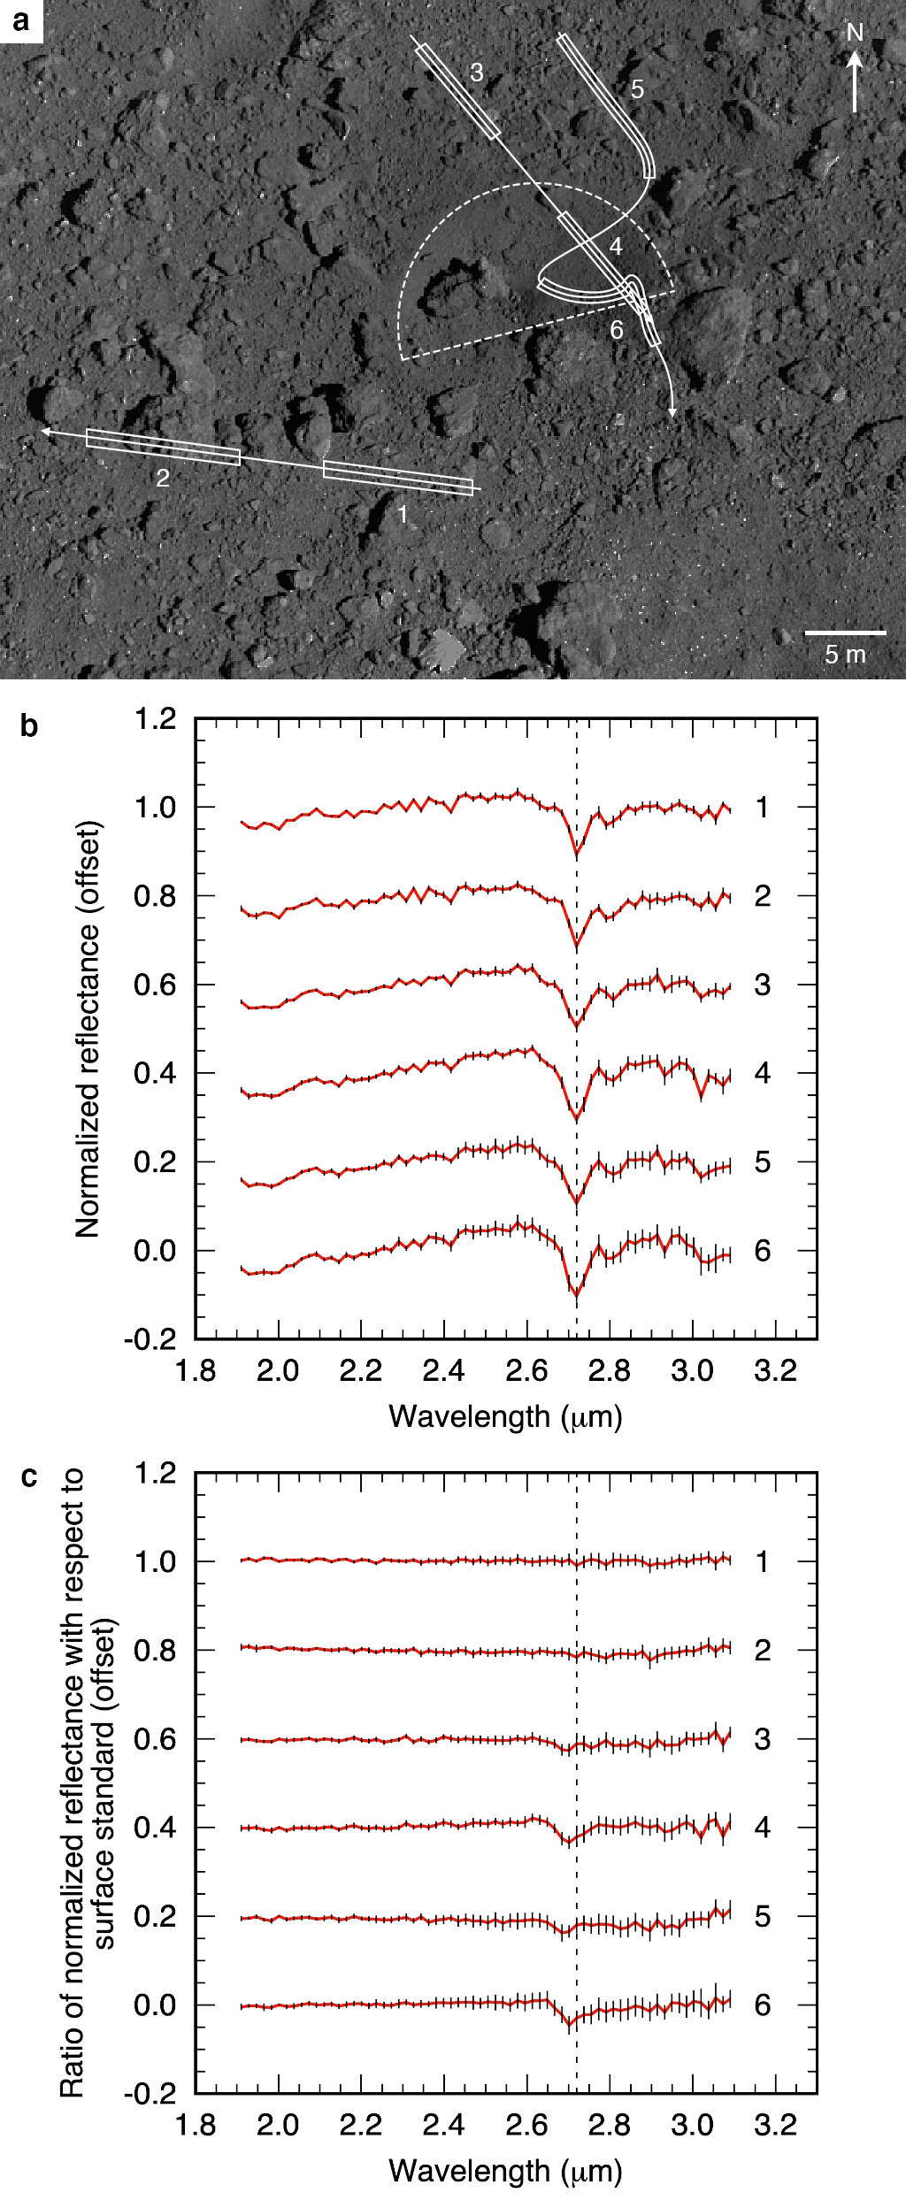
Fig. 1. | NIRS3 observations of the SCI crater region. a. Context image taken by the ONC-T camera. The dashed semi-circle represents the rim of the SCI crater (Arakawa et al., 2020). The arrows indicate the motion of NIRS3 footprints during three descent operations. b. NIRS3 spectra averaged over regions corresponding to boxes in a. Error bars are 1σ within the boxes. c. Ratios of the normalized spectra shown in b to the ones of the surface standard. The spectra are normalized and vertically shifted for clarify. The dashed vertical lines at 2.72 µm denote the peak position of hydroxyl absorption feature.

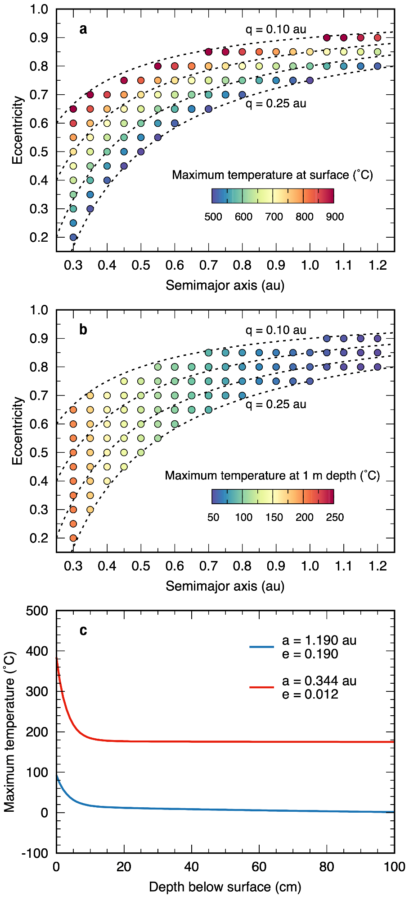
Fig. 2 | Maximum surface and subsurface temperatures at the SCI crater region. a. Maximum surface temperature for one revolution at a given Sun-approaching orbit. A grain density of 2,420 kg m⁻³, a porosity of 41%, a thermal conductivity of 0.16 W m⁻¹ K⁻¹, and the temperature-dependent heat capacity (Wada et al., 2018) have been assumed. The dashed curves denote the perihelion distance $q$ of 0.10, 0.15, 0.20 and 0.25 au. b. Same as a but for a depth of 1 m. c. Maximum temperature profile at the current orbit (blue) and the closest orbit to the Sun (red).

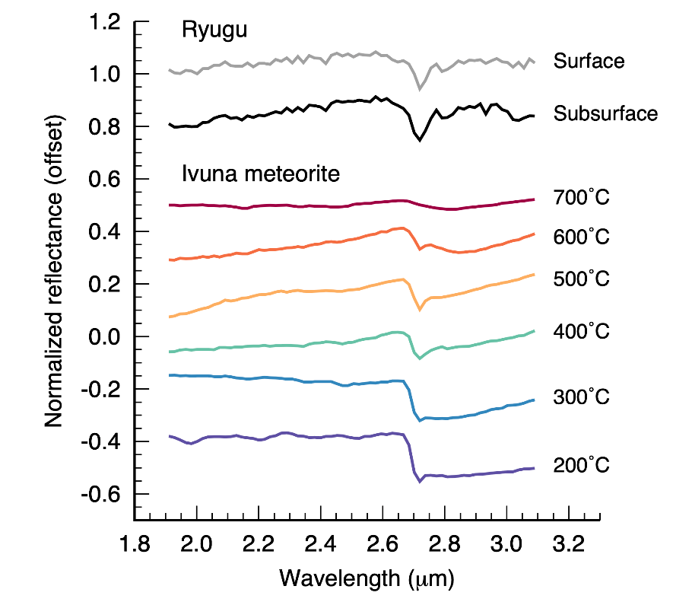
Fig. 3 | Ryugu’s surface and subsurface spectra compared with laboratory spectra of heated Ivuna meteorite sample. The spectra of Ivuna meteorite taken from the Reflectance Experiment Laboratory (RELAB) database (Hiroi et al., 1996) are resampled with the same resolution as Ryugu spectra. The spectra are normalized and vertically shifted for clarify.

Supplementary information

Supplementary Table 1. Details of observations of the SCI crater region.

Site  # | Observation date and time  (UTC) |  | # of  spectra | Solar distance  (au) | Phase angle  (˚) | LIDAR range  (m) | Surface  temp.  (˚C)
1 | 2019-05-16 | 02:36:21 – 02:37:46 | 8 | 1.25 | 31.1 | – | $${35}_{-9}^{+9}$$
2 |  | 02:38:50 – 02:40:16 | 8 | 1.25 | 31.1 | – | $${23}_{-15}^{+16}$$
3 | 2019-05-30 | 02:35:50 – 02:37:16 | 8 | 1.21 | 33.7 | 252 – 277 | $${41}_{-8}^{+7}$$
4 |  | 02:38:30 – 02:39:56 | 8 | 1.21 | 33.7 | 298 – 325 | $${50}_{-9}^{+7}$$
5 | 2019-06-13 | 02:00:17 – 02:01:43 | 8 | 1.17 | 35.7 | 82 – 107 | $${41}_{-12}^{+17}$$
6 |  | 02:02:26 – 02:03:51 | 8 | 1.17 | 35.7 | 119 – 145 | $${42}_{-13}^{+20}$$

Supplementary Table 2. Details of observations of the surface standard.

Observation date and time  (UTC) |  | # of spectra | Longitude  (˚) | Latitude  (˚) | LIDAR range  (km) | Surface temp. (˚C)
2019-05-15 | 10:22:09 – 10:44:56 | 128 | 321 – 340 | 4 – 7 | 8.5 – 9.0 | $${32}_{-11}^{+7}$$
2019-05-29 | 06:58:34 – 07:21:21 | 128 | 112 – 136 | -33 – -30 | 13.1 – 13.7 | $${40}_{-9}^{+5}$$
2019-06-12 | 02:46:54 – 03:09:41 | 128 | 314 – 327 | -44 – -29 | 18.5 – 19.1 | $${44}_{-1}^{+2}$$

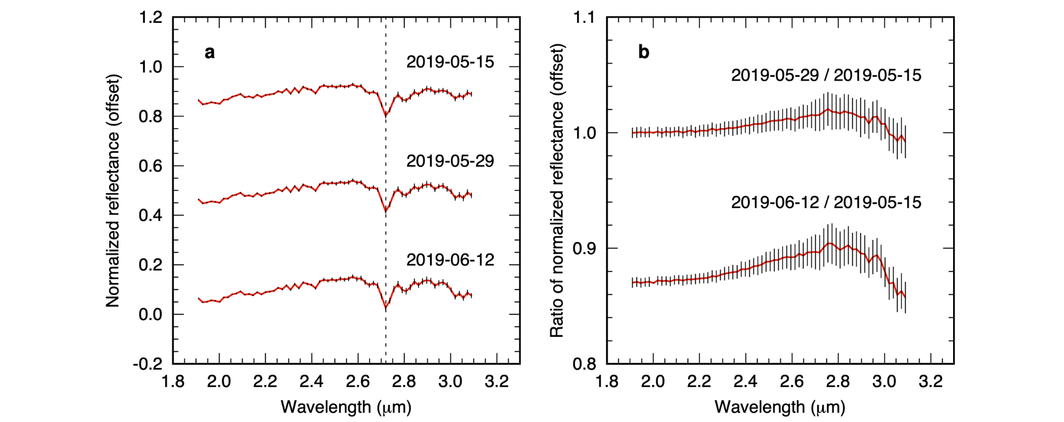
Supplementary Figure 1. NIRS3 spectra of the surface standard. a. Spectra averaged over regions having the similar surface temperature to the SCI crater region. The details of these spectra are listed in Supplementary Table 2. b. Ratios between the normalized spectra shown in a. The non-flat shape of the ratio-spectra indicates the residual of thermal correction. The spectra are normalized and vertically shifted for clarify.

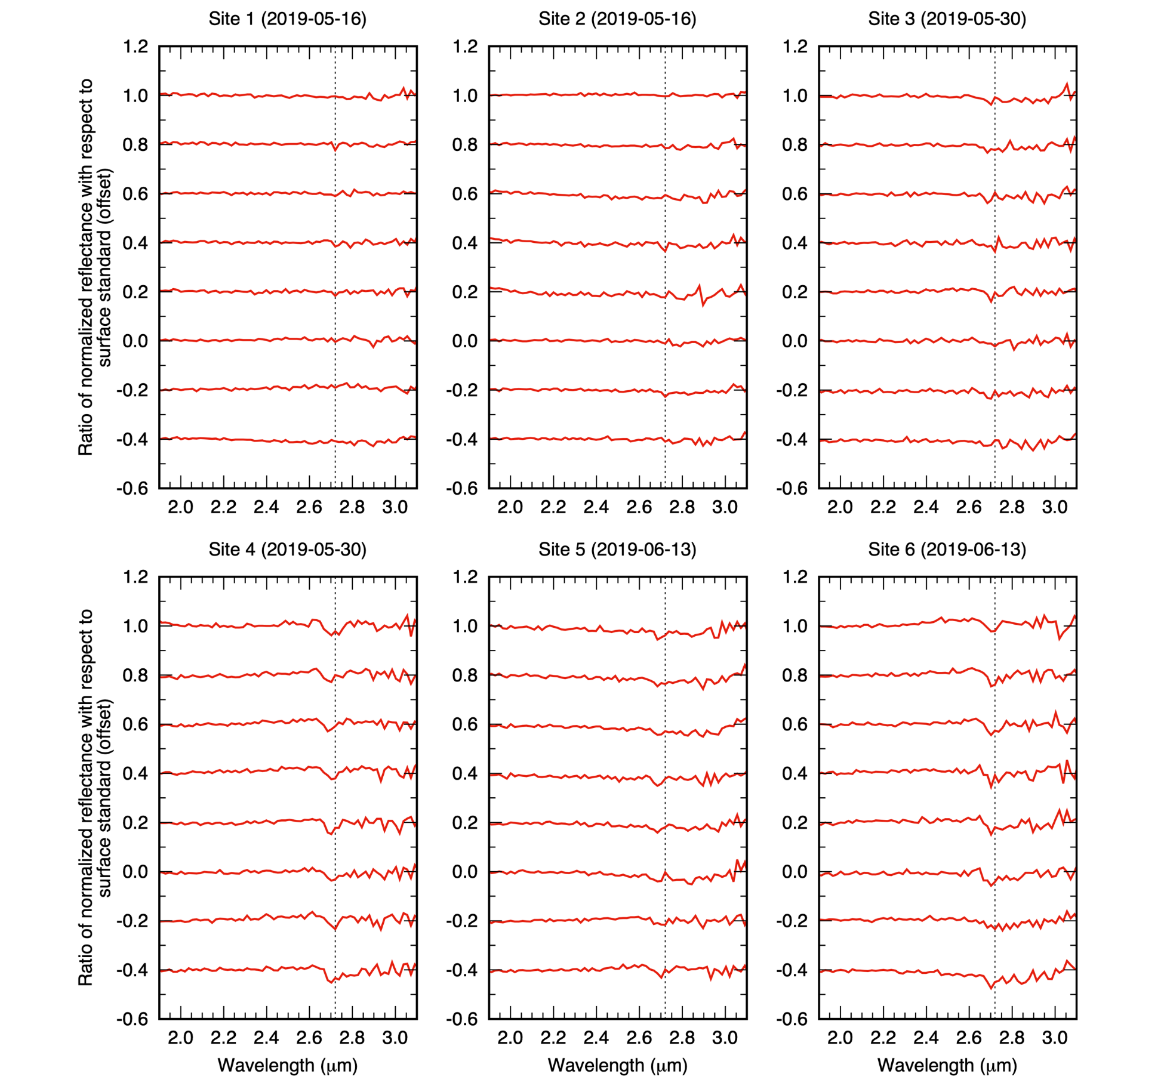
Supplementary Figure 2. Individual spectra used for the average spectra of the SCI crater region. The spectra are divided by the ones of the surface standard and vertically shifted for clarify.

