Title:
Recurring Causes of Human Spaceflight Mishaps During Flight Tests and Early Operations

Forum:
NESC Academy

Target Audience:
General engineering, operations, and S&MA personnel

Target Date/Time:
Thursday 5/14/20 from 1:30-3:00 p.m. EDT

Abstract:
Dr. Tim Barth, NASA Engineering and Safety Center (NESC) systems engineer, and Steve Lilley, NASA Safety Center senior safety engineer, will present the findings and recommendations from a technical study recently published by the NESC. An analysis of recurring causes underlying human spaceflight mishaps that occurred during flight tests and early operations was performed. Eight mishaps from the Apollo, Soyuz, Skylab, Space Shuttle, and Constellation Programs (i.e., the Ares-1X test flight) and early commercial suborbital operations were included in the study. Detailed event analyses were performed for the historical mishaps and aggregate data analyses conducted to identify recurring issues. The nine most frequent issues were inadequate technical controls or risk management practices, incomplete procedures, system design and development issues, inadequate inspection or secondary verification requirements, failures of organizations to learn from previous incidents, inadequate schedule controls, inadequate task analyses or design processes, flaws in the design of organizations, and issues with organizational safety cultures.

The study’s goal was to use selected flight test/early operations mishap investigations to identify recurring factor patterns and provide results to current human spaceflight programs to inform and stimulate their mishap risk management efforts. Study results can provide current human spaceflight programs with data and examples to seed discussions and questions such as:
- What else can be done within my area of responsibility to ensure crew safety?
- What are we doing now that needs to be improved?
- What could be stopped and replaced with a better approach?
- What is working in other subsystems than can be extended to my subsystem?

Bios:

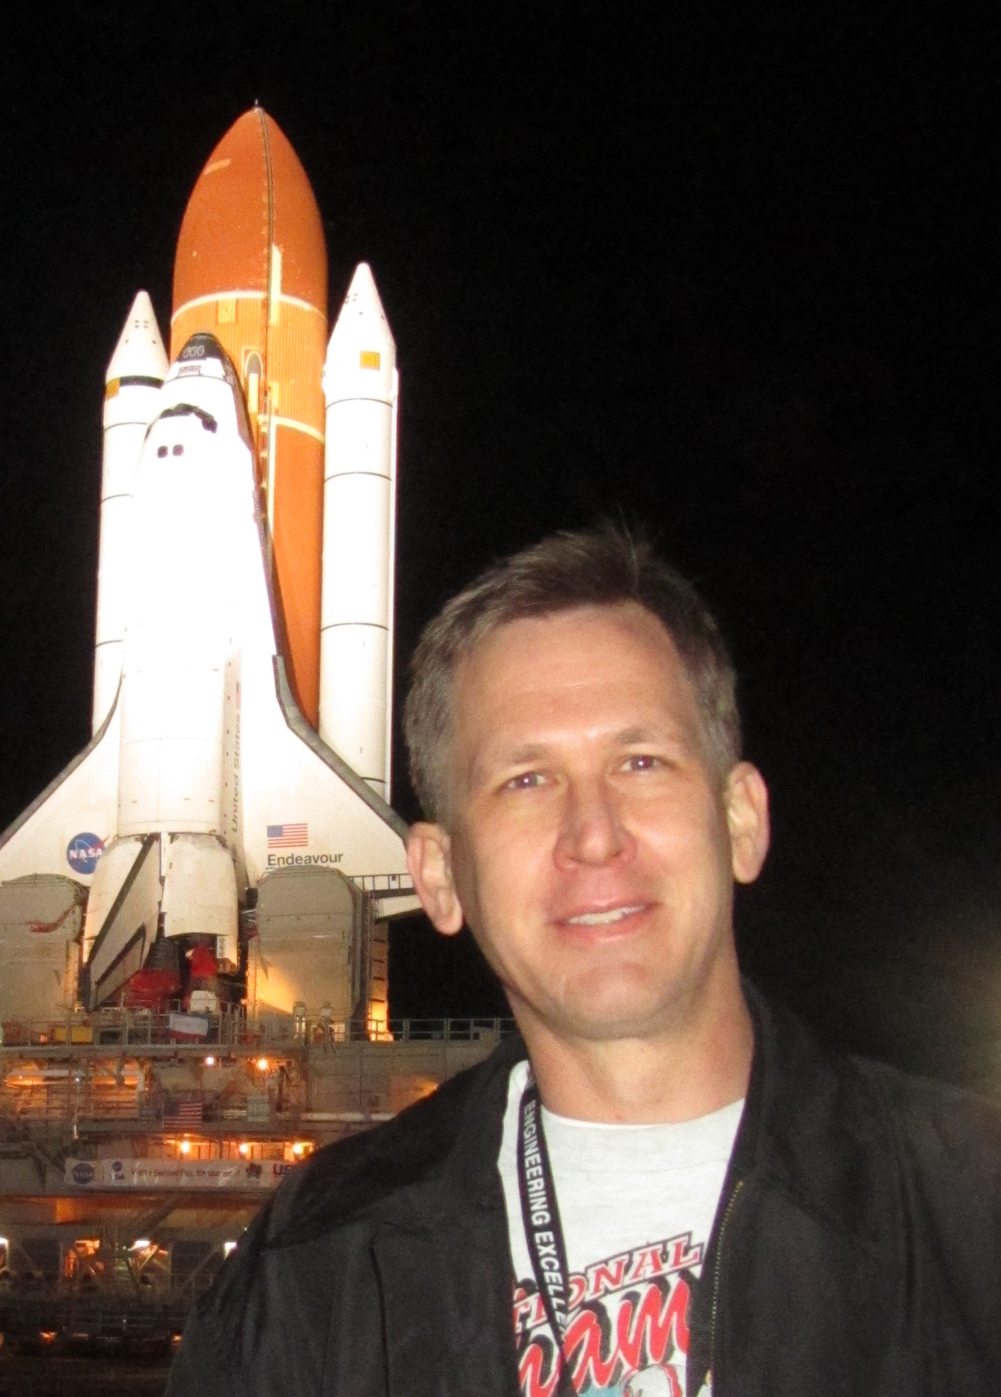

Tim Barth joined the Integration Office in the NASA Engineering and Safety Center (NESC) in 2006. Tim’s NESC responsibilities include leading multi-disciplinary independent technical assessment teams, chairing an Agency-wide Systems Analysis Team, and serving as a technical liaison to the Exploration Ground Systems and Launch Services Programs. Tim has led many successful teams and projects to improve the safety, efficiency, and effectiveness of spacecraft and launch vehicle ground processing operations. He joined NASA in 1988, and his previous positions include KSC Spaceport Technology Development Manager, Senior Systems Engineer for the Center Director’s Engineering Staff, and several technical management and project engineering positions in Space Shuttle Engineering and Operations. Tim also led strategic efforts to establish new industrial engineering, operations analysis, and human factors engineering capabilities at KSC. Tim has a Ph.D. in Systems and Industrial Engineering from the University of Central Florida, an M.S. degree in Aerospace Engineering from the University of Arizona, and a B.S. degree in Mechanical Engineering from the University of Nebraska. He has authored more than 40 technical articles and delivered over 30 presentations at national and international conferences, symposia, and workshops.

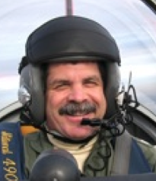

Steve Lilley has served as the Senior Safety Engineer for the NASA Safety Center (NSC) Mishap Investigation Support Office from 2008 to 2020; he is now the Program Analyst for the NSC Knowledge Sharing Analysis Office. Over 35 years of experience as an instructor pilot and safety officer for USN and NASA aviation, risk management, airfield management, explosives safety, afloat safety, occupational safety and health, human factors and afloat environmental programs enabled Steve to provide actionable risk mitigation options to risk owners worldwide. His data analysis team works with NASA Centers and industry leaders to refine leading safety metrics from the NASA Mishap Information System (NMIS) and publish system failure case studies. Steve’s education includes a BA from the University of California at Berkeley.

