International Space Station (ISS) Thruster Plume Contamination and Erosion Control for Visiting Spacecraft
James E. Martinez^{1*}, Erica S. Worthy¹
¹Structural Engineering Division, NASA Johnson Space Center, Houston, TX USA
* Corresponding author: james.e.martinez@nasa.gov
The ISS is the largest and most complex platform for space science utilization in low Earth orbit. Multiple sites for external payloads, with exposure to the associated natural and induced environments, are available to support a variety of space science utilization objectives. Contamination is one of the induced environments that can impact performance, mission success, and science utilization on the vehicle. The ISS has been designed, built, and integrated with strict contamination requirements to provide low levels of induced contamination both on the ISS vehicle’s own contamination-sensitive surfaces and on external payload assets [1].
Spacecraft monopropellant and bipropellant thrusters can impact spacecraft surfaces with high speed droplets of unburned and partially burned propellant and catalyst bed particulates (Figure 1, A-B). These impacts can produce contaminant deposition and also surface erosion damage to optically sensitive hardware and systems (e.g., windows, camera lenses, solar cells, and protective coatings). On the ISS, operational constraints are levied on the position and orientation of the solar arrays to mitigate erosion effects during thruster operations [2].
In the case of an uncharacterized thruster on a visiting spacecraft, copper witness coupons were exposed to hot-fire testing in a ground test vacuum chamber to gather information about particles in the thruster plume (Figure 1, C-D). Thruster level, number of pulses, and pulse duration were all varied to simulate different flight conditions. Following hot-fire testing, the copper witness coupons were evaluated with scanning electron microscopy (SEM) and energy dispersive spectroscopy (EDS) to look for particle impingement, erosion, (pitting), and contaminant constituents (Figure 2, A-B).
Evaluations of on– and off–axis contaminant mass flux measurements were performed on witness coupons exposed to hot-fire tests in a ground test chamber. Particle analysis was performed using EDS map data (Figure 2, C-D). EDS particles were filtered by chemistry, binarized, binned, counted and measured for size per given field of view area. This experimental data will be used to develop an analytical model to quantify contaminant mass as a function of thrust and pulse width. This model can be used to simulate induced contamination/erosion to ISS from spacecraft thruster firings and assess compatibility with ISS contamination control requirements [3].
The authors would like to graciously acknowledge and thank Courtney Steagal and Randy Olsen of The Boeing Co., Space Environments, Houston, TX for their time and support with this study.
[1] External Contamination Environment at ISS, Presentation to the Payload Operations and Integration Working Group (POIWG) #41, Huntsville, Alabama, April 2019.
[2] Improvements in Modeling Thruster Plume Erosion Damage to Spacecraft Surfaces, 13th International Symposium on Materials in the Space Environment, June 2015.
[3] International Space Station Bipropellant Plume Contamination Model, AIAA 2002-3016.
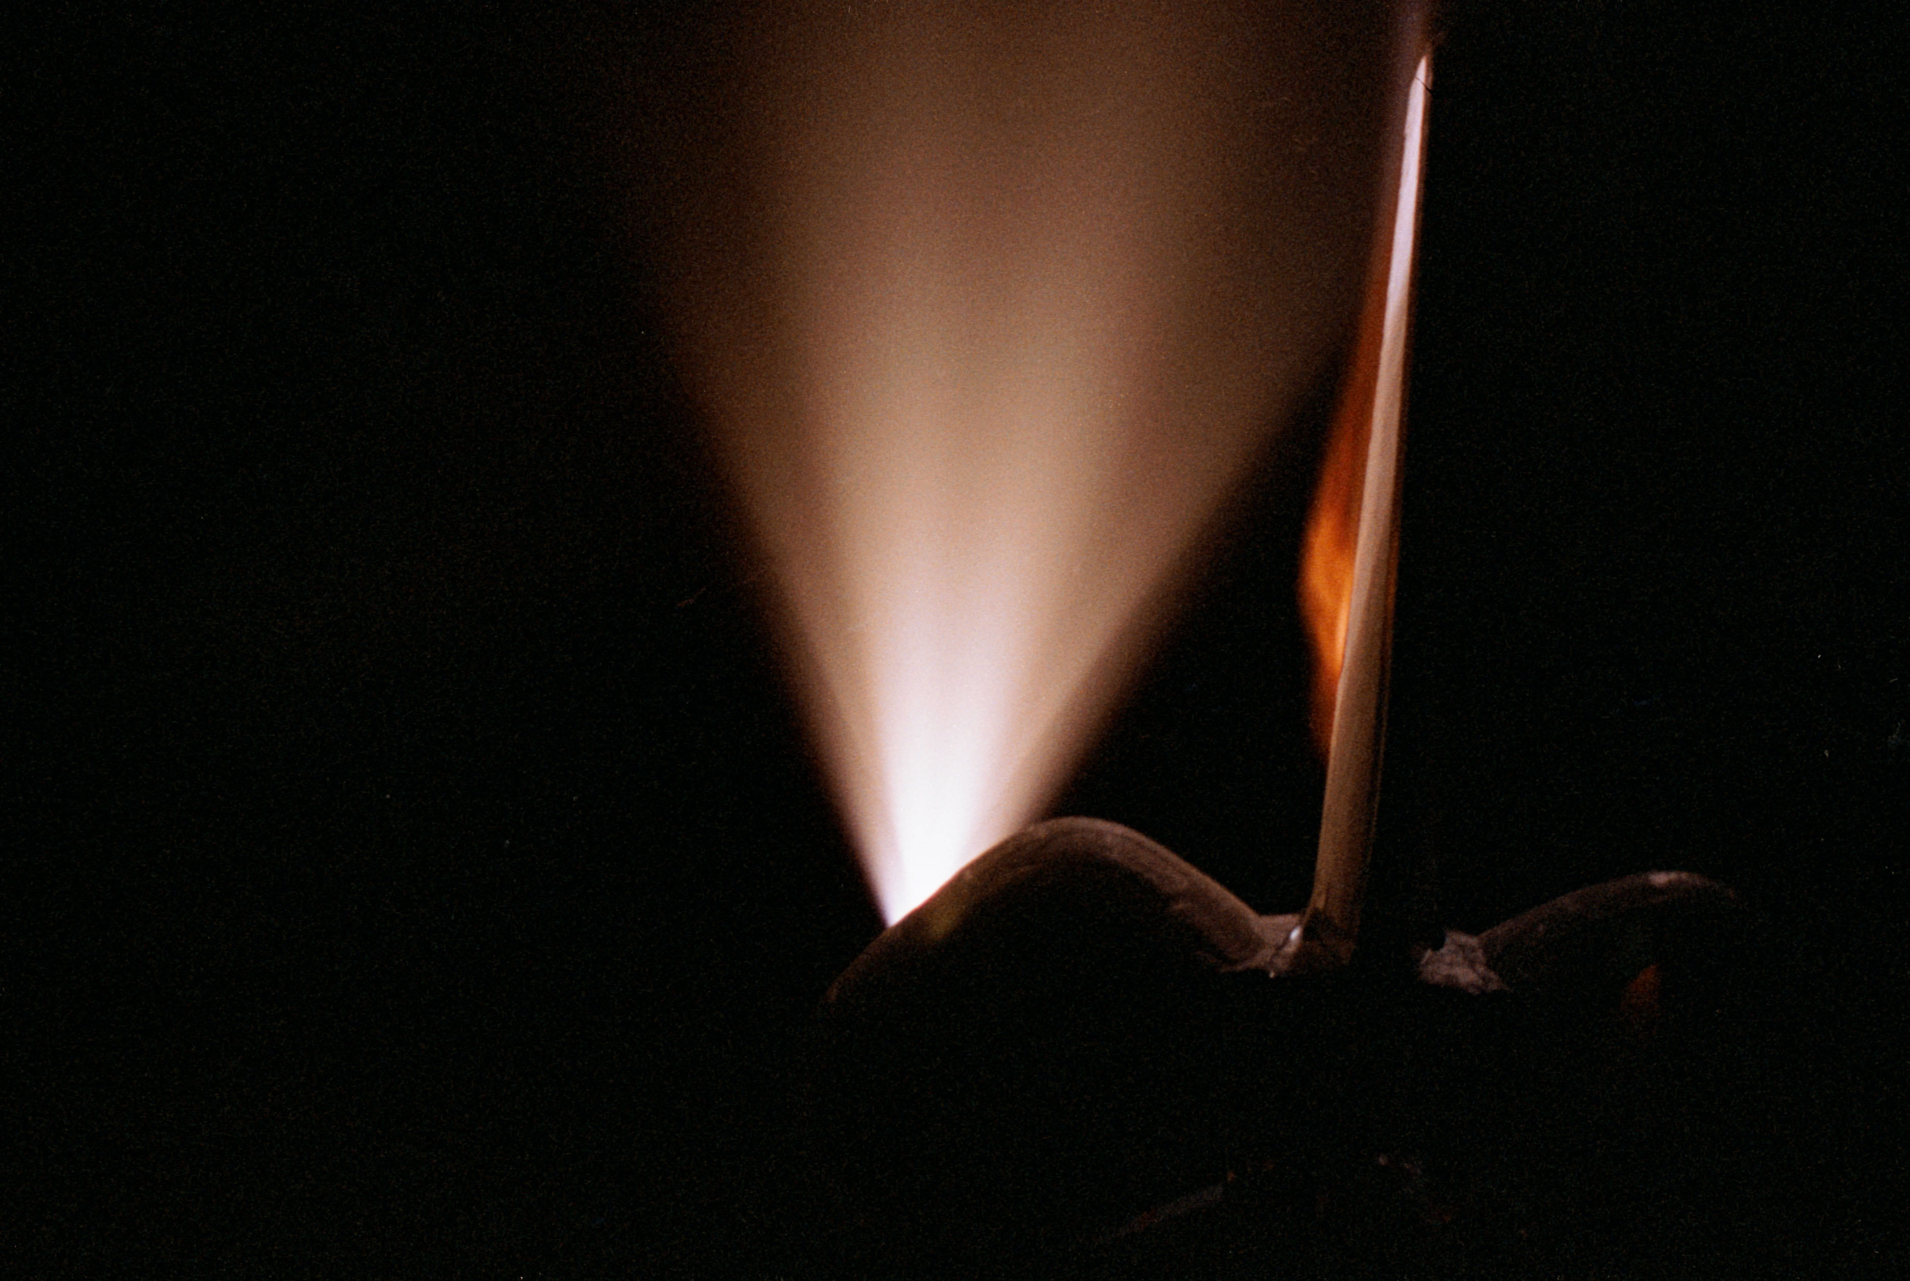
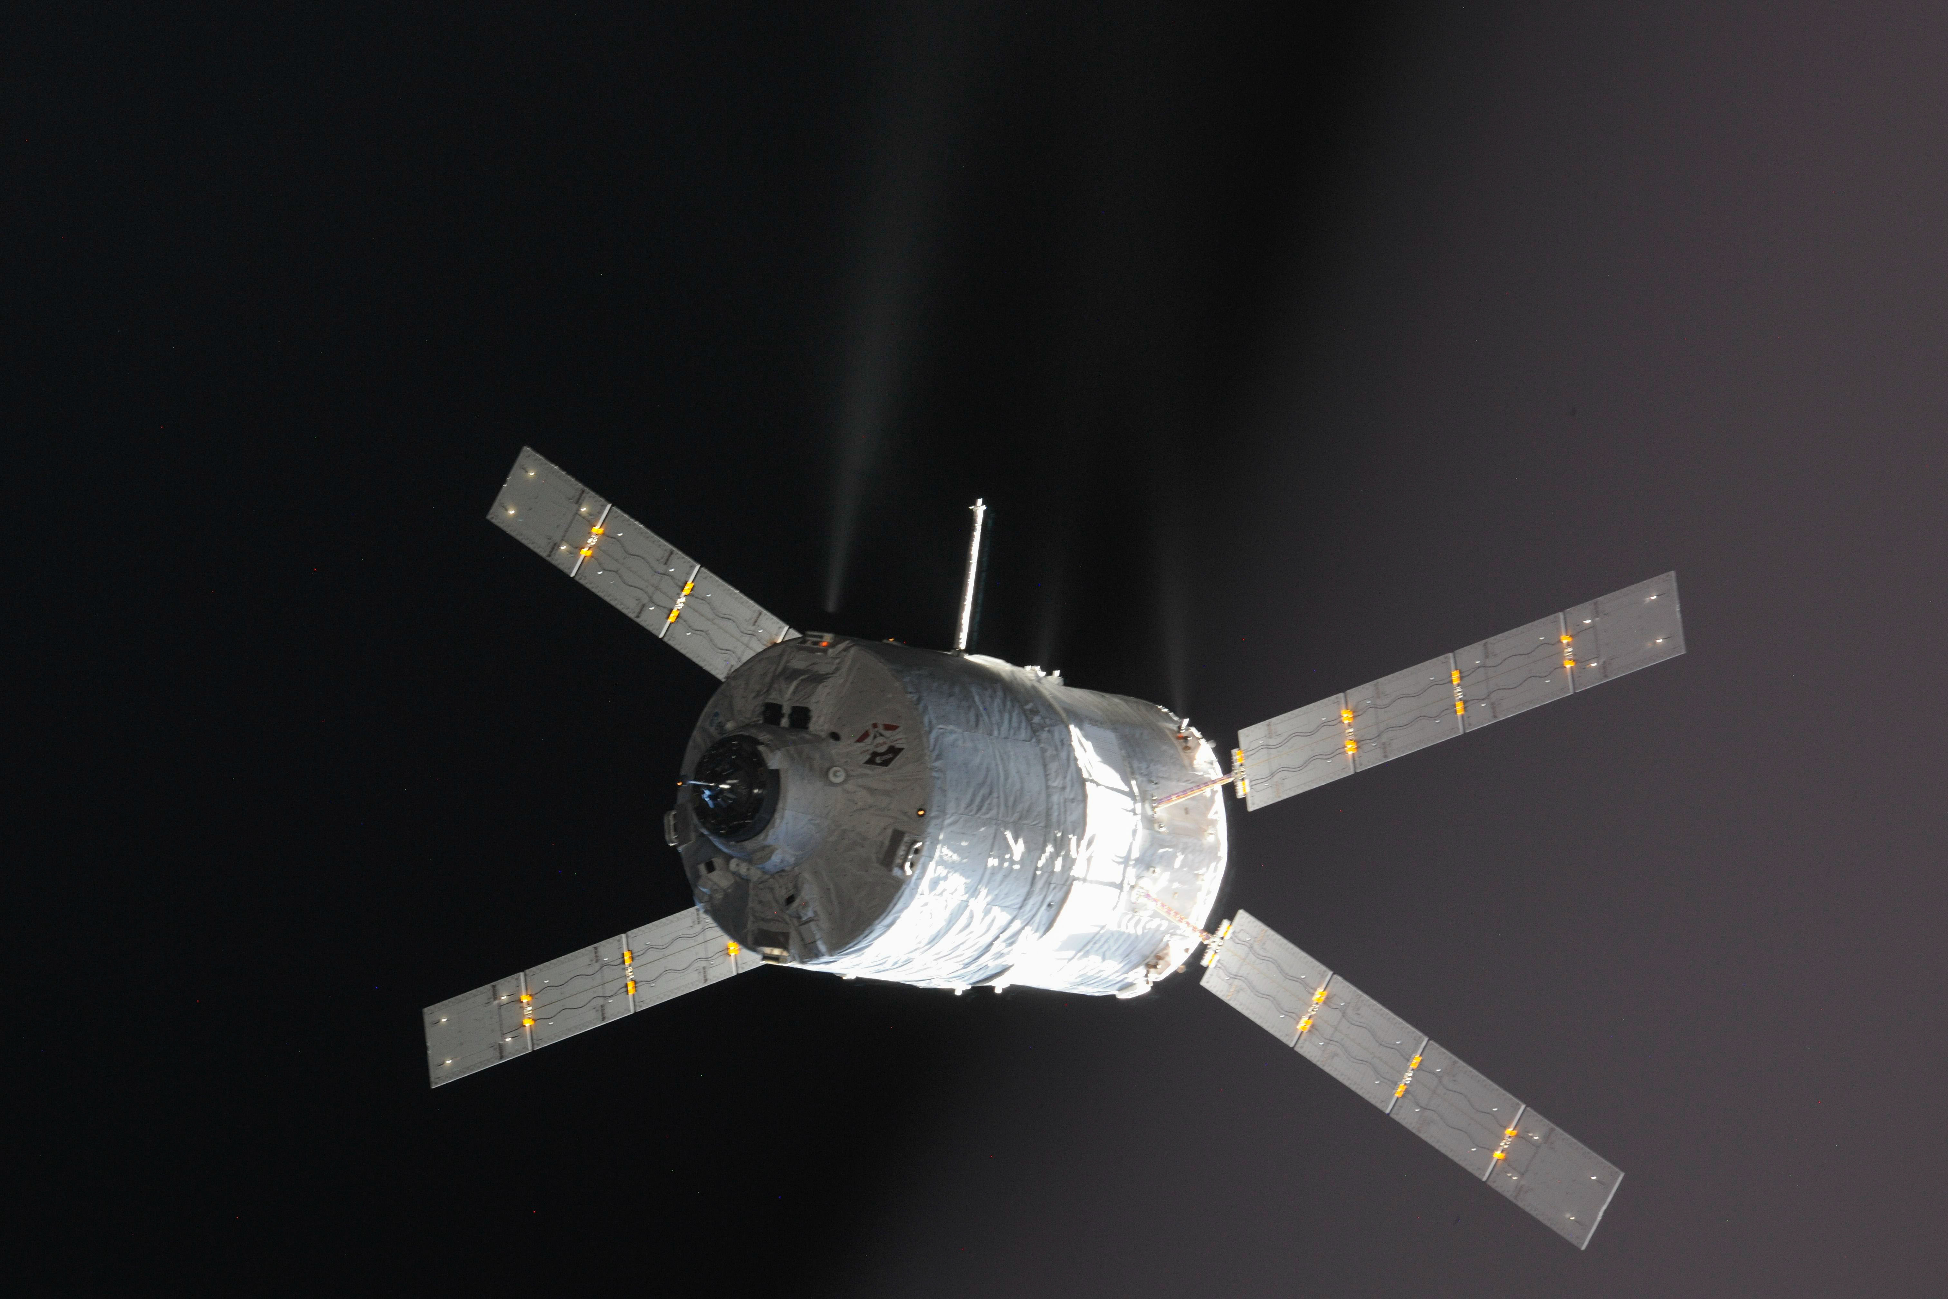
A
B
(A) Ignition of Space Shuttle Discovery’s Aft Primary Thrusters, (B) ATV-4 vehicle approaching ISS.
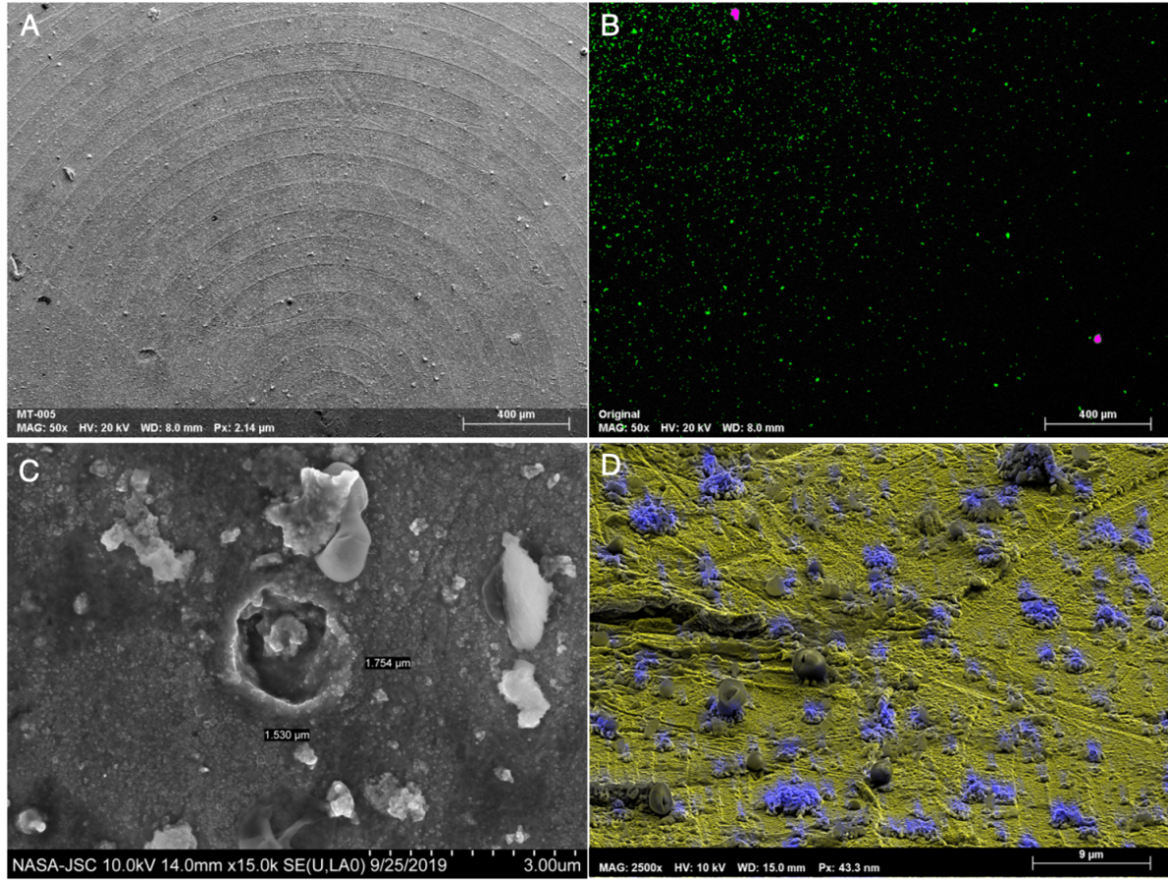
(A) Low-Mag SE2 Electron Image of Test Target Coupon, (B) EDS Map of A, (C) Erosion caused by High-Velocity Contaminant Impact, (D) EDS Map Showing Impinged Debris.

