Design Variants of a Common Habitat for Moon and Mars Exploration

Robert L. Howard, Jr., Ph.D.
NASA Johnson Space Center
2101 NASA Parkway, Mail Code SF3
Houston, TX 77058
robert.l.howard@nasa.gov

Abstract— The Common Habitat is a long-duration habitat concept based on the Skylab II architecture that leverages a single, multi-destination design applicable to microgravity Mars transit, 1/6 g lunar surface, 3/8 g Mars surface, and 1 g Earth. A trade study for the Common Habitat will address vertical versus horizontal internal orientation and a crew size of four or eight crew. This has resulted in the creation of four variants of the Common Habitat: Four Crew Horizontal Configuration, Four Crew Vertical Configuration, Eight Crew Horizontal Configuration, and Eight Crew Vertical Configuration.
Design guidelines that shaped the four configurations are discussed, including: mission duration, destinations/missions, pressure vessel, hatches and docking, subsystems and utilities, lander integration and offloading, and eight-crew extensibility. Functional capabilities for crew-related systems are also discussed, including: private habitation, meal preparation, meal consumption, medical operations, exercise, group socialization and recreation, human waste collection, hygiene, logistics, spacecraft monitoring and commanding, mission planning, robotics and teleoperation, scientific research, maintenance and fabrication, and EVA. Each of the four Common Habitat designs will be presented, with a deck-by-deck description of each workstation, crew station, or subsystem along with an assessment of its degree of compliance with the guidelines and functional capabilities. Finally, forward work will be identified that will down-select a single Common Habitat. This includes multiple analyses that will be performed on the four variants, a down-selection process, and design refinement goals for the selected variant.

Table of Contents
1. Introduction 1
2. The Common Habitat Mission 2
3. Common Habitat Design Overview 5
4. Common Habitat Key Habitability Requirements and Recommendations 7
5. Four-Crew horizontal Common Habitat Layout 10
6. 4-Crew Vertical Common Habitat Layout 11
7. 8-Crew Horizontal Common Habitat Layout 12
8. 8-Crew Vertical Common Habitat Layout 13
9. Forward Work to Select a Single Common Habitat 15
10. Acknowledgements 15
11. References 15
12. Biography 16

- Introduction
The Common Habitat is a long duration space habitat concept derived from what has been informally dubbed “Skylab II.” The original Skylab space station featured a primary habitat, the Orbital Workshop [1], that used a Saturn S-IV stage liquid hydrogen tank as the primary pressure vessel. Skylab II is a notional extension of this idea, pioneered at NASA Marshall Space Flight Center [2], that uses a Space Launch System (SLS) liquid oxygen (LOX) propellant tank, shown in Figure 1, in a similar manner as the pressure vessel of a space habitat.
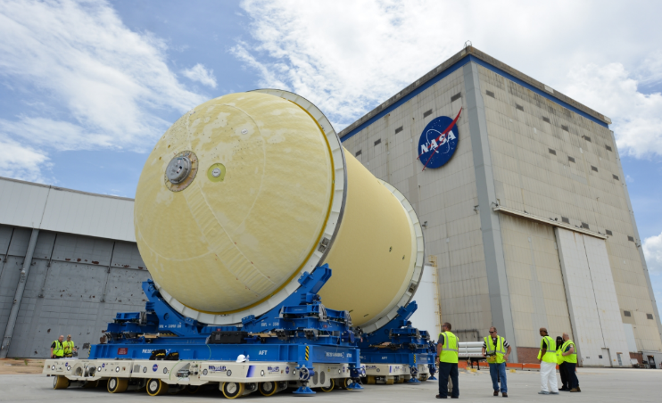
Figure 1. SLS Liquid Oxygen Tank
Because the pressure vessel is typically a very long lead time item for any spacecraft and because propellant tanks are designed to higher pressure levels than needed for habitable pressure vessels, a propellant tank conversion to habitat can save time and money in a habitat acquisition. The Common Habitat uses the SLS Core Stage liquid oxygen (LOX) tank as its pressure vessel.
The Common Habitat moves beyond the Skylab II concept in that it is developed to use a common design [3] for lunar surface, Mars surface, and Mars in-space transit missions up to 1200-days in duration, as well as an Earth trainer for each of the above missions. The Common Habitat is not tied directly to any specific NASA design reference mission or architecture. Instead, four basic architectures are described for the Common Habitat.

- The Common Habitat Mission
Multi-Destination Architectures
The lunar surface architecture is a fixed outpost in the south polar region of the Moon. This architecture assumes up to four elements docked to the Common Habitat: one external airlock, two small pressurized rovers, and one logistics module. While some lunar missions may require multiple logistics module, only one is docked at any given time. A surface mobility system such as the Jet Propulsion Laboratory (JPL) All-Terrain Hex-Legged Extra-Terrestrial Explorer (ATHLETE) is used to move large payloads on the lunar surface, including original placement of the outpost. [3] An external element provides power generation, communications transmission and receiving, and active thermal heat rejection. Data, power, and thermal fluid connections link it to the Common Habitat. Active-active mating adapters (AAMAs) form pressurized tunnels between the Common Habitat and docked elements. These AAMAs serve a similar function to the Pressurized Mating Adapter (PMA) on the International Space Station (ISS) and may enable elements with dissimilar docking systems to dock. They also can enable exchange of fluids, power, or data between spacecraft.
The Mars surface architecture contains generally the same elements as the lunar surface architecture but is presumably located in the mid or equatorial latitudes of the Martian surface.
The Mars in-space transit architecture structurally mates the Common Habitat to an unpressurized element that provides propulsion, attitude control, power generation, communications transmission and receiving, and active thermal heat rejection. An external airlock is permanently docked as well as at least one logistics module. Additional modules may be docked to the Common Habitat or structurally mated (but not docked) to other locations on the unpressurized element. These logistics modules can be released or replaced in Cislunar space or Mars orbit. Also, a Mars lander and Mars ascent vehicle (MAV) (which may or may not be the same spacecraft) can dock to any open docking ports. AAMAs are used to facilitate docking operations. Gateway, Orion, or other crew vehicles may also dock to an open docking port while in Cislunar space. While this architecture is primarily intended to represent the transportation legs of human missions to Mars, it could alternately be used for missions to other destinations including deep space asteroids, Venus orbit, or for near-Earth missions in Cislunar space or even low Earth orbit (LEO).
The Earth trainer architecture enables one or more Common Habitats to train crew for the three space architectures. Like the two Skylab trainers currently at the Smithsonian Air and Space Museum and Space Center Houston, the Common Habitat trainer is a high-fidelity simulator, potentially a flight backup or qualification unit. The trainer can be used in conjunction with other simulator elements to conduct crew training or analog studies as either a standalone unit or docked/mated with any of the other elements that are part of the in-space, lunar surface, or Mars surface architectures.
Mission Duration
An 1200-day mission is used as the duration for all the Common Habitat missions. [3] This number is a bookend for the longest in-space Mars example, where the Mars transit vehicle successfully travels from Earth to Mars in a conjunction class trajectory, but the crew does not land on the surface and instead spends a ~500-day period in Mars orbit. This could be either an orbital mission or a Phobos/Deimos mission. No known design reference missions (DRMs) have suggested 1200-day surface missions, but the Common Habitat is sized to include them in the potential surface trade space. Shorter missions could be achieved with simply a reduction in the number or outfitting of logistics modules, with no change to the internal configuration of the habitat.
Design Trade Space
Two key unknowns help to define the design space and must be resolved through design trades. [3]
The first unknown concerns habitat orientation. Is a vertical orientation or horizontal best for the common architecture? The habitat interior can be arranged in either a vertical or horizontal configuration. It is not initially clear if there is an advantage of one over the other. Many habitat studies have assumed only one orientation, whether by preference or external direction/constraint, and thus few studies have been performed to determine if one orientation is better suited than the other.
The second unknown concerns crew size. The default for most NASA studies since development began of the Orion crew capsule is a four-person crew. In the case of a four-person crew, the entire SLS Core Stage LOX tank is not needed. Instead, a Common Habitat would be formed from the two dome sections and only half of the tank barrel length. However, it is possible that a four-person crew is not large enough. Thus, an eight-person crew is also explored. Prior to this study there was no evidence to suggest how an eight-person habitat might differ from a four-person habitat and no documentation of the relative strengths and weaknesses of each.
This trade space lends itself to four variants of the Common Habitat: four-crew horizontal, four-crew vertical, eight-crew horizontal, and eight-crew vertical. However, there could be thousands of potential iterations of each one of these. As evidence of this, in prior years, this project has operated as an unfunded study leveraging engineering and industrial design NASA interns to create internal layouts, but due to the shortness of a summer internship tour no one intern was able to model more than one variant completely. It was obvious that different skill levels and different design styles were confounding factors and it would not be a valid comparison to compare a horizontal habitat produced by one intern with a vertical habitat produced by another. Any fair comparison would have to have only one design team pursuing all four variants.
This has finally been achieved. In a special topics course in the University of Houston’s Space Architecture master’s degree program, one student team produced initial layouts of the four concepts. These concepts were subsequently refined under Innovation Charge Account funding by a NASA Center for Design and Space Architecture contractor, and then further modified by the author. The resulting computer aided design (CAD) models with the pressure shell hidden and visible are shown in figures 2-5.
Details of each design will be discussed later in this paper. It should be noted that the workstations and crew areas within each CAD model contain assorted outfitting – laptops, tools, science instruments, etc. These outfitting items are placeholders and do not represent definitive design selections. They do serve to help differentiate between different work areas (e.g. science versus maintenance) and they suggest a variety of different levels of scale possible in the Common Habitat. It is also worth noting that the CAD models are populated with numerous human models, far in excess of the crew size for each habitat. These models merely illustrate human interaction with various crew stations and workstations throughout the habitats.
Additionally, some key design details are being pursued in separate studies, leveraging NASA crowdsourcing opportunities. A NASA JSC Hackathon was leveraged to develop an initial concept for a multi-gravity crew restraint that can function as a seat in gravity fields but provide a non-intrusive restraint in microgravity. The NASA@Work crowdsourcing platform is being used to seek design solutions for other crew restraints and mobility aids including multi-gravity counterparts for hand rails, foot restraints, ladders or stairs, and safety railings.
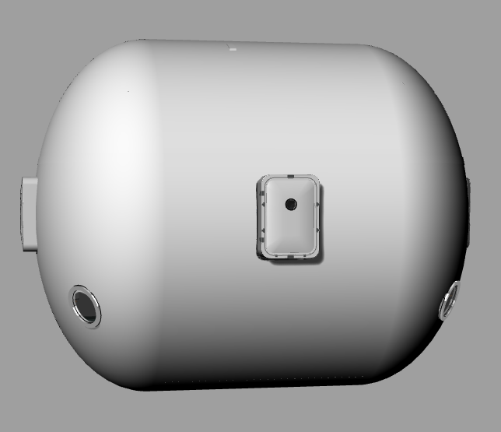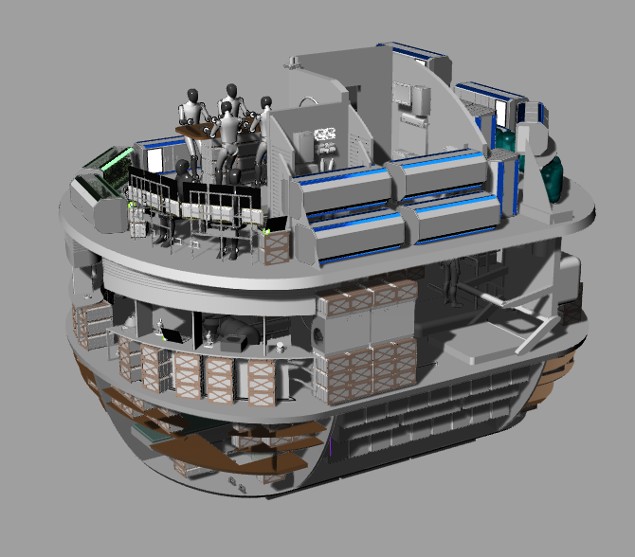
Figure 2. Four-Crew Horizontal Common Habitat
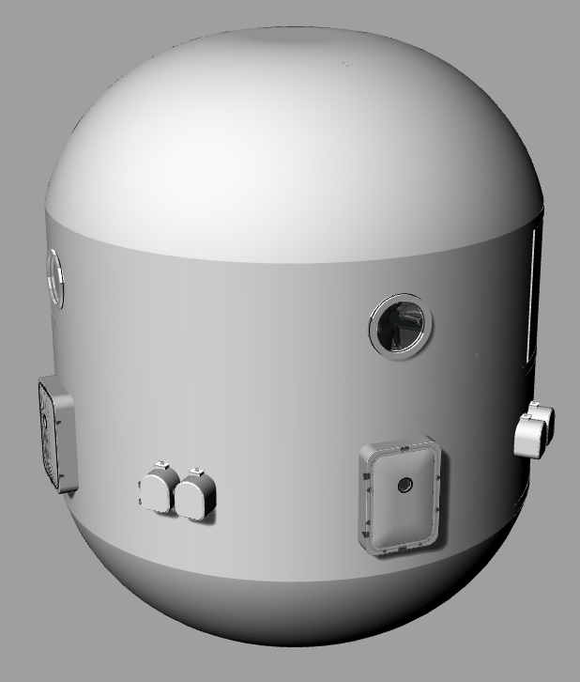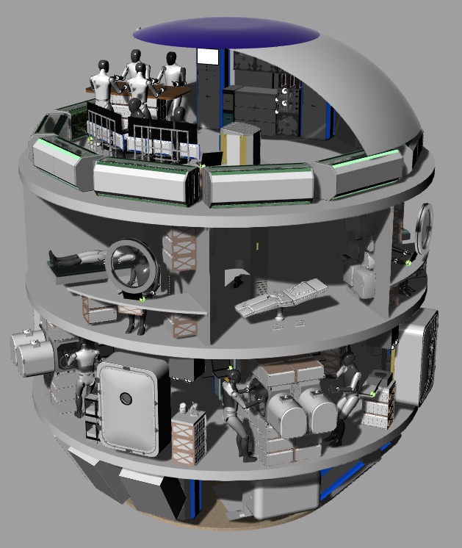
Figure 3. Four-Crew Vertical Common Habitat
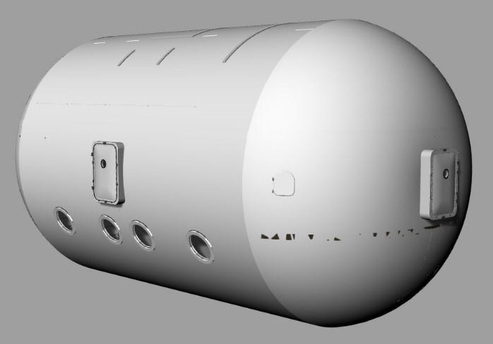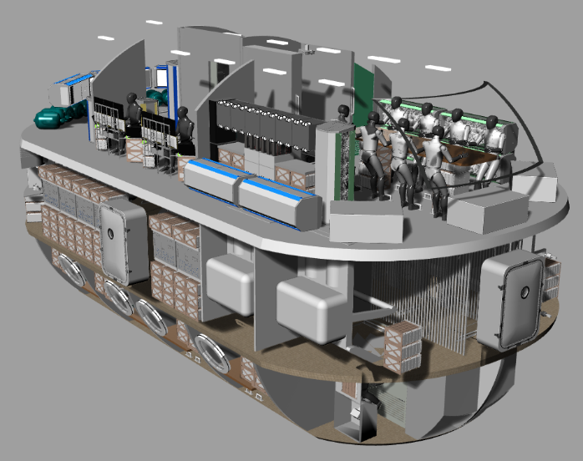
Figure 4. Eight-Crew Horizontal Common Habitat
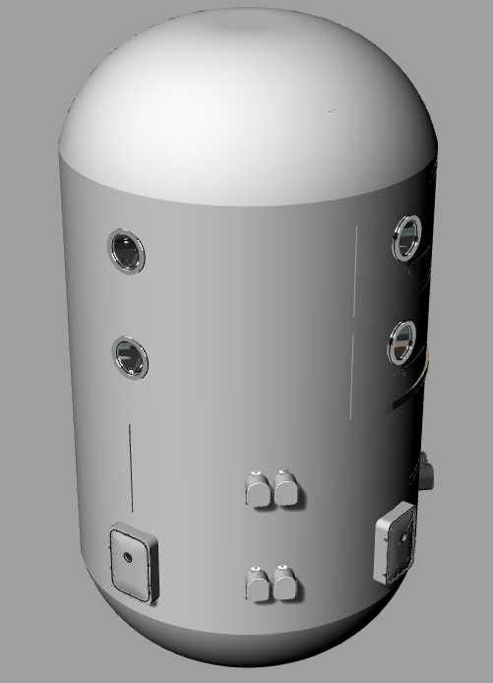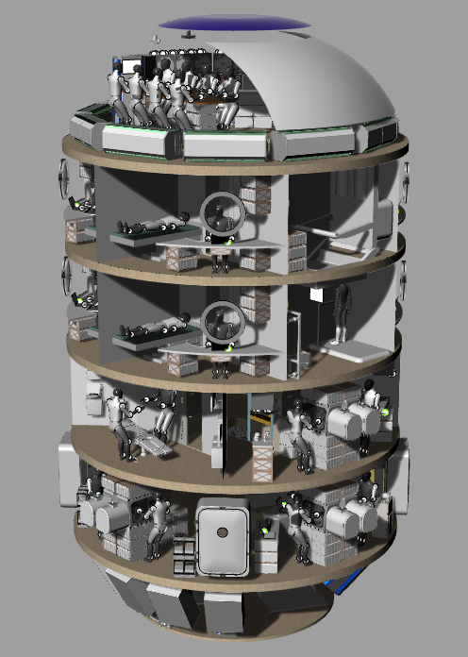
Figure 5. Eight-Crew Vertical Common Habitat
- Common Habitat Design Overview
Pressure Vessel
As previously mentioned, the Common Habitat uses the SLS LOX Tank as the pressure vessel and primary structure. [3] The LOX tank has a diameter of 8.41 meters. Each dome has a height of 2.65 meters. The barrel is composed of two rolled segments, each with a height of 5.15 meters. Figure 6 shows a breakdown of the structural elements of the SLS LOX Tank. The eight-crew variants use the full LOX tank, while the four-crew variants use only one barrel segment, as suggested in Figure 7. Internally, the Common Habitat is divided into decks, with a nominal deck height of 2.5 meters. (Decks in domes of the vertical configurations and the upper/lower decks of the horizontal configuration are not constant height due to the curvature.).
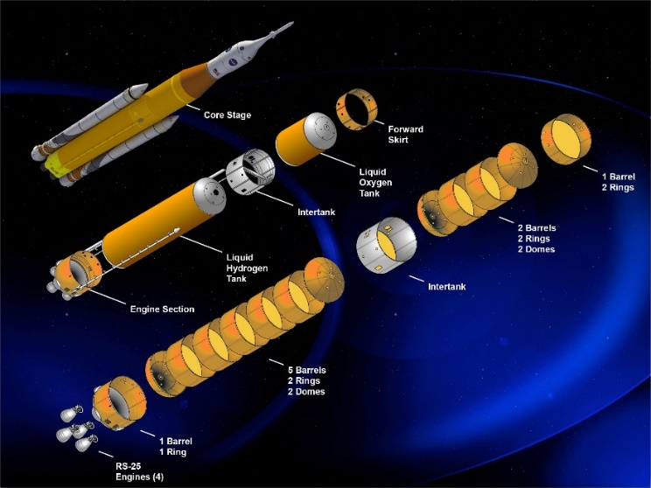
Figure 6. SLS LOX Tank Structure
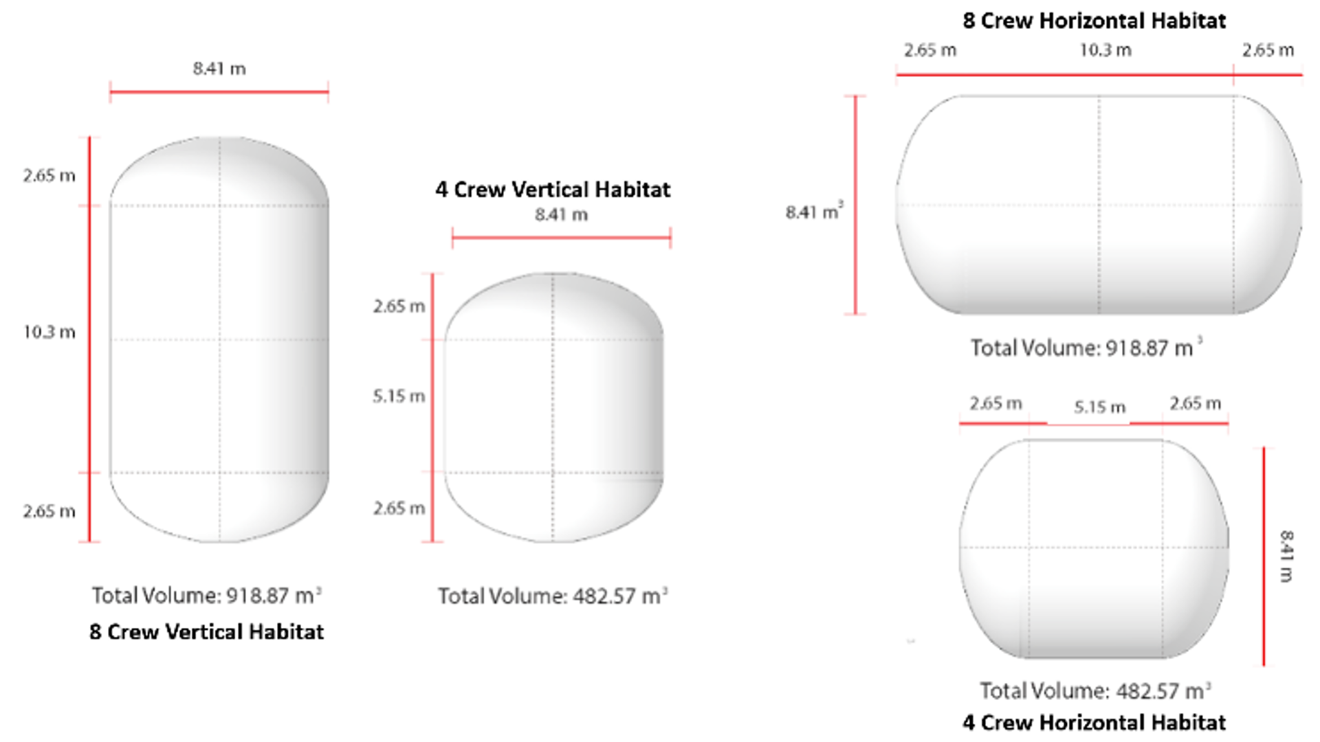
Figure 7. Orientation and Dimensions of Common Habitat Variants
Hatches and Docking
All four variants of the Common Habitat incorporate four hatches at 90-degree intervals on the same deck. Each hatch is 40 inches wide by 60 inches tall (roughly 1 meter x 1.5 meters). This hatch size was used in the NASA Constellation Program’s Lunar Surface Systems Project for the lunar habitats studied under Lunar Surface Scenarios 1.0 – 12.2. The hatch modeled in CAD is, of course, a notional hatch that is used as a placeholder pending more detailed design.
The hatches are surrounded by the docking system (not shown in the CAD models), which is a fully passive system similar to those developed by the NASA pressurized rover team and prototyped on the Generation 1 MMSEV and NASA Constellation Pressurized Excursion Module. This passive system is derived from the MMSEV Suitport concept. Passive Marmon flanges surround each hatch. A device called an Active-Active Mating Adapter (AAMA) serves as a type of Pressurized Mating Adapter, using Marmon clamps to form an airtight seal between the AAMA and the Marmon flanges. Details and advantages of the AAMA are out of scope of this study.
Deck Numbering
Because all the Common Habitat variants have more than one habitable deck, it is important to develop an appropriate numbering scheme. Unfortunately, there are contradictory numbering schemes among terrestrial analogs. Water going surface vessels use a numbering scheme where deck one, or the main deck, is the horizontal surface that forms the “roof” of the hull, that typically being the highest deck that runs from stern to stern. The deck immediately below this deck is deck two, with deck numbering increasing downwards. (Any horizontal levels above deck one are numbered in increasing order as 01, 02, etc.) Submarines are similar, with the main deck or deck one being the uppermost deck in the cylindrical pressure vessel. The deck immediately below is deck two. However, for terrestrial buildings, the first floor is the floor on ground level, with the second floor being immediately above. Multi-deck aircraft typically have only a single deck, with a few having two or three decks. In those cases, the main deck is generally the widest deck, with the deck above being the upper deck and the deck below being the lower deck.
The horizontal variants of the Common Habitat have three decks and will therefore use a scheme similar to the aircraft deck scheme, with its decks designated as upper deck, mid deck, and lower deck. The vertical variants of the Common Habitat will use the terrestrial building scheme with the lower dome designated as deck one, with deck numbering incrementing above, such that the upper dome of the four-crew vertical habitat is deck four and the upper dome of the eight-crew vertical habitat is deck six.
Subsystems and Utilities
While volume allocations have been made for subsystems and utilities, only limited sizing was conducted for the Common Habitat study. More detailed design will require additional resources and is best deferred until after down-selection to a single variant has been completed. For simplicity at this design phase, the Gateway program’s philosophy of repackaging subsystems into pallets (as opposed to the International Space Station philosophy of using subsystem racks) has been implemented, though the Common Habitat can conceivably utilize both racks and pallets, as well as any of several other approaches to subsystem integration. The pallets are slightly advantageous over ISS racks as their narrower form factor allows additional options in their placement.
Mark Jernigan, Manager for Life Support Equipment for NASA’s Deep Space Habitat development effort has indicated that, “a fully closed loop system with no preinstalled assemblies and no redundancy is 10 pallets, with full ARS (Air Revitalization System) redundancy 13 [pallets].” [4] To accommodate additional environmental control and life support subsystem (ECLSS) demands that will be imposed by the Common Habitat’s plant growth and maintenance capabilities a minimum of 15 ECLSS pallets are included in each Common Habitat variant.
At this stage, less sizing was performed for the avionics subsystem. An assumption was made that all avionics can package within a single Gateway pallet envelope.
The power subsystem was assumed to require a more distributed approach. Roughly half-size Gateway pallets were used for power with an allocation of one half-pallet per deck. All of power generation and storage is assumed to be in a separate element and thus the internal pallets are responsible for power management and distribution.
The thermal system is not modeled in the Common Habitat. Cold plates are assumed to be integrated with other hardware at this level of fidelity. Pumps are assumed to be in the volumes between decks.
Utilities are also not modeled, but include cabin air in, cabin air exhaust, thermal fluid, power, data, potable water, waste water, up to three science gases (cabin air, oxygen, nitrogen), and contaminated waste fluid (medical, science, maintenance). Utilities are assumed to be routed in the volumes between decks and in several key vertical trunks.
Lander Integration and Offloading
The size of the Common Habitat makes it clear that it is not compatible with any recent NASA lander concepts for either the Moon or Mars. While lander solutions will encompass multiple papers, some of the underlying assumptions will be briefly referenced here.
Lunar Surface
The Lunar architecture assumes the Common Habitat is launched with an attached service module to Cislunar space by the Space Launch System (SLS) or a variant of the Space X Starship. Once in Cislunar space, the service module provides stationkeeping and other support services while it awaits the launch and integration of a Joinable Undercarriage to Maximize Payload (JUMP) Lander, a heavy cargo lander launched as separate core stages to Cislunar space and autonomously assembled. [5] Once the JUMP Lander has integrated with the Common Habitat, the service module detaches and the JUMP Lander provides transit, descent and landing on the lunar surface.
Once on the surface, the Common Habitat is offloaded from the JUMP Lander by a team of Tri-ATHLETE cargo handling robots. [6] They then provide transportation from the lander to the outpost site and emplace the Common Habitat at the site, resting the habitat on structures 3D printed from lunar regolith – a concept currently under development at the NASA Kennedy Space Center.
Mars Surface
The Mars surface architecture begins the same way, with SLS or Starship launching the Common Habitat. However, instead of being integrated with a JUMP Lander, it is instead integrated first to a Mars lander (notionally an upscaled version of either the Hypersonic Inflatable Aerodynamic Decelerator (HIAD) or Mid lift over drag (L/D) lander concepts) and then the Common Habitat / Mars lander stack is integrated with an in-space propulsion stage. The in-space stage provides transit to Mars, where the lander performs entry, descent, and landing.
Once on the surface, the Common Habitat is similarly offloaded by pre-deployed Tri-ATHLETEs. The Mars scenario is the sizing case for the Tri-ATHLETEs, which must be able to collectively lift the Common Habitat in Mars’ 3/8 gravity. Like on the Moon, the Tri-ATHLETES transport the Common Habitat to an outpost site and emplace it on 3D printed ground structures.

- Common Habitat Key Habitability Requirements and Recommendations
In short duration missions, the crew may tolerate adverse conditions in ways that cannot be sustained in long duration missions. The famous example is the alleged “crew mutiny” of Skylab 4 [7] when the crew was out of contact with mission control for approximately 90 minutes. This incident centered around crew work schedules, but numerous factors including flight experience, work schedule, hygiene, clothing, and flight crew equipment [7] were collectively adding stress to the crew leading up to the incident. For long duration missions, care must be taken to eliminate “nuisance factors” as they can have a cumulative degrading effect on the crew over time. Forcing the crew to endure adverse conditions over a protracted period of time can have unintended consequences.
Primary Applied Documents and Experience
Several NASA standards and references are key drivers that affect the performance needed in the Common Habitat. The primary governing document is NAA Standard 3001 (NASA-STD-3001) [8] and an important companion document is the Human Integration Design Handbook (HIDH). [9] The Human-Systems Integration Requirements (HSIR) [10] is a Constellation-era document that also has useful information. Additionally, the NASA Human Research Program (HRP) maintains a database [11] of risks to human spaceflight. Many of these risks can be either mitigated or exasperated by space habitat design decisions. In addition to NASA documentation, the author has brought to the table lessons learned from NASA Desert Research and Technology Studies (RATS) testing and the Gateway Next Space Technologies for Exploration Partnerships (NextSTEP) Appendix A testing. Both test series involved human-in-the-loop testing of long duration spacecraft prototypes. Several test reports were produced for Desert RATS [12] and a technical publication [13] was produced for NextSTEP.
Food and Beverage
NASA-STD-3001 requires hot water for hot food and beverage hydration and cold water for cold beverages. [8] There are also requirements to ensure safety and nutritional content, acceptability to the crew, sufficient calories, and vehicle capacity for preparation, consumption (including group dining), cleanup, and stowage. There is also a requirement for food and beverage heating. For sanitation, there are requirements for contamination control, cleaning, and trash collection / waste control. [8]
Variety is of high importance in order to continue to maintain food acceptability. This may impact food stowage, meal preparation, and meal consumption equipment and configurations. Food expiration is a concern as an 1200-day mission exceeds current shelf life for certain foods. Food palatability is also an issue as the crew may over time become intolerant of prepackaged foods. Possible mitigations may include refrigeration, frozen cold stowage and fruit and vegetable growth chambers. Food preparation methods reminiscent of terrestrial cooking may also be introduced, potentially including one or more of food processing, baking, frying, broiling, and steaming.
Waste Management and Hygiene
Privacy is a requirement for body waste management at all mission durations, driving the need for a private waste management compartment (WMC). [8] Given the duration of a long duration mission and the likelihood of multiple expeditions spanning a decade or more, there is a need to perform both nominal and contingency maintenance on the waste collection system (WCS.), driving the need to ensure maintenance access volume inside the WMC.
Similarly, privacy is also required for hygiene, which must include oral hygiene, personal grooming, and body cleansing. [8] The long duration missions drive a need for a capable hygiene system as the crew could be exposed to any number of substances (whether from IVA or EVA sources) that require immediate cleaning in order to prevent the creation of additional hazards by their presence.
The Waste and Hygiene Compartment (WHC) on ISS has received negative crew comments for combining waste management and hygiene into a single compartment. In verbal conversation, one astronaut compared it to placing your shower in the same stall as a public restroom toilet. There is anecdotal evidence that some ISS crew members will conduct hygiene operations in other areas of the space station (e.g. logistics modules) that were not designed for hygiene tasks in order to avoid having to use the WHC for this purpose. While this is not captured in a NASA standard, separating the waste and hygiene functions into separate compartments should be considered a minimum capability in order to meet crew behavioral needs.
Recent habitat mockup tests have allowed NASA habitability researchers to consider the impact of multiple hygiene and waste management compartments. Flown astronaut crew reacted favorably to scenarios where more than one toilet and more than one hygiene facility was available in a mockup spacecraft. No requirement has ever considered this as a needed option, but there are obvious crew timeline benefits to an architecture with two toilets and two hygiene compartments for a four-person crew. Additionally, there are obvious redundancy benefits in the event of a maintenance problem.
Sleep Accommodation
Adequate crew sleep is necessary to prevent the risk of fatigue-induced errors and sleep accommodation is therefore required [8] Given that crew tasks at this mission duration may involve driving rovers and manipulating drilling or cutting tools, quality sleep is an important safety feature that cannot be discounted as a non-minimal capability.
Private quarters are required at this mission duration. [8] There are no requirements in the standards to define what must exist within those private quarters, but they may need to be considered as a location for more than simply sleeping. Crew have commented in crew evaluations that they like to use their ISS crew quarters as a getaway when they have a few free moments in their schedules. While not explicitly stated in requirements, private quarters will need to allow for personal activities performed by crew members away from other crew.
Medical Care
Mars is the driving case for Common Habitat medical care. A strict interpretation of NASA-STD-3001 requires medical Level of Care V [8] for human mission to Mars. According to the standard, this includes space motion sickness, first aid, private audio, anaphylaxis response, clinical diagnostics, private video, private telemedicine, trauma care, medical imaging, dental care, autonomous and sustainable advanced life support and ambulatory care, and basic surgical care. It is also recommended to provide 360-degree caregiver access to an injured crew member.
Exercise Countermeasures
NASA-STD-3001 does not provide explicit guidance for countermeasures as a function of duration. It does require “countermeasures to meet crew bone, muscle, sensory-motor, and cardiovascular standards.” [8] Some in the NASA countermeasures community prefer to see crew exercise countermeasures introduced for missions of 8-days or greater in duration, though this is not an existing standard. It does, however, suggest that exercise may be necessary from the very beginning of any Common Habitat crew expedition.
It is also worth noting that some conventional wisdom may be in error when considering deconditioning effects on the lunar or Martian surfaces. The HIDH notes that “greater loss of leg muscle strength than arm muscle strength is expected because locomotion is performed with the upper body during spaceflight.” [9] This is true for microgravity spaceflight, where virtually all prior human spaceflight experience lies. But locomotion on the Moon will involve the legs and may involve a combination of upper and lower body muscle groups. There is a possibility that exercise subject matter experts (SMEs) who have a microgravity mindset may underestimate the upper body deconditioning on the Moon, which may create a risk for crew members being unable to perform critical tasks requiring upper body strength. And given the longer duration and broad spectrum of potential crew activities within this mission class, there is a greater likelihood that key mission tasks or even crew survival operations may require upper body performance. (e.g. EVA activities, incapacitated crew member scenarios, etc.)
All uses of the Common Habitat will at minimum require similar degrees of exercise countermeasures as those required for crews aboard the International Space Station – 1 hour for aerobic exercise and 1.5 hours for resistive exercise per crew member per day. [9]
The ISS devices – Advanced Resistive Exercise Device (ARED), Cycle Ergometer with Vibration Isolation System (CEVIS), and second-generation Treadmill (T2) – represent the state of the art in long duration exercise devices. However, not even the ISS suite of exercise equipment and protocols are validated for a mission of this length.
There are devices at a concept / study level that are hoped to repackage these capabilities in smaller packages, but it will be some time before they can either pass or fail an attempt at validation and even longer before they can become flight hardware. As an example, E4D (formerly known as Tarzan or as the Potential European Device) [14] is viewed by some as a possible replacement for ARED, though the device is still in development and has not yet proven itself. Thus, for this study, the ARED will be modeled instead of E4D, representing a potential mass savings opportunity if E4D should prove to be viable.
The ISS exercise devices are the most capable countermeasures systems that can be identified today. For the Common Habitat study, until there is further exercise system development, the ISS exercise system (ARED, CEVIS, and T2) will serve as the initial baseline.
Crew Recreation
There are vague standards in place with respect to crew recreation. NASA-STD-3001 requires that recreational capabilities be provided, but does not state what they must be, indicating that the nature and duration of the mission may play a role. [8] HIDH indicates that recreation is especially important for long duration missions. [9] The simplistic solutions acceptable in short duration missions such as looking out of a window or simply enjoying the reduced gravity environment are likely no longer sufficient and recreational materials and games – both group and individual – should be assessed as potential minimum capabilities.
Displays and Controls
There are no standards that explicitly state requirements for display real estate, audio annunciation, or windows. Instead, NASA-STD-3001 requires that the design provide sufficient situational awareness for efficient and effective task performance for all levels of crew capability and all levels of task demands. [8] The arrangement of displays and controls within the internal architecture must also result in a workload that does not overload or underload the crew. [8]
It is well known that one of the psychological stressors of human spaceflight is a sense of isolation. This will likely be increased in long duration missions beyond Earth orbit. This will make the need for situational awareness and control become not just a mission performance and safety issue, but also a behavioral health issue. The crew will need to know that they have all needed insight into the state of their exploration outpost and the level of control to initiate any intervention necessary to operate and maintain their system. This will imply multiple means of conveying information, both as high-level summaries and as deep dives into specific subsystems or components. This may also imply just-in-time training capabilities to expand crew member skill sets on an as-needed basis.
Situational awareness and control to demonstrate Earth independence will be an important capability. This may involve enough access to vehicle telemetry, software, and subsystem components to perform operations that have previously been ground-only operations in human spaceflight history.
Meaningful Work
Lack of meaningful work is considered a psychological stressor that should be considered in long duration human spaceflight. [9] Preparing for, conducting, and recovering from EVAs will not consume all of the astronaut’s available work hours, suggesting a need for some form of intravehicular activity (IVA). While aboard the Mir space station, US astronaut Norm Thagard had to wait for many of his science experiments to be delivered to the station. [15] NASA psychologist Al Holland states, “The situation of work underload is one of the worst situations you can ask a high-achieving, bright, interested astronaut to subject himself to.” [15]
For long duration missions, meaningful work and contingency response impose significant volume drivers and can become a dominant driver for vehicle volume. Crew work may encompass scientific research, robotic teleoperations, EVA operations, spacecraft monitoring and commanding, mission planning, maintenance and repair, and logistics operations. Mission objectives, crew size and workload, and vehicle volume are interrelated drivers will determine the minimum capabilities for meaningful work.
Using ISS as an example, the four pressurized research modules in the US operational segment (USOS), Destiny, Centrifuge Accommodation Module, Japanese Experiment Module, and Columbus Module contain a total of 37 research racks. [16] This translates to 128.54 m3 of ISS pressurized volume (including translation paths and operator work volumes) allocated specifically to active scientific research. This does not include logistics module or node stowage related to science payloads. While ISS is a microgravity platform, all six of its primary research domains (biology & biotechnology, Earth & space science, educational activities, human research, physical science, and technology) have potential research investigations that could be conducted on the Moon.
Radiation
Radiation cannot be addressed without giving consideration to the August 4, 1972 solar particle event (SPE). [17] This event was significant because it occurred between the landing of Apollo 16 (April 24, 1972) and the launch of Apollo 17 (December 7, 1972). With the uncertainties in both launch scheduling and space weather forecasting, no mission planner could have planned to miss the August 4 event. It was simply luck that neither mission was in space on August 4 – or said differently, it was luck that the SPE occurred on August 4 instead of during either of the two missions. NASA-STD-3001 imposes the “as low as reasonably achievable” [18] principle for radiation protection, does allow mission developers to trade the degree of radiation shielding rather than impose burdens impossible to meet. That being said, SPE protection is unavoidable as long duration missions generally cannot make the assumption that an SPE will not occur during the period of crew occupancy. Vehicle designers may trade between a permanent SPE shelter or one that is constructed – such as by moving stowage items to build a temporary shelter.
Long duration missions must also worry about Galactic Cosmic Radiation (GCR). It is very difficult to protect against GCR radiation. However, without protection, a lunar surface mission might exceed a crew member’s lifetime career dose limit. Unfortunately, it is unclear if a GCR solution exists that does not involve use of local materials – e.g. burying habitat, covering habitat with regolith, placing habitat in a cave or lava tube, etc. This of course only works for surface habitats. In-space vehicles are at the mercy of the ambient radiation environment.
Survivability
Survivability refers to the fact that the vehicle and crew should be expected to continue to function throughout the mission. This may be addressed in ways including redundancy, reliability, maintainability, and reparability of vehicle components. Any components that are to be accessed by the crew – whether nominally or otherwise – must have sufficient access volume for the crew to perform the necessary tasks and any needed tools, spares, personal protective equipment, and other items must be manifested and stowed onboard.
The long duration of Common Habitat missions means that spacecraft elements will experience greater use and thus be more likely to experience failures due to wear and tear. But the duration also provides more options for crew intervention to recover from unplanned contingencies and may open the door to more elaborate repair activities involving depot-level repair and light fabrication capability.
Architectural Configuration
NASA-STD-3001 requires that the spacecraft have the volume necessary to accommodate both the number of crew and mission tasks and support behavioral health. The architectural layout must give special consideration to the human experience. Key considerations include separation of public from private spaces, work areas from off-duty areas, noisy areas from quiet areas, clean areas from dirty areas, and functional arrangement. Translation paths and hatches must consider not only individual crew members, but crew motion as a group, crew members carrying or otherwise manipulating other items, traffic flow, etc. The layout must avoid trip hazards and other sources of congestion that could cause astronauts to lose their balance at critical moments (e.g. piloting), become trapped, or otherwise fall into positions that could cause harm to themselves or the vehicle. Translation distances and sequence of operations will also be of importance in driving architectural layout.

- Four-Crew horizontal Common Habitat Layout
Lower Deck
The lower deck is a private, individual non-work volume of the Common Habitat, shown in Figure 8. It includes four private crew quarters (windows not visible in this view but shown in Figure 1). Additionally, there are two Waste Management Compartments (WMCs) and two Hygiene Facilities on this deck. It is worth noting that the hygiene facilities have both a clothes changing and storage room and an inner bathing room. Two bulk stowage areas line the outer walls between the crew quarters. While not visible, the Common Habitat water tanks are located beneath the lower deck floor.
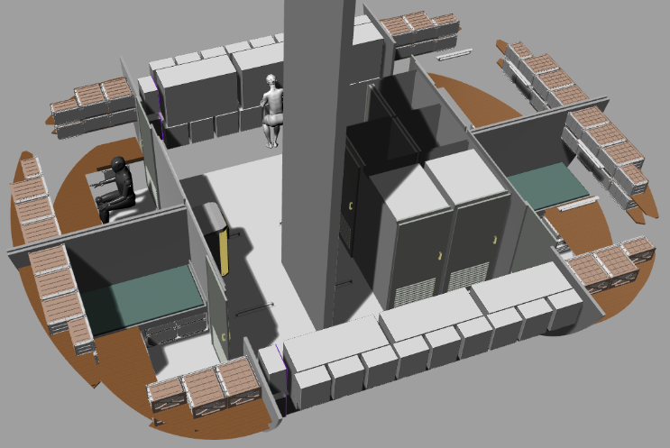
Figure 8. Lower Deck of the Four-Crew Horizontal Common Habitat
Mid Deck
The mid deck is the primary working volume for the Common Habitat, shown in Figure 9. The deck is essentially divided into quadrants as viewed in this figure. Exercise is in the lower right, represented by rough CAD sketches. Note that display screens are provided for T2 and CEVIS use, allowing the crew member to view videos or other activity while performing aerobic exercise. Maintenance and Fabrication is in the upper right. Obscured in this image are two maintenance glove boxes intended for maintenance involving hazardous materials. Physical science is in the upper left and life science in the lower left. Also present but not visible in this view, four freezers are in upper bay in the life science section. Hatches are not shown in the current view but are 60-inch tall by 40-inch wide rectangular rounded hatches located at 90-degree intervals between the equipment as shown in Figure 2.
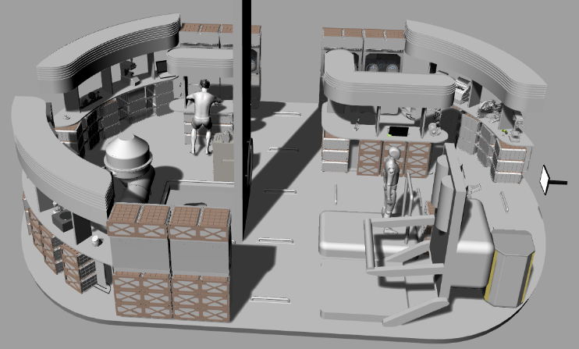
Figure 9. Mid Deck of the Four-Crew Horizontal Common Habitat
Upper Deck
With some exceptions, the upper deck, shown in Figure 10, is primarily a social volume. A central feature of the deck is the galley and wardroom. Two pallets are allocated for plant growth and the galley includes four freezers for fresh food stowage along with meal preparation equipment, wet and dry trash, a work surface for meal preparation, and six mid deck locker equivalent stowage volumes. While work-related, a dual-seat command and control workstation is located on this level because its presence allows the wardroom to double as a crew meeting space. Not visible in this view, the upper deck also features a large projection view screen mounted on the pressure vessel. (A projector is visible near the top left of the vertical wall.) A dedicated medical facility is located adjacent to the galley with a hygiene facility between medical and command and control. Most of the habitat’s subsystem pallets and Nitrogen Oxygen Recharge System (NORS) tanks are also on this deck. If the wardroom table is stowed and the stowage beneath the table is relocated, a large open volume is created on this deck that can be made available for crew recreation. This also opens up space for more comfortable viewing of the projection screen.
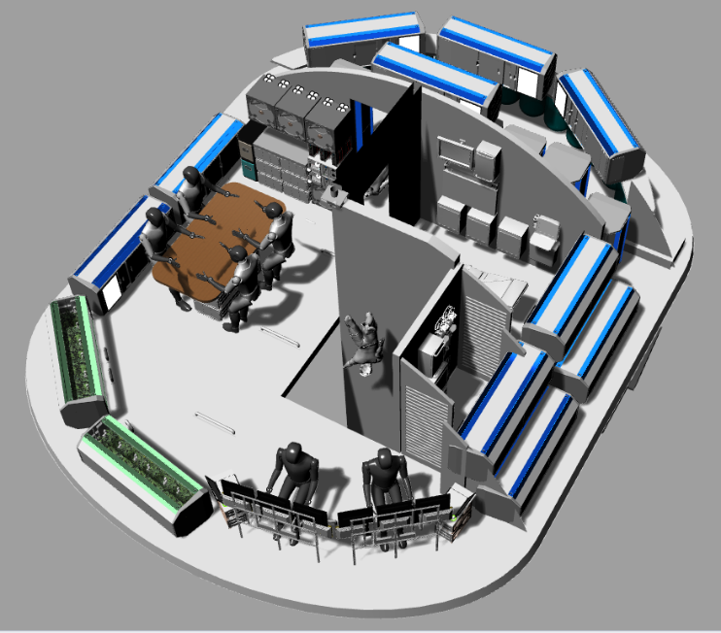
Figure 10. Upper Deck of the Four-Crew Horizontal Common Habitat

- 4-Crew Vertical Common Habitat Layout
Deck 1
Deck 1, shown in Figure 11, is primarily a subsystems deck. The majority of the habitat’s subsystem pallets and all NORS tanks are located on this deck. Additionally, the exercise equipment (ARED, T2, and CEVIS) are on the deck, with a small stowage allocation for exercise device accessories. Two display monitors are positioned for visibility by the T2 and CEVIS operators. Finally, a small bulk stowage location – 50 cargo transfer bag equivalents (CTBE) – is on this deck. The NORS tank, ECLSS pallets, and stowage are on a rotating rack (not pictured) that allows units to be rotated into position for removal or maintenance. It is forward work to determine the power, fluid, and data connections that can be maintained during rotation versus those that will have to be disconnected first. A large water tank occupies the remainder of the lower dome beneath the Deck 1 floor.
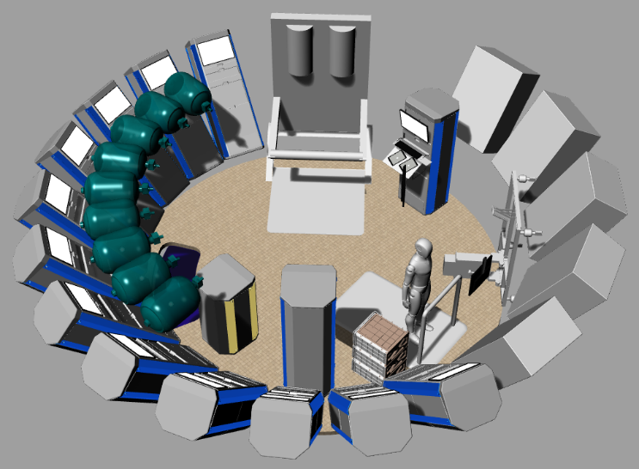
Figure 11. Deck One of the Four-Crew Vertical Common Habitat
Deck 2
Deck 2, shown in Figure 12, is the primary working volume of the Common Habitat. It is also the ingress and egress location, with four hatches at 90-degree intervals. The deck is divided into quadrants between each hatch. The quadrant at the top of the figure is life science. The cube-like structures that appear to be floating are science freezers that are mounted to the ceiling, which has been removed in this view for visibility. Directly opposite life science is physical science. On the left and right sides are the maintenance / fabrication work areas. The left side is focused on non-additive manufacturing. The right side is additive manufacturing, assembly, electronics, and inspection. Note that the sciences and maintenance all have glove boxes with transfer ports to the exterior. These allow samples and/or hardware to be transferred from the exterior space environment to the glove boxes without passing through the cabin.
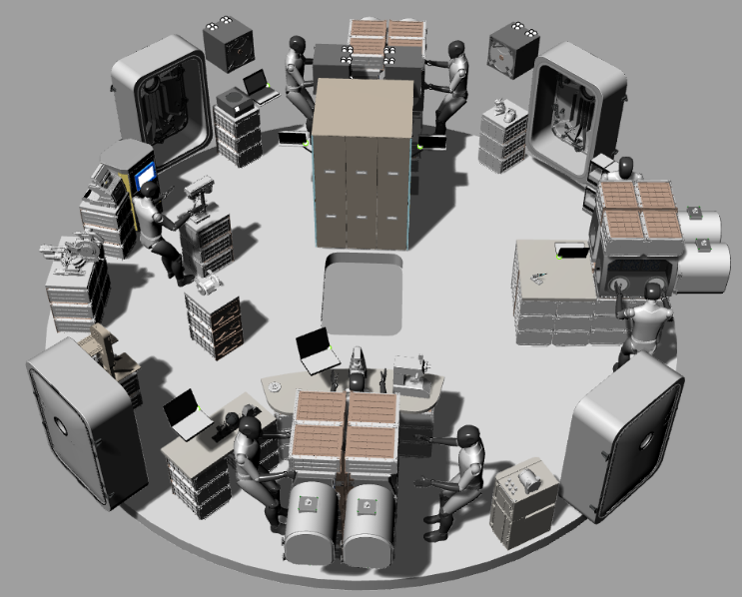
Figure 12. Deck Two of the Four-Crew Vertical Common Habitat
Deck 3
The third deck is devoted to functions requiring privacy. Four identical crew quarters, two hygiene stations, and two waste management compartments are on this deck. The deck also includes the medical facility. Not visible in this figure, a water tank is located over the hallway, covering both hygiene stations and both waste containment compartments.
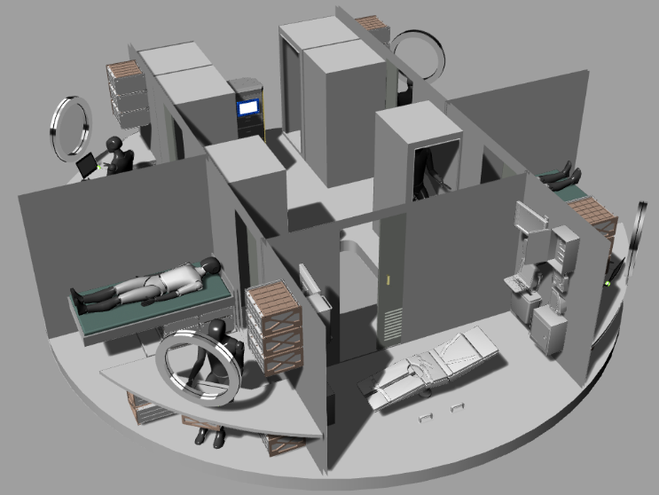
Figure 13. Deck Three of the Four-Crew Vertical Common Habitat
Deck 4
Deck 4 is primarily a social volume, shown in Figure 14. Eleven pallet-sized plant growth chambers ring the entire perimeter of the deck, providing volume for fresh fruits and vegetables. The galley is flanked by two ECLSS pallets to support the additional workload caused by the plant growth. Bulk food stowage is located behind the galley. A wardroom table facilitates crew dining and meetings with a large projection screen positioned for view by crew at the table. Like with the four-crew horizontal variant, the wardroom table can be stowed and the stowage beneath it relocated to create a large open volume on this deck. Finally, two command and control workstations support vehicle operations. An overhead water tank is not shown in this image but is visible in Figure 2.
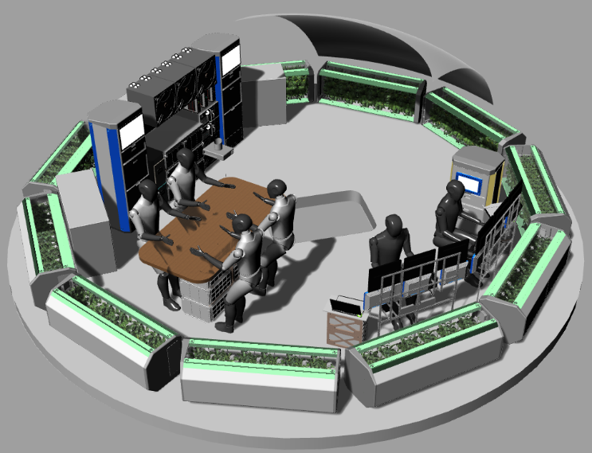
Figure 14. Deck Four of the Four-Crew Vertical Common Habitat

- 8-Crew Horizontal Common Habitat Layout
Lower Deck
The Lower Deck, shown in Figure 15, is almost completely consumed by the Crew Quarters. The eight identical crew quarters fill the entire barrel section of the deck. The Lower Deck also features four waste and hygiene facilities built into the domes, two at either end. Their design is unique to the horizontal eight-crew configuration. The hygiene changing room serves as an outer room to both the Waste Management Compartment and to the full body Hygiene Compartment, the latter two of which are at 90-degree angles to one another. A central hallway connects all eight crew quarters and the four changing rooms and also provides the vertical passageway to the Mid Deck. The habitat’s water tanks are located beneath the Lower Deck floor.
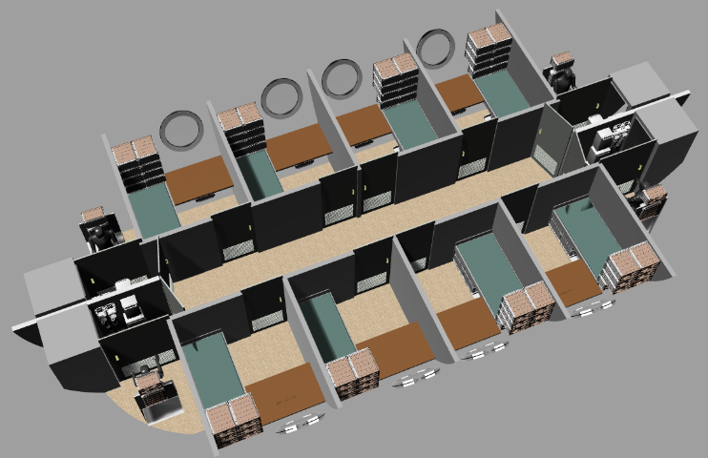
Figure 15. Lower Deck of the Eight-Crew Horizontal Common Habitat
Mid Deck
The Mid Deck, shown in Figure 16, takes advantage of the increased size of the eight-crew habitat to increase the volume available for exercise countermeasures and working functions. The exercise suite is doubled, with two ARED, two T2, and two CEVIS devices. Separation between the devices is also intended to reduce the potential for sweat from one crew member to impact another. As with the other variants, display monitors are provided in front of all T2 and CEVIS machines. Maintenance and fabrication occupies the center of the mid deck, with different classes of tools (additive manufacturing, non-additive, electronics, etc.). Life science (top right) and physical science (bottom right) have increased glove box volume. In general, the Mid Deck has increased floor space for staging hardware, whether logistics, science payloads, or maintenance activity.
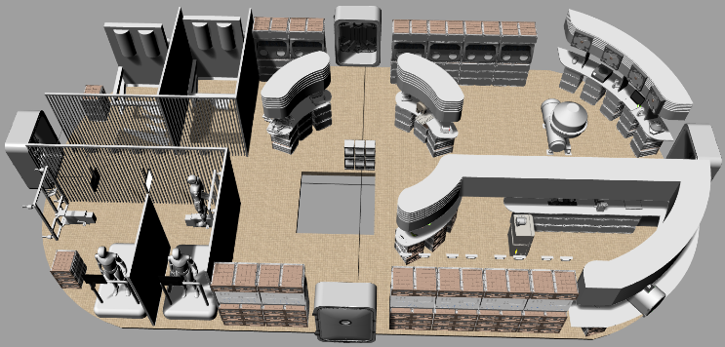
Figure 16. Mid Deck of the Eight-Crew Horizontal Common Habitat
Upper Deck
The Upper Deck for the eight-crew habitat is generally similar to its four-crew counterpart. Shown in Figure 17, the galley and wardroom table are doubled in size. A large projection screen is also provided for group viewing. The same capability to stow the wardroom table and relocate the stowage beneath it exists in this habitat as in the four-crew variants. The command and control workstations are relocated to be adjacent to the galley, but in an enclosed room. The number of plant growth pallets is increased to five and three 10-CTBE stowage bags are allocated for additional food stowage.
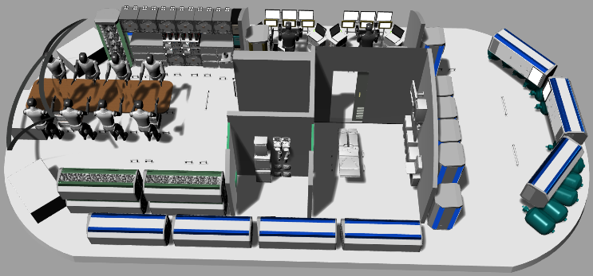
Figure 17. Upper Deck of the Eight-Crew Horizontal Common Habitat

- 8-Crew Vertical Common Habitat Layout
Deck 1
Much like the four-crew vertical habitat, Deck 1 features the primary subsystems volume and a bulk stowage volume. Shown in Figure 18, it also includes half of the habitat’s exercise equipment – in this case one each of ARED, T2, and CEVIS. Also like its smaller counterpart, a water tank is located beneath the deck floor.
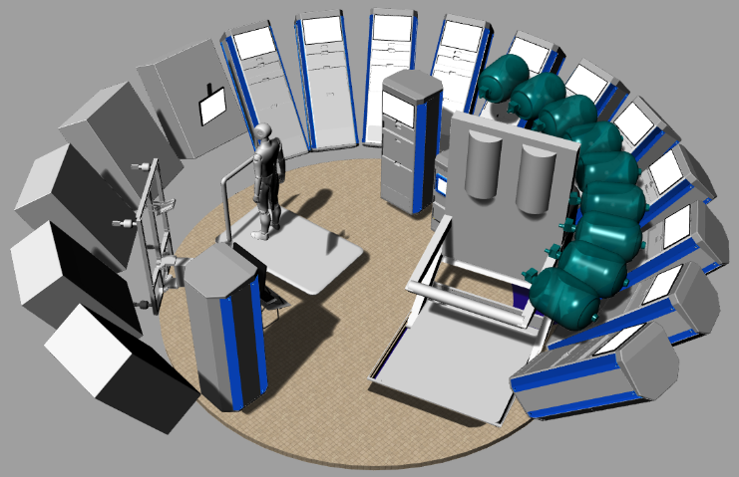
Figure 18. Deck One of the Eight-Crew Vertical Common Habitat
Deck 2
Figure 19 illustrates Deck 2, which is one of two working volumes in this variant of the Common Habitat. Deck 2 is also the ingress / egress point, with four hatches at 90-degree intervals. This deck contains two physical science work areas, located 180 degrees apart from each other. This is essentially a doubling of the physical science capacity of the four-crew vertical habitat. The deck also contains two maintenance and fabrication work areas – a replication of the capacity and configuration in the four-crew variant.
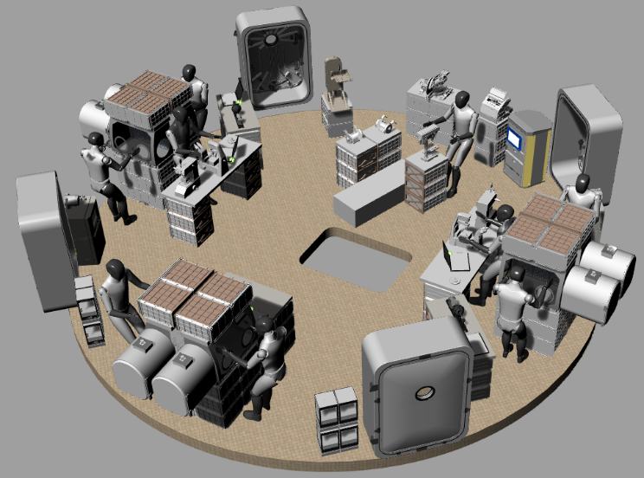
Figure 19. Deck Two of the Eight-Crew Vertical Common Habitat
Deck 3
Deck 3, shown in Figure 20, completes the working volumes of the eight-crew vertical Common Habitat. The life science capability is placed in two volumes at 180 degrees from each other. It doubles the life science capacity of the four-crew vertical configuration. Two other working volumes complete this deck. The two command and control workstations are enclosed in a separate room. Opposite it, also isolated in its own room, is the medical facility.
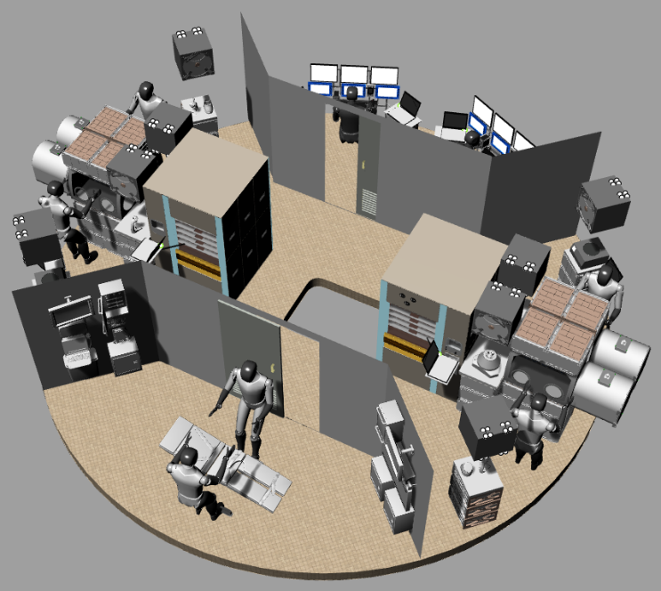
Figure 20. Deck Three of the Eight-Crew Vertical Common Habitat
Decks 4 and 5
Decks 4 and 5 form the private habitation decks of the eight-crew vertical Common Habitat. They are nearly identical in design to Deck 3 of the four-crew vertical Common Habitat. The key difference is that the volume that had been allocated to medical is replaced with crew exercise on both decks. On deck 4, the allocation is for aerobic exercise and is occupied by one CEVIS and one T2 device, both with display monitors for their operators, shown in Figure 21.
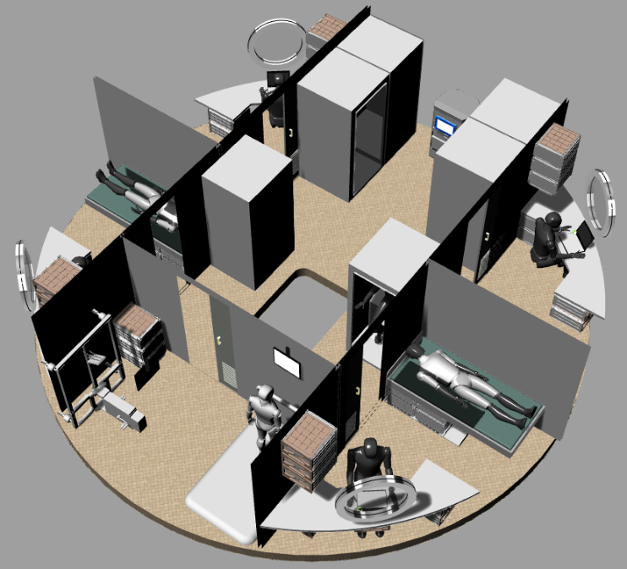
Figure 21. Deck Four of the Eight-Crew Vertical Common Habitat
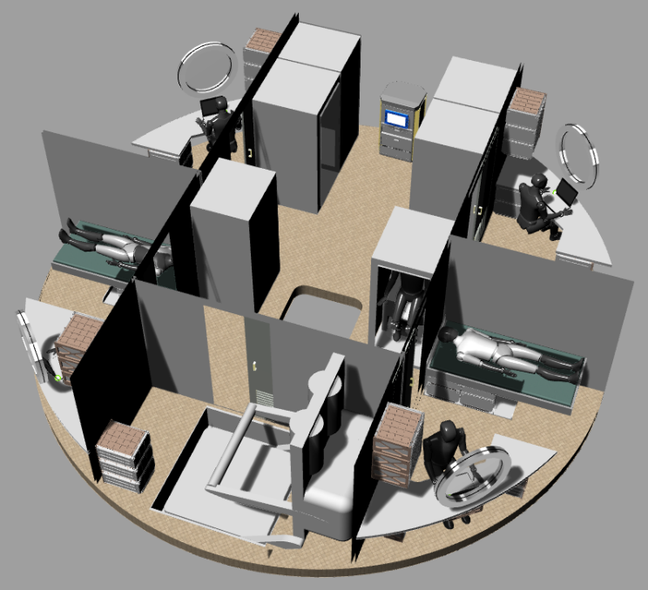
Figure 22. Deck Five of the Eight-Crew Vertical Common Habitat
On deck 5, shown in Figure 22, the former medical volume is given to resistive exercise with an ARED in that location. It is worth noting that the ARED is slightly taller than the available deck height and is therefore sunk into the deck. Placement of the T2 and CEVIS on deck 4 is carefully positioned to avoid interference with this protrusion. (In all four configurations the ARED either protrudes up or down as needed to fit into the volume.) Also, just like Deck 3 of the 4-crew vertical configuration, a water tank is located over the hallway of deck 5, covering both hygiene stations and both waste containment stations.
Deck 6
Shown in Figure 23, Deck 6 is the social gathering space of the eight-crew vertical Common Habitat. Like the four-crew variant, it includes eleven plant growth chambers. And like the eight-crew horizontal variant, it doubles the galley as well as provides wardroom table accommodation for eight. And also, like the four-crew vertical, it positions a large projection screen on the upper dome for crew viewing. Just as with all other variants, the wardroom table can be stowed and the stowage beneath it relocated.
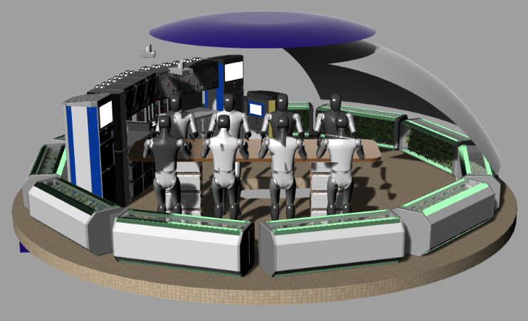
Figure 23. Deck Six of the Eight-Crew Vertical Common Habitat

- Forward Work to Select a Single Common Habitat
It is not enough to have merely created the four variants of the Common Habitat. The next step is to determine which one to select for further development. To make this decision in a non-arbitrary manner and in the absence of driving program requirements, several analyses will be performed to drive out the relative benefits and liabilities of each variant, with the hope that there will be significant distinctions between the four.
The four variants will be subjected to the following eight assessments: stowage assessment, functional analysis, crew time assessment, science productivity analysis, maintenance capacity analysis, contingency responsiveness analysis, radiation exposure analysis, ray tracing analysis, and a virtual reality habitability evaluation. These assessments will collectively identify the strengths and weaknesses of each variant, allowing an objective decision to be made to select a single Common Habitat for further development.
With the questions of crew size and internal orientation resolved, data from these assessments will be used to drive a series of design upgrades to the selected habitat. Additionally, increased fidelity will be applied to components within the habitat. Focused detail design will be applied to select crew systems to ensure that they will function appropriately in 0 g, 1/6 g, 3/8 g, and 1 g thereby ensuring the single Common Habitat design can function as an Earth trainer, lunar surface habitat, Mars surface habitat, and microgravity transit habitat.
The next step will be to compare the Common Habitat against its destination-specific counterparts. This will be done though a series of comparative virtual reality evaluations involving the Common Habitat and prior NASA concepts for Moon, Mars, and microgravity long duration spacecraft. With this complete, a study will be conducted to determine options to manufacture Common Habitats within a timeline and budget compatible with NASA exploration goals.
In parallel with these efforts, other studies will examine challenges of deploying a Common Habitat. The SLS LOX tank is clearly too large a structure – even if launched empty – for the landers currently under development for the Artemis program, with the possible exception of Space X’s Moon Starship. Concept studies are pursuing options to land a Common Habitat on the Moon by means of in-space assembly of lander descent stages to produce heavy cargo landers that can still be launched by Falcon Heavy / Vulcan / New Glenn class commercial launch vehicles. [5] Other future studies will take on the challenges of Mars in-space transit and Mars entry, descent, and landing.
These future analyses will collectively determine the viability of the Common Habitat approach for long-duration human exploration of the Moon and Mars.

- Acknowledgements
The author offers thanks David Smitherman of NASA Marshall Space Flight Center and Brand Griffin of Genesis Engineering (at the time employed by Gray Research) for initial work pioneering the Skylab II concept, Scott Howe of the NASA Jet Propulsion Lab who has consistently provided Skylab II support as well as Tri-ATHLETE information, Sasakawa International Center for Space Architecture and their graduate students for participating in the Common Habitat project, NASA@Work, the NASA JSC EMERGE Employee Resources Group’s JSC Hackathon, the NASA Innovation Charge Account for FY 2019 funding, members of the Center for Design and Space Architecture for CAD model refinements, all interns and other students who have contributed to prior iterations of the Common Habitat, Skylab II, or predecessor habitat studies, and all team members of current and prior NASA lunar, Mars, and deep space architecture studies.

- References
[1] Belew, Leland (ed.), “Skylab, Our First Space Station, NASA SP-400, Marshall Space Flight Center, NASA Scientific and Technical Information Office, 1977.
[2] Griffin, Brand, Smitherman, David, Kennedy, Kris, Toups, Larry, Gill, Tracy, Howe, A. Scott, “Skylab II Making a Deep Space Habitat from a Space Launch System Propellant Tank,” AIAA Space 2012, Pasadena, CA, September 11-13, 2012.
[3] Howard, Robert, “Opportunities and Challenges of a Common Habitat for Transit and Surface Operations,” IEEE Aerospace 2019, Big Sky, MT, March 2-9, 2019.
[4] Direct email communication. 7:12 pm. December 28, 2019.
[5] Howard, Robert, “A Joinable Undercarriage to Maximize Payload (JUMP) Lunar Lander for Cargo Delivery to the Lunar Surface.” AIAA Propulsion and Energy Forum 2019. Indianapolis, Indiana. August 19-22, 2019.
[6] Heverly, Matt, Matthews, Janet, Frost, Matt, McQuin, Chris, “Development of the Tri-ATHLETE Lunar Vehicle Prototype,” Proceedings of the 40th Aerospace Mechanisms Symposium, NASA Kennedy Space Center, May 12-14, 2010.
[7] Giaimo, Cara, “Did 3 NASA Astronauts Really Hold a ‘Space Strike’ in 1973?,” Atlas Obscura, August 28, 2017, https://www.atlasobscura.com/articles/did-skylab-4s-astronauts-really-go-on-strike, accessed October 6, 2019.
[8] NASA, NASA Space Flight Human-System Standard Volume 2: Human Factors, Habitability, and Environmental Health, NASA-STD-3001, Volume 2, January 10, 2011.
[9] NASA, Human Integration Design Handbook (HIDH), NASA/SP-2010-3407/REV1, June 5, 2014.
[10] NASA, Constellation Program Human-Systems Integration Requirements, CxP 70024, Revision E, November 19, 2010.
[11] NASA Human Research Program, Risks, Human Research Roadmap, https://humanresearchroadmap.nasa.gov/Risks/, accessed October 6, 2019.
[12] Litaker, Harry, Archer, Ronald, Szabo, Richard, Twyford, Evan, Conlee, Carl, Howard, Robert, “Human Habitation Field Study of the Habitat Demonstration Unit (HDU),” Acta Astronautica, Volume 90, Number 2, Elsevier Ltd., October 2013.
[13] Gernhardt, Michael, Chappell Steve, Beaton, Kara, Litaker, Harry, Bekdash, Omar, Newton, Carolyn, Stoffel, James, “Deep Space Habitability Design Guidelines Based on the NASA NextSTEP Phase 2 Ground Test Program,” NASA/TP-2020-220505.
[14] Swan, Bobbie Gail, “GFE Exercise,” September 2017, https://ntrs.nasa.gov/archive/nasa/casi.ntrs.nasa.gov/20170009178.pdf, accessed October 7, 2019.
[15] NASA Headquarters History Office, “Long Duration Psychology,” https://history.nasa.gov/SP-4225/long-duration/long.htm accessed October 5, 2019.
[16] NASA, “International Space Station User’s Guide – Release 2.0,” http://www.spaceref.com/iss/ops/ISS.User.Guide.R2.pdf, accessed October 6, 2019.
[17] Wild, Jim, “Space Radiation: the Apollo crews were extremely lucky,” The Conversation, July 17, 2019, http://theconversation.com/space-radiation-the-apollo-crews-were-extremely-lucky-120339, accessed October 5, 2019.
[18] NASA, NASA Space Flight Human-System Standard Volume 1, Revision A: Crew Health, NASA-STD-3001, Volume 1, July 30, 2014.

- Biography
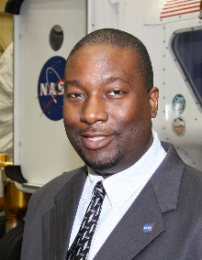
Robert Howard is the Habitability Domain Lead in the Habitability and Human Factors Branch and co-lead of the Center for Design and Space Architecture at Johnson Space Center in Houston, TX. He leads teams of architects, industrial designers, engineers and usability experts to develop and evaluate concepts for spacecraft cabin and cockpit configurations. He has served on design teams for several NASA spacecraft study teams including the Orion Multi-Purpose Crew Vehicle, Orion Capsule Parachute Assembly System, Altair Lunar Lander, Lunar Electric Rover / Multi-Mission Space Exploration Vehicle, Deep Space Habitat, Waypoint Spacecraft, Exploration Augmentation Module, Asteroid Retrieval Utilization Mission, Mars Ascent Vehicle, Deep Space Gateway, as well as Mars surface and Phobos mission studies. He received a B.S. in General Science from Morehouse College, a Bachelor of Aerospace Engineering from Georgia Tech, a Master of Science in Industrial Engineering with a focus in Human Factors from North Carolina A&T State University, and a Ph.D. in Aerospace Engineering with a focus in Spacecraft Engineering from the University of Tennessee Space Institute. He also holds a certificate in Human Systems Integration from the Naval Postgraduate School and is a graduate of the NASA Space Systems Engineering Development Program.

