OVERVIEW of NASA’s SSERVI RESOURCE (Resource Exploration and Science of OUR Cosmic Environment) PROJECT. Jennifer L. Heldmann¹, Matthew C. Deans¹, Darlene S. S. Lim¹, Anthony Colaprete¹, Richard Elphic¹, Dana Hurley², Andy Rivkin², Dava Newman³, Janine Captain⁴, Kris Zacny⁵, Josh Coyan⁶, Anna Wagner⁷, Zara Mirmalek⁸, Alexandra Matiella Novak², Deena Khalil⁹, Carter Emmart¹⁰, Pamela Harman¹¹ and the NASA RESOURCE Team. ¹NASA Ames Research Center, ²Johns Hopkins University / Applied Physics Lab, ³Massachusetts Institute of Technology, ⁴NASA Kennedy Space Center, ⁵Honeybee Robotics, ⁶U.S. Geological Survey, ⁷U.S. Army, Cold Regions Research Environment Laboratory (CRREL), ⁸NASA Ames Research Center / BAER Institute, ⁹Howard University, ¹⁰American Museum of Natural History, ¹¹SETI Institute.

Introduction: In Situ Resource Utilization (ISRU) near the sites of robotic and/or human missions may enable sustainable and affordable exploration of the SSERVI (Solar System Exploration Research Virtual Institute) Target Bodies. Key to using space resources is knowing their location, quantity, distribution, and extractability. In addition, operations and hardware associated with each ISRU prospecting, excavation, transportation, and processing step must be examined, tested, and integrated to enable effective ISRU (Sanders 2015).
Project Description: The RESOURCE (Resource Exploration and Science of OUR Cosmic Environment) project addresses these ISRU needs through a structured program directly linking science and exploration. We are relevant to NASA’s Science Mission Directorate (SMD) by characterizing potential resources on SSERVI Target Bodies through scientific investigation. Our work is relevant to NASA’s Human Exploration and Operations Mission Directorate (HEOMD) through engineering, hardware and software development and testing for future near-term ISRU missions. We abide by the mantra that “science enables exploration and exploration enables science.” To that end, RESOURCE includes the following four tasks:
Task 1: Assess and characterize resource inventories of SSERVI Target Bodies. First we develop a semi-quantitative mineral potential model of resource assessment for water ice on SSERVI Target Bodies utilizing state-of-the art knowledge regarding resource inventories to identify prospective regions for the occurrence of ice, volatiles, or other resources. This analysis is then used to develop predictive capabilities for resource identification where remote sensing data may be insufficient.
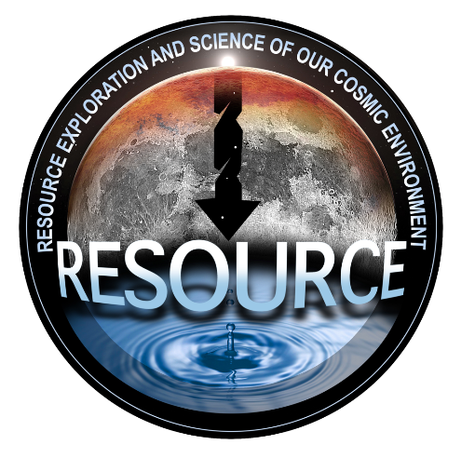
Task 2: ISRU technology development and testing. Here we focus on technologies relevant to enabling lunar ISRU missions. First we focus on a lunar resource prospecting payload to advance the state of current rover-mounted systems. We will also analyze lunar mining and demonstrate technologies for the collection and processing of extracted water for future mining feasibility.
Task 3: Assessing concepts of operations, capabilities and related human-robotic interactions in support of lunar robotic ISRU exploration. Here we focus on optimization of the robotic and human interactions for a mission to prospect for resources and conduct lunar ISRU and optimize human-machine collaboration (HMC) and human factors engineering task allocation. We design and test different components of mixed reality (including augmented reality (AR) and virtual reality (VR)) to enhance and optimize the productivity of a lunar polar rover mission.
Task 4: Future ISRU robotic mission support activities (lunar test case). Through this work we produce data products to support lunar polar rover mission traverse planning purposes. We are developing advanced mission planning capabilities for a lunar polar rover prospecting mission and will integrate mission scheduling tools into the ground data system software suite.
Citizen Science / Science Activation / Public Engagement. RESOURCE is also committed to sharing the excitement of this work with students and the public. Students and post-doctoral researchers are integral members of our team. We also partner with multiple NASA Science Activation teams and will 1) provide content for the OpenSpace data visualization project at the American Museum of Natural History (AMNH), 2) provide women Subject Matter Experts (SMEs) to support the SETI Institute’s “Reach for the Stars: NASA Science for Girl Scouts” program, 3) deliver topical seminars through multiple online platforms, and 4) team with Howard University, a Historically Black College & University (HBCU), to help develop highly effective teachers who then elect to serve in either urban schools or in education systems with a predominantly marginalized student population.

