Constraints on Triple Oxygen Isotope Kinetics

Justin A. Hayles
Jacobs-JETS, Astromaterials Research and Exploration Science, Johnson Space Center
National Aeronautics and Space Administration
Houston, TX 77058, U.S.A.
justin.a.hayles@nasa.gov

Bryan A. Killingsworth
US Geological Survey
MS 954 National Center
12201 Sunrise Valley Drive
Reston, VA 20192

Abstract
Isotopic disequilibrium is not as well constrained as equilibrium, hindering interpretation of isotopic variations. Kinetic isotope effects, a subset of disequilibrium, are common in nature and have been assumed to be distinct from equilibrium and mass independent isotope effects based on underdeveloped criteria. Using basic physical principles, we provide needed mechanistic constraints on mass-dependent kinetic isotope effects for the triple oxygen isotope system. We find some kinetic isotope effects yield large isotopic variations, exceeding equilibrium, which could be mistaken for mass independent relationships. Meanwhile, other kinetic isotope effects are found to have triple oxygen isotope relationships that could be mistaken for equilibrium isotope effects. Comparison against prior case studies of thermal decomposition of calcite (CaCO₃) and brucite (Mg(OH)₂) further tests our results. Although oxygen is the focus here, our approach applies to any system with more than two isotopes.
Keywords: Isotope Geochemistry, triple-oxygen, oxygen-17, mass-dependent isotope fractionation, Kinetic isotope effects
1. Introduction
For ease of interpretation, it is convention to assume geochemical systems have reached thermodynamic equilibrium. Recent observations of triple isotopic variations in igneous rocks (Antonelli et al., 2019; Cano et al., 2020) and small oxygen isotope (¹⁶O-¹⁷O-¹⁸O) variations in low temperature minerals (Bindeman et al., 2016; Pack and Herwartz, 2014; Passey et al., 2014; Sengupta and Pack, 2018; Sengupta et al., 2020; Sharp et al., 2016; Wostbrock et al., 2020; Wostbrock et al., 2018) highlight that tighter constraints on disequilibrium mass-dependent isotope effects are needed. Because the isotope variations being considered are often small, it becomes more important to clearly establish the isotopic distinctions that characterize isotope effects arising from different mechanisms (e.g., equilibrium, kinetics, mass independence). Previous work has established a broad framework for describing isotopic disequilibrium (Bao et al., 2015), but critical details characterizing one end member, kinetic isotope effects, have yet to be established. Here we explore the general theory of kinetic isotope effects for three-isotope systems with applicability to cases where equilibrium cannot be assumed. We consider special cases of kinetic isotope effects that are potentially recognizable based on their specific isotopic fractionations and contextual considerations. Results from theory are further tested against two experimental isotopic case studies of mineral thermal decomposition for calcite (Miller et al., 2002) and brucite (Clayton and Mayeda, 2009). For these cases, comparison of theoretical fractionations with experimental results indicates that both reactions can be readily described by mass-dependent kinetic isotope effects. The scope of this study is limited to reactions which are well described by transition state theory and do not require consideration of contributions from mass-independent or otherwise atypical contributions and reaction mechanisms.

1.1 Triple-Isotope Equilibrium Fractionation Theory
Partition function ratios can be used to calculate equilibrium constants for isotope fractionation. The reduced Partition Function Ratio (β_{h}) accounts for the dominant quantum mechanical component of harmonic molecular vibrations (Wolfsburg et al., 2010). For a single species in a statistical system of stable molecules, β_{h} is given by
${{}_{}^{x}β}_{h}=\frac{σ}{{}_{}^{x}σ}\prod_{i}^{3n-6}{\frac{{}_{}^{x}{u_{i}}}{u_{i}}\frac{e^{-{{}_{}^{x}{u_{i}}}/2}}{e^{-{u_{i}}/2}}\frac{(1-e^{-u_{i}})}{(1-e^{-{}_{}^{x}{u_{i}}})}}$ (1).
The term ${}_{}^{x}u$ equals ${h{}_{}^{x}ω}/{K_{B}T}$ where ω is the harmonic vibrational frequency, $h$ is Planck’s constant, $K_{B}$ is Boltzmann’s constant, while the product is taken over all vibrational frequencies (3n - 6, or 3n - 5 for linear molecules) and “^{x}” indicates an isotopic substitution (e.g., ¹⁷O, or ¹⁸O) (Bigeleisen and Goeppert-Mayer, 1947; Urey, 1947). The parameter $σ$ is the symmetry number. For equilibrium, the fractionation factor α is given by the ratio of β for two species.
Two parameters are used to describe mass-dependent fractionation relationships, κ [= ln(¹⁷β) / ln(¹⁸β)] and θ [= ln(¹⁷α) / ln(¹⁸α)]. Both are mass dependency exponents with κ being the equivalent of the parameter θ for a single species versus an unbound oxygen atom (Bao et al., 2016; Cao and Liu, 2011). Under the harmonic approximation for equilibrium isotope effects in the oxygen isotope system, κ for a stable species is bounded between values of ~0.5305 at $1/m$ mass dependency and ~ 0.5232 at $1/\sqrt{m}$ mass dependency (Dauphas and Schauble, 2016; Hayles et al., 2017), where m is the mass of ¹⁶O, ¹⁷O, or ¹⁸O.
The relationship between κ and θ can be written (Cao and Liu, 2011):
$$θ=κ_{A}+\left(κ_{A}-κ_{B}\right)\frac{ln⁡({}_{}^{18}{β_{B})}}{\ln\left({}_{}^{18}{α_{A-B}}\right)} (2).$$
From this equation $θ$ may exist outside the confines of κ if ${ln({}_{}^{18}{β_{B})}}/{ln({}_{}^{18}{α_{A-B}})}$ is sufficiently large because κ and β are not strict functions of each other (i.e., $\left(κ_{A} - κ_{B}\right)≠0$, strictly, when $\left|{ln⁡({}_{}^{18}{β_{B})}}/{ln⁡({}_{}^{18}{α_{A-B}})}\right| ≫ 1$) (Hayles et al., 2017). Values of $θ$ for equilibrium are not confined to bounds of κ, particularly at low temperatures in scenarios with small fractionations (Dauphas and Schauble, 2016; Hayles et al., 2017). To avoid potential interpretational pitfalls of $θ$ variability at small fractionations an alternate parameter, ΔΔ′¹⁷O can be used to describe mass-dependent relationships and can be written as:
$Δ{Δ'}^{17}O=\left(θ-C\right)\ln\left({}_{}^{18}{α_{A-B}}\right)(3)$.
For the purposes of this study, C is set to the high-temperature limit of κ_{h} (=[1/m₁₆ - 1/m₁₇]/[1/m₁₆ - 1/ m₁₈] = 0.5305). Unlike $θ$, $Δ{Δ'}^{17}O$ remains finite for small fractionations (Dauphas and Schauble, 2016; Hayles et al., 2017). For the discussion here, both the choice of C=0.5305 and the use of $Δ{Δ'}^{17}O$, rather than $θ$, provide a significant degree of simplification. The use of $Δ{Δ'}^{17}O$, in particular, brings theoretical results closer to typically measured parameters, such as δ’¹⁸O ( =ln(¹⁸R/¹⁸R_{standard}) ) and ${Δ'}^{17}O$ ( =ln(¹⁷R/¹⁷R_{standard})-C ln(¹⁸R/¹⁸R_{standard}) ), for ease of comparison.

2. Kinetic Isotope Effects

Here, we consider a unidirectional reaction involving a single isotopic substitution. Located between reactant and product along the reaction coordinate is a transition state (TS), assumed to be in equilibrium with the reactants (Wolfsburg et al., 2010). In contrast to a stable molecule, a TS loses one vibrational degree of freedom to a single decomposition mode corresponding, for instance, to creation or destruction of a bond. This decomposition mode is characterized by an imaginary frequency (IF) (Wolfsburg et al., 2010). The contribution to β from harmonic components of a TS follows equation 1 except with one less vibrational degree of freedom. From Bigeleisen and Wolfsberg (1958):
$${{}_{}^{x}β}_{IF}{}_{}^{x}{β_{h}^{‡}}=\frac{σ}{{}_{}^{x}σ}\frac{{}_{}^{x}{ν_{h}^{‡}}}{ν_{h}^{‡}}\prod_{i}^{3n-7}{\frac{{}_{}^{x}{u_{i}^{‡}}}{u_{i}^{‡}}\frac{e^{-{{}_{}^{x}{u_{i}^{‡}}}/2}}{e^{-{u_{i}^{‡}}/2}}\frac{(1-e^{-u_{i}^{‡}})}{(1-e^{-{}_{}^{x}{u_{i}^{‡}}})}} (4).$$
Here, all terms are the same as in equation 1. The added term ${{}_{}^{x}{ν_{h}^{‡}}}/{ν_{h}^{\begin{aligned}‡\end{aligned}}}$ (β_{IF}) is the ratio of imaginary frequencies for the isotopically substituted and unsubstituted species. For reactions where the decomposition mode coordinate corresponds to a bond extension and rupture, β_{IF} is given by
$${{}_{}^{x}β}_{IF}={\left(\frac{μ}{{}_{}^{x}μ}\right)}^{1/2}(5)$$

(Bigeleisen and Wolfsberg, 1958), where μ is the reduced mass of the decomposition fragments. Unlike harmonic contributions to the TS (${}_{}^{x}{β_{h}^{‡}}$), under this framework, β_{IF} is independent of temperature given a constant structure. Under the harmonic approximation, the kinetic isotope effect is given by the ratio of ${{}_{}^{x}β}_{h}$ for the reactant and ${{}_{}^{x}β}_{IF}{}_{}^{x}{β_{h}^{‡}}$ for the TS. For ¹⁶O-¹⁷O-¹⁸O, ${{}_{}^{x}β}_{h}$ for a stable molecule is strictly >1, however, ${{}_{}^{x}β}_{IF}{}_{}^{x}{β_{h}^{‡}}$ can be greater or less than 1 depending on the contributions of ${}_{}^{x}{β_{h}^{‡}}$ (>1) and ${{}_{}^{x}β}_{IF}$ (<1).

2.1 Early Transition State kinetic isotope effects
Additional constraints are available by considering reaction complexity, proximity of the TS to the reactant/product, and whether the isotopically substituted site is directly involved in a broken bond. The Hammond-Leffler postulate suggests that a TS most closely resembles the structure of the adjacent intermediate, reactant, or product that is close in energy to the TS (Hammond, 1955; Leffler, 1953). A TS can be considered, non-exclusively, to be early when close in energy and geometry to reactants, or late when close in energy and geometry to products. This is extended to vibrational frequencies and sensitivity of vibrational frequencies to isotopic substitutions (i.e., geometry and force constants). The most constraint on kinetic isotope effects is for early TS reactions which are adjacent to the reactant. An early TS typically corresponds to fast exothermic reactions where activation energy is small, e.g., oxidation of H₂SO₃ by O₃ (Sheng et al., 2018). For early TS kinetic isotope effects, harmonic components of ${}_{}^{x}{β_{h}^{‡}}$ (for the transition state) correspond to vibrational components that resemble those present in ${{}_{}^{x}β}_{h}$ (for the reactant) except for one vibrational mode lost to a decomposition mode. The contribution to β from this “lost” mode, ${}_{}^{x}{β_{"lost"}}$, is less than ${{}_{}^{x}β}_{h}$ or equal to ${{}_{}^{x}β}_{h}$ for decomposition of a single diatomic reactant. For ideal simple early kinetic isotope effects an approximation is
${{}_{}^{x}α}_{KIE}≈{{}_{}^{x}β}_{IF}{}_{}^{x}{β_{"lost"}^{-1}} (6)$.
This approximation yields ${{}_{}^{x}α}_{KIE}$ values corresponding to normal kinetic isotope effects, with light isotopologues reacting preferentially because both ${{}_{}^{x}β}_{IF}$ and the inverse of ${}_{}^{x}{β_{"lost"}}$ favor the lighter isotope in the TS. This suggests that early TS reactions typically yield normal kinetic isotope effects where $θ_{KIE}$ can be approximated as
$θ_{KIE-Early}≈\frac{κ_{IF}ln{{}_{}^{18}{β_{IF}}}+κ_{"lost"}ln{{}_{}^{18}{β_{"lost"}^{-1}}}}{\ln{{}_{}^{18}{β_{IF}}}+\ln{{}_{}^{18}{β_{"lost"}^{-1}}}} (7)$.
The upper and lower limits of $θ_{KIE}$ for such an ideal early-TS kinetic isotope effect are the upper and lower limits of $κ_{IF}$ and $κ_{"lost"}$. For both $κ_{IF}$ and $κ_{"lost"}$ one limit corresponds to 1/m mass dependency (e.g., 0.5305). The other limits are given by $1/\sqrt{m}$ mass dependency for $κ_{"lost"}$ (e.g., 0.5232) and ln(m) mass dependency for $κ_{IF}$ (e.g., 0.5158) (Dauphas and Schauble, 2016; Hayles et al., 2017; Yeung and Hayles, 2021). Because both $\ln{{}_{}^{18}{β_{IF}}}$ and $\ln{{}_{}^{18}{β_{"lost"}^{-1}}}$have the same sign, equation 7 yields an accessible range of $θ_{KIE}$ for ideal early-TS kinetic isotope effects of 0.5158 to 0.5305. Although some early TS reactions may exceed these θ limits, most should not. It follows that early TS kinetic isotope effects are temperature dependent for the same reason as equilibrium isotope effects are; however, the trend in θ tends to be inverted. For ¹⁶O-¹⁷O-¹⁸O, lower-temperature equilibria tend towards lower θ than high-temperature equilibria. For early TS kinetic isotope effects, as well as many other kinetic isotope effects, this trend is reversed where higher θ values typically accompany lower-temperature processes. Reactions with low forward and high reverse reaction barriers are more likely to be expressed as kinetic isotope effects. For this reason, kinetic isotope effects within these limits should be well represented in nature. This may be a chemical reason that many expressed kinetic isotope effects tend to be characterized by θ between 0.516 and 0.5305 (Bao et al., 2016; Yeung and Hayles, 2021).
For second-degree kinetic isotope effects, where the substituted isotope is not involved in the active reaction site, $ln({{}_{}^{x}β}_{"lost"})$ is smaller due to a weakened influence of isotopic substitution on the frequency lost to the decomposition mode. For an ideal early second-degree kinetic isotope effect, ${{}_{}^{x}α}_{KIE}≈{{}_{}^{x}β}_{IF}$ (Wolfsberg, 1960) and $θ_{KIE}≈κ_{IF}$. This same approximation can be applied to very high-temperature kinetic processes due to the high-temperature limit where ${}_{}^{x}{β_{h}^{‡}}={{}_{}^{x}β}_{h}=1$.

2.2 Generalized kinetic isotope effects

For reactions with late transition states or intermediate precursors to the TS, there is no general constraint on structure of the TS relative to the reactants. For these reactions,
$${{}_{}^{x}α}_{KIE}=\frac{{{}_{}^{x}β}_{IF}{}_{}^{x}{β_{h}^{‡}}}{{{}_{}^{x}β}_{h}} (8),$$
which also contains the special case of equation 6 and allows for an atypical scenario $\ln\left({}_{}^{x}{β_{h}^{‡}}\right)>-ln⁡( \frac{{{}_{}^{x}β}_{IF}}{{{}_{}^{x}β}_{h}})$ yielding an inverse kinetic isotope effect or, alternatively, a case where $\ln\left({}_{}^{x}{β_{h}^{‡}}\right)≈-ln⁡( \frac{{{}_{}^{x}β}_{IF}}{{{}_{}^{x}β}_{h}})$, yielding small fractionations. The TS's mass dependency exponent, $κ^{‡}$, is given by
$$κ^{‡}=\frac{κ_{IF}ln{{}_{}^{18}{β_{IF}}}+κ_{h}^{‡}ln{{}_{}^{18}{β_{h}^{‡}}}}{\ln{{}_{}^{18}{β_{IF}}}+\ln{{}_{}^{18}{β_{h}^{‡}}}} (9).$$
Unlike the terms in equation 7, here the terms $\ln{{}_{}^{18}{β_{IF}}}$ (-) and $\ln{{}_{}^{18}{β_{h}^{‡}}}$ (+) are opposite sign. This yields a larger range for $κ^{‡}$ than $κ_{IF}$ or $κ_{h}^{‡}$, with $κ^{‡}$ being unbounded particularly when $κ_{IF}≠κ_{h}^{‡}$ and $ln⁡({}_{}^{18}{β_{h}^{‡})}≈ -ln⁡({}_{}^{18}{β_{IF})}$. Using these terms, $θ_{KIE}$ is given by
$$θ_{KIE}=κ^{‡}+(κ^{‡}-κ_{h})\frac{ln⁡({}_{}^{18}{β^{‡}})}{ln⁡({}_{}^{18}{α_{KIE}})} (10),$$
which is equivalent to equation 2 (Cao and Liu, 2011). Because $κ^{‡}$ is unbounded, $θ_{KIE}$ is also unbounded (i.e., can approach ±∞) particularly when fractionations are small. At ${}_{}^{18}{α_{KIE}}$≈ 1, there is potential for a large deviation of $θ_{KIE}$ from a more typical value of ≈0.5. These controls imply that $θ_{KIE}$ for complex and slow reactions will be unbounded and typically deviate from the high-temperature limit (= 0.5305) more than for most equilibrium exchanges (Young et al., 2002b). For the oxygen isotope system $θ_{KIE}$ tends to be lower than for equilibrium, as previously suggested, although not strictly (Dauphas and Schauble, 2016; Hayles et al., 2017; Young et al., 2002a).

2.3 Monte Carlo Treatment
Monte Carlo models are used here to approximate ranges expected for equilibrium, generalized kinetic reactions, and early TS kinetic reactions (Figures 1 and 2). Parameter ranges and methodology for the Monte Carlo models are given in the supplemental. Figure 1, panels b and c, display that ${{}_{}^{x}β}_{IF}$ allows for sizable fractionations even at elevated temperatures. In figure 2, contours of the probability density function show regions containing the densest 95% of model results at 25°C, 300°C, and 800°C.
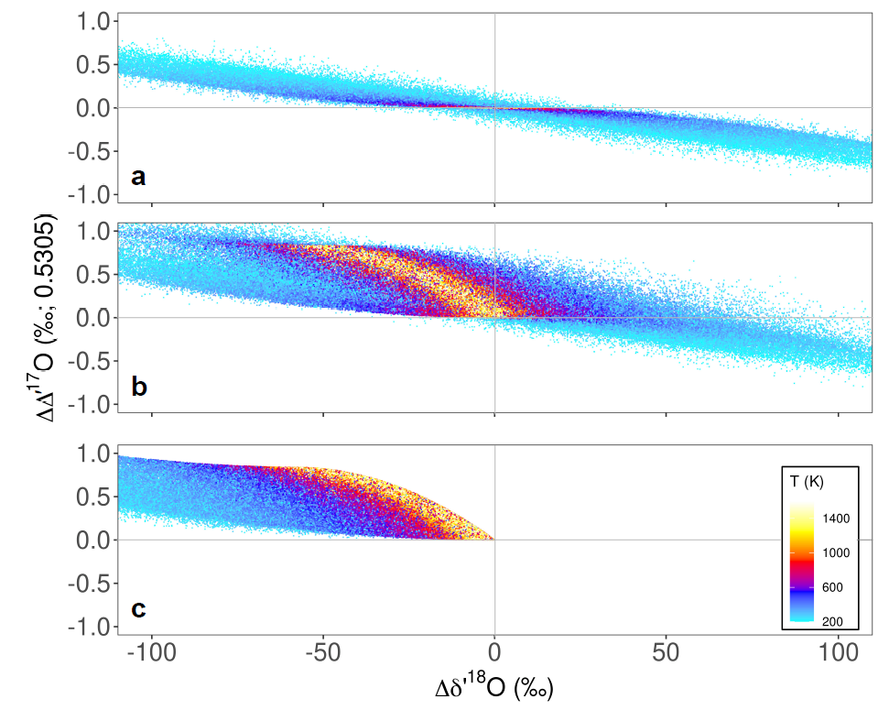
Figure 1: Monte Carlo models of 16O-17O-18O a) equilibrium isotope effects, b) generalized kinetic isotope effects, and c) early TS kinetic isotope effects. Temperature is plotted as color. Each model result (n=107) corresponds to hypothetical molecule/transition-state pair defined by randomly selected bond force constants and masses. Details of the model design are given in the SI.

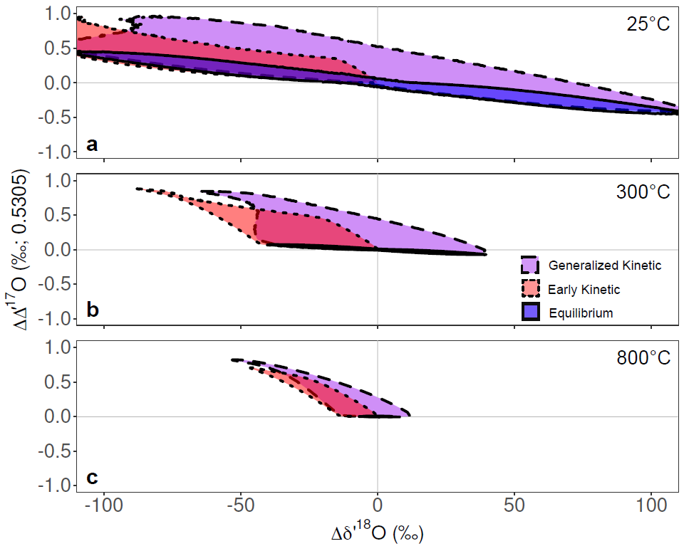
Figure 2: 95% density weighted distributions of isotope effects for the Equilibrium, Generalized Kinetic and Early TS Kinetic models at a) 25°C, b) 300°C and c) 800°C. Each contour contains the respective envelope with the highest 95% point density.

3. Discussion: Kinetic Isotope Effects
The larger range of kinetic isotope effects versus equilibrium isotope effects can be attributed to cases where the IF term is significant. In particular, ΔΔ′¹⁷O is in many cases dominated by the IF contribution to isotope fractionation. Equations 2, 3, and 4 can be combined to give,
$Δ{Δ'}^{17}O_{KIE}=Δ{Δ'}^{17}O_{IF-O}+\left(Δ{Δ^{'}}^{17}O_{h-O}^{‡}-Δ{Δ^{'}}^{17}O_{h-O}\right) (11)$.
In equation 11, $Δ{Δ'}^{17}O_{KIE}$ is the total change in $Δ{Δ'}^{17}O$ due to the kinetic isotope effect and $Δ{Δ'}^{17}O_{IF-O}$, $Δ{Δ'}^{17}O_{h-O}^{‡}$ and ${Δ'}^{17}O_{h-O}$ are the partial contributions from the imaginary frequency, harmonic vibrations of the transition state and harmonic vibrations of the reactant relative to a phase with no isotopic preference (e.g., atomic oxygen), respectively. The term $Δ{Δ^{'}}^{17}O_{h-O}^{‡}-Δ{Δ^{'}}^{17}O_{h-O}$ remains confined within the range of equilibrium isotope effects, which is more variable at low temperatures and more confined at high-temperatures. For instance, from the 90% interpercentile ranges of Monte Carlo results, values for $Δ{Δ^{'}}^{17}O_{h-O}^{‡}-Δ{Δ^{'}}^{17}O_{h-O}$ range ±0.32‰ at 25°C, ±0.19‰ at 100°C, ±0.06‰ at 400°C, 0.006‰ at 800°C. In contrast, $Δ{Δ'}^{17}O_{IF-O}$ is temperature-independent. Monte Carlo results of $Δ{Δ'}^{17}O_{IF-O}$ yield values ranging from slightly below 0‰ to 0.83‰ with larger values correlating with a smaller mass of the oxygen-bearing decomposition fragment. The temperature independence and high $Δ{Δ'}^{17}O$ stemming from an imaginary frequency contribution could result in a kinetic isotope effect being mistaken for a mass independent isotope effect. The value of $Δ{Δ'}^{17}O_{KIE}$ in excess of the range of equilibrium isotope effects at that temperature can provide constraint on the mass of the translating atoms associated with the substituted oxygen in the imaginary frequency of the transition state. This dependency of $Δ{Δ'}^{17}O_{KIE}$ on the imaginary frequency shows how a multi-isotope approach can more tightly constrain transition state structures than is possible via traditional two-isotope methods.
To further this discussion, we consider three special-case, but not uncommon, scenarios for transition states that can predict regions which a kinetic isotope effect could fall on the figure 2 plot. For these Special Cases, consider a transition state consisting of four molecular fragments, an isotopically substituted site (“*O”), and molecular fragments of Mass-1 (M₁), Mass-2 (M₂), and Mass-3 (M₃). The mass of *O can only be the isotopic masses of ¹⁶O, ¹⁷O or ¹⁸O corresponding to use of equations 4 and 5. The masses of M₁, M₂ and M₃ can be any possible molecular mass including 0.
Special Case 1: The transition state consists of decomposition fragments *O-M₁ and M₂. The mass of M₂ is very large and the mass of M₁ is relatively small. In this scenario, a very large mass of M₂ causes the reduced mass of the two decomposition fragments to be approximately equal to the mass of *O-M₁. This maximizes the dependency on the relative difference in mass between the differently substituted isotopologues of *O-M₁, yielding larger contributions from the imaginary frequency. One example of such a reaction is the thermal decomposition of brucite (see case study in section 4) where a water molecule containing the substituted *O is released in the final step, leaving an MgO-like defect at the surface (Churakov et al., 2004). This special case results in transition states that yield the most extreme possible positive ΔΔ′¹⁷O near the top edge of the kinetic fields in Fig. 2 with more positive ΔΔ′¹⁷O and more negative Δδ′¹⁸O associated with lighter evolved fragments (i.e., lower mass of M₁). This is expected to be particularly true for fractionations involving OH or H₂O in mineral dehydroxylation or dehydration reactions which may be limited by a surface process involving translation of a hydroxyl or water molecule in the rate-limiting step (Churakov et al., 2004).
Special Case 2: This scenario is the inverse of Special Case 1, where here the mass of M₂ is small and the mass of M₁ is very large, with decomposition fragments *O-M₁ and M₂. Again, brucite dehydroxylation can be used as an example of such a scenario if the composition of the MgO defect is of interest rather than the released water. The MgO defect is attached to a very large mass (i.e., a mineral grain). Substituting the mass of the oxygen in the MgO for another isotope will yield a negligible change in the total mass of the macroscopic mineral grain. This yields an insensitivity to the isotope mass of β_{IF} and therefore β_{IF} ≈ 1. This yields a kinetic isotope effect which falls within the equilibrium isotope effect field in Figure 2.
Special Case 3: The imaginary frequency corresponds only to a translation of M₃ and does not involve translation of M₁, M₂ or *O. Similar to Special Case 2, because it is not involved in the translation, the imaginary frequency term is insensitive to isotopic substitution of *O. This yields isotope effects which also fall within the equilibrium field. This scenario is likely to be the most commonly encountered as it corresponds to most hydrogen transfer reactions, such as the rate-limiting steps for the neutral mechanisms of silica polymerization (McIntosh, 2012).
It has been commonly stated that kinetic isotope effects have lower values of θ than equilibrium isotope effects (Clayton and Mayeda, 2009; Hayles and Bao, 2015; Young et al., 2002a). The results presented here largely agree with that interpretation, but Special Cases 2 and 3, as well as other intermediate scenarios, will yield kinetic isotope effects with similar θ values to those from equilibrium isotope effects and may have what are typically considered high θs. It cannot be assumed that kinetic isotope effects will always have lower θ values than equilibrium isotope effects. The reaction mechanism should be considered before evaluating the significance of a given θ.
As has been indicated in Special Cases 1 and 2, mass-dependent kinetic isotope effects give extreme ΔΔ′¹⁷O from reactions characterized by a significant mass differential between decomposition fragments. Therefore, ideal case studies for exploring the limits of mass-dependent kinetic isotope effects are thermal decompositions of solids yielding two oxygen-bearing phases, one evolved as a gas and one remaining as a point defect in the surface of a solid. Additionally, these reactions occur at elevated temperatures providing a larger potential difference between kinetic isotope effects, where a large component is temperature-independent, and equilibrium isotope effects, which approach unity at high-temperature. We thus explore case studies of thermal decomposition of two minerals, brucite and calcite.

4. Case Studies: Thermal Decomposition of Calcite and Brucite
Two of the most studied thermal decomposition reactions are those for calcite and brucite. Thermal decomposition of calcium carbonate to produce lime (CaO) is a process that has been important to humans for millennia for production of plasters, mortars and cements (Friesem et al., 2019). As a result, CaCO₃ thermal decomposition is perhaps the most studied thermal decomposition reaction. However, to our knowledge, a molecular-level mechanistic understanding sufficient to describe isotope effects associated with CaCO₃ thermal decomposition is currently lacking. Likewise, the thermal decomposition of brucite has been well studied primarily as a precursor step for solid-phase sequestration of CO₂ as MgCO₃ (Churakov et al., 2004). In a geological sense, these reactions are relevant to occurrences of carbonate thermal decomposition in fault environments (Collettini et al., 2013) and dehydroxylation of Mg-hydroxide species in micrometeorites (Suttle et al., 2017).
Importantly for this study, triple oxygen isotope studies have been conducted investigating thermal decomposition of calcite and brucite. Miller et al. (2002) studied CaCO₃ thermal decomposition using laser-assisted vacuum thermal decomposition. The resulting unusual isotope effect was described as mass-independent because of a relatively large Δ’¹⁷O_{CaO} offset from the terrestrial fractionation line, of -0.23‰ (C=0.52), that was not concomitant with a large change in δ’¹⁸O. A combination of mass-dependent processes of opposite sign was later suggested as a possible explanation (Eiler et al., 2013). In a similar vacuum decomposition study, the kinetic isotope effect associated with thermal decomposition of brucite was investigated by Clayton and Mayeda (2009) to understand the isotope composition of water derived from meteoritic material. The observed isotope effects for brucite dehydroxylation were exceptionally large, in both Δ’¹⁷O and δ^{′18}O, and were interpreted as mass-dependent kinetic isotope effects. To evaluate the theory presented above, we reexamine the results of these two case studies using Density Functional Theory (DFT)-based predictions within a framework that facilitates comparison of theory and observation.
4.1. Case Studies: Isotope Systematics of Decomposition Reactions and Calculation of Equilibrium Isotope Effect and Kinetic Isotope Effect Effects
Thermal decomposition for both brucite and calcite is dissociative, yielding two products: a gas phase (i.e., CO₂ or H₂O) and a solid phase (i.e., CaO or MgO). In sequential kinetic reactions, only the fractionation associated with the rate-limiting step (e.g., reaction pathway or TS) is expressed. The rate-limiting transition state for solid -> solid + gas dissociation reactions will yield two kinetic isotope effects, one corresponding to the gaseous product and one corresponding to the solid product. The composition of the reactant changes through the reaction according to mass balance or,
$$\frac{R_{f}}{R_{0}}=f^{\frac{{(n}_{g}α_{g}+n_{s}α_{s})}{n_{total}} - 1} \left(12\right).$$
In this equation $f$ is the fraction of the reactant remaining, n is the number of oxygen atoms in that species $R_{f}$ and $R_{0}$are the ratios of the rare isotope (i.e., ¹⁷O or ¹⁸O) to the common isotope (i.e., ¹⁶O) for the reactant at fraction $f$ and at the start of the reaction, respectively, and $α_{g}$ and $α_{s}$ are the kinetic isotope effects for the gaseous and solid products, respectively. The instantaneous products’ compositions will chase the evolving reactant composition. The cumulative product composition is what is measured at the end of the reaction, at a given $f$. The composition of the measured cumulative product relative to the starting material for a given fractional reaction is then,
$$\frac{R_{prod}}{R_{0}}=\frac{α_{prod}}{1-f}\left(\frac{1-f^{\frac{{(n}_{g}α_{g}+n_{s}α_{s})}{n_{total}} }}{\frac{{(n}_{g}α_{g}+n_{s}α_{s})}{n_{total}}}\right) (13).$$
All terms in this equation are shared by both products except for $R_{prod}$ and $α_{prod}$, which refer to the isotope ratio and the kinetic isotope effect, respectively, of either the gaseous or solid product that is being calculated. The difference in isotope composition between products is therefore independent of the fractional progression of the reaction and is given simply by the ratio of the fractionation factors corresponding to each product. This aspect allows modeled theoretical isotope effects for the gas and solid phase products of brucite or carbonate thermal decomposition to be compared against measured experimental results without influence of the effects of partial reaction. Although the decompositions were conducted under vacuum with active pumping for collection of the gaseous products in the original experimental studies, the reverse reaction for carbonate thermal decomposition is known and has been shown to readily occur when the evolved gas is not immediately removed (Miller et al., 2002). It was not adequately tested whether a partial degree of back reaction could still occur during diffusion of gaseous product through the solids being reacted; therefore we leave open the possibility of equilibrium back reaction even in a system with active pumping and collection of gaseous products. Accordingly, a degree of equilibrium exchange between the products can be added to Eq. 13 by exchanging $α_{prod}$ with the weighted average of kinetic isotope effect and equilibrium isotope effect fractionations.
For reevaluation of these experiments, the fractionation parameters needed for equations 12 and 13 are generated through frequency analysis of optimized transition state and stable structures of CO₂, H₂O_{(v)}, CaO, MgO and Mg(OH)₂ and CaCO₃ using quantum chemical methods. The Density Functional Theory method ωB97X-D/Def2TZVP is used for transition state and reactant calculations and B3LYP/6-311G+(d) is used for all equilibrium isotope effect calculations (Chai and Head-Gordon, 2008; McLean and Chandler, 1980). Fractionation calculations use unscaled frequency results between models using the same theoretical method. Energy calculations use a frequency scale factor of 0.955 (Johnson, 2020). All calculations are conducted in Gaussian16 (Frisch et al., 2016). Model structures can be found in the supplemental.
Direct comparison can be made between our theoretical results and the previously published experimental results. Here, we do not apply normalization with respect to the isotope composition of the initial reactant material because such plotted data would be affected by unknown variable reaction yields. Instead, all ¹⁸O/¹⁶O and ¹⁷O/¹⁶O ratios are normalized to the composition of the reacted material that is equivalent to the weighted mean oxygen isotope composition of the products. This mean-weighting is done according to the number of oxygen atoms in each product (i.e., for the products of CaCO₃ decomposition, one oxygen atom in CaO and two in CO₂). An equivalent normalization is also applied to calculated fractionation factors for the products by normalizing to the mean fractionation weighted by the number of oxygen atoms in the respective product. Because the difference in isotope composition between the products is constant, as informed by equation 13, product-mean-normalization eliminates the effects of partial reaction yield.

4.2. Case Study 1 Results: Thermal Decomposition of Calcite

Figure 3 presents results normalized to the mean oxygen isotope composition of the products from thermal decomposition of calcite (NBS-18 and NBS-19) from Miller et al. (2002), product-mean-oxygen normalized calculated kinetic isotope effects for thermal decomposition and the calculated equilibrium isotope effect between CO₂ and CaO. The procedure of normalizing the results to the mean oxygen isotope composition of the products is informed by equation 13 and is not equivalent to normalizing results to the composition of the initial reactant. An alternative presentation using reactant-normalization is given in the supplemental (Figure S1), which indicates these experiments are characterized by between 90% and 100% reaction completion. Theoretical fractionations including values of θ can be found in Table 1. The calculated kinetic isotope effect corresponds to a potential transition state on the (10$\overline{1}$4) surface (see Fig 3 inset). This state appears to be the final step where the CO₂ molecule is released from the mineral surface. Prior to this state, the third C-O bond of the carbonate has already separated and the oxygen corresponding to the resulting CaO has descended into the surface, however, no stable transition states or intermediates corresponding to these steps were located. The results from Miller et al. (2002) are well described by the calculated composite kinetic isotope effect with 2-30% back-exchange of CO₂ with CaO. The match of the theoretical results indicates a reaction temperature of 560°C ± 60°C. This temperature is consistent with the known vacuum thermal decomposition temperature range of 426-726°C using a furnace as opposed to laser heating (Dash et al., 2000).
Table 1: Calculated kinetic isotope effects for calcite and brucite thermal decomposition and equilibrium isotope effects for back exchange reactions. Uncertainties for Δδ′¹⁸O are assumed to be ±1‰ and for ΔΔ′¹⁷O ±0.01‰ or better.

Calcite thermal decomposition
Reaction | T | Δδ′¹⁸O | ΔΔ′¹⁷O (0.5305) | θ
CaO-CaCO₃ | 400°C | -19.71‰ | +0.016‰ | 0.5297
 | 560°C | -13.38‰ | +0.006‰ | 0.5300
 | 800°C | -8.32‰ | +0.002‰ | 0.5302
CO₂-CaCO₃ | 400°C | -14.55‰ | +0.475‰ | 0.4977
 | 560°C | -16.26‰ | +0.487‰ | 0.5005
 | 800°C | -17.95‰ | +0.493‰ | 0.5030
Brucite thermal decomposition
A-C | T | Δδ′¹⁸O | ΔΔ′¹⁷O  (0.5305) | θ
MgO-Mg(OH)₂ | 150°C | -3.40‰ | +0.008‰ | 0.5282
 | 300°C | -2.06‰ | +0.005‰ | 0.5279
 | 450°C | -1.42‰ | +0.004‰ | 0.5274
H₂O-Mg(OH)₂ | 150°C | -51.06‰ | +0.821‰ | 0.5144
 | 300°C | -49.79‰ | +0.820‰ | 0.5140
 | 450°C | -49.23‰ | +0.820‰ | 0.5138
C-D | T | Δδ′¹⁸O | ΔΔ′¹⁷O  (0.5305) | θ
MgO-Mg(OH)₂ | 150°C | -2.49‰ | -0.005‰ | 0.5324
 | 300°C | -3.54‰ | +0.002‰ | 0.5300
 | 450°C | -3.52‰ | +0.003‰ | 0.5297
H₂O-Mg(OH)₂ | 150°C | 6.29‰ | -0.004‰ | 0.5297
 | 300°C | 2.48‰ | +0.004‰ | 0.5321
 | 450°C | 0.62‰ | +0.007‰ | 0.5421
D-E (rate limiting) | T | Δδ′¹⁸O | ΔΔ′¹⁷O  (0.5305) | θ
MgO-Mg(OH)₂ | 150°C | -4.88‰ | +0.002‰ | 0.5301
 | 300°C | -4.98‰ | +0.007‰ | 0.5291
 | 450°C | -4.43‰ | +0.007‰ | 0.5288
H₂O-Mg(OH)₂ | 150°C | -34.20‰ | +0.779‰ | 0.5077
 | 300°C | -37.46‰ | +0.783‰ | 0.5095
 | 450°C | -39.70‰ | +0.786‰ | 0.5107
Equilibria
 | T | Δδ′¹⁸O | ΔΔ′¹⁷O  (0.5305) | θ
H2O-MgO | 150°C | 10.46‰ | -0.002‰ | 0.5302
 | 300°C | 11.00‰ | -0.006‰ | 0.5300
 | 450°C | 9.67‰ | -0.004‰ | 0.5300
CO2-CaO | 400°C | 24.29‰ | -0.035‰ | 0.5291
 | 560°C | 17.08‰ | -0.018‰ | 0.5295
 | 800°C | 10.97‰ | -0.007‰ | 0.5298

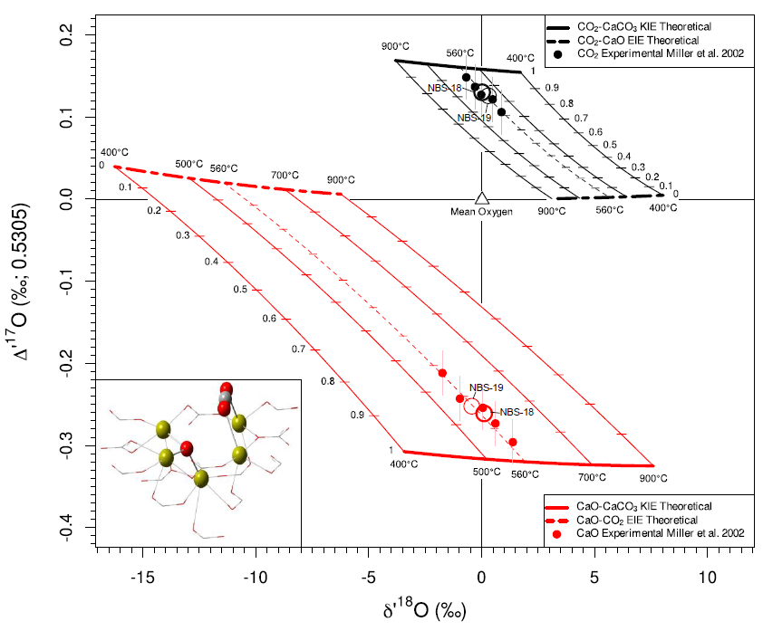
Figure 3: Product-mean-normalized isotope compositions and independent theoretical kinetic and equilibrium fractionations for the products of thermal decomposition of calcite (NBS-18 and NBS-19). Plotted values for fractionations and experimental results are renormalized to the mean oxygen composition of products with the mean (i.e., the mean of the products at a given stage of partial reaction completion) at the origin. Circles corresponding to the re-normalized mean results from thermal decomposition of NBS-19 and NBS-18 (bolded circle) are plotted along with individual results. Means for NBS-18 and NBS-19 thermal decomposition results are taken prior to re-normalization. The experimental results for CaCO3 thermal decomposition are best matched with a decomposition temperature of 560°C ±60°C which is in the range known for vacuum thermal decomposition temperature of calcite. Some degree of partial back-exchange is needed to explain the array of experimental results.

These calcite decomposition results were previously interpreted as mass-independent (Miller et al., 2002), which led to a later interpretation of a possible magnetic isotope effect (Buchachenko and Lawler, 2017), or as the result of mass-dependent processes with opposed isotope effects (Eiler et al., 2013). We find that the large Δ’¹⁷O fractionation for thermal decomposition of calcite can be explained by a single, rate-limiting kinetic reaction yielding two fractionations corresponding to each of the products. There is a degree of an opposing isotope effect in back-exchange which is well described by equilibrium between the product CO₂ and CaO. Although an attempt was made to reduce back-exchange during the experiments, we speculate that the exchange likely occurred during diffusion through the product layer either directly at the mineral surface or through the previously reacted powder which absorbed the laser first at the top of the pile. In contrast to the previous explanation by Eiler et al. (2013), here back-exchange is shown to attenuate, rather than contribute to, the large Δ’¹⁷O signal from the kinetic isotope effect.
Here, the calcite decomposition structure yields a calculated free energy 330 kcal/mol above the reactant. Some experimental studies have determined activation energies just as high, but most results are typically ~200 kcal/mol (Dash et al., 2000; Maciejewski and Reller, 1987). The calculated free energy of the transition state is likely overestimated relative to the reactant due to the truncated model structure and the need, due to computational constraints, to freeze atoms near the active site. Further studies with larger clusters or periodic boundary conditions can be done to test if this overestimation is the case and to better constrain the activation energy.

4.3. Case study 2 Results: Thermal Decomposition of Brucite

Figure 4 presents the product-mean-oxygen normalized results from thermal decomposition of brucite from Clayton and Mayeda (2009). The original study interpreted these results as being consistent with kinetic isotope effects which we agree with and quantify here. Alongside the experimental results, calculated kinetic isotope effects for the three optimized transition states and equilibrium fractionations between H₂O_{(g)} and MgO are plotted. The three calculated transition states correspond to structures on the brucite (1$\overline{1}$00) surface and are each located between the intermediate structures for pathway A-C-D-E from Churakov et al. (2004). It is estimated that the total activation energy of the reaction on the (1$\overline{1}$00) surface is 184 kJ/mol which is comparable to, but slightly higher than, previous results and is consistent with the experimental range of 63-243 kJ/mol. (Churakov et al., 2004). Churakov et al. (2004) suggested that the rate-limiting step is the transition from A-C which corresponds to the first Mg-O bond break and the largest activation energy. However, the triple oxygen isotope effect cannot be explained with step A-C being rate-limiting. Based on a match between our calculated isotope effect and the experimental measurements, it is determined that step D-E, corresponding to the desorption of the water molecule, is the rate-limiting step.
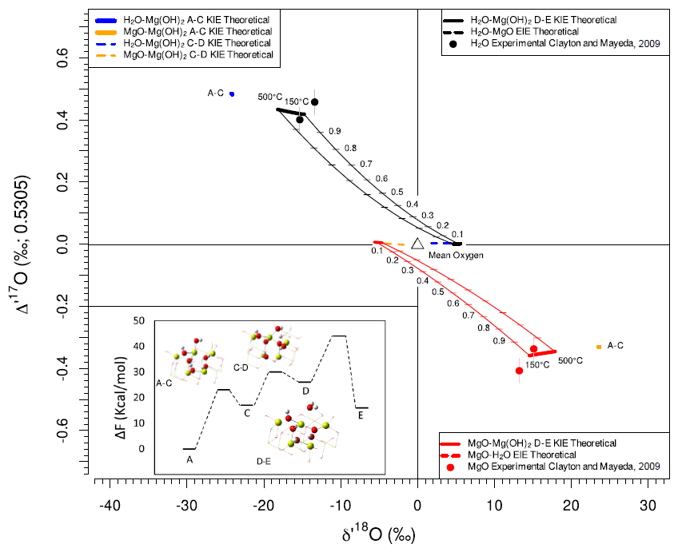
Figure 4: Product-mean-oxygen normalized isotope compositions and independent theoretical kinetic and equilibrium fractionations for the products of thermal decomposition of brucite. Plotted values for fractionations and experimental results are renormalized to the mean oxygen composition of products with the mean at the origin. Theoretical arrays for partial back
exchange of H2O and MgO are plotted but no back exchange is needed to explain the experimental results. The experimental results for thermal decomposition of brucite are best matched by the predicted kinetic isotope effect from TS D-E. The energies in the inset are taken from Churakov et al. (2004) but similar energies for the transition states were calculated for the models in this study.

Activation energies determined for the models in this study are higher than but comparable to the results of Churakov et al. (2004). Estimated activation energies relative to the reactant are 117 kJ/mol for A-C, 184 kJ/mol for C-D and 176 kJ/mol for D-E. Activation barriers for individual reaction steps (with the exception of A-C) were not determined.
4.4. Discussion: Case Studies

In Figure 5, all calculated kinetic isotope effects are plotted along with the predicted 95% probability density function (PDF) field of kinetic and equilibrium isotope effects for temperatures > 100°C. All calculated kinetic isotope effects for these polyatomic molecules fall within the 95% range. All but three of the calculated kinetic isotope effects, including the CaO-CaCO₃ and MgO-Mg(OH)₂ kinetic isotope effects that match the experimental data, fall within the field of equilibrium isotope fractionations. This is due to a small influence of the substituted oxygen on the mass of the associated decomposition fragment in each of these steps yielding β_{IF} near unity. Most of these fall under Special Case 2 because the substituted atom is on a defect site on the mineral surface. The exceptions are the kinetic isotope effects corresponding to step C-D for Mg(OH)₂ thermal decomposition. Step C-D is a hydrogen transfer reaction putting the isotope effects for both products of step C-D under Special Case 3. We re-emphasize that kinetic isotope effects are not always characterized by θ values lower than those for equilibrium isotope effects. Kinetic isotope effects can have what are typically considered high θ values (e.g., 0.529; see Table 1). Still, the much larger accessible range of kinetic isotope effects in Δδ′¹⁸O-ΔΔ′¹⁷O space allows the differentiation between many kinetic isotope effects versus equilibrium.
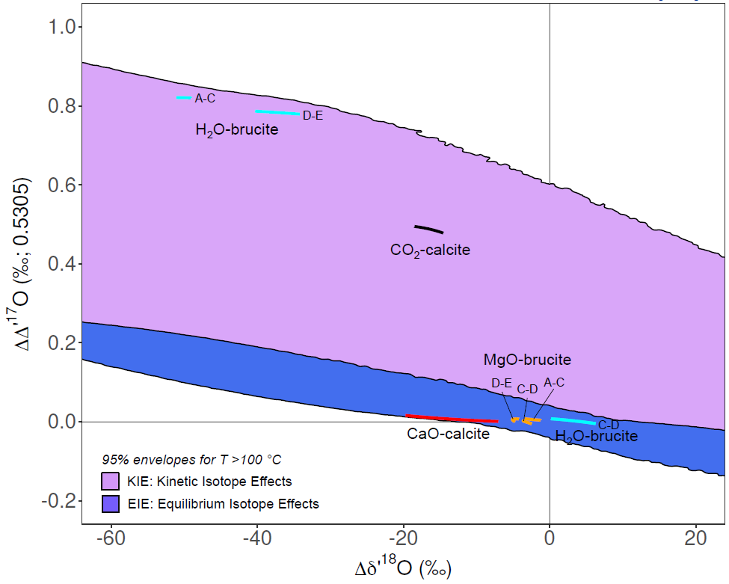
Figure 5: Calculated Kinetic Isotope effects for thermal decomposition of calcite and brucite plotted with envelopes containing 95% highest model density fields of kinetic isotope effects and equilibrium isotope effects from Monte Carlo models for temperatures > 100°C. Calculated CaCO3 thermal decomposition fractionations are plotted from 400-900°C and Mg(OH)2 thermal decomposition fractionations A-C, C-D and D-E are plotted from 150-450°C. MgO: orange, H2O: light blue, CO2:black, CaO:red.

5. Conclusion
As multi-isotope geochemistry evolves, it will be increasingly necessary to understand kinetic isotope effects. We show kinetic isotope effects in the ¹⁶O-¹⁷O-¹⁸O system can give fractionations outside the limits of equilibrium. This includes regions where values of θ and Δ¹⁷O could be conventionally interpreted as mass-independent. Reactions with early transition states, characterized by transition states similar in structure to the reactants, generally yield kinetic isotope effects favoring the lighter isotope with $θ_{KIE}$ between 1/m (0.5305) and ln(m) (0.5158) mass dependency. This approximation is most applicable to fast exothermic reactions found in a range of common processes. In contrast, complex reactions involving intermediates occurring between the reactant and TS, or reactions with high activation barriers yield a larger variability in $θ_{KIE}$ relative to equilibrium and may exhibit inverse kinetic isotope effects. It is predicted ΔΔ’¹⁷O in a kinetic isotope effect is largely dictated by the imaginary frequency indicating the utility of triple isotope effects for constraining the structure of rate-limiting transition states. At its upper limit the IF contribution can result in kinetic isotope effects with ΔΔ′¹⁷O as high as 0.83‰. Kinetic isotope effects for the thermal decomposition of calcite (CaCO₃) and brucite (Mg(OH)₂) were calculated using DFT methods and compared with experimental results. The thermal decomposition of CaCO₃, previously interpreted as mass-independent, is here fully explained by a single rate-limiting kinetic step yielding two mass-dependent kinetic isotope effects attenuated by partial equilibrium back-exchange between the product CO₂ and CaO. Likewise, thermal decomposition of brucite is here fully explained by a single rate-limiting step corresponding to the desorption of water from the (1$\overline{1}$00) surface with no evidence of back-exchange. These case studies illustrate the potential of multiple-isotope techniques for constraints on rate-limiting transition state structures of reactions, giving an extra dimension beyond what is possible with consideration of only two-isotope effects. From general theoretical considerations and the presented case studies it is shown that kinetic isotope effects cannot be sufficiently differentiated from equilibrium isotope effects based on whether the reaction presents a low, or high θ alone without consideration of Δδ′¹⁸O and/or reaction mechanism. The results of this study apply equally to the interpretation of mass dependency of isotope effects for oxygen, as examined here, and in other isotope systems with more than two isotopes.
Acknowledgements
We thank the reviewers Andreas Pack and Martin Miller for comments which improved the clarity of this manuscript. JAH was supported by NASA’s Planetary Science Research Program during this work. Computational resources provided by National Science Foundation Postdoctoral Fellowship (EAR-1806124) to JAH were utilized in this study.

References
Antonelli, M.A. et al., 2019. Kinetic and equilibrium Ca isotope effects in high-T rocks and minerals. Earth and Planetary Science Letters, 517: 71-82.
Bao, H., Cao, X., Hayles, J.A., 2015. The confines of triple oxygen isotope exponents in elemental and complex mass-dependent processes. Geochimica Et Cosmochimica Acta, 170: 39-50.
Bao, H., Cao, X., Hayles, J.A., 2016. Triple Oxygen Isotopes: Fundamental Relationships and Applications. Annual Review of Earth and Planetary Sciences, 44(1): 463-492.
Bigeleisen, J., Goeppert-Mayer, M., 1947. Calculation OF Equilibrium Constants for Isotopic Exchange Reactions. Journal of Chemical Physics, 15(5): 261-267.
Bigeleisen, J., Wolfsberg, M., 1958. Theoretical and Experimental Aspects of Isotope Effects in Chemical Kinetics. Advances in Chemical Physics, 1: 15-76.
Bindeman, I.N., Bekker, A., Zakharov, D.O., 2016. Oxygen isotope perspective on crustal evolution on early Earth: A record of Precambrian shales with emphasis on Paleoproterozoic glaciations and Great Oxygenation Event. Earth and Planetary Science Letters, 437: 101-113.
Buchachenko, A., Lawler, R.G., 2017. New Possibilities for Magnetic Control of Chemical and Biochemical Reactions. Accounts of Chemical Research, 50(4): 877-884.
Cano, E.J., Sharp, Z.D., Shearer, C.K., 2020. Distinct oxygen isotope compositions of the Earth and Moon. Nature Geoscience, 13(4): 270-274.
Cao, X., Liu, Y., 2011. Equilibrium mass-dependent fractionation relationships for triple oxygen isotopes. Geochimica et Cosmochimica Acta, 75: 7345-7445.
Chai, J.-D., Head-Gordon, M., 2008. Long-range corrected hybrid density functionals with damped atom–atom dispersion corrections. Physical Chemistry Chemical Physics, 10(44): 6615-6620.
Churakov, S.V., Iannuzzi, M., Parrinello, M., 2004. Ab Initio Study of Dehydroxylation−Carbonation Reaction on Brucite Surface. The Journal of Physical Chemistry B, 108(31): 11567-11574.
Clayton, R.N., Mayeda, T.K., 2009. Kinetic Isotope Effects in Oxygen in the Laboratory Dehydration of Magnesian Minerals. The Journal of Physical Chemistry A, 113(10): 2212-2217.
Collettini, C., Viti, C., Tesei, T., Mollo, S., 2013. Thermal decomposition along natural carbonate faults during earthquakes. Geology, 41(8): 927-930.
Dash, S., Kamruddin, M., Ajikumar, P.K., Tyagi, A.K., Raj, B., 2000. Nanocrystalline and metastable phase formation in vacuum thermal decomposition of calcium carbonate. Thermochimica Acta, 363(1): 129-135.
Dauphas, N., Schauble, E.A., 2016. Mass Fractionation Laws, Mass-Independent Effects, and Isotopic Anomalies. Annual Review of Earth and Planetary Sciences, 44(1): 709-783.
Eiler, J., Cartigny, P., Hofmann, A.E., Piasecki, A., 2013. Non-canonical mass laws in equilibrium isotopic fractionations: Evidence from the vapor pressure isotope effect of SF6. Geochimica Et Cosmochimica Acta, 107: 205-219.
Friesem, D.E., Abadi, I., Shaham, D., Grosman, L., 2019. Lime plaster cover of the dead 12,000 years ago – new evidence for the origins of lime plaster technology. Evolutionary Human Sciences, 1: e9.
Frisch, M.J. et al., 2016. Gaussian 16 Rev. C.01, Wallingford, CT.
Hammond, G.S., 1955. A Correlation of Reaction Rates. Journal of the American Chemical Society, 77(2): 334-338.
Hayles, J., Bao, H., 2015. The reduction and oxidation of ceria: A natural abundance triple oxygen isotope perspective. Geochimica et Cosmochimica Acta, 159: 220-230.
Hayles, J.A., Cao, X., Bao, H., 2017. The statistical mechanical basis of the triple isotope fractionation relationship. Geochemical Perspectives Letters, 3(0): 1-11.
Johnson, R.D.I., 2020. NIST Computational Chemistry Comparison and Benchmark Database. NIST.
Leffler, J.E., 1953. Parameters for the Description of Transition States. Science, 117(3039): 340.
Maciejewski, M., Reller, A., 1987. How (UN)reliable are kinetic data of reversible solid-state decomposition processes? Thermochimica Acta, 110: 145-152.
McIntosh, G.J., 2012. A theoretical kinetic model of the temperature and pH dependent dimerization of orthosilicic acid in aqueous solution. Physical Chemistry Chemical Physics, 14(2): 996-1013.
McLean, A.D., Chandler, G.S., 1980. Contracted Gaussian basis sets for molecular calculations. I. Second row atoms, Z=11–18. The Journal of Chemical Physics, 72(10): 5639-5648.
Miller, M.F. et al., 2002. Mass-independent fractionation of oxygen isotopes during thermal decomposition of carbonates. Proceedings of the National Academy of Sciences, 99(17): 10988.
Pack, A., Herwartz, D., 2014. The triple oxygen isotope composition of the Earth mantle and understanding Delta O-17 variations in terrestrial rocks and minerals. Earth and Planetary Science Letters, 390: 138-145.
Passey, B.H. et al., 2014. Triple oxygen isotopes in biogenic and sedimentary carbonates. Geochimica Et Cosmochimica Acta, 141: 1-25.
Sengupta, S., Pack, A., 2018. Triple oxygen isotope mass balance for the Earth's oceans with application to Archean cherts. Chemical Geology.
Sengupta, S., Peters, S.T.M., Reitner, J., Duda, J.-P., Pack, A., 2020. Triple oxygen isotopes of cherts through time. Chemical Geology, 554: 119789.
Sharp, Z.D. et al., 2016. A calibration of the triple oxygen isotope fractionation in the SiO2–H2O system and applications to natural samples. Geochimica et Cosmochimica Acta, 186: 105-119.
Sheng, F. et al., 2018. Theoretical study of the oxidation reactions of sulfurous acid/sulfite with ozone to produce sulfuric acid/sulfate with atmospheric implications. RSC Advances, 8(15): 7988-7996.
Suttle, M.D., Genge, M.J., Folco, L., Russell, S.S., 2017. The thermal decomposition of fine-grained micrometeorites, observations from mid-IR spectroscopy. Geochimica et Cosmochimica Acta, 206: 112-136.
Urey, H.C., 1947. The Thermodynamic Properties of Isotopic Substances Journal of the Chemical Society(MAY): 562-581.
Wolfsberg, M., 1960. Note on Secondary Isotope Effects in Reaction Rates. The Journal of Chemical Physics, 33(1): 2-6.
Wolfsburg, M., Van Hook, A.W., Paneth, P., Rebelo, L.P.N., 2010. Isotope effects: in the chemical, geological, and bio sciences. Springer.
Wostbrock, J.A.G. et al., 2020. Calibration of carbonate-water triple oxygen isotope fractionation: Seeing through diagenesis in ancient carbonates. Geochimica et Cosmochimica Acta, 288: 369-388.
Wostbrock, J.A.G. et al., 2018. Calibration and application of silica-water triple oxygen isotope thermometry to geothermal systems in Iceland and Chile. Geochimica et Cosmochimica Acta, 234: 84-97.
Yeung, L.Y., Hayles, J.A., 2021. Climbing to the Top of Mount Fuji: Uniting Theory and Observations of Oxygen Triple Isotope Systematics. Reviews in Mineralogy and Geochemistry, 86(1): 97-135.
Young, E.D., Galy, A., Nagahara, H., 2002a. Kinetic and equilibrium mass-dependent isotope fractionation laws in nature and their geochemical and cosmochemical significance. Geochimica Et Cosmochimica Acta, 66(6): 1095-1104.
Young, E.D., Galy, A., Nagahara, H., 2002b. Kinetic and equilibrium mass-dependent isotope fractionation laws in nature and ther geochemical and cosmochemical significance. Geochimica et Cosmochimica Acta, 66(6): 1095-1104.

