Improvements in Ionic Liquid Technology for Carbon Dioxide Removal Applications
Burcu Gurkan
Case Western Reserve University, Cleveland, OH, 44106
Darrell Jan
NASA Ames Research Center, Moffett Field, CA, 94035
Carbon dioxide removal from cabin air continues to be of vital importance for future space missions. Current and proposed approaches have employed solid sorbents, hollow fiber membrane separators, and direct liquid sorbent contactors. Recent developments in ionic liquids have potential to improve performance in all three of these technologies. Efficient encapsulation of ionic liquids by polymeric shell can enable their use in a solid sorbent-like configuration without significant integration intervention to the current space technology. Poly(ionic liquid)-ionic liquid membranes have the potential to cross over the Robeson selectivity-permeability upper bound, and thereby outperform traditional membranes used in hollow fibers. Advances in ionic liquid chemistry enables performance improvements in liquid sorbent contactors owing to the tunable gravimetric CO₂ capacity, reaction enthalpy and liquid viscosity. This paper will describe recent work in each of these areas.

Nomenclature

$α$ = Selectivity (e.g., CO₂ to N₂)
AA = Amino Acid
AHA = Aprotic Heterocyclic Anion
BT = Breakthrough Time
[2-CNpyr] = 2-cyanopyrrolide
CDRA = Carbon Dioxide Removal Assembly
CO₂ = carbon dioxide
[EMIM] = 1-ethyl-3-methylimidazolium
[EtSO₄] = ehtylsulfate
FTM = Facilited Transport Membrane
GO = Graphene oxide
IL = Ionic Liquid
ISS = International Space Station
kg = kilogram
MC = Membrane Contactor
MOF = Metal Organic Framework
[P₂₂₂₈] = tetraethylphosphonium
[P₆₆₆₁₄] = trihexyltetradecylphosphonium
$P_{{CO}_{2}}$ = Permeability of CO₂
PIL = Polymerized IL
ppm = parts per million
RH = Relative Humidity
rIL = reactive Ionic Liquid
SILM = Supported Ionic Liquid Membrane
[TCM] = tricyanomethanide
[Tf₂N] = bis(trifluoromethylsulfonyl)imide
wt = weight

Introduction
R
emoval of Carbon Dioxide from the spacecraft crew habitat atmosphere is of considerable importance to future NASA missions. The International Space Station (ISS) currently uses the Carbon Dioxide Removal Assembly (CDRA), which relies on a packed bed of molecular sieve solid sorbent. However, a number of other technologies have been considered to reduce energy requirement, mass, and maintenance, and several are being evaluated for use in future missions.¹
Solid amine systems are functionally similar to molecular sieve systems. The solid amine may have some advantages in terms of capacity and water tolerance, although it will also release a small amount of ammonia to the atmosphere. Both US² and European³ versions of the solid amine systems have been developed. Solid sorbent systems generally employ a swing bed design, with one bed being cooler and adsorbing, while the other is warmer and desorbing. A simplified process diagram is shown in Figure 1 for the system that is currently in use at ISS.
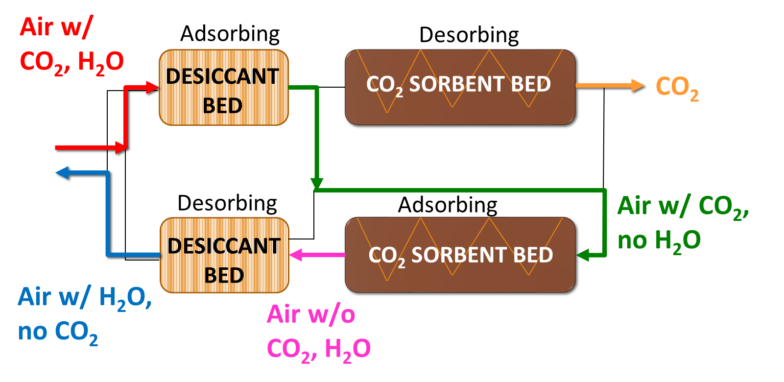
Figure 1. Simplified schematics of the current CO₂ removal assembly with zeolite sorbents. Desiccant bed has silica gel to remove water. Sorbent bed regenerates at 350 °C.
Liquid sorbent systems have also been considered. These require some means of special handling of liquids in the microgravity space environment. One approach has been to use a powered centrifuge.⁴ Hollow fiber membranes can be used to hold the liquid sorbent, requiring the membrane material to be highly permeable to CO₂.⁵ Others have proposed using surface tension devices to hold the liquid in place.⁶ Liquid sorbent systems can be used in a continuous flow mode. Liquid sorbents can also be encapsulated in a material such as silicone, enabling their use in a solid sorbent-like configuration.⁷
The characteristic of cabin air and desired CO₂ product from a sorbent scrubber system are summarized in Table 1. Any sorbent-based system will have to process significant airflow. The rate of CO₂ production is roughly 1 kg of CO₂ per crew per day. For example, to maintain CO₂ at 2500 ppm for a crew of 4, removing 4 kg of CO₂ requires processing at least 800,000 liters of air per day, or about 20 cfm, if the removal process is 100% efficient. Associated with the significant flow rate, the pressure drop through the sorbent system must be in a reasonable range. The CO₂ capacity of the sorbent is important, as is the speed of transport, or kinetics, so that the quantity of sorbent required is not too large. If the sorbent is regenerated by heating, then the energy for regeneration is relevant. The longevity of the sorbent, i.e. stability, is also important as the logistic support from Earth may be limited to nonexistent for as much as 3 years for an extended duration mission. Many sorbents have some volatility, therefore the vapor pressure is desired to be low. The non-methane volatile organic compounds are desired to not exceed 20 ppm in exhaust air (processed air from the scrubber). A flowing, liquid sorbent-based system must operate within a usable range of viscosities.
Table 1. Characteristics of the cabin air and the CO₂ product from sorbent carbon scrubber.
 | T (˚F) | O₂ | CO₂ | Pressure (psia) | Water
Cabin Air | 65 – 80 | 2.7 – 3.44 psia | 2500 ppm | 13.9 – 15.2 | 25 – 75 % RH
CO₂ Product | 61 - 113 | < 1 v% | > 97 v% | 20 | < sat. 65 ˚F

This paper provides an overview of the solid and liquid sorbent systems with an emphasis on recent developments in ionic liquids (ILs) for these systems. ILs are salts that melt below 100 ˚C and most are liquid below room temperature. ILs are known to be nonflammable solvents with negligible vapor pressures and high thermal stabilities (i.e., 400 ˚C). ILs are reported to have high CO₂ solubilities and are tailorable solvents with great flexibility in tuning the physicochemical properties for a specific application.⁸ Owing to their tunable reactivity, ILs are promising solvents for separations at low partial pressures of CO₂, such as cabin air. However, containment of ILs is necessary in microgravity while ensuring sufficiently large air-liquid interface exist. In the remaining of the paper, a perspective on ILs for CO₂ air revitalization system, in particular adsorption, absorption and membrane separations, will be provided with supporting data from literature.

Brief History on Ionic Liquids for CO₂ Separations
Owing to their bulky ion structures, the liquid structure of ILs generally provide a large entropic space for CO₂ solubility. The ILs of interest for physical dissolution of CO₂ have been primarily based on the imidazolium cation (see Scheme 1 for the structure),⁹ due to its low viscosity (~ 30 cP at 20 ˚C) and commercial availability. It is found that long alkyl chains and fluorination in the cation promotes solubility of CO₂. While these ILs maybe suitable for pre-combustion CO₂ capture where the partial pressure of CO₂ is relatively high (> 8 bar), the CO₂ capacity of the physically absorbing ILs are not sufficient when partial pressure of CO₂ in the gas mixture is low (< 1 bar). Typical Henry’s law constants of CO₂ in ILs range from 10 to 50 bar per mole fraction at room temperature.¹⁰ Appending an amine group to the imidazolium cation was shown to increase the solubility at low partial pressures of CO₂.¹¹ The reaction between the amine group and CO₂ results in the formation of ammonium and carbamate ions with hydrogen bonding that results in tremendous increase in viscosity. ILs with amino acid (AA) based anions such as prolinate eliminates ammonium formation and forms carbamic acid upon reacting with CO₂ (shown in inset of Figure 2); however still suffers from viscosity increase due to intra and inter molecular H-bonding. Elimination of such hydrogen bonds by the design of ILs with aprotic heterocyclic anions (AHA) such as 2-cynanopyrrolide where the amine reacts with CO₂ to form a carbamate (also shown in inset of Figure 2) with no accompanied hydrogen transfer prevents the increase in viscosity upon CO₂ absorption.¹² This reaction mechanism is seen to depend on the cation. In the case of alkyl phosphoniums, reaction involves only the anion as shown in the reaction scheme in Figure 1. However, in the case of imidazolium, CO₂ binds to the cation as well as the anion, yielding both the anion-CO₂ (route A) and cation-CO₂ (route B) complexes as well as protonated anion side products as shown in Scheme 1. In the presence of water, additional side product is the bicarbonate as shown in reaction route C in Scheme 1. Brennecke and co-workers showed the side reactions of B and C are reversible, similar to reaction A in Scheme 1 and that the protonated AHA is stabilized within the IL to prevent its evaporation and the reaction with CO₂ is reversible.¹³ Bonilla et al.¹⁴ showed that formation of bicarbonate upon CO₂ absorption by [P₂₂₂₈][2-CNpyr] in the presence of 4 mol of H₂O per mol of IL is still reversible and that the CO₂ capacity is maintained after several cycles with no evidence of decomposition. As water is known to reduce the viscosity of the base IL, presence of water could improve the diffusivity of CO₂. On the other hand, with large amounts of water present, the reaction enthalpy is expected to change which would have direct consequences to regeneration energy requirement and possibly increase the energy demand. Another factor that has not been studied in detail is the kinetics of the possible reactions (routes A, B and C in Scheme 1) that may coexist.
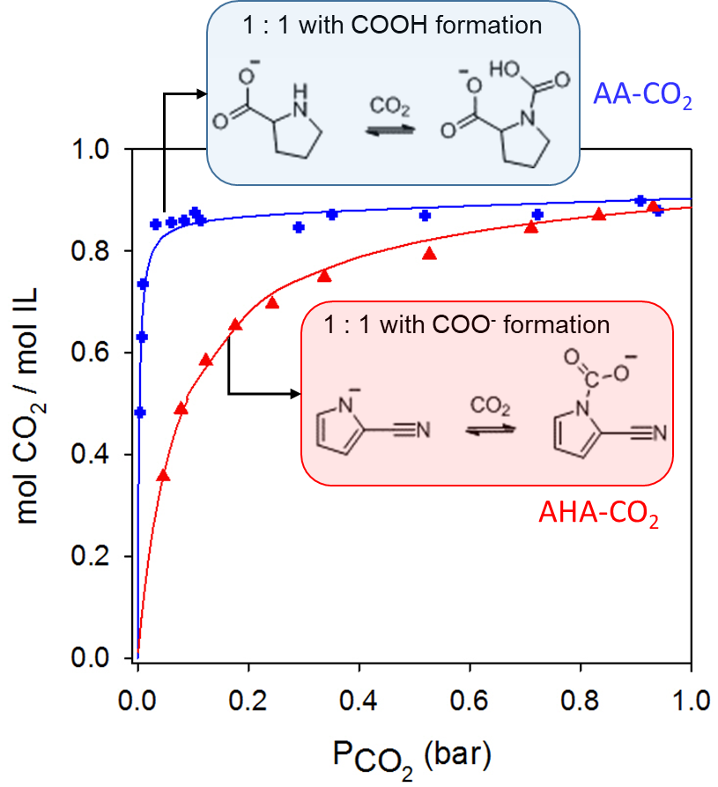
Figure 2. CO₂ absorption isotherms for phosphonium prolinate (AA=amino acid) and 2-cyanopyrrolide (AHA=aprotic hetero- cyclic anion) at 22 ˚C. The cation is phosphonium, [P₆₆₆₁₄].The inset shows the reactions with CO₂. Replotted from refs.^{15, 16}

In comparison to conventional amines such as monoethanolamine, ILs with AHAs were found to have much smaller reaction enthalpies; thereby lowering the heat requirement for desorption of CO₂ and regeneration of the IL in the absence of significant amount of water. However, the gravimetric CO₂ capacities suffer from high molecular weight of ILs. Some improvements could be obtained by the choice of a smaller inactive counter ion with a lower mass. One should also consider that there may be some limit to this strategy as the smaller ions may not necessary yield ILs to begin with.
While the molecular weight and chemical affinity to CO₂ dictates the gravimetric CO₂ absorption capacities in ILs, the viscosity impact the absorption rates. ILs usually have high viscosities; typically > 20 cP at room temperature for non-reactive and much greater for the CO₂ reactive ILs. This can be a disadvantage in flow processes where significant mass transfer limitations maybe present. To eliminate this challenge, alternatively, ILs have been incorporated into support structures such as fumed silica,¹⁵ carbon,¹⁶ and polymeric membranes^{17,18} where the main strategy is to maximize the IL loading and gas-liquid surface area.
Scheme 1. Parallel reactions of CO₂ and ILs with imidazolium cation and AHAs. Specific example shows capture of CO₂ by [EMIM][2-CNpyr] reaction with (routes A-C) and without (routes A and B) water. Adapted from ref.¹⁷
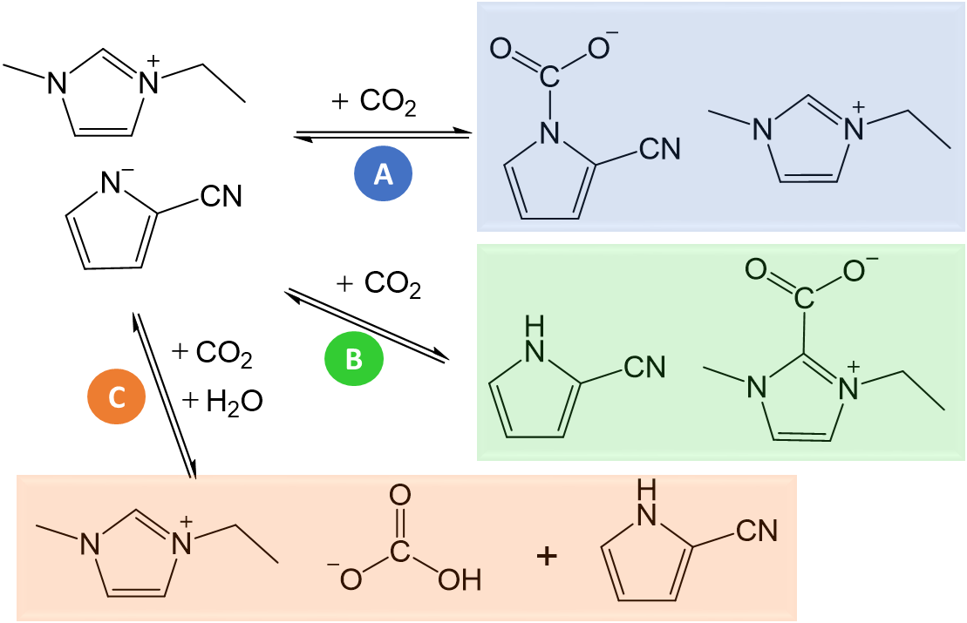
Whether ILs are utilized as solvents or active materials within a support, the critical properties for CO₂ removal and their significance in space technologies as well as existing knowledge gap in these can be summarized as below. The presence of water has an influence in each of these considerations and should be further evaluated for ILs.
- Vapor Pressure and Toxicity. Safety is top priority. ILs are accepted as ‘benign’ solvents owing to their extremely low vapor or negligible pressures. However, most common ILs are found to be toxic in nature, in particular cations with long alkyl chain substituents as well as fluorinated ions.¹⁵ In general, aprotic ILs are found to be more toxic than protic ones and toxicities are reported to vary with organisms and trophic levels. There aren’t any toxicology studies on the less common CO₂-reactive ILs with aprotic heterocyclic anions.
- CO₂ capacity. This determines the footprint and mass of the CO₂ separation unit assuming no additional machinery is needed to support the system. The working CO₂ capacity is a more relevant property and it gets dictated by the difference in capacities at the absorbing and desorbing conditions. Thermodynamically, it is never possible to remove all of the absorbed or adsorbed CO₂. At very low partial pressures of CO₂, strongly binding ILs such as those with AAs have higher molar capacities compared to AHAs. The gravimetric capacity is further tuned by the choice of the cation.
- Reaction enthalpy. The energetics to shift the reaction equilibrium impact the power requirement for the regeneration. This is when assuming heat is applied to desorb the complexed CO₂ (i.e., endothermic reactions). ILs offer tunability in this metric where AA ILs are strongly binding to CO₂ with similar reaction enthalpies as the amines and AHA ILs have weaker binding with almost the half of the enthalpy per CO₂ compared to amines. The binding affinity depends on the basicity of the IL. In the presence of water, the reaction mechanism involves additional reaction between CO₂ and water, and the energetics associated with these systems are not well characterized.
- Diffusivity of CO₂ and rate of absorption. The high viscosity of ILs limits the mass transport of CO₂ which significantly affects the absorption rates. The traditional approach of dilution may address this issue. However, for space applications, the diluent should have no vapor pressures. To increase absorption rate and shorten the diffusion path of CO₂, flow systems based on thin liquid-film flow are desired. Alternatively ILs can be supported within a solid framework which creates large gas-liquid contact area. However, this strategy lowers the gravimetric CO₂ capacity due to the presence of inactive mass.
- Long-term stability. Thermal and mechanical integrity (for supported ILs) are crucial for applications in space for increased reliability and reduced crew time. There is a knowledge gap in these properties in regards to long-term performance efficiency and under microgravity conditions. ILs are known to be thermally stable. However, this is not de facto for all of the reactive ILs. In particular, when ILs are impregnated to membranes or encapsulated, the long-term thermal stability of the resulting material needs to be investigated. Additionally for the composite type materials, aging needs to be considered due to variable pressure changes. For instance, the impact of the trans membrane pressure over time is not well known for IL-containing solids, gels or hybrids.

Encapsulated Ionic Liquids
ILs have been encapsulated in polymeric or carbonaceous shells via microfluidic extrusion, hollow capsule impregnation, vapor phase deposition, or Pickering-emulsion templated encapsulation. These IL capsules substantially increase the gas-liquid surface area which impacts CO₂ uptake rate. The typical IL loading of the capsule is high (>50 wt%)¹⁶ compared with that of supported IL materials (30 wt%).¹⁷ It has been shown that the “one-pot” Pickering emulsion method provides an easily scalable synthetic route and the resulting IL capsules, Figure 3, can achieve high IL core loading (i.e., 80 wt%) with a gas permeable shell that greatly enhances CO₂ absorption rate.¹⁸ Pickering emulsions form by two immiscible phases that are stabilized by solid particles at the interface. For IL capsules that form by this method, graphene oxide (GO) sheets were utilized to makeup the interface as illustrated in Figure 4. The GO sheets are connected by an in-situ polymerization technique thus yielding isolable capsules with IL core.
Figure 3. Optical microscopy image (i) (inset shows image after pressing) and SEM image (ii) of [HMIM][TFSI] capsules synthesized by Pickering emulsion method. The IL core is 80 wt%. Reprinted with permission from Industrial & Engineering Chemistry Research 58 (24), 10503-10509.¹⁷ Copyright 2020 American Chemical Society
IL capsules could be considered for direct replacement of zeolites that are currently being used in the CO₂ removal assembly at ISS. Figure 1 provides an overly simplified process diagram with two sets of beds for the CO₂ adsorption system with zeolites. Due to the hygroscopic nature of zeolites, a desiccant bed is placed prior to the adsorbent bed. Regeneration of zeolite occurs at a temperature of about 350 °C and typical adsorption-desorption cycle is 20 minutes. Alternative sorbents of interest for this system include metal organic frameworks (MOFs) which are similar to zeolites in terms of their adsorption mechanism and therefore presents similar sensitivity to water. In this regard, IL capsules are more promising. There has been few demonstrations of encapsulated ILs, mostly within a polymeric shell such as polydimethylsiloxane (with [P₂₂₂₈][2-CNpyr] core)¹⁹ and carbon.^{16a}
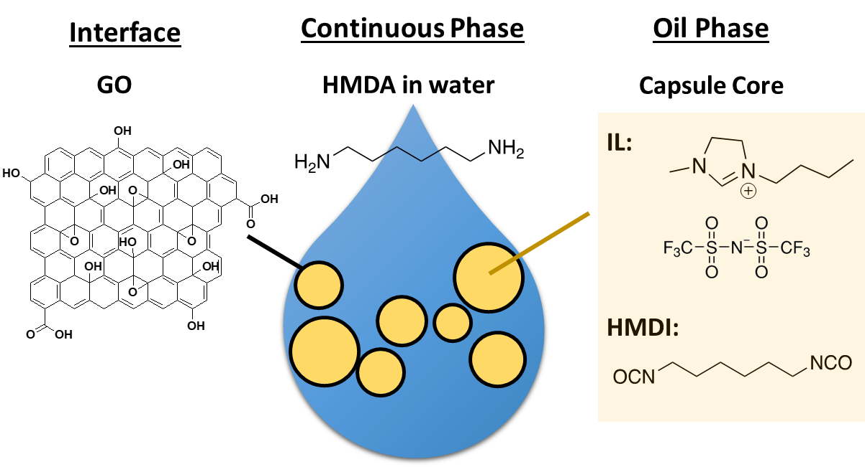
Figure 4. Pickering emulsions (oil-in-water) for encapsulation of ILs. HMDA in the aqueous phase crosslinks individual GO sheets and HDMI in the oil phase initiates the polymerization between the GO sheets thus forming the polyurea sell matrix around GO sheets and encapsulated the oil phase which is the IL.
Recently, Lee et al.²⁰ encapsulated [EMIM][2-CNpyr] (rIL) within a graphene oxide reinforced polyurea shell via Pickering emulsions where the rIL core (active mass) is 60 wt%. These capsules were able to achieve similar gravimetric capacities to zeolite 13X, based on masses of both the shell and the core (active+inactive), and were consistent upon 4 absorption-desorption cycles as seen in Figure 5. rIL capsules also demonstrated no capacity fade when a gas feed consisting of 5000 ppm CO₂ in N₂ with 100 % RH was tested in a breakthrough measurement while zeolite 13X became inactive in capturing CO₂ under the same conditions. It should be noted that while the capacity was maintained even in 100 % RH, the regeneration temperature had to be increased to 90 ˚C to fully desorb the capsules within the same time frame in comparison 40 ˚C at dry feed conditions.
While the rIL capsules in Lee et al.’s work demonstrated similar gravimetric capacities to zeolites with dry feed gas, the CO₂ uptake rate was observed to be slower in the breakthrough measurements.²⁰ This is understandable since the CO₂ needs to diffuse across the shell material and then into the core where the viscous liquid slows its transport. We have formulated rIL/IL mixtures and encapsulated these mixtures in order to improve the CO₂ absorption rate of their corresponding capsules. As seen in Figure 6, the capsule core composition greatly impacts the absorption rates and the breakthrough times. When lower viscosity, non-reactive ILs were incorporated into the core as in the case of Mix1 and 2 in Figure 6, the breakthrough curves resemble a steeper S-shape suggesting that the absorption rate is improved. This is achieved at the cost of gravimetric capacity since the non-reactive IL increases inactive mass of the capsule while lowering the composition of the active mass.
The rIL/IL capsules demonstrate great promise for CO₂ removal in ISS. However, further research is needed to thoroughly understand the impact of capsule size, composition and architecture on packing density, CO₂ permeation and diffusivity, and ultimately the adsorption rate of CO₂. Additionally, these capsules need to be tested to determine the long-term stability and cyclability in consideration of microgravity conditions, and thermal and mechanical wear over time.
Figure 5. Right: CO₂ isotherm of rIL capsule under low CO₂ partial pressures at 25 ˚C. For comparison, zeolite 13X and empty capsules (after extraction of the rIL core) were also tested. The shaded region refers to CO₂ pressures below 3.8 Torr. Left: Cyclability of the rIL capsules upon 4 absorption-desorption cycles. Absorption was at 25 ˚C and desorption was at 40 ˚C under vacuum. The image in the inset shows the actual measurement cell with the rIL capsules. rIL = [EMIM][2-CNpyr].¹⁹

Membranes with Ionic Liquids
To date, several groups studied IL/membrane systems for CO₂ separation primarily for post-combustion flue gas treatment. These have been classified as supported IL membranes (SILMs), polymerized ionic liquid membranes (PILs), IL-gel membranes, and membrane contactors (MCs) with IL absorbents. The Noble group established the pioneering work in this area and developed various composites and gels.²¹ Each of these systems are reported to have some advantages and also drawbacks.
Figure 6. Breakthrough curves measured for encapsulated ILs in an adsorbing bed with a feed gas of 5000 ppm of CO₂ in N₂. The CO₂ concentration in the effluent, C, over the feed, C₀, with respect to time. At t=25 min, the gas is switched from bypass (baseline) to the adosorbing bed. rIL=[EMIM][2-CNpyr], Mix1=[EMIM][TFSI]_{0.5}[2-CNpyr]_{0.5}, Mix2=[EMIM][TFSI]_{0.5}[2-CN pyr]_{0.5}
MC is a mature technology that combines the selectivity from the liquid absorber and the interfacial contact area from the porous membrane, thus providing a linearly scalable process that achieves independent control of liquid and gas flows. MCs with ILs are relatively new. A CO₂ removal system using a hollow fiber contactor with ILs, as seen in Figure 7, was demonstrated by Yates et al.⁵ Irabien and co-workers²² performed several studies on the cross-flow membrane contactors using ILs such as [EMIM][EtSO₄]. According to the findings of this group, CO₂ absorption rate is the main limitation for MCs with ILs.
SILMs offer high surface area and low solvent requirement, but suffer from instability due to the solvent escaping from the supporting structure. According to a 2007 report by the Department of Energy, National Energy Technology Laboratory (DOE/NETL-IR-2007-124), this issue has been suppressed with some success using 1-hexyl-3-methylimidazolium bis(trifluoromethyl sulfonyl)imide however the decrease of capillary forces was not eliminated and the selectivity of CO₂ at elevated temperatures was decreased.²³ Furthermore, the CO₂ capacity in these systems is low due to the limited amount of the absorber fluid within the structure. PILs do not present some of the issues of SILMs, however the reported permeabilities are relatively low due to the poor CO₂ diffusivity in these dense films. IL-gel membranes²⁴ have the advantage of liquid-like CO₂ transport properties. Though, these materials are not ideal in microgravity environment due to their fragile mechanical integrity.
The polymer matrix of membranes incorporating ILs have been primarily polytetrafluoroethylene, polyvinylidene fluoride and polyethylsulfones.⁹ Novel designs of block-copolymers that are able to phase separate are shown to improve gas separation performance.²⁵ Bara et al.^{21a} further incorporated “free” ILs in polymerized ILs for enhanced stability at high pressures. It is suggested that the Coulombic interactions between PIL and IL stabilize the overall structure with the additional benefit of improved diffusivity as a result of the plasticizing effect by the “free” IL. In a 2016 review by Dai et al.²⁶, three main needs were summarized: (1) new IL/membranes with high CO₂ capacity, low viscosity and fast absorption kinetics; (2) improved mechanical strength in PIL-ILs; (3) studies investigating the stability of these systems at realistic conditions.
Membranes are less energy intensive compared to adsorption or absorption techniques²⁷ however limited in their selectivities and permeabilities as described by Lloyd Robeson in 1991.²⁸ The Robeson upper bound is a relationship between membrane permeability ($P_{{CO}_{2}}$) and membrane selectivity ($α$) in polymeric membranes as described for CO₂/N₂ separations by equations 1 and 2, respectively.

Figure 7. Hollow fiber membrane contactor with ILs as suggested by Yates et al.⁵
$P_{{CO}_{2}}=D_{{CO}_{2}}×H_{{CO}_{2}}$ Eqn. 1
$α=P_{{CO}_{2}}/P_{N_{2}}$ Eqn. 2
where $D_{{CO}_{2}}$is diffusivity of CO₂ and $H_{{CO}_{2}}$is the solubility in terms of Henry coefficient. More commonly, it is the ideal permeability that is measured with either a pure CO₂ or N₂ feed stream to determine selectivity. It is in fact more important to measure the mixed gas permeabilities to determine the selectivity at practical conditions and furthermore determine the consistency of selectivity over time.
In 2008, Robeson redefined the upper bound to accommodate improvements in membrane technology.²⁹ Membranes that are capable of surpassing this upper bound are promising candidates for CO₂ separations because they achieve high permeabilities without sacrificing selectivity, or vice versa. A type of membrane explored in recent years that has consistently surpassed the Robeson upper bound is facilitated transport membranes (FTMs). FTMs are capable of combining the selection capability of reactive processes with the small mass, volume, and energy requirements of membrane processes.³⁰ This reactive process is either achieved by the polymer (fixed-carrier) or the mobile carrier (i.e., ILs or amines incorporated to polymer films) in the membrane; see Figure 8. The reactive component of the membrane, reversibly reacts with CO₂ to produce a CO₂-carrier complex with its own concentration gradient across the membrane. This creates a significant increase in CO₂ permeability without increasing the permeability of other gases, thereby maintaining high selectivity. FTMs use the same solution-diffusion mechanisms as other membranes, in addition to a reactive transport mechanism as illustrated in Figure 8 (dashed red arrows).
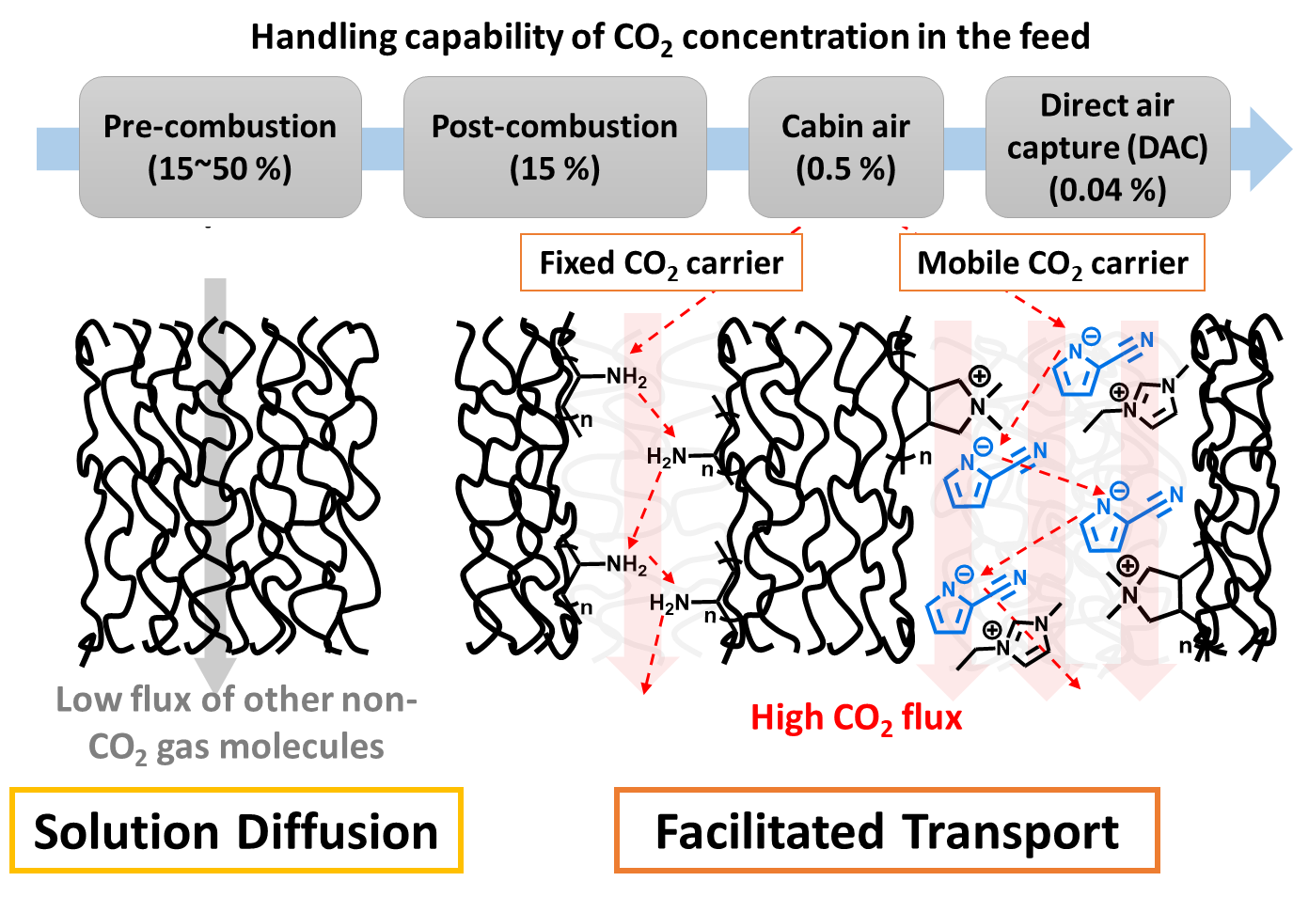
Figure 8. Concept diagram of facilitated transport of CO₂ in FTM with a fixed carrier: -NH₂ functionalized polymer (middle) and mobile rIL (right), in comparison to solution-diffusion membranes (left). The concept of using a poly(ionic liquid) with rIL carrier is to establish Columbic interactions to prevent loss of rIL upon pressure swing (shown in the right sketch).
Winston Ho group’s pioneering work on FTMs for CO₂ separations has successfully crossed over the Robeson upper bound and these membranes utilized amine functionality in the polymer and also in the mobile carrier. Some of the earlier FTMs were based on cross-linked poly(vinyl alcohol) with both the fixed and mobile amine carriers. CO₂/N₂ selectivities in the order of 490 and permeabilities of about 6200 Barrers were reported at 110 °C, using a feed mimicking a flue-gas ($P_{CO_{2}}$ < 0.2 atm) and 2-aminoisobutyric acid potassium salt as the mobile carrier.³¹ More recently, membranes with high molecular weight polyvinylamine films and piperazine glycinate mobile carrier with thickness as thin as 100-200 nm were achieved via solution casting on polyethersulfone and polysulfone substrates.³² The penetration of the casting solution into the substrate pores were prevented by the high viscosities achieved at low concentrations owing to the high molecular weight polyvinylamine which served as the fixed carrier for CO₂. When the substrate pores are filled with CO₂-reactive components, the permeability diminishes due to the significantly decreased diffusivity of CO₂ and the shutting down of the ‘hopping’ mechanism for the facilitated transport. These thin films of active membranes are reported to yield permeance of about 110 GPU and CO₂/N₂ selectivity of 140 at post-combustion flue gas conditions.
Matsuyama group have also studied FTMs where double-network hydrogel films were impregnated with phosphonium-based ILs with amino acid (glycintae and prolinate)³³ and aprotic heterocyclic anions (2-cyanopyrrolide, pyrazolide, imidazolide and indazolide).³⁴ These are among the highest CO₂ permeable and selective membranes reported in literature: CO₂ permeability of 52000 Barrer and a CO₂/N₂ permselectivity of 8100 were obtained at 70% RH and 0.1 kPa CO₂ partial pressure.³⁵
Although the field of FTMs for CO₂ separations have demonstrated significant improvements, the choice of polymers are still limited and ensuring compatibility of the mobile carrier with the polymeric fixed carrier is critical as phase separation may occur otherwise. Additionally, studies to date have focused primarily on carbon capture from post-combustion flue gas emitted from coal fired power plants where the partial pressure of CO₂ is higher than in the cabin air or ISS. Therefore, evaluation of FTMs for CO₂ separations from cabin air are needed. Another unmet need in this area is the stability of FTMs to ensure the active layer does not propagate into the substrate layer and impede permeation over time. To prevent this, fillers such as zeolites and silica³⁶ and reinforcing materials such as polyaniline nanorods³⁷ have been incorporated into composite membranes. However, the presence of fillers present another issue which is poor interfacial adhesion and, as a result, decay of separation performance over time. IL compatible polymers with improved air processing capability is still needed in addition to long-term stabilities and selectivities before these materials can be used at ISS.

Capillary Flow Systems with Ionic Liquids
Another technology that has potential to be adapted for absorptive separations that can function under microgravity conditions is the capillary flow system. The liquid flow system relying on capillary action involves flowing the liquid through an arrangement of V-shaped troughs where the liquid attraction to the walls is the driving force, as illustrated in Figure 9; adapted from ref.³⁸ In microgravity, the pressure in the liquid is predominantly determined by surface tension forces related to the liquid height, h in Figure 9d, in the corner of the V-channel. Negative pressure gradient develops as the elevation of the liquid surface centerline (shown by the dashed line in Figure 9d) gets smaller towards the outlet, thereby enabling liquid flow. The lubrication theory holds in this case since the length of the V-channel (the length of the corner the liquid wets) is much larger then the height of the liquid. Combined effects of surface tension, wetting and contactor geometry create capillary pressure gradients which mimic gravity thereby enabling flow. By making the troughs small enough, while still retaining the desired capillary effects, it is possible to to create a large surface area to volume ratio, thus enabling sufficient mass transport. The capillary control approach can be used for both the CO₂ -absorbing contactor and the CO₂ -releasing degasser. A complete description of this approach can be found in (Weislogel, Torres, Jenson, Graf, Hand, Belancik, Jan, and Levri).
Figure 9. Diagram of a capillary flow device.⁴⁹ Liquid is held in the device (a) by capillary forces in the V-shapes (b, c and d), while air is flowed across the troughs where CO₂ is captured by the liquid sorbent. Shown in the far right (d) is the schematics of capillary-driven interior corner flow with Q volumetric flow rate and a liquid height of H₁ at the inlet and H₂ at the outlet of an open wedge channel in the capillary flow device.
In 2017, this system was tested at ISS for the first time using a non-toxic viscous ersatz fluids.³⁹ Initial tests show successful establishment of a liquid flow due to capillarity. These experiments also studied the evaporation rate for target fluids in microgravity to isolate its effect from capillary-driven flow. ILs appear to be viable candidates for this system as they lack evaporation and can provide a benchmark for capillary-driven flow characteristics in microgravity without the interference of change of phase. There have been no studies of rILs in the capillary-driven flow systems. It is mentioned in a NASA Innovative Advanced Concepts report in 2016, that chemical stability of some rILs may have been a issue. Nonetheless, the promise of ILs can be further explored by understanding the factors governing the stability and capillary-flow characteristics in these systems to improve upon these metrics considering the high viscosity of rILs. Formulations based on ILs may be able to address the high viscosity and stability concerns.

Conclusion
The viable technologies for removal of CO₂ from cabin air include scrubbing with adsorptive materials or hybrids such as encapsulated ILs, separating with facilitated transport membranes such as poly(ionic liquid)-IL composite films, and capturing by capillary flow systems where a liquid sorbent such as ILs come in contact with CO₂ through the open V-shaped channels. The important parameters for the IL-based CO₂ removal systems are:
- Vapor pressure and toxicity. Not every IL is the same and lack of vapor pressure needs to be confirmed for IL-based formulations. Toxicity is another property that is not well studied for ILs, in particular for rILs.
- CO₂ capacity. Gravimetric uptake capacity at low CO₂ partial pressures influences the footprint and mass of the CO₂ removal system.
- Reaction enthalpy. Becomes a factor in estimating the energy requirement when temperature is applied to regenerate the active material.
- Diffusivity of CO₂. Sorption and desorption kinetics are influenced by diffusivity (and viscosity) as well as the structural framework for the encapsulated ILs and membranes.
- Long-term stability. The materials should be cyclable upon temperature or pressure swings without significant capacity loss.
Should a membrane be part of the CO₂ removal system, then (i) CO₂ permeability/selectivity from mixed gas, (ii) mechanical strength and structural integrity, (iii) durability, (iv) stability, and (vi) chemical resistance are also important.
Advances in the structural design of ILs allowed increases in gravimetric CO₂ capacities, decreases in regeneration energy requirements, and diffusivity of CO₂. Recently, encapsulated rILs demonstrate great promise, outperforming zeolites in terms of capacity, regeneration temperature and moisture stability. Also recently, FTMs with ILs are reported to demonstrate unprecedented CO₂ permeabilities and selectivities. ILs, IL capsules and FTMs are all scalable materials thus potentially enabling the materialization into practice. However, to realize ILs in a practical CO₂ removal system for spacecrafts and ISS, further research focusing on their stability and aging, and flow characteristics in microgravity are needed. Furthermore, the impact of water on the kinetics and energetics of CO₂ absorption by ILs need to be investigated in more detail.

Acknowledgments
This work was supported by the NASA Early Career Faculty Award #80NSSC18K1505.

References
1. Knox, J. C. In Development of Carbon Dioxide Removal Systems for NASA’s Deep Space Human Exploration Missions 2017-2018, 48th International Conference on Environmental Systems Proceedings, July 2018.
2. (a) Shaw, L. A. In International Space Station as a Development Testbed for Advanced Environmental Control and Life Support Systems, 49th International Conference on Environmental Systems Proceedings, July 2019; (b) Ranz, H.; Dionne, S.; Garr, J. In A Thermally-Regenerated Solid Amine CO2 Removal System Incorporating Water Vapor Recovery and Ullage Air Recovery, 49th International Conference on Environmental Systems Proceedings, July 2019.
3. Bockstahler, K.; Hartwich, R.; Matthias, C.; Johannes, W.; Hovland, S.; Laurini, D. In Status of the Advanced Closed Loop System ACLS for Accommodation on the ISS, 48th International Conference on Environmental Systems Proceedings
July 2018.
4. Isobe, J.; Henson, P.; MacKnight, A.; Yates, S.; Schuck, D.; Winton, D. In Carbon Dioxide Removal Technologies for U.S. Space Vehicles: Past, Present, and Future, 46th International Conference on Environmental Systems Proceedings, July 2017.
5. Yates, S.; Kamire, R.; Henson, P.; Bonk, T. In Scale-up of the Carbon Dioxide Removal by Ionic Liquid Sorbent (CDRILS) System, 49th International Conference on Environmental Systems Proceedings, July 2019.
6. (a) Weislogel, M.; Jenson, R. In Passive no moving parts capillary solutions for spacecraft life support systems, 49th International Conference on Environmental Systems Proceedings, July 2019; (b) Torres, L.; Jenson, R.; Weislogel, M. In An ISS testbed approach to passive fluid phase separator device development for life support, 49th International Conference on Environmental Systems Proceedings, July 2019.
7. Vericella, J. J.; Baker, S. E.; Stolaroff, J. K.; Duoss, E. B.; Hardin, J. O.; Lewicki, J.; Glogowski, E.; Floyd, W. C.; Valdez, C. A.; Smith, W. L.; Satcher, J. H.; Bourcier, W. L.; Spadaccini, C. M.; Lewis, J. A.; Aines, R. D., Encapsulated liquid sorbents for carbon dioxide capture. Nat Commun 2015, 6 (1), 6124.
8. (a) Rogers, R. D.; Seddon, K. R., Ionic liquids - Solvents of the future? Science (New York, N.Y.) 2003, 302 (5646), 792-793; (b) MacFarlane, D. R.; Seddon, K. R., Ionic liquids - Progress on the fundamental issues. Aust J Chem 2007, 60 (1), 3-5; (c) Seddon, K. R.; Plechkova, N. V., Ionic Liquids UnCOILed: Critical Expert Overviews. 2012.
9. Wang, J.; Luo, J.; Feng, S.; Li, H.; Wan, Y.; Zhang, X., Recent development of ionic liquid membranes. Green Energy & Environment 2016, 1 (1), 43-61.
10. Lei, Z.; Dai, C.; Chen, B., Gas Solubility in Ionic Liquids. Chemical Reviews 2014, 114 (2), 1289-1326.
11. Bates, E. D.; Mayton, R. D.; Ntai, I.; Davis, J. H., CO2 Capture by a Task-Specific Ionic Liquid. J Am Chem Soc 2002, 124 (6), 926-927.
12. Gurkan, B.; Goodrich, B. F.; Mindrup, E. M.; Ficke, L. E.; Massel, M.; Seo, S.; Senftle, T. P.; Wu, H.; Glaser, M. F.; Shah, J. K.; Maginn, E. J.; Brennecke, J. F.; Schneider, W. F., Molecular Design of High Capacity, Low Viscosity, Chemically Tunable Ionic Liquids for CO₂ Capture. J Phys Chem Lett 2010, 1 (24), 3494-3499.
13. (a) Bonilla, G. M. A.; Morales-Collazo, O.; Brennecke, J. F., Effect of Water on CO2 Capture by Aprotic Heterocyclic Anion (AHA) Ionic Liquids. Acs Sustainable Chemistry & Engineering 2019, 7 (19), 16858-16869; (b) Seo, S.; DeSilva, M. A.; Brennecke, J. F., Physical Properties and CO2 Reaction Pathway of 1-Ethyl-3-Methylimidazolium Ionic Liquids with Aprotic Heterocyclic Anions. The Journal of Physical Chemistry B 2014, 118 (51), 14870-14879.
14. Avelar Bonilla, G. M.; Morales-Collazo, O.; Brennecke, J. F., Effect of Water on CO2 Capture by Aprotic Heterocyclic Anion (AHA) Ionic Liquids. ACS Sustainable Chemistry & Engineering 2019, 7 (19), 16858-16869.
15. Thuy Pham, T. P.; Cho, C.-W.; Yun, Y.-S., Environmental fate and toxicity of ionic liquids: A review. Water Research 2010, 44 (2), 352-372.
16. (a) Moya, C.; Alonso-Morales, N.; de Riva, J.; Morales-Collazo, O.; Brennecke, J. F.; Palomar, J., Encapsulation of Ionic Liquids with an Aprotic Heterocyclic Anion (AHA-IL) for CO2 Capture: Preserving the Favorable Thermodynamics and Enhancing the Kinetics of Absorption. The Journal of Physical Chemistry B 2018, 122 (9), 2616-2626; (b) Stolaroff, J. K.; Ye, C.; Oakdale, J. S.; Baker, S. E.; Smith, W. L.; Nguyen, D. T.; Spadaccini, C. M.; Aines, R. D., Microencapsulation of advanced solvents for carbon capture. Faraday Discuss 2016, 192 (0), 271-281.
17. (a) Erto, A.; Silvestre-Albero, A.; Silvestre-Albero, J.; Rodríguez-Reinoso, F.; Balsamo, M.; Lancia, A.; Montagnaro, F., Carbon-supported ionic liquids as innovative adsorbents for CO2 separation from synthetic flue-gas. Journal of Colloid and Interface Science 2015, 448, 41-50; (b) Arellano, I. H.; Madani, S. H.; Huang, J.; Pendleton, P., Carbon dioxide adsorption by zinc-functionalized ionic liquid impregnated into bio-templated mesoporous silica beads. Chem. Eng. J. 2016, 283, 692-702.
18. Huang, Q.; Luo, Q.; Wang, Y.; Pentzer, E.; Gurkan, B., Hybrid Ionic Liquid Capsules for Rapid CO2 Capture. Ind Eng Chem Res 2019, 58 (24), 10503-10509.
19. Stolaroff, J. K.; Ye, C.; Nguyen, D. T.; Oakdale, J.; Knipe, J. M.; Baker, S. E., CO2 Absorption Kinetics of Micro-encapsulated Ionic Liquids. Energy Procedia 2017, 114, 860-865.
20. Lee, Y.-Y.; Edgehouse, K.; Klemm, A.; Mao, H.; Pentzer, E.; Gurkan, B., Capsules of Reactive Ionic Liquids for Selective Capture of Carbon Dioxide at Low Concentrations ACS Applied Materials & Interfaces, under review 2020.
21. (a) Bara, J. E.; Noble, R. D.; Gin, D. L., Effect of “Free” Cation Substituent on Gas Separation Performance of Polymer−Room-Temperature Ionic Liquid Composite Membranes. Ind Eng Chem Res 2009, 48 (9), 4607-4610; (b) Bara, J. E.; Hatakeyama, E. S.; Gin, D. L.; Noble, R. D., Improving CO2 permeability in polymerized room-temperature ionic liquid gas separation membranes through the formation of a solid composite with a room-temperature ionic liquid. Polymers for Advanced Technologies 2008, 19 (10), 1415-1420; (c) Zhou, J.; Mok, M. M.; Cowan, M. G.; McDanel, W. M.; Carlisle, T. K.; Gin, D. L.; Noble, R. D., High-Permeance Room-Temperature Ionic-Liquid-Based Membranes for CO2/N2 Separation. Ind Eng Chem Res 2014, 53 (51), 20064-20067; (d) Dai, Z. D.; Noble, R. D.; Gin, D. L.; Zhang, X. P.; Deng, L. Y., Combination of ionic liquids with membrane technology: A new approach for CO2 separation. Journal of Membrane Science 2016, 497, 1-20.
22. (a) Santos, E.; Albo, J.; Irabien, A., Acetate based Supported Ionic Liquid Membranes (SILMs) for CO2 separation: Influence of the temperature. Journal of Membrane Science 2014, 452, 277-283; (b) Gómez-Coma, L.; Garea, A.; Irabien, A., Non-dispersive absorption of CO2 in [emim][EtSO4] and [emim][Ac]: Temperature influence. Sep Purif Technol 2014, 132, 120-125; (c) Albo, J.; Luis, P.; Irabien, A., Carbon Dioxide Capture from Flue Gases Using a Cross-Flow Membrane Contactor and the Ionic Liquid 1-Ethyl-3-methylimidazolium Ethylsulfate. Ind Eng Chem Res 2010, 49 (21), 11045-11051.
23. Luebke, D.; Ilconich, J. B.; Myers, C.; Pennline, H. W., Carbon Dioxide Separation with Supported Ionic Liquid Membranes. 2007.
24. Moghadam, F.; Kamio, E.; Yoshioka, T.; Matsuyama, H., New approach for the fabrication of double-network ion-gel membranes with high CO2/N2 separation performance based on facilitated transport. Journal of Membrane Science 2017, 530, 166-175.
25. Wiesenauer, E. F.; Nguyen, P. T.; Newell, B. S.; Bailey, T. S.; Noble, R. D.; Gin, D. L., Imidazolium-containing, hydrophobic-ionic-hydrophilic ABC triblock copolymers: synthesis, ordered phase-separation, and supported membrane fabrication. Soft Matter 2013, 9 (33), 7923-7927.
26. Dai, Z.; Noble, R. D.; Gin, D. L.; Zhang, X.; Deng, L., Combination of ionic liquids with membrane technology: A new approach for CO2 separation. Journal of Membrane Science 2016, 497, 1-20.
27. National Academies of Sciences, E.; Medicine, A Research Agenda for Transforming Separation Science. The National Academies Press: Washington, DC, 2019; p 114.
28. Robeson, L. M., Correlation of separation factor versus permeability for polymeric membranes. Journal of Membrane Science 1991, 62 (2), 165-185.
29. Robeson, L. M., The upper bound revisited. Journal of Membrane Science 2008, 320 (1), 390-400.
30. Tong, Z.; Ho, W. S. W., Facilitated transport membranes for CO2 separation and capture. Separation Science and Technology 2017, 52 (2), 156-167.
31. Huang, J.; Zou, J.; Ho, W. S. W., Carbon Dioxide Capture Using a CO2-Selective Facilitated Transport Membrane. Ind Eng Chem Res 2008, 47 (4), 1261-1267.
32. Chen, Y.; Ho, W. S. W., High-molecular-weight polyvinylamine/piperazine glycinate membranes for CO2 capture from flue gas. Journal of Membrane Science 2016, 514, 376-384.
33. Kasahara, S.; Kamio, E.; Ishigami, T.; Matsuyama, H., Amino acid ionic liquid-based facilitated transport membranes for CO2 separation. Chem Commun 2012, 48 (55), 6903-6905.
34. Kamio, E.; Matsuki, T.; Moghadam, F.; Matsuyama, H., Development of facilitated transport membranes with low viscosity aprotic heterocyclic anion type ionic liquid as a CO2 carrier. Separation Science and Technology 2017, 52 (2), 197-208.
35. Moghadam, F.; Kamio, E.; Matsuyama, H., High CO2 separation performance of amino acid ionic liquid-based double network ion gel membranes in low CO2 concentration gas mixtures under humid conditions. Journal of Membrane Science 2017, 525, 290-297.
36. Xing, R.; Ho, W. S. W., Crosslinked polyvinylalcohol–polysiloxane/fumed silica mixed matrix membranes containing amines for CO2/H2 separation. Journal of Membrane Science 2011, 367 (1), 91-102.
37. Zhao, J.; Wang, Z.; Wang, J.; Wang, S., High-performance membranes comprising polyaniline nanoparticles incorporated into polyvinylamine matrix for CO2/N2 separation. Journal of Membrane Science 2012, 403-404, 203-215.
38. Moher, S.; Weislogel, M.; Graf, J.; Soto, L., The Dynamics of Massively Parallel Open Capillary Channel Systems for Direct-Contact Liquid Sorbent Applications in Spacecraft Life Support. In 49th International Conference on Environmental Systems, Boston, MA, 2019.
39. Sargusingh, M.; Weislogel, M.; Viestenz, K.; Jenson, R., Capillary Structures for Exploration Life Support Payload Experiment. In 48th International Conference on Environmental Systems Albuquerque, New Mexico 2018.

Nord Distinguished Assistant Professor, Department of Chemical and Biomolecular Engineering, 10900 Euclid Ave., Cleveland, OH 44106.
Advanced Exploration Systems Life Support CO₂ Removal Co-Lead, Ames Air Lead, Bioengineering Branch, NASA Ames Research Center, Mail Stop 239-15.

