- Appendix I Validation of RDR against DAA Alerting Requirements for A1 and A2 Classes
The Detect and Avoid (DAA) Radar Declaration Range (RDR) specifications, as outlined in Paragraph Error! Reference source not found. (RADAR TRACKS SECTION), were based on a 25-second allocation for pilot reaction (coordination with air traffic control plus maneuver command input) and the subsequent unmanned aircraft (UA) turning horizontally to remain well clear. The turning to remain well clear is assumed to be 1.5 $°/s$ turn rate for high speed, A1 (100 to 291 KTAS), UA and 3 $°/s$ for medium speed, A2 (40 to 200 KTAS), UA. These requirements are expressed as range values and specified for head-on intruders of three different sizes, along with their corresponding speeds. For intruders approaching from other bearing angles, RDR correction factors are applied to the head-on RDR requirements (see Tables K-1 - K-3 in Appendix K or Table 2-4 RDR VALUE TABLES). As a result, the RDR requirements are a function of intruder speed (size) and bearing angle to the intruder. This appendix examines whether the RDR requirements subject to radar field of regard (FOR) limitations allow sufficient time for DAA alerting prior to a LoWC. For these analyses, the proposed non-cooperative well clear volume of 2200-ft horizontal and +/-450-ft vertical was used.
  - Extraction of RDR Time Margin before Loss of Well Clear
The RDR time margin is defined as $Δt=t_{LoWC}-t_{decl}$ where $t_{LoWC}$ is the time of LoWC and $t_{decl}$ is the radar declaration time. A large $Δt$ allowing enough time for pilot responses is desirable. In order to validate the RDR requirements, $Δt$ was calculated for all LoWC, a subset of the encounter set documented in Appendix K-2 for both the A1 and A2 UA classes.
As illustrated in Figure I - 1, the time index corresponding to the initial LoWC was first recorded as $t_{LoWC}$. The index used for $t_{decl}$ depends on how the intruder enters the FOR of the UA. If the intruder entered the FOR beyond the RDR, then $t_{decl}$ was the time index in which the intruder entered the RDR volume. However, if the intruder entered the FOR within the RDR volume, then a 15 second delay was added to simulate the time required to generate a track.
RDR and FOR are specified in these Minimum Operational Performance Standards (MOPS) for DAA Air-to-Air Radar (ATAR). The RDR Time Margin before LoWC can be extracted and recorded for each encounter resulting in unmitigated LoWC. The RDR Time Margin before LoWC for each encounter can then be plotted against the corrective Minimum Average Time of Alert of 55 seconds. It assumes that the track is maintained for an intruder from time of declaration to initial LoWC and does not check if the intruder remains within FOR and RDR before reaching LoWC.
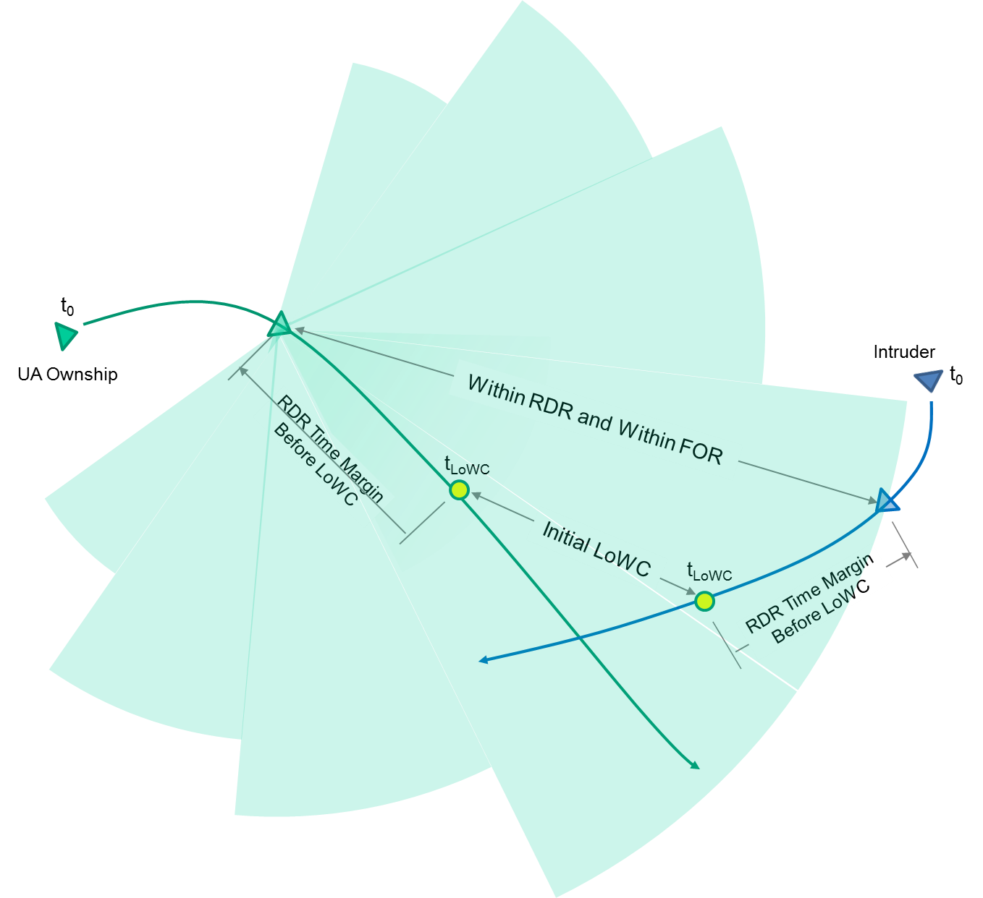
Figure I - 1: RDR time before LoWC against corrective alerting requirements
  - Assessing RDR Time Margin with Respect to DAA Alerting Requirements
In order to validate the RDR requirement parameters against the DAA alerting requirements, two sets of analyses are performed. The first examines the statistics of RDR time margins relative to alerting requirements’ timeline for both A1 and A2 UAs. The second analysis qualitatively compares the distribution of track declaration relative to the alerting requirements separated by ownship speed, and different intruder size (speed) at different bearing angles to understand if there are any high late alert rates in specific sectors of the RDR surveillance volume.
The following figures and tables present the analysis of the RDR time margins compared to the DAA corrective alert requirements. Figure I - 2 and Figure I - 3 show weighted histograms of the RDR time margins for A1 and A2 LoWC encounters respectively. These figures are binned and color coded relative to the Minimum Average Corrective Alert Time of 55 seconds before the hazard (HAZ) and Corrective Late Alert threshold at 20 seconds before HAZ (see DO-365A Appendix L).
Table I - 1 and Table I - 2 provide the statistics of the data shown in Figure I - 2 and Figure I - 3.
For A1 UA, the vast majority (a weighted 95.19%) of LoWC encounters have an RDR time margin greater than or equal to the minimum average corrective alert threshold. However, for A2 UA, there is a notable degradation in the probability of radar declaration before the minimum average corrective alert time (a weighted 71.47% of LoWC). Additionally, up to 7% of A2 LoWC encounters against non-cooperative intruders will result in late corrective alert. This difference in A1 and A2 results is attributable to A2 UA’s inclusion of low ownship speed in the 40-100 KTAS range which is further discussed in subsequent sections.
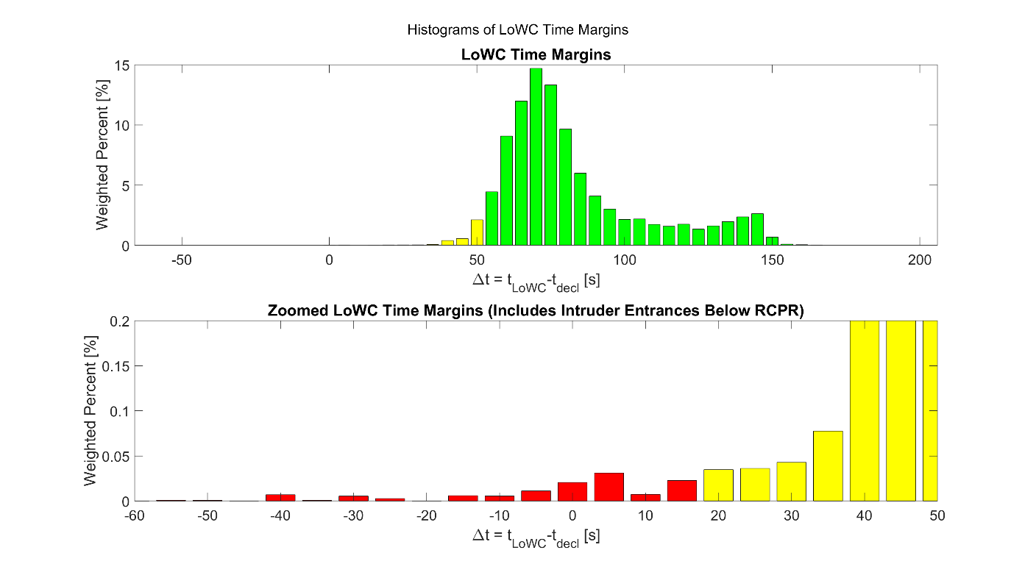
Figure I - 2: RDR time margin color coded for alerting requirements for A1 UA.

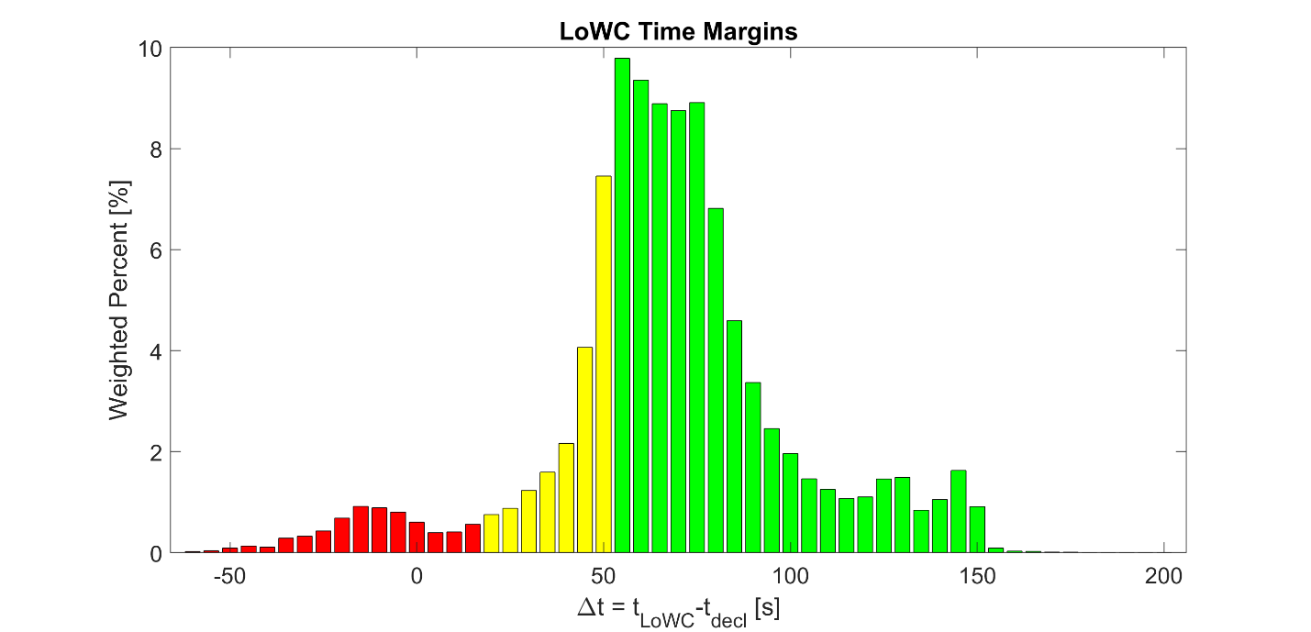
Figure I - 3: RDR time margin color coded for corrective alerting requirements for A2 UA.

Table I - 1: Statistics of A1 UA LoWC encounters relative to the DAA alerting requirements.
Alerting  $Δt$ Bracket [s] | A1 UA (59,423 LoWC encounters)
Alerting  $Δt$ Bracket [s] | # of LoWC Encs | % of LoWC Encs | Weighted % of LoWC Encs
Before Avg Corr Alert  $$Δt≥55$$ | 56,832 | 95.64 | 95.19
Before Late Corr Alert  $$20≤Δt<55$$ | 2,515 | 4.23 | 4.67
After Late Corr Alert  $$Δt<20$$ | 76 | 0.13 | 0.14

Table I - 2: Statistics of A2 UA LoWC encounters relative to the DAA alerting requirements.
Alerting  $Δt$ Bracket [s] | A2 UA (299,643 LoWC encounters)
Alerting  $Δt$ Bracket [s] | # of LoWC Encs | % of LoWC Encs | Weighted % of LoWC Encs
Before Avg Corr Alert  $$Δt≥55$$ | 213,119 | 71.12 | 71.47
Before Late Corr Alert  $$20≤Δt<55$$ | 64,325 | 21.47 | 21.53
After Late Corr Alert  $$Δt<20$$ | 22,199 | 7.41 | 7.00

The A1 UA’s RDR Time Margin distribution for different intruder speed (size) and bearing angles are compared in Figure I - 4 for different ownship speeds. Each dot represents a LoWC encounter. When the distribution is referenced to the minimum average corrective alert requirements of 55-sec and the late corrective alert time of 20-sec, these results indicate that the A1 ATAR will declare a intruder track with sufficient margin to support DAA operation with pilot-ATC coordination for the different encounter geometries against the different non-coop intruder sizes. Additionally, the conservative approach of deriving the RDR requirements based on the highest ownship speed of 291 KTAS stressing collision geometries had produced some potential trade-space if A1 ATAR is operating at lower ownship speed in the 100-200 KTAS range.

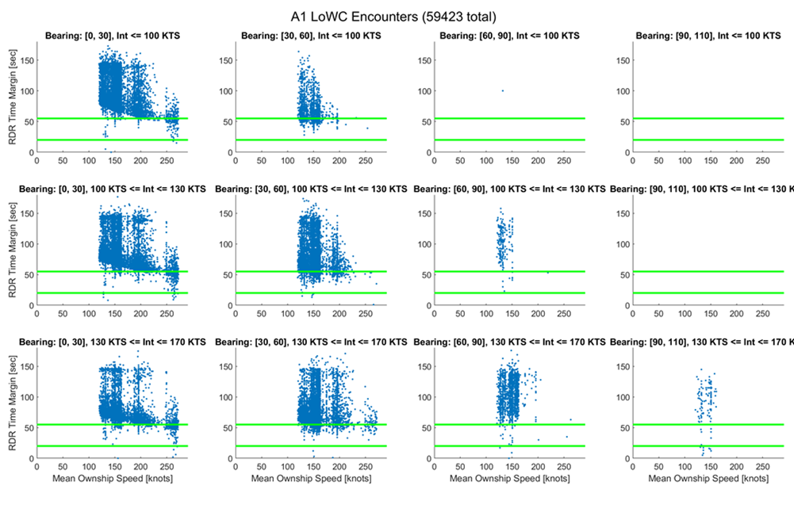
Figure I - 4: RDR Time Margin Distribution for A1 UA with LoWC encounters at different bearing angles and intruder speeds (sizes).

The medium speed UA’s RDR Time Margin distribution for different intruder speed (size) and bearing angles are compared in Figure I - 5 as function of ownship speeds. It should be noted only 10% of all A2 LoWC encounters are plotted here to minimize clutter and reveal trends. As before, each point represents a LoWC encounter with the radar track declaration time relative to its unmitigated LoWC point. For encounters with ownship operating in the 100 to 200 KTAS range, the A2 RDR requirements can easily accommodate declaring intruder tracks with sufficient time to support DAA corrective alerting requirements. However, for ownship operating at lower speeds (40-100 KTAS), the number of encounters with late declaration becomes increasingly noticeable across all bearing angles and intruder speeds (sizes). These results provide some qualitative insights to the contribution of encounters with slow ownship speeds to the likelihood of late track declaration. Although mostly a function of the encounter characteristics and somewhat beyond the scope of this effort, it can be speculated for low-speed UA operations, there is increased probability of ownship turning, vertically converging geometries, and/or being overtaken by faster intruders from astern (DO-365A A.2.6.3) resulting in the intruders approaching from beyond the A2 ATAR’s FOR regardless of the RDR requirements. Because A2 covers a wide range of ownship speeds, it should be further noted that the probability of late-declaration identified in Figure I-3 and Table I-1 [Have to fix the caption & cross reference] was averaged across the 40-200 KTAS ownship speed range. The trend for increasing probability for late track declaration against a non-coop intruder should be expected if an UA with A2 equipage operates predominantly in the low-speed range.
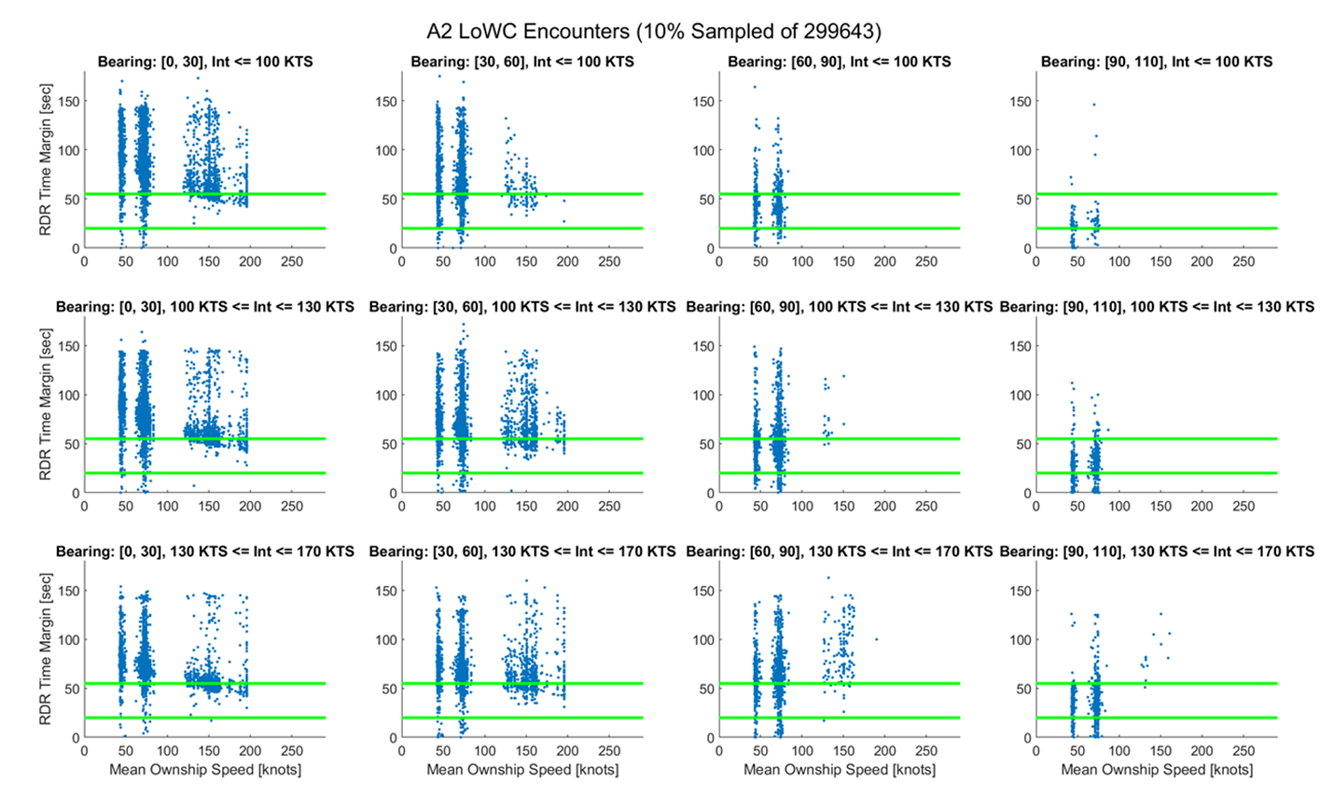
Figure I - 5: RDR Time Margin Distribution for A2 UA with LoWC encounters at different bearing angles and intruder speeds (sizes).

J APPENDIX J VALIDATION OF RDR OF A3 CLASS AGAINST DAA ALERTING REQUIREMENTS

J.1 Introduction
The Detect and Avoid (DAA) Radar Declaration Range (RDR) specifications are based on Maneuver Initiation Range (MIR). The MIR is the range to the intruder at the latest moment by which a maneuver must have been initiated to prevent loss of well clear. To give time for the pilot to react, plan and execute a maneuver, and possibly to coordinate with air traffic control, the RDR is computed with time margin added to the MIR.
At the completion of this analysis, the RDR/FOR requirements for the low-SWaP class of ATAR radar are being finalized. Based on exploratory work performed as part of this analysis effort in conjunction with NASA and work perform by NASA, three candidate RDRs were selected. Each set of RDRs corresponds to a different required pilot response time before the MIR is reached. The three pilot response times are 10, 17, and 25 seconds. These different pilot response times resulted in three sets of candidate RDR and RDR correction factors for each intruder size. Then RDR correction factors are computed as the ratio of the RDR at each bearing, to the (head-on) RDR at 0°. The three sets of RDR candidates, and their correction factors, are shown in Table J-1. This appendix examines whether the RDR requirements subject to radar Field of Regard (FOR) limitations allow sufficient time for DAA alerting prior to a Loss of Well Clear (LoWC). Currently, it is expected that an RDR candidate corresponding to a pilot response time of 25 seconds will be chosen for the Low-SWaP RDR. However, results for each set of RDR candidates is provided in this appendix for completeness.

J.1.1 Low-Size, Weight, and Power (SWaP) Encounter Set
The non-cooperative low SWaP analysis described in the introduction utilized a low-SWaP encounter set synthesized by MIT/LL. The analysis on this encounter set is to support the requirements for the A3 class of low-SWaP ATAR radar. The low-SWaP Encounter set was synthesized by overlaying randomly sampled segments of unmanned aircraft systems (UAS) trajectories from NASA’s UAS Trajectory Database with intruder trajectories sampled from the uncorrelated encounter model. One million encounters were generated. This dataset represents encounters against non-cooperative Visual Flight Rules (VFR) intruders with and without Loss of Well Clear (LoWC). The encounters have a minimum initial separation of 800 ft vertically and 1.5 Nautical Mile (NM) horizontally. The maximum horizontal miss distance (HMD) was 3 NM and maximum vertical miss distance (VMD) was 1500 ft. The closest approach always occurred 30 seconds before the end of the encounter. The encounter durations were mostly 180 seconds, except for some that were extended to 300 seconds, to satisfy initial minimum separation.
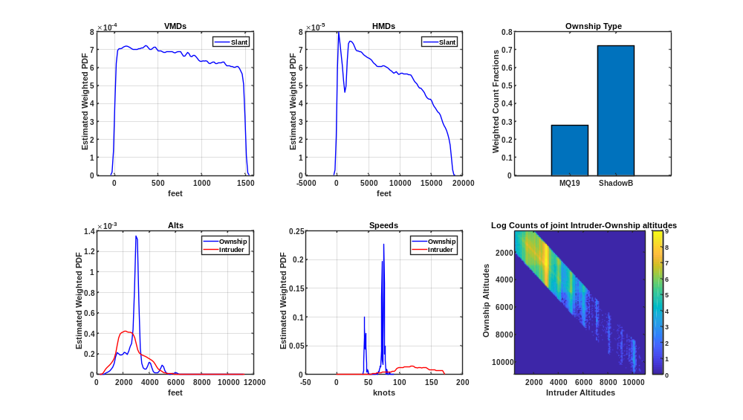
Figure J-1 shows the weighted encounter speed distributions. The ownship speeds are between 40 and 100 knots. The intruder speeds are between 0 and 170 knots. The Intruder speed distribution has most of its density at higher speeds than the ownship distribution, which increases the probability of intruder overtake geometries. Intruder overtake is one of the encounter geometries that can lead to late detection. Figure J-2 shows the altitude distributions.
Shadow
Aerosonde
Figure J-1 Low-SWaP Encounter Speed Distribution
Figure J-2 Low-SWaP Encounter Altitude Distribution
In this analysis LoWC events are the primary concern, but they are uncommon. Therefore, an umbrella weighting scheme was used. The encounter set had a disproportionately large number of LoWC events, which were given small weights, to provide a better statistical picture of LoWC encounters. Applying the weights gives the probability that an event occurs in the low-SWaP uncorrelated encounter set.
Table J-1 shows the density of encounters with unmitigated LoWC, based on HMD* of 2,200 ft and h* of 450 ft from the DAA MOPS for non-cooperative DAA well clear <DO-365 paragraph ref once revised>. It also shows the density without LoWC, and the density resulting in near mid-air collision (NMAC). The weighed density of Low-SWaP encounters with LoWC is 4%, and the density of those resulting in NMAC was 0.2%.
Table J-1 Summary of Unmitigated Separation
Encounter Type | Total | Total % | Weighted %
All Encounters | 1 Million | 100 | 100
Encounters with No LoWC | 662,008 | 66.2% | 96.0%
Encounters with LoWC | 337,992 | 33.8% | 4.0%
Encounters Resulting in NMAC | 65,929 | 6.6% | 0.2%

J.1.2 Low-SWaP RDR Candidates:
At the completion of this analysis, the FOR and RDR requirements for the low-SWaP class of ATAR radar are being finalized. Based on exploratory work performed as part of this analysis effort in conjunction with NASA and work perform by NASA, three candidate sets of RDR were selected. Each set of RDRs corresponds to a different required pilot response time before the MIR is reached. The three pilot response times are 10, 17, and 25 seconds. The candidates are provided in Table J-1. The RDR candidate corresponding to a pilot response time of 25 seconds was chosen for the RDRs of the A3 class. However, results for each set of RDR candidates are provided in this appendix for completeness. Also note that the the 25 seconds RDRs and the associated correction factors were slightly different than the values in the MOPS due to a late change to official values of RDRs. This minor difference should not affect the trends observed in this analysis.

Table J-1 Low-SWaP RDR Candidates with Correction Factors
Intruder Size | Small |  |  | Medium |  |  | Large
Pilot Response Time (sec) | 10 | 17 | 25 | 10 | 17 | 25 | 10 | 17 | 25
RDR (NM) | 1.69 | 2.10 | 2.57 | 2.04 | 2.40 | 2.93 | 2.58 | 2.99 | 3.46
Relative Azimuth Bearing: | RDR Correction Factors: |  |  | RDR Correction Factors: |  |  | RDR Correction Factors:
$$0°<θ≤30°$$ | 1.0 | 1.0 | 1.0 | 1.0 | 1.0 | 1.0 | 1.0 | 1.0 | 1.0
$$30°<θ≤60°$$ | 0.937 | 0.919 | 0.907 | 0.932 | 0.937 | 0.928 | 0.902 | 0.911 | 0.926
$$60°<θ≤90°$$ | 0.916 | 0.843 | 0.788 | 0.930 | 0.910 | 0.855 | 0.924 | 0.918 | 0.914
$$90°<θ$$ | 0.632 | 0.594 | 0.565 | 0.723 | 0.716 | 0.679 | 0.801 | 0.798 | 0.796
Field of Regard | Azimuth: +/- 110°, Elevation: +/- 15°

J.2 FOR/RDR Time Margin as a Metric for Evaluating Performance
To validate the RDR and FOR against DAA alerting requirements, FOR/RDR time margin was used as a metric. The time margin is the time measured from the first entry into the RDR within the FOR limits, to the time of the initial LoWC. The time margin was extracted from 337,992 LoWC low SWaP encounters. These encounters included linear (non-accelerating and nearly co-altitude) trajectories as well as accelerating (turning and vertically converging) flight paths. As illustrated in Figure J-3, the time corresponding to the first LoWC was recorded as $t_{LoWC}$, and the time of the first entry into RDR, is recorded as $t_{RDR}$ for each encounter. RDR is subject to the RDR correction factors and the FOR limits.
To validate RDR against DAA alerting metrics, time margin statistics are compared to the Late Alert Threshold (LAT) and the Minimum Average Alert Time (MAAT). For a good candidate RDR, the average time margin should be greater than the MAAT. The probability of detection occurring after the Late Threshold should be minimized. Hence, the sum of all probability density with a time margin less than the LAT should be minimized. This will be discussed in greater detail in Section J.3.
It should be noted that the time margin does not specifically account for the time required to establish intruder tracks, nor does it check if the intruder remains within the FOR and RDR before reaching LoWC. However, Appendix L shows that the number of encounters subject to the 15s track establishment requirement is relatively small compared to the full encounter dataset. Therefore, the time margin represents a slightly optimistic assessment of the Radar MOPS performance against the DAA alerting timeline. Section J.4 compares the time margin statistics when the final entry into FOR/RDR is used instead.
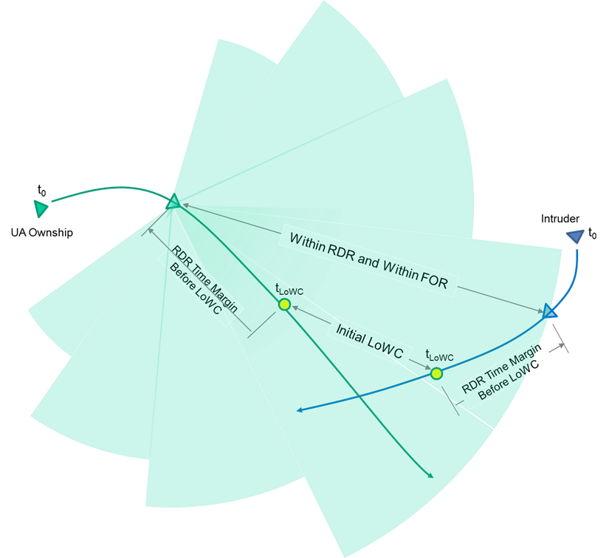
Figure J-3 RDR Time before LoWC against Corrective Alerting Requirements
J.3 Results
The time margin, measured from the time of entry into FOR/RDR to the time of LoWC, is compared to DAA alerting schedule requirements: the Minimum Average Alert Time (MAAT) and the Late Alert Threshold (LAT). Systems are required to have an average alert time (prior to LoWC) greater than the MAAT, so it is used as a basis of comparison with the mean and median time margin. The LAT was based on the 10th percentile (see DO-365 L.2.3 paragraph 4) of total response time prior to LoWC. The time margin CDF, at each time margin $t_{TM}$, shows how many intruders are detected after $t_{TM}$ seconds prior to LoWC. Therefore, the time margin CDF at the LAT is a useful guideline for comparing the number of late alerts with various FOR and RDR configurations. In particular, the FOR/RDR parameters could be chosen to keep the probability of late alerts below 10%. A target is assumed to be detected as soon as it enters both the FOR and RDR. The Corrective LAT (20 sec) was used as the benchmark for late alerts in this analysis.

Time margin PDF Plots
The time margin Probability Density Function (PDF) is shown in Figure J-4, Figure J-5, and Figure J-6 for each set of the candidate RDR requirements. In each figure, four subplots are shown for different intruder sizes. The RDR used for that intruder size is shown on the right side of the plot. The densities are normalized to all LoWC encounters (left vertical axis) with the respective intruder size. On the right vertical axis, the densities are normalized to all encounters (for that intruder size). The horizontal axis (time margin, $t_{TM}$) represents seconds before LoWC, and the vertical axis is the probability density of encounters whose intruders were detected (entered FOR and RDR) with that time margin. The PDF histogram is color-coded, with blue representing normal encounters, which are in the FOR before they enter the RDR. The remaining encounters are categorized as those that were previously outside of the Azimuth FOR before their first detection (orange), those which were previously outside of the Elevation FOR prior to their first detection (green), and those that were outside of both FOR and entered diagonally (violet). Encounters that enter the FOR within the RDR, referred to as Pop-up Encounters, and this categorization are discussed in Appendix L.
Both Warning and Corrective LAT and MAAT are shown in Figure J-4, Figure J-5, and Figure J-6. Warning alert times are shown as red lines and Corrective alert times are shown as black lines. The MAAT are shown as a dotted lines and the LAT are shown as solid lines. The Corrective LAT (20 sec) will later be used as a benchmark for the probability of late detection because it is more conservative than the Warning LAT (15 sec). We can see that for all three RDR candidates, the time margin probability density to the left of the Corrective LAT is greatest for large intruders and the least for small intruders. This is expected, because of the increased probability of intruder overtake scenarios, since intruder speeds in the encounter set were much higher than the A3 class ownship speeds (see Figure J-2). It appears that the average time margin is higher than the Warning MAAT for all RDR candidates and intruder sizes. Only for the highest RDR candidate set, shown in Figure J-6, do the average time margins appear to be greater than the Corrective MAAT. In these PDF histograms, the probability density in the y-axis indicates the density contained in a 2 second bin.

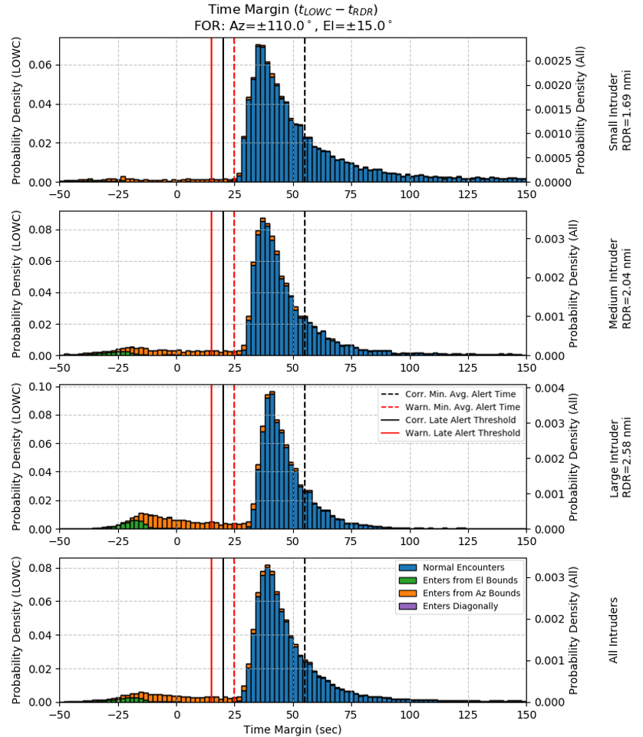
Figure J-4 Time margin PDF for 10 sec Pilot Response Time

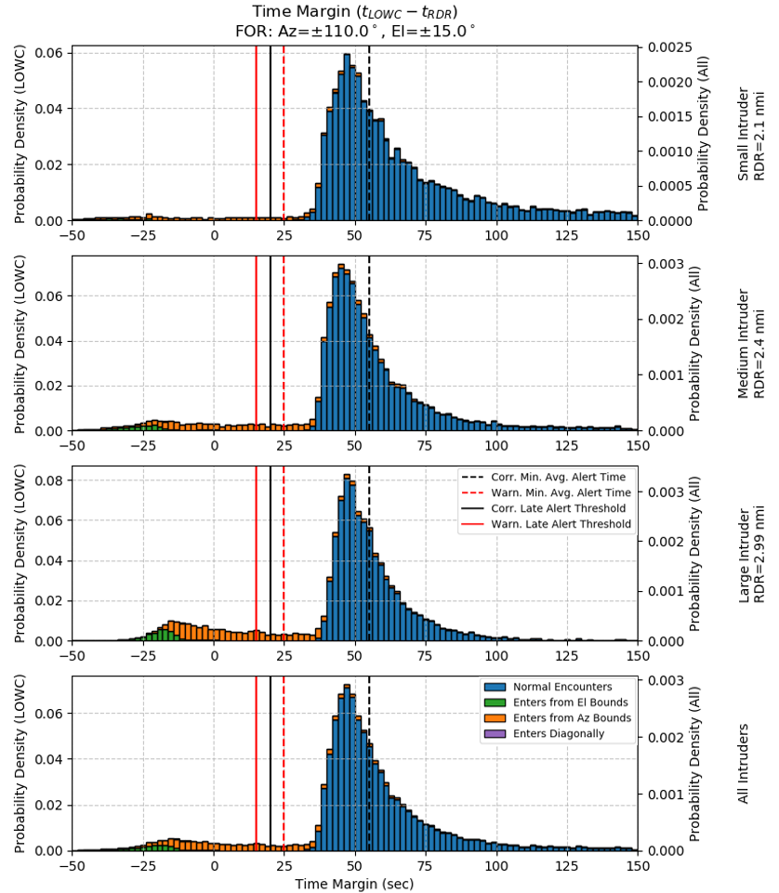
Figure J-5 Time Margin PDF for 17 sec Pilot Response Time

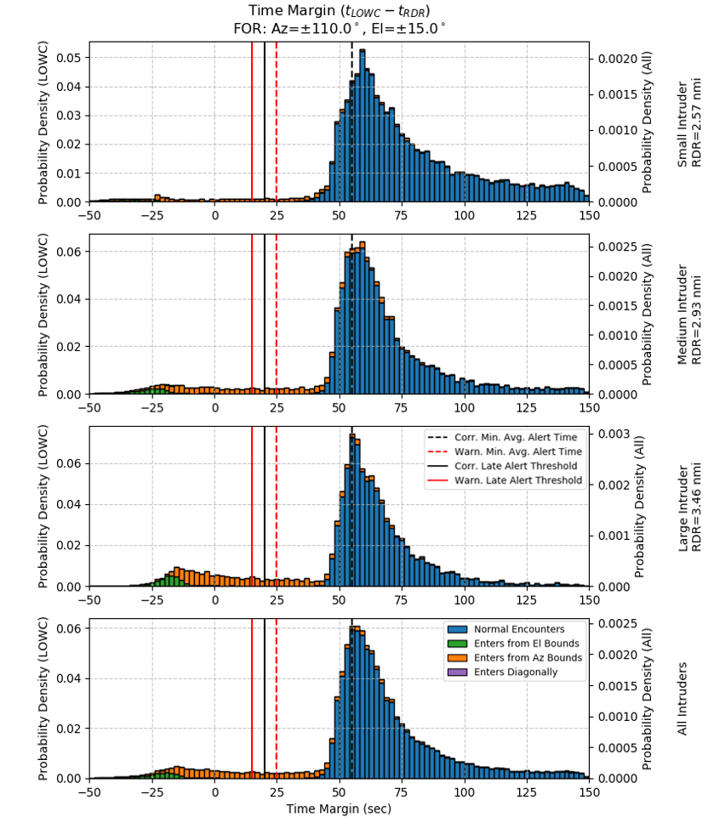
Figure J-6 Time margin PDF for 25 sec Pilot Response Time
Comparing Figure J-4, Figure J-5, and Figure J-6, we can see that the larger RDR candidates, which are based on higher Pilot Response Times, have their distribution shifted higher accordingly. For example, comparing the 10 second Candidate to the 17 second candidate, the densities appear to be shifted higher by 7 seconds. However, when looking at the PDF, the Pop-up encounters (any categories, other than Normal Encounters) do not appear to be largely affected by increased RDR.

Time margin Summary Statistics
Table J-2 below shows a summary of statistics for the three candidate RDR sets, and FOR configuration of +/- 15° Elevation and +/- 110° Azimuth. Between 3.8-5.3% of small intruders (resulting in LoWC) were detected after the Corrective LAT (20 sec before LoWC). Whereas 8.2-10.9% of medium intruders, and between 12.9-15.6% of large intruders, and 8.7-11.1% of all intruders (LOWC) were detected after the LAT. Increasing RDR dramatically increases the mean time margin but has a more modest effect on the median time margin. All average time margins were greater than the Warning Minimum Average Alert Time (25 sec). However, only the 25 sec Pilot Response Time resulted in a median time margin greater than the Corrective Minimum Average Alert Time (55 sec). Increased FOR might be desirable to reduce the late detection probabilities, especially for the two shorter RDR candidates.
Table J-2 Summary of Time Margin Statistics for RDR Candidates, First Entry into FOR/RDR
Intruder Size | Small |  |  | Medium |  |  | Large |  |  | All
LoWC Prob. (All) | 0.0418 |  |  | 0.0404 |  |  | 0.0392 |  |  | 0.0403
Pilot Response Time (sec) | 10 | 17 | 25 | 10 | 17 | 25 | 10 | 17 | 25 | 10 | 17 | 25
RDR (NM) | 1.69 | 2.10 | 2.57 | 2.04 | 2.40 | 2.93 | 2.58 | 2.99 | 3.46 | (see Small, Medium, Large)
Mean TM (sec) | 55.2 | 68.2 | 82.2 | 42.1 | 51.7 | 63.5 | 38.5 | 46.5 | 55.8 | 44.1 | 54.0 | 65.5
Median TM (sec) | 44 | 56 | 69 | 41 | 49 | 61 | 41 | 49 | 59 | 42 | 50 | 62
Late Detection Prob. (LoWC) | 0.053 | 0.045 | 0.038 | 0.109 | 0.095 | 0.082 | 0.156 | 0.143 | 0.129 | 0.111 | 0.099 | 0.087
Late Detection Prob. (All) | 0.002 | 0.002 | 0.002 | 0.004 | 0.004 | 0.003 | 0.006 | 0.006 | 0.005 | 0.004 | 0.004 | 0.004

FOR Comparison Data:
Table J-3 through Table J-6 below show the density of intruders detected after the Corrective Late Threshold (20 sec). It provides a more detailed look at the effects of FOR and RDR on the probability of late intruders, and the average time margin. Table J-3 shows probabilities for all intruder sizes, and Table J-4 through Table J-6 show probabilities for each size. The dominant factor in the probability of late detections is azimuth FOR.
From Table J-3, we can see that for the three candidate RDR (with an Elevation FOR of +/-15°), increasing Azimuth FOR from +/- 110° to 135° decreases the number of late detections to less than half. Late detections decrease from 11.1% to 4.7%, 9.9% to 4.0%, and 8.7% to 3.4%, for three sets of candidate RDRs (the 10 sec, 17 sec, and 25 sec pilot response times, respectively). Elevation FOR has a modest effect on late detections, in comparison.

Probability of Late Detections:
All Intruder Types
Table J-3 Weighted Probability of All Intruders Detected After the Corrective Late Threshold
Density of All LoWC Encounters |  | FOR: Azimuth |  |  |  |  |  | Pilot Response Time
 |  | 75° | 90° | 105° | 110° | 120° | 135° | Pilot Response Time
FOR: Elevation | 5° | 0.2775 | 0.1969 | 0.1448 | 0.1289 | 0.1013 | 0.0671 | 10 sec
FOR: Elevation | 10° | 0.2658 | 0.1833 | 0.1293 | 0.1125 | 0.0843 | 0.0486 | 10 sec
FOR: Elevation | 15° | 0.2647 | 0.1820 | 0.1280 | 0.1111 | 0.0825 | 0.0469 | 10 sec
FOR: Elevation | 20° | 0.2643 | 0.1817 | 0.1276 | 0.1107 | 0.0822 | 0.0465 | 10 sec
FOR: Elevation | 5° | 0.2581 | 0.1792 | 0.1289 | 0.1137 | 0.0874 | 0.0562 | 17 sec
FOR: Elevation | 10° | 0.2484 | 0.1684 | 0.1163 | 0.1003 | 0.0737 | 0.0416 | 17 sec
FOR: Elevation | 15° | 0.2473 | 0.1673 | 0.1150 | 0.0989 | 0.0721 | 0.0400 | 17 sec
FOR: Elevation | 20° | 0.2470 | 0.1670 | 0.1148 | 0.0987 | 0.0718 | 0.0397 | 17 sec
FOR: Elevation | 5° | 0.2385 | 0.1631 | 0.1143 | 0.0995 | 0.0745 | 0.0469 | 25 sec
FOR: Elevation | 10° | 0.2302 | 0.1540 | 0.1039 | 0.0885 | 0.0632 | 0.0350 | 25 sec
FOR: Elevation | 15° | 0.2293 | 0.1529 | 0.1027 | 0.0873 | 0.0618 | 0.0338 | 25 sec
FOR: Elevation | 20° | 0.2289 | 0.1526 | 0.1025 | 0.0870 | 0.0616 | 0.0335 | 25 sec

Large Intruders
Table J-4 Weighted Probability of Large Intruders Detected After the Corrective Late Threshold
Density of LoWC Encounters with Large Intruders |  | FOR: Azimuth |  |  |  |  |  | Pilot Response Time,  RDR
 |  | 75° | 90° | 105° | 110° | 120° | 135° | Pilot Response Time,  RDR
FOR: Elevation | 5° | 0.3459 | 0.2574 | 0.1847 | 0.1627 | 0.1269 | 0.0773 | 10 sec, 2.58 NM
FOR: Elevation | 10° | 0.3425 | 0.2534 | 0.1791 | 0.1564 | 0.1195 | 0.0686 | 10 sec, 2.58 NM
FOR: Elevation | 15° | 0.3423 | 0.2530 | 0.1787 | 0.1557 | 0.1187 | 0.0677 | 10 sec, 2.58 NM
FOR: Elevation | 20° | 0.3423 | 0.2529 | 0.1786 | 0.1556 | 0.1185 | 0.0677 | 10 sec, 2.58 NM
FOR: Elevation | 5° | 0.3293 | 0.2409 | 0.1693 | 0.1495 | 0.1139 | 0.0667 | 17 sec, 2.99 NM
FOR: Elevation | 10° | 0.3261 | 0.2373 | 0.1646 | 0.1439 | 0.1075 | 0.0598 | 17 sec, 2.99 NM
FOR: Elevation | 15° | 0.3257 | 0.2369 | 0.1642 | 0.1432 | 0.1067 | 0.0590 | 17 sec, 2.99 NM
FOR: Elevation | 20° | 0.3257 | 0.2369 | 0.1641 | 0.1431 | 0.1066 | 0.0590 | 17 sec, 2.99 NM
FOR: Elevation | 5° | 0.3130 | 0.2245 | 0.1539 | 0.1347 | 0.0996 | 0.0570 | 25 sec, 3.46 NM
FOR: Elevation | 10° | 0.3101 | 0.2214 | 0.1497 | 0.1297 | 0.0938 | 0.0508 | 25 sec, 3.46 NM
FOR: Elevation | 15° | 0.3097 | 0.2209 | 0.1493 | 0.1290 | 0.0930 | 0.0503 | 25 sec, 3.46 NM
FOR: Elevation | 20° | 0.3097 | 0.2209 | 0.1493 | 0.1289 | 0.0929 | 0.0503 | 25 sec, 3.46 NM

Medium Intruders
Table J-5 Weighted Probability of Medium Intruders Detected After the Corrective Late Threshold
Density of LoWC Encounters with Medium Intruders |  | FOR: Azimuth |  |  |  |  |  | Pilot Response Time,  RDR
 |  | 75° | 90° | 105° | 110° | 120° | 135° | Pilot Response Time,  RDR
FOR: Elevation | 5° | 0.2826 | 0.1925 | 0.1411 | 0.1249 | 0.0964 | 0.0629 | 10 sec, 2.04 NM
FOR: Elevation | 10° | 0.2739 | 0.1810 | 0.1273 | 0.1103 | 0.0811 | 0.0457 | 10 sec, 2.04 NM
FOR: Elevation | 15° | 0.2732 | 0.1800 | 0.1260 | 0.1091 | 0.0794 | 0.0440 | 10 sec, 2.04 NM
FOR: Elevation | 20° | 0.2729 | 0.1799 | 0.1258 | 0.1089 | 0.0792 | 0.0437 | 10 sec, 2.04 NM
FOR: Elevation | 5° | 0.2624 | 0.1734 | 0.1241 | 0.1076 | 0.0819 | 0.0519 | 17 sec, 2.40 NM
FOR: Elevation | 10° | 0.2551 | 0.1644 | 0.1130 | 0.0958 | 0.0695 | 0.0384 | 17 sec, 2.40 NM
FOR: Elevation | 15° | 0.2545 | 0.1634 | 0.1118 | 0.0947 | 0.0680 | 0.0369 | 17 sec, 2.40 NM
FOR: Elevation | 20° | 0.2543 | 0.1633 | 0.1116 | 0.0944 | 0.0678 | 0.0366 | 17 sec, 2.40 NM
FOR: Elevation | 5° | 0.2389 | 0.1563 | 0.1085 | 0.0926 | 0.0684 | 0.0423 | 25 sec, 2.93 NM
FOR: Elevation | 10° | 0.2328 | 0.1485 | 0.0994 | 0.0829 | 0.0584 | 0.0317 | 25 sec, 2.93 NM
FOR: Elevation | 15° | 0.2322 | 0.1476 | 0.0984 | 0.0821 | 0.0573 | 0.0307 | 25 sec, 2.93 NM
FOR: Elevation | 20° | 0.2319 | 0.1475 | 0.0982 | 0.0819 | 0.0571 | 0.0304 | 25 sec, 2.93 NM

Small Intruders
Table J-6 Weighted Probability of Small Intruders Detected After the Corrective Late Threshold
Density of LoWC Encounters with Small Intruders |  | FOR: Azimuth |  |  |  |  |  | Pilot Response Time, RDR
 |  | 75° | 90° | 105° | 110° | 120° | 135° | Pilot Response Time, RDR
FOR: Elevation | 5° | 0.1748 | 0.1203 | 0.0956 | 0.0887 | 0.0737 | 0.0597 | 10 sec, 1.69 NM
FOR: Elevation | 10° | 0.1468 | 0.0902 | 0.0638 | 0.0556 | 0.0407 | 0.0258 | 10 sec, 1.69 NM
FOR: Elevation | 15° | 0.1439 | 0.0873 | 0.0610 | 0.0526 | 0.0376 | 0.0226 | 10 sec, 1.69 NM
FOR: Elevation | 20° | 0.1428 | 0.0863 | 0.0600 | 0.0516 | 0.0367 | 0.0216 | 10 sec, 1.69 NM
FOR: Elevation | 5° | 0.1528 | 0.1035 | 0.0808 | 0.0742 | 0.0600 | 0.0485 | 17 sec, 2.10 NM
FOR: Elevation | 10° | 0.1301 | 0.0798 | 0.0550 | 0.0474 | 0.0336 | 0.0218 | 17 sec, 2.10 NM
FOR: Elevation | 15° | 0.1275 | 0.0773 | 0.0523 | 0.0446 | 0.0307 | 0.0188 | 17 sec, 2.10 NM
FOR: Elevation | 20° | 0.1265 | 0.0764 | 0.0517 | 0.0441 | 0.0302 | 0.0182 | 17 sec, 2.10 NM
FOR: Elevation | 5° | 0.1348 | 0.0892 | 0.0689 | 0.0622 | 0.0496 | 0.0402 | 25 sec, 2.57 NM
FOR: Elevation | 10° | 0.1159 | 0.0697 | 0.0479 | 0.0406 | 0.0286 | 0.0186 | 25 sec, 2.57 NM
FOR: Elevation | 15° | 0.1134 | 0.0674 | 0.0454 | 0.0380 | 0.0260 | 0.0159 | 25 sec, 2.57 NM
FOR: Elevation | 20° | 0.1124 | 0.0665 | 0.0449 | 0.0375 | 0.0255 | 0.0154 | 25 sec, 2.57 NM

Mean Time Margin:
Table J-7 through Table J-10 show the mean time margin for a matrix of FOR and candidate RDR configurations. The mean time margin is affected strongly by RDR in all cases. Large intruders have the most pop-up encounters, which have a significant effect of decreasing the mean. In Table J-8, for Large intruders we can see that FOR has a slightly stronger effect on the mean. For example, if we increase the Azimuth FOR from 110° to 135°, the mean time margin is increased almost as much as if increased the RDR by adding 7 seconds of pilot response time. Whereas small intruders have mostly normal (non-pop-up) encounters; Their mean time margin shows a weak dependence on the Azimuth FOR and is mostly only affected by RDR.

All Intruder Types
Table J-7 Mean Time Margin for All Intruders
Mean Time Margin (sec), All LoWC Encounters |  | FOR: Azimuth |  |  |  |  |  | Pilot Response Time
 |  | 75° | 90° | 105° | 110° | 120° | 135° | Pilot Response Time
FOR: Elevation | 5° | 36.27 | 40.50 | 42.72 | 43.64 | 45.43 | 48.06 | 10 sec
FOR: Elevation | 10° | 34.92 | 39.95 | 42.71 | 43.84 | 45.94 | 49.07 | 10 sec
FOR: Elevation | 15° | 34.91 | 40.10 | 42.97 | 44.11 | 46.24 | 49.36 | 10 sec
FOR: Elevation | 20° | 34.95 | 40.22 | 43.09 | 44.23 | 46.35 | 49.45 | 10 sec
FOR: Elevation | 5° | 45.36 | 50.09 | 52.64 | 53.68 | 55.68 | 58.51 | 17 sec
FOR: Elevation | 10° | 43.71 | 49.31 | 52.48 | 53.75 | 56.09 | 59.38 | 17 sec
FOR: Elevation | 15° | 43.64 | 49.41 | 52.72 | 53.99 | 56.35 | 59.65 | 17 sec
FOR: Elevation | 20° | 43.66 | 49.52 | 52.82 | 54.08 | 56.43 | 59.72 | 17 sec
FOR: Elevation | 5° | 56.31 | 61.31 | 64.18 | 65.37 | 67.67 | 70.74 | 25 sec
FOR: Elevation | 10° | 54.36 | 60.32 | 63.88 | 65.30 | 67.95 | 71.52 | 25 sec
FOR: Elevation | 15° | 54.23 | 60.38 | 64.07 | 65.49 | 68.17 | 71.76 | 25 sec
FOR: Elevation | 20° | 54.22 | 60.46 | 64.16 | 65.58 | 68.25 | 71.83 | 25 sec

Large Intruders
Table J-8 Mean Time Margin for Large Intruders
Mean Time Margin (sec), LoWC Encounters with Large Intruders |  | FOR: Azimuth |  |  |  |  |  | Pilot Response Time,  RDR
 |  | 75° | 90° | 105° | 110° | 120° | 135° | Pilot Response Time,  RDR
FOR: Elevation | 5° | 27.79 | 32.37 | 36.28 | 37.81 | 40.58 | 44.40 | 10 sec, 2.58 NM
FOR: Elevation | 10° | 27.13 | 32.26 | 36.50 | 38.08 | 40.95 | 45.04 | 10 sec, 2.58 NM
FOR: Elevation | 15° | 27.53 | 32.72 | 36.91 | 38.46 | 41.30 | 45.26 | 10 sec, 2.58 NM
FOR: Elevation | 20° | 27.72 | 32.91 | 37.07 | 38.60 | 41.41 | 45.32 | 10 sec, 2.58 NM
FOR: Elevation | 5° | 34.61 | 39.87 | 44.28 | 45.91 | 49.05 | 53.31 | 17 sec, 2.99 NM
FOR: Elevation | 10° | 33.68 | 39.61 | 44.36 | 46.10 | 49.36 | 53.83 | 17 sec, 2.99 NM
FOR: Elevation | 15° | 34.02 | 40.03 | 44.73 | 46.45 | 49.66 | 54.02 | 17 sec, 2.99 NM
FOR: Elevation | 20° | 34.18 | 40.20 | 44.87 | 46.57 | 49.75 | 54.07 | 17 sec, 2.99 NM
FOR: Elevation | 5° | 42.61 | 48.62 | 53.54 | 55.38 | 58.85 | 63.50 | 25 sec, 3.46 NM
FOR: Elevation | 10° | 41.35 | 48.17 | 53.52 | 55.49 | 59.11 | 63.98 | 25 sec, 3.46 NM
FOR: Elevation | 15° | 41.63 | 48.53 | 53.85 | 55.79 | 59.37 | 64.14 | 25 sec, 3.46 NM
FOR: Elevation | 20° | 41.75 | 48.68 | 53.98 | 55.90 | 59.45 | 64.19 | 25 sec, 3.46 NM

Medium Intruders
Table J-9 Mean Time Margin for Medium Intruders
Mean Time Margin (sec), LoWC Encounters with Medium Intruders |  | FOR: Azimuth |  |  |  |  |  | Pilot Response Time,  RDR
 |  | 75° | 90° | 105° | 110° | 120° | 135° | Pilot Response Time,  RDR
FOR: Elevation | 5° | 34.66 | 39.56 | 41.65 | 42.52 | 44.17 | 46.89 | 10 sec, 2.04 NM
FOR: Elevation | 10° | 32.14 | 37.98 | 40.80 | 41.95 | 44.07 | 47.47 | 10 sec, 2.04 NM
FOR: Elevation | 15° | 31.94 | 37.96 | 40.96 | 42.13 | 44.29 | 47.69 | 10 sec, 2.04 NM
FOR: Elevation | 20° | 31.96 | 38.07 | 41.06 | 42.23 | 44.38 | 47.75 | 10 sec, 2.04 NM
FOR: Elevation | 5° | 43.14 | 48.68 | 51.12 | 52.18 | 53.98 | 56.81 | 17 sec, 2.40 NM
FOR: Elevation | 10° | 40.36 | 46.89 | 50.16 | 51.52 | 53.80 | 57.27 | 17 sec, 2.40 NM
FOR: Elevation | 15° | 40.08 | 46.81 | 50.29 | 51.66 | 53.96 | 57.47 | 17 sec, 2.40 NM
FOR: Elevation | 20° | 40.05 | 46.90 | 50.38 | 51.74 | 54.03 | 57.53 | 17 sec, 2.40 NM
FOR: Elevation | 5° | 54.78 | 60.28 | 63.02 | 64.22 | 66.43 | 69.45 | 25 sec, 2.93 NM
FOR: Elevation | 10° | 51.72 | 58.26 | 61.91 | 63.39 | 66.11 | 69.82 | 25 sec, 2.93 NM
FOR: Elevation | 15° | 51.38 | 58.15 | 61.98 | 63.46 | 66.20 | 69.98 | 25 sec, 2.93 NM
FOR: Elevation | 20° | 51.32 | 58.20 | 62.05 | 63.52 | 66.27 | 70.03 | 25 sec, 2.93 NM

Small Intruders
Table J-10 Mean Time Margin Small Intruders
Mean Time Margin (sec), LoWC Encounters with Small Intruders |  | FOR: Azimuth |  |  |  |  |  | Pilot Response Time, RDR
 |  | 75° | 90° | 105° | 110° | 120° | 135° | Pilot Response Time, RDR
FOR: Elevation | 5° | 50.69 | 53.49 | 53.61 | 53.71 | 54.31 | 55.13 | 10 sec, 1.69 NM
FOR: Elevation | 10° | 50.27 | 53.88 | 54.50 | 54.91 | 55.88 | 57.26 | 10 sec, 1.69 NM
FOR: Elevation | 15° | 49.94 | 53.82 | 54.67 | 55.15 | 56.24 | 57.74 | 10 sec, 1.69 NM
FOR: Elevation | 20° | 49.80 | 53.85 | 54.76 | 55.25 | 56.36 | 57.89 | 10 sec, 1.69 NM
FOR: Elevation | 5° | 63.70 | 66.65 | 66.87 | 67.04 | 67.71 | 68.58 | 17 sec, 2.10 NM
FOR: Elevation | 10° | 62.99 | 66.74 | 67.58 | 67.99 | 69.11 | 70.48 | 17 sec, 2.10 NM
FOR: Elevation | 15° | 62.66 | 66.66 | 67.74 | 68.21 | 69.45 | 70.96 | 17 sec, 2.10 NM
FOR: Elevation | 20° | 62.52 | 66.69 | 67.79 | 68.27 | 69.54 | 71.07 | 17 sec, 2.10 NM
FOR: Elevation | 5° | 77.46 | 80.63 | 81.01 | 81.23 | 82.03 | 82.97 | 25 sec, 2.57 NM
FOR: Elevation | 10° | 76.51 | 80.50 | 81.52 | 82.02 | 83.20 | 84.69 | 25 sec, 2.57 NM
FOR: Elevation | 15° | 76.16 | 80.36 | 81.64 | 82.20 | 83.51 | 85.15 | 25 sec, 2.57 NM
FOR: Elevation | 20° | 76.00 | 80.37 | 81.68 | 82.30 | 83.62 | 85.29 | 25 sec, 2.57 NM

Time Margin CDF Plots
Figure J-7, Figure J-8, and Figure J-9 show the time margin CDF for the three candidate RDR sets. The horizontal axis represents time margin as seconds before LoWC. The vertical axis represents the density of intruders detected after this time. The probabilities (on the left) are normalized to all LoWC encounters with the indicated intruder size, where the bottom subplot is all intruder sizes. Note that the dataset “All Encounters” is the sum of “Normal” and “Undetected or Pop-up” LOWC encounters.
Referring to the time margin CDF in Figure J-7 through Figure J-9, we can graphically find the weighted median time margin by finding the Time margin where the CDF equals 0.5 (for All Encounters). We can see that the median is always greater than the Warning MAAT (25 sec). The density of Late detected intruders (shown earlier in Table J-3 through Table J-6) is the value of the CDF at the Corrective LAT (20 sec).
Starting from the right side of the CDF plots, in Figure J-7 through Figure J-9, and tracing Normal Encounters (blue) towards 0 seconds, we can find the time margin after which all encounters are with Pop-up intruders, by finding where the “Normal Encounters” CDF decreases to a cumulative density of 0.0. At the same time margin, the CDF of “All Encounters” diverges from the “Undetected or Pop-up Encounters” CDF.
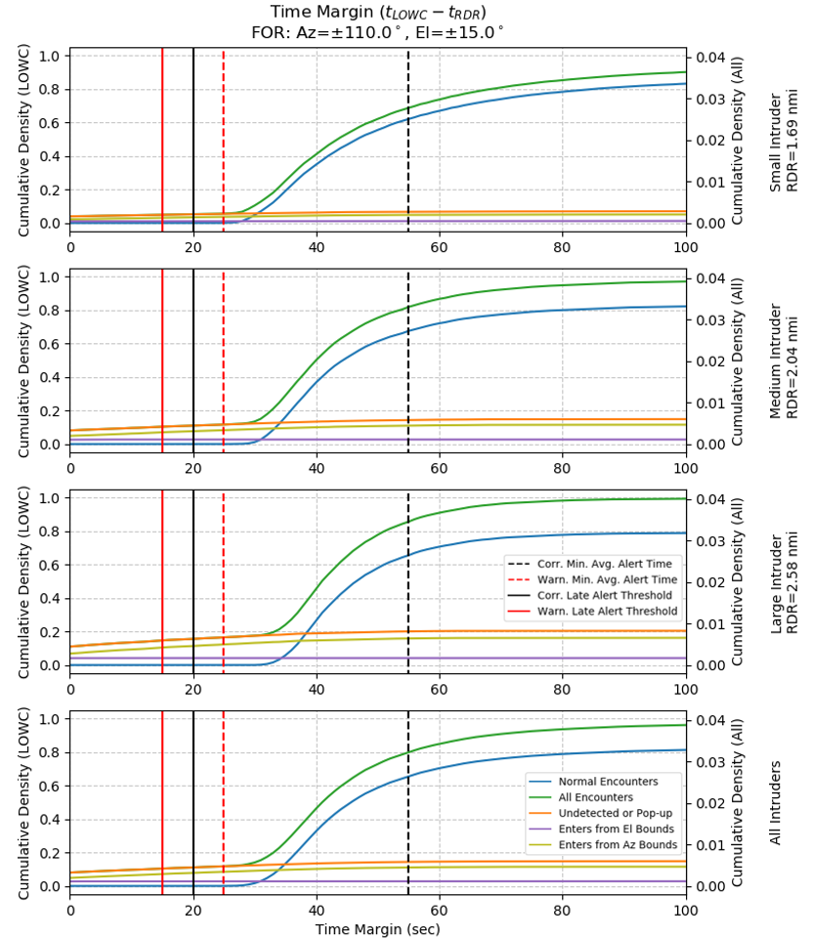
Figure J-7 Time Margin CDF for 10 sec Pilot Response Time
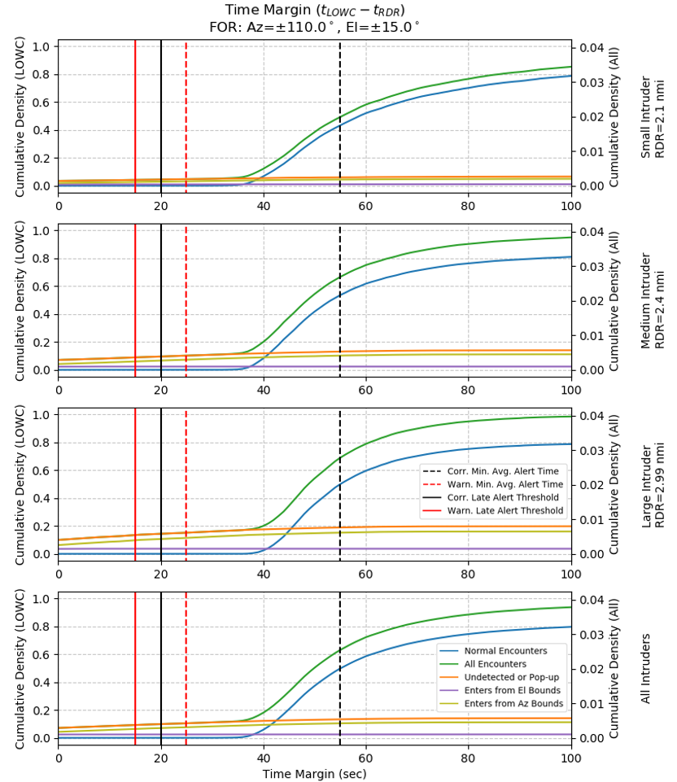
Figure J-8 Time Margin CDF for 17 sec Pilot Response Time
The time margin CDF shown in Figure J-8 (17 sec response time) reaches its median (at 0.5) at a higher time margin (sooner before LoWC) than in Figure J-7. Detection occurs sooner in normal encounters. It is difficult to see change in the CDF of Undetected or Pop-up Encounters (Enters FOR Within RDR), by comparing Figure J-7 through Figure J-9. We saw in Table J-3 through Table J-6 that additional Azimuth FOR is more effective than increased RDR, for reducing the number of Pop-up encounters, which cause late detections. Therefore, it would lower the Pop-up Encounter CDF, especially for Large Intruders.
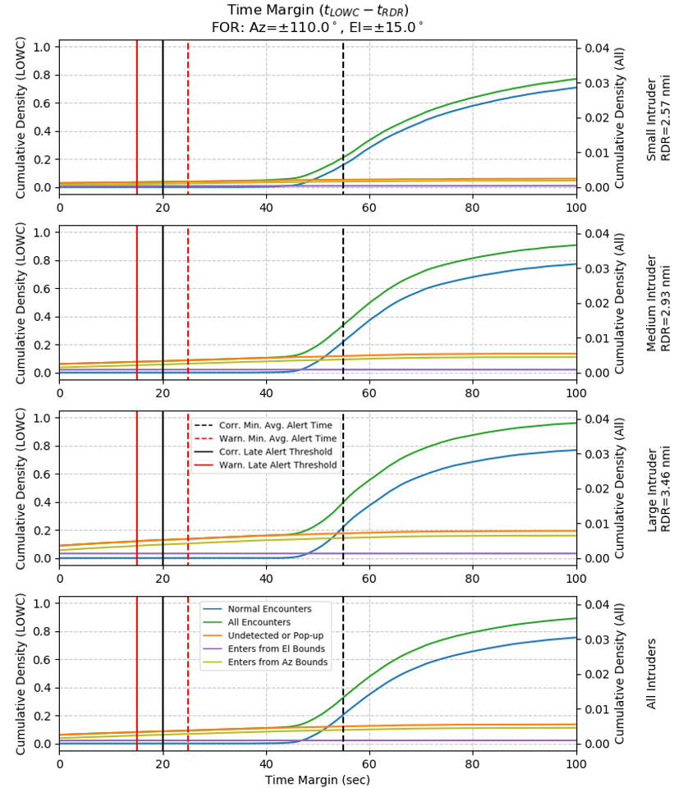
Figure J-9 Time Margin CDF for 25 sec Pilot Response Time
The median CDF (All Encounters, 50th percentile, CDF=0.5) is greater than the Corrective Minimum Average Alert Time (55 sec), only for the 3rd RDR candidate in Figure J-9.

J.4 Using the Final Entry into FOR/RDR for Time Margin
The time margin has been defined as the time between the first entry into FOR/RDR and LoWC. But in some encounters, multiple entries occur. Below we examine the time margin statistics, using the final entry into FOR/RDR. Overall, it slightly increases the average time margin, and it increases the probability of Late Detections. Using the final entry adds a significant density of Pop-up encounters between 0-30 seconds, which appear to be taken from throughout the higher side of the distribution.
Using the final entry into FOR/RDR decreases the mean time margin by 2-7 seconds, while the median is only decreased by 0-3 seconds. The probability of late detection is increased by 1-3% (of LoWC encounters).
Table J-11 Summary of Time Margin Statistics for RDR Candidates, Final Entry into FOR/RDR
Intruder Size | Small |  |  | Medium |  |  | Large |  |  | All
LoWC Prob. (All) | 0.0418 |  |  | 0.0404 |  |  | 0.0392 |  |  | 0.0403
Pilot Response Time (sec) | 10 | 17 | 25 | 10 | 17 | 25 | 10 | 17 | 25 | 10 | 17 | 25
RDR (NM) | 1.69 | 2.10 | 2.57 | 2.04 | 2.40 | 2.93 | 2.58 | 2.99 | 3.46 | (see Small, Medium, Large)
Mean TM (sec) | 49.0 | 60.8 | 73.5 | 38.8 | 47.2 | 57.9 | 36.2 | 43.5 | 52.0 | 40.4 | 49.4 | 59.7
Median TM (sec) | 43 | 54 | 66 | 40 | 48 | 59 | 41 | 48 | 57 | 41 | 49 | 60
Late Detection Prob. (LoWC) | 0.0682 | 0.0626 | 0.0574 | 0.129 | 0.119 | 0.110 | 0.178 | 0.168 | 0.157 | 0.131 | 0.122 | 0.113
Late Detection Prob. (All) | 0.003 | 0.003 | 0.002 | 0.005 | 0.005 | 0.004 | 0.007 | 0.007 | 0.006 | 0.005 | 0.005 | 0.005

The time margin statistics from the last Entry into FOR/RDR from Table J-11, are less accurate though more conservative. Using these statistics ignores the fact that intruders may briefly leave the FOR/RDR. These statistics ignore the fact that the ownship (or intruder) would have maneuvered after the first entry. Also, using the last entry into FOR/RDR makes it difficult to compare time margin statistics between FOR configurations, because additional FOR allows the ownship to detect later re-entries into FOR, hence making performance look worse for a wider FOR.

Figure J-10 shows the time margin PDF, based on the final entry into FOR/RDR, for the RDR candidate with 25 seconds of pilot response time. Compared to the PDF in Figure J-9, there are considerably more pop-up encounters between 0 and 50 seconds. The PDF histogram uses 2 second bins.
Figure J-10 Time Margin PDF for 25 sec Pilot Response Time, Based on Final Entry into FOR/RDR
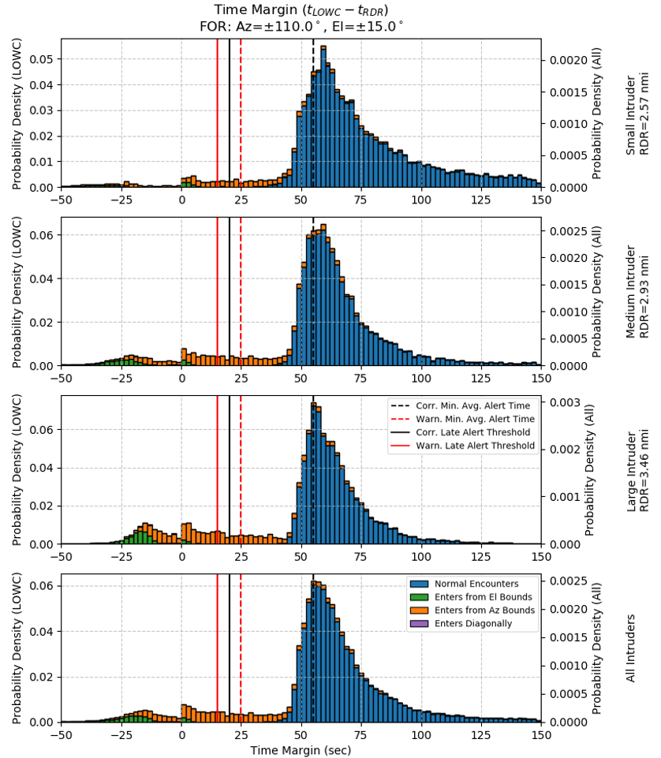

J.5 Estimating Bank Angles
The encounter data used in this analysis did not include ownship attitude states, except for yaw which was approximated by heading. Pitch was estimated by comparing horizontal and vertical velocities. Bank angles were assumed to be zero in the results shown throughout this appendix. It was assumed that the ownship’s radar or EO/IR hardware is likely to be mounted on a gimbal for stabilization during turns to offset bank angles. However, stabilization hardware could be prohibitively heavy for low-SWaP aircraft. When the ownship is performing a horizontal maneuver, the bank angle can sometimes cause the intruder to exit the ownship’s elevation FOR. A concern was raised that ownship maneuvers could result in further delays in the alerting schedule. Therefore, bank angles were estimated using the ownship’s speed and turn rate. The FOR/RDR time margin analysis was repeated with estimated bank angles with similar results. However, when the time margin analysis was performed using the last entry into FOR/RDR, there were considerably more late pop-up encounters.
Time margin statistics and late detection probabilities are shown in Table J-12. The time margin statistics were only modestly affected when we used the standard time margin definition which was the first entry into FOR/RDR. The late detection probability increased by less than 0.5%, and the mean time margin was decreased by less than 0.5 seconds. These results reflect that for most of the ownship maneuver encounters, the intruder was detected prior to the maneuver. Similar results were seen for other FOR configurations.

Table J-12 Time Margin Statistics with Estimated Bank Angles, First Entry into FOR/RDR
Intruder Size | Small |  |  | Medium |  |  | Large |  |  | All
LoWC Prob. (All) | 0.0418 |  |  | 0.0404 |  |  | 0.0392 |  |  | 0.0403
Pilot Response Time (sec) | 10 | 17 | 25 | 10 | 17 | 25 | 10 | 17 | 25 | 10 | 17 | 25
RDR (NM) | 1.69 | 2.10 | 2.57 | 2.04 | 2.40 | 2.93 | 2.58 | 2.99 | 3.46 | (see Small, Medium, Large)
Mean TM (sec) | 54.9 | 68.0 | 82.0 | 41.7 | 51.3 | 63.2 | 38.1 | 46.1 | 55.4 | 43.8 | 53.7 | 65.2
Median TM (sec) | 44 | 56 | 69 | 40 | 49 | 61 | 41 | 49 | 58 | 41 | 50 | 61
Late Detection Prob. (LoWC) | 0.054 | 0.045 | 0.039 | 0.113 | 0.097 | 0.085 | 0.160 | 0.147 | 0.133 | 0.114 | 0.101 | 0.090

In Figure J-11, the time margin PDF histograms look very similar to the histograms in Figure J-6, which shows the time margin PDF, assuming a bank angle of zero. The main difference is the occurrence of additional pop-up encounters, and more encounters categorized as entering the RDR from outside of the Elevation FOR. This is expected because at the end of a banked turn, a nearby intruder may return to the elevation FOR. The y-axis in Figure J-11 indicates the density contained in 2 second bins.
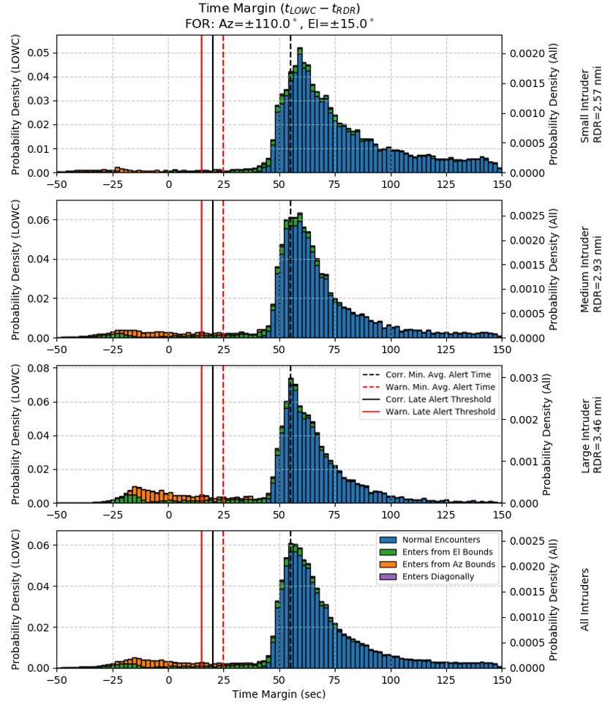
Figure J-11 Time Margin PDF for 25 sec Pilot Response Time, with Estimated Bank Angles

When we used the last entry into FOR/RDR to compute time margin, the bank angles have a much greater impact on the statistics, which are shown in Table J-13. This indicates that in most of the horizontal ownship maneuver cases, the intruder was detected prior to starting the maneuver, but the intruder was undetectable during the maneuver. We can think of the results in Table J-13 as how the radar would perform if it were fixed directly to the aircraft chassis. Whereas the statistics shown in Table J-11 (assuming bank angles are zero) show how the radar would perform if the radar is mounted to a gimbal that keeps the radar level during a banked turn. The late detection probability in Table J-13 is approximately 10% more, and the mean time margin was 3 to 14 seconds lower, compared to Table J-11.
Table J-13 Time Margin Statistics with Estimated Bank Angles, Final Entry into FOR/RDR
Intruder Size | Small |  |  | Medium |  |  | Large |  |  | All
LoWC Prob. (All) | 0.0418 |  |  | 0.0404 |  |  | 0.0392 |  |  | 0.0403
Pilot Response Time (sec) | 10 | 17 | 25 | 10 | 17 | 25 | 10 | 17 | 25 | 10 | 17 | 25
RDR (NM) | 1.69 | 2.10 | 2.57 | 2.04 | 2.40 | 2.93 | 2.58 | 2.99 | 3.46 | (see Small, Medium, Large)
Mean TM (sec) | 39.6 | 47.8 | 56.1 | 32.7 | 39.1 | 46.7 | 30.9 | 36.4 | 42.6 | 33.8 | 40.3 | 47.6
Median TM (sec) | 38 | 47 | 56 | 37 | 44 | 53 | 38 | 45 | 52 | 37 | 45 | 53
Late Detection Prob. (LoWC) | 0.172 | 0.166 | 0.162 | 0.229 | 0.217 | 0.208 | 0.271 | 0.260 | 0.249 | 0.229 | 0.219 | 0.211

Figure J-12 shows the time margin PDF, when time margin is defined as the time interval between the last entry into FOR/RDR (detection) and LOWC, and ownship bank angles are estimated. The y-axis indicates the probability density contained in a 2 second bin. The reduced average time margin and increased late detection probability is apparent by the additional density of encounters between 0 and 50 seconds. It is important to note that in these additional late encounters, the intruder would have been detected prior to the maneuver. But it shows that track coasting is an important feature of the radar tracker. Track coasting is when radar tracks still appear, based on the last known state of the intruder, after detections stopped occurring. Mounting the radar on a gimbal stabilization system to offset bank angles would improve situational awareness during horizontal maneuvers. Another approach to improve awareness during horizontal maneuvers, would be to increase the Elevation FOR enough to offset the maximum anticipated bank angle.
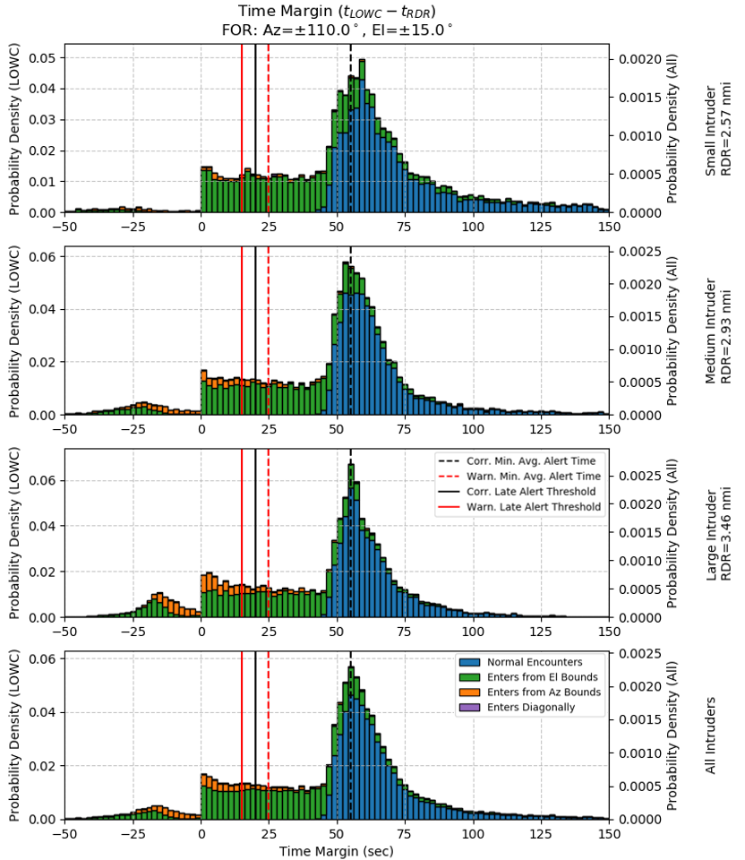
Figure J-12 Time Margin PDF for 25 sec Pilot Response Time, with Estimated Bank Angles, Using the Final Entry into FOR/RDR

J.6 Conclusions
This modeling and simulation effort demonstrated the benefits of increased RDR and FOR on detection time. Increasing RDR increases the mean time margin and is useful to provide earlier detection for normal encounters at lower relative bearings. For example, comparing the three RDR candidate sets (increasing RDR) the mean time margin was 44.1, 54.0, and 65.5 seconds (see Table J-2 and Table J-7).
Increasing FOR (particularly Azimuth) helps with the less common Pop-up Encounters, where the intruder enters the FOR within the RDR. Low-SWaP UA have a lower horizontal closure rate in their encounters, allowing for a lower RDR. However, the increased probability of Intruder Overtake scenarios and faster ownship turning scenarios, makes the late detection of Pop-up Intruders more likely. Increasing Azimuth FOR from 110° to 135° decreases late alerts from 11.1% to 4.7%, 9.9% to 4.0%, and 8.7% to 3.4% for the three candidate RDR sets (see Table J-3). Increasing Elevation FOR from 15 to 20° had a negligible effect on late detections, (decreased by less than 0.1%). Depending on the cost, increased Azimuth FOR may be justified for Low-SWaP UA, considering the reduction in late detected Pop-up intruders.
While increasing elevation FOR was not effective for reducing late detections in general, it could help maintain awareness during horizontal maneuvers. Section J.5 revealed some effects of ownship bank angles during horizontal maneuvers, which limit detection capability. Intruder track coasting should be enabled to maintain awareness of the intruder’s predicted trajectory for the duration of the ownship maneuver. Also, mounting the radar and EO/IR systems on a gimbal stabilization system to offset bank angles would significantly improve detection capability during banked turns.
Three sets of RDR candidates were considered in this analysis. Each one was based on a Maneuver Initiation Range (MIR) and additional time for the ownship pilot to respond to a detected intruder and initiate a maneuver. The three pilot response times were 10, 17, and 25 seconds. All three RDR candidates resulted in average detection prior to the Warning MAAT (25 sec). However, only the longest RDR candidate (25 sec pilot response time), had a higher average detection time greater than the Corrective MAAT (55 sec). Therefore, if Corrective Alerts are required for Low-SWaP Unmanned Aircraft (UA), then the largest RDR candidate should be used.

- Appendix K Probability of Intruder Entering Radar Field of Regard (FOR) within the Radar Declaration Range (RDR) for A1 and A2 CLASSES
  - Introduction
Subparagraph 2.2.7.v (Line 20906-20910 of Phase I) of these MOPS covers the cases where the intruder enters the FOR within the RDR (e.g., ownship maneuver or intruder overtake). Concerns were raised regarding the likelihood of these events and their geometries. This section describes the effort to estimate the probability of the previously undetected intruder entering the FOR within the RDR and those potentially affected by the 15 second delay for the radar to establish a track.
The values for RDR used within this appendix are characterized in Table K - 1 - Table K - 3. Within these tables, the results are broken down by A1 (high speed) and A2 (medium speed) UA. The nominal RDR value depends on the size of the intruder and UA speed, Table K - 1. The RDR value used for a specific sector of the RDR volume is then calculated by multiplying the nominal RDR value by the appropriate correction factor, based on intruder bearing angle, found in Table K - 2 for A1 UA and Table K - 3 for A2 UA. Note the RDR values are from an earlier version and are slightly different from those calculated in the Appendix H. Nonetheless, the trends and statements in this appendix and J should still hold regardless.
Table K - 1: Nominal RDR Values for A1 and A2 UA Based on Intruder Size (Speed).

Intruder Size | A1 Nominal RDR [nm] | A2 Nominal RDR [nm]
Small ($s_{int}≤100$ KTAS) | 5.01 | 3.75
Medium ($100<s_{int}≤130$ KTAS) | 5.38 | 4.10
Large ($130>s_{int}$ KTAS) | 5.89 | 4.56

Table K - 2: RDR Angular Correction Factors for A1 UA.
Intruder Bearing Angle | RDR Correction Factor for A1 UA
Intruder Bearing Angle | Small | Medium | Large
$$\left|angle\right|<30$$ | 1.00 | 1.00 | 1.00
$$30≤\left|angle\right|<60$$ | 0.58 | 0.66 | 0.76
$$60≤\left|angle\right|<90$$ | 0.33 | 0.50 | 0.65
$$90≤\left|angle\right|<110$$ | 0.16 | 0.25 | 0.40

Table K - 3: RDR Angular Correction Factors for A2 UA.
Intruder Bearing Angle | RDR Correction Factor for A2 UA
Intruder Bearing Angle | Small | Medium | Large
$$\left|angle\right|<30$$ | 1.00 | 1.00 | 1.00
$$30≤\left|angle\right|<60$$ | 0.68 | 0.78 | 0.85
$$60≤\left|angle\right|<90$$ | 0.37 | 0.51 | 0.69
$$90≤\left|angle\right|<110$$ | 0.22 | 0.29 | 0.42

  - Encounter Set
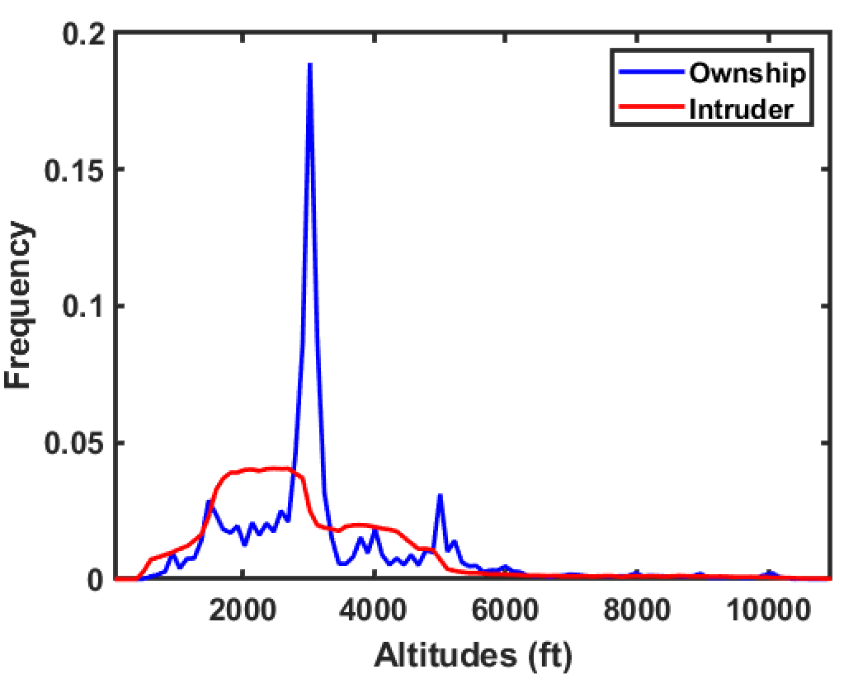
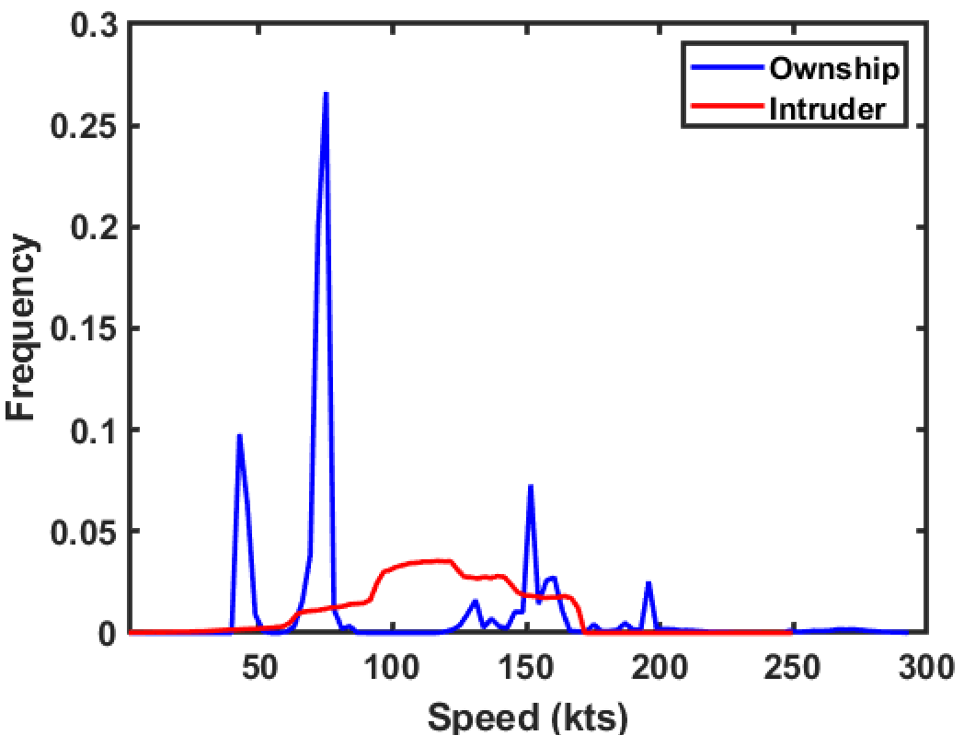
The one million encounters were generated by pairing segments sampled from NASA’s projected UAS trajectory database with a VFR flight trajectory sampled from MIT Lincoln Laboratory’s uncorrelated encounter model. The UAS trajectory database contains trajectories of 19 types of UAS missions, including flood inundation, cargo delivery, border control, air quality monitoring, etc. This encounter set represents encounters against VFR, non-cooperative intruders with and without Loss of Well Clear (LoWC). For these analyses, the proposed non-cooperative well clear volume of 2200-ft horizontal and +/-450-ft vertical was used. Numerical weights are provided with every encounter to represent the likelihood of the encounter occurring. Figure K - 1 shows the speed and altitude distributions of the ownship (UAS) and the intruder at their closest point of approach.
Figure K - 1: Speed and Altitude Distributions of Ownship and Intruder.
This analysis is specifically for A1 and A2 UA ownship encounters within this set. A1 is the high-speed class with UA traveling between 100 and 291 KTAS while A2 is the medium speed class with UA traveling between 40 and 200 KTAS. See Table K - 4 for the statistics related to the LoWC encounters for A1 and A2 UA.
Table K - 4: LoWC Encounters Statistics for A1 and A2 UA.
 | A1 UAS (201,885 encs) |  |  | A2 UAS (985,329 encs)
 | # of Encs | % of Encs | Weighted % of Encs | # of Encs | % of Encs | Weighted % of Encs
LoWC | 59,423 | 29.43 | 3.73 | 299,643 | 30.41 | 3.82
  - Event Filtering & Additional Assumptions
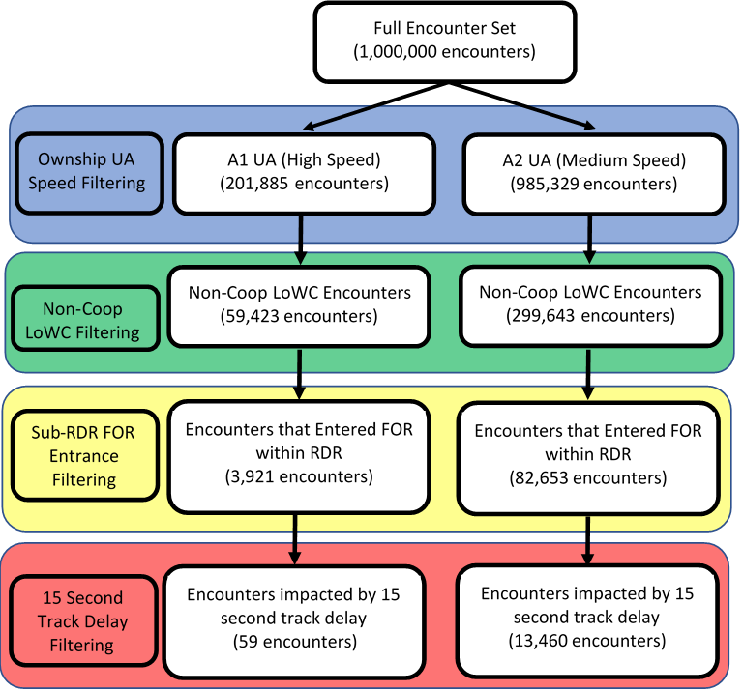
A series of filters was employed to extract encounters with an intruder entering the radar FOR within the RDR that are potentially affected by the 15 second delay for radar to establish a track. First, the one million encounters were filtered into A1 and A2 UA class encounters. Then, LoWC encounters were identified for each set. Following that, those encounters where the intruder entered the FOR within the RDR volume were extracted. Finally, those sub-RDR FOR entrance encounters were filtered to find the encounters potentially impacted by the 15 second track delay.

Figure K - 2: Event Filtering Process Flow Diagram.
In the above filtering process, once the LoWC encounters were identified, the UA Ownship trajectory was used to estimate its bank- and pitch-angle propagation. The effect of angle of attack was assumed to be negligible. The UA’s attitude in conjunction with relative position to the intruder was used to determine if the intruder is within the radar’s FOR and where in the FOR the intruder is located, per Paragraph 2.2.6 (RADAR FIELD OF REGARD SECTION). Evaluated at 1-second intervals, if the previously undetected intruder first appeared within FOR with range less than 95% of RDR, the encounter was then selected for further analysis. The first time instance of the intruder entering the radar FOR is marked and compared with the encounter time instance corresponding to first LoWC to determine the time margin, $Δt$, remaining as illustrated in Figure K - 3. Positive time margin represents that the intruder entered the radar FOR within RDR before LoWC while negative time margin indicates LoWC occurred before intruder can be detected.
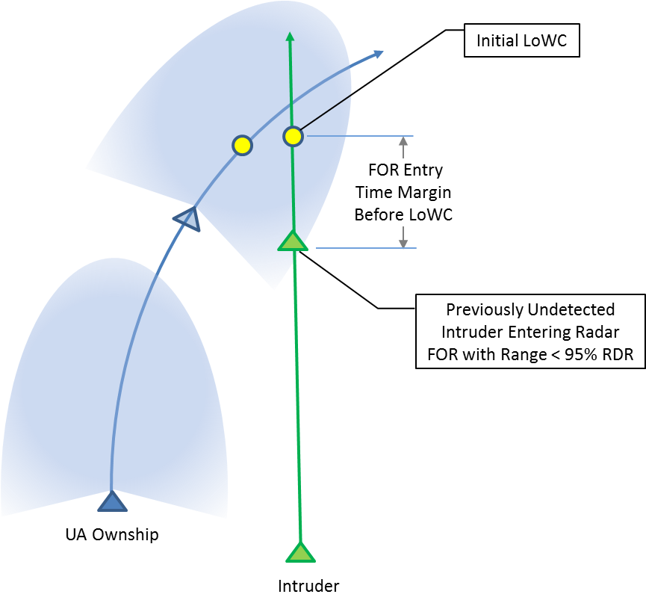
Figure K - 3: Capturing the FOR Entry Time Margin
Finally, those encounters which had a $Δt≤30$ seconds were identified as those potentially impacted by a 15 second delay. It is assumed for encounters with $Δt$ more positive than +30 seconds, even if the radar takes 15 seconds to establish track, there is at least 15 seconds remaining before LoWC, approximately corresponding to the DAA late warning alert.
It should be noted that any encounters that entered the radar FOR below the radar closest performance range (RCPR) were automatically eliminated from this analysis as it is assumed the radar cannot identify these intruders and are effectively not within the radar’s FOR. For A1 UA, the RCPR is a horizontal distance of 4,000 ft and there was a total of 64 encounters that were removed from this set. For A2 UA, the RCPR is a horizontal distance of 2,200 ft and there was a total of 12,936 encounters removed from this set. For A1, every RCPR encounter case, the intruder was overtaking the ownship UA often with either the ownship or intruder changing altitude.
  - Results
As illustrated in Figure K - 2 and tabulated in Table K - 5and Table K - 6, the probability of an intruder entering the UA FOR within the RDR in a LoWC encounter is 6.78% for A1 UA and 25.20% for A2 UA (weighted percentages of all LoWC encounters in each set) The probability of one of these LoWC encounters being impacted by a 15 second delay, that is having a time margin below 30 seconds between intruder track declaration and the initial LoWC, is less than 1% for A1 and at 4.80% for A2 UA.
Table K - 5: Sub-RDR FOR Entrance Filtering Results for A1, LoWC Encounters.
How the intruder entered the FOR | A1 UA, LoWC Encounters (59,423 total)
How the intruder entered the FOR | # of Encounters | % of LoWC Encounters | Weighted % of LoWC Encounters
Within RDR | 3,921 | 6.60 | 6.78
Within RDR with $Δt≤30$ seconds | 59 | 0.10 | 0.08
Below 4000’ RCPR | 64 | 0.11 | 0.12

Table K - 6: Sub-RDR FOR Entrance Filtering Results for A2, LoWC Encounters.
How the intruder entered the FOR | A2 UA, LoWC Encounters (299,643 total)
How the intruder entered the FOR | # of Encounters | % of LoWC Encounters | Weighted % of LoWC Encounters
Within RDR | 82,653 | 27.58 | 25.20
Within RDR with $Δt≤30$ seconds | 13,460 | 4.49 | 4.80
Below 2200’ RCPR | 12,936 | 4.32 | 3.47

Encounters with high positive FOR entry time margin are not expected to be adversely affected by the 15-second delay for the radar to establish track and should be able to declare/display the intruder track before the DAA late warning alert. Additionally, encounters with LoWC occurring significantly before the intruder entering FOR (negative FOR Entry Time Margin) are not likely to be affected by the 15-second delay for the radar to establish track since Loss of Well Clear has already occurred. These are predominantly geometries where the UA Ownship is overtaken by the intruder with some vertical offset, and the intruder enters the radar FOR in front of the Ownship well after LoWC has already occurred.
The results can be further broken down by the UA ownship maneuvering history within the 20 seconds prior to intruder entering FOR within RDR. This break down provides information on whether the ownship maneuvering is resulting in the sub-RDR FOR entries of intruders or if it is the underlying geometry of the encounter. This breakdown is provided in Table K - 7 and Table K - 8, below.
For A1 UA, about half of the encounters occur with the ownship not maneuvering. These cases then make up the most likely scenarios when accounting the weighted percent of LoWC encounters (3.48% weighted). While there are many more examples of UA in climbing maneuver encounters as compared to turning encounters within this set, these two maneuvers are roughly equivalently likely when the weightings are considered. Finally, it is unlikely that the UA is both turning and climbing within for A1 UA.
For A2 UA, there is a substantial increase in sub-RDR entrance encounters as compared to A1 UA. The majority of the sub-RDR entrance encounters occur when the ownship is turning (74.27% of the sub-RDR entrance encounters which represent 18.60 % weighted of overall LoWC encounters). The authors would like to note that if the A2 UA encounters that have an ownship speed greater than 100 KTAS are examined, see
Table K - 9, the results are very similar to the results for the A1 UA. This indicates two things are occurring. The first is that most of the sub-RDR entrance encounters are occurring for ownships traveling slower than 100 KTAS. The second is that the majority of the sub-RDR entrance cases for the slower ownships coincides with the ownship turning.
Table K - 7: A1 Ownship UA Maneuvers Within 20 sec Before Intruder Enters FOR
Manuever Type | A1, 3,921 Sub-RDR Encounters, 59,423 LoWC Encounters
Manuever Type | # of Encounters | % of Sub-RDR Encounters | Weighted % of LoWC Encounters
None | 2203 | 56.18 | 3.48
Climbing | 904 | 23.06 | 1.73
Turning | 475 | 12.11 | 0.91
Climbing & Turning | 339 | 8.65 | 0.66

Table K - 8: A2 Ownship UA Maneuvers Within 20-sec Before Intruder Enters FOR
Manuever Type | A2, 82,653 Sub-RDR Encounters, 299,643 LoWC Encounters
Manuever Type | # of Encounters | % of Sub-RDR Encounters | Weighted % of LoWC Encounters
None | 9,622 | 11.64 | 2.98
Climbing | 4,852 | 5.87 | 1.59
Turning | 61,387 | 74.27 | 18.60
Climbing and Turning | 6,792 | 8.22 | 2.03

Table K - 9: A2 Ownship UA Maneuvers Within 20 sec Before intruder Enters FOR for Ownship Speed Greater than 100 KTAS
Manuever Type | A2 Ownship Speed Greaters than 100 KTAS, 3,652 Sub-RDR Encounters, 55,477 LoWC Encounters
Manuever Type | # of Encounters | % of Sub-RDR Encounters | Weighted % of LoWC Encounters
None | 2,193 | 60.05 | 3.77
Climbing | 858 | 23.49 | 1.78
Turning | 474 | 12.98 | 0.99
Climbing and Turning | 127 | 3.48 | 0.26

  - FOR Entry within RDR Encounter Geometries
Figure K - 4 and Figure K - 5 show how and when the intruder entered the ATAR FOR for these sub-RDR FOR entry encounters. The horizontal axis in these figures is labeled $Δt=t_{LoWC}-t_{decl}$ where $t_{LoWC}$ is the initial index where LoWC first occurred and $t_{decl}$ is the radar declaration time which, for these cases, is the time index of when the intruder entered the FOR/RDR plus 15 seconds to account for the track acquisition delay. The vertical axis is the weighted percent of the sub-RDR entry encounters. There are three different lines in these figures. The blue line is the percent of encounters currently within the FOR and RDR—that is, the encounters currently seen, at a given $Δt$, by the UA radar. The magenta line is the percent of encounters currently unseen but within the azimuth range of the radar—that is, encounters that are at an elevation above or below the FOR of the radar but at a range less than the RDR. The red line is the percent of encounters currently outside the azimuth field of regard—that is, encounters that are approaching from the side of UA. For all three lines, the values are the weighted percent of all of the sub-RDR FOR entry cases. As such, these figures provide insight into which types of encounters are mostly likely to occur and at what time before a LoWC event are they likely to be within the UA FOR given the intruder entered the FOR within the RDR.
It can be concluded from Figure K-4 and Figure K-5 [need to fix these cross-refs] that for an encounter with a sub-RDR FOR entry, it is more likely that the intruder will enter the FOR from the top or bottom of the elevation angle limits rather than the azimuth angle limits for both A1 and A2 UA ownship classes against non-cooperative intruders. Notionally increasing the ATAR elevation FOR limits may provide greater benefits than increasing the azimuth limits given this encounter set and its encounter characteristics. This potential trade space can lead to earlier declaration of non-coop intruders and should be analyzed based on encounter sets representing specific ownship operations.
With the current ATAR FOR limitations, A2 UAs are expected to exhibit higher probability of intruders remaining undetected, beyond the limits of ATAR FOR late into the LoWC encounters compared to A1 UAs. This observation is consistent with the late declaration/alerting analysis in Appendix I, and is generally attributable to the trajectories and encounter characteristics when the A2 UA is operating in the 40-100 KTAS range.
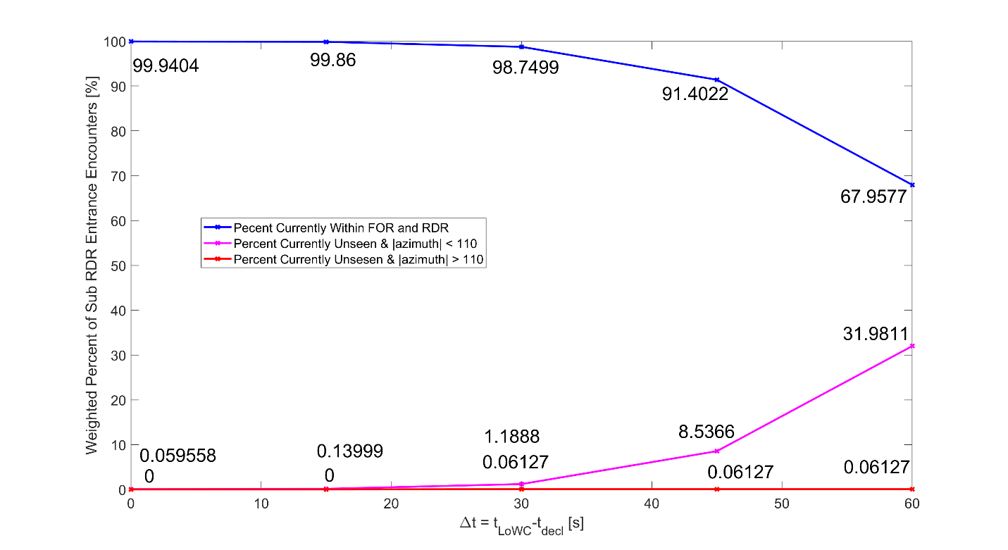
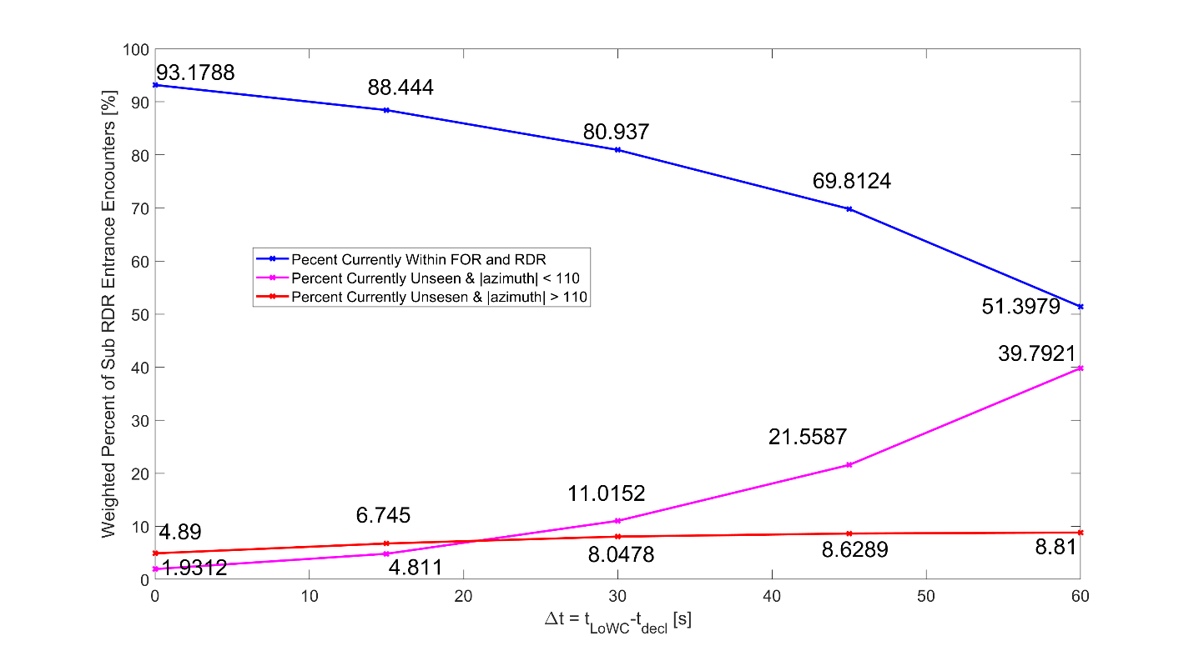
Figure K - 4: A1 Probability of Detection for Sub-RDR FOR Entry Encounters.
Figure K - 5: A2 Probability of Detection for Sub-RDR FOR Entry Encounters.

  - Conclusions
To quantify the effects of the 15-sec delay assumption for the ATAR to establish an intruder track, series of filters were used to count and estimate the probability of LoWC encounters where the intruder enters the UA ownship’s FOR within RDR based on the provided encounter set. Encounters that are potentially affected by the 15 second delay for the ATAR to establish track are tabulated and examined.
It was found that for LoWC encounters, there is a 6.78% probability for A1 UA that a conflicting intruder will enter the FOR within the A1 RDR. Furthermore, less than 0.1% of A1 LoWC encounters are expected to be affected by the 15-sec delay for the A1 ATAR to establish track.
On the other hand, for A2 UA, 25.20% of LoWC encounters with the non-coop intruder to enter the A2 FOR within the RDR, and 4.8% of LoWC encounters are estimated to be impacted by the 15-sec delay for the A2 radar to establish track likely leading to late alerting. Additionally, 3.47% of A2 UA LoWC encounters will result in no detection or declaration by the A2 ATAR at all. These adverse characteristics are a direct result of the UA operating at the lower speed regime where there is an elevated probability for intruders to approach from beyond the ATAR FOR limits. Analyses in this appendix further attributed these challenges to the ATAR’s elevation and azimuth FOR.limits as the primary factors instead of the 15-sec delay. Furthermore, it could be argued that for some of these stressing encounters, the intruder will likely have detected the UA well before LoWC and is expected to have maneuvered to maintain separation, especially for faster intruder approaching the slow UA from astern. Given these considerations, no additional resources are recommended to shorten the 15-sec delay for the ATAR to establish a track.

L APPENDIX L PROBABILITY OF AN INTRUDER ENTERING THE RADAR FIELD OF REGARD WITHIN THE RADAR DECLARATION RANGE OF A3 CLASS

L.1 Introduction
Subparagraph 2.2.7.22 of these Minimum Operational Performance Standards (MOPS) addresses a track establishment timing requirement for cases where an intruder enters the Field of Regard (FOR) within the Radar Declaration Range (RDR). A concern was raised regarding the likelihood of this event and the encounter geometries which would lead to this event. These encounters are referred to as “Pop-up Encounters” in this appendix, and the intruders in such encounters are referred to as “Pop-up Intruders”. This section describes the Modeling and Simulation (M&S) effort completed to estimate the following parameters for the A3 class of radar: 1) the probability of Pop-up Intruders, and 2) the probability that timely detection of intruders is impacted by the 15 second delay for the air-to-air radar to establish a track for Pop-up Encounters.
Three sets of RDRs distinguished by the pilot response time beyond the maneuver initiation range (MIR) were investigated for most of the metrics presented in this appendix. The pilot response times are 10, 17, and 25 seconds, respectively. These RDR values are presented in Appendix J. The purpose of this variation of RDR was to understand the impact of limited surveillance range on the metrics. In addition, the azimuth and elevation ranges of the FOR were varied for some metrics to show the trade space between various metrics. Note that the encounter set used in this analysis is the same as that identified in Appendix J, Section J.1.1.

L.2 Event Filtering & Additional Assumptions
Before any analysis was performed, all encounter trajectory data was augmented with relative states and attitude angle estimates; then they were tagged with event meta-data. Events included FOR/RDR and hazard region entry and exit times, with a resolution of 1 second. The effect of angle of attack in pitch estimates was assumed to be negligible. Finally, the time margin between entry into FOR/RDR and LoWC was computed for each encounter. A positive time margin indicates that the intruder entered the radar FOR/RDR before LoWC, while a negative time margin indicates that LoWC occurred before the intruder could be detected. The time margin was used to determine which encounters are impacted by the 15s track establishment requirement.
A series of event filtering was employed as shown in Figure L-1 to extract Pop-up Encounters that are affected by the 15 second delay for radar to establish a track.
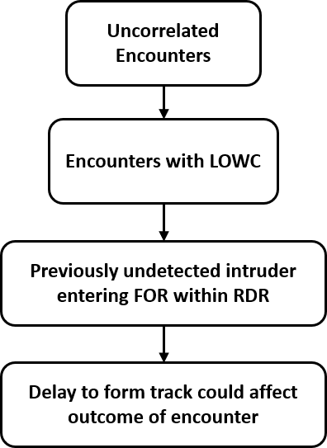
Figure L-1 Event Filtering Process Flow Diagram
The UA’s attitude in conjunction with relative position to the intruder was used to determine if the intruder is within the radar’s Field of Regard. Evaluated at 1 second intervals, if the previously undetected intruder first appeared within the FOR with a range less than 90% of RDR, the encounter was considered a Pop-up Encounter and marked for further analysis. The time of the first intruder entry into the radar FOR is marked and compared with the encounter time instance corresponding to first LoWC to determine the time margin remaining as illustrated in Figure L-2.

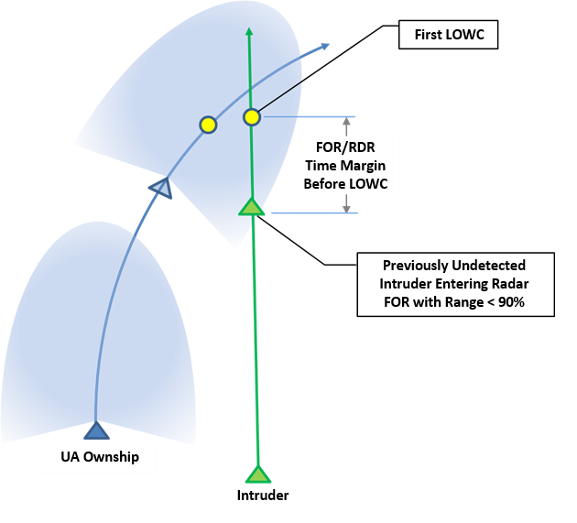
Figure L-2 Capturing the FOR/RDR Entry Time Margin
To further filter the encounters that are affected by the 15 second delay for the radar to establish a track, only encounters with FOR entry time margin between -10 to +30 seconds were selected. With 30 seconds, If the radar takes 15 seconds to establish a track, there are 15 seconds remaining before LoWC, which corresponds to the Warning Late Alert Threshold (see Table 2-21 in the MOPS for Detect and Avoid (DAA) Systems). For encounters with a FOR/RDR entry time margin more negative than 10 seconds, the intruder becomes detectable well after LoWC has already occurred and is thus unlikely to be affected by how long it takes for the radar to establish a track.

L.3 Results:
The probability of encounters affected by a 15-second track delay is evaluated as the weighted density of encounters with a time margin between -10 and 30 seconds. As shown in Table L-1, the portion of LoWC encounters affected by a 15-second track delay is between 5-6% which is almost twice the amount as affected in phase 1, which included faster ownship encounters. Also, the portion of LoWC encounters that are Pop-up encounters is between 13-15%, which is about twice as much as in Phase 1.
Table L-1 Weighted Probability of Pop-up Intruders, Based on First Entry into FOR/RDR
Pilot Response Time | 10 sec | 17 sec | 25 sec
Prob. Of Pop-up Enc. (LoWC) | 0.1490 | 0.1430 | 0.1380
Prob. Affected by 15 sec Track Delay (LoWC) | 0.0644 | 0.0591 | 0.0538
Prob. Of Pop-up Enc. (All) | 0.0060 | 0.0058 | 0.0056
Prob. Affected by 15 sec Track Delay (All) | 0.0026 | 0.0024 | 0.0022
Initial FOR Candidate | Azimuth: +/- 110°  Elevation: +/- 15°

Table L-2 shows a more detailed look at the probabilities of encounters affected by the 15-second track delay for a matrix of FOR configurations. Note that, at the time of analysis, the FOR requirements were not finalized. Therefore, a set of FOR configurations was explored to understand the trade space between azimuth and elevation FOR. Increasing the Azimuth FOR greatly reduces the number of Pop-up encounters and subsequently decreases the number affected by the track delay. A higher RDR has a more modest effect in both reducing Pop-up encounters and reducing those affected by the track delay.
Table L-2 Weighted Probability of Encounters Affected by 15 sec Track Acquisition Time
Density of LoWC Encounters |  | FOR: Azimuth |  |  |  |  |  | Pilot Response Time
 |  | 75° | 90° | 105° | 110° | 120° | 135° | Pilot Response Time
FOR: Elevation | 5° | 0.0759 | 0.0565 | 0.0449 | 0.0413 | 0.0361 | 0.0254 | 10 sec
FOR: Elevation | 10° | 0.1094 | 0.0810 | 0.0638 | 0.0577 | 0.0481 | 0.0328 | 10 sec
FOR: Elevation | 15° | 0.1228 | 0.0908 | 0.0712 | 0.0644 | 0.0536 | 0.0365 | 10 sec
FOR: Elevation | 20° | 0.1276 | 0.0939 | 0.0735 | 0.0665 | 0.0552 | 0.0374 | 10 sec
FOR: Elevation | 5° | 0.0715 | 0.0526 | 0.0417 | 0.0383 | 0.0324 | 0.0213 | 17 sec
FOR: Elevation | 10° | 0.1027 | 0.0753 | 0.0592 | 0.0530 | 0.0430 | 0.0278 | 17 sec
FOR: Elevation | 15° | 0.1153 | 0.0844 | 0.0659 | 0.0591 | 0.0477 | 0.0308 | 17 sec
FOR: Elevation | 20° | 0.1198 | 0.0873 | 0.0681 | 0.0611 | 0.0491 | 0.0316 | 17 sec
FOR: Elevation | 5° | 0.0674 | 0.0494 | 0.0388 | 0.0352 | 0.0284 | 0.0175 | 25 sec
FOR: Elevation | 10° | 0.0966 | 0.0707 | 0.0544 | 0.0481 | 0.0373 | 0.0227 | 25 sec
FOR: Elevation | 15° | 0.1084 | 0.0788 | 0.0607 | 0.0538 | 0.0416 | 0.0254 | 25 sec
FOR: Elevation | 20° | 0.1126 | 0.0816 | 0.0627 | 0.0557 | 0.0429 | 0.0261 | 25 sec

For the purposes of evaluating RDR/FOR requirements against impending EO/IR track establishment requirements, the same parameters were computed assuming a 5-second track delay based on feedback from RTCA committee members. To observe the probability of a 5-second track delay impacting an encounter, the total density of Pop-up encounters with time margins between -10 and 20 seconds was computed. The upper limit is the Warning Late Threshold with an additional five seconds from the track delay. Table L-3 shows that less encounters were impacted by the shorter delay, as expected. Using a 5 second track delay requirement decreases the density of affected Pop-up encounters by 1-2% of LoWC encounters. Decreasing the track delay requirement to 5 seconds provides similar results as increasing the Azimuth FOR to 120°.

Table L-3 Weighted Probability of Encounters Affected by 5 sec Track Acquisition Time
Density of LoWC Encounters |  | FOR: Azimuth |  |  |  |  |  | Pilot Response Time
 |  | 75° | 90° | 105° | 110° | 120° | 135° | Pilot Response Time
FOR: Elevation | 5° | 0.0564 | 0.0417 | 0.0318 | 0.0291 | 0.0251 | 0.0175 | 10 sec
FOR: Elevation | 10° | 0.0890 | 0.0654 | 0.0501 | 0.0448 | 0.0367 | 0.0249 | 10 sec
FOR: Elevation | 15° | 0.1023 | 0.0750 | 0.0574 | 0.0514 | 0.0421 | 0.0284 | 10 sec
FOR: Elevation | 20° | 0.1069 | 0.0782 | 0.0596 | 0.0534 | 0.0435 | 0.0293 | 10 sec
FOR: Elevation | 5° | 0.0532 | 0.0389 | 0.0292 | 0.0269 | 0.0224 | 0.0148 | 17 sec
FOR: Elevation | 10° | 0.0834 | 0.0608 | 0.0461 | 0.0410 | 0.0327 | 0.0213 | 17 sec
FOR: Elevation | 15° | 0.0959 | 0.0697 | 0.0528 | 0.0470 | 0.0374 | 0.0242 | 17 sec
FOR: Elevation | 20° | 0.1003 | 0.0726 | 0.0549 | 0.0489 | 0.0387 | 0.0250 | 17 sec
FOR: Elevation | 5° | 0.0499 | 0.0363 | 0.0269 | 0.0245 | 0.0192 | 0.0123 | 25 sec
FOR: Elevation | 10° | 0.0780 | 0.0569 | 0.0420 | 0.0368 | 0.0279 | 0.0176 | 25 sec
FOR: Elevation | 15° | 0.0898 | 0.0649 | 0.0482 | 0.0424 | 0.0322 | 0.0203 | 25 sec
FOR: Elevation | 20° | 0.0940 | 0.0676 | 0.0502 | 0.0442 | 0.0334 | 0.0210 | 25 sec

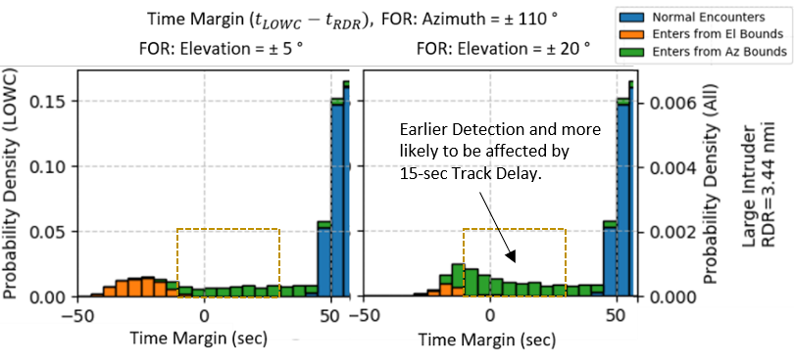
It should be noted that increasing the Elevation FOR increases the time margin of some Vertical Convergence encounters, which moves some density from ${(t}_{TM}<-10)$, into $(-10<t_{TM}<30)$ sec.
Figure L-3 The Effect of Elevation FOR on Pop-up Encounter Density
This can be seen in Figure L-3, where two time margin probability density function (PDF) histograms are compared with an Elevation FOR of 5° and 20°. In the distribution on the right there is more density in the dotted box. This shows that increasing Elevation FOR causes more encounters to be affected by the track delay, but it represents an overall performance improvement. An increase in Azimuth FOR decreases the impact of a 15 second Track-Delay requirement because some density is moved to a higher time margin to the right of the box, and it also represents a performance improvement. The same effects can be seen in Table L-2 and Table L-3, with probability density decreasing (green) with greater Azimuth FOR and increasing (red) with greater Elevation FOR, although increasing either FOR improves performance.
Figure L-4 shows the time margin Probability Distributions for Pop-up Encounters. The probability that detections are potentially impacted by the 15 and 5 second track delays is enclosed in the yellow and red dotted boxes, respectively. From top to bottom, the Probability Distributions shown correspond to RDRs using 10 second, 17 second, and 25 second Pilot Response Times. The probability density in the y-axis indicated the density contained in a 5 second bin.
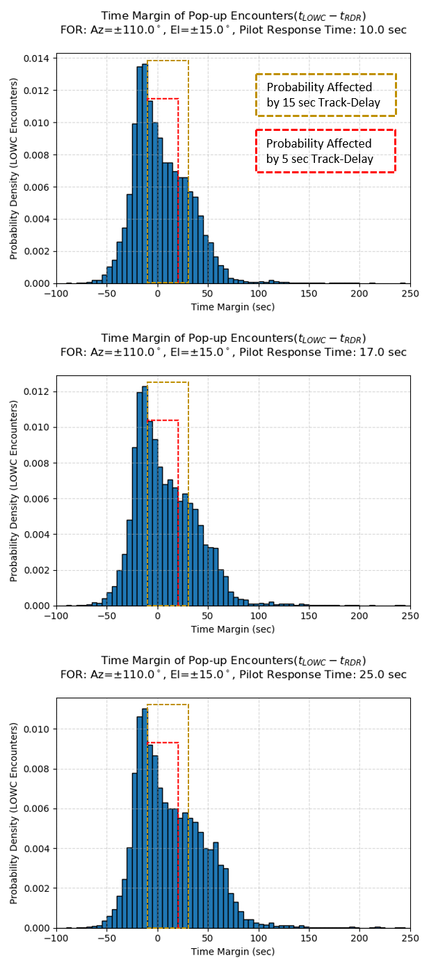
Figure L-4 Weighted Time Margin PDF, Pop-up Intruders

Encounter Categorization
To understand the encounter geometries which prove to be problematic for the 15s track establishment requirement, Pop-up Encounters were categorized based on whether they entered the FOR from the Elevation or Azimuth limits. Intruders that entered the FOR from outside the azimuth limits may be ownship maneuver scenarios and/or intruder overtake scenarios. Those that enter from outside the elevation limits are vertical convergence scenarios. Ownship maneuver was the most common encounter type, and vertical convergence was the least common. The elevation and azimuth were evaluated at 1 sec before the first entry into FOR and RDR. Cases where the intruder entered the FOR from outside the azimuth limits and the elevation limits at the same time were rare. The weighted probability of the encounter occurring is provided below in Table L-4.
Table L-4 Weighted Probability of Encounter Categories
Density of Pop-up  Encounters (LOWC) |  | Pilot Response Time:
 |  | 10 sec | 17 sec | 25 sec
Categories | Enters from Outside Az FOR Limits | 0.11600 | 0.11300 | 0.11300
Categories | Enters from Outside El FOR Limits | 0.02860 | 0.02530 | 0.02260
Categories | Enters from Outside Both FOR Limits | 0.00450 | 0.00374 | 0.00272

Figure L-5 shows the Distribution of time margins between -50 and 30 seconds. The density is almost entirely Pop-up Encounters, except for the density labeled ‘Normal Encounters’, in blue. The Pop-up encounters are divided as entering FOR from Azimuth Bounds, Elevation Bounds, or both (labeled Enters Diagonally). For time margins from -40 to -20 seconds, we can see that entering from Elevation Limits is the most common category. Therefore, Vertical Convergence is common in these encounters. However, Vertical Convergence is very rarely the cause of late detection for time margins greater than -10 seconds.
Comparing Figure L-5, Figure L-6, and Figure L-7, we can see that the density of Pop-up Encounters looks very similar between the three RDR candidates. The densities are distributed almost identically. In Figure L-5 we can see some additional density of Normal Encounters between 25 and 30 seconds before LoWC, which there is almost none of in Figure L-7 for the third RDR candidate. This is expected since RDR mostly only affects normal encounters. The probability on the y-axis indicate the density per bin, which is 1 second wide.

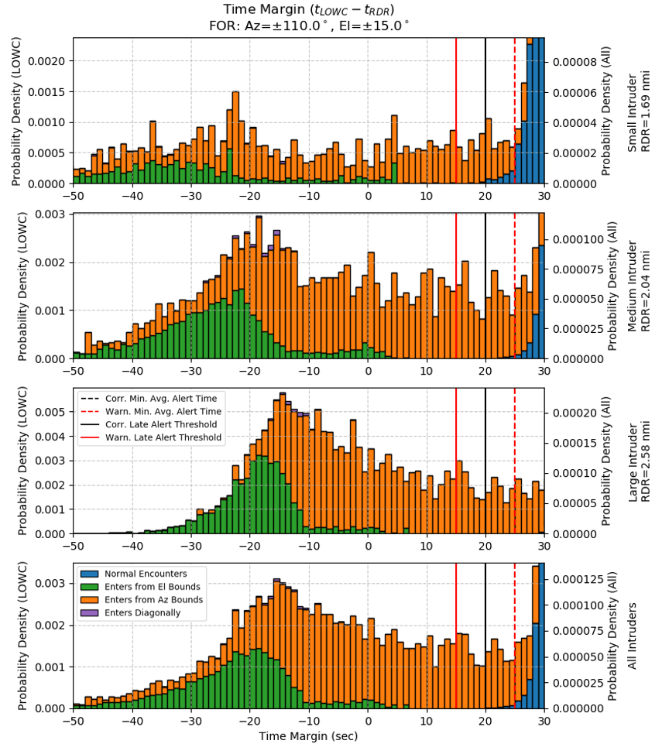

Figure L-5 Categorization of Pop-ups by Entry Beyond Az or El FOR, Pilot Response Time: 10 sec

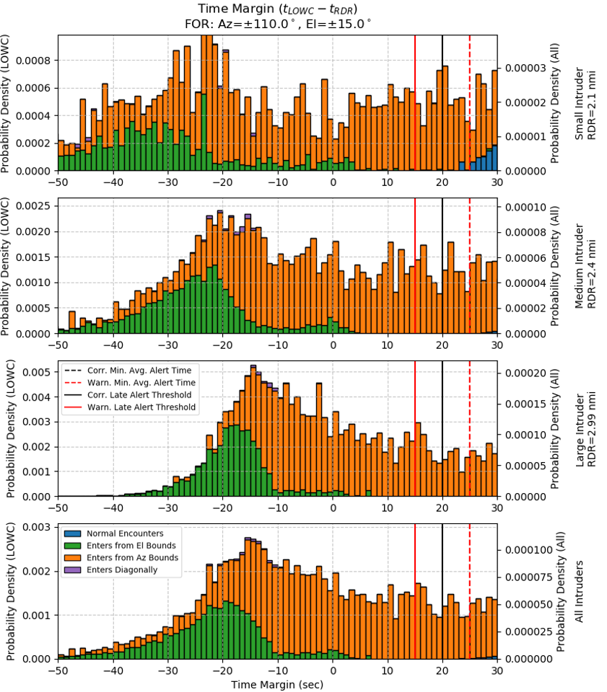
Figure L-6 Categorization of Pop-ups by Entry Beyond Az or El FOR, Pilot Response Time: 17 sec

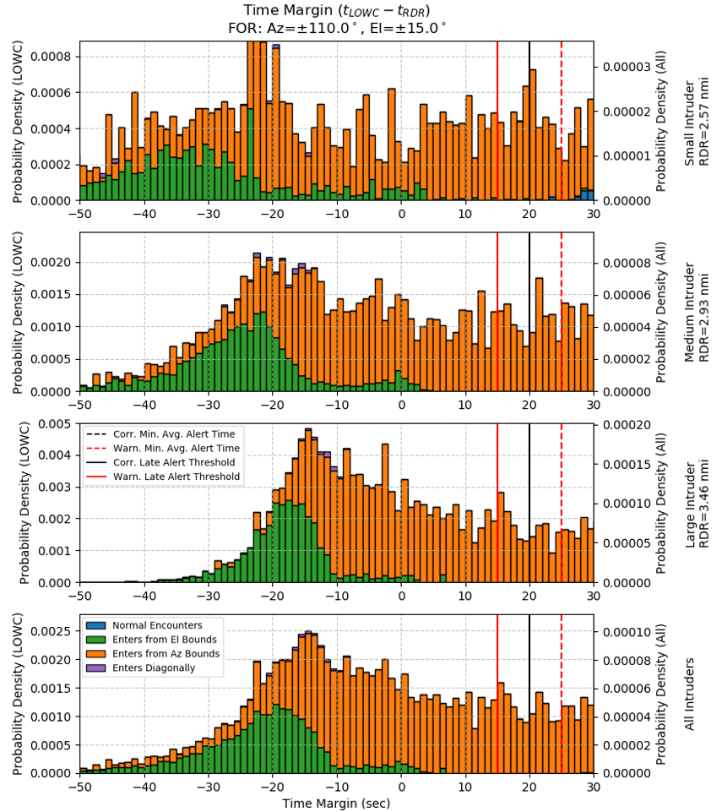
Figure L-7 Categorization of Pop-ups by Entry Beyond Az or El FOR, Pilot Response Time: 25 sec

Using the Final Entry into FOR/RDR for Time Margin
The time margin has been defined as the time between the first entry into FOR/RDR and LoWC. But in some encounters, multiple entries occur. If we define the time margin as the interval between the final entry into FOR/RDR and LoWC, the apparent impact of the 15 second track delay is increased, as well as the probability of Pop-up encounters.
Using the final entry increased the probability of Pop-up encounters by at most 4.2% of LoWC encounters. The probability that the 15-second track delay impacts detection is increased by at most 2.8%. Table L-5 shows the total probability of Pop-up encounters and the probability that the 15 second delay adversely affects detection, based on the final entries into FOR/RDR.
Figure L-8 shows a close look at the time margin PDF when the final entry into FOR/RDR is used. Compared to Figure L-7, there is considerably more density for time margins between 0 and 30 seconds, right before LoWC.
Table L-5 Weighted Probability of Pop-up Intruders, Based on Final Entry into FOR/RDR
Pilot Response Time | 10 sec | 17 sec | 25 sec
Prob. Of Pop-up Enc. (LoWC) | 0.1790 | 0.1800 | 0.1820
Prob. Affected by 15 sec Track Delay (LoWC) | 0.0838 | 0.0828 | 0.0819
Prob. Of Pop-up Enc. (All) | 0.0072 | 0.0073 | 0.0073
Prob. Affected by 15 sec Track Delay (All) | 0.0034 | 0.0033 | 0.0033
Initial FOR Candidate | Azimuth: +/- 110°  Elevation: +/- 15°

This experiment only considered unmitigated encounters, without any DAA considerations. In many cases, the ownship would act to avoid LoWC, preventing the next entry from occurring. Also, many cases with multiple FOR/RDR entries, involve brief periods where the intruder leaves FOR and returns quickly (less than a few seconds). Therefore, the probabilities shown in Table L-1 are more accurate. The statistics in Table L-5 are provided because they are more conservative. However, for the comparison of FOR configurations (Table L-2 and Table L-3), using the last entry into the FOR/RDR distorted detection performance because increased FOR allows for later re-entries into FOR/RDR.
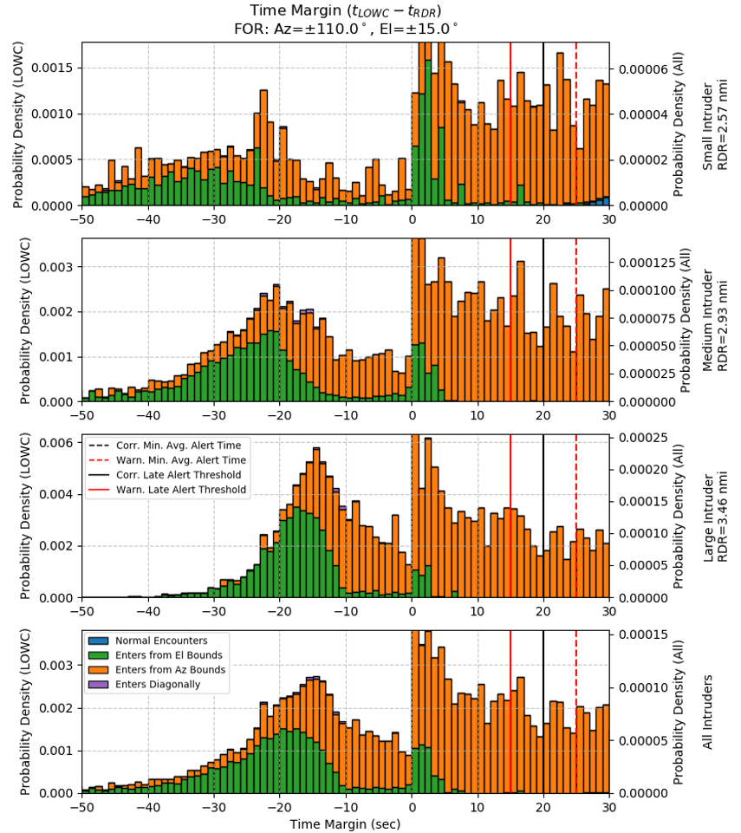
Figure L-8 Extra Density of Pop-ups, based on Final Entry into FOR/RDR, Pilot Response Time: 25s

L.4 Conclusions
A modeling and simulation effort was carried out to estimate the probability of non-cooperative Pop-up Encounters that result in LoWC, and specifically those that are affected by the 15 second requirement for a radar to establish a track. The FOR of the A3 class was the focus of this analysis, although the RDR, azimuth range, and elevation range were varied as independent parameters for some metrics. A “Pop-up Encounter” was defined as an encounter in which a previously undetected intruder enters the FOR within 90% of the RDR.
Given an Azimuth FOR of +/- 110°and an Elevation FOR of +/- 15°, the probability of Pop-up Encounters was between 13.8-14.9%, (for the highest to lowest candidate RDR requirements, respectively). The probability of a 15 second track delay requirement potentially causing late detection was between 5.4 and 6.5%. The probability of a 5 second track delay requirement causing late detection was between 4.2 and 5.2%, which is a modest improvement over the 15-second requirement. Increasing the Azimuth FOR to 135° decreases the probability of the 15 second track delay causing late detections to between 2.5 and 3.7%. Overall, increasing Azimuth FOR has the strongest impact on reducing the number of Pop-up Encounters affected by the track establishment requirement, so a higher Azimuth FOR should be considered. Requiring a shorter delay to form a track (5 sec) has less of a potential impact to detection, but it only potentially decreases late detections by 1-2% of LoWC encounters.
This analysis was based on unmitigated probabilities of LoWC. It is unfeasible to remove FOR limitations and entirely remove Pop-up encounters. Inevitably there will be cases where intruders enter the FOR within the RDR. Most of these encounters are not dangerous because the intruder would see the ownship and maneuver to prevent LoWC. Likely the most dangerous cases are Vertical Convergence scenarios. Assessing the probability of Midair Collision (MAC) requires closed-loop simulations with Pilot response models (for intruder/ownship), and a visual detection model for the intruder.
Figure L-9 shows a simple fault tree showing conditions for a possible MAC. The first being that the two aircraft have trajectories which result in a Near-Midair Collision (NMAC). The second was the primary concern of the current simulation, which is that the ownship UA’s radar does not detect the intruder soon enough to avoid it. The last condition is whether the intruder sees or detects the ownship UA soon enough to avoid it. It is recommended that the probabilities determined as part of this analysis are inputted into a safety analysis (e.g. fault tree) to assess to suitability of candidate RDR configurations in relation to the track establishment requirement.
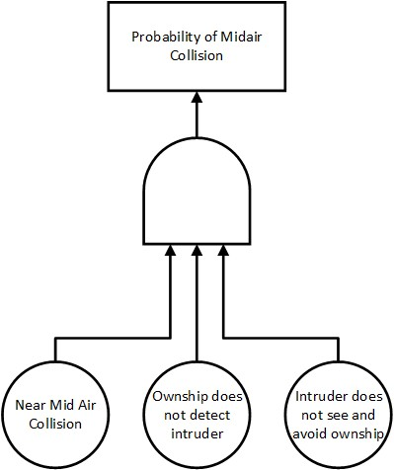
Figure L-9 Midair Collision Fault-Tree

