 | 

UAS Traffic Management

Conflict Management Model

FAA-NASA UTM Research Transition Team: Sense and Avoid Working Group
NASA Co-Lead: Marcus Johnson
FAA Co-Lead: Jarrett Larrow

1. Introduction 4
2. Scope of Document 5
3. UTM Scenarios and Use Cases 5
4. Operational Assumptions 7
4.1 Airspace Environment 7
4.2 Airspace Cooperative Surveillance 8
4.3 Meteorological and Topographical Conditions 9
4.4 UAS Operations 9
5. UTM Architecture 10
6. Risks Associated with UAS Operations 11
7. Conflict Management Model 13
7.1 Strategic Separation 15
7.1.1 Flight Awareness Service 15
7.1.2 Strategic Deconfliction Service 16
7.1.3 Flight Notification Service 19
7.1.4 Operation Planning and Operation Planning Service 19
7.2 Tactical Separation 23
7.2.1 Conformance Monitoring Service 23
7.2.2 Conflict Advisory and Alert Service 25
7.2.3 Dynamic Rerouting Service 27
7.2.4 Surveillance Service 29
7.2.5 Geographic Flight Containment 31
7.2.6 Visibility and Audibility Enhancements 34
7.2.7 Location Broadcast / Vehicle-to-Vehicle Communication 35
7.2.8 Ground Surveillance 36
7.2.9 Detect and Avoid 36
7.2.10 Collision and Obstacle Avoidance 41
Appendix A: Off Nominal Conditions 44
R01: Excursion from Operation Volume 45
R02: Incursion of Intruding Aircraft into the Operation Volume 48
R03: Loss of Control 49
R04: Loss or Degradation of Command, Control, and Communication 51
R05: Loss or Degradation of UAS Services 53
R06: Loss or Degradation of Navigation 55

Introduction
Integration of Unmanned Aircraft System (UAS) operations into the NAS will present a variety of issues and challenges. Both NASA and FAA have activities and initiatives underway to identify and respond to a range of challenges and ensure the safety and integrity of the NAS. NASA’s Research and Development approach includes supporting the integration of UAS into the NAS in the near-term while pioneering the more extensive transformative changes that increasingly autonomous aviation systems will bring over the mid- to far-term. FAA’s focus includes both these R&D aspects, as well as operational implementation and potential impacts to current NAS processes, procedures, and systems. Joint, structured plans and teaming, within the construct of the Research Transition Team (RTT), can provide the necessary cross-organizational construct to successfully transfer new operational concepts and technologies for commercialization by industry, or adoption by the FAA and other federal agencies to help them achieve their missions.

The objective of the Sense and Avoid Subgroup is to explore operator solutions to ensure that unmanned aircraft do not collide with other aircraft (unmanned [UA] or manned). In conjunction with Communication and Navigation (C&N) Subgroup, SAA will analyze the effectiveness of operational coordination through sharing of intent information in combination and in contrast to active avoidance. Also, for each use case identified by the Concepts & Use Cases Working Group (CWG) consistent with the phase of operation, SAA will analyze trade-space between sensing and detection capability of UA versus the UA’s capability to maneuver and evaluate technology options for sharing positioning information in use cases. SAA will also identify potential considerations for radio frequency and network capacity, interoperability, density of operations, priority of positioning information on technology, reliability, etc. and explore industry wide solutions sets for near-term and longer-term operations.

NASA is spearheading the validation and research of UTM concept elements with its partners using combinations of simulations and field trials. The tests are aligned with NASA’s spiral development and evaluation schedule of Technical Capability Levels (TCL) that demonstrate and evaluate increasingly complex operations. Figure 1 UTM Research Technical Capability Levels summarizes these capabilities for UTM.

Each new TCL extends the capabilities of the previous level. The number of services provided and types of UAS operations supported increase. As a set, the successive iterations support a large range of UAS from remotely piloted vehicles to command directed UAS and fully autonomous UAS. The UTM RTT, recognizing the diversity of operating environments, technological areas, and activities, has been broken into four subgroups focused on: (1) Concepts and Use Cases; (2) Data Exchange and Information Architecture; (3) Sense and Avoid (SAA); and (4) Communications & Navigation. While the research reflected in this document is primarily applicable to SAA, it also reflects the work of the Concepts and Use subgroup and integrates the other sub teams’ findings.

Capability 1  - Airspace volume use notification  - Over unpopulated land or water  - Minimal general aviation traffic in area  - Contingencies handled by UAS pilot  - Enable agriculture, firefighting, infrastructure monitoring | Capability 3  - Beyond visual line-of-sight  - Over moderately populated land  - Some interaction with manned aircraft  - Tracking, vehicle-to-vehicle, internet connected  - Public safety, limited package delivery
Capability 2  - Beyond visual line-of-sight  - Tracking and low-density operations  - Sparsely populated areas  - Procedures and “rules of the road”  - Longer range applications | Capability 4  - Beyond visual line-of-sight  - Urban environments, higher density  - Autonomous vehicle-to-vehicle, internet connected  - Large-scale contingency mitigation  - News gathering, deliveries, personal use
Figure 1: UTM Research Technical Capability Level.

Scope of Document
This document describes UTM services and concepts that support the FAA UTM use cases. The general conflict management model values the use of redundant mitigation technologies that operate over different time horizons to reach a target level of safety for the operation. Separation provision contributes to the safety of the overall separation and each participant (USS, UAS, Other airspace users) is responsible for ensuring separation is maintained between aircraft. The intent of this document is to capture a strategy for combining separation provisions into a conflict management strategy that supports safe small UAS operations in the airspace.

UTM Scenarios and Use Cases
The UTM Use Cases represents the collaborative research efforts between the FAA and NASA as joint members of the Unmanned Aircraft System Traffic Management (UTM) Research Transition Team (RTT). The packages comprise of 1) Terms and Definitions, 2) Foundational Principles, 3) Concept Narratives, 4) Use Cases, 5) Operational Views, and 6) Roles and Responsibilities of actors interacting within what is encompassed by the Technical Capability Level UTM operating environments. The following should not be considered established policy or construed as regulatory in nature. What is presented is meant to communicate the current, agreed upon understanding between the FAA and NASA on features of UTM as exemplified through use cases and concept narratives for the purposes of supporting joint NASA/Industry Demonstrations, UTM Pilot Program, and Industry standards development.

The concepts and use case working group from the FAA-NASA UTM Research Transition Team (RTT) developed a set of use cases to formulate general conceptual elements and support the derivation of systems engineering products by the UTM RTT working groups. The Use Cases cover a range of predominantly nominal operations, as well as off-nominal scenarios, and the main conceptual elements and interactions within them in a UTM environment. Each use case details a set of possible sequences and/or interactions between the system and its users that occur to achieve the operational goals defined for the environment being explored. Such cases enable analyses to identify, clarify, and organize system requirements - including Operation Views (OVs), Information Flows and Data Exchange Diagrams, and Roles and Responsibility Allocation Tables.

Use case scenarios do not prescribe specific solutions for how an operation should achieve a required operational goal (e.g., means by which an unmanned aircraft stays within the prescribed boundaries of the operation’s associated airspace volume) but rather identify operational requirements. This allows the UTM RTT working groups to develop and ultimately specify the appropriate supporting performance requirements for each TCL. Table 2 details the use cases that form the basis for the conflict mitigation model described in this document.

Table 1: Summary of UAS Traffic Management Use Cases
TCL1-1 | Two VLOS Operations with Voluntary Use of UTM for Coordination
TCL2-1 | One BVLOS Operation, One VLOS Operation with Voluntary UTM Participation for Coordination
TCL2-2 | Two BVLOS Operations near an Airport in Uncontrolled Airspace
TCL2-3 | Priority Operation – Emergency Medical Aircraft in Uncontrolled Airspace
TCL2-4 | BVLOS Operation Conformance Violation from Uncontrolled Airspace into Class D Airspace
TCL3-1 | One-Way BVLOS Flight, Separate Landing/Take-Off Locations
TCL3-2 | Negotiation versus Prioritization between Operators Due to Dynamic  Restriction (Off-Nominal)
TCL3-3 | UAS Interaction with Manned Aircraft in Low-Altitude Uncontrolled Airspace
TCL3-4 | BVLOS Operation Lost-Link Event
TCL3-5 | High Density UTM Operations in Uncontrolled Airspace
TCL3-6 | Last-Mile Rural Deliveries in Uncontrolled Airspace under the Mode C Veil
TCL3-7 | UTM Priority Considerations in Uncontrolled Airspace
TCL3-8 | UAS Operator Loss of Performance Capabilities in Uncontrolled Airspace
TCL4-1 | BVLOS UTM Operation within UAS Facility Maps
TCL4-2 | Historical UTM Information Queries by Authorized Entities
TCL4-3 | UAS Urgency / Distress Condition with Alternate Landing and UTM
TCL4-4 | UAS Volume Reservation in Controlled Airspace
TCL4-5 | Report to FAA due to UAS Flight Incident

Foundational principles generated from the use cases that guide the scope of the concepts described in this document are as follows:
- UTM is a separate, but complementary set of services to the Air Traffic Management (ATM) system, based primarily on the sharing of information on airspace constraints and flight intent.
- Participation in UTM is required for beyond visual line of sight (BVLOS) UAS operations not participating in ATM.
- UTM services are available in uncontrolled/Class G airspace and in designated areas in controlled airspace – initially under 400 ft above ground level (AGL).
- With UTM, Operators are responsible for the coordination, execution, and management of operations, with rules of the road established by FAA. (FAA interacts with UTM only for information/data exchange purposes, as required.)
- UTM requires increasing levels of engagement/interaction with services as the complexity of the operations increases.
- UAS Operators are responsible for ensuring compliance with all FAA regulations. (UAS operators can use services (e.g., authentication, weather, communications, aircraft tracking, flight planning, and navigation) from third parties, but UAS operators are responsible for meeting the regulatory requirements.)
- UAS are required to meet the performance and equipage requirements established for the type of operation and associated airspace volume/route they are undertaking - including the ability to contain operations within a specified airspace volume or remain clear of a specified volume either through geo-fencing or operational control.
- FAA has on-demand access to information regarding UTM operations, including flight status, aircraft location, and intent information.
- Other airspace users - manned aircraft operators and UAS VLOS operators – have access to information through the UTM system regarding the conduct of UTM operations.
- FAA may require certain data to be logged / archived by Operators should the FAA and other federal entities request that information (e.g., safety, security, or post-hoc analysis of events of interest).
- All UAS operators and/or UAS service suppliers, under UTM construct are responsible for tracking their own aircraft and sharing data with other users as required. (FAA does not provide track and locate services; however, FAA maintains their authority to manage airspace.)

Operational Assumptions

Airspace Environment
Small UAS are defined as unmanned aircraft that are 55 lbs. or less. Small UAS operations will be primarily conducted in Class G airspace and authorized areas in Class B,C,D, and E as defined in 14 CFR §71 and depicted in Figure 1.
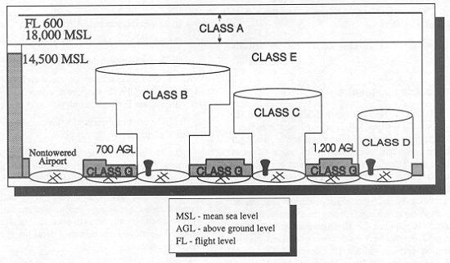
Currently, commercial VLOS operations (Part 107) can operate in uncontrolled airspace or in controlled airspace within the boundaries of FAA-published UAS Facility Maps without requiring direct coordination with air traffic control. The definition provided by the FAA for these maps is as follows:
Figure 2: Airspace Classes

UAS Facility Maps show the maximum altitudes around airports where the FAA may authorize part 107 UAS operations without additional safety analysis. The maps should be used to inform requests for part 107 airspace authorizations and waivers in controlled airspace.

Operations in controlled airspace are required to provide notification to air traffic, however when the operation is conducted under the maximum altitude of the facility map the Low Altitude Authorization and Notification Capability (LAANC) can facilitate automated authorizations without requiring direct coordination between the Part 107 operator and air traffic controllers. The facility maps and LAANC for Part 107 operations provide insight into potential mechanisms to allow BVLOS operations in controlled airspace in the future under a UTM ecosystem.

Airspace Cooperative Surveillance
In remote and rural environments, it is not anticipated that surveillance of manned aircraft will be available for most areas of operation within Class G. However, in accordance with 14 CFR §91.215, within the Mode-C veil, manned aircraft will provide position reports from the surface to 10,000 ft MSL within 30 nautical miles of the primary airport within Class B airspace. The FAA AIM states in Section 4-1-20(a)(3) that for airborne operations in Class G airspace, the transponder should be operating unless otherwise requested by ATC. Furthermore, per §91.225, ADS-B Out equipment is required after January 1, 2020 in and above Class B and C airspace, and within 30 NM of the large airports listed in appendix D of Part 91. UAS operations in authorized areas may make use of cooperative surveillance information.

Manned aircraft may be equipped with a Mode A transponder, a Mode A/C transponder, or a Mode S transponder with or without ADS-B Out (1090ES or UAT) in the Mode-C veil and in and around Class C airspace. Manned aircraft are likely to have no transponder or ADS-B Out system in Class G airspace outside the transponder (14 CFR §91.215) and ADS-B (14 CFR §91.225) mandated airspace. Even within transponder and ADS-B mandated airspace, aircraft may not be operating that equipment, either because the aircraft was not originally certified with an electrical system, or the aircraft is operating with an ATC authorized deviation (14 CFR §91.215(d), 91.225(g)). At low altitudes, 500 ft AGL and below, it is likely that manned aircraft will be operating under Visual Flight Rules (VFR) and using a 1200 Mode A code in transponder and ADS-B mandated airspace.

Meteorological and Topographical Conditions
UAS operations are initially limited to visual meteorological conditions as specified using the visual minima in 14 CFR §91.155. Under Part 107, UAS shall operate during daylight or in twilight (30 minutes before official sunrise to 30 minutes after official sunset, local time) with appropriate anti-collision lighting. Night operations may be authorized if the UAS has enhancements that improve visibility or detection during nighttime hours. The UAS operator is expected to determine meteorological conditions, remaining in VMC, maintaining VFR visibility minimums, or maintain cloud separation minimums for the duration of the UAS operation. UAS operators are expected to monitor atmospheric conditions to ensure that operational limitations are not exceeded for their UAS with respect to wind, air density, precipitation, and temperature.

UAS Operators are expected to check terrain clearance during flight planning and monitor proximity to the topography during the UAS operation. UAS ground control station equipment may be exposed to a variety of different environmental conditions. The GCS equipment may also be in weather protected and non-weather protected stationary, ground vehicle, maritime environments. GCS equipment may even be part of a mobile ground vehicle. UAS operators shall ensure that equipment for the ground control station will be qualified for the appropriate environment in which it is expected to operate.

UAS Operations
Operational limitations will be placed on the UAS due to airspace regulations, vehicle performance, and/or the technical capabilities of the UAS and USS separation mitigations. For operational limitations that are placed on the UAS, the pilot will have access to information and controls necessary to ensure operations are conducted within the limitations. The information may be from onboard sensors, ground sensors, cloud-based services, or databases. Included in such operational limitations would be the status and geographical extent of the command and control data link coverage. Operational limits are typically included in an Airplane Flight Manual, Service Operating Manuals, and/or Pilot’s Operating Handbook, but other documents may be also used for UAS.
More details pertaining to the relevant UAS operations considered in the scope of this document can be found in the UTM Concept of Operations v1.0.

UTM Architecture
UTM is intended to support safe and efficient UAS operations in low-altitude airspace by providing information and services to UAS operators and other NAS stakeholders. The five core principles of UTM are: (1) only authenticated operations are allowed in the airspace, (2) UAS should avoid each other, (3) UAS should avoid manned aircraft, (4) UAS operators should have complete awareness of all constraints in the airspace, and (5) public safety UAS have priority within the airspace. These principles, as well as the concept's guiding tenet: flexibility where
possible, and structure where necessary, provide a framework for the development of a UTM system that is different from the current ATM system that supports manned aviation.

The UTM construct utilizes industry's ability to supply services where these services do not exist (e.g., uncontrolled airspace). In this construct, the FAA will maintain regulatory and operational authority for airspace and traffic operations. Through UTM, FAA will provide directives, constraints, and authorizations or restrictions. The FAA will institute operational constraints at any time, and the FAA will have on-demand access to airspace operators and situation awareness of airspace operations continuously through UTM.
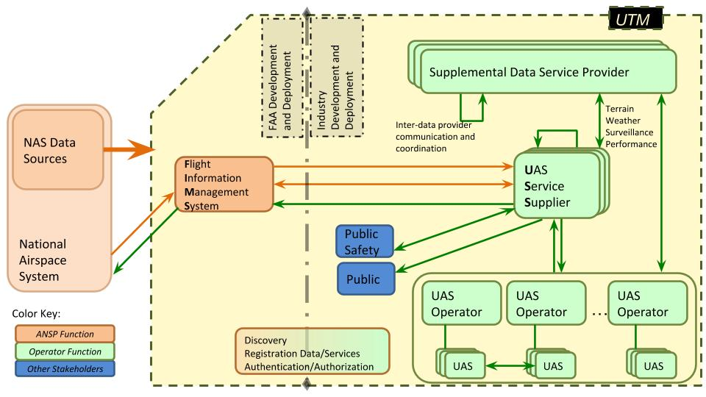
Figure 3: UAS Traffic Management System Architecture.
In the UTM architecture, the Flight Information Management System (FIMS) is operated by the FAA. It interfaces with the other NAS systems and provides directives and constraints to the UAS operations via the UAS Service Supplier (USS) Network. The USS could be operated by the UAS operators, other commercial, or government entities. The operators use the USS to organize and coordinate their operations and meet all constraints and directives from the FIMS system. The FIMS system has access to all operations and is informed about any deviations that could have an impact on the NAS.

More details pertaining to the services provided within the UTM ecosystem can be found in the UTM Concept of Operations v2.0.

Risks Associated with UAS Operations
The conflict management approach to UTM focuses on addressing hazards associated with UAS operations. For the purposes of this document, risk will be defined as the combination of frequency of an occurrence (often expressed as a probability), and the associated level of severity of the occurrence. The consequence of an occurrence will be defined as a harm. The primary categories of harm for the UTM conflict management approach are:
● Fatal injuries to third parties on the ground
● Fatal injuries to third parties in the air
● Damage to critical infrastructure
There are other risks and harms associated with an operation that need due consideration when presenting a compelling safety argument to the ANSP, however that is outside the scope of this document. UTM considers a performance and risk-based approach to addressing the harms associated with a given operation, thus context of the operation environment and the subsequent air and ground risk define the risk environment and the conflict management model classifies the technology barriers available to a UAS Operator as a means to address the harms and the subsequent risk associated with the proposed operation environment. To this end the UAS Operator would: define a concept of operations for the missions aligned with their business cases, a proposed Area of Operation, identify the harms and develop a safety case utilizing technology, procedures, and the operational environment to provide barriers to address the associated risk. This culmination of information would be reviewed by the ANSP who would issue a Performance Authorization which represents a contract with the UAS Operator allowing for UAS operations in accordance with the Concept of Operations within the Approved Area of Operation subject to any ANSP prescribed Operation Conditions and Limitations. Therefore, within the Approved Area of Operations and subject to any relevant Operation Conditions and Limitations the UAS Operator would be able plan missions and conduct operations. The Approved Area of Operations would only represent the maximum extent of airspace requested from the UAS Operator that allows for an acceptable level of air and ground risk given the safety barriers specified by the UAS Operator. Therefore, operations over highly populated areas or within highly trafficked airspace would not be within the Approved Area of Operation unless a UAS Operator demonstrated suitable safety mitigations to address the risk in those areas.

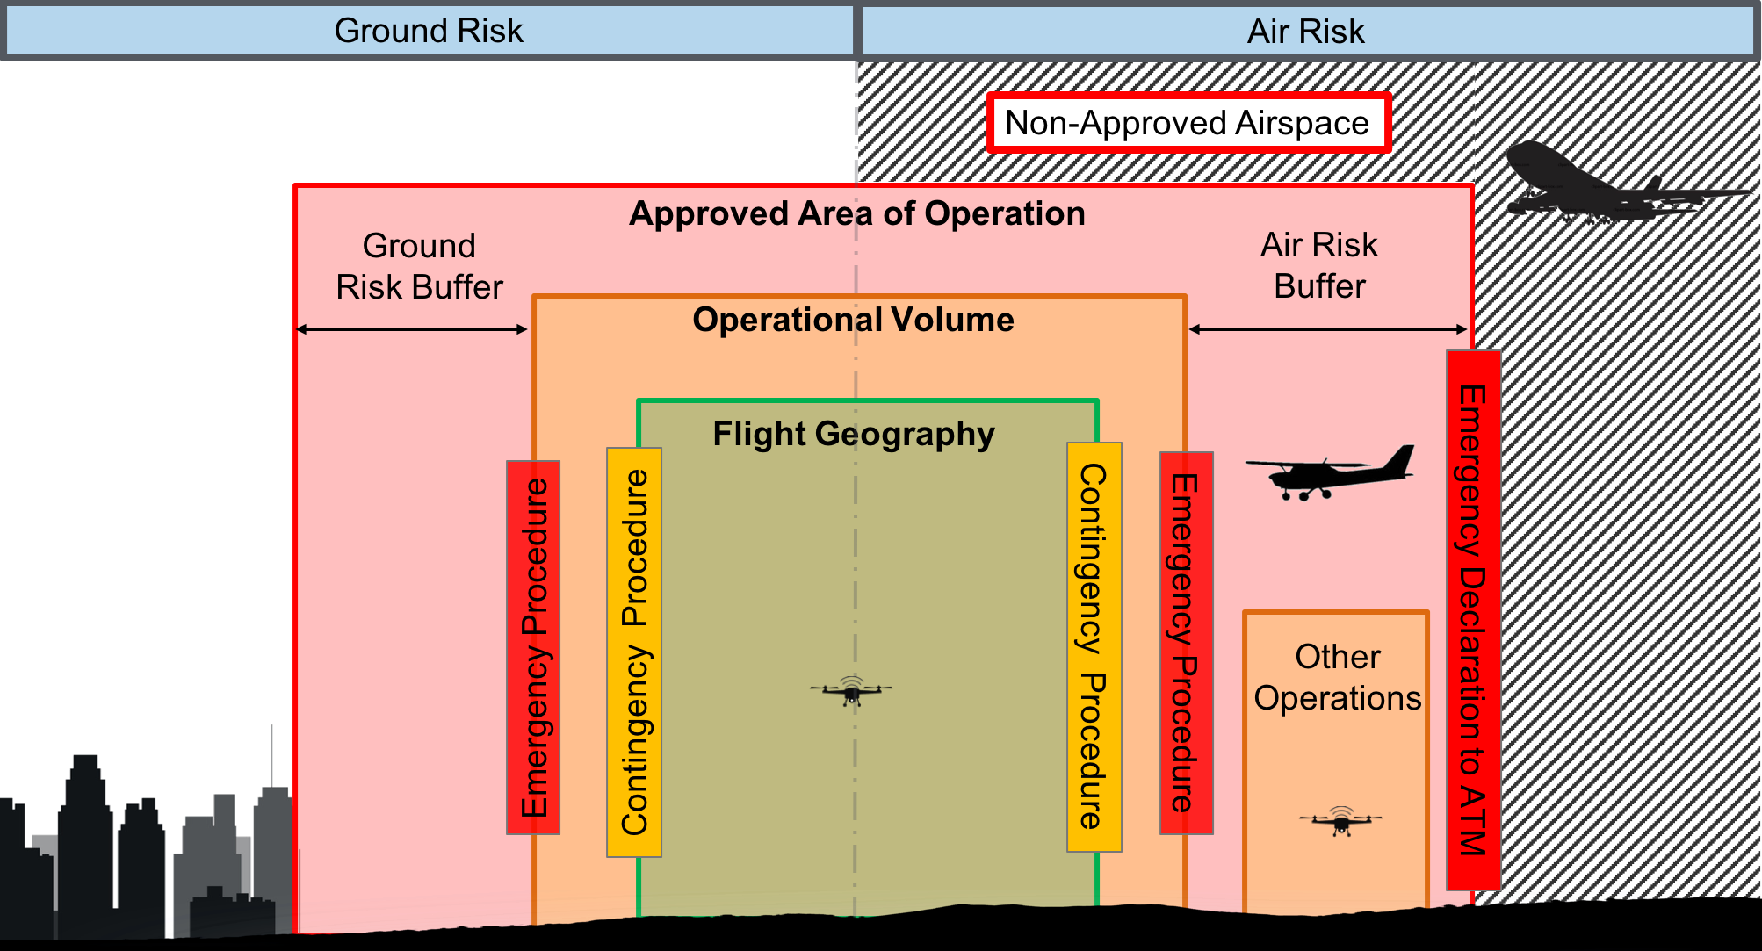
Figure 4: Airborne and ground risk posed to a UAS Operation.

The UAS Operator missions would involve submitting a Flight Geography to a USS and working with a USS to develop an Operation Volume which defines the intent of the UAS Operator. The location of Operation Volumes would consider any air or ground risk spatial or temporal buffering to ensure compliance with the performance authorization. The USS would support deconfliction of Operation Volumes with other UAS Operators and providing mitigations to support separation from manned aviation. The UAS Operator would attempt to accomplish their mission while remaining within the Flight Geography and employing tactical mitigations and contingency procedures to maintain containment within the Flight Geography and avoid incursions of other aircraft within their flight geography. Excursions from the Flight Geography initiate emergency procedures as potential risk of airborne collisions with other aircraft and injury to persons or property on the ground increases. Areas with adjacent Non-Approved airspace (e.g. Class B Airspace) may constitute for an elevation of the emergency procedures to include services from the air traffic management system as risk to has increased of airborne collisions with aircraft under the services provided by air traffic control. Both the air and ground risk hazards must be identified and addressed by the UAS Operator in the development of the safety case and monitored during operations to ensure safety for all users of the airspace.

The primary harm that the conflict mitigation model is addressing is fatal injuries to 3rd parties due to an airborne collision. This harm is typically a result of airborne conflicts between aircraft with human occupants and unmanned aircraft, however as density of operations increase there is the risk that the number of UA to UA conflict avoidance maneuvers will increase and thus will increase the possible risk of airborne collisions with passenger carrying aircraft due to loss predictable UA flight profiles. Airborne conflicts between non-passenger carrying unmanned small UAS pose minimal imminent harm of fatal injuries to 3rd parties in the air. The frequency of occurrence of fatal injuries to 3rd parties in the air is often a function of the density of aircraft, both manned and unmanned, in the airspace.

The secondary harm that the conflict mitigation model is addressing is fatal injuries to 3rd parties or property on the ground due to collision. This harm is especially relevant for operations over people and operation in, around populated areas, and operation near structures. This harm can be a result of direct contact between a part of a UA and a person or structure on the ground or can be a result of collateral damage due to an airborne collision.

It should be noted that some contributing factors, such as atmospheric conditions, communication performance, and navigation performance can limit or degrade the effectiveness of the mitigations used to address the air and ground risks and therefore considerations should be made as to the applicability and limits of the technologies employed for separation in the environment in which they will operate.

Conflict Management Model
USS services follow a conflict mitigation approach like ICAO Doc 9854, “Global Air Traffic Management Operational Concept,” in which separation mitigations are divided into strategic conflict management and tactical conflict management (e.g. separation provision, collision avoidance). Conflict management is applied on three layers, comprising: a) Strategic Conflict Management, b) Separation Provision, and c) Collision Avoidance.
- Strategic Conflict Management aims to reduce the need to apply the Separation Provision layer and strategic actions will normally occur prior to departure.
- Separation Provision is the tactical process of keeping aircraft away from hazards by an appropriate separation criterion.
- Collision Avoidance must activate when the separation provision layer has been compromised.
The UTM Conflict Management model considers a risk-based approach which requires the UAS Operator to only employ mitigations that are appropriate for the risk in the environment in which they are operating their UAS. The model considers strategic and tactical separation mitigations from both the UAS Service Supplier and/or Supplemental Data Service Supplier and the UAS Operator and UAS capabilities. A UAS Operator may be able to take advantage from mitigations currently present by manned aviation in the airspace if those mitigations are deemed to be applicable and acceptable by the FAA (e.g. See and Avoid). This document will focus on the contributions that a USS/SDSP and a UAS Operator/UAS contribute to preventing airborne collisions.

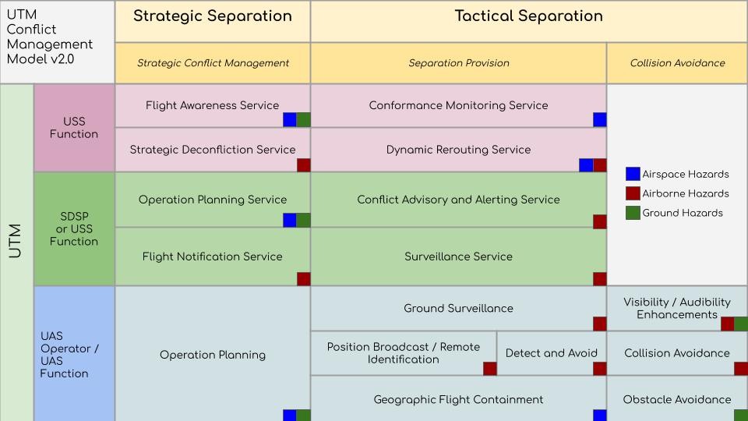
Figure 5: UTM Conflict Management Model.
The UTM Conflict Management Model considers functions that can only be provided by a USS given data exchange requirements of the USS Network and shared responsibilities across UAS Operators, function that can be accomplished by an SDPS or a USS to support a UAS Operator and functions that are solely provided by the UAS Operator and UAS. Strategic separation mitigation occurs prior to departure of the UA, whereas tactical separation mitigations are employed once the UA is aloft. It is acknowledged that there may exist a limit to the horizon of effectiveness of a USS or SDSP mitigation and therefore it is assumed that collision avoidance functions are functionally allocated to UAS capabilities. The limits of the time horizon solely depend on the performance of the service and communication means in which the service is delivered. Furthermore, even if a high performing and rapid USS/SDSP service is possible the potential for degraded lost communication render the need for both strategic and tactical separation mitigations being employed by a UAS Operator, unless the risk to the environment low enough to warrant the relaxation of this requirement. Due to the size, weight, power, and cost limitations of small UAS the UTM Conflict Management model encourages a balance of redundancy of mitigations technologies with reliability of individual technologies. A UAS Operator may opt to subscribe to a USS service to help accommodate for performance limitations with onboard capabilities. For example, a UAS Operator may utilize a Conflict Advisory and Alerting Service with a larger coverage area to supplement their onboard detect and avoid system that has a limited field of view and range to meet the required performance necessary for safe separation in the airspace. The UTM Conflict Management model identifies services and technologies that address airspace hazards, airborne hazards, and ground hazards and the subsequent section will outline the functionality and use of these technologies to support avoidance of collisions with airborne and ground objects.

Strategic Separation

Flight Awareness Service
Flight awareness services provide a UAS operator contextual geographic information that aids an operator’s awareness of areas which pose airborne and ground hazards and limitations or constraints that would impact flight operations. The contextual geographic data, constraints, and information can be provided by other data service (e.g. mapping, constraint management); however the Flight Awareness service is required to synthesize the data prescribed from authoritative sources to provide the operator with an informed awareness of known hazards and limitations within a prescribed geographic area. The primary functions of the flight awareness service are to:
- Provide information to a UAS operator regarding airspace and ground constraints to aid flight planning
- Perform constraint management by checking the proposed operation intent against all known airspace and ground hazard and/or constraint.
- Provide an advisory to the UAS operator when the proposed operation intent is impacted by a known hazard and/or constraint.
The use of the Flight Awareness Service is not limited to strategic mitigations, as it can be levied by tactical mitigations, however the data, information, and limitations are intended to have longer update cycles and therefore are often considered “static” data when used by other services. While the Flight Awareness Service is expected to encapsulate authoritative airspace and ground constraint data from known FAA sources, advanced capabilities allow for utilizing authoritative data from local, regional, and state sources to provide localized information that identified relevant hazards for UAS operations conducting missions in a geographic region. The Flight Awareness Service is a function that is seen as critical to supporting UAS operations and aligns with the UTM tenet that a UAS operators should have complete awareness of constraints in the airspace. While there can be many types of airspace and ground constraints, some of the common ones are identified in Table 3.

Table 2: Example Constraints used by Flight Awareness Service.
Airspace Constraints | Ground Constraints
Dynamic Constraints (e.g. UAS Volume Reservation) | Private Property
Controlled Airspace and Special Use Airspace | Public Gatherings
National Parks | Restricted Areas (e.g. National Monument)
Local Municipality Restrictions | Sensitive Areas (e.g. Prison)
National Security Restrictions (e.g. Power Plant) | Obstacle / Terrain Hazards
Right of Way Airways (e.g. Power Transmission Facilities)

Strategic Deconfliction Service
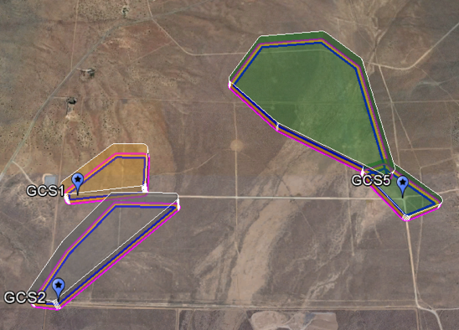
Figure 6: Depiction of segmented four-dimensional Operation Volumes.

The deconfliction of intended operation intent (e.g. Operation Volumes) between UAS that are subscribed to a UAS Service Supplier (USS) is a core function of UTM that supports the tenet that UAS should avoid each other. The underlying deconfliction service is strategic in nature and is facilitated by an UAS operator submitting their intended operation volumes to the Strategic Deconfliction Service. The Strategic Deconfliction Service compares the proposed intended operation volumes with other UAS operator’s operation volumes to identify spatiotemporal conflicts. This comparison occurs across all operations within a geographic area that have been declared on the USS network. The Strategic Deconfliction Service will notify all UAS operator impacted by the spatiotemporal and support the operators in attempting to resolve the conflict. If no conflicts are present, the Strategic Deconfliction Service notifies the operator that their operational intent is conflict-free, and the operator can proceed with the operation.
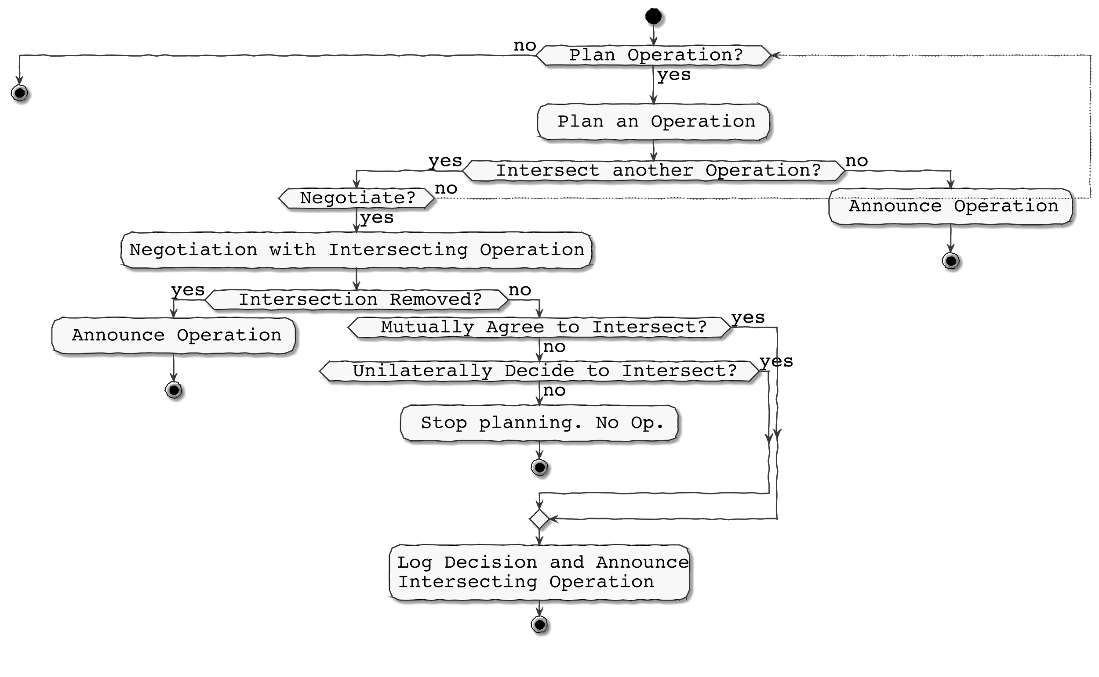
Figure 7: Strategic deconfliction process flow diagram.
If a strategic conflict does occur with the planned operation, the Strategic Deconfliction Service will notify the operator who is proposing the intended operation and the operator can:
- obtain information pertaining to the nature of the conflict, revise and re-submit a conflict-free operation, OR
- initiate an automated negotiation to the UAS operator(s) in conflict, through the USS network, and de-conflict the operations, OR
- proceed with the intended operation, given other tactical separation mitigations are in place for their operation. All Operators in conflict would be notified that the conflict exists and that tactical mitigations must be used to resolve any realized conflicts between identified operations.
A Strategic Deconfliction Service operates under the following principles:
- A UAS operation supported by a USS should be free of 4-D intersection (spatial and temporal) with all other known UAS Operations prior to departure.
- A prioritization scheme for operations is needed within strategic deconfliction to support various types of operations within an airspace.
- Negotiation schemes should be part of a strategic deconfliction service to support automated mediation between conflicting UAS operations.
- A strategic deconfliction service shall allow for overlapping operation volumes, given that other conflict mitigations are in place.
The objective of the strategic deconfliction service is to minimize the likelihood of planned airborne conflicts between UAS operations.

Table 3: Recommended Parameters for an Operational Volume to Support Strategic Deconfliction.
Field | Units | Description | Example
ordinal | Integer | This integer represents the ordering of the operation volume within the set of operation volumes. Need not be consecutive integers. | 1,2,3
volume_type | string | This string represents whether an operation volume is a trajectory-based operation (TBOV) or an area-based operation (ABOV). | TBOV, ABOV
near_structure | Boolean | This Boolean represents whether the operation volume is within 400 feet of a structure | false
effective_time_begin | String ($date-time) | Earliest time the operation will use the operation volume. Uses the ISO 8601 format conforming to pattern: YYYY-MM-DDThh:mm:ss.sssZ. Seconds may have up to millisecond accuracy (three positions after decimal). The ‘Z’ implies UTC times and is the only time zone accepted. | 2015-08-20T14:11:56.118Z
effective_time_end | String ($date-time) | Latest time the operation will done with the operation volume. It must be greater than effective_time_begin. Uses the ISO 8601 format conforming to pattern: YYYY-MM-DDThh:mm:ss.sssZ. Seconds may have up to millisecond accuracy (i.e., three positions after decimal). The ‘Z’ implies UTC times and is the only time zone accepted. | 2015-08-20T15:11:56.118Z
actual_time_end | String ($date-time) | Time that the operational volume was freed for use by other operations. Should be populated and stored by the USS. Uses the ISO 8601 format conforming to pattern: YYYY-MM-DDThh:mm:ss.sssZ. Seconds may have up to millisecond accuracy (i.e., three positions after decimal). The ‘Z’ implies UTC times and is the only time zone accepted. | 2015-08-20T14:31:56.118Z
min_altitude_wgs84_ft | number($double) | The minimum altitude for this operation in this operation volume. In WGS84 reference system using feet as units.
max_altitude_wgs84_ft | Number ($double) | The maximum altitude for this operation in this operation volume. In WGS84 reference system using feet as units.
operation_geography | string | The type of Geometry. In this case, must be ‘Polygon’ per GeoJSON spec. Note that the “coordinates” member is validated to be an array of size one.
beyond_visual_line_of_sight | Boolean | Describes whether the operation volume is beyond the visual line of sight of the RPIC.

Flight Notification Service
Flight Notification Service is intended to disseminating information regarding UAS operations in each geographic area to other airspace users, non-UAS stakeholders, local, state, and tribal governments, and the general public. This service is a strategic mitigation and promotes transparency within the UTM system. The medium in which information might reach the end users will vary on the use of the information. For instance, an application on a cellular device or tablet that provides UTM airspace operations information might be suitable for some users, like general aviation pilots, but not for others. Examples of mediums for distributing flight notifications: (1) mobile application, (2) webpage, (3) voice broadcast communication, (4) written notice, and/or (5) public forum announcement. Typical information that will be shared may vary depending on the audience but will likely include the elements for a given geographic area:
● Density of operations
● Expected duration at given density levels
● Expected maximum UAS operating altitudes
● Approximate launch/recovery locations
Advance capabilities may include cockpit displays for manned aircraft which would include additional information, like UAS positions, and network-based remote identification for law enforcement. Most functions of this service are meant to provide other non-UTM stakeholders transparency of UAS operations to raise awareness and ensure that they are active participants in contributing to the safety of the national airspace (e.g. incorporate UAS flight notifications into preflight procedures for manned aviation). Future capabilities may incorporate a standardized density criterion that requires the Flight Notification Service to issue notice of areas where manned aircraft must demonstrate vigilance or should consider avoiding due to an elevated air risk. In these circumstances the Flight Notification Service would be responsible for monitoring density of operations in each area and providing notice by established by the established means for manned aviation (e.g. Recommended Minimum Operating Altitude, Notice to Airmen, Temporary Flight Restriction, etc.)

Operation Planning and Operation Planning Service
Operation planning is a critical safety function supporting UAS flight operations. The objective of operation planning is for an UAS operator to define a region of operation, e.g. Operation Volume, that meets the needs of their mission while complying with the constraints and limitations of their approval to safely operate. The operation plan is developed prior to the operation and indicates the volume of airspace within which the operation is expected to occur, the times and locations of the key events associated with the operation, including launch, recovery, and any other information deemed important (e.g., segmentation of the operation trajectory by time). The operation plan as proposed may be impacted by other planned operations (e.g., overlapping airspace volumes) or other constraints (e.g., airspace restrictions), therefore the Operator should assess all appropriate information affecting the planned operation and make amendments to the plan as applicable. The Operator gathers airspace constraints provided by a competent authority and any localized airspace restrictions that could affect the proposed flight.

Operation planning serves as a critical safety function for the UAS operation and can make use of strategic mitigation to mitigate air and ground risk, such as:
- Restricting boundary of Area of Operation to geographic regions with acceptable air and ground risk.
- Restricting time in which operations are conducted to periods in which result in an acceptable air and ground risk.
- Restricting behavior of operation to ensure interoperability with other aircraft, compliance with airspace constraints and avoidance of ground obstacles.
- Restricting exposure or duration of an operation to reduce the likelihood of the air risk and ground risk for the Area of Operation

For low altitude airspace small UAS flight operations, a UAS operator must consider the air risk and ground risks associated with their mission. The operation planning safety function is crucial to ensuring the safety of the airspace and should consider at least the following factors:
- Mission Success and Vehicle Performance
  - Achievable flight path Trajectory
  - Minimum required endurance and maximum vehicle range
  - Command, control, and communication coverage range and quality of service
  - UAS performance and flight behavior (e.g., turn radius, launch/recovery procedures, etc.)
  - UAS navigation error
  - Contingency management procedures
  - UAS Services coverage areas and quality of service.
- Environmental Conditions
  - Atmospheric conditions (e.g., direction and magnitude of wind)
  - Terrain and ground hazards (e.g., Man-made Structures, Foliage)
- Airspace Conditions and Flight Rules
  - Airspace structure and flight rules
  - Approved Area of Operation (e.g. Performance Authorization)
  - Operation conditions and limitations (e.g. night flights)
The operation planning safety function can be challenging to address as the environment increases in complexity. The awareness of air and ground hazards and a means to validate that the safety mitigations are effective at addressing relevant hazards pose an undesirable burden on UAS Operators who wish to conduct operations in complex environments. UTM services offer an opportunity to assist an UAS Operator in meeting the operation planning safety function for complex operation (e.g. BVLOS) and/or operations in a complex environment. A service providing operation planning, denoted as Operation Planning Service, supports the UAS operator in developing and modifying operation plans to:
- Avoid overflight of areas of unacceptable ground risk
- Avoid flight into areas with flight restrictions
- Avoid flight into areas with unacceptable air risk
- De-conflict with other UAS operations
The Operation Planning Service could provide information, advisories, and guidance to UAS Operators prior-to, during, and after the planning process of a UAS flight operation.

To use the Operation Planning Service, UAS operator submits a set of user-defined four-dimensional volumes or trajectories consisting of geographic information and time, that represents the physical location of the planned operation. UTM supports more efficient use of the airspace by allowing for multiple 4D volumes that are overlapping in time and space to be submitted and form a chain of volumes that will be used for a single operation. This chain or set of user-defined 4D volumes or trajectories that contain the intended flight path of UAS are called a Flight Geography. The Operation Planning Service compares the Flight Geography with known hazards and constraints in and around the proposed Flight Geography and outputs notification of conflicting hazards.
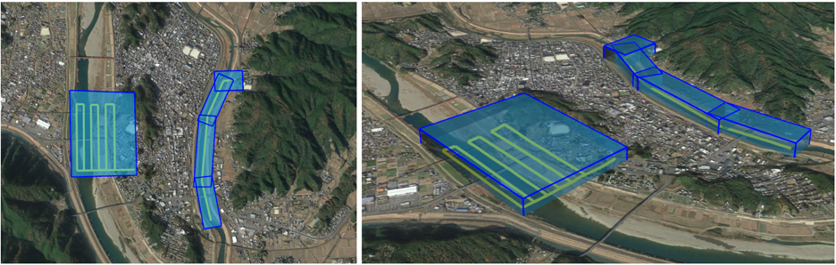
Figure 8: Depiction of 4 dimensional segmented Flight Geographies.

The creation of a Flight Geography can be defined by the UAS Operator, however as the complexity of the operation and environment increase UAS Operator may use Operation Planning Service to support flight planning. The basic function of the Operation Planning Service is to evaluate the suitability of the Flight Geography by: (1) identifying known air and ground hazards during the pre-flight phase of an operation, and (2) ensuring that the Flight Geography is properly defined (or converted from a trajectory) such to use as a means to communicate intent within UTM. More advanced features of the Operation Planning Service may include evaluating the fitness of the UAS to fly within the Flight Geography, the automatic refinement of a Flight Geography given known hazards, quantification of risk associated with spatial or temporal aspects of the Flight Geography, and scheduling and sequencing of operations into a fixed location (e.g. Part 135 parcel delivery). These advanced features may require additionally input from the UAS Operator regarding the performance of the aircraft, communication and navigation performance, contingency management actions, launch/recovery behavior, etc. The service may also other utilize supplemental data to provide the appropriate context to evaluate the Flight Geography (e.g. atmospheric information). A Operation Planning Service supports UAS operators by considering factors required for safe and efficient missions and operates under the following assumptions:
- All phases of flight of the UAS operation must be contained within a 4D volume of the Flight Geography
- Each 4D volume of the Flight Geography must have a start and end time
- Contingency locations must be identified for each volume in a Flight Geography (e.g. alternate landing location, lost link waypoint, etc.)
- Contingency locations should be contained within their respective flight volume of a Flight Geography, unless in-time Flight Geography modification is supported during flight.
- An Operation Planning Service must promote efficient and safe use of the airspace during flight planning

Table 4: Parameters Required for Flight Geography.
Field | Units | Description | Example
ordinal | Integer | This integer represents the ordering of the flight geography within the set of operation volumes. Need not be consecutive integers. | 1,2,3
volume_type | string | This string represents whether an operation volume is a trajectory-based operation or an area-based operation. | TBOV,ABOV
gufi | String | Globally unique flight identification number | 4ce9f71-97e1-414e-85a9-118f919aa920"
effective_time_begin | String ($date-time) | Earliest time the operation will use the operation volume. Uses the ISO 8601 format conforming to pattern: YYYY-MM-DDThh:mm:ss.sssZ. Seconds may have up to millisecond accuracy (three positions after decimal). The ‘Z’ implies UTC times and is the only timezone accepted. | 2015-08-20T14:11:56.118Z
effective_time_end | String ($date-time) | Latest time the operation will done with the operation volume. It must be greater than effective_time_begin. Uses the ISO 8601 format conforming to pattern: YYYY-MM-DDThh:mm:ss.sssZ. Seconds may have up to millisecond accuracy (three positions after decimal). The ‘Z’ implies UTC times and is the only timezone accepted. | 2015-08-20T15:11:56.118Z
actual_time_end | String ($date-time) | Time that the operational volume was freed for use by other operations. Should be populated and stored by the USS. Uses the ISO 8601 format conforming to pattern: YYYY-MM-DDThh:mm:ss.sssZ. Seconds may have up to millisecond accuracy (three positions after decimal). The ‘Z’ implies UTC times and is the only time zone accepted. | 2015-08-20T14:31:56.118Z
min_altitude_wgs84_ft | number($double) | The minimum altitude for this operation in this operation volume. In WGS84 reference system using feet as units.
max_altitude_wgs84_ft | Number ($double) | The maximum altitude for this operation in this operation volume. In WGS84 reference system using feet as units.
operation_geography | string | The type of Geometry. In this case, must be ‘Polygon’ per GeoJSON spec. Note that the “coordinates” member is validated to be an array of size one.

Tactical Separation

Conformance Monitoring Service
UTM Services can support UAS operations by providing a UAS operator with enhanced situation awareness, safety mitigations, contingency support, and compliance with the requirements stipulated under an authorization to operate. On such means of supporting compliance to operational requirements is to support an operator’s ability to conform to their Operation Volume and provide notifications when they are not in conformance. The objective of the Conformance Monitoring Service is to monitor the state of an operation to ensure that a UAS Operator is aware of potential deviations from the intended operation intent (e.g. Operation Volume).
The Operator’s prescribed Flight Geography can be considered a declaration of operation intent that they are agreeing to contain their aircraft within. By adding spatiotemporal buffers to the Flight Geography, an Operation Volume is defined which can be shared with other airspace users within USS network. The intention of conformance monitoring is to (1) notify a UAS operator that they have started to deviate from the declared intent and (2) notify other airspace users when that deviation poses a credible hazard to their operations. The operator notification provides the opportunity to inject corrective action prior to a prolonged deviation that could impact other airspace users. Furthermore, the conformance monitoring serves as a notification and communication means to support an Operator’s mitigations to ensure containment of their operations to their Authorized Area of Operation.
During flight planning, the UAS operator develops and shares a Flight Geography with the Conformance Monitoring Service. Two additional buffers are imposed on the Flight Geography, a Conformance Volume and Operation Volume, to ensure proper separation between UAS Operator’s intent is prescribed that accounts for variations in navigation performance, vehicle performance, and containment mitigation performance of the UA. The buffers also may consider a minimum reaction time necessary to avoid a conflict from other airspace users in the event of a Flight Geography breach. The Operation Volume represents a declaration of operational intent within the USS Network and is used to notify other airspace users of potential hazards due to the proposed operation. Conformance monitoring is a means to support a UAS operator in adhering to their Operational Volume by providing notifications and alerts when an operator has deviated from this intent.
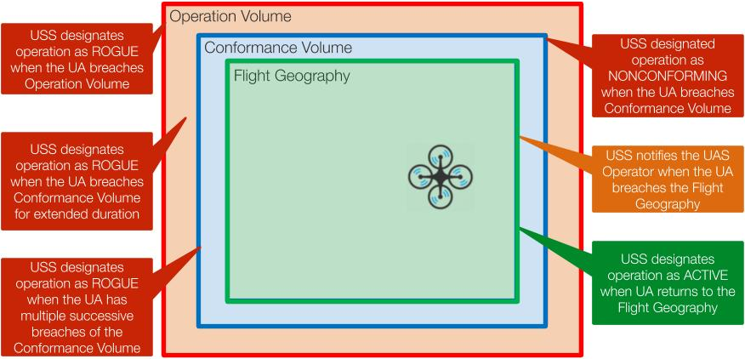
Figure 9: Conformance Monitoring Service alerts and notifications.
During flight planning a UAS Operator submits a Flight Geography to their USS and their USS supports the development of an Operation Volume. The Operation Volume is considered a declaration of intent that is shared with the USS network for strategic deconfliction and situation awareness and serves as an agreement between the USS and UAS Operator as to the extent of geographic area that is intended for operation by the UA. The Conformance Monitoring service is a means for a USS to support a UAS operator in containing their operation the prescribed Operation Volume by providing alerts when an operator has: (1) breached their Flight Geography, (2) breached their Conformance Volume, (3) breached their Operation Volume, and (4) persisted outside their Flight Geography for an unacceptable duration of time. The Conformance Monitoring Service is considered foundational to supporting community-based traffic management as it supports tracking, and notification of non-compliant behavior. A Conformance Monitoring Service may eventually be a feature of a broader compliance monitoring function that supports a UAS Operator in ensuring that their operation is following the terms of their Performance Authorization. This future capability may include monitoring the state of required services, equipage, or operation limitations and other regulatory requirements. A Conformance Monitoring Service operates under the following principles:
- UAS Operators shall provide real-time telemetry and state information to a USS, to enable the Conformance Monitoring Service to track the UAS
- A USS provider shall track a subscribed UAS and issue alerts to the UAS Operator when conformance to Flight Geography has been lost.
- A USS must define a Conformance Volume for each Operation Volume of an operation.
- A Conformance Volume must be contained in all four dimensions within its associated Operation Volume.
- When conformance with operation intent has been lost, the USS shall change the state of the operation from “ACTIVE” to “NON-CONFORMING”
- When compliance with operation intent has been regained, the USS shall change the state of the operation from “NON-CONFORMING” to “ACTIVE”
- If there is a severe deviation from operation intent or the state of the operation remains “NON-CONFORMING” for a sufficient duration of time, the USS shall elevate severity of the infraction by changing the state of the operation from “NON-CONFORMING” to “ROGUE”
- Operations that enter a “ROGUE” state are considered in breach of the operation intent and therefore cannot return to an “ACTIVE” state, rather they must abort their mission. NOTE: UAS Operators are encouraged to conduct thorough flight planning, to ensure sufficient buffers based on the capability of their UAS and the current and forecasted environmental conditions, and utilize additional services (e.g. dynamic re-routing) to ensure that they are maintaining compliance to their intended plans, or modifying their plans given changing airspace or vehicle conditions to ensure consistency of UAS performance during the operation
- A USS shall announce operation state changes to the UAS Operator who caused the state change, other subscribed UAS Operators that are in the local proximity, and the USS Network to disseminate the announcement to other UAS Operators conducting missions in the local proximity.
There is an interplay between the Strategic Deconfliction Service and the Conformance Monitoring Service which highlights the trade-off between the efficiency and safety of the airspace. The Strategic Deconfliction Service encourages UAS Operators to plan operation volumes as efficiently as possible to minimize pre-departure conflicts. This typically results in planning operations in underutilized airspace or reducing the spatial and/or temporal exposure of the operation volumes in the airspace. In contrast, the conformance monitoring service encourages UAS Operators to create operation volumes that are sufficiently sized to account for the performance of their aircraft and to be cognizant of changing conditions during the operation that may require more (or less) spatial and/or temporal exposure of the operation volumes to ensure mission success (e.g. atmospheric conditions). UAS Operators should consider “ROGUE” operations as an undesired operational state and are encouraged to ensure that the occurrence of a “ROGUE” operation is extremely rare. The combination of flight planning, Strategic Deconfliction Service and the Conformance Monitoring Service are foundational to community-based traffic management and support a UAS operator in designing, de-conflicting, and monitoring Operation Volumes to reduce the likelihood of mid-air collisions and containing missions within Authorized Areas of Operations.

Conflict Advisory and Alert Service
Conflict Advisory and Alert Service supports a UAS operator by providing real-time or near real-time data regarding the proximity to potential conflicting aircraft. The main functions of the Conflict Advisory Service are to provide a UAS Operator (or Remote Pilot in Command) informative, suggestive, or directive guidance with regards to aircraft that could pose a hazard to their operations. This service relies on surveillance data sources to provide awareness of hazards in the airspace. In contrast to other separation services (e.g. strategic deconfliction) the conflict advisory and alert service is intended to support the resolution of tactical air-to-air conflicts with other aircraft, as opposed to deconfliction with UAS operation intent or airspace constraints. The Conflict Advisory and Alert Service can utilize surveillance information from the following sources (when available):
- Aircraft position and operation information within USS Network due to non-conformance to Flight Geography
- Aircraft position and operation information within USS Network due overlapping Operational Volumes
- Self-reporting aircraft position from other UAS operators via UAS Reports (UREP)
- Primary returns from networked surveillance sources (e.g. tactical ground-based radar, EO/IR sensor)
- Secondary returns from networked transponder-based surveillance sources (e.g. secondary surveillance radar, ADS-B).
The Conflict Advisory and Alert Service is considered a tactical mitigation and can be provided by a service supplier to support an operator, however, still requires an operator to be engaged in the decision to resolve the identified conflicts.
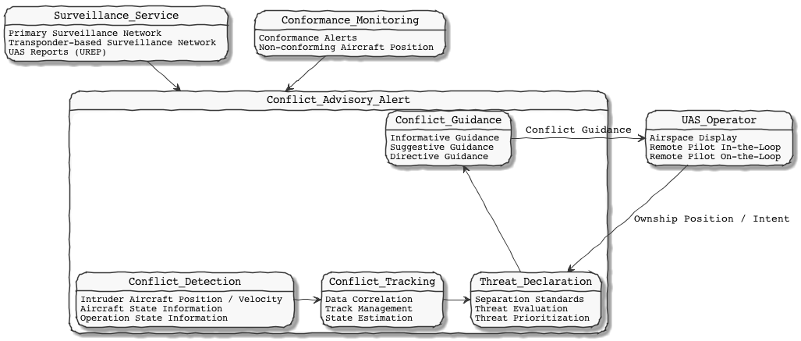
Figure 10: Functional diagram depicting the Conflict Advisory and Alerting Service.
The service is decomposed into four functional elements: (1) Conflict Detection, (2) Conflict Tracking, (3) Threat Declaration, and (4) Conflict Guidance. Conflict detection is the primary interface for the conflict advisory and alert service to collect surveillance data from different sources. This function would establish the integrity, uncertainty, surveillance volume, and relevance of aircraft or operation information provided from each surveillance source. The conflict detection function would also be responsible for the discovery of surveillance services, quality of surveillance service monitoring, and management of performance limitations of surveillance sources. The conflict tracking function is aimed at using the relevant surveillance information to perform data association and correlation to establish how multiple position reports (from different sources and/or over a time series) are coalesced to a single track to present to an Operator. Furthermore, the conflict tracking function will determine when tracks are established, stale, lost, and/or need to be removed. The conflict tracking function will also assign a track identification which may be synonymous with a UAS identification, if known or can be correlated. The conflict tracking function will also project a state estimate over a time horizon to establish intent of a vehicle if that information is not known or reliable. The threat declaration logic retains and manages separation criteria and right of way rules that are applicable to conflicts given the type of conflict and the rules or limitations of the airspace. These separation criteria and/or right of way rules are then used to evaluate and determine the credibility of an intruding aircraft to pose a threat to the ownship UAS. Furthermore, intruding aircraft that are established as credible hazards or threats are then prioritized amongst other credible airborne hazards within the airspace. The prioritization of the threats also establishes the severity of the threat and whether a threat is communicated as a traffic advisory or conflict alert. The severity of a threat aircraft can change with the progression of the conflict. In such cases, the threats are declared in order of priority to the conflict guidance function. Guidance is provided to the UAS Operator in three different forms based on the level of automation available in the service: informative, suggestive, or directive. The types of guidance provided are generally distinguished as follows:
- Informative Guidance will typically provide the necessary information to produce air traffic on a map and basic information regarding the state of an aircraft (airspeed, vertical rate, call sign, etc.). It provides no explicit maneuver guidance to a UAS Operator.
- Suggestive Guidance will typically provide additional information to informative guidance by indicating of a range of possible maneuvers to avoid a conflict. The UAS Operator makes the determination of what action to take based on the options presented and their judgement of the nature of the conflict.
- Directive Guidance will provide a pilot a specific maneuver to resolve a conflict. The UAS Operator makes the determination of what action to take based on the maneuver presented and their judgement of the conflict.
An underlying assumption of the Conflict Advisory and Alert Service is that there exists a traffic display that depicts the conflict guidance and there exists a human to perform the function of determining the resulting maneuver command. The suggestive and directive guidance are beneficial in aiding a UAS Operator to more quickly identify and resolve credible threats and potentially reduces their workload. Several modes of operation could be considered for a UAS Operator’s interaction with their UAS while using this service:
- Pilot-in-the-Loop: Pilot views situation awareness display, is provided informative or suggestive guidance regarding threat aircraft and serves the function of determining and commanding the conflict resolution maneuver
- Pilot-on-the-Loop (Manage by Consent): Pilot views situation awareness display, is provided directive guidance regarding maneuvering against threat aircraft and serves the function to command the resolution maneuver
- Pilot-on-the-Loop (Manage by Exception): Pilot views situation awareness display, is provided directive guidance regarding a planned automated maneuver command against a threat aircraft and serves the function to negate the execution of the resolution maneuver, if inappropriate.
The pilot-off-the-loop, or automated command and execution mode of operation is possible given an automated dynamic rerouting function (either as a service or UAS capability). This mode of operation would remove the pilot’s ability to intervene in conflict resolution and would be subject to the guidelines, regulations, and limitations imposed by the FAA.

Dynamic Rerouting Service
Dynamic Rerouting Service supports a UAS operator by providing modifications to intended operation volumes and directive guidance to change flight path to minimize the likelihood of airborne conflicts and maximize the likelihood of conforming to airspace restrictions and maintaining mission objectives. The Dynamic Rerouting Service is a tactical service that is an extension of pre-departure strategic deconfliction by supporting an Operator with conflicting intent, performing automated prioritization and negotiations when intent is in conflict. Dynamic Rerouting Service requires a higher level of automation, over that of strategic deconfliction, given that the service it is a tactical service employed while the UA is aloft. Furthermore, this service supports an UAS operator to recover from excursions from their Operation Volume by providing preventative Operation Volume and flight path modifications that capture the unintended behavior and support the UAS operator in returning to the mission. The Dynamic Rerouting Service will more readily account for predicted excursions due to atmospheric conditions (e.g. winds) or pre-planned contingency actions (e.g. loss of command and control link). In addition to support flight path and operation intent modifications the Dynamic Rerouting Service can also support air-to-air conflict resolution (if surveillance is available) by leveraging the Conflict Advisory and Alert Service features to provide a conflict resolution flight path maneuvers and operation volume modification.
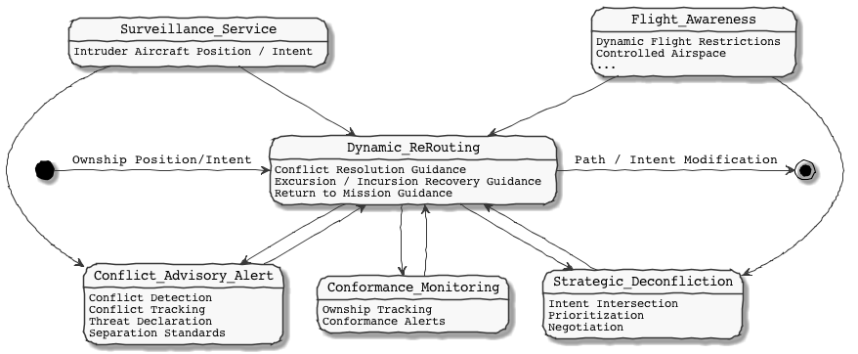
Figure 11: Functional diagram depicting the Dynamic Rerouting Service.
The Dynamic Rerouting Service denotes a higher level of automation that is reliant on several other functional services to support the automation. Conflict Advisory and Alert Services and Surveillance Services provides the information and possibly maneuver recommendations against intruder aircraft, whereas Strategic Deconfliction Services and Flight Awareness Services provide information, intersection detection, and negotiation support against resolving conflicts with other UAS Operation Volumes and airspace constraints. Conformance Monitoring Services provide UAS state information for context on when other UAS are out of conformance and boundaries of the UAS ownship for consideration in conflict resolution. Ownship position, state, intent, remaining endurance, aircraft performance, onboard geofence boundaries, and other state and operation information are needed from a UAS Operator to support the Dynamic Rerouting Services. Additionally, the Dynamic Rerouting service relies on a UAS Operator and/or the Strategic Deconfliction service to announce the operation plan modification to the USS Network. While the Dynamic Rerouting Service is intended to be a higher level of automation, UAS Operator interaction can still be supported in a variety of different ways, such as:
- RPIC submits request to the Dynamic Rerouting Service for a conflict-free path given revised mission parameters, while UAS is aloft
- Maneuver guidance presented to RPIC due to identified airborne hazard (e.g. intruder aircraft) or ANSP directive (e.g. Dynamic Restriction) and RPIC approves maneuver (e.g. manage by consent) or doesn't intervene (e.g. manage by exception)
Additional services may be included to interface with the Dynamic Rerouting service, (such as Communication Services, Weather Services, Dynamic Risk Reduction Services, etc.) to further provide context to the selection of a conflict resolution or recovery maneuver. The Dynamic Rerouting Service is assumed to operate under the following principles:
- A UAS operation modification supported by a USS should be free of 4-D intersection (spatial and temporal) with all other known UAS Operations when vehicle is aloft.
- The strategic deconfliction prioritization scheme for operations is for dynamic rerouting to support various types of operations within an airspace.
- A dynamic rerouting service shall minimize airborne conflicts and seek to reduce intersections of 4D operation volumes
- A dynamic rerouting service shall provide operation plan modifications to the USS consistent with and in the event of pre-programmed contingency actions taken by the UAS
- A dynamic rerouting service should serve mission objectives
- A dynamic rerouting service shall allow for overlapping operation volumes, given that other separation mitigations are in place.
The Dynamic Rerouting Service can reduce the performance burden on a detect and avoid capability by networked-based surveillance infrastructure to extend the time horizon of conflict detection and resolution. In addition, the Dynamic Rerouting Service provides contextual airspace, operations, and constraint information in the maneuver selection process that takes into consideration the airspace environment (e.g. air traffic, airspace constraints, ground constraints, weather, etc.). While many of the dynamic re-route features could be developed as automation onboard the UA the contextual airspace environment information is readily dynamic and often not available onboard the UAS. The Dynamic Rerouting Service offers a means to offload the requirement of onboard automation from having to account for the airspace environment in complex environments. A Dynamic Rerouting Service does not remove the need for onboard tactical separation mitigations (e.g. DAA) but rather reduces the likelihood of needing to utilize such a capability in operations.

Surveillance Service
The Surveillance Services consist of set of strategic and tactical services that can support air risk assessment for safety case development, support pre-departure flight planning with airspace heat maps based on common traffic patterns, and support tactical flight operations by providing real-time tracking information of air traffic for a given geographic area. Surveillance services consist of two primary means of collecting information regarding airborne hazards: terrestrial surveillance, and airborne surveillance. Surveillance technologies typically will either depend on transponder technology (cooperative) or will be independent of transponders or additional equipment onboard an aircraft (non-cooperative). Data for the Surveillance Service can be provided from a single sensor, a network of sensors, or sensors fused from different sources.
Table 5: Examples of surveillance technologies.
 | Non-cooperative | Cooperative
Airborne | Airborne Radar on UAS,  UAS Reports (UREP), EO/IR Sensors | Vehicle-to-Vehicle Communication, ADS-B (air-to-air), Remote ID
Terrestrial | Primary Ground Radar, EO/IR Sensors,  RF Sensors | Secondary Ground Radar

The Surveillance Service serves to support UAS operators throughout different phases of operation.
Safety development using a Surveillance Service can provide UAS Operators with historical airspace density maps, common aircraft routes and traffic patterns, and quantify air risk due to existing airspace users for a given geographic area. This historical data can offer insight into seasonal, monthly, weekly, and hourly trends in use of the airspace, and help a UAS Operator identify when periods of the day are typically underutilized. This capability allows UAS operators awareness of the existing likelihood of potential airborne conflict while conducting operation in a given geographic area. Thus, empowering UAS operators to determine appropriate strategic and tactical mitigations that are consistent with the level of air risk for that airspace. This data can also aide the regulator in establishing the target level of safety for a given airspace.
Flight Planning using a Surveillance Service can provide an UAS Operator awareness of areas within locations in the airspace that would yield a higher likelihood of air traffic and develop Operation Volumes that consider the airspace structure, common routes of the airspace, and common times of day when the airspace is underutilized. Advanced features of this service could offer pre-departure risk profiles of the airspace given trend analysis from historical data, allowing and operator to use risk-based Go/No Go criteria to determine if the pre-departure risk is low enough to support a successful mission. This Surveillance Service supporting flight planning can aid a UAS operator in compliance with their Performance Authorization.
Real-time Detection using a Surveillance Service is a capability that allows for a UAS Operator to gain a more complete awareness of the airspace they are using to conduct UAS operations. The real-time aspect of the service supports other services, like Conflict Advisory and Alert Service and Dynamic Rerouting, to provide support in conflict detection and resolution. This service in conjunction with an Authentication and Authorization service can also support the identification of aircraft that are non-participants of UTM.

Geographic Flight Containment
When a UAS Operator conducts flight planning they design an operation which has an acceptable air and ground risk and they may employ supporting services and capabilities help contain the UA to that operation plan. Geographic flight containment is a capability that supports a UAS Operator by (1) providing alerts to the Operator of a potential of deviation from a geographic area and (2) by providing an onboard forcing function to prevent a UA from blundering outside of a geographic area. Geographic flight containment is a location-based service and a subset of capabilities associated with geographic virtual fencing (also denoted as geo-fencing). Geographic flight containment is characterized in two ways:
- Static Geographic Flight Containment is onboard and ground-based containment mitigations that are based on geographic volume(s) that are static for the entirety of the UAS operation. An Authorized Area of Operation specified in the Performance Authorization is an example of a static geographic volume in which a containment mitigation could be applied. The Static Geographic Flight Containment mitigation can be viewed as a failsafe to ensure that a UA halts forward progression from the defined geographic containment boundary and the UA returns to an acceptable location within the geographic boundary. The static geographic flight containment mitigation will likely require a higher level of reliability if the geographic boundary lies adjacent to areas of elevated air or ground risk.
- Dynamic Geographic Flight Containment is onboard and ground-based containment mitigations that are based on geographic volume(s) that can change during an UAS operation. The Flight Geography is an example of a geographic volume that can change during a flight in which a containment mitigation could be applied. The Dynamic Geographic Flight Containment mitigation can be considered a means to support containment of a UA to its announced intent which would reduce the likelihood of a non-conforming operation.
It should be noted that a complementary capability of geographic flight containment is a boundary enforcing a geographic flight restriction. A geographic flight containment mitigation will confine a UA into a geographic area, whereas a geographic flight restriction mitigation will restrict entry of a UA from a geographic area. These capabilities may have similarities in functionally but are fundamentally attempting to achieve different objectives.

The geographic flight containment mitigation should define a preventative and recovery threshold in which to apply the mitigations that are wholly constrained within or equivalent to the desired volume of containment. For the dynamic geographic containment, the preventative and recovery thresholds would be contained within the Flight Geography. These thresholds define actions to be taken if the UA blunders beyond the threshold. If a UA crosses the preventative threshold,
- The geographic flight containment mitigation MUST issue a declaration to the UAS Operator that action is necessary to avoid an excursion from the volume of containment (e.g. Flight Geography).
- The geographic flight containment mitigation MUST initiate a course correction procedure to maintain the UA position within the volume of containment. This initiation can be facilitated by an informative, suggestive, or direct alert to a UAS Operator, or an automated response by onboard capabilities on the UA.
- The preventative threshold SHOULD consider atmospheric conditions, UA characteristics (e.g. speed, heading, climb rate, etc.), and navigation error in its definition and can be spatial and/or temporally defined.
- The preventative threshold MUST be no larger than the recovery threshold.

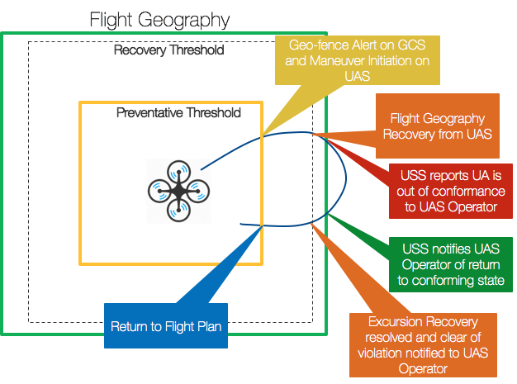
Figure 12: Relationship between Flight Containment Capability and Conformance Monitoring Services.
Simple implementations of a preventative threshold may be statically defined a priori launch of the UA, whereas more advanced capabilities may incorporate dynamically changing preventative thresholds. While a preventative threshold represents the initiation of a corrective maneuver to prevent the UA from breaching the volume of containment (e.g. flight geography), a recovery threshold represents the point at which the aircraft can no longer prevent an excursion from the containment volume. At this threshold, contingency action is necessary to arrest UA forward progression outside the containment volume and a recovery maneuver is required to return the UA inside the containment volume. If a UA crosses the recovery threshold,
- The geographic flight containment mitigation MUST issue a declaration to the UAS Operator that a contingency action is occurring to recover the UA due to an excursion from the volume of containment (e.g. Flight Geography).
- The geographic flight containment mitigation MUST initiate a corrective action to arrest forward progression of the UA position outside the volume of containment and return the UA to with the volume of containment. This initiation is likely an automated response by onboard capabilities on the UA.
- The recovery threshold SHOULD consider atmospheric conditions, UA characteristics (e.g. speed, heading, climb rate, etc.), and navigation error in its definition and can be spatially and/or temporally defined.
- The corrective threshold MUST be no larger than the respective volume of containment (e.g. Flight Geography).
The geographic flight containment mitigations can implement functionality onboard the UA and on the ground systems of the UAS, however due to the loss of command and control link events an onboard mitigation is a required capability of any geographic flight containment system. Common mitigation strategies currently used by geographic flight containment systems to date include heading changes, climb or descend to an altitude, hover in place, navigate to a fixed location, and deploying a parachute. Geographic flight containment mitigations are expected to operate under the following principles:
- Navigation Data Integrity, Availability, and Accuracy Monitoring is necessary to ensure the validity, timeliness, accuracy, and security of the data used to determine that flight containment action is necessary.
- Airspace Displays are required to maintain an UAS Operator’s situation awareness to their UA proximity to geo-fence boundaries and actions taken as a result of excursions.
- Conformance Monitoring is a necessary capability for detecting crossing preventative and recovery thresholds and excursions from the volume of containment.
- UAS Operator alerts are required to maintain a UAS Operators situation awareness and should be factored into the definition of the preventative and recovery thresholds if UAS Operator response is expected.
- Corrective Action is expected when breaching a threshold and latency and command and control data link should be considered in the threshold definitions if UAS Operator response is required.
- Reliability and Security should be factored into the development of geographic flight containment mitigations such that design considerations are made to improve the resilience (to factors like interference), reduces the dependencies on external infrastructure or internal systems of the UAS and consider threat planes associated with security threats to the threshold definitions, monitoring, or corrective maneuver initiation. Considerations like independence of the navigation source from the UA autopilot are an example of possible resilience being added to the capability.

Table 6: Recommended Parameters for Flight Containment Capability.
Variable Name | Type | Description
geoFenceAvailable_nonDim | INTEGER | 0: Non-Available, 1: Available
geoFenceEnable_nonDim | INTEGER | 0: Disable, 1: Enable
geoFenceStartTime | INTEGER | Time at which geofence is enabled in Coordinated Universal Time (UTC). Use ISO 8601 format conforming to pattern: YYYY-MM-DDThh:mm:ss.sssZ. Seconds must have up to millisecond accuracy (three positions after decimal). The ‘Z’ implies UTC time and is the only time zone accepted.
geoFenceEndTime | INTEGER | Time at which geographic fence is disabled in Coordinated Universal Time (UTC). Use ISO 8601 format conforming to pattern: YYYY-MM-DDThh:mm:ss.sssZ. Seconds must have up to millisecond accuracy (three positions after decimal). The ‘Z’ implies UTC time and is the only time zone accepted.
geoFenceType_nonDim | INTEGER | 0: Circular- Point and Radius, 1: Polygon
geoFenceMinAltitude_ft | FLOAT | Minimum defined altitude of geographic fence (ft)
geoFenceMaxAltitude_ft | FLOAT | Maximum defined altitude of geographic fence (ft)
geoFenceCircularPointLat_deg | FLOAT | Latitude of circular origin point of geographic fence (deg)
geoFenceCircularPointLon_deg | FLOAT | Longitude of circular origin point of geographic fence (deg)
geoFenceCircularRadius_ft | FLOAT | Radius of circular geographic fence (ft)
geoFenceDynamicPolygonPoint_deg | STRING | Specify dynamic location of polygon vertices in the following format: ”[Lat_1,Lon_1],[Lat_2,Lon_2],....[Lat_n,Lon_n]" (include quotation marks).  This is a time dependent variable (UTC time stamped), specify “geoFenceDynamicPolygonPoint_deg” as many times as the polygon shape changes during the flight (e.g. for a fixed polygon geofence it’ll have the same values of Lat_n, Lon_n all along the flight).  Report at least seven decimal degrees. (deg)

Visibility and Audibility Enhancements
Visibility and audibility enhancements address the risks associated with airborne conflicts and injury or death to persons on the ground. These typical represent passive mitigations that rely on other parties to initiate resolution of a conflict and is considered a good practice to aid the see and avoid mitigation of manned aircraft and persons on the ground. There are two main mitigations that have been identified to support increasing the situation awareness and acuity of others in the proximity of a UA: anti-collision lighting, and audible broadcast alerting. Future work is needed in defining standards around active mitigations, such as tactical and audible alerts, to raise situation awareness of the UAS Operator, while using supporting conflict management services or capabilities.
Anti-Collision Lighting. Under Part 107 regulations you can fly during daylight hours (30 minutes before official sunrise to 30 minutes after official sunset, local time) or twilight with the appropriate anti-collision lighting (107.29). Furthermore, an operator can seek a waiver under Part 107 to operate the UA at night, under reduced visibility, or beyond visual line of sight, which would also warrant the use of the appropriate anti-collision lighting. Under Part 107, the performance of the anti-collision lighting must be such that the light is visible for three statute miles or more. Anti-collision lighting is aviation red or aviation white and either blinking or strobing, as opposed to UA navigation lights that are often a solid red, green, and/or white. While not required during daylight hours, anti-collision lighting may be used to increase the likelihood of a manned aircraft or other remote pilots to see and avoid the UA. Further industry standards may consider establishing lighting patterns to provide a visual means to alert other airspace users of an off-nominal or emergency UA condition.

Audible Broadcast Alerting. While not required under existing Part 107 regulation, the need for BVLOS operations to employ an automated safe landing capability is warranted when operations occur over or near populated areas, and/or over a gathering of people. An automated safe landing capability considers two primary factors to reduce the risk to people on the ground: (1) avoiding people and/or property during landing (e.g. obstacle avoidance), (2) raise situation awareness of persons in landing area to allow for time to vacate. The latter factor can be facilitated in a strategic means by pre-designating a secure landing location, or tactical means by visual (e.g. lighting) or audible (e.g. speakers) mitigations. Audible broadcast alerting can be implemented as a failsafe to provide an alert to persons at risk due to the descent or landing of the UA. Performance of the audible broadcast is dependent on the navigation precision, altitude, rate of descent, proximity and expected mobility of the persons at risk.

Location Broadcast / Vehicle-to-Vehicle Communication
Location broadcast is typically related to UAS remote identification; however, the presence of the capability may also enable situation awareness of UAS traffic to other users of the airspace. The suitability to support separation using a location broadcast is dependent on the performance of the broadcast, security, reliability, and availability of the broadcast, and UA equipage requirements. There may be two means to receive location information: (1) transponder-based broadcast or network-based broadcast and/or (2) vehicle-to-vehicle communication. To support conflict management the broadcast will need to provide information necessary to derive the following data:
- Current UA position prescribed in Latitude, Longitude and Altitude
- Current UA flight course
- Current UA ground speed
- Current UA health and state (e.g. failure-mode, emergency)
- UA unique identifier to correlate UA with operational information
Additionally, including information such as UA intent in the position broadcast would improve the performance of conflict resolution. The performance, reliability, security, and availability of the position information will determine the suitability for use as a conflict mitigator. Low performance and reliability position broadcast information (e.g. Remote ID) may only serve as situation awareness information, whereas position broadcast information with higher reliability and performance (e.g. vehicle-to-vehicle communication) may serve to support detect and avoid or collision avoidance conflict resolution mitigations. Standards development is ongoing in supporting Remote Identification position sharing that is specific to a transponder-based broadcast and a network-based broadcast. The remote ID transponder-based broadcast can support air-to-air position sharing with other aircraft that operate in geographic areas or at altitudes that are not readily supported by a network. Limitations in transmit power and allowable RF frequencies may limit the range of this air-to-air broadcast to a proximity near the UA. Network-based remote ID broadcast focuses on leveraging network infrastructure to support position sharing and therefore both the UA and the other airspace users are required to participate in the network to benefit from the information. Network-based remote ID broadcast may extend the range in which positions can be shared, but at the cost of limiting the availability of the information to areas in which have network coverage.
Vehicle-to-vehicle (V2V) communication is a bi-directional means of sharing information between two aircraft in proximity of each other. V2V may service many different purposes beyond what is necessary for safety in the UTM conflict management model (e.g. remote identification), however for the purposes of this document V2V will focus on communicating: (1) position information to support situation awareness, (2) aircraft state information to support collision avoidance, and (3) operation information to support contingency management. Future uses of V2V may support communication between the vehicle and infrastructure to support obstacle avoidance or vertiport operations, and/or sequencing and spacing between UA during higher density proximity operations (e.g. corridors).

Ground Surveillance
To support safe separation from other aircraft UAS Operators may employ a ground surveillance capability. Ground surveillance can be accomplished by visual means (e.g. visual observer), or digital means (e.g. ground-based radar, camera system, radio frequency tracking) and requires communication with the remote sensor that is accomplishing the surveillance. Ground surveillance capabilities can be defined as a sensor that detects non-cooperative or cooperative traffic. Where cooperative traffic are those in which data sharing exists between the aircraft and the surveillance sensor (e.g. local ADS-B receiver) and non-cooperative traffic are aircraft in which no data sharing technologies are present. The ground surveillance capability is managed and operated by the UAS Operator and is distinctly different from a networked surveillance service which can be offered by a service supplier. Ground surveillance accomplishes the detection and tracking of airborne objects and can also support a UAS operator in the evaluation, prioritization, and threat declaration of airborne traffic that poses a threat to the UAS operation. Ground surveillance can contribute to the overall detect and avoid solution of a UAS Operator to meet their regulator requirement (e.g. 14 CFR § 91.113). Effective surveillance capabilities should provide the following minimum information to the operator about nearby traffic in potential conflict: course, ground speed, altitude, position (latitude/longitude).

Detect and Avoid
The UTM service-based architecture supports UAS Operators in ensuring safe separation from other aircraft by offering services that raise situation awareness, provide alerting, and/or provide directive guidance and commands to resolve conflicts. While the services can offer a UAS Operator valuable safety benefit in remaining separated from other aircraft and obstacles, the services alone do not preclude the need for a tactical detect and avoid (DAA) capability. Service providers can: (1) supersede certain required DAA or UAS Operator functionality, (2) supplement existing DAA functionality to enhance performance (or reduce performance requirements on the UAS equipment) and (3) provide contextual data to UAS DAA equipment that exogenous to its sensor suite. In this regard UTM services are complementary to UAS DAA capabilities and can be beneficial to UAS Operators to comply with regulatory and safety requirements using low size, weight, power, and cost vehicles.

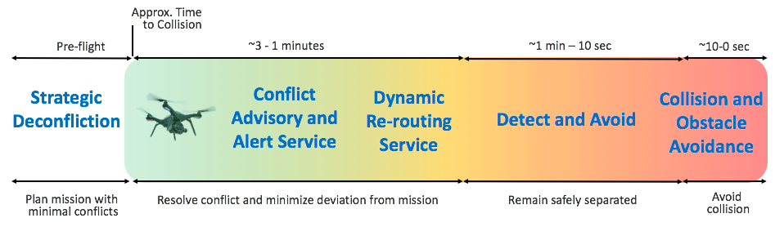
Figure 13: Example of separation strategy including USS Services and UAS capabilities.
The interplay between UAS Services and UAS capabilities in resolving airborne conflicts can be depicted along a conflict timeline. Figure 12 depicts an example of different services and capabilities supporting a UAS Operator in ensuring safe separation. Notably, each service and capability has slightly different objectives corresponding to their function and their applicability on the conflict timeline. For instance, at larger time to collision a Conflict Advisory and Alert Service may be informing to the UAS Operator of conflicts with the objective to resolve the conflict with minimal deviation from the current flight path, whereas a detect and avoid capability would be trying to keep the UA at a miss distance larger than a prescribed separation criterion, and a collision avoidance system has the objective to avoid a near mid-air collision to a different separation criterion. UTM Services may factor in more contextual information about the airspace, such as no-fly zones, to aid in compliance with regulatory requirements, whereas a collision avoidance capability may focus only on means to create as much distance as possible between aircraft to avoid a collision, regardless of the airspace context. The conflict timeline in Figure 12 is notional and the effective time horizon of each mitigation may vary based performance. Furthermore, the time horizon of each mitigation may overlap and the initiation of the mitigation may vary based on the what hazard is in conflict with the UA (e.g. timeline may vary if it is a manned aircraft vs. a static obstacle). In the UTM conflict mitigation model concept of detect and avoid capability can be decomposed into to safety functions: Detect, Track, Evaluate, Prioritize, Declare, Determine Action, Command, Execute, and Communicate. The Return-to-Course function is typically viewed as a navigation function rather than a conflict mitigation safety function, however for the context of this document it is assumed that it is applicable within the UTM Conflict Management model. Several safety functions can be accomplished using UTM services (e.g. surveillance, conflict advisory and alert, dynamic re-routing) as a mitigation and/or UAS capabilities as a mitigation (e.g. detect and avoid system). Typically, the safety function of detect and avoid can be partitioned into a self-separation function and collision avoidance function, however for the purposes of this document self-separation will be denoted as a detect and avoid (DAA) capability and collision avoidance (and obstacle avoidance) will be considered a separate function and will be addressed in subsequent sections. It is noteworthy that detect and avoid and collision avoidance share similar sub-functions and could also share similar services, sensors, and/or capabilities. The subsequent discussion will focus on UAS detect and avoid capabilities.

For UAS operations the US national airspace often provides few guarantees as to the nature of the potential airborne conflicts that could be experienced during a UAS operation. Existing requirements imposed on certain airspaces might increase the likelihood of more uniform equipage however there are exceptions to existing requirements and extenuating circumstances also can occur within these airspaces which motivates the need for a UAS detect and avoid capability when operating beyond visual line of sight. In lower risk environments UTM services may be sufficient to comply with see and avoid requirements for a UAS operating BVLOS, however in moderate to high risk environments it is generally understood that a collision avoidance system is required in conjunction with a UTM separation services and/or UAS DAA capability that meets the appropriate performance requirements. A DAA capability should be fit for purpose, only imposing requirements that are consistent with risk posed by the operation within the respective operational environment, and address airborne hazards existing from cooperative (e.g. transponder equipped) and non-cooperative traffic. A DAA capability must consist of the following elements:
- Sensors to detect non-cooperative airborne traffic (e.g. manned and unmanned)
- Sensors to detect cooperative airborne traffic (e.g. manned and unmanned)
- A tracking system that includes track initialization, data correlation, and track management, and incorporates multi-sensor information in the data correlation.
- Threat detection, prioritization, and alerting logic based on quantifiable separation standards
- An airspace informative display that provides contextual airspace and environmental information, traffic information, and advisory, alerts, and notifications of airborne hazards. (note alerting may vary based on the mode of operation: pilot-in-the-loop, pilot-on-the-loop, pilot-off-the-loop)

For DAA capabilities with higher level automation, suggestive and/or directive conflict resolution commands may be included as part of the airspace display capabilities or automated response may notify the remote pilot after an automated conflict resolution maneuver has been commanded or executed. When determining a course of action, a conflict resolution algorithm should consider: the threat aircraft, proximal traffic, airspace constraints, vehicle performance, environmental conditions, geographic containment, right-of-way rules, and separation standards.

Table 7: Example surveillance sensors for a DAA capability.
Sensors | Non-cooperative | Cooperative
Sensors | Airborne Radar  Ground-based Radar  Acoustics  Sonar  Electro-optical  Infrared  Laser Systems / LIDAR  Motion Detection / Cameras | Mode A/C/S Transponder  ADS-B In  Vehicle-to-Vehicle Communication (e.g. DSRC, C-V2X)

Table 8 provides example sensor technologies that have been proposed to address both the non-cooperative and cooperative airborne hazards. For small UAS there are practical considerations with respect to the size, weight, power, and cost of equipping with the necessary sensors to avoid airborne hazards and therefore UAS operators should consider supplementing UAS DAA capabilities with UTM separation services to meet any relevant regulatory safety requirements with regards to a conflict management strategy.

Since different sensors, algorithms, and modes of operation may be suitable to meet the needs of a DAA solution given the environment and conditions in which an operation is conducted it is useful to abstract key measures that could be used in evaluating the effectiveness of a DAA solution. The measures noted in Table 9 and Table 10 can be used to form the basis of a performance standard around different types of technologies that contribute to a DAA solution.

Table 8: Measures of performance for DAA solutions.
 | Measure of Performance | Description
Detection | Detection Range | The effective ranges that objects can be detected. This is often a mapping of detection range as a function of radar cross section.
Detection | Detection Range Accuracy | The position error associated with the detections.
Detection | Field of Regard - Azimuth | The horizontal angle describing the total area that can be captured by a movable sensor.
Detection | Field of Regard - Elevation | The horizontal vertical describing the total area that can be captured by a movable sensor.
Detection | Azimuth Accuracy | The error associated with the azimuth measure of the field of regard.
Detection | Elevation Accuracy | The error associated with the elevation measure of the field of regard.
Detection | Time-to-Track | The time it takes to establish a track of an object. This often requires multiple successive position report.
Detection | Probability of Detection | The likelihood that an object will be detected within the field of regard. Often derived as a ratio of detected targets to the sum of all radar returns. This probability will change given the range from the sensor and geometry of the encounter.
Detection | Update Rate | The rate at which a sensor will provide updates as to the position and time of detection of the objects within the field of regard.
Detection | Transmission Delay | Transmission time delay associated with transmitting data packet information from a source to a destination
Detection | Packet Loss Ratio | Packet Delivery/Reception Ratio: ratio of data-packets-sent to data-packets-received
Threat Tracking and Alert | Target Track Capacity | The number of objects that can be simultaneously tracked
Threat Tracking and Alert | Probability of Lost Tracks | The probability of a track losing consistent position returns and becoming stale
Threat Tracking and Alert | False Alarm Rate | An erroneous object detection decision caused by noise or other interfering signals exceeding the detection threshold
Threat Tracking and Alert | Frequency of Strengthening Alerts | Frequency of alert commanding increased maneuver magnitude
Threat Tracking and Alert | Frequency of Weakening Alerts | Frequency of alert commanding decreasing maneuver magnitude
Threat Tracking and Alert | Frequency of Reversal Alerts | Frequency of alert commanding reversal of maneuver direction
Threat Tracking and Alert | Frequency of Yo-Yo Alerts | Frequency of multiple subsequent reversal alerts for a given conflict
Threat Tracking and Alert | Look ahead Time | Temporal parameter used to predict the anticipated actions of aircraft over a time horizon
Threat Tracking and Alert | Expected UAS Response Time | The expected time associated with a UA completing a resolution maneuver
Threat Tracking and Alert | Expected Climb/Descent Rate | The rate of climb and descent expected of a UAS performing a vertical resolution maneuver
Threat Tracking and Alert | Expected Turn Rate | The rate of course change expected of a UA performing a horizontal resolution maneuver
Threat Tracking and Alert | Expected Time to Hover | The time required for a UA to halt forward motion and hover
Conflict Determination and Resolution | Conflict Duration | Total time from first conflict alert to clear of conflict.
Conflict Determination and Resolution | Horizontal Miss Distance at Closest Point of Approach | The horizontal distance at the point in which the UA and object reached the closest possible distance
Conflict Determination and Resolution | Vertical Miss Distance at Closest Point of Approach | The vertical distance at the point in which the UA and object reached the closest possible distance
Conflict Determination and Resolution | Total Horizontal Path Deviation | The summation of all horizontal relative distances between the current UA position and the desired path over the course of the route.
Conflict Determination and Resolution | Total Vertical Path Deviation | The summation of all vertical relative distances between the current UA position and the desired path over the course of the route.
Conflict Determination and Resolution | Maximum Horizontal Path Deviation | The maximum horizontal distance between the current UA position and the desired path over the course of the route.
Conflict Determination and Resolution | Maximum Vertical Path Deviation | The maximum vertical distance between the current UA position and the desired path over the course of the route.
Conflict Determination and Resolution | Probability of Induced Conflicts | The likelihood of a conflict resolution maneuver creating a secondary conflict with other objects
Conflict Determination and Resolution | Probability of Near Mid-air Collisions | The likelihood of an object having a near mid-air collision with the UA, given that two aircraft are at a relative state.
Conflict Determination and Resolution | Probability of Loss of Separation | The likelihood of an object coming within a proximity of the UA, defined by a prespecified spatial and/or temporal criteria.

In order to determine the effectiveness of a task and objectives for a DAA solution the measures of performance in Table 9 establishes quantitative means to assess the value attribute of the DAA solution. However, a DAA solution independent of context is not practical to determine whether the solution is effective, therefore Table 10 describes measures of suitability, which are measures of the DAA solution that demonstrate its ability to be supported in the operational environment. Measures of suitability are often more qualitative in nature than quantitative. As many of the conflict resolution tasks are dependent on the airspace in which a UA is operating Table 10 provides some example measures which are common to all environments but does not detail measures that may be specific within the context of a specific airspace or operational environment.

Table 9: Measures of suitability for DAA solutions.
 | Measure of Suitability | Description
Detection | Mean time to failure | The predicted elapsed time between inherent failures of a DAA solution during nominal operation
Detection | Availability | The probability that a system in operational at a given point in time under a set of environmental conditions. Availability is dependent on the reliability and maintainability of the system
Detection | Susceptibility to Weather | The ability of the DAA solution being available, and/or reliable under a given environmental condition
Threat Tracking and Alert | Separation Criteria | Spatial and/or temporal definition of required minimum separation between the UA and other objects
Threat Tracking and Alert | Alert Criteria | Spatial and/or temporal definition of required minimum separation in which a UA is alerted that action is needed to be taken to avoid a potential collision
Threat Tracking and Alert | Clear of Conflict Criteria | Spatial and/or temporal definition of the release of alert due to a hazardous object
Threat Tracking and Alert | Saliency of Display Information | The degree to which the information is relevant at the point in time in which it is accessed
Threat Tracking and Alert | Usability of Display Information | The degree to which the information was interpretable and understandable and met the purpose for which it was required
Threat Tracking and Alert | Usefulness of Display Information | The degree to which the information served the purpose that it was desired to fulfill
Threat Tracking and Alert | Reliability/Accuracy of Display Information | The degree to which information is available when required and is correct at the point in time at which it was reported and is error free
Threat Tracking and Alert | Appropriateness/Safety of Maneuver | Degree to which a maneuver is suitable & fitting to the problem/ situation and has a desired level of safety.

Collision and Obstacle Avoidance
Collision Avoidance is a UAS capability where the UAS takes appropriate action to prevent a midair collision with an airborne hazard. Typically for manned aircraft the separation volume called a near-midair collision (NMAC) is used to establish the minimum conflict avoidance separation distance to be maintained between aircraft. A NMAC is defined as an incident associated with the operation of an aircraft in which a possibility of collision occurs as a result of proximity of less than 500 feet to another aircraft, or could be more qualitatively reported by a pilot or flight crew member as a collision hazard existing between two or more aircraft. Quantification of the NMAC has been used in collision avoidance systems, such as the traffic collision avoidance system (TCAS) and is defined as when two aircraft come within 100 feet vertically and 500 feet horizontally. For UAS conflicts with manned aircraft it is generally accepted that the NMAC is an appropriate measure for a collision avoidance capability. However, for UA conflicts with other UA it is not unanimously agreed amongst the community that an NMAC is an appropriate measure to use as a collision avoidance separation criterion as the NMAC is inherently tied to the loss of life from a midair collision (MAC) which is not a direct consequence of a UA to UA collision. For a collision avoidance capability, action is expected to be initiated within a relatively short time horizon before closest point of approach and is considered the capability that is engaged when all other modes of separation have failed. Given the size, weight, power, and cost limitations of small UAS it may be necessary that collision avoidance systems leverage similar detection technologies as employed by a detect and avoid system, however the objectives of collision avoidance are inherently different than that of detect and avoid. As collision avoidance is final mitigation to resolve conflicts with airborne hazards its main objective is to maximize the distance between the UA and the airborne hazard within the minimal amount of time. Considering this objective, performance requirements for sensors should be at high levels of integrity and assurance (i.e. robustness) to ensure the effectiveness of the collision avoidance mitigation within the detection volume. Future considerations for refined NMAC definitions for conflicts between UA should be based on navigation performance to encourage efficient use of the airspace. UA navigation performance requirements and subsequent UA to UA NMAC definitions can be specified based on likelihood (e.g. density of UA operations) and consequence (e.g. population density) of a collision between unmanned aircraft for a given airspace.

Obstacle Avoidance is a UAS capability that is used to take appropriate action to prevent a collision with a static or a “low and slow” dynamic obstacle that is in proximity of the UA. Often obstacle avoidance would be used in the take-off and landing phases of flight or during unplanned emergency landings and initiate when the vehicle is near the surface of the earth. While described as an independent system in this document, the obstacle avoidance capability may share similar enabling technologies and sensors as the collision avoidance system to accomplish separation from obstacles. However, there is clear distinguishing differences between collision avoidance requirements and actions and those of an obstacle avoidance system. Closure rate between the hazard and the UA may be the most significant difference, where collision avoidance is designed to mitigate airborne hazards moving at higher velocities and obstacle avoidance addresses static obstacles and dynamic obstacles moving at slower velocities. Moreover, the actions produced by the systems may also yield different results. It may be more advantageous to descend during collision avoidance conflict whereas climbing or hovering may be a more appropriate response in obstacle avoidance hazards. The main objective of an obstacle avoidance system is to maintain a minimum distance between the UA and a terrestrial obstacle. Often this objective is achieved by halting forward motion towards the static obstacle and requires high robust sensor performance at very close proximity around the UA. Many challenges are posed on the interoperability between collision avoidance and obstacle avoidance systems if sensors are shared between the given technologies. DAA and collision avoidance systems must account for higher closure rates and require greater sensor range, whereas obstacle avoidance systems must perform in highly cluttered environments requiring short sensor range with high update rates.

Table 10: High-Level Requirements for Collision Avoidance and Obstacle Avoidance Capabilities.
High Level Requirement | Requirement Justification
A collision avoidance capability must be required for BVLOS operations. | This requirement addresses the residual risk of collision hazard in the event of a loss of link event.
A collision avoidance capability should use a minimum separation distance based on required navigation performance of an airspace. | This requirement promotes the safe and efficient use of airspace.
A collision avoidance capability must be an onboard automated capability. | This requirement addresses the residual risk of collision hazard in the event of a loss of link event.
A collision avoidance capability must maximize the distance between the UA and another aircraft within a minimal amount of time. | This requirement addresses the hazard associated with operating an aircraft so close as to create a collision hazard (e.g. Part 91.111, Part 107.37).
An obstacle avoidance capability must be required for Operations over People. | This requirement addresses the residual risk to persons or property due to an unplanned or emergency landing.
An obstacle avoidance capability should use a minimum separation distance based on required navigation performance. | This requirement promotes the efficient use of airspace and the consideration of safety with respect to persons and property on the ground.
An obstacle avoidance capability should use different minimum separation distance requirements for static and dynamic obstacles. | This requirement promotes the efficient use of airspace and the consideration of safety with respect to persons and property on the ground.
An obstacle avoidance capability must be an onboard automated capability. | This requirement addresses the residual risk of collision hazard in the event of a loss of link event.
An obstacle avoidance capability should have an onboard audible alert. | This requirement promotes indirect mitigations by non-participants on the ground by raising situation awareness.
An obstacle avoidance capability shall halt forward motion of the UA towards the obstacle or re-direct the UA away from the obstacle. | This requirement addresses the hazard associated with operating an aircraft in proximity of structures (e.g. Part 91.119, Part 107.351).

Given that the locus of control for DAA, collision avoidance and obstacle avoidance may overlap, future research should consider the interoperability between these systems. Furthermore, given the highly dynamic nature of dynamic obstacles in urban environments (e.g. pedestrians at a crosswalk), additional research is needed to establish guidelines, best practices, and policies for automated safe landing. An automated safe landing capability will require interoperability with obstacle avoidance and risk monitoring capabilities.

Appendix A: Off Nominal Conditions
During UAS flight operations there is the potential that a UAS may enter an off-nominal condition or encounter another aircraft that is in an off-nominal condition. Since small UAS will not carry passengers, the elevation of an off-nominal condition to the declaration of an emergency would only occur if there is a credible hazard posed to persons on another aircraft and/or persons on the ground. The potential for collision between UAS may also warrant hazard declarations when operations are occurring over people and could pose a probable likelihood of causing harm to persons on the ground. For the purposes of this document, the following off-nominal conditions shall be defined to capture the severity of the event:
- Urgency - A condition in which aircraft performance has been compromised but can still safely land; contingency procedures may need to be enacted and stakeholders may need to be notified.
- Distress - A condition in which aircraft performance has been severely compromised and safe landing is no longer certain; contingency procedures are enacted, and impacted stakeholders are provided notification and information relevant to maintaining safety of the NAS.
There are many credible hazards, noted in Table 12, which need to be addressed to operate UAS safely in the NAS, however this appendix addresses a subset of these critical hazards from the lens of conflict management.

Table 11: Critical hazards for UAS Operations.
Identifier | Hazard Risk Statement
R01 | Excursion from Operation Volume
R02 | Aircraft incursion on UAS Operation Volume
R03 | Loss of Control
R04 | Degradation or Loss of Command, Control, and Communication
R05 | Degraded or Loss of Services and Capabilities
R06 | Degraded or Loss of Navigation
R07 | Degraded or Loss of Surveillance
R08 | Adverse Environmental Conditions
R09 | Loss of Safe Landing Capability
R010 | Loss of Energy

R01: Excursion from Operation Volume
An Operation Volume represents the intent of a UA operating in the airspace and therefore a UAS Operator would conduct flight planning to define a flight geography that avoids areas of unacceptable air and ground risk. The USS would support an operator by incorporating the appropriate spatial and temporal buffering to define the operational volume, and onboard and ground-based mitigations would help contain the UA to within the Operation Volume. However, if there are failures within this layered mitigation, they pose a potential threat to other aircraft operating in a local proximity and/or a potential threat to persons or property on the ground. Each off-nominal scenario is different, however often an excursion from an operation volume is caused by exogenous atmospheric factors (e.g. turbulence, wind gusts), human error, or a component failure on the UAS.
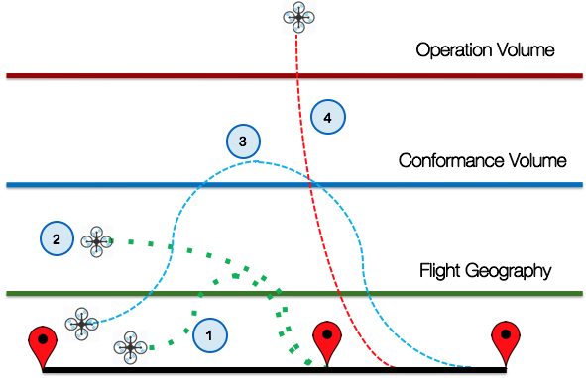
Figure 14: Scenarios of unmanned aircraft departing flight path and blundering through different operational boundaries.
While there are numerous possibilities of factors that can lead to an off-nominal condition the following procedures can serve as guidance for expected actions, reportable events, and data logging requirements. The following scenarios are related to excursion from the Flight Geography:
- Momentary excursion and return to the Flight Geography
- Prolonged exposure outside the Flight Geography
- Large excursion that results in a breach of the Conformance Volume and timely return to the Flight Geography
- Excursion outside of the Operation Volume
UAS Operators should be conducting flight planning, incorporating onboard technologies that support safe use of the airspace, and designing Flight Geographies such that excursions from flight geographies are a rare occurrence. The space between the Flight Geography and the Conformance Volume serves as a buffer to allow for these occasional deviations, however it is expected that the UAS Operator is employing contingency actions to reduce the severity of the deviations. Large deviations beyond the Conformance Volume, sustain time outside of the Flight Geography and/or excursions from the Operation Volume represent a deviation from the intent of the operation and are grounds for communication of an off-nominal condition to other stakeholders of the airspace. The roles and responsibilities of UAS, UAS Operator and USS are anticipated to change as the progression from a nominal state of the aircraft transitions into an urgency or distress condition. Table 13 details the roles and responsibilities delineation for the USS, UAS Operator, and UAS during deviations from an Operation Volume. These procedures assume the persistent command, control, and tracking of the aircraft are maintained during the excursion. Procedures associated with the loss of command, control, and communications with the UA are addressed elsewhere in this Appendix.

Table 12: Roles and responsibilities during excursion from Operation Volume.
 | USS | UAS Operator | UAS
Within Flight Geography | Responsible for monitoring UA conformance to Flight Geography | Responsible for:  - Defining Flight Geography and containing UA within Flight Geography  - Ensuring UA Geographic Flight Containment mitigations are enabled (if applicable) | Responsible for:  - Enforcing Geographic Flight Containment Mitigations (if applicable)  - Displaying Operation Volume to UAS Operator  - Providing alerts and executing corrective action if preventative or recovery thresholds are crossed
Excursion from Flight Geography | Responsible for:  - Notifying UAS Operator of Flight Geography breach  - Logging Event Data as Noncompliance Event | Responsible for commanding corrective maneuvering to return UA to Flight Geography, and/or modifying the Flight Geography to maintain ACTIVE operation state | Responsible for executing corrective maneuvering to return UA to Flight Geography
Breach of Conformance Volume | Responsible for:  - Notifying UAS Operator of Conformance Volume breach  - Declaring NON-CONFORMING operation to USS Network  - Declaring an operation ROGUE to the UAS Operator and USS Network when the UA has multiple successive breaches of the Conformance Volume  - Logging Event Data as Off-nominal Event by soliciting an Off-nominal Report from the UAS Operator | Responsible for:  - Commanding corrective maneuvering to return UA to Flight Geography, and/or modifying the Flight Geography to maintain ACTIVE operation state  - Completing an Off-nominal Report upon the completion of the operation | Responsible for executing corrective maneuvering to return UA to Flight Geography
Prolonged exposure outside of Flight Geography | Responsible for:  - Notifying UAS Operator of Time-to-Violation prior to NON-CONFORMING operation declaration  - Notifying UAS Operator of Time-to-Violation prior to ROGUE operation declaration  - Declaring NON-CONFORMING or ROGUE operation to USS Network, based on the duration of exposure outside the Flight Geography  - Share position information of UA with USS Network  - Logging Event Data as Off-nominal Event by soliciting an Off-nominal Report from the UAS Operator | Responsible for:  - Commanding corrective maneuvering to return UA to Flight Geography, and/or modifying the Flight Geography to maintain ACTIVE operation state  - Notifying USS if unable to provide corrective maneuver or UA is unable to execute corrective maneuver by declaring a state of URGENCY or DISTRESS and ABORTING the operation  - Update vehicle-to-vehicle status message to reflect off-nominal condition (if applicable)  - Completing an Off-nominal Report upon the completion of the operation | Responsible for:  - Executing corrective maneuvering to return UA to Flight Geography  - Providing vehicle health status, command and control link status, and telemetry to the UAS Operator to determine whether execution of corrective maneuver is achievable.
Return to Flight Geography | Responsible for declaring the return of the UA to an ACTIVE operation to the UAS Operator and the USS Network | Responsible for:  - Verifying remaining UA flight path is contained within Flight Geography  - Ensuring UA Geographic Flight Containment mitigations are re-enabled (if applicable) | Responsible for:  - Enforcing Geographic Flight Containment Mitigations (if applicable)  - Displaying Operation Volume to Operator, and  - Providing alerts and executing corrective action if preventative or recovery thresholds are crossed
Excursion from Operation Volume | Responsible for:  - Notifying UAS Operator of Operation Volume breach  - Declaring ROGUE operation to USS Network  - Share position information of UA with USS Network  - Logging Event Data as Off-nominal Event by soliciting an Off-nominal Report from the UAS Operator  - Declaring URGENCY or DISTRESS condition to FIMS (to disseminate to the relevant air traffic facilities) if UA poses a credible hazard to nearby manned aircraft operations  - Providing any relevant data to FIMS  - Increase USS service area to capture expected flight path (as applicable) | Responsible for:  - Initiating safe landing procedures to route UA to the nearest location suitable for a safe landing  - Notify USS of intended flight path while ABORTING OPERATION, to ensure awareness of other operations impacted by the change  - Update vehicle-to-vehicle status message to reflect off-nominal condition (if applicable)  - Completing an Off-nominal Report upon the completion of the operation | Responsible for:  - Executing Safe Landing Procedure  - displaying any revisions to Operation Volume to UAS Operator

The Log Event Data is a set of data that is requested from a UAS Operator and/or USS, recorded for time histories over the course of the event, and made available upon request by appropriate governmental agencies (e.g. FAA, NTSB).

As part of the Performance Authorization process, a UAS Operator will get approval for an Area of Operation in which the measures to ensure safety of the operation have been deemed appropriate given the Operators safety mitigations. Based on the design of the Area of Operations, the air risk and/or ground risk outside of this Approved Area of Operations could potentially be unacceptably high given the safety mitigations employed by the UAS Operator. A breach of the approved Area of Operation may constitute communication between a USS and relevant air traffic facilities through FIMS when operations are conducted adjacent to controlled airspace if a credible hazard exists.

R02: Incursion of Intruding Aircraft into the Operation Volume
Operation Volumes are constructs that aid a UAS Operator in ensuring that their UA does not breach airspace with flight restriction and reduces the likelihood of airborne conflicts with other UA in the airspace. While operation volumes can be issued as notices of intent to operate to other aircraft in the airspace, via a notification service, they do not constitute as “reservations” or exclusive rights to airspace use over a duration of time. Therefore, a manned aircraft, who is not participating in UTM, is within their rights to use airspace that has been published to UTM as a UAS Operation Volume. This inherent fact underlines the need for clarity on right of way rules, such as those established under 14 CFR Part 91.113, 14 CFR Part 91.111, and 14 CFR Part 107.37. While “well clear” definitions are currently in development (e.g. Science and Research Panel recommended well clear definition between sUAS and manned aircraft), it should be considered that the context of each airspace may warrant different application of separation requirements. Current discussions have explored the concept of UA to manned aircraft separation employing a dualistic separation by airspace structure (i.e. expected manned aircraft routes and traffic patterns) and separation by a “well clear” standard to reduce the burden on UAS Operators to deploy large size, weight, power, and cost equipment, and design complicated onboard automation capabilities to enter complex airspace that already benefits from air traffic control and airspace structure. This dualistic separation approach would be applied by UAS Operators defining an Operation Volume a sufficient separation from a known airspace structure and monitoring manned aircraft that fly within that structure. If manned aircraft are flying within the bounds of their airspace structure and the UA are contained within the bounds of their Operation Volume then safe separation has been achieved, even in the distance between the airspace structure and the Operation Volume is smaller than a “well clear” separation definition. If either the manned aircraft or the UA have deviated from their expected airspace structure/Operation Volume, then separation requirements are dictated by the “well clear” definition. This approach has inherent draw-backs in that it relies on the assumption that a characterization of where manned aircraft operate in a given airspace has been conducted to derive the expected airspace structures and the use of surveillance of manned aircraft that capture the status of aircraft within those structures is available. Service Suppliers that offer a surveillance service could satisfy these assumptions to provide the benefits of smaller separation requirements to the UAS Operator. In the absence of this dualistic construct the more conservative “well clear” definition would apply for each operator to comply with and diligence is required by the UAS Operator to design their Flight Geography in such a way that it would not inherently trigger false alarms for a DAA system around known traffic patterns.
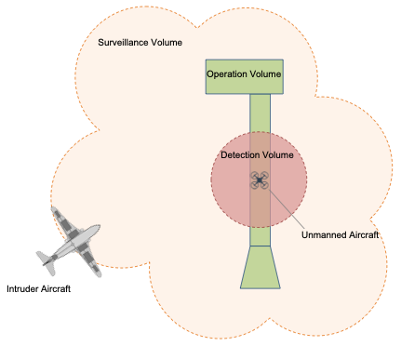
Figure 15: Depiction of boundaries considered for the incursion of an intruding aircraft.
As an operator determines the mitigations employed to address conflict management within the airspace they wish to fly, an understanding of how the interplay between the mitigations is warranted. Figure 15 depicts the surveillance volume provided by a surveillance service or ground surveillance capability, the Operation Volume defined by the UAS Operator, and the detection volume defined by the performance of a detect and avoid and/or collision avoidance capability. For a conflict mitigation strategy that employs both services and capabilities the following requirements should be considered
- An Operation Volume should consider the detection volume in its definition to reduce false alerts
- An Operational Volume must be wholly defined within the boundaries of the surveillance volume to reduce missed alerts
- A detection volume must be wholly contained within the boundaries of the surveillance volume across the entirety of the flight path to reduce popup alerts
Inconsistencies in situation awareness, alerting, and corrective actions may be caused if care is not taken by the Operator in ensuring that the surveillance volume properly supports their operation and the definition of the Operation volume and required performance of the detection volume are not appropriately defined.
Table 13: Roles and responsibilities during intruder incursion on Operation Volume.
 | USS | Surveillance Services and Capabilities | UAS Operator | UAS
Manned Aircraft within Surveillance Volume (i.e. surveillance service) | Responsible for:  - Notify USS Network of any operations modifications to the Operation Volume | Responsible for:  - Making position reports available for all intruding manned aircraft in the Surveillance Volume  - Tracking intruder aircraft and providing updates to known position, heading, speed, etc.  - (Optional) Providing alerts to UAS Operator / UAS of intruder aircraft detected within close proximity of UAS Operation Volume or UA | Responsible for:  - Displaying current position of UA and nearby intruder aircraft on the same display  - Track intruder manned aircraft and UA aircraft to determine the threat of the intruder to the operation  - Notify USS of any Operation Volume modifications, as a pre-emptive action taken to avoid a potential conflict | Responsible for:  - Providing current UA position and operation information
Manned Aircraft within Detection Volume (i.e. detect and avoid capability) |  |  | Responsible for:  - Monitoring relative position and closure rates between UA and intruder  - Determine if corrective action in needed based on DAA alerting and separation requirements (e.g. well-clear)  - Notify USS of any Operation Volume modifications, taken to avoid a potential well clear violation | Responsible for:  - Detect and track intruder through DAA capability  - Providing DAA alerting to UAS Operator for determination of corrective action  - Executing Corrective Action to resolve conflict  - Monitoring conflict with intruder and providing a clear of conflict notification to the UAS operator
Manned Aircraft breaches Flight Volume
Manned Aircraft in close proximity (i.e. collision avoidance capability) |  |  | Responsible for:  - Notify USS of any Operation Volume modifications, taken to avoid a potential near midair collision (NMAC)  - Completing an Off-nominal Report upon the completion of the operation | Responsible for:  - Detect and track intruder through collision avoidance capability  - Notify UAS Operator of collision threat  - Determine and execute corrective action to avoid a NMAC  - Notify UAS Operator of collision avoidance corrective action initiation  - Monitoring conflict with intruder and providing a clear of conflict notification to the UAS operator

R03: Loss of Control
For the purposes of this document, a loss of control will be defined as a loss of predictable behavior of the UA. Common causes of a loss of control may be a vehicle malfunction resulting in a “fly away”, intentional or unintentional interference with the command and control capabilities of the aircraft by third parties (e.g. cyber-attack), or adverse atmospheric conditions resulting in the aircraft exhibiting unpredictable behavior. One of the challenges for the UAS Operator is ensuring that they have a sufficient awareness of their locus of control of the vehicles behavior and identifying when unexpected behavior is occurring. Common ways operators may accomplish this monitoring is through direct means such as tracking the UA along its flight path, observing responsiveness of the execution of command maneuvers and the observation of health monitoring systems onboard the vehicle. Indirect means may also be employed to support UAS Operators, such as observation of their aircraft by other UAS Operators though remote identification, vehicle-to-vehicle communication or UAS reports (UREP) or distress broadcasts from the UA as observed by other ground systems. The loss of control is a hazardous condition for UAS and should be declared immediately by a UAS Operator once the state is identified. Loss of control constitutes an urgency or distress condition given the environment in which the UA is being operated and notice should be provided from a UAS Operator to a USS and subsequently to impacted ATC facilities through FIMS (when applicable). Table 15 details the roles and responsibilities associated with an UA loss of control.

Table 14: Roles and responsibilities during a loss of UA control.
 | ATC | USS | UAS Operator | UAS
Excursion from Operation Volume due to Loss of Control | None | Responsible for:  - Notifying UAS Operator of Operation Volume breach  - Declaring ROGUE operation to USS Network  - Share position information of UA with USS Network  - Logging Event Data as Off-nominal Event by soliciting an Off-nominal Report from the UAS Operator | Responsible for:  - Initiating safe landing procedures to route UA to the nearest location suitable for a safe landing  - Notify USS of intended flight path while ABORTING OPERATION, to ensure awareness of other operations impacted by the change  - Update vehicle-to-vehicle status message to reflect off-nominal condition (if applicable)  - Completing an Off-nominal Report upon the completion of the operation | Responsible for:  - Executing Safe Landing Procedure  - displaying any revisions to Operation Volume to UAS Operator
Incursion into non-approved controlled airspace due to Loss of Control | Responsible for:  - Request relevant information from FIMS to determine impact on manned operations  - Initiating airspace controls and actions to ensure aircraft under ATC services are separated from the UA under URGENCY or DISTRESS condition | Responsible for:  - Determining whether UA poses a credible hazard to manned aircraft  - Declaring URGENCY or DISTRESS condition to FIMS (to disseminate to the relevant air traffic facilities) if UA poses a credible hazard to nearby manned aircraft operations  - Providing any relevant tracking and operation data to FIMS  - Increase USS service area to capture expected flight path (as applicable) | Responsible for:  - Provide relevant UAS and operations information to USS to support USS or FIMS contingency management mitigations | Responsible for:  - Executing Automated Detect and Avoid and/or collision avoidance Functions to not pose a collision hazard to manned aircraft  - Executing Automated Safe Landing Procedure based on communication timeout  - displaying any revisions to Operation Volume to UAS Operator (if possible)

To ensure the safety of the airspace, it is the responsibility of all UAS operators to support efforts to safely address instances of a loss of control. To this end the following would be required of all UAS Operators receiving services from a USS:
- A UAS Operator flying beyond visual line of sight MUST be connected to the Flight Information Management System (FIMS) through a UAS Service Supplier function
- A UA in vehicle-to-vehicle communication with a UA in distress MUST report that encounter to the UAS Operator who relays that information to their subsequent USS and that information is shared with the local USS Network.
- The “right of way” of unmanned aircraft MUST be provided to the UA under a known urgency or distress condition.
The Log Event Data is a set of data that is requested from a UAS Operator, recorded for time histories over the course of the event, made available to other entities impacted by the event. The following table details some of the data logging requirements for loss of control event.

Last Known Information | Format | V2V | UAS Operator to USS | USS to Other Impacted Operators | USS to FIMS (if required)
GUFI | [text] | X | X | X | X
Latitude | [float] | X | X | X | X
Longitude | [float] | X | X | X | X
Altitude [WGS84] | [float] | X | X | X | X
Course | [float] | X | X | X | X
Ground Speed | [float] | X | X | X | X
Remaining Endurance | [float] |  | X |  | X
C2 Data Link Status | [Boolean] |  | X |  | X
Navigation Integrity Status | [Boolean] |  | X |  | X
Control of UA | [Boolean] |  | X |  | X
Priority Message | [text] | X | X | X

R04: Loss or Degradation of Command, Control, and Communication
The procedures and requirements associated with loss or degradation of the command and control link are the primary topic of discussion in the Communication and Navigation Working Group within the RTT, however this document considers the implications of this condition on ensuring separation. Table 16 describes different derived requirements to be considered to address the collision hazard condition under a loss of command, control, and communication.

Table 15: Communication Contingency Management Requirements.
Re. ID | Requirement Text | Requirement Justification
OSM.001 | The operator MUST have the means to detect loss of communication between aircraft and its operator. | The UTM system is built for operators to perform missions within constraints and directives that can change over time. Therefore, operators must know whether they can communicate or not with their UA to adhere to dynamic constraints and directives.
OSM.002 | The operator SHOULD make the means to detect loss of communication with aircraft known to USS. | USS, with appropriate data from Supplemental Data Service Provider (SDSP), should be able to provide communications quality of service information for a mission when the means to detect loss of communication is known. This will likely reduce the loss of communication incidence during a mission.
OSM.003 | The operator MUST define steps to mitigate the loss of communication with aircraft. | Operators must communicate with their UA to adhere to constraints and directives, which can change during a mission. Therefore, mitigation steps must be in place to resolve the loss of communication safely.
OSM.004 | The operator SHOULD make the steps to mitigate the loss of communication with aircraft known to USS. | USS, with similar information from other operators and adjacent USSs, should be able to support mitigation steps with minimal impact on overall operations under its service.

A loss of command and control does not inherently indicate that an operation must be aborted. For a UA that has onboard autonomous mission capabilities and detect and avoid capabilities, BVLOS operations may continue the operation by providing notice to other airspace users of a degraded state and utilizing the advance onboard technology to navigate and separate from other aircraft. Furthermore, operations over people may also continue with a sufficient autonomous safe landing capability. If these advance capabilities do not exist, a more conservative approach must be taken to ensure safety. Another means of regaining control of the operation is for a UA to have redundancy in the C2 links to reduce the likelihood of a loss of C2. In the event of a loss of C2 a UA may opt to execute procedure to regain the C2 link, this procedure must be communicated with the USS and any relevant changes to the Operation Volume to execute the procedure must be input immediately. The USS shall change the operation state to non-conforming to notify nearby operators of a reduced UAS Operator capability and a loss of USS tracking. Furthermore, upon a loss of C2 the UA shall update the V2V message to represent the change in controllability state and other UAs receiving this update via V2V communication shall submit a UREP to notify the USS network of the whereabouts of the UA under loss of C2 condition.

Table 16: UAS and Operator navigation requirements under loss of communication operating condition.
Hazard Condition | Derived Conflict Management Requirements
Collision hazard under loss of communication | UA shall assume authority to execute collision avoidance maneuvers during a loss of communication.
Collision hazard under loss of communication | UAS Operator shall define alternative landing location which are known to the UA and USS as part of their flight planning.
Collision hazard under loss of communication | UAS shall display link quality of service to the UAS Operator via an airspace display interface.
Collision hazard under loss of communication | Under a loss of communication condition, the UAS Operator shall provide necessary partial and/or temporal updates to the Operational Volume to be consistent with the contingency mitigation steps
Collision hazard under loss of communication | Under a loss of communication condition, the UAS Operator shall monitor surveillance services, surveillance capabilities, and UREP reports to validate conformance to UA contingency mitigation
Collision hazard under loss of communication | Under a loss of communication condition, UA shall share information regarding degraded communication capability via the vehicle to vehicle communication

If the C2 link cannot be regained after a duration of time the UA shall initiate a safe landing sequence at a pre-designated alternate landing location. The UAS Operator shall be monitoring the expected procedure and time associated with the contingency mitigation plan and close the Operation Volume after the contingency plan is expected to complete. During the loss of link and subsequent contingency plan, the UAS Operator shall be monitoring any available surveillance feeds, including UREPs, to identify any deviations from the expected contingency plan. If a deviation is observed the UAS Operator must immediately declare an emergency to their respective USS and provide the last known information regarding the flight. The loss of C2 process is depicted in Figure 1.
Figure 16: High-level Loss of C2 Communications Mitigations.

R05: Loss or Degradation of UAS Services
Service that support a UAS operation will be utilized by a UAS Operator to ensure safety, security, mission success, efficient use of the airspace and equitable access to the airspace. Not all services will be considered critical for the safety of operations, however those that are critical to operations pose challenges to UAS Operators when the integrity or availability of those services are in question. In the conflict mitigation model, the services that result in harm can be categorized as follows:
- Degraded supplemental data services that are inherent to the conflict mitigation strategy of a single operator. An example is the loss of connection of UAS Operator with a Surveillance Service provided by a SDSP.
- Degraded shared services that are inherent to the conflict mitigation strategy that was utilized amongst many UAS Operators. An example is the loss of performance of a Conflict Advisories and Alert Service provided by a USS that supported a large UAS Operator subscription based in a geographic area.
- Degraded Service Provider who provides a set of services that are inherent to conflict mitigation strategies for a UAS Operator subscription base in a geographic area. An example is the loss of a surveillance data feed that degrades the performance of Conflict Advisory and Alert Services, Flight Planning Services, and Dynamic Re-routing Services or a loss of all services provided by a USS.
- Degradation of the Flight Information Management System which is a requirement for UAS Operators to connect to if conducting BVLOS operations in order to receive communications, directives, and information regarding the state of the airspace from the ANSP.
To ensure the safety of the airspace, it is the responsibility of all UAS operators, USS and SDSP providers to support efforts to safely address instances of a loss of UAS services. To this end the following would be required of each of the stakeholders:
- A UAS Service Supplier MUST monitor the integrity, availability, and security of the services they provide.
- A Supplemental Data Service Provider MUST monitor the integrity, availability, and security of the services they provide.
- A USS and/or SDSP supporting a UAS Operator MUST provide the health status information of their services AND notify UAS Operators if the performance of their service has degraded below a range specified in their service agreement
- A UAS Operator MUST monitor the availability of the connection to the services providers they are utilizing to support their operation
- A UAS Operator MUST monitor the integrity and performance of the services supporting their operations to ensure that they are following their performance authorization
The determination of the phase and severity of emergencies due to a loss of UAS services is circumstantial and could yield an infinite variety of possible emergency situations therefore specific procedures can heuristically be described but would be on a service by service basis. However, a basic process can be followed in the absence of more explicit procedures established by the service providers.
- Upon a loss of degradation of a service the UAS Operator attempts to regain the service or waits a pre-specified amount of time for the service provider to regain the service before continuing with their mission
- If the service is unable to be restored then UAS Operator aborts their operation, updates their route to the nearest pre-specified alternate landing location, updates their Operation Volume (if possible), and commands a landing sequence once they have arrived at their alternate land location. It should be noted that during this transition, UAS tactical separation mitigations and available USS services are used to ensure conflict resolutions while en-route to the alternate landing location.
- If a loss of FIMS is encountered the UAS Operator has a duration of time prespecified by the ANSP before initiating any mission abort actions, as FIMS is not critical to ensuring separation between aircraft. However, without connecting to FIMS a UAS Operator has lost the ability to receive communications from the ANSP with regards to the accessibility and state of the airspace.

R06: Loss or Degradation of Navigation
Table 17: Navigation Contingency Management Requirements.
Re. ID | Requirement Text | Requirement Justification
OSM.005 | The operator MUST have the means to detect loss of aircraft onboard navigation. | The UTM system is built for operators to perform missions within constraints and directives. Therefore, when UA is not maintaining the necessary navigation solution accuracy and integrity to adhere to constraints and directives, the operator must know this condition.
OSM.006 | The operator SHOULD make the means to detect loss of aircraft onboard navigation known to USS. | USS, with appropriate data from SDSP, should be able to provide navigation service quality forecast for UAS mission when its means to detect loss of navigation is known. This will likely reduce the loss of navigation incidence during a mission.
OSM.007 | The operator MUST define steps to mitigate the loss of aircraft onboard navigation. | UA must maintain the necessary navigation solution accuracy and integrity to adhere to constraints and directives. Therefore, mitigation steps must be in place to resolve the loss of navigation safely.
OSM.008 | The operator SHOULD make the steps to mitigate the loss of aircraft onboard navigation known to USS. | USS, with similar information from other operators and adjacent USSs, should be able to support mitigation steps with minimal impact on overall operations under its service.
OSM.009 | The operator MUST collect off-nominal situation data. | When UTM operations encounter off-nominal situations, data must be collected to take lessons learned to reinforce operational compliance and to enhance operational safety.

The procedures and requirements associated with loss or degradation of the command are not explicitly covered in this document however considerations of the implications of this condition on ensuring separation are explored. Table 19 describes different derived requirements to be considered to address the collision hazard condition under a loss of navigation.

Table 18: UAS and Operator navigation requirements under loss of navigation operating condition.
Hazard Condition | Derived Conflict Management Requirements
Collision hazard under loss of navigation | UA shall assume authority to execute collision avoidance and obstacle avoidance maneuvers until a UA is on the ground
Collision hazard under loss of navigation | UAS Operator shall define alternative landing location which are known to the UA and USS as part of their flight planning
Collision hazard under loss of navigation | UAS shall display navigation quality of service to the UAS Operator via an airspace display interface
Collision hazard under loss of navigation | Under a loss of navigation condition, the UAS Operator shall provide necessary partial and/or temporal updates to the Operational Volume to be consistent with the contingency mitigation steps
Collision hazard under loss of navigation | Under a loss of navigation condition, the UAS Operator shall declare an emergency to the USS
Collision hazard under loss of navigation | Under a loss of navigation condition, UA shall share information regarding loss of navigation capability via the vehicle to vehicle communication

The navigation function is a critical enabler of BVLOS, operations over people, and can fundamental to supporting many onboard separation technologies. In environments in which the UA is flying over areas with low ground risk and even low air risk the required performance of the navigation capabilities might be minimal for BVLOS operations; such as only requiring a UA to have a global navigation solution. Whereas operations over people heighten the navigation requirement to include both a global and local navigation solution and a safe landing capability. Furthermore, to support separation, a collision avoidance and obstacle avoidance capability would need to be onboard the UA. In the event of a loss of navigation condition, where the global navigation source is lost, if the local navigation source is available the operation can continue while the quality service of the local navigation source is maintained. A navigation quality of service degradation alert will be displayed to the UAS Operator and the UA will attempt to regain the global navigation source to continue the full operation. If the global navigation source is not regained or the local navigation source becomes unavailable, then UA would initiate a safe landing sequence. The UAS Operator will modify the Operation Volume to communicate the safe landing sequence to the USS, declare an emergency to the USS as the UA tracking will no longer be available/reliable. If equipped with a V2V communication capability, the UA will notify other UA in the vicinity of an emergency state due to loss of navigation. Other UAs receiving this update via V2V communication shall submit a UREP to notify the USS network of the whereabouts of the UA under loss of navigation condition. The UAS Operator shall send all required off-nominal information regarding the loss of navigation to the USS as required.

Federal Aviation Administration. “UAS Traffic Management Concept of Operations v1.0”, March 2018. https://utm.arc.nasa.gov/docs/2018-UTM-ConOps-v1.0.pdf
Federal Aviation Administration. “UAS Traffic Management Concept of Operations v2.0”, March 2020. https://www.faa.gov/uas/research_development/traffic_management/media/UTM_ConOps_v2.pdf
Rios, Joseph L, Irene S. Smith, David R. Smith, UAS Reports (UREPs): Enabling Exchange of Observation Data Between UAS Operations. NASA Technical Memorandum. NASA/TM-2017-219462. February 2017. http://hdl.handle.net/2060/20170003878
Surveillance Services may be provided through a USS or directly to the UAS Operator/UAS as a supplemental data service provider. Surveillance Capabilities could be provided by ground surveillance as described in Section 7.2.8.
Jung, J., & Nag, S. (2020). Automated Management of Small Unmanned Aircraft System Communications and Navigation Contingency. In AIAA Scitech 2020 Forum (p. 2195).
J. Jung, S. Nag, H. C. Modi, “Effectiveness of Redundant Communications Systems in Maintaining Operational Control of Small Unmanned Aircraft,” 38tth DASC 2019, San Diego, CA, September 8-12, 2019., in press.
Jung, J., & Nag, S. (2020). Automated Management of Small Unmanned Aircraft System Communications and Navigation Contingency. In AIAA Scitech 2020 Forum (p. 2195).

