Sensitivity of the ACCP Value Framework
Science Benefit Score

John McLaughlan
Virginia Tech, Blacksburg, VA
Marie L. Ivanco, Christopher A. Jones², Shaun A. Deacon³
NASA Langley Research Center, Hampton, VA, 23681

NASA’s priorities for Earth Science are informed by the 2017-2027 Decadal Survey for Earth Science and Applications from Space of the National Academies of Sciences, Engineering and Medicine. In that document, five Designated Observables are identified as priorities for implementation: Aerosols, Cloud-Convection-Precipitation, Surface Biology, Mass Change, and Surface Deformation Change. In 2019, NASA initiated four multi-year studies to formulate, assess, and recommend potential Observing System concepts that are responsive to the recommendations of the Earth Science Decadal Survey. The Aerosols, Clouds, Convection, and Precipitation (ACCP) study investigates opportunities for synergistic science resulting from implementations that combine both Aerosols science objectives and Clouds, Convection, and Precipitation science objectives.
The formulation and assessment of science-driven space mission concepts is challenging. The formulation of these missions involves defining science goals and objectives, gathering information on the state of the art of instrument capabilities, documenting the Program of Record and forecasting satellite lifetimes, defining feasible alternatives for spacecraft platforms and access to space, and identifying potentially enabled applications. The assessment of the Observing Systems concepts that are put forward is a complex activity. Study teams must assess many alternatives against multiple objectives of varying nature. The task’s complexity is increased by the great number of stakeholders that have an interest in the Observing Systems recommended at the conclusion of the study as there typically are as many value systems as stakeholders involved. As a result, heuristic-based approaches are insufficient to assess the sets of Observing Systems concepts that are formulated, and a structured analytical approach is required. For the ACCP study, a Value Framework was designed to introduce structure, transparency, and traceability in the decision process.
To assess the value of an Observing System, the ACCP study team uses the Value Framework to consider the benefits provided by an Observing System with respect to the associated cost and risk. Benefits are then further decomposed into three distinct categories: benefits obtained from the achieved science, benefits obtained from potentially enabled applications, and benefits obtained in the programmatic domain (Figure 1.). Approaches have been developed and implemented to assess these five components of Value. This paper focuses on the sensitivity associated with the assessment of the science benefit of the ACCP Observing System concepts.
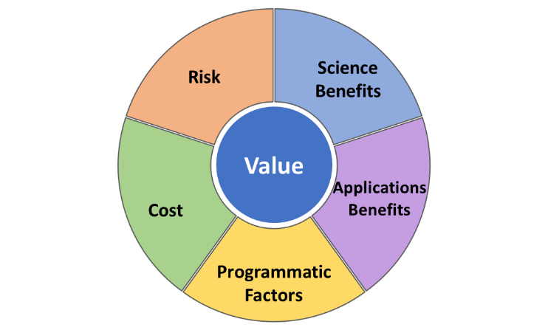
Figure 1: The Five Components of Value
Here, we define the science benefit of an Observing System concept as the evaluation of the degree to which that concept addresses each science objective of the Science and Applications Traceability Matrix (SATM). In the SATM, the ACCP science team has mapped the research goals outlined in the Earth Science Decadal Survey to eight science objectives. Geophysical variables of interest are associated with each science objective, and minimum and enhanced desired uncertainty and instrument capabilities are defined for these geophysical variables.
In the ACCP Value Framework, science benefit is decomposed into two elements: Utility and Quality. Utility is defined as the importance of a geophysical variable in addressing a given science objective. It is independent of the Observing System concept that is being assessed and resides within the SATM. Utility has been quantified by the subject matter experts of the Science and Applications Leadership Team by means of a modified Delphi method.
Quality is defined as how well a geophysical variable is obtained. Quality is therefore dependent upon the Observing System concept under study. Quality scores are produced by Science Impact Teams, who use Observing Systems Simulation Experiments (OSSEs) to compare the predicted performance of the instruments suites with the desired capabilities listed in the SATM. The simulation results are augmented by Expert Judgment to compensate for some of the simulation’s limitations.
Utility and Quality are then combined into a science benefit score for each geophysical variable. These science benefit scores are then further combined to yield an aggregated science benefit score for each objective of the SATM a given Observing System concept. The approach for conducting the assessment of the science benefit of the Observing System concepts developed for the ACCP study has been described in greater detail in Ivanco and Jones⁴.

Prior to and during the implementation of the approach, it was important to characterize the behavior of the science benefit scores. Several questions were investigated to confirm that the approach would enable a meaningful comparison of the concepts and provide for effective differentiation between these concepts. To that end, it was important to understand the impacts of two main concerns on the science benefit score. First, the impact of atypical score distributions was investigated, such as the impact of clustered Utility or Quality scores on the aggregated science benefit score. Second, the impact of the number of subject matter experts, their scoring style, and the sensitivity of the aggregated group results to a score submitted by one individual were characterized.
This paper presents the results of a sensitivity analysis that was conducted to answer these research questions. Topics that are addressed in the paper are: the sensitivity of the Utility score, the impact of the Utility score average on the aggregated science benefit score, the sensitivity of the Quality score, the impact of an individual’s use of the scoring scale (narrow vs. wide scoring), the impact of the scores provided by one individual on aggregated group results, and the behavior of the combined science benefit score based on the range of scores obtained for Utility and Quality.
This paper includes derivations of the sensitivity analysis equations, numerical analyses of the behavior of the combined benefit score, and the conclusions drawn from the results of the work that was conducted. This sensitivity analysis provided important insights in the design of the approach used to assess the science benefit of Observing System concepts for the ACCP study. The results of this analysis were key to ensuring that the aggregated science benefit scores would enable the team to differentiate and contrast across concepts. They also supported the characterization of the potential impact of a single subject matter expert on the aggregated group results to inform group composition and participation. Lastly, the analysis provided more confidence in the approach, by allowing a greater understanding of the behavior of the scoring process, therefore ensuring transparency and traceability in the assessment. The paper discusses this series of benefits associated with the results obtained from the sensitivity analysis in the concluding remarks.

4 Ivanco, M., & Jones, C. (2020). Assessing the Science Benefit of Space Mission Concepts in the Formulation Phase, 2020 IEEE Aerospace Conference.

Aerospace Engineer, Space Mission Analysis Branch, MS 462, Hampton, VA, 23681, AIAA member. ² Aerospace Engineer, Space Mission Analysis Branch, MS 462, Hampton, VA, 23681, AIAA member. ³ Aerospace Engineer, Space Mission Analysis Branch, MS 462, Hampton, VA, 23681.

