APOLLO LUNAR LANDING GN&C LESSONS LEARNED 190318.0945/181015.1400
Al Ragsdale AMA Inc.

The purpose of this memo is to summarize the Apollo Lunar Module (LM) landing guidance, navigation, and control (GN&C) and to indicate some lessons learned that might be useful for future lunar landings.
There has been a huge change in computer technology, displays, and sensors since the Apollo lunar landings in 1969 to 1972. Many of the problems encountered during the lunar landings were due to limitations of primitive computer capability that no longer apply to modern computers. However, just because we can now make software and displays much more complex does not mean we should.

PGNCS (Primary Guidance Navigation and Control System)

The PGNCS (pronounced "Pings") consisted of the LM Guidance Computer (LGC) and its software to support a lunar landing mission, starting with undocking from the Command and Service Module (CSM) in lunar orbit, descending to a landing on the moon, aborting to orbit if necessary, launching from the moon, and flying a rendezvous to dock with the CSM.

The LGC was introduced in August 1966. It was comparable to home computers such as the Apple II, TRS-80, and Commodore PET that appeared a decade later. It used 55 watts of power, weighed 70 lb, and was 24 x 12.5 x 6.5 inches in size. Its clock speed was 2.048 MHz. It used a word length of 15 data bits plus 1 parity bit (or 2 bytes per word). It had 36,864 words of Read-Only Memory (ROM, 72 Kbytes using the modern standard of 8 bits per byte) where the programs resided, and 2048 words of Random Access Memory (RAM, 4 Kbytes) for variable data storage.

The crew communicated with the LGC via a Display and Keyboard (DSKY) [Figure 5] which had three five-digit Light Emitting Diode (LED) displays, windows to identify the current program, verb, and noun, an activity light that was lit if the computer was doing something, and about a dozen warning lights, including an annoying "Opr Err" (Operator Error) light. The keyboard was similar to a large modern calculator number keypad, as well as +, -, VERB, NOUN, CLR (Clear), PRO (Proceed), KEY REL (Release), ENTR (Enter), and RSET (Reset) keys. Verbs told the computer to do something, and nouns identified what was to be displayed or changed.

For example, punching the sequence "VERB-0-6-ENTR-NOUN-6-0-ENTR" meant display forward speed, altitude rate, and altitude, in decimal (instead of octal), in the three register displays. There were no decimal points on the DSKY. For example, NOUN 60 displaying "+00123, -00045, +00145" meant the forward velocity was 12.3 fps, the altitude rate was -4.5 fps, and the altitude was 145 ft. The crew had to know where the decimal points were, or determine them from a checklist. For another example, "VERB-5-7-ENTR" told the computer to incorporate landing radar data into the state calculations.

The guidance, navigation, and control software for the LM lunar landing consisted of 39 programs, identified by two-digit numbers. For example, Program Zero-Zero, or P00, was the idle program during which the computer only performed timing and bookkeeping functions, and Program 20 was the rendezvous radar navigation program. The landing guidance was contained in Programs 63 to 67, consisting of three flight phases: P63 Braking Phase, P64 Approach Phase, and the Landing Phase in which the pilot could select P65 (all auto), P66 (auto throttle), or P67 (all manual).

The Program 63 (P63) Braking Phase guided the LM while thrusting from orbital speed (about 5560 fps at 50,000 ft altitude) to approach speed (450 fps at 7,300 ft altitude). The Program 64 Approach Phase guided the LM from a position and pitch attitude where the crew could see the landing site to a position at 100 ft altitude directly above the landing site, descending at 3 fps. During P64 the pilot could 'redesignate' or change the landing target by pushing the Proceed key on the DSKY and then tilting the joystick forward, backward, left, or right, to move the desired landing target in that direction.

Program 65 Auto Landing zeroed forward and lateral velocity, and maintained a 3 fps descent rate until touchdown.

In Program 66, the pilot controlled the LM's forward and lateral velocity with manual attitude controls
via the Rotational Hand Controller (RHC) and commanded the desired sink rate with a three-position Rate of Descent (ROD) paddle switch. To initiate P66 the pilot had to change the control mode from Auto to Attitude Hold and move the ROD switch. Each click of the ROD switch up or down changed the sink rate by one foot per second. After the pilot selected P66 for landing he could not go back to P65.

Program 67 was complete manual control, including the throttle. This option was quickly abandoned before the Apollo 11 flight because simulations demonstrated that the pilot workload was too high.

All the actual landings were made using P66. Eventually both P65 and P67 were removed from the LGC because they were not used and to make room for other program modifications.

The PGNCS obtained its attitude and acceleration data from an Inertial Measurement Unit (IMU) platform that maintained its orientation with respect to the stars. The orientation of the platform relative to the inertial frame was called the Reference-to-Stable Member Matrix (REFSMMAT). The REFSMMAT was defined so that the attitude Euler angles: pitch, yaw, and roll, would be near zero at the landing. Different REFSMMATs were used for other mission events.

AGS (Abort Guidance System)

The Abort Guidance System (AGS) computer was a separate backup flight computer even simpler than the PGNCS. It calculated the LM attitude and accelerations using a strapdown inertial system with rate gyros and accelerometers rigidly attached to the body structure, and basically operated as an analog autopilot. It had to be initialized from the PGNCS to operate correctly. It was not as accurate as the PGNCS, and could not support a landing, but was sufficient to guide the LM to a safe orbit after a landing abort. The AGS was originally called the 'Back Up Guidance System' but was renamed when 'BUGS' became a word meaning computer errors. The AGS was developed independently from PGNCS by a different contractor to try to avoid the possibility of duplicated errors.

The AGS Data Entry and Display Assembly (DEDA) [Figure 6] had one address register and one five-digit data register. It had 2048 ROM and 2048 RAM of 18-bit words, about 4 Kbytes of each.

The AGS was first used by Apollo 10 to simulate an abort in lunar orbit in May 1969. During the Apollo 11 rendezvous with the CMS, the AGS was used to acquire attitude control when a series of maneuvers resulted in gimbal lock, and the PGNCS lost its attitude reference. During the Apollo 13 mission abort, the AGS was used for most of the return to earth, including two mid-course maneuvers, because of limited electrical power and water for cooling of the PGNCS.

Flight Control System (FCS)

The flight control system of the LM for the Landing Phase was a rate command attitude hold (RCAH) system, provided by either the PGNCS Digital Autopilot (DAP) or the AGS, acting as an analog autopilot. The LM Commander could select "Auto" or "Att Hold" options independently for each of the roll, pitch, and yaw axes via mode switches. [Figure 4] The control inceptor was a three-axis joystick called the Rotational Hand Controller (RHC), or ACA (Attitude Control Assembly), spring loaded to return to center. There was a small detent near the center with less spring force, so the pilot could feel when he was making an input. Both the LM Commander and LM Pilot (co-pilot) had duplicate joysticks, but only the Commander flew the vehicle during the landings. The rotation command effectors were 16 Reaction Control System (RCS) thrusters with 100 lb of thrust each, four quadrants of four jets mounted on four corners around the ascent stage. There was also a "Pulse" mode that fired a minimum duration pulse each time the stick moved out of detent, and a "Direct" mode that fired RCS jets as long as the stick was out of detent. The Pulse and Direct modes were not used during the landing. The RCS jets could also be used for translation control during rendezvous and docking, but not during the landing.

In the Space Shuttle the manual mode was called Control Stick Steering (CSS) and was also an RCAH type system. The Pitch axis could be CSS while the Roll and Yaw axes were Auto, or vice versa. The Roll and Yaw modes had to be the same, since they are aerodynamically coupled. The Space Shuttle speedbrake could also be Manual or Auto, but it had to be Auto if the Pitch mode was Auto.

For translation control the LM Commander had a Thrust Translational Control Assembly (TTCA). A lever on the side of the TTCA selected whether it functioned as a throttle or RCS thruster command inceptor. As a throttle, the TTCA moved up to full throttle and down to idle. The LM engine could be throttled in the range from 10% to 60% of maximum thrust. If the command was above 60% the engine ran at 100% thrust. During landings the throttle was used only in P67. Most of the time the throttle was automatically driven by the guidance program.

For small translational maneuvers, especially during rendezvous and docking, the TTCA fired 2 or 4 RCS thrusters to accelerate the vehicle in the direction the TTCA handle was moved: up, down, left, right, forward, or aft relative to the cabin.

Analog Instruments

During the lunar landings the LM Commander used the analog flight instruments described below and shown in Figures 1 and 2. Notice that most of the flight instruments were on the left side of the cockpit, where the LM Commander was standing. The LM Pilot (functioning as a co-pilot) stood on the right side and monitored the AGS DEDA [Figure 6] and the LM systems panel as shown in Figure 3.

- Attitude was provided by a three-axis Flight Director Attitude Indicator (FDAI), sometimes called an 'artificial horizon' or 'eight ball', indicating the pitch, yaw, and roll Euler angles relative to the nominal attitude at the landing site. In a nominal landing, the Euler angles were all zero at touchdown. The attitude indicator also had three body axis rate indicators and three flight director needles indicating the difference between the present attitude and the guidance attitude commands. (The Space Shuttle Orbiter initially used the same attitude indicator.)

- Altitude and descent rate were provided by a vertical tape altimeter with an altitude rate tape beside it. This instrument displayed range and range rate relative to the CSM during the rendezvous.

- A cross-pointer indicated forward and lateral velocity on horizontal and vertical bars. Both bars were centered when the LM was moving only in the vertical direction. The pilot could select the scale of the needles to indicate either 20 or 200 fps velocity at full scale deflection. For speeds above 200 fps, the forward velocity could be displayed on the DSKY. During rendezvous the cross-pointer displayed the elevation and azimuth rates of the rendezvous radar antenna, which tracked the CSM, and thus showed the angular rates relative to the target.

- A G-meter, labelled 'T/W' for Thrust-to-Weight, showed the acceleration due to non-gravitational forces in lunar Gs.

- A blue lunar contact light indicated when the LM was about 5 ft above the surface, when one of three probes on the LM's legs touched the surface.

With modern display technology it would be possible to replace all these analog instruments with a single screen display, or better yet, a Head-Up Display (HUD) so the pilot could see outside at the same time.

Apollo Lunar Module GN&C Lessons Learned

* Head up versus head down at ignition
Apollo 11 started the braking burn (P63) with the windows pointed down at the surface so the crew could verify their location from landmarks. This necessitated a 180-degree yaw at about 45,000 ft altitude, so the astronauts would be able to see the landing site through the windows later in the landing burn. For other reasons described below, Apollo 11 landed about 4 miles from the intended target.

For Apollo 12 a Verb-Noun input to correct a downrange error had been added to the DSKY. The crew decided the navigation was good enough that they flew the braking phase with the windows up, unable to see the surface until P64 when they were below 8,000 ft high. When the LM pitched down at the beginning of P64, Pete Conrad seemed surprised that he could see their target, the Surveyor 3 landing crater, directly in front of them as intended.

* Landing Radar and Rendezvous Radar conflict caused program alarms during landing
The LM had both landing radar and rendezvous radar systems. The rendezvous radar antenna was on top of the LM to track the Command Module overhead in lunar orbit, and the landing radar antenna was on the bottom of the LM to track the altitude and velocity of the LM relative to the surface. Because of the limited memory available, the landing and rendezvous radars shared memory locations in the PGNCS computer, as well as hardware displays in the cockpit. The landing altimeter and altitude rate tapes in the cockpit became range and range rate during rendezvous. The cross-pointer, consisting of a square instrument with horizontal and vertical bars, showed forward and lateral velocity during the landing and showed elevation and azimuth rates during a rendezvous. During the descent of Apollo 11 both landing and rendezvous radars were turned on, in case an abort was needed. After the 180 deg yaw maneuver at 45,000 ft altitude both radars were sending data to the computer. This produced the '1202' alarms that meant the radar was sending more data than the computer had time to process. Later it produced the '1201' alarm, meaning that there was no remaining memory for storing radar data. This distracted the crew during the P64 approach phase, but did not affect the automatic guidance.

* Apollo 11 Navigation Error
Apollo 11 landed, flying westward, about 4 miles west of its intended target. The landing occurred 1800 ft west of a steep-walled crater 620 ft in diameter called "West Crater" and about 200 ft past another smaller 100 ft diameter crater, now called "Little West" crater.

When the LM appeared from behind the moon, after doing the Descent Orbit Insertion (DOI) burn behind the moon, it was moving about 20 fps downrange faster than planned and was 5000 ft lower than the planned 50,000 ft altitude. The DSKY indicated the pericynthion was 9.1 nmi, while ground tracking showed 8.2 nmi. The downrange rate error built up to around 30 fps during the powered descent, until it was corrected by the landing radar at around 30,000 ft altitude. There have been several explanations for why this error occurred. One explanation is that there were gravity anomalies called 'mascons' or mass concentrations in the moon that caused errors in the estimated gravity. Another explanation is that there was air in the docking tunnel that provided an unplanned impulse when the LM undocked from the CSM. These effects should not have caused such a large error.

The PGNCS navigated by integrating accelerations measured by the IMU, a platform that maintained its orientation with respect to the stars. Accelerometers mounted on the IMU provided acceleration data that was converted to a lunar-centered inertial frame. These accelerations were integrated by a program called 'Average G'. The integrated navigation state typically drifted less than 1 mile in position and 1 fps in velocity per hour. At intervals, the navigated state was updated from ground tracking data which was accurate to about 0.1 mile. The LM navigated state had been updated about two hours before the landing. The error should have been less than 2 fps and less than 2 miles. None of the other Apollo lunar landing missions had large navigation errors.

Average G was not operating until the P63 program was called in preparation for the descent braking burn. After undocking, Neil Armstrong fired several thrusters to test the controls and observe surface landmarks. For rotations, the RCS jets were usually fired (a relatively frequent occurrence while maintaining a fixed attitude within a deadband with no aerodynamic damping) in balanced couple pairs, so there was essentially zero translational acceleration. But during the landing the Balanced Couple switch was turned off, and jets only thrusted upward to prevent downward thrusting during the landing. So, at undocking and every time a jet was fired a small incremental acceleration was added to the vehicle's velocity without being sensed by the navigation program (while Average G was not running). This resulted in the lower orbit and higher downrange speed that resulted in going several miles past the original target.

* Manual attitude control with auto throttle worked best
P65 was completely automatic and would land the LM with a 3 fps sink rate at the target latitude and longitude, if the navigated state was correct. If Apollo 11 had stayed in P65 it probably would have crashed because the navigated state was off by about 4 miles.

At 1000 ft altitude the Apollo 11 LM was descending about 30 fps, moving forward about 100 fps, decelerating in a nose up attitude, and approaching a steep-walled crater (West Crater) surrounded by car-sized boulders. At 700 ft altitude, Armstrong switched to Att Hold and lowered the pitch attitude to fly across the crater. At 400 ft altitude he clicked the ROD switch that engaged P66 with automatic throttle and manual attitude control, tilting the vehicle based on visual inputs and the forward and lateral velocity indicated by the cross-pointer. He nearly leveled off at 300 ft altitude, and again at 80 ft altitude. He touched down with a sink rate of about 2 fps, sliding forward and to the right at about 3 fps. There was about 40 sec of propellants remaining, which would have mandated an abort in 20 sec.

All of the Apollo landings were made using P66. The pilots usually activated P66 at around 500 ft altitude.

Interestingly, the Space Shuttle also had an autoland system that was never used for landing in 135 flights. It was planned to fly STS-1 in Auto for the entry until the vehicle became subsonic near the heading alignment circle (HAC). However, the vehicle encountered a limit-cycle in yaw RCS on the first roll reversal at about Mach 20. John Young switched to CSS to stop the oscillation, and for the rest of the entry switched to CSS to do the roll reversals, going back to Auto when the flight director needles were centered. John Young flew CSS around the HAC to touchdown. Joe Engle flew STS-2 in CSS for the entire entry to touchdown, the only time that happened. STS-3 flew the autoland to an altitude of about 125 ft. At that point, switching to manual CSS control produced a severe pilot induced oscillation. The rest of the Space Shuttles were flown in manual CSS from near the heading alignment circle at subsonic speed to touchdown.

* Keep the pilot's displays as simple as possible
In landing a spacecraft on a target, it is essential that the pilot have a visual out-the-window indication of the direction the craft is moving. In the LM, because of the primitive computers and display technology at the time, this information was provided during the Landing Phase by a number on the DSKY, called the Landing Point Designator (LPD). The LPD indicated the current guidance landing target relative to the forward body axis of the LM. There were two scales etched on the Commander's window, a red one on the inside, and a green one on the outside [as shown in Figure 7]. If the Commander moved his head so the scales were aligned, the scales indicated angles relative to the LM forward body axis. The LM had to be yawed to keep the LPD along the scale vertically. During the landing the LM Pilot (co-pilot) read off altitude, altitude rate, and the LPD angle to the Commander, for example, "700, down 21, 43" meant an altitude of 700 feet, a descent rate of 21 feet per second, and an LPD angle of 43 degrees. At lower altitudes, when the landing site was directly below the LM, the DSKY changed to a display of altitude, altitude rate, and forward velocity. There were flight director needles on the attitude indicator, showing the difference between guidance attitude commands and the vehicle attitude, but these could be misleading if the navigation was wrong.

With present technology a head-up display (HUD) can easily display all the required information: altitude, altitude rate, the guidance target, as well as a flight director and the velocity vector. A horizontal situation indicator showing the position and projected path of the vehicle as seen from above would also be necessary for precise vertical landings. The displays should be kept as simple as possible, with optional declutter modes to remove information that is no longer needed. Because of the computer's increased capability there is a temptation to flood the pilot with too much data.

* Landing on a tilted surface
Originally it was planned to make the lunar landing approach over flat terrain. When Apollo 12 almost backed into a crater, it was decided to simulate and train for landing on a sloped surface, especially determining when to abort before the vehicle tipped over. When Apollo 15 made its approach near Mount Hadley (over 14,000 ft high) it was necessary to model the terrain profile during the approach. Since the LGC computer ROM was already full, some other software had to be deleted to make room for the terrain profile. The profile consisted of a table lookup of the ground elevation at ten distances from the landing site at Hadley Rille. This would not be a problem with modern computers, but it must be remembered that the surface may not be flat at or near the landing site.

* Fuel slosh
Before Apollo 10 fuel slosh was not being simulated in the LMS. But Apollo 10 showed that fuel slosh caused the RCS jets to fire more and consume more fuel than planned. The LM also oscillated more than the simulator especially during manual attitude control. After Apollo 11, baffles were added in the fuel tanks to reduce fuel slosh, but it still should be considered in the design of the control system and training simulations.

* Gimbal Lock caused by having only three IMU gimbals
The PGNCS attitude was derived from the gimbal angles of the IMU relative to the Reference to Stable Member Matrix, in a pitch, yaw, and roll sequence. If the LM maneuvered so that the middle (yaw, as explained later) Euler angle was close to 90 deg, the axes of two of the three Inertial Measurement Unit gimbals would be parallel and the platform would tumble trying to turn 180 deg in pitch and roll instantly, thus losing its attitude reference. In any sequence of three Euler angles, there is a mathematical (and mechanical) discontinuity when the middle angle passes through 90 deg. This condition is called 'gimbal lock'.

To explain why this happens, imagine an aircraft headed east performing a perfect loop. Using an Euler angle sequence of yaw, pitch, and roll, the aircraft is initially at 90 deg yaw, 0 pitch, and 0 roll. The pitch (middle angle) would increase until it reached 90 deg. When the pitch angle went through 90 degrees, the heading (yaw) would instantly change by 180 deg from east to west, and the roll attitude would jump from zero (head up) to 180 (head down). The Euler pitch angle would begin to decrease although the body pitch rate would still be positive.

Gimbal lock occurred during the Apollo 11 rendezvous, and almost happened during Apollo 13. The AGS was used to recover from gimbal lock, because it had no gimbals, and used numerical integration of rotational rates to determine attitude. Using a fourth gimbal mechanically prevents gimbal lock, because there are always three gimbals that are not parallel. The Space Shuttle used a four gimbal IMU.

The gimbal angle problem produces a 'divide by zero' error in the equations for calculating Euler angles. To avoid the problem, quaternions are now preferred for attitude calculations. Quaternions consist of four numbers: three that define the axis of rotation, and a fourth number to define the angle of rotation around that axis. Quaternions also have several other useful properties that simplify attitude calculations, such as being easily transposed, normalized, and multiplied.

* Docking alignment using overhead window
The LM docking tunnel was at the top of the LM. It was originally planned that the Commander could look out through an overhead window to dock with the CSM. Simulations indicated that this was not desirable, could become mentally confusing because the attitude and thrust controllers were perpendicular to the pilot's line of sight, and could become literally a pain in the neck practicing in earth gravity in the simulator. It was decided that the LM would fly within a few feet of the CSM and then rotate so the docking tunnel faced the probe on the CSM. The Command Module Pilot would then complete the docking, since he was sitting upright and looking in the direction of motion. Even so, in the Apollo 11 docking the LM and CSM were slightly misaligned, and both vehicles were in Attitude Hold mode. After a brief tug of war with RCS jets firing on both vehicles, Armstrong realized what was happening and turned off the LM Attitude Hold. It was another detail nobody had anticipated. Training and simulations need to simulate docking dynamics of misaligned vehicles.

* Crew Training : LMS, ISLGC, LLRV
The Apollo lunar landings demonstrated the flexibility of human explorers and the capability of dealing with unexpected failures, especially Apollo 11 and Apollo 13. It is not safe to assume that an automatic system will never fail. The crew should be trained to deal with and recover from unexpected failures. The procedures for navigating and controlling the LM were learned in fixed base simulators, primarily the LM Mission Simulator (LMS) at JSC (and a copy at KSC). Crews typically served as the backup crew for a mission, and became the primary crew three missions later. For example, the backup crew for Apollo 12 in November 1969 became the primary crew for Apollo 15 in July 1971. They had at least a year of training in the LMS. The LMS simulated the PGNCS with an interpretive simulation called the ISLGC (Interpretively Simulated LM Guidance Computer). MIT provided tapes with the current PGNCS software that was hard-wired in the real LGC. The ISLGC converted the LGC instructions to the instruction set of the Honeywell DDP-224 computers used for the LMS simulator.

Helicopter training was required for the LM commanders who flew the landings. The Lunar Landing Training Vehicle (LLTV), known as the "flying bedstead", provided realistic flight experience in simulated lunar gravity. Since lunar gravity was one-sixth of earth gravity, forward and lateral acceleration required larger pitch and roll motions than expected. Five LLTVs were built, including two prototype Lunar Landing Research Vehicles (LLRVs) and all the pilots who made lunar landings trained in them. There were three LLTV accidents in which pilots had to eject, including Neil Armstrong in May 1968.

* Backup Procedures for Manual Launch and Rendezvous
There was no procedure for a manual landing without guidance, until P66 with the vehicle near the surface at slow speed. If the landing guidance failed in P63 or P64 the only option was to abort. The PGNCS or AGS were capable of aborting to a safe orbit any time from ignition to touchdown.

There was a backup procedure for launching the LM from the moon into a safe orbit without any guidance. It consisted of a profile of pitch attitude (determined by a scale in the overhead window) versus time from liftoff. The LM ascent stage had a constant-thrust engine without gimbals. Attitude control during ascent was only by firing RCS jets.

The LM rendezvous could be flown manually (but not optimally) by displaying the range and range rate on the vertical tapes used for altitude and altitude rate during the landing. The data was provided by the rendezvous radar antenna that tracked a transponder on the CSM. During a rendezvous the cross-pointer displayed the elevation and azimuth angle rates of the radar antenna. By keeping the angle rates near zero, and adjusting the range rate within 'gates' that depended on the range, a rendezvous could be accomplished manually.

With existing technology it would be possible to provide a display of the vehicle location with respect to the target on an R-bar V-bar diagram. R-bar is the direction of the gravity vector (local vertical) at the target, and V-bar is perpendicular to R-bar in the direction of the target velocity. This simplifies making a manual rendezvous with an orbiting target.

* Definition of Vehicle Body Axes and Euler Angles
The Lunar Module GN&C software used the standard for rockets (not aircraft) to define body axes. The X-body axis pointed upward from the crew's viewpoint, along the nominal thrust direction. To keep the axes in a right hand rule, the Z-body axis was forward from the crew viewpoint, and the Y-body axis was to the right. Yaw was a rotation around the X-body axis, and roll around the Z-body axis. Since this was different from the usual aircraft body axes convention (X forward, Y right, and Z downward) it required redefinition of algorithms for calculating Euler angles and quaternions. In the future it might be better to use standard definitions and use proven software to avoid errors.

The LM IMU gimbal angles used an Euler angle sequence of pitch (inner gimbal), yaw (middle gimbal), and roll (outer gimbal). This was to reduce the possibility of gimbal lock, which occurs when the middle Euler angle or gimbal angle, approaches 90 degrees. Modern inertial platforms use four gimbals to avoid gimbal lock, and strapdown inertial reference systems are as accurate as inertial platforms.

* Metric vs Customary Units
Internally, LGC calculations were made using metric units. Values for displays were converted to customary units (feet, pounds, etc). To avoid confusion and possible errors, the crew should learn to use metric units, especially since there may be international partners in future space flights. Customary units are used In this memo because Apollo used them.

* Call the crewmember on the right the "Co-Pilot" not the "Pilot".
Originally the crewmember on the right of the LM was called the "Systems Engineer" because that was the main function he performed, keeping track of voltages, pressures, tank quantities, [Figure 3] the backup computer [Figure 6], and reading off values from the DSKY [Figure 5] to the "Commander" who was actually piloting the craft. Because one Apollo astronaut took offense at not being called a 'Pilot" everything in the LM cockpit and checklists had to be changed. This mistaken nomenclature unfortunately continued into the Space Shuttle. The "Pilot" was the person who did not fly the craft. The LM and Shuttle Pilots performed the functions historically delegated to a "Co-Pilot" and should be called that.

About the Author
Al Ragsdale began work on the Lunar Module Mission Simulator (LMS) at Johnson Space Center in October 1967, as an employee of Singer-Link. He was responsible for the Equations of Motion and Mass Properties math models for the LMS, and for verification testing of the Lunar Landing and Rendezvous software. He flew the daily LMS preflight checkouts before crew training from 1968 to 1972. He was at Mission Control during the Apollo 11 landing, and also provided simulation support during Apollo 13. He was Project Engineer for the Orbiter Aeroflight Simulator (OAS) used for training for the Space Shuttle Approach and Landing Tests, and worked at the Onboard Navigation (ONAV) console at Mission Control for the first eight STS orbital missions.

GLOSSARY

ACA Attitude Control Assembly, a three-axis joystick, also called the RHC
AGS Abort Guidance System, the backup guidance system of the LM that was limited to
aborts to orbit
ALT Space Shuttle Approach and Landing Tests
Att Hold attitude hold, a flight control mode that maintains the attitude when the pilot releases
the controls
CSM Command and Service Modules
CSS Control Stick Steering
DAP Digital Autopilot
DEDA the AGS Data Entry and Display Assembly
deg degrees
DOI Descent Orbit Initiation, a burn that lowered the LM orbit from a 60 nmi circular orbit to
an orbit with a pericythion of 50,000 ft
DSKY Display and Keyboard, the human interface with the LM Guidance Computer
FCS Flight Control System
FDAI Flight Director and Attitude Indicator, the three-axis 'artificial horizon' or 'eight ball'
fps feet per second
ft feet
GN&C Guidance, Navigation, and Control
HAC Heading Alignment Circle, the approximately circular ground track of the Space Shuttle
turning to align with the final approach to the runway
HUD Head Up Display, instrumentation projected on a screen in the window so the pilot can see
outside at the same time
IMU Inertial Measurement Unit, a stable platform that maintained alignment with the stars
and sensed rotations and external accelerations in an inertial frame
ISLGC Interpretively Simulated LM Guidance Computer, a program that converted the LGC code provided by MIT into instructions of the DDP-224 computers of the LMS
JSC Johnson Space Center
Kbyte 1000 bytes (one byte = 8 bits)
KSC Kennedy Space Center
LED Light Emitting Diode
LGC Lunar Module Guidance Computer
LM Lunar Module
LMS Lunar Module Mission Simulator, fixed base trainer for the LM
LPD Landing Point Designator, a numerical indication of the guidance landing point
LLRV Lunar Landing Research Vehicle, a prototype for the LLTV
LLTV Lunar Landing Training Vehicle, a jet and rocket vehicle that could simulate lunar gravity by varying its thrust, the 'flying bedstead'
MIT Massachusetts Institute of Technology
MHz megahertz, a million cycles per second
nmi nautical miles (1 nmi = 6076.115 ft)
OAS Orbiter Aeroflight Simulator, trainer used for the Space Shuttle Approach and Landing Tests
P00 Program Zero-Zero, the idle program of the LGC
P20 Rendezvous Radar navigation program of the LGC
P63 LGC Braking Phase guidance for the lunar landing
P64 LGC Approach Phase guidance for the lunar landing
P65 LGC Automatic Landing guidance for the lunar landing
P66 LGC semi-automatic landing guidance for the lunar landing, with auto-throttle rate of descent
control and manual attitude controls
P67 LGC all manual guidance for the lunar landing, with the LGC showing commands on the FDAI,
but the pilot having control of the attitude and the throttle
PDI Powered Descent Initiation, the beginning of the Braking Phase (P63) burn
Pericynthion the lowest altitude in a lunar orbit
PGNCS Primary Guidance, Navigation, and Control System in the LGC, pronounced 'Pings'
RAM Random Access Memory, computer memory that contains variable data
R-bar the average radius vector of an orbiting vehicle, opposite the direction of gravity
RCAH Rate Command Attitude Hold, an FCS that rotates the vehicle at a rate proportional to the
control inceptor input, and holds the attitude when the input is zero
RCS Reaction Control System, small rocket motors (100 lb thrust in the LM) that fire to control the
rotation and attitude of a space vehicle
RHC Rotational Hand Controller, a three axis joystick, also called the ACA
ROD Rate of Descent, the downward vertical velocity or altitude rate of a vehicle
ROM Read Only Memory, computer memory that contains the program instructions
sec seconds
STS Space Transportation System, the official name of the Space Shuttle
TTCA Thrust Translation Control Assembly, a combined throttle and RCS translational control inceptor
V-bar the average horizontal velocity direction of a spacecraft, perpendicular to R-bar

REFERENCES

"Abort Guidance Subsystem Study Guide Lunar Module LM-3," LSG 770-430-6-LM-3, Grumman Aircraft Engineering Corp., Bethpage, NY, Dec 1967

"Apollo 11 Mission Report," MSC-00171 (also NASA SP-238), Manned Spacecraft Center, Houston, TX, Nov 1969

"Apollo 11 (AS-506) Mission Operation Report," Report No. M-932-69-11, NASA Office of Manned Space Flight, 24 June 1969

"Apollo Lunar Module Primary Guidance, Navigation, and Control System Student Study Guide," Familiarization Course F3100, A C Electronics, 1 Oct 1967

Eyles, Don, "Tales from the Lunar Module Guidance Computer," American Astronautical Society, AAS 04-064, Breckenridge, CO, February 2004

"Guidance System Operations Plan for Manned LM Earth Orbital and Lunar Missions Using Program Luminary 1C, Section 5 Guidance Equations," R-567, MIT Instrumentation Laboratory, Cambridge, MA, Nov 1969

Klumpp, Allan R., "Apollo Lunar Descent Guidance," MIT Charles Stark Draper Laboratory, Cambridge, MA, June 1971

"LMS-ISLGC Reference Information, Luminary 96," General Electric Apollo Systems Department, Houston, TX, 14 Apr 1969

"Lunar Module LM10 through LM14 Vehicle Familiarization Manual," LMA790-2, Grumman Aircraft Engineering Corp., Bethpage, NY, 1 Nov 1969

Melle, Elling, "Radar Section Study Guide, Lunar Module LM-5," LSG 770-154-5-LM-5, Grumman Aircraft Engineering Corp., Bethpage, NY, Apr 1969

Stengel, Robert F., "Manual Attitude Control of the Lunar Module," AIAA Paper Number 69-892, August 1969

Wikipedia, "Apollo 11"

FIGURE 1. LUNAR MODULE COCKPIT
(Numbers indicate Panel Numbers in the following figures)
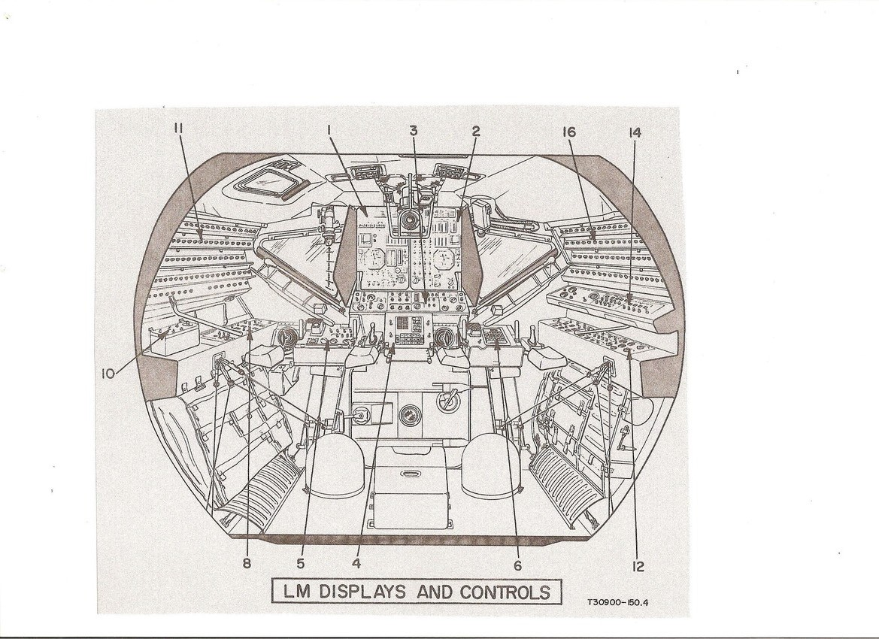

FIGURE 2. LM COMMANDER'S INSTRUMENT PANEL
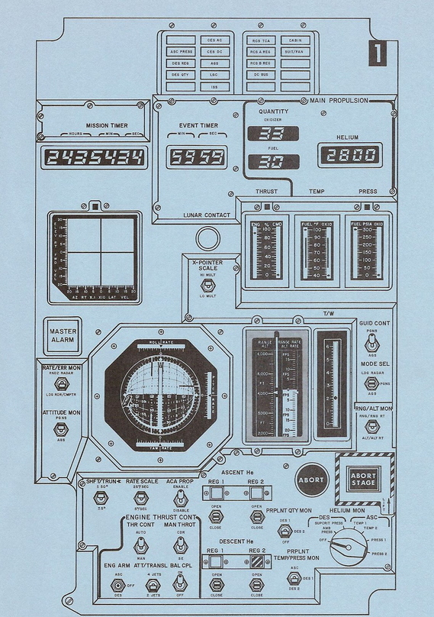

FIGURE 3. LM PILOT'S INSTRUMENT PANEL

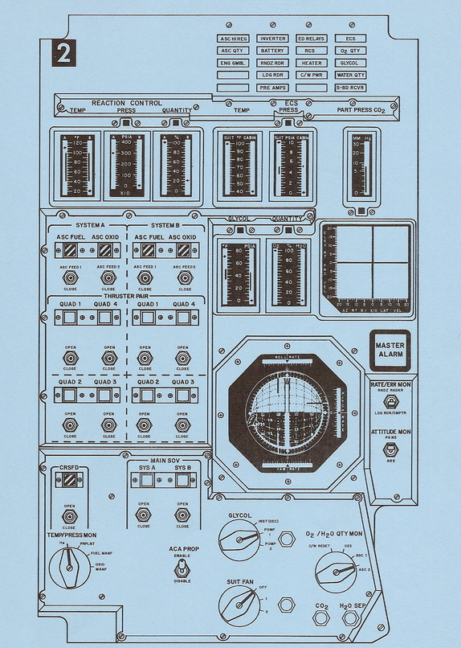

FIGURE 4. LM PANEL 3 (FLIGHT CONTROL MODES)

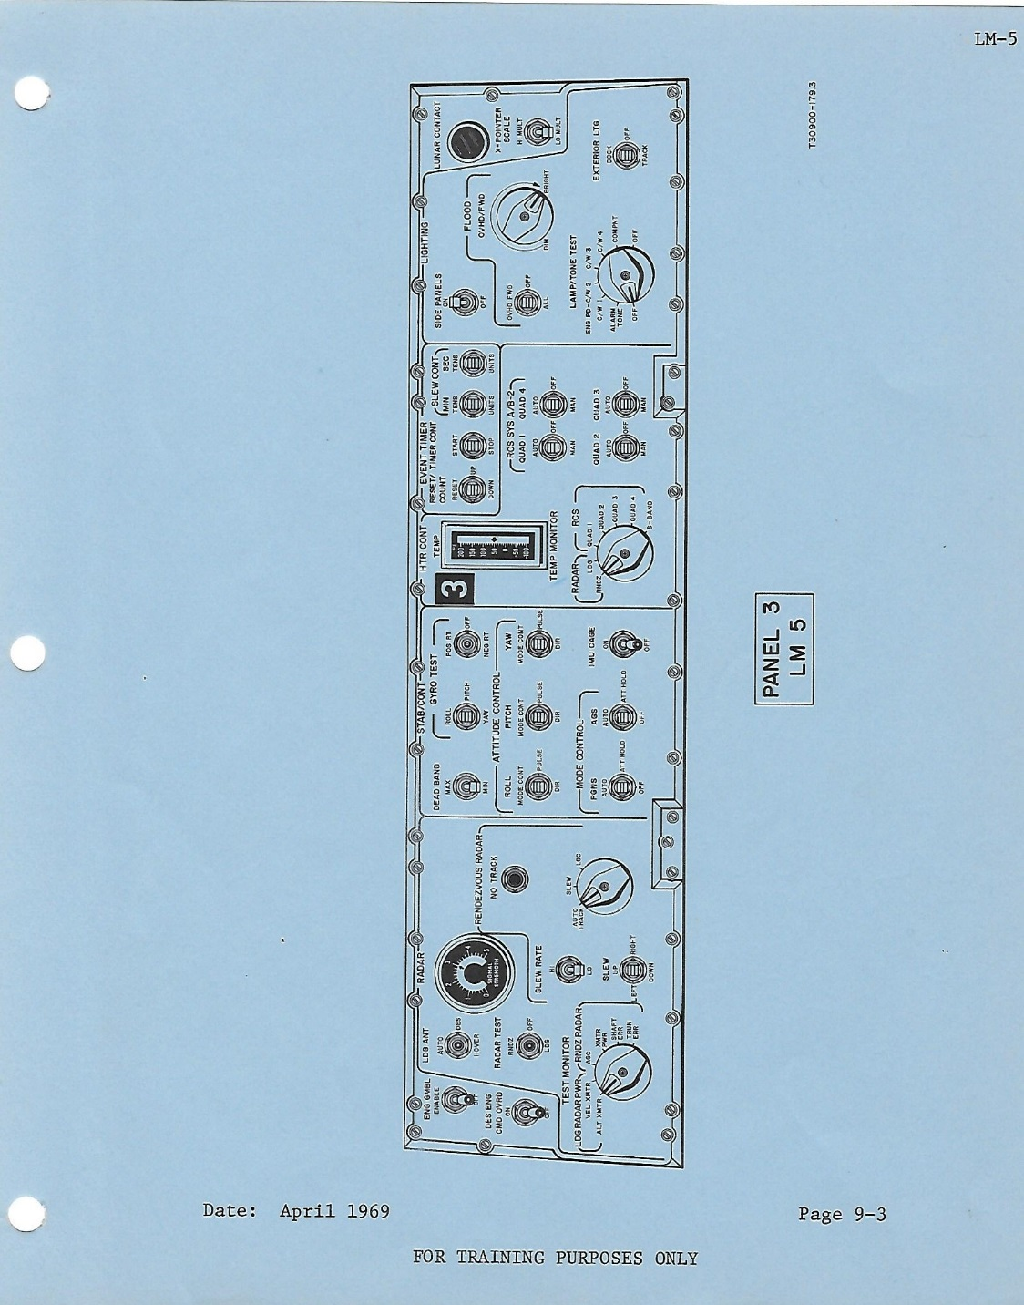

FIGURE 5. PRIMARY GUIDANCE NAVIGATION AND CONTROL SYSTEM (PGNCS)
DISPLAY AND KEYBOARD (DSKY)

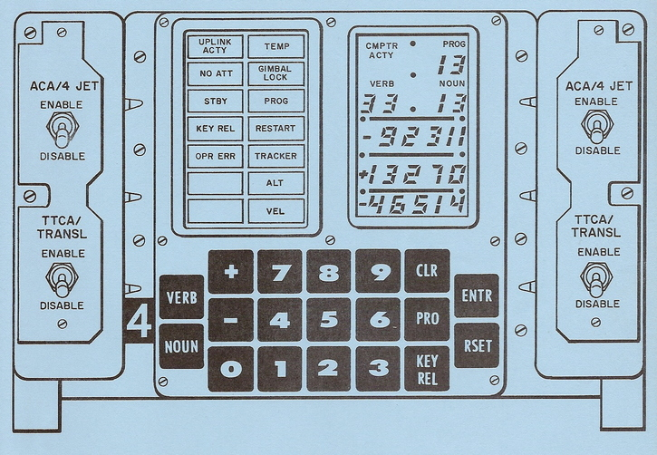

FIGURE 6. ABORT GUIDANCE SYSTEM (AGS) DATA ENTRY AND DISPLAY ASSEMBLY (DEDA)

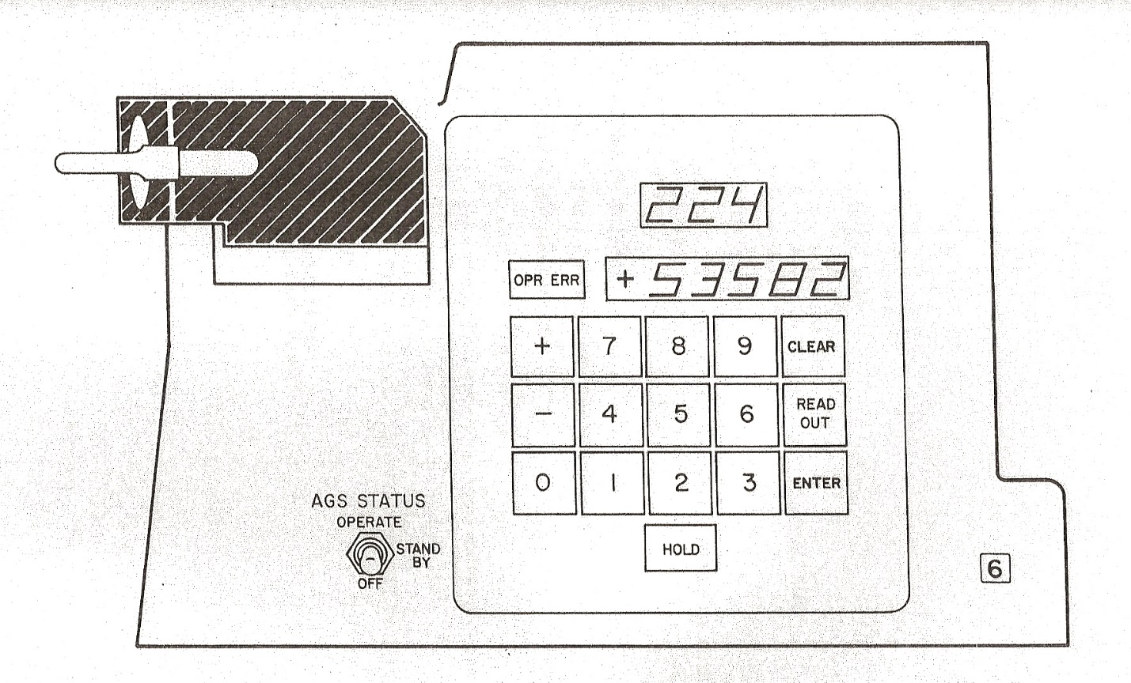

FIGURE 7. LM LANDING POINT DESIGNATOR (LPD)
