Stereo Camera Simulation for Lunar Surface Photogrammetry
Ryan J. Thompson, Paul M. Danehy, Michelle M. Munk
NASA Langley Research Center, Hampton, VA 23681
Manish Mehta and Michael S. Manginelli
NASA Marshall Space Flight Center, Huntsville, AL 35812
Chi Nguyen
Aerospace Innovations, LLC, Yorktown, VA 23692
Orrin H. Thomas
Cardinal Systems, LLC, Flagler Beach, FL 32136

Extended Abstract
The interaction between a spacecraft descent engine exhaust plume and loose surface material during powered landing is not well-understood but plays a significant role in landing dynamics. Plume-surface interaction (PSI), and the ejection of surface material, or regolith, can pose a danger to the landing system and the environment in the vicinity of the landing site. Plume-induced ejecta can obscure the spacecraft’s view of the landing site, adding to the difficulty and danger of crewed and uncrewed landings [1]. The presence of this ejecta can also be detrimental to the performance of landing sensors, such as radar and lidar, which are critical to the safety of autonomous landings [1]. Historically, fast-moving ejecta has inflicted damage upon several landing systems, including the Apollo landers and the Mars Science Laboratory [1]. Additionally, the rocket plume and resulting ejecta have the potential to erode and otherwise disturb the landing site and surrounding area. This is especially relevant when planning for the landing of several spacecraft within a small region (or lunar “base”), as is being considered for the Artemis program. During previous lunar and Martian landings, cratering in regolith directly under the descent engine(s), caused by plume-surface interactions, has been observed to occur (Fig. 1). While several previous studies have investigated PSI during landings on the Moon and Mars using existing data, to date there have been no dedicated instruments for studying PSI flown on landing craft [1, 2]. Terrestrial PSI experiments can give some insight to the physics involved, but often these studies do not reflect the atmospheric and flow conditions present in extraterrestrial landings [1]. The lack of dedicated in-flight PSI studies has hindered the development of accurate PSI simulation tools. This motivates the design and implementation of flight hardware for the in-situ investigation of extraterrestrial PSI.
The upcoming Commercial Lunar Payload Services program poses an opportunity for dedicated PSI instrumentation to be flown on a commercial lunar lander. In response to this opportunity, the Stereo Cameras for Lunar Plume-Surface Studies (SCALPSS) imaging system is being designed and prepared for flight on the Intuitive Machines Nova-C robotic lander, scheduled for a lunar landing in October of 2021. SCALPSS is being developed by NASA Langley Research Center, in collaboration with NASA Marshall Space Flight Center. The SCALPSS imaging system consists of four cameras mounted along the base of the Nova-C lander body, pointed directly under the descent engine. This camera arrangement will provide multiple stereoscopic views of the area under the lander, enabling quantitative photogrammetric measurement of the plume-induced crater in the regolith that will form during landing. The SCALPSS system will be used to measure the volume of regolith displaced by the descent engine plume during and after landing. This measurement will provide valuable information about the rate of regolith ejection and the geometry of the plume-induced crater, which will aid in the development and validation of PSI models.
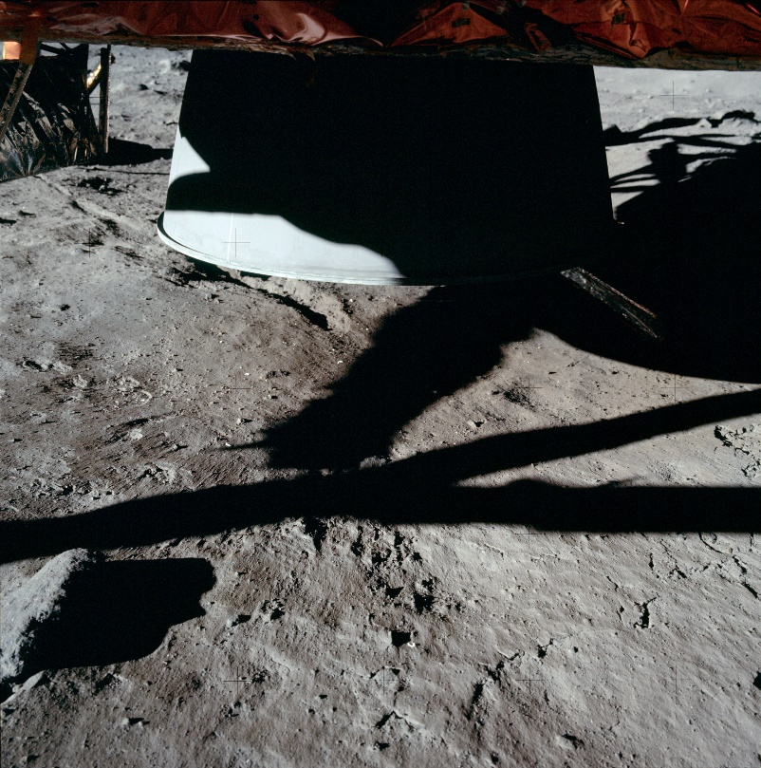
Fig. 1 Region of lunar surface under the Apollo 11 descent engine (top middle). The top layer of loose regolith has been swept away by the plume of the engine, exposing the underlying rock and creating a small crater [3].

The success of the SCALPSS system depends on each of the four cameras having an unobstructed view of the ground below the lander, which necessitates careful integration of the cameras with the Nova-C lander. The landing system employed by the Nova-C consists of a single descent engine and 6 landing legs arranged in a hexagonal pattern. The structure of the lander allowed a large degree of flexibility in the placement of the SCALPSS cameras. This flexibility permitted the optimization of the camera system design, but the large available design space necessitated a system for accurately and quickly evaluating the performance of many candidate configurations. Due to the project’s timeline, the design phase for the SCALPSS camera system was concurrent with the design of the Nova-C lander. Additionally, the camera system was subject to several engineering constraints, such as proximity to the lander body and sunlight illumination, which further complicated the design process. This challenging design environment motivated the use of computer-generated camera view simulations that incorporated the 3D model of the lander, which is the focus of the work presented here.
We used 3D computer graphics software (Autodesk 3ds Max), which supports camera modeling, to create an environment containing the Nova-C 3D model with four virtual SCALPSS cameras placed at specified locations on the lander model. In the environment, a plane approximating the lunar surface was placed directly under the lander model. This plane served as the viewing target of the virtual cameras. For a specified SCALPSS camera configuration, the virtual cameras could be placed accordingly and the view of each camera could be simulated (Fig. 2). In addition, the field of view of each of the four cameras could be projected onto the “ground” plane, allowing the ground coverage area of the camera system to be determined via a MATLAB routine (Fig. 3). This coverage area served as a useful parameter for describing the performance of the camera configuration being simulated. In order to perform photogrammetry using the camera system, two or more cameras must have overlapping views of the ground directly under the lander; this photogrammetric viewing region is hereafter referred to as stereo coverage or stereo area. To study the plume-induced crater, a circular region approximately three meters in diameter centered under the descent engine was deemed the “area of interest” (AOI). Accurate measurements of the crater require as much of this AOI to be accessible to photogrammetry as possible. That is, the percent of area within the AOI that also falls within the stereo coverage region must be as high as possible. While two cameras viewing the same region of ground is the minimum for photogrammetric analysis, more than two cameras viewing the same region improves the accuracy of the measurement. High-performing camera configurations have large stereo coverage areas and a high AOI percent coverage, with as many cameras as possible viewing the region under the lander. To properly assess the performance of a given camera configuration, all of these characteristics must be evaluated for that configuration.
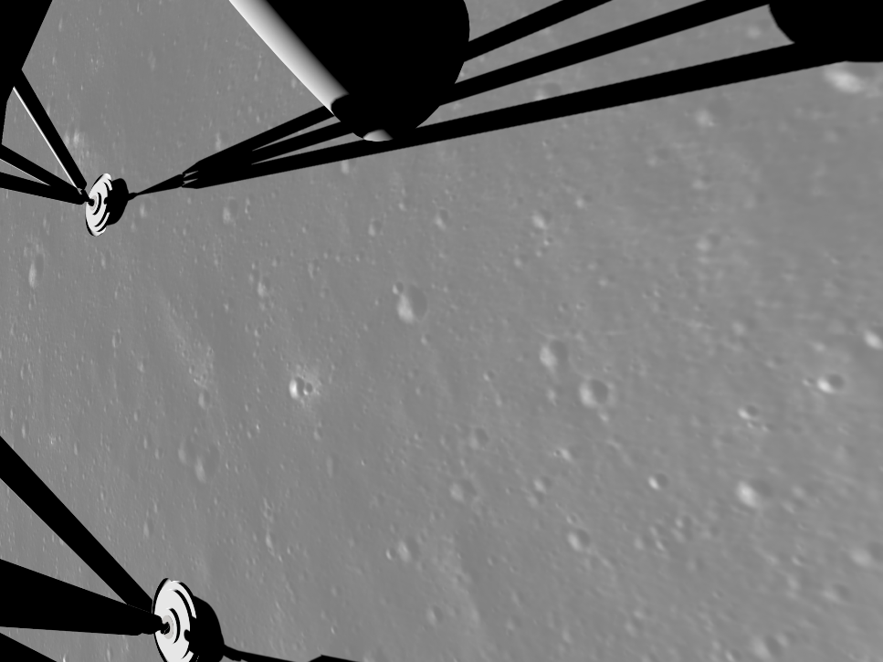
Fig. 2 A simulated post-landing SCALPSS camera view of the region under the Nova-C lander. The landing legs are visible in the bottom left and top left, and the descent engine nozzle is visible in the top middle. Simulated shadows from sunlight are cast under the lander.

The virtual environment described here allowed the photogrammetric performance of candidate SCALPSS camera configurations to be evaluated, accounting for obstructions to the camera views such as the Nova-C landing legs and descent engine nozzle. This proved to be an essential resource throughout the SCALPSS design stage, during which numerous configurations were developed, tested, and improved in the virtual environment. Frequent changes in the design of the Nova-C lander added another layer of complexity to the design of the camera system. However, these changes could be quickly incorporated in the analysis by importing updated models of the Nova-C lander into the environment. Throughout the design process, over 30,000 total configurations that spanned the available design space were evaluated in this environment. High-performing configurations were evaluated against the engineering constraints and further optimized using the environment. This process, after several iterations, resulted in the selection of a “final” camera system design to be flown on the Nova-C. The stereo coverage map for this configuration is shown in Fig. 3.
The chosen design provides an estimated 14.05 square meters of stereo coverage, with 85% of the AOI accessible to photogrammetry. In comparison with all of the configurations tested during the design process, the chosen design performs in the top 1% of configurations with respect to stereo coverage and the top 5% with respect to AOI percent coverage. The design also places two of the four cameras in the shadow of the Nova-C upon landing, which will protect them from intense sunlight and improve the longevity of the two cameras. In addition, the design employs a symmetric camera configuration, which simplifies the design and manufacturing of the camera mounting hardware. These mounts place the cameras approximately 25 centimeters from the body of the Nova-C, which is necessary for ensuring large stereo coverage. This placement satisfies the design constraint that the cameras must be mounted as closely as reasonably possible to the lander body to avoid damage from ejected rocks and dust during landing. The large stereo coverage and AOI percent coverage provided by this configuration, together with its satisfactory fulfillment of the design constraints, ultimately led to its selection as the final design.

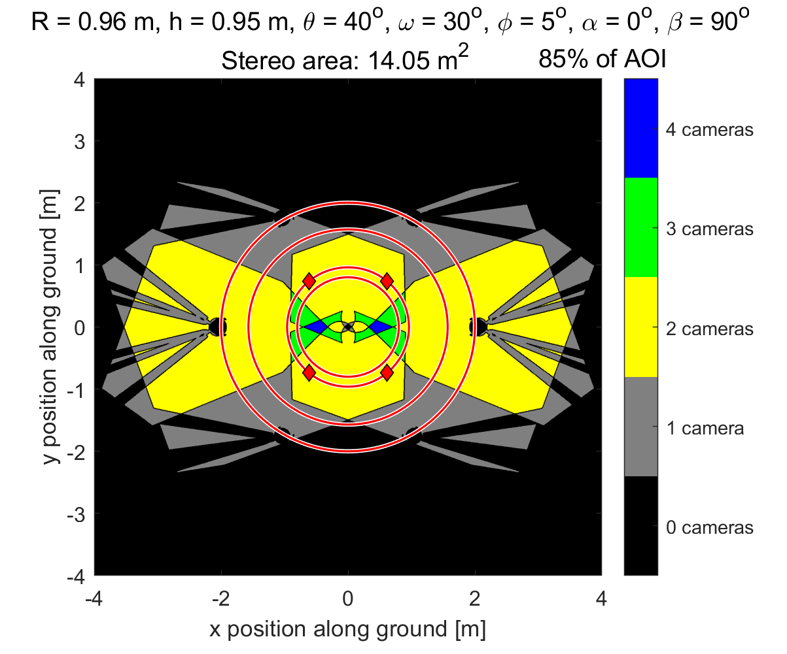
Fig. 3 The post-landing stereo coverage area map for the chosen SCALPSS camera configuration. Coverage data is simulated in Autodesk 3ds Max and plotted in MATLAB. Photogrammetry is possible in regions visible by two or more cameras. The red circles, from inner to outer, are: the Nova-C lander body outline, the camera mounting circle, the area of interest (AOI) for photogrammetry, and the lander footpad circle. The red diamonds show the locations of each of the four cameras.

The SCALPSS camera system for studying the descent engine plume-surface interaction during the planned Nova-C lunar landing has been designed and analyzed in the 3D virtual environment described here. This process has ensured that the camera system has met all constraints, will integrate well with the Nova-C lander during manufacturing, and will provide a large stereo coverage area under the lander. The operation of SCALPSS, if successful, will be the first dedicated plume-surface interaction measurement during an extraterrestrial landing.

References
[1] Mehta, M., “Rocket Plume Interactions for NASA Landing Systems,” [Presentation slides], 2019, URL: https://ntrs.nasa.gov/search.jsp?R=20200000979 [retrieved 22 May 2020].
[2] Immer, C., Lane, J., Metzger, P., and Clements, S., “Apollo video photogrammetry estimation of plume impingement effects,” Icarus, Vol. 214, No. 1, 2011, pp. 46-52.
doi: 10.1016/j.icarus.2011.04.018
[3] Metzger, P. T.; Lane, J. E.; Immer, C. D.; and Clements, S., "Cratering and Blowing Soil by Rocket Engines During Lunar Landings" (2008). International Conference on Case Histories in Geotechnical Engineering. 1.

Aeronautics Research Intern, Advanced Measurements and Data Systems Branch and PhD Student, Department of Mechanical and Aerospace Engineering, University of Virginia, Charlottesville, VA.
Senior Technologist for Advanced Measurement Systems, Advanced Measurements and Data Systems Branch, AIAA Associate Fellow.
SCALPSS Principle Investigator, Space Technology and Exploration Directorate, AIAA Associate Fellow.
Aerothermodynamics Subject Matter Expert, Aerosciences Branch, AIAA Senior Member.
Aerospace Engineer, Aerosciences Branch, AIAA Member.
Principle Scientist.
Software Engineer.

