Investigation of the 2016 Eurasia heat wave as an event of the recent warming

Eunkyo Seo¹, Myong-In Lee¹*, Siegfried D. Schubert^{2,3}, Randal D. Koster², Hyun-Suk Kang⁴

¹ School of Urban and Environmental Engineering, Ulsan National Institute of Science and Technology, Ulsan, Korea
² Global Modeling and Assimilation Office, NASA Goddard Space Flight Center, Greenbelt, Maryland, United States
³ Science Systems and Applications, Inc., Lanham, Maryland, United States
⁴ Korea Meteorological Administration, Seoul, South Korea

July 2, 2020

Draft
To be submitted to ERL

Eunkyo Seo is currently affiliated in ‘Center for Ocean-Land-Atmosphere Studies, George Mason University, Fairfax, Virginia, United States’
_____________________________________________________________________ *Corresponding author: Prof. Myong-In Lee, School of Urban and Environmental Engineering, Ulsan National Institute of Science and Technology, UNIST-gil 50, Ulsan 44919, Republic of Korea (milee@unist.ac.kr)
Abstract
This study investigates the physical mechanisms that contributed to the 2016 Eurasian heat wave during boreal summer season (July–August, JA), characterized by much above normal temperatures over eastern Europe, East Asia, and the Kamchatka Peninsula. It is found that the 2016 JA mean surface air temperature, upper-tropospheric height, and soil moisture anomalies are characterized by a tri-pole pattern over the Eurasia continent and a wave train-like structure not dissimilar to recent (1980-2016) trends in those quantities. A series of forecast experiments designed to isolate the impacts of the land, ocean, and sea ice conditions on the development of the heat wave is carried out with the Global Seasonal Forecast System version 5 (GloSea5). The results suggest that the tri-pole blocking pattern over Eurasia, which appears to be instrumental in the development of the 2016 summer heat wave, can be viewed as an expression of the recent trends, amplified by record-breaking oceanic warming and internal land-atmosphere interactions.

Index Terms and Keywords
2016 Eurasian heat wave, recent warming, GloSea5, record-breaking oceanic warming, land-atmosphere interaction

- Introduction
The unusually severe heat wave events that have occurred around the world in recent decades have had a profound negative impact on human health, ecosystems, and socioeconomies (Coumou and Rahmstorf, 2012; WMO, 2011). Observations are consistent in showing that, since the middle of the 20th century, most global areas have experienced significant warming in daily maximum and minimum temperatures (Donat et al., 2013b; Donat et al., 2013a; Caesar et al., 2006). One of the impacts of the warming trend has been to increase the frequency, intensity and/or duration of heat wave events across much of North America, Eurasia and Australia: an impact that appears to be due not only to an increasing mean temperature, but also to an increase in its variability (Stocker et al., 2013; Perkins et al., 2012; Choi et al., 2009; Sun et al., 2014). Over Eurasia, the prominent summer temperature trend exhibits an inhomogeneous pattern with accelerated warming centered on eastern Europe, East Asia, and the Kamchatka Peninsula (Horton et al., 2015; Cohen et al., 2012). This is associated with a wave train-like atmospheric circulation trend pattern that appears to have been instrumental in the development of a number of the most extreme heat waves including the 2003 European and 2010 Russian heat wave events (Dole et al., 2011; Schubert et al., 2011) and in the general increase in heat wave occurrence over East Asia (Erdenebat and Sato, 2016; Ito et al., 2013).
A number of previous studies have examined the role of anomalous boundary conditions (e.g. sea surface temperature (SST), soil moisture, and sea ice) in the development of major heat waves. For example, dry land surface conditions appear to have played a role in the development of recent Eurasian summer heat waves (Beniston, 2004; Ferranti and Viterbo, 2006; Fischer et al., 2007b; Fischer et al., 2007a; Seo et al., 2018). Here, deficits in soil moisture, driven by larger evapotranspiration rates or by precipitation deficits, contribute to the development of persistent atmospheric high-pressure systems which, in turn, act to amplify the surface dryness and warming. Anomalous SSTs can also act to drive extremely hot weather by forcing large-scale atmospheric teleconnections including the development of persistent ridges (Kenyon and Hegerl, 2008; Alexander et al., 2009). Examples of heat waves where anomalous SST appear to have played a role in their development include those that developed over Russia in 2010, over Southern Australia in 2009 (Pezza et al., 2012), over central and southern United States in 2011 (Hoerling et al., 2013), and over East Asia in 2013 (Jing-Bei, 2014). In the case of the 2010 Russian heat wave, the wave train-like spatial pattern of the surface temperature anomalies over Eurasia was to a large extent determined by an internally forced atmospheric Rossby wave that appears to have been amplified by the recent trends in SSTs resembling a linear combination of the cold phase of a Pacific decadal mode, the warm phase of an Atlantic multidecadal oscillation (AMO)-like mode, and the long-term trend pattern (Schubert et al., 2014). This includes record high SSTs in the tropical Atlantic that produced strong local convection and altered monsoon circulations, which helped to produce anticyclonic conditions over Russia (Trenberth and Fasullo, 2012). Furthermore, such a wave train-like pattern is related to the steady warming derived by external forcing and heterogeneous warming induced by internal dynamic processes of land-atmosphere interactions that manifest quasi-stationary waves (Sato and Nakamura, 2019). In the case of East Asia, the increasing occurrence of summer extreme heat events also appears to be linked to changes in both summer arctic sea ice and high-latitude snow cover over land (Tang et al., 2014).
During the summer of 2016, Eurasian countries were engulfed by an extreme heat wave. On a global basis, summer temperatures were the hottest on record since 1880. In this study, we carry out a series of well-controlled numerical hindcast experiments designed to isolate the separate influences of the large-scale oceanic, land, and sea ice conditions on the development and maintenance of the 2016 heat wave. Furthermore, we examine the extent to which the development is a manifestation of the wave-like spatial structure of the recent warming trend over Eurasia.

- Data and Methodology
  - Observational data
The high-resolution (0.5° horizontal degree) gridded CRU Time-series (TS) version 4.01 data produced by the University of East Anglia was used as one of the observational land surface air temperature products (Harris et al., 2014). These monthly data cover the period 1901-2016 and are used in the continental scale long-term trend analysis. A gridded land-only Global Historical Climatology Network (GHCN) daily maximum temperature anomaly dataset produced by U.S. National Climatic Data Center (NCDC) was used in the analysis of recent changes in climate extremes (Menne et al., 2012). The observational daily mean surface air temperature (SAT) was obtained from the 6-hourly Japanese 55-year Reanalysis (JRA-55) (Kobayashi et al., 2015), which was also used as the near-surface atmospheric forcing for the offline land surface model (LSM) simulation. The observations-based geopotential height (GPH) data were taken from the Modern-Era Retrospective analysis for Research and Applications, Version 2 (MERRA-2) for 1980–2016 (Gelaro et al., 2017). The SSTs used were from the Advanced Very-High-Resolution Radiometer (AVHRR)-based Optimal Interpolation Sea Surface Temperature (OISST) for 1982–2016 (Reynolds et al., 2007), and sea ice concentrations were obtained from the National Snow and Ice Data Center (NSIDC, http://nsidc.org/) for 1987–2016. The validation of the soil moisture produced by the offline LSM simulation used the satellite-based European Space Agency Climate Change Initiative (ESA CCI) volumetric soil moisture data covering 1980–2016, which represents soil moisture in the top few centimeters of soil (~5 cm) (Dorigo et al., 2017). The research period for this study is 37 years (1980–2016); we used as much of the available observations in this period as possible.

  - LSM offline simulation
This study first integrated the stand-alone LSM model in GloSea5 to obtain a realistic land surface reanalysis. The Joint UK Land Environment Simulator (JULES) LSM was driven by observed atmospheric surface conditions including 2-m air temperature and humidity, precipitation, 10-m wind speed, radiative fluxes, and pressure at the surface. These historical observations were obtained from the 6-hourly JRA-55 Reanalysis. Precipitation was corrected with monthly mean values from the Climate Prediction Center Merged Analysis of Precipitation (CMAP) dataset (Xie and Arkin, 1997). Our land reanalysis was carried out at a resolution of 0.5° latitude × 0.5° longitude across the land areas of the globe. Among 4 vertical sub-surface layers, the top-level representing volumetric soil moisture at a depth of approximately 10 cm captures the geographical distribution of JA mean soil moisture climatology and anomalous soil moisture conditions in 2016 reliably in comparison with the ESA CCI volumetric soil moisture (Supplementary Figure 1), even though the range of volumetric soil moisture in both datasets is quite different due to differences in the representative depth of soil and other factors (Koster et al., 2009). The interannual variation of the soil moisture anomalies over East Asia over 37 years also exhibits a significantly high temporal correlation (r = 0.64) with the CCI data. Our land reanalysis provided the observational surface soil moisture examined in this study; it was also used to initialize the multi-layer soil moisture conditions in the fully coupled ensemble forecasts.

  - Experiment Design
This study used the UK Met Office GloSea5-GC2.0 coupled atmosphere-land-ocean-sea ice model (MacLachlan et al., 2015) (the specific model description refers to the Supplementary) to perform a set of ensemble seasonal forecasts that address the impact of initial conditions on the simulation of the 2016 Eurasian heat wave. We conducted four sets of ensemble forecast experiments (Table 1). From Exp1 to Exp3, one of the sets of initial conditions was replaced by the model climatology, such as for soil moisture (Exp1), ocean (Exp2) and sea ice (Exp3), respectively. Exp4 was initialized with all anomalous observed states in July 2016. Note that the operational GloSea5 seasonal forecast in the Korea Meteorological Administration (KMA) has the same configuration as Exp1. Comparison of Exp4 with Exp1, Exp2, and Exp3, respectively, isolates the impact of soil moisture, ocean, and sea ice components on the extreme event. All experiments consist of 50 ensemble members.
Soil moisture initialization follows the Standard Normal Deviate Scaled (SNDS) method (Seo et al., 2018), wherein the observed anomalies from the offline reanalysis (see above) were added to the coupled model’s soil moisture climatology after scaling the observed variance to the coupled model’s variance. The coupled model’s soil moisture statistics were obtained from the soil moisture fields for the given date from a long-term GloSea5 integration covering 15 years (1997–2011). The adjusted soil moisture initial state minimizes a systemic drift toward the model climatology. Climatological soil moisture initial conditions were obtained from a pre-existing yearly-averaged monthly land surface reanalysis in which JULES was forced offline using the Integrated Project Water and Global Change (WATCH) Forcing Data methodology applied to ERA-Interim data (WFDEI) (Weedon et al., 2011). Ocean and sea ice components are initialized by the Forecast Ocean Assimilation Model (FOAM) Ocean Analysis (Blockley et al., 2014) using a variational data assimilation system for the NEMO ocean model (NEMOVAR) in the operational GloSea5 coupled forecasts and hindcasts. Climatological ocean and sea ice initial conditions (both surface and subsurface) were obtained from the averages of the ocean and sea ice initial conditions over the 20-yr GloSea5 hindcast period (1991–2010).
The atmosphere in all of the runs was initialized with conditions produced by the U.K. Met Office four dimensional variational (4D-Var) data assimilation system (Rawlins et al., 2007). Each 50-member ensemble consists of 10 members started on each day between July 1 and July 5 of 2016. Initial conditions were perturbed on a given day using the Met Office Stochastic Kinetic Energy Backscatter (SKEB2) scheme (Bowler et al., 2009). Each run was conducted for 62 days, i.e., through the end of August.

- Results
  - Heat wave Days and Intensity
Figure 1 shows the spatial pattern of the recent (1980–2016) linear trend of the JA mean SAT, the 300hPa GPH, and surface soil moisture anomalies. The trend map for SAT reveals regions of significant warming in eastern Europe, East Asia, and the Kamchatka Peninsula (Fig. 1a) consistent with a tri-pole pattern of 300 hPa GPH anomalies (Fig. 1b). It is noteworthy that the wave-train like pattern of the temperature trend resembles the leading mode of the combined Eurasian summer SAT and precipitation variability (1979-2012), characterized by a projection (associated time series) that has an increasing trend (Schubert et al., 2014). Furthermore, when the leading SST pattern of global warming is prescribed in five atmospheric general circulation models (AGCMs) (Schubert et al., 2009), the resulting JA-mean surface temperature response (Supplementary Figure 2) is also similar in structure to the recent warming trend over Eurasia, especially with significant warming signals in eastern Europe and East Asia. The linear trend of the soil moisture anomalies exhibits roughly the same spatial pattern as that of the SAT anomalies but with opposite sign, suggesting a substantial land-atmosphere feedback (Fig. 1c). Such a temperature-soil moisture relationship is relatively strong in the transitional regions where the time-mean soil moisture is neither too dry nor too wet (Koster et al., 2011; Seo et al., 2018), including the regions of soil moisture dryness in the recent period (Schubert et al., 2014). However, the spatial pattern of the soil moisture long-term trend is not identical to that of the SAT since the soil moisture is determined not only by the energy balance but also by the water balance. Comparing the 2016 JA anomalies (Figs. 1d, 1e, and 1f) to the trends (Figs. 1a, 1b, and 1c), we see considerable similarities, although there is a slight phase shift of the positive anomalies over eastern Europe toward the central Eurasia region, presumably due to the prominent sea ice melting over the Kara Sea during 2016. Based on this aspect, we try to understand the 2016 Eurasian heat wave as a concurrent event of the recent warming and internal variability.
The interannual variation of the JA-mean SAT in eastern Europe (35–60°E, 50–70°N; Fig. 2a) and East Asia (95–125°E, 30–50°N; Fig. 2b) highlights the record-breaking heat wave signal in 2016 as well as a secular warming trend in both regions over the 37-year time period. The interannual variation of heat wave days and intensity (definition is described in the Supplementary) in eastern Europe (Fig. 2c) and East Asia (Fig. 2d) shows not only the pronounced year-to-year variability but also decadal variability and a trend. For East Asia, the heat wave days and intensity show an increasing trend and also the remarkable signal in 2016, which shows up regardless of whether the 90th or the 95th percentile is used as the threshold. For eastern Europe, the heat wave variables also show an increasing trend, and the 2016 summer is ranked as the second hottest summer during that time period, exceeded only by the Russian heat wave of 2010. The 2016 Eurasia heat wave can be considered as a continental-scale extreme hot event because anomalous warming occurred simultaneously over eastern Europe and East Asia. Figs. 2e and 2f display the evolution of daily SAT in eastern Europe and East Asia, respectively, during the summer of 2016. The time series of the two regions resemble each other, with both approximately indicating a July 25 start and August 25 end to the heat wave. As such, we focus in the following on the evolution of the heat wave event during this period.

  - Model hindcasts of the 2016 Eurasian heat wave
Figure 3 (left panels) shows the anomalies of the land, ocean, and sea ice roughly three weeks prior to the development of the heat wave (here we show 5-day averages at the beginning of July). The soil moisture anomalies are characterized by dry conditions over eastern Europe, eastern Siberia, and the Kamchatka Peninsula and wet conditions over southwest Siberia (Fig. 3a). The wet conditions are the result of positive precipitation anomalies that occurred in June of 2016 (not shown). The soil dryness ahead of the 2016 hot summer was likely impacted by the exceptionally low snow cover that extended across the Eurasia continent during the spring, which provided low amounts of meltwater to the land surface (Supplementary Figure 3).
The soil moisture anomaly pattern over Eurasia during early July (Fig. 3d) shows some similarities to the trend pattern of the JA-mean soil moisture (c.f. Fig. 1c), suggesting that the land surface conditions going into the heat wave in early July include an imprint from the recent warming trend. To quantify the agreement between the soil moisture trend and the anomaly pattern at a specific year, we calculate a spatial correlation between them over the Eurasia continent (30–180°E, 40–80°N). Note that for each year, when computing the spatial correlations, the trend is recomputed excluding the year in question. The results show that the evolution of the spatial correlation between the trend pattern and the pattern of the anomalies during any one year (utilizing either the JA-mean or the 1–5 July mean soil moisture) is characterized by generally increasing values, such that the 1–5 July soil moisture anomaly exhibits its strongest agreement (highest positive correlation) with the soil moisture trend in 2016 (Fig. 3g). Turning to the SST, Fig. 3e shows that the initial state (1-5 July 2016) is characterized by weak La Niña–like conditions in the tropical Pacific with, however, predominantly warm anomalies including those in the North Atlantic and the North Pacific (Fig. 3e). In fact, focusing on the global mean (Fig. 3h), 2016 is the warmest, though it is likely that it is the spatial variations in the SST (rather than the global mean) that are more relevant for producing the wave-like temperature anomalies over Eurasia. For the sea ice conditions, the anomalous melting in the Kara Sea occurred in 2016 (Fig. 3f) when the amount of Arctic sea ice anomalies are ranked as the second (1–5 July mean) and the third (JA-mean) lowest values historically (Fig. 3i). Overall, it is clear that the early July 2016 initial conditions of soil moisture (Fig. 3a), SST (Fig. 3b), and sea ice (Fig. 3c) used to initialize the four sets of numerical experiments with the GloSea5 forecast system contain not only signatures of the recent trends, but also have magnitudes that are substantially above the typical interannual variability. The memory of initialized soil moisture, SST, and sea ice has about one month or more in the GloSea5 forecast system, whereas there are dependencies by region and variable (Supplementary Figure 4). Note that although only SST and sea ice fraction are shown here, the other (e.g., subsurface) ocean and sea ice variables are also initialized to early July 2016 values (or to climatology, if specified) in our experiments.
The key results of the four sets of experiments are presented in Fig. 4, focusing now on the SAT and the eddy GPH at 300hPa during the mature period of the heat wave (25 July–25 August). The observations show positive anomalies of SAT and GPH that are coincident over eastern Europe, East Asia and the Kamchatka Peninsula (Figs. 4a and 4b): as we have already seen these are essentially the same three regions that have also experienced significant warming as part of the recent trend (c.f. Figs. 1a and 1d). The in-phase relationship between SAT and upper-level GHP anomalies suggests a barotropic structure that acts to sustain the heat wave. In Exp4 (the control experiment), the SAT over Eurasia is simulated somewhat realistically including the observed three main hot spots, although the wave-like structure is less clear due to a systematic warm bias of the forecast model (Fig. 4c), and the East Asia heatwave is particularly muted. Exp4 also reproduces the observed tri-pole GPH pattern over Eurasia realistically (Fig. 4d).
A comparison of the results of Exp1 and Exp 4 indicates that soil moisture initial conditions produce significant surface warming over eastern Europe but not over East Asia and the Kamchatka Peninsula (Fig. 4e). Corresponding to the result of SAT, the model simulation captures the observed soil moisture dryness well over eastern Europe but not over East Asia (Supplementary Figure 5). The soil moisture initialization does have a considerable impact on the GPH pattern over Eurasia, contributing to the development of a realistic tri-pole blocking structure (Fig. 4f). In particular, there are statistically significant responses of land surface dryness, showing strengthened land-atmosphere feedback with the observed main areas started in early July and maintained throughout the forecast lead time up to 2 months (Supplementary Figure 6). While statistically significant, the amplitude of the GPH impact is, however, about three times less than the observed. In contrast, comparing Exp2 and Exp4 indicates that realistic ocean initial conditions help the model reproduce the overall pattern of the continental scale anomalous surface warming over Eurasia at a statistically significant level (Fig. 4g), although with weaker than the observed amplitude. The initial SST anomalies are sustained with a similar pattern during the heat wave period, and the model simulates this pattern realistically (Supplementary Figure 5). The observed (modeled in Exp4) amplitude of the temperature anomaly over eastern Europe and East Asia is 3.7 ℃ (2.0 ℃) and 2.0 ℃ (0.82 ℃), respectively, and the oceanic states induce temperature anomalies of 1.3 ℃ and 0.36 ℃ for these regions. Ocean-induced GPH anomalies are weaker than the observed anomalies and show less agreement with the observations compared with those induced by soil moisture initialization (Fig. 4h). The impact of sea ice initialization is mostly weak and not statistically significant (Figs. 4i and 4j).
Thus, the results suggest that both the early July initial ocean states and initial soil moisture anomalies had some impact on the subsequent development of the 2016 boreal summer heat wave, characterized by much above normal temperatures over eastern Europe, East Asia, and the Kamchatka Peninsula, while there is little evidence that the anomalous sea ice played a significant role. Somewhat surprisingly, the soil moisture’s impact was stronger on the GPH than on the SAT, while the reverse was true for the impact of the SST.
Further considerations (and the results from two supplemental experiments) enhance our interpretation of these results. It is critical to note first that the initial atmospheric conditions for all of the simulations performed include the Eurasian blocking tri-pole structure that appears to be a critical component of the heat wave’s development. As a result, the experiments as designed effectively evaluate the ability of the evolving soil moisture, SST, and sea ice anomalies to maintain and/or amplify the already existing atmospheric pattern – a pattern that is itself reflected in, and supported by the recent trends in the surface variables. Again, the comparison of Exp4 and Exp1 indicates that the initial soil moisture conditions do help maintain this wave pattern. Our supplemental experiments, however, suggest that soil moisture’s effectiveness in this regard may depend on the background state. In the supplemental experiments (sExp1 and sExp4), which are repeats of Exp1 and Exp4 but using climatological SSTs and sea ice throughout all simulations (see Table 1), the resulting inferred soil moisture impact (Supplementary Figure 7) is essentially absent; the difference pattern obtained from these experiments is generally statistically insignificant. It would appear that without the background state induced by the concurrent SST and sea ice anomalies, the soil moisture anomalies do not help maintain the wave pattern present in the atmospheric initial conditions.

- Conclusions
This study investigates the physical mechanisms underlying the 2016 Eurasia heat wave. The spatial pattern of the heat wave event is similar to the recent warming pattern as manifested in the long-term trends (covering the last 37 years) in July–August mean SAT and soil moisture anomalies over Eurasia; for both the 2016 event and the overall trends, the data show a continental-scale wave structure with strong signals in eastern Europe, East Asia, and the Kamchatka Peninsula. Record-high temperature anomalies over Europe and East Asia were seen in the summer of 2016.
The GloSea5 seasonal forecast system is used to evaluate the external factors contributing to the production of the 2016 Eurasian heat wave. The extreme event appears to be a phenomenon connected with the recent warming, given that the patterns of the soil moisture, ocean, and sea ice anomalies at the onset of the event resemble the patterns associated with the warming trend. The 2016 initial soil moisture conditions are seen to contribute significantly to the observed upper-atmospheric circulation anomalies over Eurasia (cf. Figs. 4b and 4f); however, this contribution is not realized in parallel experiments utilizing climatological SST and sea ice distributions, suggesting that this soil moisture impact relies on a background state influenced by realistic SST and sea ice conditions. As for the heatwaves themselves, while soil moisture conditions contribute only to the eastern Europe heatwave (cf. Figs. 4a and 4e), the highly anomalous (particularly warm) 2016 SST initial conditions contribute to warming across Eurasia (cf. Figs. 4a and 4g). The sea ice initial conditions appear to have insignificant impact.
The fact that, in the observations, the upper-level GPH anomalies are in phase with the SAT patterns suggests that the SAT anomalies are reinforced by internal atmospheric dynamical processes. The importance of simulating a proper GPH field for the prediction of heatwaves underlines the importance of realistic soil moisture initialization in a forecast system. Based on the results above, we can speculate that the current operational configuration of GloSea5 system, for example, failed to predict the 2016 Eurasian heat wave because it could not properly predict the upper-level GPH anomalies due to its use of a climatological soil moisture initialization . Overall, the present study contributes to our understanding of the 2016 heat wave in the context of recent warming trends.

Acknowledgements
This study was supported by the Korea Meteorological Administration Research and Development Program under Grant KMI2017-02410.

Data availability
The CRU surface temperature data were downloaded from http://data.ceda.ac.uk/, and GHCN maximum temperature data were taken from ftp://ftp.ncdc.noaa.gov/pub/data/ghcn/daily/grid/. The MERRA-2 reanalysis data were obtained from https://disc.gsfc.nasa.gov/. The OISST SST data were downloaded from ftp://ftp.cdc.noaa.gov/Datasets/noaa.oisst.v2.highres/. The NSIDC sea ice concentration data were obtained from ftp://sidads.colorado.edu/pub/DATASETS/NOAA/G02202_V3/. The ESA CCI surface soil moisture data were requested via https://www.esa-soilmoisture-cci.org/. The land surface variables from the LSM offline simulation may be requested from the authors.
Table 1. GloSea5 Experiment design to forecast the 2016 Eurasian heat wave. ‘O’ indicates that initial conditions of the experiment were prescribed realistically at the given starting dates; ‘Climatology’ indicates that initial conditions were prescribed by climatological-mean fields without year-to-year variation.
 | Exp1 | Exp2 | Exp3 | Exp4 | sExp1 | sExp4
Soil moisture initialization | Climatology | O | O | O | Climatology | O
Ocean initialization | O | Climatology | O | O | Climatology | Climatology
Sea ice initialization | O | O | Climatology | O | Climatology | Climatology

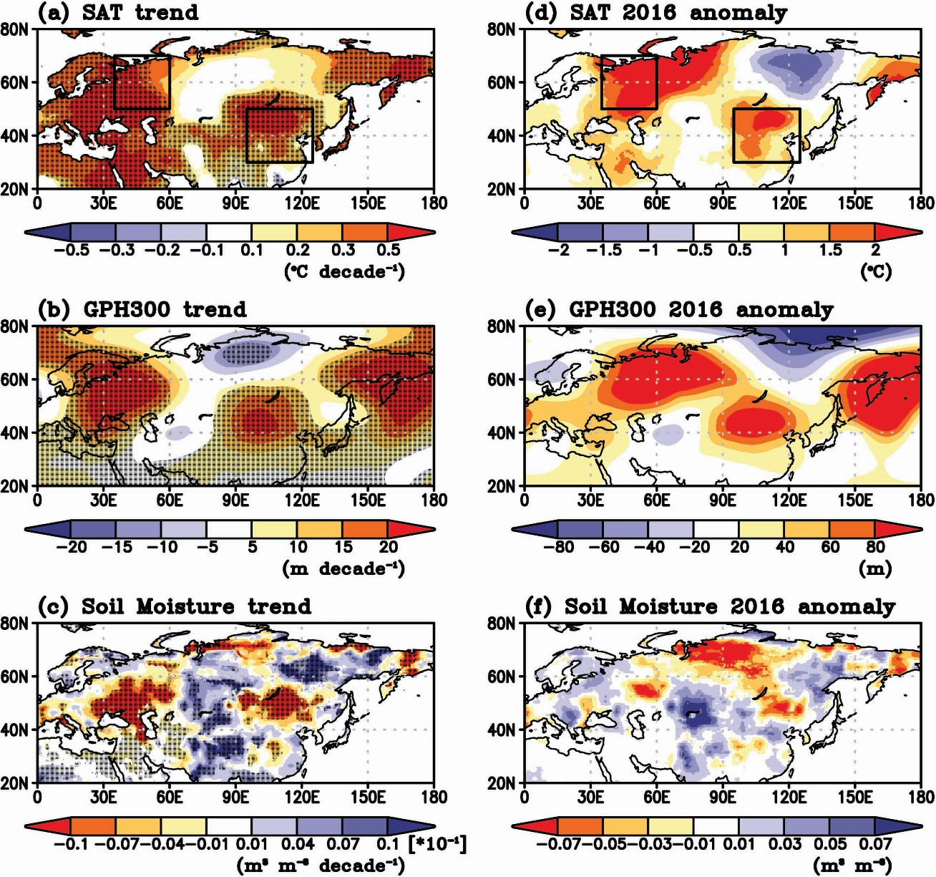
Figure 1. Recent (1980-2016) trends and 2016 anomaly patterns of JA mean surface temperature, 300hPa GPH, and surface soil moisture over the Eurasia. JA trend maps are for (a) CRU SAT (unit is ℃ 10-year-1), (b) MERRA-2 300hPa GPH (unit is m 10-year-1), and (c) surface volumetric soil moisture (unit is m3 m-3 10-year-1) from a JULES offline simulation. The dotted area indicates statistical significance at the 95% level from the Student's t-test. Anomaly maps of JA mean (d) SAT (unit is ℃), (e) 300hPa GPH (unit is m), and (f) surface soil moisture (unit is m3 m-3) in 2016. The solid rectangle represents the major hot spots: eastern Europe (35–60°E, 50–70°N) and East Asia (95–125°E, 30–50°N).

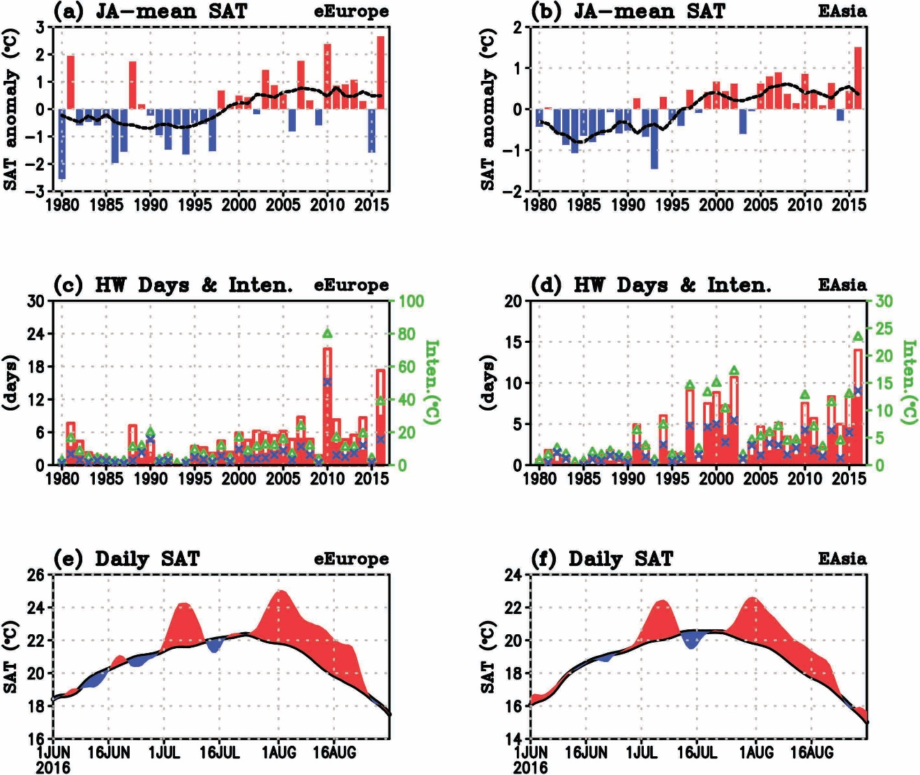 Figure 2. Time series of surface temperature and heat wave variables over eastern Europe and East Asia. Interannual variation of JA-mean area-averaged SAT anomalies from the CRU observation over (a) eastern Europe (eEurope) and (b) East Asia (EAsia) defined in Fig. 1. Black line represents the 10-year running mean of color bars. Heat wave days and intensity with GHCN daily near-surface land temperature on (c) eastern Europe and (d) East Asia for 1980–2016. Heat wave days and intensity are represented by using 90th and 95th threshold, respectively, where the opened bar and triangle (green) mark denotes these variables by 90th criteria and filled bar and cross (blue) mark denotes these variables by 95th criteria in (c) and (d). Daily SAT time series on (e) eastern Europe and (f) East Asia for the 2016 summer season by the production of the JULES offline simulation. Red and blue area in the daily SAT time series indicates the anomalous warming and cooling, respectively, compared to the daily climatology (black line).
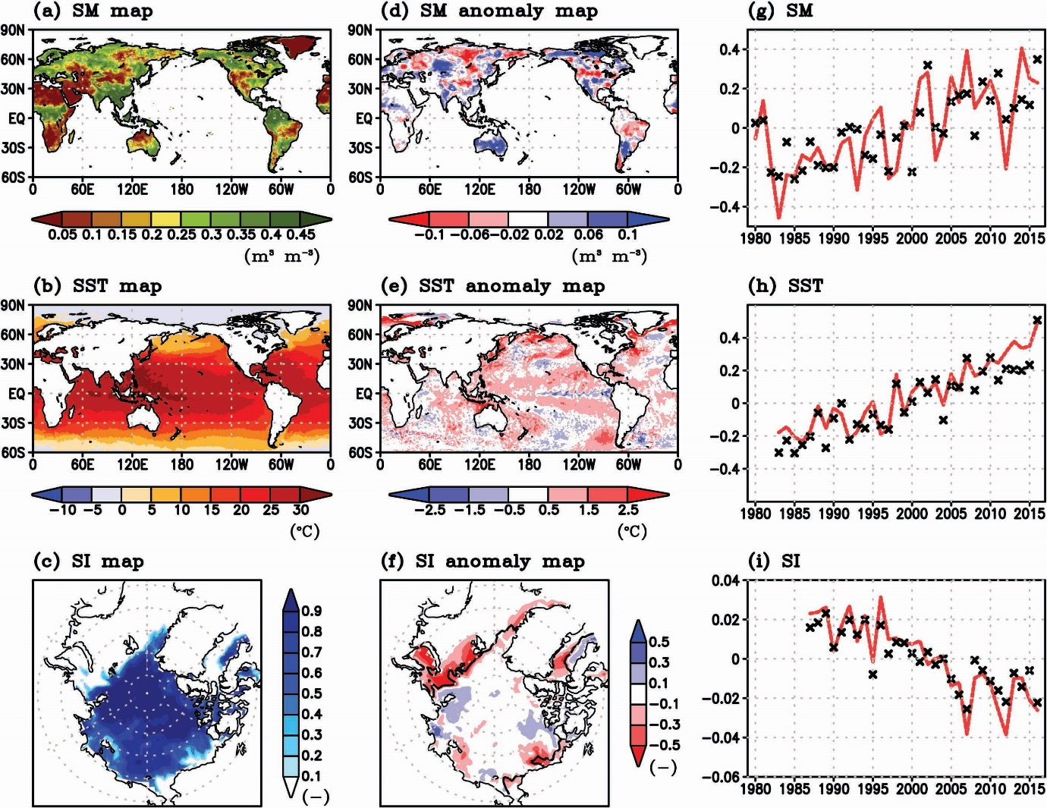
Figure 3. Pre-conditions of the 2016 Eurasia heat wave for land, ocean, and sea ice variables. 1–5 July averaged map of (a) top-level (~10cm) volumetric soil moisture (unit is m³ m⁻³), (b) SST (unit is ℃), and (c) sea ice fraction and their anomaly maps are displayed in (d), (e), and (f), respectively. Black line in the sea ice anomaly map indicates 0.15 contour line of (c). Interannual variation of JA (red solid line) and 1–5 July (cross notation) mean value for (g) the agreement between the soil moisture long-term trend and the anomaly pattern at specific year over the Eurasia continent (30–180°E, 40–80°N), (h) global averaged SST and (i) Arctic sea ice fraction anomalies relative to their long term climatology.
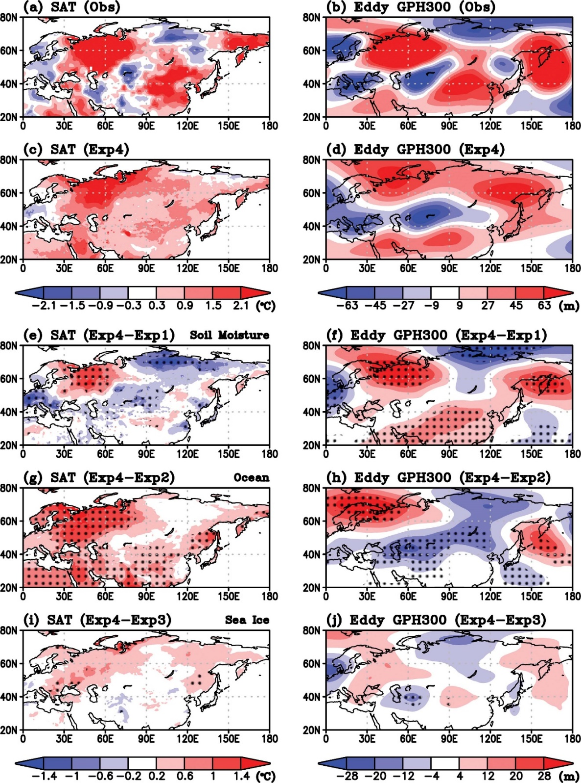
Figure 4. Spatial patterns of SAT and upper-troposphere height from the observation and model simulations during the heat wave period. Observed anomaly map of (a) SAT (unit is ℃) and (b) 300hPa eddy height (unit is m) during the 2016 Eurasia heat wave active period (25 July–25 August). The anomaly map of Exp4 (c) SAT and (d) 300hPa eddy height compared to 20 years (1991–2010) GloSea5 hindcast. Difference maps of these variables for (e, f) Exp1, (g, h) Exp2, and (i, j) Exp3 compared to Exp4. The dotted area in (e–j) represents statistical significance at the 95% level from the Student's t-test.
Supplementary

Global Forecast System
The atmospheric component of the model is the Global Atmosphere model version 6.0 (GA6.0) (Walters et al., 2017), and the land surface component is the Joint UK Land Environment Simulator (JULES). The ocean component is the Nucleus for European Modelling of the Ocean (NEMO) (Madec, 2008), and the sea ice component is the Los Alamos sea ice model (CICE) (Rae et al., 2015). The atmosphere model has N216 horizontal resolution of 0.56° latitude × 0.83° longitude, with hybrid-sigma coordinates consisting of 85 vertical levels topped at 85 km. Below the surface, there are 4 layers in the land (0.1, 0.25, 0.65, and 2 meters) and 75 levels in the ocean. CICE is divided into five sea ice thickness categories, with four vertical ice layers and one snow layer in each category.

Heat wave Days and Intensity
A heat wave day is identified for a given grid point or station when the daily maximum surface temperature exceeds the 95th percentile value of the climatological temperature distribution there for more than 2 consecutive days (Anderson and Bell, 2011). This study also used the 90th percentile value. Heat wave intensity is defined as:
$Intensity=\sum_{i=1}^{n}{(T_{i}-T_{pct})}$ (1)
where T_{i} is the daily maximum temperature on the ith heat wave day, T_{pct} is the 90th or 95th value at a specific grid, and n is the total number of heat wave days during the warm season (July–August in this study) of each year.

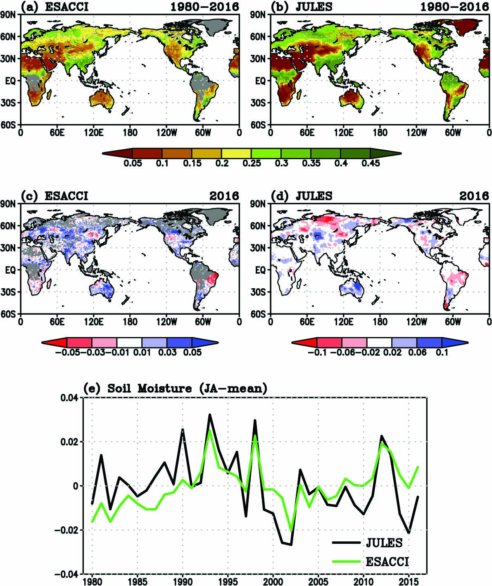
Supplementary Figure 1. Comparison of surface soil moisture from the LSM offline simulation with ESA CCI satellite-based dataset. JA-mean volumetric soil moisture (unit is m3 m-3) climatology for 37 years (1980–2016) from (a) ESA CCI and (b) JULES offline LSM simulation. Soil moisture anomalies in 2016 are shown for (c) ESA CCI and (d) JULES. Missing values in ESA CCI in (c) are indicated in gray. (e) Time series of volumetric soil moisture anomalies over East Asia (95–125°E, 30–50°N) by ESA CCI and JULES.
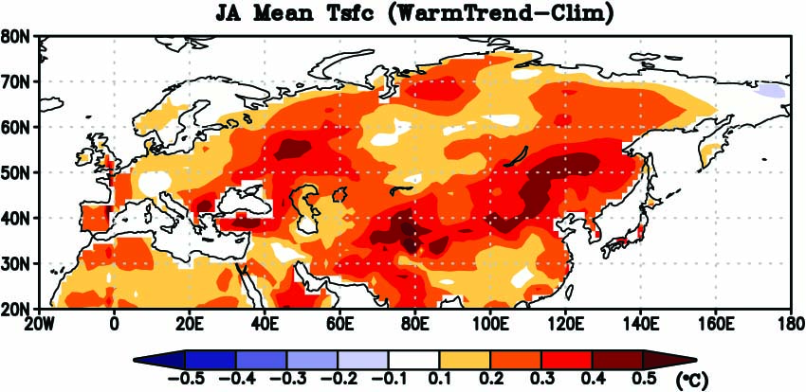
Supplementary Figure 2. JA-mean surface temperature response to SST anomaly pattern related to global warming. Multi-model averaged JA-mean surface temperature (unit is ℃) responses to the leading SST anomaly pattern of global warming. The anomalies for each model are calculated for its JA-mean response to the simulation forced with climatological SSTs. Participated 5 AGCMs are the National Center for Atmospheric Research (NCAR) Community Climate Model version 3.0 (CCM3.0), NCAR Community Atmosphere Model version 3.5 (CAM3.5), the National Oceanic and Atmospheric Administration (NOAA) Global Forecast System (GFS), NOAA Geophysical Fluid Dynamics Laboratory (GFDL) Atmosphere Model version 2.1 (AM2.1), and the National Aeronautics and Space Administration (NASA) Seasonal-to-Interannual Prediction Project version 1 (NSIPP1).

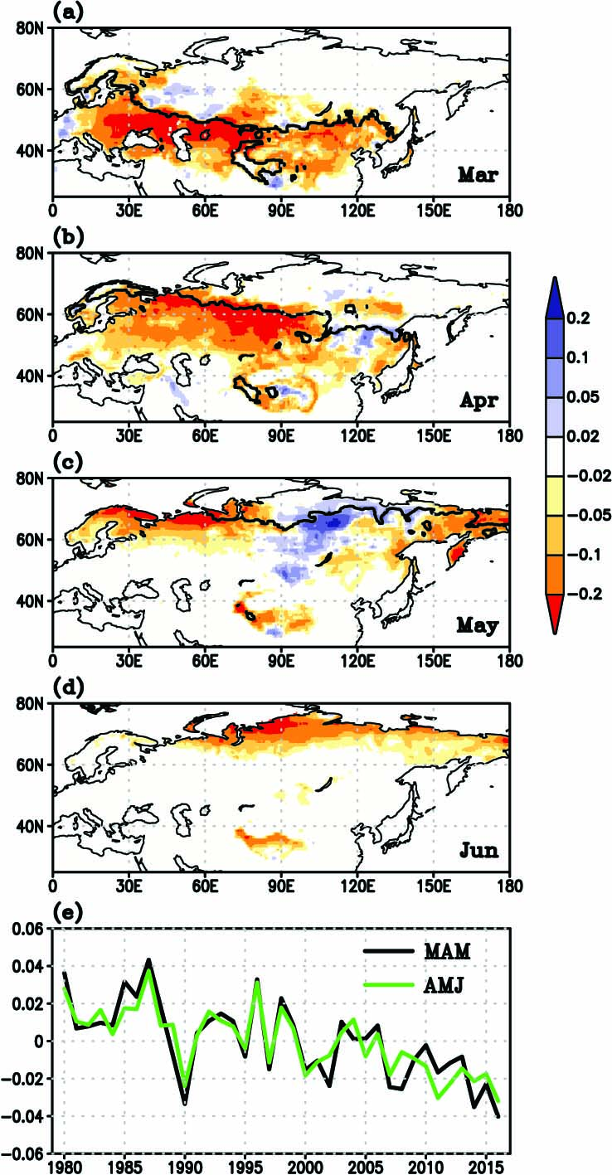
Supplementary Figure 3. Preceding snow-covered fraction of the 2016 East Asia over the Eurasia continent. Monthly mean anomaly map of the snow-covered fraction of (a) March, (b) April, (c) May, and (d) June by the JULES offline simulation. Black line in the anomaly maps indicates that the monthly climatology value is 0.8. (e) Time series of March–May (black line) and April–June (green line) time-mean snow-covered fraction anomalies averaged over the Eurasian continent (0–180°E, 20–80°N).
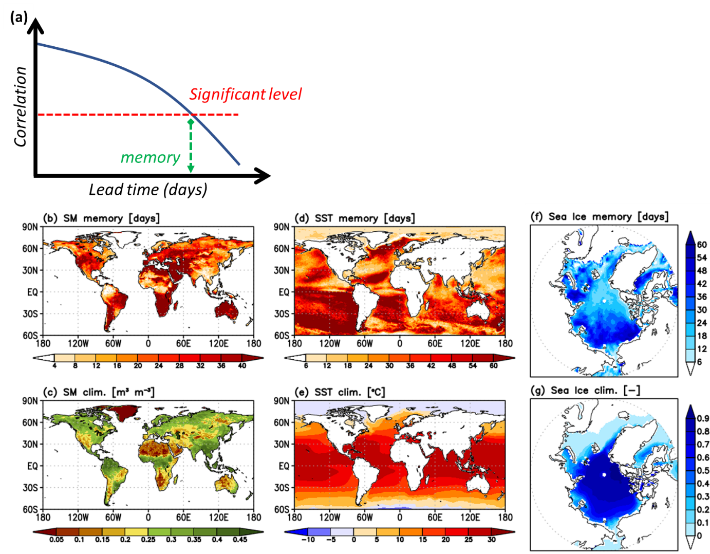
Supplementary Figure 4. (a) The memory is defined in which the daily autocorrelation for each variable, depending on forecast lead times, meets the significant value of the 95% confidence level. The memory of (b) root-zone (~0.35m) soil moisture, (d) SST, and (f) sea ice concentration in the GloSea5 forecast system during the boreal summer season (June–August). JJA-mean climatology of (c) the soil moisture, (e) SST, (g) sea ice concentration for 20 years (1991–2010) from the forecast system.

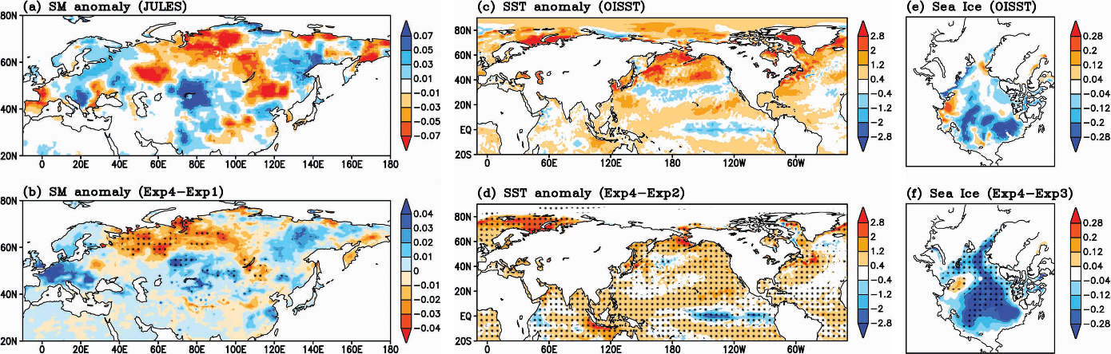
Supplementary Figure 5. The observed (a) surface soil moisture (unit is m³ m⁻³), (c) SST (unit is ℃), and (e) sea ice concentration during the heat wave period. Difference maps of these variables for (b) Exp1, (d) Exp2, and (f) Exp3 compared to Exp4. The dotted area represents statistical significance at the 95% level from the Student's t-test.

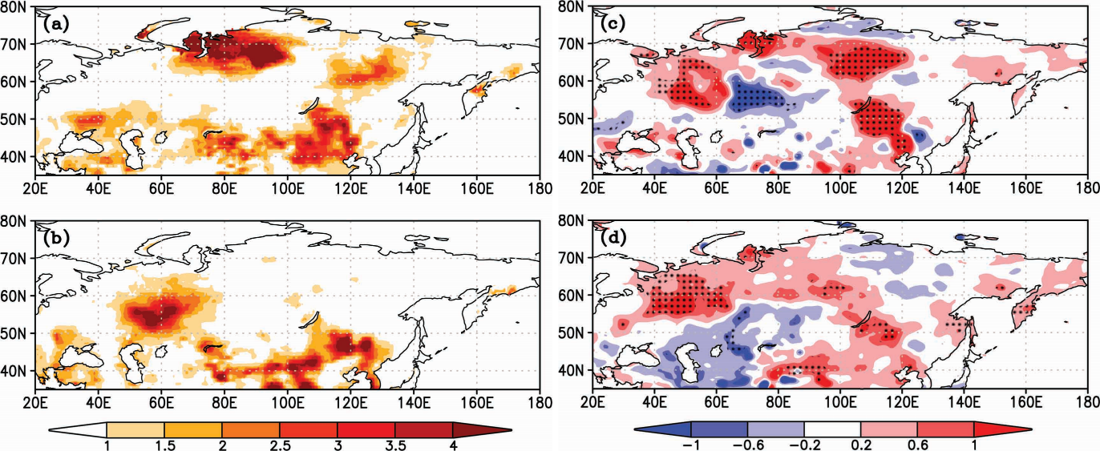
Supplementary Figure 6. Spatial distribution of observed soil moisture-temperature coupling matric during heat wave (a) pre-developed (5–24 July) and (b) active (25 July–25 August) period. (c) and (d) are the same as (a) and (b), respectively, but for the model difference between Exp4 and Exp1. The dotted area represents statistical significance at the 95% level from the Student's t-test. Here, the coupling matric is based on Miralles et al. (2012), and the observational dataset is obtained by the product of the LSM offline simulation.

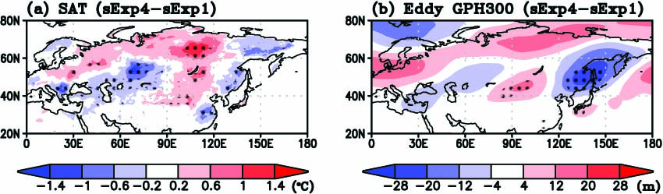
Supplementary Figure 7. Impact of soil moisture initialization without the background warming states on the representation of SAT and 300hPa eddy GPH. The spatial distribution of (a) SAT (unit is ℃) and (b) 300hPa eddy GPH (unit is m) responses to realistic soil moisture initial conditions, as same as Figs. 4E and 4F, respectively, but the climatological oceanic and sea ice background states are prescribed. The dotted area represents statistical significance at the 95% level from the Student's t-test.

Reference
Alexander L V, Uotila P and Nicholls N 2009 Influence of sea surface temperature variability on global temperature and precipitation extremes Journal of Geophysical Research: Atmospheres 114
Anderson G B and Bell M L 2011 Heat waves in the United States: mortality risk during heat waves and effect modification by heat wave characteristics in 43 US communities Environmental health perspectives 119 210
Beniston M 2004 The 2003 heat wave in Europe: A shape of things to come? An analysis based on Swiss climatological data and model simulations Geophysical Research Letters 31
Blockley E, Martin M, McLaren A, Ryan A, Waters J, Lea D, Mirouze I, Peterson K, Sellar A and Storkey D 2014 Recent development of the Met Office operational ocean forecasting system: an overview and assessment of the new Global FOAM forecasts Geoscientific Model Development 7 2613-38
Bowler N E, Arribas A, Beare S E, Mylne K R and Shutts G J 2009 The local ETKF and SKEB: Upgrades to the MOGREPS short‐range ensemble prediction system Quarterly Journal of the Royal Meteorological Society 135 767-76
Caesar J, Alexander L and Vose R 2006 Large‐scale changes in observed daily maximum and minimum temperatures: Creation and analysis of a new gridded data set Journal of Geophysical Research: Atmospheres 111
Choi G, Collins D, Ren G, Trewin B, Baldi M, Fukuda Y, Afzaal M, Pianmana T, Gomboluudev P and Huong P T T 2009 Changes in means and extreme events of temperature and precipitation in the Asia‐Pacific Network region, 1955–2007 International Journal of Climatology 29 1906-25
Cohen J L, Furtado J C, Barlow M, Alexeev V A and Cherry J E 2012 Asymmetric seasonal temperature trends Geophysical Research Letters 39
Coumou D and Rahmstorf S 2012 A decade of weather extremes Nature climate change 2 491
Dole R, Hoerling M, Perlwitz J, Eischeid J, Pegion P, Zhang T, Quan X W, Xu T and Murray D 2011 Was there a basis for anticipating the 2010 Russian heat wave? Geophysical Research Letters 38
Donat M G, Alexander L V, Yang H, Durre I, Vose R and Caesar J 2013a Global land-based datasets for monitoring climatic extremes Bulletin of the American Meteorological Society 94 997-1006
Donat M G, Alexander L V, Yang H, Durre I, Vose R, Dunn R, Willett K, Aguilar E, Brunet M and Caesar J 2013b Updated analyses of temperature and precipitation extreme indices since the beginning of the twentieth century: the HadEX2 dataset Journal of Geophysical Research: Atmospheres 118 2098-118
Dorigo W, Wagner W, Albergel C, Albrecht F, Balsamo G, Brocca L, Chung D, Ertl M, Forkel M and Gruber A 2017 ESA CCI Soil Moisture for improved Earth system understanding: state-of-the art and future directions Remote Sensing of Environment 203 185-215
Erdenebat E and Sato T 2016 Recent increase in heat wave frequency around Mongolia: role of atmospheric forcing and possible influence of soil moisture deficit Atmospheric science letters 17 135-40
Ferranti L and Viterbo P 2006 The European summer of 2003: Sensitivity to soil water initial conditions Journal of Climate 19 3659-80
Fischer E, Seneviratne S, Lüthi D and Schär C 2007a Contribution of land‐atmosphere coupling to recent European summer heat waves Geophysical Research Letters 34
Fischer E M, Seneviratne S, Vidale P, Lüthi D and Schär C 2007b Soil moisture–atmosphere interactions during the 2003 European summer heat wave Journal of Climate 20 5081-99
Gelaro R, McCarty W, Suárez M J, Todling R, Molod A, Takacs L, Randles C A, Darmenov A, Bosilovich M G and Reichle R 2017 The modern-era retrospective analysis for research and applications, version 2 (MERRA-2) Journal of Climate 30 5419-54
Harris I, Jones P D, Osborn T J and Lister D H 2014 Updated high-resolution grids of monthly climatic observations - the CRU TS3.10 Dataset International Journal of Climatology 34 623-42
Hoerling M, Kumar A, Dole R, Nielsen-Gammon J W, Eischeid J, Perlwitz J, Quan X-W, Zhang T, Pegion P and Chen M 2013 Anatomy of an extreme event Journal of Climate 26 2811-32
Horton D E, Johnson N C, Singh D, Swain D L, Rajaratnam B and Diffenbaugh N S 2015 Contribution of changes in atmospheric circulation patterns to extreme temperature trends Nature 522 465-9
Ito H, Johnson N C and Xie S-P 2013 Subseasonal and interannual temperature variability in relation to extreme temperature occurrence over East Asia Journal of climate 26 9026-42
Jing-Bei P 2014 An investigation of the formation of the heat wave in southern China in summer 2013 and the relevant abnormal subtropical high activities Atmospheric and Oceanic Science Letters 7 286-90
Kenyon J and Hegerl G C 2008 Influence of modes of climate variability on global temperature extremes Journal of Climate 21 3872-89
Kobayashi S, Ota Y, Harada Y, Ebita A, Moriya M, Onoda H, Onogi K, Kamahori H, Kobayashi C and Endo H 2015 The JRA-55 reanalysis: General specifications and basic characteristics Journal of the Meteorological Society of Japan. Ser. II 93 5-48
Koster R, Mahanama S, Yamada T, Balsamo G, Berg A, Boisserie M, Dirmeyer P, Doblas-Reyes F, Drewitt G and Gordon C 2011 The second phase of the global land–atmosphere coupling experiment: soil moisture contributions to subseasonal forecast skill Journal of Hydrometeorology 12 805-22
Koster R D, Guo Z, Yang R, Dirmeyer P A, Mitchell K and Puma M J 2009 On the nature of soil moisture in land surface models Journal of Climate 22 4322-35
MacLachlan C, Arribas A, Peterson K, Maidens A, Fereday D, Scaife A, Gordon M, Vellinga M, Williams A and Comer R 2015 Global Seasonal forecast system version 5 (GloSea5): a high‐resolution seasonal forecast system Quarterly Journal of the Royal Meteorological Society 141 1072-84
Madec G 2008 NEMO ocean engine: Note du Pole de Modelisation, Institut Pierre-Simon Laplace URL:< http://www. nemo-ocean. eu/About-NEMO/Referencemanuals
Menne M J, Durre I, Vose R S, Gleason B E and Houston T G 2012 An overview of the global historical climatology network-daily database Journal of atmospheric and oceanic technology 29 897-910
Miralles D, Van Den Berg M, Teuling A and De Jeu R 2012 Soil moisture‐temperature coupling: A multiscale observational analysis Geophysical Research Letters 39
Perkins S, Alexander L and Nairn J 2012 Increasing frequency, intensity and duration of observed global heatwaves and warm spells Geophysical Research Letters 39
Pezza A B, Van Rensch P and Cai W 2012 Severe heat waves in Southern Australia: synoptic climatology and large scale connections Climate Dynamics 38 209-24
Rae J G, Hewitt H, Keen A, Ridley J, West A, Harris C, Hunke E and Walters D 2015 Development of global sea ice 6.0 CICE configuration for the Met Office Global Coupled Model Geoscientific Model Development Discussions (Online) 8
Rawlins F, Ballard S, Bovis K, Clayton A, Li D, Inverarity G, Lorenc A and Payne T 2007 The Met Office global four‐dimensional variational data assimilation scheme Quarterly Journal of the Royal Meteorological Society 133 347-62
Reynolds R W, Smith T M, Liu C, Chelton D B, Casey K S and Schlax M G 2007 Daily high-resolution-blended analyses for sea surface temperature Journal of Climate 20 5473-96
Sato T and Nakamura T 2019 Intensification of hot Eurasian summers by climate change and land–atmosphere interactions Scientific reports 9 1-8
Schubert S, Gutzler D, Wang H, Dai A, Delworth T, Deser C, Findell K, Fu R, Higgins W and Hoerling M 2009 A US CLIVAR project to assess and compare the responses of global climate models to drought-related SST forcing patterns: overview and results Journal of Climate 22 5251-72
Schubert S, Wang H and Suarez M 2011 Warm season subseasonal variability and climate extremes in the Northern Hemisphere: The role of stationary Rossby waves Journal of Climate 24 4773-92
Schubert S D, Wang H, Koster R D, Suarez M J and Groisman P Y 2014 Northern Eurasian heat waves and droughts Journal of Climate 27 3169-207
Seo E, Lee M-I, Jeong J-H, Koster R D, Schubert S D, Kim H-M, Kim D, Kang H-S, Kim H-K, MacLachlan C and Scaife A A 2018 Impact of soil moisture initialization on boreal summer subseasonal forecasts: mid-latitude surface air temperature and heat wave events Climate Dynamics
Stocker T F, Qin D, Plattner G-K, Tignor M, Allen S K, Boschung J, Nauels A, Xia Y, Bex V and Midgley P M 2013 Climate change 2013: The physical science basis Intergovernmental Panel on Climate Change, Working Group I Contribution to the IPCC Fifth Assessment Report (AR5)(Cambridge Univ Press, New York)
Sun Y, Zhang X, Zwiers F W, Song L, Wan H, Hu T, Yin H and Ren G 2014 Rapid increase in the risk of extreme summer heat in Eastern China Nature Climate Change 4 1082-5
Tang Q, Zhang X and Francis J A 2014 Extreme summer weather in northern mid-latitudes linked to a vanishing cryosphere Nature Climate Change 4 45-50
Trenberth K E and Fasullo J T 2012 Climate extremes and climate change: The Russian heat wave and other climate extremes of 2010 Journal of Geophysical Research: Atmospheres 117
Walters D, Boutle I, Brooks M, Thomas M, Stratton R, Vosper S, Wells H, Williams K, Wood N and Allen T 2017 The Met Office unified model global atmosphere 6.0/6.1 and JULES global land 6.0/6.1 configurations Geoscientific Model Development 10 1487
Weedon G, Gomes S, Viterbo P, Shuttleworth W, Blyth E, Österle H, Adam J, Bellouin N, Boucher O and Best M 2011 Creation of the WATCH forcing data and its use to assess global and regional reference crop evaporation over land during the twentieth century Journal of Hydrometeorology 12 823-48
WMO 2011 Weather extremes in a changing climate: Hindsight on foresight. Author Geneva)
Xie P and Arkin P A 1997 Global precipitation: A 17-year monthly analysis based on gauge observations, satellite estimates, and numerical model outputs Bulletin of the American Meteorological Society 78 2539-58

