Virtual Diagnostics Interface (ViDI) for Planning Laser-Based Wind Tunnel Experiments
Ian P. Bashor and Christopher S. Combs,
The University of Texas at San Antonio, San Antonio, Texas, 78249
Ryan J. Thompson and Paul M. Danehy
NASA Langley Research Center, Hampton, VA 23681

Abstract
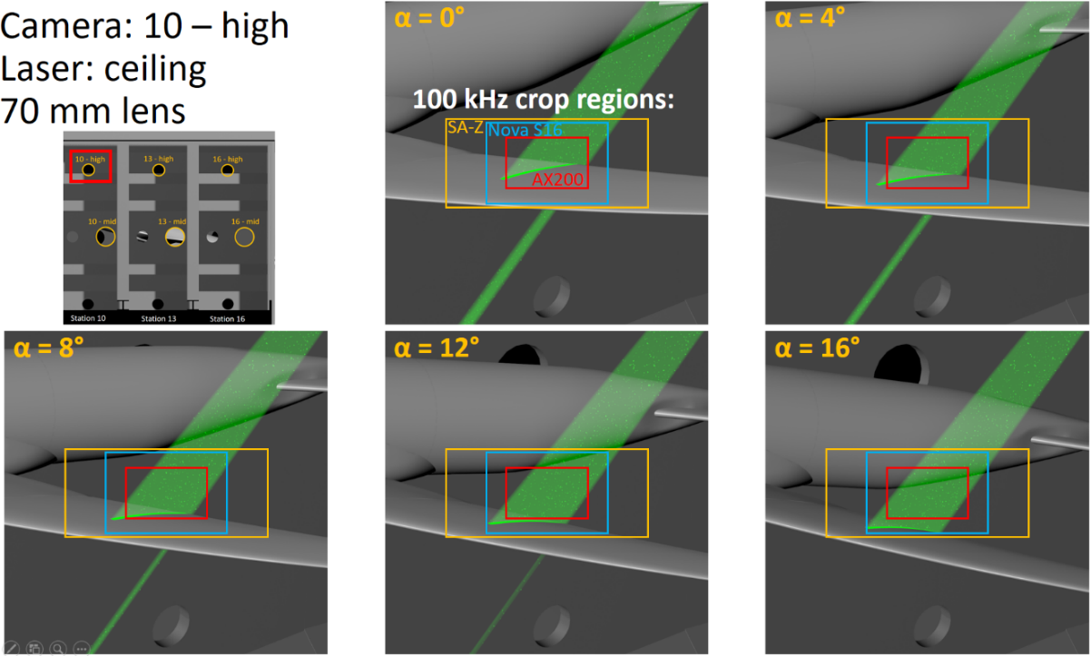
Virtual Diagnostics Interface (ViDI), originally introduced by Richard Schwartz in 2004 and described again by Alderfer, et. al., in 2007, is an interactive 3D software tool developed at NASA Langley Research Center to serve three main purposes: assist in pre-test planning, enhance post-test image analysis and visualization, and serve as a central location for data storage and distribution., ViDI is composed of custom-developed software and Autodesk® 3ds Max® as it incorporates Computer Aided Design (CAD) models with the results obtained from optical diagnostics. This software tool has proven useful in the field of optical diagnostics where pre-test planning of beam paths, optical elements, and test articles must be carried out to avoid interference, ensure spatial resolution is sufficient, and the camera Field of View (FoV) is adequate for the field of interest. Typically, practical considerations such as the distance a camera is from the region of interest, the angles at which the camera is oriented and issues such as the size of the camera and its sensor and size and focal length lens as well as the path of the laser need to be taken into account to predict a successful measurement. An example application of ViDI is shown in Fig. 1 where an experiment to investigate flow separation over the wing of the High Lift Common Research Model (HL-CRM) is currently being planned in the National Transonic Facility (NTF) at NASA Langley Research Center.
Fig. 1 Example of ViDI in pre-test analysis of beam path, camera angle, and anticipated FoV.
In Fig. 1 the beam path of the laser is shown impinging on the model wing at various angles of attack (α). The camera FoV (cropped for operation at a frame rate of 100 kHz) from 3 separate cameras, the Photron SA-Z, Nova S16, and AX200, are then overlaid on the model to ensure an adequate camera is selected. ViDI helps with pre-test planning and mitigates costly and time-consuming mistakes in selecting the camera, camera angle, and beam path during this experiment. This is especially useful in the NTF, where access to the experimental setup is limited and thus performing even small modifications to the setup can be difficult and delay testing. Another advantage of ViDI is in the post processing of optical diagnostics, as the results from the flow field can be overlaid with the CAD model of the test article. The geometry of the model can be clearly viewed with the resulting data obtained from experiment, making the results easier to interpret and multiple data sources viewable at once. An example of this was the work done by Combs, et. al., in 2015 as Nitric Oxide Planer Laser Induced Florescence (NO-PLIF) was used to visualize the flow fields of the Reaction Control System jets (RCS) and the wake region of the Orion Multipurpose Crew Vehicle (MPCV). This data was overlaid with the original model and surface pressure measurements from Pressure Sensitive Paint (PSP) testing to understand how the RCS jets were interacting with the wake region of the MPCV and inducing heating on the capsule body. Using ViDI as a post processing tool allowed for the clear and effective visualization of the NO-PLIF and PSP data on the capsule body.
A comprehensive outline of ViDI and its uses in test planning, diagnostics, and post-processing of data will be given. This will consist of an overview and examples of how ViDI has been used since the early 2000’s. The result will be the introduction of ViDI to those not immediately familiar with its application.

Acknowledgments
This work is supported by the Aeronautics Research Mission Directorate (ARMD) Aerosciences Evaluation and Test Capabilities (AETC) Portfolio. It is also supported through a NASA grant (80NSSC19M0194) to the University of Texas, San Antonio.

References

Graduate Research Assistant, Department of Mechanical Engineering, AIAA Student Member.
Dee Howard Endowed Assistant Professor, Department of Mechanical Engineering, AIAA Senior Member.
Aeronautics Research Intern, Advanced Measurements and Data Systems Branch and PhD Student, Department of Mechanical and Aerospace Engineering, University of Virginia, Charlottesville, VA.
Senior Technologist for Advanced Measurement Systems, Advanced Measurements and Data Systems Branch, AIAA Associate Fellow.
Schwartz, R. J., "ViDI: Virtual Diagnostics Interface Volume 1-The Future of Wind Tunnel Testing," Contractor Report NASA/CR-2003-212667, December 2003.
Alderfer, D. W., Danehy, P. M., Inman, J. A., Berger, K. T., Buck, G. M., and Schwartz, R. J., "Fluorescence visualization of hypersonic flow over rapid prototype wind-tunnel models," In 45th AIAA Aerospace Sciences Meeting and Exhibit, p. 1063. 2007. doi: 10.2514/6.2007-1063
Autodesk 3ds Max Product Information, Autodesk Inc., https://www.autodesk.com/products/3ds-max/overview?support=AD VANCED&plc=3DSMAX&term=1-YEAR&quantity=1, viewed June 1, 2020.
Combs, C. S., Clemens, N. T., Danehy, P. M., Bathel, B. F., Parker, R., Wadhams, T., Holden M., and Kirk, B., “Fluorescence Imaging of Reaction Control Jets and Backshell Aeroheating of Orion Capsule.” Journal of Spacecraft and Rockets 52, no. 1 (2015): 243-252. doi: 10.2514/1.A32946

