Costa Rica & Panama Ecological Forecasting II
Identifying Current and Future Areas of Environmental Concern in La Amistad International Park to Inform Resource Management

Contents
Suitability Map Creation 1
Conflict Map Creation 9
Results 10
2019 10
Suitability Maps 10
Conflict Maps 13
2029 18
Suitability 18
Conflict 21

Suitability Map Creation
Suitability maps were created for the three categories: urban, ecological significance, and agriculture. Data was reclassified on a scale from one to three with one indicating low suitability, two indicating moderate suitability, and three indicating high suitability. In a few cases, data was reclassed in a binary fashion and only low (one) and high (three) suitability were used. Tables 1 and 2 show the data used to create each suitability map as well as how the data was reclassified and the logic behind these decisions.

To create the agricultural suitability map for 2019, the shapefiles provided by partners for pineapple, palm plantations, and pastures with less than 30% tree coverage in 2018 were reclassified. To create the ecological suitability map for 2019, flood risk and landslide shapefiles provided by the partners, as well as the zone of reforestation from 2005, the land cover layer from 2005, and the road layer from the Digiital Atlas of Costa Rica from 2014, and the Mapa de bosques de Costa Rica provided by partners were used. To create the urban suitability map for 2019, the road layer and financial instutions layer from the the Digiital Atlas of Costa Rica from 2014, along with regional poverty data provided by partners and from INEC, and the evidence likelihood of urbanization the DEVELOP team created from our landcover classification maps were used. See table 1.

To create the agricultural suitability map for 2029, the shapefiles provided by partners for palm plantations and pastures with less than 30% tree coverage in 2018 along with the 2029 land cover map created by the DEVELOP team were used. To create the ecological suitability map for 2029, the 2029 land cover map created by the DEVELOP team as well as biodiversity maps from biodiversitymapping.org were used. To create the urban suitability map for 2029, the evidence likelihood of urbanization the DEVELOP team created from our landcover classification maps were used as well as the urban area identified in our 2029 land cover classification map. See table 2.

Table 1. Suitability Map Creation for 2019. Table includes the data used, the criteria used to reclassify that data, and the reclassification of the data using a scale from one (low suitability) to three (high suitability) for meeting each sub-objective, objective, and goal within the three categories: agriculture, ecological significance, and urban.
Agricultural
Goal | Objective | Sub-objective | Data used | Criteria | Classification
Increase the agricultural area with environmentally sustainable production practices | Increase coverage of livestock pastures with silvopastoral systems | Identify areas of grass with poor tree cover | PASTOS_PILOTOS  Capa compartida de pastos con menos de 30% de cobertura árborea para el 2018. | Pasture outside of protected, buffer, and corridor area is most suitable all land within buffer, protected area, and corridors is unsuitable for livestock pastures | 3: Pasture outside protected area, buffer zone, and corridors  2: Grassland, bare soil, and agricultural land outside of protected area, buffer zone, and corridors  1: All land within protected area, buffer zone, and corridors
 | Increase the coverage of the agricultural area with an agroforestry system | Identify areas of agricultural use with low tree cover | Capa compartida de piña para el 2018. | Area closer to pineapple plantation is more suitable than area further away and bare soil, agriculture, pineapple, and grassland are more suitable than other land cover types to convert to pineapple plantation | Created 1.5km buffer from pineapple.  3: Agriculture, bare soil, grassland, pineapple plantation within buffer zone  2: Agriculture, bare soil, grassland, and pineapple plantation outside of the buffer zone  1: All other and cover classifications
 |  | Identify areas of agricultural use with low tree cover | Capa compartida de palma aceitera para el 2018. | Area closer to palm plantation is more suitable than area further away and bare soil, agriculture, pineapple, and grassland are more suitable than other land cover types to convert to palm plantation | Created 1km buffer from palm plantations.  3: Agriculture, bare soil, grassland, pineapple plantation within buffer zone  2: Agriculture, bare soil, grassland, and pineapple plantation outside of the buffer zone  1: All other and cover classifications
Ecological Significance
Goal | Objective | Sub-objective | Data used | Criteria | Classification
Identify potential areas for implementing ecosystem-based climate change adaptation and mitigation measures | Identify areas vulnerable to natural hazards | Identify flood areas | Layer titled: "RiesgodeInundaciones2014crtm05" Layer titled: "Modeloinund2014crtm05" Ambas en el Atlas Digital de Costa Rica 2014 | The lower the risk for flooding, the higher the suitability | 3 (high suitability): Low risk of flooding  2 (moderate suitability): Moderate risk of flooding  1 (low suitability): High risk of flooding
 | Identify areas vulnerable to natural hazards | Identify landslide areas | Layer titled: "Corona de deslizamientos". Servicio WFS | Landslide area and the area immediately around landslides will need greater protection than area further from landslides. This was a binary classification (moderate suitability not included). | 3 (high suitability): Land less than 1km from landslide  1 (low suitability): Land greater than 1km from landslide
 | Identify areas with major forest cover degradation | Identify the areas in greatest need of restoration | Layer titled: "Zonaoptimreforescrtm05" in the Atlas Digital of Costa Rica 2014. | Reclassification was based off the sub-objective: identifying areas with the greatest need for reforestation. Additional data from the 2019 landcover map and the basemap in ArcMap helped to identify zones with sparse forest cover. Areas with high forest cover were given a 1 (low suitability), areas with moderate forest cover were given a 2 (moderate suitability), and areas with no forest cover and was not near urban areas was given a 3 (high suitability) | 3 (high suitability): Zone bh-T tropical humid forest  2 (moderate suitability): zone Bmh-T: deep tropical rainforest; bp-MB : lowland rainforest; bp-P: premontane rainforest; bmh-P: very humid premontane forest; bmh-MB: very humid lowland forest  1 (low suitability): Zones bmh-P6: very humid premontane forest transition to basal); bp-M: mountain rainforest
 | Identify areas with major forest cover degradation | Identify areas with the greatest potential for biomass increase | Layer titled: "Capacusocr2008crtm05" in the Atlas Digital of Costa Rica 2014. | Inside protected areas: buffer zone, and corridors, already forested (protected forest or protected area) is not likely to increase in biomass. Agricultural land and permanent crops are also unlikely to gain biomass. Agricultural land with limitations are moderately likely. Managed forests are highly likely. Outside of these areas, managed forests and cattle raising areas remain highly suitable, protected forests remain unlikely to gain, and all agricultural land is considered unlikely to gain biomass. | 3: Managed forest, cattle raising or managed forest  2: Agriculture with limitations within the buffer/protected area/corridors  1: Agriculture, protected area, protected forest, permanent crops, and agriculture and agriculture with limitations outside the buffer/protected area/corridors
Increase national forest cover to 60% by 2030 | Identify areas for potential reforestation | Identify areas that are in initial forest succession | Layer titled: "Mapa de bosques de Costa Rica". Link de descarga: https://datosprias.cenat.ac.cr:5001/sharing/kRsap15aU | Areas with low tree cover is seen to be more suitable for reforestation, per the objective | 3 (high suitability): Grass  2 (moderate suitability): Non – Forestry; Forest Planting  1 (low suitability): Deciduous Forest; Mature Forest; Palm Forest; Secondary Forest; Mangrove; Clouds; Cloud Shadows; Paramo
Increase national forest cover to 60% by 2030 | Identify areas for potential reforestation | Identify potential areas of biological corridors between protected areas across the fragmented landscape | Zone of absolute protection and buffer zone shapefiles | Forest fragments are less than or equal to 10 hectares (100000 sq m) but greater than or equal to 1 hectare (10000 sq m). Intact forest is greater than 10 hectares. Following this, a corridor analysis was run (distance from fragments and intact forest) and lower values, which indicate less distance between fragments and intact forest, is more suitable. Corridors within protected areas, buffer, and corridors are more suitable. | 3: Less than 2,323 square meters distance between fragment and intact forest and inside protected area, buffer, or corridor  2: Less than 2,323 square meters distance between fragment and intact forest and outside protected area, buffer, or corridor  1: Greater than 2,323 square meters distance between fragment and intact forest
Increase national forest cover to 60% by 2030 |  |  | Layer titled: "Redcamino2014crtm05" in the Atlas Digital of Costa Rica 2014. | The closer to roads, the lower the suitability for reforestation | 3 (most suitable): 0.059 - 0.24 degrees from road  2 (moderate): 0.007 - 0.059 degrees from road  1 (least suitable): 0 - 0.007 degrees from road
Urban
Goal | Objective | Sub-objective | Data used | Criteria | Classification
Promote sustainable urban growth consistent with land use capacity | Identify potential areas that will function as urban nodes of economic growth | Identify potential areas of commercial use | Layer titled: "Redcamino2014crtm05" in the Atlas Digital of Costa Rica 2014. | The closer to a road, the greater likelihood the land was suitable for commercial development | 3 (most suitable): 0 - 0.007 degrees from road  2 (moderate): 0.007 - 0.059 degrees from road  1 (least suitable): 0.059 - 0.24 degrees from road
 |  | Identify potential areas of commercial use | Evidence Likelihood of Urbanization | The higher likelihood of the land cover changing to urban the higher the suitability for commercial use | 3 (most suitable): 0.24-0.39  1(least suitable): 0-0.24
 |  | Identify potential areas of commercial use | Distance from financial institutions | The closer to a financial institution, the greater likelihood the land was suitable for commercial development | 3 (most suitable): 0-.12 degrees from institutions  2 (moderate suitability): 0.12-0.20 degrees from institutions  1 (least suitable): 0.20-0.43 degrees from institutions
 |  | Identify potential areas of residential use | INEC-Households below poverty line | Lower poverty levels (category) means higher development | 3 (most suitable): 1  2 (moderate): 2  1 (least suitable): 3-5

Table 2. Suitability Map Creation for 2029. Table includes the data used, the criteria used to reclassify that data, and the reclassification of the data using a scale from one (low suitability) to three (high suitability) for meeting each sub-objective, objective, and goal within the three categories: agriculture, ecological significance, and urban.
Agricultural
Goal | Objective | Sub-objective |  | Data used |  |  | Criteria |  | Classification
Increase the agricultural area with environmentally sustainable production practices | Increase coverage of livestock pastures with silvopastoral systems | Identify areas of grass with poor tree cover |  | Shared layer of grass with less than 30% coverage by 2018. 2029 Land cover map |  |  | Certain land cover types within 5km of large areas (>=5km) of agricultural land predicted for 2029 will be more likely to transition to pasture for livestock. Protected area, buffers, and corridors is unsuitable for pasture. |  | 3: Grassland, agricultural land, and bare soil within 5km from large agricultural areas and not protected area, buffers, and corridors  2: Grassland, agricultural land, and bare soil more than 5km from large agricultural areas  1: All protected area, buffers, or corridors, and other land cover types outside of protected area, buffers, and corridors
 | Increase the coverage of the agricultural area with an agroforestry system | Identify areas of agricultural use with low tree cover |  | 2029 Land cover map and |  |  | Land closer to predicted pineapple plantation in 2029 more suitable |  | 3: 0 - 0.01 degrees from pineapple plantation  2: 0.01 - 0.08 degrees from plantation  1: 0.08 - 0.36 distance and all area inside protected area
 |  |  |  | 2029 Land cover map and palm plantation layer from 2018 |  |  | Land closer to predicted palm plantation in 2029 more suitable. Palm plantation layer from 2018 was buffered and any agricultural area predicted in 2029 within that buffer was considered palm plantation. |  | 3: 0-0.011 degrees from palm plantation  2: 0.011-0.010 degrees from palm plantation 1:0.10-0.7 degrees from palm plantation and all area inside protected area
Ecological
Goal | Objective | Sub-objective |  | Data used |  |  | Criteria |  | Classification
 | Identify areas with major forest cover degradation | Identify areas with the greatest potential for biomass increase |  | 2029 Land cover map |  |  | Grassland, bare soil, and secondary forest have greatest suitability for biomass increase and these land cover types are more likely to experience biomass increase within protected area and buffer zone and corridors |  | 3: Grassland, bare soil, and secondary forest in 2029 in protected areas, buffer zone, and corridors  2: Grassland, bare soil, and secondary forest outside of protected areas, buffer zone, and corridors  1: Everything but grassland, bare soil, and secondary forest
Increase national forest cover to 60% by 2030 | Identify areas for potential reforestation | Identify areas that are in initial forest succession |  | 2029 and 2019 land cover maps |  |  | Areas of deforestation within protected area buffer area, and corridors would be more likely to be reforested than deforestation outside of protected area and buffer zone. Grasslands, bare soil, and agricultural land (including pineapple plantations) within protected areas, buffer zones, and corridors are more suitable than other land cover types for reforestation. |  | 3: Deforestation and grassland, bare soil, and agriculture within absolute protected area, buffer area, and corridors  2: Deforestation outside protected area and buffer area  1: Other land cover types
Increase national forest cover to 60% by 2030 | Identify areas for potential reforestation | Identify potential areas of biological corridors between protected areas across the fragmented landscape |  | 2029 land cover map |  |  | Forest fragments are less than or equal to 10 hectares (100000 sq m) but greater than or equal to 1 hectare (10000 sq m).Intact forest is greater than 10 hectares. Following this, a corridor analysis was run (distance from fragments and intact forest) and lower values, which indicate less distance between fragments and intact forest, is more suitable. Corridors within protected areas, buffer, and corridors are more suitable. |  | 3: Less than 1,970 square meters distance between fragment and intact forest and inside protected area, buffer, or corridor  2: Less than 1,970 square meters distance between fragment and intact forest and outside protected area, buffer, or corridor  1: Greater than 1,970 square meters distance between fragment and intact forest
Increase national forest cover to 60% by 2030 | Identify areas for potential reforestation | Identify potential areas of biological corridors between protected areas across the fragmented landscape |  | biodiversitymapping.org and shapefiles from partners of protected areas |  |  | Areas with higher biodiversity are more suitable than areas with lower biodiversity and areas that are either currently protected or within the buffer zone are more suitable than land with no protections or restrictions |  | 3: All land inside absolute protected areas and areas with high biodiversity within the buffer zone  2: Area with moderate biodiversity within the buffer zone and areas with high biodiversity outside the buffer zone  1: Low biodiversity inside the buffer zone and area outside the buffer zone with moderate or low biodiversity
Urban
Goal | Objective |  | Sub-objective |  | Data used | Criteria |  | Classification
Promote sustainable urban growth consistent with land use capacity | Identify potential areas that will function as urban nodes of economic growth |  | Identify potential areas of commercial use |  | Evidence Likelihood of Urbanization | The higher likelihood of the land cover changing to urban the higher the suitability for commercial use |  | 3: 0-0.03 likelihood  2: 0.03-0.10 likelihood  1: 0.10-0.39 likelihood
 |  |  |  |  | Landcover map from 2029 | Closer to urban areas, higher suitability for commercial development |  | 3: 0-0.06 degrees from urban area  2: 0.06-0.17 degrees from urban area  1: 0.17-0.37 degrees from urban area

Conflict Map Creation
Once suitability maps were created for each category, they were paired to create three conflict maps: conflict between agricultural and ecological goals, agricultural and urban goals, and ecological and urban goals. This was done by adding the two suitability maps together using Raster Calculator in ArcMap. Each suitability map ranges from 1-3 thus each of these conflict maps ranges from 2-6, with higher values indicating higher conflict.

A conflict map for all three categories was also created by adding the three suitability maps together in Raster Calculator in ArcMap. This conflict map ranges from 3-9 with higher values indicating higher conflict.

Results

2019

Suitability Maps

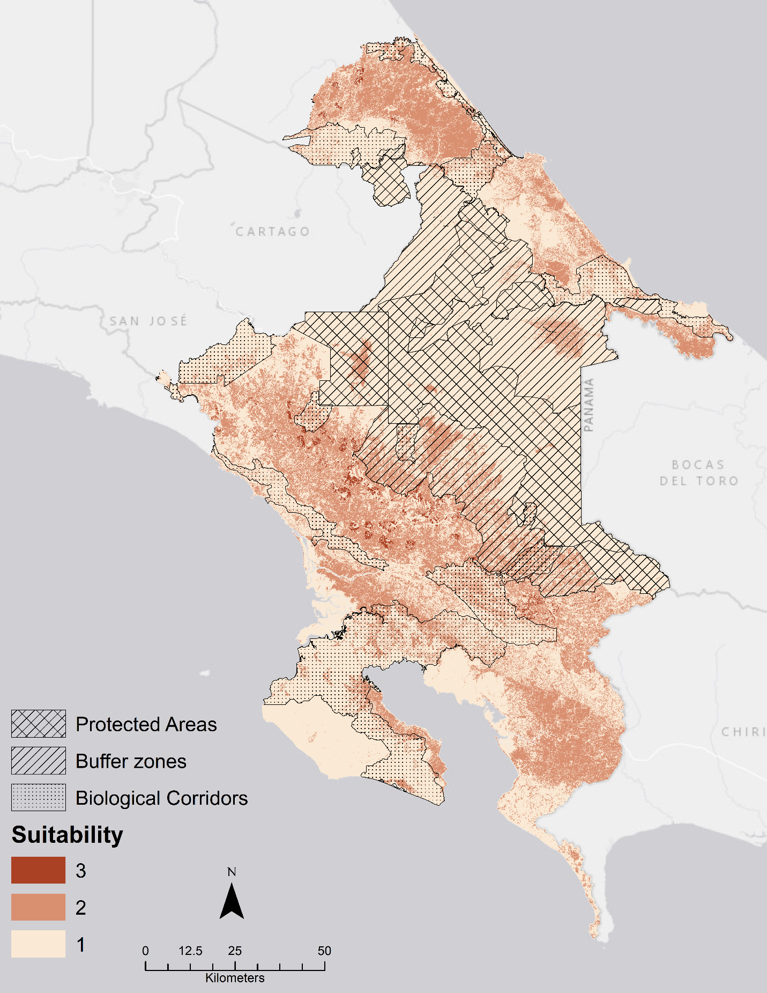
Figure 1 Suitability Map-Agriculture 2019
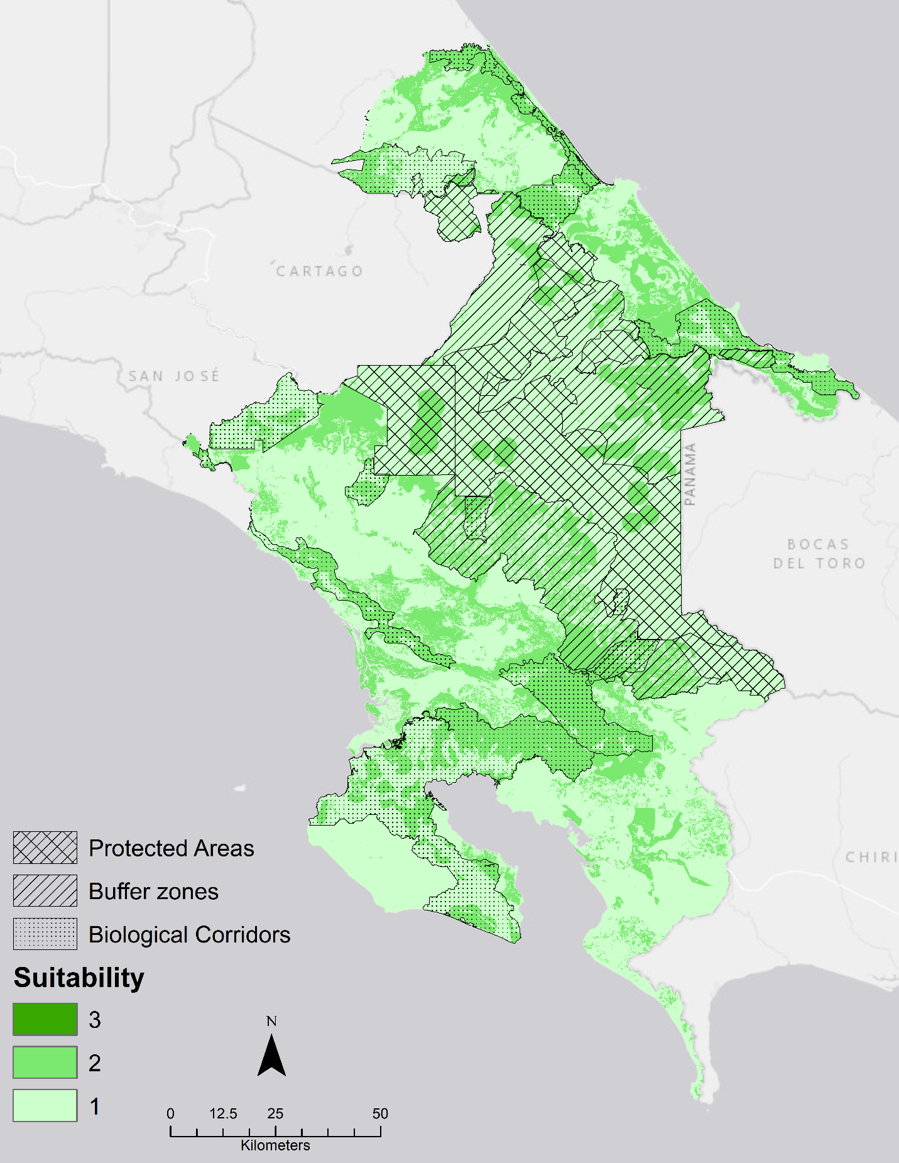
Figure 2 Suitability Map-Ecological Significance 2019
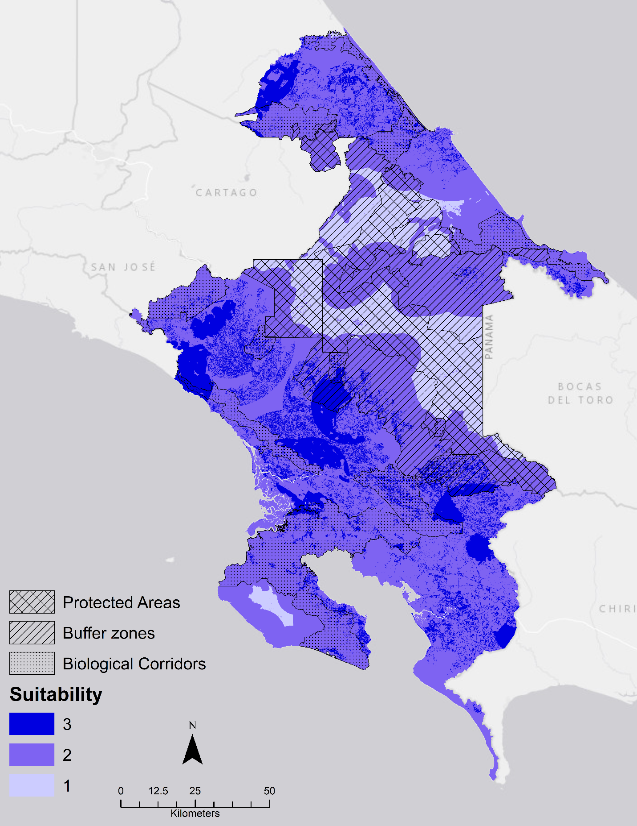
Figure 3 Suitability Map- Urban 2019

Conflict Maps
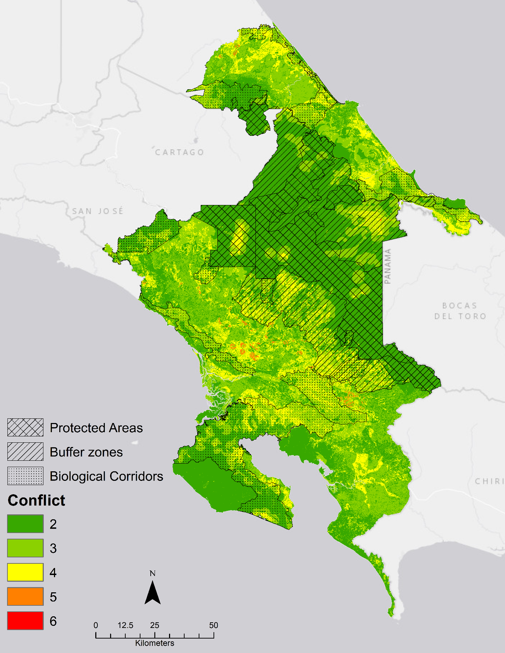
Figure 4 Conflict between Ecological-Agricultural goals- 2019
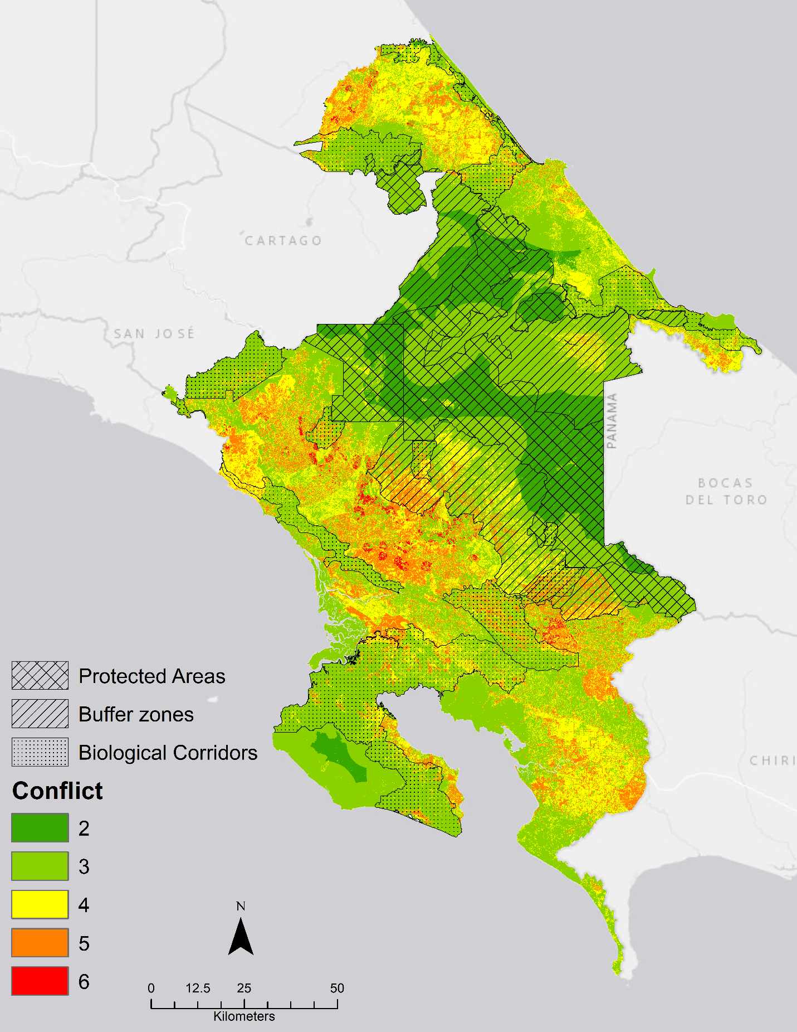
Figure 5 Conflict between Ecological-Urban goals- 2019
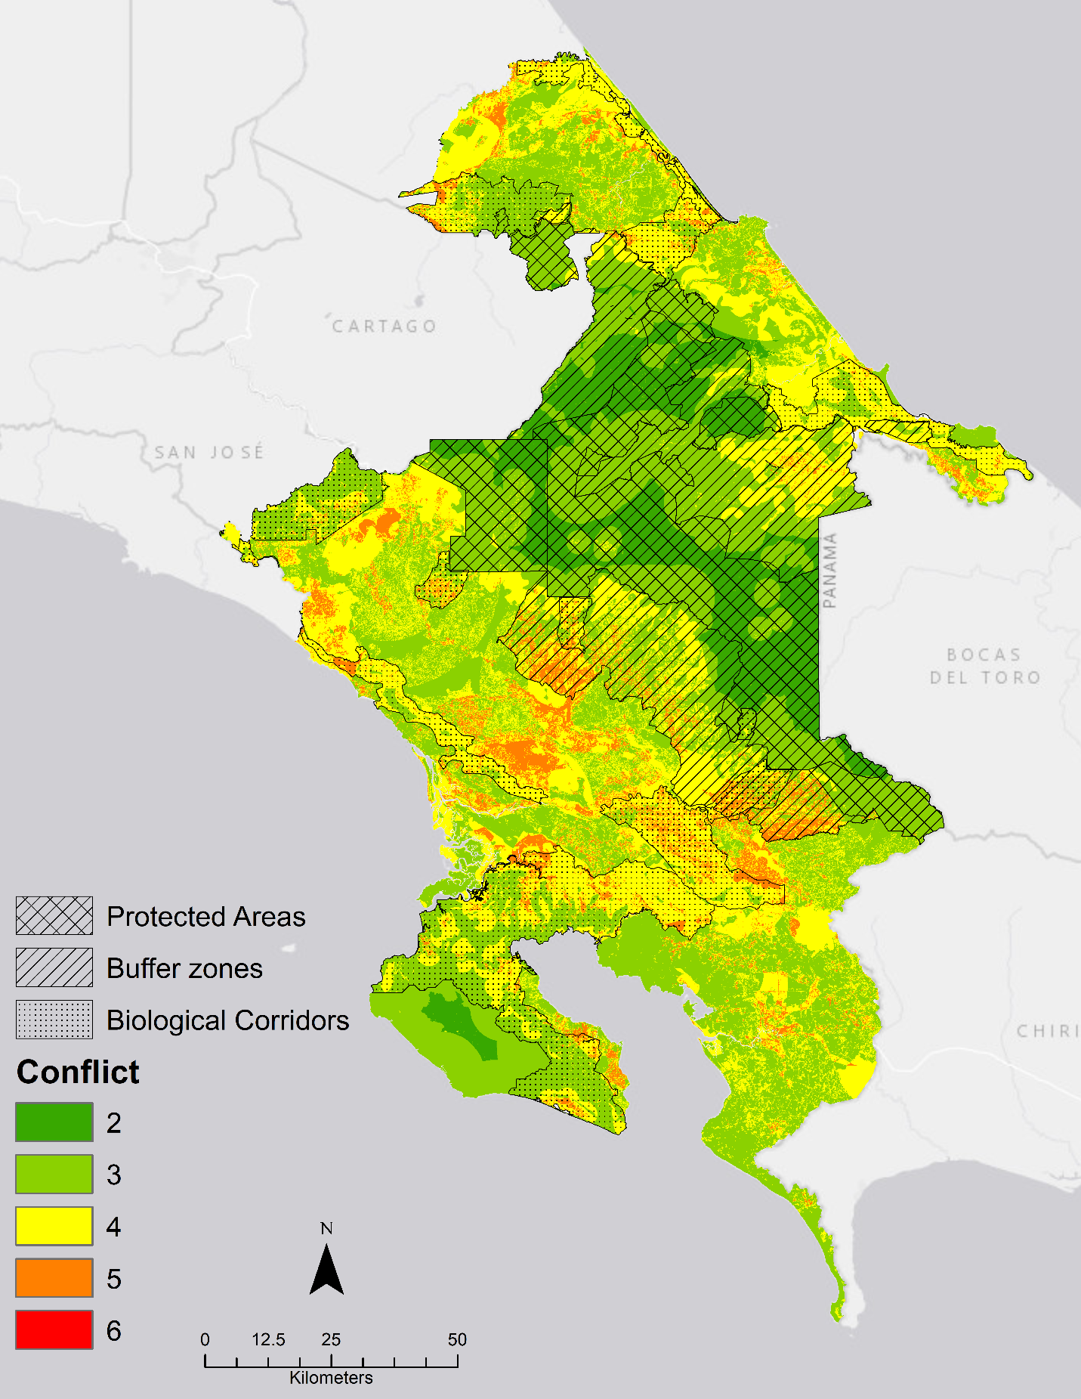
Figure 6 Conflict between Agricultural-Urban goals- 2019
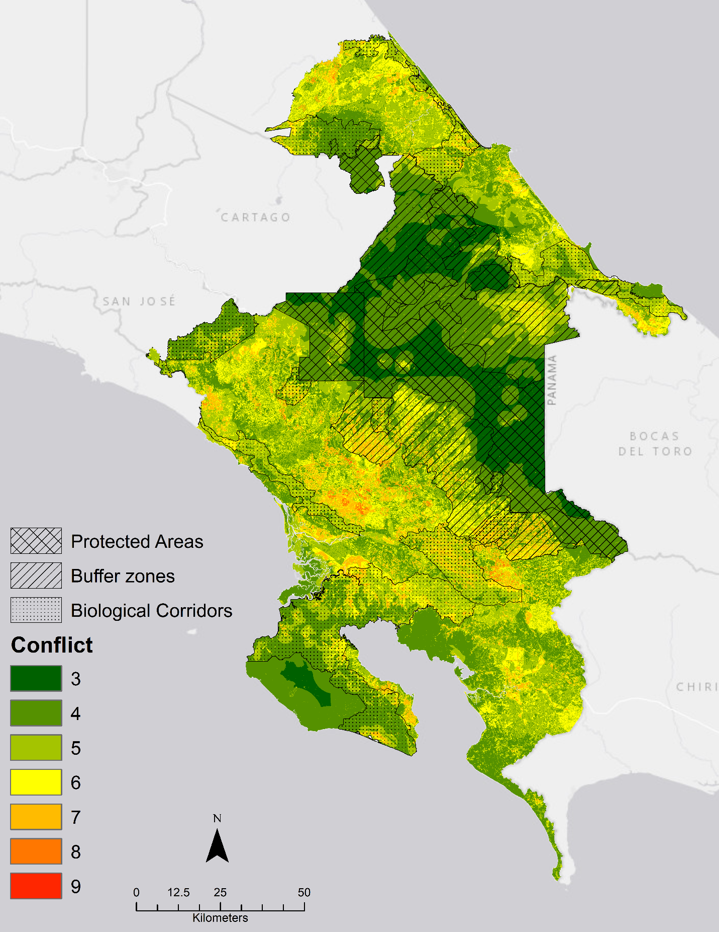
Figure 7 Conflict between all three goals-2019

2029

Suitability
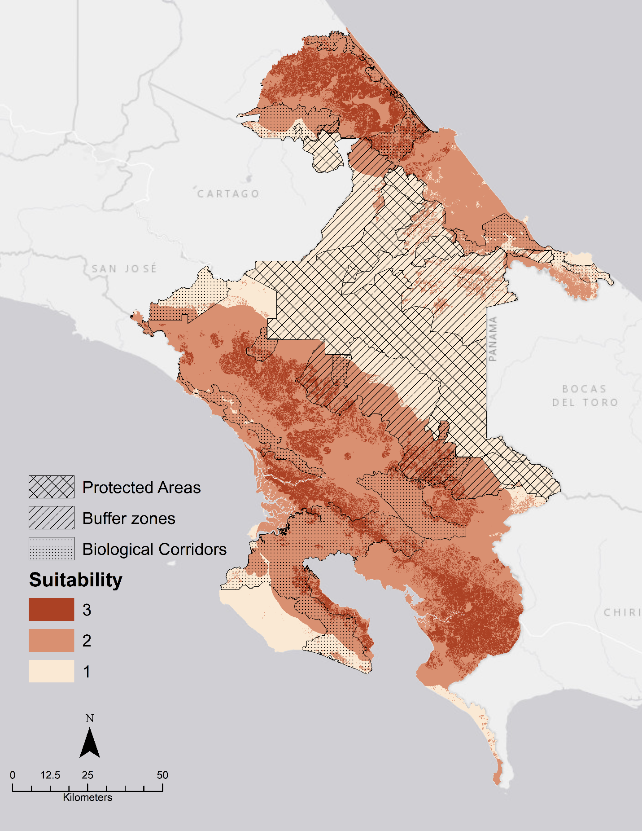
Figure 8 Suitability Map Agriculture- 2029
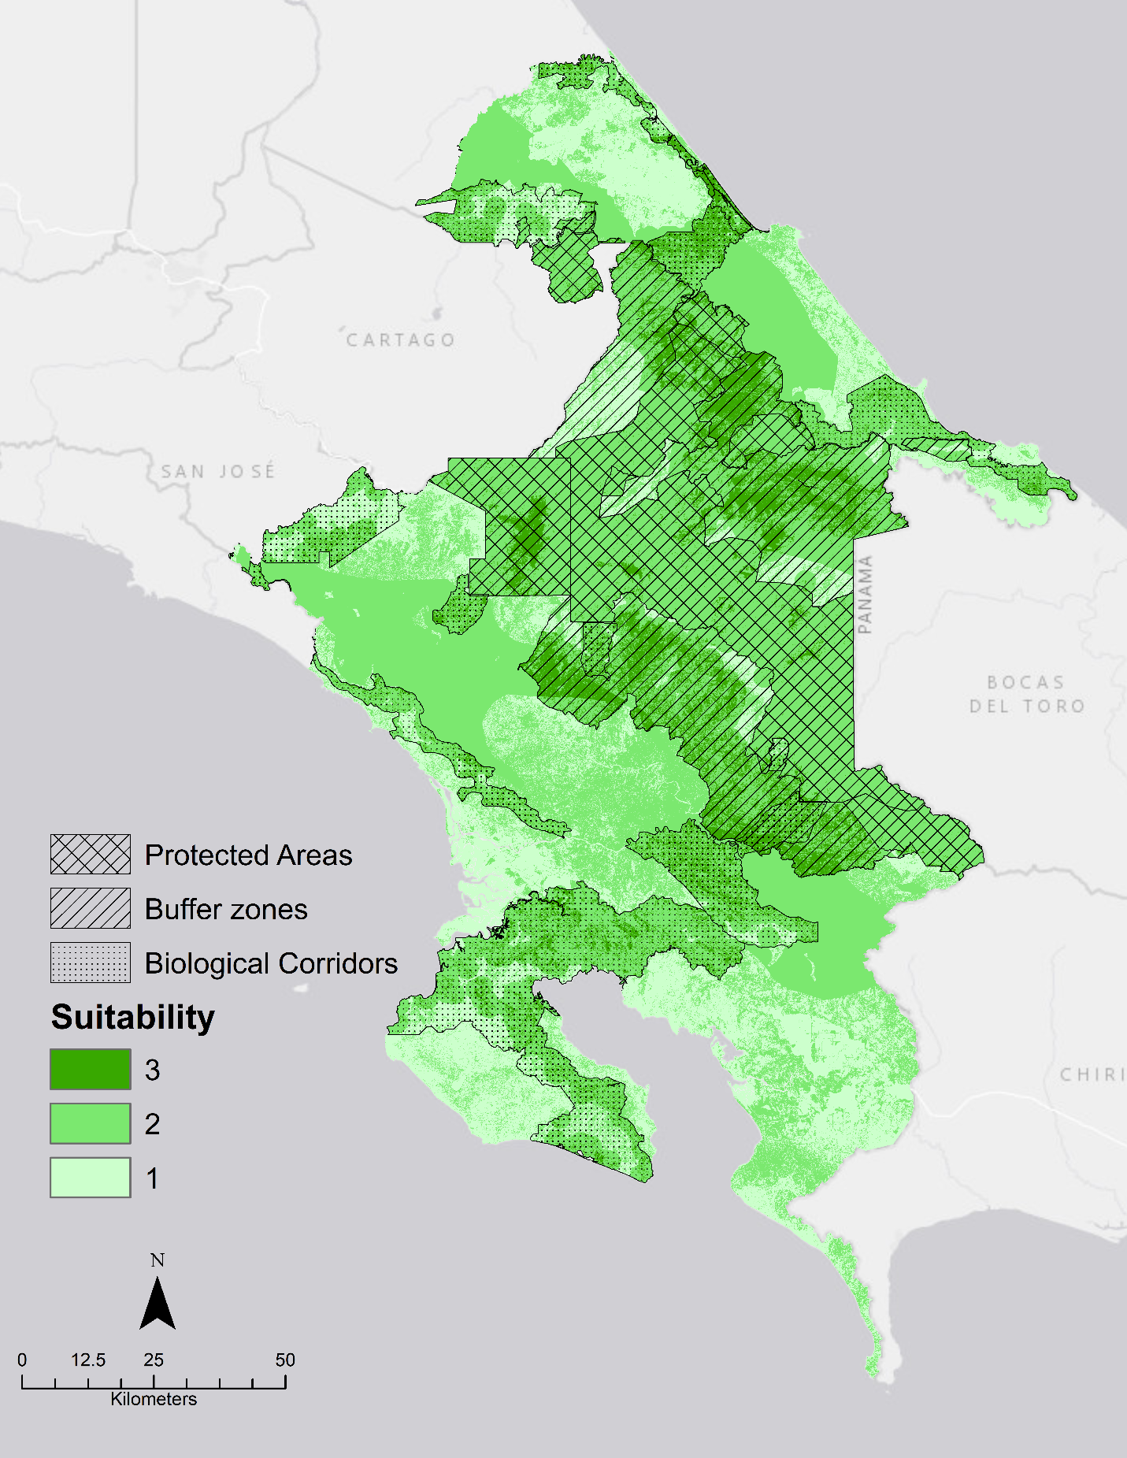
Figure 9 Suitability Map Ecological Significance- 2029
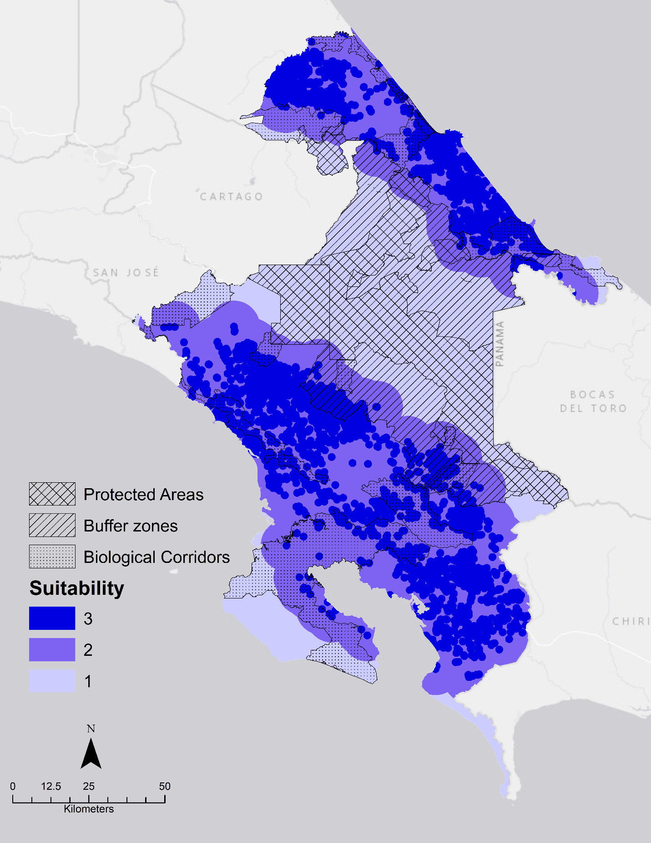
Figure 10 Suitability Map Urban-2029

Conflict
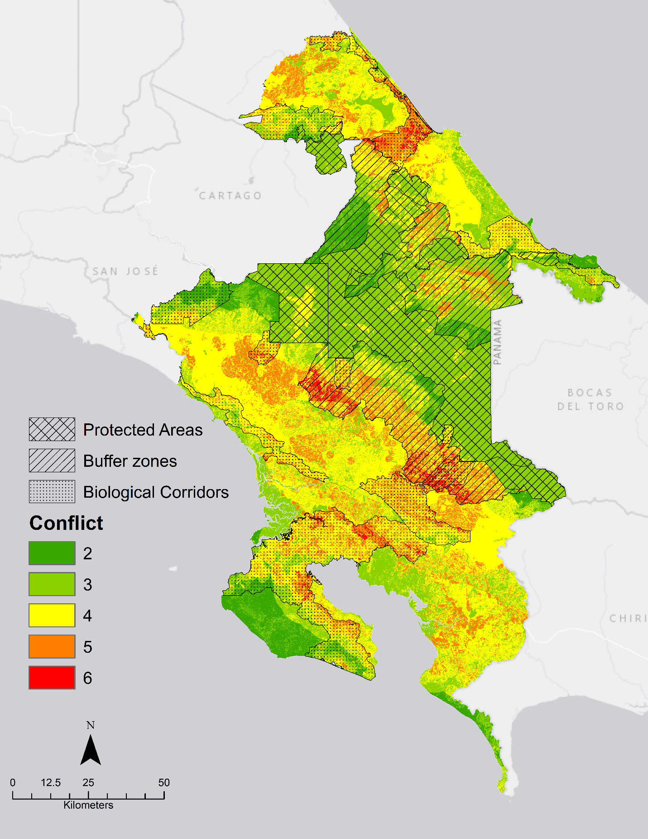
Figure 11 Conflict between Agricultural and Ecological goals-2029
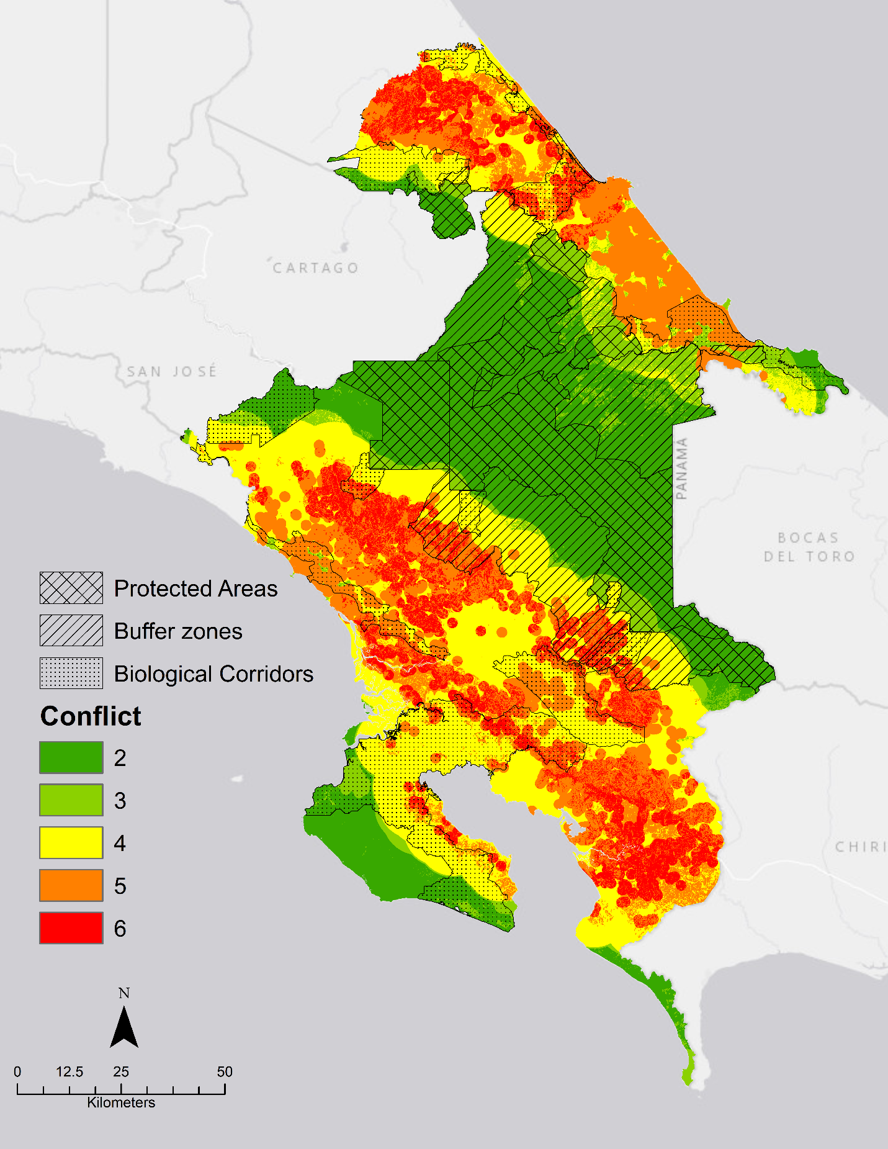
Figure 12 Conflict between Agricultural and Urban goals-2029
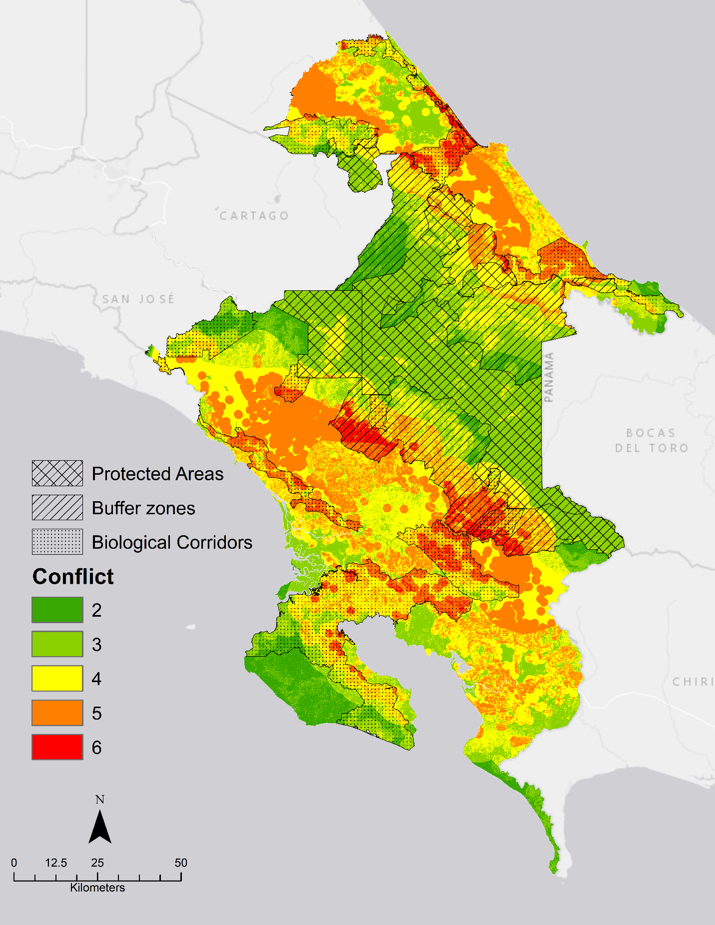
Figure 13 Conflict between Ecological and Urban goals-2029
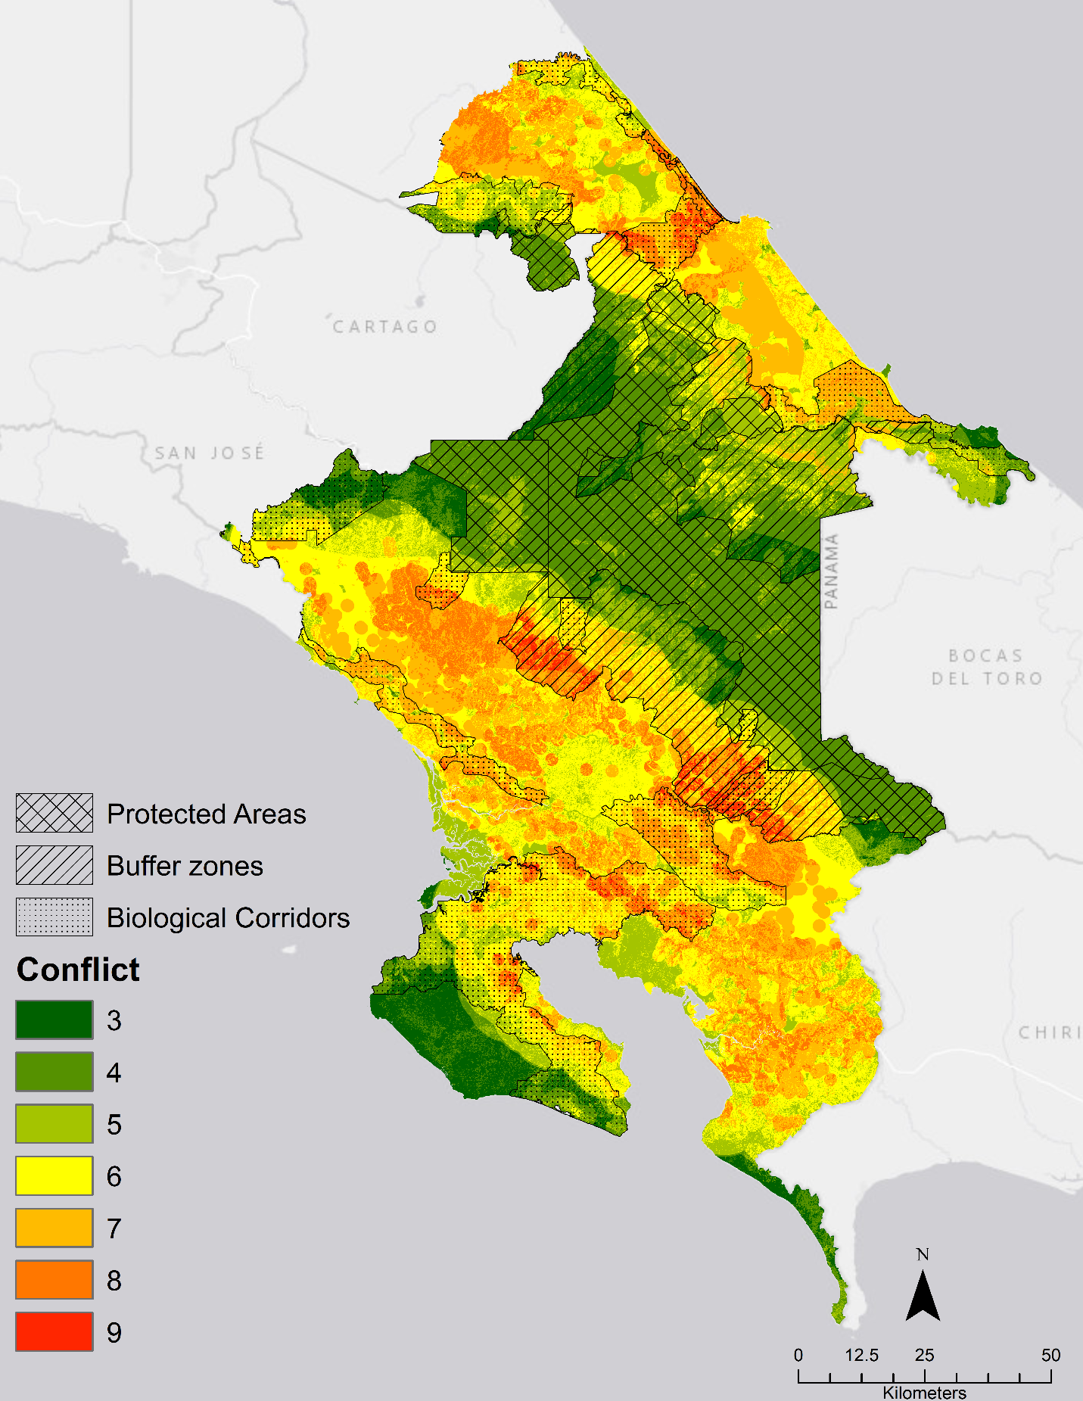
Figure 14 Conflict between all three goals-2029

