Seeding Mechanism for High-Pressure Nozzles
Aditya S. Acharya, K. Todd Lowe, Wing F. Ng,
Virginia Polytechnic Institute and State University, Blacksburg, Virginia 24061
and
Paul M. Danehy
NASA Langley Research Center, Hampton, Virginia 23666
NASA tests new launch and entry vehicle configurations in wind tunnels, where flow visualizations and quantitative flowfield measurements are often desired. Some of these vehicles have rocket motors for propulsion, retro-propulsion, or reaction control. Unseeded, high-pressure air is often used to simulate these rocket motor plumes. However, it is difficult to make off-body measurements in these regions, for several reasons. First, the plumes themselves are usually unseeded and at such low pressures that the flow velocity cannot currently be measured. Second, the plumes displace seeded tunnel air, preventing measurements such as laser sheet visualizations. Third, they force shock waves ahead of the vehicle, which melts the ice crystal fog commonly used for many visualization and measurement techniques. The Virginia Tech Advanced Propulsion and Power Lab has designed and tested a novel method for seeding the flow in these small-scale, high-pressure nozzles to allow quantitative measurement with a particle-based measurement such as particle image velocimetry (PIV). The method involves a Venturi contraction to draw the seed liquid out of a reservoir and into the nozzle channel, wherein shearing forces atomize the seed into particles. The concept was tested with a laser sheet visualization, which showed the nozzle spray pattern and the controllability of the seeding flow rate. This relatively inexpensive and simple technique may prove useful in wind tunnel experiments involving particle-based laser diagnostics and small, high-pressure nozzles.
- Nomenclature
$γ$ = specific heat ratio
$c_{n}$ = particles per unit volume
D = representative particle diameter
I = light scattering intensity
M = Mach number
r = temperature recovery factor
$T_{0}$ = total temperature
$T_{wall}$ = adiabatic wall temperature
- Introduction
The Space Launch System (SLS) is a heavy-lift launch vehicle that is currently under development by the National Aeronautics and Space Administration (NASA). It consists of a core stage and two solid rocket boosters (SRB) that separate from the core after their fuel is exhausted, about two minutes after launch. This separation is aided by booster separation motors (BSM) located on the nose and aft skirt of both SRBs; these motors are fired for one second to move the SRBs away from the core and reduce the chance of contact.
NASA Langley Research Center has run several tests of scale SLS models in their Unitary Plan Wind Tunnel (UPWT) to study the aerodynamics of booster separation and ensure that the SRBs separate safely [1]. Figure 1 shows a variant of model, the SLS-28005, in the tunnel along with its separation rig and SRBs. The nose and aft skirt of a standard SRB model is shown in Figure 2; the four visible holes on each are the converging-diverging BSM nozzles, which can be activated at various total pressures up to 1500 psia.

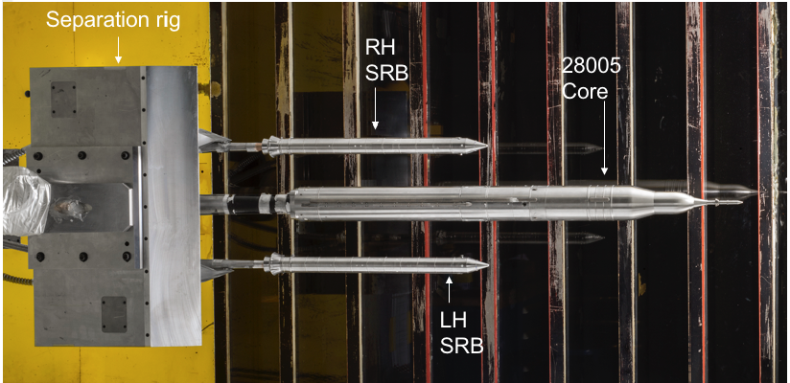
Fig. 1 SLS model in the UPWT with SRBs and separation rig [1].

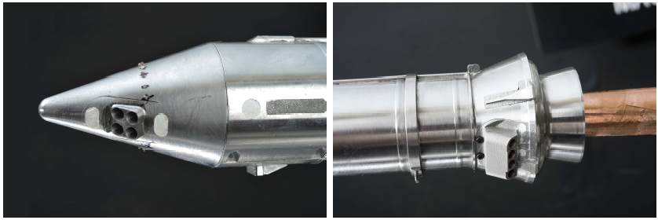
Fig. 2 Forward (left) and aft (right) BSM nozzles on model SRBs [1].

These models were used in experiments involving Doppler Global Velocimetry [2] and laser light sheet visualizations [3], where a problem with the high-pressure nozzles became apparent. These studies depend on the scattering of laser light by particles introduced into the flow; however, instruments recorded insufficient scattered light signals from regions around the BSMs. While this decrease in scattering intensity may be partially explained by the sublimation/evaporation of particles near the warm model surface or after they are processed by a shock wave, it is important to note that the BSM nozzles expelled dry, unseeded air, which likely displaced much of the incoming seeded air upon expansion. Figure 3 shows the results of the laser visualization study by Danehy et al. near the forward BSMs of an SRB. As the BSM pressures increased, the green “sheet” of scattered light intensity clearly diminished, save for a specific pattern in the nozzle plumes that may have formed from air condensation.

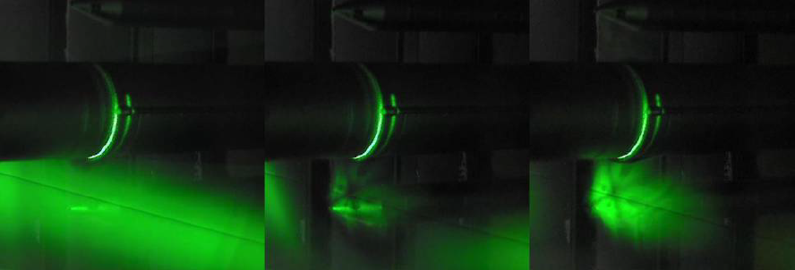
Fig. 3 Laser sheet visualization at three different BSM pressures: 0 (left), 728 psi (middle), and 1509 psi (right) [3].

A similar issue was found in the study by Lowe et al, in which the authors were unable to obtain results in the vicinity of unseeded BSM plumes. Thus, a clear need to develop a seeding mechanism for such nozzles in high-speed flows was established; the high pressures and small size presents unique challenges in both particle generation and dispersal. In addition to the motivating SLS application, this development may be useful in other studies, for example, experimental testing of supersonic retropropulsion vehicles for descent and landing on planetary surfaces [4]. This paper presents a study conducted at the Virginia Tech Advanced Propulsion and Power Lab to investigate a novel seeding technique for high-pressure nozzles exposed to high-speed airflow.
- Analysis
Specific parameters for the BSM nozzles in the SLS studies were supplied by colleagues from NASA, as follows: – plenum total pressures ranging up to 1500 psia, plenum total temperatures of 100-200°F, minimum throat diameter of 0.08 in, and a nozzle exit Mach number of 2.5. Though a variety of seeding techniques exist, these parameters and the desire to reasonably fit such a system within volume constraints of models and the UPWT test section presented a unique situation that seemed to complicate their implementation.
As stated previously, there are two challenges faced when designing a seeding mechanism: seed particle generation and seed dispersal. Condensation and atomizers are two frequently used methods of generating seed particles [5]. Condensation involves the evaporation of some seed liquid into gaseous form, after which condensation occurs onto impurities within the flow, creating small liquid particles. Atomizers, such as nebulizers, disintegrate liquid into individual droplets through shearing forces.
As Melling describes, a form of atomization occurs in Laskin nozzles [6], wherein compressed air is blown into a reservoir of seed liquid, which creates air bubbles that contain submicron floating liquid droplets. These air bubbles rise into an impactor which only allows the micron-scale droplets through. A basic diagram of a Laskin nozzle from the Melling text is provided in Figure 4. The droplets themselves are created from the shearing process of the compressed air within the liquid reservoir [7,8]. Laskin nozzles have been used with success in several studies involving high-speed flows [9,10]. However, many experiments using Laskin nozzles to generate particles then go on to disperse them into a flow using some sort of distributor bar [11], which would likely be impractical at the small scales involved in SLS model testing.

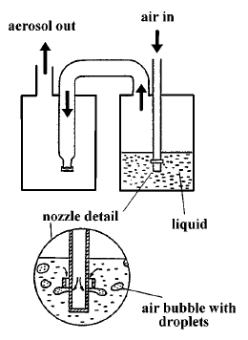
Fig. 4 Laskin nozzle diagram [5].

With apparently minimal literature on seed delivery at small scales, it was concluded that some new technique would need to be developed. In seeking a method that would minimize reliance on moving parts or pre-existing machines, this study explored the use of a Venturi contraction to draw out seed from a reservoir of liquid. If the channel leading to the BSM was equipped with a Venturi contraction whose subsonic throat was connected to the reservoir, and both the reservoir and channel were fed the same total pressure, the small static pressure drop at the Venturi throat would cause the liquid to move from the reservoir into the channel. Additionally, it was determined that shear forces in the BSM channel, particularly in the nozzle, would break apart the seed liquid into fine droplets in similar fashion to Laskin nozzles. Thus, such a system would hypothetically satisfy both particle generation and particle dispersal needs. A particular advantage of this method was its simplicity and the ease with which it could be implemented into the existing SLS test at the UPWT; the tubing could be made quite small and fit within SRB models themselves. Figure 5 shows a basic diagram of the concept; note that the same total pressure is fed to both the BSM channel and the seed liquid reservoir. The liquid is depicted as being sheared into particles, most notably in the nozzle itself (mitigating any concerns of a film building up along the length of the channel).

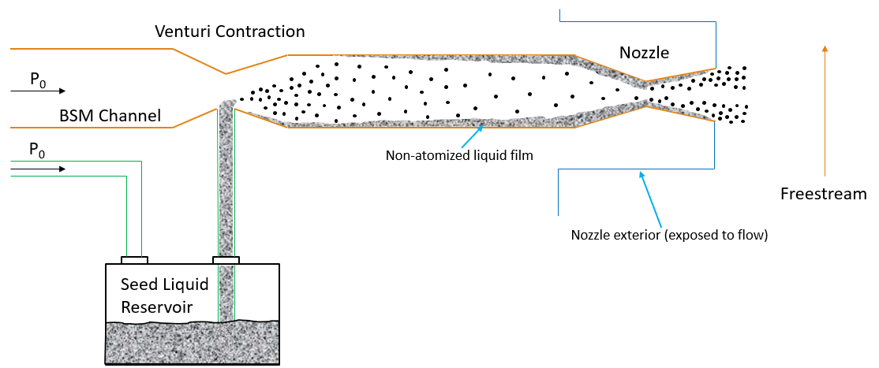
Fig. 5 Venturi seeding concept diagram.

Sizing the Venturi contraction was a challenge, as the authors could identify very little existing engineering data to link design parameters to particle size, concentration and liquid flow rates. A previous study has compared the gauge pressure of compressed air within a Laskin nozzle and the resulting seed flow rate [6]; the study examined air pressures of 5-40 psig. A pressure difference of around 10 psi was selected for sizing analysis, in order to keep seed flow rates somewhat limited. Assuming a perfect gas with a total pressure at the top of the given range (1500 psia), standard isentropic relations and the Area-Mach relationship dictated that the area of the Venturi throat be about 1/7 the area outside of the throat.
It was also important to select a fluid to serve as the seed liquid. A concern noted by NASA Langley was the potential for below-freezing temperatures and frost buildup near the nozzle if water was chosen as the liquid. If this happened, frost may accumulate and block off a portion of the nozzle flow. This possibility was examined by determining the adiabatic wall temperature the adiabatic wall temperature of a surface exposed to a fluid flow [12],

$T_{wall}=\frac{T_{0}\left(1+r\frac{γ-1}{2}M^{2}\right)}{1+\frac{γ-1}{2}M^{2}}$ ( 1 )
Note that the temperature recovery factor r was determined experimentally by Leontiey et al. to be about 0.885 for turbulent boundary layers in supersonic flow. The nozzle exit Mach number of 2.5 was used for this calculation.
For a total temperature of 100°F, the lowest of the given UPWT BSM range, the adiabatic wall temperature was calculated to be 63.6°F. However, the Advanced Propulsion and Power Lab proof-of-concept experiment was slated to occur at room temperature; for a total temperature of 65°F, the adiabatic wall temperature dropped to 36.2°F. While there appeared to be little threat of frost buildup purely from wall heat transfer, it was also important to consider the temperature drop of airflow due to its source’s pressure drop, be that a compressor or pressure tank. This temperature drop was calculated with standard isentropic relations for various situations involving a pressure tank; for example, a pressure tank supplying the airflow into the BSM may reduce from 2200 psi to 1500 psi over the course of a test run. For this pressure drop, a total temperature of 100°F was found to fall to 41.2°F, while a total temperature of 65°F fell to just 14.9°F. These temperature values were low enough that the risk of water freezing, even in the UPWT, was deemed significant. Instead, the oil DEHS (Di-Ethyl-Hexyl-Sebacat) was selected for its low freezing point of -54°F and its negligible health risks.

- Experimental Methods
As described earlier, a Venturi contraction seed delivery concept was selected, with natural shearing forces providing the necessary particle generation. This concept involved the Venturi contraction as well as a seed reservoir, nozzle, and pressurized gas source. In the interest of minimizing size and making implementation within the SLS model easier, 1/8 in. OD aluminum tubing (0.085 in. ID) was selected to form the throat of the Venturi contraction. The calculated area ratio dictated a channel diameter of close to 0.225 in., and thus 3/8 in. OD aluminum tubing (0.245 in. ID) was chosen.
The tubing and Swagelok components comprised the bulk of the rig. The Venturi contraction was simply two Swagelok reducers that sandwiched the 1/8 in. tube between 3/8 in. tubes. The reservoir was constructed using a large piece of NPT pipe capped at one end, with a tee allowing for pressure to be fed in and seed to be ejected out. A compressed nitrogen tank was used to supply the desired pressures to the rig, with flexible high-pressure hosing forming the tank’s connections. Figure 6 shows a side-view diagram of this design; note the nitrogen tank connected to both the BSM channel and seed reservoir. The reservoir and channel were side-by-side on the same surface, with the connection between them being an arc-shaped tube. That tube descended all the way into the seed reservoir, so as to draw out as much liquid as possible.

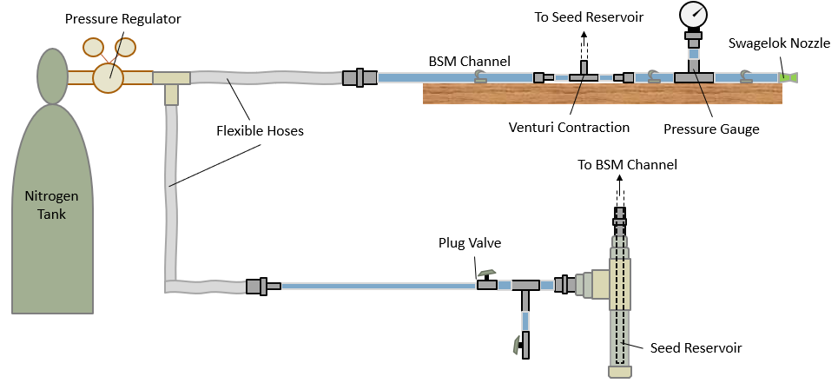
Fig. 6 Diagram of the experiment rig.

Lastly, the nozzle was created by conically drilling into a Swagelok plug so that the throat diameter was 0.08 inches and the exit-throat area ratio was 2.64. A simple diagram of this is shown in Figure 7, with the red region marking the conical drilling.

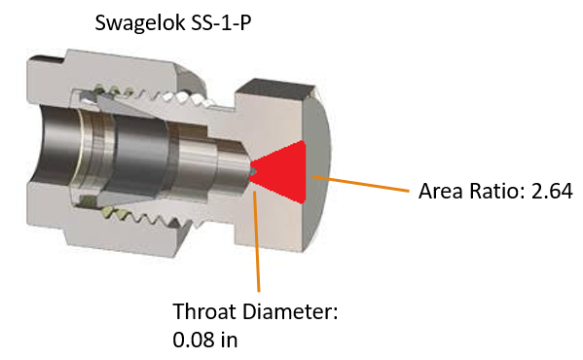
Fig. 7 Diagram of the nozzle, fabricated from a Swagelok SS-1-P component.

Figure 8 is a photograph of the actual rig after fabrication. The tank feed, BSM channel, and seed reservoir are clearly visible. Note the tall, arced segment of 1/8 in. tubing connecting the reservoir to the Venturi contraction: this pressurized line supplied the seed to the channel flow that eventually exited through the nozzle. Several clamps were added after this picture was taken to better secure the rig.

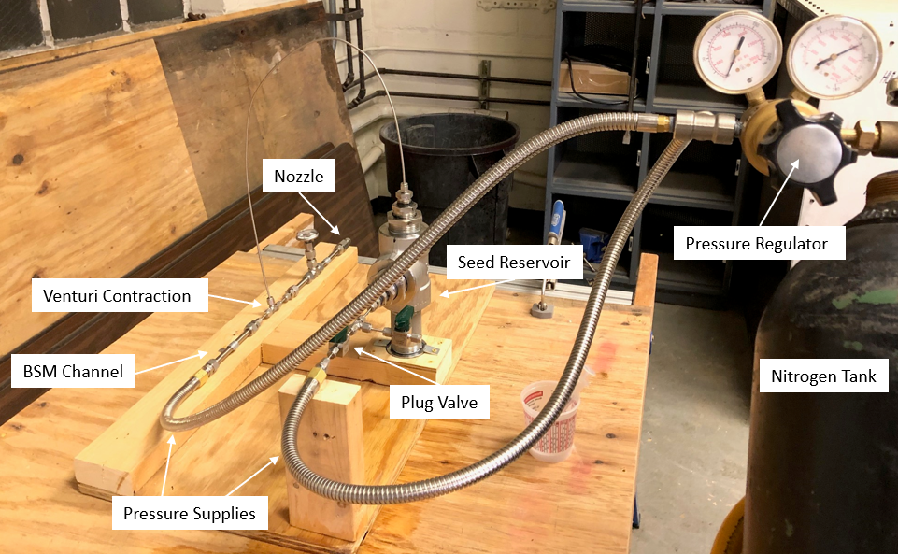
Fig. 8 The as-built experiment rig.

Laser sheet visualization was used to assess the technique, as that was where the BSM problem originally became apparent. A Genesis MX-Series continuous wave laser (488 nm wavelength) was directed at an oscillating scanning mirror, creating a vertical laser sheet perpendicular to the direction of the nozzle’s jet. A Thorlabs DCC3240M camera was mounted downstream to capture the visualization images.
A point of emphasis in the experiment was the ability of a user to control the volumetric flow rate of the DEHS seed; because this was a proof-of-concept study, no specific rate was specified, and it was determined that NASA end-users should have the ability to vary the rate as they saw fit. The plug valve, labeled in Figures 6 and 8, served to test the extent of this ability. Quantitatively, flow rate control was measured by timing the emptying of the reservoir for a known volume of liquid at different plug valve states. Qualitatively, the laser sheet visualization provided images of light scattering intensity, which from Mie and geometry scattering theory is proportional to the number of particles per unit volume [13].

$I∝c_{n}D^{2}$ ( 2 )

- Results
Initially, the system was run by expelling nitrogen from the tank into the reservoir and BSM channel; DEHS from the reservoir was observed to have successfully moved from the reservoir into the channel and emitted as a spray from the nozzle. To further assess the system and determine whether flow rate was indeed controllable, a series of trials was conducted with 4 oz of DEHS in the seed reservoir. Two parameters were varied: the pressure and the state of the plug valve. In order to easily identify differences in seed flow rates, the plug valve was simply varied between fully open and 90% closed (by valve-handle angle). Tests occurred at total pressures of 300 and 800 psi; note that it was observed that total pressures over 1000 psi drained the reservoir too quickly to provide any useful results with the simplified setup used. Table 1 presents the results of these trials, in addition to the liquid volumetric flow rate, mass ratios of DEHS to air, and volume ratios of the same, calculated from timing the drainage of the reservoir.

Table 1 DEHS timed trials at various pressures and valve states.
Test | Pressure [psi] | Plug Valve State | Time to Drain [s] | Liquid Volumetric Flow Rate [mL/s] | Mass Flow Ratio (DEHS/Air) | Volume Flow Ratio
1 | 300 | Open | 15.7 | 7.54 | 0.1398 | 0.0037
2 | 300 | 90% Closed | 24.0 | 4.93 | 0.0916 | 0.0024
3 | 800 | Open | 8.9 | 13.29 | 0.0932 | 0.0064
4 | 800 | 90% Closed | 25.7 | 4.61 | 0.0323 | 0.0022

The volumetric flow rate and flow ratios were clearly influenced by the positioning of the valve. As expected, moving the valve towards a closed position decreased volumetric flow rates. This is quantitative evidence that the liquid flow rate is controllable in the proposed method. Interestingly, despite the increase in flow rate for open-valve cases from 300 to 800 psi, flow rate remained about the same between the two closed-valve cases. The plug valve was adjusted by hand, and thus prone to error; a precision flow controller would eliminate this error and accurately meter the liquid flow.
Laser sheet visualizations were also generated for each of these cases. In accordance with equation (2), less intensity was expected in closed-valve trials compared to open-valve trials. Figure 9 shows the mean intensity (1000 ms exposure time per image) of the 300 psi trials over the full duration of both the open and closed-valve cases, as well as the ratio of the two images for comparison. In the ratio image, the region outside of the spray itself contained widely fluctuating data due to the low intensity values; this region was conditionally excluded from the image for easier interpretation. Figure 10 is the same set of images for the 800 psi case. The data from both figures support the notion that the seed flow rate was significantly affected by the plug valve. It should be noted that the flow rates themselves were rather high, as judged visually from the amount of liquid exiting the nozzle.

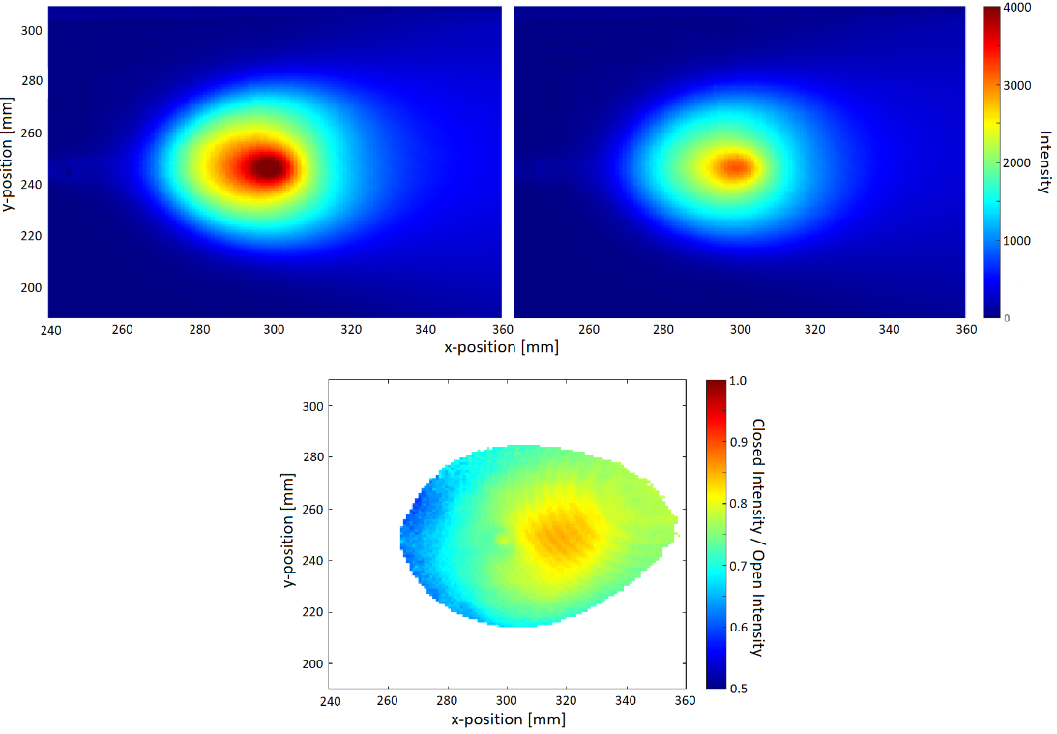
Fig. 9 Intensity of DEHS spray light scattering at 300 psi with valve open (top left), 90% closed (top right), and as ratio of closed to open (bottom).

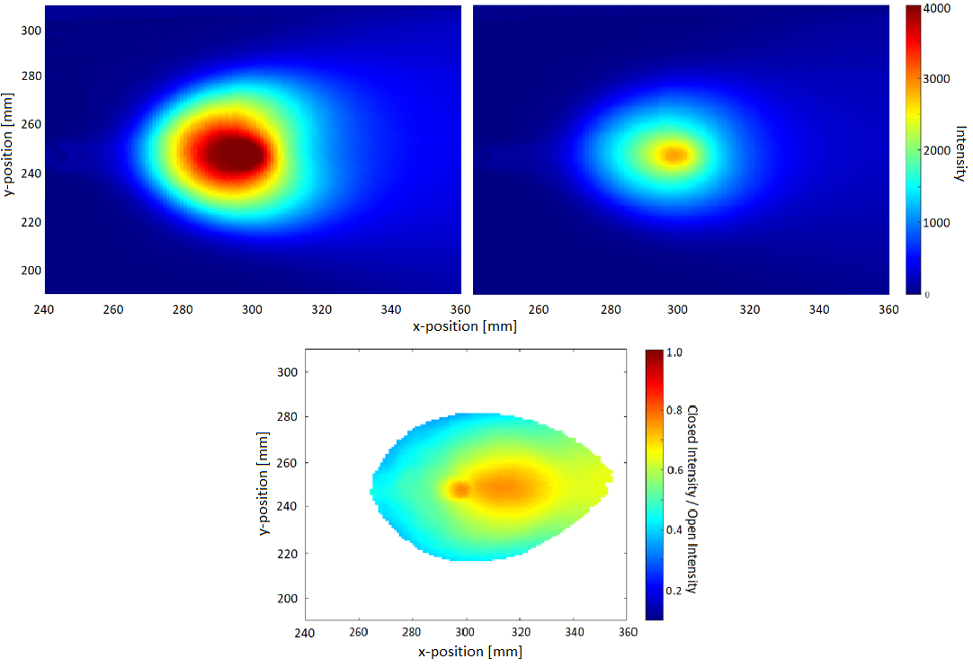
Fig. 10 Intensity of DEHS spray light scattering at 800 psi with valve open (top left), 90% closed (top right), and as ratio of closed to open (bottom).

- Conclusion
A novel method was designed and tested for introducing seed particles into flow at high total pressures and small scales, particularly motivated by applications in NASA SLS wind tunnel testing. A Venturi contraction was used to draw the DEHS seed liquid out of a reservoir and into the air feed line for a miniature nozzle, where shearing forces atomized the liquid into particles in similar fashion to a Laskin nozzle. The system successfully generated a fine spray that ejected out of a nozzle, and the flow rate of seed was shown to be controllable using plug valve in the pressure feed to the seed reservoir.
Further study is needed to assess the impact of the plug valve on particle size. Additionally, some different area ratios for the Venturi contraction may be worth testing to limit the seed flow rate. The use of a proper mass controller instead of a simple valve would likely also be beneficial in giving the user maximum control of the system.
Overall, the novel Venturi concept may be a suitable way to introduce seeded air into flows at small scales and high pressures. The concept is relatively simple, inexpensive, and easy to implement into existing wind tunnel models.

Acknowledgments
The authors gratefully acknowledge the support from the NASA Langley Research Center, through the National Institute of Aerospace sub-award activity number 201166-VT.

References
[1] Winski, C. S., Danehy, P. M., Watkins, A. N., Shea, P., Meeroff, J., Lowe, K. T., and Houlden, H., “Space Launch System Booster Separation Supersonic Powered Testing with Surface and Off-Body Measurements”, AIAA Aviation 2019 Forum, Dallas, Texas, 2019.
doi: 10.2514/6.2019-3505
[2] Lowe, K. T., Byun, G., Shea, S., Boyda, M., and Winski, C. S., “Three-Velocity-Component Cross-Correlation Doppler Global Velocimetry for the Space Launch System Booster Separation Test in the NASA Langley Unitary Plan Wind Tunnel”, AIAA Aviation 2019 Forum, Dallas, Texas, 2019.
doi: 10.2514/6.2019-3506
[3] Danehy, P. M., Wisser, B. M., Fahringer, T. W., Winski, C. S., Falman, B. E., Shea, S., Boyda, M., and Lowe, K. T., “Laser Light Sheet Flow Visualization of the Space Launch System Booster Separation Test”, AIAA Aviation 2019 Forum, Dallas, Texas, 2019.
doi: 10.2514/6.2019-3507
[4] Berry, S., Rhode, M., Edquist, K., and Player, C., “Supersonic Retropropulsion Experimental Results from the NASA Langley Unitary Plan Wind Tunnel”, 42nd AIAA Thermophysics Conference, Honolulu, Hawaii, 2011.
doi: 10.2514/6.2011-3489
[5] Melling, A., “Tracer Particles and Seeding for Particle Image Velocimetry,” Measurement Science and Technology, Vol. 8, No. 12, 1997, pp. 1406–1416.
doi: 10.1088/0957-0233/8/12/005
[6] Echols, W.H., Young, J. A., “Studies of Portable Air-Operated Aerosol Generators”, NRL Report 5929, 1963.
[7] Sabroske, K. R., Hoying, D. A., and Rabe, D. C., U.S. Patent for a “Laskin Nozzle Particle Generator”, Patent Number 5498374, dated Mar. 12, 1996.
[8] Kähler, C., Sammler, B., and Kompenhans, J., “Generation and Control of Tracer Particles for Optical Flow Investigations in Air”, Experiments in Fluids, Vol. 33, No. 6, 2002, pp. 736–742.
doi: 10.1007/s00348-002-0492-x
[9] Raffel, M., Höfer, H., Kost, F., Willert, C., and Kompenhans, J., “Experimental Aspects of PIV Measurements of Transonic Flow Fields at a Trailing Edge Model of a Turbine Blade”, 8th International Symposium on Applications of Laser Techniques to Fluid Mechanics, Lisbon, 1996.
[10] Van der Draai, R., van Schinkel, R., Telesca, A., Scarano, F., Elsinga, G., and Feenstra, G., “Application of PIV in (Local) Supersonic Flows in DNW Wind Tunnels”, 41st AIAA/ASME/SAE/ASEE Joint Propulsion Conference & Exhibit, Tucson, Arizona, 2005.
[11] Scarano, F., and van Oudheusden, B.W., “PIV Investigation of a Planar Supersonic Wake Flow”, 11th Int. Symp. on Application of Laser Techniques to Fluid Mechanics, Berlin, 2002.
[12] Leontiev, A., Popovich, S., Strongin, M., and Vinogradov, Y. “Adiabatic Wall Temperature and Heat Transfer Coefficient Influenced by Separated Supersonic Flow.” EPJ Web of Conferences, Vol. 159, 2017, p. 00030.
doi: 10.1051/epjconf/201715900030
[13] Bohren, C. F., and Huffman, D. R. Absorption and Scattering of Light by Small Particles, John Wiley & Sons, 2008.

Graduate Research Assistant, Department of Aerospace & Ocean Engineering, Student Member AIAA
Associate Professor, Department of Aerospace & Ocean Engineering, Associate Fellow AIAA
Christopher C. Kraft Endowed Professor, Department of Mechanical Engineering, Associate Fellow AIAA
Senior Technologist for Advanced Measurement Systems, Associate Fellow AIAA
https://www.swagelok.com/en/catalog/Product/Detail?part=SS-1-P#

