4-Bed CO2 Scrubber – From Design to Build
Gregory E. Cmarik
Jacobs Space Exploration Group, Huntsville, AL, 35812

Warren T Peters
NASA Marshall Space Flight Center, Huntsville, AL, 35812

James C. Knox
Dynetics Technical Services, Huntsville, Alabama, United States 35812
Four-bed technology is an International Space Station (ISS) mainstay for metabolic Carbon Dioxide (CO2) removal and crew life support. The current generation is known as the Carbon Dioxide Removal Assembly (CDRA) and has a long history of unplanned maintenance as well as obsolete core components. The 4-bed CO2 Scrubber was commissioned to operate with no unplanned maintenance for 3 years while removing 4 crew-equivalents of CO2 at a target inlet concentration of 2 torr CO2. This work goes into detail of the various design aspects that have been undertaken to ensure a successful project design and successful build leading to an upcoming flight. This work will discuss the compromises caught both early and late in the design cycle and the adaptations in response. Finally, the expected performance of the system once launched will be discussed based on summaries of data from the testbed.

Nomenclature
ISS = International Space Station  CO2 = Carbon Dioxide  CDRA = Carbon Dioxide Removal Assembly  NASA = National Aeronautics and Space Administration  MSFC = Marshall Space Flight Center  4BMS = 4-bed molecular sieve  4BCO2 = 4-Bed Carbon Dioxide Scrubber Flight Demonstration  ETHOS = Environmental and Thermal Operating Systems  MCC = Mission Control Center  TRL = Technology Readiness Level  EDU = Engineering Development Unit  TSAC = Thermal Sorption and Compression  MTL = Moderate Temperature Loop  LTL = Low Temperature Loop  AAA = Avionics Air Assembly  BER = Basic EXPRESS Rack  AR = Air Revitalization  ORU = Orbital Replacement Units | SCFM = Standard (0°C, 1 atm) Cubic Feet per Minute  DAB = Desiccant-Adsorbent Bed  COTS = Commercial off the Shelf  CCAA = Common Cabin Air Assembly  VES = Vacuum Exhaust System  CCB = Cycle Controller Box  RPC = Remote Power Control  FDIR = Fault Detection, Isolation, and Recovery  DAN = Domain Adapter Node  BIT = Built-In Test  TVSA = Thermal Vacuum Swing Adsorption  CBM = Common Berthing Mechanism

Introduction
T
HE National Space Exploration Campaign Report released by NASA outlines the agencies plan to “...conduct breakthrough research and tests on the advanced technologies necessary for long voyages in deep space.” This campaign report outlines the shift to lunar surface missions but has not explicitly altered the ongoing efforts to advance carbon dioxide (CO2) removal technologies.¹ At Marshall Space Flight Center (MSFC), one of these efforts is focused on producing an International Space Station (ISS) flight demonstration of the next-generation four-bed molecular sieve (4BMS) system known as the Four Bed CO2 Scrubber (4BCO2).
Among NASA’s long term goals is to have long-duration crewed missions including a three-year mission to Mars. Improving life support technologies is critical to ensuring mission success.² Existing technologies are insufficient in several regards: reliability, performance vs resource usage, and closed loop operation. 4-bed technology is presently operating in a partial closed-loop configuration onboard the ISS.³⁻⁵ 4BCO2 is intended to produce the same high purity CO₂ product while proving that the remaining concerns of reliability and performance have been addressed.
Recent works described the efforts over recent years to identify, address, and mitigate the major causes of unreliable operation as well as improve performance.⁶⁻⁷ The lessons learned from two decades of on-orbit operation of 4-bed technology were implemented in a testbed at MSFC. Transitioning these design features to a flight system has wrung several compromises out of the design. The design has been finalized, assembly has begun, and the 4BCO2 flight demonstration is expected to be operating in 2021. This work will discuss the progress of the flight demonstration in parallel with testbed operation.

Lessons Learned
A brief historical review of the successes and failures of the Carbon Dioxide Removal Assembly (CDRA) will provide the starting point for the 4BCO2 flight demonstration. After almost 30 years on orbit between two units, a large number of faults and failures have occurred.³ Hindsight is an invaluable resource not available to most system designers. Detailed failure analysis allows the next-generation system to not repeat the same fault causes. While it has been argued that the failures are an inherent property of 4-bed technology and the use of zeolites, substantial evidence has been gathered to dismiss this opinion.
CDRA’s successes include delivering high-purity, dry CO₂ for closed loop oxygen recovery without further processing and maintaining cabin CO₂ partial pressures below its original design parameters. The current version, CDRA-5, is operating without major incidents and minimal ΔP increases since mid-2015 which supports all of the theories of dust mitigation which could be implemented in that design. Over the combined 30 years on orbit, CDRA’s failures are numerous and have cost more crew-hours than any other system on-orbit. Zeolite dust can be traced to a majority of failures while the remaining faults are unique situations.
Valve failures have occurred repeatedly, primarily due to zeolite dust which causes leaks and high torque. Dust has also clogged filters which restricts airflow until the system can no longer function. Repair and rehabilitation of the system from these failures requires excessive crew time and effort. Several mechanical issues with the initial rectangular bed design and monolithic heater core led to excessive dust generation and particle escape. The heater core did not allow visibility to verify sorbent packing thus voids could exist which contribute to dusting. Other causes of dust were rapid repressurization, deflection of thin bed walls, and trace water ingestion from unknown points.
In addition to dust from the sorbent beds, several mechanical failures were caused by thermal fatigue and aging. Temperature sensor failures within the bed occurred due to fatigue. Heater sheets were operated near their thermal limit every cycle which led to delaminations, shorts, and failures.
Unfortunately, CDRA cannot be upgraded or maintained indefinitely. Material and component obsolescence has caught up with the age of the system. This was part of the impetus for a competition among flight experiments for CO₂ removal on the ISS.² The recent report⁶ on efforts leading to the design and the build progress of the 4BCO2 system show the reasons for optimism. Also, the modifications to CDRA appear to have successfully improved its reliability. These improvements plus further design inclusions in 4BCO2 were developed with the goal of resulting in maintenance-free operation for 3 years. In the event of planned or unplanned maintenance, 4BCO2 is designed to be more easily maintained than CDRA.

Flight Integration Objectives
The 4BCO2 project was commissioned with many lofty goals and stretch objectives.

The main goals were:  - Remove CO₂ for a four crew mission at an inlet CO₂ concentration of 2 torr  - Minimize or eliminate dust and dust-related failures  - Reduce resource requirements  - Operate under the control of ETHOS at MCC-Houston and use the ARCTURUS system  - Deliver on a compressed schedule with limited analysis and accept the loss of mass optimization | The stretch objectives as originally proposed or later adopted include:  - Use 120VDC power  - Use LTL and AAA for cooling  - Operate in a Basic EXPRESS Rack (BER) and be compatible with an AR Rack installation  - Initially vent CO₂ to space but also provide compatibility with closed loop oxygen recovery systems onboard the ISS  - Operate for 3 years with no unplanned maintenance events  - Design for easy maintenance  - Utilize hardware safety controls and avoid safety-critical software  - Minimize on orbit assembly, launch as one unit with an installation package  - All avionics and power supplies are internal  - Planned upgrade: new air blower  - Measure performance (i.e. CO₂ removal rate)
Unrealized goals:
- Advanced/autonomous control software
- Integration with a low TRL Thermal Sorption and Compression (TSAC) system
- Duplicate system to operate as ground EDU
- Complete set of system spares
- Use MTL cooling water and cold plates

The 4BCO2 flight demonstration was designated as a Class 1-E flight experiment. Although this classification relaxes many rules, the payload must still comply with interface and safety requirements, which are significant for such a large and complex system. In keeping with the designation as a flight experiment, the software was directed to be Class D and non-safety critical. This reduced the intensiveness of testing but necessitated hardware fail-safes (i.e. solenoid valves) to satisfy ISS hazard control requirements. Fault detection code doesn’t control hazards, instead it was implemented to preserve hardware based on the lessons learned from CDRA. These designations also mean that quality assurance will be maintained throughout the assembly but in many cases has been relegated to observation instead of control.
The project objectives have some stark differences from CDRA outside of the primary function of removing metabolic CO₂. The launch and integration of 4BCO2 is severely constrained versus CDRA. As an EXPRESS rack experiment, 4BCO2 must provide its own structure and integration hardware. The decision to launch as a single unit to minimize on-orbit assembly of such a large experiment is the primary cause of high launch mass. The primary structure internally supporting all parts of 4BCO2 was significantly overbuilt due to the shortened schedule and a parallel design process. This situation is independent of the CO₂ removal technology and reflects the challenges of integration with limited time and analysis.
CDRA was designed as an assemblage of Orbital Replacement Units (ORUs) within the AR rack while power supplies and avionics were separate. CDRA system performance was inferred via station sensors. 4BCO2 contains all power supplies and avionics within a single package. 4BCO2 also contains sensors for direct measurement of CO₂ concentration to calculate CO₂ removal rate.
Air selector valves were identified at an early stage as a key focus for development. A competition between three candidates in a stress test against zeolite dust was conducted with the valve developed by a team at MSFC emerging as the top candidate. The project was given further direction to utilize multi-disciplinary design and production which essentially makes various branches at MSFC both suppliers and customers. Collaboration with other NASA centers and integration of commercially available hardware has been mostly successful but some challenges have emerged. These challenges are discussed later.
An engineering unit, which would be built with identically rated parts to the flight unit, was rejected from the proposal. The existing 4-bed research unit at MSFC was tasked with prototype integration testing. This testbed is affectionately known as Linus. The data from Linus is used for performance determination and in computer simulations. Reductions in station resource consumption, such as reduced power consumption and LTL (water-cooling) flow, are being explored with Linus.

Flight Demonstration

Mechanical Design
The project has experienced many successes already. The precooler (air-water heat exchanger), built by Mezzo Technologies, has performed with much improved heat transfer efficiency over the heritage plate-and-fin unit at a marginal cost of increased pressure drop on both air and water sides. This more efficient compact heat exchanger could allow for reduced ISS resource (i.e. LTL coolant) usage. The pressure and temperature sensors from GP:50 and the humidity and CO₂ sensors from Vaisala passed thermal and vibration testing without incident.
Air ducts in CDRA were built with mitered corners, but this becomes a severe performance hit as flow rates are increased. Smoothed air ducts were designed by ES62 and 3D printed for testing. Prototype parts showed great promise by reducing flow resistance by a factor of 3 and were iteratively improved. The flight versions were produced from titanium by Carpenter Additive. These printed ducts enabled shapes that would not be reasonable or even possible with mitered ducts such as tight corners which retain clearance for joint couplings. The designs also include extra functional mounting tabs to improve the routing and packaging of the system. Additionally, fitting bosses were incorporated directly into the printed ducts. The shape of the ducts reduced system pressure drop by roughly 10% thus enabling a higher flowrate at the nominal blower speed and an increased CO2 removal rate.
The desiccant-adsorbent beds (DABs) were built by ES62 and built with branch-release drawings while quality oversight was maintained. The success of this process was early delivery of the DABs which can be traced to one individual’s exceptional dedication and attention to detail. Co-location of engineers, designers, machinists, and integrators provided close coordination and caught potential issues early in the development cycle. It also provided adaptability in the case of late revisions. The downside to conducting these design processes separately is a major contribution to the inability to optimize structure mass. Effectively, the primary structure houses and protects the DABs without utilizing them for any structural support.
The DAB heater cores, shown in Figure 1, replaced nearly all aspects of the CDRA heater core. Cartridge heater rods cantilevered from a support plate are being used instead of an assembly of planar heater sheets and aluminum loose within the sorbent bed. The rod heaters from Watlow have a thermal limit over 1000°F, thus preventing the failure causes in the sheets. Heat spreading fins allow zeolite beads to fill around the surfaces instead of being poured through channels. The heater rods are supported by a 3D printed heater plate which combines a strong structure with tortuous heat conduction paths and a large air flow cross-sectional area. The heater core design allows the heater wires to be routed outside the bed pack thus eliminating wire strain from the compaction of the sorbent.
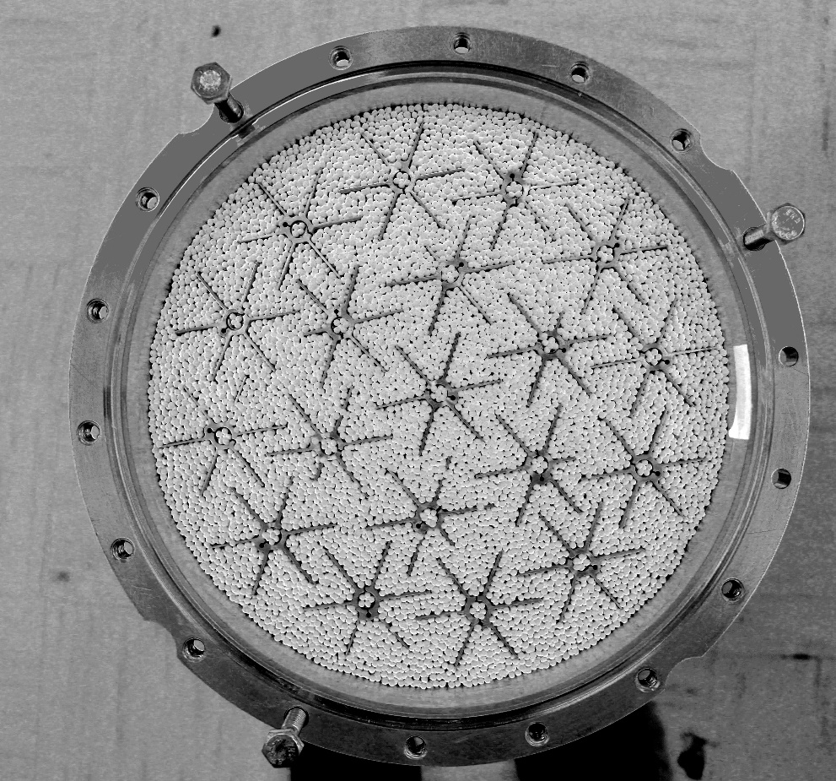
Figure 1. Sorbent bed filled with zeolite for the 4BCO2 system.
During the DAB assembly process, several late revisions were imposed to address risks both likely and unlikely. A change to the heat spreading fins to use a compression fit resulted in the sorbent loading procedure becoming more complex with additional parts. One of the faults previously mentioned was that the CDRA heater core created conditions ripe for dust generation. The 4BCO2 heater core was intended to be assembled with clear lines of sight in a shallow layer-by-layer procedure, which ensures visibility and prevents voids in blind spots. The compression fit design required the whole heater core to be assembled prior to filling, with modifications to the assembly and packing procedures. Fortunately, procedures were developed and tested while rebuilding the Linus system with flight heater cores. The packing process was conducted successfully with the difference in loaded mass of sorbent between beds of only one-quarter of one percent. Other revisions pertained to the material choice and torque specification of fasteners and interconnector stanchions.
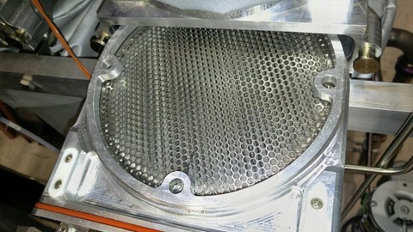
Figure 2. Pleated filter element and filter slide designed for use in 4BCO2.
While avoiding unplanned maintenance is a primary goal, the 4BCO2 flight demonstration has several planned maintenance events after installation. The simplest is removal, inspection, and reinstallation of the removable filter shown in Figure 2. The more complex event is the installation of a next-generation magnetic bearing blower. The system will be launched with one of the few remaining heritage CDRA blowers. This blower is well-proven and robust but is considered an obsolete and expiring component, thus a new blower and controller is being built under contract with Calnetix Technologies. Calnetix has incorporated several design recommendations from the subject matter experts at NASA to improve dust-tolerance. This blower is projected to consume less power at the flowrates fundamentally required for maintaining the 2 torr condition. A possible event is installation of 4BCO2 in the AR rack to replace a CDRA, but this requires significant further evaluation.
The requirement to measure the performance of this experiment requires both sensors and a sample port. The sample port allows astronauts to attach a gas sample canister which will be returned for analysis on the ground. The total air flowrate of the system is inferred from pressure drop and thermal profiles which are mapped prior to launch. Two CO₂ sensors will measure the difference in concentration of air entering and exiting the system. Protecting the outlet sensor is necessary because a 4-bed system will exhaust hot, humid air for several minutes. A small desiccant buffer using the same Sorbead WS used in the DABs reversibly adsorbs the excess water vapor each half-cycle while having minimal interaction with CO2. A sample pump from KNF moves a small flow of air through this sample loop and returns it to the exhaust stream.
One of the most unexpected CDRA failures was the spectacular delta pressure rise soon after the dash-4 DABs were installed. This was attributed to the sorbent possessing a susceptibility to traces of water vapor in a thermal cycling environment. The source and magnitude of water vapor is not certain, but this susceptibility was directly tested in the sorbent selection process previously reported.⁸⁻⁹ In the event of water breakthrough from the desiccant bed, a dew point sensor has been installed which monitors a small fraction of air from the blower on a bypass line. This sensor will directly monitor the desiccant bed performance to eliminate the risk of water breakthrough and ensure the product CO2 delivered to the carbon dioxide management system is dry.

System Analysis
Thermal analysis of the system is very challenging due to the cyclic nature of heat sources. Nominal operation in the BER will use rack cooling air which is pulled through the system by four circulating fans. The air flow pattern is less than ideal as it needs to pass by the DABs prior to reaching the necessary components for cooling. Should the system be selected to replace CDRA, the system would be installed in the reverse direction versus the BER installation where this flow path would allow cooling air to pass almost directly from source to where it is needed.
Further thermal analysis is ongoing with regard to LTL coolant usage. While CDRA used LTL for the precooler and vacuum pump cooling and MTL for electronics. 4BCO2 is using LTL for the same two components while the AAA of the EXPRESS rack cools avionics. The LTL coolant loop flows through the precooler, a shutoff valve, and then the air save vacuum pump in series. This cooling solution for the air save pump runs the risk of chilling below ambient dew point which may lead to water droplet formation. As this is a COTS part, it won’t be modified beyond adding an acoustic enclosure, but this change creates a sensitive thermal solution.
Payload integration is a major issue and includes routing of ISS resources to 4BCO2, i.e., air, vacuum, power, data, and LTL. This payload will be installed in the Destiny Lab Module. The conditioned air is supplied from a tee to be installed in the existing CDRA supply ducting in order to draw cool, dry air from the module Common Cabin Air Assembly (CCAA). The extended routing increases the flow resistance and heat pickup of the air. Increased flow resistance has a direct negative performance impact while the effect of a temperature increase is beneficial to a point. Vacuum will be connected to the Vacuum Exhaust System (VES) via at first the rack then later via a new vacuum routing dedicated for the various CO2 removal flight experiments.
Acoustics analysis is one of the most challenging issues for a payload as only the final unit can be accurately tested. 4BCO2 contains several motors, thus reducing noise levels will be challenging. The closest analog to the system is the Linus testbed, but this is a poor testing substitute due to many loud pieces of facility equipment nearby the test stand. An attempt was made to analyze the acoustic profiles of the equipment in this system and incorporate sound dampening in the path forward. The air save pump was identified as a major source and is being designed into an acoustic enclosure that also controls thermal dissipation. Best efforts are being made to pass the ISS acoustic requirements given the experiment status of this payload and the inclusion of COTS hardware.
Human factors were considered in the design in many places. The system is larger than the BER rack depth and required a bump-out. This bump-out has a front enclosure panel which is very strong to accommodate crew kick loads. The interface panel where all of the system connectors are located was arranged per recommendations. The gas sampling port was placed behind a hatch in the front enclosure of the system and the design modified for ease of use. Anticipated on-orbit maintenance activities were practiced on a mock-up and refined with help from these experts.

Avionics and Software
The Cycle Controller Box (CCB) contains the primary avionics and power supplies. All power for the system comes from a single 120VDC supply from a station remote power control (RPC) module. The cycle controller issues commands for most actions to control the system. The blower, airsave pump, and each air selector valve have a dedicated controller. All components in the system receive power and commands from the cycle controller. The cycle controller is designed to be updated with new software, should the need arise.
Software for the 4BCO2 flight demonstration was built to be operator controlled with nearly all properties as adjustable parameters. The team coordinated with the ETHOS flight controllers who have been operating CDRA and took lessons learned to design the software for operator ease of use. Nominal system operation is on a schedule in order to be simple and robust in the event that ground operators cannot issue commands. Once the system is commanded to operate, the design should allow for indefinite autonomous operation. Stopping the system will place it in a non-operating or standby state. This state is defined by a set of commands to effectors and valves to protect hardware and isolate process flows. The system can be commanded to stop at the most favorable point for quick restarts or it can be stopped immediately.
Fault detection, isolation, and recovery (FDIR) is a myriad of thresholds and timers based on specific events and experiences from CDRA and ground testbeds. FDIR is always active in the system and a fault causes the system to issue commands to achieve a standby state. Each fault parameter can be adjusted or masked in the event of nuisance failures. Ultimately, the power to the system can be removed at the RPC which stops the system. Removing power shuts the vacuum and LTL flow valves, thus placing the system in a safe, isolated state. As a result, the ISS flight software was modified to incorporate opening the 4BCO2 RPC into its safety algorithms to ensure the 4BCO2 solenoid valves close.
The communication system is the ARCTURUS network and utilizes an AdLink miniPC (also known as a Domain Adapter Node or DAN). The 4BCO2 application layer to be installed on the DAN will act as the interface between the avionics and ETHOS operators. This includes obtaining and converting telemetry to and from engineering units, processing commands, and installing new software versions. The miniPC boots much more slowly than 4BCO2, so 4BCO2 boots into a standby state and waits for commands from ETHOS. The primary downside of the ARCTURUS system is the limitation where only one command can be issued at a time. This property of the system led to the design of built-in sequences.
Built-in events, tests, and sequences were included in the software. The tests are familiar to the ETHOS operators and are similar to CDRA active built-in tests (BIT). These tests are used as health checks for individual effectors. Some new events occur at the half-cycle transitions and including a blower speed reduction and modulated repressurization of the sorbent bed. Sequences were developed because of the need to issue multiple commands in quick succession. The main impetus of these sequences was the new air selector valve. The valves are only permitted to rotate in one direction to ensure the dust mitigating features operate as intended. To enter the operational state, the valve may need to traverse 270° and briefly open towards a bed at vacuum which could damage hardware, particularly the blower. These sequences are run by the cycle controller when given the command to operate and are also standalone operator commands.

Major Issues and Adjustments
A major challenge during DAB assembly was the difficulty of welding Aluminum 6061 to MSFC Class A specifications. While the beds were welded successfully, the qualification process was unable to accept 6061 welds in this application. Xometry produced sorbent bed drums, each machined from solid billets of Aluminum 6061-T6, in place of welded beds. This process was completed quickly and the products were accepted by the quality process. Final stack-up tolerance of assembled DAB stacks was within 0.004 inches for both DABs which are each 38.5 inches tall.
A straightforward concern is the risk of overheating. While the beds are nominally heated to 400°F, this does not mean the whole bed is at uniform temperature. Zeolite beads are a thermal insulator and heat is applied with the bed at vacuum, thus thermal leakage from the beds is minimal. In the event of loss of control and continuous heating of one bed, the worst case thermal risk was determined to never reach catastrophic (1 second) touch temperature hazards on the exterior of the system. After operator control of this payload and of the ISS was considered, the hazard was considered to be controlled by the opening the RPC supplying 4BCO2.
Four bed CO₂ removal technology is a thermal vacuum swing adsorption system (TVSA) tuned to produce high purity CO₂ from an extremely dilute, humid feed gas. The vacuum can be supplied by a mechanical device, such as is used in closed loop operations, or the vacuum of space. This flight experiment will utilize the VES which has a set of interface requirements. One of these is that a payload cannot vent a pressure exceeding 40 psia, but also all payloads attached should withstand that pressure as well. The requirement was interpreted to extend throughout the payload which required extensive analysis at extraordinary conditions and led to delays. The lesson learned is that determination of which situations are realistic may require input from disciplines outside of those who are tasked with satisfying the requirement. To resolve the situation, the system would accommodate the requirement up to a valve which may be open during operations or shut at various points. If the valve was open, the remainder of the payload cannot pressurize due to the orientation of check valves and position of other valves during operating states. Whereas when the valve is shut, the analysis showed the requirement was satisfied.
Zeolite dust is considered a chemical hazard. Based on measurements from the 4BCO2 prototype, Linus, the dust which might be generated and escape is conservatively projected to be tens of milligrams over 3 years of operation. Conversely, a substantial amount of dust was collected from CDRA DAB ORUs. The 4BCO2 filter is pleated which provides a capacity of more than the worst case observed in CDRA beds while also capturing smaller particles. The projections for dust from Linus are two orders of magnitude below this. Counter-intuitively, the lack of dust in this case led to difficulty in estimating mass and thus significant consternation over the risks that dust would pose to crew. Eventually, the risk was recognized to be acceptably low.
The heritage air blower had a heritage control unit when installed in CDRA, but none are available for 4BCO2. Obtaining a new motor controller became of the most substantial challenges faced by the project. Celeroton is a world leader in this field and has previously provided a controller which can operate this exact blower at MSFC. A new unit was specified which would work with 120VDC and fit in the small space allotted. During preliminary testing, while tuning the controller to the blower, an anomaly occurred. This anomaly involved high current draw and overheating of electrical connector potting material in the blower. The effects of this incident are an insignificant air leak in the blower and the requirement to build a new piece of avionics to monitor this motor and controller to prevent overcurrent conditions.
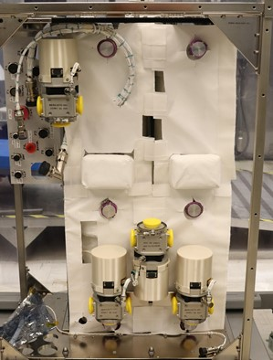
Figure 3. Photo of ongoing assembly of the 4BCO2 flight experiment.
The projected mass of the flight demonstration payload is higher than it would be as a purpose built exploration system. A mass reduction for 4BCO2 DABs of roughly 20% versus CDRA DABs was achieved without intensive optimization. The components which are unique to this flight project are the primary structure, front enclosure, rack integration structure, launch support structure, and launch closeout panels, each contributing significantly to launch mass and may not exist in an exploration system. Figure 3 shows a recent photo of progress on the assembly and integration of the payload.
The objective of minimal on-orbit assembly added mass and volume to the system. The major reasons for this choice were to minimize crew time usage, ensure a leak-tight installation, and accelerate schedule. The system size necessitates a Common Berthing Mechanism (CBM) on the launch vehicle to translate into the ISS, but few vehicles utilize this system. The system will launch onboard a Cygnus spacecraft.

Projections: Mass, Power, Performance
The projected mass of the core system is 515lbs while the separately launched BER integration structures and materials add an additional 101lbs. Launch weight of the core system is 706lbs of which 190lbs is disposable flight support structure. The target mass for a next-generation CO₂ removal technology is to be less than the equivalent CDRA mass of 440lbs. An estimate of a purpose-built exploration 4BCO2 integrated in a manner similar to CDRA would be the same mass minus roughly 40 lbs saved due to the pair of smaller DABs.
Power consumption is expected to be 975W average with peak usage of 1350W which is a reduction from CDRA of 1100W and 1500W, respectively.¹⁰ The greatest reduction is in heater power due to smaller sorbent masses while mechanical improvements in the air-save pump and blower will net additional gains. LTL usage will be less than CDRA’s flowrate of 262lb/hr as a flowrate of 200lb/hr has been targeted. No MTL coolant is being used.
Productivity is a function of cabin CO₂ concentration and increases almost linearly. At the target 2 torr inlet CO₂ concentration, removal rate is expected to be 4.6kg/day when venting to space vacuum. If the CO₂ concentration increases to 3 and 4 torr, removal is 6.8kg/day and 7.9kg/day, respectively. This performance can be measured directly within 4BCO2 rather than relying on other station capabilities. A more in-depth comparison between CDRA-4EU and Linus shows that at the current operating goal of 4 crew-equivalent at 2 torr, the system CO₂ removal efficiency increases from 76% to 85%.¹⁰ Optimizations of performance as well as average and peak power consumption are presently being explored.
The major goal of eliminating dust has been successfully achieved by all indications. Bed preparation techniques practiced on Linus where plate travel of only 4mm was observed after 1800hrs. These techniques were optimized for 4BCO2 which resulted in the two DABs to be filled with sorbent masses within 0.1lb difference. Recoverable dust from Linus is projected to be less than half a gram after 3 years of operation while escaped dust may be up to 2.5% of that amount.

Conclusions and Recommendations
The prospects for a reliable 4-bed molecular sieve technology for space exploration CO₂ removal are high. The 4BCO2 flight demonstration aims to fly an experiment which validates the years of technical and scientific work regarding sorbent testing, mechanical design, and system operation. Reliability projections of every component which was found to fail in CDRA are in excess of 3 years of nominal, continuous operation with no unplanned maintenance. Reductions in power usage with increased capability has been achieved in a similar volume to CDRA. Mass reductions have been argued as if this system was a set of ORUs for an AR rack installation, but the payload has far exceeded mass targets.
Should 4-bed molecular sieve technology be selected for future missions, several recommendations should be considered:
- The first is to minimize interfaces because each interface with a service requires large volumes and masses not only within the payload but also to traverse the spacecraft. Hoses, ducts, and cables contribute to the crowding issue onboard the ISS and this EXPRESS rack integration adds seven more (process air, LTL, vacuum, power, data).
- The second is to revisit the goal of minimal on-orbit assembly. One option is to launch integrated into a rack such as was the case for CDRA. On-orbit assembly would still need to be minimal, but assemblies must fit through smaller docking hatches. Note that neither CDRA nor 4BCO2 will fit through the Gateway hatch as a single unit given that they use smaller PMA sized hatches.
- The third is to establish expectations and prepare waivers for interface requirements as early as possible. Referencing such ground rules would accelerate schedule significantly.
- The fourth is to accept design revisions only in writing. Changes may be necessary, but all changes have impacts. Proper attribution of both good decisions and schedule slips is essential.
- The final recommendation is to maintain concentrations of expertise in small teams who are able to freely and closely work together. This is especially important in niche research situations such as zeolite-based adsorption system. Quality oversight and involvement is essential but the overhead of absolute control can destroy the ability of such a team to succeed on time. The delivery approach of non-trivial components, such as DABs, can be viewed as a huge success.
Future testing goals include optimizing performance with the present conditions and system. Alternative operating modes include either ingesting cabin air instead of conditioned air or venting directly to cabin instead of returning air to the CCAA. The next steps for the 4BCO2 flight demonstration is to complete assembly and begin system testing.

Acknowledgments
The authors of this work would like to acknowledge the contributions of the ES62 mechanical designers and machinists. The development teams for the air selector valves, avionics and software, system mechanical design, and system analysis have made essential contributions and improvements over the development cycle. The commercial vendors building custom components for this flight project have produced parts with excellent quality.

References
1. NASA, National Space Exploration Campaign Report 2018.
2. Anderson, M. S.; Macatangay, A. V.; McKinley, M. K.; Sargusingh, M. J.; Shaw, L. A.; Perry, J. L.; Schneider, W. F.; Toomarian, N.; Gatens, R. L. In NASA environmental control and life support technology development and maturation for exploration: 2018 to 2019 overview, Submitted for publication, 49th International Conference on Environmental Systems, Boston, Massachusetts, 2019.
3. Balistreri, S.; Bryant, Z. In International Space Station (ISS) Environmental Control and Life Support (ECLS) System Overview of Events 2018-2019, 49th International Conference on Environmental Systems: 2019.
4. Knox, J. In Development of Carbon Dioxide Removal Systems for NASA’s Deep Space Human Exploration Missions 2017-2018, 48th International Conference on Environmental Systems: 2018.
5. Perry, J. L., The Impacts of Cabin Atmosphere Quality Standards and Control Loads on Atmosphere Revitalization Process Design. 2019.
6. Cmarik, G. E.; Knox, J. C., CO2 Removal for the International Space Station–4-Bed Molecular Sieve Material Selection and System Design. 2019.
7. Cmarik, G. E.; Knox, J. C.; Huff, T. L., Analysis of Performance Degradation of Silica Gels after Extended Use Onboard the ISS. In 48th International Conference on Environmental Systems, Albuquerque, 2018.
8. Knox, J. C.; Gauto, H.; Miller, L. A. In Development of a Test for Evaluation of the Hydrothermal Stability of Sorbents used in Closed-Loop CO2 Removal Systems, International Conference on Environmental Systems, Bellevue, Washington, Bellevue, Washington, 2015.
9. Knox, J. C.; Cmarik, G. E.; Watson, D. W.; Giesy, T. J.; Miller, L. A., Investigation of Desiccants and CO2 Sorbents for Exploration Systems 2016-2017. In 47th International Conference on Environmental Systems, Charleston, 2017.
10. Knox, J. C.; Stanley, C., Optimization of the Carbon Dioxide Removal Assembly (CDRA-4EU) in Support of the International Space System and Advanced Exploration Systems. In International Conference on Environmental Systems, Bellevue, Washington, 2015.

ECLSS Engineer, Jacobs Space Exploration Group, and MSFC/ES62.
Aerospace Engineer, NASA, and MSFC/ES62.
Aerospace Engineer, Dynetics Technical Services, and MSFC/ES62.

