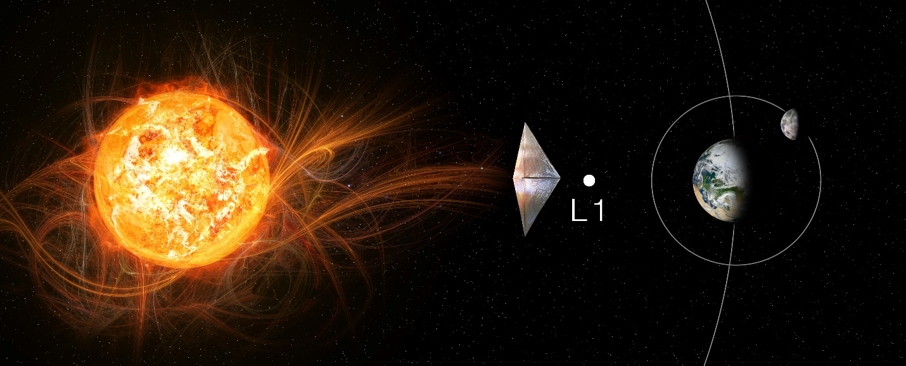

Solar Cruiser
Technology Maturation Plans

July 1, 2020

Les Johnson / NASA MSFC
Frank Curran / MZNBLUE Corp.
On Behalf of the Solar Cruiser Project Team

Contents
1.0 SOLAR CRUISER Solar Sail System Technology Maturation Plan Introduction 4
2.0 Overview 5
3.0 State-of-the-Art and Technology Advancement Plans 10
4.0 Detailed Technology Roadmap 30
5.0 Risks 34
6.0 Summary 37
7.0 Solar Cruiser Active Mass Translator (AMT) Technology Maturation Plan Introduction 38
8.0 Overview 39
9.0 State-of-the-Art and Technology Advancement Plans 41
10.0 Risks 47
11.0 Summary 48
12.0 SOLAR CRUISER Solar Sail Attitude Determination and Control Software (SSADCS Software) System Technology Maturation Plan Introduction 50
13.0 Overview 51
14.0 State of the Art (SOA) 54
15.0 Detailed Technology Roadmap 56
16.0 Risks 59
17.0 Summary 60
18.0 Appendices 61
18.1 Acronyms 61
18.2 Figure List 62
18.3 Table List 62
18.4 References 62
18.5 NASA TRL Definitions 64
18.6 AD² Definitions 66
18.7 Risk Definitions 67

Two key NASA strategic documents—Our Dynamic Space Environment: Heliophysics Science and Technology Roadmap for 2014–2033 and 2013 Solar and Space Physics: Science for a Technological Society—contain over a dozen references describing the value of solar sails to enable revolutionary new observational capabilities. Based on these needs, the NASA Marshall Space Flight Center (MSFC) developed the Solar Cruiser mission concept to mature solar sail technology for use in future Heliophysics missions, as well as missions of interest across a broad user community (e.g., space weather and Earth polar observatories). Solar Cruiser would serve as a pathfinder for missions that observe the solar environment from unique vantage points such as a high inclination solar mission opening a fundamentally new range of observational capabilities for the Heliophysics Program and for space weather monitoring. Sustained observations away from the Sun-Earth line (SEL) present unique opportunities for answering the outstanding science questions of Heliophysics, improving space-weather monitoring and prediction, and revealing new information about our Sun and solar system. High solar inclinations are particularly compelling. Investment in, and demonstration of, the technology needed to enable polar missions is essential to making this unique vantage point possible in the next decade.

Propellantless solar sails can be used to create artificial equilibria and maintain indefinite station-keeping at locations sunward of L1 along the SEL, or at any desired offset from the SEL leading or trailing the Earth in its orbit. They can change the heliocentric inclination of a spacecraft from the ecliptic to as high as solar polar, stopping and remaining at any intermediate inclination orbit in between. Sails can be used to hover over the Earth’s poles, using solar photon pressure to offset the Earth’s gravitational attraction, creating functional equivalents of geostationary earth orbits.
The Solar Cruiser mission would fly a small spacecraft with a large (>1,600 square meter) solar sail containing embedded reflectivity control devices (RCDs) and photovoltaic cells. The mission concept includes successful deployment of the solar sail, validation of all sail subsystems, controlled station-keeping inside of the Sun-Earth L1 point, attitude control of the sail with the RCDs (including spinning and de-spinning), demonstration of pointing performance for science imaging, and an increase in heliocentric inclination (out of the ecliptic).

To demonstrate the requisite sail technology, the Solar Cruiser project will design, fabricate, deploy, and fly the Solar Sail Propulsion Element (SSPE). The SSPE incorporates the following three systems:
- The Solar Sail System (SSS) provides the large propulsive surface required for acceleration and smaller reflectivity-changing surfaces for roll control.
- The Active Mass Translator System (AMT) provides SSPE motion with respect to the sailcraft bus for pitch and yaw control.
- The Solar Sail Attitude Determination and Control System (SSADCS) consists of embedded software to 1) provide autonomous sailcraft attitude estimation, attitude pointing control, and reaction wheel momentum management following sail deployment and 2) execute the uplinked inertial attitude pointing commands to maintain the desired sailcraft trajectory.

The plans for maturing each of these technology systems to TRL 5 and beyond are described herein.

Solar Cruiser Solar Sail System Technology Maturation Plan Introduction
Solar sails have been under development for ultra-high delta-V missions for decades (McInnes, 1999 and Vulpetti, 2015). In fact, they are called out as a key technology in the major strategic documents guiding science and technology directions for NASA’s Science Mission Directorate (SMD – NASA, 2014 and NRC, 2013). NASA’s Science and Technology Directorate (STMD) is currently sponsoring a next-generation (86 m²) solar sail demonstration in the Near-Earth Asteroid Scout mission (NEAS) (Johnson, 2014 and Russell-Lockett, 2020). The planned Solar Cruiser solar sail demonstration now under Phase-A development for SMD will go well beyond NEAS with a sail area of over 1,600 m² to demonstrate the efficacy of sails for near-term space weather and Earth-observing platforms and farther-term (5 to 15-year timeframe heliophysics missions. The Solar Cruiser sailcraft makes up Work Breakdown Structure (WBS) Element 6.0. As shown in Figure 1, the sailcraft element is divided into the Sailcraft Bus (SB) and the Solar Sail Propulsion Element (SSPE).

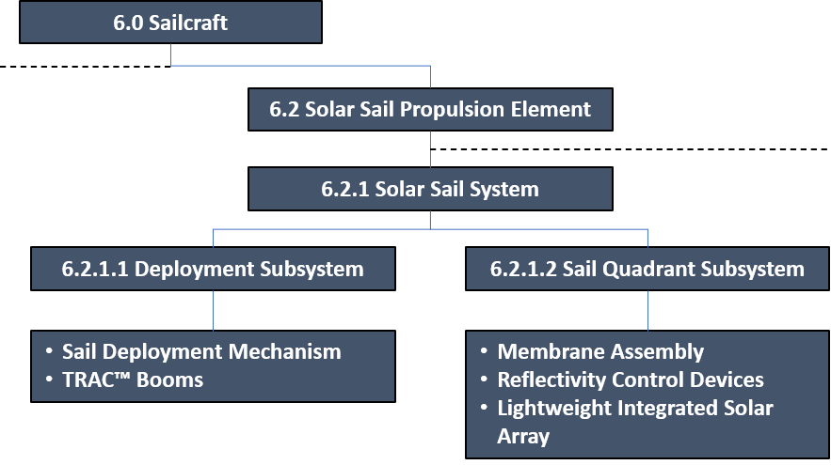
Figure 1. Solar Cruiser work breakdown structure element 6.0 (sailcraft).

The latter is composed of the three sub-Elements, the Solar Sail System (SSS - WBS 6.2.1), the Active Mass Translator (AMT- WBS 6.2.2) and the Solar Sail Attitude Determination and Control Software System (SSADCS—WBS 6.2.3). These three systems each contain the technologies that need to be advanced in the Phase B effort. The Solar Cruiser Principal Investigator (PI) has directed the development of Technology Maturation Plans (TMP) for each of these systems. This SSS Technology Maturation Plan (TMP) was developed using the Technology Assessment Process (TAP) provided in the SALMON library which is taken from the NASA Systems Engineering Handbook (SP-2016-6105-Rev2). The TAP requires a baseline technology maturity assessment for Technology Readiness Level (TRL) followed by an assessment of Advancement Degree of Difficulty (AD²) prior to finalization of the TMP. As described below, the SSS is composed of five Critical Technology Elements (CTE) that will be advanced to TRL 5 on the component level then collectively on the system level prior to the Project’s Preliminary Design Review (PDR). The system will be advanced beyond TRL 5 prior to the Critical Design Review to reduce risk to the extent possible on the ground prior to the planned Technology Demonstration Mission (TDM) required to fully validate the technology for future flights. The advancement plans revolve around a milestone-driven schedule developed by Solar Cruiser Principal Investigator (PI) that includes non-advocate reviews to assess progress and plans at key development points. The first of these, a Technical Concept Review (TCR) was held February 25–26, 2020. The following sections provide an overview of the SSS, a description of the State-of-the-Art (SOA), the specific development roadmaps for pre- and post-PDR development efforts and a section on risks and risk mitigation plans.

This TMP describes the efforts underway to assure that the SSS is at Technology Readiness Level (TRL) 5 by the Preliminary Design Review (PDR) and as far along the development path as possible on the ground. In fact, the SSS is the heart of the sailcraft and contains five Critical Technology Elements (CTE) contained in Sail Deployment (SD) and Sail Quadrant (SQ) subsystems (also shown in Figure 1 as WBS sub-Elements 6.2.1.1 and 6.2.1.2, respectively). These subsystems are grouped to reflect the general development flow with the DS components developed at Roccor and the SQ components and integration at NeXolve. Roccor has overall responsibility for SSS delivery.

Overview
The deployment and flight of the SSS in the Solar Cruiser Technology Demonstration Mission (TDM) will advance the key technologies necessary for large-scale solar sailing on both the component and system levels. Solar Cruiser’s four-quadrant sail will be the largest ever demonstrated by nearly an order of magnitude. In fact, MSFC has envisioned the evolutionary growth of sail technology (shown in Figure 2) from the small demonstration-class to technology capable of supporting high-return science missions like the long-sought high inclination solar missions (HISM - Kobayashi, K., et al. 2020 and Johnson, L., et al. 2020).

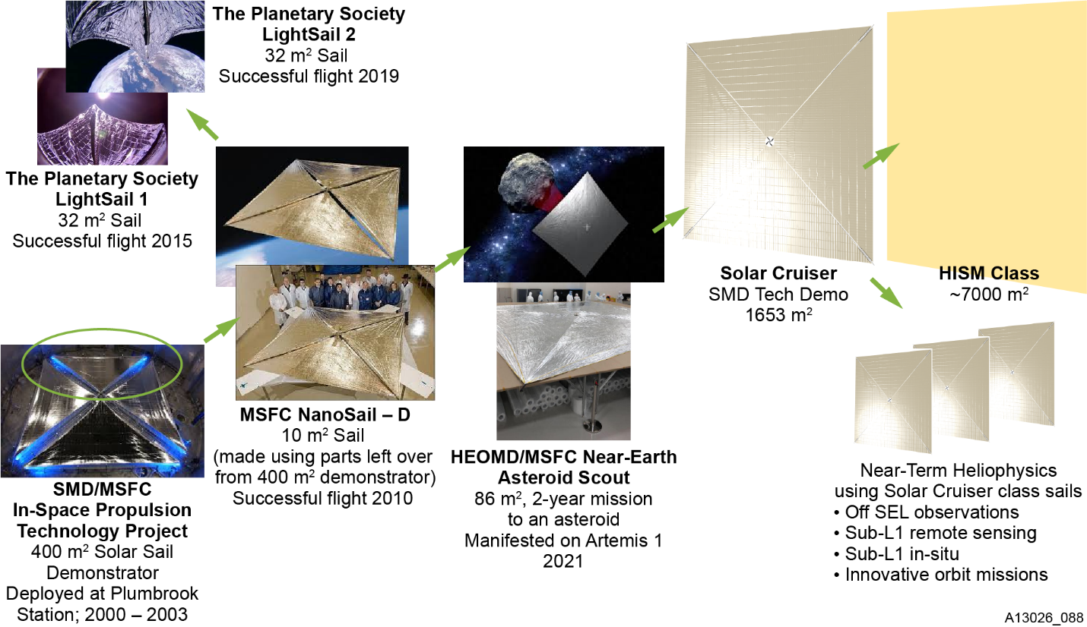
Figure 2. Solar Cruiser SSS advancement in the context of solar sail evolution from large ground-based technology demonstration to space flight.

The first steps along the MSFC-led evolutionary road to large sails have already been taken and, as discussed below, each of these has contributed to the coming Solar Cruiser step which will advance the technologies pioneered in the earlier steps to flight readiness. These past and on-going demonstrations include, for example, the S4 large-scale ground demonstration in NASA’s Plum Brook Station (Young, 2007), the NanoSail-D2 (Alhorn, 2011), and LightSail 2 (Ridenoure, 2015) have illustrated the potential of the solar sailing concept. The upcoming Near-Earth Asteroid Scout mission (NEAS) will be a further advancement down this path (Russell-Lockett, 2020). While these demonstration programs provide an excellent technology foundation, they are not sufficient to provide the full complement of technologies required for practical, ultra-high ΔV applications. Demonstration of the Solar Cruiser SSS will provide the final step and demonstrate the Critical Technology Elements (CTE) required to make the “as-demonstrated” Solar Cruiser SSS immediately applicable to missions that must stationkeep off the SEL or Sub-L1 in space weather science and/or early warning National Oceanic and Atmospheric Administration (NOAA) missions (Denig et al, 2014), as well as for use in other novel missions.

For this, the PI has developed a detailed set of eight Level 1 (L1) Baseline Technical Requirements (BTR) and Threshold Technical Requirements (TTR) for demonstration in the TDM. These are shown in Table 1 and, as shown on the right, the SSS is involved in meeting all BTR’s and TTR’s.

Table 1. Solar Cruiser Level 1 requirements.
Level 1 Requirement | Rationale | SSADCS | SSS | AMT
BTR1: Solar Cruiser shall demonstrate controlled flight by maintaining a thrust vector within 0.2° (TBR) in a sub-L1 Halo orbit for 45 days.  TTR1: Solar Cruiser shall demonstrate controlled flight by maintaining a thrust vector within 1° (TBR). | Demonstrates the ability of a solar sail system to provide controlled navigation to destinations providing novel vantage points of interest to Heliophysics, including station keeping sub-L1, sustained operations off the SEL, etc. Best estimates of thrust vector uncertainties are further refined with more advanced filter development prior to Systems Requirements Review (SRR). | X | X | X
BTR2: Solar Cruiser shall demonstrate the ability to manage momentum at Sun incidence angles (SIA) of at least 17° to effect a change in inclination from the ecliptic plane ≥0.05° over a 30-day period.  TTR2: Solar Cruiser shall demonstrate the ability to manage momentum at SIA of at least 10°. | Demonstrates the capability for the sail system to change heliocentric inclination that is extensible to future missions. | X | X | X
BTR3: Solar Cruiser shall demonstrate sailcraft acceleration of >0.12 mm/s2.  TTR3: Same as BTR3 | Demonstrates thrust performance necessary to enable near-term Heliophysics missions from destinations providing novel vantage points of interest to Heliophysics, including station keeping sub-L1, sustained operations off the Sun-Earth line (SEL), etc. |  | X
BTR4: Solar Cruiser shall maintain an intentional and controllable sailcraft roll angular velocity about the sailcraft X-axis of 0.039 ± 0.004 deg/s after solar sail deployment over a 24-hour period.  TTR4: Solar Cruiser shall demonstrate an intentional and controllable sailcraft roll angular velocity about the sailcraft X-axis ≥0.001 deg/s after solar sail deployment. | Demonstrates capability to spin the sail for scalability—sails approaching 7,000 m2 require spinning to prevent large boom masses and buckling. | X | X | X
BTR5: Solar Cruiser shall demonstrate pointing accuracy of <60 arcsec (Pitch/Yaw) and <6.8 arcmin (Roll) (3σ) after solar sail deployment.  TTR5: Same as BTR5 | Necessary for a sailcraft to be considered a stable platform extensible for Heliophysics remote sensing. | X | X
BTR6: Solar Cruiser shall demonstrate pointing stability of <20 arcsec/min (Pitch/Yaw) and <13.6 arcmin/min (Roll) (3σ) after solar sail deployment.  TTR6: Same as BTR6 | Necessary for a sailcraft to be considered a stable platform extensible for Heliophysics remote sensing. | X | X
BTR7: Solar Cruiser shall demonstrate pointing jitter of <10 arcsec/sec (Pitch/Yaw) and <1.34 arcmin/sec (Roll) (3σ) after solar sail deployment.  TTR7: Same as BTR7 | Necessary for a sailcraft to be considered a stable platform extensible for Heliophysics remote sensing. | X | X
BTR8: Solar Cruiser shall demonstrate >14.2W (TBR) BOL of analog sail-embedded photovoltaic power generated during flight. | Demonstrates the ability to locally generate power, remote from the sailcraft bus, for remote instruments or control systems using available, extensible, scalable technology. Baseline performance requirement specified is sized based on anticipated peak power needs of the Reflective Control Device (RCD) technology and may be reevaluated after technology maturation development prior to SRR. |  | X

The SSS is composed of the SD and SQ subsystems. These, in turn, are comprised of the five Critical Technology Elements (CTE) shown in Figure 3 followed by brief descriptions of each. These are: 1) the solar sail deployment mechanism (SDM), 2) the deployable TRAC™ Booms (TB), 3) the sail membrane assembly (MA), 4) the Reflectivity Control Devices (RCDs), and 5) the Lightweight Integrated Solar Arrays (LISA). As noted above, these are grouped into two subsystems—the Deployment Subsystem (DS) consisting of the SDM and TBs and the Sail Quadrant (SQ) subsystem consisting of the MA with integrated RCD and LISA panels.

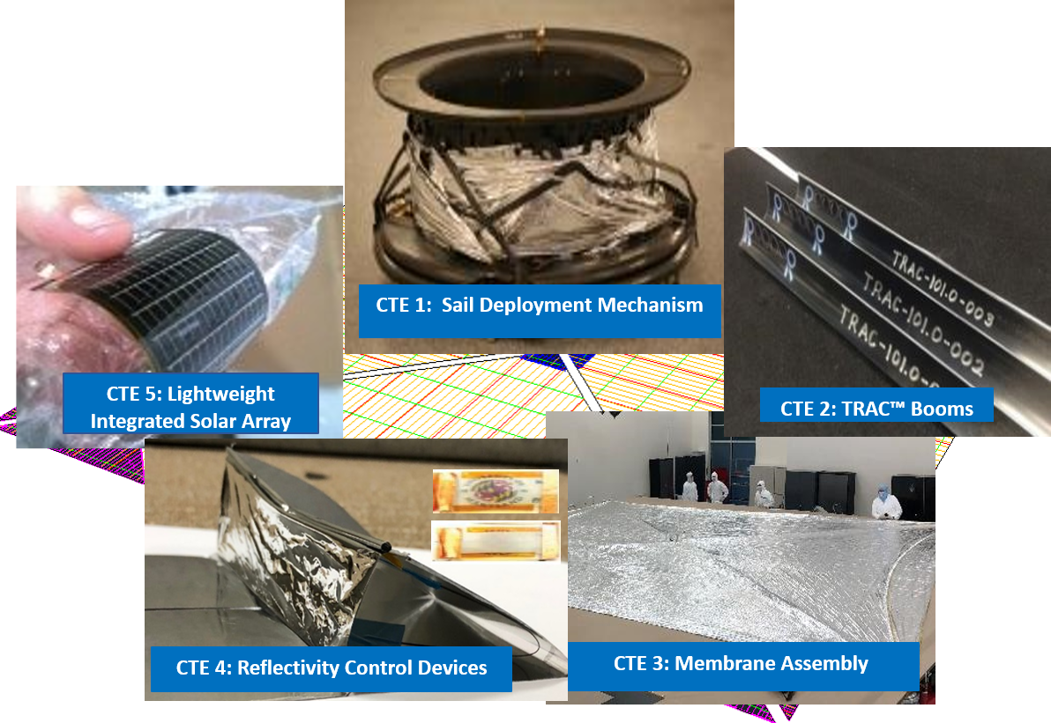
Figure 3. Solar Cruiser SSS critical technology elements.

Critical Technology Element 1: Sail Deployment Mechanism (SMD) - The SDM is used to stabilize the sail in the stowed configuration for launch, and then actuate to deploy the TB/MA combinations in space. The mechanism includes a boom deployer as well as a quadrant stowage hub. Similar to NanoSail-D2 (Few, 2018) and the Flexible Unfurlable and Refurlable Lightweight deployment mechanism (FURL) (Banik, 2010), the four TB’s are stowed on a common spool and deployment is actuated via a single drive motor. The stowage hub is mounted above the boom deployer and spins freely on a bearing such that as the booms deploy, the hub rotates and allows the quadrants to unfurl. Roccor is an industry leader in the development of deployment mechanisms and will provide this mechanism for Solar Cruiser.

Critical Technology Element 2: TRAC™ Booms - The solar sail membrane is deployed and tensioned using four high-strain composite (HSC) triangular, rollable, and collapsible TRAC™ booms (TB). TB’s have a triangular cross-section that flattens and rolls around a spool for stowage (Banik, 2010b). Small TB’s have been flight-validated by NanoSail-D2 and demonstrated to TRL 7 for the upcoming NEAS mission (Russell-Lockett, 2020). Both of these sailcraft employed metallic (Elgiloy™) TB. For Solar Cruiser, the four TB’s will be fabricated from lightweight, stiff and thermally stable carbon fiber reinforced polymer (CFRP) materials. Furthermore, the HSC TB’s will be tapered in cross-section along their length as a weight saving measure; a critical feature required to meet Solar Cruiser’s A_{c} goal. Roccor is a leader in the development of deployable HSC structures (see SOA section below) and will provide the booms for Solar Cruiser.

Critical Technology Element 3: Membrane Assembly (MA) - The solar sail architecture employs a four-quadrant design. When deployed, each quadrant is a right triangle with slightly over 400 m² area of space-proven aluminized CP1 (NeXolve Holding Company) membrane to provide the reflective surface necessary to meet Solar Cruiser’s A_{c} goal. In addition to the CP1 membrane material, the MA includes design features including reinforced edges and corners, embedded rip-stops, gore-to-gore seams, electrical jumpers, and catenaries to redistribute film stress resulting is a higher quality surface. Collectively, these add-ins are referred to as “features.” The MA will be packaged using the proven Z-fold method currently being automated for large sail applications. The MA will be configured with tented RCD’s and LISA panels to demonstrate RCD’s for large sail momentum management and the efficacy of embedded photovoltaic technology (see CTE’s 4 & 5 below). Once these technologies are incorporated, the product becomes the Sail Quadrant (SQ) subsystem that will be integrated with, and deployed by, the Deployer subsystem . NeXolve is a proven provider of large scale CP1-based products and will supply the SQ’s for the Solar Cruiser projects.

Critical Technology Element 4: Reflectivity Control Devices (RCD) - RCDs will be used to provide roll for the Sailcraft. RCDs are a thin film component, on the order of 10 microns plus transparent outer ITO/CP1 layers (Munday, 2015). These devices are made from a CP1 and Liquid Crystal Polymer (LCP) formulation that can be either reflective or transmissive depending on applied voltage. The RCDs will be deployed at an angle of approximately 40 degrees relative to the sail surface in order to generate roll torque. Half of the RCDs will be oriented to produce clockwise (CW) torque and the other have to produce counter-clockwise (CCW) torque (Ma, 2017). The RCDs are located on each of the outer SQ corners (8 total corners) and present enough deployed area, with margin, to control the sail. NeXolve along with Dr. Jeremy Munday of UC Davis (original RCD developer) are currently working a task under Solar Cruiser Phase A funding to continue development the CP1/LCP formulation, scale the technology beyond the test coupon level, refine power and voltage requirements, and develop the “tenting mechanism” required for implementation.

Critical Technology Element 5: Lightweight Integrated Solar Array (LISA) - LISA is a fully thin-film, flexible, sail-integrated solar array. The technology has been under development at NASA’s MSFC since 2012 (Carr, 2018). Commercial thin-film solar cells are embedded into bare CP1 using a solvent weld technique; without the use of an adhesive. The solar cells are electrically interconnected with welded, thin-film metal ribbon and power is routed to the spacecraft bus via copper traces embedded on the backside of the solar sail CP1. The top sides of LISA solar cells are encapsulated with a solution processed polyimide (also without adhesive). This creates a very thin (<100um), low mass (<160g/m²) solar power generator that can be directly embedded “in-sail.” LISA has the potential to enable point of load power generation, for example, co-located RCD’s and could also be used to provide spacecraft bus power for added science capability. LISA is currently tested to TRL6 for Low Earth Orbit applications and several LISA samples are currently being exposed in-space on the MISSE-FF (Materials on International Space Station Experiment Flight Facility) platform.

The SSS combines these CTE’s to store and deploy the propulsive surface for solar sailing and contains integrated RCD’s for momentum control and the embedded LISA for in-space demonstration. The solar sail system builds on past and ongoing developments of all of the CTE’s and over $1M in resources are currently being expended on NASA- and Air Force-funded Small Business Innovative Research (SBIR) contracts at two of Solar Cruiser’s key team members (Roccor and NeXolve) on technology developments directly applicable to Solar Cruiser. Figure 4 shows a preliminary (SBIR-funded) partial Sailcraft design showing the stowed SSS.

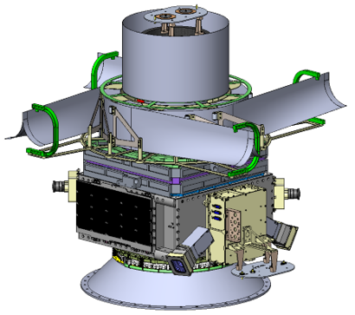
Figure 4. Preliminary mechanical drawing of SSS integrated into the sailcraft.

The SOA for each CTE along with the specific advancement strategies for each CTE and the CTE’s in combination, are provided in following sections.

State-of-the-Art and Technology Advancement Plans
A successful Solar Cruiser flight will require the advancement of the five CTE’s shown in Figure 3 above. These CTE’s are listed in Table 2 along with both current assessments of both TRL an and AD² and top-level advancement descriptions.

Table 2. Solar Cruiser SSS CTE overview.
CTE | Description | TRL/AD² | Advancement Descriptions
1 | Sail Deployment Mechanism (SDM) | 4/3 | Design modification from heritage FURL SDM for larger TRAC™ Booms and SQs; analytic model to support spacecraft integration
2 | Triangular, Rollable & Collapsible Boom (TB) | 4/3 | Increased cross-section, increased length, tapering, and analytic model to support integrated sail model
3 | Membrane Assembly (MA) | 4/3 | Factor of 20 increase over NEAS in membrane area, automated folding process, embed LISA and RCD to form sail quadrant (SQ)
4 | Reflection Control Devices (RCD) | 4/5 | Demo (application, adhesion, electronic control) required optical capability, environmental testing, embed in MA in SQ fabrication
5 | Lightweight Integrated Solar Array (LISA) | 5/2 | Test demo of existing (TRL 6 in LEO) technology in Solar Cruiser environment, embed in MA in SQ fabrication

TRL and AD² definitions are shown in Appendix 1 and are the NASA versions approved by SMD. The basis for the TRL/AD2 estimates are provided in the SOA section below. An independent, non-advocate panel reviewed the CTE status as part of the PI-directed Technical Concept Review (TRC) held on February 25-26, 2020. The development plan starts with the advancement of the CTEs on an individual basis and then combines the CTEs to advance the TRL on the system level. In the sections below, the SOA and advancement plans for each CTE are described. This is followed by a section that shows the overall development schedule along with a table showing the key milestones, their timing and the significance of each.

Element 1 — Sail Deployment Mechanism (SDM)
Roccor is responsible for the SDM. Table 3 shows the assessed entrance TRL with justification followed by a discussion of this assessment and advancement requirements.

Table 3. CTE 1: SDM state-of-the-art assessment.
Entrance TRL: 4
Definition: A low fidelity system/ component breadboard is built and operated to demonstrate basic functionality and critical test environments, and associated performance predictions are defined relative to final operating environment.
Justification
- NanoSail-D2, LightSail-1, FURL and NEAS deployers similar in concept—all have TRAC™ Booms stowed on common spool
- The Solar Cruiser SDM will be scaled (with lessons learned) from the AFRL’s FURL design (licensed by Roccor). The FURL deployer has been demonstrated extensively and is less than 20% different in size compared to the required SDM.
- Roccor has developed a mechanism similar in design to the planned Solar Cruiser SDM for a Tier 1 Prime (undisclosed) with four booms on a central hub with similar size and footprint to the required SDM.

As previously described, this mechanism entails a boom deployer as well as a sail quadrant stowage hub. The four TB’s used to deploy and tension the sail are stowed on a common spool and are deployed using a single motorized mechanism. This mechanism design draws heritage from the FURL mechanism (Banik, 2010a). Roccor has exclusively licensed the FURL technology from AFRL and has since gained extensive experience working with the FURL mechanism. The FURL design was matured through extensive testing in both ambient and environments (vibration and over 50 stowage/deployment cycles demonstrated in cold TVAC). The FURL sail-boom interface is a mature design and is directly applicable to Solar Cruiser. Figure 5 shows a conceptual schematic of the planned Solar Cruiser deployer.

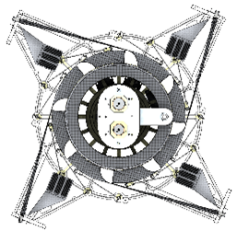
Figure 5. Top-down view of Solar Cruiser SSS conceptual design, stowed.

Figure 6 shows the stowed (top left) and deployed FURL System (center) with key integrated features called out.

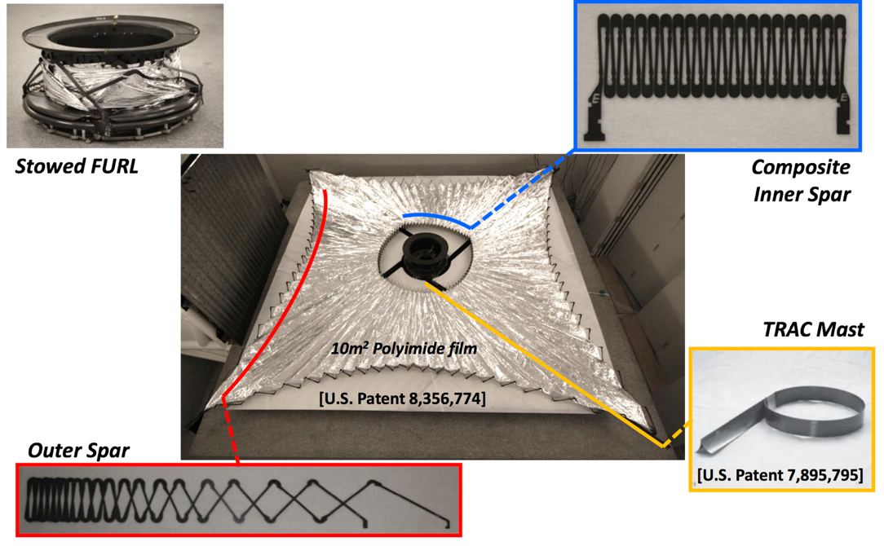
Figure 6. Stowed (top left) and deployed FURL (SDM center) sail with key features.

The quadrant stowage hub is mounted above the boom deployer and spins freely on a bearing such that as the booms deploy, the hub rotates and allows the quadrants to unfurl. This approach is considered to be mature, having been flight-demonstrated on NanoSail-D2 and flight-qualified as part of the NEAS mission. SDM design for Solar Cruiser will heavily leverage the FURL mechanism design. A proprietary exploded schematic of the FURL design was redacted from Figure 7 in this public version of the SSS TMP. Roccor also has significant expertise with the design of similar spooling mechanisms. Figure 7 also shows a boom spooling mechanism, three of which are on-orbit after successful deployment (https://www.roccor.com/harris-launches-its-first-smallsat-roccor-proudly-on-board/).

 | 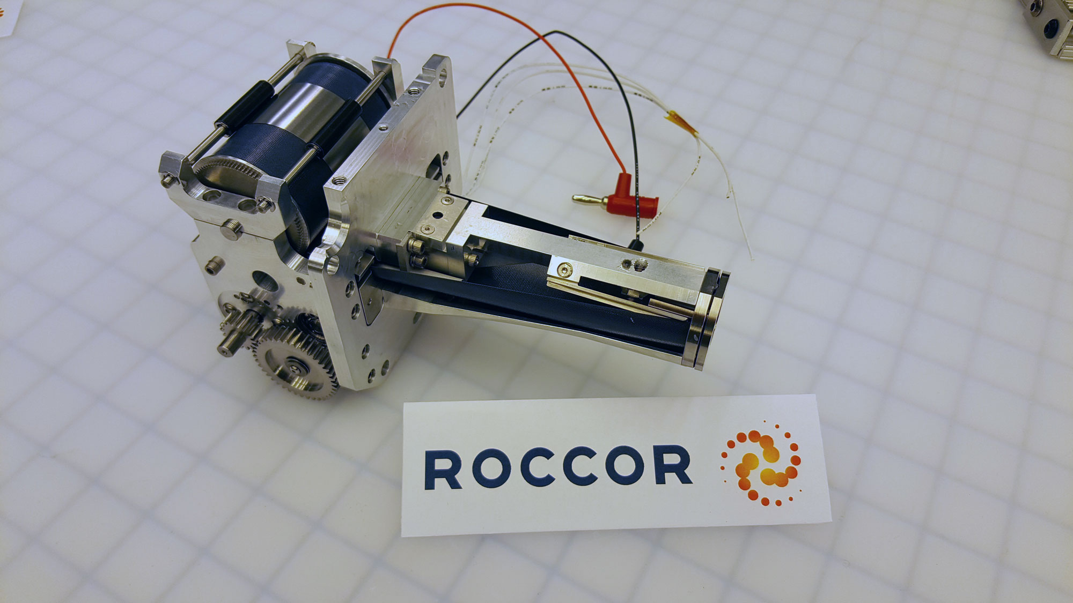
Figure 7. Right: Redacted proprietary exploded view of FURL (left). Right: Heritage boom spooling mechanism designed, fabricated, qualified by Roccor and currently on-orbit.

While the deployed area of Solar Cruiser is orders of magnitude larger that the FURL solar sail, the required scaling from existing SDM technology (e.g. FURL) is minimal. Scaling of the existing FURL design and generation of the quadrant stowage hub design are straight forward engineering activities with an assessed AD² of 3. For the Solar Cruiser technology advancement effort, a full-size brassboard SDM will be developed and tested to achieve TRL 5 on the component level prior to PDR. On the system level, this full-sized brassboard SDM will be integrated with four sub-length brassboard TB’s (on the order of 7.5m each, ~1/4-scale), as well as four SQ simulators (one a brassboard and three Mylar™ SQ simulators) to form a brassboard SSS. This brassboard SSS will be deployed, subjected to environmental testing and redeployed. Following PDR, a full-scale deployment test will be performed prior to CDR with two prototype TB (full-length, ~29.5m), a prototype SQ, and the SDM used in TRL 5 testing (now considered a prototype by virtue of its full environmental testing) to further demonstrate flight readiness.

Element 2 — High Strain Composite (HSC) Triangular, Rollable and Collapsible (TRAC) Booms
As with the SDM, Roccor is responsible for the TB’s. Table 4 shows the assessed entrance TRL with justification and a discussion of this assessment and advancement requirements follow.

Table 4. CTE 2: TB state-of-the-art assessment.
Entrance TRL: 4
Definition: A low fidelity system/ component breadboard is built and operated to demonstrate basic functionality and critical test environments, and associated performance predictions are defined relative to final operating environment.
Justification
- Booms having the TRAC cross-sectional geometry, but fabricated from Elgiloy, have flown on Nanosail-D2, LightSail, and will be flying on the upcoming NEAS mission.
- High Strain Composite (HSC) TB’s have been demonstrated and matured as part of AFRL’s FURL solar sail effort.
- HSC TBs of 6m length fabricated (TRL 4-class breadboard) and delivered to NASA Goddard in 2018 for the CORSAIR program.

The SQ’s will be deployed and tensioned using four TB’s. Essentially all solar sails to date—the NASA ISTP demonstrations in 2004 (Young, 2007), NanoSail-D2 (Alhorn, 2011) and LightSail (Ridenoure, 2015)—have employed four quadrant sails. All of these sails, with the exception of IKAROS, have utilized structural booms to both deploy and support the sail membrane in the deployed configuration. Furthermore, all of these sails that have flown to date, with the exception of IKAROS, have utilized TRAC booms. TRAC booms can be wound much like a tape measure on a central hub and spooled out using a deploying motor to form a stiff and stable structure are the SOA for practical deployment of large sails. To date, flight-verified and qualified TB’s have been manufactured from Elgiloy™, a high yield strength metallic alloy. The change to composite material is planned for Solar Cruiser to minimize boom mass while also providing high strength, stiffness and on-orbit thermal stability. Other rollable boom cross-sectional geometries considered for Solar Cruiser include the slit-tube (otherwise known as a Storable Tubular Extendible Member, or STEM) and the “Double-omega” architecture (also known as the Collapsible Tubular Mast, CTM). Analysis has shown that TRAC booms provide the highest second area moment of inertia for a given flattened height, and therefore the highest bending stiffness, for any other type of rollable boom [Banik and Murphy, 2010], making this cross-sectional geometry the most structurally and volumetrically efficient option.

The Solar Cruiser TB has a triangular cross-section that flattens and rolls around a spool for stowage (see Figure 8). An early example of this design manufactured with the original Elgiloy™ material is shown in Figure 9 (left). Roccor has extended this technology using the HSC technology that will be required for Solar Cruiser. HSC TBs (6 m) developed and delivered for Goddard Space Flight Center’s (GSFC’s) Comet Rendezvous, Sample Acquisition, Investigation, and Return (CORSAIR) mission (NASA Phase III SBIR contract #NNX16CG03P) are shown in Figure 9 (right). HSC TBs were also developed and demonstrated under the Sail Trimming Actuator for Targeted Reentry (STARTR) program which was a NASA-funded Phase I SBIR (Contract No. 80NSSC19C0513) for the development of a steerable drag sail.

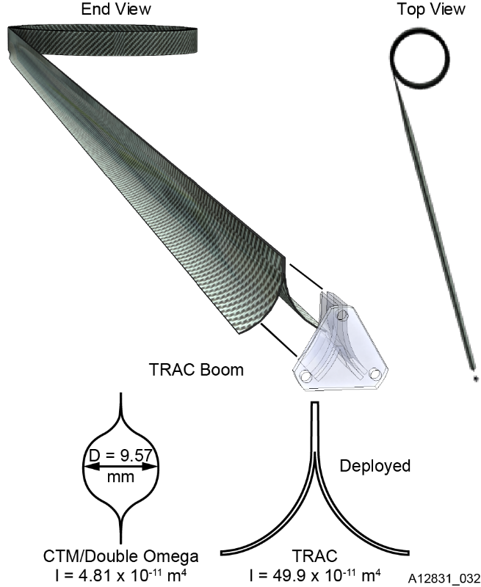
Figure 8. Illustration of TRAC boom geometry, as well as a comparison of Inertia for the Double Omega and HSC TRAC™ Boom cross-sectional geometries.

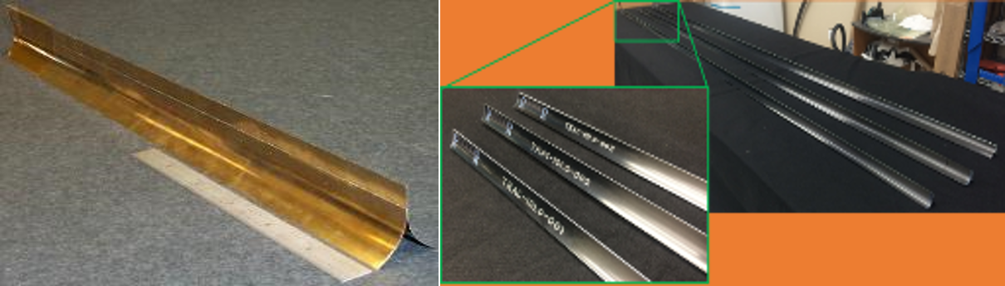
Figure 9. Left: AFRL Elgiloy TRAC™ boom technology translated to 3 m and 6 m High Strain Composite TRAC™ booms delivered to GSFC as part of Roccor’s Phase A support for the comet sample return mission (CORSAIR) study.

Preliminary analyses performed during Phase A have shown that the baselined TB design will support the required membrane tension without buckling, will provide an adequate sail structural first mode natural frequency, as well as exhibit minimal on-orbit thermal deformations as a result of worst-case thermal gradients. To meet the aggressive Ac goal for Solar Cruiser, cross-sectional tapering of the booms along their length will also be implemented for major mass savings. Roccor has already demonstrated the fabrication of composite structures of comparable length to what will be required for Solar Cruiser and has the requisite experience with the materials and processes to be used for Solar Cruiser - long (25 m-class) HSC TBs will be fabricated in August 2020 as part of a NASA-funded Phase II SBIR effort at Roccor.
As noted previously, the TB architecture has flight heritage (NanoSail-D2, TRL 9) and a longer version is stowed and awaiting flight (NEAS). While composite TB’s have not yet flown, they have been matured by AFRL as part of the FURL solar sail system. Similar to Solar Cruiser, the FURL solar sail (Banik, 2010a), incorporates four composite TB’s that stow on a central hub and deploy to tension the solar sail membrane. The FURL solar sail has successfully undergone environmental testing (vibration, thermal cycling, and Thermal-Vacuum deployment). However, the FURL booms (~3 m) are not as long as those planned for Solar Cruiser (~29 m). Roccor has demonstrated the fabrication of 15 m composite booms (Figure 10) and has the modular tooling, curing oven capacity and demonstrated trimming system required to accommodate tapered boom fabrication up to and beyond the length required by Solar Cruiser.

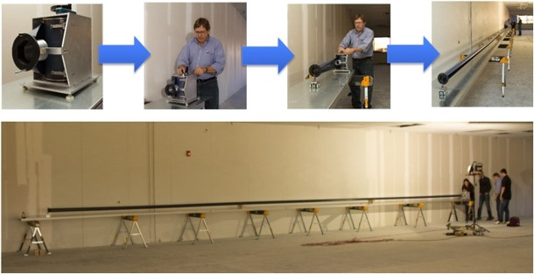
Figure 10. Demonstrated long boom fabrication capability at Roccor.

The other major element of the TB is the sail-boom interface hardware. This hardware is an integral part of the TB and secures the sail and maintains the sail tension within acceptable limits despite thermally induced deformations within the system. Heritage sails have used compliant spring interfaces between the sail and distal end of booms, an example of which is shown in Figure 11 (left).Also shown in Figure 11 (right) is the attachment tab developed under Roccor’s STARTR SBIR.
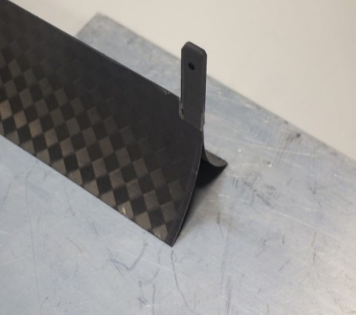
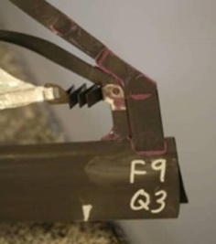
Figure 11. FURL sail-boom interface and STARTR attachment tab technology to be used for Solar Cruiser.

Based on the success of early TRAC™ Boom developments, the FURL demonstration, the STARTR program results, and Roccor’s demonstrated large boom fabrication capability, TB technology has been independently assessed at TRL 4 with an AD² of 3. The assignment of 3 for AD² is based on the assessment that both existing physical hardware and analysis indicate that the necessary TB advancement will require straightforward engineering efforts, i.e. while minor manufacturing issues may be encountered and require resolution, no back-up boom design is necessary. For the Solar Cruiser technology advancement effort both a full-size TB will be developed and tested to achieve TRL 5 on the component level prior to PDR. On the system level, four subscale brassboard booms (~7.5m length, ~1/4-scale) will be fabricated and assembled with one sub-scale brassboard SQ, three thin film Mylar™ SQ simulators and a full-scale prototype SDM. This brassboard SSS will be deployed, subjected to environmental testing and redeployed. Following PDR, a full-scale deployment test will be performed prior to CDR with two prototype TBs, a prototype SQ, and the prototype SDM used in TRL 5 testing to further demonstrate flight readiness.

Element 3 — Membrane Assembly (MA)
NeXolve is responsible for the MA under contract to Roccor. Table 5 shows the assessed entrance TRL with justification and a discussion of this assessment and advancement requirements follow.

Table 5. CTE 3: MA state-of-the-art assessment.
Entrance TRL: 4
Definition: A low fidelity system/ component breadboard is built and operated to demonstrate basic functionality and critical test environments, and associated performance predictions are defined relative to final operating environment.
Justification
- S4 was a packaged 4 quadrant 400 m² CP1 solar sail that was fully deployed in vacuum in the Space Power Facility at the Plum Brook Station in 2005
- Nanosail-D2 was a 10 m² 4 quadrant CP1 drag sail, launch to LEO in Dec 2010 and successfully deployed in Jan 2011
- NEA Scout is an 86-m² monolithic solar sail made from CP1 film. The sail includes seams, rip-stops, reinforced edges and corners, electrical jumpers, and catenaries. The flight sail was thoroughly tested including: dynamics, thermal / vacuum, space environmental effects, deployed, and refolded / repackaged. The flight article is now integrated with the payload and awaiting launch vehicle integration with SLS.
- Large (tennis court-sized) deployable thin film structure with full environmental testing (JWST Sunshield Membrane Assembly) JSWT spacecraft (manufacturing complete 9/16, payload integration in progress (Reference)
- Multiple MISSE missions to validate CP1 characteristics in space and correlate them to ground testing (References)
- Two long-term storage and redeployment (S4 to NanoSail-1, NanoSail-2D storage)
- NeXolve—key roles (manufacturing and INT) in all of the above.

In fact, NeXolve has an extensive background in the development of large, deployable, thin-film structures including several solar sails. Figure 12 details this heritage starting with the S4 program in the early 2000s (Figure 13), followed by the NanoSail-D (sail cut from S4 SQ—Figure 14) project, the NEAS sail (Figure 15) and the JWST Sunshield Membrane Assemblies (Figure 16 and Beck, 2009).
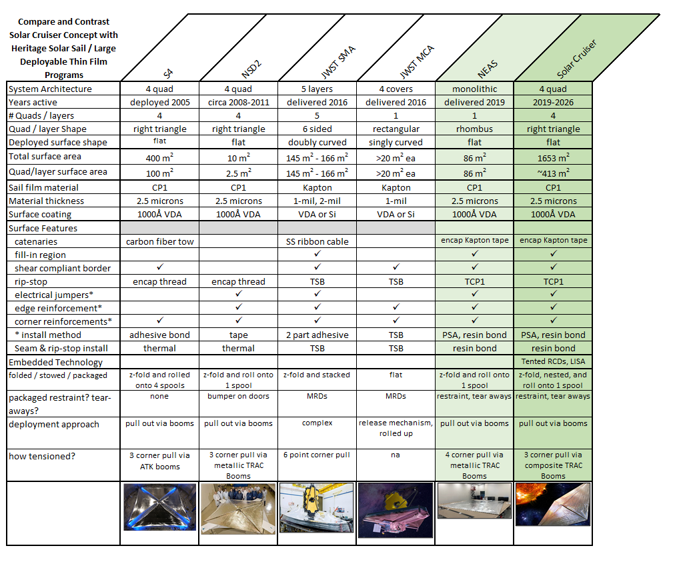
Figure 12. Deployable thin-film development heritage.

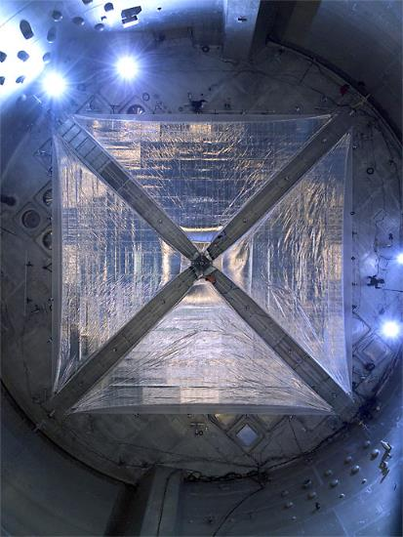
Figure 13. 400-m² four-quadrant sail deployment in NASA’s Plum Brook Stations Space Power facility under the Les Johnson-directed ISTP (2004).

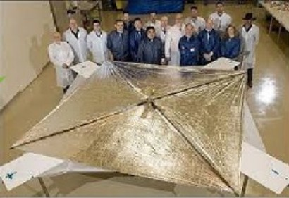
Figure 14. NanoSail-D2 extended in NeXolve facility.

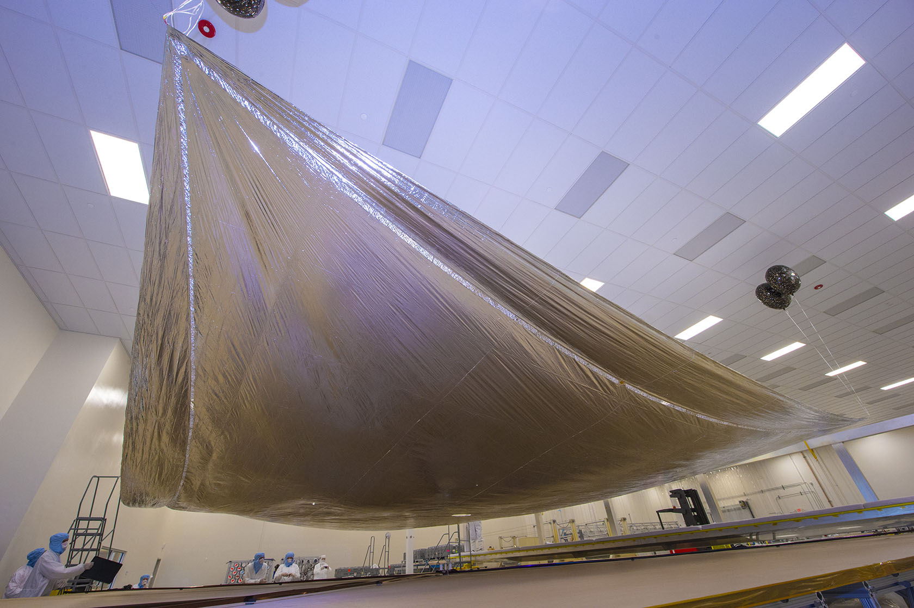
Figure 15. NEAS sail extended in NeXolve facility.

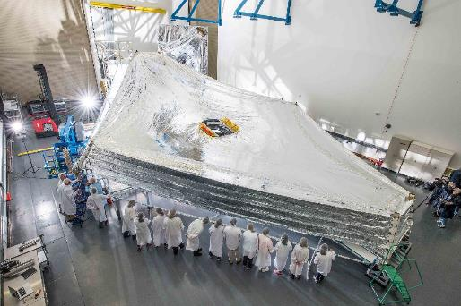
Figure 16. Prototype JWST Sunshield Membrane Assembly in a Northrop-Grumman facility.

Figure 17 shows the dimensions of the planned MA. All Solar Cruiser Sail Quadrants, including the four flight SQ’s will be manufactured in the NeXolve facility in Huntsville, AL used for and NEAS and JWST (shown in Figure 18). The facility has a footprint large enough to fabricate and deploy one full-scale Solar Cruiser sail quadrant at a time. However, to meet the Solar Cruiser schedule, NeXolve will employ an innovative, staggered-manufacturing scheme in which one SQ is folded once fabrication reaches the half-way point so that fabrication of the first half of the next quadrant can run in series. A separate facility (locations under evealuation) will be used for SQ testing.

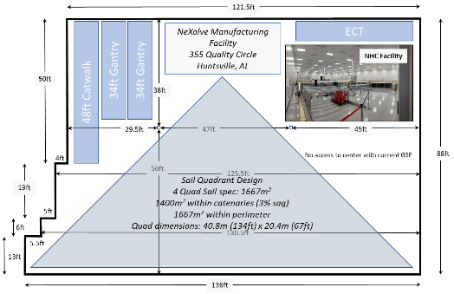
Figure 17. Solar Cruiser sail quadrant dimensions.

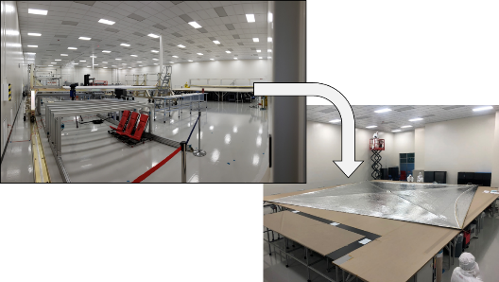
Figure 18. NeXolve facility in Huntsville, AL: a) configured for production and b) configured for testing and shown with monolithic NEAS sail deployed.

The same basic NEAS configuration will be used with the sail membrane material filling the region between the catenary and outside straight edge to maximize the sail’s propulsive area. Other key features of the sail membrane include seams, rip-stop, corner reinforcements, edge reinforcements and electrical jumpers for electrostatic discharge grounding (ESD) grounding and electrical connections (Young, 2007). The planned membrane material is CP1 (Reference http://www.nexolvematerials.com/low-cure-polyimides/cp1-polyimide) space- and sail-proven aluminized 2.5 μm CP1 polyimide substrate with a 1,000 Angstrom thick Al coating deposited using a well-established Vapor Deposited Aluminum (VDA) process. CP1 is a fluorinated polyimide which has demonstrated durability in space and has a high glass transition temperature of 263ºC. The high-temperature benefit is important for future missions involving operations at <0.5 AU. CP1 coupons were extensively tested in the MSFC Space Environmental Effects test facility and shown to be durable and not subject to charging (Garrett and Minow, 2007; Edwards, et al., 2004) and flown on MISSE. Identical membrane material (albeit in significantly smaller quadrant sizes) was successfully flown on NanoSail-D2 (Alhorn, 2011) and will be flown on NEAS (Russell-Lockett, 2020). Based on this history of ground and space testing, CP-1 is considered fully-qualified for the space environments expected to be encountered for the Solar Cruiser mission and in foreseeable, larger scale implementations. While not identical, NeXolve provided the large-scale, thin-film, multi-layer reflector system for JWST demonstrating their world-class capability with respect to the fabrication and handling of materials for very high-priority SMD missions.

Both analysis and testing has shown that the planned CP1 membrane technology is more than sufficient for the Solar Cruiser application. Long-term storability was demonstrated by the referenced NanoSail-D2 program—the 10-m² sail membrane successfully deployed in the NanoSail-D2 flight was cut from the S4 quadrants deployed in the ISPT Plum Brook Station testing and then packed and stored for approximately a decade.

Solar Cruiser will demonstrate the integration of two embedded technologies, LISA for in-situ power generation (CTE 5), and RCD panels for momentum control (CTE 6). While these CTE’s will be discussed separately below, SQ-specific technology is related to membrane integration and this will be accomplished using bonding materials and processes successfully developed for multiple similar applications including LISA-T (Carr, 2018) and JWST (Back, 2009).

While adaptation of the sail membrane materials (CP1 with features) will be relatively straightforward for Solar Cruiser, the ability to reliably pack and repack (fold/unfold/refold) would be very time-consuming in the large sail implementation of Solar Cruiser. The basic process for packing the sail is shown in Figure 19.

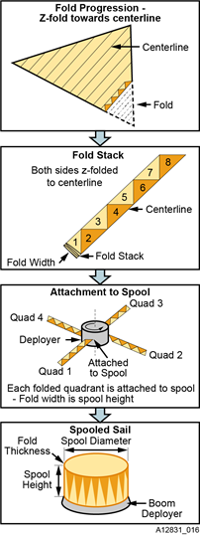
Figure 19. Sail quadrant packaging process.

Both the NanoSail-D2 and NEA Scout sails (10 m² and 86 m², respectively) were arduously hand-folded by skilled MSFC/NeXolve teams. An example of SOA packaging and deployment processes is shown in Figure 20.

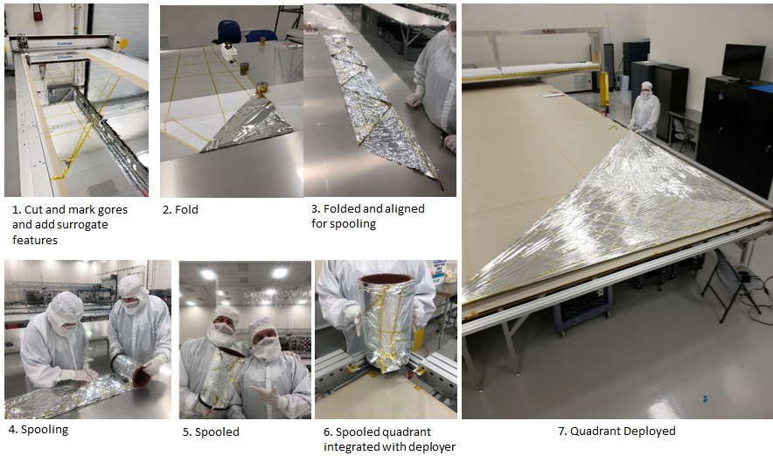
Figure 20. Manual sail packaging and deployment example.

While it would be possible to apply human-intensive processes for Solar Cruiser-class quadrants, a more repeatable, rapid packaging scheme is sought. Fortunately, schemes for manufacturing and automated folding of large scale sails have been devised and are currently being developed through a NASA MSFC funded Phase 2 SBIR with NeXolve (NeXolve, 2018). NeXolve’s approach to initial and recurring folding and packaging is to determine and optimize the mix of touch labor and mechanisms for sail folding and fabrication processes. Figure 21 and Figure 22 illustrating the production scheme being developed are redacted in this public release (proprietary to NeXolve).

Figure 21. Notional semi-automated sail folding process.

Figure 22. Notional sail folding process.
The Phase 2 SBIR efforts will lay the groundwork for the scheme that will be refined and implemented in Phase B. To date under SBIR funding, a backer removal/folding mechanism was successfully developed and demonstrated on a small scale. This design is the starting point for development and scale up of the mechanism for Solar Cruiser.

Packaging of four quadrant sails also needs development. Packaging involves several steps that will be similar to those used for NEAS; a packaged NEAS sail is shown in Figure 23.

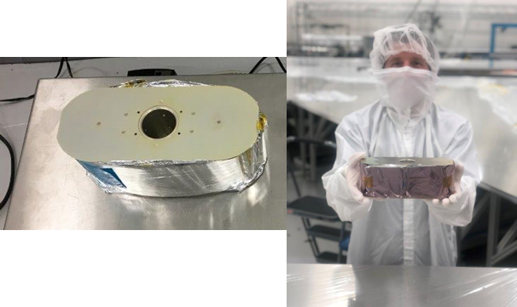
Figure 23. Packaged NEAS sail—flight unit.

The first step is attaching the vertex of 4 folded sail quadrants to a central spool that is part of the deployer mechanism. Once attached, the spool (horizontal orientation) will be rotated and the 4 quadrants carefully wrapped, while nested, around the spool. A primary challenge at this point will be “sail blossoming.” Blossoming occurs when air is trapped air within the folds and makes the sail bulge during spooling. A common analogy is flattening a bag while folding. To avoid blossoming, the fold process must minimize the path length for trapped air to escape. Gravity can also contribute to the problem. Regardless, once fully spooled, the packaged sail must be restrained, or constrained, to prevent “blossoming” and/or sagging due to gravity. Thus, a removable belt will be applied upon completion of spooling. At that point a restraint will be installed around the spooled sail to deploy ahead of the boom and sail deployment. The restraint will be secured around the spooled sail with tear-away tabs that are connected to the booms. The belt will be removed after the restraint is installed. During deployment, the boom deployment will tear the tear-away tabs and the restraint will fold back and out of the way allowing the spooled quadrants to deploy. Packaging development is in process in Phase A conjunction with the parallel Phase II SBIR with demonstration planned before the start of Phase B.

Referring back to Table 2, SQ technology has been determined by independent review to have a TRL of 4 with respect to Solar Cruiser sailcraft implementation. The assessed AD² is 3. These assessments are based on the lowest TRL/AD² component/process approach. The sail membrane material (with features) is assessed at TRL 5 and AD² 2 based on its demonstration in multiple ground and space tests, its past ease of scalability, and analysis that shows no known unknowns in further scaling. Scaling and deployment demonstrations in Phase A are designed to increase the TRL/AD² = 5/1. The scalability, manufacturing, folding, and packaging issues represent the largest hurdles - Phase 1 SBIR efforts moved these to TRL/AD² = 4/3 and this is the basis for the overall MA (and thereby SQ) rating. Development milestones (Table 6) will increase the TRL on the MA component level to 5 via development of the manufacturing process and fabrication of a full-scale brassboard MA assembly. The MA/SQ will be advanced to TRL 5 through the assembly and testing of a medium fidelity brassboard unit with a 1/16th scale SQ prior to PDR. After PDR, a full SQ will be deployed with two full scale brassboard TB’s and a brassboard SDM to demonstrate deployment to the extent possible on the ground.

Element 4 — Reflectivity Control Devices (RCD)
NeXolve is responsible for RCD development, fabrication, and SQ integration under contract to Roccor. Table 6 shows the assessed entrance TRL with justification and a discussion of this assessment and advancement requirements follow.

Table 6. CTE 4: RCD state-of-the-art assessment.
Entrance TRL: 4
Definition: A low fidelity system/ component breadboard is built and operated to demonstrate basic functionality and critical test environments, and associated performance predictions are defined relative to final operating environment.
Justification
2017 development and demonstration of an operational RCD coupon:
- Developed LCP formulation
- Postage stamp sized coupon (LCP in epoxy base) by JM at University of Maryland (now at UC/Davis)
- Demonstrated 90/10 reflectivity / transmission change with applied voltage

The implementation of an effective momentum management system is considered the largest obstacle to the controlled flight of Solar Cruiser-class and larger sails. While control schemes involving mechanical solutions like guy wires, articulating booms, etc. have been studied, their practicality decreases with boom length. The use of passive reflectivity control devices (RCD) is an innovative option made possible by a new generation of electroactive polymer dispersed liquid crystal (PDLC) materials that change in reflectivity with applied voltage (Ma, 2017). These devices are simple in principle. With no applied voltage (no induced electric field), the polymer molecules are randomly oriented, and the RCD panel is opaque (reflective) to incident light. An applied voltage causes the molecules to reorient and the panel becomes transmissive as shown in Figure 24.

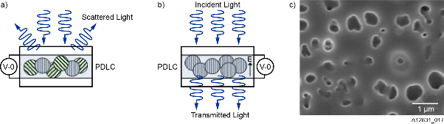
Figure 24. Schematic of a polymer dispersed liquid crystal (PDLC) device. Upon application of an applied bias, the device switches from (a) opaque to (b) transparent.

The devices consist of micro-sized liquid crystal droplets dispersed in a matrix of a UV-curable adhesive (Norland NOA65 - Ma, et al., 2017). A scanning electron microscope image of a representative RCD is shown in Figure 25.

Figure 25. Scanning electron microscope image of the PDLC (voids show location of liquid crystal droplets).

The efficacy of RCD’s for momentum control was successfully demonstrated in space by the Japan Aerospace Exploration Agency (JAXA). Their Interplanetary Kitecraft Accelerated by Radiation of the Sun (IKAROS) used proprietary PDLC technology in attitude control experiments (Ishida, 2017). The JAXA technology was 1st generation and capable of only a change in reflectivity (ΔR) from full to specular with applied voltage—this produced a change in transmission of about 25% (Tsuda, et al., 2013). The IKAROS flight brought the 1st generation SOA to TRL 9 and proved the efficacy of PDLC-based materials for solar sails.

The relatively low delta in reflectance ΔR inherent to the Japanese technology does not, however, translate well to large solar sails. Because the torque imparted by an RCD panel of a given area is directly proportional the ΔR, a next generation of high ΔR materials is needed to reduce both panel area and complexity for large sails. These materials have been pioneered for solar sail applications by Dr. Jeremy Munday at UMD (Ma, et al., 2017; Murray, et al., 2017). A typical reflectivity plot for this class of materials is shown in Figure 26 (Munday, 2017).

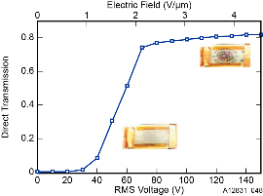
Figure 26. RCD optical transmissivity data from recent development at UMD (Munday, 2017).

As shown in the figure, a ΔR of ~80% is possible and it is anticipated that the Solar Cruiser panels will provide a significant improvement in “control per unit area” compared to their Japanese analogs. Fundamental demonstrations of the transmissivity changing characteristics are complete, have been tested for vacuum compatibility at the coupon level, and have been replicated by the commercial source (Solar Cruiser team member NeXolve).

In addition to the basic PDLC materials and manufacturing, both bonding and out-of-plane (OOP) technologies must be demonstrated. As promised in the original submission, a Phase A effort has optimized the RCD panel dimensions and positioning with respect to both roll control performance and panel integration (wiring, sail fold avoidance, etc.). The results of this trade place the devices at the at the far corners of the solar sail with all primary panels deployed out-of-plane to maximize attitude control performance. Adhesion of the RCDs to the CP1 membrane uses the same process qualified for LISA-T (see CTE 5 below and Johnson, 2017). Current roll control estimates set the total RCD areas to be less than 10 m² of area will be covered by RCDs (than 1% of total membrane area). The RCD’s will be housed in a composite frame and tented at a 40 degree angle with deployment accomplished using thin tape springs to provide control out of the sail plane torque, enabling full roll control of the sailcraft. This spring design has been demonstrated on a laboratory scale and the “flight type” tenting frame design has been developed (see Figure 27). This is a relatively simple, one-time deployment mechanism developed under NASA Phase 2 SBIR funding.
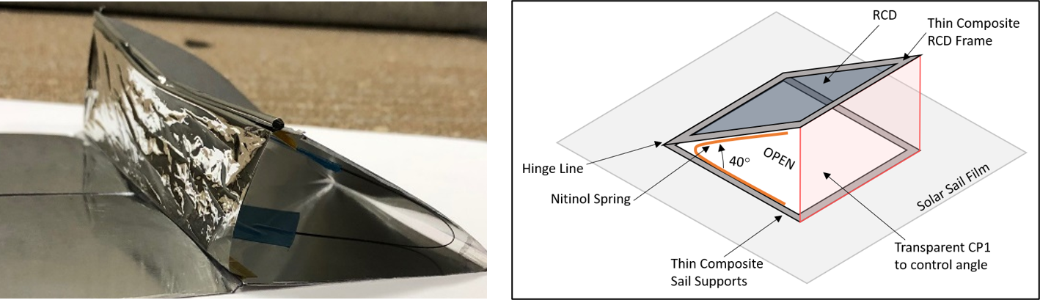
Figure 27. Laboratory-class tent mechanism demonstration (left) and composite frame planned RCD element design (right).

Independent assessment places the TRL and AD² for the RCD technology at 4 and 5, respectively. In December of 2019, NeXolve advanced the original RCD technology from the University research level to manufacturing demonstration level by first replicating the University results and then producing and testing laboratory-class coupons made using a flight-like LC/CP1 formulation. There is concern that the baselined LC material will not function as required when subjected to the environmental testing required to meet flight requirements. Specific concerns include the consistency of the ΔR and the durability for the panels across the qualification temperature range. For this reason, an AD² of 5 has been assigned and, while not required by the TMD PEA, an alternative LCD technology path is in progress with an independent source (Beam Co.). All are RCD-based (RCD technology is at the core of the technology demonstration) and involve the use of different LC options.

The environmental testing required to increase RCD technology beyond TRL 5 on the component level will be accomplished in the same MSFC facility used to qualify the LISA technology as discussed below.

Element 5 — Lightweight Integrated Solar Array (LISA)
Dr. John Carr is the Solar Cruiser Co-Investigator for LISA and will direct all development efforts. As shown in Table 7, LISA technology has already been developed to TRL 5 under the LISA-T program. NeXolve is responsible for LISA fabrication, and SQ integration under contract to Roccor.

Table 7. CTE 4: LISA state-of-the-art assessment.
Past Development to TRL 5
Definition: Medium-fidelity system/component brassboard built & operated to demonstrate overall performance in a simulated operational environment with realistic support elements that demonstrate overall performance in critical areas. Performance predictions made for subsequent development phases.
Justification
- Identification of critical functions and associated subsystems and components complete.
- Relevant environments defined—subset from system operational environments that address key operational risks.
- Scaling requirements identified/documented.
- Prototype-fidelity critical components fabricated (available) and characterized in all required critical environments – final analytical analysis to show compatibility for Solar Cruiser environment to be performed early in Phase B
- System level performance predictions complete.

As with RCD technology for momentum management, remote power generation (i.e. no connection to the spacecraft bus) may be required for large-scale applications beyond Solar Cruiser. For these applications, thin-film photovoltaic (PV) array elements will be integrated directly into the SQ to for demonstration in the integrated SSS. The selected LISA technology is a fully thin-film, flexible, sail-integrated solar array that has been under development at MSFC since 2012 under NASA Space Technology Mission Directorate’s Lightweight Integrated Solar Array and anTenna (LISA-T) small spacecraft development program (Johnson, et al., 2017 and Carr, 2018). The Solar Cruiser system will not require the “anTenna” feature, but the proposed LISA system will be nearly identical. Areas of the aluminized CP1 sail will be selectively left as uncoated CP1, that is, non-aluminized. As mentioned above, commercial thin-film solar cell modules will then be embedded into these areas without adhesive using a CP1 resin solvent weld. Copper indium gallium (di)selenide (CIGS) solar cells with NeXolve’s fluorinated polyimide nanocomposite CORIN®XLS as a top side protective coating will be used for the Solar Cruiser system. Examples of the CP1-CIGS-CORIN®XLS stack-up are shown in Figure 28.

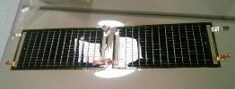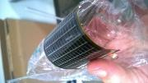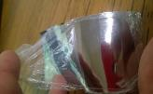
Figure 28. LISA sample coupons: CP1embedded, CORIN® XLS encapsulated CIGS.

The CIGS stack-up and fabrication processes have been tested to TRL6 in a LEO environment in a large environmental chamber (shown in Figure 29—note that this is the same facility that will be used to perform all required environmental testing on the RCD technology in Phase B discussed above) at MSFC (Finckenor 2017).

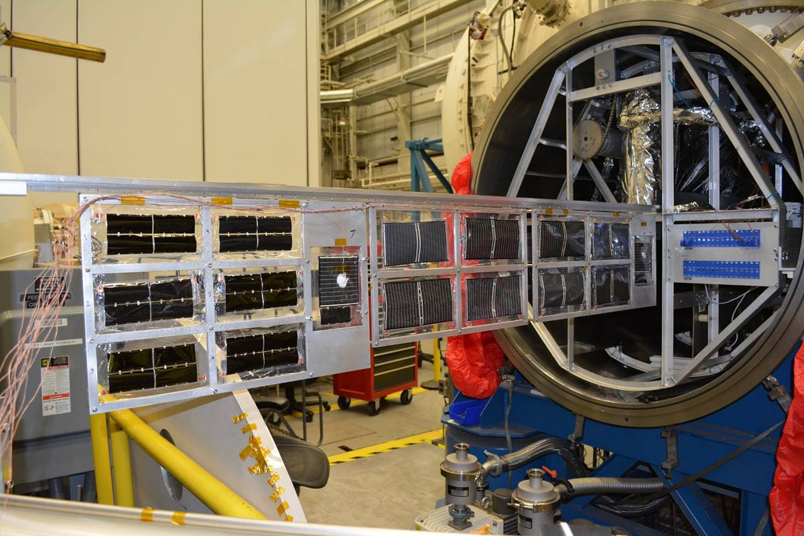
Figure 29. MSFC space environmental test facility (open prior to LIAS testing)—facility to be used for RCD Phase B environmental demonstrations.

Required environmental testing included vent and high vacuum operation, neutral atomic oxygen, particulate radiation (electron and proton), thermal extreme operation and thermal cycling, as well as medium-near ultraviolet radiation exposure. Combined environmental effects on LISA assemblies are currently being conducted on the International Space Station MISSE-FF platform (MISSE). Sample return is expected in mid-2020 and will be evaluated prior to the start of Phase B. For Solar Cruiser, these environments are transferrable. The humidity exposure, ascent vent, and high vacuum operation tests are directly transferable and neutral atomic oxygen is not part of the Solar Cruiser operational environment. The particulate radiation, thermal operation and cycling, as well as ultraviolet radiation LISA-T testing were all completed at extended ranges beyond LEO to show extensibility into higher orbits and deep space. Initial thermal and radiation analysis indicates acceptable overlap and applicability of this extended LISA-T testing; that the Solar Cruiser mission environment is enveloped by the testing already completed. These environments and, thereby the TRL6 rating, should be transferrable to the Solar Cruiser TDM. A more in-depth analysis of radiation, thermals, and ultraviolet equivalent sun hours will be performed prior to fully justify TRL6 for LISA in the Solar Cruiser environment early in Phase B. The planned maximum voltage for each string is 40 V. This is well-above the voltage required for RCD operation and below the voltage where arc-over issues must be considered (Bodeau, 2011).

The commercial source of the required LISA panels is Ascent Solar Technology, Inc. (AST). The required panels will be a slight modification to AST Model Number B-066-570-170. The modification required is a straightforward (AD² = 1) dimensional change. NeXolve will procure the panels integrate them into the SQ using the same fabrication and integration capabilities developed for the LISA-T program. For example, the thin-film solar cells are embedded into bare CP1 using a solvent weld technique; without the use of an adhesive. The solar cells are electrically interconnected with welded, thin-film metal ribbon and power is routed to the spacecraft bus via copper traces embedded on the backside of the solar sail CP1. The top sides of LISA solar cells are encapsulated with a solution processed polyimide (also without adhesive). This creates a very thin (<100um), low mass (<160g/m2) solar power generator that can be directly embedded “in-sail.”

As noted above, the TRL for the LISA technology is 5 and TRL 6 is anticipated through early Phase B analysis. The SSS with LISA will be brought to TRL 5 on a system level via testing of a fully integrated sub-scale SQ prior to PDR. System level testing of a full quadrant with a full 3 panel LISA system will then be performed prior to CDR.

Detailed Technology Roadmap
The PI-developed technology/system advancement flow is shown in Figure 30. This flow is designed to provide the stepwise advancement of both the individual CTE’s and the SSS to TRL 5 before the Preliminary Design Review. The SSS will then be advanced beyond TRL 5 on the system level prior to CDR. Note that LISA is an exception—this CTE has already been assessed at TRL 5 by independent review and will be inserted directly into the system integration process in its current technology state.

As noted in the sections above and shown in Figure 30, each CTE will be advanced to TRL 5 on the component level. To achieve TRL 5 on the system level, the CTE’s will be combined as shown into the DS and SQ subsystems and then these will be combined into a brassboard SSS consisting of a full-scale brassboard SDM, four ¼-scale brassboard booms, one sub-scale brassboard SQ, and three thin film Mylar™ SQ. This brassboard SSS will be deployed, subjected to environmental testing and redeployed. The detailed milestone schedule is shown in Figure 31 and the key milestones along with their timing and significance are shown in Table 8.
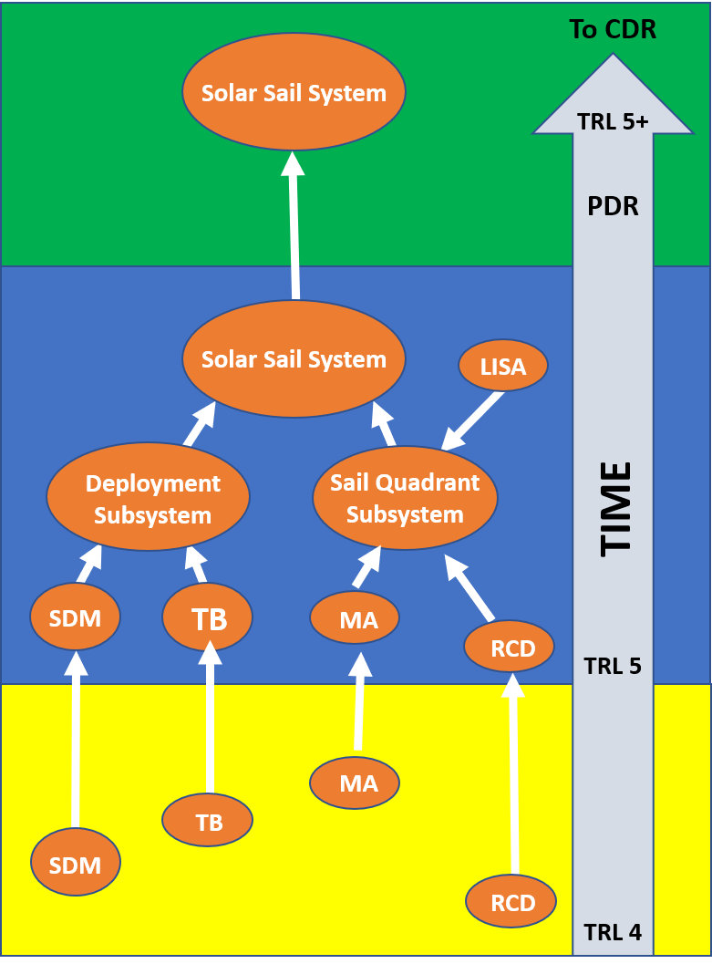
Figure 30. Solar Cruiser component and system technology maturation flow.

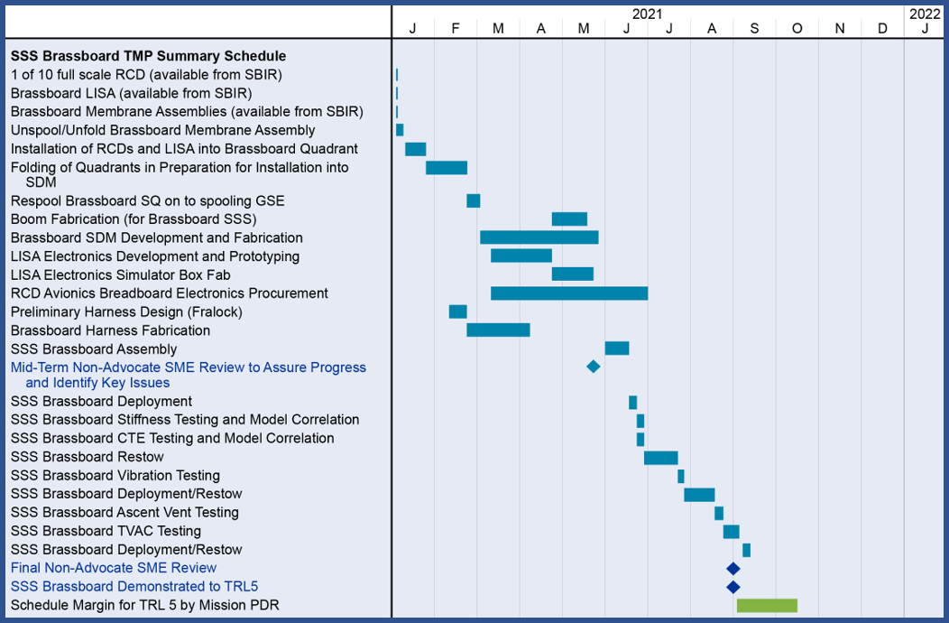
Figure 31. SSS technology development roadmap to TRL pre-PDR.
Table 8. Technology maturation milestone description with planned accomplishment timeframe and significance.
TRL 5 Definition: A medium fidelity system/ component brassboard is built and operated to demonstrate overall performance in a simulated operational environment with realistic support elements that demonstrate overall performance in critical areas. Performance predictions are made for subsequent development phases. | Major Milestones to TRL 5 | Timeframe | Significance
 | 1/10th scale RCD available for testing and ½-scale brassboard RCD unit | Q2/21 | RCD samples available for performance demonstration and MA integration into SQ
 | Brassboard LISA panel delivered from SBIR and TRL 6 analysis complete | Q2/21 | Component-level TRL 6 panel available for MA integration into SQ
 | Semi-automated MA folding process demo’s and 1/16-th scale brassboard SQ and 3 Mylar™ SQ simulators fabricated and spooled | Q2/21 | Required folding process demo’d, SQ at TRL 5 on integrated component level (MA at TRL 5) and brassboard SQ (and simulators) available for integration testing
 | Full-scale brassboard TB fabricated and tested for mechanical properties, four ¼-scale brassboard TBs fabricated for system-level testing | Q3/21 | TB at TRL 5 on component level and brassboard TBs available for system-level testing
 | Full-scale brassboard SDM fabricated and functionally tested | Q3/21 | Brassboard SDM at TRL 5 on component level and ready for system-level integration testing
 | Brassboard SSS system assembled | Q3/21 | Brassboard SSS ready for integration testing subject to non-advocate review.
 | Mid-term non-advocate review | Q3/21 | Peer review to assure brassboard SSS ready for integration testing
 | SSS brassboard restow | Q3/21 | Brassboard restowed after boom stiffness and CTE testing and model correlation – ready for environmental testing
 | SSS deployment and restow after vibe testing | Q3/21 | Brassboard completion of vibration testing required for TRL 5 advancement – ready for TVAC testing
 | SSS deployment and restow after TVAC testing | Q3/21 | Brassboard completion of TVAC testing required for TRL 5 advancement – ready for final non-advocate review.
 | Final non-advocate review for concurrence that TRL 5 criteria met | Q3/21 | TRL 5 achieved

Environmental test requirements will be tailored from the full Solar Cruiser environments suite shown in Table 9. Planned testing and analyses for the brassboard components and brassboard system will go beyond the standard “simulated operational environments” required for TRL 5. For example, LISA testing already performed along with planned pre-PDR analysis will be at TRL 6. The RCD’s will be similarly tested at the component level prior to PDR. The brassboard testing will include full TVAC and vibe sequences.

Table 9. Solar Cruiser environments table.
Thermal Vacuum | SLS-SPEC-159: Space sink temperature assumed to be 3K  From NEA Scout thermal analysis—solar sail membrane -100C to +80C  SIS (Revision 3, 2019.09.03): RPL’s undergo thermal vacuum bakeout per ASTM E2900
Radiation | SLS-SPEC-159: See “Spacecraft Radiated Emissions (RE) Enveloped Case” Figure 5.3
Plasma Environment | SLS-SPEC-159: See “Solar Wind” in Table 3.3.3.4-1 in SLS-SPEC-159  Short, single event geosynchronous charging may occur
Acoustic | SIS (Revision 3, 2019.09.03): 1/3 Octave Band SPL—tested on shake plate from ~25Hz to 10,000Hz
Micrometeoroid | SLS-SPEC-159: Section 3.3.6
Solar Flux | SLS-SPEC-159: 1372 W/m² @ 1 AU (assuming a mean of 1367 +/- 5 W/m²  Using inverse square, recommend using W/m² @ 0.984 AU—which is the closest distance to sun in sub-L1 orbit
Total Ionizing Dose | SLS-SPEC-159: Section 3.3.1.10.2 (Geomagnetically Unshielded)
Random vibration (at ESPA/Solar Cruiser I/F) | SIS (Revision 3, 2019.09.03): Payload interface random vibration tested from 20 Hz to 2000 Hz—PSD (g²/Hz) remained within 0.006–0.04
Sine Vibration | SIS (Revision 3, 2019.09.03): Axial and Lateral Sine Vibration tested from 5-100 Hz; axial remained between 0.6 and 0.9 Sine Level (G), while lateral remained between 0.5 and 0.9 G
Shock | SIS (Revision 3, 2019.09.03): SRS (g-peak) was 100 from 100-335Hz and was 720 from 336Hz-10000Hz
Pressure | SLS-SPEC-159, deep space vacuum environments: 5.5 * E⁻¹² psia (2.7 * E⁻¹⁰ Torr)  Depress rate of 0.15psi/sec (9 psi/min) [TBR; per SLS-RQMT-216]
Humidity | SIS (Revision 3, 2019.09.03): 18.1–98.8% (TBR) relative humidity during ground operations
EMI/EMC | SLS-SPEC-159  SIS (Revision 3, 2019.09.03) including ref. NASA-STD-8719.24
Cleanliness | SIS (Revision 3, 2019.09.03): level 500A per IEST-STD-CC1246 and adherence to NASA-STD-6016

To advance SSS technology readiness prior to CDR, a single quadrant prototype demonstrator with two full-scale prototype TB, a full-scale prototype SQ (with a full LISA and RCD compliment), and the prototype SDM used in TRL 5 testing. The detailed milestone schedule is for the development and demonstration of this prototype is shown in Figure 32 and the key milestones along with their timing and significance are shown in Table 10.

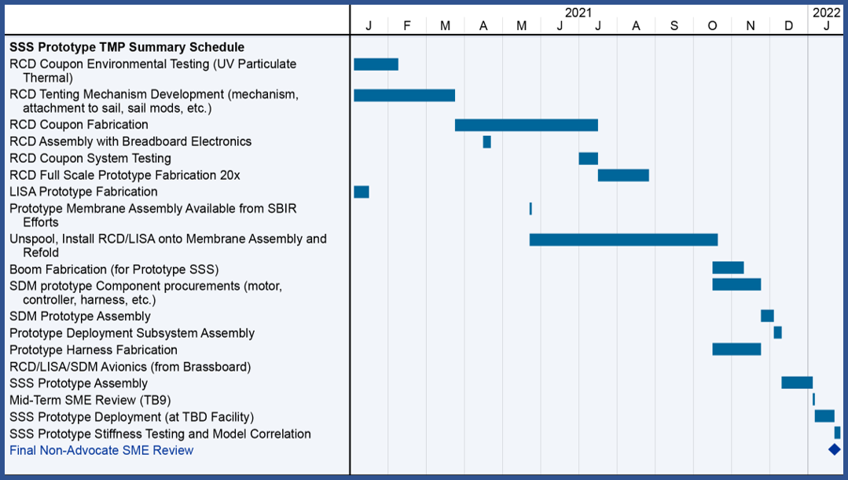
Figure 32. SSS technology development roadmap between PDR and CDR.
Table 10. Technology maturation milestone description with planned accomplishment timeframe and significance.
Major Milestones post-TRL 5 | Timeframe | Significance
Full-scale prototype LISA panels delivered | Q1/21 | Panels from AST available for integration into full-scale SQ
Full-scale prototype MA completed (NASA SBIR funding) | Q2/21 | MA available for integration into full-scale prototype SQ
RCD environmental coupon testing | Q2/21 | UV, particulate and thermal testing in same MSFC facility used to bring LISA to TRL 6 - RCD at TRL 6 at component level
RCD tenting and deployment system fabricated and demonstrated | Q2/21 | Tenting design ready for prototype RCD unit production
Fabrication of 20 full-scale RCD units complete | Q4/21 | RCD technology ready for integration into full-scale SQ
RCD’s and LISA panels integrated into MA (unspooling and respooling complete) | Q1/22 | Full-scale SQ available for integration and deployment testing
Fabrication of 2 full-scale prototype TB’s and delivery to NeXolve | Q1/22 | Full-scale prototype TB’s available for integration and deployment testing
Full-scale prototype SDM delivered to NeXolve | Q1/22 | Full-scale prototype SDM available for integration and deployment testing
SSS prototype assembly | Q1/22 | Full-scale prototype SSS (single SQ) ready for deployment testing
Mid-term non-advocate review | Q1/22 | Review to assure prototype deployment readiness
SSS deployment complete | Q1/22 | Full-scale deployment takes prototype to the limits of ground testing – SSS ready for TDM demonstration
Final non-advocate review | Q1/22 | Final review to assure readiness for flight system development

Risks
The Solar Cruiser program has performed an in-depth risk assessment with the support of non-advocate SME’s. The assessment will be revisited on a regular basis as the project progresses. Major specific project milestones have been established for those reviews (shown in Figure 31 and Figure 32 and in Table 8 and Table 10 above). The first of these reviews was performed as part of a PI-directed project TCR in Q2/20. The Top 5 risks are shown in Table 11. Figure 33 presents the risks in the standard 5x5 format.

As shown in the table, risk mitigation strategies have been developed for each risk. One common risk-reduction theme involves interim reviews by SME’s. Past inputs from SMD reviewers have indicated concern over a lack of detail leading up to meeting the TRL 5 and TRL 6 exit criteria. In fact, meeting these criteria typically requires multiple iterations with extensive testing at varying levels of fidelity While the nature (and number) of these tests precludes roadmap inclusion, interim SME review is inserted to assure progress is on schedule and that issues are identified in a timely manner.

RCD technology performance is viewed as a major technical risk to the Solar Cruiser project. As a global risk reduction strategy, the Solar Cruiser program has maintained a target for baseline RCD area to provide at least a factor of 2 in roll control torque. This still implies that RCDs are ~0.6% of the total SSS sail surface. RCD system area can be increased significantly without major degradation to the overall SSS performance (i.e. A_{c}) and is a key risk reduction option.

Further conservatism is built into the program by the fact that the SSS roadmap is based on the SOA as described above. Aggressive development efforts are in progress across the technology elements and significant advances are anticipated. The demonstration of LCD material compatibility with CP1 is one example of this—the compatibility was demonstrated in the laboratory of the planned industrial source (Solar Cruiser team member NeXolve) before (Q1/20) the original anticipation date (Q4/20).

Table 11. SSS risks and mitigation strategies.
Risk # | Risk Title | Risk Statement | Risk Type | Risk Assessment |  |  | Mitigation Plan
 |  |  |  | L | C | T | Mitigation Plan
SSS-1 | Under-Performance of RCD Technology | RCD panels do not provide the predicted torque per unit area and/or required power system requirements exceeding baseline design | T,S | 3 | 3 | 9 | - Increase in-quadrant RCD area  - Early environmental testing for thermal issues  - On-going development of alternate LCD/CP1 formulation  - Non-advocate pre-Phase B review to assess best RCD alternative  - Funded pre-PDR reserve
SSS-2 | Quadrant Material Issues | Scale up of quadrant design/packaging leads to unacceptable deployment characteristics (e.g. tearing, stiction) | T,S | 3 | 2 | 6 | - Multiple early 1/16th manual deployments followed by immediate SME review  - Full-scale quadrant deployment test a minimum of 1 year prior to PDR  - Addition of additional rip-stop and/or edge connection protection  - Continued funding and testing of toughened CORIN alternative material  - On-going analysis of large-scale adhesion properties and SME review  - Funded pre-PDR reserve
SSS-3 | Sail Deployment Issues | Hardware failure, excessive deployment torque, cable entanglement | S | 2 | 3 | 6 | - Torque motor design with more than 100% margin on worst case analysis procurement from proven source with minimal customization;  - High-fidelity model of all cable spooling processes, multiple laboratory deployment followed by integrated deployments from 1/16th to full scale on one boom  - Three non-advocate progress reviews before flight system build  - Funded reserve (prior to PDR and CDR)
SSS-4 | Inadequate Automated Quadrant Fold and Unfold System | The planned automated packaging/repackaging system does not provide sufficient capability to meet test and flight requirements | S | 2 | 3 | 6 | - Early testing of planned system design with multiple iterations in Phase A  - Continued development/assessment of alternative designs  - Three non-advocate progress reviews before flight system build  - Funded reserve (prior to PDR and CDR)
SSS-5 | TRAC™ Boom and/or sailcraft structural issues | Excessive boom deformations due to either thermal or unexpected (low) modal frequency excitations, boom buckling due to unexpected boom loads | S | 2 | 3 | 6 | - Extensive modeling using proven non-linear failure modes and effects software with iterations on boom design as necessary  - Test to failure to demonstrate 100% + margins (stiffness, CTE, etc.)  - Progressive testing from bench to partial to full scale component deployment  - Three non-advocate progress reviews before flight system build  - Funded reserve (prior to PDR and CDR)

Risk SSS-1: RCD technology is at the heart of the SC demonstration and must be developed and implemented to meet major SC mission success criteria. Two major areas of concern have been identified by the SC team and independently validated. These are 1) the RCD perform with respect to ΔR across the required qualification envelope and 2) the strength of the material with respect to stresses associated with deployment and in-flight operation. Both of these concerns are being addressed in the Phase A effort and the development milestones and schedule shown reflect the need to address these as quickly as possible. As noted above, the total RCD panel area is expected to have a “worst case” value of 10 m² (less than 2% of the total sail area). A simple mitigation strategy for a slight underperformance would entail a small increase in total panel area. A possibility of significant underperformance by the baseline material is being addressed through the development of a second LCD alternative. This is the Project’s top risk and the PI has assigned a team led by his Co-I for LISA to oversee the planned risk mitigation steps. The mid-term independent review will also provide a key decision point (e.g. move to alternate LC material or away from LC technology). If LC technology proves unworkable, alternate control strategies are under evaluation—boom gimballing for pitch and yaw and bus-mounted vanes for roll control.

Risk SSS-2: There are no known issues in scaling from the SOA to Solar Cruiser-sized SQ’s. Similar polymer-based materials (e.g. mylar and Kapton) have been used in larger applications (e.g. the tennis court-sized JWST heat shields) and the order-of-magnitude scaling required for the CP1 sails between NanoSail-D2 and NEAS was accomplished using straightforward engineering practices. The major concerns in scaling to Solar Cruiser dimensions are stricture (binding between the sail folds that leads to damage during deployment) and elongation (unacceptable fabric stretching/sagging). The planned development path is designed to reduce this risk (or identify issues) in Phase A with early 1/16th scale demonstrations. The issue will be independently assessed after the first deployment in Q3/20 and there are 6 months of funded schedule margin prior to PDR to implement CP1-based quadrant improvements. Scaling by a factor of 40 from the ISTP demonstration, however, may introduce unknown risks. If issues arise (e.g. unanticipated tears during deployment), additional rip-stop and/or corner support can be added. In the unlikely event that the strength of CP1 is judged to be inadequate, a toughened material, CORIN is being developed under a NASA MISSE FF Phase II SBIR (Reference). This material would provide an increase of 5 to 10 in tear strength, an improvement of 20 to 40% elongation (with respect to the baselined CP1) and will be ready in time for substitution based on the ongoing schedule. The planned Phase 1 demonstration should increase the AD2 of for CP1 from 3 to 1 and the off-ramp to CORIN would be taken early in Phase B if CP1 is not suitable (again, highly unlikely).

Risk SSS-3: Sail deployment issues can result from hardware failure, excessive deployment torque, cable entanglement. These risks are mitigated through 1) selection of motor having at least a 3:1 torque margin over worst case resistive torques within the system; 2) Extensive testing of prototype hardware to assess parameters such as resistive torque, causes and prevention of entanglement, etc.; 3) non-advocate progress reviews before flight system build; and 4) providing funded reserve (prior to PDR and CDR) to address the issues as required. The mitigation steps above are design to examine and reduce these risks.

Risk SSS-4: An inadequate Automated Quadrant Fold and Unfold System performance may result from the planned automated packaging/repackaging system (under development) not providing sufficient capability to meet test and flight requirements. Risk are mitigated though early testing of planned system design with multiple iterations in Phase A, continued development/assessment of alternative designs, 3 non-advocate progress reviews before flight system build, and lastly having a funded reserve (prior to PDR and CDR) to address issues that arise. The system underdevelopment is an optimized mix of touch labor and mechanization of processes that should improve sail folding quality (tolerance) while reducing risk to the SQ.

Risk SSS-5: Inadequate TRAC boom structural properties could result in excessive boom deformations due to either thermal and/or unexpected (low) modal frequency excitations, as well as the potential for boom buckling due to unexpected boom loads. This risk will be addressed through detailed design, analysis and testing activities. Roccor’s experienced personnel will establish ample margins on key parameters such as thermal expansion, buckling strength and stiffness. Margins will be demonstrated through high fidelity non-linear finite element analysis performed by Roccor’s experienced staff, as well as through the fabrication and testing of hardware. Testing will include an assessment of CTE, force/deformation testing to measure stiffness, as well as a buckling test.

Likelihood | 5
Likelihood | 4
Likelihood | 3 |  | 2 | 1
Likelihood | 2
Likelihood | 1 |  |  | 3,4,5
 |  | 1 | 2 | 3 | 4 | 5
 |  | Consequence
Figure 33. SSS risk ranking.

Summary
The Solar Cruiser Technology Demonstration Mission is dependent on the successful deployment and demonstration of the Solar Sail System in space. All the components and other Solar Cruiser technologies can be tested on the ground. The size of the sail system precludes test-as-you-fly demonstration. The technology advancement plan developed by the Solar Cruiser PI and subjected to non-advocate review provides a stepwise path to bring all five of the SSS Critical Technology Elements to TRL 5 prior to their integration into a brassboard to be tested to beyond TRL 5 prior to the Preliminary Design Review. Technology advancement will then continue through the development and demonstration of a prototype composed of a full-scale sail quadrant (a full-size membrane assembly with a full complement of reflectivity control devices and lightweight integrated solar array panes), two full-length booms, and a full-scale sail deployment mechanism. The Solar Sail System development effort builds on 20 years of solar sail technology research, development and flight experience directed by the Solar Cruiser PI. The Project’s detailed technology roadmaps include frequent peer reviews (one already completed) to assure progress without the advocate bias.

Solar Cruiser Active Mass Translator (AMT) Technology Maturation Plan Introduction
Solar sails have been under development for ultra-high delta-V missions for decades (McInnes, 1999 and Vulpetti, 2015). In fact, they are called out as a key technology in the major strategic documents guiding science and technology directions for NASA’s Science Mission Directorate (SMD – NASA, 2014 and NRC, 2013). NASA’s Science and Technology Directorate (STMD) is currently sponsoring a next-generation (86 m²) solar sail demonstration in the Near-Earth Asteroid Scout mission (NEAS) (Johnson, 2014 and Russell-Lockett, 2020). The planned Solar Cruiser solar sail demonstration now under Phase-A development for SMD will go well beyond NEAS with a sail area of over 1,600 m² to demonstrate the efficacy of sails for near-term space weather and Earth-observing platforms and farther-term (5 to 15 year timeframe heliophysics missions. The Solar Cruiser sailcraft makes up Work Breakdown Structure (WBS) Element 6.0. As shown in Figure 34, the sailcraft element is divided into the Sailcraft Bus (SB) and the Solar Sail Propulsion Element (SSPE).

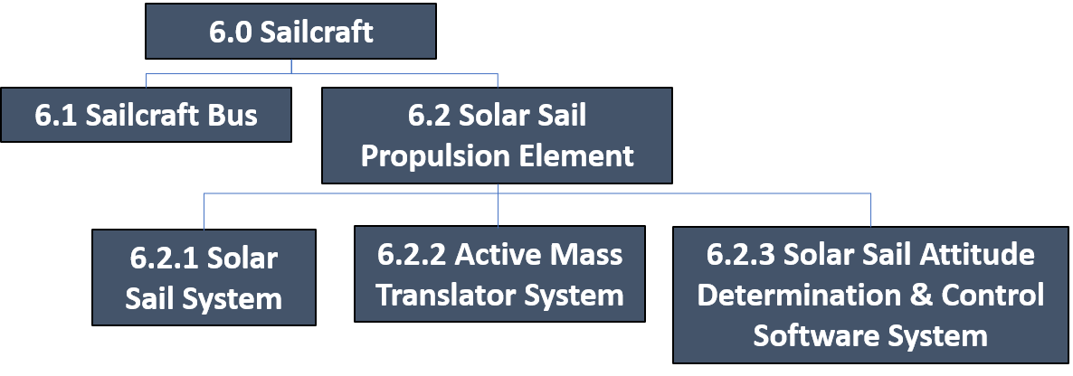
Figure 34. Active Mass Translator in Solar Cruiser WBS hierarchy.

As shown, the AMT system combines with the Solar Sail System (SSS) and the Solar Sail Attitude Determination and Control System Software (SSADCS) – WBS 6.2.1 and WBS 6.2.3, respectively - to form the SSPE which is the focus of the proposed Technology Demonstration Mission (TDM). Functionally, the AMT serves as the mechanical interface between the sailcraft bus and the SSS and provides two-axis translation to counteract solar sail-induced disturbance torques in pitch and yaw. Two-axis, single-stage translation units are in common use for industrial manufacturing, printing, etc. and are not considered new technology. Solar Cruiser-unique technology advancements are needed to meet launch and in-space environmental requirements within the project-imposed mass constraint. The Solar Cruiser driving requirements are shown in Table 12. The trace directly to the Solar Cruisers Baseline Technology Requirements (BTR) 1, 2, & 4 which are BTR1: Solar Cruiser shall demonstrate controlled flight by maintaining a thrust vector within 0.2° (TBR) in sub-L1 Halo orbit for 45-days; BTR2: Solar Cruiser shall demonstrate the ability to manage momentum at sun incidence angles (SIA) of at least 17° to effect a change in inclination from the ecliptic plane ≥0.05° over a 30-day period; and BTR4: Solar Cruiser shall maintain an intentional and controllable sailcraft roll angular velocity about the sailcraft X-axis of 0.039 ± 0.004 deg/s after solar sail deployment over a 24-hour period.

Trace | Level | Parameter | Requirement | Current Phase A Value
BTR3 | 2 | Sailcraft mass (kg) | <113.3 | 94.6
BTR3 | 3 | AMT mass (kg) | <8.4 | 6.9
BTR4 | 2 | Torque capacity (Nm) | ≥9.22E-4 (P/Y) | 2.0E-3 (P/Y)
BTR4 | 3 | Translation distance, X- & Y-axes (cm) | >±25 | ±29
BTR4 | 3 | Translation speed, X- & Y-axes (mm/s) | >0.3 | 0.5
Table 12. Solar Cruiser driving requirements.

This Technology Maturation Plan (TMP) was developed using the Technology Assessment Process (TAP) provided in the SALMON library (Reference 1) which is taken from the NASA Systems Engineering Handbook (SP-2016-6105 Rev2). The TAP requires a baseline technology maturity assessment for Technology Readiness Level (TRL) followed by an assessment of Advancement Degree of Difficulty (AD²) prior to finalization of the TMP. For this, an internal Project assessment of TRL/AD2 = 5/2 was made and presented to a Principal Investigator (PI)-directed non-advocate review panel in an overall Technical Concept Review (TCR) held February 25 – 26, 2020. As a result of this review, the TRL assessment was revised down to TRL 4 based mainly on concerns over the change in design from the carriage and roller bearing design to the dovetail and groove design developed in response to NEAS lessons learned. The panel agreed, however, that this was a straightforward engineering effort and with the AD² assessment of 2. The TRL and AD² definitions are provided in Section 6.5 and Section 6.6, respectively. It is noted here that because the AD² is low and the planned brassboard development and test approach will move the system well beyond TRL 5 prior to the Solar Cruiser Preliminary Design Review (PDR) with full thermal-vacuum (TVAC) and random vibration (RV) testing, a protoflight approach will be employed beyond PDR. This TMP developed includes 1) a brief overview of the AMT, 2) a description of the state-of-the-art (SOA) and advancement plans, and 3) a brief discussion of risks and risk mitigation plans. The advancement plans revolve around a milestone-driven schedule developed by Solar Cruiser Principal Investigator (PI) that includes non-advocate reviews to assess progress and plans at key development points.

Overview
Table 13 shows the CTE’s included in the Solar Cruiser along with their current, peer-reviewed TRL/AD² status and a brief description of the advancements needed to meet Solar Cruiser requirements.

Table 13. Solar Cruiser critical technology elements with AMT highlighted.
CTE | Description | TRL/AD² | Advancement Descriptions
1 | Sail Deployment Mechanism (SDM) | 4/3 | Design modification from heritage FURL SDM for larger TRAC Booms™ and SQs; analytic model to support spacecraft integration
2 | Triangular, Rollable & Collapsible Booms (TB) | 4/3 | Increased cross-section and length of tapered boom and analytic model to support integrated sail model
3 | Membrane Assembly (MA) | 4/3 | Factor of 20 increase over NEAS in membrane area, automated folding process, embed LISA and RCD to form Sail Quadrant (SQ)
4 | Reflection Control Devices (RCD) | 4/5 | Demo (application, adhesion, electronic control) required optical capability, environmental testing, embed in MA in SQ fabrication
5 | Lightweight Integrated Solar Array (LISA) | 5/2 | Test demo of existing (TRL 6 in LEO) technology in Solar Cruiser environment, embed in MA in SQ fabrication
6 | Active Mass Translator (AMT) | 4/2 | Scaling with lessons learned from NEA Scout hardware, full environmental testing, ICD’s for sailcraft bus, SSADCS, & SSS interfaces
7 | Solar Sail Attitude Determination & Control System Software (SSADCS) | 4/2 | Adaptation of NEA Scout software to larger sail control (MSFC), ICD for implementation on sailcraft

The AMT has two roles on Solar Cruiser – it serves as the physical interface between the sailcraft bus and the Solar Sail System (SSS) and it supports sailcraft pitch and yaw control (i.e. manages torques and momentum about the in-plane body axes) by adjusting the sailcraft Center-of-Mass (C_{m}) with respect to its Center-of-Pressure (C_{p}). The key technology advancements lie providing the required YZ travel while meeting all environmental requirements (mainly launch loads and thermal) within project-allotted mass and volume limits. The Solar Cruiser development team delivered a “same-purpose” device for the NEAS mission and the NEAS sailcraft is now packaged and ready for launch (Few, 2016 and Few, 2018) This development has provided the experience (especially through lessons learned) to take on the challenge of the scaling needed for the Solar Cruiser AMT – size comparison shown in Figure 35.
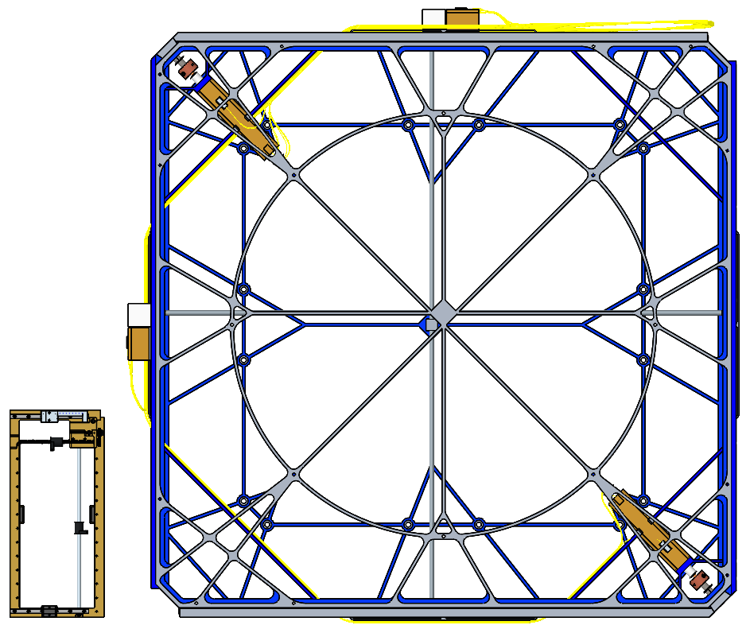
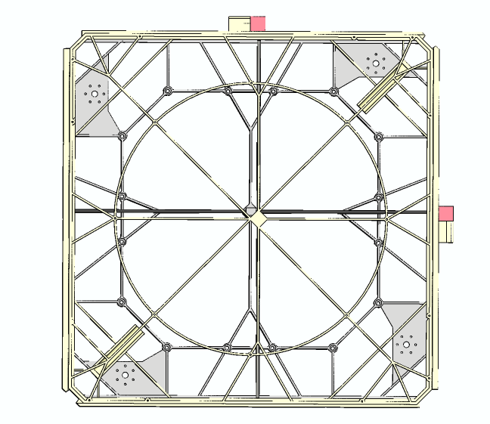
Figure 35. AMT scale comparison – NEAS (left), Solar Cruiser (right).

The following section describes the SOA of the AMT along with the schedule-driven milestones planned for AMT development. It should be noted that while this development demonstrates the feasibility of scaling for next-generation missions, the Solar Cruiser AMT will be directly applicable to near-term solar sail-based space weather and Earth-observing missions.

State-of-the-Art and Technology Advancement Plans
The AMT SOA is based on the unit developed for the NEAS mission (Few, 2016 and Few, 2018). The Solar Cruiser development team was responsible for the design and delivery of the fully-qualified NEAS AMT now awaiting flight (TRL 7 for the NEAS application). Figure 36 (a) shows a detailed computer-aided-design (CAD) model rendering of the NEAS unit and Figure 36 (b) shows the actual NEAS flight unit. In the NEAS design, the translation capability is provided by a simple carriage-and-roller bearing design.

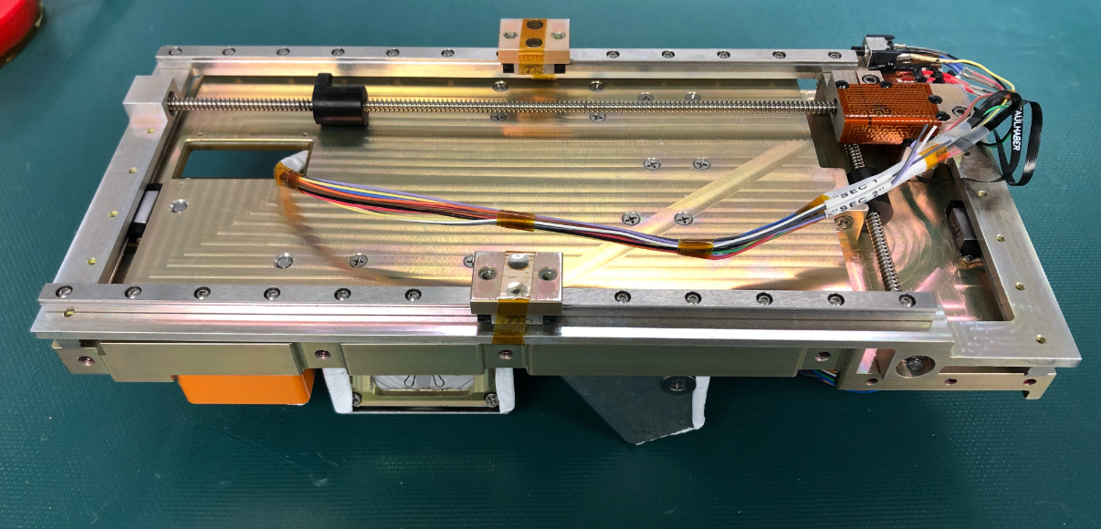
a) NEAS CAD Model Rendering.

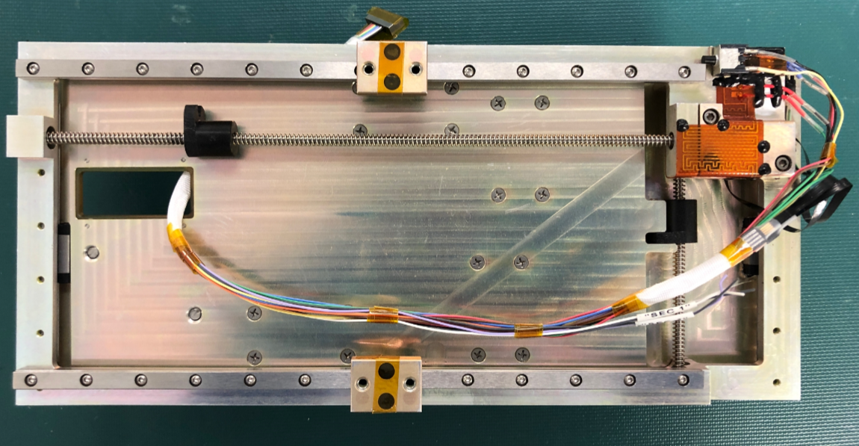
b) NEAS Flight Unit, installed to Y-axis interface plate
Figure 36. NEAS AMT design.

While the carriage-and-roller bearing-based design used in NEAS was an excellent path-finding breadboard (TRL/AD² = 4/2) for the Solar Cruiser team, the very large increase in sail area (1,654 m² versus 86 m²) mandates changes based on lessons learned in that development – Solar Cruiser is more than an AD² = 1 scaling exercise. Table 14 provides an overview of the Solar Cruiser baseline (TRL 4 description as reviewed at the TCR noted above.

Entrance TRL: 4 | Justification
Definition: A low fidelity system/ component breadboard is built and operated to demonstrate basic functionality and critical test environments, and associated performance predictions are defined relative to final operating environment. | NEAS unit (designed in PTC CREO 4.0), delivered for flight after full environmental testing) serves as low-fidelity breadboard – straightforward engineering development.  High-fidelity Thermal Desktop 6.1 modeling indicates thermal issues less-exacting than NEAS  All key parts for this mechanism (e.g. stepper motors, heaters, T-sensors) available as COTS. All structural parts require standard materials and fabrication techniques.
Table 14. AMT State-of-the-Art.

As discussed above, the first non-advocate review placed the TRL at 4. While the NEAS hardware development is considered a low-fidelity breadboard in the development path, it was not considered to be the medium-fidelity brassboard needed for TRL 5. The AD², however, is assessed at 2. This means that the advancement to TRL 5 (and beyond) is considered to be a straightforward engineering effort. In fact, the lessons learned from NEAS played a major role in this assessment. NEAS’s AMT required small stepping motors that were not space-qualified in vacuum and proved to be a major issue. Fortunately, larger, space-qualified stepper motors (shown in Figure 37) are available for the Solar Cruiser AMT (Avior P14-009-0503). Similarly, the size restrictions on NEAS led to thermal and mechanical issues that will not be as restrictive in the much larger Solar Cruiser design.

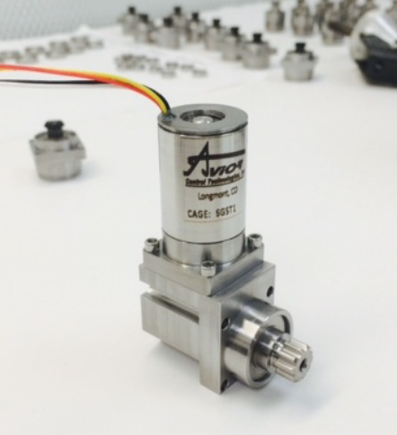
Figure 37. Translation motor technology – COTS Avior Stepper Motor developed for GSFC (P14-009-0503).

To take account of both a key lesson-learned from NEAS and NASTRAN NX model findings to date, all brassboard testing will be performed using a flight-like (prototype-class) wiring harness. This is the major load on the AMT and the use of a prototype harness will identify issues (if any) in early functional testing to be addressed prior to the planned extended environmental testing.

Table 15 shows major milestones, their timing in Phase B, and their significance with respect to the required technology maturation to TRL 5 (in this case beyond TRL 5) prior to PDR. A more detailed schedule taken directly from the Solar Cruiser Integrated Master Schedule (IMS) is shown in Figure 38.
Table 15. Technology maturation milestone description with planned accomplishment timeframe and significance.
TRL 5 Definition: A medium fidelity system/ component brassboard is built and operated to demonstrate overall performance in a simulated operational environment with realistic support elements that demonstrate overall performance in critical areas. Performance predictions are made for subsequent development phases. | Major Milestones to TRL 5 | Timeframe (FY) | Significance
 | Phase B trades complete, high-fidelity AMT brassboard design complete. | Q2/21 | Full NASTRAN NX model sufficient for brassboard development complete. Analysis includes TVAC/vibe characterizations
 | AMT brassboard design non-advocate review | Q2/21 | Peer-review of design prior to major fabrication steps
 | AMT brassboard assembly complete | Q3/21 | Brassboard assembled and ready for functional testing – with flight-like (prototype-class) cable harness.
 | Ambient demonstration of full translation, mechanical interfaces and load bearing structures complete. | Q4/21 | Brassboard completes operational testing (full functionality) with realistic simulated inputs/outputs – brassboard ready for environments testing.
 | Vibe testing complete with post-vibe functional testing | Q4/21 | Vibe environmental requirement met
 | TVAC testing complete with post-TVAC functional testing | Q4/21 | TVAC environmental requirement met
 | Accelerated life testing complete | Q4/21 | Brassboard exercised to demonstrate lifetime motion with margin in short timeframe
 | Final non-advocate review to demonstrate that TRL 4 exit criteria have been met | Q4/21 | AMT technology development complete with more environmental testing than required for TRL 5 – technology ready for protoflight development phase
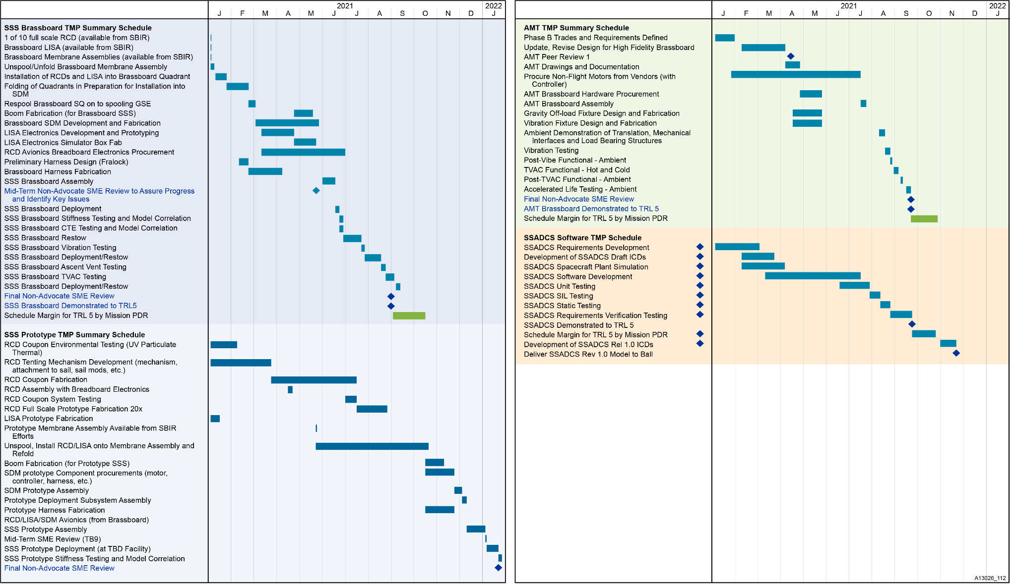
Figure 38. Detailed TMP schedule taken directly from the Solar Cruiser Integrated Master Schedule.
As shown in the table, the first step in the progression is the development of a high-fidelity model to guide design and fabrication efforts. The NASTRAN NX finite element modelling tool was selected and is in use to guide the design. Figure 39 shows a recent product from the modeling effort.

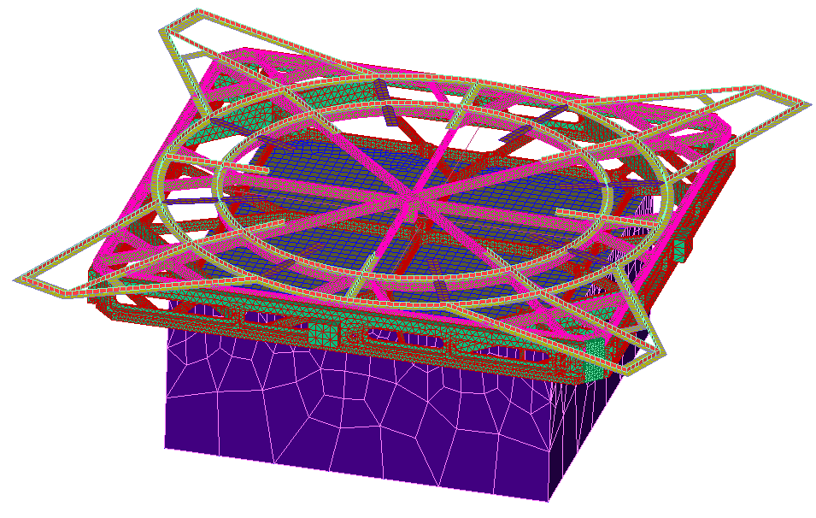
Figure 39. Sample AMT finite element model product.

This model has advanced since the beginning of Phase-A based, in part on a major NEA Scout finding. NEA Scout’s AMT pushed the limits of the carriage-and-roller bearing design employed and it was determined early in Phase-A that the design would not scale to Solar Cruiser requirements. Based on this lesson learned, a dovetail ring-and-groove configuration has been selected. Figure 40 shows a cross-sectional view of the dovetail design along with a representation of the proposed AMT-to-sailcraft bus interface deck. It is noted here that AMT fabrication requires the use of standard, well-proven materials (e.g. 7075-T7351 Al, Teflon pellets), machining processes (Ni-plating), and fastening techniques (e.g. Helicoil inserts).

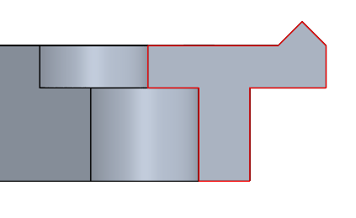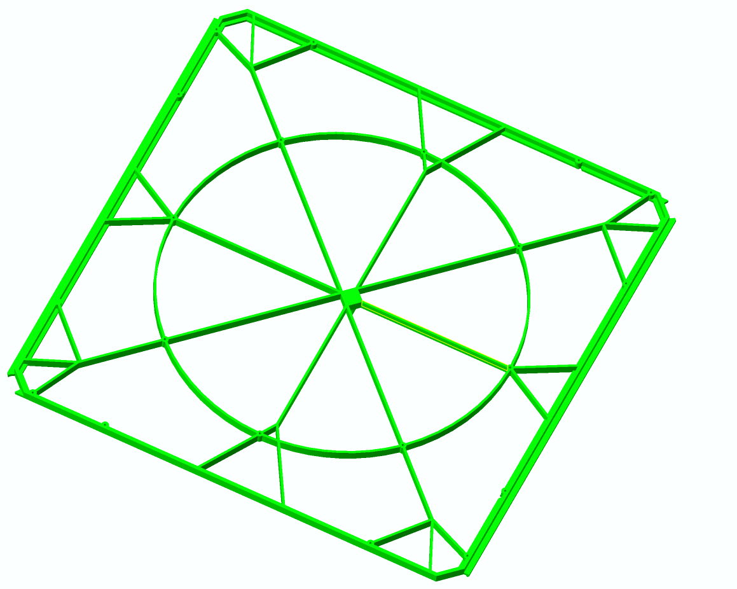
Figure 40. SSS interface with known design, materials and manufacturing processes.

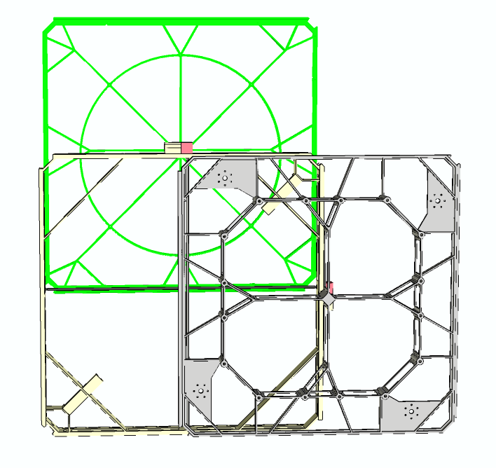
As shown in Figure 38, modeling will be the focus of the AMT design efforts in Q1/21 that will culminate in a peer-reviewed design at the end of that Quarter. These efforts will build on the significant modeling work performed in Phase A that have resulted in the preliminary designs shown in Figure 41 (top view with stages extended to show full travel) and Figure 42 (side view unextended with preliminary cable routing).
± 11.750
± 11.750
Figure 41. AMT top view, travel requirement of 23.5” (59.7 cm) – sized to support launch loads.

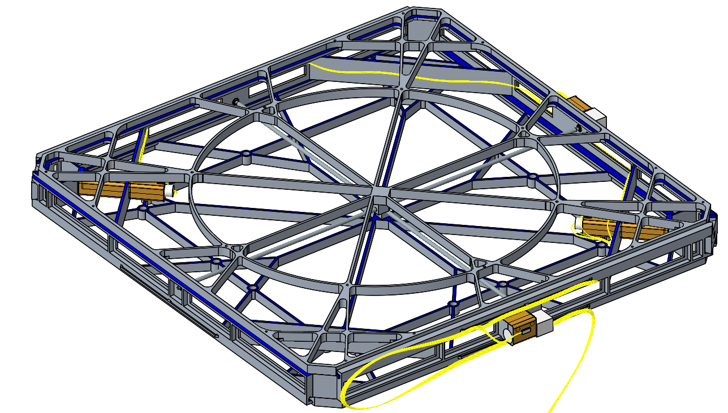
Figure 42. AMT deck with preliminary cabling configuration (in maize).

Further, preliminary designs for thermal control using available technology have been developed as shown in Figure 43. All of these parts will be procured on a schedule (see Figure 38) compatible with the AMT TMP.

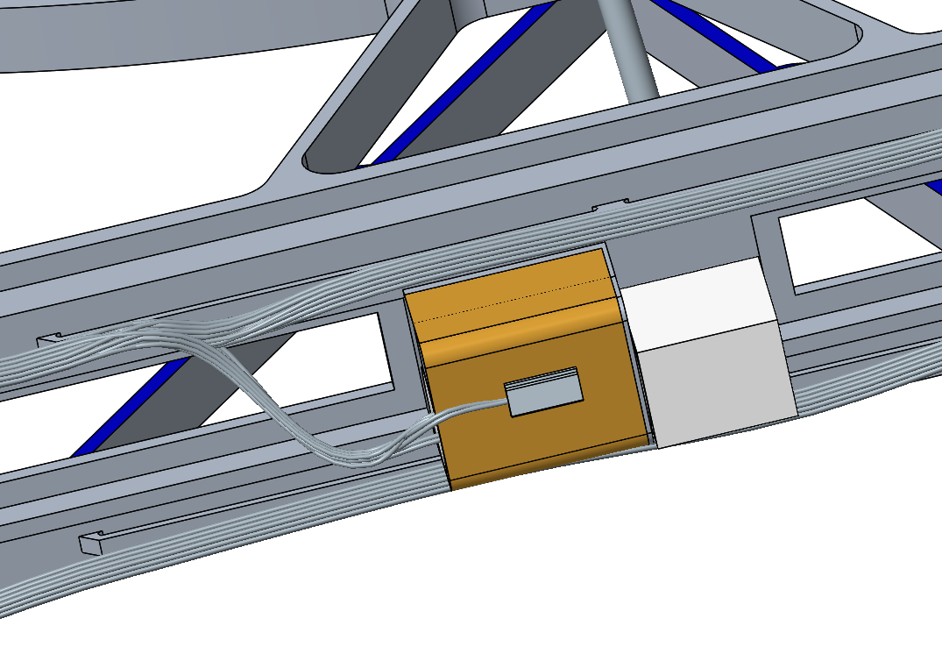
Figure 43. Thermal mitigation using NEA Scout proven, COTS survival heaters and temperature sensors.

The non-advocate review scheduled for the end of Q2/21 will initiate the path to the development of an aluminum brassboard to be fabricated for first functional then full environmental testing. This testing is scheduled for completion prior to the end of Q3/FY21 leaving more than 30 days of funded margin for issue resolution.

As noted above, the brassboard will be subjected to full environmental testing prior to PDR. This goes beyond the standard “simulated operational environments” required for TRL 5. Test requirements will be tailored from the full Solar Cruiser environments suite shown in Table 16.

Table 16. Solar Cruiser environments table.
Thermal Vacuum | SLS-SPEC-159: Space sink temperature assumed to be 3K  From NEA Scout thermal analysis – solar sail membrane -100C to +80C  SIS (Revision 3, 2019.09.03): RPL’s undergo thermal vacuum bakeout per ASTM E2900
Radiation | SLS-SPEC-159: See “Spacecraft Radiated Emissions (RE) Enveloped Case” Figure 5.3
Plasma Environment | SLS-SPEC-159: See “Solar Wind” in Table 3.3.3.4-1 in SLS-SPEC-159  Short, single event geosynchronous charging may occur
Acoustic | SIS (Revision 3, 2019.09.03): 1/3 Octave Band SPL – tested on shake plate from ~25Hz to 10,000Hz
Micrometeoroid | SLS-SPEC-159: Section 3.3.6
Solar Flux | SLS-SPEC-159: 1372 W/m² @ 1 AU (assuming a mean of 1367 +/- 5 W/m²  Using inverse square, recommend using W/m² @ 0.984 AU – which is the closest distance to sun in sub-L1 orbit
Total Ionizing Dose | SLS-SPEC-159: Section 3.3.1.10.2 (Geomagnetically Unshielded)
Random vibration (at ESPA/Solar Cruiser I/F) | SIS (Revision 3, 2019.09.03): Payload interface random vibration tested from 20 Hz to 2000 Hz – PSD (g²/Hz) remained within 0.006 – 0.04
Sine Vibration | SIS (Revision 3, 2019.09.03): Axial and Lateral Sine Vibration tested from 5-100 Hz; axial remained between 0.6 and 0.9 Sine Level (G), while lateral remained between 0.5 and 0.9 G
Shock | SIS (Revision 3, 2019.09.03): SRS (g-peak) was 100 from 100-335Hz and was 720 from 336Hz-10000Hz
Pressure | SLS-SPEC-159, deep space vacuum environments: 5.5 * E⁻¹² psia (2.7 * E⁻¹⁰ Torr)  Depress rate of 0.15psi/sec (9 psi/min) [TBR; per SLS-RQMT-216]
Humidity | SIS (Revision 3, 2019.09.03): 18.1 – 98.8% (TBR) relative humidity during ground operations
EMI/EMC | SLS-SPEC-159  SIS (Revision 3, 2019.09.03) including ref. NASA-STD-8719.24
Cleanliness | SIS (Revision 3, 2019.09.03): level 500A per IEST-STD-CC1246 and adherence to NASA-STD-6016

While the extent of testing will be fully defined in the planned early-Phase B trades (Figure 38—early Q2/21), it will be modeled on the successful NEAS qualification test program that took the NEAS sailcraft to flight readiness (packaged for launch and shipped—TRL 7) shown in Table 17.

Table 17. NEAS qualification test sequence to be modified for Solar Cruiser.
Stepper Motor Acceptance | Subsystem Random Vibe | System Random Vibe | Thermal Bake Out | Subsystem Thermal-Vacuum | Life Cycle Verification
Motor bake-out followed by vacuum testing to determine thermal performance | Workmanship with post-vibe testing to assure build meets specifications | Increased fidelity test including mass simulators for interfacing systems | Removes volatile residuals prior to full TVAC | TVAC including mechanical interface simulators run AFT hot and cold for multiple (7) temperature cycles – thermocouples included for thermal model calibration | Qual AMT run for 4x duty cycle (note: this will be a long test for Solar Cruiser

Once the vibe, TVAC and accelerated endurance testing are completed in late Q3/FY21, a final non-advocate review will be completed to assure both that TRL 4 exit criteria have been met (TRL 5 achieved) and that the environmental testing beyond TRL 5 requirements have reduced the risk to a point (essentially AD² = 1) that proceeding directly to a protoflight development effort is warranted. will once again assess progress before protoflight fabrication and functional/environmental testing is warranted. This will end the technology development phase.

Risks
The Solar Cruiser program has performed an in-depth risk assessment with the support of non-advocate SME’s. The assessment will be revisited on a regular basis as the project progresses. Specific major project milestones have been established for those reviews (shown in Table 4 with the project schedule in Figure 38). The most recent revision was performed after the PI-directed TCR in Q2/20. As noted in the SOA section, the AMT technology advancement efforts is judged to be a relatively low risk (AD² of 2), straightforward engineering effort. Advancement planning has greatly benefitted from the lessons learned in the NEAS AMT development and qualification process. Only two major risks have been identified and these are shown in Table 18. A 5x5 assessment of the SSPE risks are shown in Figure 44.

Table 18. AMT risks and mitigation strategies.
Risk # | Risk Title | Risk Statement | Risk Type | Risk Assessment |  |  | Mitigation Plans
 |  |  |  | L | C | T | Mitigation Plans
AMT-1 | Failure of translation system during design life verification testing | Excess friction caused by materials issue (e.g. thermal deformation) causes seizure or other failure mechanism. | S | 1 | 2 | 2 | - Early non-advocate review to identify issue  - Funded schedule reserve needed for one full prototype iteration
AMT-2 | Cable deformation during accelerated thermal testing | Cable deformation either causes snag resulting in electrical issues or unacceptable stress on YZ translation system | S | 1 | 2 | 2 | - Early non-advocate review to identify issue  - Brassboard testing to be performed with flight-type (prototype-class) cable harness to assure high fidelity loads assessment.  - Funded schedule reserve needed for one full prototype iteration

Risk AMT-1: The Solar Cruiser design team have benefitted from NEAS lessons learned and developed a detailed model of the planned dovetail and groove design. Further, the Solar Cruiser thermal design should be less stressing than those of NEAS and key parts (the stepper motors) are available as a commercial product (not the case with NEAS). Still, the Solar Cruiser design is a significant departure from the NEAS AMT – much larger and with greatly increased travel requirements. The primary concern is the endurance of the design in accelerated endurance testing. No fundamental design flaws are anticipated and the planned environmental testing in which this issue would be identified is beyond that required for TRL 5. If a modification is required prior to initiation of the protoflight development effort, there is sufficient time for this to be completed well before (at least two Quarters before) CDR.

Risk AMT-2: As with the solid framework, extensive modeling and test iterations in the cable routing design will be performed prior to prototype cabling fabrication and testing. In addition to non-advocate review, major risk mitigation steps are built into the AMT maturation approach. First, the pre-PDR testing will involve a brassboard that goes beyond the “medium-quality” level required for TRL 5. This brassboard will be nearly flight-like and will include a flight-like (prototype) cable harness to address key functional load issues in this time frame. Second, the brassboard cable will be subjected to extended environmental testing (beyond that required for TRL 5 prior to PDR.

Likelihood | 5
Likelihood | 4
Likelihood | 3
Likelihood | 2
Likelihood | 1 |  | 1, 2
 |  | 1 | 2 | 3 | 4 | 5
 |  | Consequence
Figure 44. SSPS risk ranking.

Summary
The Active Mass Translator (AMT) is an essential Solar Cruiser sailcraft. It provides the bridge between the sailcraft bus and the solar sail system (SSS). More importantly, it provides the two dimensional translation needed to adjust the sailcraft center-of-mass with its center-of-pressure for pitch and yaw control. This method was developed for similar application for NEAS. The NEAS sailcraft is now packaged and ready to fly (TRL 7). The Solar Cruiser AMT will be significantly larger than the NEAS unit but the basic functionality will be the same. In fact, lessons learned from the NEAS development have driven a change in translation mechanism from the classic carriage-and-roller bearing design to a more elegant dovetail ring-and-groove design. Detailed modeling using NASTRAN NX, Solidworks, Thermal Descktop 6.1 and other design tools will guide development efforts. The development plan involves a number of low-risk steps that take a high-fidelity (near-prototype) unit through extensive functional and environmental testing (beyond the requirement for TRL 5) prior to PDR. While the ATM will require careful development, the starting TRL is 4 only because this type of unit has never been developed for a space-based application like Solar Cruiser before. It is considered to be a straightforward engineering effort that simply requires consideration of all of the requirements (e.g. harsh environmental testing and endurance) that make space applications unique. It is noted that the Solar Cruiser design eases the thermal issues that were problematic in NEAS and that high TRL stepper motors (and other key components) are available for the planned AMT – this was not the case for NEAS. It is also noted that the Solar Cruiser PI has instituted a non-advocate review plan the will employ subject matter experts to evaluate progress and provide feedback to the PI in a timely manner should issues arise.

SOLAR CRUISER Solar Sail Attitude Determination and Control Software (SSADCS Software) System Technology Maturation Plan Introduction
Solar sails have been under development for ultra-high delta-V missions for decades (McInnes, 1999 and Vulpetti, 2015). In fact, they are called out as a key technology in the major strategic documents guiding science and technology directions for NASA’s Science Mission Directorate (SMD – NASA, 2014 and NRC, 2013). NASA’s Science and Technology Directorate (STMD) is currently sponsoring a next-generation (86 m²) solar sail demonstration in the Near-Earth Asteroid Scout mission (NEAS) (Johnson, 2014 and Russell-Lockett, 2020). The planned Solar Cruiser solar sail demonstration now under Phase-A development for SMD will go well beyond NEAS with a sail area of over 1,600 m² to demonstrate the efficacy of sails for near-term space weather and Earth-observing platforms and farther-term (5 to 15 year timeframe heliophysics missions. The Solar Cruiser sailcraft makes up Work Breakdown Structure (WBS) Element 6.0. As shown in Figure 45, the sailcraft element is divided into the Sailcraft Bus (SB) and the Solar Sail Propulsion Element (SSPE).

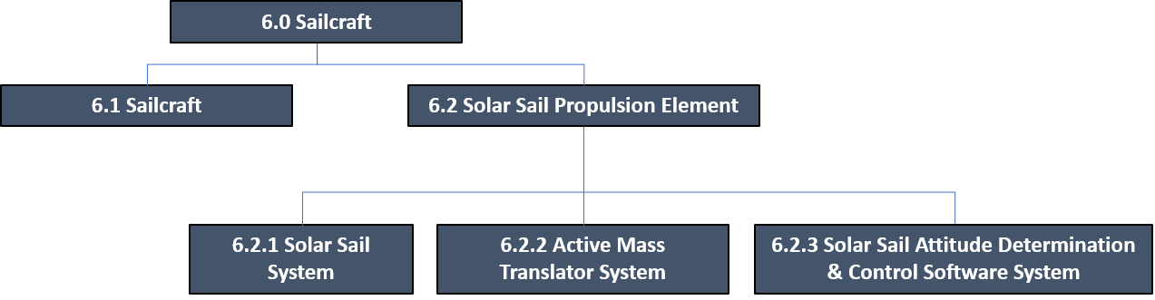
Figure 45. Solar Cruiser work breakdown structure element 6.0 (sailcraft).

The latter is composed of the three sub-elements (systems): the Solar Sail System (SSS) (WBS 6.2.1), the Active Mass Translator (AMT) System (WBS 6.2.2), and the Solar Sail Attitude Determination and Control Software System (SSADCS software) (WBS 6.2.3) software. Each element contains the technologies that need to be advanced in the Phase B effort. The Solar Cruiser Principal Investigator (PI) has directed the development of Technology Maturation Plans (TMP) for each of these elements. This SSADCS software Technology Maturation Plan (TMP) was developed using the Technology Assessment Process (TAP) provided in the SALMON library, which is taken from the NASA Systems Engineering Handbook (SP-2016-6105-Rev2). The TAP requires a baseline technology maturity assessment for Technology Readiness Level (TRL) followed by an assessment of Advancement Degree of Difficulty (AD²) prior to finalization of the TMP. The SSADCS software is one of Solar Cruiser’s seven Critical Technology Elements (CTEs) included in the SSPE. These are shown in Table 19 and the SSADCS software will be advanced to TRL 5 via comprehensive development and software-in-the-loop (SIL) testing prior to Preliminary Design Review (PDR).

Table 19. SSPE Critical Technology Elements (CTE).
CTE | Description | TRL/AD² | Advancement Descriptions
1 | Sail Deployment Mechanism (SDM) | 4/3 | Slight modification and scaling from Flexible, Unfurlable, Refurlable (FURL) (and other classified Roccor design) SDM heritage to fabricate full-scale brassboard for integration with four ¼-scale brassboard TRAC™ (Triangular Rollable and Collapsible) booms (TBs), one 1/16th -scale sail quadrant (SQ) and three SQ simulators for system-level testing to TRL-5 prior to PDR. Full-scale SDM integrated with two prototype TBs and one full-scale Prototype SQ for full deployment test prior to Critical Design Review (CDR).
2 | High-Strain Composite (HSC) TB | 4/3 | Fabrication of four ¼-scale brassboard TB’s based on Roccor CORSAIR (and other) High-Strain Composite, Triangular, Rollable, Collapsible TRAC™ boom heritage for integration with full-scale brassboard SDM, one 1/16th-scale SQ and three quadrant simulators for TRL 5 demo prior to PDR. Fabrication of one full-scale prototype TB prior to PDR. Two full-scale prototype TBs fabricated and integrated with full-scale SQ prototype, and full-scale prototype SDM for full deployment test prior to CDR.
3 | Membrane Assembly (MA) | 4/3 | Fabrication of 1/16th-scale SQ brassboard (CP1 fabric-S4, NanoSail-D, and NEAS heritage) with integrated Reflection Control Devices (RCD) and Laser Interferometer Space Antenna (LISA) panels) for testing with three SQ simulators, full-scale SDM, ¼-scale TB in four quadrant system to TRL 5 prior to PDR. Full-scale CP1 MA quadrant fabrication and automated folding process demo prior to PDR. Full-scale prototype (>20 MA increase over NEAS) SQ fabrication, integration with full-scale prototype SDM and two full-scale prototype TB’s for full deployment test prior to CDR.
4 | Reflection Control Devices (RCD) | 4/5 | Fabrication and testing of 1/10th-scale coupons for performance and environmental testing to component level 5 prior to PDR. Fabrication of ½ -scale brassboard for integration into 1/16th-scale brassboard SQ for system-level testing to TRL 5 prior to PDR. Fabrication and integration of 10 full-scale prototype panels for integration into full-scale SQ for full-scale single SQ deployment (two prototype TB, full-scale prototype SDM) prior to CDR)
5 | Lightweight Integrated Solar Array (LISA) | 5/2 | Analysis to show component level TRL 6 from existing test data prior to PDR, Integration of one prototype LISA panel into 1/16th-scale SQ fabrication for system level testing to TRL 5 prior to PDR. Full-scale (3 panel) into full-scale SQ for full-scale single SQ deployment (two prototype TB, full-scale prototype SDM) prior to CDR.
6 | Active Mass Translator (AMT) | 4/2 | Scaling with lessons learned from NEAS hardware to full-scale brassboard demo including environmental testing beyond system level TRL 5 prior to PDR, protoflight development after PDR
7 | Solar Sail Attitude Determination & Control Software System (SSADCS software) | 4/3 | Adaptation of NEAS software to larger sail control (Marshall Space Flight Center (MSFC)), full Software-in-the Loop testing to achieve TRL 5 prior PDR and ICD to turn over to Ball.

Prior to the Critical Design Review (CDR), the system will be advanced beyond TRL 5 (past the realm of technology development) via “proto-flight-class” hardware-in-the loop (HIL) testing. The advancement plans revolve around a milestone-driven schedule, developed by the Solar Cruiser PI, which includes non-advocate reviews to assess progress and plans at key development points. The first of these, a Technical Concept Review (TCR) was held February 25–26, 2020. The following sections provide an overview of the SSADCS software, a description of the State-of-the-Art (SOA), the specific development roadmaps for pre-PDR development efforts, and a description of risks and risk mitigation plans.

Overview
The SSADCS software controls the sailcraft attitude in flight and operates in both autonomous and/or direct commanding mode. In the autonomous mode, the software takes inputs from the sailcraft sensor suite, which includes two star trackers, four coarse sun sensors, and an Inertial Measurement Unit (IMU), and outputs commands to a set of actuators as required to maintain sailcraft pointing control and manage momentum within predetermined limits. These actuators are the Reaction Wheels (RW), the Active Mass Translator (AMT), the Reflectivity Control Devices (RCD), and the small electric thrusters on the sailcraft (back up only in the post-solar sail deployment configuration). The SSADCS software controls the sailcraft using the RWs as the main attitude control actuator and commands the RWs as required for holding a pointing attitude or for slew maneuvers to a new attitude. The SSADCS software will autonomously monitor the RWs speeds, or momentum, to avoid RW saturation. If the RW’s speeds exceed pre-determined thresholds, the SSADCS software will autonomously command the AMT, the RCDs, or Indium Field-Effect Electric Microthruster (IFMs; backup only) to produce counter disturbance torques to reduce the accumulated reaction wheel momentum. The AMT is translated in plane to produce a pitch and/or yaw counter disturbance torque in a closed loop feedback system. Similarly, the SSADCS software commands selected RCDs to produce counter-disturbance roll torques. While the RWs are the main sailcraft attitude control actuator, the SSADCS software will be commanded to switch from RW control to the use of RCDs, or IFMs (backup), as the main roll actuator to impart a spinning maneuver on the sailcraft during roll demonstration mission phases.

In the SSADCS software direct commanding mode, commands are uplinked from the ground to the sailcraft and executed by the SSADCS software. This direct commanding mode is used to instruct a new sailcraft attitude. New sail attitudes are commanded in order to change the sail thrust vector which allows to perform minor trajectory corrections maneuvers, needed to keep the sailcraft on course. Trajectory corrections are conducted using the improving-knowledge from the Sail Thrust Model (STM). Other direct commanding SSADCS software functions include instructing new sailcraft attitudes to perform specific sail characterizations, such as changing the sail sun incidence angles, as well as using the RCDs to induce roll torques. A brief overview of the typical Ground/Mission Operations cycle is shown in Figure 46. The resources and tools used to process this data and provide commands to the SSADCS software are shown in Table 20. The cycle starts with the downlink of raw data from the sailcraft sensors, as well as data on position and velocity from the Deep Space Network (DSN), to resources in the Huntsville Operations Support Center (HOSC).

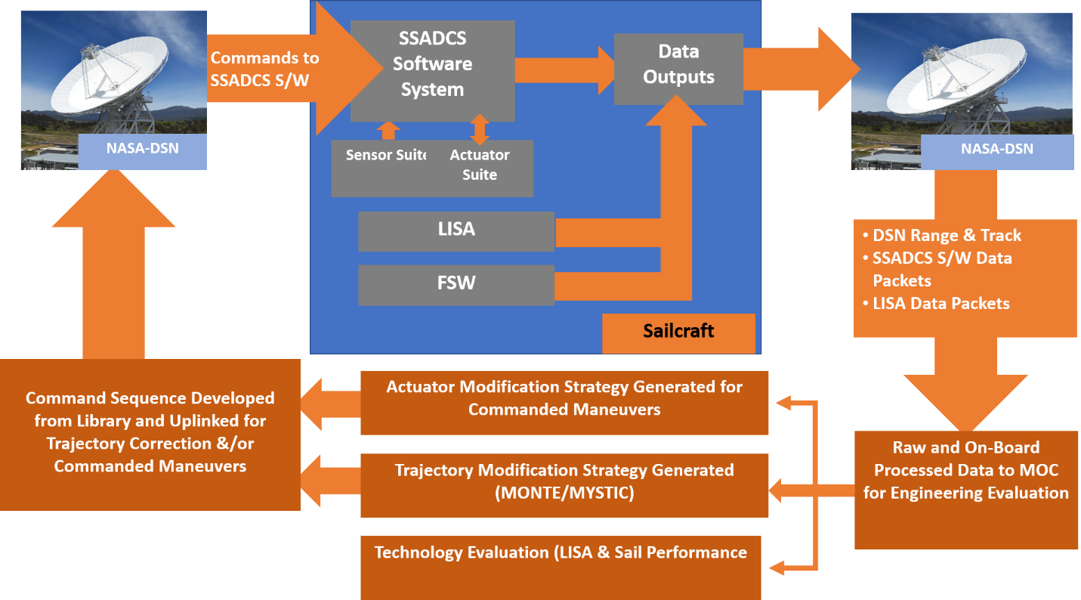

Figure 46. Sail pointing cycle for both autonomous and discrete pointing control.

This data is then analyzed, and commands are generated for uplink as needed for sailcraft operation. The sailcraft is mainly in autonomous mode, as discussed above, with momentum management performed completely on the sailcraft by the SSADCS software. The following steps provide an overview of the process and role of the SSADCS software in the discreet “trajectory adjustment” mode:

- Sailcraft position is acquired from the DSN and input to the Mission Analysis, Operations, Navigation Toolkit Environment (MONTE)
- Sensor data is input to the Sail Thrust Model (STM) and sail characteristic estimations are developed and input to MONTE
- MONTE compares actual versus projected trajectory and provides mission design outputs to the MYSTIC (a state-of-the-art low thrust trajectory tool)
- MYSTIC develops a new preliminary Thrust Vector File (TVF), including new pointing/timing information, and outputs this to the Tele-science Resource Toolkit (TReK)
- The preliminary TVF is evaluated (in TReK) against known constraints (e.g., thermal limits, flight rules, physical sail limitations) and iterated until a final TVF is determined
- The final TVF and instrument files are converted into a sequence of time-tagged commands and uploaded for verification and transmittal to the sailcraft
- Uplinked commands are executed by the SSADCS software and executed.

The direct commanding mode is used for exercising/evaluating sailcraft capabilities (e.g., slewing, RCD-initiated roll control, inclination change), ground personnel select the appropriate commands from the command library. These commands are uploaded to, and executed by, the SSADCS software.

Table 20. Solar Cruiser Tools and Resources.
Mission Operations Element/Tool |  | Definition/Capability
HOSC Infrastructure |  | - Connectivity required for all aspects of mission operations, including ground communications, Solar Cruiser uplink/downlink, etc.  - Data storage with physical and network security  - Web portal for user access and 24/7 customer service desk
Sail Thrust Model (STM) |  | - Models sail characteristics based on sensor inputs  - Used to provide inputs to trajectory modeling (MONTE) software
Mission analysis, Operations, Navigation Toolkit Environment (MONTE) |  | - Mission design tool takes Solar Cruiser tracking data and STM inputs and provides inputs to MYSTIC software for trajectory calculations
MYSTIC Software |  | - Low-thrust trajectory modeling tool takes inputs from MONTE to generate and verify new thrust vector formulations (TVF) used to select new sailcraft pointing commands
Tele-science Resource Kit (TReK) |  | - Framework to build, validate, and deliver command files for uplink to Solar Cruiser

The software development and testing will heavily leverage similar TRL advancement for the NEAS sailcraft (see Section 3.0). While the NEAS sailcraft is significantly smaller than Solar Cruiser, the SSADCS software functionality is identical (i.e., the SSADCS software must control sailcraft thrust pointing in order to perform ground commanded trajectory corrections to keep the sailcraft on course and manage torque disturbances while conducting autonomous control of yaw, pitch, and roll). The differences lie in the sensor and actuator suites employed by the two sailcraft, as discussed below.

State of the Art (SOA)
The software development and testing will heavily leverage similar TRL advancements from the NEAS sailcraft (Orphee, 2018; Stilner, 2017; Heaton, 2017; Orphee, 2017). Just like Solar Cruiser, NEAS’ SSADCS software actuates the sailcraft RWs for attitude control. RW status is monitored, and actuators are used to desaturate the RWs in response to disturbance torques. While the NEAS sailcraft is significantly smaller than Solar Cruiser, it employs similar sensors and actuator types, with exception the RCDs and IFM thrusters (back up). The Solar Cruiser SSADCS software will also receive and execute uplink commands for discrete sailcraft actions. Table 21 shows the Solar Cruiser SOA that was reviewed independently at the PI-directed TCR discussed above.

Definition: A low fidelity system/component breadboard is built and operated to demonstrate basic functionality and critical test environments, and associated performance predictions are defined relative to final operating environment. | - Solar Cruiser SSADCS software has been developed. This is based on the NEAS system (delivered for flight) with estimated ~80% reusability. Based on TCR discussions, this breadboard is beyond the “low-fidelity” state required for TRL 4, but TRL 4 (rather than medium-fidelity TRL 5 brassboard status) was kept for conservatism.  - Software development platform (the MSFC Control Software Development Tool (MCSDT) for full software-in-the-loop testing in place) was first developed for, and successfully employed for, Fast, Affordable, Science and Technology Satellite (FASTSAT) and upgraded successfully for NEAS. Upgrades for Solar Cruiser are already in place.  - Known coding and validation processes are in place. Coding is done with the “MathWorks Simulink & Model Advisor” development platform, which enforces DO178 standards. The software is auto-coded into C language and provided as an executable C function, exactly as in NEAS.
Table 21. Solar Cruiser SSADCS Software State-of-the-Art.

The two significant differences between Solar Cruiser and NEAS are related to sail size and the sailcraft hardware suite of sensors and actuators:
- The much larger Solar Cruiser SSPE size increases the magnitude of the disturbance torques due to solar sail ripples, thermal deformation, uneven tensioning, different sail wrinkle patterns, and the very low natural frequency modes inherent to large flexible structures. These are modeled using the same sail torque model as NEAS, scaled to Solar Cruiser size sail, to provide a basis for estimating actuator sizing requirements. While nothing the size of Solar Cruiser has flown in space and full ground testing is not practicable/possible, the MSFC SSADCS software team has developed bounding models based on existing ground and space data with recent upgrades from both NEAS lessons learned and findings from Interplanetary Kitecraft Accelerated by Radiation of the Sun (IKAROS) flight data (Yamaguchi, 2009). The model was developed at MSFC and has been exercised to estimate worst case disturbances (pitch, yaw, and roll) for sizing of the AMT and the RCDs.
- There are differences in the sensor and actuator suite hardware employed by the two sailcraft. As noted above, both Solar Cruiser and NEAS SSADCS software activate RWs for attitude control while using the AMT to counter-act pitch and yaw disturbance torques. Both sailcraft use RWs for the majority of attitude control (pointing) functions. Solar Cruiser will use larger RWs but have essentially identical inputs and outputs (Reaction Wheel Spec). NEAS uses a cold gas reaction control system (RCS) for roll momentum management; however, Solar Cruiser will use RCD technology for this. While cold gas thrusters and RCDs are different physically, the software control signals are functionally the same: ON/OFF for the thruster valve and ON/OFF for the RCD voltage. The AMT for Solar Cruiser is much larger than the NEAS’ AMT, but the control algorithm is identical—both are YZ translators that use well-characterized, commercial-off-the-shelf (COTS) stepper motors and linear actuators. Thus, the software implementation is functionally identical. The Solar Cruiser sailcraft sun sensors will have the same functionality and nearly identical inputs and outputs as those used on NEAS. This will be the same for the star tracker, with the exception, however, that Solar Cruiser will use two rather than one to achieve the better pointing knowledge required by the Solar Cruiser sailcraft.

As with NEAS, software development will be performed at MSFC using the MSFC Control Software Development Tool (MCSDT). The MCSDT was first established for the successful MSFC Fast, Affordable, Science and Technology Satellite (FASTSAT) mission (Boudreaux, 2013) and upgraded extensively for the development of the NEAS SSADCS software. All SSADCS software development is done within the “MathWorks Simulink & Model Advisor” development platform, which enforces DO178 standards. The software is auto-coded into C language and provided as an executable C function. The NEAS SSADCS software was developed and verified using the MCSDT. The simulator incorporates the SSACDS software and exercises it using simulated inputs and outputs for the sensor and actuator suites, respectively. The sensors are all COTS equipment and are modeled based on known specifications. The AMT and RCD technologies have been characterized and implemented in the MCSDT modeling. The output from SSADCS software development is auto-coded in and provided as an executable product (C code) that is input to the sailcraft control system. This is identical to the NEAS process. On NEAS, the executable code was sent to Jet Propulsion Laboratory (JPL) (the sailcraft bus integrator) for validation in their HIL simulator prior to incorporation into the sailcraft system. The NEAS sailcraft with the SSADCS software has been fully tested and delivered for Space Launch System (SLS) Engineering Model (EM)-1 launch for full flight implementation. Solar Cruiser SSADCS software development will follow an essentially identical path. The MCSDT is being upgraded for the Solar Cruiser requirements and, as noted above, is used in “beta-testing” mode to support RCD and AMT sizing efforts to date. From these preliminary development efforts, it is estimated that approximately 80% of the NEAS MCSDT SIL system will be directly applicable. As with NEAS, the executable code developed in the MCSDT will be sent to the sailcraft integrator (Ball Aerospace (Ball) rather than JPL in this case) to be tested in the Ball HIL system.

Internal Project review placed the SSADCS software at TRL 4, and the independent panel concurred with this assessment with the caveat that the current state is beyond the “low-fidelity” breadboard state. Strong arguments were made for “medium-fidelity” brassboard/TRL 5 status. TRL 4 was maintained for conservatism and because the effort to achieve TRL 5 will essentially result in a protoflight system to be turned over to the sailcraft integrator for HIL testing approximately one month prior to PDR. All concurred this was straightforward engineering and that internal assessment of AD² = 2 was accurate.

Detailed Technology Roadmap
Since the SSADCS software development effort is judged to be straightforward engineering (AD² = 2), the software development will be performed at MSFC by personnel with direct experience from the very recent NEAS SSADCS software development program. The modifications of the MCSDT tool from the NEAS program are known and in process. These are:
- Adaptation of a second star tracker sensor model and corresponding attitude filter update in the SSADCS software
- Modification of the control logic for autonomous and discrete RCD commanding in place of the NEAS cold-gas reaction control system
- Modification of the control bounds to account for the larger YZ translation of the Solar Cruiser AMT
- Modifications of the control bounds to account for the higher flexibility of the much larger sail
- Modification to adapt for the Blue Canyon Technologies (BCT) (rather than JPL) bus hardware.

This is the same development platform used for NEAS. The simulator incorporates the SSACDS software and exercises it using simulated inputs and outputs for the sensor and actuator suites, respectively. Based on lessons learned on both the FASTSAT and NEAS in which strict version control was found to be essential. The software development process will include established version releases. The software testing flow required to establish TRL 5 prior to PDR at MSFC (identical to NEAS) is shown in the first two blocks in Figure 47. The output from this SSADCS software development is auto-coded in and provided as an executable products (C code) for HIL testing at Ball. At this point, the technology development effort is complete.

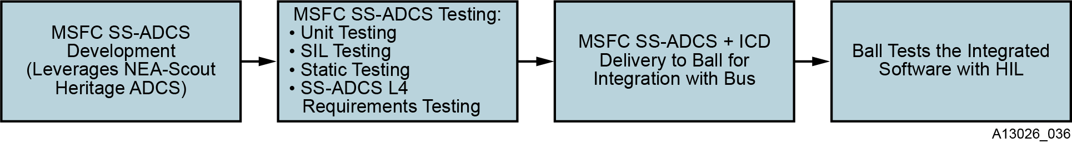
Figure 47. Solar Cruiser SSADCS software development flow.

This flow includes the following three major test phases:
- Software Unit Testing: Each software sub-function is tested to ensure the code is producing the intended output. Unit testing will include “code-coverage” testing.
- Software-in-the-loop testing (SIL): These tests are executed using a dynamic sailcraft simulation running closed loop with the flight software on a standalone system (no flight hardware).
- Static testing: Static testing of the compiled auto-coded C language enforcing software compliance with MISRA C®, MISRA C++, JSF++, CERT® C, CERT® C++, standards, and enforces other “user-defined/custom” rules.

By PDR, MSFC will deliver executable C-code, a parameter file, and corresponding interface content to Ball. A full software Interface Control Document (ICD) will be delivered to Ball for integration with the bus Flight Software (FSW) at PDR.

Table 22 shows the major technology maturation milestones and their significance with respect to risk reduction for the flight program. Figure 48 provides a more detailed schedule taken from the Solar Cruiser Integrated Master Schedule.

Table 22. Technology maturation milestone description with planned accomplishment timeframe and significance.
TRL 5 Definition: A medium fidelity system/component brassboard is built and operated to demonstrate overall performance in a simulated, operational environment with realistic support elements that demonstrate overall performance in critical areas. Performance predictions are made for subsequent development phases. | Major Milestones to TRL 5 | Timeframe | Significance
 | Final definition of SSADCS software requirements complete | Q2/21 | Required inputs on sail characteristics updated with most recent analysis from SSS technology advancement efforts
 | Draft ICD complete | Q3/21 | ICD available for software development, initiation of version control
 | Mid-term non-advocate review | Q3/21 | Coordinated with SSS and AMT mid-term reviews, peer review to assure readiness to proceed
 | Software unit testing complete | Q3/21 | Subfunctions and full code-coverage demonstrated
 | Software-in-loop testing complete | Q4/21 | Flight-like software run in closed-loop dynamic simulation or standalone system (TRL 5 requirement)
 | Static and verification testing complete | Q4/21 | Executable C code compiled, verified, and ready for delivery to Ball for HIL testing
 | Final non-advocate review to demonstrate that TRL 4 exit criteria have been met | Q4/21 | Peer review for TRL 5 achievement and readiness for delivery for sailcraft integration

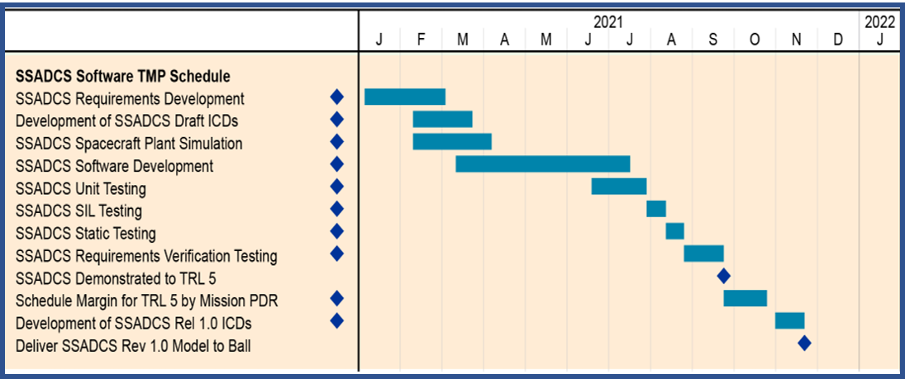
Figure 48. SSADCS software technology maturation schedule.

Risks
As noted above, the SSADCS software development effort is expected to be a straightforward, low-risk engineering development effort. The only known risk is associated with acquiring valid inputs for the sail characteristics that affect momentum management. The unprecedented size of the sail introduces unknowns in, for example, flex modes that impact sail code file parameters. This risk is shown in Table 23 and presented in standard 5x5 format in Figure 49.

Table 23. SSADCS software risks and mitigation strategies.
Risk # | Risk Title | Risk Statement | Risk Type | Risk Assessment |  |  | Mitigation Plans
 |  |  |  | L | C | T | Mitigation Plans
SSADCS-1 | Insufficient sail model inputs | Sail model inputs fail to adequately characterize sail behavior (e.g., low frequency flex modes) leading to inability to develop required code command capability for in-flight sail control. | T | 2 | 2 | 4 | - Early non-advocate review to identify issue  - Updates on sail characteristics from SSS technology maturation hardware testing and analysis in Q3 to assure best known inputs.  - High margins (>2x) used in all impacted control algorithm development.  - Ability to update SSADCS software in flight if issue unexpected sail behavior observed in characterization phase.  - Funded schedule reserve

Risk SSPS-1: Building commands to control the Solar Cruiser sailcraft depends on the availability of inputs that adequately model the sail and actuator characteristics that are important to momentum control (sail surface ripple, low frequency flex modes, RDC performance, etc.). The unprecedented size of the planned sail and the new technologies required for implementation make exact characterizations impossible and are the reason a Technology Demonstration Mission is required. The risk exists that one or more of the estimations made for SSADCS software development will be inadequate and unacceptable control performance will be experienced in flight. Fortunately, sail flight is relatively forgiving in that there are no high-thrust events and the mission is standard. To make up for the uncertainty in knowledge that will only be gained through flight, the Solar Cruiser PI has mandated several risk mitigation strategies. First, a factor of at least 2 has been built into all actuator requirements. For example, the STM as upgraded to the extent possible for the Solar Cruiser sail was exercised to provide inputs for RCD surface requirement determination. Further, key final-code decisions (e.g., coefficients for flex-body smoothing filters) will be made after the SSS technology developments have progressed to 2Q/21. Finally, worst case analyses will be run through the TRL 5 development efforts, and code variations will be evaluated and input to the TReK library for rapid application, if unexpected behavior is seen in the sail characterization phase of the mission.
Likelihood | 5
Likelihood | 4
Likelihood | 3
Likelihood | 2 |  | 1
Likelihood | 1
 |  | 1 | 2 | 3 | 4 | 5
 |  | Consequence
Figure 49. SSPS risk ranking.

Summary
The SSADCS software controls the sailcraft attitude in flight and operates in both autonomous and/or direct commanding mode. In autonomous flight, the SSADCS software takes inputs from the sailcraft sensor suite and adjusts the sailcraft actuators to maintain stable flight within preset limits. In direct commanding mode, the SSADCS software accepts and executes uploaded commands to adjust actuators to modify the trajectory (to maintain course) or implement commands for specific maneuvers (e.g., slewing, roll demonstration, inclination change). Solar Cruiser SSADCS software development heavily leverages the recently delivered NEAS scout system. They are functionally similar with changes required to account for larger sail size and differences in sensors and actuators. The basic framework is the same and the technology advancement effort to progress from the current TRL 4 to TRL 5 by PDR has been reviewed and determined to be a straightforward, low-risk engineering development with an AD² of 2. In fact, this development effort is expected to yield executable code that is fully tested in the software-in-the-loop environment. At this point, the software will be turned over to the sailcraft integrator (Ball) for full hardware-in-the-loop testing at the protoflight level. In keeping with the overall program philosophy, the Solar Cruiser PI has instituted a non-advocate review plan that will employ subject matter experts to evaluate progress and provide feedback to the PI in a timely manner, should issues arise.

Appendices

Acronyms
AD² Advancement Degree of Difficulty
AFM Atomic Force Microscope
AMT Active Mass Translator
APRA Astrophysics Research and Analysis
BOX Buried Oxide
CAT-XGS Critical-Angle Transmission X-ray Grating Spectrometer
CDR Critical Design Review
CMM Coordinate Measuring Machine
DDT&E Design, Development, Test, and Evaluation
DRIE Deep Reactive-Ion Etching
DRM Design Reference Mission
FWHM Full Width at Half Maximum
GAS Grating Array Structure
GOES Geostationary Operational Environmental Satellite
GPR Goddard Procedural Requirements
HDXI High Definition X-ray Imager
HETGS High-Energy Transmission Grating Spectrometer
HPD Half-Power Diameter
IFM Indium Field-Effect Electric Microthruster
ISIM Integrated Science Instrument Module
KDP Key Decision Point
L1 Level 1
L2 Level 2
MCR Mission Concept Review
MEMS Micro Electro Mechanical Systems
MIT Massachusetts Institute of Technology
MKI MIT Kavli Institute for Astrophysics and Space Research
NEA Near-Earth Asteroid
NPR NASA Procedural Requirement
OP-XGS Off-Plane Reflection Gratings
PCOS Physics of the Cosmos
PDR Preliminary Design Review
PPBE Programming, Planning, Budgeting, and Execution
RCWA Rigorous Coupled-Wave Analysis
SAT Strategic Astrophysics Technology
SDO Solar Dynamics Observatory
SEM Scanning Electron Micrograph
SLTF Stray Light Test Facility
SNL Space Nanotechnology Laboratory
SOA State-of-the-Art
SOHO Solar and Heliospheric Observatory
SOI Silicon-On-Insulator
SOTA State of the Art
TRL Technology Readiness Level
TWINS Two Wide-Angle Imaging Neutral-Atom Spectrometers
WFIRST Wide Field Infrared Survey Telescope
XGA X-ray Gratings Array
XGS X-Ray Grating Spectrometer
XMA X-ray Mirror Assembly

Figure List
Figure 1. Solar Cruiser work breakdown structure element 6.0 (sailcraft). 4
Figure 2. Solar Cruiser SSS advancement in the context of solar sail evolution from large ground-based technology demonstration to space flight. 5
Figure 3. Solar Cruiser SSS critical technology elements. 7
Figure 4. Preliminary mechanical drawing of SSS integrated into the sailcraft. 9
Figure 5. Top-down view of Solar Cruiser SSS conceptual design, stowed. 11
Figure 6. Stowed (top left) and deployed FURL (SDM center) sail with key features. 11
Figure 7. Right: Redacted proprietary exploded view of FURL (left). Right: Heritage boom spooling mechanism designed, fabricated, qualified by Roccor and currently on-orbit. 12
Figure 8. Illustration of TRAC boom geometry, as well as a comparison of Inertia for the Double Omega and HSC TRAC™ Boom cross-sectional geometries. 14
Figure 9. Left: AFRL Elgiloy TRAC™ boom technology translated to 3 m and 6 m High Strain Composite TRAC™ booms delivered to GSFC as part of Roccor’s Phase A support for the comet sample return mission (CORSAIR) study. 14
Figure 10. Demonstrated long boom fabrication capability at Roccor. 15
Figure 11. FURL sail-boom interface and STARTR attachment tab technology to be used for Solar Cruiser. 16
Figure 12. Deployable thin-film development heritage. 18
Figure 13. 400-m² four-quadrant sail deployment in NASA’s Plum Brook Stations Space Power facility under the Les Johnson-directed ISTP (2004). 18
Figure 14. NanoSail-D2 extended in NeXolve facility. 19
Figure 15. NEAS sail extended in NeXolve facility. 19
Figure 16. Prototype JWST Sunshield Membrane Assembly in a Northrop-Grumman facility. 20
Figure 17. Solar Cruiser sail quadrant dimensions. 20
Figure 18. NeXolve facility in Huntsville, AL: a) configured for production and b) configured for testing and shown with monolithic NEAS sail deployed. 21
Figure 19. Sail quadrant packaging process. 22
Figure 20. Manual sail packaging and deployment example. 22
Figure 21. Notional semi-automated sail folding process. 23
Figure 22. Notional sail folding process. 23
Figure 23. Packaged NEAS sail—flight unit. 24
Figure 24. Schematic of a polymer dispersed liquid crystal (PDLC) device. Upon application of an applied bias, the device switches from (a) opaque to (b) transparent. 25
Figure 25. Scanning electron microscope image of the PDLC (voids show location of liquid crystal droplets). 26
Figure 26. RCD optical transmissivity data from recent development at UMD (Munday, 2017). 26
Figure 27. Laboratory-class tent mechanism demonstration (left) and composite frame planned RCD element design (right). 27
Figure 28. LISA sample coupons: CP1embedded, CORIN® XLS encapsulated CIGS. 28
Figure 29. MSFC space environmental test facility (open prior to LIAS testing)—facility to be used for RCD Phase B environmental demonstrations. 29
Figure 30. Solar Cruiser component and system technology maturation flow. 31
Figure 31. SSS technology development roadmap to TRL pre-PDR. 31
Figure 32. SSS technology development roadmap between PDR and CDR. 33
Figure 33. SSS risk ranking. 37
Figure 34. Active Mass Translator in Solar Cruiser WBS hierarchy. 38
Figure 35. AMT scale comparison – NEAS (left), Solar Cruiser (right). 40
Figure 36. NEAS AMT design. 41
Figure 37. Translation motor technology – COTS Avior Stepper Motor developed for GSFC (P14-009-0503). 42
Figure 38. Detailed TMP schedule taken directly from the Solar Cruiser Integrated Master Schedule. 43
Figure 39. Sample AMT finite element model product. 44
Figure 40. SSS interface with known design, materials and manufacturing processes. 44
Figure 41. AMT top view, travel requirement of 23.5” (59.7 cm) – sized to support launch loads. 45
Figure 42. AMT deck with preliminary cabling configuration (in maize). 45
Figure 43. Thermal mitigation using NEA Scout proven, COTS survival heaters and temperature sensors. 46
Figure 44. SSPS risk ranking. 48
Figure 45. Solar Cruiser work breakdown structure element 6.0 (sailcraft). 50
Figure 46. Sail pointing cycle for both autonomous and discrete pointing control. 53
Figure 47. Solar Cruiser SSADCS software development flow. 57
Figure 48. SSADCS software technology maturation schedule. 58
Figure 49. SSPS risk ranking. 59
Figure 50. Risk matrix standard scale. 72

Table List
Table 1. Solar Cruiser Level 1 requirements. 6
Table 2. Solar Cruiser SSS CTE overview. 10
Table 3. CTE 1: SDM state-of-the-art assessment. 10
Table 4. CTE 2: TB state-of-the-art assessment. 13
Table 5. CTE 3: MA state-of-the-art assessment. 17
Table 6. CTE 4: RCD state-of-the-art assessment. 25
Table 7. CTE 4: LISA state-of-the-art assessment. 28
Table 8. Technology maturation milestone description with planned accomplishment timeframe and significance. 32
Table 9. Solar Cruiser environments table. 33
Table 10. Technology maturation milestone description with planned accomplishment timeframe and significance. 34
Table 11. SSS risks and mitigation strategies. 35
Table 12. Solar Cruiser driving requirements. 39
Table 13. Solar Cruiser critical technology elements with AMT highlighted. 40
Table 14. AMT State-of-the-Art. 42
Table 15. Technology maturation milestone description with planned accomplishment timeframe and significance. 43
Table 16. Solar Cruiser environments table. 46
Table 17. NEAS qualification test sequence to be modified for Solar Cruiser. 47
Table 18. AMT risks and mitigation strategies. 47
Table 19. SSPE Critical Technology Elements (CTE). 51
Table 20. Solar Cruiser Tools and Resources. 54
Table 21. Solar Cruiser SSADCS Software State-of-the-Art. 55
Table 22. Technology maturation milestone description with planned accomplishment timeframe and significance. 58
Table 23. SSADCS software risks and mitigation strategies. 59
Table 24. NASA TRL Definitions. 69
Table 25. Advancement Degree of Difficulty Level Definitions. 71

References
Alhorn, D., et al. "Nanosail-D: The small satellite that could!" 25th Annual AIAA/USU Conference on Small Satellites 2011 (8-11 August), Logan, UT. https://digitalcommons.usu.edu/smallsat/2011/all2011/37/
Avior Control Technology, Inc., “Product Description Document,” Prepared for: NASA Goddard Space Flight Center, 2016
Back, J, Schuettplez, B, Ewing, A., Laue, G.; “James Webb Space Telescope Sunshield Membrane Assembly”; 50th AIAA/ASME/ASCE/AHS/ASC Structures, Structural Dynamics, and Materials Conference; 04 May 2009 - 07 May 2009; https://doi.org/10.2514/6.2009-2156
Banik, J. and Ardelean, E., “Verification of a Retractable Solar Sail in a Thermal-Vacuum Environment”, 51st AIAA/ASME/ASCE/AHS/ASC Structures, Structural Dynamics, and Materials Conference 2010 (12-15 April), Orlando, FL. https://arc.aiaa.org/doi/pdf/10.2514/6.2010-2585
Banik, Jeremy, Murphy, Thomas; “Performance Validation of the Triangular Rollable and Collapsible Mast”; SSC10-II-I; 24th Annual AIAA/USU Conference on Small Satellites, Aug 9-12, 2010. https://digitalcommons.usu.edu/smallsat/2010/all2010/10/
Boudreaux, Mark, Steve Pearson, and Joseph Casas. "The Fast, Affordable, Science and Technology Satellite (FASTSAT) Mission." (2013). https://digitalcommons.usu.edu/smallsat/2013/all2013/117/
Carr, J., “Thin film solar arrays for small spacecraft,” NASA/Marshall Space Flight Center, September 2018, https://ntrs.nasa.gov/archive/nasa/casi.ntrs.nasa.gov/20190001046.pdf
Denig, W., Redmon, R., and Mulligan, P., “NOAA Operational Space Environmental Monitoring - Current Capabilities and Future Directions,” EGU General Assembly 2014 (27 April - 2 May), Vienna, Austria, id.4525 https://ui.adsabs.harvard.edu/abs/2014EGUGA.. 16.4525D/abstract]
Edwards, D; Semmel,C; Hovater, M; Nehls, M; Gray, P; Hubbs, W; and Wertz, G; "Solar sail material performance property response to space environmental effects", Proc. SPIE 5554, Photonics for Space Environments IX, (18 October 2004); https://doi.org/10.1117/12.562809
Few, A., “Development of a High Performance, Low Profile Translation Table with Wire Feedthrough for a Deep Space CubeSat”,2016 https://ntrs.nasa.gov/search.jsp?R=20160007003
Few, A., et al., “Testing and Development of the NEA Scout Solar Sail Deployer Mechanism”; 44th AMS Aerospace Mechanisms Symposium 2018 (May 16-18), Cleveland, OH. https://ntrs.nasa.gov/search.jsp?R=20180005158
Garrett, H. and Minow, J; “Charged Particle Effects on Solar Sails Final Report”, ISPT-SS-06-101; March 2007
Heaton, A., “Near Earth Asteroid Scout Solar Sail Thrust and Torque Model”, The Fourth International Symposium on Solar Sailing, 17055, ISSS, Kyoto, Japan, 2017. http://www.jsforum.or.jp/ISSS2017/papers/paper/17055_Paper_Mr.%20Andrew%20Heaton.pdf
Ishida, H., et al., “Optimal Design of Advanced Reflectivity Control Device for Solar Sails Considering Polarization Properties of Liquid Crystal”, 4th International Symposium on Solar Sailing (ISSS) 2017 (17-20 January); Kyoto, Japan, https://issfd.org/ISSFD_2017/paper/ISTS-2017-d-061__ISSFD-2017-061.pdf
Johnson, L., Castillo-Rogez, J., Dervan, J., and McNutt, L. “Near Earth Asteroid Scout,” AIAA Space 2014 Conference and Exposition (4-7 August, 2014), San Diego, CA https://arc.aiaa.org/doi/pdf/10.2514/6.2014-4435
Johnson L, Carr J, Boyd D. “Lightweight Integrated Solar Array and anTenna (LISA-T)”, 2017. https://ntrs.nasa.gov/archive/nasa/casi.ntrs.nasa.gov/20170009482.pdf
Johnson, L., et al. 2020
Kobayashi, K., et al. 2020
Ma, D., Murray, J., and Munday, J., “Controllable propulsion by light: steering a solar sail via tunable radiation pressure,” Advanced Optical Materials 2017, Vol. 5, no. 4, 1600668. https://onlinelibrary.wiley.com/doi/abs/10.1002/adom.201600668
McInnes,C. “Solar sail mission applications for non-Keplerian orbits,” Acta Astronautica Volume 45, Issues 4–9, August–November 1999, pp. 567-575. https://www.sciencedirect.com/science/article/pii/S0094576599001770
MISSE:https://nexolvemy.sharepoint.com/personal/brandon_farmer_nexolve_com/Documents/Microsoft%20Teams%20Chat%20Files/5eecdeacdf3bfb2c7a13f8f401c17802131e.pdf
MISSE 1: https://www.nasa.gov/centers/langley/news/factsheets/MISSE.html
Munday, J., “Propellantless Attitude Control of Solar Sail Technology Utilizing Reflective Control Devices,” Grant NNX15AW53A; 09/2015 – 09/2017 https://ntrs.nasa.gov/search.jsp?R=20160007912
National Aeronautics and Space Administration, “Our Dynamic Space Environment: Heliophysics Science and Technology Roadmap for 2014–2033,” https://smd-prod.s3.amazonaws.com/ science-red/s3fs-public/atoms/files/2014_HelioRoadmap_Final_Reduced_0.pdf
National Research Council, “Solar and Space Physics: A Science for a Technological Society,” Washington, DC: The National Academies Press, 2013. https://doi.org/10.17226/13060
NeXolve Holding Company, “Low Cure Polyimides: CP1 Polyimide,” at http://www.nexolvematerials.com/low-cure-polyimides/cp1-polyimide.
NeXolve Holding Company; “Packaging and Manufacturing Processes to Enable Production of Very Large Solar Sails for Next Generation Missions – SBIR Phase II Proposal”; Z10.02-6573, 2018
Orphee, J., “Solar Sail Attitude Control System for the NASA Near Earth Asteroid Scout Mission”, The Fourth International Symposium on Solar Sailing, 17091, ISSS, Kyoto, Japan, 2017. https://ntrs.nasa.gov/search.jsp?R=20170001501
Orphee, J., “Solar Torque Management for the Near Earth Asteroid Scout CubeSat Using Center of Mass Position Control”, AIAA SciTech Forum, (AIAA 2018-1326) https://arc.aiaa.org/doi/pdf/10.2514/6.2018-1326
Reaction Wheel Specs: https://storage.googleapis.com/blue-canyon-tech-news/1/2020/04/BCT_Datasheet_ReactionWheels.pdf
Ridenoure, R., et al. "LightSail Program Status: One Down, One to Go." Proceedings of the 29th Annual AIAA/USU Conference on Small Satellites 2015 (8-13 August), Logan, UT. https://digitalcommons.usu.edu/smallsat/2015/all2015/32/
Roccor, LLC; “Sail Trimming Actuator for Targeted Reentry (STARTR) – Phase I Final Report”; TR19‐1002; Contract Number 80NSSC19C0513; XXXX
Russell-Lockett, T., et al., "Near-Earth Asteroid Scout Flight Mission," IEEE Aerospace and Electronic Systems Magazine, Vol. 35, No. 3, March 2020, pp. 20-29; https://ieeexplore.ieee.org/abstract/document/9076194/
Stiltner, B., "Cold Gas Reaction Control System for the Near Earth Asteroid Scout CubeSat", AIAA SPACE and Astronautics Forum and Exposition, AIAA SPACE Forum, (AIAA 2017-5185) https://arc.aiaa.org/doi/pdf/10.2514/6.2017-5185
TSUDA, Yuichi, et al. "Challenges and Results on Attitude Control Operation of World’s First Solar Power Sail IKAROS." The Journal of Space Technology and Science 27.1 (2013): 1_69-1_78. https://www.jstage.jst.go.jp/article/jsts/27/1/27_1_69/_article/-char/ja/
Vulpetti, G., Johnson, L., & Matloff, G., “Solar Sails: A Novel Approach to Interplanetary Travel.” NewYork: Springer, 2015. https://books.google.com/books?hl=en&lr=&id=jaExBQAAQBAJ&oi=fnd&pg=PR5&dq=Solar+Sails:+A+Novel+Approach+to+Interplanetary+Travel&ots=0RKXI0iFKz&sig=HCCO7UrT0viTs0l9pjN-UFUX538
Yamaguchi, T., Mimasu, Y., Tsuda, Y., Funase, R., Sawada, H., Mori, O., ... & Yoshikawa, M. (2009). Trajectory Analysis of Solar Sail Spacecraft Considering the Large Uncertainty of Solar Radiation Pressure. ISSFD21, 2009. https://www.researchgate.net/profile/Yuichi_Tsuda/publication/253058678_TRAJECTORY_ANALYSIS_OF_SOLAR_SAIL_SPACECRAFT_CONSIDERING_THE_LARGE_UNCERTAINTY_OF_SOLAR_RADIATION_PRESSURE/links/560bd37608ae6de32e9b0131.pdf
Young, R., Montgomery, E., and Adams, C. “TRL assessment of solar sail technology development following the 20-meter system ground demonstrator hardware testing.” In 48th AIAA/ASME/ASCE/AHS/ASC Structures, Structural Dynamics, and Materials Conference 2007 (23-26 April), Honolulu, Hawaii, p. 2248; https://arc.aiaa.org/doi/pdf/10.2514/6.2007-2248

NASA TRL Definitions
TRL definitions per NASA Procedural Requirement (NPR) 7123.1B, Appendix E are reproduced in their entirety in Table 24.

Table 24. NASA TRL Definitions.
TRL | Definition | Hardware Description | Software Description | Exit Criteria
1 | Basic principles observed and reported | Scientific knowledge generated underpinning hardware technology concepts/applications. | Scientific knowledge generated underpinning hardware technology concepts/applications. | Peer reviewed publication of research underlying the proposed concept/application.
2 | Technology concept and/or application formulated | Invention begins, practical applications is identified but is speculative, no experimental proof or detailed analysis is available to support the conjecture. | Practical application is identified but is speculative; no experimental proof or detailed analysis is available to support the conjecture. Basic properties of algorithms, representations, and concepts defined. Basic principles coded. Experiments performed with synthetic data. | Documented description of the application/concept that addresses feasibility and benefit.
3 | Analytical and experimental critical function and/or characteristic proof-of- concept | Analytical studies place the technology in an appropriate context and laboratory demonstrations, modeling and simulation validate analytical prediction | Development of limited functionality to validate critical properties and predictions using non-integrated software components. | Documented analytical/experimental results validating predictions of key parameters.
4 | Component and/or breadboard validation in laboratory environment | A low-fidelity system/component breadboard is built and operated to demonstrate basic functionality and critical test environments, and associated performance predictions are defined relative to final operating environment. | Key, functionality critical software components are integrated and functionally validated to establish interoperability and begin architecture development. Relevant environments defined and performance in the environment predicted. | Documented test performance demonstrating agreement with analytical predictions. Documented definition of relevant environment
5 | Component and/or breadboard validation in relevant environment. | A medium-fidelity system/component brassboard is built and operated to demonstrate overall performance in a simulated operational environment with realistic support elements that demonstrate overall performance in critical areas. Performance predictions are made for subsequent development phases | End-to-end software elements implemented and interfaced with existing systems/simulations conforming to target environment. End-to-end software system tested in relevant environment, meeting predicted performance. Operational environment performance predicted. Prototype implementations developed. | Documented test performance demonstrating agreement with analytical predictions. Documented definition of scaling requirements
6 | System/sub-system model or prototype demonstration in a relevant environment. | A high-fidelity system/component prototype that adequately addresses all critical scaling issues is built and operated in a relevant environment to demonstrate operations under critical environmental conditions. | Prototype implementations of the software demonstrated on full-scale, realistic problems. Partially integrated with existing hardware/software systems. Limited documentation available. Engineering feasibility fully demonstrated. | Documented test performance demonstrating agreement with analytical predictions
7 | System prototype demonstration in an operational environment. | A high-fidelity engineering unit that adequately addresses all critical scaling issues is built and operated in a relevant environment to demonstrate performance in the actual operational environment and platform (ground, airborne, or space). | Prototype software exists having all key functionality available for demonstration and test. Well integrated with operational hardware/software systems demonstrating operational feasibility. Most software bugs removed. Limited documentation available. | Documented test performance demonstrating agreement with analytical predictions
8 | Actual system completed and "flight qualified" through test and demonstration | The final product in its final configuration is successfully demonstrated through test and analysis for its intended operational environment and platform (ground, airborne, or space) | All software has been thoroughly debugged and fully integrated with all operational hardware and software systems. All user documentation, training documentation, and maintenance documentation completed. All functionality successfully demonstrated in simulated operational scenarios. Verification and Validation (V&V) completed. | Documented test performance verifying analytical predictions.
9 | Actual system flight proven through successful mission operations. | The final product is successfully operated in an actual mission. | All software has been thoroughly debugged and fully integrated with all operational hardware and software systems. All documentation has been completed. Sustaining software support is in place. System has been successfully operated in the operational environment | Documented mission operational results.

AD² Definitions
AD² (Advancement Degree of Difficulty) is a description of what is required to move a system, subsystem, or component from one TRL to the next. TRL is a static description of the current state of the technology as a whole. AD² is what it takes, in terms of cost, schedule, and risk to advance to the next TRL. AD² is defined on a scale of 1–9 in a manner similar to TRL. The description of the AD² levels is shown in Table 25.

Table 25. Advancement Degree of Difficulty Level Definitions.
AD² | Definition | Risk | Category | Success Chance
1 | Exists with no or only minor modifications being required. A single development approach is adequate. | 0% |  | Guaranteed Success
2 | Exists but requires major modifications. A single development approach is adequate. | 10%
3 | Requires new development well within the experience base. A single development approach is adequate. | 20%
4 | Requires new development but similarity to existing experience is sufficient to warrant comparison across the board. A single development approach can be taken with a high degree of confidence for success. | 30% | Well Understood (Variation) | Almost Certain Success
5 | Requires new development but similarity to existing experience is sufficient to warrant comparison in all critical areas. Dual development approaches should be pursued to provide a high degree of confidence for success. | 40% | Known Unknowns | Probably Will Succeed
6 | Requires new development but similarity to existing experience is sufficient to warrant comparison on only a subset of critical areas. Dual development approaches should be pursued in order to achieve a moderate degree of confidence for success. Desired performance can be achieved in subsequent block upgrades with high confidence. | 50%
7 | Requires new development but similarity to existing experience is sufficient to warrant comparison in only a subset of critical areas. Multiple development routes must be pursued. | 70%
8 | Requires new development where similarity to existing experience base can be defined only in the broadest sense. Multiple development routes must be prepared. | 80% | Unknown Unknowns | High Likelihood of Failure (High Reward)
9 | Requires new development outside of any existing experience base. No viable approaches exist that can be pursued with any degree of confidence. Basic research in key areas needed before feasible approaches can be defined. | 100% | Chaos | Almost Certain Failure (Very High Reward)

Risk Definitions
The standard risk scale for consequence and likelihood are taken from Goddard Procedural Requirements (GPR) 7120.4D, Risk Management Reporting. The definitions for Likelihood and Consequence categories are provided in Figure 50.

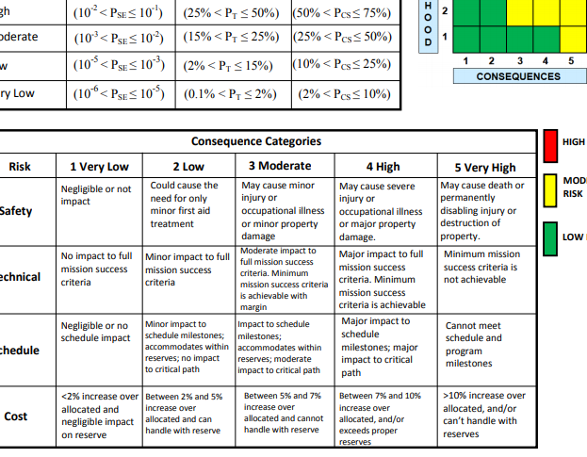
Figure 50. Risk matrix standard scale.

