- Appendix A Safety and Operational Suitability Analysis using an Electro-optical/infrared sensor
  - Introduction
This appendix describes a Modeling and Simulation study to support the development of minimum performance requirements for an electro-optical/infrared (EO/IR) sensor based on safety and operational suitability metrics. This study specifically assesses the sensitivity of these metrics to sensor measurement errors and detection range.
  - EO/IR sensor Model Description and Characteristics
The EO/IR sensor model used in this analysis was based on a white paper published by Safran Electronics & Defense [1]. All references to an EO/IR sensor in this appendix refer to the minimum performance EO/IR sensor model described in the white paper. Although the EO/IR sensor model was developed by Safran, the model is intended to be generic. The key characteristics of the EO/IR sensor model as stated in the Safran white paper are described in this section.
The EO/IR sensor model emulates errors of bearing, elevation, bearing rate, elevation rate, range, and range-rate measurements or estimates from the ownship to the intruder. An EO/IR sensor cannot natively detect range and range-rate, so the sensor must perform additional processing to extract that information.
    - Bearing and elevation error model
The bearing and elevation errors are modeled as Gaussian white noise. The standard deviation of the bearing and elevation errors is:
$$σ=1 mrad$$
The bearing and elevation errors are not time correlated.
    - Bearing and elevation rate error
The bearing and elevation rate errors are modeled by Gauss Markov noise [2]. The standard deviation of the bearing and elevation rate errors is:
$$σ=1.4 mrad/s$$
The time correlation is dependent on the sensor sampling frequency. It is defined as approximately 10 samples in the Safran white paper. In the simulation, the EO/IR sensor model was executed at 10 Hz, so the resulting time correlation was 1 second.
    - Range error model
The range estimation accuracy is dependent on the intruder type and the true range. For a Cessna type aircraft, the range error is the following:
$$ε\left(R\right)=μ\left(R\right)+CRE\left(R,t\right)$$
$$μ\left(R\right)=50-0.15∙MAX\left(0;R-3000\right)$$
$$σ\left(R\right)=0.03∙R$$
where $ε$ is the total range error, $μ$ is the range bias error, $σ$ is the range error standard deviation, and $R$ is the true range. $CRE\left(R,t\right)$ is colored random error as a function of range R and timestep t:
$$CRE\left(R,t\right)=σ(R)∙randn\left(1\right)\sqrt{1-{(e}^{-\frac{dt}{τ}}){(e}^{-\frac{dt}{τ}}) }+CRE\left(t-dt\right)e^{-\frac{dt}{τ}}$$
The function $randn(1)$ returns a number drawn from a standard normal distribution. The correlation time (τ) for range error is 5 seconds and $dt$ is 0.1 seconds. The initial value of the colored random error is:
$$CRE\left(R,0\right)=σ\left(R\right)∙randn\left(1\right).$$
Figure A-1 shows plots of the range bias, random range error, and total range error from one execution of the model.
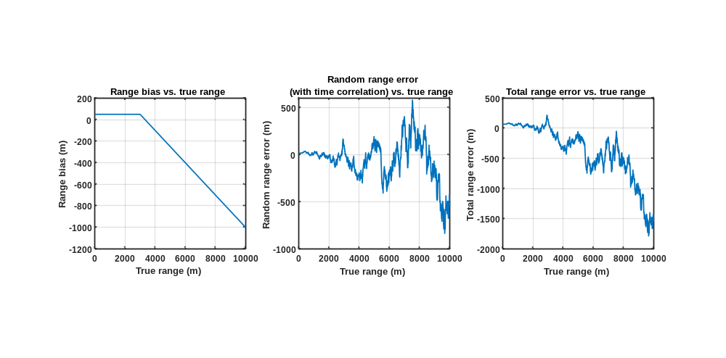
Figure A-1 Range estimation error plots
    - Range-rate error model
The range-rate error is modeled by Gauss Markov noise [2]. The standard deviation of the range-rate error is:
$$σ\left(RR\right)=0.05∙RR$$
Where $RR$ is the true range-rate. The EO/IR sensor needs 5 seconds since the time of first detection to start outputting a valid range-rate. The time correlation for the range-rate is 2 seconds.
    - Detection range
The baseline detection range is set to 2.5 NMi, a candidate range requirement for the low-speed UAS operations considered.
  - Encounter Model
To evaluate the performance of the EO/IR sensor model, one million uncorrelated encounters between one UAS with low-size, weight, and power (SWaP) sensors and one noncooperative intruder were simulated. Uncorrelated encounters are situations where intervention from Air Traffic Control (ATC) is unlikely, such that aircraft blunder into close proximity. The Unmanned Aircraft System (UAS) trajectory was sampled from NASA’s Airspace Concept Evaluation System UAS database [3], and the intruder trajectory was sampled from MIT Lincoln Laboratory’s Uncorrelated Encounter Model [4].
NASA’s UAS mission flights consist of different mission types, including aerial imaging and mapping, law enforcement, and air quality monitoring. The low SWaP encounter set includes two types of UAS: the RQ-7 AAI Shadow B and the MQ-19 AAI Aerosonde. The models used for these aircraft are similar to those in the Eurocontrol Base of Aircraft Data [5]. The trajectories cover the entire continental US.
The Uncorrelated Encounter Model is derived from radar data of observed aircraft operations under visual flight rules in the National Airspace System. The model is sampled to produce random aircraft trajectories that are statistically representative of noncooperative trajectories. Each encounter is specified by the initial positions and orientations of the two aircraft in the simulation and the nominal dynamic maneuvers that may occur leading up to the time of closest approach.
Filters were applied to the ownship and intruder speeds and altitudes such that the dynamics of the sampled trajectories are within the bounds for low SWaP UAS, and the intruders they are expected to encounter. The low SWaP UAS speeds are constrained to be between 40 and 110 kts, and the intruder speeds range from 0 to 170 kts—the 95 percentile speed for non-cooperative intruders in the Uncorrelated Encounter Model. The encounters occur at altitudes between 500 ft above ground level and 11,000 ft mean sea level (MSL), in airspace classes E and G. Although Class E only goes up to 10,000 ft MSL when it is adjacent to class B or class C airspace, altitudes up to 10,999 feet were included to represent low SWAP UAS missions that are flown slightly above 10,000 ft. The resulting altitude and speed distributions are shown in Figure A-2.
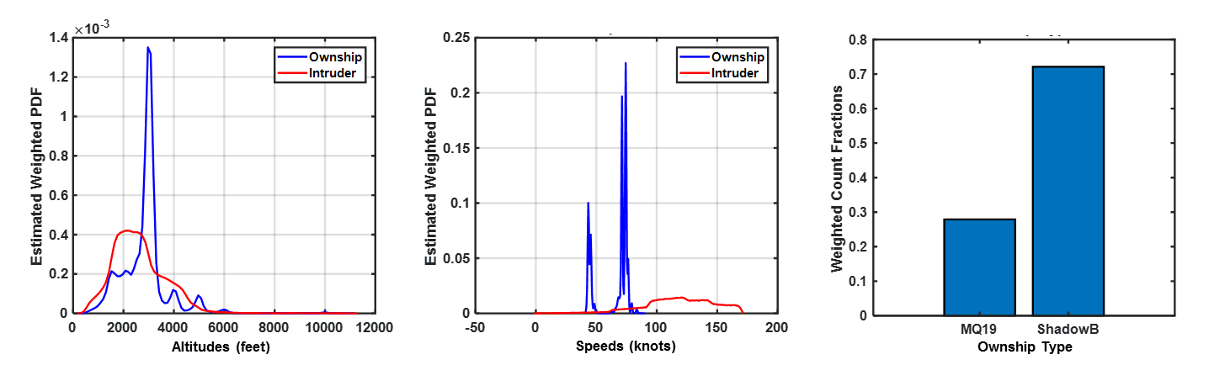
Figure A-2 Encounter Characteristics
a) Altitudes b) Speeds c) Ownship Type

  - Analysis Setup
This analysis was setup so that the effect of varying the EO/IR parameters on safety and operational suitability metrics could be isolated. This was done by taking the baseline EO/IR sensor model configuration and sweeping its parameters to be less than and greater than their baseline values. In the end-to-end simulation, the ownship was equipped with an EO/IR sensor with the modified parameters. EO/IR sensor measurements of the intruder were input to DAIDALUS, a Detect-And-Avoid (DAA) algorithm developed by NASA [6]. The simulated ownship uses DAIDALUS output to perform maneuvers to remain well clear from the intruder. The simulation was first run with no avoidance maneuvers performed by the ownship to get baseline values for the metrics; this is referred to as the nominal run. After that, the end-to-end simulation was run one million times per sensor configuration so that the aggregate metrics could be collected and analyzed.
Initially, the five parameters that were swept were range bias, angular (bearing and elevation) rate error, detection range, range error, and range-rate error. Table A-1 shows the different configurations that were analyzed. Configuration 1 is the default configuration as all of the parameters are equal to their baseline values. Configuration 2 turns the range bias off. The range bias was disabled for every subsequent run because the effect of the range bias on the metrics was minimal. Configurations 3-6 swept through the angular rate error, configurations 7-11 swept through the detection range, configurations 12-16 swept through the range error, configurations 17-21 swept through the range-rate error, and configurations 22-24 swept through the range and range-rate errors together.
Table A-1 Analysis Configurations
Configuration | Range bias | Angular rate error (% of $σ$) | Detection Range (NMi) | Range error (% of $σ$) | Range-rate error (% of $σ$)
1 | On | 100% | 2.5 | 100% | 100%
2 | Off | 100% | 2.5 | 100% | 100%
3 | Off | 50% | 2.5 | 100% | 100%
4 | Off | 75% | 2.5 | 100% | 100%
5 | Off | 125% | 2.5 | 100% | 100%
6 | Off | 150% | 2.5 | 100% | 100%
7 | Off | 100% | 1 | 100% | 100%
8 | Off | 100% | 1.5 | 100% | 100%
9 | Off | 100% | 2 | 100% | 100%
10 | Off | 100% | 3 | 100% | 100%
11 | Off | 100% | 4 | 100% | 100%
12 | Off | 100% | 2.5 | 50% | 100%
13 | Off | 100% | 2.5 | 75% | 100%
14 | Off | 100% | 2.5 | 125% | 100%
15 | Off | 100% | 2.5 | 150% | 100%
16 | Off | 100% | 2.5 | 400% | 100%
17 | Off | 100% | 2.5 | 100% | 50%
18 | Off | 100% | 2.5 | 100% | 75%
19 | Off | 100% | 2.5 | 100% | 125%
20 | Off | 100% | 2.5 | 100% | 150%
21 | Off | 100% | 2.5 | 100% | 400%
22 | Off | 100% | 2.5 | 400% | 400%
23 | Off | 100% | 2.5 | 800% | 800%
24 | Off | 100% | 2.5 | 1200% | 1200%

After the initial parameter sweep, additional configurations were evaluated to contextualize the results. These configurations were:
- No error: no measurement error or detection range limits on the EO/IR sensor
- Varying range and range-rate error together: the range and range-rate error were both increased together to 400%, 800% and 1200% of their baseline values
- 4000 ft. vertical: the vertical alerting threshold of DAIDALUS was set to 4000 ft. (similar to the DO-365 MOPS recommendation for encounters with noncooperative aircraft)
  - Simulation Setup
The end-to-end simulation consisted of an ownship aircraft and an intruder aircraft. The ownship aircraft was equipped with DAIDALUS version 1.0.1, the SC-228 Pilot Model [7], and the EO/IR sensor model. The EO/IR sensor model output was assumed to model the EO/IR sensor tracker output, so was input directly into DAIDALUS. The intruder was not equipped with a DAA system, a Collision Avoidance System, a transponder, or ADS-B.
The DAIDALUS algorithm used by the ownship was configured to:
- Have a horizontally buffered conflict volume based on the non-cooperative well-clear definition (2200 ft horizontal, 450 ft vertical, 0 s modTau)
- Provide horizontal RWC guidance (banding) based on the ownship being able to turn at 7 deg/s
- Not issue preventive alerts
- Have the alert output be passed through a 4-second hysteresis filter and a 2-of-4 M-of-N filter
The SC-228 Pilot Model used by the ownship was configured to:
- Operate in deterministic mode—i.e. always turn in the direction of the minimum horizontal maneuver
- Issue only horizontal maneuvers
- Issue guidance at 7 deg/s
- Add a 15-degree buffer on minimum suggestive horizontal guidance
- Have a 5 second initial delay, 11 second ATC coordination delay (bypassed if the alert level output by DAIDALUS is warning or above), a 3 second execution delay, and total update delays shown in Table A-2.
Table A-2 SC-228 Pilot Model Update Delay Times
Alert Level | None | Proximate | Preventive | Corrective | Warning | Recovery/WCV
Total Update Time | 24 s | 24 s | 15 s | 9 s | 9 s | 3 s

The EO/IR sensor was integrated in the simulation environment as follows:
- Take the true ownship and intruder states in the global simulation frame and calculate relative states in the ownship body reference frame (Note: no errors are applied to the ownship state)
- Convert the relative states from Cartesian coordinates to spherical coordinates
- Apply the error model as described in Sections A.2.1-A.2.4 to the relative states
- Convert the relative states with error from spherical coordinates to Cartesian coordinates
- Convert relative states back from the ownship body reference frame to the global simulation frame
The EO/IR sensor model used by the ownship was setup per the configurations described in Section A.4. One million encounters were simulated using each configuration and the aggregate metrics were collected and analyzed.
  - Metrics
The analysis configurations were compared using several safety and operational suitability metrics. These metrics provide an indication of whether a system equipped with an EO/IR sensor will be able to operate safely without interfering with the operations of other aircraft and without causing DAIDALUS to alert unnecessarily. These metrics and their formulation are shown in Table A-3 and Table A-4.
Table A-3 Safety Metrics
Metric | Notes
Risk Ratio | $$\frac{P(NMAC|encounter, with mitigation)}{P(NMAC|encounter, without mitigation)}$$  A Near Mid-Air Collision (NMAC) occurs when the separation between two aircraft is less than 500 ft horizontally and 100 ft vertically. If the ratio is less than one, then the mitigated system reduces the risk of NMAC. For example, a risk ratio of 0.1 indicates a 90% reduction in risk. If the ratio is greater than one, then the system increases the collision risk.  A 95% confidence interval for each risk ratio was estimated through bootstrapping [8]. One hundred resamples were used to compute each confidence interval.
Loss of Well Clear Ratio | $$\frac{P(LoWC|encounter, with mitigation)}{P(LoWC|encounter, without mitigation)}$$  Similar to risk ratio, if the Loss of Well Clear (LoWC) ratio is less than one, then the mitigated system reduces the risk of Loss of Well Clear.  A 95% confidence interval for each LoWC ratio was estimated through bootstrapping [8]. One hundred resamples were used to compute each confidence interval.

Table A-4 Operational Suitability Metrics
Metric | Notes
Split Alert Probability | $$P\left(Split \right| Encounter)$$  Splits are based off of the alert level from DAIDALUS. An encounter has a split if DAIDALUS issues an alert of any type, the alert clears, and then DAIDALUS issues another alert of any type. Note: preventive alerts are suppressed in the simulation so this metric is not impacted by preventive alerts. Additionally in this simulation, the alert issued by DAIDALUS is put through a hysteresis filter and M-of-N filter to improve alert operational suitability. This metric is computed using only encounters that have a nominal Loss of Well Clear to focus on encounters where an alert is necessary.  Given the same risk ratio, systems with lower split alert probabilities are desirable, since fewer splits indicate greater stability in the DAIDALUS alerting.
Expected Number of Split Alerts | Related to the split alert probability, this metric is presented as a probability density function (PDF). It is the distribution of the number of split alerts that occur in encounters that have a nominal LoWC. As before, distributions with lower numbers of splits are desirable.
Reversal Probability | $$P(Reversal | Encounter)$$  Reversals are based off of commanded headings from the pilot model. An encounter has a reversal if the commanded heading changes sign—e.g., from turn left to turn right. Note: commanded headings are always executed in the simulation. This metric is computed using only encounters that have a nominal LoWC to focus on encounters where an alert is necessary.  Given the same risk ratio, systems with lower reversal probabilities are desirable, since fewer reversals indicate greater stability in the DAIDALUS guidance.
Expected Number of Reversals | Related to the reversal probability, this metric is presented as a PDF. It is the distribution of the number of reversals that occur in encounters that have a nominal LoWC. As before, distributions with lower numbers of reversals are desirable.
Pilot Workload | $$\frac{Total Number of Maneuvers Performed in All Encounters}{Total Number of Encounters with Nomianl LoWC}$$  Pilot workload is approximated as the average number of maneuvers performed while the ownship is in an alerted state per nominal LoWC. This metric can be interpreted as the average number of maneuvers performed per necessary alert (a nominal LoWC is considered a necessary alert condition). This numerator is computed using all encounters.
Alert Ratio | $$\frac{P\left(Alert\right|encounter, with mitigation)}{P(NMAC|encounter, without mitigation)}$$  Given the same risk ratio, systems with lower alert ratios are desirable, since fewer alerts indicate fewer unnecessary maneuvers.

  - Results
This section summarizes the aggregate metrics collected from simulating the one million encounters for all of the configurations described in Section A.4.
    - Safety Metrics
      - Risk Ratio
Figure A-3 shows the risk ratios for all of the configurations that were evaluated. The percentages in the figure reflect the percentage of the baseline error (described in Section A.2) used for that configuration – e.g. in the Risk Ratios (var. ang. rate) plot, 50% indicates that the angular rate error was 50% of the baseline value for that configuration. The black lines indicate the 95% confidence intervals.
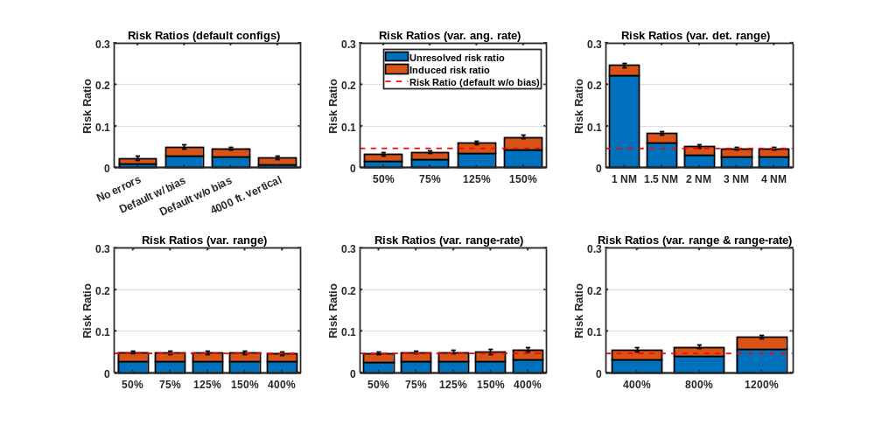
Figure A-3 Risk Ratios
The default with range bias and default without range bias configurations have similar risk ratios. The risk ratio is highly correlated with increasing the angular rate error and decreasing the detection range. The risk ratio is insensitive to increasing the range error, even when the error is increased to four times its default value. That trend mostly holds for varying the range-rate error as well, except in the 400% error configuration where the risk ratio slightly increases. The risk ratio is sensitive to scaling both the range and range-rate errors together, with errors much larger than the default sensor model configuration.
      - LoWC Ratio
Figure A-4 shows the LoWC ratios for all of the configurations that were evaluated.
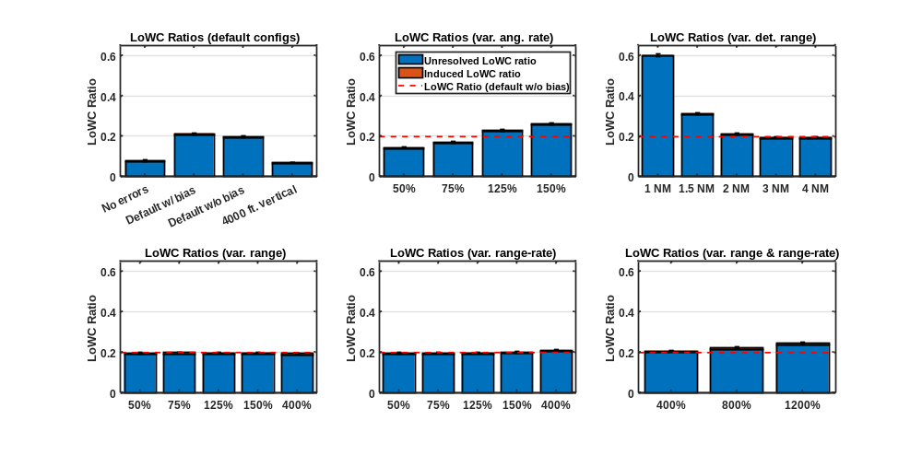
Figure A-4 LoWC Ratios
The LoWC ratio follows the same trends as the risk ratios. The default with range bias and default without range bias configurations have similar LoWC ratios. The LoWC ratio is highly correlated with increasing the angular rate error and decreasing the detection range. The LoWC ratio is insensitive to increasing the range error, even when the error is increased to four times its default value. That trend mostly holds for varying the range-rate error as well, except in the 400% error configuration where the LoWC ratio slightly increases. The LoWC ratio is sensitive to increasing both the range and range-rate errors together.
    - Operational Suitability Metrics
      - Split Alert Probability
Figure A-5 shows the weighted split alert probability for all of the evaluated configurations. A weighted probability indicates that encounter likelihood was taken into account when the probability was computed.
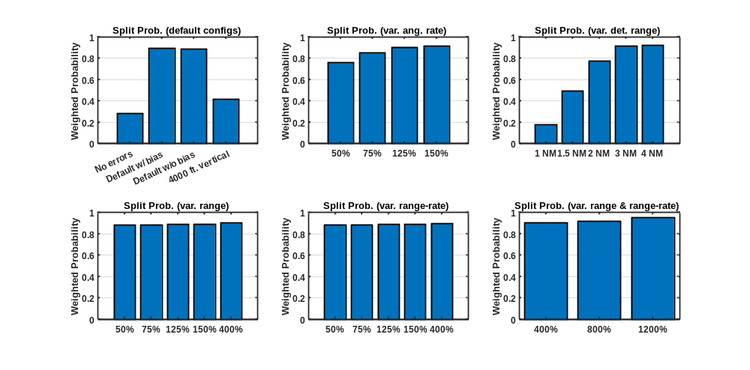
Figure A-5 Split Alert Probability
The default with range bias and default without range bias configurations have split alert probabilities close to 90%, while the no errors configuration has a split alert probability close to 30%. The near threefold increase in split alert probability is due to EO/IR sensor noise. The effect that increasing sensor noise has on the split alert probability is also seen when the angular rate error is increased. Detection range has a more substantial effect on the split alert probability, where increasing the detection range increases the split alert probability: in these encounters, there is a larger time opportunity for the alert to split. For the variable range and variable range-rate configurations, the split alert probability is essentially saturated.
      - Expected Number of Split Alerts
Figure A-6 shows the weighted probability distribution of the expected number split alerts for all of the evaluated configurations. This metric was computed using only encounters that had a nominal LoWC. The dashed lines indicate the average number of splits for the configuration of the same color.
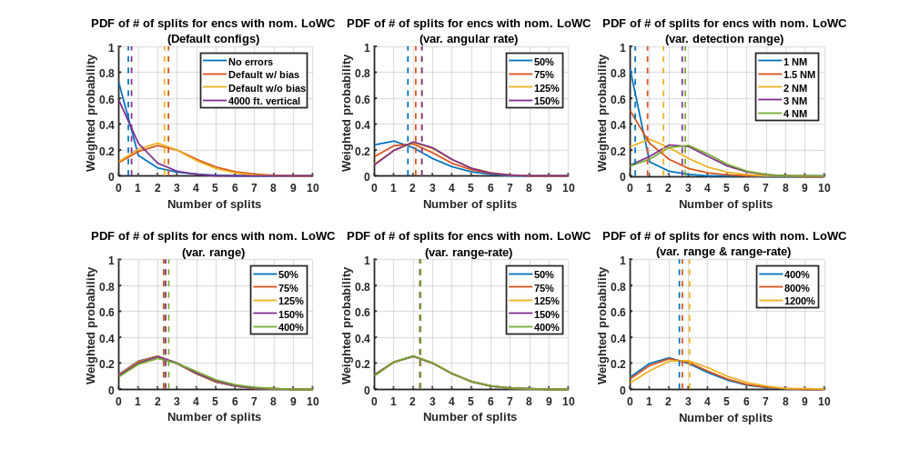
Figure A-6 Expected Number of Split Alerts
The default with range bias and default without range bias configurations have very similar distributions, showing that the range bias does not have a significant effect on the expected number of split alerts. When the angular rate error is increased, the expected number of split alerts also increases. As the detection range increases, so does the expected number of split alerts. There is almost no variability in the expected number of split alerts for the variable range, variable range-rate and variable range and range-rate configurations.
      - Reversal Probability
Figure A-7 shows the weighted guidance reversal probability for all of configurations that were evaluated.
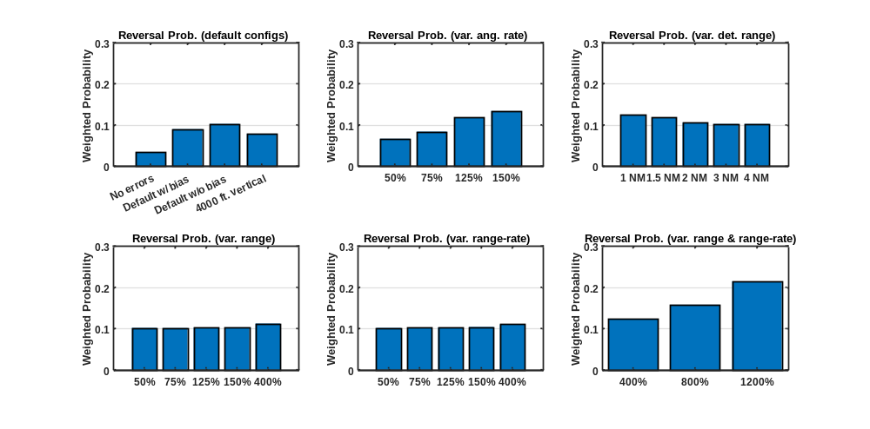
Figure A-7 Reversal Probability
The guidance reversal probability is most sensitive to increasing the range and range-rate error together. When the range or range-rate error is increased independently, there is an insignificant effect on the guidance reversal probability. The guidance reversal probability is also sensitive to increasing the angular rate error.
      - Expected Number of Reversals
Figure A-8 shows the weighted probability distribution of the expected number of guidance reversals for all of the evaluated configurations. This metric was computed using only encounters that had a nominal LoWC. Note: the y-axis is zoomed to show detail.
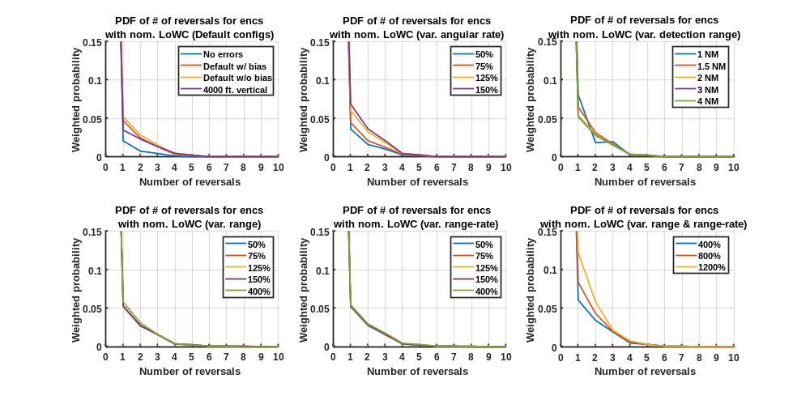
Figure A-8 Expected Number of Guidance Reversals
The probability distribution of guidance reversals was largely consistent among all of the evaluated configurations.
      - Pilot Workload
Figure A-9 shows the number of alerted maneuvers performed per nominal LoWC.
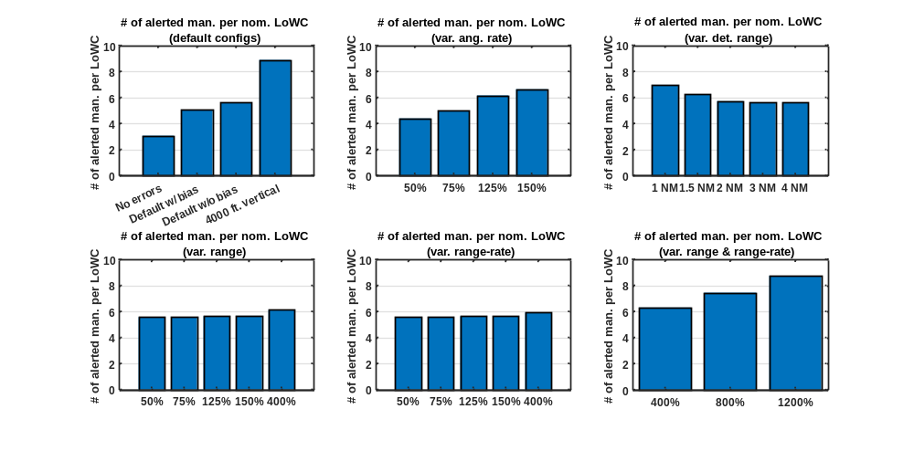
Figure A-9 Pilot Workload
The default without range bias configuration performed more maneuvers than the default with range bias configuration. The 4000 ft. vertical performed almost nine maneuvers per nominal LoWC. This can be understood as the ownship performing maneuvers even when there was not a nominal LoWC—i.e. the ownship was performing unnecessary maneuvers. The trend follows where increasing the angular rate error degrades metric performance. Decreasing the detection range increases the number of alerted maneuvers slightly even though there is a reduced time to issue alerts. Increasing the range or range-rate error independently does not have a significant effect on the number of maneuvers performed, while increasing them together does.
      - System Operating Characteristic (Alert Ratio and Risk Ratio)
The system operating characteristic (Figure A-10) shows the relationship between risk ratio and alert ratio for a given configuration, which allows simultaneous evaluation of safety and operational suitability. A smaller risk ratio and alert ratio are desirable.
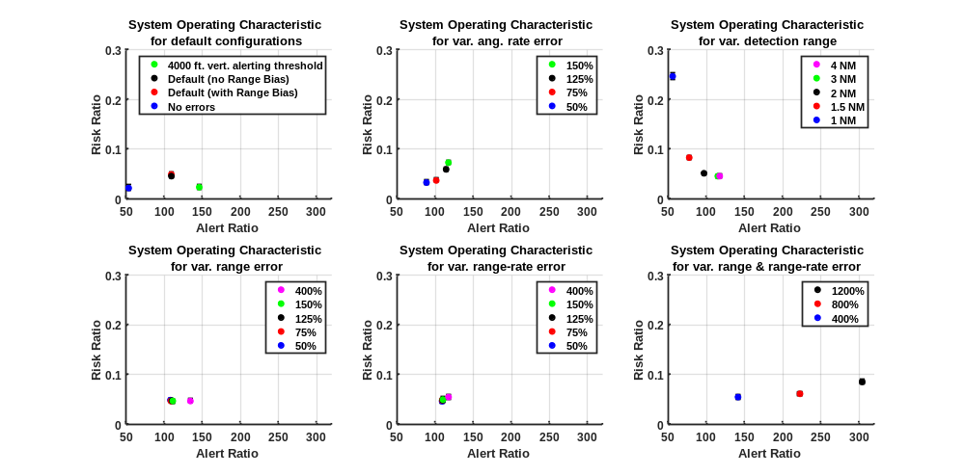
Figure A-10 System Operating Characteristic
For the default configurations, the no errors configuration had the smallest risk ratio and alert ratio, whereas the 4000 ft. vertical alerting threshold had a risk ratio similar to the no error configuration, but a larger alert ratio. For angular rate, the system operating characteristic shows a positive relationship between risk ratio and alert ratio. For detection range, there is an inversely proportional relationship between risk ratio and alert ratio. When the range error is increased beyond 400%, the alert ratio increases. Increasing the range-rate error does not significantly affect the system operating characteristic, even when the error is increased to 400% of the baseline value. When the range and range-rate error are increased together, there is only a slight increase in risk ratio but a large increase in alert ratio.
    - Additional Analyses
Additional analyses were performed to understand if the time correlation of a parameter could affect the metrics defined in Section A.6. These analyses involved running the baseline EO/IR configuration while increasing the time correlation of a parameter and analyzing the results.
      - Increasing Angular Rate Error Time Correlation
Figure A-11 shows the plots for the configurations where the angular rate error time correlation parameter (angRateTau) was increased for bearing and elevation. The baseline value of the angular rate error time correlation was 1 second.
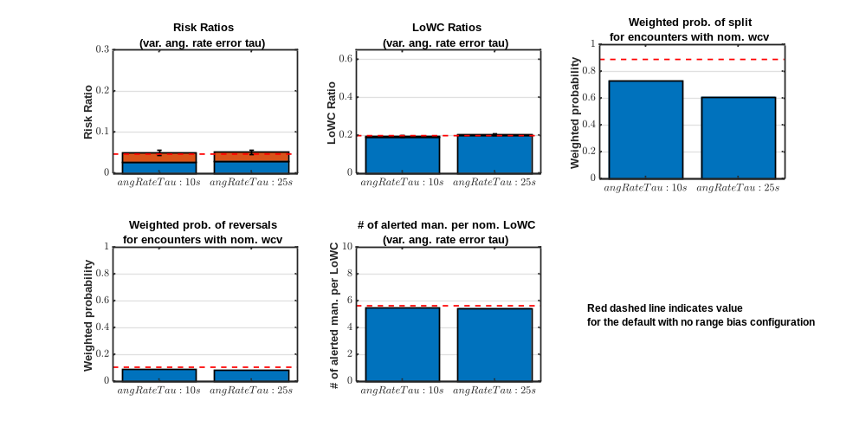
Figure A-11 Metrics for Variable Angular Rate Error Time Correlation Configurations
There are no noticeable effects to any of the metrics other than split alert probability, which decreased as the angular rate error time correlation was increased. This was due to the higher time correlation smoothing out the angular rate measurements.
      - Increasing Range and Range-rate Error Time Correlation
Figure A-12 shows the plots for the configurations where the range and range-rate error time correlation was increased individually and together. The baseline value of the range error time correlation is 5 seconds and the baseline value of the range-rate error time correlation is 2 seconds.
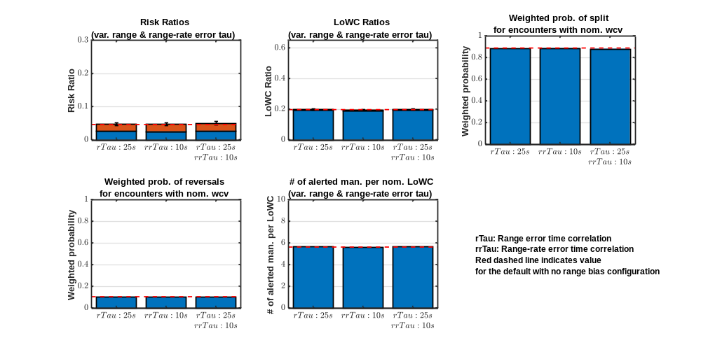
Figure A-12 Metrics for Variable Range and Range-Rate Error Time Correlation Configurations
There are no discernable effects on the metrics from increasing the range and range-rate error time correlation.
  - conclusions
Analysis of the safety and operational suitability metrics shows that increasing the angular rate error and decreasing the detection range have a negative effect on DAA performance. The range and range-rate error can be increased up to four times their baseline values before DAA performance degrades. Based on these results, the minimum specification recommendations are:
- Angular rate error: maximum $σ$ < 2.1 mrad/s (0.12 deg/s)
  - The metrics degrade significantly when $σ$ is 150% of the baseline sensor value (1.4 mrad/s)
- Detection range: minimum of 2 NMi
  - Decreasing detection range to below 2 NMi degrades metric performance substantially. However, this analysis did not evaluate whether there was sufficient time available to coordinate with ATC, so this analysis should not be used as the sole basis to set range limits.
- Range error: $σ$ should not exceed 12% of true range
  - Performance starts to degrade when standard deviation is 400% of default (3% of true range)
- Range-rate error: $σ$ should not exceed 20% of true range-rate
  - Performance starts to degrade when standard deviation is 400% of default (5% of true range rate)
Note that, according to the Safran Electronics & Defense team, the recommended range error may not be achievable when the range is far out and close to the required detection range. The Safran Electronics & Defense team proposes an alternative range error requirement of 20% of true range for a range that is 85% of the detection range and up. An exact configuration of this was not conducted, but could be inferred from results for configurations 22 and 23, shown on the bottom right corner of Figures A-3 to A-10. Whereas this relaxation of requirements appears to lead to very little degradation of the safety metrics, the operational suitability metrics, such as reversal probability, pilot workload, and alert ratio, are likely to be impacted by > 5%.

  - References

[1] | SAFRAN ED, "White Paper EO/IR Sensor Model," 2019.
[2] | "Appendix Q," in Minimum Operational Performance Standards (MOPS) for Detect and Avoid (DAA) Systems, DO-365, RTCA. Inc., 2017.
[3] | S. Ayyalasomayajula, R. Sharma, W. F. A. Trani, N. Hinze and S. Spencer, "UAS Demand Generation Using Subject Matter Expert Interviews and Socio-Economic Analysis," in Proceedings of the AIAA Aviation Conference, 2015.
[4] | A. Weinert, E. Harkleroad, J. Griffith, M. Edwards and M. Kochenderfer, "Uncorrelated Encounter Model of the National Airspace System Version 2.0 (ATC-404)," Lincoln Laboratory, Lexington, MA, 2013.
[5] | A. Nuic, D. Poles and V. Mouillet, "An Advanced Aircraft Performance Model for Present and Future ATM Systems," International Journal of Adaptive Control and Signal Processing, Vol. 24, No. 10, pp. 850-866, 2010.
[6] | C. Muñoz, A. Narkawicz, G. Hagen, J. Upchurch, A. Dutle, M. Consiglio and J. Chamberlain, "DAIDALUS: Detect and Avoid Alerting Logic for Unmanned Systems," in 34th IEEE/AIAA Digital Avionics Systems Conference, Prague, Czech Republic, 2015.
[7] | MIT Lincoln Laboratory, "A Model of Unmanned Aircraft Pilot Detect and Avoid Maneuver Decisions," MIT Lincoln Laboratory, 2017.
[8] | B. Efron, "Better Bootstrap Confidence Intervals," Journal of the Americal Statistical Association, vol. 82, no. 397, pp. 171-185, 1987.

