Propulsion System
Khary I. Parker∗, David C. Folta∗∗
∗ NASA/Goddard Space Flight Center, Propulsion Branch, Greenbelt, MD, United States of America
∗∗ NASA/Goddard Space Flight Center, Navigation and Mission Design Branch, Greenbelt, MD, United States of America
Abstract:
During mission design, many trades are made that have varying levels of impact on the spacecraft. The types of subsystems that are selected affect the spacecraft mass, volume, power, and cost. Choosing the right propulsion system for a CubeSat mission is key to that mission’s success. There are many CubeSat propulsion systems on the market today. The CubeSat community desires to understand how to assess the available propulsion systems and how to apply them to their mission designs. The purpose of this chapter is to inform the reader of the key factors that must be considered when evaluating and applying these systems for various missions.
Keywords: CubeSat, SmallSat, propulsion, mission, sizing
- Overview
The need for highly reliable and capable CubeSat propulsion systems becomes more important as the variety of mission applications increases. There is an expectation that these systems are commercial-off-the-shelf (COTS) and ready to fly. As of 2020, the majority of these propulsion systems are very early in their development. The purpose of this chapter is to assist developers in understanding how to evaluate and apply these propulsion system for a mission. The types of propulsion systems range from chemical, electric, solid, and propellantless (e.g., solar sails, tethers, etc.). To meet the goals of this chapter, only chemical and electric propulsion systems will be considered.
In order to select the appropriate solution, the mission goals and objectives need to be clear. Additionally, the solution should accommodate all applicable types of maneuvers: mid-course corrections, orbit insertions, stationkeeping and pointing once the mission orbit is achieved, and, if necessary, disposal. For example, a mission that has tight pointing requirements may elect to employ a cold gas or electrospray propulsion system to meet that requirement. However, it may also need a monopropellant or gridded ion system for orbit insertion. On the other hand, a 3-axis stabilized planetary observation mission may be able to meet the trajectory, orbit-insertion, and attitude control requirements with a single type of propulsion system.
The decision of which type of system to use depends on a number of factors: available mass, volume, power, desired transit time (i.e., how long it takes to get to mission orbit), propulsion system performance requirements, and cost. A chemical propulsion system generates a gas to propel a spacecraft^{[1, 2, 3, 4]}. This gas comes from either a compressed gas or saturated liquid (e.g., cold gas systems), or via a chemical reaction (e.g., monopropellant, bipropellant, and solid propulsion systems). The compressed gas and chemical reaction systems typically require high propellant feed pressures, which can be a safety concern for CubeSats. A chemical propulsion system is typically less expensive, less complex, and requires less power than an equally sized electric propulsion (EP) system. Chemical systems can also produce more thrust, allowing a spacecraft to achieve its final orbit in less time than an electric system.
EP systems accelerate plasma by generating either an electromagnetic (e.g., hall effect, vacuum discharge) or electrostatic (electrospray, gridded ion, etc.) field^{[1, 2, 9]}. There are also electrothermal EP systems that pre-heat either hydrazine (arcjets, resistojets) or saturated liquids (micro cavity discharge) to increase their respective performance. The advantages of an EP system over chemical are: lower propellant mass, less volume, and higher performance in terms of specific impulse. The higher specific impulse is the primary reason that EP is the system of choice for long duration station keeping or interplanetary missions.
Even with the differences stated above, power availability is a limiting factor for both types of systems. Propulsion systems must draw as little power as possible given limited solar array size and battery capacity. EP systems require more energy than chemical systems to power their PPU and the thruster. Because of this, spacecraft using EP systems will have larger solar arrays and batteries. There are design modifications that can be made to accommodate higher power propulsion systems, but the changes could affect other subsystems in the spacecraft. During the planning stage, if the higher power propulsion system is found to adversely affect the mission then a lower power system should be considered. These are but a few of the considerations a mission designer needs to keep in mind.
Section 2 discusses the key figures of merit and other evaluation criteria that are used to assess the chemical and electric propulsion systems on the market and in development today. Section 3 discusses how to size both chemical and electric propulsion systems by means of an example. Finally, Section 4 discusses trajectory designs using chemical and electric propulsion systems for different mission architectures.
Nomenclature:
F | Thrust, N |  | v_{e} | Combustion exit velocity at the nozzle, m/s
I_{sp} | Specific Impulse, s |  | t_{b} | Thruster burn time, s
Δv | Change in Velocity, m/s |  | m_{i} | Initial (wet) spacecraft mass, kg
I_{d} | Density Specific Impulse, (kg-s)/m³ |  | m_{f} | Final (dry) spacecraft mass, kg
I_{t} | Total Impulse, Ns |  | ρ | Density, kg/m³
V_{S/C} | CubeSat Spacecraft Volume, U or L |  | g₀ | Earth gravity acceleration, m/s²
m_{p} | Propellant mass, kg |  | γ | Total Thrust Correction Factor
$${\dot{m}}_{p}$$ | Propellant mass flow rate, kg/s |  | Μ | Mass of planet, kg
I_{b} | Ion beam current, A |  | V_{b} | Effective beam voltage, Vdc
η_{m} | Thruster mass utilization efficiency |  | e | Ion Charge, A

- Propulsion System Assessment
There are fundamental performance metrics, or Figures of Merit (shown in Table 15.1), that are used to assess the capabilities of any propulsion system. Any single metric is not sufficient to understand a system completely. One must use a combination of these metrics to characterize system performance, as well as system mass and volume. For EP systems, thrust and specific impulse (I_{sp}) are further derived from first principles, to consider the propellant’s ionic mass and charge, as well as the voltage and current needed to accelerate the propellant ions.
Table 15.1: CubeSat Propulsion Figures of Merit*^{[8]}
Figures of Merit | Units (SI) | Newtonian Physics | EP Application^{[9]} | Definition
Thrust (F) | N | $$F={\dot{m}}_{p}v_{e}$$ | $$F=\frac{γ\sqrt{\frac{2M}{e}}I_{b}\sqrt{V_{b}}}{1000}$$ | Total amount of force produced by a system or thruster.
Specific Impulse (I_{sp}) | sec | $$I_{sp}=\frac{F}{g_{0}\dot{m}}$$ | $$I_{sp}=\frac{γη_{m}}{g_{0}}\sqrt{\frac{2eV_{b}}{M}}$$ | Measures propellant performance by quantifying the total impulse per unit mass of propellant.
System Change in Velocity (Δv) | m/s | $$∆v=g_{0}I_{sp}\ln\left(\frac{m_{i}}{m_{f}}\right)$$ |  |  | Quantifies system ability to change its velocity based on propellant performance and spacecraft mass.
Density Specific Impulse (I_{d}) | kg-s  L | $$I_{d}=ρI_{sp}$$ |  |  | Used to compare propellant performance for given I_{sp} and density. This is generally how well the propellant packages.
Total Impulse (I_{t}) | Ns | $$I_{t}=\int_{0}^{t_{b}}{Fdt}=Ft_{b}$$ |  |  | Change in momentum given by integrating thrust over a given burn time. Quantifies total amount of force produced by the propellant.
Volumetric Impulse | $$\frac{Ns}{L} or \frac{Ns}{U}$$ | $$\frac{I_{t}}{V_{S/C}}$$ |  |  | This efficiency parameter used for SmallSat propulsion systems describes the amount of total impulse (Ns) a system imparts to a body per unit volume (U or L).
Propellant Mass Fraction† | None | $$ζ=\frac{m_{p}}{m_{f}}$$ |  |  | Quantifies the efficiency of a propulsion system to move a given mass (m_{f}).
* See Sec. 15.1 for variable definitions.
† This parameter is not found in Ref. 8. However, it is a commonly used Figure of Merit for evaluating system performance.

A key parameter mission planners base their missions on is Δv for both chemical and electric systems. This works well for characterizing discrete impulse maneuvers using chemical systems. However, electric systems operate continuously, and their maneuver accelerations are integrated over the total burn duration. This can result in a Δv for an EP system that could be misleading. The parameters that should be considered, especially when comparing EP and chemical systems, are propellant mass, propellant mass fraction, and other propellant mass based Figures of Merit from Table 15.1.
Other metrics to consider for chemical and electric propulsion systems are the launch and thermal environmental tests that have been conducted, throughput (amount of propellant that can flow through a thruster before performance degrades), total steady-state on time (the length of time a thruster operates before performance degrades), and pulse mode operation capability. For electric systems, a vendor should provide thrust and I_{sp} ranges over a pre-defined input power range, or at a set of as-tested design points. For chemical systems, a vendor should provide thrust and I_{sp} range over pre-defined propellant feed pressures, or at a set of as-tested design points.
A propulsion system can also be assessed by understanding the maturity of its development, which can be described by Technology Readiness Levels (TRLs). The TRLs are a set of voluntary guidelines followed by the U.S. government to rate the development status of a technology. NASA has developed TRLs that can be applied to any system within a spacecraft or launch vehicle^{[16]}. The Spacecraft Propulsion Subcommittee, of the Joint Army, Navy, NASA, Air Force (JANNAF) Interagency Propulsion Committee, has also developed a set of TRL guidelines that specifically address CubeSat propulsion system maturity^{[17]}. These JANNAF guidelines are based on TRLs defined by NASA and Department of Defense. A system has to demonstrate pre-defined exit criteria before being assigned a TRL ranking. A system prototype that demonstrates required performance in its flight environment, as defined by the TRL 6 exit criteria, is considered qualified for flight. These qualification criteria are typically governed by applicable flight design and safety requirements such as those defined in AIAA S-080^{[5]}, GSFC-STD-7000A (GEVS)^{[18]}, NASA-STD-8719.24^{[6]}, and AFSPCMAN 91-710^{[7]}.
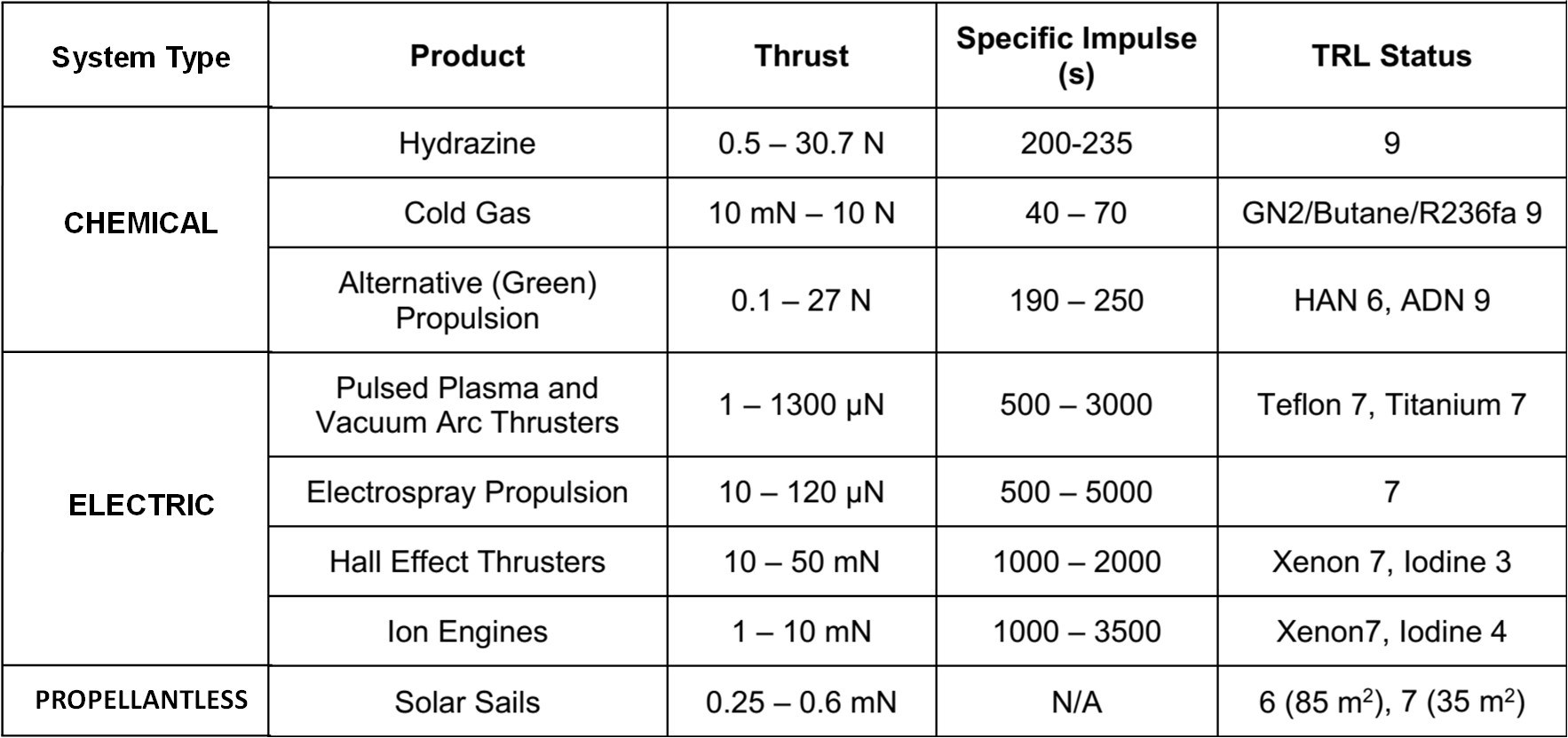The NASA Ames Research Center (ARC) publishes the State of the Art of Small Spacecraft Technology^{[10]} (SoA) document, that covers recent developments and status of technologies for various CubeSat subsystems. Their section on propulsion systems provides an overview of the various types of systems and technologies currently on the market. Table 15.2 lists the various types of propulsion systems the NASA-ARC SoA addresses.
Table 15.2: Propellant System Types for Small Spacecraft^{[10]}
A review of the NASA-ARC SoA shows that there are many types of CubeSat propulsion systems on the market. Propulsion system technology developers use the aforementioned assessment tools to communicate the capability and development status of their systems. An understanding of these tools will help mission designers select the best propulsion system for their missions.
- Propulsion System Sizing
The sizing methods discussed here can be applied to many mission types. Note that the sizing examples discussed here are purposely not optimized in order to highlight the iterative nature of the process. By pointing out how the design “does not close”, or is incomplete, illustrates how other considerations need to be made to reach an optimal design. These examples will also highlight the information passed between systems engineers, mechanical designers, orbit analysts, and attitude control system (ACS) developers during trade studies, to understand the mission needs and requirements levied on the propulsion system.
The example mission is to fly a lunar communications CubeSat, called CommCubeSat1, in cislunar space. It is a 3-axis controlled, 12U CubeSat that will provide communications between Earth and the Moon for a baseline mission duration of 1 year. It will be deployed from a launch vehicle upper stage in cislunar space and then achieve a transfer trajectory to reach a critically inclined lunar elliptical orbit, at 250 km × 6365 km, with an inclination of 57.4°. The maximum spacecraft wet mass (dry mass + propellant mass) allocation is 24.0 kg.
For this example, a proposed chemical and an electric propulsion system were selected from the NASA-ARC SoA for comparison. Note that the selection of these specific systems is not an endorsement and should not be interpreted as rating them better as or worse than any other. However, they will be used to discuss the considerations made when sizing different types systems in a realistic example. For these examples, the VACCO green propellant Integrated Propulsion System (IPS) will represent the proposed chemical propulsion system, and the Busek BIT-3 RF Ion propulsion system will represent the potential electric propulsion system. Their Figures of Merit are shown in Table 15.3.
Table 15.3: Sample CubeSat Propulsion Systems^{[10]}
 | Integrated Propulsion System (IPS) | BIT-3
Propellant | LMP-103S  (ADN Based) | Iodine  (Solid)
Manufacturer | VACCO | Busek
Propellant Mass Capacity (kg) | 5.7 | 1.5
Total Propellant Volume (L) | 4.6 | 0.3
Propulsion System Dry Mass (kg) | 9.0 | 1.5
Peak Power (W) | 15.0† | 80.0
# of Thr./ Avg. Unit Steady-State Thrust (N) | 4 / 1.0 | 1 / 0.0012
Steady-State Thrust (N) | 4.0 | 0.0012
Steady-State Specific Impulse (sec) | 220.0 | 2,160.0
Δv (m/s) | 585.0 | 1,367.1
Propellant Mass Fraction (%) | 31.1 | 6.7
Density Specific Impulse (kg-s/L) | 272.8 | 9,288.0
Total Impulse (Ns) | 12,297.5 | 31,773.5
Volumetric Impulse (Ns/L) | 2,673.4 | 105,911.8
TRL Status | 6 | 5
† Includes catbed heater power on time for ~30 min.

  - Chemical Propulsion System Sizing
A ballistic orbit trajectory has been designed with an insertion delta-v (Δv) of 269.4 m/s (methodologies of determining this will be discussed in the next section). An initial guess of the spacecraft dry mass (instruments, avionics, propulsion system, structure, power system, etc.) is assumed to be 15.0 kg based on available component data. Component masses widely vary according to how well developed they are. To account for these variations, a percentage margin^{[11]} is added to these masses to obtain a more conservative estimate. For this example the conservative dry mass estimate (m_{f}) is determined to be 20.0 kg. This mass estimate includes the conservative dry mass estimate of the baselined VACCO Integrated Propulsion System (IPS), which is 9.0 kg.
Orbital analysis determines the minimum spacecraft acceleration needed to reach the mission orbit in order to calculate the required total steady-state thrust force. This acceleration is constrained by the spacecraft body dynamic modes and the dynamic modes of any deployables (e.g., solar arrays, magnetometer, booms, etc.). Figure 15.1 shows the relationship between acceleration and spacecraft wet mass for given total thrust. The labels on the right of the plot indicate the standard small satellite sizes for the corresponding spacecraft wet masses^{[21]}.
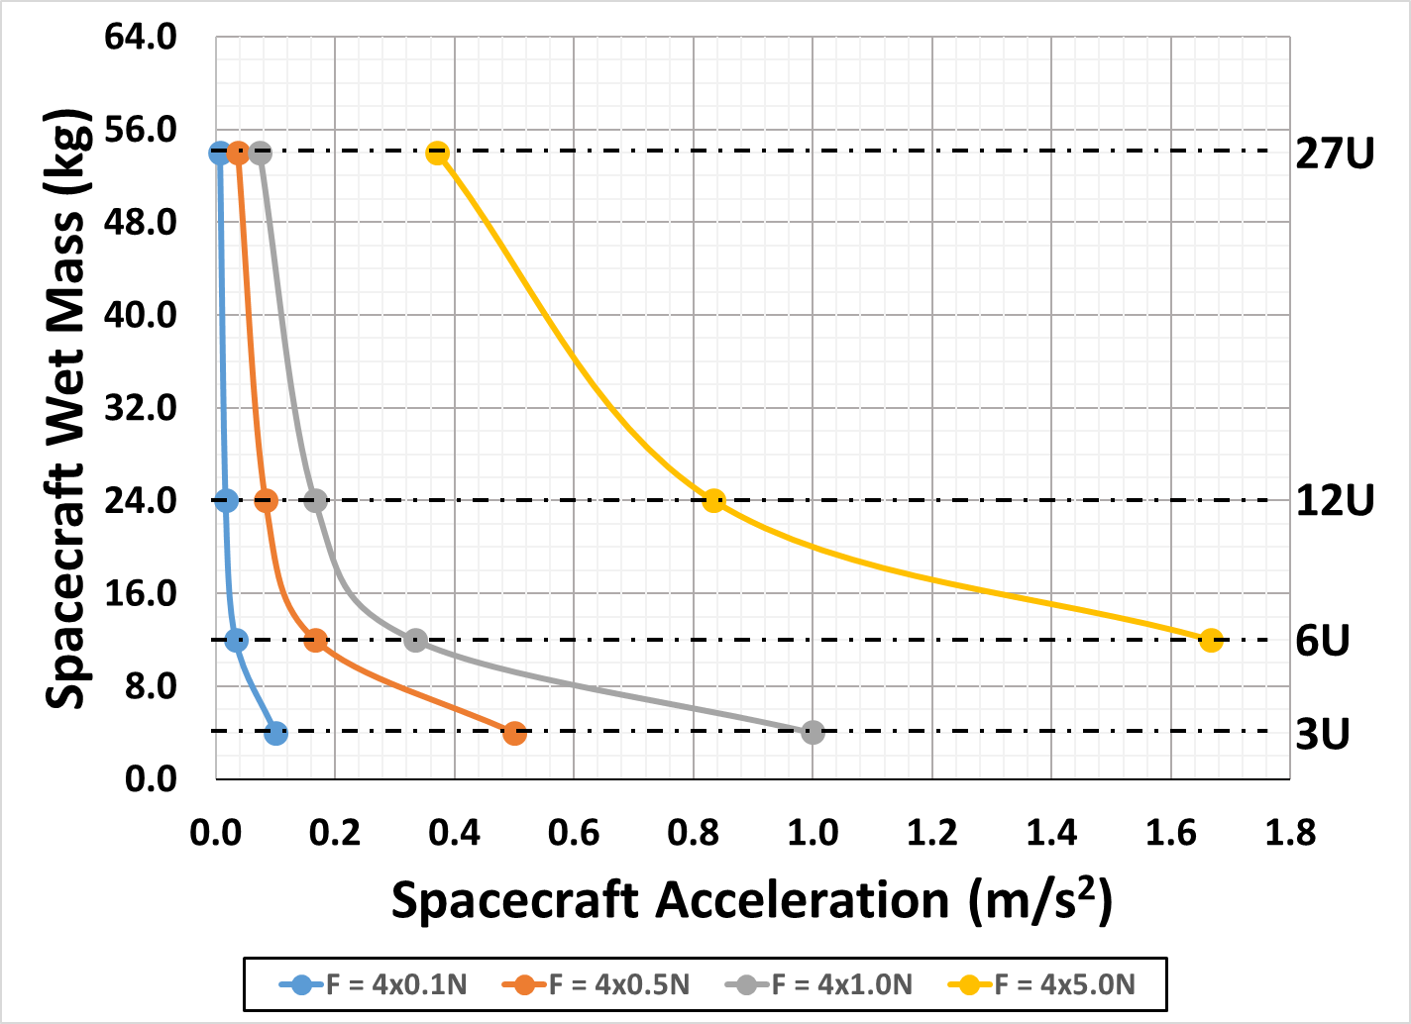
Figure 15.1: Spacecraft Acceleration Plot for Various Thrust Classes
Using the allocated spacecraft wet mass of 24.0 kg in this example, the calculated acceleration is 0.16 m/s², and resulting in a total steady-state thrust of 4.0 Newtons (N) needed to perform the mission. The total thrust will be produced using four 1.0 N force thrusters that will be mounted to the spacecraft aft face, as shown in Figure 15.2.
The 1.0 N chemical thruster baselined for this example mission is the Bradford-ECAPS 1.0 N High Performance Green Propellant (1N HPGP) thruster. This thruster operates with the LMP-103S green propellant, and has a reported steady-state I_{sp} of 220.0 sec^{[10]}. Variability in thruster manufacturing and in on-orbit conditions (thermal, power, etc.) during thruster operation can cause suboptimal performance, though. To account for these variations and provide propellant margin, the thruster performance is adjusted by -3σ. In this case, the worst case steady-state I_{sp} and total thrust are assumed to be 209.0 sec and 3.7 N, respectively.
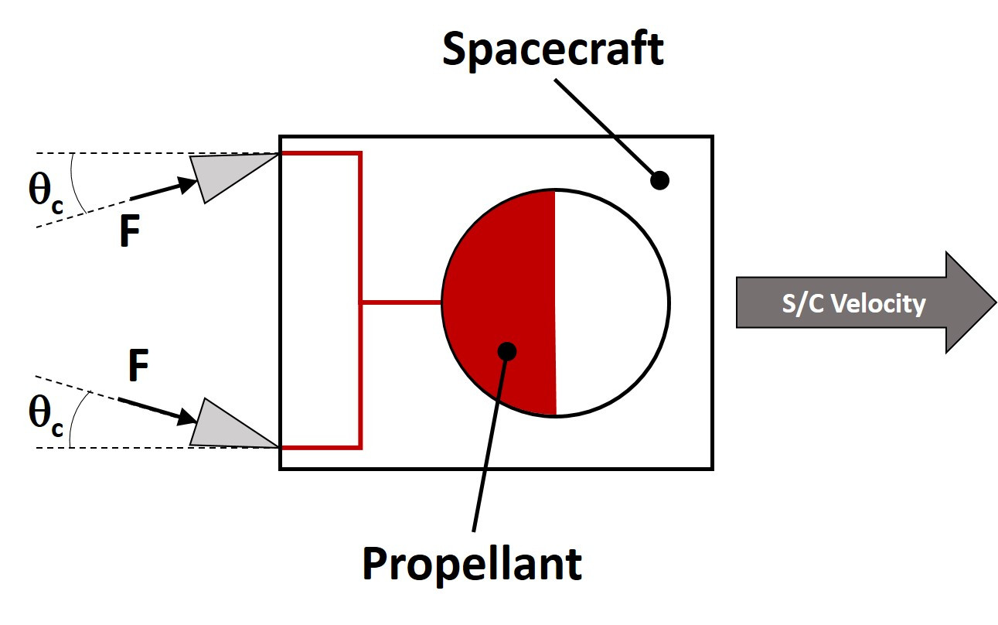
Figure 15.2: Spacecraft Thruster Orientation
A spacecraft can take advantage of full thruster performance when its thrust vector (F) is parallel to the spacecraft velocity vector (see Figure 15.2). The thrust vector could be angled, or canted, off of the velocity vector by a cant angle (θ_{c}), typically determined by the ACS engineer, to provide 3-axis control authority. Known as cosine loss, this effectively reduces thruster performance on the spacecraft in return for pointing control by a factor equal to the cosine of the cant angle. For this example, the ACS engineer defined θ_{c} to be 15.0°. Hence, the cosine of θ_{c} is multiplied by the worst-case steady-state thrust force and I_{sp} to reflect the reduced performance. Therefore, the effective thrust force (F_{eff}) imparted to the spacecraft from our set of thrusters at steady state is calculated to be about 3.6 N, and the effective I_{sp} ((I_{sp})_{eff}) is 201.9 sec.
Another design requirement that must be accounted for when sizing a propulsion system is momentum unloading. Many different external forces (such as solar pressure, gravity gradients, magnetic fields, and atmospheric pressure) act on the spacecraft. These forces create disturbance torques when they are not coincident with the spacecraft center of mass. The reaction wheels (part of the ACS) typically absorb the momentum imparted by these torques in order to maintain spacecraft attitude. To do this, they produce momentum that is equal to and opposite of the direction of the disturbance torque. However, they do have a maximum speed, limiting the amount of momentum they can absorb. Rotating at their maximum speed for long durations can lead to the wheels becoming oversaturated or excessive wear on the wheel bearings. To extend wheel life and spin the wheels back down, specific thrusters are fired to generate an opposing angular momentum to that of the spinning wheel, thereby “dumping”, or unloading the momentum. This is known as a ΔH maneuver. When performing this maneuver, the thrusters cycle, or pulse, on/off for a short period of time. The pulsing, or pulse mode, thruster performance is characterized by a thruster’s impulse bit, given in terms of Newton-seconds (Ns). Thruster minimum impulse bit is driven by the minimum amount of time a thruster valve can cycle open/close while flowing enough propellant to produce measurable thrust. The corresponding pulse mode I_{sp}, which is lower than steady-state I_{sp}, is calculated based on the thruster impulse bit, and consumed propellant.
The total amount of propellant needed for the ΔH maneuvers is calculated using Eq. 15.1. It is based on the total angular momentum the spacecraft will need to unload during the life of the mission, the thrusters’ pulse mode performance, and the effective length of the thrusters’ moment arm:
$m_{p,ΔH}=\frac{ΔH}{I_{sp,pl}g_{0}L_{CA}}$ (Eq. 15.1^{[13]})
For this example, assume that the total life time accumulated angular momentum (ΔH) is 76.8 Newton-meter-second (Nms), pulsed specific impulse (I_{sp,pl}) is 178.0 sec^{[19]}, and the thruster moment arm (L_{CA}) is 0.25 m. Therefore, given that the acceleration of gravity on Earth (g₀) is 9.81 m/s², the propellant mass needed over the course of the mission for momentum unloading (m_{p,ΔH}) is 0.18 kg.
Using Eq. 15.2, the Δv propellant mass (m_{p,Δv}) is calculated using the spacecraft dry mass, ΔH propellant mass, and worst case steady-state I_{sp}. This equation shows a conservative approach to calculating Δv propellant mass by considering the ΔH propellant mass as part of the spacecraft dry mass.
$m_{p,Δv}=m_{i}-m_{f}$ (Eq. 15.2)
$$=\left(m_{f}+m_{p,ΔH}\right)e^{\frac{Δv}{g_{0}I_{sp}}}-\left(m_{f}+m_{p,ΔH}\right)$$
$=\left(m_{f}+m_{p,ΔH}\right)\left(e^{\frac{Δv}{g_{0}I_{sp}}}-1\right)$
From Eq. 15.2, the Δv propellant mass is 2.9 kg. Using this result along with the ΔH propellant mass calculated in Eq. 15.1, the total propellant mass is 3.1 kg.
Once the total propellant mass is known, the maximum propellant volume, a key consideration for mechanical packaging, can be determined using the propellant density at the maximum expected temperature. Based on a propellant density of 1240.0 kg/m³ ^{[10]} for the selected LMP-103S, the propellant volume is 2.5 L. With the total propellant mass being 3.1 kg, the total spacecraft wet mass is 23.1 kg, including margins. Therefore, the VACCO IPS appears to meet mission requirements. As the spacecraft design matures (i.e., changes in component masses, refining orbit parameters, cost, etc.), this process will be iterated until a satisfactory solution is found. A summary of the results of this first iteration with a chemical propulsion system is detailed in Table 15.4.
Table 15.4: CommCubeSat1 Chemical Propulsion System Sizing
Insertion Δv (m/s) | 269.5
S/C dry mass (kg) | 20.0
Prop System Dry Mass (kg) | 9.0
Thruster Cant Angle (°) | 15.0
Worst-Case Thrust Force (N) | 3.6
-3σ Specific Impulse (sec) | 201.9
ΔH Propellant Mass (kg) | 0.2
Δv Propellant Mass Used (kg) | 2.9
Propellant Vol. Used (L) | 2.5
S/C Wet Mass (kg) | 23.1

  - Electric Propulsion System Sizing
If CommCubeSat1 uses an EP system, it will have to burn continuously given the low amount of thrust it produces. Analytically, the maneuver accelerations are integrated over the total burn duration required for the spacecraft to reach its mission orbit. The result of that analysis is the amount of propellant consumed. Inputs into this analysis are the performance curves of the candidate EP systems, the performance curves for the candidate solar arrays, and the potential mission launch and departure dates. Given that CommCubeSat1 will deploy as a secondary payload near cislunar space, the deployment energy of the spacecraft can be assumed. In addition, gravity models, planetary eclipse, and near body perturbations are also used as inputs. These results are evaluated to determine the optimal trajectory scenarios, EP system, solar array and battery size.
Section 4.1 discusses the orbital analysis that was performed assuming two Busek BIT-3 systems as the baseline. The thrust and I_{sp} vs. input power curves^{[14]} (Figure 15.3) are used as input into the orbital analysis for this mission. The results in Section 4.1 show that their combined performance appears to reach the mission orbit using a small amount of propellant, if there is an appropriately sized solar array and battery. Each BIT-3 contains 1.5 kg of solid iodine propellant. With an 83% efficient power-processing unit (PPU)^{[14]}, the BIT-3 draws up to 80.0 W to produce a maximum thrust of 1.2 mN with an I_{sp} of 2160.0 sec. Since two systems are needed, the total required power is 160.0 W and the maximum thrust produced is 2.4 mN.
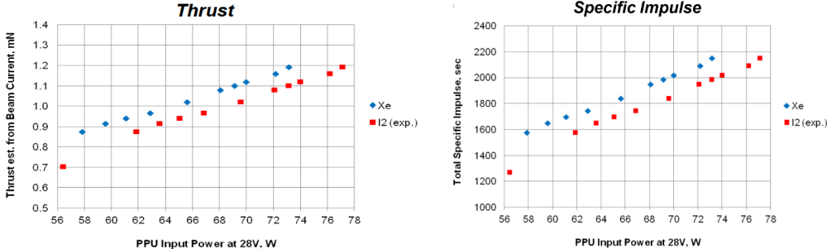
Figure 15.3: Busek BIT-3 Performance Curves^{[14]}
A spacecraft consideration to be accounted for is that the BIT-3 PPU will dissipate about half of its input power in as waste heat, which is up to 40.0 W per system. For a CubeSat, this is not a trivial amount of heat to manage. Therefore, the thermal engineer will have to develop a way to remove this heat from the EP system and the spacecraft into their thermal control system.
Table 15.5 shows the results for the CommCubeSat1 EP system design. The results show that the use of two BIT-3 systems is oversized, given the small amount of propellant used. At this point, the Project leads can elect to keep both BIT-3 systems and use the extra propellant for extended mission, or downsize to a single BIT-3 and save mass, power, and cost. As the design matures this process will be iterated until a satisfactory solution is found.
Table 15.5: CommCubeSat1 Electric Propulsion System Sizing
S/C dry mass (kg) | 18.0
Max. Input Power (W) | 160.0
Max. Thrust Force (N) | 0.0024
Specific Impulse (sec) | 2160.0
Propellant Mass Used (kg) | 0.4
Prop System Dry Mass (kg) | 3.0
S/C Wet Mass (kg) | 21.4

Although these examples are simplified, they show mission developers what is involved in sizing different propulsion system types. There are key differences in sizing for chemical and EP systems and each has their respective advantages and disadvantages. The next section will take these concepts a step further and compare these same propulsion systems for different mission applications.
- Propulsion Technology Mission Applications
The trajectory is another key aspect in designing a mission. This section explores the trajectory designs for three missions: lunar, libration, and planetary. Each mission will use the CommCubeSat1 spacecraft bus, as well as the previously selected chemical and electric propulsion systems. The propulsion system sizing methods for the Lunar Mission was discussed in the Section 3 will be used to calculate sizing results for the libration and planetary trajectories. This section will also discuss the orbital mechanics parameters used to determine the inputs needed to size the propulsion systems. Disturbance torques are not considered in this example, which incorporates third body perturbations, solar radiation pressure acceleration, and lunar gravity modeling. The propulsion system sizing comparisons for these missions are summarized in Section 4.4. As with the previous example, these non-optimal designs provide a feasible assessment of their implementation including trajectory constraints required for their use and a representative result.
  - Lunar Mission Example
The trajectories designed for the Lunar Mission incorporate multi-body dynamics to minimize the lunar orbit insertion Δv and propellant mass. The final orbit is the critically inclined lunar elliptical orbit of 57.4° with a semi-major axis of 5049 km and an eccentricity of 0.605^{[15]}. Figure 15.4(a) shows the EP system transfer and capture, while Figure 15.4(b) presents the chemical system. Both figures use a solar rotating coordinate frame for the transfer followed by a lunar centered inertial frame for the near lunar arrival and capture. The chemical design incorporates the same force models used for the EP design. To capture into the mission orbit with a EP system, consideration needs to be given to the Earth, Moon, Sun dynamic system about the Moon at the arrival distance of ~60,000 km. The chemical design permits a direct capture into the mission orbit with a maneuver performed at a radius of 1,937 km.
Based on these trajectory parameters, the chemical system has an insertion Δv of 269.5 m/s, a total transfer time of 102 days, with a maximum maneuver duration of 29 minutes. The EP system results in a total transfer time of 184 days and a maneuver duration of 82.5 days, in an anti-velocity vector direction throughout the maneuver. Looking at Figure 15.4(a), the wavy lines around the lunar orbit represent the spacecraft spiraling down to its final orbit. The spiraling maneuver is further highlighted in this figure’s inset. The resulting insertion Δv is 730.0 m/s. (This Δv is not used to size an EP system and is only provided for the purpose of comparison.)
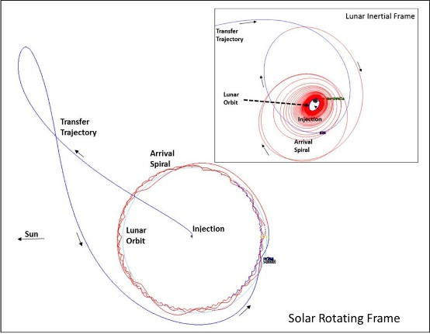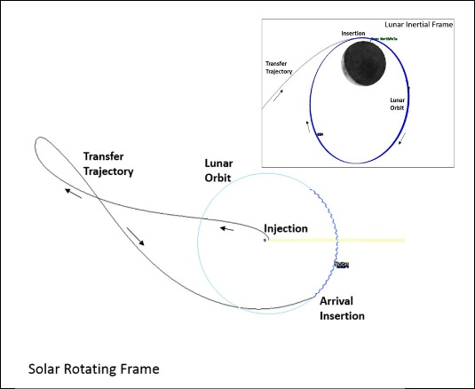
a) EP Trajectory Design b) Chemical Trajectory Design
Figure 15.4: Lunar Mission Trajectory Design
  - Libration Orbit Example
A libration orbit design was generated for CommCubeSat1 based on the lunar mission system parameters discussed in the previous section. This orbit is a direct transfer from a low Earth parking orbit of 200 km to a Sun-Earth Libration-1 (SE-L1) Lissajous orbit that has a Y-amplitude of 1,370,457 km (a 4.0° × 14.0° angle off the Sun-Earth line). The designs shown in Figure 15.5(a) and Figure 15.5(b) are illustrated in a Solar Rotating Coordinate Frame. Insertion into the Lissajous orbit is a single maneuver targeting a required energy level that permits the transition onto the libration orbit.
The chemical system insertion Δv of 174.0 m/s has a maximum burn duration of 19 minutes. The EP system has a maximum burn duration of 19.4 days, consuming 0.2 kg of propellant, where half of the burn is performed before the Sun-Earth X-Z plane crossing. Looking at Table 15.6, the libration orbit insertion Δv for the chemical and EP systems are similar, but this is attributed to the maneuver being performed in open space, with similar changes in inertial velocity, and not influenced by a maneuver location within the gravitational effects of Earth. This illustrates the misleading nature of using Δv to size an EP system.
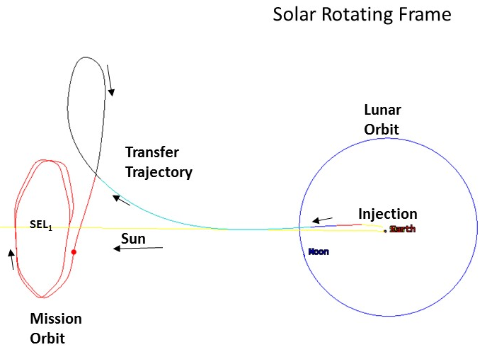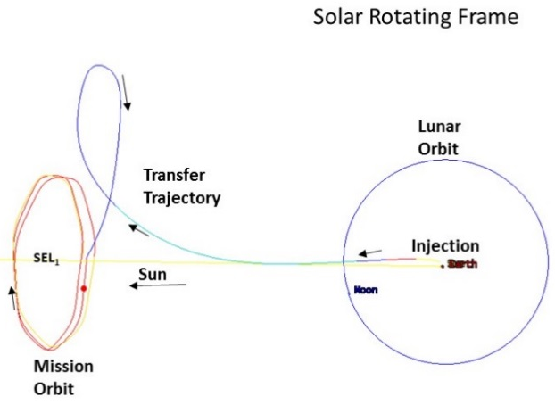
a) EP Trajectory Design b) Chemical Trajectory Design
Figure 15.5: SE-L1 Lissajous Orbit Design
  - Planetary Mission (Mars) Example
A planetary mission design was generated for CommCubeSat1 using a Mars capture trajectory into the Phobos orbit (assuming a 9,216 km circular orbit). This design is based on a Type-I heliocentric transfer from Earth to Mars. Several other transfer types could be used, but this feasible case was designed to demonstrate only the differences in the capture dynamics and the capture maneuver.
The designs shown in Figure 15.6(a) and Figure 15.6(b) are presented in a Mars Inertial Coordinate Frame. The initial location is based on the heliocentric position with respect to Mars so that the planetary excess energy is zero. This excess velocity is required as the initial condition for the EP system as it targets a zero excess planetary velocity upon arrival. The differences in this example are more prominent than in the previous examples. Two chemical maneuvers (approximately 729.7 m/s each) are required to capture the Phobos orbit. An additional chemical maneuver (approximately 511.1 m/s), based on Oberth’s rule^{[20]}, is performed to increase the maneuver’s efficiency and to circularize. The total Δv magnitude with the chemical system is 1,970.5 m/s and has a total burn duration of 5.3 hours. The EP maneuver begins at the zero excess velocity location and a burn duration of approximately 215 days, and 2.1 kg of propellant is required to reach the Phobos mission orbit. The spacecraft wet mass for the EP cases is 24.0 kg.
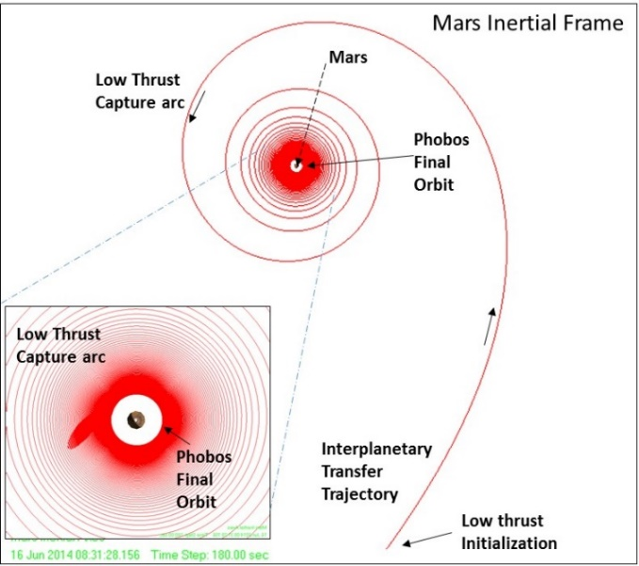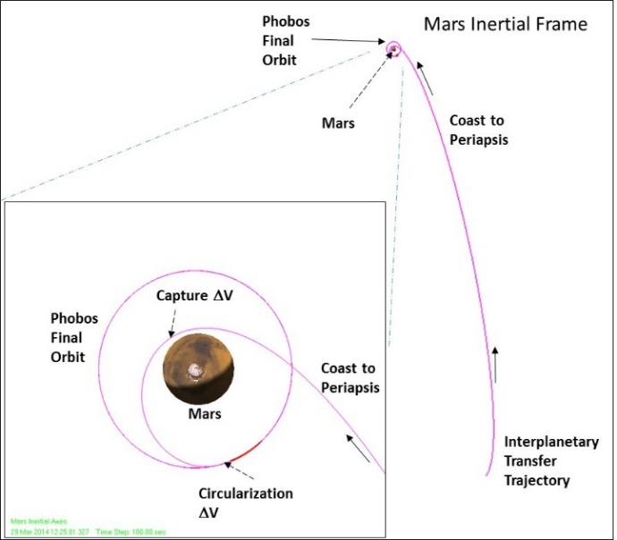
a) EP Trajectory Design b) Chemical Trajectory Design
Figure 15.6: Mars Capture to Phobos Orbit
  - Summary of Examples
The above non-optimal examples present feasible designs using the selected chemical and EP systems. Table 15.6 shows the results from each of these designs. The Figures of Merit that are prefixed with “Mission” are calculated based on the sizing results. The Figures of Merit that are prefixed with “Spacecraft” or “Propulsion System” are based on the capability of the selected propulsion system within the spacecraft bus, as defined in Table 15.3.
Table 15.6 shows missions using the EP system are more efficient with respect to propellant use, but requires longer maneuver durations. Longer maneuvers lead to longer mission operational support (including navigation tracking during the maneuver) and hence greater mission cost. The selected chemical system provides lower transfer times for the lunar and libration trajectories. However, the selected chemical propulsion system is not feasible for the planetary mission.
Table 15.6: Comparison Parameters for Chemical and Electric Propulsion Systems
 | Lunar Chemical | Lunar EP | Libration Chemical | Libration EP | Planetary Chemical | Planetary EP
Spacecraft Wet Mass (kg) | 23.1 | 24.0 | 22.0 | 24.0 | 54.6 | 24.0
Insertion Δv (m/s) | 269.5 | 730.0 | 174.0 | 172.0 | 1970.5 | 1935.0
Effective I_{sp} (sec) | 201.9 | 2,160.0 | 201.9 | 2,160.0 | 201.9 | 2,160.0
Δv Propellant Mass (kg) | 2.9 | 0.4 | 1.9 | 0.2 | 34.4 | 2.1
Mission Propellant Mass (kg) | 3.1 | 0.4 | 2.0 | 0.2 | 34.6 | 2.1
Mission Propellant Volume (L) | 2.5 | 0.1 | 1.6 | 0.04 | 27.9 | 0.5
Mission Total Impulse (Ns) | 6,173.3 | 8,472.9 | 4,017.9 | 4,024.6 | 68,472.1 | 44,483.0
Mission Propellant Mass Fraction (%)† | 15.6 | 1.5 | 10.1 | 0.7 | 172.9 | 8.4
Propulsion System Total Impulse (Ns)† | 11,285.8 | 63,547.1 | 11,285.8 | 63,547.1 | 11,285.8 | 63,547.1
Spacecraft Propellant Mass Fraction (%)† | 28.5 | 11.3 | 28.5 | 11.2 | 28.5 | 12.0
Propulsion System Propellant Mass (kg) | 5.7 | 3.0 | 5.7 | 3.0 | 5.7 | 3.0
Propulsion System Dry Mass (kg) | 9.0 | 3.0 | 9.0 | 3.0 | 9.0 | 3.0
Spacecraft Bus Dry Mass w/o Prop. Sys. (kg) | 11.0 | 23.6 | 11.0 | 23.8 | 11.0 | 21.9
Burn Duration  (hrs.) | 0.5 | 1980.0 | 0.3 | 465.8 | 5.3 | 5148.5
Total Transfer Time (days) | 102.0 | 184.0 | 111.0 | 121.0 | 203.0 | 418.0
† Based on propellant capacity listed in Table 15.3.

- Conclusion
This chapter discussed the methods used to assess and size a CubeSat propulsion system. The Figures of Merit and TRLs help mission designers evaluate the systems on the market. The examples presented illustrate how to size a system for different types of missions. Each of these designs highlight various considerations and trades that could be made to reach an optimal system, such as a lighter weight chemical system with similar performance compared to what is being assessed, or a lower power EP system with higher thrust. Other trades that could be made include using a lighter mission payload (e.g., communications system, instrument, etc.), other trajectory options, or making a lighter structure. Frequently these design iterations take many weeks, or months, to close, but, understanding and proper application of these tools will lead to successful missions.
- References
- Humble, R., Henry, G., & Larson, W. (Eds.). (1995). Space Propulsion Analysis and Design (Rev.). New York, NY: McGraw-Hill Co.
- Wertz, J., Everett, D., Puschell, J. (Eds.). (2011). Space Mission Analysis and Design. Space Technology Library Space Technology Series. El Segundo, CA: Microcosm Press. Dordrecht, Netherlands: Kluwer Academic Publishers.
- Sutton, G., Biblarz, O. (Eds.). Rocket Propulsion Elements (7th ed.). New York, NY: John Wiley & Sons, Inc.
- Brown, C. (1996). Spacecraft Propulsion. AIAA Education Series. Washington, D.C.: American Institute of Aeronautics and Astronautics, Inc.
- “Space Systems – Metallic Pressure Vessels, Pressurized Structures, and Pressure Components,” ANSI/AIAA S-080A-2018, American Institute for Aeronautics and Astronautics, March 20, 2018.
- “NASA Expendable Launch Vehicle Payload Safety Requirements,” NASA-STD-8719.24, National Aeronautics and Space Administration, September 30, 2015.
- “Range Safety User Requirements Manual,” AFSPCMAN 91-710, United States Air Force Space Command, November 3, 2016.
- Hargus, W.A. and Singleton, J.T., “Annual Assessment of CubeSat Propulsion Technology and Maturity,” Proceedings of the 6th Government CubeSat Technical Interchange Meeting, Pasadena, CA, April 2014.
- Goebel, D., Katz, I., Fundamentals of Electric Propulsion: Ion and Hall Thrusters. JPL Space Science and Technology Series, Jet Propulsion Laboratory, California Institute of Technology, NASA, March 2008.
- Weston, S., State of the Art of Small Spacecraft Technology, Small Spacecraft Systems Virtual Institute. Ames Research Center, Moffett Field, CA, NASA/TP-2018-220027, 2018.
- “Mass Properties Control for Space Systems,” ANSI/AIAA S-120A, American Institute for Aeronautics and Astronautics, November 23, 2015.
- “Electrical Power Systems for Unmanned Spacecraft,” AIAA S-122, American Institute for Aeronautics and Astronautics, January 5, 2007.
- Willis, W., “Propulsion System Design for MDL Studies,” NASA Goddard Space Flight Center, Unpublished, July 2018.
- Courtney, D., Tsay, M., Demmons, N., “Busek SmallSat Technologies,” Planetary CubeSat Symposium, NASA Goddard Space Flight Center, August 2018.
- Folta, D., et al., Applications of multi-body dynamical environments: The ARTEMIS transfer trajectory design, Acta Astronautica, doi:10.1016/j.actaastro.2011.11.007.
- “NASA Systems Engineering Processes and Requirements,” NPR 7123.1, National Aeronautics and Space Administration, February 14, 2020.
- Hargus, W., “JANNAF Guidelines for the Application of Technology Readiness Levels (TRLs) to Micro-Propulsion Systems,” JDOC 2019-0004FO, JANNAF 10th Spacecraft Propulsion Meeting, Dec. 2019.
- “General Environmental Verification Standard (GEVS),” GSFC-STD-7000, National Aeronautics and Space Administration, April 22, 2013.
- Anflo, K., et al., “Flight Demonstration of New Thruster and Green Propellant Technology on The PRISMA Satellite,” SSC07-X2, 2007 Small Satellite Conference, Logan, UT, Aug. 2007.
- Blanco, P., Mungan, C., “Rocket Propulsion, Classical Relativity, and the Oberth Effect,” The Physics Teacher, 57, 439 (2019); https://doi.org/10.1119/1.5126818, Sept. 2019.
- Hevner, et al., “An Advanced Standard for CubeSats,” SSC11-II-3, 2011 Small Satellite Conference, Logan, UT, Aug. 2011.

