IAC-19-C3.4.1x49723

On-Orbit Flight Testing of the Roll-Out Solar Array

Matthew K. Chamberlainª*, Stephen H. Kiefer^{b}, Matt LaPointe^{c}, Pete LaCorte^{d}

ª NASA Langley Research Center, Hampton, VA 23681, matthew.k.chamberlain@nasa.gov
^{b} Deployable Space Systems, Santa Barbara, CA 93111, steve.kiefer@dss-space.com
^{c} Deployable Space Systems, Santa Barbara, CA 93111, matt.lapointe@dss-space.com
^{d} Deployable Space Systems, Santa Barbara, CA 93111, peter.lacorte@dss-space.com
* Corresponding Author

Abstract

The Roll-Out Solar Array (ROSA) is an innovative, lightweight solar array with a flexible substrate that makes use of the stored strain energy in its composite structural members to provide deployment without the use of motors while still packaging efficiently. The ROSA flight experiment was launched to the International Space Station (ISS) on June 3rd, 2017 as a part of the eleventh SpaceX commercial resupply mission. After two weeks of storage, ROSA was extracted from the Dragon spacecraft, deployed, and put through a week of tests to verify its structural characteristics as well as the performance of photovoltaics. The structural dynamics experiments included active excitation of out-of-plane bending modes, and a study of the thermal-structural interaction of the structure during day-night transitions. Data was gathered from a small number of accelerometers located at key points on the solar array and from cameras observing numerous photogrammetry targets spread out over the structure and the photovoltaic blanket. The goal in this effort was to better understand the performance of ROSA and to improve modeling efforts for future designs of similar solar arrays. Of particular interest are the first few system modes and mode shapes of the array, the amount of structural damping present, and degree of structural-thermal interaction seen during eclipse exit.
Keywords: (Roll-Out Solar Array, ROSA, solar array, International Space Station, flight testing, structural dynamics, high strain composites, STEM booms)

- Introduction
Growing demands for electrical power in space and the constant desire to generate such power more efficiently have driven the Air Force Research Laboratory (AFRL) and the National Aeronautics and Space Administration (NASA) to support the development of new photovoltaic architectures based around flexible blankets. Such architectures hold the promise of providing power using lighter structures that pack more efficiently than traditional rigid panel solar arrays, all at a lower cost. One such example of a new flexible blanket architecture is the Roll-Out Solar Array (ROSA) developed by Deployable Space Systems Inc. (DSS). ROSA is an unfurlable array that achieves high efficiency metrics and low cost through the use of photovoltaics and simple structural elements that can roll up in parallel to stow for launch [1]. The main structural elements are storable tubular extendible members (STEM) –sometimes referred to as slit tubes, boom, or STEM booms in this paper (see Fig. 1) [2]. The booms are constructed of a thin high-strain composite laminate carbon fiber reinforced epoxy (CFRP) that is flexible enough to permit them to be flattened and rolled up on a cylindrical mandrel for stowage and stiff enough to provide the energy needed to deploy the whole array in space [3-4]. The booms tension the flexible Integrated Modular Blanket Assembly (IMBA) between the mandrel and the root structure of the array. The IMBA consists of lightweight photovoltaic solar power modules (SPM) and their electrical harnessing attached to mesh. The use of the composite STEM booms to provide deployment energy eliminates the need for heavy motors and mechanisms in the array. This arrangement, coupled with an easily scalable design make ROSA attractive for a wide range of space missions. For a 15 kW wing, ROSA would reduce the mass by 33 percent and stowed volume by 75 percent compared to rigid panel arrays [5].
Neither the idea of rolling up a solar array nor using flexible photovoltaic blankets is entirely new. The ISS itself utilizes eight extremely large flexible solar arrays [6] as do Milstar communications satellites [7]. Both utilize complicated but stiff and reliable deployable masts as their means of deploying and tensioning their arrays. The initial solar arrays on the Hubble Space Telescope (HST) featured Flexible Roll-Up Solar Arrays (FRUSA) but had to be replaced because of unanticipated thermally-induced vibrations in their stainless steel Bi-STEM booms [8].
ROSA differs from these past designs in that it achieves low cost and high packaging efficiency while relying on a simple and light deployment mechanism built into the structure of the array, saving the weight of deployment motors and mechanisms. By making the structure out of a composite laminate with a low coefficient of thermal expansion, thermal effects like those seen on HST can be largely alleviated.

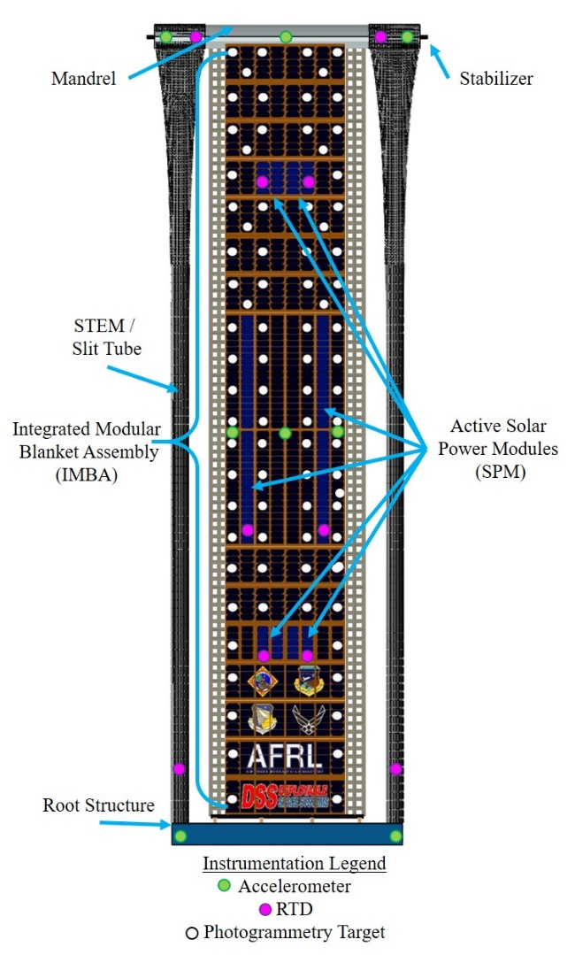
Fig. 1. Substructures and instrumentation of ROSA

One of the distinct challenges in developing any large deployable lightweight spacecraft structure is finding ways to validate its structural performance through testing on the ground. Realistic measurements of deployment effectiveness, structural modes, and, particularly damping, are difficult to obtain in an environment with gravity and air. Various tests can be carried out on the ground in thermal vacuum chambers and using offloading systems in order to validate computer models of predicted effectiveness, but finding testing facilities of the right scale is difficult and it is hard to anticipate all the complexities presented by operation in space [9]. Gravity offloading structures for large deployables can themselves require complex design and testing. For this reason, flight testing of lightweight space structures, when feasible, is especially attractive.
AFRL and DSS developed the ROSA flight experiment as a way of validating ground tests and model predictions of the performance of the solar array. The experiment was integrated and flown under the management and direction of the Department of Defense Space Test Program (STP). Launched on June 3rd, 2017 aboard the 11th NASA Commercial Resupply Mission, the experiment was conducted between June 17th and 25th aboard the International Space Station. A vast amount of data was gathered from structural, thermal, and photovoltaic experiments.
In this paper, the ROSA flight experiment objectives, design, and instrumentation are described at a high level. Highlights of the analysis of data from the experiments conducted on the ISS are shared as well. Finally, the conclusions drawn from experimentation and their implications for future use of ROSA and similar lightweight solar arrays are also discussed.

- Flight Experiment Objectives and Design
The ROSA flight experiment [10-15] featured a scaled down 5.40 meter long by 1.67 meter wide array partially populated with three different types of active solar cells. Unlike a typical ROSA implementation, the flight experiment was designed to be retracted by keeping the composite booms flattened to the mandrel even at full deployment and by attaching a lanyard and retraction motor to the mandrel. The entirety of the ROSA flight experiment was built on top of a Flight Releasable Attachment Mechanism (FRAM) that provided both a means of mounting inside the depressurized trunk portion of the Dragon spacecraft and an interface with the ISS Special Purpose Dexterous Manipulator (SPDM) for data and power transfer. Attached to the base plate of the experiment were power and data management equipment and cameras for verifying deployment. The base plate also included a system capable of exciting out-of-plane base motion for charactering wing structural dynamics This system was built around a stepper motorand ball screw attached to the center of the root structure of the solar array. This arrangement allowed for very fine control of out of plane motion while guide rails on either side of the root of the array restrained it from moving in any other direction. The flight experiment in its stowed configuration on the FRAM is shown in Fig. 2.
Two weeks after launch, ROSA was removed from Dragon using the SPDM and positioned for deployment. Over the next seven days, ROSA was the subject of a series of experiments meant to achieve the four main objectives discussed in the subsections below.

  - Objective #1: Verify Deployment
The first objective of the flight experiment and the first to be completed was to verify the ability of ROSA to deploy itself in microgravity. Deployment had been tested extensively on the ground prior to launch using various gravity offloading systems as shown in Fig. 3, but such systems create additional unrealistic point loads, inertias, and frictions that will not be present in space. One of the reasons to test in space is to discover the “unknown unknowns” of deployment. The International Space Station was a great platform to this end because it provided five full-motion video cameras that were focused on the wing during deployment as well as a means of viewing wing diagnostic data in real time through the SPDM connection.

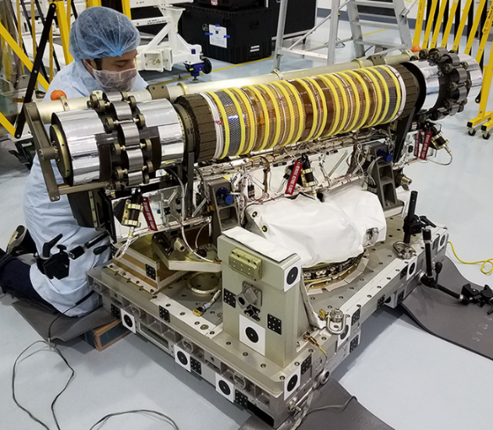
Fig. 2. ROSA stowed for launch [Image Credit: DoD Space Test Program]

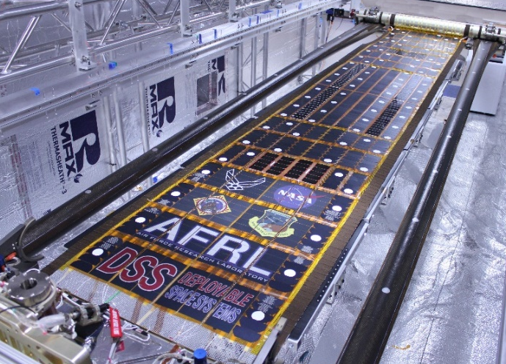
Fig. 3. ROSA during ground deployment testing in a thermal chamber [Image Credit: Deployable Space Systems, Inc.]

  - Objective #2: Verify Structural Dynamics
The second objective of the flight experiment was to measure the fundamental frequency of natural vibration, the corresponding mode shape, and its damping to help validate structural model predictions. As a secondary element of this objective, it was also desirable to characterize any other modes and mode shapes below 2 Hz. The dynamic structural response of large space structures like ROSA is one of the most difficult quantities to accurately measure on the ground due to the interaction that temperature, vacuum, and gravity have on a lightweight tensioned blanket system. Operational spacecraft are dynamic vehicles, commonly rotating to track objects, thrusting to maintain orbit, and gimballing solar arrays to point at the sun. Any large appendage such as a solar array deforms and oscillates in response to these motions. If the appendage vibrates at a frequency near or below that of the spacecraft controller, it can cause the vehicle to lose attitude control. Thus accurately predicting these frequencies of vibration and critical damping constants is important.
The ROSA flight experiment was designed around the objective of exciting the first structural mode by permitting the root of the wing to move out of plane on two sliders after deployment. A linear actuator powered by a stepper motor built into the root structure of the wing was used to impart sinusoidal out-of-plane motion with a prescribed amplitude and frequency during experimentation. Pre-flight modeling and ground testing showed that this excitation should easily excite the primary structural mode of ROSA and a number of higher frequency modes.

  - Objective #3: Assess Thermal Performance
The third objective of the ROSA flight was to measure the structural vibration response to rapid temperature change when transitioning from orbital night to daylight and vice versa. As a relatively thin structure, the rapid change in lighting at eclipse causes the entirety of the solar array to change temperature at a high rate. If that rapid heating were to occur on the same time scale as the natural period of structural vibration, it might cause the wing to vibrate. In fact, this thermally-induced snap was the primary reason for replacing the first Hubble Space Telescope solar arrays. Hubble used relatively small diameter stainless steel Bi-STEM overlapped booms while ROSA uses larger diameter dimensionally stable carbon fiber epoxy composite STEM booms that do not overlap. Therefore no thermal vibration behavior was expected on ROSA due to the low coefficient of thermal expansion of the composite.

  - Objective #4: Evaluate Power Generation
The final objective of the flight experiment was to evaluate the robustness of the solar power modules and harnessing used on ROSA. Northrup Grumman, Spectrolab, and SolAero each provided two functional SPMs to be integrated into the flight experiment. One SPM from each manufacturer was placed on each side of the array. In total, the six strings of solar cells were capable of generating 300 W of power but only covered ten percent of the total surface area of the solar array. The remaining area of the array was filled with mass simulators to reduce cost of the experiment while accurately representing the mass and stiffness distribution of a fully populated wing. The goal in having active SPMs on the array was not to test the industry standard solar cells in themselves but rather to make sure that they could survive storage, launch, and deployment as elements of the ROSA architecture. By placing the SPMs on either side of the array, the hope was that any damage would be localized to one side an apparent in comparisons of the power generated on orbit.

- Flight Operations And Instrumentation
Two weeks after launch, the ROSA flight experiment was removed from the trunk of Dragon and positioned using the SPDM in such a way that it had maximum visibility and ideal lighting for viewing from a number of high definition cameras located on the outside of the ISS. Once in place, the SPDM joints were held in place throughout deployment and the vast majority of dynamics experiments. After several days of structural dynamics and thermal/structural experiments, the SPDM was repositioned so that ROSA had as close to a perpendicular angle of incidence with the sun as safely possible to test the photovoltaics in the solar array blanket.
Throughout experimentation, live streams of several cameras on or around ROSA were available as was a live downlink of various wing diagnostics at a rate of 20 Hz. Later, full sets of data from the experiments of greatest interest were downloaded at a sampling rate of 200 Hz. The live streams of data allowed controllers on the ground to rapidly assess results and make changes to the test plan on the fly. This arrangement proved especially useful during structural testing and when planning tests around eclipse cycles and data dropouts.
Structural dynamics were primarily measured in real-time using single degree of freedom accelerometers placed at the root of the booms, on the mandrel and at the center of the blanket as shown in Fig. 1. These accelerometers were oriented so that they measured only out-of-plane motion. A single triaxial accelerometer was placed on the baseplate of ROSA but was damaged prior to launch.
A second source of structural dynamics data was photogrammetric analysis of video shot of the array using ISS external cameras. The entirety of ROSA and its FRAM were covered with various photogrammetry targets including orange spheres on the array stabilizer, black circular targets on the FRAM, retroreflective silver circles on the IMBA, and silver permanent marker circles on the slit tubes (see Figs. 1 - 3). Each type of target was chosen based on location, lighting, and the expected contrast between the target and its background. For instance, retroreflective stickers could not be added to the slit tubes due to fear that their adhesive could stick two layers of the tube together during stowage and interfere with deployment. Similarly, since the only sources of light besides earth albedo would be coming from the ISS and Sun located perpendicular to the array, retroreflectors were judged to be of little use on the sides or back face of the solar array and FRAM. When in low earth orbit, the constantly-shifting light made it difficult to consistently distinguish any of the targets except the retroreflective stickers on the IMBA, as shown in Fig. 4.
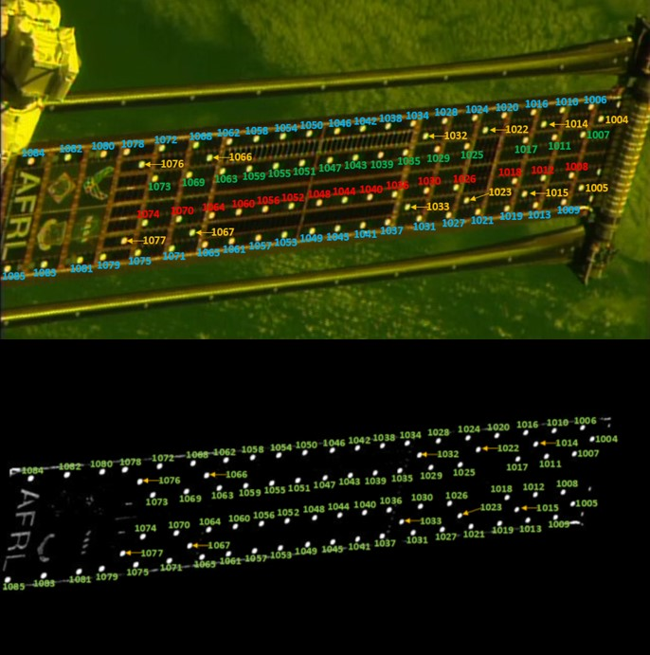
Fig. 4. Numbered images of photogrammetry targets during daytime (top) and night (bottom)

Finally, the wing was instrumented with 21 resistance temperature detectors (RTDs) on the tip mandrel and blanket to evaluate any thermally-induced vibrations in the wing.

- Experimental Results and Discussion
Each of the four scientific objectives of the ROSA flight experiment was accomplished. In this section, the experiments carried out to accomplish each goal is described in the order in which they occurred during the window of ROSA flight operations.

4.1 Deployment
On command, ROSA released its launch restraint bolts and unfurled to its full-length in 3 minutes 21 seconds under the power of the stored strain energy in the high strain composite STEM booms. It is shown fully deployed on the end of the SPDM in Fig. 5. Five cameras on the outside of the ISS and four cameras on board the ROSA flight experiment recorded the deployment from various angles and verified the function of certain mechanisms in the array.
The measured deployment time was within 2 seconds of that observed in deployment tests on the ground, indicating the mechanisms and composite booms were healthy after 10 months of storage, launch, and 215 on-orbit thermal cycles. The torque delivered by the booms during deployment was inferred based on the current from a damper used to control the rolled STEM boom. During deployment on-orbit, each boom output 32 lb-in +/-3 lb-in whereas on the ground they output 35 lb-in +/-1 lb-in. The correlation of this torque output is a testament to the robust understanding and test qualification practices used in this new deployable boom material system consisting of high strain carbon fiber composites.
The thin mesh blanket unrolled along with the booms and was lightly tensioned at the end of deployment. A subsequent operation activated a tensioning system, applying 19 lb of total force to the blanket through four discrete constant-force springs evenly spaced along its root edge.

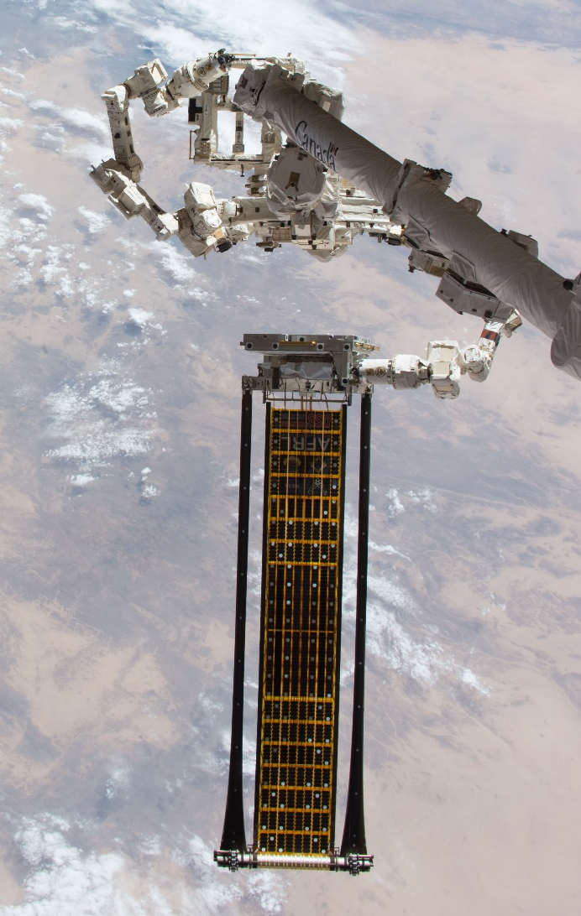
Fig. 5. ROSA flight experiment deployed on ISS with SPD shown at top [Image Credit: NASA JSC]

Retraction of the solar array was not considered a scientific objective but rather a housekeeping requirement as plans called for ROSA to be re-stowed in the trunk of the Dragon capsule for disposal. Following the conclusion of other experiments, retraction was attempted June 25th. A lanyard drawn in by a motor successfully rolled the STEM booms and tensioned blanket to within millimetres of the stowed position but a slight telescoping misalignment prevented stowage latches from engaging. Allowed to re-deploy, ROSA unfurled in approximately the same time it had originally taken to deploy. Retraction was attempted two more times without success so two more successful deployments also occurred. Since stowage inside the trunk of Dragon was impossible in the deployed state, NASA made the decision to jettison ROSA into the atmosphere from its FRAM using a built-in custom Lightband mechanism. This planned contingency was carried out on June 26th, 2017 as shown in Fig. 6.

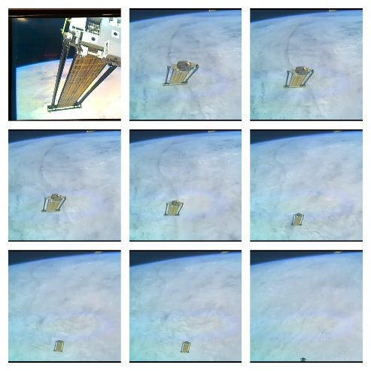
Fig. 6. Montage of ROSA during jettison

4.2 Structural Dynamics
Prior to flight, two teams of analysts had created finite element models of ROSA and calibrated these models based on the ground testing in a thermal vacuum chamber. The biggest difference between the two models was that one was constructed in Abaqus [16] using an interconnected series of beam elements with their stiffness similar to the IMBA mesh as the structure of the blanket while the other utilized ANSYS [17] to model the IMBA as a series of shell elements. The models were created independently as an internal check on pre-flight predictions and were not intended as a test of the relative performance of the different software packages or modelling approaches. As is shown in Tables 1 and 2, the models resulted in similar first structural modes at about 0.5 Hz but the shell-based blanket model was able to predict more complex blanket mode shapes. It also was able to predict eleven modes below 2 Hz whereas the model using a mesh of beam elements only predicted 5 modes in the same range. Following comparison with thermal vacuum testing results, these models were adjusted and used to predict the in-flight structural dynamics of ROSA and plan the experiments meant to excite the structural modes [18-19].

Table 1. Selected pre-flight finite element predictions of structural modes
Description of Predicted Mode Shape |  |  |  |  | ANSYS Shell Blanket Model |  |  |  |  |  |  |  | Abaqus Mesh Blanket Model
 |  |  |  |  | Mode |  |  | Predicted Frequency (Hz) |  |  |  |  | Mode |  | Predicted Frequency (Hz)
Structural Bending |  |  |  |  | 1 |  |  | 0.54 |  |  |  |  | 1 |  | 0.50
Structural Torsion |  |  |  |  | 2 |  |  | 0.66 |  |  |  |  | 2 |  | 0.64
Blanket Torsion |  |  |  |  | 3 |  |  | 0.91 |  |  |  |  | 4 |  | 1.24
Blanket Saddle |  |  |  |  | 4 |  |  | 0.93 |  |  |  |  | * |  | *
Blanket Drum |  |  |  |  | 5 |  |  | 0.94 |  |  |  |  | 3 |  | 0.98
2nd Order Lateral Blanket Drum |  |  |  |  | 6 |  |  | 1.12 |  |  |  |  | * |  | *
3rd Order Lateral Blanket Drum |  |  |  |  | 7 |  |  | 1.49 |  |  |  |  | * |  | *
2nd Order Blanket Twist |  |  |  |  | 8 |  |  | 1.78 |  |  |  |  | * |  | *
2nd Order Blanket Drum |  |  |  |  | 9 |  |  | 1.79 |  |  |  |  | 5 |  | 1.88
2nd Order Blanket Saddle |  |  |  |  | 10 |  |  | 1.82 |  |  |  |  | * |  | *
In-Plane Bending |  |  |  |  | 11 |  |  | 1.87 |  |  |  |  | 6 |  | 2.22
* Indicates that shape was not predicted by FEM prior to flight
Table 2. Selected predicted FEM mode shapes
Description |  | Structural Bending |  | Structural Torsion |  |  | Blanket Torsion |  | Blanket Saddle |  | Blanket Drum |  |  | 2nd Order Lateral Blanket Drum |  | 2nd Order Blanket Drum | In-Plane Bending
FEM Mode Shape |  | 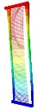 |  | 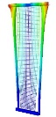 |  |  |  |  | 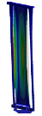 |  | 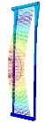 |  |  | 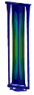 |  | 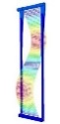 | 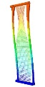
Table 3. Structural dynamics results based on accelerometer data
Mode | ANSYS Predicted Frequency (Hz) |  | Abaqus Predicted Frequency (Hz) |  |  | Measured Frequency from Acccelerometers (Hz) |  |  |  | Measured Damping (%) |  | Actual Mode Shape Observed
1 | 0.54 |  | 0.50 |  |  | 0.41 |  |  |  | 3.50 |  | 1st structural bending
2 | 0.66 |  | 0.64 |  |  | 0.60 |  |  |  | 3.90 |  | 1st structural torsion & right edge flap
3 | * |  | * |  |  | 0.66 |  |  |  | 1.60 |  | 1st structural torsion & right edge flap
4 | * |  | * |  |  | 0.81 |  |  |  | 1.70 |  | Left blanket edge flap
5 | * |  | * |  |  | 0.91 |  |  |  | 0.85 |  | 1st blanket drum/saddle (day)
6 | * |  | * |  |  | 1.18 |  |  |  | 1.55 |  | 1st blanket drum/saddle (night)
7 | * |  | * |  |  | 1.71 |  |  |  | 0.70 |  | 3rd order right blanket edge flap
8 | * |  | * |  |  | 1.80 |  |  |  | 1.05 |  | 2nd order blanket drum/saddle
* Indicates that shape was not predicted by FEM prior to flight
The other unexpected phenomena was that the right edge of the IMBA blanket seemed to vibrate at greater amplitude and lower frequency than the left edge. At some excitation frequencies, it appeared that the predicted simple structural modes of the blanket were split into two with distinct right and left mode shapes. It is hypothesized that this behaviour was caused by uneven tensioning across the width of the blanket although the cause of the unevenness is not known. Post-flight modelling in which tension was dropped to nearly zero along the right edge produced similar structural modes.
Rigorous analysis [18] of the downloaded accelerometer data by two separate teams identified at least eight structural modes below 2 Hz, and quantified the damping associated with each mode as shown in Table 3. Finite element predictions of the structural torsion mode and the blanket drum mode are very close to their measured values but many other blanket modes seen in testing involved the right edge moving independently or smeared together, something pre-flight modelling could not have anticipated. For instance, the measured mode shape that looked like a combination of “saddle” and “drum” modes was found near the pre-flight ANSYS predictions for both of those modes. Damping for the modes below 2 Hz varies between 0.7% and 3.9% but the higher modes in that group tend to have lower damping perhaps because they are not as heavily affected by interaction between the array and the ISS robot arm [18].
Photogrammetric analysis of video provided a second way of testing the structural dynamics of ROSA. Unfortunately, most of the targets placed on the array proved too hard to resolve from the cameras on the ISS. The retroreflective circles covering the blanket were the exception. Many of them were visible for large portions of both daylight and night experimental runs in large enough numbers to give a far better impression of the shape of the IMBA when the blanket was excited than could be extrapolated from the six accelerometers alone.
Two teams, one from NASA Langley Research Center (LaRC) and another from NASA Johnson Space Center (JSC), independently analyzed video recordings from a select set of four experimental runs to extract time histories of the displacements of the targets [22]. The four experimental runs that were selected were the ones in which accelerometer data indicated the highest responses to input excitation and they were chosen so as to have a complete range of system responses up to 2 Hz. One run was a night experiment in which the blanket modes were excited. The Eigenvalue Realization Algorithm (ERA) [20-21] was used to reconstruct the mode shape associated with each mode seen in the time histories from a given run. In general, the structural modes identified through photogrammetry agree with the results obtained from accelerometer data. As shown in Table 4, they also provide a better appreciation of the intricacies of the blanket mode shapes, especially at higher frequencies.
Several interesting trends were noted in the structural modes besides the low fundamental frequency. First, the loose right edge of the blanket sometimes shows up alone at about 0.61 Hz but is often combined with the structural torsion mode. This combination of mode shapes appears again around 0.66 Hz. Second, the predicted “drum” and “saddle” modes do not appear separately as predicted by pre-flight modelling. Instead, a combined mode is observed around 0.89 Hz during daytime runs and 1.14 Hz during experimental runs when the wing was in eclipse. It is possible that these are actually one mode that shifts based on the wing temperature. Three other modes (the 2nd, 3rd, and 4th) each had varied frequencies that measured between 2% and 4% higher at night than during the day –perhaps due to tightening of metallic elements in the blanket tensioning system. Further finite element model calibration will be needed in the future to help explain the origin of all of the combined mode shapes observed on-orbit.

Table 4. Measured modes with photogrammetry-based mode shapes
Mode | Measured On-Orbit Frequency (Hz) | Blanket Mode Shape
1 | 0.39 | 1st structural bending
 |  | 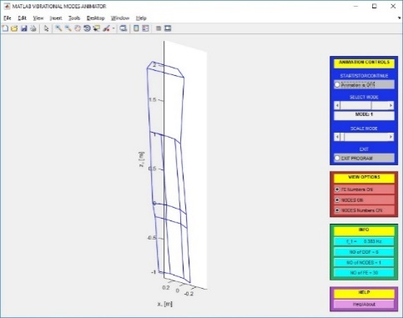
2 | 0.61 | 1st structural torsion and right blanket edge flap
 |  | 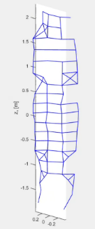
3 | 0.66 | 1st structural torsion and right blanket edge flap
 |  | 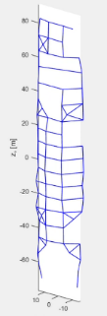
4 | 0.78 | Left blanket edge flapping
 |  | 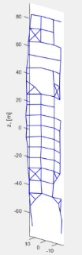
5 | 0.89 | 1st blanket drum/saddle (day)
 |  | 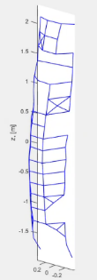
6 | 1.14 | 1st blanket drum/saddle (night)
 |  | 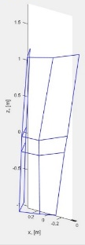
7 | 1.64 | 3rd order right blanket edge flap
 |  | 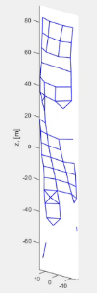
8 | 1.83 | 2nd order blanket drum/saddle
 |  | 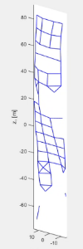

Isolating the shape of the blanket modes just below 2 Hz was difficult. In Fast Fourier Transforms of the data gathered in this range, the mode or modes are not as clearly defined as others. It is possible that with the loose right blanket edge, the cluster of blanket modes were predicted to be found between 1.78 and 1.87 Hz have either combined or become even closer to each other.
It is the judgement of the authors that the plate-based finite element model of ROSA likely would have provided a good estimate of the on-orbit dynamics had the wing not experienced low right edge blanket tension and unexpected interaction with the ISS robot arm. Similarly, the other finite element model likely would have estimated the first mode well. The simpler Abaqus model however could not model more complex high-order blanket modes.

4.3 Wing Thermal Performance
The temperatures of the STEM booms and SPMs were recorded constantly throughout the mission. Besides the 90 minute day/night cycle in low earth orbit, temperatures were affected by the numerous shadows cast by the space station, sometimes causing differentials between particular SPMs or between the two booms. This is shown for one orbit in Fig. 7. The absolute minimum and maximum temperatures observed (see Table 5) were associated with deep night bright daylight respectively and were consistent with the worst-case thermal analysis predictions. During sunrise, the STEM temperature rose approximately 7 °C per minute for the first four minutes, peaking at 77 °C during full solar illumination. During sunset, STEM temperature dropped 12 °C per minute for the first 4 minutes, settling at a minimum of -46 °C.
The SPM temperatures followed a similar but less severe trend except that one of the SPMs located near the center of the blanket dropped down to -55 °C just before sunrise, colder than the STEMs. The maximum SPM temperature peaked at 38 °C.
During structural dynamics testing, it was noted that certain blanket modes (2nd, 3rd, and 4th) from low temperature night-time runs had higher frequencies than modes with the same shape that were reconstructed from warmer daytime runs. In addition, some blanket modes seemed to be associated solely with daylight or night temperatures. The exact cause of this shift is not known but could be related to the blanket tensioning system.
Accelerometer data from two eclipse entries and four eclipse exits was also examined for signs of significant dynamic behavior induced by the sudden change of temperature experienced in either situation. During the two eclipse entries examined, no significant dynamic events were noted. For eclipse exits, a small amount of out of plane vibration was observed just after daybreak and took several minutes to damp out. This activity appeared to be localized to the IMBA and occurred at frequencies well above the major structural and blanket modes observed during the dynamics excitation. The peak accelerations seen during this activity after sunrise was an order of magnitude below that seen during sine sweep tests and appeared to have little active modal effective mass.

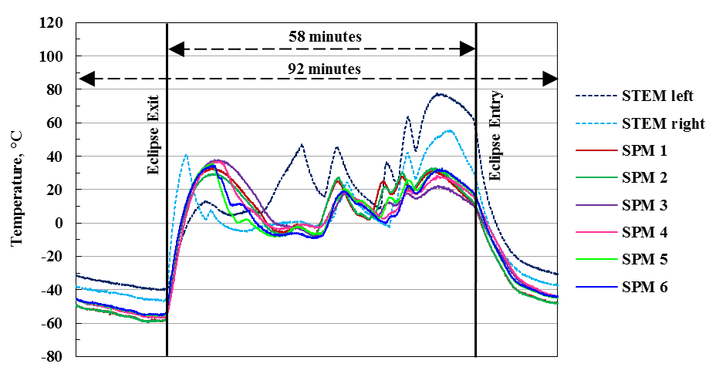
Fig. 7. Typical temperature profile during an orbit[5]

Table 5. Measured STEM boom temperature
 |  | Ground Tests |  | On-orbit Measured
 |  | Max | Min | Max | Min
Deployment |  | 90°C | -65°C | 54°C | 0°C
Deployed |  | -- | -- | 77°C | -46°C
Eclipse Exit |  | -- | -- | 7°C/min
Eclipse Entry |  | -- | -- | -12°C/min

4.4 Power Production
The ability of the active SPMs and their harnessing to survive through ten months of storage, launch, hundreds of day/night thermal cycles, and deployment was assessed by measuring the temperature, voltage, and current output of each SPM across a shunt resistor with the array repositioned for more perpendicular exposure to sunlight. The voltage sweeps were conducted while the sun incidence angle was within +/-30 degrees of the wing normal but exact incidence angle could not be measured. Five sweeps were performed on each SPM with two sets of sweeps performed per orbit over two orbits for a total of 20 sweeps per SPM. Without accurate incidence angle measurements, efficiency is hard to judge but power could be calculated. The voltage and current data points from the sweeps were adjusted based on the measured array temperature in space to match manufacturer measured values at known temperatures and curve-fit to a sinusoidal shape with the same period as the orbit of the ISS (92.65 minutes) as shown in Fig. 8. This curve could then be translated into the time domain and the maximum power calculated. Compared to the identical SPMs on either side of the array, the performance throughout the sweeps was nearly identical, with a maximum 1-2 % difference in power output for each manufacturer. Ignoring the unlikely occurrence that each of the sets of SPM samples had been damaged in identical ways during launch, these results indicate that they were in fact completely undamaged and had not been degraded during their journey into space [5, 14].

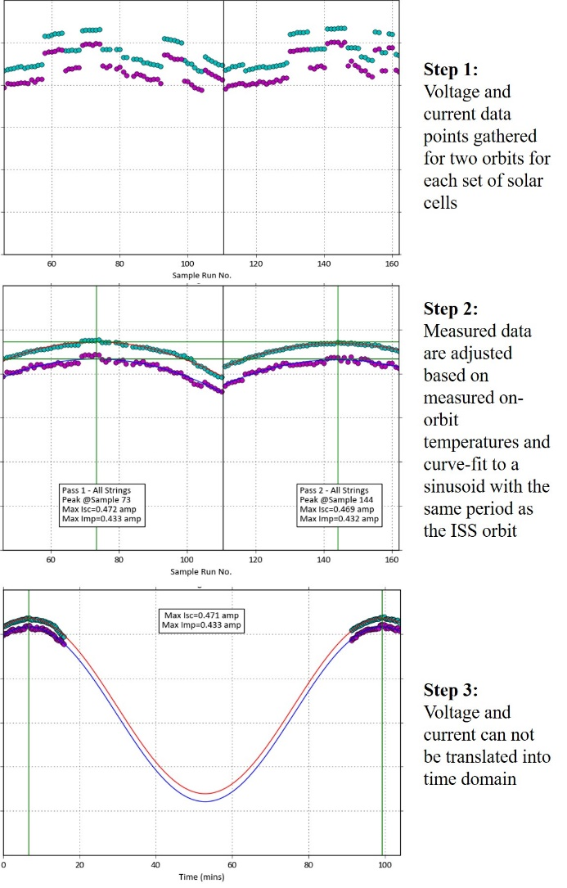
Fig. 8. Fitting measured voltage and current to orbital period to find estimated maximum power

- Closing Thoughts
The ROSA flight experiment successfully accomplished all of its scientific objectives. Deployment was successful and occurred in nearly the exact same amount of time measured on the ground. The array was subsequently retracted and subsequently re-deployed three times. The torque delivered by the high strain composite booms during deployment correlated well with ground tests, proving that the STEM boom development process had generated a solid understanding of the behavior of the composite.
The structural dynamics of ROSA were the most thoroughly studied aspect of the array during the flight experiment. Both the primary and secondary objectives of the structural dynamics experiments were achieved in that the primary structural mode was identified and a number of modes below 2 Hz were also characterized. Throughout five days of testing, the driven dynamics of the solar array were consistent and it exhibited a stable thermal-structural response. The primary structural mode was 20% below its expected value, was harder to excite in space than on the ground, and appeared highly damped. Analysis of video and ISS robot arm torques indicates that ROSA and the arm were exhibiting coupled dynamics. Despite another anomaly in the behavior of one side of the solar array blanket, the structural torsion mode and blanket drum mode were found measured within 10% of their predicted values. Damping of each of the structural modes below 2Hz was found to vary between 0.7 and 3.9% on-orbit. Finally, photogrammetry proved a useful tool for measuring the dynamics of the solar array blanket, especially at higher frequencies as the mode shapes became more complex.
The advantages of the use of materials with low coefficients of thermal expansion were shown in the relatively benign thermal performance of ROSA throughout testing. Although some structural modes may have shifted between day and night, no significant structural response was induced by shadows or the rapid temperature changes coming into or emerging from eclipse.
Photovoltaic power conversion from the six active strings of solar cells was at expected levels, indicating that standard SPMs and their harnessing will see no ill effects from rolling, storage, launch, thermal cycling or deployment as a part of a lightweight ROSA-like solar array.
Looking beyond the huge volume of data collected, the experiment represented the first deployment of a new solar array architecture in space and the first ever deployment of high-strain composite STEM booms. It merits pointing out that the International Space Station proved an amazing resource for this experiment and could do so for other deployable structures –especially those gossamer structures for which instrumentation is difficult.
The authors hope that the example of the ROSA flight experiment will help to inspire further large scale deployable structure experiments on the ISS and wider acceptance of the use of high strain composites. The overall performance of a ROSA-type array is now much better understood, which should make commercial, civilian, and military mission planners more comfortable with scaling the design to serve various missions in need of its ability to deliver large power outputs in a lightweight and compact form factor. Space Systems Loral (now part of Maxar Technologies) is already building and testing a larger version of ROSA that is being offered to customers with all of its spacecraft [13]. Since the flight experiment, ROSA arrays have also been selected for launch in 2022 as part of the power and propulsion element (PPE) –the first module of NASA’s planned Lunar Gateway [23]. The PPE makes use of solar electric propulsion, a technology popularly suggested as a means for transporting cargo to and from destinations such as Mars but which depends on the availability of large, relatively light solar arrays. ROSA arrays will also fly aboard the NASA Double Asteroid Redirection Test (DART) mission scheduled to launch in 2022 [24]. The data collected during the ISS experiment is already being used to predict the frequency and mode shapes of these larger wings [25].

Acknowledgements
This flight experiment has required the tireless effort and unwavering support of dozens of individuals and organizations. Jeremy Banik of the AFRL Space Vehicles Directorate served as the principal investigator for the experiment and his organization provided principle experiment design, oversight, and sponsorship. Launch was brokered by and payload integration was funded and managed by the Department of Defense (DoD) Space Test Program (STP) Houston office. The Space Test Program developed the jettison system and the robotic interfaces to the OTCM. They also led the integration of the completed payload to the ISS and to the SpaceX Dragon capsule in addition to developing the command and data handling architecture needed to get from the payload to the ground, and commands from the ground to the payload. ROSA hardware design, development, construction, and testing was provided by Deployable Space Systems, Inc. Ecliptic Enterprises Corp. developed the data acquisition and control unit. LoadPath, LLC., in conjunction with AFRL fabricated and validated the composite slit tube columns and material system. Photogrammetry metrology system design and analysis was provided by the NASA Langley Research Center (LaRC) Advanced Measurements and Data Systems Branch and the Johnson Space Center (JSC) Image Science and Analysis Group. The LaRC Structural Dynamics Branch assisted with structural dynamics analysis predictions. Additional mission funding was provided by the U.S. Air Force Space and Missile Systems Center (SMC/AD).

References

- U.S. Patent 8,683,755 Directionally Controlled Elastically Deployable Roll-Out Solar Array, Spence, B., White, S., April 1, 2014.
- Rimrott, F.P.J, Storable Tubular Extendable Member - A Unique Machine Element, Journal of Machine Design, Vol. 37, 1965. pp. 156-165.
- Murphey, T., Francis, W., Davis, B., Mejia-Ariza, J., Santer, M., Footdale, J., Schmid, K., Soykasap, O., Guidanean, K., Warren, P., High Strain Composites, 2nd AIAA Spacecraft Structures Conference, Kissimmee, Florida, AIAA 2015-0942, 5-9 January, 2015.
- Sanford, G., Banik, J., Structural Testing of a Slender Composite Slit-Tube, 20th International Conference on Composite Materials, Copenhagen, 19-24 July 2015.
- Banik, J.A., Kiefer, S.H., LaPointe, M. and P. LaCorte, On-Orbit validation of the Roll-Out Solar Array, 39th IEEE Aerospace Conference, 3-10 March 2018, Big Sky, MT.
- E. Thornton, G. Chini, D. Gulick, Thermally Induced Vibrations of a Self-Shadowed Split-Blanket Solar Array, 35th AIAA Structures Structural Dynamics and Materials Conference, AIAA-94-1379, Hilton Head, SC, April 18-20, 1994.
- J. Gibb, MILSTAR’s Flexible Substrate Solar Array—Lessons Learned. 26th Aerospace Mechanisms Symposium, NASA Goddard Space Flight Center, 1992.
- E, Thornton, Y. Kim, Thermally induced bending vibrations of a flexible rolled-up solar array, AIAA Journal of Spacecraft and Rockets, vol. 30, no. 24, pp. 438-448, 1993.
- Banik, J.A., and Urioste, B.J., Space Flight Testing, in: Testing Large Ultra-Lightweight Spacecraft, AIAA Progress Series in Aeronautics and Astronautics. Vol 253. 2017. Editors: Banik, J., Jenkins, C., pp. 215-253.
- Banik, J.A., and Hausgen, P., Roll-Out Solar Arrays (ROSA): Next Generation Flexible Solar Array Technology for DoD Spacecraft, 2017 AIAA SPACE and Astronautics Forum and Exposition, 12-14 September 2017, Orlando, Florida. AIAA-2017-5307.
- ASA homepage, International Space Station Research and Technology, Roll Out Solar Array (ROSA), https://www.nasa.gov/mission_pages/station/research/experiments/2139.html, (accessed April 15, 2017).
- Werner, D., Market Disruptor, Aerospace America, October, pp. 34-38, 2017.
- Genna, M., Innovation: Solar Array Success for SSL Implementation—A Space Systems Loral Focus, SatMagazine, September, pp. 104-105, 2017.
- Spence, B., LaPointe, M., White, S., LaCorte, P., and S. Kiefer, International Space Station (ISS) ROSA Solar Array Flight Experiment Mission and Results, 36th Annual Space Power Workshop, 23-25 April 2018, Los Angeles.
- Yates, H. and B. Hoang, SSL ROSA Qualification Status, 36th Annual Space Power Workshop, 23-25 April 2018, Los Angeles.
- Abaqus/CAE 6.14 User’s Guide, Dassault Systèmes Simulia Corp., Providence, RI, USA.
- ANSYS® Mechanical, Release 18.2, Help System, Mechanical User’s Guide, ANSYS, Inc, Canonsburg, PA, USA.
- Chamberlain, M.K., Kiefer, S.H., and Banik, J.A., On-Orbit Structural Dynamics Performance of the Roll-Out Solar Array, 4th AIAA Spacecraft Structures Conference, AIAA SciTech Forum, 8-12 January 2018, Orlando, FL. AIAA-2018-1942.
- Chamberlain, M.K., Kiefer, S.H., and Banik, J.A., Structural Analysis Methods for the Roll-Out Solar Array Flight Experiment, 5th AIAA Spacecraft Structures Conference, AIAA SciTech Forum, 7-11 January 2019, San Diego, CA. AIAA-2019-2376.
- Juang, J.-N., Horta, L.G., and Phan, M.: System/Observer/Controller Identification Toolbox from Input/Output Measurement Data. User's Guide, NASA TM-107566, 1992.
- Horta, L.G., Juang, J-N, and Chen, C.-W.: Frequency Domain Identification Toolbox. NASA TM-109039, 1996.
- Chamberlain, M.K., Kiefer, S.H., and Banik, J.A., Photogrammetry-Based Analysis of the On-orbit Structural Dynamics of the Roll-Out Solar Array, 5th AIAA Spacecraft Structures Conference, AIAA SciTech Forum, 7-11 January 2019, San Diego, CA. AIAA-2019-2375.
- Maxar Press Release, Maxar Selected to Build, Fly First Element of NASA’s Lunar Gateway, May 23, 2019, https://www.businesswire.com/news/home/20190523005725/en/, (accessed September 27, 2019).
- Deployable Space Systems Press Release, DSS to Provide ROSA Solar Array for NASA’s Double Asteroid Redirection Test (DART) Mission, April 21, 2018, https://www.dss-space.com/post/dss-to-provide-rosa-solar-array-for-nasas-double-asteroid-redirection-test-dart-mission, (accessed September 30, 2019).
- Werner, D., Space Station Experiment May Reveal Future for Satellite Solar Arrays, AIAA Aerospace America. October 2017.

