Artemis Sustained Translational Acceleration Limits: Human Tolerance Evidence from Apollo to ISS

James M. Pattarini, NASA
Jeffrey T. Somers, KBR
Jacquelyn Charvat, KBR
Devan Petersen, KBR
Nathaniel Newby, KBR
Preston C. Greenhalgh, KBR
Michael B. Stenger, NASA
Stuart M. C. Lee, KBR

National Aeronautics and Space Administration
Lyndon B. Johnson Space Center
Houston, Texas 77058
June 2020

Table of Contents

- Introduction 3
II. Body Posture and Sustained Translational Acceleration Tolerance 3
III. Considerations for Artemis 2024 Mission 4
IV. Available Data 4
Apollo Data 4
Apollo Results 5
Flight Duration Effects on Orthostatic Tolerance 6
Sex Effects 7
Spaceflight Analogues 7
V. Countermeasures to Acceleration-Induced Hypotension 8
VI. Artemis Sustained Translational Acceleration Limits 9

- INTRODUCTION

The designers of the next generation of lunar landers may adopt novel, crew-body orientations outside of our flight history or applied to flight durations and environments outside of our experience. Current sustained translational acceleration requirements in NASA-STD-3001 are applicable only to crewmembers in a seated posture and are thus inadequate to address human tolerance in non-seated configurations. Initial designs for the Apollo Lunar Module (LM) included seats for both commander and pilot; however, these were subsequently removed from the vehicle due to mass constraints and a willingness to accept the unknown risks for short-duration missions given the limited human physiologic data at the time. In the years since Apollo, our evidence base has grown immensely.

Initial Artemis mission timelines under consideration will be longer than the longest Apollo mission, by a significant margin, with timeframes more analogous to longer Space Shuttle missions. Given the incidence of postflight orthostatic intolerance following shuttle missions, a significant risk may exist for lander design(s) pursuing a standing crew configuration similar to Apollo LM.

New sustained translational acceleration limits developed to address this risk are presented herein. These limits were derived from evaluations of Apollo biomedical and flight profile data during lunar descent and ascent operations, Soyuz and Space Shuttle flight profile and post-landing biomedical data, and analogue bed rest post-exposure data on orthostatic intolerance.

- BODY POSTURE AND SUSTAINED TRANSLATIONAL ACCELERATION TOLERANCE

Nearly all aircraft and spacecraft designed for humans have employed a seated, often-reclined, posture. This serves to reduce the resting workload of the pilot, but also significantly augments acceleration tolerance, a critical need in high-performance aircraft. For astronauts returning to Earth after a prolonged period in microgravity, a seated body posture combined with a seat/vehicle orientation to direct the vast majority of reentry acceleration loading into the +Gx (chest-to-back) vector has been employed for every vehicle designed to date over the past half century.

Humans experience a 10% to 20% decrease in cardiac output with a shift from seated to standing posture due to a decline in venous return and increased lower extremity venous filling due to gravity. This occurs in normal, healthy subjects without consideration of any deconditioning effects of spaceflight exposure (29). Conversely, lower extremity venous return is augmented by sitting, furthermore by squatting, with forward hip flexion and engagement of the abdominal muscles mobilizing additional return from the splanchnic vasculature (24, 5, 2, 26, 13, 29, 36). The range of non-straining, standing +G_{z} (head-to-foot) tolerance ranges from 19.62-49.05 m/s² for healthy subjects, contrasted with 68.67-88.29 m/s² for seated subjects of both sexes (33, 13, 5, 3, 4, 7).

The Apollo LM is the only spacecraft to date designed to be piloted in something other than a seated posture during periods of acceleration loading. The short-mission durations, lack of data on cardiovascular deconditioning in microgravity, relatively mild acceleration profiles (discussed in detail below), and tight vehicle mass constraints all contributed to the choice to allow crew to pilot the vehicle in a standing posture for both lunar descent and ascent operations (14).

- CONSIDERATIONS FOR 2024 LUNAR MISSION

The Artemis mission architecture differs significantly from Apollo mission design in a number of key factors that may have an impact on crew performance at the time of Human Landing System (HLS) acceleration loading. Artemis Phase 1 missions using the Lunar Gateway will more than double the time spent in microgravity before descent to the lunar surface (4.5 days for Apollo vs. 10-11 days from Earth to HLS landing for Artemis). Initial lunar surface durations likewise are more than twice the longest Apollo mission duration at 6.5 days. It should also be noted that due to the use of Near Rectilinear Halo Orbit (NRHO) for Orion/Lunar Gateway staging, rendezvous opportunities for HLS occur once every ~7 days; subsequent Artemis missions are expected to extend lunar surface stays in weekly increments. The NRHO orbital staging also introduces significant transit times between NRHO and Low Lunar Orbit (LLO) (>12 hours), with the potential for higher acceleration loads during HLS ascent to rendezvous than required for Apollo, given the Apollo Command Module (CM) staged in LLO for LM return. Artemis HLS design reference architecture currently is baselined for crew to be suited in a standing posture for all dynamic phases of flight. For designs adopting this architecture, Gz accelerations on the crew are only permissible in the +G_{z} direction while standing, after prolonged microgravity exposure.

- AVAILABLE DATA

Apollo Data
The primary objective of Apollo LM data review was to assess the cardiovascular stress associated with lunar ascent and descent operations. Initial review included all publicly accessible data, which were largely limited to post-mission reports and Biomedical Results from Apollo. These resources yielded heart rate graphs for the commander at the controls of the LM during descent and ascent from the lunar surface, but did not include subjective crew or physician reporting on signs or symptoms of hypotension or orthostatic intolerance. Blood pressure was not monitored during Apollo mission operations. To supplement this data, Apollo medical records and supplemental mission reports were reviewed.

The acceleration profile of the Apollo LM also was reconstructed from primary NASA sources for both descent and ascent phases of flight, and verified by vehicle mass, fuel mass, engine thrust for primary maneuvers, and burn times. The discrete heart rate data were then plotted against mission specific events (e.g., powered descent initiation, touchdown, liftoff, and engine cut-off) as well as pre and postflight heart rate during standing and -50 mmHg of lower body negative pressure (LBNP), a stressor with cardiovascular responses similar to standing (37).

Apollo Results
Across the 6 Apollo missions, the mean heart rate in the initial minutes of the descent to lunar surface was greater than 85 beats per minute (bpm), ranging from 65 to more than 100 bpm across crewmembers (Figure 1). In general, heart rate was relatively stable until the time of peak G-load when some astronauts experienced a moderate increase of 10-20 bpm; however, heart rate did not decrease substantially when G-loads decreased after TD-6 minutes. Mean heart rate across the 6 astronauts continued to rise, peaking at ~120 bpm proximal to touchdown, with a range of 94 to 153 bpm across missions. It is impossible to differentiate orthostatic from psychological drivers of heart rate in these missions without blood pressure measurements. The heart rate response was highest during the first lunar landing, likely reflecting the psychological tension associated with the mission objective. Crew heart rate response did not consistently decrease as more astronauts performed the descent during subsequent missions.

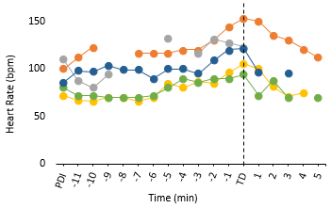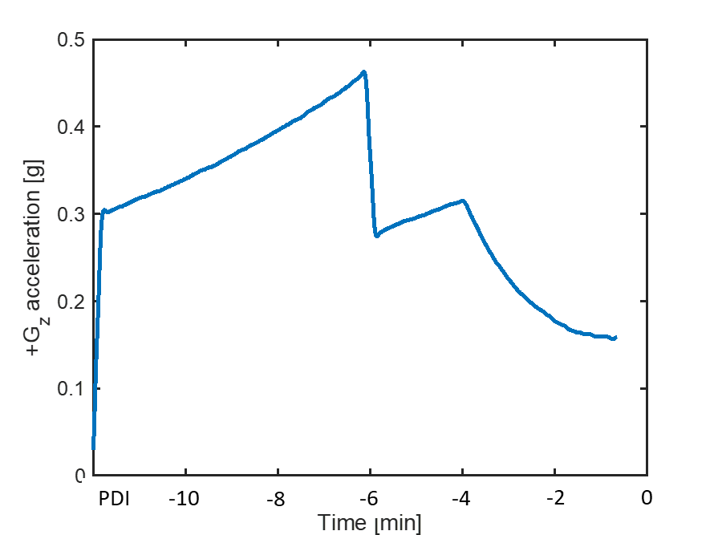

Figure 1. Heart rate response (left panel) from the Apollo commanders from powered descent initiation (PDI) to touchdown (TD) on the lunar surface. The right panel shows the model of the G_{z} loads, beginning at 0-G during lunar orbit, peaking above 0.4-G, and ending at 0.16-G on the lunar surface.

The mean heart rate in Apollo astronauts before descent engine ignition was ~80 bpm. It should be noted the mean heart rate measured during the ascent phase of the lunar mission was similar to that measured during initial part of the descent phase (2.94 to 3.92 m/s²) but ~20 bpm lower than during the latter portion of descent when the G-loads were lower (Figure 2). While the initial spike in heart rate (10-20 bpm) likely included orthostatic and psychological contributions, that heart rate remained stable thereafter, even in the setting of increasing acceleration loading suggests orthostatic stress was well tolerated at Apollo loads and mission durations. In a majority of cases, the heart rate measured before engine ignition was similar to that measured during ascent. The mean heart rates reported here are comparable to before ascent engine ignition, and do not reach the level of mean heart rate reported during Space Shuttle reentry (30), for 3 of the 5 Apollo astronauts for whom data were collected.

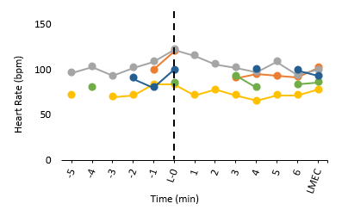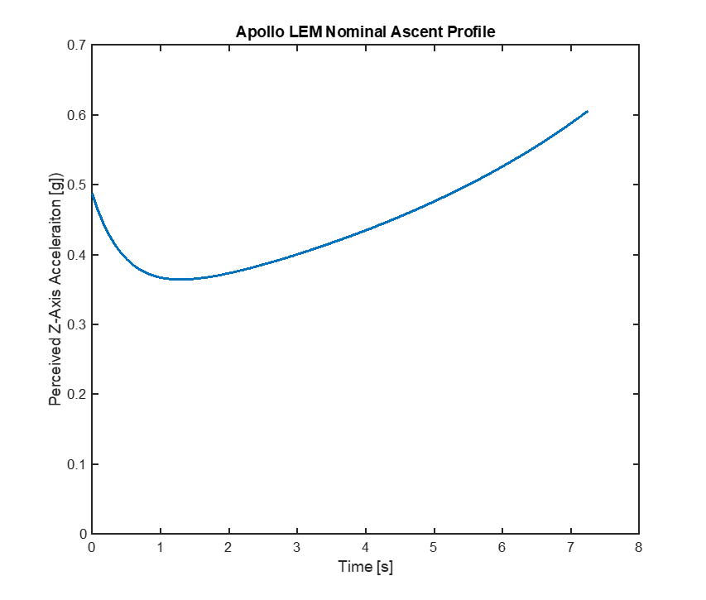
Figure 2. Heart rate response (left panel) from the Apollo commanders before and during ascent from the lunar surface to LM engine cut-off (LMEC). The right panel displays G_{z} load reconstruction, beginning at engine ignition.

Limitations included an incomplete archiving of data; only heart rate were recorded (no blood pressure data), and data were recorded almost exclusively for the commander (very limited data was available for the LM pilot due to only one data channel being used for transmission of biomedical data). In addition, there were no baseline conditions during which data were recorded. Timing of data recorded from flight surgeon and Biomedical Engineer Flight Controller (BME) notes is unlikely to be exact and may not exactly correlate with acceleration reconstruction, and there was no consistent reporting structure across missions. Finally, there were periods of data loss because of poor sensor quality and adhesives, and the difficulty in interpreting handwriting from the BME and surgeon logs.

Review of the post-mission reports and the results of the Apollo Medical Operations Summit (27) yielded additional information that provide additional context. Almost all crewmembers reporting experiencing symptoms of the cephalad fluid shift (e.g., full-headedness) during the adaptation to spaceflight that was treated by using nasal decongestants. However, the majority of crews reported no issues with nausea, vomiting, or disorientation during their mission. All crews had a small exercise device onboard that was used during rest and relaxation without a specific exercise prescription. While the crew suggested that the exercise provided psychological benefits and aided in stretching and relieving low back pain, its infrequent use was unlikely to have prevented cardiovascular deconditioning (8, 9, 32). Crews frequently reported periods of sleep deprivation associated with factors such as work schedules, sleep shifting, discomfort of sleeping in their suits, and lack of a suitable sleeping surface in the LM. Some crews used sleep medications with moderate effectiveness, providing 4-5 hours of sleep per night. Finally, the function of the Apollo waste management system was sufficiently problematic to provoke some crewmembers to use medications to promote constipation to limits its use. It is unclear how this affected their fluid consumption and body fluid status.

Flight Duration Effects on Orthostatic Tolerance

The NASA Johnson Space Center’s Cardiovascular and Vision Laboratory has previously reported on the significant effect of flight duration on orthostatic intolerance when comparing results from Space Shuttle missions (</= 17 days) to long-duration missions (Mir and ISS) when astronauts participated in a tilt test on landing day (19, 22). However, no specific examination of flight duration effect has been conducted in astronauts for similar durations as the original Artemis proposal. It should be noted that for Artemis Phase I, ascent from the lunar surface may occur at or beyond the flight duration times of the longest shuttle missions. Bed rest and spaceflight studies have demonstrated a rapid decrease in plasma volume (16) and the development of signs of orthostatic intolerance after exposures as short as 24 hours (23) but no individual investigation sought to determine whether the consequences of cardiovascular deconditioning are exacerbated after, for example, 2 weeks compare to 1 week.

For the purposes of this assessment, heart rate, mean arterial blood pressure and tilt test survival data were reviewed from the Cardiovascular and Vision Laboratory’s database of stand and tilt tests administered to Space Shuttle astronauts. Specifically, the responses to standing or 80° head-up tilt before launch (5-10 days) and on landing day (R+0) in astronauts completing short (2-4 d, n=39), medium (6-8 d, n=60), and longer duration (15-17 d, n=39) Space Shuttle flights were examined. Preliminary analysis of these data suggest that there were no significant effect of flight duration (P=0.72) on test survival time during the stand or tilt (Figure 3). There was a significant interaction between the effect of group (flight duration) and the heart rate response to standing (stand or tilt HR-supine HR). While the 3 groups had a similar heart rate response to standing preflight (ΔHR=+18 bpm), the heart rate response to standing was lower after the longer duration Space Shuttle missions (ΔHR=+25 bpm) than after short and medium duration missions (ΔHR=+30 bpm). Perhaps the lower heart rate delta in longer duration crew is because of improvements in countermeasure practices, such as more consistent use of fluid loading (1) and the adoption of liquid cooling to prevent whole body heating when wearing the shuttle protective garment (LES or ACES) (25). There also was a significant interaction between group and the mean arterial pressure response to standing or tilt, but the interpretation of these results is less clear. The short and long-duration Space Shuttle mission astronauts had a similar mean arterial pressure response before and after spaceflight (Short Pre: +6, R+0: +5 mmHg; Longer Pre: +3, R+0: +3 mmHg), but response in the medium duration astronauts was greater on landing day than before launch (Pre: +1; R+0: +4 mmHg).

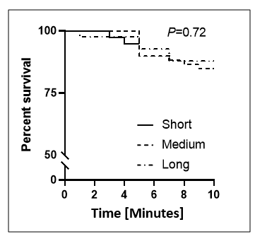
Figure 3. Percentage of Space Shuttle astronauts still upright during stand or head-up tilt tests on landing day after short (2-4 d), medium (6-8 d), and longer duration (15-17 d) spaceflights.

From these analyses, we conclude that orthostatic tolerance is reduced after short-duration spaceflight missions and does not appear to worsen across the length of the missions examined (17 days). Limitations to this analysis include there were relatively few female astronauts, particularly in the early missions. Critically, neither sex or use of countermeasures was controlled for (e.g., in-flight exercise and end-of-mission fluid loading or compression garment use) (18). There was a mixture of stand test (5-minute stand) and tilt tests (10-minute head-up tilt) administered, with all the short-duration astronauts participating in stand tests; this data set is a mixture of operationally administered test and results from scientific studies. Finally, while almost all astronauts participated in orthostatic tolerance tests during the early phases of the Space Shuttle program, only first time flyers and those with previous observations of postflight orthostatic intolerance were required to participate in these tests when the tilt test was used operationally between January 1997 (STS-81) and June 2008 (STS-124) (19).

Sex Effects

Although there were no reports of symptoms consistent with orthostatic intolerance during lunar descent or ascent, all the astronauts were men with a history high performance aircraft experience or who received centrifuge training. Given that the proportion of women in the astronaut corps has been increasing (12) and that it has been publicly stated that the first Artemis mission will include at least one woman, the effects of sex on the cardiovascular responses to acceleration should be considered with regard to lunar descent and ascent. From terrestrial centrifuge data, non-deconditioned female pilots show equal or superior tolerance to +G_{z} loading when compared to height-matched male counterparts in a seated configuration (4, 7). However, spaceflight deconditioned females are more susceptible to post-spaceflight orthostatic intolerance when re-exposed to 9.81 m/s² in a standing posture (6, 35).

Spaceflight Analogues

There are some inherent difficulties in using ground-based models of spaceflight to predict tolerance to partial gravity loads that will be experienced by astronauts during descent and ascent from the lunar surface. In particular, there are few studies that have used a post-bed rest orthostatic test protocol that simulates a partial gravity environment.

Grenon et al. (10, 11) performed tilt tests after 14-16 days of 4° head-down tilt bed rest that consisted three 10-minute stages of head-up tilt at 30°, 60°, and 90° followed by 120 minutes of passive standing. For this review, only the initial 10 minutes of 30° of tilt was considered because this level of orthostatic stress is approximately equal to 4.91 m/s². All of the male subjects in these studies (10, 11) completed this duration of heat-up tilt; however, only 50% of the women were able to complete following bed rest (11). Based upon estimations from their published survival curve, it appears that the first subject to become presyncopal did so after 3.7 minutes of 30° head-up tilt with additional subjects becoming presyncopal at 6.8 minutes (n=1) and 8.7 minutes (n=2) of tilt.

- COUNTERMEASURES TO ACCELERATION-INDUCED HYPOTENSION

Given that no data yet exist to support lunar surface operations at 1/6-G will be protective against the cardiovascular deconditioning associated with prolonged microgravity exposure, it is an appropriate, albeit conservative, assumption that the incidence of presyncope and orthostatic intolerance after lunar surface operations will not be significantly different than the incidence after similar durations of pure-microgravity spaceflight. Preliminary analysis of results from partial gravity conditions simulated during parabolic flight suggest that lunar-equivalent G-levels produce a headward fluid shift, judged by jugular vein distension and pressure, similar to that experienced during weightlessness (17, 21).

Lower body compression garments are a standard and long-used mitigation for orthostatic intolerance associated with long-duration spaceflight activities, employed by both US and Russian space programs for all current and upcoming crew vehicles (Crew Dragon, CST-100, Orion, Soyuz). Historical data from the Russian space program have demonstrated the efficacy of lower body compression to augment reentry acceleration tolerance on the Soyuz spacecraft following long-duration missions (34)., The Cardiovascular and Vision Laboratory has previously demonstrated that lower body compression garments are an effective countermeasure to hypotension following exposure to bed rest and spaceflight missions of ~2 weeks. Specifically, no subjects became presyncopal during a 15-minute 80° head-up tilt test after 14 days of bed rest when wearing lower body compression garments (30). These data are particularly important because the subjects, which included 4 women, were exposed to a higher level (~9.81 m/s²) and longer duration (15 minutes) of acceleration than currently expected for ascent from the moon, and that the subjects performed no additional countermeasures (i.e., no in-bed rest exercise or fluid loading) before head-up tilt on the last day of bed rest. There currently are no plans to include a vigorous exercise program during the initial lunar missions, as have been performed on the Space Shuttle (18) or the ISS (20). Similar to bed rest results, wearing a lower body compression garment (LBCG) after 12-16 days of spaceflight was demonstrated to prevent tachycardia and result in a greater decrease in stroke volume, normally observed in astronauts who stand or are tilted upright without compression garments (31).

Given that there is not an expectation that exposure to 1/6-G will be protective against cardiovascular deconditioning, consideration should be given to the appropriate countermeasures to acceleration after extended stays on the lunar surface (≥30 d), or for acceleration loading outside the standing limits in section VI of this paper for missions <30 days at the time of descent/ascent operations. Clearly, factors such as the magnitude and duration of the acceleration, orientation of the astronauts relative to the acceleration vector, standing vs. seated body configuration, composition of the crew by sex, and level of deconditioning due to the length of the mission will affect G-tolerance during descent and ascent from the lunar surface. Inclusion of in-suit cooling (25) or other means to mitigate thermal loading should be mandatory, and is required for all current spaceflight operations by both US and Russian space programs because of the deleterious effect of thermal loading on acceleration tolerance (28). Fluid loading protocols likewise in current use also should be considered for provocative profiles (15, 1).

- ARTEMIS SUSTAINED TRANSLATIONAL ACCELERATION LIMITS

Based on the synthesis of the aforementioned human tolerance data, new sustained translational acceleration limits were derived for Artemis Human Landing System architectures (Table 1 and Figure 4). These limits assume a standing orientation unless otherwise labeled, as existing NASA-STD-3001 limits applicable to seated, long-duration crewmembers already exist. The provision of a seated posture or use of a LBCG significantly augments acceleration tolerance in the +G_{z} vector as outlined previously, and this is reflected in a higher limit threshold for designs employing these mitigations. Further assumptions underlying the new sustained translational acceleration limits include:
- Must adequately account for the effects of deconditioning within the mission profiles under consideration, and provide guidance for longer >30-day missions in the future
- Must account for the current and expected future U.S. astronaut corps composition, reflecting significant differences from Apollo
- Must be capable of piloting the vehicle under all mission phases – limits must preserve full crew functionality to mitigate risk of orthostatic intolerance precipitating piloting or command errors during critical operations under loading
- Additional equipment (suit) mass borne by the crewmember is less than 20% of the crewmember’s shirt sleeve mass
- All limits further assume adequate restraint(s) are provided for all body postures during the period of sustained loading

Adequate restraint for the purposes of sustained translational acceleration limits are defined as devices sufficient to arrest motion between the occupant and vehicle interior by applying counterforce. Restraints also must prevent unintended contact between the crewmember and the interior of the vehicle within the sustained translational acceleration limits described herein, while facilitating continual access to and operation of vehicle displays and controls. Figure 4 provides all +G_{z} sustained translational acceleration limits derived from the aforementioned data sources and methods. Where data were available, allowed acceleration envelopes were drawn to encompass demonstrated tolerance for both male and female subjects from the above sources. All limits were constructed, reviewed, and concurred by the NASA subject matter expert panel members listed in Acknowledgements. For additional information on –G_{z} sustained translational acceleration limit rationale reference Pattarini JM, Watkins SD, Somers JT, Barratt MR. R.CTS.216 (3.10.2.1) Sustained Translational Acceleration Update Recommendation.

For calculation of sustained translational acceleration exposures against the limits in Figure 4, each exposure duration is accumulated across the specific phase of flight. For example, if 9.81 m/s² was sustained for 5 seconds, followed by 3 seconds of 5 m/s², and then 12 m/s² was sustained for 2 seconds, then the total exposure to 9.81 m/s² for this example would be 7 seconds (exposure to 12 m/s² would be 2 seconds). This accumulation would continue across the entire phase of dynamic flight. The authors are currently developing a methods paper for calculation of several crew requirements where further sustained translational acceleration calculation details will be found.

Table 1. -Gz sustained translational acceleration limits.
Duration (s) | 0.5 | Sustained
Acceleration (m/s²⁾ | 0.0 | 0.0

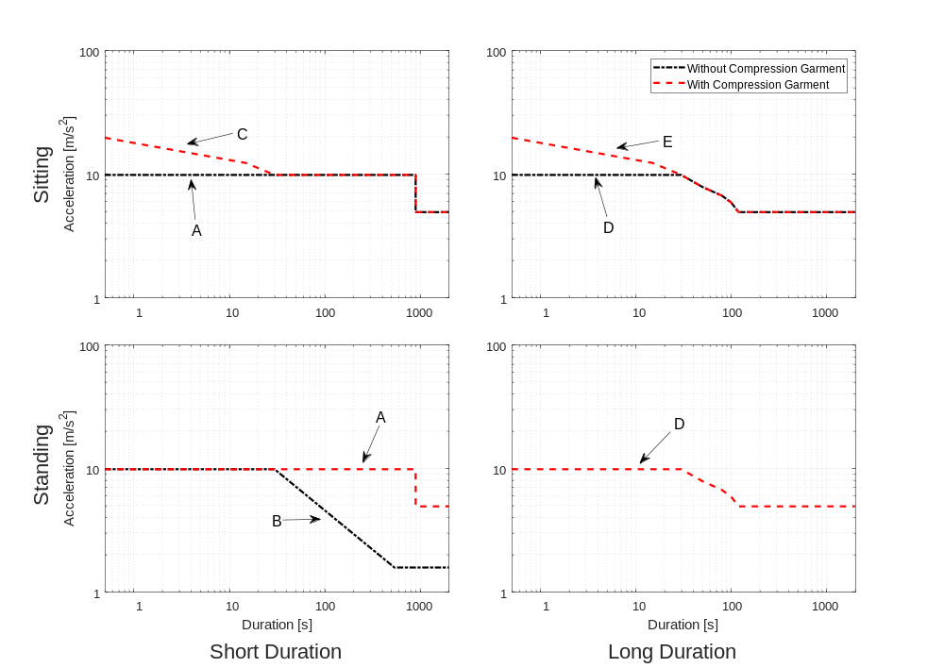

Duration (s) | 0.5 | 10 | 15 | 30 | 50 | 80 | 90 | 100 | 120 | 150 | 540 | 540 < t < 900 | ≥ 900
A (m/s²) | 9.81 | 9.81 | 9.81 | 9.81 | 9.81 | 9.81 | 9.81 | 9.81 | 9.81 | 9.81 | 9.81 | 9.81 | 4.91
B (m/s²) | 9.81 | 9.81 | 9.81 | 9.81 | 7.10 | 5.27 | 4.89 | 4.57 | 4.07 | 3.54 | 1.57 | 1.57 | 1.57
C (m/s²) | 19.6 | 13.0 | 12.7 | 9.81 | 9.81 | 9.81 | 9.81 | 9.81 | 9.81 | 9.81 | 9.81 | 9.81 | 4.91
D (m/s²) | 9.81 | 9.81 | 9.81 | 9.81 | 7.85 | 6.67 | 6.24 | 5.89 | 4.91 | 4.91 | 4.91 | 4.91 | 4.91
E (m/s²) | 19.6 | 13.0 | 12.3 | 9.81 | 7.85 | 6.67 | 6.24 | 5.89 | 4.91 | 4.91 | 4.91 | 4.91 | 4.91

Figure 4. +G_{z} sustained translational acceleration limits. A. Seated without Lower Body Compression Garment (LBCG) or Standing with LBCG, Short Duration, B. Standing without LBCG, Short Duration, C. Seated with LBCG, Short Duration, D. Seated without LBCG or Standing with LBCG, Long Duration, and E. Seated without LBCG, Long Duration

Acknowledgements

The authors would like to acknowledge the assistance of NASA, KBR, and external panel members in assisting with this effort.

Bernard Adelstein NASA
Jay C. Buckey Dartmouth College
Tammy Chelette U.S. Air Force
Mark Cramer NASA
Smith Johnston NASA
Benjamin Levine University of Texas Southwestern Medical Center
Charles Marshik NASA
Brett Montoya NASA
Peter Norsk NASA
Jim Pawelczyk Pennsylvania State University
Taylor Phillips-Hungerford NASA
Lee Stone NASA
Zachary Taylor NASA

References
1. Bungo MW, Charles JB, Johnson PC Jr. Cardiovascular deconditioning during space flight and the use of saline as a countermeasure to orthostatic intolerance. Aviat Space Environ Med 56:985-990, 1985.
2. Cameron JR, Skofronick JG, Grant RM. Medical Physics: Physics of The Body. Medical Physics Publishing Corporation, 1992.
3. Coats BW, Sharp MK. Simulated stand tests and centrifuge training to prevent orthostatic intolerance on Earth, moon, and Mars. Anal Biomed Eng 3:1119-1131, 2010.
4. Convertino VA, et al. Female exposure to high G: chronic adaptations of cardiovascular functions. No. AFRL-HE-BR-TP-1998-0079. Air Force Research Lab Brooks AFB TX Human Effectiveness Directorate, 1998.
5. Frey MAB, Tomaselli CM, Hoffler WC. Cardiovascular responses to postural changes: differences with age for women and men. J Clin Pharmacol 34.5:394-402. 1994.
6. Fritsch-Yelle JM, Whitson PA, Bondar RL, Brown TE. Subnormal norepinephrine release relates to presyncope in astronauts after spaceflight. J Appl Physiol 81:2134-41, 1996.
7. Gillingham KK, et al. Women's G tolerance. No. USAFSAM-TR-85-34. School of Aerospace Medicine Brooks AFB TX, 1986.
8. Greenleaf JE, Bernauer EM, Ertl AC, Trowbridge TS, Wade CE. Work capacity during 30 days of bed rest with isotonic and isokinetic exercise training. J Appl Physiol 67:1820-1826, 1989.
9. Greenleaf JE, Vernikos J, Wade CE, Barnes PR. Effect of leg exercise training on vascular volumes during 30 days of 6 degrees head-down bed rest. J Appl Physiol 72:1887-1894, 1992.
10. Grenon SM, Hurwitz S, Sheynberg N, Xiao X, Judson B, Ramsdell CD, Kim C, Cohen RJ, Williams GH. Sleep restriction does not affect orthostatic tolerance in the simulated microgravity environment. J Appl Physiol 97:1660-1666, 2004.
11. Grenon SM, Xiao X, Hurwitz S, Sheynberg N, Kim C, Seely EW, Cohen RJ, Williams GH. Why is orthostatic tolerance lower in women than in men? Renal and cardiovascular responses to simulated microgravity and the role of midodrine. J Investig Med Off Publ Am Fed Clin Res 54:180-190, 2006.
12. Harm DL, Jennings RT, Meck JV, Powell MR, Putcha L, Sams CP, Schneider SM, Shackelford LC, Smith SM, Whitson PA. Invited review: gender issues related to spaceflight: a NASA perspective. J Appl Physiol 91:2374-2383, 2001.
13. Holmgren A, Ovenfors CO. Heart volume at rest and during muscular work in the supine and in the sitting position. Acta Medica Scandinavica 167.4:267-277, 1960.
14. Kelly TJ. Moon Lander: How we developed the Apollo lunar module. Smithsonian, 2009.
15. Kozlovskaya IB, Grigoriev AI. Russian system of countermeasures on board of the International Space Station (ISS): the first results. Acta Astronaut 55:233-237, 2004.
16. Leach CS, Alfrey CP, Suki WN, Leonard JI, Rambaut PC, Inners LD, Smith SM, Lane HW, Krauhs JM. Regulation of body fluid compartments during short-term spaceflight. J Appl Physiol 81:105-116, 1996.
17. Lee S. Martin D. Miller C. Scott J. Laurie S. Macias B. Ploutz-Snyder L. Stenger M. What level of gravity is required to prevent spaceflight-associated neuro-ocular syndrome (SANS)? Human Research Program Investigators’ Workshop. Galveston, TX: 2019
18. Lee SM, Moore AD, Fritsch-Yelle JM, Greenisen MC, Schneider SM. Inflight exercise affects stand test responses after space flight. Med Sci Sports Exerc 31:1755-62, 1999.
19. Lee SMC, Feiveson AH, Stein SP, Stenger MB, Platts SH. Orthostatic intolerance after International Space Station and Space Shuttle missions. Aero Med Hum Perform 86:A54–A67, 2015.
20. Loehr JA, Guilliams ME, Petersen N, Hirsch N, Kawashima S, Ohshima H. Physical training for long-duration spaceflight. Aero Med Hum Perform 86:A14-23, 2015.
21. Martin DS, Lee SMC, Matz TP, Westby CM, Scott JM, Stenger MB, Platts SH. Internal jugular pressure increases during parabolic flight. Physiol Rep 4, 2016.
22. Meck JV, Reyes CJ, Perez SA, Goldberger AL, Ziegler MG. Marked exacerbation of orthostatic intolerance after long- vs. short-duration spaceflight in veteran astronauts. Psychosom Med 63:865-873, 2001.
23. Nixon JV, Murray RG, Bryant C, Johnson RL Jr, Mitchell JH, Holland OB, Gomez-Sanchez C, Vergne-Marini P, Blomqvist CG. Early cardiovascular adaptation to simulated zero gravity. J Appl Physiol 46:541-548, 1979.
24. Olufsen MS, Ottesen JT, Tran HT, Ellwein LM, Lipsitz LA, Novak V. Blood pressure and blood flow variation during postural change from sitting to standing: model development and validation. J Appl Physiol 99.4:1523-1537, 2005.
25. Perez SA, Charles JB, Fortner GW, Hurst V 4th, Meck JV. Cardiovascular effects of anti-G suit and cooling garment during space shuttle re-entry and landing. Aviat Space Environ Med 74:753-757, 2003.
26. Rossberg F, Penaz J. Heart rate and arterial pressure variability in humans during different orthostatic load. Physiol Res 41:19-23, 1992.
27. Scheuring RA, Jones JA, Novak JD, Polk JD, Gillis DB, Schmid J, Duncan JM, Davis JR. The Apollo Medical Operations Project: Recommendations to improve crew health and performance for future exploration missions and lunar surface operations. Acta Astronaut 63:980-987, 2008.
28. Schlader ZJ, Wilson TE, Crandall CG. Mechanisms of orthostatic intolerance during heat stress. Auton Neurosci 196:37-46, 2016.
29. Sjostrand T. Volume and distribution of blood and their € significance in regulating circulation. Physiol Rev; 33:202-28. 58, 1953
30. Stenger MB, Lee SMC, Ribeiro LC, Phillips TR, Ploutz-Snyder RJ, Willig MC, Westby CM, Platts SH. Gradient compression garments protect against orthostatic intolerance during recovery from bed rest. Eur J Appl Physiol 114:597-608, 2014.
31. Stenger MB, Lee SMC, Westby CM, Ribeiro LC, Phillips TR, Martin DS, Platts SH. Abdomen-high elastic gradient compression garments during post-spaceflight stand tests. Aviat Space Environ Med 84:459-466, 2013.
32. Stremel RW, Convertino VA, Bernauer EM, Greenleaf JE. Cardiorespiratory deconditioning with static and dynamic leg exercise during bed rest. J Appl Physiol 41:905-909, 1976.
33. U.S. Army Air Forces. Your Body in Flight: An Illustrated “Book of Knowledge” for the Flyer. Fairfield, OH, USA: Air Service Command, 1943.
34. Vil-Viliams IF, Kotovskaya AR, Gavrilova LN, Lukjanuk VYu, Yarov AS. Human +Gx tolerance with the use of anti-G suits during descent from orbit of the Soyuz space vehicles. J Gravitational Physiol J Int Soc Gravitational Physiol 5:P129-130, 1998.
35. Waters WW, Ziegler MG, Meck JV. Postspaceflight orthostatic hypotension occurs mostly in women and is predicted by low vascular resistance. J Appl Physiol 92:586-94, 2002.
36. Wieling W, et al. Physical countermeasures to increase orthostatic tolerance. J Intern Med 1:69-82, 2015.
37. Wolthuis RA, Bergman SA, Nicogossian AE. Physiological effects of locally applied reduced pressure in man. Physiol Rev 54:566-595, 1974.

