Terminal Area Size and Switching Technique Analysis for Unmanned Aircraft Systems Operations

Sagar Kc
Aerospace Engineer
NASA Langley Research Center
Hampton, Virginia USA
sagar.kc@nasa.gov
Devin P. Jack
R&D Engineer
Adaptive Aerospace Group
Hampton, Virginia USA
djack@adaptiveaero.com

Abstract— Unmanned Aircraft Systems (UAS) need to be able to comply with the Code of Federal Regulations Part 91 ‘see and avoid’ requirement. Detect and avoid (DAA) is an essential enabler for integrating UAS into the National Airspace System. A DAA system is a suite of sensors, trackers, and alerting and guidance algorithms that assists a remote pilot in maintaining separation from airborne traffic. Previous works have focused on operations transiting to and from Class A or special use airspace. More recent efforts have defined DAA system requirements for operations in and around the airport terminal environment. In continuation of this effort, this paper defines the DAA Terminal Area (DTA) size and switching technique for the DAA Well Clear (DWC) volume while transitioning between en route and the terminal area.
Keywords – Unmanned Aircraft Systems, Terminal Area, Detect and Avoid

Introduction
Detect and avoid (DAA) is an essential component of integrating unmanned aircraft systems (UAS) into the National Airspace System (NAS) in order to ensure that unmanned aircraft (UA) remain well clear of intruder aircraft. A DAA system is a suite of sensors, trackers, and guidance and alerting algorithms used to enable UAS compliance with the Code of Federal Regulations (14 CFR) Part 91 [1] ‘see and avoid’ requirements. The published RTCA DO-365 [2] outlines Minimum Operational Performance Standards (MOPS), or minimum technical requirements, for DAA system for UAS transiting to/from Class A, or special use airspace, but does not include requirements for terminal operations.
Currently, UAS are required to fly under IFR (Instrument Flight Rules) [3]. However, under the ‘see and avoid’ requirement, UAS will still need to maintain separation from air traffic even when air traffic control (ATC) is not providing the separation service, such as at non-towered airports with instrument approaches. Research is being performed by the NASA UAS Integration in the NAS (UAS-NAS) Project [4], to develop requirements to facilitate routine UAS operations (e.g. take-offs, and landings) within towered and non-towered airport terminal environment. Previous work developed the parameters
for a smaller Terminal DAA Well Clear (DWC) volume than
that for the en route environment. The DAA algorithms use the DWC definition to alert UAS pilots of a potential Loss of Well Clear (LoWC) and to provide guidance to remain well clear of other aircraft [5, 6]. The DAA Terminal Area (DTA) is the volume within which the terminal DWC definition is applied for alerting and guidance purposes. The DTA, as defined in this study, was a cylindrical volume centered at the runway center point, and extending up to 2,500 feet. This fast-time study, in which the simulation performed analysis within short period of time to produce data for relatively longer period of time, is focused on deriving the appropriate DTA size and DWC switching method when transitioning from the en route to the terminal area.

DAA Well-Clear Definition
Per 14 CFR 91.113 [1], “vigilance shall be maintained by each person operating an aircraft so as to see and avoid other aircraft. When a rule of this section gives another aircraft the right-of-way, the pilot shall give way to that aircraft and may not pass over, under, or ahead of it unless well clear.” Thus, the onboard pilot must ensure that the aircraft is well clear of other traffic, based on the pilot’s judgement. In the case of a UAS, a quantitative definition of well clear is required to provide a reference for the DAA algorithms to use for providing alerting and guidance. Table 1 presents the DWC parameters for both the en route and terminal environments.
TABLE 1. DAA WELL CLEAR PARAMETERS
Parameters | Symbol | Values
Parameters | Symbol | En Route DWC | Terminal DWC
Vertical Displacement | h* | 450 Feet | 450 Feet
Modified Tau | $$τ_{mod}^{*}$$ | 35 Seconds | 0 Second
Horizontal Miss Distance | HMD* | 4000 Feet | 1500 Feet

Anytime all parameters for DWC are violated by an intruder, the UA has a LoWC. LoWC is defined as:

$\left[0≤τ_{mod}≤τ_{mod}^{*}] and [HMD≤HMD^{*}\right] and \left[-h^{*}≤dh≤h^{*}\right]$ (1)

where τ_{mod} is the temporal separation, HMD is the horizontal miss distance, and dh and h* are the vertical separation. The UA is “well clear” of other traffic as long as it is outside of the minimum thresholds- $τ_{mod}^{*}$ , HMD*, and h*.

DAA Well Clear ALerting
DO-365 defines DAA alerting scheme consisting of three alert types: Preventive, Corrective, and Warning. Each alert protects a Hazard Alert Zone (HAZ) which is closely tied to the DWC volume. A preventive alert means the traffic is currently not a threat, but needs to be monitored for potential increase in threat level; typically by a change in altitude by the UA or the intruder. A corrective alert means the traffic is a threat and an appropriate maneuver should be coordinated with ATC. A warning alert means immediate action is required, followed by communication with ATC or the intruding traffic.
A DAA system issues alerts with respect to the time before reaching the HAZ volume. The HAZ volume definitions and alerting times are listed in Table 2. According to an earlier study [7], there is insufficient time for effective coordination with ATC in the terminal area prior to needing to maneuver to deconflict with traffic. Therefore, the corrective alert is not issued in the terminal area. The terminal HAZ is smaller than the en route HAZ primarily to prevent alerts for traffic that is properly flying the Visual Flight Rules (VFR) pattern to land.
TABLE 2. DWC ALERTING SCHEME
 | DWC Alerting Criteria |  | Preventive Alert | Corrective Alert | Warning Alert
En Route DWC | Hazard Zone (HAZ) | $τ_{mod}^{*}$ (Seconds) | 35 | 35 | 35
En Route DWC | Hazard Zone (HAZ) | HMD* (Feet) | 4,000 | 4,000 | 4,000
En Route DWC | Hazard Zone (HAZ) | h* (Feet) | 700 | 450 | 450
En Route DWC | Alert time (Seconds before HAZ) |  | 55 | 55 | 25
Terminal DWC | Hazard Zone (HAZ) | $τ_{mod}^{*}$ (Seconds) | N/A | N/A | 0
Terminal DWC | Hazard Zone (HAZ) | HMD* (Feet) | N/A | N/A | 1,500
Terminal DWC | Hazard Zone (HAZ) | h* (Feet) | N/A | N/A | 450
Terminal DWC | Alert time (Seconds before HAZ) |  | N/A | N/A | 30

Experiment design

DAA Terminal Area Dimensions
A DTA is a cylindrical region around a runway in which the Terminal DWC definition is applied to account for the reduced separation between aircraft arriving and departing the active runway. In order to arrive at a recommended DTA size and DWC switching method combination that provided acceptable alerting behavior, it was necessary to look at a range of DTA sizes. Thus, DTA radius sizes of 3, 3.5, 4, 4.4, and 5 nautical miles (NM) were used for the analysis.. During the experiment, typical landing approaches i.e., straight-in, extended base, and VFR pattern were simulated to resemble the airport terminal environment. The intruder aircraft made extended base entries as well as 45 degree entries to join the VFR patterns while the UA always made straight-in instrument approaches per DO-365 assumptions. These intruders varied in airspeed, pattern altitude, vertical rate etc. that will be discussed in more detail shortly. Fig. 1 illustrates the test conditions for the experiment, in which the dotted lines represent the aircraft flight paths prior to landing.

DWC Switching Methods
DWC switching methods provide possible ways to implement terminal DWC when a UA transitions from the en route to terminal environment. Two switching methods tested in this experiment were ownship-centric and intruder-centric.
For ownship-centric switching, if the UA is outside the DTA, the en route DWC definition is applied to all traffic detected by the UAS, regardless of whether the traffic is within or outside the DTA. Once the UAS enters the DTA, the terminal DWC definition is applied to all traffic regardless of their positions (Fig. 2).
In the case of intruder-centric switching, the en route DWC definition is applied to all traffic detected by the UAS that are outside of the DTA. Conversely, the terminal DWC definition is applied to all traffic that are inside the DTA, regardless of the UA position (Fig. 2).

Encounter Geometry
Encounters were created to represent standard VFR operations around an airport. Intruders were modeled at various
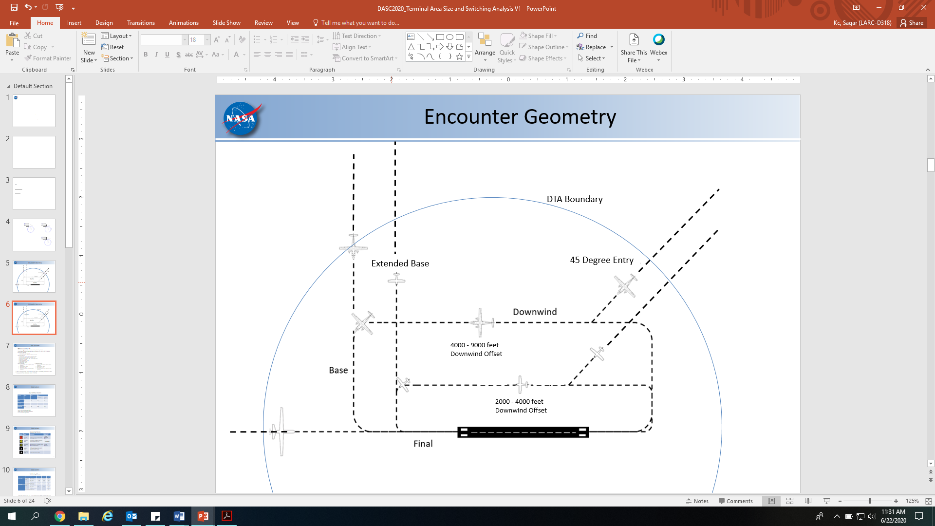
Fig. 1. Illustration of DAA Terminal Area operations.

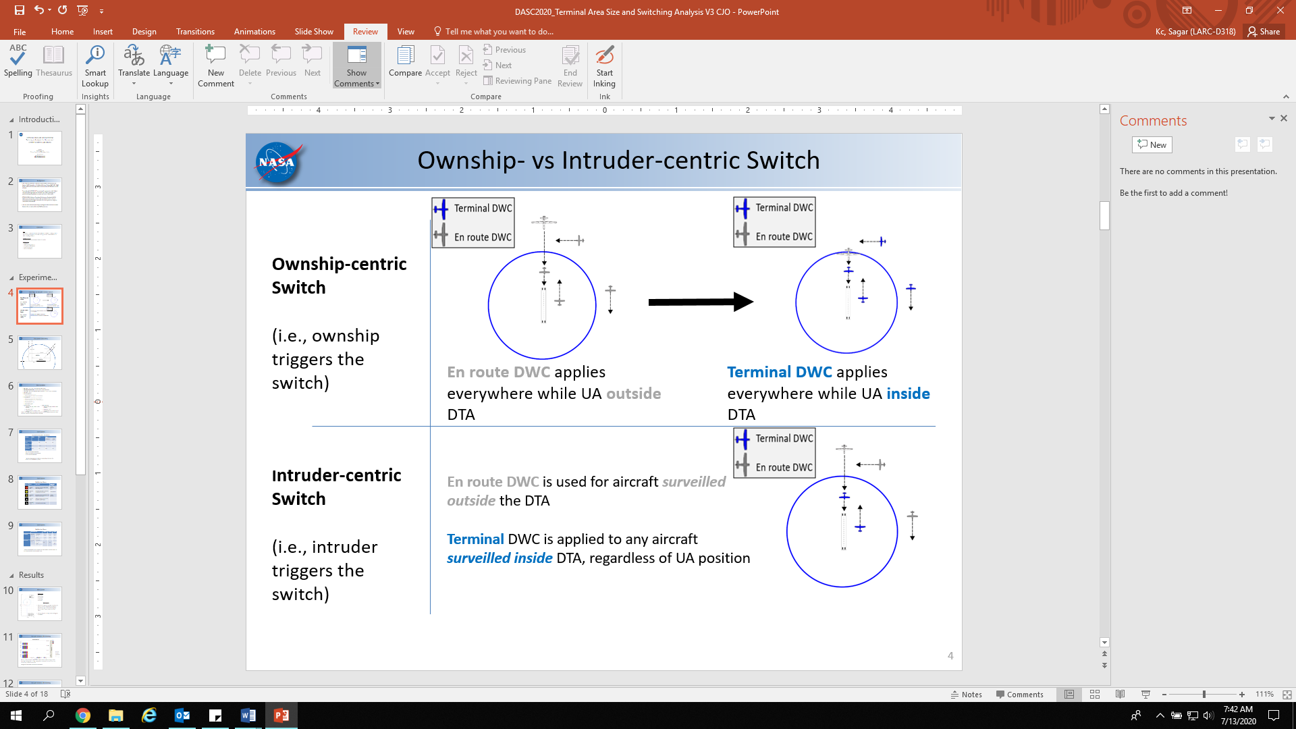
Fig. 2. Ownship-centric versus intruder-centric switching.
combinations of airspeeds, flight paths, and DTA sizes. A variety of aircraft performance parameters such as vertical rate, bank limit, etc., were also used for the encounter sets. These variables generated a large number of combinations in order to encompass the large design space of potential encounters.
The UA was flying an instrument approach to the active runway on a constant glideslope of 3 degrees with the airspeed ranging from 40 – 200 KTAS in 20 KTAS increments. The touchdown time offset between the UA and the intruder were 50, 60, 70, 80, and 90 seconds with the UA landing behind the intruder in all cases. These touchdown time offsets were chosen to represent a nominal scenario in which an intruder lands well ahead of the UA [8].
The intruders were grouped by engine type as piston and turbine intruders. These were categorical groupings used to define approach speed and traffic pattern dimensions. For instance, the piston engine intruders flew a standard 1,000 feet pattern altitude, while the turbine engine intruders flew a standard 1,500 feet pattern altitude. These intruders made either a 45 degree entry to a VFR pattern or an extended base entry. A complete list of all the variables are presented in Table 3.

TABLE 3. EXPERIMENT VARIABLES

 | Variable | Values
 | Touchdown Time Offset | 50, 60, 70, 80, 90 seconds
 | DTA size | 3, 3.5, 4, 4.4, 5 NM
UAS | DWC Switching Methods | Ownship-centric, Intruder-centric
UAS | Approach Path | -3 degree glideslope
UAS | Airspeed | 40-200 KTAS (In 20 KTAS increments)
Intruder | Approach Path | Full VFR Pattern, Extended Base
Intruder | VFR Pattern Vertical rate | -500 feet per minute
Intruder | Base Entry Vertical rate | -3, -6 degree glide slope
Intruder | Bank Limit | 15, 30 degrees
Intruder | Normal Acceleration | 1.25g
Intruder | Final Glideslope | -3 degree
Intruder | Runway Length | 8000 feet.
Intruder | Downwind Offset (Piston) | 2000-4000 feet (In 500 feet increments)
Intruder | Downwind Offset (Turbine) | 4000-9000 feet (In 1000 feet increments)
Intruder | Pattern Altitude (Piston) | 1000 feet
Intruder | Pattern Altitude (Turbine) | 1500 feet
Intruder | Base Altitude (Piston) | 750 feet
Intruder | Base Altitude (Turbine) | 1125 feet
Intruder | Airspeed (Piston) | 60-120 KTAS (In 20 KTAS increments)
Intruder | Airspeed (Turbine) | 100-200 KTAS (In 20 KTAS increments)

RESULTS
During the analysis, en route alerts present at the time a UA crossed the DTA were studied. Since the UA was landing at least 50 seconds after the intruders, all encounters were designed to avoid a loss of well clear. Hence, any corrective or warning alerts issued for intruders on an extended base entry or a 45 degree entry to the VFR traffic pattern would create a false sense of urgency. These alerts are undesirable as they do not reflect a need for an avoidance maneuver.
For the purpose of this study, different alert levels were assigned different numbers. 0, 1, 2, and 3 were assigned for no alert, preventive, corrective, and warning alert respectively. In some encounters, when the UA speed was very high, the UAS did not cross the DTA boundary by the time the intruder got to the touchdown point because of the minimum 50 seconds time offset. For those encounters, no alerting data for ownship-centric switching was available since the UAS did not switch from the en route to the terminal DWC definition. To account for those encounters with no alerting data, number 9 was assigned to distinguish them from other alert levels.

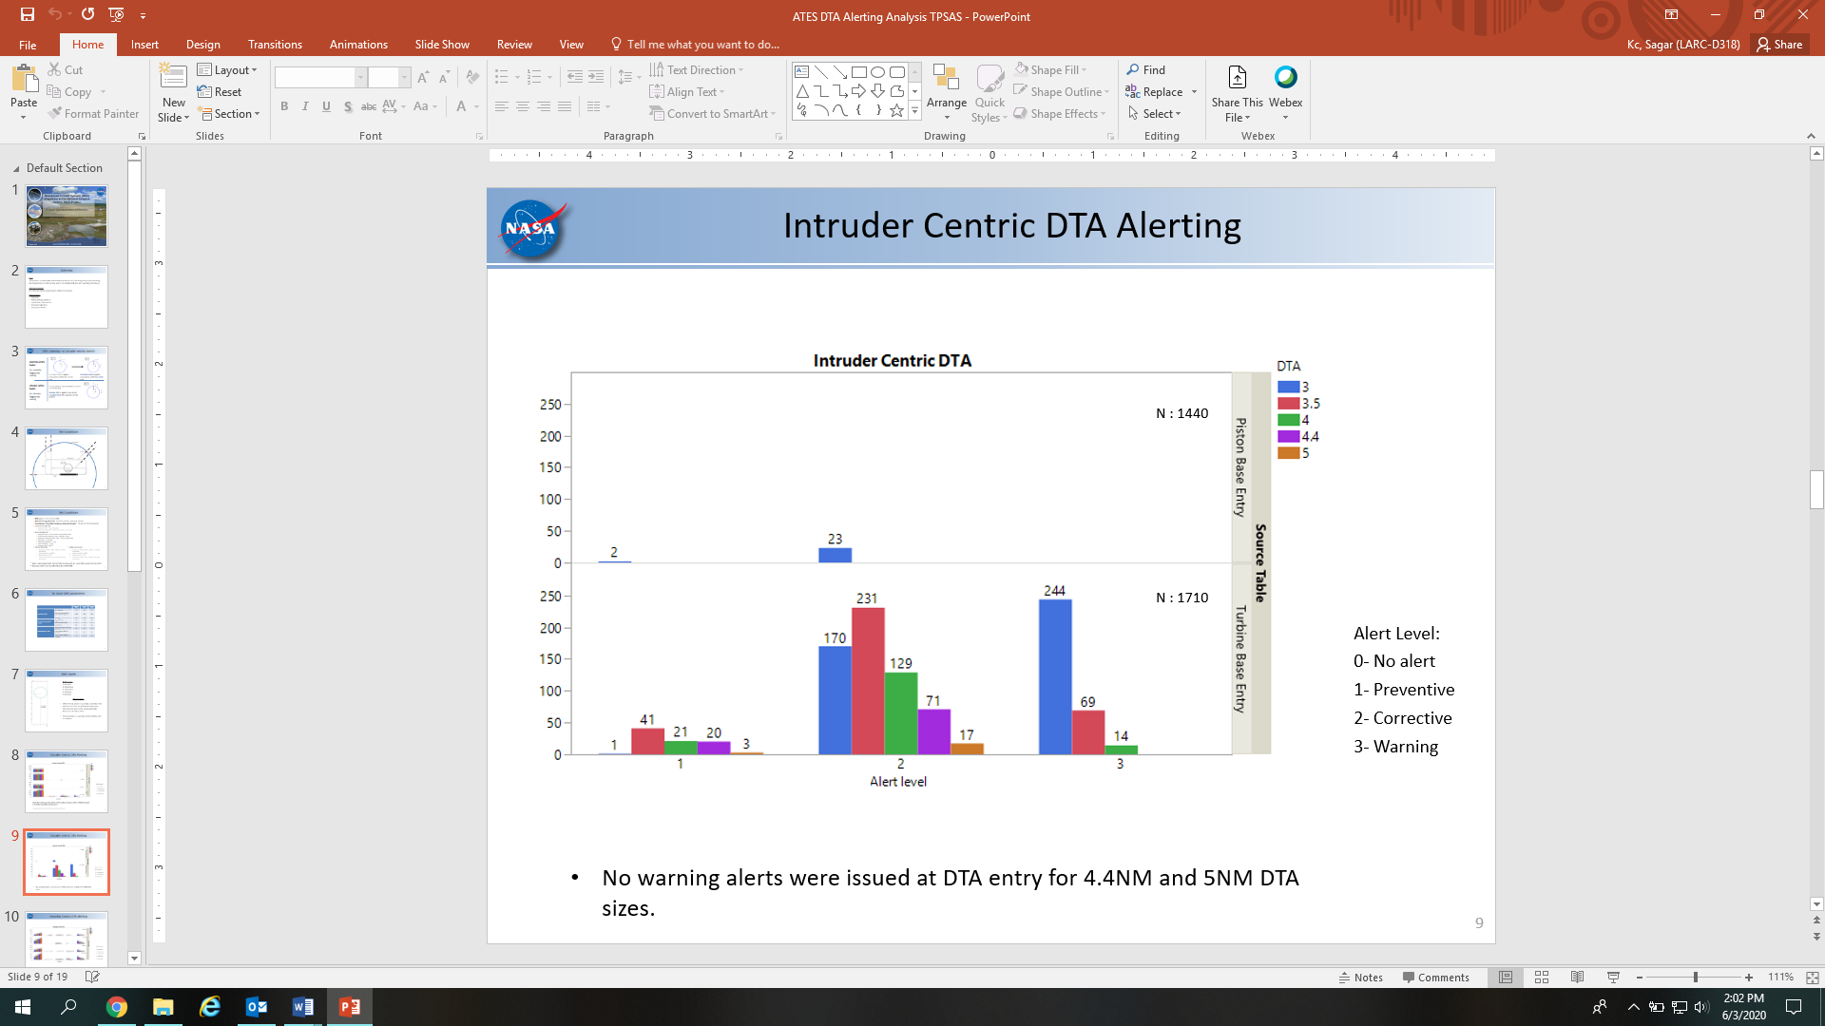
Fig. 3. Alerting data for intruder-centric switching.
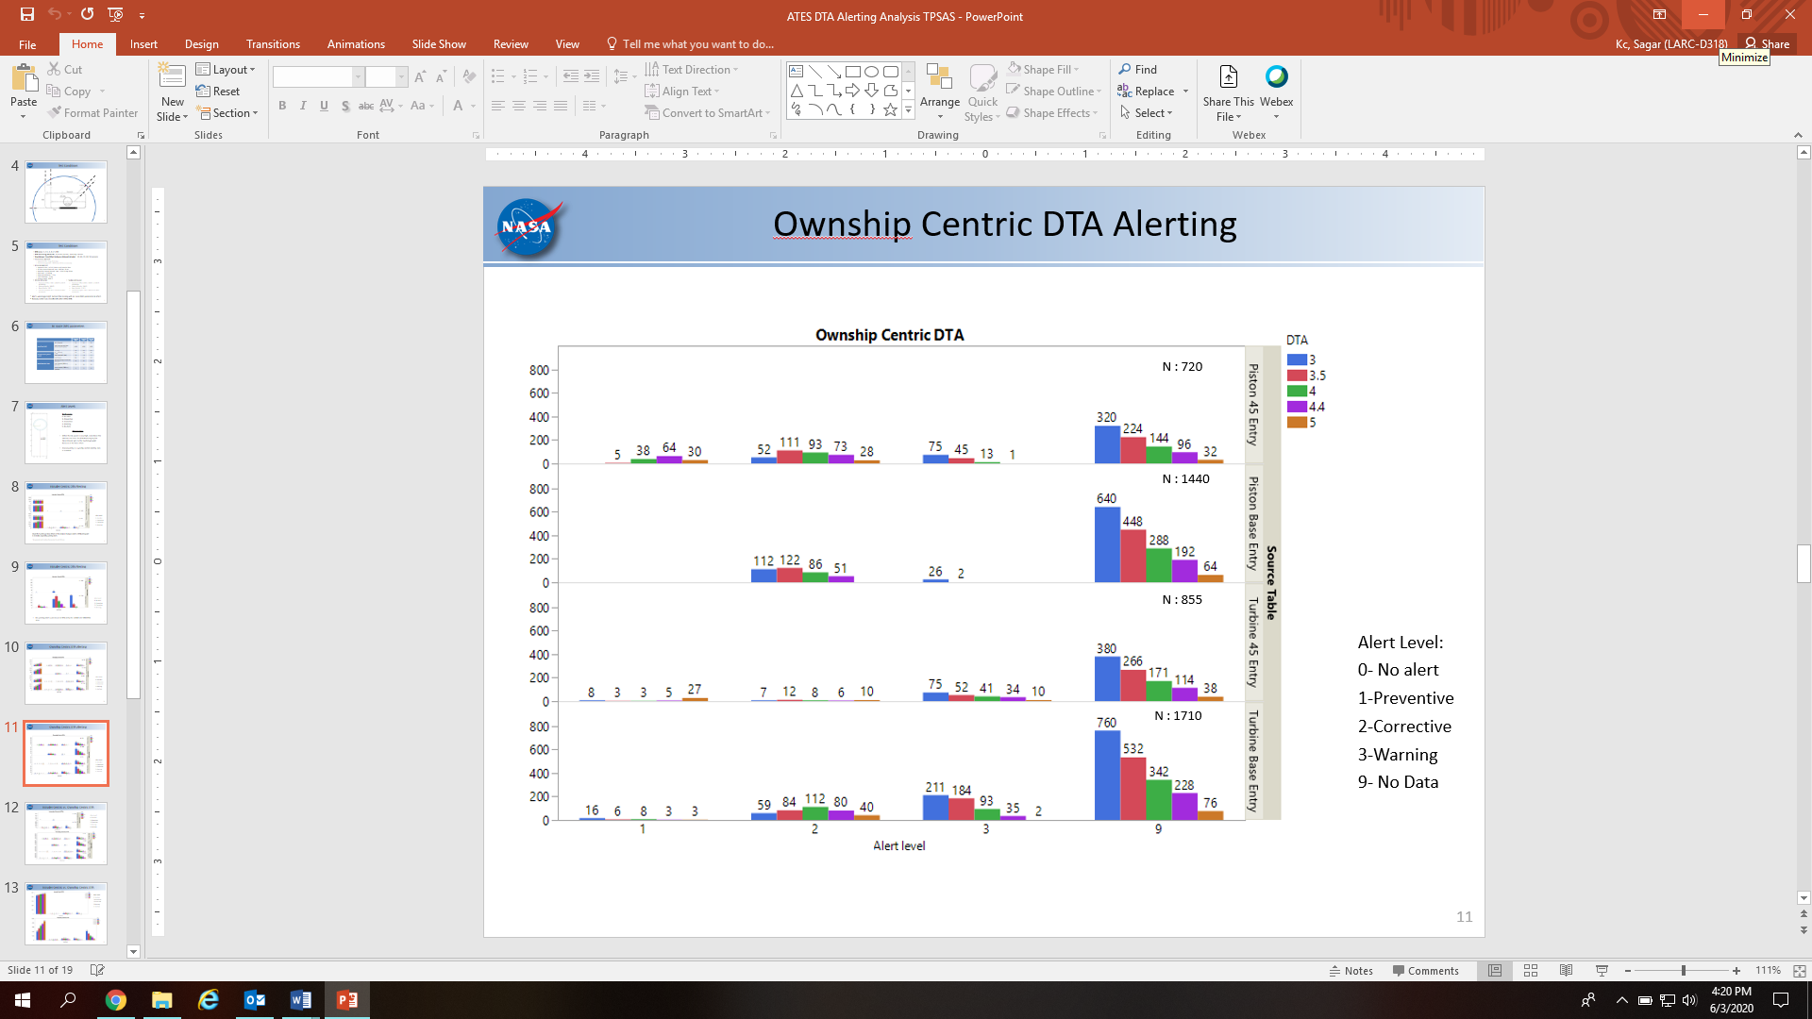

Fig 4. Alerting data for ownship-centric switching.
A total of 4,725 encounters were generated from all the variable combinations for each DWC switching method and DTA size. The encounters were divided into piston and turbine intruders, which was further divided into base entry and 45 degree entry traffic.
As the cumulative chart for intruder-centric switching is compared with that of ownship-centric switching, a deeper understanding about the effect of DTA sizes on alerting behavior can be gained. As depicted in Fig. 5, only a handful of warning alerts were issued for intruder-centric switching with DTA size of 4 NM while no warning alerts were issued for DTA sizes of 4.4 and 5 NM. On the other hand, there were many more warning alerts with ownship-centric switching for all DTA sizes.

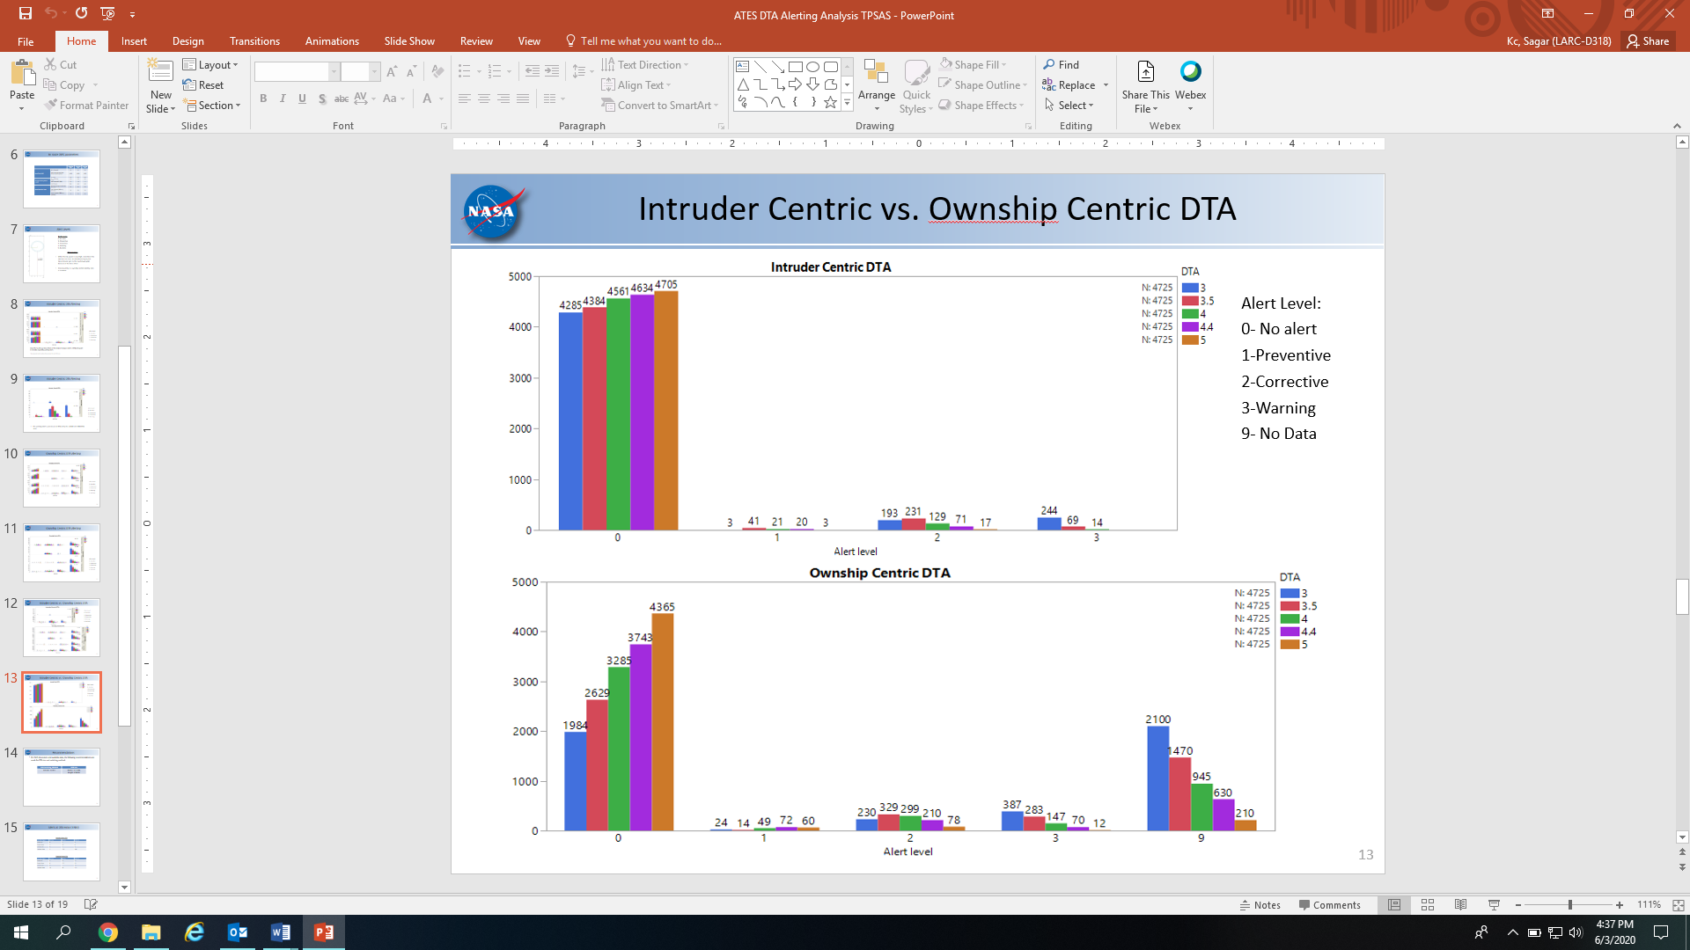
Fig. 5. Cumulative Alerting data for intruder-centric and ownship-centric switching.

Conclusions

As part of the greater effort to allow routine UAS operations in the NAS, this fast time study made recommendations for appropriate DTA size and DWC switching technique. Safety of flight is of utmost importance while integrating UAS in the NAS. While safety critical alerts must be issued by the DAA system during UAS flight operations, it is also imperative that undesirable and nuisance alerts be minimized. Based on the results of the study, desirable alerting behavior was achieved using intruder-centric DWC switching in combination with a DTA size ranging between 4 and 5 NM. These findings directly support requirements for terminal operations in RTCA DO-365A.

acknowledgements
The authors would like to express gratitude to UAS-NAS Project Tech Lead Tod Lewis for valuable guidance throughout design and execution of this study. Furthermore, the authors wish to thank members of SAIC software development team, Keith Hoffler (Adaptive Aerospace Group), and NASA Researcher Anna Trujillo for their unrelenting support and inputs. This research was funded by the Detect and Avoid Well-Clear subproject of NASA’s UAS-NAS project.

references
- Federal Aviation Administration, “14 CFR 91 General Operating and Flight Rules,” Federal regulations, Department of Transportation, Washington, D.C., April 2018. URL https://www.ecfr.gov/cgi-bin/retrieveECFR?gp=&SID=de5f9357d1e2716832f6ca8b6f84244a&mc=true&n=pt14.2.91&r=PART&ty=HTML.
- RTCA Special Committee 228, “DO-365: Minimum Operational Performance Standards (MOPS) for Detect and Avoid (DAA) Systems,” RTCA, Inc. (2017)
- RTCA, Inc.:,“UAS Landing Requirements,” Requirements from SC-228 committee meeting. SC-228 (2018)
- M.J. Vincent, R.D. Roper, “Concept of Operations for UAS Detect-and-Avoid in Terminal Operations,” In: NASA (ed.). NASA Langley Research Center, Hampton, VA (2018)
- A.C. Trujillo, D.P. Jack, D. Tsakpinis, “En Route Detect and Avoid Well Clear in Terminal Area Landing Pattern,” AIAA 2018-2872. AIAA Aviation Forum, Atlanta, GA, 2018 , pp. 11.
- M.J. Vincent, A.C. Trujillo, D.P. Jack, K.D. Hoffler, D. Tsakpinis, “A Recommended DAA Well-Clear Definition for the Terminal Environment,” AIAA 2018-2873. AIAA Aviation Forum, Atlanta, GA, 2018, pp 13.
- R. Rorie, K. Monk, S. Brandt, Z. Roberts, L. Fern, “A Comparison of Two Terminal Area Detect and Avoid Well Clear Definition,” 10.2514/6.2019-3182.
- Federal Aviation Administration, “Arrival Procedures and Separation,” August 2019. FAA Order JO 7110.65, Para 3-10-3. URL https://www.faa.gov/air_traffic/publications/atpubs/atc_html/chap3_section_10.html

