Pupil Aberrations in the LISA Transceiver Design

J. P. Lehan¹, J. M. Howard¹, Hui Li¹, Ryan Derosa¹, Mark Wilson², and Jeff Livas¹

¹ NASA Goddard Space Flight Center, Greenbelt, Maryland, USA 20771
² KBR, Inc., 7701 Greenbelt Road, Greenbelt, Maryland, USA 20770

Abstract

The LISA mission is a space-based gravitational wave detector consisting of three spacecraft with two transceiver telescopes per spacecraft. In addition to tight wavefront error control as expected for an interferometric system, there are tight pupil imaging and optical path length specifications. We use concepts gleaned from pupil aberration theory to understand these latter two constraints and show how these concepts led to a successful design for the LISA transceiver.

Introduction

LISA is a space-based gravitational wave detection mission run out of the European Space Agency (ESA) with participation by the USA’s National Aeronautics and Space Administration (NASA¹) for critical technologies. LISA was selected as the L3 mission in 2017 by ESA, with a launch planned in the mid-2030’s and technology milestones in the near future. One of the NASA-led technologies is the detection system transceivers, the optical design of which we will discuss here.

The LISA detection system consists of three spacecraft orbiting the sun at 1 AU in an equilateral triangular constellation with about 2.5 million km sides. Each spacecraft has two identical transceivers, two optical benches (OB’s), and two test masses (TM’s) that form the reference masses for the gravitational wave detection.

Detection is via heterodyne interferometry with a local oscillator reference laser where the science signal is the change in arm length along each of the three sides as a gravity wave passes through the constellation. In more optical design terminology, the signal is the optical path length (OPL) from sending transceiver system to receiving transceiver system.

Transceiver Optical Design Space

The photoreceivers are quadrant detectors, with bandwidth of about 20 MHz. The detecors quadrants are employed to correct tip and tilt in the (ideally) planar wavefront. Thus the transceiver design is afocal. The tilt is a result of the inevitable jitter between transceivers over the extremely-long baseline in spite of every effort to make the baseline free from external forces so the test masses are in free fall. Because of this jitter, a design goal is to eliminate the tilt-to-length (TTL) coupling in the transceivers. Put in more optical design terms, one wants the OPL through the transceiver to be independent of the field angle or, at worst, minimize the differential change in OPD with angle. Being an interferometric system, OPL changes at the sub-nanometer level are of significance, a result of the required strain sensitivity of the constellation. This change in OPL with angle is the definition of TTL with units of length/angle. Since the system is afocal, it is most insightful to look at this design goal in terms of pupil aberrations rather than image aberrations.

Other design goals and constraints are shown in Table A and Figure 1. There are significant geometric constraints that limit the design solution space. These are levied by the other parts of the detection system (OB and TM) as well as the geometry assumed in the data reduction. The large magnification (~ 134x beam expansion/reduction), large distance from the last (powered) mirror to the stop, and the virtual stop conjugate location being so far from a mirror make meeting all the performance goals challenging.

Table A: Design specifications and constraints. For this transceiver the mirror referencing and numbering are for receiver mode so, for example, M1 is the primary mirror and the largest mirror in the system.

Specification | Value | Type | Rationale
Magnification | 1/134.5 | Derived
Entrance pupil location | @ Test Mass Plane | Geometric | Data reduction
Exit pupil (stop) size | 2.24 mm | Sub-system compatibility | Laser beam waist size
Stop location | > 240 mm past primary vertex | Sub-system interface (geometric) | stop on optical bench  (stray light)
Unobscured design | NA | Trade study result | Backscattered light
Entrance pupil diameter | 300+/-1 mm | Derived | Radiometry (for pair)
WFE | < λ/88.6 RMS | Allocation (design residual – over science FOV) | Flowed from WFE budget (DL @ interferometer arm level)
Wavelength | 1064 nm | Sub-system compatibility | Laser trades result
Science FOV | 20 μrad (radius) | Derived | Jitter + point ahead + margin
Acquisition FOR | 225 μrad (radius) | Derived | Estimated from astrometry
TTL | <0.6 nm/μrad | Allocation (Science FOV only) | TTL budget
Co-boresighting | < 0.12 mrad | Derived (image space) | Derived from TTL budget

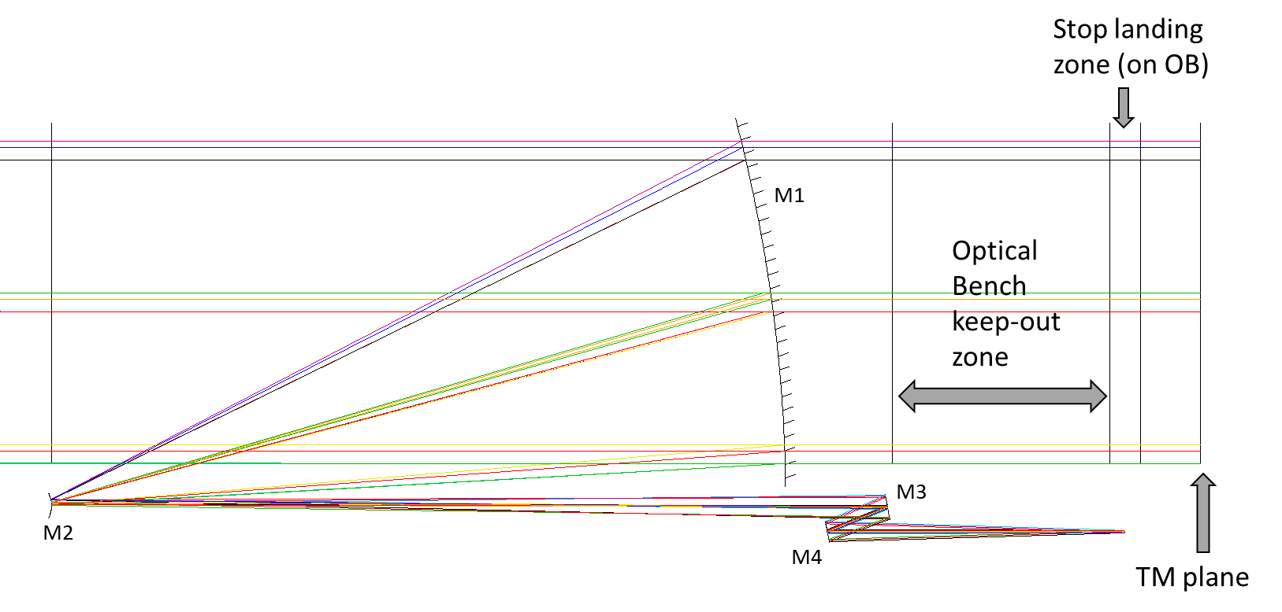
Figure 1: LISA telescope 725-v5b (discussed below) meeting specifications of Table A and illustrating mechanical constraints to the design solution space. The optical bench (OB) keep–out zone allows space for the detection and transmitter optics for this arm of the interferometer. Note also the mirror numbering scheme for the transceiver adopted in the text and tables.

For a more thorough discussion of the mission and top-level requirements, the reader is referred to the LISA website.² In spite of the mechanical constraints, there are a host of design forms that will meet the design goals. The NASA team explored a number of design forms^{3,4} but settled on an unobscured three-mirror-anastigmat (TMA) with an added fold mirror to direct the beam toward the Optical Bench (OB) as required (see Fig. 1). The fold flat has distinct advantage during alignment in that the co-boresighting specification can be decoupled from the WFE specification (see Table A).

We discuss two recent designs variation of this TMA form below. The first is a more classic TMA design and the second is a modified design incorporating ideas from pupil aberration theory and nodal aberration theory. First, however, we briefly review a few aspects of pupil aberration theory. For a review of nodal aberration theory, the reader is referred to the literature.⁵

Concise Review of 3rd Order (Seidel) Pupil Aberration Theory

Pupil aberrations are a natural part of Seidel’s formulae but are infrequently used. Most often they are of interest because, in wide field designs, the pupil aberrations degrade imaging over the field (distortion and radiometry). Rarely is the pupil in itself of interest. Our design proved to be one of those rare cases.

In Seidel’s treatment, the pupil aberrations are found from the image formulae by merely swapping the roles of the marginal and chief rays (see Table B). Algebraically, this is a trivial exercise but the meaning that results from this is far from trivial.

Table B: Seidel pupil and image aberrations of a surface. Җ is the Lagrange invariant$,Җ=\overline{A}y-A\overline{y}$,
$Δ\left(\frac{u}{n}\right)=(\frac{u^{'}}{n^{'}}-\frac{u}{n})$, $Δ\left(\frac{1}{n}\right)=(\frac{1}{n^{'}}-\frac{1}{n})$, $A=nu+nyc$ , and c is the surface curvature. The barred quantities are analogous with the chief and margin ray roles reversed. We have adopted the notation of Shack.⁶
Image Aberrations | Pupil Aberrations
$$S_{I}=-A^{2}y ∆\left(\frac{u}{n}\right)$$ | $${\overline{S}}_{I}=-{\overline{A^{ }}}^{2}\overline{y} ∆\left(\frac{\overline{u}}{n}\right)$$
$$S_{II}=-A\overline{A}y ∆\left(\frac{u}{n}\right)={\overline{A}}/AS_{I}$$ | $${\overline{S}}_{II}=-A\overline{A}\overline{y} ∆\left(\frac{\overline{u}}{n}\right)=A/{\overline{A}}{\overline{S}}_{I}$$
$$S_{III}={-\overline{A}}^{2}y ∆\left(\frac{u}{n}\right)={\overline{A}}/AS_{II}$$ | $${\overline{S}}_{III}={-A}^{2}\overline{y} ∆\left(\frac{\overline{u}}{n}\right)=A/{\overline{A}}{\overline{S}}_{II}$$
$$S_{IV}=-Җ^{2}c ∆\left(\frac{1}{n}\right)={\overline{S}}_{IV}$$ | $${\overline{S}}_{IV}=-{\overline{Җ}}^{2}c ∆\left(\frac{1}{n}\right)=-Җ^{2}c ∆\left(\frac{1}{n}\right)$$
$$S_{V}={\overline{A}}/A \left(S_{III}+S_{IV}\right)$$ | $${\overline{S}}_{V}=A/{\overline{A}} \left({\overline{S}}_{III}+{\overline{S}}_{IV}\right)$$
$$S_{VI}={\overline{A}}/A S_{V}+{\left({\overline{A}}/A \right)}^{2}S_{IV}$$ | $${\overline{S}}_{VI}=A/{\overline{A}} {\overline{S}}_{V}+{\left(A/{\overline{A}} \right)}^{2}{\overline{S}}_{IV}$$

This mirroring between the pupil and image aberrations is not wholly unexpected given the relationship between an image point and its corresponding pupil and that all the expressions in Table B are based solely on paraxial (linear) quantities.

Pupil aberrations can be expanded in a polynomial form in similar manner to image aberrations; however, the one-to-one correspondence of Table B between the aberrations in the pupil and the image plane ends at the Seidel level. This become apparent when one reflects on the fact that the pupil aberrations describe a different conjugate relationship of the optical system than the image aberrations. Nonetheless, when examining the pupil aberration behavior, we can employ some of the familiar tools employed to visualize image aberrations (keeping in mind that the interpretation is different). In this paper we will employ what we will call the “chief ray spot diagram” to differentiate it from the spot diagram employed in visualizing image aberration behavior at a single field point and image plane. As the name implies, it is a plot of the chief ray (x, y) locations as they cross a given assumed plane for a set of fields probing the full field. This plane need not be “the” pupil plane which is typically defined to be the paraxial (or first order) location for the central field. In our examples, however, this is the case to simplify the discussion and space restrictions.

Case I: All Conic Design

The first case we looked at in terms of pupil aberration was an all conic design that meets the design goal set out in Table A under the packaging constraints shown in Fig. 1. The design has the programmatic reference name 725-v5b. The 725 refers to the M1-M2 distance (set at the packaging maximum to ease M1 fabrication). The rest are series and sub-series references. Table C shows the prescription and Figure 1 shows Y-Z cross section with rays for 3 fields (-225 μrad, 0, +225 μrad measured in receiver-mode object space).

Table C: Design parameters for the all-conic design 725-v5b. Apertures have been left out of the table for brevity. Tilts and decenters are relative to the Cassegrain front end common axis (M2-to-M1 vertices).

Optic | Radius (mm) | Conic | Thickness (mm) | Tilt/Decenter
M1 | -1475.246 | -1 | -725 | 0/0
M2 | -25.813 | -1.092 | 816.107 | 0/0
M3 | -482.876 | -1 | -50 | 22/90.444
M4 | ∞ | 0 | 272.456 | 11/-25.577
Stop | ∞ | NA | 0 | 0/-25.579

In this design, the M3-M4 combination directs the beam to the stop within the packaging constraints. To get beam clearance in the space available, M3 was tilted. This has an insignificant effect on the wavefront of any individual field. It does, however, introduce additional aberration at the entrance pupil. This is apparent in the chief-ray spot diagram as illustrated in Fig. 3. Note that the pattern looks like coma. This immediately suggests the dominant cause of aberration, which is the tilting of M3 to satisfy the packaging constraints. Perhaps less obvious is that it also results in a higher maximum TTL. (TTL = 0.079 nm/μrad at the –y edge of the science field.) This design clearly meets the specification (Table A), but was found that small deviations from the ideal design (small mirror mis-alignments, etc.) caused the TTL to rise rapidly out of specification for the as-built system making the fabrication and alignment costly, difficult, and thus higher risk than desirable. This behavior is presaged by the TTL response over the larger acquisition FOR. The TTL of the design exceeds the 0.8 nm/μrad specification at about 50 μrad in field. This is only 2.5x the science field radius and indicative of the relatively low margin in the design.

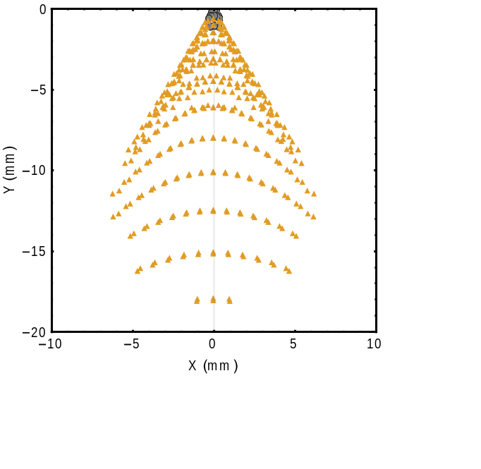
Fig 2: Chief ray spot diagram in the test mass (TM) plane. The TM plane is the plane of the paraxial (gut ray) entrance pupil for the transceiver when used in receive mode (see Table A). Circles are for fields within the science FOV, triangles for fields outside the science FOV but still within the acquisition FOR.

Case II: Conic & freeform design

Armed with new insights into the correlation between TTL and pupil imaging, the above design was modified slightly. M3 acts as a field mirror (see Fig 1.) and is thus the natural choice for altering the pupil imaging with de minimus impact on the wavefront performance. The resultant design has the programmatic reference name 725-v7b. Tables D & E show the prescription and Fig. 4 shows the Y-Z cross section with rays for three fields (-225 μrad, 0, +225 μrad measured in receiver-mode object space).

Table D: Design parameters for the mixed conic-freeform design, 725-v7b. Apertures have been left out of the table for brevity. Tilts and decenters are relative to the Cassegrain front end common axis (M2-to-M1 vertices).

Optic | Radius (mm) | Conic | Thickness (mm) | Tilt (Rx)/Decenter Y
M1 | -1475.246 | -1 | -725 | 0/0
M2 | -25.813 | -1.093 | 825.5 | 0/0
M3 | NA (freeform) | NA (freeform) | -65 | 12.142/ -1.566
M4 | ∞ | 0 | 293.49 | 12.321/-28.667
Stop | ∞ | NA | 0 | 0/-28.669

Term | Value
X² | -0.00102 mm⁻²
Y² | -0.000972 mm⁻²
X²Y | 1.72764x10⁻⁷mm⁻³
Y³ | 1.67230x10⁻⁷mm⁻³
Table E: Surface parameters for M3 for LISA design 725-v7b. An x-y polynomial was chosen for this surface but a number of other representations or basis sets (Zernikes, etc.) would result in a design with roughly equivalent performance.

The form chosen for M3 is a x-y polynomial but other options would yield approximately equivalent results. Note the Y3 term in Table E serves to eliminate the coma-looking pupil aberration of Fig. 2. The residual aberration is greatly reduced but not completely eliminated. The pupil spot diagram for this design is shown in Fig. 3. The TTL has dropped to 0.001 nm/μrad, exceeding the design goal and leaving margin for fabrication, alignment, integration, launch, and gravity release in the TTL budget. A similar examination of the TTL response over the acquisition field performed above tells us why. The TTL of this improved design does not exceed the 0.8 nm/μrad specification anywhere over the entire 225 μrad acquisition field! This is also apparent qualitatively by comparing Figs. 2 and 3. The chief ray spot diagram of the improved design is about 15 times smaller in x extent and 22 times smaller in y extent. Fig. 4 shows a Y-Z cross section of the same fields as Fig. 1. Note that the incoming chief rays for the extreme fields overlap at this scale which is not the case in Fig. 1. This has the additional advantage of reducing the overall beam footprint on M1, thus yielding a smaller, lighter telescope.

This improved design is currently being pursued for mission adoption.

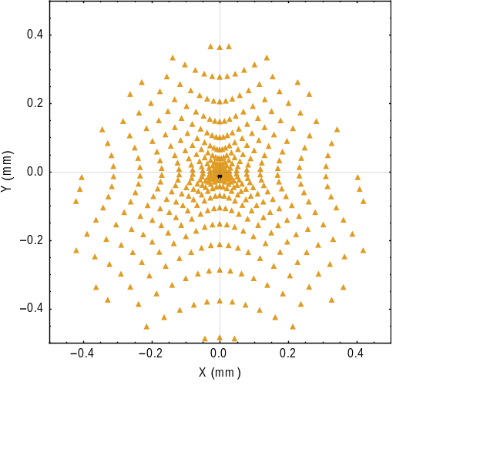
Fig 3: Chief ray spot diagram in the test mass (TM) plane for the design of Table D & E. The TM plane is the plane of the paraxial (gut ray) entrance pupil for the transceiver when used in receive mode. Circles are for fields within the science FOV, triangles for fields outside the science FOV but still within the acquisition FOR.

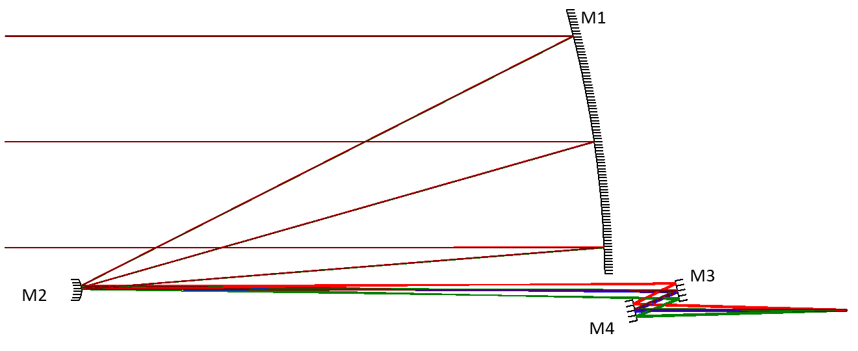
Figure 4: LISA telescope 725-v7b. By turning M3 into a freeform, the pupil aberrations are reduced dramatically without compromising the wavefront quality. Note that the extreme-field chief rays (for +/-225 μrad fields) appear to overlay the chief ray of the central field (0 μrad) at M1. Compare with Fig. 1, where the separation is readily apparent.

Discussion

We reviewed some recent progress in the design for the LISA transceivers. The insight into the connection of the tilt-to-length specification to pupil aberration theory led to a rapid convergence to a design acceptable both in wavefront error and tilt-to-length and meeting all optical performance specifications for the mission with margin.

We introduced the chief ray spot diagram as one of a number of possible tools for visualizing some of the pupil aberration behavior of the system. One can imagine that such tools would allow more insight into ways to manage pupil aberrations in wide-field systems as well. Indeed, we hope to see some pupil aberration calculations and visualization tools become standard in commercial lens design programs.

An understanding of pupil aberrations should be an arrow in a designer’s quiver of methods for design improvement.⁷ Just as it is often more insightful to look in Fourier space than x-y space for particular diffraction problems, the same is true for pupil aberrations.

References

1. https://lisa.nasa.gov and links found therein.

2. See, for example https://www.cosmos.esa.int/documents/678316/1700384/LISA_L3_20170120+-+Submitted.pdf/5b036a72-ed33-dbad-871d-f16ed282723d

3. Sankar, S. R., and J. C. Livas, "Optical telescope design for a space based
gravitational-wave mission," Proc. SPIE 9143 pp. 914314-1-7 (2014).

4. Livas, J., et al, “Telescopes for space-based gravitational wave missions,” Opt. Eng. 52(9) pp. 091811-1-8 (2013).

5. Fuerschbach, K., Ph.D. Thesis, University of Rochester, Chapter 2 (2014) and references therein.

6. Shack, OPTI 514 class notes (1989).

7. For an open-literature primer on pupil aberrations, see Sasian, J., “Theory of sixth-order wave aberrations,” Appl. Optics, 49 (16) D69-95 (2010).

