Lessons Learned: Using UTM Paradigm for Urban Air Mobility

Savita A. Verma, Spencer C. Monheim, Kushal A. Moolchandani, Priyank Pradeep, Annie W. Cheng, David P.Thipphavong,
Victoria L. Dulchinos, Heather Arneson, Todd A. Lauderdale
NASA Ames Research Center, Airspace Systems Division, Moffett Field, CA, USA
savita.a.verma@nasa.gov, spencer.c.monheim@nasa.gov, kushal.a.moolchandani@nasa.gov, priyank.pradeep@nasa.gov,
annie.w.cheng@nasa.gov, david.p.thipphavong@nasa.gov, victoria.l.dulchinos@nasa.gov, heather.arneson@nasa.gov, todd.a.lauderdale@nasa.gov

Christabelle S. Bosson, Eric R. Mueller, Bogu Wei
Uber Technolgies Inc., Uber Elevate, San Francisco, CA, USA
cbosson@uber.com, eric.mueller@uber.com, bogu@uber.com

Abstract—Urban Air Mobility (UAM) aims to reduce congestion on the roads and highways by offering air taxi as an alternative to driving on surface roads. Integration of UAM operations in the National Airspace System (NAS) has been the focus of the research conducted at NASA Ames Research Center. A simulation was performed in collaboration with Uber Technologies Inc to investigate if NASA’s UTM architecture and its implementation as demonstrated in the 2019 UTM field tests were extensible for UAM operations, and if the data exchange between multiple operators as planned under UTM were adequate for UAM operations in the shared airspace. In order to explore these research questions, three Use Cases were defined to investigate different airspace management challenges. This paper will describe the lessons learned from exercising the uses cases and the airspace management services including scheduling and separation developed to facilitate initial UAM operations.

Introduction

Urban Air Mobility (UAM) is gaining interest as the need for On Demand Mobility in today’s congested road traffic is increasing in metropolitan areas [1,2]. UAM is envisioned as the concept to transport passengers and cargo safely and efficiently using innovative aircraft in these urban areas [3]. It is expected to improve mobility for the general public, decongest road traffic, reduce transport time, and reduce strain on existing public transport networks [3]. There exist several challenges to UAM, such as integration of procedures with airspace and the airport, maintaining operations within acceptable noise levels, gaining public acceptance, developing a path for vehicle certification, and more.
Integration of UAM operations in the National Airspace System (NAS) has been the focus of the research conducted at NASA Ames Research Center under the Air Traffic Management – eXploration (ATM-X) UAM sub-project. Previous research on UAM operations focused on understanding the capabilities and limitations of helicopter operations in the current day environment that might be applicable to UAM [4]. The research found that current day requirements for helicopter operations, similar to UAM operations, for obtaining verbal clearances to Class Bravo airspace was the biggest limiting factor. Digitizing communication would not be a feasible solution for such clearances for UAM operations since it would simply substitute the verbal communications, changing the nature of the workload but not reducing the workload for the air traffic controllers. To make the UAM operations scalable, the traffic management for the small Unmanned Aircraft Systems (sUAS) was proposed as a solution. The UAS Traffic Management (UTM) paradigm [5, 6], describes a service-oriented architecture with a focus on third party services.
The study reported in this paper explores the application of the UTM architecture to UAM operations. A simulation performed in collaboration with Uber Technologies investigated if the performance of the UTM architecture and its implementation from UTM’s Technical Capability Level 4 (TCL-4) [6,7] were extensible for UAM operations, and if the data exchange between multiple operators as planned under UTM were adequate for UAM operations in shared airspace. The main objectives of this engineering evaluation were to explore information and data exchange requirements, identify key questions regarding access of controlled airspace from the Air Navigation Service Provider (ANSP) perspective, and to explore digital airspace integration procedures.

In the next section, Section II, different concepts of operations that exist for UAM operations will be described. In Section III, a description of the method that includes a high-level overview of the system configuration, airspace definitions, traffic scenarios, and engineering evaluation use cases will be provided. Section IV will describe the results from analyzing the post-simulation data and also capture some of the lessons learned. Section V will include a summary and proposed next steps.

Background
The approach to airspace management for UAM operations simulated in this study is an extension of the concept for UTM to enable UAM operations, with special consideration given to ensuring the extensions are interoperable with the existing Air Traffic Management (ATM) system. Details of the UTM operational concept are included in the Federal Aviation Administration’s (FAA’s) UTM Concept of Operations (ConOps) document [12]. An integral aspect of this airspace management approach is the idea that third parties will provide airspace management services to aircraft. The UTM architecture described in [5, 6] refers the service providers for UAS as UAS Service Suppliers (USS). It is likely that service providers for UAM operators will be differentiated in the future, but for now we refer to them as USS in this paper. The tests described in this paper were designed to highlight key challenges related to extending the UTM concept to UAM and establish the simulation and testing infrastructure necessary to develop more detailed concepts and procedures for UAM operations in the NAS.
The study assumed the following operating assumptions: aircraft operations simulated in this study were conducted under today’s visual flight rules (VFR), with a qualified pilot in command onboard the aircraft. Each all-electric, vertical takeoff and landing (eVTOL) aircraft is expected to have a capacity of transporting up to four passengers and the pilot. Operations will depart from and arrive at vertiports that have been constructed to the relevant guidelines and approved for this UAM use case; they will not operate out of unprepared sites. Aircraft will fly along highly structured routes that are known and acceptable to the local air navigation service provider and communities. These flights will be relatively short because they are conducted within a metropolitan area, normally under twenty minutes.
An important consideration for accessing Class B airspace is the manner in which “airspace authorization” is achieved. Airspace authorization is the means by which an operation is approved to operate in a particular airspace. Today, authorization may be granted through submission of a flight plan and verbal clearance from an air traffic controller (e.g., for Instrument Flight Rules [IFR] operations), or be allowed without explicit clearances (e.g., for VFR operations in uncontrolled airspace). Authorization to conduct a particular operation will require that aircraft are appropriately certified, and pilots are licensed for the types of operations they will conduct, that maintenance schedules are being followed, that weather conditions are appropriate, and other criteria are met. It is expected that systems and procedures will be developed to support automated, digital authorization of an operation that enables aircraft to access terminal airspaces (i.e. airspace classes B, C, and D) without first receiving a verbal clearance or making verbal contact with air traffic control. This authorization would occur using the UTM architecture after some modifications have been made to it.
Within busy controlled airspace there will likely need to be specially designated “airspaces” in which UAM aircraft are allowed to operate without verbal clearances or contact with air traffic controllers. These “UAM-authorized airspaces” are envisioned as discrete subspaces of the greater Class B, C, or D airspace that would be geographically static over weeks or months, though their accessibility for UAM operations could be relatively dynamic, based on current air traffic flows, weather, airport configurations, and other factors. Similar to helicopter routes, these “airspaces” would be located in areas not typically used by traditional aviation and would avoid noise-sensitive areas or geographies with other incompatible land uses. The airspace used for UAM operations would continue to be classified according to the surrounding airspace, just as the special flight rules area (SFRA) [14 CFR Part 93 Subpart G)] above Los Angeles International Airport (LAX) continues to be designated Class B, but permits access using a different authorization method. Importantly, as envisioned, the UAM airspace/routes would not be associated with a particular UAM operator, and any appropriately qualified and authorized UAM aircraft would be permitted to operate in them.
The key operational benefit of the UAM airspace/routes are that operations in Class B, C, or D airspace would not require traditional air traffic control services provided by ANSPs and utilize instead services provided by a third party (e.g., a USS) in conjunction with pilot responsibilities. In effect, the traditional ANSP services necessary to ensure the safety and efficiency of operations in these otherwise complex environments would be replaced by highly structured routes, common aircraft operating characteristics and procedures, as well as information exchanges between participating aircraft facilitated by their respective USS. Significant work remains for the UAM community to define the requirements for these services and the technologies that will deliver them.

Methods

Extension of the UTM paradigm
The UTM architecture delineates the functions provided by the ANSP, third party service providers or the USS Network. This service-oriented architecture includes connection to the regulatory authority via the Flight Information Management System (FIMS). FIMS is a central, cloud-based component that enables information exchange between ANSP (e.g. FAA) systems and the USS Network. The USS enables UAM operators to communicate with each other and with the ANSP about both planned and ongoing operations.
The UTM system developed for TCL-4 [6,7] field tests were used as the starting point for UAM operations in this research. Compared to the current UTM operations that serve the sUAS that fly below 400 AGL, UAM operations pose a higher safety risk compared to UTM operations as they are envisioned to transport people flying between 500 AGL and 3,000 AGL, with more interactions with other traffic. Given such differences, this research aimed to understand the applicability of the UTM paradigm and architecture for coordinating operations within the UAM routes that are shown in the Airspace section.
Within the UTM paradigm, USS submit operations with their intended flight path as operational volumes. The operational volumes can be either Transit Based Operational Volumes (TBOV) or Area Based Operational Volumes (ABOV). TBOVs are based on a known route or flight profile, where lateral and vertical boundaries are built around a centerline. The TBOV includes any geographical buffer required to account for the UAS’ ability to maintain flight along the centerline (navigation performance capabilities, environmental factors, etc.). ABOVs represent a larger block of airspace encompassing a mission profile because the projected route may be too complex (e.g., survey operation) or dynamic (e.g., search and rescue mission) to describe, or if the UAS has minimal navigation capabilities and can only perform visual line of operations. TBOVs were selected for this study since they could be adapted for routes that were planned for UAM flights shown in Fig. 1.
The design and size of the TBOVs is expected to be managed by the UAM operator. This study contrasted two approaches to TBOV design; NASA and Uber each designed their TBOVs with different parameters. In both designs the maximum length of TBOV was set to 100,000 feet to prevent any operator from blocking large portions of airspace for their operations and to allow several TBOVs to be built for the experimental UAM routes. This can be compared to the 6000 feet maximum length of TBOV allowed in UTM.

Fig. 1 shows a notional representation of the TBOVs, and how they are stitched together to represent a UAM path between two vertiports. NASA planned for each TBOV’s maximum traversal time to be 60 sec in length. The dimensions of the NASA-defined volumes were 500 ft vertical by 1500 ft lateral between planned, adjacent routes that traverse opposite directions. The spacing between the routes and the height/width of the volume were calculated based on the following assumptions:
- Flights will have required navigational accuracy of 0.1 nmi, which is approximately 600 ft on either side (laterally) of the route;
- A 150 ft buffer is added to the lateral distance, required by additional services such as a conformance monitoring/ Separation Service used by NASA and also by the target generator that was used to fly the UAM flights;
- A 250 ft buffer was added above and below the vehicle.
Uber designed its volumes such that each TBOV connects two consecutive waypoints of the route.
- TBOVs are set at 75 ft either side laterally of the vehicle and 100 ft each side vertically making the rectangular cross section of the volume 150 ft wide and 200 ft tall.
- For the Uber routes that intersected with NASA routes, TBOVs provided by Uber started at the crossing fixes.

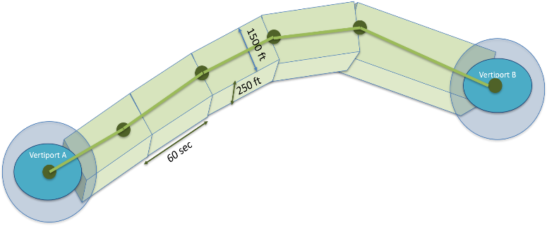
Figure 1. Notional diagram representing a series of TBOVs along a route between origin and destination pair.

Uber’s projections of air traffic assume airspace utilization with many routes connecting vertiports in cities. These engineering evaluations allowed investigation of the given volumetric dimensions around the routes that assumed far-term future Required Navigation Performance (RNP) levels.

Airspace
The technical approach taken by NASA involved constructing the initial UAM airspace system by connecting UTM TCL4 and Testbed [12] at NASA Ames Research Center. Several services were developed for UAM operations and connected to Testbed to investigate information requirements for multiple UAM operator coordination. The two UAM operators (i.e. NASA and Uber) operated in the same airspace using the UTM architecture to share operational information. The test focused on the basic services originating from the UTM paradigm, that would be required for UAM routes operating in Classes B/D/E/G airspaces. NASA also planned to test additional services, such as scheduling and conflict detection and resolution. For the purposes of the engineering evaluation, the interaction of these flights with Air Traffic Control (ATC) was not considered. Although the concept of operations is still being finalized, it is likely that for UAM operations, routes will be pre-defined and published and shared with all operators, which was not a requirement for UTM operations.
Routes were planned in Dallas-Fort Worth airspace. There were some routes that connected the large airports like Dallas-Fort Worth (DFW), Dallas-Love Field (DAL) and Addison (ADS). Both DFW and DAL are in Class B airspace whereas ADS is in Class D airspace. Most of the routes in Class B airspace were designed to fly UAM vehicles at 500 or 1000 ft AGL. There were some routes that were designed and developed in Class E/G airspace to study the interaction between the different operators. Interaction with sUAS was not considered when these routes were developed and should be considered in future studies. The routes in Class G and E airspace had routes flowing in the opposite directions that were 1500 ft apart. Fig. 2 shows the UAM routes planned in the DFW area and their colors show the altitude at which those flights were planned.

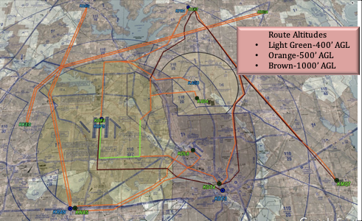
Figure 2. Routes planned for Engineering Evaluation in DFW Area.

Traffic Scenarios

There were two traffic scenarios used for the engineering evaluation that defined the level of simulated UAM traffic. However, the results of only one scenario is described in this paper; this scenario operated about 110 NASA operations on all the UAM routes tested. The number of Uber operations planned for the entire simulation were about 85 for their traffic scenario. This led to a total of 200 operations planned for the 40 min period. UTM TCL-4 performance limits were considerably expanded to achieve the 200 simultaneous operations since TCL-4 implementation did not test with more than 40 operations.

Use Cases

The Use Cases were developed to investigate non overlapping resources between multiple operators, as a reasonable approximation of actual implementation of operations, before more complex conditions were considered. The rationale was to allow development of services that start by providing situational awareness to the two UAM operators and expand to scheduling and separation functions in both the strategic and tactical timeframes. Thus the use cases were built with increasing complexity with the goal of allowing future operations where routes would be shared among operators.

Use Case A: Two UAM Operators, Different Resources, Shared Airspace
Use Case A was developed to evaluate two UAM operators that manage different resources in a shared airspace. NASA and Uber provided their own separate sets of pre-defined UAM routes which were shared as adaptation data prior to running the simulation (Fig. 3 and 4). In this use case, Uber and NASA did not share any routes or vertiports, but were aware of each other’s routes and vertiports. Executing the UTM paradigm, the USSs shared position information with each other and operated within the same operational area. Each operator was responsible for the management and scheduling of their flights on their own set of UAM routes. All UAM flights were assumed to be equipped with ADS-B out, and their real-time positions were available. NASA and Uber agreed to allow 4D volumes to overlap among their operations, disabling the negotiation function, in order to leverage other separation services. Uber’s UAM flights operated with some of their basic services such as route generation and flight trajectory management. NASA operated with some of its additional services for scheduling and separation in some of the runs.
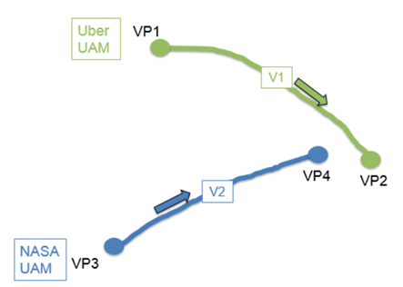
Figure 3. Use Case A. Multiple operators-different resources in shared space.

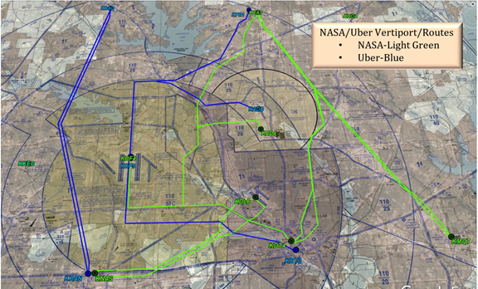
Figure 4. Use Case A. NASA and Uber routes in DFW Area.

Use Case B: Multiple UAM Operators, Constrained Resources, Shared Airspace
Use Case B was focused on multiple UAM operators in shared airspace with constrained resources (see Fig. 5).
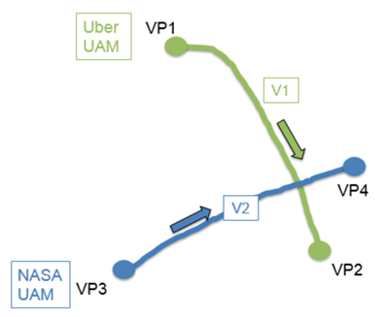
Figure 5. Use Case B. Multiple operators sharing resources (crossing points) in shared airspace.

The crossing fixes between the NASA and Uber flights served as the constrained resources. The following process was used for Use Case B: NASA submitted its TBOV for any given flight to the NASA USS, followed by Uber’s submission of their flight’s TBOV. It was expected that Uber would submit its TBOVs overlapping the crossing fixes, six minutes prior to the NASA flight’s scheduled/ desired departure time, and it was used by NASA’s scheduling service to condition the traffic flows, when applicable. At that time, the scheduling service was provided with scheduled departure times and Estimated Times of Arrival (ETAs) to any constraint points along the route and at the destination vertiport. Thus, NASA flights saw Uber flights as fixed constraints and would be re-scheduled to avoid the Uber flights. NASA services continued to deconflict NASA flights with each other using a set of separation minima described in Section F, and also de-conflict with Uber’s TBOVs.
Fig. 5 and 6 show the interaction between NASA and Uber routes, and examples of the crossing fixes that required pre-departure scheduling in the strategic time frame. Fig. 6 also shows that a new NASA route was added in Class G airspace to create the constrained and shared resource (crossing fixes) between the NASA and Uber operators.

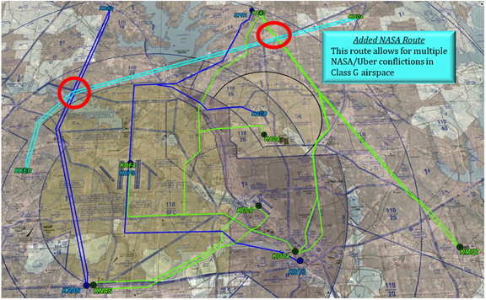
Figure 6. Use Case B. Crossing fixes between Uber and NASA routes

Use Case C: Multiple Operators, Shared Airspace, Managed Contingency
The objective of Use Case C was for NASA and Uber UAM operators to share the airspace and manage a contingency that needed to be resolved in a tactical time frame. The initial steps involved in NASA’s and Uber’s pre-departure and pre-planning activities were the same as in Use Case A.
At some point during the flight, the Uber UAM flight detected a battery issue. The Uber USS determined the nearest vertiport was VP5 as depicted in Fig. 7. The new Uber operational volume V3, overlapped their own volume V1, enroute at the contingency point, and also overlapped NASA’s flight volume V2, destined to vertiport VP4.
The Uber USS submitted an operational plan change request to volume V3, and updated the ETA and the operation’s end time, which was then accepted by the system. The Uber UAM aircraft received the approval and adjusted its flight maneuvers to stay within V3. The Uber contingency aircraft was given the highest priority in the system and was treated as a “priority or exempt flight” (i.e., hard constraint) by NASA Scheduling and Separation Services in the runs where those services were utilized. Uber elevated that operation to an emergency severity. NASA Separation Services detected conflicts and issued resolution maneuvers to the NASA aircraft to maintain separation between Uber’s contingency aircraft (with its new operational volume) and the NASA UAM aircraft and its volume.

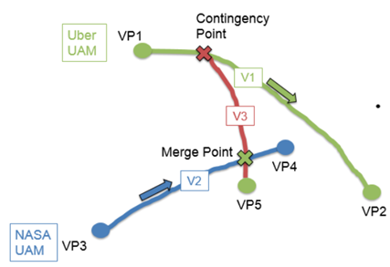
Figure 7. Use Case C. Operators share airspace and manage a contingency.

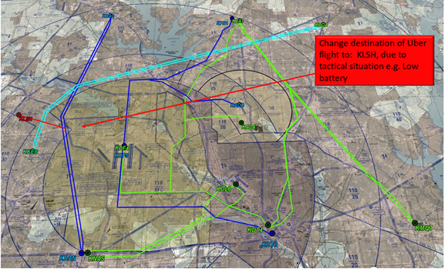Figure 8. Use Case C. Change in Uber flight due to tactical situation

All operational plan changes by Uber’s Operation Management service were communicated to the Uber USS and the NASA USS for mutual situational awareness. The details communicated were similar to a new operation which include the updated/new volume, end times, and priority of the operation. Uber’s USS shared this information with NASA’s USS and Scheduling and Separation Services.

Uber Services and Parameters
Uber has developed a set of core airspace management services tailored to controlled airspace access. They include a Route Generation Service which handles the nominal route creation that ingests and converts waypoint-based routes to ARINC429-inspired route structure. The Operation Management Service handles the lifecycle of each operation including their creation, activation, publication and termination. An Operation Lifecycle Manager is responsible for managing the state of each operation from creation/scheduling to landing/closing. In addition, the service conforms to the UTM specification and provides the UTM operational states (proposed, accepted, activated, nonconforming, rogue, closed) for each of Uber’s operations. State transitions processed here are triggers to other services; i.e., sending closure announcements to other USSs when an operation closes.
An Operation Volume Service generates TBOVs as part of the operation creation process. The TBOV Generation configuration was described above.
A Flight Monitoring Service continuously performs trajectory conformance monitoring by comparing the flown trajectory with the predicted trajectory. Any deviations that are detected trigger appropriate state transitions in the Operation Management Service.
A Vehicle Integration Service (VIS) handles commands to the vehicles (e.g. takeoff, landing), and uses those commands as triggers to call the other services. When a contingency plan is commanded, VIS immediately calls the Operation Management Service to generate the new set of TBOVs and update them.

NASA Services and Assumptions
NASA services had similar functions as Uber’s Basic Services. The trajectories generated for NASA UAM aircraft used a Target Generator (TG) prior to departure, which incorporated the simulated UAM aircraft model characteristics such as speed and flight profiles during climb and descent. The Fleet Operator then generates the TBOVs that encompass the trajectory, which is then submitted by the USS as part of the operation plan. The operation volumes were built to be up to 60s temporal length for every operation. The Fleet Operator was responsible for the states and lifecycle of all NASA’s operations, connects NASA airspace management services with NASA’s simulation environment (Testbed) and with the NASA USS (NUSS). Like other USS, NUSS was responsible for trajectory conformance monitoring and announced the operations as non-conforming when they departed their given operational volumes.
To evaluate the impact of strategic scheduling and tactical separation services on the UAM operations, NASA also utilized additional services – Scheduling Service and Separation Service – that were tested in selected runs. These services were used to manage scheduling and separation of UAM operations in addition to the strategic de-confliction by operation volumes under the UTM paradigm. NASA’s Scheduling Service provided the strategic de-confliction function and conditioned the flows with pre-defined in-trail, crossing, and merge points spacing requirements for the NASA flights and also took into consideration Uber’s flights and their volumes that overlapped with NASA flight’s volume at the crossing points. NASA’s Scheduling Service, Network Scheduler (NS), is based on a scheduler developed for NASA’s Airspace Technology Demonstrations 1 and 2 (ATD-1 and ATD-2) and has a tested and proven outcome and stability [10]. The NS manages the schedule by scheduling arrivals at nodes on a route network. Given that TBOVs are used in UAM operations, the scheduling algorithm is modified to accept the ETAs from the NASA flights and TBOVs from other operators using a node blocking functionality that separates flights from the beginning and end of the TBOV. The result is that TBOVs may overlap, but the vehicles are separated by the relevant spacing requirement. NASA’s Scheduling Service assumed that the capacity at each vertiport was one arrival and one departure per minute, thus the departure demand built into the traffic ranged between 40s and 90s. The Scheduling Service worked towards 45s in-trail separation and 15s separation at the crossing points. The crossing point restriction was applied inside the controlled airspace only; it was assumed that the Separation Service will have the flexibility to maneuver outside controlled airspace. Uber sent 15-20s volumes with a buffer of 45s on either side for flights that shared the crossing point with NASA’s flights, and the scheduling service applied 15s on either side of Uber’s TBOV, making the constraint volume approximately 140s long centered on the crossing points.

The other service that was developed and tested in some runs was NASA’s Separation Service (Auto Resolver-AR)[11], which provided the tactical de-confliction function. The Target Generator was used for generating trajectories prior to departure, but the Separation Service (AR) algorithm also constantly predicts trajectories when the UAM operation is airborne. This service generated commands to the vehicle for maneuvering them for conflicts, which are then passed to the Target Generator via the Fleet Operator and commands the targets/vehicles. The look ahead time for conflicts was set to 5 minutes by the service. The separation minima used by this service was 400ft of vertical separation and 1200ft lateral separation between two NASA UAM aircraft. The same separation minima that was applied between UAM and other VFR aircraft. The separation minima that was applied between NASA and Uber was 750ft lateral and 250ft vertical. At the vertiports, arrival compression was taken into account and the vertiports were assumed to have a “bubble” around the vertiport where the separation criteria would not be applied. The radius of this “bubble” was set to 1 nmi. This simplification allowed the services to focus on the enroute separation requirements.

Experimental Matrix
The experimental conditions included the three Use Cases (A, B, and C) as detailed earlier, under four different conditions including:
- Baseline (Basic services only),
- Use of Scheduling Service (NS) only
- Use of Separation Service or AutoResolver (AR) only
- Use of both Scheduling and Separation Services (NS +AR)

The next section discusses results and for brevity, mostly focuses on Use Case B where both NASA and Uber shared resources in the airspace (crossing points) in a strategic time frame. Some results in Use Case C where there was tactical deconfliction required, due to an emergency case, are also shared. These metrics described below point to some key differences from the way operations are defined for UTM.

Results and Lessons Learned

This section focuses on results contrasting the NASA and Uber services under the three use cases, and examines the number of volumes per operation, the number of TBOVs per operation per route, and the position messages per operation. Recall that the nature and type of missions envisioned for UAM is different than UTM in many ways, and researchers wished to explore potential system limits that might be encountered with the UAM concept. The number of volumes per operation is expected to depend upon the complexity of the intended operations, airspace constraints, and route changes. Increases in number of volumes per operation is likely to stress the system by adding latency between publish and response time to messages required for those operations. Increased TBOVs also create more messaging requirements as USSs provide more position updates, which can also stress the system.

Number of Volumes per Operation

Distribution of number of TBOVs for Baseline Scenario
The number of volumes generated for each operation in each of the three Use Cases are depicted in Fig. 9, 10 and 11 for the Baseline scenario where basic services were utilized in each of the three simulation runs. In the histogram plots, the horizontal axis shows the number of operational volumes in a single operation and the vertical axis shows the number of operations with a given number of volumes for both NASA and Uber operations.
Use Case A has fewer operations in total, since there were fewer routes flown, and they were not shared between NASA and Uber. Use Cases B and C have higher numbers of operations, and those operations have higher numbers of operational volumes due to the length of the new routes that were added for Use Cases B and C.
Uber flights utilized basic services in all their operations and generated the same number of routes and operations, which explains why their number of volumes per operations is consistent across Use Cases (10 or 15 volumes for most operations). In Use Case C, there are several Uber operations with six volumes per operation because those flights were exercised as emergency or high priority flights and updated their operations with few volumes while they intersected the NASA flights.
For the NASA flights, the number of volumes per operation is similar for Use Cases B and C, which is about 20 or 25 volumes per operation, whereas Use Case A shows that most of the NASA operations have 20 volumes per operation. NASA generated volumes that were kept under or equal to 60 sec as temporal length for its operations whereas Uber generated volumes of different sizes, which could at times overlap among its operations. This data shows that different operators in the operational world could design TBOVs with different parameters that could signify UAM vehicles with different performance characteristics. However, the smaller the lateral, vertical or temporal length of the volume could place greater demands on conformance monitoring. Larger number of volumes per operation were possible because the UTM TCL4 performance limits were expanded.

Figure 9. Number of volumes per operation, Use Case A, Baseline Condition for NASA and Uber flights
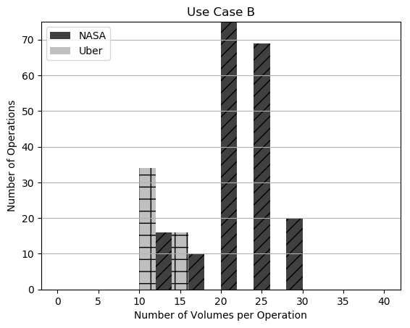
Figure 10. Number of volumes per operation, Use Case B, Baseline Condition for NASA and Uber flights
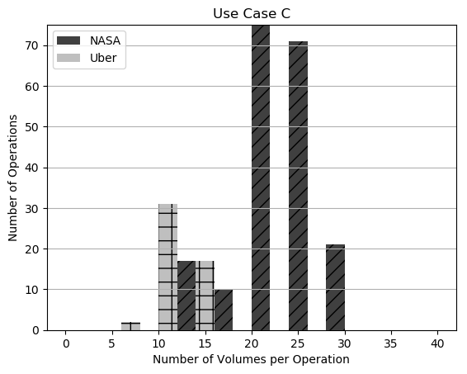
Figure 11. Number of volumes per operation, Use Case C, Baseline Condition for NASA and Uber flights.

Distribution of Number of TBOVs with Advanced Services
This subsection describes the effect of the strategic Scheduling Service or the Separation Service on the distribution of number of TBOVs per operation for NASA operations only. The following histogram plots (Fig. 12 and 13) show the distribution of TBOVs for Use Case B only. Fig. 12 shows that when both strategic scheduling and separation services are utilized, the flow of traffic is conditioned and highest number of volumes per operation is shifted to the right. There are about 30 volumes for about 58 operations and there are a few flights (under 10) that have 35 or 40 volumes per operation as well. The higher number of TBOVs are generated because the advanced services tend to modify trajectories leading to extra waypoints, around which extra volumes may be generated. This effect is particularly pronounced when the strategic Scheduling Service (NS) is utilized (Fig. 13). The service tends to use Trajectory Generator to delay flights on the ground when it detects conflicts with Uber flights at the crossing points, and those trajectory generations provide additional waypoints. These additional waypoints add new volumes keeping the design of the TBOVs in mind. Thus, advanced services should be designed keeping the design for the generation of TBOVs in mind, since they impact the number of TBOVs per operation.

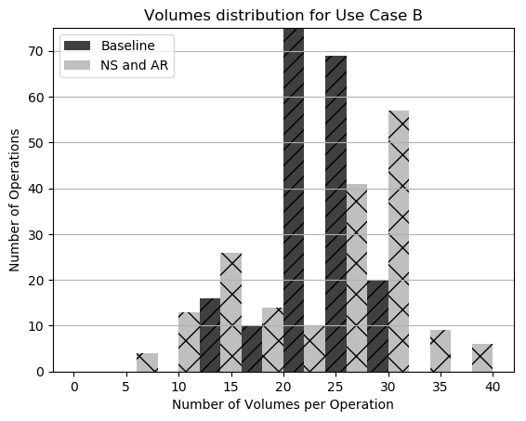Figure 12. Number of Volumes per operation for basic services and advanced service for NASA operations

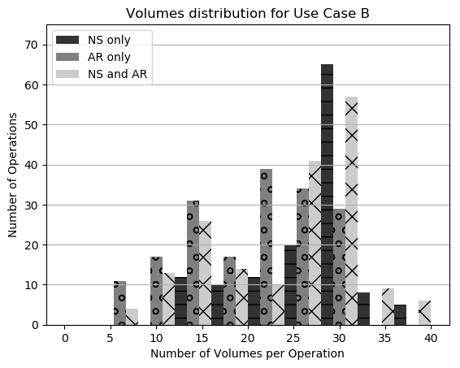
Figure 13. Number of Volumes per operation for basic services and advanced service for NASA operations

Number of TBOVs per Operation per Route

The number of TBOVs per operation per route is shown in Fig. 14 and 15 for NASA and Uber flights respectively for Use Case B, Baseline condition, where only basic services were utilized by both NASA and Uber. The number of volumes per operation per route is proportional to the length of the route for Uber flights except for one outlier (Fig. 15), whereas it is not always proportional to the length of the route for NASA flights but has a linear trend with a few outliers (Fig. 14). One of the reasons that the number of volumes is scattered for the NASA flights (Fig. 14) vs Uber flights is that flight route length depends on the route structure; a route with more turns is likely to have a larger number of waypoints and thus larger number of TBOVs generated around those waypoints, especially when the design restricted the size of the NASA volumes to be under 60 sec. In general, when total number of operations increase in the airspace, a higher number of volumes generally means that the volumes sizes are smaller and that conformance to the volumes can be a challenge for the overall system.

Figure 14. Number of Volumes per operation per route for NASA flights.

Figure 15. Number of Volumes per operation per route for Uber flights.

Number of POSITION Messages per Operation

Distribution of Number of Position Messages for Baseline Scenario
The average number of position messages per nmi that were exchanged during the course of the simulation for each of the three Use Cases are compared for the Baseline condition where basic services were utilized. The largest fraction of the messages between the different operations for NASA and Uber flights were position messages, which an aircraft sends every second while it is airborne; the distribution of position messages is listed in Table 1. As expected, the data show that the average number of position messages were directly proportional to the length of the routes, that ranged from 13.5 to 33 miles for NASA flights and from 18 nmi to 26 nmi for the Uber flights.

Uber had fewer operations due to fewer routes planned in all Use Cases and that is reflected the lower number of Position messages per nmi of the route. For NASA flights, it’s observed that Use Case A has the fewest routes and produced the fewest Position messages. Use Cases B and C have additional Position messages shared due to additional routes and crossing points between NASA and Uber flights. This increase in the Position messages using the UTM TCL-4 implementation required the addition of several machines to archive the position data since they were recorded at 1 hz. Operators may decide to share Position data among themselves at all times to allow for tactical separation and collision avoidance for UAM operators, which was not considered a need for UTM operations, where strategic deconfliction of operations was sufficient to enable safe operations.
Table 2 lists the Total number of Position messages produced during the entire simulation run and shows that the number of Position messages were in the range of 100,000-120,000 for NASA operations and in the range of 21,000-27,000 for Uber flights. This means that although only basic services were utilized during the Baseline condition, the number of Position messages shared was similar across the different Use Cases within each Operator’s flights.

Table 1. Average number of Position messages per nmi for Use Case A, B and C, Baseline condition for both NASA and Uber flights
Use Case | NASA | Uber
A | 621 | 552
B | 700 | 669
C | 654 | 492

Table 2. Total number of Position messages for Use Case A, B and C, Baseline condition for both NASA and Uber flights
Use Case | NASA | Uber
A | 118,034 | 26,728
B | 100,594 | 26,283
C | 115,529 | 21,898

Distribution of Number of Position Messages with Operational Services Provided
In this subsection, for NASA operations only, the effect of having the Scheduling Service (NS) or the Separation Service (AR) is compared with the distribution of total number of Position messages exchanged in Use Case B. Table 3 shows the highest total number of position messages were seen for Baseline conditions, when the traffic flow is not conditioned. It was also observed that the Total number of Position messages exchanged were reduced when both the NASA advanced services were utilized. Table 3 shows that when Scheduling Service is utilized by itself, it has the least total number of Position messages. This is the case because the service delays the flight pre-departure on the ground and Position messages are shared only when the flight is airborne. The total number of Position messages exchanged when both services are utilized is higher than Scheduling Service acting alone. This is because the Scheduling service imposes ground delay, but Separation Service may increase the position messages due to maneuvers or resolutions that it sends to de-conflict the operations, it may also delay the flight pre-departure.

In contrast, the Separation Service has relatively fewer Position messages exchanged than Baseline since it also imposes a small amount of ground delay for operations that may have an imminent conflict at the time of departure

Table 3. Average number of Position messages per nmi for Use Case B, Baseline compared to Advanced services (scheduling and separation) for NASA flights

Scenario | Total Position messages
Baseline | 137,602
Scheduling and Separation services | 86,247
Scheduling Service Only | 76,919
Separation Service Only | 114,210

Discussion
The results show that generation of TBOVs or operational volumes is an essential service to the UTM paradigm that was adopted and tested for UAM operations. However the design and implementation of this service has an effect on the size and the number of the volumes per operation. It was essential to remove the maximum TBOV spatial length imposed by UTM for UAM operations because UAM vehicles followed a specific route that could be several miles long. It was observed that if the length of the route took the flight through several grid cells, it led to higher numbers of discovery or position messages to be exchanged. Also, if the route had many turns or merge points, this affected the number of TBOVs that were generated for those extra waypoints, even if the route length were kept the same.
Most aircraft followed one of a few routes. Thus for operations on the same routes, the TBOVs that were submitted had the same geometric boundaries with temporal overlapping. It may be more efficient to only have a pointer to the 3D volumes and operation-specific time thresholds for each volume. The size of the operational volume was a design consideration but a large volume size, especially on the crossing points, led to a reduction in density of flights passing through the crossing points. This was because the separation and scheduling service was based on avoiding the TBOVs of the other operator, whereas the usage of scheduled time of arrival with some buffers would have considerably improved the density of operations over the crossing points.
It was also observed that the TBOV around merging points tend to be small, generally due to close waypoints associated with routes that have two-way operations for multiple operators. The trajectory predictions made pre-flight were generally not found to be very precise due to uncertainties in the system, and simulation capabilities led to the actual operational volumes around crossing points to be larger than expected. NASA operations expected Uber operations to provide their TBOVs at the crossing and merge points around six minutes prior to departure of the flight. From discussions between NASA and Uber, it was realized that providing operational data more than six minutes prior to departure would require larger buffers at the merge points to accommodate for uncertainties in the system,. In this study, trajectory predictions with uncertainties such as winds were not included and would be expected to have an additional impact on the size of the TBOVs. In the operational world, operators may design TBOVs keeping the performance characteristics of the vehicle in mind. The smaller the buffers used in the design of the TBOVs, the higher are needs placed on conformance monitoring.
It is likely that the UAM concept of operations will require that UAM routes and airspace are pre-published and shared with all operators in a given region. This is significantly different from UTM operations where flight plans and strategic deconfliction is performed at the time an operation is submitted. In contrast, UAM routes and airspace will need to be strategically deconflicted from traditional traffic, so that they could operate with minimal or no ATC monitoring.
In this research, strategic de-confliction was provided by NASA’s Scheduling Service for UAM operations. This service deconflicted NASA flights from the Uber flights while keeping the Uber flights as a constraint to condition the flows. An alternative to this pre-departure scheduling would be the use of scheduled times of arrival at merge points and crossing points that could also be achieved tactically.
Similarly, NASA’s tactical Separation Service was used for de-confliction of UAM operations, which can help with inflight re-routing or maneuvering, but the time required to authorize the new operational volume could be on the order of several seconds, which can have an impact on the conformance of the flight to the new route. Thus, there is a need for a look ahead time that takes into account the time required for the system to authorize the new TBOV.
The number of position messages increased when NASA’s advanced services- Separation Service was used to de-conflict UAM operations, which can stress the performance of the system when the total number of operations increase. Position updates were made at 1hz and it was observed that UTM TCL4 system did not test at such a high tempo of operations; future work will investigate alternate protocols for handling high number of Position messages.

Conclusion
NASA and Uber utilized the UTM paradigm for UAM operations with different use cases, in a study where resources between the two sets of operations were shared in terms of crossing points. Strategic deconfliction at the crossing points was explored and found to require a balance between when the operation details could be shared by the size of the volumes assigned to the crossing points. It was observed that NASA’s tactical separation service was able to manage de-confliction with a high priority flight and results showed that the look-ahead time must also incorporate the time required to obtain approval of the new route, in allowing conformance to the new route. Increases in number of volumes per operation, or position messages being exchanged, are likely to stress the system and add to the latency between publish and response message time, requiring higher buffer sizes that may be a potential source of inefficiencies.

This study showed that overall, the UTM architecture can be successfully applied for UAM operations and that the implementation of services can have a considerable impact on the efficiency of the system. Future work will focus on improving the implementation of the advanced services and also investigating sharing routes between multiple operators.

References
- Mueller, E.; Kopardekar, P. & Goodrich, K. (2017). Enabling Airspace Integration for High-Density On-Demand Mobility Operations. 17th AIAA Aviation Technology, Integration, and Operations Conference. 5-9 June 2017, Denver, Colorado. AIAA 2017-3086
- Uber Elevate, “Fast-Forwarding to a Future of On-Demand Urban Air Transportation," 2017, https://www.uber.com/elevate.pdf.
- Thipphavong, D.P. et.al. (2018) Urban Air Mobility Airspace Integration Concepts and Considerations. 18th AIAA Aviation Technology, Integration, and Operations Conference. 25th-29th June 2018, Atlanta, Georgia.
- Verma S.; Keeler, J.; & Edwards, T. (2019). Exploration of Near-term Potential Routes and Procedures for Urban Air Mobility. 19th AIAA Aviation Technology, Integration, and Operations Conference. 17th June 2019, Denver, Dallas, Texas.
- Kopardekar, P.; Rios, J.; Prevot, T; Johnson, M.; Jung, J.; & Robinson III, J. E. (2016). Unmanned Aircraft System Traffic Management (UTM) Concept of Operations. 16th AIAA Aviation Technology, Integration, and Operations Conference, 17th June 2016, Washintong D. C.
- Rios, J L.; Smith I. S.; Venkatesen P.; Homola J. R.; Johnson M. A.; & Jung J. (2019). UAS Service Supplier Specification. NASA/TM-2019-220376.
- Rios, J. L.; Smith, I. S.; Venkatesan, P.; Smith, D. R.; & Baskaran, V (2018). UTM UAS Service Supplier Development - Sprint 2 Toward Technical Capability Level 4
NASA/TM-2018-220050.
- “Concept of Operations v2.0 Unmanned Aircraft System (UAS) Traffic Management (UTM).” Federal Aviation Administration, Washington, D.C., 2020.
- Kopardekar, P., Rios, J., Prevot, T., Johnson, M., Jung, J., and Robinson, J. E., “UAS Traffic Management (UTM) Concept of Operations to Safely Enable Low Altitude Flight Operations,” 16th AIAA Aviation Technology, Integration, and Operations Conference, AIAA AVIATION Forum, AIAA 2016-3292, Jun. 2016. doi: 10.2514/6.2016-3292.
- B. T. Baxley, W. C. Johnson, J. Scardina, and R. F. Shay, “Air Traffic Management Technology Demonstration-1 Concept of Operations (ATD-1 ConOps), Version 3.0,” p. 101.
- Bosson, Christabelle, and Todd A. Lauderdale. "Simulation evaluations of an autonomous urban air mobility network management and separation service." In 2018 Aviation Technology, Integration, and Operations Conference, p. 3365. 2018.
- Robinson, J.E.; Lee, A. & Lai, C.F. (2017). “Develeopment of a High-fidelity simulation environment for shadow-mode assessments for air traffic concepts.” Royal Aeronautical Society: Modeling and Simulation in Air Traffic Management Conference, London, UK, November 2017

