SCA Test Report
H4RG-20828
WFIRST
February 10, 2020
NASA/Goddard Space Flight Center
Detector Systems Branch
Detector Characterization Laboratory

Approved by: 02/10/2020
Laddawan Miko, PhD Date
Detector Systems Branch
NASA Goddard Space Flight Center
Code 553
laddawan.r.miko@nasa.gov

Analysis and Data Acquisition performed by:

Analia Cillis
Assistant Research Scientist
Center for Research and Exploration in Space Science & Technology II (CRESST II)
Code 665

Christopher Bennett
Detector Test Engineer
Science Systems and Applications Inc.
Code 553

Stephanie Cheung
Detector Test Engineer
Science Systems and Applications Inc.
Code 553

Benjamin Cho
Detector Test Engineer
Science Systems and Applications Inc.
Code 553

Lane Meier
Detector Software Engineer
Conceptual Analytics, LLC
Code 553

Roger Foltz
NASA Goddard Space Flight Center
Code 553
Augustyn Waczynski
DCL Lead
NASA Goddard Space Flight Center
Code 553
Contents
1. Summary 4
2. Power Dissipation 6
3. Conversion Gain 7
4. Flat Field 8
5. Noise 9
5.1 CDS Noise 10
5.2 Total Noise 12
6. Dark Current 16
7. Quantum Efficiency 20
8. Linearity 21
9. Disconnected Pixels 24
10. Persistence 25
11. Inter-pixel Capacitance 29
12. Pixel Operability 31
13. Guide Mode Functionality 33
14. Summary 34
Appendix 1 – Table of Report Data 35

Summary
This report summarizes the measured performance for the Sensor Chip Assembly (SCA), which is identified in Table 1. The SCA architecture is a substrate-removed HgCdTe detector with an area of 4096x4096 pixels (with a reference pixel area of four pixels deep around all four sides, available to substitute corresponding image pixels) and a pixel pitch of 10 µm.
This SCA has been tested at the Goddard Space Flight Center (GSFC/NASA) Detector Characterization Laboratory (DCL). Teledyne (the vendor) classifies its detectors into different grades based on testing performed at its facility. The classification of this SCA and the tested dates are included in Table 1 below. The tests performed on this array are derived from the document WFIRST-PROC-09220_WFIRST-SCA-ATP_-.docx.
A summary of the test parameters, requirements, and test results is presented in Table 2. The details of each test are subsequently described in the report.
In the Summary (Table 2), SCA results are reported at an operating temperature of 95K, and 1.0 V bias voltage. In the detailed section of each test, the results for 90 K (1.0V bias voltage) and 95 K (0.5V bias voltage) are also reported. For all cases, the frame time used is 2.764 seconds. Reference pixel correction was applied to every raw frame.

Table 1: SCA detector Reported
SCA identification: | H4RG-20828
Classification: | Flight
Tested Dates: | 11/25/2019 – 12/13/2019
WOA | WOA-WFIRST-WFI-0220
Position in the HyC Dewar during the test | Position 1

Table 2: Summary Table: Operating temperature of 95 K and bias voltage of 1.0 V.
Test Parameter | Requirement | SCA Req. # | Test Results
Power Dissipation | <20mW | RSCA-011 | Measured Power Dissipation (mW)
Power Dissipation | <20mW | RSCA-011 | 6.3
CDS Noise | N/A | N/A | Median (e) |  | Mean (e) |  |  | Modal (e)
CDS Noise | N/A | N/A | 13.86 |  | 14.05 |  |  | 13.78
Total Noise | < 6.5 e- median  < 12 e- per px | RSCA-030  RSCA-021 | Median (e) | Mean  (e) |  |  | Modal  (e) |  | (%) Pixels passing
Total Noise | < 6.5 e- median  < 12 e- per px | RSCA-030  RSCA-021 | 5.34 | 5.71 |  |  | 5.29 |  | 99.50
QE | >40% for 0.48-0.6µm  >60% for 0.6-0.8µm  >80% for 0.8-2.1µm  > 70 % per px | RSCA-024  RSCA-021 | (%) Pixels passing
QE |  | RSCA-024  RSCA-021 | 98.53
Linearity | >80 ke  Can be linearized to  < 1% for > 97% of px | RSCA-021 | (%) Pixels passing
Linearity | >80 ke  Can be linearized to  < 1% for > 97% of px | RSCA-021 | 99.81
Dark Current | < 0.05 e-/s median  < 0.5 e- /s per px | RSCA-033  RSCA-021 | Median (e/s) | Mean (e/s) |  |  | Modal (e/s) |  | (%) Pixels passing
Dark Current | < 0.05 e-/s median  < 0.5 e- /s per px | RSCA-033  RSCA-021 | 0.000 | 0.007 |  |  | 0.000 |  | 99.90
Persistence  10 min  (50 ke) | < 0.15 e-/s median | RSCA-039 | Median (e/s) |  | Mean (e/s) |  |  | Modal (e/s)
Persistence  10 min  (50 ke) | < 0.15 e-/s median | RSCA-039 | 0.052 |  | 0.054 |  |  | 0.046
Persistence  10 min  (300 ke) | < 0.50 e-/s median;  < 0.8e-/s per px | RSCA-038 | Median (e/s) | Mean (e/s) |  |  | Modal (e/s) |  | (%) Pixels passing
Persistence  10 min  (300 ke) | < 0.50 e-/s median;  < 0.8e-/s per px | RSCA-038 | 0.144 | 0.156 |  |  | 0.135 |  | 99.90
Inter-pixel Capacitance | <2.5% | RSCA-035 | Mean (%) |  |  | Maximum (%)
Inter-pixel Capacitance | <2.5% | RSCA-035 | 1.313 |  |  | 1.363
Pixel Crosstalk: Cosmic Rays | < 1% above IPC | RSCA-034 | Mean (%) |  |  | Maximum (%)
Pixel Crosstalk: Cosmic Rays | < 1% above IPC | RSCA-034 | 1.524 |  |  | 1.533
Guide mode Functionality | Guide Window size, position, illumination level, shape | RSCA-067 | yes

Power Dissipation
The detector voltages were measured (see Table 3) and the power dissipation calculation is shown in Table 4 below.

Table 3: Voltage and Current
 | Detector Side Voltage (mV) | Current  (mA) | Power  (mW)
SUB | 0.47 | -0.001 | 0.000
CELLDRAIN | 14.60 | -0.755 | -0.011
DRAIN | 28.80 | -1.380 | -0.040
DSUB | 1099.00 | 0.811 | 0.891
VDDA | 3348.00 | 0.003 | 0.009
VBIASGATE | 2233.00 | 0.002 | 0.004
VDD | 3328.00 | 0.915 | 3.044
VRESET | 127.00 | -0.813 | -0.103
VBIASPOWER | 3332.00 | 0.762 | 2.539

Table 4. Power dissipation
SCA Total Power dissipation
Total Power Dissipation (mW) | 6.3

Conversion Gain

Photon transfer curve method was used to calculate gain. Ten flat field images at 1400 nm with 11 frames were acquired to that end. Inter-pixel capacitance (IPC) correction calculated from single reset data was applied. The conversion gain is reported in Table 5.

Table 5. Conversion Gain
Conversion Gain [counts/e-]
1.0 V | 0.5759
0.5 V | 0.5224

Electrical gain correction per channel was applied for each test. Two sets of reset-on data taken at different bias voltage were acquired. The averages for each voltage were obtained and the resulting frames were subtracted. From the difference frame, the mean value of each channel was obtained, generating a 32 scalar vector. The 32 scalar vector was normalized. For all results in this report, the vector is applied as correction of the gain for each channel.

Flat Field

Flat field images were generated using gain raw data. The gain data was acquired with the following settings: 10 exposures of 11 read frames, 1400nm. After reference pixel corrections, the difference between the last and the first frame (excluding the zero frame) was obtained for each exposure, and the median value between the 10 exposures was calculated. Afterward, the flat field image was corrected by dark current and electrical gain. The resulting image for bias 1.0 V and temperature 95 K is presented in Figure 1.

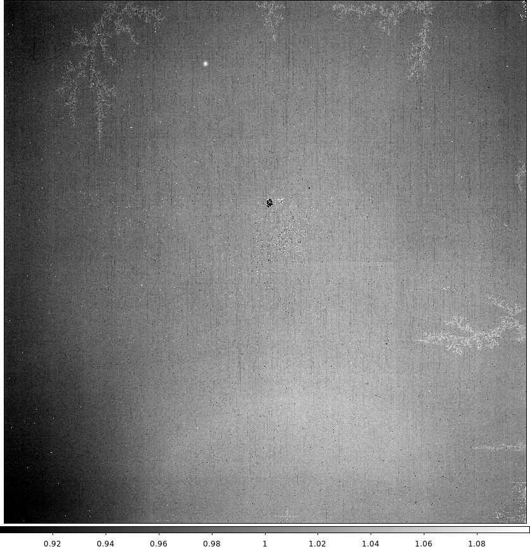
Figure 1. Flat Field Image: 95 K, 1 V. Linear Scale [0.9, 1.1]. No correction for non-uniform illumination of the detector was applied to the image.

Noise

Noise is the fluctuation of the detector signal in absence of an external source. CDS noise and Total Noise are reported in the following subsections.

CDS Noise
The CDS noise is calculated from a set of five dark exposures collected with 100 read frames, 0 skip frames. Data was taken for 95 K and 1.0 V. There is no requirement for CDS Noise. For data analysis, reference pixel correction was applied to all frames. The non-overlapping frames were subtracted to create 50 differences. The standard deviation was calculated per pixel using the 50 difference frames, resulting in a CDS frame per exposure. Conversion gain was applied to obtain CDS noise in electrons. The per-pixel median of the five CDS frames was then computed and electrical gain correction was applied to obtain a single CDS frame for which the mean, median, and Gaussian mean are reported in Table 6. The corresponding noise image per pixel and histogram are presented respectively in Figure 2 and 3.
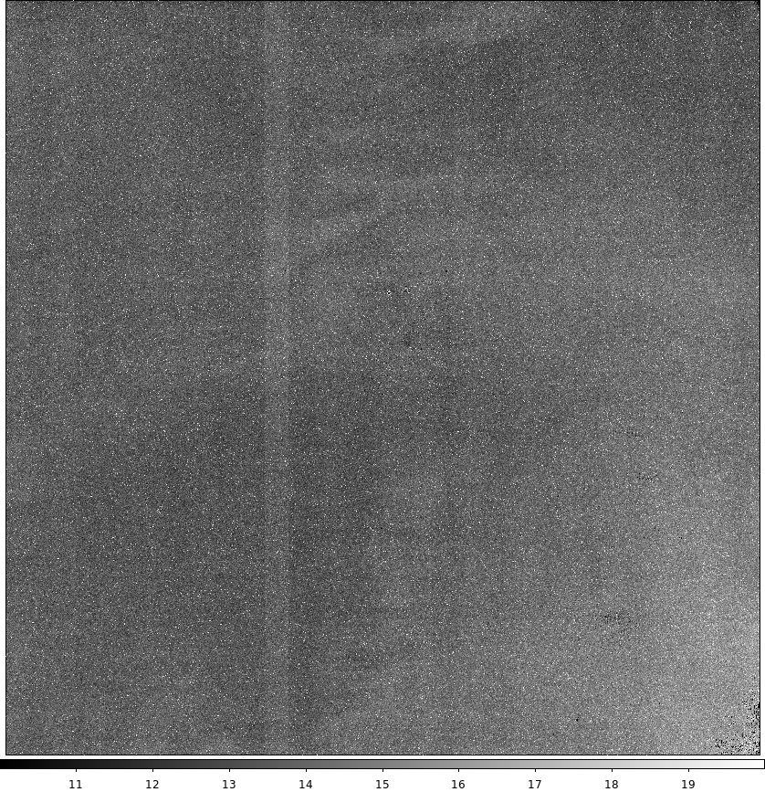
Figure 2. CDS Noise images: at 95 K and bias voltage of 1.0 V. Units: electrons. Linear scale [10:20]. No correction for leach system floor noise was applied to generate the image.
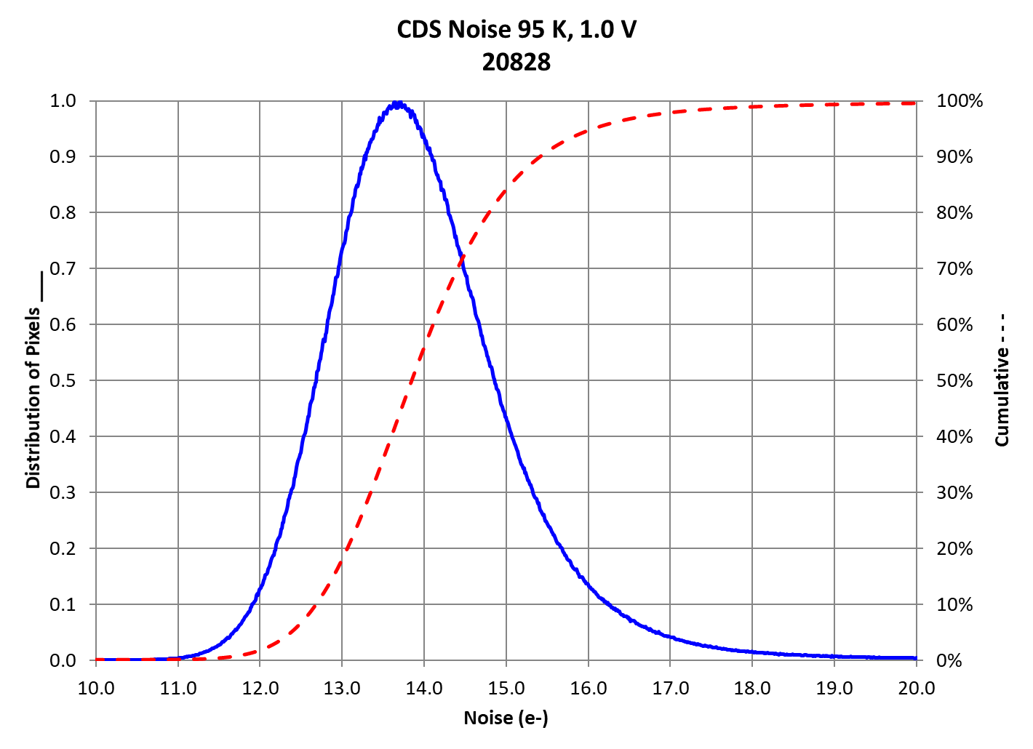
Figure 3. CDS Noise Distribution and Cumulative: temperature 95 K and bias voltage of 1.0 V.
Table 6. CDS Noise Statistics
 | 95K  1.0 V | 95K  0.5 V | 90K  1.0V | 90K  0.5V
Median (electrons) | 13.86 | 15.92 | 13.33 | 15.51
Mean (electrons) | 14.05 | 16.12 | 13.54 | 15.71
Gaussian Mean (electrons) | 13.78 | 15.84 | 13.25 | 15.43

Total Noise
The total noise should be less than 6.5 electrons in median value and less than 12 electrons per pixel. The total noise was acquired with the following settings: 55 read frames, 0 skip frames, and 100 exposures. For the data analysis, reference pixel correction was applied for all frames and the slope per pixel was taken using all frames. The total noise per pixel was calculated as the standard deviation of the slopes multiplied by the total time (55 frames, ~150 sec). Conversion gain was applied to obtain results in electrons. Electrical gain correction was applied to the final result. Total noise image at 95 K and 1.0 V is presented in Figure 4. Figure 5 presents total noise images at 95 K, 0.5 V; and at 90 K, 1.0 V. The histograms are shown in Figure 6 (for 95 K and 1.0 V) and Figure 7 (for 95 K, 0.5 V; and 90 K, 1.0 V). Mean, median, Gaussian mean, and percentage of pixels passing requirement are reported in Table 7.
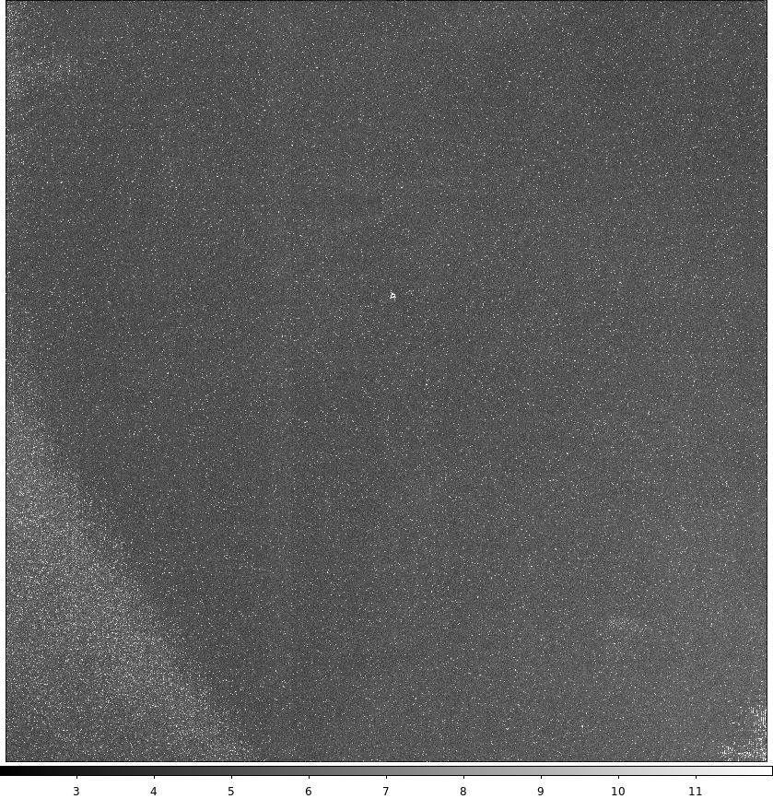
Figure 4. Total Noise image: at 95 K and bias voltage of 1.0 V. Units: electrons. Linear scale [2:12].

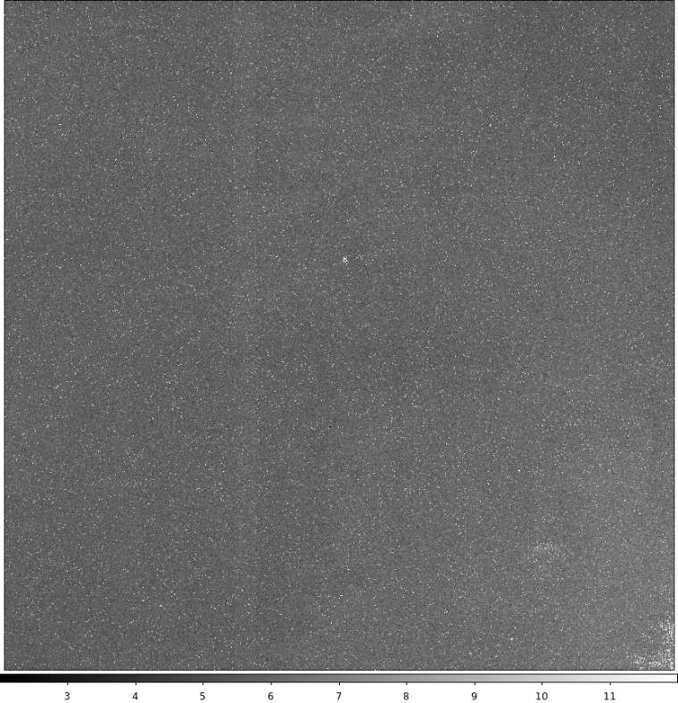
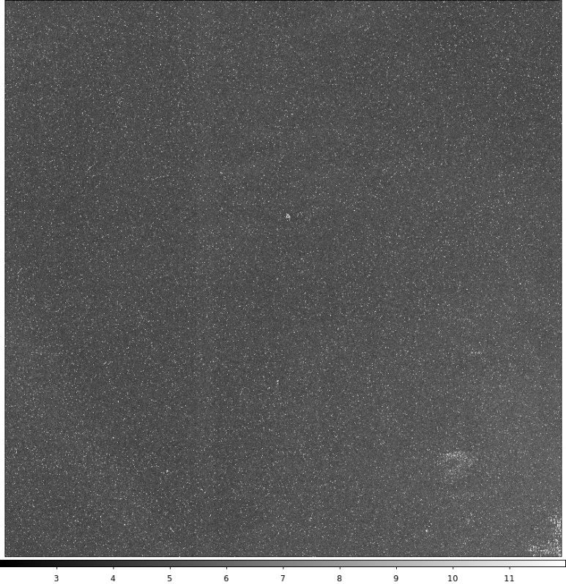
Figure 5: Total Noise at 95K, 0.5V (top) and 90 K, 1.0V (bottom). Units: electrons. Linear scale [2:12].

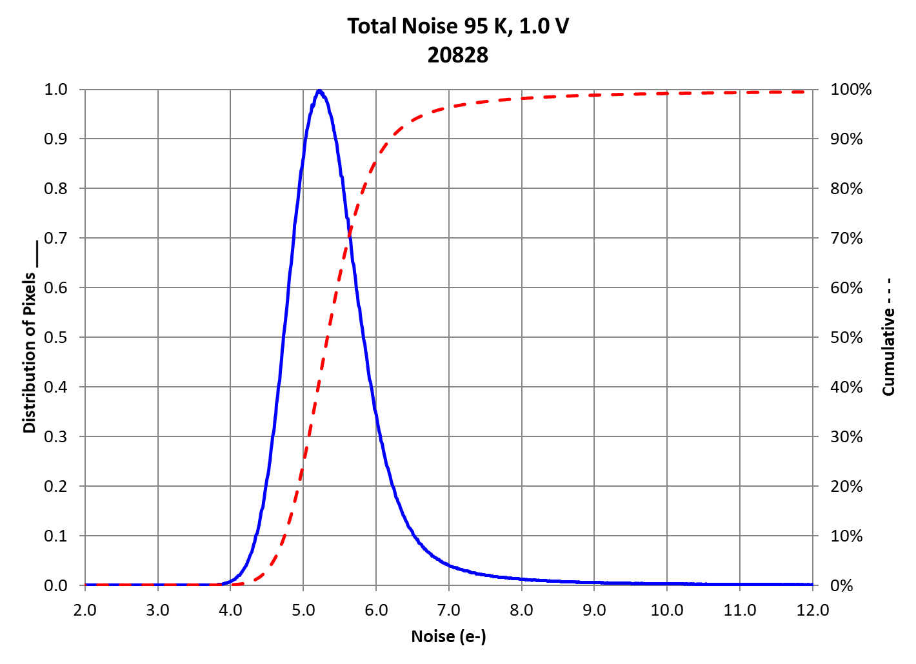
Figure 6. Total Noise Distribution and Cumulative: at temperature 95 K and bias voltage of 1.0 V. The total noise should be less than 6.5 electrons in median value and less than 12 electrons per pixel.
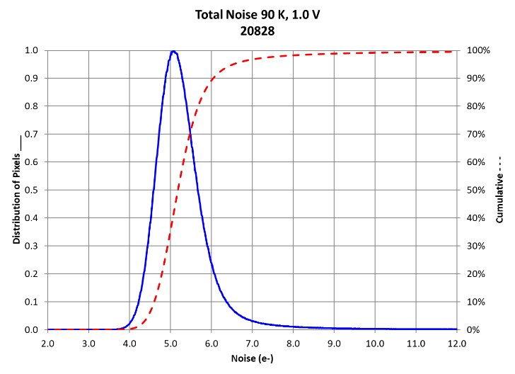
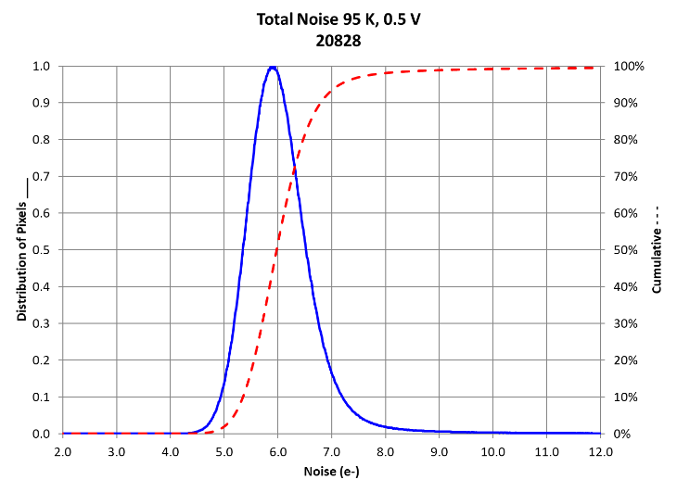
Figure 7. Total Noise Distribution and Cumulative: at temperature 95 K, bias voltage of 0.5 V (left), and 90 K and 1.0 V (right).

Table 7. Total Noise Statistics (*)
 | 95K  1.0 V | 95K  0.5 V | 90K  1.0V | 90K  0.5V
Median (electrons) | 5.34 | 5.98 | 5.19 | 5.82
Mean (electrons) | 5.71 | 6.31 | 5.57 | 6.16
Gaussian Mean (electrons) | 5.29 | 5.94 | 5.13 | 5.78
% of px passing req. | 99.50 | 99.56 | 99.48 | 99.55

(*) Total noise was evaluated at ~150 sec, which corresponds to 55 frames.

Dark Current
Dark current is the thermally induced, self-generated detector signal in the absence of an external source. It is highly dependent on the operating temperature of the detector. The dark current median shall be less or equal to 0.05 electrons per second and less than 0.5 electrons per second per pixel.
Dark current was measured with the following settings: 101 read frames, 25 skip frames, and at least four exposures. After applying reference pixel corrections, the zero frame was subtracted from the rest of the frames, and the slope between all frames was calculated. Conversion gain was applied to obtain the result in electrons. Electrical gain correction was applied to the final result. Dark current image for 95 K and 1.0 V is shown in Figure 8. In Figure 9 the dark current images for 95 K, 0.5 V and 90 K, 1.0 V are displayed. Dark distribution for 95 K and 1.0 V is presented in Figure 10, while dark distribution for 95 K, 0.5 V and 90 K, 1.0 V is in Figure 11. Dark Current statistics are presented in Table 8.

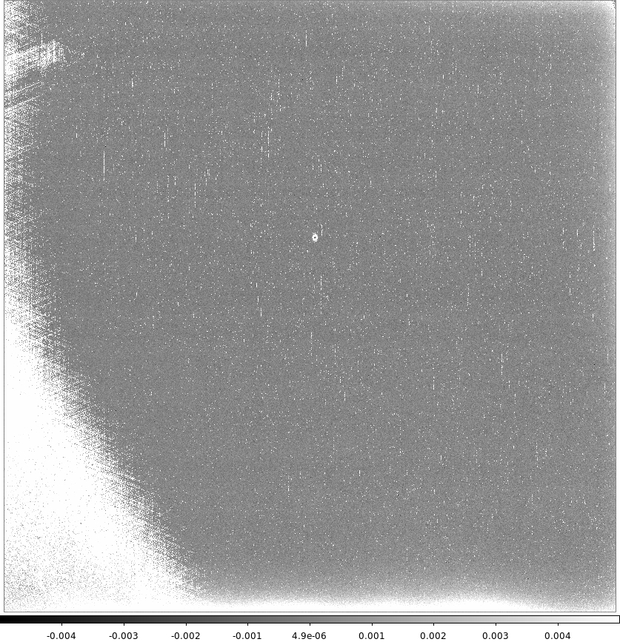

Figure 8. Dark Response Image for 95 K and 1.0 V. Units: electrons/sec. Linear scale [-0.005:0.005].
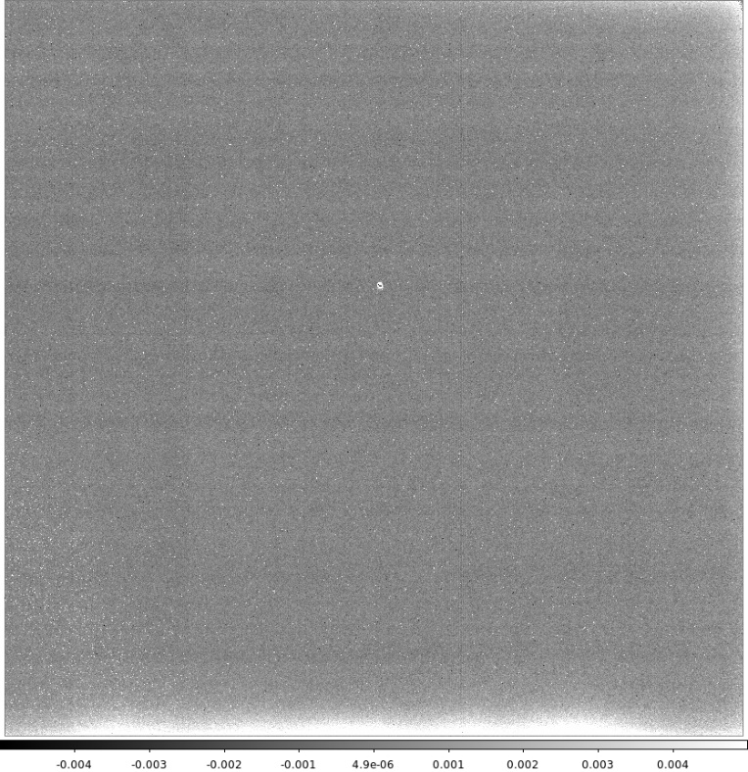
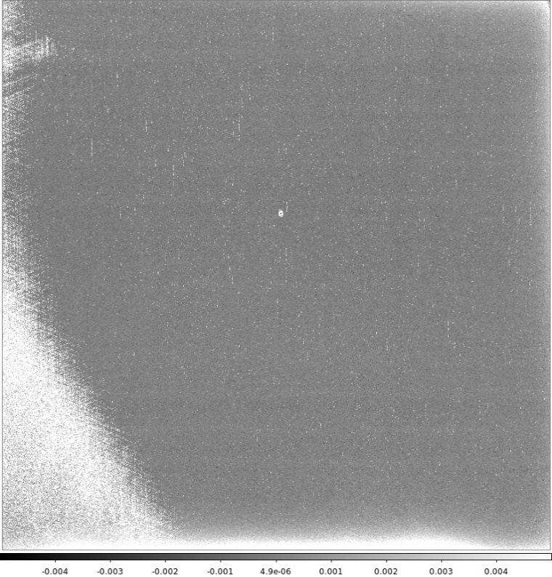
Figure 9. Dark Response Image for 95 K, 0.5 V (top) and 90 K, 1.0 V (bottom). Units: electrons/sec. Linear scale [-0.005:0.005].
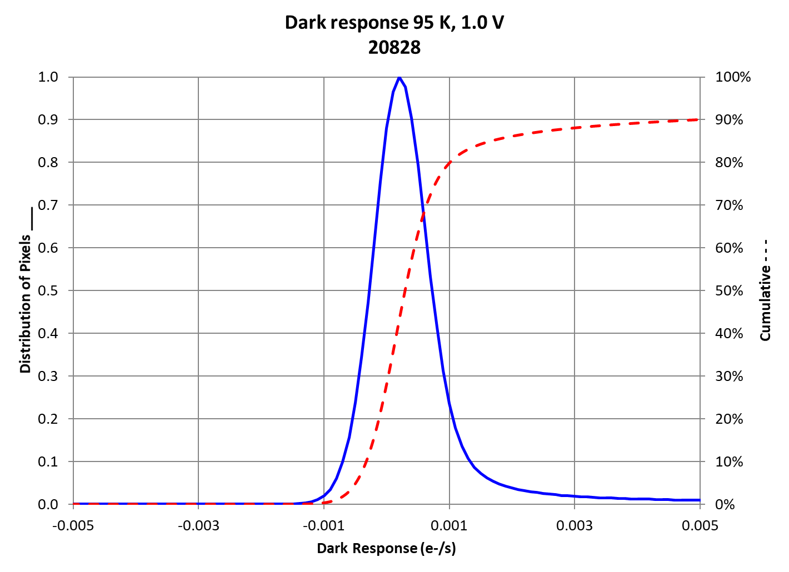
Figure 10. Dark response distribution and cumulative for 95 K and 1.0 V. The dark current median shall be less or equal to 0.05 electrons per second and less than 0.5 electrons per second per pixel.
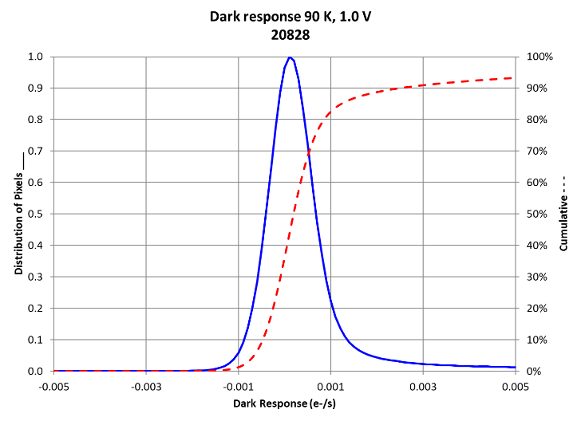
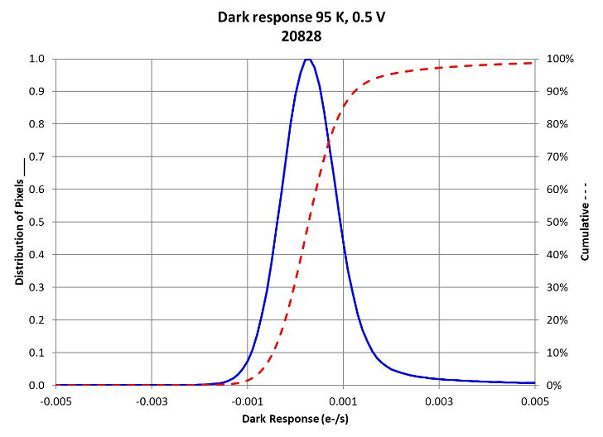
Figure 11. Dark response distribution and cumulative for 95 K, 0.5 V (left) and 90 K, 1.0V (right).

Table 8. Dark Response Statistics
 | 95K  1.0 V | 95K  0.5 V | 90K  1.0 V | 90K  0.5 V
Median  (e-/sec) | 0.000 | 0.000 | 0.000 | 0.000
Mean  (e-/sec) | 0.007 | 0.001 | 0.002 | 0.000
Gaussian Mean  (e-/sec) | 0.000 | 0.000 | 0.000 | 0.000
% px passing req. | 99.90 | 99.99 | 99.98 | 99.99

Quantum Efficiency

The detector quantum efficiency (QE) shall be measured over the wavelength range of 400nm to 2800nm with the requirement that QE be > 80 % between 800 nm and 2100 nm in median value and QE > 70 % per pixel. For each wavelength (starting from 400 nm with increments of 50 nm) the number of frames was adjusted to obtain ~4000 counts of accumulated signal. The QE versus wavelength for 1.0 V and 95 K is plotted in Figure 12.

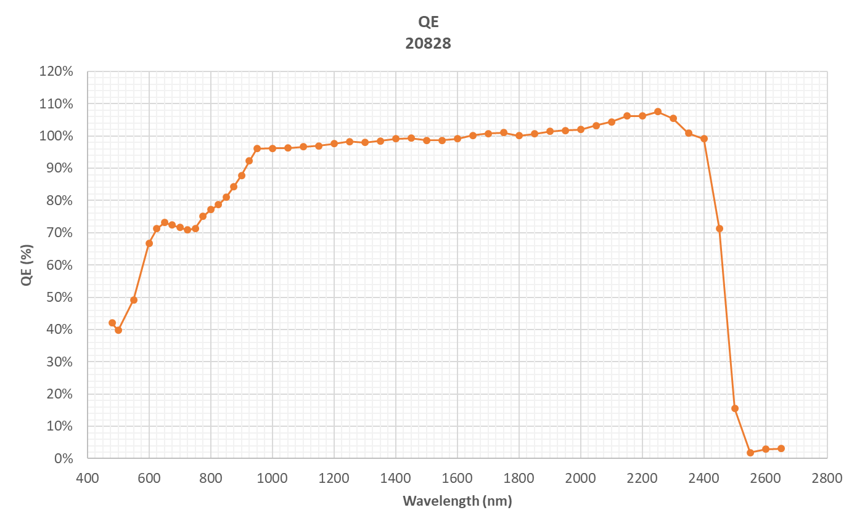
50% QE Cutoff = 2470.6 nm

Figure 12. QE vs wavelength. QE shall be >40% for 480-600nm; >60% for 600-800 nm; >80% for 800-2100 nm.

Linearity

Linearity is the measure of the deviation of the output signal from a fit as the detector integrates signal between 0 ke and 80 ke. Each pixel has a unique 7-coefficient polynomial against which linearity is measured. Linearity per pixel is reported in the form of the maximum normalized residual (MNR). MNR is calculated by taking the vector of residuals between a pixel’s measured integrated signal and its polynomial fit for the signal range between approximately 2 ke and 80 ke, then normalizing the vector of residuals by the polynomial fit and reporting the maximum value of the resulting vector.
Figure 13 shows MNR per pixel map for signal range up to full scale of the ADC. Figure 14 shows the corresponding distribution of MNR per pixel.
In Table 9, the mean, median, and Gaussian mean values are based on image pixels that meet the linearity signal thresholds: only pixels that accumulate signal until 80 ke are included in the calculations. The percentage of pixels passing in the Summary, Table 2, is determined by dividing the number of image pixels that meet the project's linearity requirement (97% of pixels must be less than 1%) by the total number of image pixels (4088 x 4088).

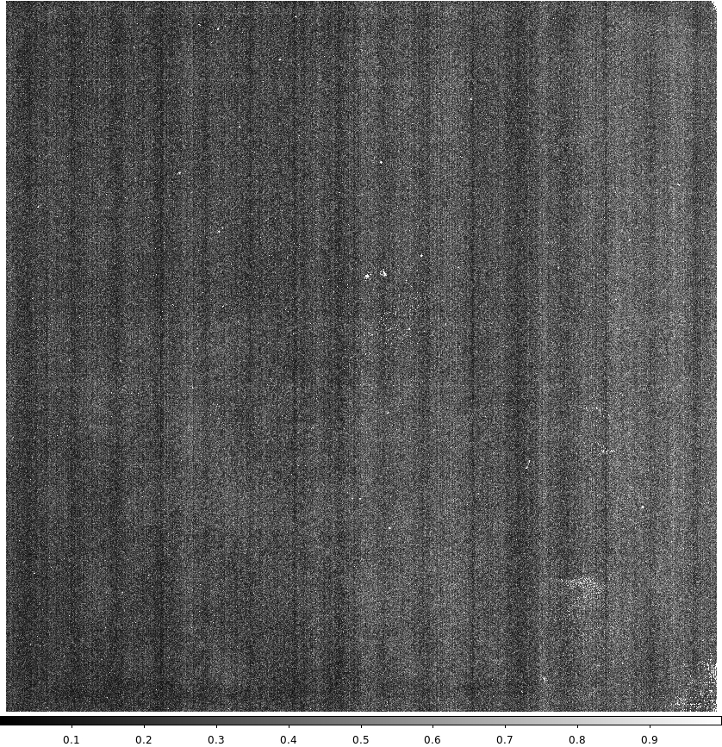
Figure 13. Linearity: Maximum normalized residual per pixel. Units: percentage. Linear scale [0:1].
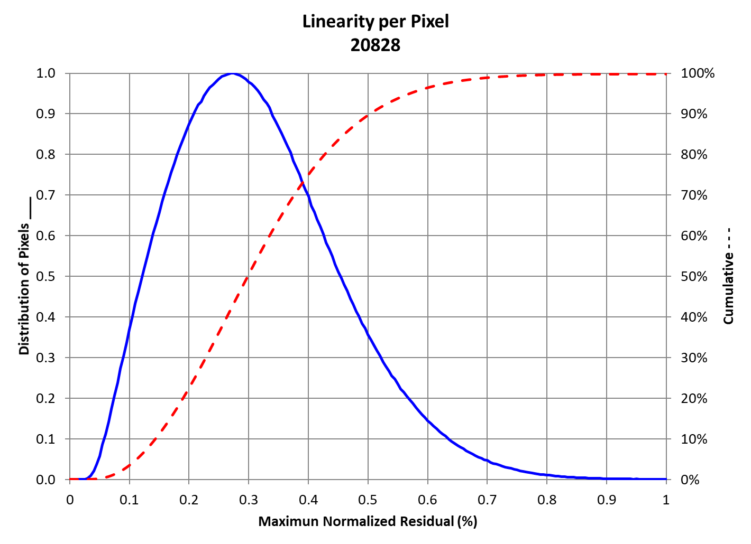
Figure 14. Linearity: Distribution of MNR per pixel and Cumulative. It shall be linearized to less than 1%.

Table 9. Linearity Statistics
Linearity of 4088x4088 Pixels
% of pixels meeting requirement | 99.81

Disconnected Pixels
The disconnected pixel test was performed by collecting detector data at different DSUB voltages and with constant Vreset when the detector is at room temperature. The slope of signal versus DSUB voltage was calculated per pixel. Disconnected pixels are identified by slopes that are more than five standard deviations away from the median slope of the array.
The disconnected pixels image is presented in Figure 15. The percentage of connected pixels for this SCA is 99.97%.

Figure 15. Disconnected Pixels Mask. Connected pixels are green, disconnected pixels are black.

Persistence
Persistence is the signal remaining from the previously captured illuminated frame after the pixel has been reset. Ideally, this signal would be completely erased with the reset frame and the dark current of the detector would be the same as the baseline dark current collected prior to any external illumination; however, this is generally not the case.
Persistence shall be less than 0.15 e-/sec in median for an illumination of 50 ke and less than 0.50 e-/sec for 300 ke in median and less than 0.8 e-/sec per pixel.
Persistence data is acquired using 1400nm for the illumination wavelength at 95 K and 1.0 V. The test is repeated at 0.5 V bias voltage. Illumination occurs during exposure number one and the remaining exposures are acquired in a dark configuration. Figure 16 shows the scheme for persistence acquisition.

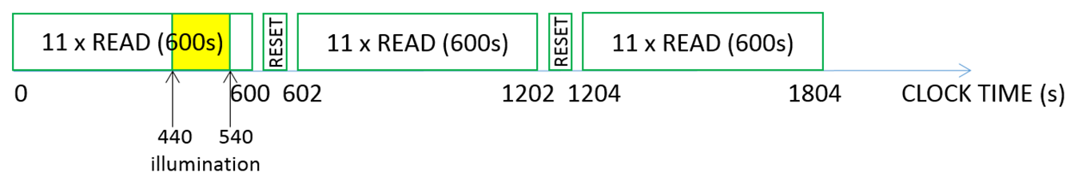
Figure 16. Scheme for persistence acquisition

Figure 17 shows low level persistence images for 95 K and 1.0 V and 0.5 V. Figure 18 shows high level persistence for the same settings. Persistence statistics are shown in Tables 10 and 11. Histogram for persistence at high level is in Figure 19.

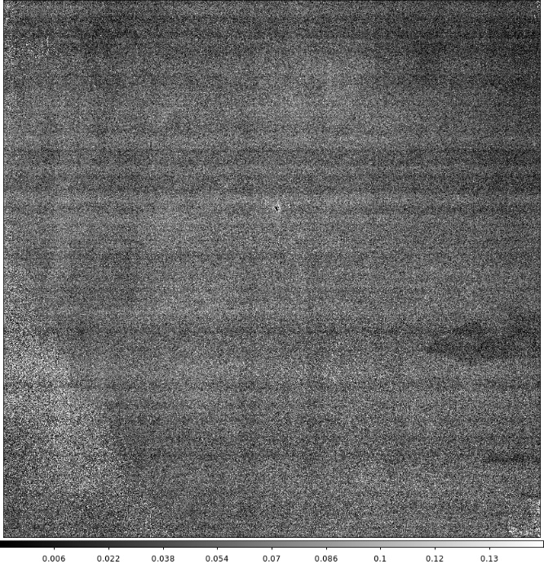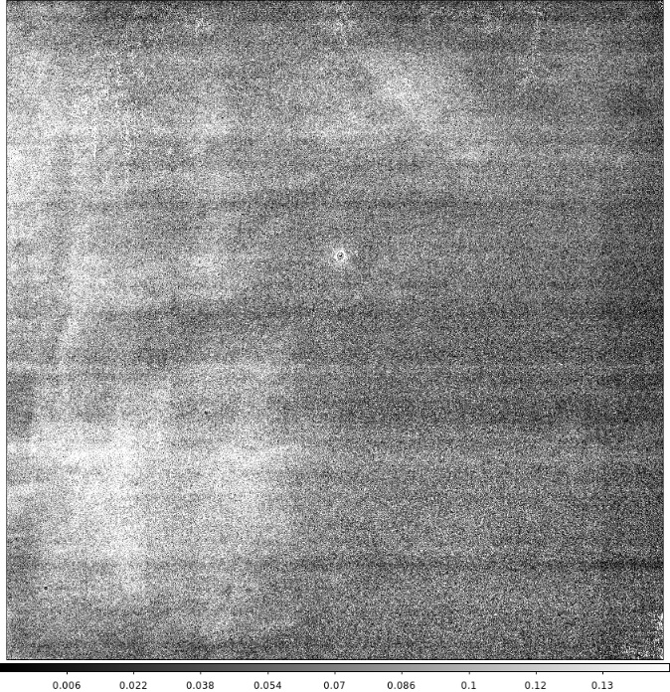

Figure 17. Low Level Persistence (10 min) at 95 K, 1.0 V (left) and 0.5 V (right). Units: [e-/sec]. Linear scale:[-0.01:0.15].
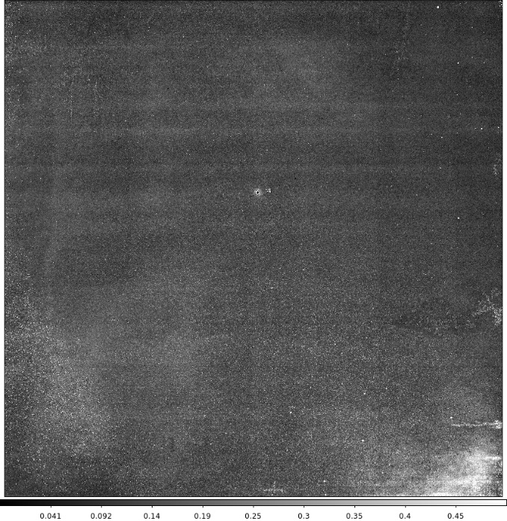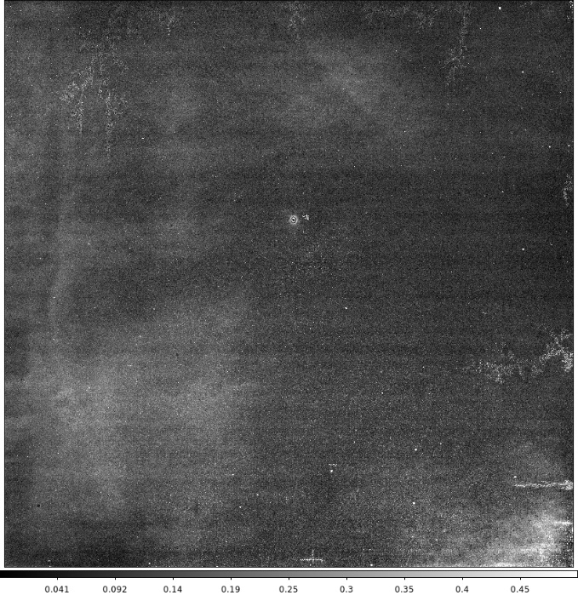
Figure 18. High Level Persistence (10 min) at 95 K, 1.0 V (left) and 0.5 V (right). Units: [e-/sec]. Linear scale [-0.01:0.5]

Table 10. Low level Persistence Statistics
 | 95K  1.0 V | 95K  0.5 V
Median (e-/s) | 0.052 | 0.078
Mean (e-/s) | 0.054 | 0.081
Gaussian Mean (e-/s) | 0.046 | 0.073
Table 11. High level Persistence Statistics
 | 95K  1.0 V | 95K  0.5 V
Median (e-/s) | 0.144 | 0.132
Mean (e-/s) | 0.156 | 0.141
Gaussian Mean (e-/s) | 0.135 | 0.124
% px passing req. | 99.90 | 99.94
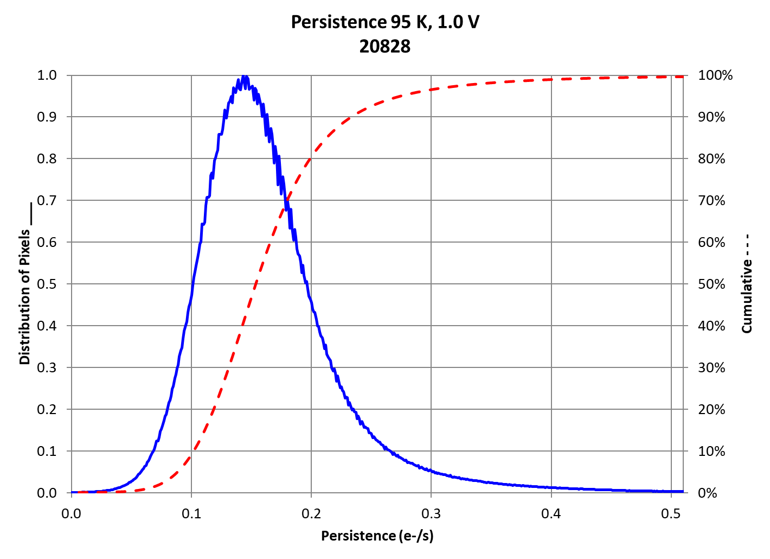
Figure 19. Histogram for high level persistence (10 min) at 95 K and 1.0 V. Persistence shall be less than 0.50 e-/sec in median for 300 ke illumination and less than 0.8 e-/sec per pixel.
The persistence versus illumination for 95 K, 1.0 V and 0.5 V are plotted in Figure 20. Persistence decay versus time for high signal level is shown in Figure 21 for 95 K 1.0 V and 0.5 V.
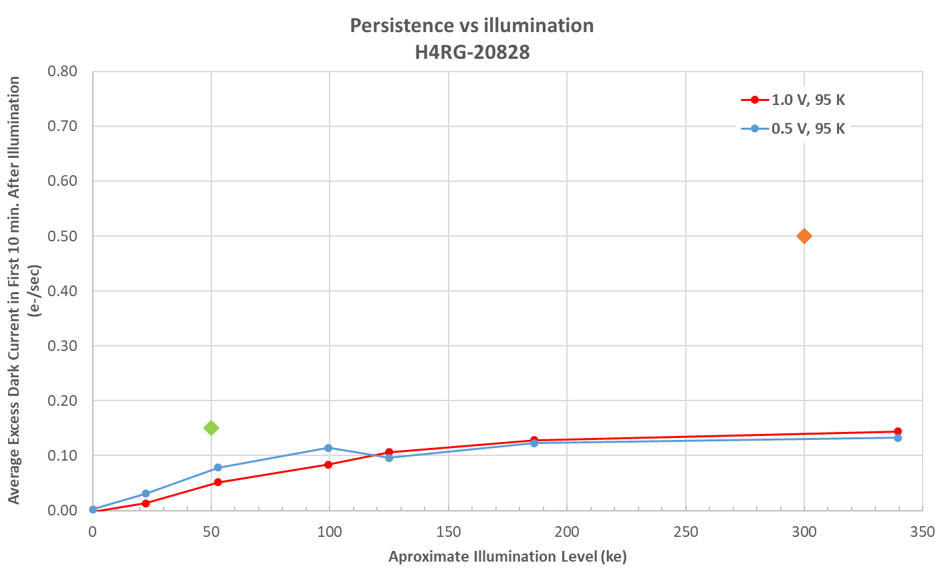
Figure 20. Persistence (10 min) versus illumination level at 95 K for 1.0 V and 0.5 V. Persistence shall be less than 0.15 e-/sec in median for an illumination of about 50 ke (green diamond) and less than 0.50 e-/sec for 300 ke (orange diamond) in median and less than 0.8 e-/sec per pixel.
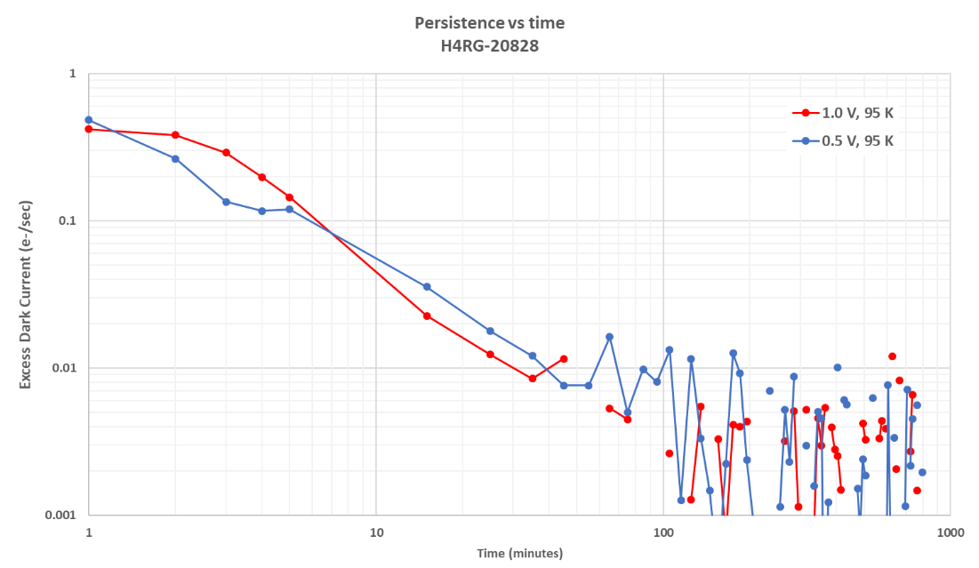
Figure 20. Persistence decay versus time for high signal.

Inter-pixel Capacitance
Inter-pixel capacitance should be less than 2.5% of the peak pixel signal to each nearest neighbor pixel. Crosstalk due to inter-pixel capacitance was measured using the single pixel reset method as described below:
- The entire array is reset to the VRESET voltage level of 0.3V. This initial VRESET voltage is designated as VRESET1.
- The entire array is read out once. This is the initial reset frame.
- A pre-determined subset of pixels is reset to a different VRESET voltage. This population is considered the reset pixels and the VRESET voltage they are reset to is designated as VRESET2.
- The entire array is read out. This is the selective-reset frame.
The crosstalk value was reported as the percentage of signal measured in a neighboring pixel with respect to the total signal found in 7x7 grid surrounding a reset pixel (reset pixel signal included). The reset bias voltage is the difference of VRESET2-VRESET1. A difference image is created by subtracting the initial reset frame from the selective-reset frame. The average signal of the outermost pixels region surrounding a reset pixel is subtracted from all pixels for local background signal correction.
The crosstalk is calculated by normalizing all pixels by the total signal in the 7x7 grid and then averaging the four immediate neighboring pixels to come to one average crosstalk value. Even detector channels were flipped during data analysis in order to preserve the asymmetry of IPC due to the direction of readout.
Figure 21 shows the percentage of charge found within the 5x5 grid of pixels around the center for 1.0 V and 0.5 V.

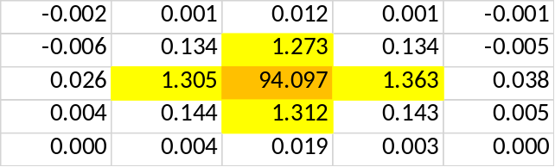
IPC matrix 1.0 V
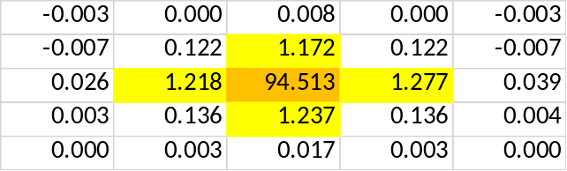
IPC matrix 0.5 V
Figure 21. IPC for 1.0 V (top) and 0.5 V (bottom). Even detector channels were flipped during data analysis in order to preserve the asymmetry of IPC due to the direction of readout.
Inter-pixel capacitance was also measured using Fe55. Figure 22 shows the percentage of charge found within the 5x5 grid of pixels around the center for 1.0 V using this method. The average of the percentage of the nearest neighbors of the ipc matrix calculated with fe55 and single pixel reset (SPR) is in Table 12.
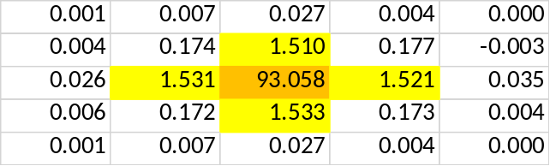
Figure 22. IPC for 1.0 V measured using fe55.
Table 12. Nearest Neighbors SPR and Fe55
 | SPR | Fe55
Av. neighbor 1.0 V [%] | 1.313 | 1.524
Diff. av neighbor Fe55 - SPR [%] | 0.211

Pixel Operability

At least 95% of pixels across the entire SCA shall be operable. An operable pixel is defined as one that meets the following performance specifications:

- Total noise < 12e⁻
- Dark current < 0.5 e⁻/s
- Quantum efficiency > 70% for a wavelength range of 0.8 to 2.1 um
- High intensity persistence < 0.8 e⁻/s

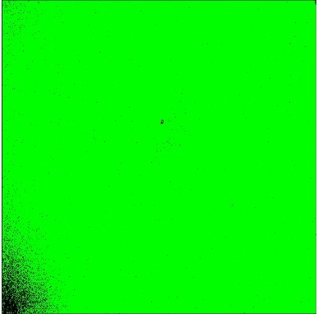
Figure 23 shows the operability mask for each requirement (Total Noise, Dark Current, QE, and Persistence) at 95 K and 1.0 V. Figure 24 is the combination of all of them. Operability Statistics are presented in Table 13.
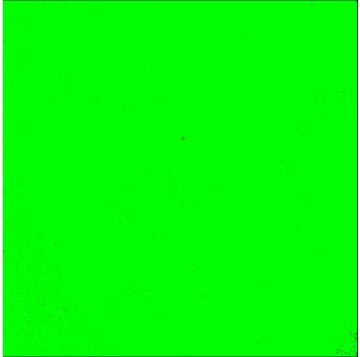

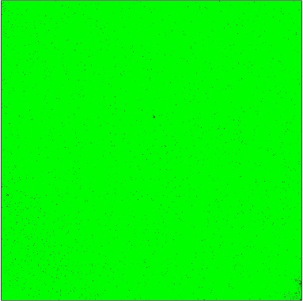

Figure 23. Operability masks (from left to right): Total Noise, Dark Current, QE, and Persistence. Green pixels are operable pixels that pass the parameter; black pixels fail the parameter.

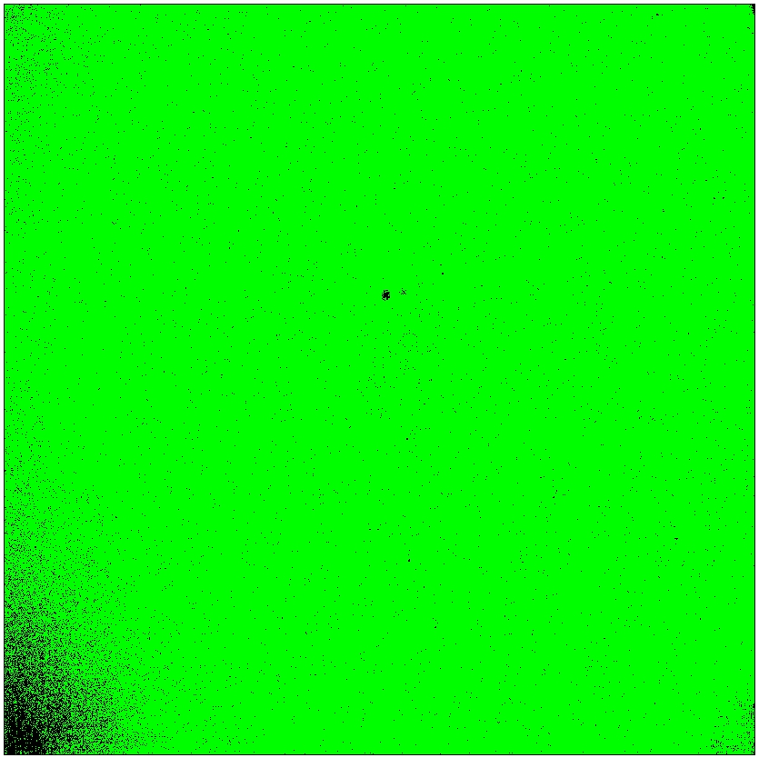
Figure 24. Combined operable pixel masks for Total Noise, Dark Current, QE, and Persistence. Green pixels are operable pixels that pass all parameters; black pixels fail one or more parameters.
Table 13. Combined operable pixel mask statistics out of 4088x4088 pixels image area.
Combined Operable Pixel Mask
Total Noise Requirement (%) | 99.50
Dark Current Requirement (%) | 99.90
QE Requirement (%) | 98.53
Persistence Requirement (%) | 99.90
Operable Pixels in % (Pass all four requirements) | 97.95

Guide Mode Functionality

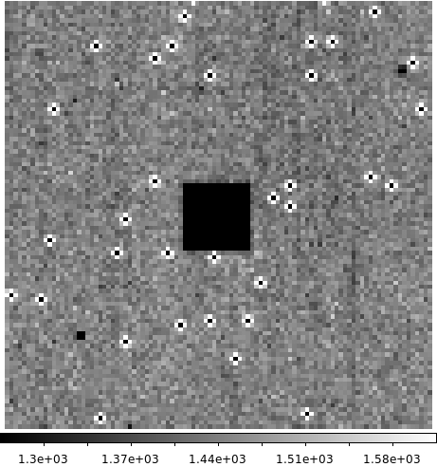
Guide Mode Functionality was evaluated in this detector. Five exposures of illuminated and dark data were acquired in science mode and guide window mode. The shape, position, and illumination level of the guide window was inspected to confirm functionality. Figure 25 shows the position of the guide window in the double CDS (illuminated CDS minus dark CDS).
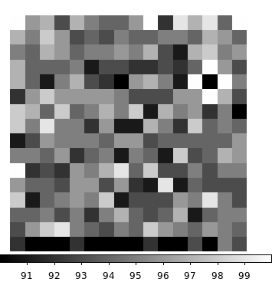
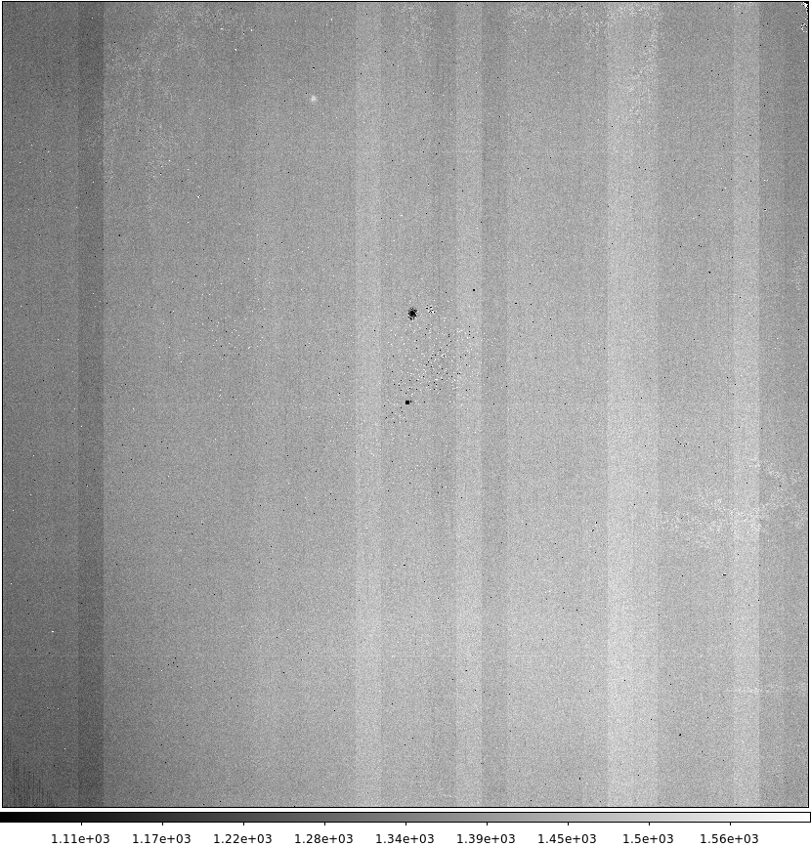

Figure 25. Left image: Position of the Guide Window (16x16 pixels) in Double CDS image of the “science data”. The left, bottom corner of the window appears at coordinates: (2048, 2048). Right image top: Zooming in of the Guide Window (square of 100 x 100 pixels, which includes the Guide Window) in the science data. Right image bottom: image of the guide window in guide window data.

Summary

H4RG 20828 passed Acceptance Test requirements.

Appendix 1 – Table of Report Data

Test | Raw Data Files Used
Log file | /dcl/wfirst/H4RG/HyC/20828_20830_20958_20960
Power Dissipation | /dcl/wfirst/H4RG/HyC/20828_20830_20958_20960
Conversion Gain | /dcl/wfirst/H4RG/HyC/20828_20830_20958_20960/ 20191203_95k_1p10m0p1_gain_20828_*
Flat Field | /dcl/wfirst/H4RG/HyC/20828_20830_20958_20960/ 20191203_95k_1p10m0p1_gain_20828_*
CDS Noise | /dcl/wfirst/H4RG/HyC/20828_20830_20958_20960/20191129_95k_1p1m0p1_noi_20828_*  /dcl/wfirst/H4RG/HyC/20828_20830_20958_20960/20191201_95k_0p6m0p1_noi_20828_*  /dcl/wfirst/H4RG/HyC/20828_20830_20958_20960/20191128_90k_1p1m0p1_noi_20828_*  /dcl/wfirst/H4RG/HyC/20828_20830_20958_20960/20191130_90k_0p6m0p1_noi_20828_*
Total Noise | /dcl/wfirst/H4RG/HyC/20828_20830_20958_20960/20191129_95k_1p1m0p1_noise_20828_*  /dcl/wfirst/H4RG/HyC/20828_20830_20958_20960/20191201_95k_0p6m0p1_noise_20828_*  /dcl/wfirst/H4RG/HyC/20828_20830_20958_20960/20191128_90k_1p1m0p1_noise_20828_*  /dcl/wfirst/H4RG/HyC/20828_20830_20958_20960/20191201_90k_0p6m0p1_noise_20828_*
Dark Current | /dcl/wfirst/H4RG/HyC/20828_20830_20958_20960/20191129_95k_1p1m0p1_dk2h_20828_*  /dcl/wfirst/H4RG/HyC/20828_20830_20958_20960/20191201_95k_0p6m0p1_dk2h_20828_*  /dcl/wfirst/H4RG/HyC/20828_20830_20958_20960/20191128_90k_1p1m0p1_dk2h_20828_*  /dcl/wfirst/H4RG/HyC/20828_20830_20958_20960/20191130_90k_0p6m0p1_dk2h_20828_*
QE | /dcl/wfirst/H4RG/HyC/20828_20830_20958_20960/20191203_95K_1p1m0p1_qe_*20828_*
Linearity | /dcl/wfirst/H4RG/HyC/20828_20830_20958_20960/20191209_95k_1p1m0p1_fw_20828_*
Disconnected Pixels | /dcl/wfirst/H4RG/HyC/20828_20830_20958_20960/20191126_295k_discon_*_20828_*
Persistence | /dcl/wfirst/H4RG/HyC/20828_20830_20958_20960/20191206_95k_1p1m0p1_pers_*_20828_*  /dcl/wfirst/H4RG/HyC/20828_20830_20958_20960/20191202_95k_0p6m0p1_pers_*_20828_*
Inter-pixel Capacitance | /dcl/wfirst/H4RG/HyC/20828_20830_20958_20960/20191203_95k_1p1m0p1_sp_delrst0p30_*_20828_*  /dcl/wfirst/H4RG/HyC/20828_20830_20958_20960/20191203_95k_0p6m0p1_sp_delrst0p30_*_20828_*
Inter-pixel Fe55 | /dcl/wfirst/H4RG/HyC/20828_20830_20958_20960/20191209_95k_1p1m0p1_fe55_20828_*
Guide Mode | /dcl/wfirst/H4RG/HyC/20828_20830_20958_20960/20191205_95k_1p1m0p1_guide_*_20828_*

