Alignment and Verification Testing of the GPS LRA Test Bed
Patricia Lyons_{a}, , James J. Lyons III_{a}, Pete Dogoda_{b}, Jim Golder_{b}, Don Lindler_{b}, Stephen Merkowitz_{c}, Evan Hoffman_{c}, David Steinfeld_{c}, John Crow_{c}, Guangjun Gao_{c}, Ken Dymond_{d}
_{a} Northrop Grumman Corp, Greenbelt, MD 20770
_{b} Sigma Space Corp, Lanham, Md 20706
_{c} NASA Goddard Space Flight Center, Greenbelt, MD 20771
_{d} Naval Research Lab, Washington, D.C. 20375

Abstract
The LRCTF (Laser Ranging Characterization and Test Facility) is a unique facility built at NASA GSFC to provide thermal-optical testing of the next generation GPS LRA (Global Positioning Satellite’s Laser Retroreflector Array) laser ranging target. The 400mm diameter target is an array consisting of 48 total internal reflection retroreflectors and has an optical cross section requirement of 100 MSM (million square meters). To verify that the array meets this requirement during on-orbit conditions, the LRCTF is equipped with a 400mm test beam, a data product output consisting of full aperture FFDPs (Far Field Diffraction Patterns) and a thermal chamber. The FFDPs are used to calculate the OCS. This paper will describe the facility design, alignment approach, and verification process.

Introduction
This paper details the NASA GSFC’s Laser Ranging Characterization and Test Facility (LRCTF) built for full aperture thermal optical characterization of the Global Positioning System’s Laser Retroreflector Array (GPS LRA). Specifically, we will present the optical design, alignment and performance verification testing. Results of the LRA thermal/on-orbit simulation testing will be covered in a forthcoming paper: only ambient optical LRA data used to demonstrate facility operation will be discussed here.
The satellite laser ranging capability provided by the LRA’s addition to the Global Positioning System will significantly improve the accuracy and stability of the International and WGS84 Terrestrial Reference Frames. Delivery of at least 22 arrays for GPS IIIF is planned with SV-11 launch availability in 2026.¹

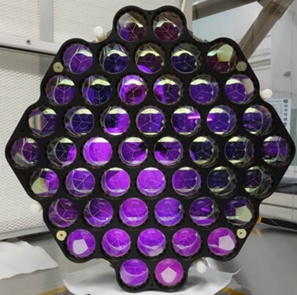
Each GPS LRA is comprised of 48 solid, 0.04mm diameter, Total Internal Reflection (TIR) cube corners having an AR coating optimized for 532nm and 1064nm. The cube corners are randomly clocked within the array to negate polarization effects thus providing uniform energy distribution within the velocity aberration annulus of the reflected beam. The mission requirements dictate a minimum 100 million square meters (MSM) Optical Cross Section (OCS) to ensure sufficient signal strength when received back at the ground station. The cube corners are fabricated from Suprasil-1, have slight dihedral angle spoiling and an exiting wavefront error of ¼ wave peak to valley (p-v) at 532nm.

The need to measure the OCS of the array under varying orbital configurations dictated the development of a dedicated facility able to acquire full aperture far field diffraction patterns (FFDP) generated by the 16 inch diameter array rather than single cube FFDPs.
Figure 1: Engineering Qualification Model LRA

Facility Overview
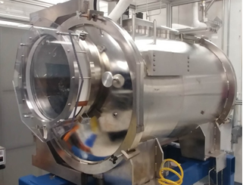
Our initial task was to identify a dedicated chamber available for long term use on center. This turned out to be a 0.81 m inner diameter by 1.22 m long Vacuum Solutions Chamber operated by Code 545, Goddard’s Thermal Engineering Branch. Dry roughing, turbo and cryo pumps allow us to obtain a vacuum of 10⁻⁶ atmospheres.
Once found, several modifications were necessary. A new door was procured to house a 0.48m diameter, 76mm thick window made of Corning 7980 and fabricated by AMF Optics (shown in Fig. 2) The window has a 0.4m diameter clear aperture and a transmitted WFE < ½ wave p-v (at 633nm). An internal thermal shroud was made whose interior was coated with Aeroglaze Z306 black polyurethane and exterior blanketed with multi-layer insulation (MLI). The shroud was also equipped with heaters and LN2 cooling lines. Type T thermocouples in conjunction with a custom Labview software program provided monitoring and temperature control. The array was bolted to a Simulated Spacecraft Interface Plate (SSIP) made from honeycomb aluminum and the assembly was blanketed with MLI. The SSIP was bolted to a rotary stage that provides adjustable angles of incidence to the solar simulator beam about the vertical axis (i.e. simulation of orbit orientation. See Fig 3). The rotation stage is driven by an Anaheim Automation stepper motor in 0.125 degree increments.
Figure 2: Vacuum Solutions chamber with 19 in window
An encompassing, exterior enclosure (7 x 3.4 x 3.1 m) surrounding both the optical bench and the chamber, was built at a later date and helped immensely in segregating our set up from other work going on in the lab. It eliminated worries of the inadvertent movement of metrology equipment and, although not a cleanroom, the enclosure also improved cleanliness.
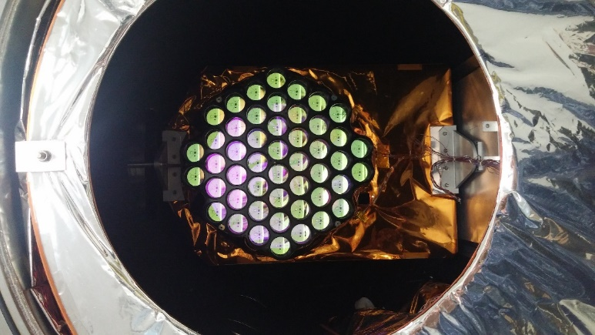
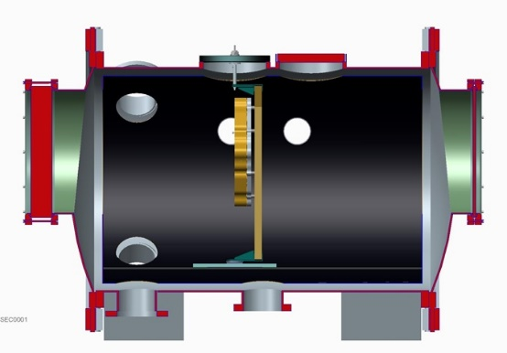

Figure 3: (left) Chamber cutaway view with LRA mounted via SSIP to rotation stage and (right) photo of array in chamber

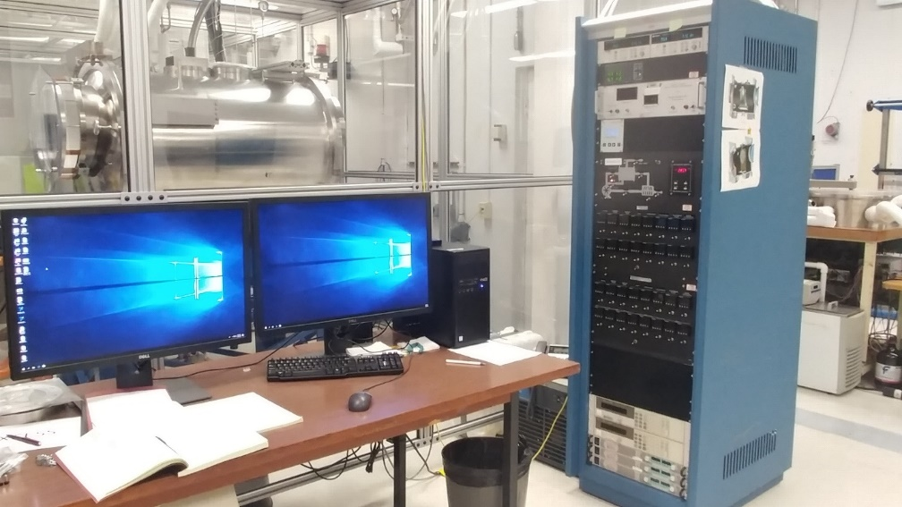

Figure 3 Chamber inside plexiglass enclosure with thermal ctrol system station in foreground

Figure 4 Chamber inside plexiglass enclosure with thermal control system station in foreground

Challenges
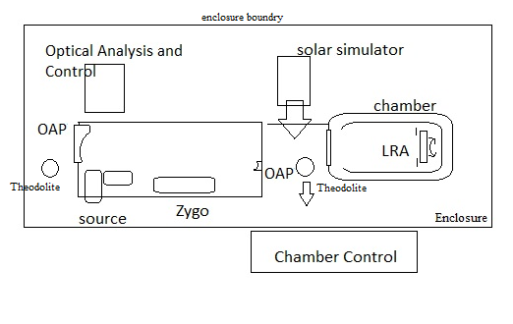
Physical space and large vibration levels were the two primary obstacles we needed to overcome. One of the initial challenges was fitting the Full Aperture Test Beam (FATB) onto an optical bench in front of the available chamber within the space allowed: we had room for a single 2.4 x 1.2 meter optical bench. The layout of the FATB was dictated by the 2.032m focal length, 0.4064m diameter off-axis parabola (OAP) needed to create the FATB while packaging the transmit and receive arms (on the Source Plate) of the optical system onto the same bench. We also had to provide enough space between the thermal chamber and optical table to be able to fully open the chamber door as well as place the solar simulator or theodolites in that area. Because we had limited room in the lab, this was kept to a minimum.

Vibration was primarily only a problem when fine tuning the alignment of the FATB using the Zygo interferometer (discussed later). Floating the optical bench was used with minimal success. Air turbulence was removed via the enclosure and the laser safety curtains. Eventually the Zygo interferometer was upgraded to a vibrationally insensitive unit to fully overcome difficulties in alignment optimization. The vibration was not a concern for obtaining the FFDPs due to the large amount of laser power available at the CCD and the short exposure times available.
Figure 5 Facility layout
Design
The overall design of the FATB was based on the Lageos II project² and is shown in Figures 6 and 7. The system has two main sections: the Source Plate (SP) and the 0.406m beam expander. The SP’s transmit arm generates a 25mm diameter collimated beam. This beam is expanded to 0.406m via a two element beam expander creating a full aperture collimated test beam which is reflected by the LRA and re-imaged by the SP to provide the FFDPs used to calculate the OCS.

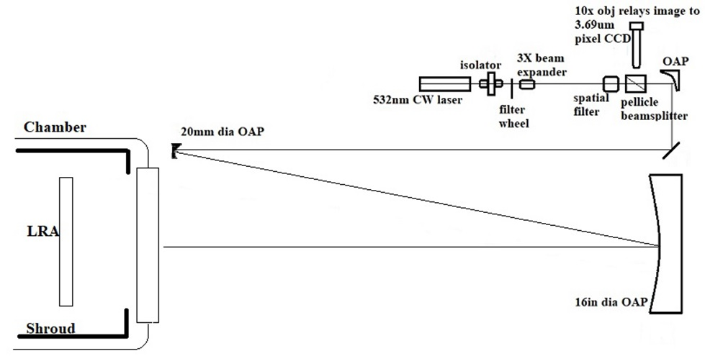
Figure 6 Full Aperture Test Beam Schematic
The Source Plate contains a 532nm CW, linearly polarized laser which passes through an isolator, ND filter wheel and into a 3X beam expander. The beam expander is needed in order to fill the 15 micron pinhole after exiting the 20X objective in the spatial filter. The non-polarizing, 1/8th wave p-v WFE pellicle beamsplitter from National Photocolor transmits the outgoing beam and reflects the return beam. The return beam focus is located at the focus of a 10X objective which magnifies the FFDP and images it onto the camera consisting of a 1928 x1448 array of 3.69micron pixels .
[Note: We replaced the original, non-polarizing cube beamsplitter with the pellicle and swapped the Apogee Ascent CCD camera (which has a window over the array) with a Newport LBP2 camera (having no window) to remove the “fringing” within the FFDPs.]

A third OAP (the Source Plate OAP or SPOAP) is common to both arms and collimates the transmitted beam and focuses the return. The SPOAP was chosen after determining that the previously incorporated 200mm focal length achromats were distorting the beam to such a degree that we could not remove parallax. The alignment, although more complicated, provides a very clean beam. Not shown, but available when needed, is a Berek Polarizer that can be placed within the transmit arm to alter its polarization state.

The beam expander consists of OAP1 and OAP2. OAP1 is a custom, 20mm diameter clear aperture, 100mm focal length, 1/8th wave (p-v at 633nm) aluminum mirror that was diamond turned by Nu-Tek. OAP1 provides a defined f/# to OAP2, serves as the aperture stop, and also provides a convenient solution to packaging the layout onto the 2.4 m bench. It is confocal with the 2.03m focal length OAP2. OAP2 is the same mirror used by the LAGEOS II project.

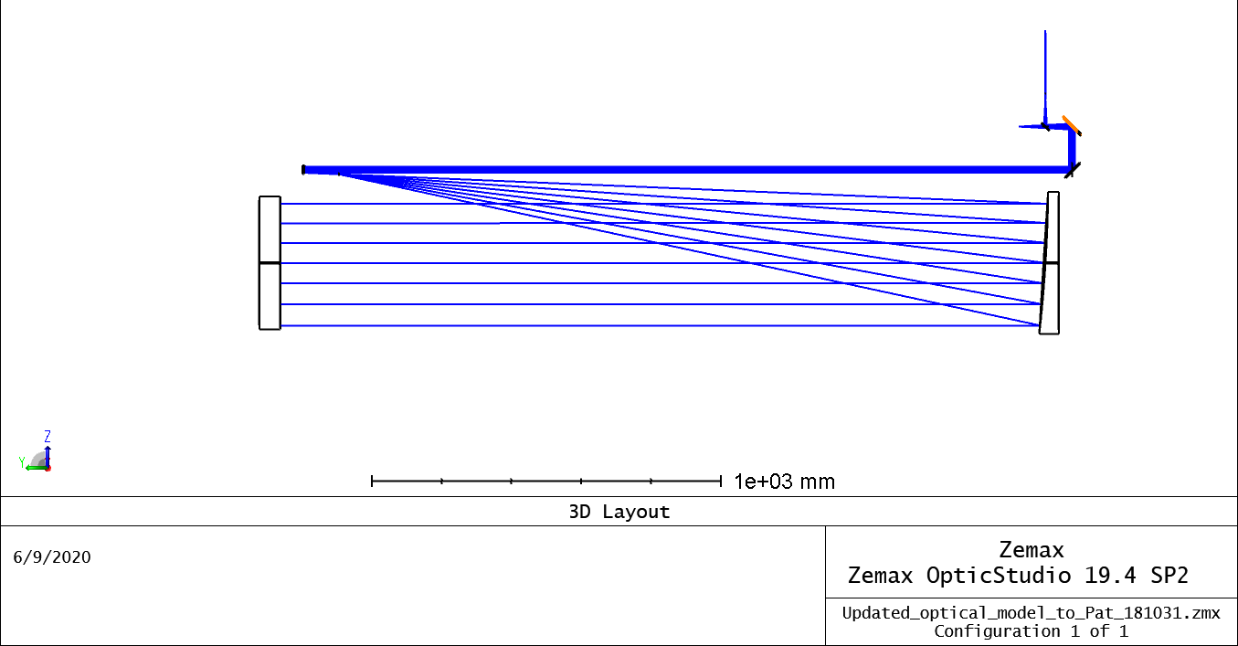
Figure 7 Zemax 3D layout of FATB
Alignment approach
An inherent difficulty in aligning the FATB is found in the large physical extent of the layout when attempting to co-align three OAPs. Generation of the FATB was complex enough we decided to break the alignment into 3 main sections: the 0.4m beam expander alignment (OAP1 to OAP2), the internal alignment of the source plate and finally the source plate to the beam expander (as defined by OAP1). Figure 8 shows the three alignment sections. The optical bench was positioned with respect to the thermal chamber such that OAP2’s center when placed near the edge of the optical table (to allow room for the SP) was centered on the LRA when it was mounted inside the chamber. All components on the optical bench were placed at the nominal height of the LRA centerline.
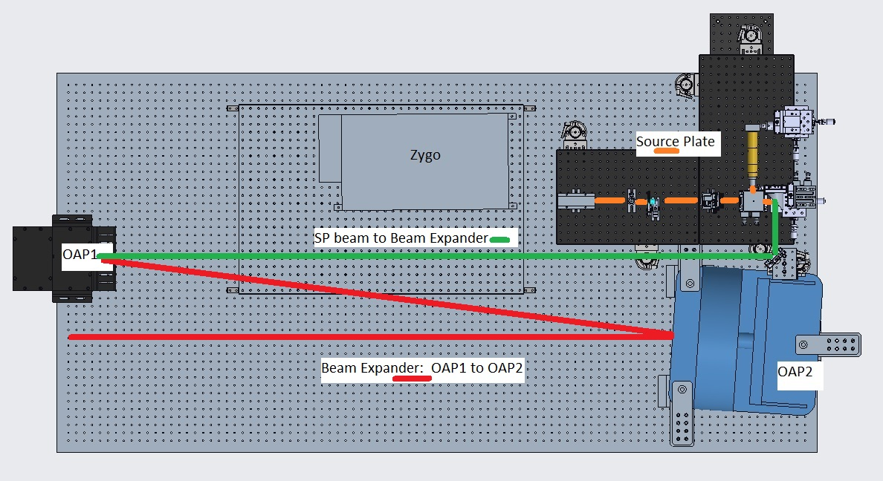
Figure 8 Three sections of alignment shown as orange, green, and red.
For each portion of the FATB alignment, we started with opto-mechanical placements of the components and then employed various optical tests to optimize the performance. This was especially critical for the beam expander because of the large despace between the mirrors.
Align Full Aperture Beam Expander
OAP1 defines our primary reference for the entire FATB. This OAP is an aluminum, diamond turned mirror with an integral flat on its back (Figure 9) whose normal was parallel to the OAP’s optical axis. We verified this reference surface independently and found it to be co-aligned. The image inset into Fig 9 was obtained by aligning OAP1 to a collimated Zygo beam using a retroreflecting ball (fringes on the left). A cube corner was then positioned to direct a portion of the Zygo beam onto the integral flat and thus back to the Zygo. No significant tilt can be seen between the nulled OAP1 wavefront and the integral flat.
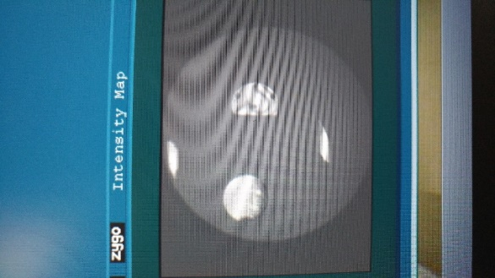
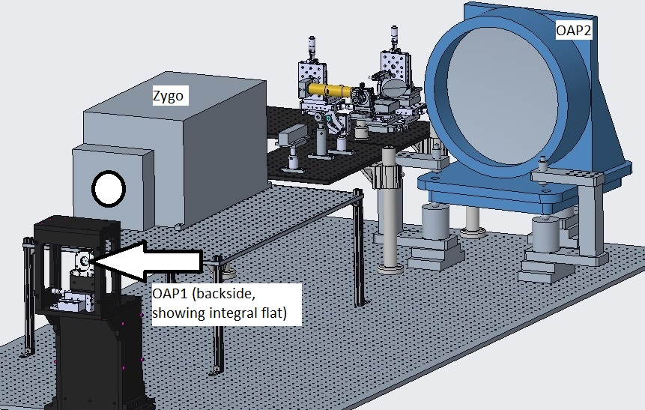
Figure 9 Integral flat diamond turned onto back of OAP1; Inset shows co-alignment of flat to OAP1 optical axis: wavefront on left and integral flat return (via cube corner) on right

The first step of our rough alignment was to place the integral flat to level and nominally square to optical bench bolt hole pattern with the center of OAP1 located at the nominal center of the SPFF. OAP2’s edge was placed 52mm from OAP1 edge. If needed, we iterated until both conditions were met.
Using custom, distance measurement gauge arrangements, we placed OAP1 and OAP2 at nominal relative despace of 2134mm while maintaining the proper decenter.
Mirror centers where set to the same height to an accuracy of 0.2mm using precision height gauges. Nominal clocking of both OAPs was also set using the height gauge and reference marks on mirrors’ edges. To precisely set the clocking of OAP1, we aligned the Zygo beam to the integral flat and observed OAP1 image. Clocking was adjusted until the image fell on axis.
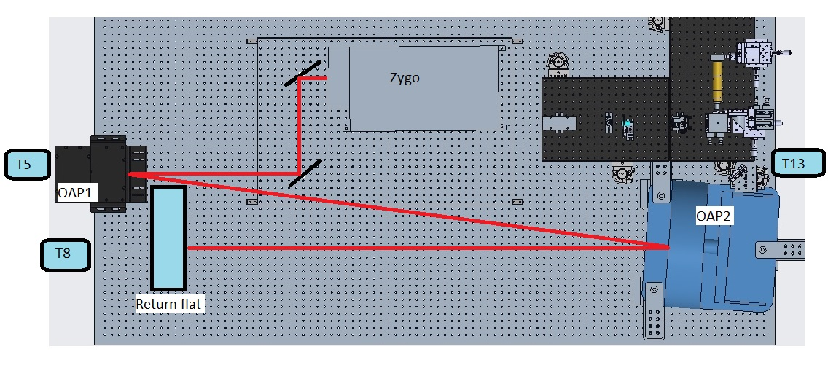
Figure 10 Metrology layout for alignment of beam expander
Figure 10 shows the metrology configuration for the final, optical, alignment of the beam expander. The beam from the Zygo interferometer was folded into OAP1, reflected off of OAP2 and then retroreflected off of a large flat. We aligned the Zygo beam to OAP1 by aperture sharing the return from its integral flat with the incident Zygo beam using theodolite T5.
A retroreflecting element was needed to obtain fringes so we placed a large flat in collimated space in front of OAP2 near OAP1. [Note: Initally this was a 0.4m diameter flat mounted in a Unertyl base. It was very heavy and required a hydraulic lift and multiple persons to take it onto and off of the table each time we needed to verify the beam expander alignment. We eventually switched to using an unmounted 0.3m diameter test plate on a tip tilt base that a single engineer could swap out. FATB wavefront error difference using the 0.3m retroreflecting flat was confirmed to be 0.75 that of the 0.4m flat.]
The retroreflecting flat was aligned to OAP1 using both theodolites T5 and T8 as shown in Figure 10. Another advantage of using the 0.3m test plate was it provided a direct view of the Zygo beam and when the system was aligned, the Zygo image was coincident with the theodolite return off the front surface. When using the 0.4m flat, a lateral transfer retroreflector was employed to provide line of sight from T8 to the flat surface.
We now were able to adjust OAP1 and OAP2 strategically to optimize alignment using the Zygo fringe analysis to guide our adjustments. Practically, OAP2 was so large, we had no controlled way to translate it, however it was also in a Unertyl mount that provided tip/tilt adjustments. OAP1 was mounted on 3 axis translation so we walked in the alignment by tilting OAP2 and translating OAP1. This was initially quite difficult due to the high levels of vibration in the lab, even with the optical table floating. Eventually, we were able to upgrade to a vibrationally insensitive interferometer which drastically reduced our level of frustration!
Our nominal full-aperture wavefront error of the beam expander is 0.8 waves p-v at 633nm or 0.95 waves at 532nm. We accepted this level of error across the 0.4m beam since this equates to approximately 0.1 wave of error across the diameter of each cube under test.

Source Plate Alignment
The SP contains the transmitting and receiving arms of the FATB on an optical breadboard. As previously mentioned, we set the nominal height of the SP optical axis so that it was at the center of the LRA in the thermal chamber. This height was transferred to a simple azimuth alignment target made of ruled paper attached to a post that bolted into the bolt holes of the SP breadboard. The entire SP was elevated to allow us to place its optical axis at the correct height (see Fig 9).
First, we leveled and aligned the SP breadboard base to the optical bench bolt hole pattern, then aligned the laser nominally along this coordinate system using the azimuth target reference and leveled using T13 (translated slightly from the position shown in Fig10). The isolator was installed and oriented so that there was maximum transmission and its incoming polarization axis aligned to the laser’s (45 degrees CCW from vertical looking along the direction of propagation).
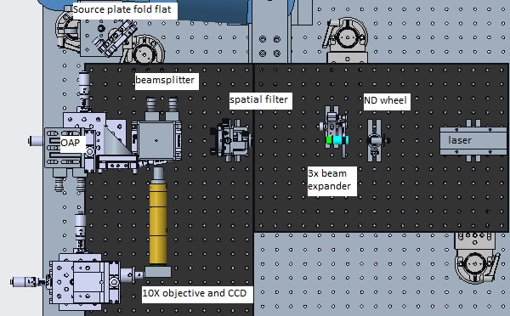
Again, the azimuth and elevation of the beam exiting the isolator (and subsequently the ND filter) was verified. The 3x beam expander was installed and aligned so that the incoming beam was centered on its input aperture and the output beam centered on its output aperture. The emerging beam was checked for stray light reflections (indicative of tilt misalignment) and again checked in azimuth and elevation.
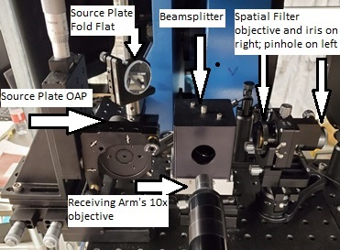
The spatial filter (SF) mount was installed next without objective or pinhole. We minimized the integral iris to assist in centering the mount on the incident beam. The entire spatial filter mount was adjusted in tip, tilt and decenter to align it along the optical axis. The objective was installed and its own independent tip and tilt control used to align the output beam in azimuth and elevation while translating the entire SF mount to maintain iris alignment to incoming beam. The SF pinhole could then be installed and aligned to the objective. Generating an emerging beam that was aligned properly, often required iterations of the SF alignment just described.
Figure 11 Source plate components (no islolator shown here). Note the SP is aligned to the bench
Figure 12 Photo of a portion of the source plate
The beamsplitter was inserted at the beam center at a despace distance that did not vignette the diverging beam. Until we were ready to work on the receiving arm it was simply placed at an “eyeballed” nominal elevation and azimuth. The SPOAP was mounted at nominal despace and decenter position with respect to the pinhole. The SPOAP is adjustable in 6 degrees of freedom. Finally the source plate fold flat was installed at nominal decenter and despace, with its normal level and aligned 45° in azimuth from the bolt hole pattern of the optical bench.
Bringing the SPOAP into alignment was tricky as we had to optimize its placement to the pinhole while aligning the emerging collimated beam in tip and tilt. To do so, we began by placing a paper at the opposite end of the table in front of OAP1. We adjusted the SPOAP until the beam appeared circular and collimated (observed by translating the paper over approximately 2 meters). We then placed a shear plate interferometer in the collimated beam and, viewing fringes with the Shear plate both vertical and horizontal, brought the SPOAP further into alignment. Finally, an alignment telescope was placed in front of OAP1 to view the image of the collimated beam while final adjustments to the SPOAP were made. See Figure 13.
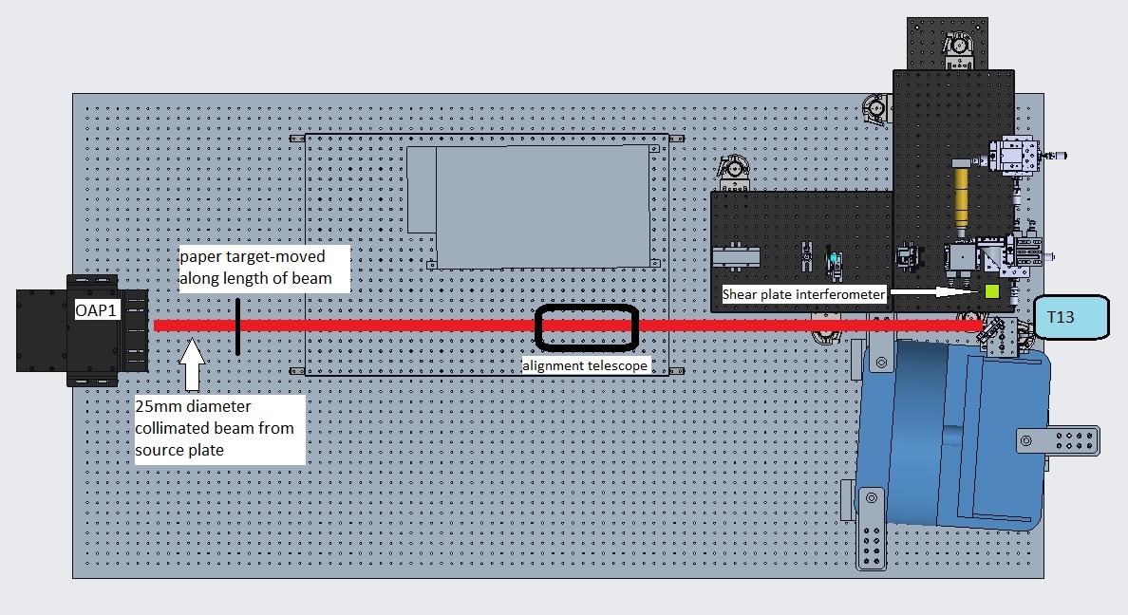
T5
Figure 13 Alignment configurations for optimizing the source plate off-axis parabola
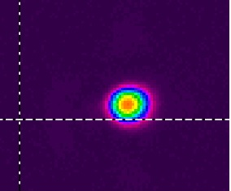
At this point, a 1/20th wave flat, with no wedge angle, was installed in place of the alignment telescope shown in Fig 13 and aligned to OAP1 using T5. The SPFF was adjusted in tip and tilt to direct the beam back through the beamsplitter unvignetted.
The beamsplitter tip and tilt was adjusted to align the reflected beam into receiver arm at the proper angle and into the camera. Small tweaks of the SPOAP were made to further fine tune the image quality.
Figure 14 Image of Source Plate beam returned from 1/20th wave flat
Source Plate to Beam Expander Alignment
Now that the image quality of the SP beam was optimized, we had to confirm alignment between the SP beam and OAP1. To do so, we aligned T5 to OAP1 and T13 to T5, thus transferring OAP1 alignment to T13. A 100 mm diameter hollow cube corner retroreflector placed in the path of the SP beam (in place of the alignment telescope in Figure 13) directed the SP beam back to T13 to within 5 arcseconds of the outgoing beam. Any angular correction needed was done with the SPFF tip/tilt. Check of decenter of the SP beam on OAP1 was done visually: horizontal decenter of the SPFF was used to correct any horizontal offsets. We were unable to correct vertical decenter of the SP beam onto OAP1. This is could be corrected by adding vertical translation capability to the SP breadboard and may be an improvement we add going forward. The vertical decenter of the SP beam requires that we add a correction factor when the OCS data is analyzed and is addressed in that section later in this paper.
Final focus to remove parallax
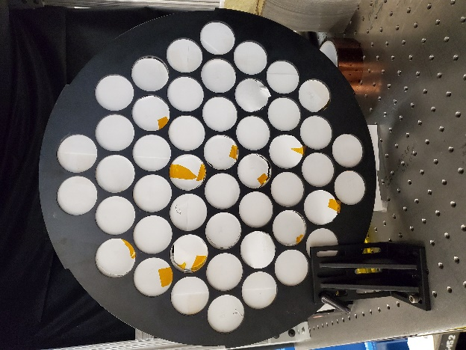
Prior to acquiring data, we must remove parallax. To do this, an aperture mask was placed on the optical bench and aligned to the LRA (Figure 15). Each aperture was able to be closed or opened so that each cube’s FFDP could be individually viewed. The FFDPs’ center positions from four cubes (one at each extreme position within the aperture: top, bottom, right and left) were compared and the focus of the CCD/10X objective assembly adjusted in focus until all FFDPs were coincident to within 2 pixels. If parallax is not removed, the velocity aberrations will not be coincident and the OCS value will be low. This is also discussed in more detail in the data analysis section to follow.
Figure 15 Aperture mask used to selectively view single cube FFDP

Data Acquisition
Once we confirmed the absence of parallax, we were ready to acquire FFDPs and calculate the OCS. To calculate the OCS, FFDP images are needed not only from the array but also from a high quality flat of known diameter. We chose a 63.5 mm diameter flat whose surface figure error was < 1/20th wave p-v at 633nm. This diameter ensured that we were encompassing a diffraction limited sub aperture of the FATB thus providing a maximum intensity of its Airy disk. The measured maximum pixel value intensity of the Airy peak of this image corresponds to its theoretical OCS and thus calibrates pixel intensity to an OCS value. The array’s FFDP is then recorded and the average pixel value in the velocity aberration annulus is determined. This pixel value is then compared to the pixel value for the reference flat’s OCS and the array’s OCS within the annulus can be determined.³
In addition to the FFDPs of the array and reference flat, we also need to measure the laser power for each FFDP. Only when the laser power is unchanged between the two FFDPs can there be a direct ratio of OCS values. Other practical matters of data acquisition included ensuring that the camera settings (gain, exposure time, and black level) were the same for each image, there was no saturation, peak pixel counts were near 255 (for 8 bit images), images consisted of single frames (no averaging), laboratory lights were off and the laser safety curtains surrounding the table on three sides were drawn.

Data Analysis
Custom IDL (Interactive Data Language) code was written to calculate the average pixel value in the velocity aberration annulus of the array’s FFDP. The code requires you enter the system plate scale so it can create a mask subtending the 22 to 26 micron annulus in units of pixels. It also requires that we enter the center of each FFDP so that it can properly position the annulus mask on the FFDP.
The plate scale was measured directly using a double slit (d=24.13mm) mask over the 1/20th wave 150mm diameter mirror. The theoretical spacing of maxima is 22 urad. The average center to center spacing of the diffraction maxima was measured at 725 um or 197 pixels providing a 0.112 microradian/pixel plate scale.
[Note: we didn’t record and subtract background images. We found that processing and subtracting back from light FFDPs provided the same pixel values as simply subtracting the image’s minimum pixel value.]
Once the peak counts of the reference mirror Airy disk was found as well as the annulus average pixel value, we were ready to calculate the array OCS. First, we needed to compute the reference mirror’s OCS which is = 4π(A/λ)⁴ For our 63.5 mm diameter mirror, the OCS is 444.31 MSM (10⁶ m²).

OCS = (Array Annulus Counts)/(Airy Peak Counts) * (Mirror Laser Power/Array Laser Power)*444.31 MSM

You can see that if the individual cubes’ FFDPs are not coincident due to parallax, the accumulative intensity of the annuli will not be maximized and the average counts in the array annulus will be low as will the resulting OCS. The value of OCS generated by this equation must be corrected for several items. Our system had approximately 6% vignetting due to the FATB being slightly offset from the array (divide by 0.94). Also, if the array was inside the chamber with the door closed, as was the norm, the losses from the window must be accounted for (divide OCS by 0.84)
The most challenging correction was that needed for beam intensity non-uniformity due to the vertical displacement of the source plate beam on OAP1 as previously mentioned. This was an issue that plagued us and really could only be resolved by completely re-configuring the source plate mount. To determine how to correct for this effect, we mapped, using the aperture mask in Figure 15, the relative power at each cube position. Looking at the equation for OCS calculation above, you can see that as the array laser power increases the OCS decreases and vice versa. The 63.5 mm calibration flat was nominally always located at the center of the beam where the intensity is highest, resulting in an OCS that is too low. Based on the map, we determined a correction multiplying factor of 1.48.

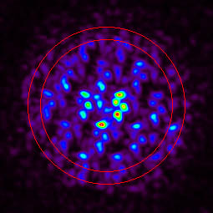
Figure 16 Ambient Array FFDP. Mean OCS =152MSM.
Velocity aberration annulus shown in red

Conclusion
Figure 16 shows a typical, ambient FFDP from the engineering unit array. The red circles in the image enclose the 22 urad to 26 urad velocity aberration annulus of interest. As mentioned above, the average pixel intensity in that region was calculated, and along with relative laser power, used to ratio the reference flat OCS calibration of pixel intensity to calculate the array’s OCS. Earlier in the paper, an OCS requirement of 100MSM was stated. This is a minimum OCS value for any on-orbit ranging situation. The nominal ambient, normal incidence OCS baseline design value is approximately 157 MSM. Our baseline ambient OCS result for the array FFDP shown in Figure 16 is 152 MSM.
NASA now has a unique facility that provides full (0.4m) aperture OCS testing capability for the GPS LRA project. It is not necessary to rely on single cube OCS measurements and extrapolation to the full array performance.
Acknowledgements
We would like to thank the NASA GSFC Building 4 Thermal Lab (Code 545) team of Mario Martins, Frank Robinson, Brian Rice, and Mike Chapman for their outstanding support without which we could not have built this facility.
References
- Merkowitz, et.al. “Thermal-Optical Performance of the GPS III Laser Retroreflector Array”, 21st International Workshop on Laser Ranging, November 2, 2018.
- Minott, et.al. “Prelaunch Optical Characterization of the Laser Geodynamic Satellite (LAGEOS2)”, NASA Technical Paper 3400, September 1993.
- Fitmaurice, et. al. “Prelaunch Testing of the Laser Geodynamic Satellite (LAGEOS)”, NASA Technical Paper 1062, October 1977.

