Mars Ascent Vehicle Hybrid Propulsion Effort
George Story
NASA Marshall Space Flight Center, Huntsville, Al, 35812, USA
Ashley Karp and Barry Nakazono
Jet Propulsion Laboratory, California Institute of Technology, Pasadena, CA, 91109, USA
Greg Zilliac
NASA Ames Research Center, Moffett Field, CA, 94035, USA
Brian Evans
Space Propulsion Group, Inc., Butte, MT 59701, USA
George Whittinghill
Whittinghill Aerospace, Camarillo, CA 93010, USA
A technology development program was undertaken to determine if the benefits of hybrid rocket propulsion could be realized for a Mars Ascent Vehicle (MAV) application. Specifically, the goal of this program was to increase the Technology Readiness Level (TRL) of a hybrid propulsion system such that it could be considered for a potential Mars Sample Return Campaign. Over the course of approximately five years, a new, wax-based fuel was developed, characterized and tested with Mixed Oxides of Nitrogen (from MON-3 to MON-25). Various ignition mechanisms were tested and solid hypergolic additives were evaluated for their potential to ignite the hybrid motor. Several hot-fire test campaigns were completed at both sub- and full-scale.
The technology development program was born out of a JPL study documented by Shotwell and Karp that identified the Single Stage to Orbit (SSTO) hybrid propulsion system for a potential Mars Ascent Vehicle to be the lowest Gross Lift Off Mass option from the ten configurations evaluated. Benefits of the hybrid option included its predicted favorable low temperature storage and operation behavior, high performance and ability to restart (enabling the SSTO). The main disadvantage of the hybrid option was its low TRL, as it essentially started as a blank sheet design with a new fuel development.
Near the end of the technology development program, a Preliminary Architecture Assessment (PAA) was completed to evaluate a single-stage hybrid propulsion system and a two-stage solid propulsion system for a potential MAV. The solid propulsion system was selected for further study in 2019, primarily because of its flight heritage.
While the hybrid technology development program made many strides, there was still a list of challenges to overcome. This paper will discuss the substantial progress and remaining challenges from the technology development effort from 2015 through 2019. This includes fuel development and reformulation, sub- and full-scale testing at Space Propulsion Group, full scale testing at Parabilis, full scale testing at Whittinghill Aerospace, hypergolic additive testing at Purdue and Penn State and the evaluation of adding hypergolic additives to a full-scale grain. It also includes a discussion of the design that resulted from the Preliminary Architecture Assessment.

Nomenclature

ARC = Ames Research Center

GOX = gaseous oxygen

GN&C = Guidance Navigation and Controls

HTPB = hydroxyl terminated polybutadiene

ISP = specific impulse

JPL = Jet Propulsion Laboratory

LITVC = liquid injection thrust vector control

LOX = liquid oxygen

MAV = Mars Ascent Vehicle

MAVRIC = Mars Ascent Vehicle Research and Innovation Campaign

MMH = monomethylhydrazine

MON = mixed oxides of nitrogen (nitrogen tetroxide w nitric acid)

MON-3 = nitrogen tetroxide with 3% nitric acid

MON-25 = nitrogen tetroxide with 25% nitric acid

MPA = MAV Payload Assembly

MSFC = Marshall Space Flight Center

N₂O = nitrous oxide

NTO = nitrogen tetroxide

O/F = oxidizer to fuel ratio

OS = Orbiting Sample

PAA = Preliminary Architecture Assessment

P_{c} = Chamber Pressure

SP1 = Space Propulsion Group fuel formulation

SP7 = fuel formulation developed for MAV

SP7A = modified regression rate fuel formulation developed for MAV

SPG = Space Propulsion Group

SRL = Sample Retrieval Lander

SSTO = Single Stage to Orbit

TEA/TEB = triethyl aluminum/triethyl boron

TRL = Technology Readiness Level

WSTF = White Sands Test Facility

Δhvap = enthalpy of vaporization

Introduction
The Mars Ascent Vehicle (MAV) is a part of the proposed Mars Sample Return (MSR) campaign. The first part of Mars Sample Return is the Mars 2020 Perseverance Rover, which will launch in 2020. Mars 2020 Perseverance Rover will extract and package (in hermetically sealed tubes) rock and regolith samples from Jezero Crater for potential return. The Mars Ascent Vehicle is a proposed mission to be launched in the Sample Retrieval Lander (SRL). A Sample Fetch Rover, currently envisioned to be deployed by the SRL, will pick up the sample tubes and deliver them to the SRL, to be inserted in the Orbiting Sample (OS) container by a Sample Transfer Arm. After the samples are secured in the OS, the MAV will launch the OS into an orbit around Mars. An Earth Return Orbiter, also proposed, would retrieve the OS from orbit and bring it back to Earth. For further details on the larger program, see reference [].
Over the last two decades there have been many studies and development efforts for a Mars Ascent Vehicle. These studies included solids, bi-prop liquids, spinning solids, gelled propellants, mono-props, and recently hybrid rocket concepts. For a detailed review, see reference []. At the end of this reference, Shotwell discusses the trades that led to the current hybrid propulsion MAV effort.
Further investigation in that 2015 trade suggested that a single stage to orbit hybrid rocket vehicle, capable of a restart, could be advantageous in the MAV role []. Low temperature capabilities, higher specific impulse and no need for staging were potential benefits over other systems. However, this system had a lower Technology Readiness Level (TRL) than some of the other concepts.
There was a hybrid rocket technology base to build on (see Figure 1). A MON-25/plexiglass/magnesium hybrid propulsion system had been developed, qualified and flown for a rocket powered target missile [26]. The American Rocket Company and the Hybrid Propulsion Demonstration Program both demonstrated a booster size 250K lbf thrust LOX HTPB hybrid design [16]. A hybrid has been used in the first commercially developed space craft to take humans to the edge of space. Space Ship One and Space Ship Two are both based on N2O and HTPB hybrids. For the hybrid Peregrine Sounding Rocket, a N2O and a liquifying paraffin-based fuel motor has been designed, tested, qualified and is waiting for a flight opportunity.
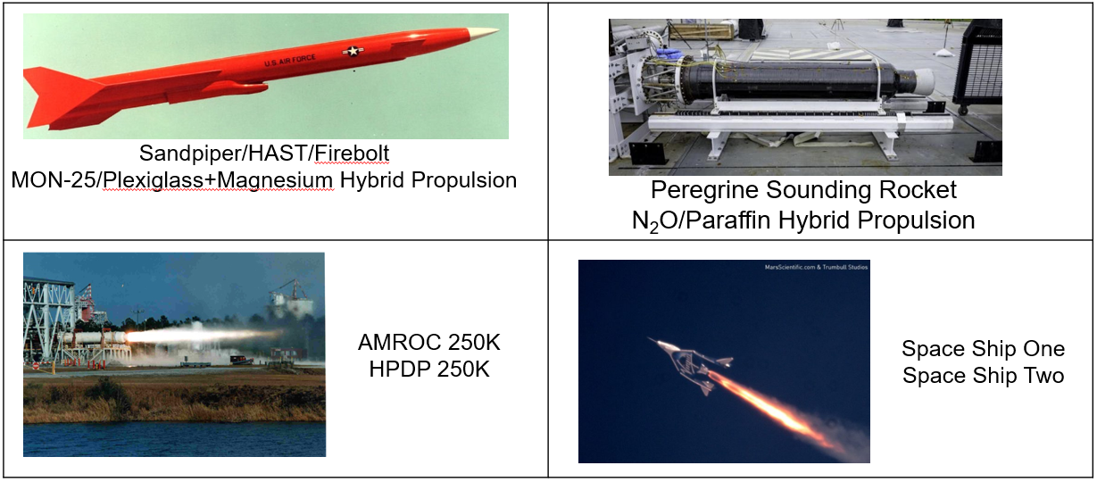
Figure 1 Hybrid Rocket Motor Technology
Since the SRL launch was proposed to be more a decade away, there was time to further develop the technology in the interim. The goal of this effort was to raise the TRL to a level that would allow its consideration for the potential flight mission. That development included solid fuel and hypergolic development, motor firings at vendor sites and an earth demonstration of that technology in a launch called MAVRIC. Reference [] goes into detail on those plans.
While in the planning stages of MAVRIC, the proposed flight of a MAV moved forward to possibly as early as 2026, significantly reducing the window for technology development. A decision was made to stop work on the MAVRIC and move directly into launch trades. A preliminary review was held by Marshall Space Flight Center (MSFC) Advanced Concepts Office, see reference []. That study led to a larger vehicle study, called a Preliminary Architecture Assessment (PAA), between a two stage to orbit solid [,] and the single stage hybrid [, ] propulsion systems. A down selection between the solid and hybrid concepts occurred in December of 2019. The down selection to the two stage solid system was primarily due the lower Technology Readiness Level (TRL) of the single stage hybrid propulsion system and the short time until the proposed launch.
A well-funded technology development effort took the clean sheet hybrid propulsion system design through a new fuel development, subscale testing and culminated in full scale testing with vacuum ignition and demonstrated restart capability. Liquid Injection Thrust Vector Control (LITVC) was demonstrated under ambient conditions. Hypergolic solid additives were discovered and tested in wax binders for potential use. Various obstacles were encountered and many were overcome. However, a number of challenges still need to be addressed if this technology is to be adopted.
The MAV hybrid effort has been a multi organizational effort, with efforts at NASA’s Jet Propulsion Laboratory (JPL), MSFC, White Sands Test Facility (WSTF), Ames Research Center (ARC), and Langley Research Center. Whittinghill Aerospace, Space Propulsion Group (SPG), Parabilis Space Technologies, Purdue University, Penn State University and Aerospace Corporation have all contributed to the effort.

Space Propulsion Group

Space Propulsion Group was brought on early in the program to establish feasibility of using hybrid rocket propulsion for the extreme temperature and long storage requirements of the MAV application. One early objective was to formulate several liquefying fuels for the application and to test those fuels in that application.
A new solid fuel formulation called SP7 [] was developed for the hybrid rocket propulsion system for a potential Mars Ascent Vehicle (MAV). The new fuel offers good propulsive performance (Isp) while meeting the storage [] and operation requirements placed upon the proposed mission. Mixed Oxides of Nitrogen (MON) were selected for the oxidizer due to the low freezing points possible with these materials. The low temperature capabilities of the fuel and oxidizer reduce the required energy associated with thermal management systems. Evaluation of the propulsive performance of SP7 was completed with two oxidizers, N₂O and MON-3, in a 2.7-in hybrid rocket motor. In addition to the baseline fuel, metallized formulations with 20% by weight aluminum particles were also tested. Ignition and stable combustion were demonstrated with both oxidizers over a wide range of operating conditions. Static test firing of SP7 demonstrated the ability for this fuel to meet the propulsion requirements of the as designed potential MAV mission. []

Subscale testing
Initial subscale 2.7 inch hybrid motor (2.6 inch fuel outer diameter) tests were completed with N₂O because the oxidizer was readily available and predicted to perform similarly to MON-3/MON-25. There was also a large data base of SP1 N2O firings to compare with. SP1 is the previously developed baseline SPG fuel. Figure 2 shows good agreement between the regression rate of SP7 with and without aluminum and N2O and MON-3. Over 25 tests were carried out for SP7 with and without aluminum with N₂O resulting in the regression rate curve shown in dark blue.

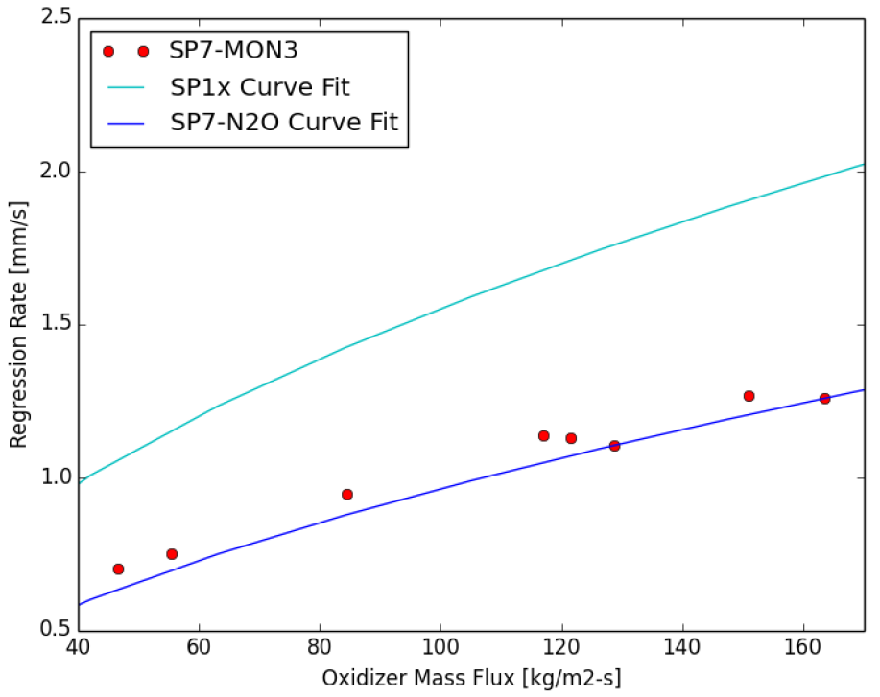
Figure 2 Comparison of Regression Rate Data for SP7/MON-3 With the Curve Fits for SP7/N₂O and SP1x/N₂O [10]

Large scale testing
Five flight-weight motors were fabricated for testing. Using those five motors, a total of 20 tests were conducted at the 11-in full scale. SPG’s large scale test configuration consisted of a filament wound motor designed and built to meet the reference mission (See Figure 3.). Early tests struggled with ignition and stability. Changes were made to the igniter flow to enhance the combustion and stability. Inadequate vaporization of the incoming oxidizer was deemed a cause of some of the instabilities. This sort of non-acoustic instability has been observed in previous motor testing with liquid oxygen (LOX). [, , , ]
In previous LOX testing at SPG, passive methods were adequate to eliminate the non-acoustic modes of instability. Similar methods were designed into the current motor system but did not prove sufficient with MON-3. The relatively low vapor pressure and significantly higher enthalpy of vaporization (Δh_{vap} = 414.5 kJ/kg for MON-3 vs. Δh_{vap} = 109.1 kJ/kg for LOX) are the likely reasons for this behavior.
After several unstable tests, it was decided that increased energy addition at the head-end of the motor was required to adequately vaporize the incoming oxidizer. In previous studies, either addition of pyrophoric materials [] or heat addition through smaller hybrid motors [16] has been shown to be adequate for LOX stabilization. The implementation time of pyrophoric materials to the existing test cell at SPG eliminated this as a possibility. Gaseous oxygen (GOX) flow into the head-end would be used in order to meet deadlines. It was proposed that once the required energy level was known, that a reactive or hypergolic additive of pyrophoric liquid could be used in the future to achieve the same effect.
The use of GOX flow at the head end increases the energy release and assists in the vaporization of the MON-3 flow. A GOX flow rate of 10% of the total MON-3 flow rate was used as a starting point. Though GOX is not a feasible option for the flight vehicle because of its low density, the demonstration of stable combustion can help to understand the stable operating limits of the motor.
Test MAV_11_19 was the first test that used GOX flow at the head-end region (see Figure 4). The test duration was 11 s, with 8 seconds of GOX flow. The termination of GOX flow prior to the end of the test was to evaluate the possibility of retaining sufficient energy for vaporization of the oxidizer. This could be a beneficial situation in a flight vehicle if the additional heat source was only required for a portion of the combustion event. However, the instability returned after the heat source was turned off.

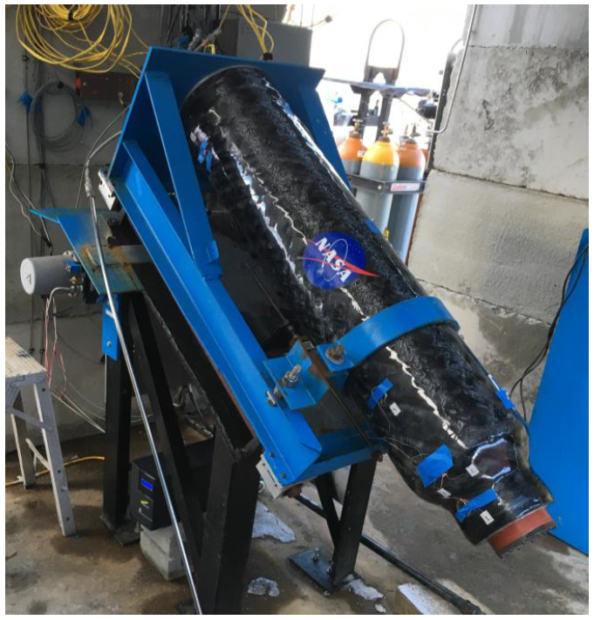
Figure 3 SPG Filament Wound Motor Prior to Test[12]
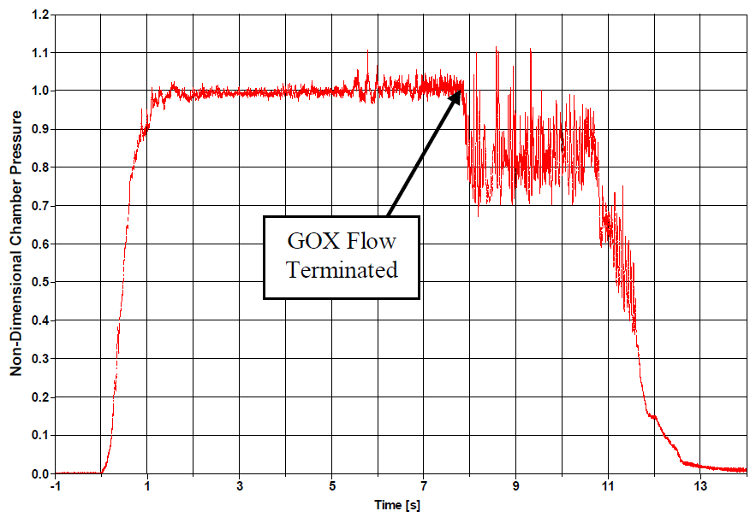
Figure 4 Non-Dimensional Chamber Pressure for Test MAV_11_19[12]

Reformulation effort
Once the motors were scaled up to full size, the regression rate of SP7 fuel was found to be higher than predicted by using a simple regression rate vs mass flux correlation. To circumvent this issue, SP7 was reformulated by changing the constituent percentages to have a regression rate that was ~15% lower. As the regression rate of liquefying fuels is strongly dependent on the liquid-phase viscosity, small fuel formulation samples were initially evaluated using a viscometer. A total of seven fuel formulations were initially evaluated to determine the viscosity vs. formulation relationship. Three formulations were initially selected for regression rate validation testing. Based on results of initial regression testing, a new formulation was selected and verified through two rounds of regression rate testing. This formulation was ultimately selected as the new formulation, SP7A [].

Mechanical Property Characterization of Fuel Grain Samples
The mechanical properties of SP7A were measured in stress relaxation tests at -20°C, 30°C, 40°C, 50°C, and 60°C (-4°F, 86°F, 104°F, 122°F, and 140°F). A viscoelastic material model, the generalized Kelvin model, was fit to the data to allow more accurate structural modeling of SP7A. Cracking during the casting process due to internal stress has been consistently observed. Annealing is a common method of relaxing internal residual stresses and was applied to the fuel grain process. Four annealing procedures were developed, tested, and compared to non-annealed samples. As the internal stresses resulting in grain failure occur during freezing and cooling of grains, a better understanding of the cooling process is needed. The cooling of 27.9-cm (11-in) and 35.6-cm (14-in) diameter grains were modeled below the glass-transition temperature using measured temperature dependent properties. [18]

Finite Element Modeling of Fuel Grain Casting Process
SP7 and SP7A grains have a propensity to crack when cast in large single pours then cooled in an oven following a stepped temperature profile (the MSFC process). This cracking is likely due to a combination of two sources: thermal stresses during cooling and non-uniform solidification of the grain. SPG investigated the former for grains 27.9-cm (11.0-in) and 35.6-cm (14.0-in) in diameter and 30.5-cm (12.0-in) long. Conclusions from the analysis included recommendations for the grain manufacturing development using a modified cool down process. [18]

Testing/plans left on the table (cold fuel into titanium skin, overwrap)
SPG was under contract in 2019 for motor F, a flight weight motor design, at one point. The design they were working on was developed after considerable interaction with the complete MAV propulsion team and addressed many of the features needed for the flight weight design: a concept to keep the fuel grain in compression at the low temperature environments expected during the mission and a lightweight motor design. Unfortunately, due to budget cuts, that design effort was stopped before manufacturing and testing could occur. [18]

Parabilis testing
In 2016, Parabilis Space Technologies was contracted to do MAV hybrid motor regression rate tests with full scale MON-3 and SP7 fuel grains in a 10” diameter motor. The full scale target vacuum thrust of 8000N required flux levels that were approximately twice that previously demonstrated by other contactors at subscale. The full scale (at the time) fuel grains were provided by SPG. Concurrently, SPG was working on getting the 3 inch diameter motor running. Parabilis conducted their tests in a vertical test stand, nozzle down, at their Lakeside, CA test facility. Parabilis installed a water fog system to contain MON vapor during shutdown (see Figure 5).
Parabilis planned 6 tests of the motor to determine performance and regression rates at ambient temperatures. Due to fuel grain delivery delays, only 4 tests that were able to be conducted prior to fiscal year end. There were problems keeping the motor ignited and combustion instability, with changes made between tests to increase the likelihood of full duration burn. After the last test of ~1 second, which auto-aborted due to instability induced low pressure oscillation, posttest inspection of the test stand indicated that ~1 lbm of molten SP7 had escaped from the motor and landed on the test stand. Cracks were seen on the ID of the grains post test.
Issues found during the Parabilis testing would continue with other vendors as the program went on, how to sustain combustion and keep the grains from cracking during tests.

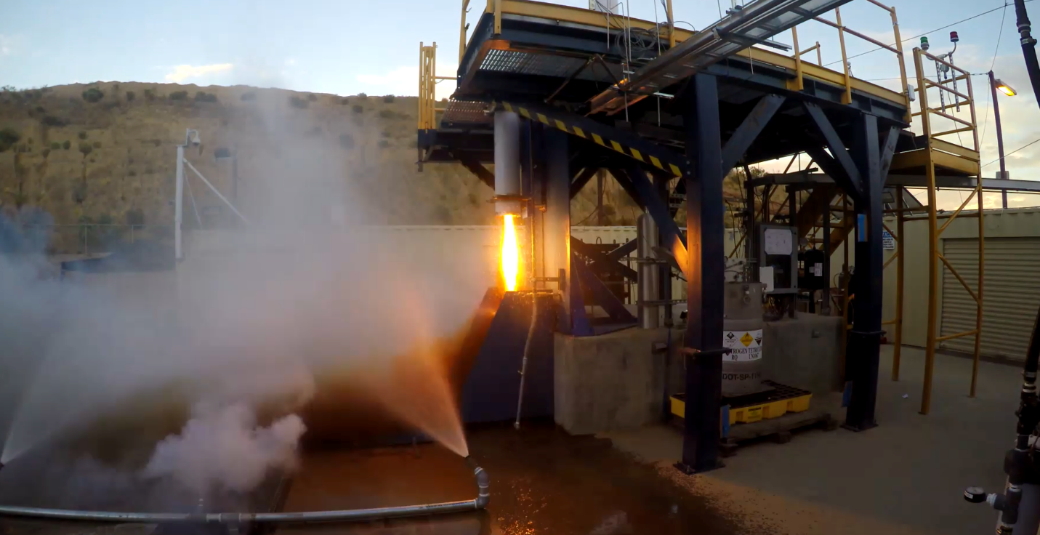
Figure 5 Parabilis Space Technologies MAV testing

MSFC Casting Effort
In late 2016, MSFC was asked to come up with a casting process for SP7 after some initial difficulty with the fuel grain fabrication. After many trial and errors (See Figure 6 and Figure 7), an initial process was found.
The initial process used a commercial wax melter to melt/mix the SP7 ingredients. The liquid ingredients were poured into ambient temperature pans and allowed to cool. This process produced the early pancake grains. See Figure 8 with machined grains ready for shipment. This technique was limited in that the grain length could not be increased with fracturing the grains.
To be able to manufacture longer grains, the process evolved via additional casting experiments. The process developed for manufacturing the rest of the grains still involved a commercial wax melter to melt/mix the SP7 ingredients. The liquid ingredients were pumped into preheated pans in an oven. After filling, the pans are held at a constant temperature to ensure the ingredients are liquid before starting the cool down process.

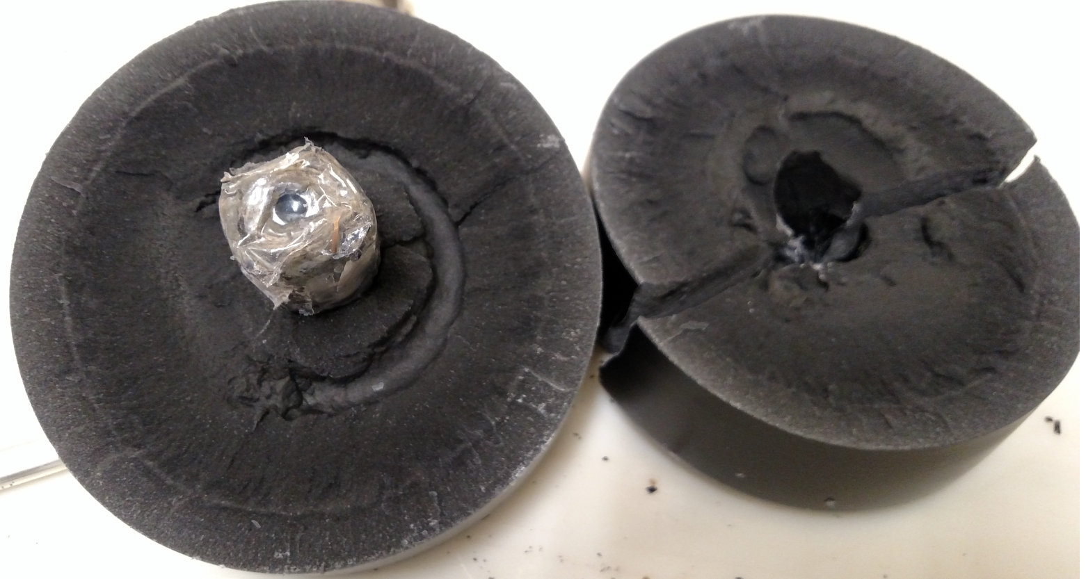
Figure 6 Early grain casting showing a mandrel design and grain cracking and voids
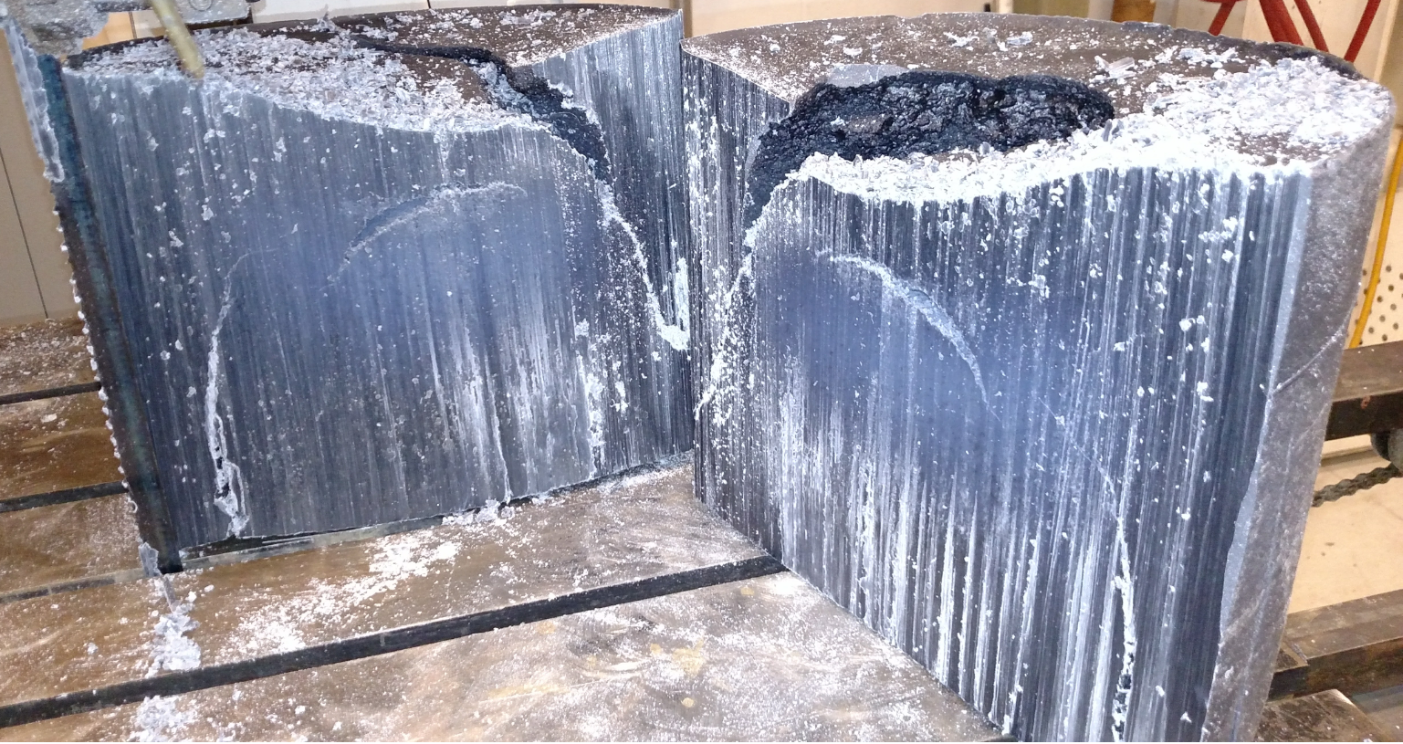
Figure 7 End Cooler technique fuel grain cut in half

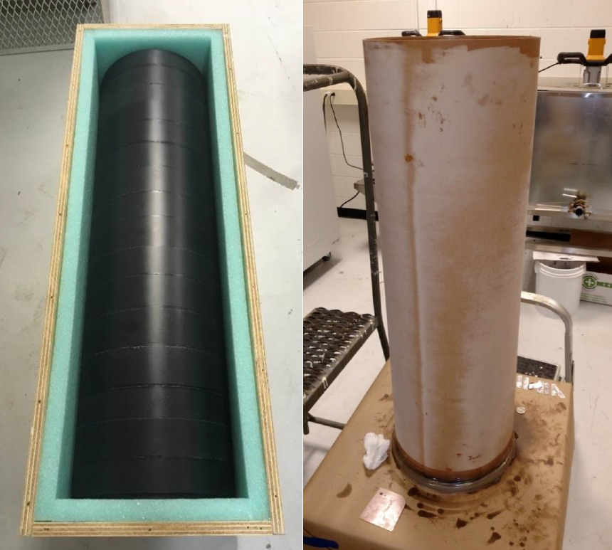
Figure 8 Multi-segment fuel grain (left) and multi-segmented fuel grain in a phenolic tube (right). [19]
The cool down process consists of a series of temperature drops and holds at temperature until the grains are at ambient temperature. This process was used to make the later large scale grains used for testing at Space Propulsion Group and Whittinghill Aerospace [].
The grains cool radially from the outside in. As the SP7 cools from a liquid to a solid, it shrinks ~15 to 20% by volume. The outside layers are pulled inward, leaving a stress field in the grains. Substantial inconsistency in whether the grains survived or cracked was discovered between batches. Sometimes the process worked well and all four of the grains coming out of the ovens were acceptable and other times when all four of the grains have cracked.
After cool down, the grains were machined to the desired shapes (center perforated grain segments). The attrition rate was relatively high as sometimes machining revealed small voids in the grains and other grains cracked during machining.
Due to the high CTE of the grains, changes in temperature would shrink the SP7 grains much more than the case materials. For the Whittinghill tests being fired to demonstrate Mars surface conditions at -20C, the grains needed to be cooled to -20C or below before being inserted in the motor case to ensure that grain was under compression at the firing conditions. This involved putting the grains in an insulated box and sliding the box into an operating cooler. The insulated box would keep the temperature delta under the rate found to crack the grains [11]. This required tight tolerances on the fuel grain assembly components to ensure it could be assembled at the cold conditions. For one motor, an insulator was kept outside the freezer and warm to ensure it was large enough to fit over the fuel grains cooled to -40C and after assembly of the cold fuel grain, warm insulator and cold phenolic tube in the freezer, the fuel grain contacting the warm insulator shattered due to the large temperature shock (see Figure 9).

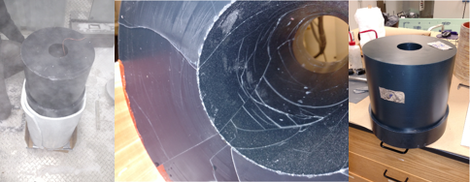
Figure 9 Processing in the -40C Freezer(left), cracks from warm insulator assembly(middle) and replacement segment (right) for Whittinghill Motor B (FT04)

Three grains were installed in a motor case using the freezer technique. The first one involved a -20 F freezer. To ensure the grains were sufficiently in compression at the firing temperature of -20C, the last two were installed in a -40 C freezer. The inside the -40C freezer assembly process got better with practice and incorporation of lessons learned from assembly of the previous grain assemblies.

In an attempt to better understand the thermal stresses that develop during casting process a COMSOL Multiphysics® model was created. Figure 10 shows the model at one point during the cooldown process, with ½ the SP7 filled pan shown in the lower left and heat rising from the center of the grain. This model is a conjugate heat transfer simulation and includes an Arbitrary Lagrangian Eulerian (ALE) interface tracking scheme to capture the changes in the level of the paraffin wax. As hybrid fuel grain is a mixture of various constituents it does not melt or solidify at a singular temperature, rather it changes phase over a broad range of temperatures. In order to capture this phenomenon, the wax mixture is modeled entirely as a fluid with additional volume force term added into the Navier-Stokes equations. This additional volume force acts as a dampening term for the fluid velocity and is determined by a set of equations designed to mimic the Carman-Kozeny relationship. As the fluid approaches the lower limit for solidification the dampening term increases as a means to approximate solidification. As expected, coupling all of these physics together results in highly non-linear behavior, which along with trying to simulate the entire casting time can lead to numerical instabilities in the model. Future work includes alleviating the numerical instability issues and potentially adding in more detail to capture the separation of the fuel billet from the casting pan during cooling.
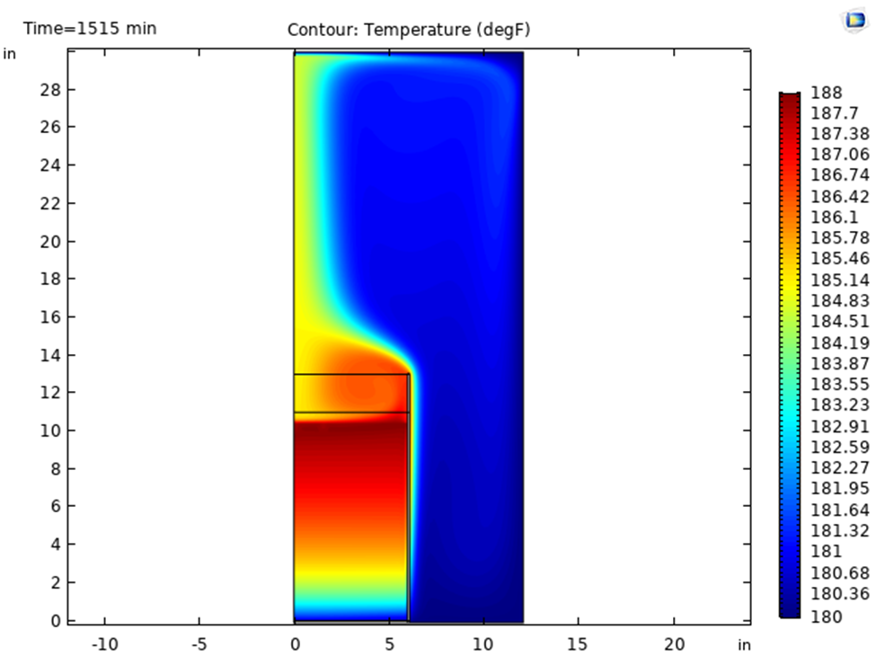
Figure 10 COMSOL Modeling of Grain Solidification

Whittinghill Aerospace

Whittinghill Aerospace was brought into the MAV hybrid team in 2017, based on their experience with other hybrids and LITVC and in order to keep two vendors competitively looking at different ideas. Whittinghill Aerospace focused on the full scale MAV design and designed a motor to meet the requirements at the time. A new test stand configuration was constructed to aid in the measurement of LITVC loads and heavy weight case hardware was built that was used throughout the life of the program. Figure 11 shows the new test stand with FT-01 firing. Details of the tests are documented in reference . Some highlights of the test program are included below.

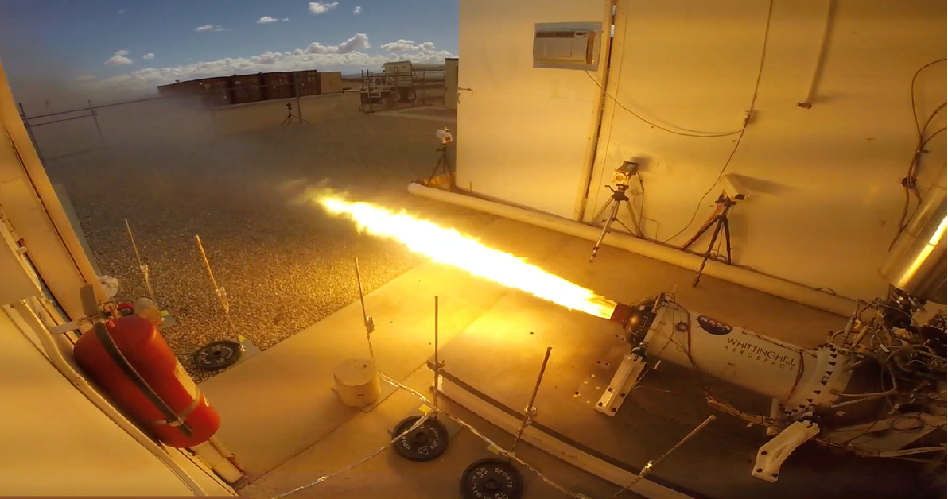
Figure 11 Whittinghill Aerospace FT-01 test

Whittinghill Aerospace Testing with MON-3

Whittinghill Aerospace started out with several heavyweight motors to gain experience with the ignition and combustion of this new fuel and oxidizer system. Details of those tests are in reference [20].

FT01

The FT01 test was a long duration test (Figure 12) with a restart to simulate the boost and orbit circularization burns. FT01 was a MON-3/SP7 motor at ambient temperature. It incorporated a tapered grain to reduce fuel residuals at the end of the test. The test ignited smoothly and ran stably for the duration, meeting the pressure stability requirement of 5% peak to peak. The nozzle erosion was lower than what had been observed in previous tests, but was still high for the requirements of this application. Also, there was non-uniform erosion of the throat.

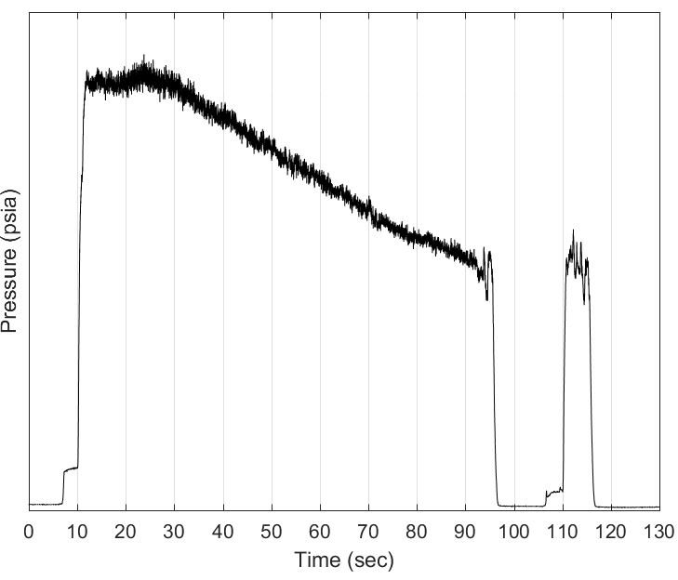
Figure 12 Whittinghill Aerospace FT01 Chamber Pressure [20]

FT02

The FT02 test incorporated a grain internal design to minimize the fuel residuals at the end of burn and a different nozzle material for evaluation of lower nozzle erosion. This test also included further demonstration of LITVC. FT02 was a MON-3/SP7 motor at ambient temperature. Also, during FT02 was a preplanned 10 second period where the tea/teb flowrate was ½ of the rest of the period. During that period (Figure 13), the motor instability increased, and even when the tea/teb flow was returned to full, the chamber pressure oscillations did not return to the earlier low levels.

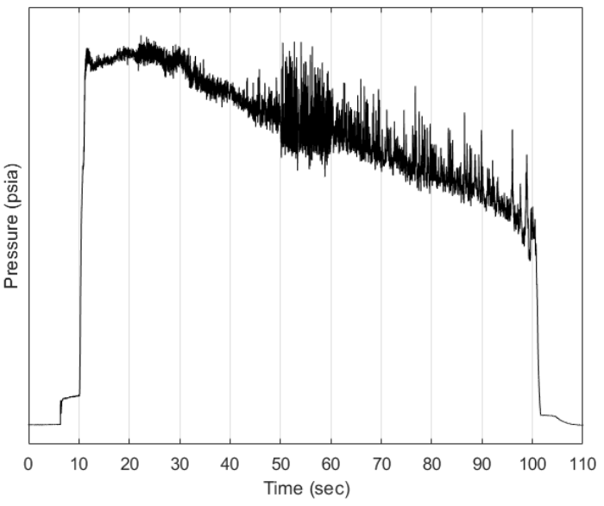
Figure 13 Whittinghill Aerospace FT02 Chamber Pressure [20]

Combustion efficiency increased during the first series of tests (Figure 14). There was steady improvement shown in the combustion efficiency during this section of the test series. Mission requirements were requiring a combustion efficiency of 95%.
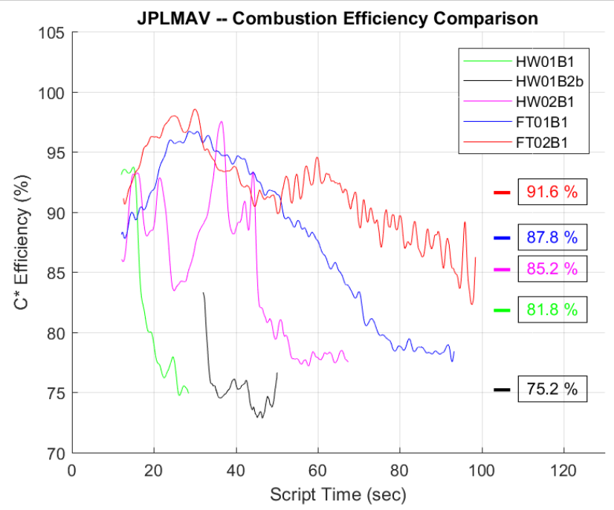
Figure 14 Whittinghill Aerospace Combustion Efficiency Results [20]

MAV Teaming Arrangement

In the interim between FT02 and Motor A (FT03), the MAV hybrid program went from competing companies and organizations to a team of companies. All parties, Purdue University and Space Propulsion Group, Whittinghill Aerospace came together to work together. Non-disclosure agreements were signed, and the parties all worked as a team. This was done in anticipation of the hybrid team winning the MAV Decision Point down select and all parties would need to make the propulsion development and flight. A plan was laid out for going forward with tests and demonstrations planed. Highlights include: Motors A-E were Whittinghill development tests for the motor, with Motor D and E being built concurrently and Motor E going to White Sands Test facility for a full duration vacuum test. Motors F and G were to be lead by Space Propulsion Group focusing on a flight weight motor case design and assembly technique.

Over time, due to various schedule and program funding issues, the Motors D, E, F and G were canceled. The loss of Motor E, with the vacuum test of a full motor with a flight sized nozzle and LITVC demonstration was a huge loss, in that the TRL level of the full system in a representative environment (Mars vacuum and temperature) couldn’t be demonstrated before the Decision Point down select. Motors F and G would have verified flight motor assembly techniques and weight estimates.

Whittinghill Testing with MON-25

Ignition test article
A concern was raised that we were not testing with a flight like ignition system. To address that concern, modifications were made to the test stand to test ignition techniques. This included a new test chamber with a view port to watch ignition of the MON-25 and ignition fluids. Various configurations and ignition fluids were tested at expected Mars pressure and temperature to ensure motor ignition. After limited success and since the ignition test article was in the same location the motor would be fired and switching the test articles in and out was not a quick process, a decision was made to press forward with the motor testing with the GOX and TEA/TEB system. One constraint to further testing was the Mojave permitting process to bring in a monomethylhydrazine (MMH).
The hybrid propulsion team worked on a design for MMH/MON-25 igniter in an attempt to ensure rapid ignition and to provide the additional heat necessary to properly vaporize cold MON-25 under near-vacuum conditions. The design is shown schematically in Figure 15 and is discussed further in []. The igniter design diverted a portion of the primary MON-25 oxidizer flow into a series of small igniter chambers located on the injector ring. The igniter chambers contained a triplet (MON-25 doublet plus center impinging MMH stream operating at the optimal mixture ratio) and were cooled by MON-25 bypass flow. The outlet of the chamber was restricted so that the igniter would initiate rapidly and achieve steady state operation independent of the pressure rise process in the main combustion chamber. This design and numerous variants were extensively studied using CFD but were never tested because of schedule pressure.

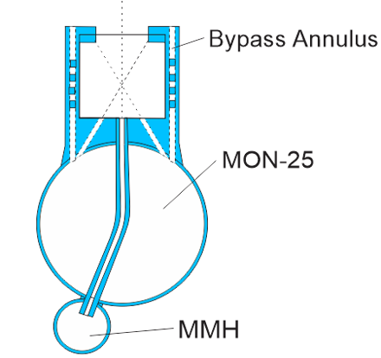
Figure 15 Cross section view of a hypergolic MON-25/MMH igniter concept.[21]

Motor A(FT03)
Motor A (FT03) was the first test of a MON-25 SP7 motor. It was also preconditioned so the oxidizer and motor were at -20C at ignition. This required additions to the test stand to include chillers for the motor and oxidizer on the stand. These chillers had to be controlled to keep the cooling rate lower than the temperature changed limits in reference [11] shown to crack the grains. It also required changes to the processing of the fuel grain assembly. The coefficient of thermal expansion of SP7 is much greater than that of the motor case. If the motor was assembled at ambient temperatures, when chilled to -20C, the grain would pull away from the case. This led to the motor case being shipped to MSFC where the grain could be installed inside a freezer to ensure the fuel was in compression at -20C. Motor A (FT03) also included devices/techniques to increase the motor combustion efficiency and lessen the nozzle erosion (HTPB fuel just upstream of the nozzle for film cooling).
Motor A(FT03) was stable under the 5% peak to peak chamber pressure requirement except for a short time after motor ignition (See Figure 16). The nozzle material was different from test FT02 and had a higher regression rate, even with the HTPB just upstream of the nozzle for film cooling. The grain was in good shape post test with minimal detrimental effects of gaping between segments visible.

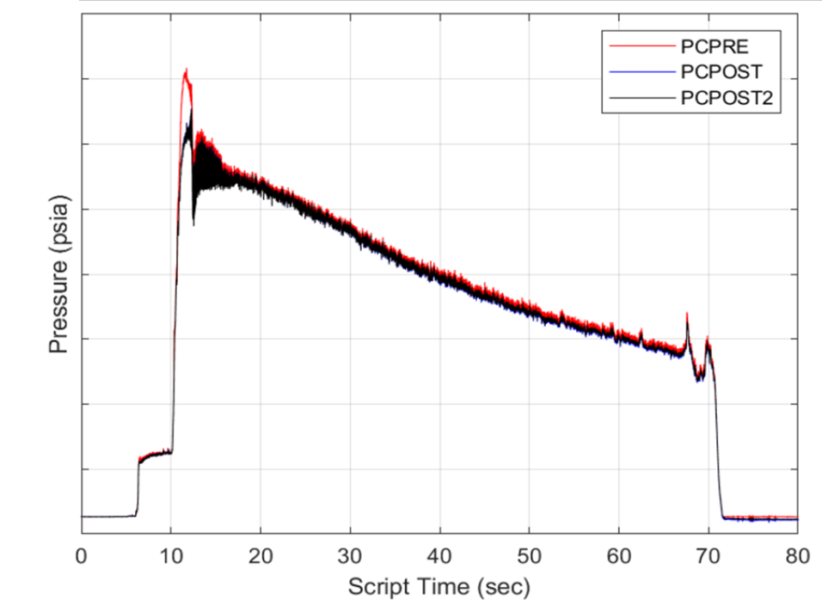
Figure 16 Whittinghill Aerospace Motor A (FT03) Chamber [22]
Post Motor A, it was determined that the SP7 regression rate was too high for a full duration flight motor to keep the vehicle outer diameter requirements. This set-in motion the work that Space Propulsion Group did to create an SP7 derivative with 85% of the regression rate, called SP7A.

Motor B(FT04)
Motor B (FT04) was the first test with SP7A and MON-25. Since SP7A had a lower regression rate, the fuel grain became longer to get a lower oxidizer to fuel ratio during the test. Changes were made to the nozzle material to reduce the throat erosion and this resulted in a redesign of the throat insulators and the aft dome of the motor. Changes were also made to the combustion efficiency increasing devices in the motor. The fuel grain design included a tapered grain to minimize fuel residuals. This fuel grain was assembled inside an even colder freezer at MSFC, with grain cool down and motor assembly at -40C. This was also first test of quicker ignition sequence, without the long GOX/Tea/Teb lead burn, to lower the ignition interval. This involved a new controller tied to the start up sequencer to move the ignition process through a series of checks to ensure flow and pressure This was being demonstrated to meet the ignition interval requirements and due to a proposed change in the way the MAV would be launched from Mars, where the MAV would be thrown up into the Martin atmosphere and ignited in the air.
Motor B (FT04) ignited quickly and was stable throughout the test (Figure 17). The nozzle erosion was much lower than previous tests. Combustion efficiency was the highest to date, with the time averaged efficiency above the requirement of 95% for 50.3 seconds. Post test inspection revealed some indications that the gaping between the fuel grain segments produced disturbances in the flow and there are some areas of increased regression in those areas. Where there was a discontinuity in the grain outer diameter, where it was notched for an insulator, it appeared there was a fuel grain stress concentration that caused a crack which lead to burning through the fuel grain to the insulator.

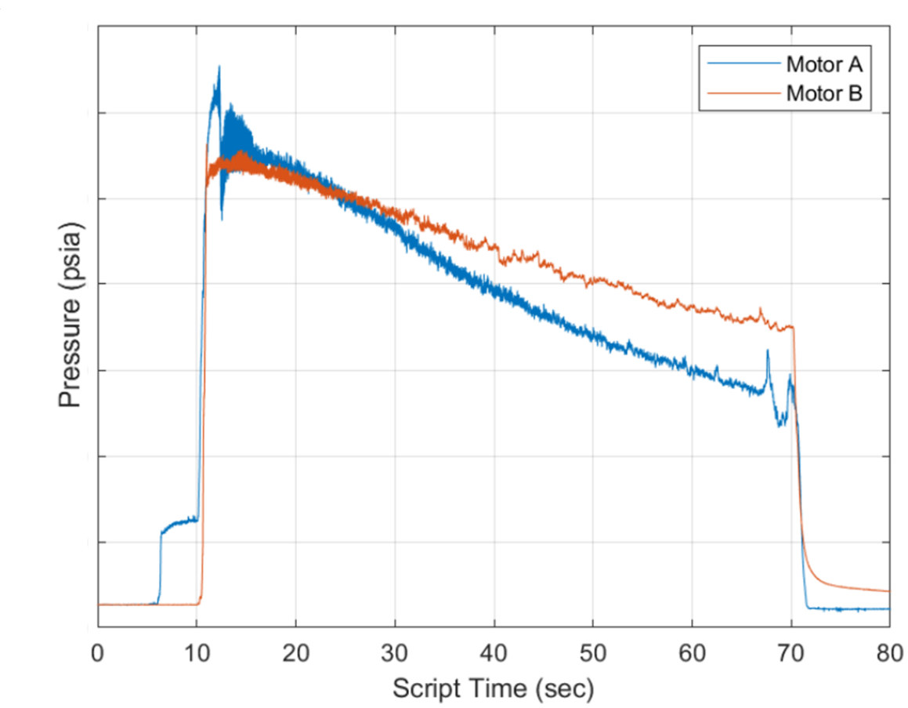
Figure 17 Whittinghill Aerospace Motor A (FT03) and Motor B (FT04) [22]

Motor C(FT05)
Motor C (FT05) was a MON-25/SP7A test with an ascent burn with a vacuum start and a second circularization burn for a total burn of 105 seconds. Vacuum ignition was accomplished by attaching a plate to the nozzle and pulling a vacuum in the motor. The ignition system was adjusted for a faster start on the first firing and preprogramed sequence on the second firing. The same nozzle material was used from Motor B (FT04) with additional pre-test processing. During this timeframe, there were two motor designs in work, the PAA design, which was a bare bones as light as possible motor design and the heavy weight motor testing that included devices to increase combustion efficiency. In order to evaluate a bare bones flight weight motor, it was decided to remove some of the combustion efficiency increasing devices to increase mass fraction of the motor.
In order to get the test in before the upcoming Decision Point down select, several compromises were made. A full duration motor designed to meet the impulse requirement, would require a larger diameter motor case and time was running out. Also, since the demonstrated SP7A regression rate was 76%, not 85%, of SP7, using the motor case and grain length meant the oxidizer to fuel ratio would be higher than optimal.
Motor C(FT05) ignited rapidly with MON-25 and SP7A in a vacuum at -20C (Figure 18). GOX and Tea/Teb were used for ignition. The motor met the 5% peak to peak pressure oscillation target throughout the burn. The motor pressure was constant for 30 seconds and then started to regress. There were small pieces of ejected material (assumed to be fuel) noted in the time of the chamber pressure spikes between 70 and 85 seconds. These events did not cause a motor instability. Motor C (FT05) had a quicker ignition than Motor B (FT04).
Post-test inspection revealed the SP7A was almost completely burned out of the motor case, with only some fuel remaining in the bottom of the case. The nozzle erosion was less that Motor B (FT04) for an additional 15 seconds of burn time and a higher oxidizer to fuel ratio. Later in the burn, when the oxidizer to fuel ratio was higher, the nozzle erosion increased. The peak erosion was noted to be at top dead center of the nozzle.

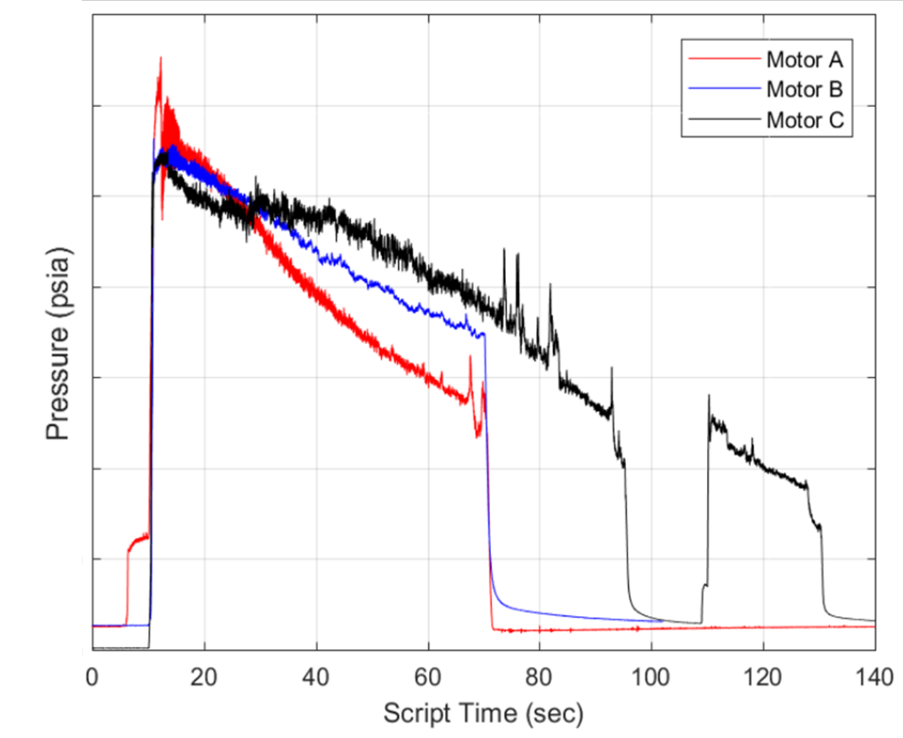
Figure 18 Whittinghill Aerospace Motor C Chamber Pressure []

The combustion efficiencies were calculated for motors C, B and A. Between Figure 19 and Figure 14, there were discussions about the cause of the combustion efficiency decreases in single port hybrid motors, hybrid rockets and rocket motors in general. This led to the research done in reference [].

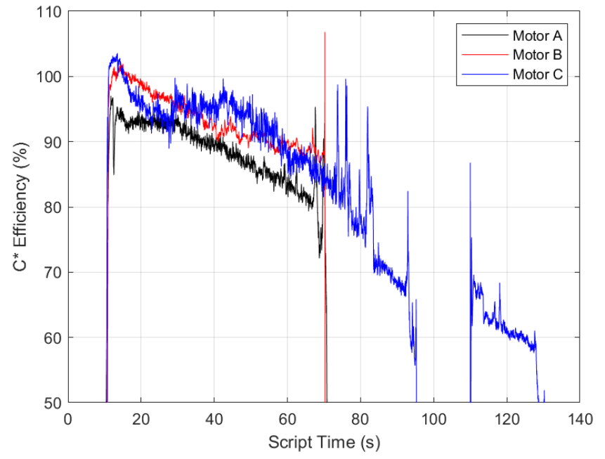
Figure 19 Whittinghill Aerospace C* Efficiency for Motors A, B and C.[22]

Motors D and E
Test E was to be a full duration test, with a boost and orbit circularization burns, in a vacuum facility at White Sands Test Facility. A key objective of that test was to demonstrate, measure and calculated the performance LITVC with a flight sized nozzle with the appropriate expansion nozzle. This test would have validated CFD models [] of the nozzle performance. Another objective was to demonstrate the fuel conditions during the coast phase of the flight, since this test stand is vertical. The effect of a vacuum on the liquid melt layer of fuel was a subject of discussion with how quickly the vacuum could pull the heat out of the surface. Test D was to be an identical motor, with shorter nozzle exit cone, fired horizontally at Whittinghill Aerospace’s Mojave test facility for comparison. However, due to schedule and program cost issues, these tests were canceled.

Hypergolic ignition
An ignition trade was conducted in 2015 []. Since the hybrid rocket design was a single stage to orbit, the ignition concept needed to produce between 2-5 ignitions, with an assumption that both the surface of the grain and the incoming oxidizer were cold. As such, ignition energies that may be sufficient at room temperature may be insufficient for this application (-20 C). However, Sandpiper [] had tested motor ignition of a MON-25 based hybrid at -54 C [- 65 F]. That data was the basis for the analysis and sizing of the ignition devices.
Several concepts were evaluated. Hypergolic fuels, which burn on contact with the oxidizer after injection, were the highest ranked. This evaluation lead to 2016 initial contracts at Penn State and Purdue Universities to evaluate materials that would be hypergolic with MON oxidizer.

Penn State

Drop Tests
Penn State did a comprehensive literature survey and designed a drop test rig to evaluate the hypergolic behavior of solid materials with N₂O₄/MON. They used MON-3 at low temperature (-10 C) to screen a large number of candidate materials in powder form. The literature survey identified 50 leading candidates, of which 42 were procured and tested in an inert argon environment. A high speed video camera (2000 fps) was used to determine the ignition delay from drop tests, see Figure 20. Seven candidates showed a positive hypergolic ignition reaction, igniting in less than 500 ms, including sodium amide, sodium cyanoborohydride, lithium amide, triaminoguanidinium azotetrazolate (TAGzT), trimethylamine borane complex, borane tert-butylamine complex, and ammonia borane. Sodium amide displayed the shortest ignition delay, less than 0.5 ms, with a visible reaction starting immediately upon contact of the MON-3 drop as recorded at 2000 fps.
The successful candidates that were compatible with the melting temperature of SP7 (~100 C) were then mixed into the wax in relatively high percentages (approximately 50 wt%, 25% also tested). These materials were sodium amide, sodium cyanoborohydride, lithium amide, TAGzT. Disc-shaped samples of the combination were cut, and tested with the same experimental procedure as used for the powders. Unfortunately, none of the additives in the SP7 matrix resulted in hypergolic ignition with MON-3. In several cases, a few milligrams of loose powder was placed on top of the samples to augment the ignition, without success. It is believed that the wax inhibited the reactions by encapsulating the hypergolic materials. []

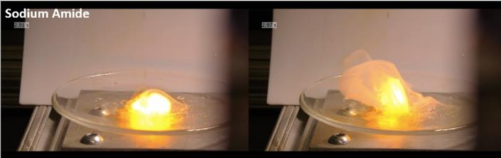
Figure 20 Penn State Drop Test

Purdue University

Drop Tests
In 2016, Purdue University determined the hypergolicity of selected chemicals by performing drop tests with liquid nitrogen tetroxide (NTO) and mixed oxides of nitrogen (MON), see Figure 21. Purdue designed and built a system that allows testing the hypergolicity of solid additives with nitrogen tetroxide and MON-25 in a nitrogen environment, with varying pressure and temperature. The main objectives of the study were to identify hypergolic additives for use with a wax-based hybrid fuel, and to quantify the influence of pressure on the reactivity of these different potential additives. Purdue also tested the influence of nitric oxide on the reactivity of the solid additives with MON-25 compared to nitrogen tetroxide. As expected, they found that ignition delays increase as pressure and temperature decreases. When comparing the results with MON-25 and NTO at 26°C, we see that nitric oxide also decreases the reactivity of the additives. The ignition delays found with MON-25 are 2 to 32 times higher compared to NTO. While the effect of nitric oxide is not fully understood, it appears that its presence affects the chemical reaction pathways in such a way as to reduce the likelihood of ignition for MON as compared to NTO. []

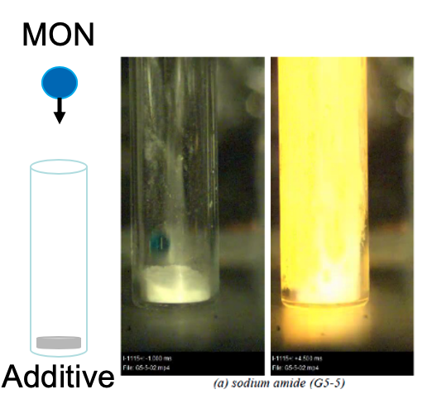
Figure 21 Purdue University Drop Test

2 inch testing.
In 2017, Purdue investigated the use of sodium amide as a potential solid hypergolic additive. The main objective of this study was to demonstrate hypergolic ignition and successive relights of a two-inch motor grain configuration, with a paraffin-based fuel and MON-3 as the oxidizer. Hypergolic ignition was achieved with grain configurations composed of a front section with 90 wt.% sodium amide in a paraffin-based fuel, and the main grain with loading of additive from 40 wt.% down to 0 wt.%. Purdue successfully and hypergolically ignited four grains with overall additive loadings between 48.3 and 15 wt.%, see Figure 22. The grains were constructed of multiple, small segments made by powdering the additive and the wax, mixing them together and pressing them in a mold. This method of grain fabrication was crucial to ensuring that the additives were not encapsulated by the wax and could be exposed to the MON during the test. Ignition delays, which are defined as the time interval between valve command and first light out of nozzle, ranged from 120 and 270 ms, depending on the grain configuration and whether it was the first, second, or third ignition, with successive ignitions taking longer. The ignition delay of the grain itself (not including the liquid fill time) averages around 80 ms, based on the same variables. Chamber pressures ranged from 80 to 118 psia, with an increasing chamber pressure and performance as the additive loading decreases. However, these ignition delay conclusions are based on a very small sample set. []

In 2018, Purdue investigated the use of sodium amide and potassium bis(trimethylsilyl)amide as solid hypergolic additives with MON-25/30. The main objective of this study was to demonstrate hypergolic ignition and sustained combustion of a paraffin-based fuel with MON-25/30 as the oxidizer at atmospheric conditions. Purdue also designed a new motor to interface with their altitude chamber facility that will be used to evaluate the hypergolic ignition and combustion of the propellants at up to 100,000 ft. Ahead of the altitude test campaign and using a combination of sodium amide, potassium bis(trimethylsilyl)amide (PBTSA) and sodium borohydride, Purdue successfully ignited and sustained combustion of a two-inch motor expanded to ambient pressure. The test used a segmented, pressure molded fuel grain and MON-25 for a three-second burn duration. The fuel grain was designed to break up the functionality of hypergolic ignition and heat addition to sustain combustion. Hypergolic ignition was achieved using a high additive loading 0.75” front segment (45% sodium amide/45% PBTSA/10% SP7 by mass). This represented 9% of the fuel mass. The three second burn was stabilized and sustained via the use of 25 wt.% sodium borohydride evenly dispersed throughout the rest (91%) of the grain. Sodium borohydride, while non-hypergolic, is reactive with nitrogen tetroxide, and was chosen for its high heat of combustion and density. At a given initial oxidizer mass flux, typical delays to reach 90% of the maximum chamber pressure ranged between 508 and 872 ms, although no correlation between the amount of potential chemical energy released in the chamber and the delays observed has been established yet. []

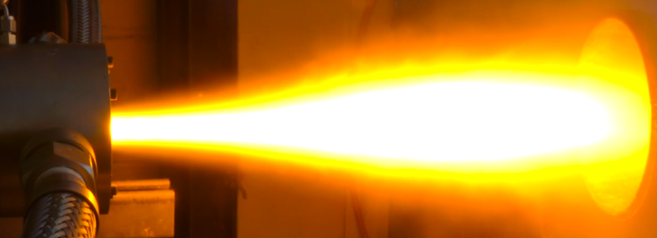
Figure 22 Purdue University 2-inch Hypergolic Ignition Test

Vacuum testing
In 2019, Purdue worked on integrating the hybrid motor into the altitude chamber to demonstrate ignition at a Mars equivalent low pressure. In theory, hypergolic delay times are inversely related to pressure, near zero pressure implies near infinite delay times. [] The first motor tested in the altitude chamber was a repeat of an ambient test with 45 wt.% NaNH2/45 wt.% PBTSA in SP7. The ignition delay and chamber pressure where close to the ambient test. (See Figure 23). However, there were differences in MON-25 feed system plumbing and motor orientation between the altitude chamber and ambient tests. A new motor was built for the altitude chamber with a longer aft mixing chamber. It was fired vertically to visually capture the plume while capturing the exhaust to maintain low pressure conditions while firing.
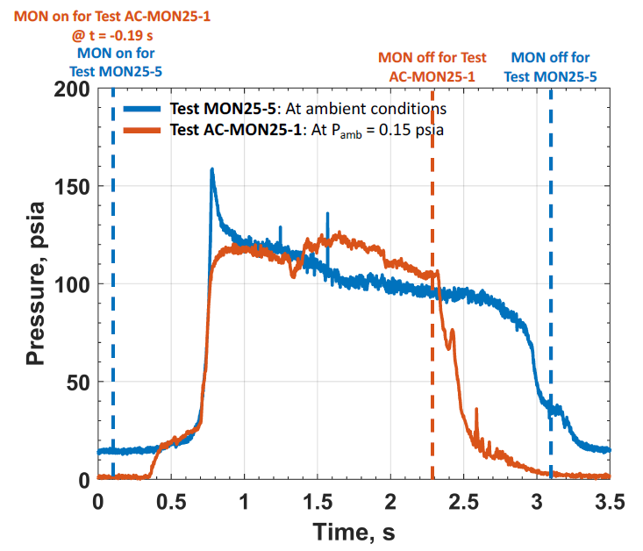
Figure 23 Purdue University Ground and Altitude Chamber (AC) Start Hypergolic Ignition Tests.
A second low temperature ignition test, including a restart was attempted. A longer (1.5 inch vs .75 inch) ignition hypergolic additive section in the first grain segment, was included since there was concern that it could burn out during the first test. The test conditions included a higher oxidizer flux to evaluate its effect. Ignition was not achieved. Reconstruction from combustion chamber thermocouple data (added for this test) showed that upon injection of the MON, the temperature in the combustion chamber dropped from ambient temperature down to ~ -40°C at the injector and ~ -60°C at the exit plane of the nozzle. This indicated that the injected liquid MON flashed to gas in the low back pressure.
The main takeaway from this test is that the liquid-solid interaction between the oxidizer and the solid hypergols is essential to lighting the hypergolic hybrid, as predicted. Higher initial flux and rapid vaporization may combine for a no start condition. See reference [] for more details.

Internship at JPL
The principle researcher at Purdue, Alicia Benhidjeb-Carayon, did a summer internship at JPL and the focus of her study was the examining the options for integration into the MAV sized hybrid motor []. She looked at two basic options for the placement of the hypergolics in the hybrid grain.
The first option was to add hypergolics mixed in the fuel just in the head end of the motor as was done with the two inch motor. This would provide surface for ignition as well as heat addition for vaporization of the incoming oxidizer. The key for this option was to lower the regression rate so it would last the entire burn.
The second option was to separate the ignition and combustion stability objective into two separate systems. A hypergolic plug or multiple plugs serve as the igniter. Also, a reactive or hypergolic material would be added to the main fuel grain. The keys for this option were designing ignition plugs that would ignite and then burn at the rate of the surrounding fuel and the amount of reactive or hypergolic material in the bulk fuel.
Moisture sensitivity was an issue affecting both concepts. One possible solution is to seal the fuel grain with materials that were incompatible with the incoming nitrogen tetroxide at ignition but compatible with the reactive or hypergolic materials in the fuel. These materials would react with the incoming MON, erode off and allow the grain to ignite. Finding suitable materials would require future materials testing.
The study concluded that the second technique, with the ignition and stability coming from different components, would be the best approach. This would allow for different, yet to be discovered reactive materials, to be investigated for this application.

Preliminary Architecture Assessment
The Preliminary Architecture Assessment (PAA) was a design study of the single stage to orbit hybrid [8, 9] and two stage to orbit solid [6, 7] MAV concepts. Experts from the relevant subsystems: propulsion, avionics, Guidance Navigation and Controls (GN&C), structures, thermal, etc. were brought together to design the vehicles, which ultimately lead to two unique vehicle designs. These vehicle designs were developed to the same level of maturity in order to inform the selection of one of the vehicles as the point of departure design for the campaign. This design cycle lasted approximately six months and ended in the recommendation of the solid vehicle for future development.

PAA Analyses
Multiple analyses were done for each subsystem, the major propulsion analyses are discussed here. For a discussion of the other subsystems, see references [8, 9].

Slosh
A slosh analysis was completed for the oxidizer tank. Multiple baffle designs were evaluated by varying the number and size of the baffles. Baffles had been assumed and the preliminary analysis confirmed that the placeholder mass was reasonable. A settling burn using the RCS system was assumed prior to the second stage burn. A more detailed analysis will have to be completed for a flight design with the vehicle GN&C slosh requirements.

Ignition
Repeatable and rapid ignition was critical for this application. Therefore, a substantial modeling effort was placed on getting the liquid hypergols to react completely. [21]

Acoustics
Ignition overpressure loads, lift off acoustics and plume induced acoustics were found to be benign as compared to an Earth environment. They are not expected to drive loads.

Liquid Injection Thrust Vector Control
Four light-weight valves are mounted to the nozzle to create shocks in the flow and deflect the thrust. The LITVC system was modeled using computational fluid dynamics to determine the amount of propellant required to control the vehicle. Ground testing, at atmospheric conditions, was used to anchor the model. The side force predicted by the CFD was much lower than what was measured. Multiple ports were modeled firing at the same time to understand the interactions. The combined side force exceeds that from a single port but efficiency is reduced. These conservative results were used to size the system. Once vacuum chamber data is available, it is recommended that this be reevaluated to determine if there is an opportunity for mass savings. [24]

Feed System and RCS
A complete feed system was designed and relevant analyses completed. These included blowdown/pressure drop to understand the pressures required and expected temperatures. Easy5, an advanced control and systems simulation [], was used to model the system at the operating temperature (-20C) and both higher and lower options to understand performance. The RCS was modeled similarly since it shares the He from the pressurization system. Range safety requirements for use of hazardous materials were taken into account for the design.

Hybrid motor
The ballistics of the motor were evaluated to determine the regression rate, thrust time history and performance. Both CEA and TDK were run, as was discussed earlier. Additionally, the low temperature motor assembly was assessed. The design relied on most of it being in compression to survive the loads. However, the analysis was done with properties for SP7, it will need to be redone with SP7A properties if it is to be used. Thrust oscillations were modeled and the eigenmodes (first four longitudinal and first transverse at the fore and aft of the motor) were identified at the beginning and end of the burns.

Structural Analyses
Positive safety margins were found for the MON tank, motor case and helium bottles. The detailed analyses led to small increases in mass, which were reflected in the final design. The primary loads were assumed to be carried through the motor case and MON tank, making their performance especially critical.

Nozzle Analyses
Nozzle throat erosion was modeled with ITRAC 1-D for different throat and nozzle materials to provide surface temperatures, erosion and char predictions and in depth thermal response. This analysis fed the PAA nozzle design.

PAA Open Issues
While a number of analyses were completed and closed during the PAA, several items were left requiring further work. These are described in the following subsections.

Nozzle Design
In an effort to find an optimal nozzle contour, a Two Dimensional Kinetics [] analysis was completed. Two Dimensional Kinetics (TDK) is a technique that advances the flow through the nozzle and evaluates the chemical process that could occur during each time step. TDK is a slower, but more realistic process then the commonly used Chemical Equilibrium Analysis [], which makes the simplifying assumption that either chemical equilibrium is reached at each step in the nozzle or that the chemical processes in the nozzle are frozen. The TDK analysis showed that the nozzle efficiency was slightly less than what was assumed (via textbook), and this was a hit to the overall specific impulse used in the design. This lessened a major advantage of the hybrid over the solid system: its higher specific impulse. One potential problem with the analysis was the limited data available for the range of chemical reactions in the motor combustion. Detailed information couldn’t be found in time to improve the analysis.
One discovery, post down select to the solid design, was that TDK can model a radial distribution of oxidizer to fuel ratios coming into the nozzle and this may (or may not) be helpful in future analyses as single port hybrids have the fuel generation from the inner radius of the grain and an oxidizer rich core.

Aeroshell
The mass of structural components is always an issue and this design has an aeroshell between the oxidizer tank and the aft deck. The propulsion components were designed to take the primary loads. However, there was disagreement about the strength required and therefore the thickness of the aeroshell. It was believed that minimal or even no aeroshell would be required due to the extremely low pressures on the Mars surface. Detailed analysis or wind tunnel tests would be needed to confirm that assertion, so an analysis assuming moderate loading was completed. There have been other studies indicating that aerodynamic coverings aren’t required for certain launch conditions from Mars []. In order to remain conservative, the design included the aeroshell, in a thickness that was deemed manufacturable.

Helium Pressurization

Helium pressurization system was sized to provide gas to expel the MON-25 out of the oxidizer tank and the hypergolic ignition fluid tank and provide the cold gas for reaction control system maneuvering. There were four helium tanks sized for blow down starting at -20C gas temperature. Since the vehicle was being designed to be stored at a lower temperature and heated to -20 C operation temperature, it was postulated that the helium tanks could be preferentially heated to a higher temperature and use less gas to provide the same functions. An analysis was done that indicated that ~1/2 the helium mass and only 3 (of the 4) helium tanks were required if the tanks were heated to 21 C before launch, saving pressurant and tank mass in the vehicle. These savings were not adopted, but could be considered for future applications.

Payload
The PAA was originally scoped for a 14 kg payload to accommodate 20 samples and the hybrid propulsion system design was sized for a 400 kg GLOM vehicle. Subsequent to the GN&C ascent analyses of the hybrid vehicle, the payload was increased to 16 kg (30 samples). The schedule did not accommodate additional analyses to update the propulsion system for the additional payload mass, however, since the vehicle was a single stage to orbit design and the propulsion system was designed for 400kg, any reduction in other components could have been used to account for the extra 2kg.

Final design
There were no major changes to the propulsion system schematic other than swapping the hypergolic fluids used for ignition from previous designs. See Figure 24. There were changes to the components as the design progressed. The PAA hybrid configuration is shown in Figure 25.

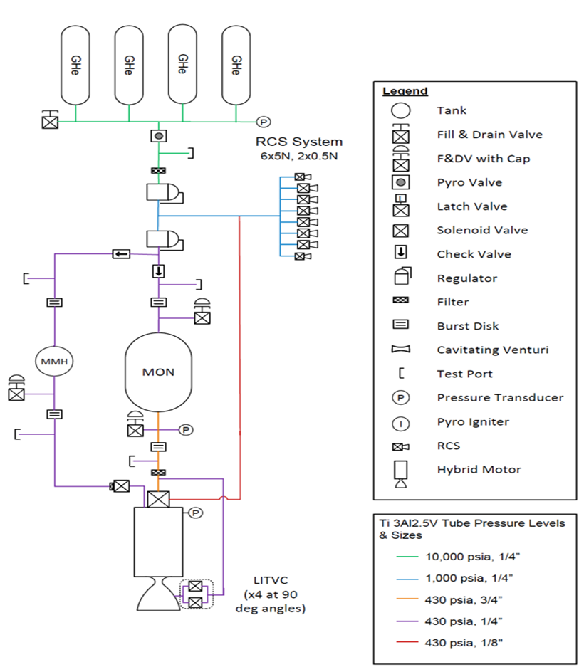
Figure 24 PAA MAV Hybrid Propulsion System Schematic
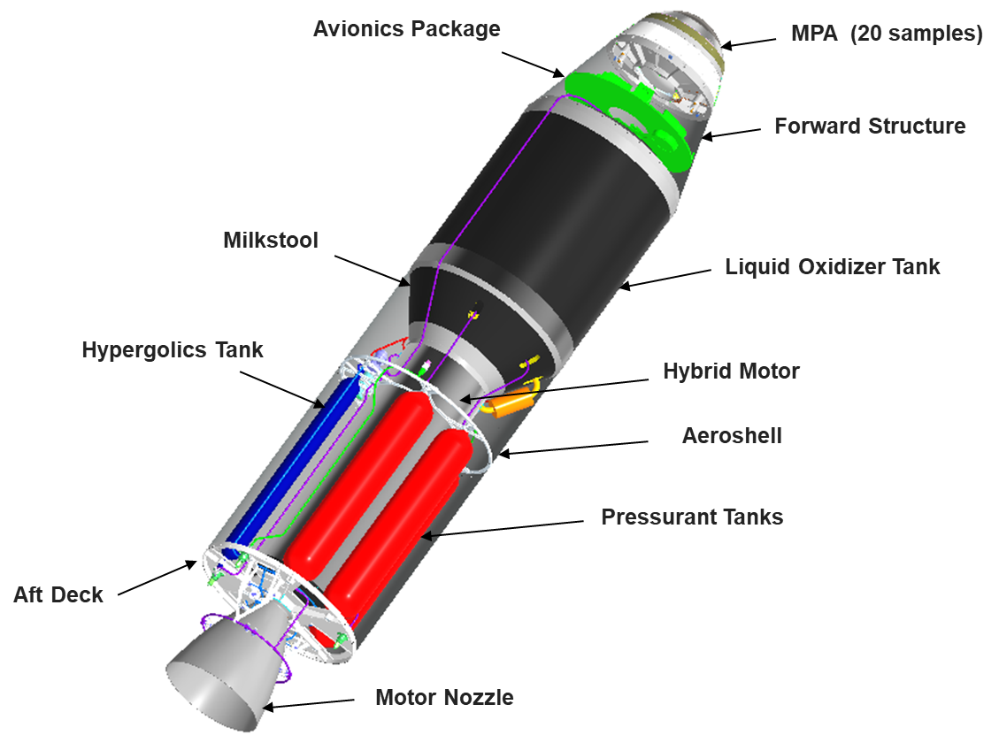
Figure 25 PAA MAV Hybrid

Decision Point Package Remaining Challenges
As part of the Decision Point Package presented on November 19, 2020, the hybrid team included a section on the remaining challenges. These challenges are listed below with some explanation of the challenge and what could have been done to address it.

- Demonstration of selected flight ignition system – During the course of the hybrid propulsion development, there were multiple concurrent efforts on going that needed time to mature before merging later in the development process. One was solid hypergolic ignition of the hybrid to understand whether it was possible and what needed to be done to make that system work. That effort proceeded at subscale, as described above. The full-scale hybrid testing to evaluate motor performance used different ignition systems, which were not ideal for flight (GOX fed hybrid motors and TEA/TEB). GOX is not practical for spaceflight due to the low density and TEA/TEB has limitations with temperature. However, these fluids were readily available and necessary to move the testing forward at the rapid cadence this technology development program required. The timeline did not allow evaluation of PAA ignition method (MMH) or solid hypergols. This left reviewers with a lack of confidence in the design, fearing that changing the ignition mechanism could be a lengthy process.
- Further understanding of nozzle performance – During the long burn times needed for the hybrid rocket to be effective, the nozzle materials evaluated eroded at rates somewhat lower than seen in large solid rocket motor nozzles. However, the small nozzle throat diameter demanded low nozzle erosion and the design requirement of 0.5 mils/sec was not met over the length of the burn. Different nozzle materials were tested and a lower O/F was recommended to reduce nozzle erosion. However more testing would be required. Also, during a requested Two Dimensional Kinetics analysis of the nozzle for an optimized bell nozzle, the code predicted higher nozzle losses then what had previously been assumed, as discussed in the previous section. This would require vacuum testing to confirm performance. The planned vacuum testing at NASA’s White Sands Test Facility was canceled in 2019 due to funding issues.
Most solid rocket nozzles are designed to fire once; the hybrid nozzle, based on similar ablative rocket nozzle technology, needed to survive a long boost firing, and heat soak back over ~10 minute coast time and a second circularization burn. The effect of the dual burn and coast time needs to be evaluated for both the fuel grain and nozzle. Those evaluations could have occurred during the WSTF vacuum testing.
- Demonstration of LITVC with MON-25 at vacuum – While LITVC had been used in the Titan booster for years, that was with NTO at atmospheric pressures. Earth ambient testing demonstrated LITVC operation with MON-3 in 2018 in full scale motors at both SPG’s and Whittinghill. However, model verification requires testing in a vacuum with MON-25. This was to have been done in the White Sands vacuum testing.
- Improved understanding of grain processing and assembly including a repeatable process – There was a learning curve associated with the processing of the SP7 fuel grains. The higher viscosity fuel could not be spun cast like traditional paraffin-based wax motors. The casting cool down process sometimes produced usable grains, at other times all the grains were cracked coming out of the oven. Some of the visibly usable grains, when machined, had flaws or cracked. Residual stresses were known to exist in the grains, but a technique for quantifying it was something yet to be understood. As the motor design changed during the development process, so did the grain manufacturing. There was not enough repetition with one design to get good confidence it would work the first time. Additional casting studies and COMSOL modeling was in work when the down select was made.
- Internal ballistics model – The need for additional energy for MON vaporization and stability coupled with the particulars of the injector design resulted in more complex regression behavior than typical hybrid motors leading to complex modeling.

Decision Point Down Select
The Decision Point between the solid and hybrid design was based on full system designs from the Preliminary Architecture Assessment [6, 7, 8, 9]. The vehicles were comparable on the basis of performance: both coming in at approximately 400 kg GLOM. Both systems could get their respective payloads in the desired orbit within required orbital dispersions. The mission timeline (Martian early spring through the end of summer) left the MAV on the surface during the warmest times of the year, making it straightforward to provide enough heat for either design to survive the thermal conditions.
The schedule, based on historical performance, provided more margin in the solid case, primarily due to developments required for the hybrid feed system. However, the schedules were fairly comparable.
There were several cost analyses made (top down, bottom up) and while there was more confidence in the solid design and a higher margin put on the hybrid design, the development, qualification [, ], and production costs were comparable.
The PAA showed the hybrid as superior for meeting orbital dispersion requirements. A solid rocket has a certain amount of variability between motors that needed to be accounted for, as well as not being able to shut off until the propellant is exhausted. The hybrid rocket vehicle has similar variability but can be turned off when it meets the appropriate orbit. In the interim between the PAA and the Decision Point, GN&C evaluated techniques to manage the solids energy to ensure it was in the proper orbit. When that was completed (additional axial thrusters were evaluated for the RCS system), bringing the solid design to the same level of insertion accuracy as the hybrid.
The decision boiled down to Technology Readiness Levels. NASA strongly recommends a TRL of 6 by a mission’s Preliminary Design Review []. A lower technology level indicates there is still substantial work to be done to get the technology to where there is confidence it can work in a flight system. While the hybrid propulsion team concluded that the hybrid TRL was 5+, it was being compared to the solid propulsion technology readiness level of 5 to 9, depending on the component in question. The lowest TRL was for the solid was the nozzle vectoring system chosen [6, 7]The review board members concluded that based on the limited time before the mission, down selecting to a solid based propulsion system was the unanimous choice.

Possible future uses of this technology
Substantial progress in the technology development was made through out this program. A full scale motor was demonstrated with vacuum ignition and a restart, making the hybrid motor with a TEA/TEB ignition a TRL of 5+. Some effort could be applied to change the ignition mechanism if desired. Therefore, the technology level was close to enabling it to be considered for flight, the ultimate goal of this effort. Table 1 shows the requirements and demonstrated achievements, with nearly all objectives having been met. It also outlines the remaining work. Future missions requiring high performance and limited heating during transportation may find this system advantageous. It has recently been proposed for several Lunar exploration opportunities.

Table 1 MAV Propulsion Progress by the end of the technology development [].

 | Required | Achieved | Notes
New propellant combination demonstrated | MON-25 w/SP7 | MON-25 w/SP7
Rapid ignition  Mars ambient Hypergolic if possible | <750 ms  0.1 psi  MMH or solid additive | 507 ms  0.1 psi  GOX/TEA/TEB
Cold propellants (Operation/ Storage Qualification) | -20ºC/-50ºC | -20ºC/-50ºC | Limited by MON-25
Mission profile burns: long first burn with coast and restart | 121.5 s (93.3 s +  +27.9 s) | 105 s (85 s + 20 s) | Achieved was full duration when motor case was manufactured. Limiting factor is nozzle erosion.
Stable combustion | P_{c}< 5% peak to peak | P_{c}< 5% peak to peak
High performance | C* > 95% | > 95% for almost 40 s | Strong dependence on chamber pressure– can be improved by lowering the nozzle erosion and potentially incorporating mixing devices
High fuel utilization | < 2% residual | ~0.4% residual
Liquid Injection Thrust Vector Control | MON-25 at vacuum | MON-3 at ambient | WSTF test descoped

Conclusions
Over the course of the MAV hybrid Technology development, from 2015 through 2019, the potential hybrid MAV moved from a clean sheet design to a series of tests demonstrating a Technology Readiness Level of 5+ for the flight design. A wax-based fuel was developed and tested and cycled through Mars Summer, Spring/Fall and Winter temperature extremes. This temperature cycling turned out to be much more challenging than what would be required a potential MSR campaign as it is understood at this time. The wax-based fuel production process was developed and scaled up to produce grain sizes to support a full-scale motor design. Multiple segments are being used with the fuel grain under compression (assembled at lower temperature) to ensure it is fully supported during combustion. The concept was demonstrated on the last several full scale tests, however, some technical assembly challenges still need to be overcome. The wax-based fuel formulation can be re-proportioned to adjust the burn rate if desired, as was done during this program due to scaling effects on the regression rate. All supporting analyses and efforts to enable the demonstration of a full duration burn of a SP7A/MON-25 hybrid motor at -20ºC with vacuum ignition were completed.
The final propulsion system was tested in a relevant environment, except for the LITVC. Unfortunately, the vacuum LITVC demonstration test, with a flight expansion nozzle, that was planned for 2019 at White Sands Test Facility was canceled due to funding issues. Progress was made in the nozzle design, resulting in a low regression rate nozzle. However, the system, with a small diameter throat and a long burn time requires a very low regression rate to prevent an excessive chamber pressure reduction. Additional system level changes, like lowering the average O/F over the burn, may be required to get the nozzle throat regression rate where we need it to be. The throat erosion lowers the chamber pressure, which is believed to have contributed to the C* efficiency decrement over the burn. The ignition system tested in the full-scale motors didn’t implement a hypergolic system that could be used in the Martin conditions. However, MMH has been demonstrated hypergolic with MON-25 at temperatures under these conditions and was slated to be tested in the future. A simpler ignition system, with hypergolic additives to the fuel grain and no additional plumbing or valves, has been researched and developed and eventually demonstrated in a vacuum at subscale conditions.
While there are still several open items left to analyze or test, this technology development effort resulted in a dramatic step forward in hybrid rocket development. A wax/MON based motor could be moved to qualification with a little more effort. Alternatives such as HTPB fuel or different methods of energy addition to stabilize the combustion could be considered. Decreased nozzle erosion is crucial to the adoption of hybrid rocket technology for long duration burns and future work in this area is recommended.

AST Solid Propulsion, Propulsion Systems, and AIAA Senior Member.
Technologist, JPL Propulsion and Fluid Flight Systems, M/S 125-211, AIAA Senior Member.
Senior Propulsion Engineer, JPL Propulsion and Fluid Flight Systems, M/S 125-211, AIAA Member.
Research Scientist, Code AOX, M.S. 260-1, AIAA Member.
Chief Engineer, AIAA Associate Fellow
Whittinghill Aerospace President, and AIAA Member
Muirhead, B.K and Karp, A., Mars Sample Return Lander Mission Concepts, 2019 IEEE Aerospace Conference.
Shotwell, R, History of Mars Ascent Vehicle Development Over the Last 20 Years, 2016 IEEE Aerospace Conference
Karp, Ashley, Hybrid Rocket Propulsion Development for a Mars Ascent Vehicle Concept, JANNAF, April 5, 2017
Karp, A. C., Nakazono, B., Shotwell, R., Benito, J., Vaughan, D. A., Story, G.T., Technology Development Plan and Preliminary Results for a Low Temperature Hybrid Mars Ascent Vehicle Concept, AIAA Propulsion and Energy Forum, 53rd AIAA/SAE/ASEE Joint Propulsion Conference, AIAA 2017-4900
McCollum, L.T., Schnell, A., Yaghoubi, D., Bean, Q., McCauley, R., and Prince, A., Development Concepts for Mars Ascent Vehicle (MAV) Solid and Hybrid Vehicle Systems, 2019 IEEE Aerospace Conference.
Prince, A., Kibbey, T., and Karp, A., A Design for a Two-Stage Solid Mars Ascent Vehicle, AIAA Propulsion and Energy 2019 Forum, AIAA-2019-4149
Yaghoubi, D. and Schnell, A., Mars Ascent Vehicle Solid Propulsion Configuration, 2020 IEEE Aerospace Conference
Story, G., Schnell, A., Yaghoubi, D., Karp, A., Nakazono, B., and Zilliac, G., A Single Stage to Orbit Design for a Hybrid Mars Ascent, AIAA Propulsion and Energy 2019 Forum, AIAA-2019-3840
Yaghoubi, D. and Schnell, A., Mars Ascent Vehicle Hybrid Propulsion Configuration, 2020 IEEE Aerospace Conference.
Evans, B., Karabeyoglu, A., Development and Testing of SP7 Fuel for Mars Ascent Vehicle Application, AIAA Propulsion and Energy Forum, 10-12 July 2017, Atlanta, GA, 53rd AIAA/SAE/ASEE Joint Propulsion Conference, AIAA 2017-4831. https://doi.org/10.2514/6.2017-4831
Farias, E, Redmond, M, Karp, A, Shotwell, R, Mechentel, F, Story, G, Thermal Cycling for Development of Hybrid Fuel for a Notional Mars Ascent Vehicle, 52nd AIAA/SAE/ASEE Joint Propulsion Conference, July 25-27, 2016, Salt Lake City, UT, AIAA 2016-4563
Evans, B. , and Cantwell, B., Development and Testing of SP7 Fuel for Mars Ascent Vehicle Application, 2019 IEEE Aerospace Conference.
Guthrie, D.; Wolf, R., “Non-Acoustic Combustion Instability in Hybrid Rocket Motors,” AIAA Paper, 26th AIAA/SAE/ASME/ASEE Joint Propulsion Conference, Orlando, FL, July 1990.
McFarlane, J., “10,000 lbf Thrust Hybrid Motor Testing at Stennis Space Center, A Hybrid Motor Testbed,” AIAA Paper 96-2694, 32nd AIAA/SAE/ASME/ASEE Joint Propulsion Conference, Lake Buena Vista, FL, July 1996.
McFarlane, J.; Kniffen, J.; Lichatwich, J., “Design and Testing Of AMROC’s 250,000 lbf Thrust Hybrid Motor,” AIAA Paper 93-2551, 29th AIAA/SAE/ASME/ASEE Joint Propulsion Conference, Monterey, CA , July 1995
Story, G.; Zoladz, T.; Arves, J.; Kearney, D.; Abel, T.; Park, O., “Hybrid Propulsion Demonstration Program 250K Hybrid Motor,” AIAA Paper 2003-5198, 39th AIAA/SAE/ASME/ASEE Joint Propulsion Conference, Huntsville, AL, August 2003.
Bradford, M.; Kniffen, R.; McKinney, B., “Hybrid Rocket Combustion Enhancement,” U.S. Patent 5582001, December 10, 1996.
Evans, B, Mallin, S., Rosing, S, Tourikis, J, and Mathias, S., MAV Hybrid Rocket Propulsion-Technology Maturation, Space Propulsion Group FY19 Report for Contract Number: 1626777
Story, G., Prince, A., Chaffin, J., Oglesby, B., Karp, A., Kibbey, T., Low Temperature Hybrid Mars Ascent Vehicle Concept Development at MSFC, AIAA Propulsion and Energy Forum, 2018 Joint Propulsion Conference, AIAA 2018-4836
Whittinghill, G., Whittinghill, I., Aumann, C., Mosser, N., Mars Ascent Vehicle Hybrid Motor Development Testing, 2019 IEEE Aerospace Conference
Ryddner, D., Weaver, A., Zilliac, G., West, J., “Pre-Ignition Environment CFD Study for a Potential Hybrid Mars Ascent Vehicle,” JANNAF 13th Modeling and Simulation, Tampa Dec. 2019.
Whittinghill Aerospace, Mars Ascent Vehicle Hybrid Rocket Design & Testing, Subcontract No. 1626034, Submitted to California Institute of Technology, Jet Propulsion Laboratory, January 15, 2020
Zilliac, G., Story, G., Karp, A., Jens, E. and Whittinghill, G., Combustion Efficiency in Single-Port Hybrid Rocket Engines, 2020 AIAA Propulsion and Power Conference, submitted for publication.
Weaver, A., West, J., Liquid Injection Thrust Vector Control System Design Sensitivity Analysis, Presented at JANNAF Conference 12/2019
Karp, A, Redmond, M, Nakazono, B, Vaughan, D, Shotwell, R, Story, G, Jackson, D & Young, D, Technology Development and Design of a Hybrid Mars Ascent Vehicle Concept, IEEE Big Sky, MT 2016
Mead, Franklin B, Bornborst, Bernard R, Certification Tests of a Hybrid Propulsion System for the Sandpiper Target Missile, Air Force Rocket Propulsion Laboratory report AFRPL-TR-69-73.
Cortopassi, A., Boyer, E., Hypergolic Ignition Testing of Solid Fuel Additives with MON-3 Oxidizer, AIAA 2017-5050, AIAA Propulsion and Energy Forum, 53rd AIAA/SAE/ASEE Joint Propulsion Conference, July 2017, Atlanta, GA.
Benhidjeb—Carayon, A., Gabl, J. R., and Pourpoint, T., Hypergolicity of Mixed Oxides of Nitrogen with Solid Fuels for Hybrid Rocket Application, 53rd AIAA/SAE/ASEE Joint Propulsion Conference, AIAA 2017-4848
Benhidjeb—Carayon, A., Gabl, J. R., and Pourpoint, T., Hypergolic Ignition and Relights of a Paraffin-based Hybrid Grain, AIAA Propulsion and Energy Forum, 2018 Joint Propulsion Conference, AIAA 2018-4661
Benhidjeb--Carayon, A, McCormick, J, Yilmaz, C, Gabl, J, Whitehead, B and Pourpoint, T, Hypergolic Hybrid Rocket Motor Characterization with MON-25 at Atmospheric and Reduced Pressures, A Propulsion and Energy 2019 Forum, August 2019, Indianapolis, IN, AIAA 2019-4338
Benhidjeb-Carayon, Drolet, Gabl, and Pourpoint, Journal of Propulsion and Power vol 35 No2 March 2019 Reactivity and Hypergolicity of Solid Fuels with Mixed Oxides of Nitrogen.pdf
Benhidjeb—Carayon, Alicia, Purdue University PHD Thesis, Reactivity and Hypergolicity of Liquid and Solid Fuels with Mixed Oxides of Nitrogen, December 2019
Benhidjeb—Carayon, Alicia, Purdue University PHD Thesis, Reactivity and Hypergolicity of Liquid and Solid Fuels with Mixed Oxides of Nitrogen, December 2019
https://www.mscsoftware.com/product/easy5
http://sierraengineering.com/TDK/tdk.html
https://www.grc.nasa.gov/www/CEAWeb/
Polsgrove, T., Percy, T., Rucker, T., Thomas, H., Update to Mars Ascent Vehicle Design for Human Exploration, 2019 IEEE Aerospace Conference
Oglesby, B, Prince, A, Story, G, Karp, A, Qualificaiton of a Hybrid Propulsion System for a Mars Ascent Vehicle, 2019 IEEE Aerospace Conference.
Prince, A, McCauley, R, Kibbey, T, McCollum, L, Oglesby, B, Stefanski, P, Mars Ascent Vehicle Propulsion System Solid Motor Technolgoy Plans, 2019 IEEE Aerospace Conference
NASA Procedural Requirements (NPR) 7120.5E, NASA Space Flight Program and Project Management Requirements. https://nodis3.gsfc.nasa.gov/npg_img/N_PR_7120_005E_/N_PR_7120_005E_.pdf
MSFC/JPL, MAV Decision Package: Peer Review, November 19, 2019

