NASA’s Space Launch System Progress Toward the Launch Pad
John Honeycutt and Chris Cianciola
NASA Marshall Space Flight Center, Huntsville, AL, 35812, U.S.A.
John Blevins
NASA Marshall Space Flight Center, Huntsville, AL, 35803, U.S.A.
NASA’s Space Launch System (SLS) took a substantial step toward the launch site in 2020 with the move of the Artemis I core stage from the manufacturing site to the test stand as the program plans for a 2021 launch. (Fig. 1) SLS is NASA’s evolvable super-heavy-lift launch vehicle to support deep space exploration. It is based on evolutionary improvement to existing proven propulsion systems. Its twin solid rocket boosters employ a five-segment motor based on the four-segment space shuttle motor. Its four RS-25 main engines will operate at thrust levels higher than those in the space shuttle program. The core stage is a new design that will support propellant tanks for the engines and serve as the attach point for the boosters. Modern streamlined manufacturing processes and materials have been incorporated into the initial configuration with planned onramps for improved performance and/or affordability in subsequent versions. The primary role of SLS is to anchor the transportation for NASA’s Artemis Program to return humans to the Moon and build on the exploration that began during the Apollo Program. This paper will discuss progress to date for the SLS Program and look ahead to important milestones in 2020 and beyond.
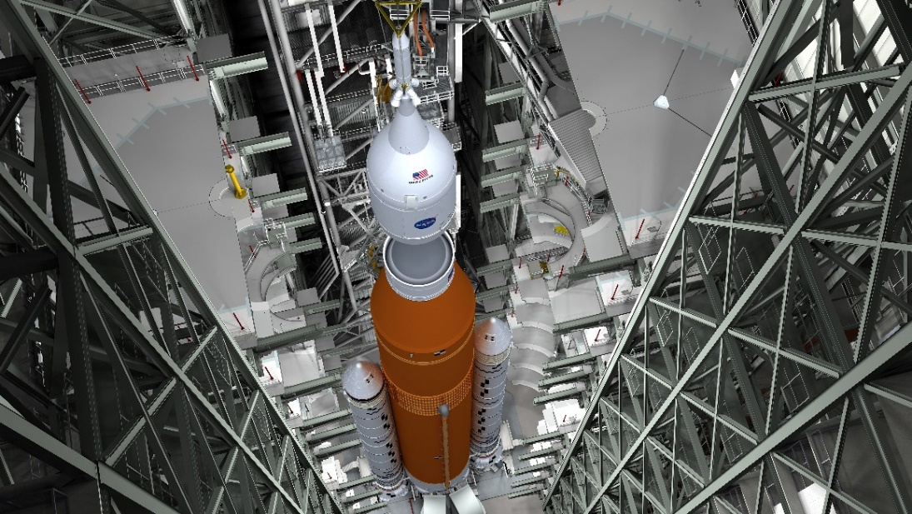
Fig. 1 Artist concept of SLS during vehicle stacking in the KSC Vehicle Assembly Building.
- Introduction
In Space Policy Directive 1, the agency is directed to “lead an innovative and sustainable program of exploration with commercial and international partners to enable human expansion across the solar system and to bring back to Earth new knowledge and opportunities. Beginning with missions beyond low Earth orbit, the United States will lead the return of humans to the Moon for long-term exploration and utilization, followed by human missions to Mars and other destinations.”
The goal set by the White House is “the first woman and the next man” on the Moon by 2024. Unlike Apollo, as indicated in the directive, the goal is continual access to any part of the Moon by landers, rovers, robots and humans, purchasing services from private companies where feasible, leading a coalition of nations, and exploring opportunities to use lunar resources to sustain operations. In 2019, this effort was appropriately named “Artemis,” twin sister of Apollo and goddess of the Moon in Greek mythology.
Work now is underway by multiple NASA centers, prime contractors and their suppliers on the critical transportation infrastructure. The Orion crew spacecraft, managed at Johnson Space Center (JSC), is the only craft for transporting crews beyond low-Earth orbit (LEO) for extended missions in deep space. SLS, managed at Marshall Space Flight Center (MSFC) is the only rocket capable of launching Orion to the Moon. Exploration Ground Systems (EGS) at Kennedy Space Center (KSC) will lead the integration and launch of SLS and Orion.
Work is also underway on a Gateway facility in a near-rectilinear halo orbit around the Moon (Fig. 2), providing a permanent command center and aggregation point for the first human landing and serve as a robust building block for expanding the lunar exploration architecture. Additionally, private industry is developing designs for a modular Human Landing System flown commercially to the Gateway to be assembled.

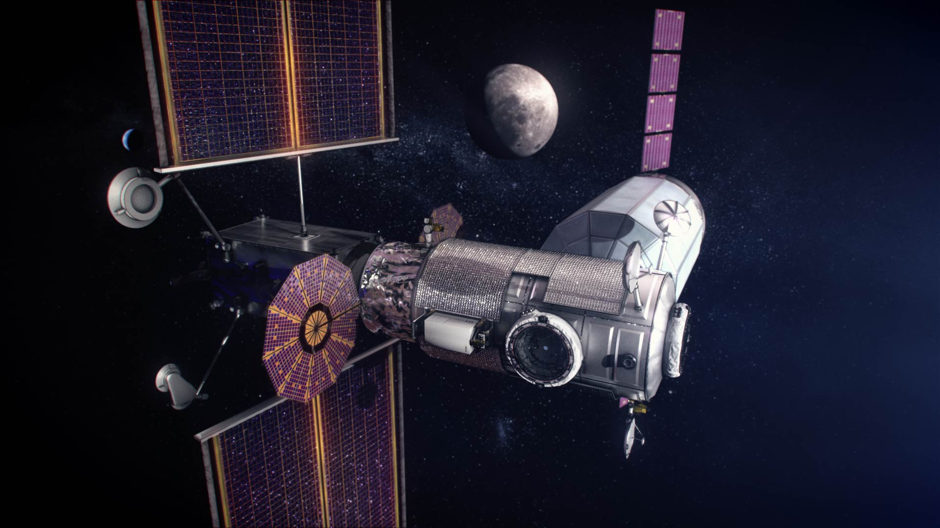
Fig. 2 Artist concept of Gateway in lunar orbit with docked Orion and lunar lander.

The Artemis I mission will be the first test flight of SLS and Orion, including an un-crewed cislunar flight and reentry and ocean recovery. The Artemis II cislunar mission will be a similar flight with crew. Artemis III will send a crew to the Moon to rendezvous with a commercially provided lander for the first human lunar landing since Apollo.
Artemis will establish American leadership and a strategic presence, prove the technologies and capabilities for sending humans to Mars, inspire a new generation, spur new science and technology, expand U.S. global economic impact, and broaden U.S. industry and international partnerships in deep space.
SLS is the transportation linchpin for NASA’s deep space exploration plans. Its unmatched mass and volume capability represent a significant capability for sending large exploration payloads to the Moon and beyond. And it has an evolutionary path to even greater mass and volume capability, which translates into simplified payload and mission design and greater payload mass and volume.
SLS is designed for deep space exploration with a capability greater than any existing launch vehicle. The initial configuration that will support the first three Artemis missions – the Block 1 vehicle – can carry 209,000 pounds to low Earth orbit (LEO) and transfer more than 59,000 pounds to trans lunar injection (TLI). (Fig. 2) The same configuration with upgraded engines, a new upper stage, and weight-savings to the core stage – Block 1B – will be able to put more than 231,000 pounds to LEO and more than 83,000 pounds to TLI. The ultimate SLS variant, Block 2, will be distinguished by new solid propellant boosters that will increase performance to more than 286,000 pounds to LEO and more than 101,000 pounds to TLI. All three Block variants are available in both crew and cargo configurations.
The focus of development efforts is the Block 1 vehicle for Artemis I. The following sections will provide major highlights in each major hardware element of the vehicle for Artemis I and later missions.

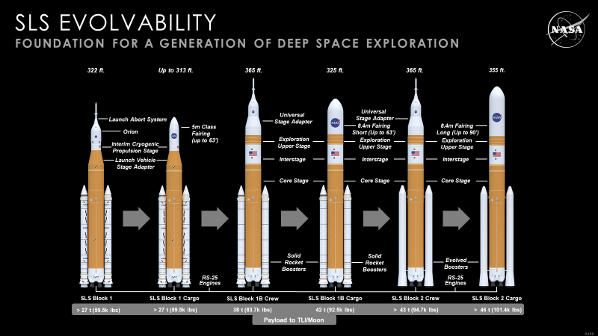
Fig. 3 SLS evolved variants showing Blocks 1, 2 and 3 crew and cargo configurations and TLI payload.
- Stages
The SLS core stage is the only totally new development of the SLS Program. Designed and built by Boeing, it contains the propellant tanks, vehicle avionics and engines, supports upper stages and payloads and serves as the attach point for the twin solid boosters. The core stage is 212 feet tall and 27.6 feet in diameter and contains 537,000 gallons of liquid hydrogen and liquid oxygen.
Boeing completed the Artemis I core stage at Michoud Assembly Facility in 2019 and barged it to NASA Stennis Space Center (SSC) in January 2020 to be installed in the B-2 stand for a Green Run test series. (Fig. 4). Historically, no NASA human-rated launch vehicle stage has flown without one or more operational tests. The SLS core stage followed precedent, and began its green run test series in 2020.
The SLS core stage Green Run is a series of eight progressively more challenging functional tests that brings the stage to life and concludes with an operational hot fire test in fall 2020 before the stage is shipped to KSC for integration and launch. Green Run is designed to ensure the stage satisfies design objectives and validates the stage design models in order to minimize risk to the mission. Test cases comprise:
• Test Case 1- modal testing to determine primary bending modes to verify vehicle models
• Test Case 2- avionics testing to include flight computers, data collection, health monitoring and other functions
• Test Case 3- fail safes – testing safety systems that shut down operations during testing
• Test Case 4- Main Propulsion System (MPS) and RS-25 leak and functional checks including command and control operations, s well as leak checks using gaseous nitrogen and helium
• Test Case 5- hydraulics and Thrust Vector Control (TVC) checks – movement of the engine steering system and related hydraulic systems
• Test Case 6- simulated countdown demonstration – launch simulation including step-by-step fueling, avionics power, propellant loading and pressurization.
• Test Case 7- Wet Dress Rehearsal (WDR) – demonstration of loading, controlling and draining more than 700,000 gallons of cryogenic propellants into the two-test stand run tanks and then returning the stage to a safe condition.
• Test Case 8- countdown/hot fire – a test of up to eight minutes of the stage and engines, generating 1.6 million pounds of thrust.

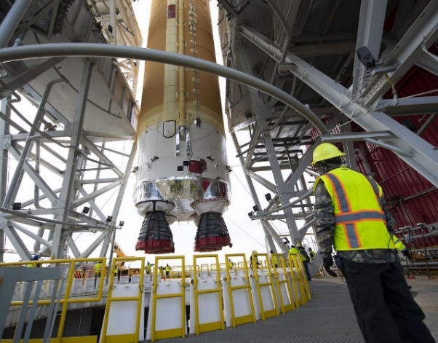
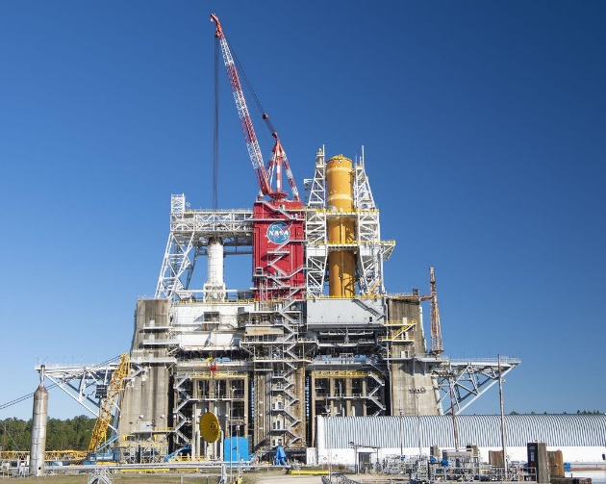
Fig. 4 Artemis I core stage in the B-2 test stand (left) and being lowered into position (right).
As this paper was in preparation in mid-July, Boeing and NASA engineers had successfully completed test cases 1-3 and had begun test case 4. At the end of Green Run, engineers will refurbish the core stage, perform final health and status checks and configure it for its journey to KSC for vehicle integration and the Artemis I mission to the Moon.
The significance of the test series is illustrated by the data NASA will collect. There are more than 600 ground test instrumentation (GTI) sensors on the stage. The core stage also has more than 1,100 flight sensors. In addition to vehicle instrumentation, over 450 high-speed and low-speed Ground Test Instrumentation (GTI) measurements are planned for green run at the B-2 test stand.
The B-2 Test Facility provides required green run video to support 70 external views and 14 internal views of the core stage. These views and video will be available in the SSC Control Room as well as at the SLS Engineering Support Center (SESC) at the HOSC (Huntsville Operations Support Center) at MSFC.
Boeing estimates that it will collect 75-100 terabytes of data that will be stored for review. That number does not include voice and video data collected by NASA. By comparison, all the data in the American Library of Congress amounts to 15 TB.
Along with activating the core stage at Stennis, the team also completed qualification of the flight computers and other avionics and software distributed among the forward skirt, intertank and engine section, as well as the stage controller and software that will be used to simulate the KSC Launch Control Center during Green Run.
As the Green Run campaign was beginning, the core stage structural test campaign was coming to an end. Also a requirement for launch, the three-year test program was the largest at MSFC since the Space Shuttle Program. From May 2017 until June 2020, the five structural test articles (STAs) underwent 199 separate test cases. More than 421 gigabytes of data were collected to add to computer models used to design the rocket and optimize it in the future.
In 2019 and 2020, preceded by tests of the engine section, intertank, hydrogen tank and payload section/upper stage STAs, the liquid oxygen tank STA completed 24 baseline tests simulating actual flight stresses.(Fig. 5) Like previous STA tests, the tank was subjected to millions of pounds of force created by hydraulic pistons while thousands of sensors, cameras and microphones captured the loads data. The final test was an ultimate “test-to-failure” that ruptured the 70x28-foot tank with a high degree of accuracy at the location and stress level predicted.
In addition to the Artemis I core stage, Boeing has completed manufacturing on all major sections of the Artemis II core stage, which are in various stages of cleaning, priming and outfitting, and work has starting on the Artemis III core stage. NASA awarded Boeing a contract addition supporting a total of up to 10 core stages, including the current two, as well as up to eight Exploration Upper Stages (EUS) that will replace the existing Interim Cryogenic Propulsion Stages (ICPS) after the first three Artemis missions.

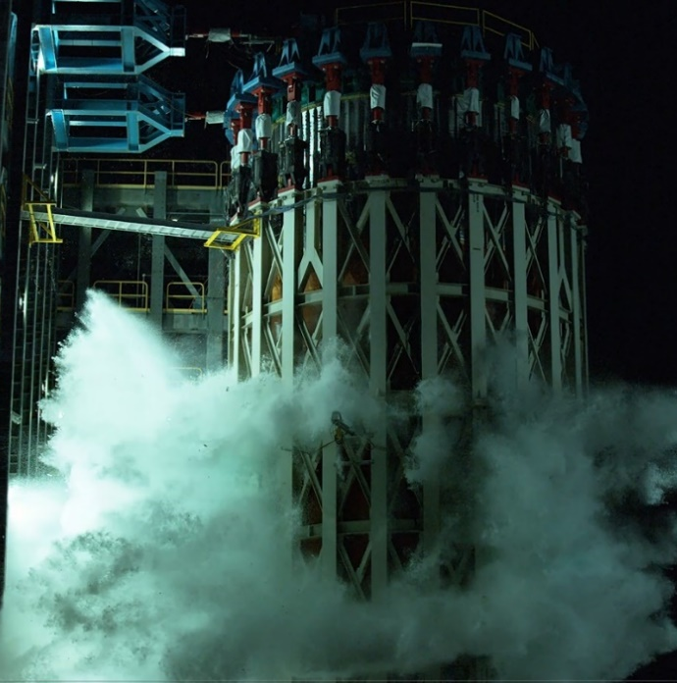
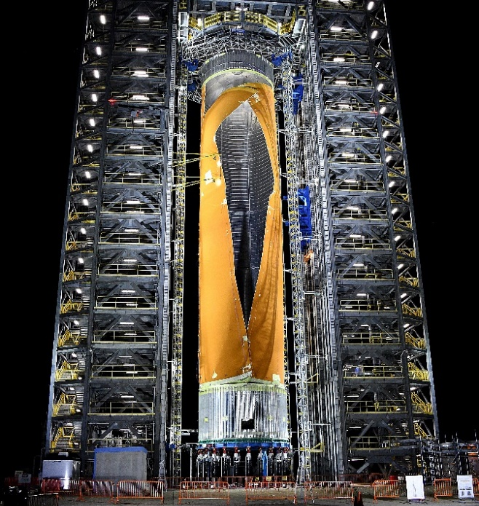
Fig. 5 Liquid hydrogen tank STA (left) and liquid oxygen tank STA (right) test-to-failure cases.
- Boosters
Roughly 75 percent of total vehicle launch thrust is generated by a pair of solid rocket boosters designed and made by Northrop Grumman. Each booster generates 3.6 million pounds of thrust.
The SLS boosters are based on the space shuttle four-segment solid rocket boosters with several improvements: a fifth segment, new non-asbestos motor case insulation, new avionics, and new nozzle insulation layup. The five-segment booster is the largest ever built for flight at 177 feet tall and 12 feet in diameter. It generates 20 percent greater average thrust and 24 percent greater total impulse than the shuttle motor. Of the booster's total weight of 1.6 million pounds, propellant accounts for 1.5 million pounds.
All 10 Artemis I motor segments are complete, as well as the Artemis II segments, and casting is underway on the Artemis III segments. The Artemis I motor segments were shipped 2,800 miles by rail from Northrop Grumman production facilities in Utah to KSC in Florida in June 2020. Workers at KSC have prepared for their arrival by assembling and testing the aft skirts and forward assemblies of the boosters and practicing stacking procedures with booster pathfinder hardware in early 2020. EGS teams began offloading the segments from the railcars in the Rotation, Process and Surge Facility (RPSF) and attached the aft segments to the aft skirts, storing the remaining segments in preparation for stacking in the Vehicle Assembly Building (VAB). (Fig. 6)

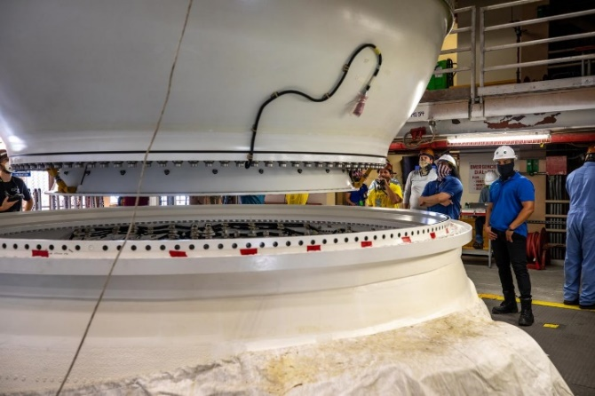
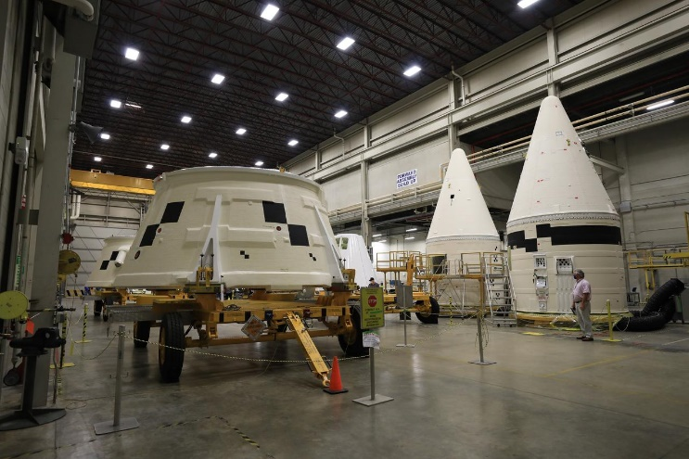
Fig. 6 Artemis I aft skirts and forward assemblies in the Booster Fabrication Facility at KSC (left) and right-hand motor segment being mated to right-hand aft skirt in the KSC Rotation, Processing and Surge Facility.
The most recent full-scale static motor test was held in the UT desert in 2016, on the path to qualification. The program has fired five full-scale motors to qualify the boosters for flight. NASA has signed with Northrop Grumman company to order long-lead parts to build the boosters for as many as six flights in addition to the three now under contract.

- Engines
Originally developed for the Space Shuttle Program, the RS-25, formerly known as the Space Shuttle Main Engine (SSME), helped power 135 shuttle missions, accumulating an experience base of more than 3,000 starts and more than one million seconds of ground test and flight operations time.
A product of Aerojet Rocketdyne of Sacramento, California, the RS-25 is roughly 14 feet tall, 7.5 feet in diameter and weighs 7,775 pounds. The first four SLS missions will be powered by 14 flown shuttle engines and two new engines assembled from shuttle-era spare parts. NASA has awarded Aerojet Rocketdyne an initial contract for six new engines for development and the Artemis V mission. Additionally, NASA awarded Aerojet Rocketdyne a contract in 2020 to manufacture 18 additional RS-25 engines. The new engines will be certified to operate at 111% thrust and cost 30% less to manufacture compared to the heritage shuttle RS-25.
The RS-25 role for SLS differs from the Space Shuttle Program. Each shuttle mission used three engines, while each SLS mission uses four. Shuttles routinely operated with SSMEs throttled to 104.5 percent, or roughly 470,800 pounds of thrust. Each SLS engine will operate at 109 percent thrust – approximately 512,000 pounds maximum thrust in a vacuum.
The SLS Program conducted a series of “adaptation” firing tests at Stennis Space Center with a pair of existing ground test RS-25s from 2015 to 2019 to certify the RS-25 to SLS performance requirements. The series also included certification of new engine controllers and testing of new parts manufactured with new techniques aimed at restarting engine production. A total of 32 tests amassed nearly 15,000 seconds of hot fire time. Development engine testing is scheduled to resume in September 2020 with additional new engine components aimed at new engine production.
As of preparation of this paper, the Artemis I RS-25 flight set had been integrated into the Artemis I core stage and was undergoing green run testing with the stage at SSC. (Fig. 7) Additionally, the Artemis II engine flight set had completed preparations, including installation of all controllers, and was awaiting a request for stage integration. Manufacturing is under way on the first six new RS-25 engines at Aerojet Rocketdyne.

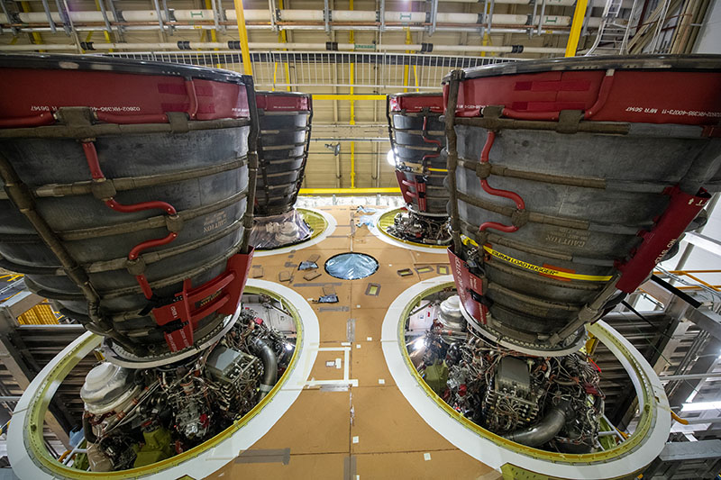

Fig. 7 Artemis I RS-25 flight set installed in core stage at Michoud Assembly Facility.
Aerojet Rocketdyne has also completed and tested six RL10 upper stage engines for Interim Cryogenic Propulsion State (ICPS), the upper stage for Block I, and the more powerful Exploration Upper Stage (EUS), the upper stage for Blocks 1B and 2, for a evolved SLS configurations. Two are assigned to ICPS stages for Artemis II and III, while the other four are assigned to the first EUS.
- Upper Stages and Payloads
The ICPS and Orion Stage Adapter (OSA) for Artemis I are complete and awaiting vehicle integration at KSC. Based on an existing Delta rocket stage, the single-engine ICPS will power the Orion vehicle to the Moon. The OSA connects SLS to Orion. The Artemis I Launch Vehicle Stage Adapter (LVSA), which covers the ICPS during launch and connects the ICPS to the core stage, was shipped from MSFC to KSC in July 2020.
Currently, the ICPS for the second Artemis mission as well as the LVSA and OSA for the second Artemis mission are in early manufacturing. LVSA and OSA panels built by AMRO Fabricating Corp. were delivered to MSFC in early 2020. Using a friction-stir robotic welding tool, technicians completed vertical welding on OSA-2 in July 2020. It was removed from the weld tool to begin welding LVSA-2. Additionally, the Artemis II OSA diaphragm that protects Orion from stray core stage gasses is complete. (Fig. 8)
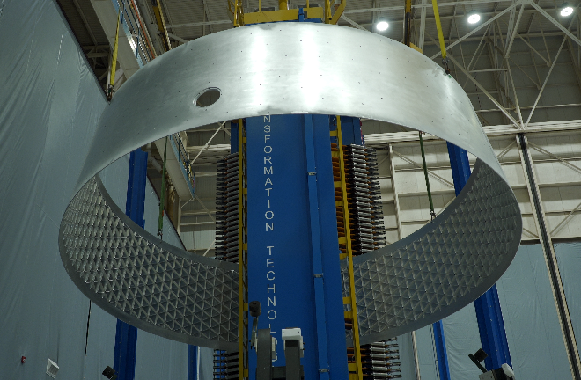
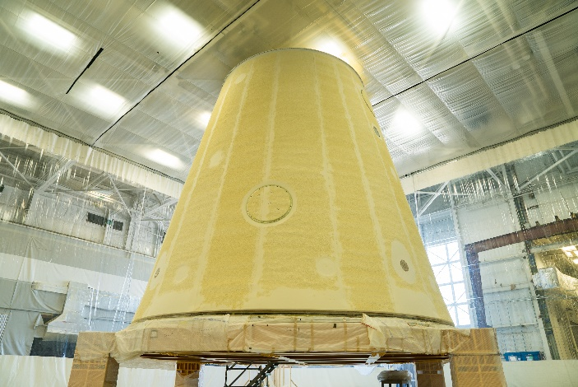

Fig. 8 Artemis I LVSA following Thermal Protection System application (left) and OSA-2 removed from Vertical Weld Center at MSFC (right).
- Conclusion
The launch vehicle for the first mission of the Artemis lunar program is complete. The upper stage and the boosters are at KSC. The core stage is scheduled to complete Green Run testing for shipment to KSC by the end of 2020. Preparations are continuing for the launch of the un-crewed Artemis I mission in 2021. The hardware and manufacturing capability and planning for SLS vehicles for Artemis II and beyond are underway, accelerated by lessons learned as part of a journey that has already begun. NASA’s Space Launch System (SLS) took a substantial step toward the launch pad in 2020 and is on its way to fulfilling its promise as a major new capability for deep space exploration.

Manager, Space Launch System Program.
Deputy Manager, Space Launch System Program.
Chief Engineer, Space Launch System Program.

