Development and Comparison of an Artificial Gravity Concept for Human Spaceflight

Cody L. Beard

._____________________________________.
(signature)

Ryan T. Joyce

._____________________________________.
(signature)

Langley Research Center, SMAB
July 17th, 2020
Development and Comparison of an Artificial Gravity Concept for Human Spaceflight

Cody L. Beard

Ryan T. Joyce

Langley Research Center, SMAB
Abstract
Artificial Gravity (AG) for a long-duration space journey has been theorized since the dawn of human spaceflight. The purpose of this project is to begin bringing those concepts into real-life. The goal and primary study for this project is to research and understand the physics behind making a rotating centrifuge and the human limitations that may contribute to the design. The research first started with finding the physics equations we can use to calculate the rotational speed required for a certain gravity or the required radius for the centrifuge structure, this equation is $a_{c}=\frac{v^{2}}{r}={w_{c}}^{2}r$, where v is linear velocity, r is the radius of the structure, and is the rotational speed. Next, it is important to understand AG may be worthwhile because of the negative health effects of microgravity. The research then leads to finding human limitations in a rotating structure. The main limitation of a human living in this habitat is the Coriolis effect, which causes discomfort and motion sickness in the subject inside the structure, this causes the three semicircular fluid canals in your head that sense balance and motion. Finally, we use that knowledge to best hypothesize and propose the radius size for the structure that would negate the Coriolis effect, and using that we can calculate the appropriate rotational speed to get the desired gravity level, for example: 1 g or 9.81 $\frac{m}{s^{2}}$ of acceleration. Overall this research can encourage increase knowledge in understanding AG, the physics and human limitation in a rotating centrifuge on future NASA long-duration Missions and Goals. This research can be a reference to future design proposals for long-duration exploration missions and colonization of planets or moons.

Introduction
Since the beginning of humankind, humanity has always wanted to explore what seems to be impossible. We have navigated across the ocean and founded the new world, flew man to the moon, and now we are onset to the next chapter of human exploration, to establish life on another planet. We are pioneers of future human explorations. As engineers, we must find the most optimal plan for humans to travel in space for long-durations without the physical damage that is caused by living in microgravity. Most human missions now are very short-duration. Astronauts fly on the ISS for a few weeks to months then return to Earth’s surface. In this case, heavy and complicated exercise equipment like the Advanced Resistive Exercise Device (ARED) and Treadmill (T2) can be used to mitigate the negative effects on the muscular and skeletal systems. [2] However, on a mission to Mars or the Moon, lasting from months to many years, these problems may get severely more problematic. Through the current countermeasures, some problems can be mitigated, but not fully resolved. Currently, based on our observation and research, observed astronauts develop muscle deconditioning, bone decalcification, and visual impairment intracranial pressure syndrome (VIIP). [4] The one countermeasure, that could potentially negate most of the problems of living in microgravity as stated is by creating an Artificial Gravity (AG) habitat. Earth’s Gravity is a linear accelerating force that keeps things on the surface and humans have adapted to. On Earth, humans usually feel approximately 9.81 $\frac{m}{s^{2}}$ of linear acceleration down on them, to make this simpler we call this 1 g or one Earth’s gravity. Artificial Gravity (AG) is created by creating a structure that could produce an apparent linear acceleration of 1 g. Based on the research, the rotating centrifuge may be the leading proposed idea in AG. This can be hypothesized because rotating centrifuge compares to linear 1 g rocket, another possible method in creating AG requires improvements in the engine, to fire throughout the journey with a greater propulsion acceleration and more fuel thus requiring more mass.

Experimentation
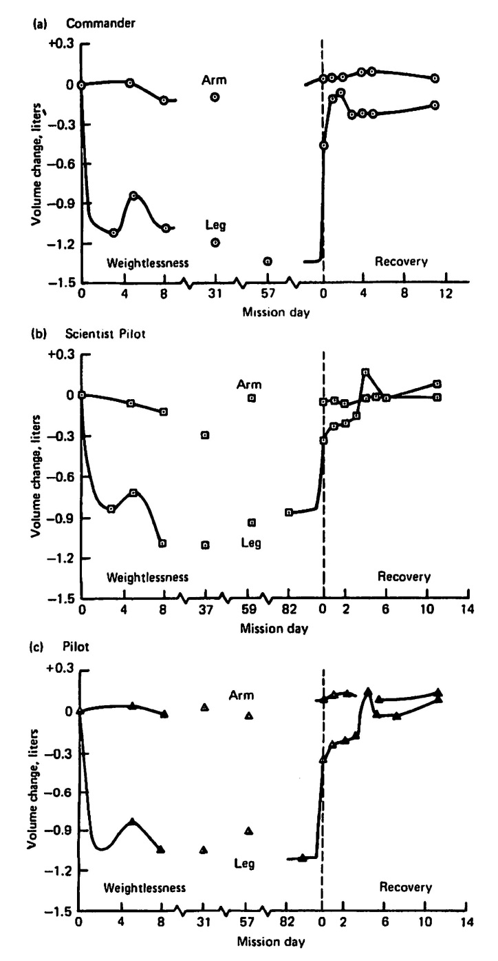
The negative health effects of microgravity were tested by The Skylab Program. “The Skylab experiments, conducted in an environmentally controlled, enclosed chamber, were termed the Skylab Medical Experiments Altitude Test (SMEAT) and represented the first mission. The three subsequent orbital missions were termed Skylab 2, 3, and 4. These three long-duration missions were 28, 56, and 84 days in duration.” [2] Pre-flight and post-flight, leg, and arm volumes were measured and calculated to determine muscle loss.
Figure 1: The figure shows the changes in upper and lowers limb volumes obtained by circumference measurements of 3-cm segments in the three crewmembers from Skylab 4 during the mission and the recovery rate once they are back on Earth. Skylab 4 has the most exercise, therefore the crew has less muscle loss compares to Skylab 2 and 3. [2]
This study found evidence of significant loss of leg volume and more importantly loss of leg tissue mass is clearly shown, even though the crew uses exercise equipment during their missions. However, during the missions, the crew were tested on different exercise equipment, the experiment found that the combination of various exercise machines reduces loss in the leg and arm muscle strength. The issue of bone decalcification can also be reduced with the right amount of exercise and nutrition intake daily.
However, the most troubling negative effect of microgravity that currently needs more research to identify the cause is the visual impairment of intracranial pressure syndrome (VIIP). The leading theorized cause of VIIP is due to microgravity exposure likely increasing intracranial pressure, likely leading to worsening vision. During the Apollo program, they found an increase in Intraocular Pressure (IOP) among astronauts. This was later confirmed by Spacelab experiments that showed an IOP rise of 20% - 25% during flight, and a decrease below baseline levels post flight. [3] This ophthalmic change is surprisingly common with astronauts that perform in a long-duration mission. “Of the 36 astronauts from the United States who have flown on long-duration missions of approximately six months aboard the International Space Station”, 15 crewmembers were confirmed to have VIIP and only 2 were confirmed without symptoms, while the other 19 are undergoing medical evaluation. [3] Currently there is no cure for the VIIP because very little is known about the cause in order to produce a treatment for it. The current solution for this is adjustable eyeglasses for astronauts’ worsening vision, a temporary solution unacceptable for long-duration missions. All the current countermeasures for negative health in microgravity are applicable for short-duration missions only. If we are considering long-duration missions like colonizing the Moon or Mars, then we need to consider Artificial Gravity, this proposed countermeasure may solve most of the negative health effects of microgravity and may also provide sense normalcy for the astronauts on their space exploration journey.
When theorizing and building a concept for AG, the physics and equations need to be considered. The size of the structure and rotational rate are dependent on each other. The equation for centripetal acceleration is $a_{c}= \frac{v^{2}}{r}={w_{c}}^{2}r= \frac{4π^{2}r}{T^{2}}$ where $w_{c}$ is the rotational speed, v is the velocity, r is the radius of the circle, and T is the period (time it takes to complete one rotation). The relationship between rotational speed and radius is quadratic, which means that rotational speed increases at a rate squared compared to the radius. The Coriolis force is the force a subject experience inside a centrifuge, producing apparent gravity.
Building a habitable rotating centrifuge has limitations. One main problem faced by many designers of a cylindrical habitat is the Coriolis effect. Coriolis effect happens when a mass is moving perpendicular to the experienced angular velocity, this phenomenon can be experienced on a merry go round. For example, if you and your friend are playing catch in a rotating merry go round, if you pass the ball to your friend the ball appears to be curving against the rotation of the merry go round. However, to the observer from the outside of the merry go round, the ball appears to move linearly.
The human limitation based on Coriolis effect may be cross-coupled angular acceleration. Cross-coupled angular acceleration phenomenon results from simultaneous rotation about two perpendicular axes, the resultant force of these two force vectors causes a sensation of tumbling, rolling, or yawing. For example, a subject is in a rotating structure, “rotation is about the vertical axis and the subject’s head is vertical.” [1] The yaw canal or semicircular canal in the horizontal plane registers the rotating motion. After a while, “the yaw canal will no longer senses the rotating” motion in the structure. [1] If the head moves 90 degrees forward, the yaw canal now is vertical with the rotation, where no rotation occurs, and the subject now senses a “counter-rotation about the horizonal axis.” [1] Simultaneously the roll canal would experience an opposite effect, from vertical to horizontal plane with the rotation. “This can be highly disorienting and induce nausea to the subject.” [1] Currently a company called Desdemona, has created a simulation “attempted to minimizing cabin alignment rotation,” thus attempted to reduce the Coriolis effect. [5] The angle of the subject equation is $Ѳ=\tan^{-1}{\frac{a_{c}}{g}}=\tan^{-1}{\frac{{w_{c}}^{2}r}{g}}$ where Ѳ is the degrees in angle, is the centripetal acceleration, is the rotational speed, and g is the desired gravitational force. [5] This device may be used to research and experiment with the effects cross-coupled on the Coriolis effect.
There were many experiments on the effects of humans in a rotating centrifuge. One of these was started in 1958 and continued in the 1960s is called the “Slow Rotating Room” (SRR). The experiment had subjects living in a 5 meters radius room, with complete living facilities. [1] The subjects were able to live for a period ranging from one day to three weeks and the rotational rates ranged from 1 to 10 rpm. The experiment concluded at 1 rpm, subjects were symptom-free. When the room was spinning at 3 rpm some subjects experienced symptoms of motion sickness and at 6 rpm most of the subjects have trouble performing tasks and felt symptoms. Finally, at 10 rpm, adapting to the new environment presented a challenge to the subjects, even after 12 days. [1] Based on this experiment, the researcher created a graph of the “comfort zone” for a rotating structure habitat shown in figure 3. 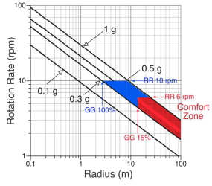
Figure 2: Based on the experiment “Slow Rotating Room” in 1960’s, “the referred to the “comfort zone” as the red area delimited by gravity levels ranging from 0.3 g to 1 g, rotation rate < 6 rpm, and gravity gradient GG < 15% (radius > 12 m).” However, looking at the more recent studies, it shows that human can sustain a higher rpm, therefore a lower radius, shown in the blue area. [1]
In 1969, an experiment conducted by Graybiel attempted to adapt humans in a 10-rpm environment, through incremental increases in rotation rate. The rotation rate incrementally increased in nine stages for a period of approximately two days per increment over the course of 16 days. [1] The experiment was shown to mitigate the symptoms of motion sickness and may help resolve the balance problems at 10 rpm. A later experiment conducted by Reason and Graybiel in 1970, shortened the increment increase period to 12-24 hours each increment, and also resulted in the same conclusion. [1] This experiment concluded that the “Slow Rotating Room” limitations may be overly conservative in their study’s conclusion. This finding is inspiring, to show that humans can adapt to a faster-rotating structure, therefore a smaller radius. There were many researches and experiments on the same topic with comfort zone chart. The researches and experiments were from “Hill and Schnitzer [1962], Gilruth [1969], Gordon and Gervais [1969], Stone [1973], and Cramer [1985].” [6] The data from the researches and experiments have conclusions that vary.

Conclusion
Overall, the initial plans and expectations were first, to identify the negative health effects of living in microgravity and the need for Artificial Gravity as countermeasure for these negative health risks. The finding that current countermeasures like exercise equipment mitigate the problem of develop muscle deconditioning and bone decalcification in short-duration missions but are not proven in long-duration missions. This discovery proves the need for countermeasures for long-duration missions. The research then identified the physics and human limitations of living in a centrifuge. The equation for the physical relationship and design of such a centrifuge was found, but the decisive answer for human limitations in a centrifuge is still unknown and up for debate. Most experiments in a rotating centrifuge were done a long time ago, and with conflicting conclusions. For example, a research done by Gilruth in 1969 conclude a minimum size radius to be 201.2 m, compared to Stone in 1973 concluding a minimum size radius to be 22.1 m. After analyzing the data, we proposed a limit for the centrifuge rotation rate at 6 rpm because most authors of these experiments agree that the maximum adaptable rotational rate for humans is 6 rpm, thus calculations conclude the radius of the structure should be approximately 25 meters. However, the only way we can get a decisive answer is getting more research and having experiments in microgravity for a long-duration of time. We got access to the NASA laptop for information and knowledge gained. We did not have access to any NASA facilities because of the current pandemic but have great supportive advisors to help us on this step to becoming a NASA employee.

References
[1] Clement, G., PhD, Charles, J. B., PhD, Norsk, P., PhD, &amp; Paloski, W. H., PhD. (2015). Human Research Program Human Health Countermeasures Element. Artificial Gravity, 1-65. Retrieved July 22, 2020, from https://ntrs.nasa.gov/archive/nasa/casi.ntrs.nasa.gov/20150009486.pdf
[2] Ploutz-Snyder, L., PhD, Ryder, J., PhD, English, K., PhD, Haddad, F., PhD, &amp; Baldwin, K., PhD. (2015). Human Research Program Human Health Countermeasures Element. Risk of Impaired Performance Due to Reduced Muscle Mass, Strength, and Endurance, 1-38. Retrieved July 22, 2020, from https://humanresearchroadmap.nasa.gov/Evidence/reports/Muscle.pdf
[3] Nelson, E. S., Mulugeta, L., & Myers, J. G. (2014). Microgravity-induced fluid shift and ophthalmic changes. Life (Basel, Switzerland), 4(4), 621–665. https://doi.org/10.3390/life4040621
[4] Ippel, C. J. (2017). Medical Report, 3-27. Retrieved July 22, 2020, from http://artificialgravity.tech/wp-content/uploads/2018/06/Medical_Report_Chris_Version1-Final.pdf
[5] Mkhoyan, Tigran & Wentink, Mark & Van Paassen, Marinus M. & Mulder, Max & Graaf, Bernd. (2019). Mitigating the Coriolis Effect in Human Centrifuges by coherent G-misalignment. 10.2514/6.2019-0714.
[6] Hall, T. W. (2016). Artificial Gravity in Theory and Practice. Artificial Gravity in Theory and Practice, 1-18. Retrieved July 22, 2020, from http://www.spacearchitect.org/pubs/ICES-2016-194.pdf

