Development and Comparison of an Artificial Gravity Concept for Human Spaceflight

Alice Elberfeld

._____________________________________.
(signature)
Ryan Joyce

._____________________________________.
(signature)

Langley Research Center, SMAB
July 23th, 2020

Development and Comparison of an Artificial Gravity Concept for Human Spaceflight

Alice Elberfeld

Ryan Joyce

Langley Research Center, SMAB
Abstract: This Internship served as a resource to find specific research about the many facets of artificial gravity. With three main areas to be addressed in detail: the negative health effects of microgravity and how current mitigation methods fall short, the knowns and unknowns of artificial gravity as a countermeasure, and past artificial gravity habitat concepts. This report primarily focuses on the negative health effects of microgravity and how current mitigation methods fall short. Through NASA resources such as the NTRS, and external sources such as the AIAA, research papers were gathered that were pertinent to the topic. Each paper was uploaded to a NASA SharePoint and abstracts were drafted to highlight the important information. The expected results were to build a library of easily accessible information that would allow for Ryan Joyce and Gabe Merrill to easily get up to speed on relevant information. This process should allow for a faster period of understanding with high relevancy material. The ability to quickly reference data will help to build an informed and detailed case for any future proposals on artificial gravity. This also prevents the need to spend many hours searching for relevant documentation, allowing for more time to be dedicated to the creation process. The project has successfully met expectations and is continuing to add pertinent documentation. Current research shows great potential for artificial gravity as a countermeasure on long duration missions. The gravity like forces created in an artificial gravity ship could help to prevent serious problems such as muscle loss, bone fractures, vision loss due to increased intracranial pressure, and would allow for transition to other gravity environments with little to no recovery period. These conditions are highly favorable for long duration missions as current mitigation methods have yet to be proven beyond one year in space and often only slow symptoms instead of preventing them.

Introduction/Background Information: The main areas of focus in the negative health effects of microgravity were in the following: Muscle Deconditioning, Bone Decalcification, Visual Impairment Intracranial Pressure Syndrome (VIIP), Fluid Shift, and why these issues may be a major problem for Mars surface explorers after a year in microgravity. Research focused on each condition’s effects and how current mitigation methods fall short. The purpose of this research was to establish the problem of microgravity and build credence for artificial gravity as a potential countermeasure.

Summary
Approach: Artificial gravity is a large-scale subject with many areas to research. In order to narrow down the search to topics relevant for future proposals the research was split into three sections: The negative health effects of microgravity, the physics of artificial gravity, and previous artificial gravity concepts. As there were three interns working on the project each pursued one area to focus their research on. The overall goal was to establish the problem with microgravity in order to build the case for a better solution. Then identify the challenges and constraints related to artificial gravity, before using past information and future concepts to build a better solution. This result would be achieved by building a collection of research papers on each subject. In order to create a format that would allow for quick reference to the needed information, an abstract was written for each paper. The abstract detailed the problem posed by the paper and the potential causes and countermeasures. A final note was added to help indicate the level of usefulness the paper would likely yield. Particularly useful information and graphs were also noted with page number references. The expectation of this method was to yield a quick and easy reference that would allow for Ryan Joyce or Gabe Merrill to quickly access the most relevant information. By providing research on the specified areas little to no additional searching will need to be done helping to free up time for Ryan and Gabe to focus on writing the proposal and to direct any future efforts in a manner that best reflects the current needs.
Description of resources: Due to the fundamental nature of the virtual internship, all resources were based online. The NASA Technical Reports Server (NTRS) was a vast database that proved highly useful. The American Institute of Aeronautics and Astronautics’ (AIAA) Aerospace Resource Central was another resource provided by NASA that allowed for access to industry wide studies and books. Other resources came from Ryan Joyce and Gabe Merrill in the form of personal research papers, personal knowledge and experience, and advice on how to effectively search for the desired results. Their willingness to communicate and share their knowledge created ample opportunity to learn and build the abstracts into a format that would best meet their needs.
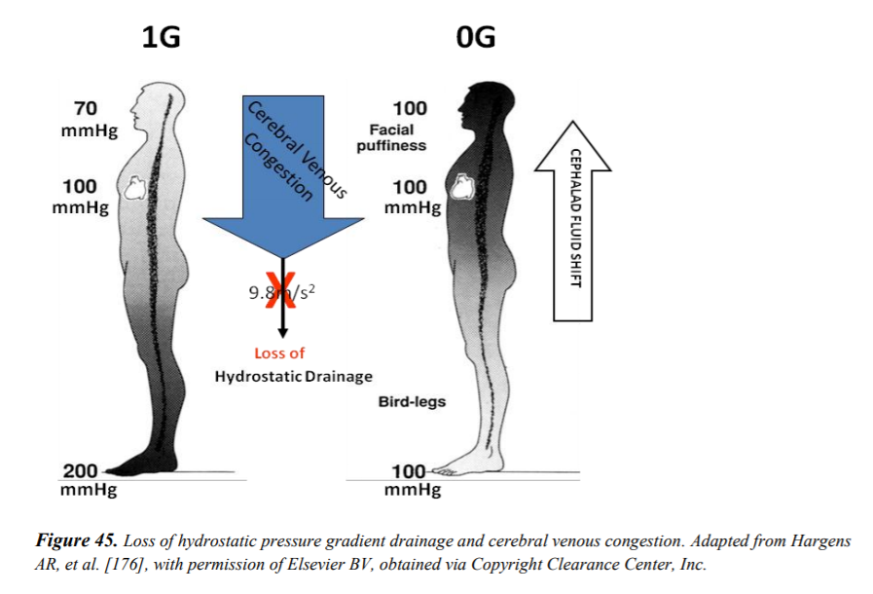
Results/Conclusion: Extended stays in microgravity result in significant risk to astronaut health. Although some countermeasures do help prolong the onset of health issues most do not entirely eliminate the problem. VIIP is one health issue of serious concern. Astronauts experience changes in vision after exposure to microgravity. The leading theorized cause is increased intracranial pressure due to fluid shift that occurs with exposure to microgravity (fig. 1). The brain can only handle a small increase in pressure (fig. 2); as pressure increases so does the pressure on the ocular nerve which can result in visual changes. Sixty percent of astronaut’s experience vision changes while in space, some of which, have not returned to pre-flight conditions even years later. With no current methods to counteract VIIP or fluid shift any long-duration mission could pose significant risk to astronauts (Alexander, 2012).
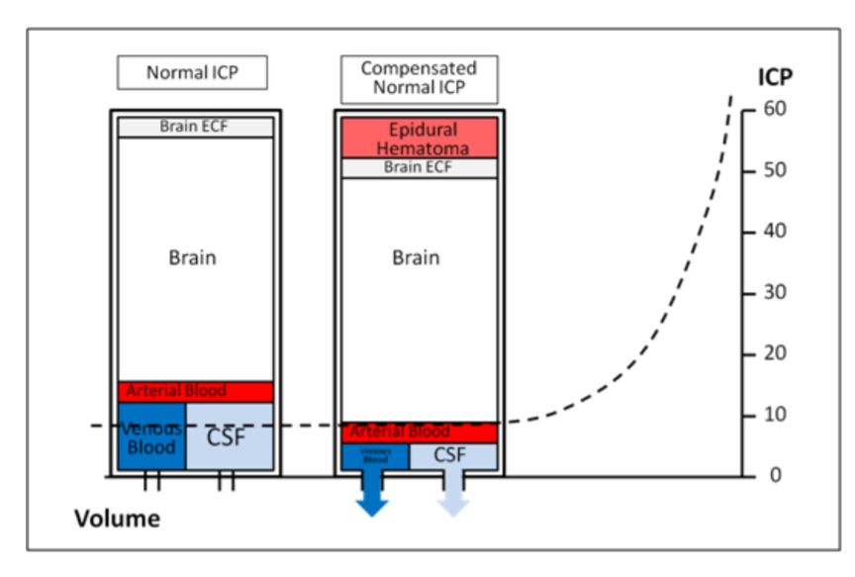

Fig. 1: Loss of hydrostatic pressure gradient drainage and cerebral venous congestion.
Fig. 2: Diagram showing the small buffering capacity that allows for increases in intracranial volume.
Both figures from “Risk of Spaceflight-Induced Intracranial Hypertension and Vision Alterations”, p. 68-69, (2012)
Fluid shift occurs in microgravity due to the body no longer having to work in gravity. There is no need to fight to pump blood to the brain and no longer can gravity assist in pumping blood to the feet. (fig. 1) The fluids start to shift away from the lower extremities collecting towards the upper body and head. The body reacts to this by excreting fluid in order to decrease the increased pressure now being exhibited on the upper body. “Bird-legs” and facial puffiness occur and stay present throughout the stay in microgravity. Over time the body will start to adapt to the new environment altering the cardiovascular system to best meet the demand. The neuroreceptors that detect when we stand up and adjusts the blood pressure to meet the temporary increase demand, lack their regular stimulation. With the disuse over time the receptors become less responsive, making returning to gravity difficult increasing the time needed to readjust. The decrease in fluid levels effect response time which, also results in more time needed to readjust to normal gravity (James, 1990). Current countermeasures being explored are lower body negative pressure suits, and small centrifuges. They both have potential to provide some relief but don’t solve the issue entirely. Artificial gravity could potentially eliminate the problem by providing forces similar to those present on Earth. Although it is important to research whether larger gravity gradients may affect these results.
Bone decalcification or bone mineral density (BMD) loss is another health risk that is of particular concern on long-duration missions. Weight-bearing bones specifically are the subject of BMD loss. In the microgravity environment bones no longer have to fight the stress of gravity; this change results in bones breaking down over time. Although resistive exercise helps to limit the loss, it does not mitigate the problem entirely. Trips to Mars that require long duration stays in microgravity pose significant risk for astronauts developing osteopenia or osteoporosis (fig. 3), as well as being at a higher risk of fractures during the mission (Axpe, 2020).
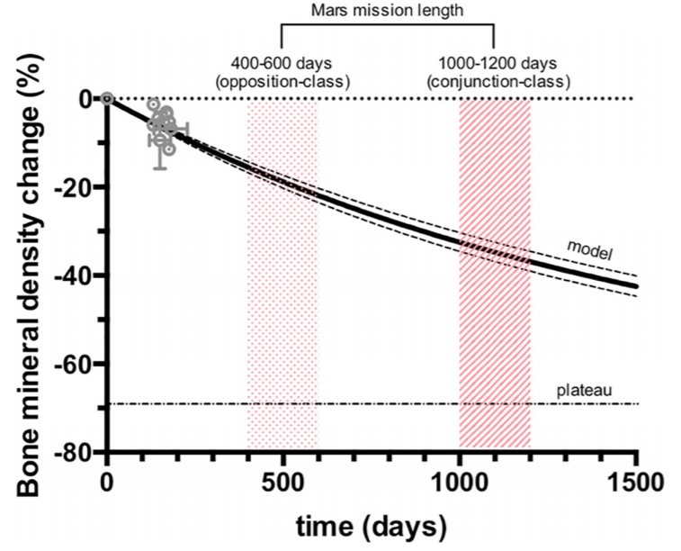
Fig. 3: Bone mineral density change at the femoral neck of astronauts versus duration of spaceflight. (Predictive Model)
- Grey dots represent experimental data obtained from previous missions.

Note: A decrease in BMD of 25% is considered severe osteoporosis.

Figure from “A human mission to Mars: Predicting the bone mineral density loss of astronauts”, p. 4, (2020)

As symptoms seen in space resemble the symptoms of osteoporosis on Earth, researchers like Baecker have looked at using Calcium and Vitamin D supplements to mitigate the loss. Although this can help patients on Earth it has proven ineffective as a countermeasure in microgravity. Microgravity induced osteoporosis varies from Earth osteoporosis by root cause. Microgravity results in a reduction in mechanical stresses on the bone inhibiting the formation process and increasing bone resorption. This type of bone loss is called disuse osteoporosis (Baecker, 2006). With the lower loading levels being the leading cause, the best countermeasure would be simulating gravitational forces to provide the necessary loads. The forces should effectively prevent the bone loss experienced in microgravity environments by restoring the stresses bones have to resist on Earth.
Muscles are yet another system at particularly high risk in microgravity environments. The decrease in muscle mass happens very quickly without the appropriate countermeasures.
“Short-term (< 30 d) space travel has shown to have detrimental effects on skeletal muscle metabolism, especially on the postural muscles of the lower extremities. As a result, marked reductions in muscle function and aerobic capacity have been reported within just a few days of microgravity exposure “(Cabrera, 2004).
In order to counteract the quick onset of muscle loss, astronauts exercise for up to two and half hours a day, six days a week. The use of resistive exercise equipment works to prevent the atrophy caused by the disuse. Although effective at slowing muscle loss it does not eliminate it entirely. Microgravity also negatively affects muscles on a metabolic level. Cabrera suggest that endurance training would work to limit these metabolic changes more effectively then standard training but still won’t eliminate it completely. (Cabrera, 2004). Another potential countermeasure is artificial gravity. The muscles used everyday just by standing up and walking around would once again have to resist a “downward” force. Not only would this prevent the muscle loss associated with microgravity but would allow for a faster recovery period upon return to Earth or upon landing on Mars.
Negative health effects of microgravity often focus on the physical however, there may be psychological effects as well. On long-duration flights far from Earth astronauts may experience “stress, sleep problems, mood change, interpersonal issues, time disorientation, headaches…, lack of motivation, and others” (Silva, 2013). Artificial gravity could provide a relief of some these symptoms by providing a more “Earth-like” environment. The more “Earth-like” it feels, the more “normal” the experience. By limiting the unfamiliar environment and providing more comfort, astronauts could feel much more connected and closer to home than they actually are.
Artificial gravity has an incredible potential to help mitigate or even prevent many of these serious issues associated with microgravity. Long-duration missions are at especially high risk due to the extended exposure to a microgravity environment. Not only is there an increased risk of health issue on the journey itself, but it also likely astronauts will face a much longer recovery period upon return to Earth. By providing an artificial gravity environment for astronauts to live and work in, the ultimate risk to their health could be greatly decreased. Not only would it allow for a faster recovery upon return to Earth, it will also allow for astronauts to transition to Mars gravity with little to adjustment period. The health of the crew is the upmost priority in any mission and artificial gravity shows great potential to limit current risks and provide a safer environment for astronauts to live and work in.
The research performed here will hopefully be of great use to any future proposals built in regard to artificial gravity. Spending the time sifting through papers and condensing the material into searchable and easily digestible portions will likely be invaluable. Ryan and Gabe will be able to build a stronger case in their artificial gravity proposal while still maintaining their many responsibilities. The specific data collected highlights the areas they wish to focus on and provides many resources that can easily be referenced.

References:

Alexander, D. J., MD, Gibson, C. R., OD, Hamilton, D. R., MD, PhD, Lee, S. M., MS, Mader, T. H., MD, Otto, C., MD, . . . Zanello, S. B., PhD. (2012). Risk of Spaceflight-Induced Intracranial Hypertension and Vision Alterations. Human Research Roadmap, 1-109. Retrieved from https://humanresearchroadmap.nasa.gov/evidence/reports/viip.pdf

Axpe E, Chan D, Abegaz MF, Schreurs AS, Alwood JS, Globus RK, et al. (2020) A human mission to Mars: Predicting the bone mineral density loss of astronauts. PLoS ONE 15(1): e0226434. https://doi.org/10.1371/journal. pone.0226434

Baecker, N., Frings, P., Boese, A., & Heer, M. (2006). Calcium and Vitamin D: Is Supplementation an Efficient Countermeasure to Bone Loss in Immobilization? 57th International Astronautical Congress. doi:10.2514/6.iac-06-a1.2.03
Cabrera, M. E., DiBella, J. A., Saidel, G. M., Radhakrishnan, K., & Stanley, W. C. (2004). A Mathematical Model of Skeletal Muscle Metabolism. Simulations of Exercise Responses after Space Travel and Endurance Training. 55th International Astronautical Congress of the International Astronautical Federation, the International Academy of Astronautics, and the International Institute of Space Law. doi:10.2514/6.iac-04-g.1.10
James, T. (1990). Cardiovascular adaptation to space flight. Space Programs and Technologies Conference. doi:10.2514/6.1990-3810
Silva, J. P., & Silva, J. P. (2013). Crew Health for Space Vehicles in a Mars Mission. AIAA SPACE 2013 Conference and Exposition. doi:10.2514/6.2013-5434

