The Mitigating Effects of Artificial Gravity on Microgravity
Elizabeth Anne Westfall 
Ryan Joyce
Langley Research Center, Systems Analysis and Concepts Directorate, Space Mission Analysis Branch
July 7th, 2020

The mitigating effects of artificial gravity on microgravity
Elizabeth Anne Westfall
Ryan Joyce
Langley Research Center, Systems Analysis and Concepts Directorate, Space Mission Analysis Branch

Abstract:

The effects of microgravity on the human body can be debilitating however, the use of artificial gravity has the potential to completely mitigate these effects. Developing an artificial gravity habitation spacecraft concept could have positive effects on the astronauts spending long durations in space. Researching the past and upcoming artificial gravity concepts was accomplished using resources provided by my mentors, i.e. NASA Technical Reports Server (NTRS), human research roadmap, and the Aerospace Research Central (ARC) in coordination with other academic sources and research papers. This research has been accomplished over a several week period that looks at past artificial gravity concepts and the implications of instituting them or new designs in the future. Also, the research examines how to improve future artificial gravity concepts by applying what we know about past designs and what we are creating today. The expected outcomes of artificial gravity are that the health risks imposed on astronauts due to not being in Earth’s gravity environment for long duration space missions will decrease. No other microgravity mitigation technique addresses neurological problems such as fluid shift and VIIP syndrome as they only address physical conditions with exercise and supplements Another outcome is that using artificial gravity should reduce the long-term health effects that happen after the astronauts return to Earth because they will not be exposed to microgravity for as long. The real outcomes should be similar, if not the same, as the expected outcomes mentioned above. This process of creating artificial gravity aboard spacecrafts has potential to create a plethora of positive outcomes. The research completed will contribute to NASA’s missions and goals because the information gathered directly relates to the goal of sending humans to Mars and beyond and the research looks at how to solve one of the major problems associated with achieving that goal soon: microgravity. This research will contribute to NASA’s mission of sending astronauts to Mars, with a lower risk assessment, because artificial gravity will potentially mitigate the health risks (VIIP syndrome) associated with long duration in space flight.

Microgravity, the lack of Earth’s normal gravitational force of 1 g, has severe and lasting effects on astronauts who venture up to space for an extended period. These effects can cause VIIP syndrome, bone mineral density loss, negative cardiovascular effects, and muscle atrophy (Ball 2002). Some effects are long lasting while others dissipate once the astronaut returns to Earth’s gravity. However, what if they are not returning directly to Earth but are going to Mars instead. The way to mitigate these negative effects could be artificial gravity, the creation of an acceleration like that of Earth gravity by using the centrifugal force or another physical force (Clement 2015). Artificial gravity has the potential to reduce the risks associated with long term space flight. This method of mitigation has been minimally explored since the early nineteen hundred’s and has produced several concepts for artificial gravity habitats: Stanford Torus, Bernal Sphere, and the O’Neill Cylinder; these are the original designs form the beginning of the research (Scharmen 2018). These designs were created to support a whole space colony of thousands of people, but we need to redesign or create new concepts in order to support a small crew of astronauts in order to get them safely to their destination before initial long-term space missions. We also need to build a modest proof of concept design so that we do not build a large-scale spacecraft that may or may not work and have wasted unnecessary money.

These larger than life concepts could be tweaked in order to get them down to the right scale or they could just be thrown out and we could design new concepts. The newer concepts look very different than the older concepts as they do not rely as heavily on the centrifugal force as in the past. Some newer designs use linear acceleration or rotate only part of the spacecraft as compared to rotating the whole vehicle. The linear acceleration model would have the astronauts lay in “sleds” and send them back and forth on a track (Gruber 2018). This is a very different idea as compared to whole rotating cylinders or rings, but this concept can reduce the Coriolis Effect, the apparent deflection of an object in motion while rotating. The Coriolis Effect can occur in certain models of artificial gravity concepts like the torus or the cylinders when the person moves perpendicular to the axis of rotation (Clément 2015). This effect can cause motion sickness and overall discomfort especially if the effect is very large which is why the radius and acceleration rate (omega) must be chosen very carefully with human comfort, cause, and physics boundaries in mind. Perceived acceleration differential is unavoidable and is when your head and feet spin at different rates because of the difference in radius. When the radius goes up, the cost probably increases and vice versa while if you increase omega, the health effects go up and vice versa. The relationship with the two variables is such that as the rotations per minute increase the radius decreases, so the perfect balance needs to be met in order to keep all the interests in balance (Clément 2015). There are numerous equations that quantify what these variables can be, but it is challenging to factor in the human limits for these environments. This is because there is no research on the topic because you cannot recreate pure microgravity on Earth’s surface. There are several studies that research what an appropriate range of tolerance is but there is no definitive answer so we must be conservative when choosing the radius and rate of rotation or perform tests in space to define appropriate bounds. These are all valid considerations for the design concepts that feature a whole rotating vehicle or a cylindrical shell. There are however, new design concepts that feature alternative ways of creating this artificial gravity without using the centrifugal and centripetal forces.

Design concepts that feature an inflatable dome or a linear sled can reduce the variables needed to make the decisions about size and parameters. Ideas such as linear sleds, or inflatable domes can reduce the Coriolis effect and therefore the need for such a thorough examination into the relationship between the radius and rotation rate (Zipay 2019). A linear sled concept does not involve rotation at all as the astronaut would be linearly accelerated on a track and then flipped around and decelerated (feet above head acceleration) (Gruber 2018). An inflatable dome is different from a rotational concept in the sense that the whole space craft is not rotating; the dome is rotating and has a track inside that the astronaut can utilize to enact artificial gravity (Zipay 2019). These newer design concepts still tend to feature a rotational element to them because the centrifugal and centripetal forces are the most common in recreating gravitational forces. This can be the rotation of a smaller part of the space craft instead of rotating the space craft in its entirety. An example would include the inflatable tank, where it will be blown up once in space and rotate with a track or stationary bike, so that the astronaut can exercise, in the inside and as it rotates you are exposed to artificial gravity (Zipay 2019). This may reduce some of the risk for the Coriolis effect because you will only be spinning a few hours per day opposed to all day for months. However, there is not set research into how long you would have to be exposed and to what the spin rate should be, we need to do more in space experiments in order to gain the knowledge about those variables.

Each of the design concepts that have been created have their benefits and flaws with some outweighing the others. There is no perfect artificial gravity design out there currently. This is because while we have been thinking about the concept for decades, we haven’t really gotten serious about implementing it therefore, the research and design concepts are just not as focused as we need to be considering. Even though the math and science behind the concepts hasn’t changed, there can always be a new idea with more people working on it. The more we discuss this idea, the newer ideas will come out of it. We have numerous design concepts, i.e. Stanford Torus, Bernal Sphere, O’Neill Cylinder, Kalpana One, Lewis One, SLS LOX Tank, Linear Sled, Rotating NTP, ARMSTRong, suspension cable model and the tethered model, just to name a few of the design concepts. All the designs have their novel solutions and their identified challenges, the question to be asked is: do their benefits outweigh their challenges or vice versa?

The Stanford Torus was originally designed to be a whole space colony so if scaled down this design has potential. It has great energy protocols that allow numerous features that other designs do not have but it also is large and therefore costly to build. It has been designed to have a giant mirror, while not one hundred percent necessary, to allow for natural sunlight, so it is not the greatest design with the mirror and size/cost to build (Martelaro 2017).
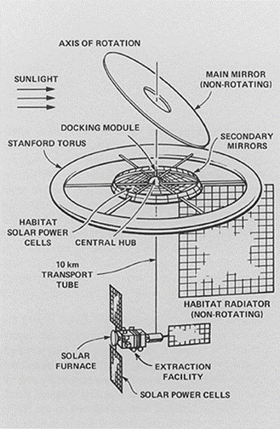
Annotation: This depicts the potential design of the Stanford Torus. It illustrates all the additional features; habitat radiator, solar furnace, main mirror, and transport tube.
Source: (Martelaro 2017)

The Bernal Sphere was another design concept built in mind of having a space colony, however if it is scaled back it does have some good features. Like the Stanford Torus, this design will have the Coriolis Effect to deal with but not in the same way. In all rotational concepts your head and feet move at different speeds, but the Bernal Sphere also includes several different gravity levels within the space craft. This design is also likely to be large even when scaled back, so that is not good, but it does have benefits like increased space to house crew members and spare parts (Fredericksen n.d.).

The O’Neill cylinder is the basis for numerous concepts and designs that are theoretically considered today. It has benefits such as the ample space inside of the craft as well as challenges such as the heavy Coriolis effect and how expensive it would be to build a solid steel cylinder. This was one of the very first designs for an artificial gravity concept so it would have to be scaled back quite a bit as it was designed for a whole space colony as well (Curreri & Detweiler 2011).

The Kalpana one is a similar design to that of the O’Neill cylinder as it is essentially just a short and fat version of the tall and skinny O’Neill cylinder. This design has more wobble control and natural light advantages than its counterparts as it its rotational axis is that of the Solar System’s north-south axis. This is another design concept that was made with the idea of a whole space colony so we would need to drastically downsize this model for it to be considerable (Globus, Arora, Bajoria, & Strout 2007).

The Lewis One is a space biosphere that is similar in design to the O’Neill cylinder and the Kalpana One but has distinct differences. This concept would feature a range of gravitational forces throughout, ranging from the Moon to Earth in small increments. This would be critically important as it would be very helpful in the adjustment the crew would face going from Earth gravity to Martian gravity and vice versa on the return home. However, it does have flaws such as the incredibly large design as it was designed in the late nineteen hundred’s when scientists were looking at artificial gravity in order to form a space colony, so if the design concept was tinkered, it would have potential (Globus 1991).

The SLS LOX Tank is recent design concept that features a tank that would rotate as opposed to rotating the whole spacecraft. This tank could be inflatable with a steel shell or just made from metal entirely. It could have treadmills or tracks on the inside so that as the astronaut exercises, they would be exposed to the artificial gravity. This is a rather different concept as the whole space craft is not rotating as fast, therefore, it reduces some of the variables that are harder to control. It does still have the Coriolis effect and it will be a bit of challenge to deal with because we are shortening the radius and therefore the spin rate will have to increase and that could have negative health effects (Zipay 2019).

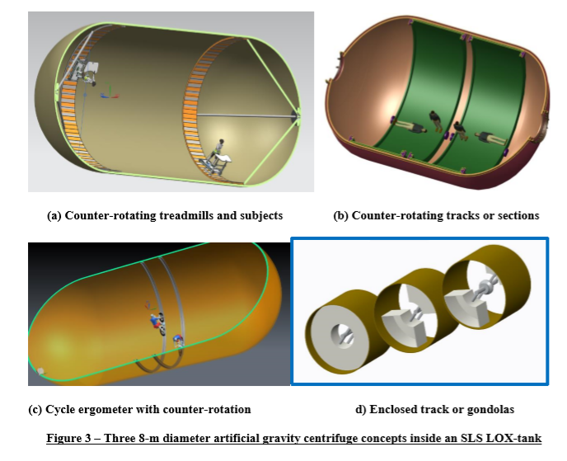
Annotation: Featured above is an image of what the SLS LOX Tank would feature on the inside. It could include a track or stationary bikes on the inside of the rotating dome.
Source: (Zipay 2019)

The linear sled is a design concept from 2018 and it would create artificial gravity by linear acceleration. It would achieve this by attaching a track to a space craft and then accelerating an astronaut forward and then flipping them and decelerating them backward (feet above head) on a sled on the track. This limits the Coriolis effect as they are not rotating the space craft, it is simply rotating the astronaut at the end of the track which could potentially still have negative effects. The length of the track and acceleration rate is similar ratio debate to that of radius and spin rate; there is simply not enough research done to be able to give a concrete number so that is a big problem with this design (Gruber 2018).

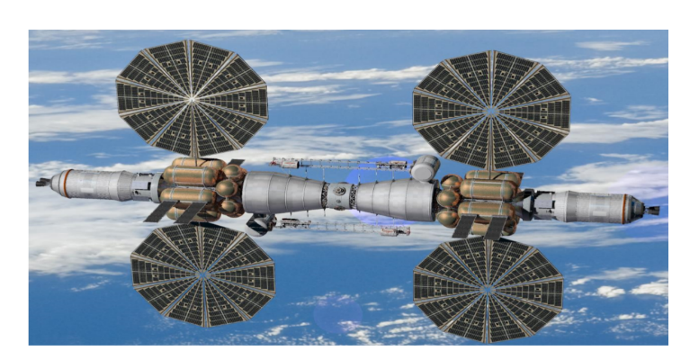
Annotation: Featured above is a depiction of the linear sled artificial gravity design, it features the sled and track on the top and bottom of the spacecraft.
Source: (Gruber 2018)

Bimodal engines (rotating NTP) provide high thrust propulsion and continuous twenty-four seven electrical power. It is compatible with artificial gravity and would be rotated about its center of mass and perpendicular to the flight vector would create the centrifugal force and the artificial gravity environment. These are high thrust engines which would require a lot of energy or fuel which would be expensive which is a big downfall. This design is naturally equipped to be an artificial gravity environment which makes it easier to implement it as opposed to other designs where you must essentially force the artificial gravity by implementing constant thrust (Borowski, McCurdy, & Packard 2014).

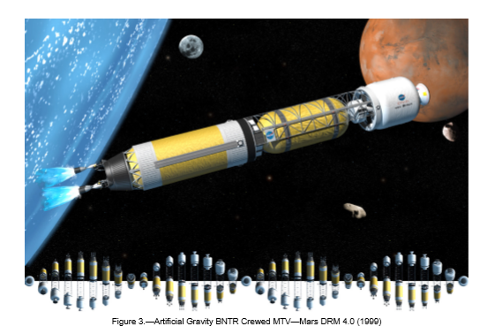
Annotation: This design depicts the bimodal engines or rotating NTP concept for artificial gravity. It features high thrust propulsions and continuous electrical power and would be rotated about its center of mass to create artificial gravity.
Source: (Borowski, McCurdy, & Packard 2014)

The ARMSTRong model is named after the late astronaut and is short for artificial gravity rotating modular space transport. This design has a main hub and two deployable wings; it would have a spin rate of 5.45 rpm and a radius of 30m in order to achieve optimal artificial gravity. This design is more cost efficient than others because of the flexible wings that deploy. If the wings are inflatable or made of a material that is flexible that does add the challenge of the stability of them once they are deployed in space, but it cuts cost down. The temperature of the wings is also of concern as the material will not support temperature retention or keeping it out so the desired temperature will most likely be unsustainable. This is a great design that has potential if the physics of it gets a little more work (Barbeau, Fehrenbach, Jacob 2013).

The suspension cable design is a popular, new design that features an inflatable shell where the crew would stay and suspension cables separating the hub and the masts and the main power supply. Rotating at 4 rpm would create the 1 g of artificial gravity however there are issues in this design. Such as CG offsets in habitat and power modules causing stability concerns; there are a lot of moving parts and pieces in this design so there is a lot of potential error sources. The suspension cables are a sturdy way to cut cost down but increase the radius; this will allow for the rotation rate to be kept at a conservative number, as current research suggest it will be lower (Joosten 2002).

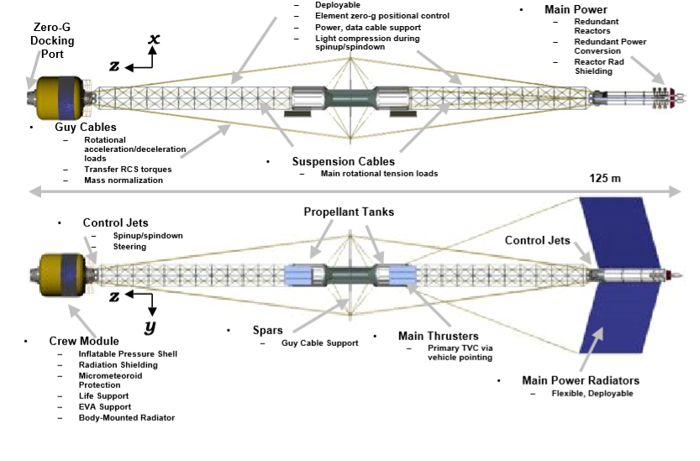
Annotation: The design pictured is one that includes a larger radius as it has suspension cables which enables it to do the latter cheaply. This will enable the rotation rate to be lowered.
Source: (Joosten 2002)

The tethered design features a dumbbell shape that would create artificial gravity by spinning about its axis with one end being a pressurized inflatable module for the crew and the other end being docking port. The docking port would act as a center for low gravity operations and as a counterweight for the crew module. There would need to be a mechanism to spin up and spin down the facility quickly which has yet to be developed. Another challenge would be tracking inertial targets form a rotating facility of this design. This design cuts down cost by using tethers which is exceptional and will allow for the radius to be rather large which will help in the Coriolis effect calculations, as well as the spin rate and radius calculations (Sorensen 2005).

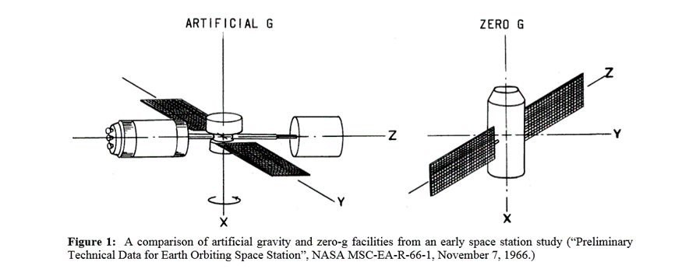
Annotation: This design concept depicts a tethered module counterweighted with a docking port. On the other side is the crew module, which would be where the artificial gravity reached one g.
Source: (Sorensen 2005)

Another design concept of the tether includes a similar setup with four different radius and spin rate ratios (2rpm/121 m, 1.5 rpm/216 m, 1 rpm/ 486 m, and 0.55 rpm and 1600m). this second rendering of the design also includes lunar and Martian gravity zones of the space craft. This would be incredibly helpful in the adjustment on the way to Mars and on the way back home for the crew as adjusting to very different gravitational levels will be challenging physically and psychologically (Carroll 2010).

All the designs mentioned above have their benefits and challenges; they are all different in numerous ways but some overlap design wise. Yet, all these designs support artificial gravity, therefore, any of them could be chosen in the future as space crafts and could be very helpful in mitigating the negative effects of microgravity.

The challenges of implementing artificial gravity are vastly outweighed by their ‘potential solutions to the problem of microgravity. Any solution to a problem this large, come with smaller problems of their own, and artificial gravity is no different. Implementing artificial gravity could be costly and risky. Effects from it could include the Coriolis effect if rotational acceleration is used and while these effects are not deadly, they are still worth taking note of due to the discomfort and disorientating effects they may have on the crew (Clément 2015). These effects can be thoroughly mitigated through protocols mentioned above in the design of the space crafts, but it will more than likely always be of concern as you cannot eliminate it. This implementation will also be costly as the design of these space craft’s features more parts than ordinary space crafts (Clément 2015). Will this cost and risk outweigh the effects of flying on a regular space craft for long durations? I think that will be very valuable to use artificial gravity as it has the potential to eliminate several negative effects that astronauts face today. If we are to implement it, we can probably control the countereffects to make them minimal which would make for more optimal conditions for a flight to Mars then we currently have available.

The rotation rate and radius ratio is one of the fundamental concerns associated with artificial gravity implementation. The rotation rate is how fast the space craft spins or rpm and the radius is how large across the space craft is. These two variables are inversely proportional as the radius increases and the rotation rate decreases (Hall 2006). If the radius is increased, that means the cost to produce the spacecraft increases significantly while if you increase the rotation rate, the health effects can be negative. The health effects have not been thoroughly researched therefore, there is no set number as to what this ratio should be. It has been shown that too high of a rpm, the humans get motion sickness and disoriented. However, the rpm needs to be high enough so that the radius can be smaller, so the cost to build is not excessive (Clément 2015). This is a careful balance and one that will be full of tradeoffs; once more research is done into the health effects of artificial gravity in space then the comfort zone can be chosen, and the radius and rotation rate ratio can be chosen with cost and health in mind (Hall 2006).

The Coriolis effect is the potential problem associated with artificial gravity implementation, while it is not fatal to astronauts it still needs to be addressed and mitigated as much as possible. The Coriolis effect is mentioned numerous times as a challenge to design concepts from the past and present. This is essentially an effect whereby a mass moving in a rotating system experiences a force (the Coriolis force) acting perpendicular to the direction of motion and to the axis of rotation. This can cause motion sickness and disorientation in astronauts if they move perpendicular to the axis of rotation (Clément 2015). It is critical that the crewmembers not be disoriented because they cannot function to the best of their abilities if they are and therefore, it will be much harder to experiment and do basic maneuvers on the space craft or the planetary body.

The negative health implications of deep space exploration are plentiful and can be severe. However, artificial gravity may be a solution to some of these health conditions because it plans to eliminate the microgravity conditions. These health effects can range from fluid shift, osteoporosis (loss of bone density), loss of muscle mass and function (atrophy), high blood pressure, cardiovascular issues, pulmonary issues, alimentary system, nervous system, sleep cycle, eye-hand coordination, peripheral nervous system, reproductive system, and the urinary system (Ball 2002). Artificial gravity has the potential to eliminate numerous problems mentioned above but not all of them as it is not a fix all solution. By enacting artificial gravity, astronauts should feel as if they are on Earth or at least as close as possible. This should reduce the conditions that arise from being in microgravity such as bone loss, fluid shift, and muscle atrophy (Ball 2002). This will not fix perceived problems such as sleep cycle issues. Another major health problem is VIIP syndrome or visual impairment intracranial pressure syndrome is when the microgravity-induced cephalad fluid shift increases intracranial pressure (ICP) and drives remodeling of the optic nerve sheath (Raykin, Forte, Wang, Feola, Samuels, Myers, Nelson, Gleason, & Ethier 2016). This condition is still being researched but it has the potential to be reduced by enacting artificial gravity.

The idea of using or creating artificial gravity has been considered infrequently for decades but was not seriously considered until recently when a mission to Mars was proposed. The concept of simulating a gravity like that of Earth has numerous potential health benefits. Artificial gravity and its effects still need to be greatly researched before enacted but this concept has great potential in the realm of long-term deep space missions. Artificial gravity could be a solution to the problem of microgravity, but it does come with its own smaller problems that need to be corrected. The physics of this idea can cause implications such as the Coriolis effect which can cause some minor health effects, but they should be outweighed by the plethora or negative implications from using the current model of space flight. The artificial gravity designs that are examined in this report are not perfect and come with flaws, but they also have their benefits. It comes down to what variables (radius, rpm) can and should be manipulated, in order to get the best possible results. If enough possible positive results can be gained, then there should be some serious consideration into enacting artificial gravity protocols in place of or in addition to current space craft protocols.

The approach of this project was to thoroughly research the health effects, physics, and past/future artificial gravity concepts in order to understand how to move forward. I planned to do the project by researching artificial gravity concepts and collaborating with my fellow interns and my mentors. In doing that, I was able to gain an all-around perspective and understand of the problem and potential solutions. The expected outcomes of the project were to find ways to mitigate microgravity on long duration deep space missions. The optimal outcome is that artificial gravity could mitigate the negative effects that microgravity has on astronauts. I used a NASA computer in order to complete this project in addition to the guidance from my mentors that I received throughout the project. I was based out of the Langley Research Center for my project, but it was completed virtually so the only tool that I utilized was the NASA computer.

I did achieve the project expectations as I did get an understanding and knowledge of artificial gravity and microgravity. We also found potential solutions to combat microgravity and its negative health effects on astronauts on long term deep space missions. Overall, we all collaborated as a team and achieved the goal of trying to find a suitable solution to microgravity and its negative effects. My recommendations for the future of this project would be to further research the newer design concepts featuring artificial gravity as well as to further investigate the radius and rotational rate ratio. I would also recommend that more research be done into the human limitations in rotational rate.

References

Ball, John R. Safe Passage Astronaut Care for Exploration Missions. National Academy Press, 2002. https://www.ncbi.nlm.nih.gov/books/NBK223785/
Barbeau, Z., Fehrenbach, S., Jacob, J. (2013, January 05). Development and Testing of and Inflatable Artificial gravity System. Aerospace Research Central. https://arc.aiaa.org/doi/10.2514/6.2013-730
Borowski, S., McCurdy, D., & Packard, T. (2014). Conventional and Bimodal Nuclear Thermal Rocket (NTR) Artificial Gravity Mars Transfer Vehicle Concepts. NASA Technical Reports Server. https://ntrs.nasa.gov/archive/nasa/casi.ntrs.nasa.gov/20160014801.pdf
Carroll, Joseph A. (2010). Design Concepts for a Manned Artificial Gravity Research Facility. http://www.spacearchitect.org/pubs/IAC-10-D1.1.4.pdf
Clément, Gilles R et al. (2015, June) “Artificial gravity as a countermeasure for mitigating physiological deconditioning during long-duration space missions.” Frontiers in systems neuroscience vol. 9 92. 17, doi:10.3389/fnsys.2015.00092 https://www.ncbi.nlm.nih.gov/pmc/articles/PMC4470275/
Curreri, Peter A., & Detweiler, Michael K. (2011, January 01). A Contemporary Analysis of the O’Neill-Glaser Model for Space-based Solar Power and Habitat Construction. NASA Technical Reports Server. https://ntrs.nasa.gov/archive/nasa/casi.ntrs.nasa.gov/20120001744.pdf
Fredericksen, Dick. (n.d). Bernal Sphere Space Settlement Detail. National Space Society. https://space.nss.org/bernal-sphere-space-settlement-detail/
Globus, Al. (1991, May). The Design and Visualization of a Space Biosphere. https://settlement.arc.nasa.gov/LewisOne/lewisOnePaper.pdf
Globus, A., Arora, N., Bajoria, A., & Strout, J. (2007). The Kalpana One Orbital Space Settlement Revised. http://alglobus.net/NASAwork/papers/2007KalpanaOne.pdf
Gruber. J., Seyedmndani, K., & Clark, T. K. (2018, February 14). Linear Sled Hybrid Artificial Gravity Concept. NASA Technical Reports Server. https://ntrs.nasa.gov/search.jsp?R=20190001171
Hall, Theodore W. (2006). Artificial gravity Visualization, Empathy, and Design. American Institute of Aeronautics and Astronautics. file:///C:/Users/eawestfa/Documents/AIAA-2006-7321.pdf
Joosten, Kent. (2002, July 16). Artificial gravity for Human Exploration Missions. https://history.nasa.gov/DPT/Technology%20Priorities%20Recommendations/Artificial%20Gravity%20Status%20and%20Options%20NExT%20Jul_02.pdf
Martelaro, Nikolas. (2017, May 18). Powering the Stanford Torus. Stanford University. http://large.stanford.edu/courses/2016/ph240/martelaro2/
Raykin, J., Forte, T., Wang, R., Feola, A., Samuels, B., Myers, J., Nelson, E., Gleason, R., & Ethier, R. (2016, February 08). Optic Nerve Sheath Mechanics in VIIP Syndrome. NASA Technical Reports Server. https://ntrs.nasa.gov/search.jsp?R=20160012465&hterms=viip+syndrome&qs=N%3D0%26Ntk%3DAll%26Ntt%3Dviip%2520syndrome%26Ntx%3Dmode%2520matchallpartial
Scharmen, Fred. “The Shape of Space: NASA Designs for Orbital Space Settlements.” Places Journal, 1 Aug. 2018, placesjournal.org/article/the-shape-of-space/?cn-reloaded=1.
Sorensen, Kirk. (2005). A Tether-Based Variable-Gravity Research Facility Concept. http://www.artificial-gravity.com/JANNAF-2005-Sorensen.pdf
Zipay, John J. (2019, January 07). Near-Term Artificial Gravity Concepts for Deep Space Missions. NASA Technical Reports Server. https://ntrs.nasa.gov/search.jsp?R=20190000843&hterms=Near-Term+Artificial+Gravity+Concepts+Deep+Space+Missions&qs=N%3D0%26Ntk%3DAll%26Ntt%3DNear-Term%2520Artificial%2520Gravity%2520Concepts%2520for%2520Deep%2520Space%2520Missions%26Ntx%3Dmode%2520matchallpartial

