Chapter 16
Electric Aircraft Cooling with Bio-Inspired Exergy Management
Rodger W. Dyson
NASA Glenn Research Center, Cleveland, OH, 44135, USA
Abstract: Future air vehicles will increasingly incorporate electrical powertrains that require very tight system-level integration of power, propulsion, thermal, fault protection, and airframe technologies. This chapter provides an overview of a new category of thermal energy conversion technology and describes the development of the resulting Thermal Recovery Exergy Efficient System, TREES. TREES can be used to enable a fully solid-state integrated thermal and fault management electric aircraft protection system, while synergistically managing and recycling both the low-grade waste heat from electrical components and the high-grade waste heat from engine components. This is achieved with exergy amplification of the powertrain waste heat, a new class of fast flight-weight breakers, a new class of long variable-conductance heat pipes with multiple switchable condensers, a new class of turbofan-integrated heat exchangers, and a gradient-based powertrain system optimizer. This approach is like the human body’s thermal management system in which the heart, arteries, and veins are analogous to the turbofan, acoustic tubes, and heat pipes proposed herein.

Key Words: Thermoacoustic, heat pipes, electric aircraft propulsion, recuperation, arterial, homeostasis, waste heat recovery, integrated power propulsion thermal

Nomenclature
A = area of tube cross section, m²
C = compliance, m³/Pa
c = sound speed, m/s
DC = direct current
f = frequency, Hz
IGBT = insulated-gate bipolar transistor
L = inertance, kg/m⁴
MOSFET = metal-oxide silicon field-effect transistor
MOV = metal oxide varistor
P = acoustic power, W
p₀ = pressure mean, Pa
PPTFA = power, propulsion, thermal, fault protection, and airframe technologies
Q = heat, J
Sp_{elec} = electric drive specific power, kW/kg
T = temperature
T_{h} = hot-side temperature, K
T_{c} = cold-side temperature, K
TREES = Thermal Recovery Exergy Efficient System
U = volume flow rate, m³/s
V_{l} = velocity gas-particle left, m/s
V_{r} = velocity gas-particle right, m/s
W = work, J
W_{ac} = acoustic work input
X = exergy, J
Z = acoustic impedance, Pa s/m³
γ = specific heat of air, 1.4
δ_{k} = particle displacement
η_{elec} = electric drive efficiency

Introduction
Electric air vehicles range from small unmanned aerial systems used for package delivery to urban air taxis for commuters to large single-aisle transport class aircraft for airlines. All these vehicles require tight integration of the power, propulsion, thermal, fault protection, and airframe technologies (PPTFA) to reach their maximum fuel, emission, noise, and mobility benefits. Historically, these technologies were designed separately and optimized at the subcomponent level. But after decades of development, each component has nearly reached its full potential, and only by integrating these traditional components together with new thermal energy conversion technologies is it possible to achieve a new level of aircraft architecture that synergistically integrates PPTFA. This chapter will present a new thermal energy conversion technology, Thermal Recovery Exergy Efficient System (TREES), for recycling and managing all the low-grade waste heat on an air vehicle. The TREES system utilizes acoustic mechanical energy distribution to pump waste heat to a higher temperature (increase exergy) and then distributes and reuses the more useful higher temperature heat throughout the aircraft via solid-state switching heat pipes that dynamically change where the heat travels during flight while also potentially improving overall fuel efficiency. This technology can be integrated with distributed fast-response solid-state fault management technology to provide a unique electric aircraft powertrain configuration that improves both system reliability and performance. This chapter will provide an overview of the TREES technology development, including both design details and test results from a recent prototype demonstration.

Technology Barriers for Air Vehicle Adoption
As shown in Figure 16.1, the history of electric aircraft propulsion can be traced back to 1883 in the form of all-electric propulsion. And like the history of electric ground vehicles, energy storage was a limiting factor in its utility. Today, however, many of the electric powertrain technologies have improved in the three categories of efficiency, specific power, and energy density to the point where small all-electric air vehicles now do have utility and larger electric air vehicles—when also employing traditional fueled systems (hybrid electric)—also offer utility. The next technology frontier for greater market adoption requires making these vehicles safe to operate. This includes having the ability to quickly respond to high-voltage/high-power electrical faults and safely manage the significant new heat loads these new technologies produce—often at low temperatures—that make it difficult to reject heat and distribute it throughout the entire air vehicle. Indeed, as seen in Figure 16.1, over time the power level, voltage, stored energy, and low-grade heat loads are expected to increase, thereby further challenging both the fault and thermal management systems.
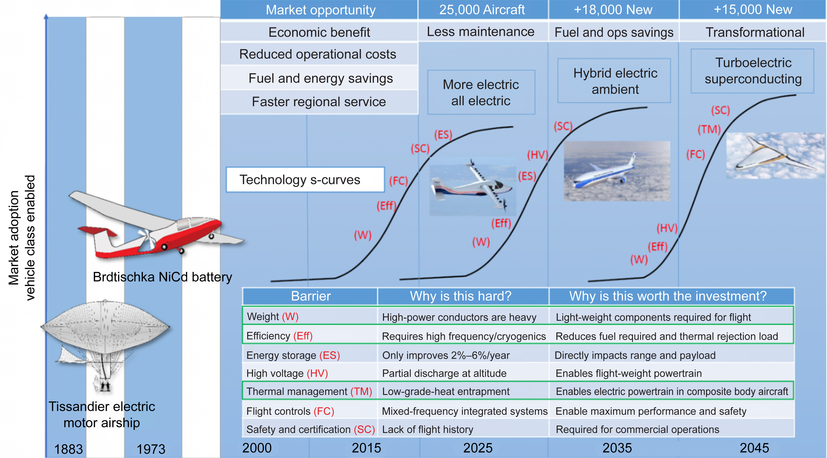
Caption: Figure 16.1. Thermal and fault management technologies are barriers for market acceptance

Credit: NASA

Fault Management Challenge
Different fault management technologies were scrutinized for integration with TREES. The high power, voltage, and current required for flight-weight electric aircraft propulsion presents a new challenge for safely managing powertrain electrical faults—especially with the DC power distribution systems currently being employed. Although AC fault management is potentially more tractable because of the cyclic zero-crossing of the voltage, most electric air vehicles are using high-voltage DC power distribution because there are both mass and controllability benefits (fewer distribution cables and machine frequency independence). Also, because of recent advances in power electronics technology both the efficiency and mass of DC machine drives is now adequate for flight use. However, high-voltage DC fault protection technology is still a pacing item for continued progress in this space.

The DC breaker technology options include electromechanical, solid state, or a hybrid of the two. A circuit breaker comparison is shown in Figure 16.2 (Armstrong, 2015). As listed in Table 16.1, the benefit of an electromechanical circuit breaker is high conduction efficiency (>99.97%) through a metal, but it has a limited opening speed of >10 ms. The solid-state circuit breaker is very fast at opening a circuit (<500 μs), but it produces 6 times more low-grade heat because of lower efficiency (<99.3%). A hybrid circuit breaker system achieves both high efficiency and reasonable opening speeds of about 1 ms, which is adequate for most terrestrial applications. Recent work by both the Advanced Research Projects Agency–Energy and U.S. Navy have continued to develop DC breaker technologies for ground use, but air vehicles have additional requirements, including

- Having a >100-μs response time to protect sensitive equipment with insulated-gate bipolar transistors (IGBTs) (a hybrid breaker at 500 μs can protect personnel and aircraft from catastrophic events, but the aircraft powertrain components can still be damaged from over-current conditions lasting this long)
- Optimizing both the volumetric density and power density because mass is such a driver for aircraft (see Fig. 16.3)
- Managing high-voltage altitude-related effects such as partial discharge, corona discharge, creepage, and clearance at up to 51,000 ft during flight conditions
- Realizing efficiency is not as important as mass because many other elements in the powertrain are less than 99% efficient, and it is necessary to achieve >7 kw/kg powertrain mass overall for a net vehicle benefit (and we propose recycling the waste heat for a net system benefit)
- Cooling with fluids, air, or other approaches on aircraft, whereas terrestrial microgrid applications may only have air convection, for example (we propose solid-state acoustic heat pumping for exergy amplification)

As shown in Table 16.1, the solid-state circuit breaker option is ideal for air vehicles if the electrical losses can be addressed. Specifically, two areas must be addressed before a solid-state circuit breaker could be successfully employed. First, the electrical losses in double-pole bidirectional solid-state circuit breakers can be significant in a megawatt electric aircraft powertrain.

Table 16.1. Fault Management Technology Options
 | Mechanical | Solid-state | Hybrid
Device to break current | Mechanical switch | Semiconductor devices | Semiconductor devices and mechanical switch
Benefits | Low conduction loss | Super-fast response time (<10 μs) Simple structure | Low conduction loss  Fast response time (1–5 ms)
Limitations | Slow response time (50 ms) | High conduction loss (~0.5%) | Complexity

Shown in Figure 16.2 is schematic of a new class of fault management technology being developed by a team from the Naval Postgraduate School that can achieve flight weight, speed, and altitude requirements if the loss of efficiency can be mitigated with thermal recycling. Previous system studies (Jansen, 2019) (see Fig. 16.3) clearly show any efficiency losses in the powertrain must be traded with an equivalent amount of mass reduction to continue to show a net vehicle block fuel benefit unless the waste heat can be recycled. Secondly, between 7 and 10 kW of low-grade thermal heat is produced for each megawatt-scale breaker in the system. Generally, the combined negative impact of both the significant loss in powertrain efficiency and the new distributed heat loads would constrain breaker technology to the selection of a hybrid circuit breaker despite its relatively slow response time. Also, electric air vehicles would need to be designed to compensate for this increased risk of powertrain component damage during fault events. However, as will be shown, a new integrated approach for managing the low-grade heat on an aircraft can mitigate both the reduction in powertrain efficiency and the release of low-grade heat throughout the aircraft from solid-state circuit breakers. Then the potentially very high-speed fault response can be leveraged to protect not just personnel and airframe, but also all the sensitive power electronics and sensors on the powertrain during both hard and soft fault events.

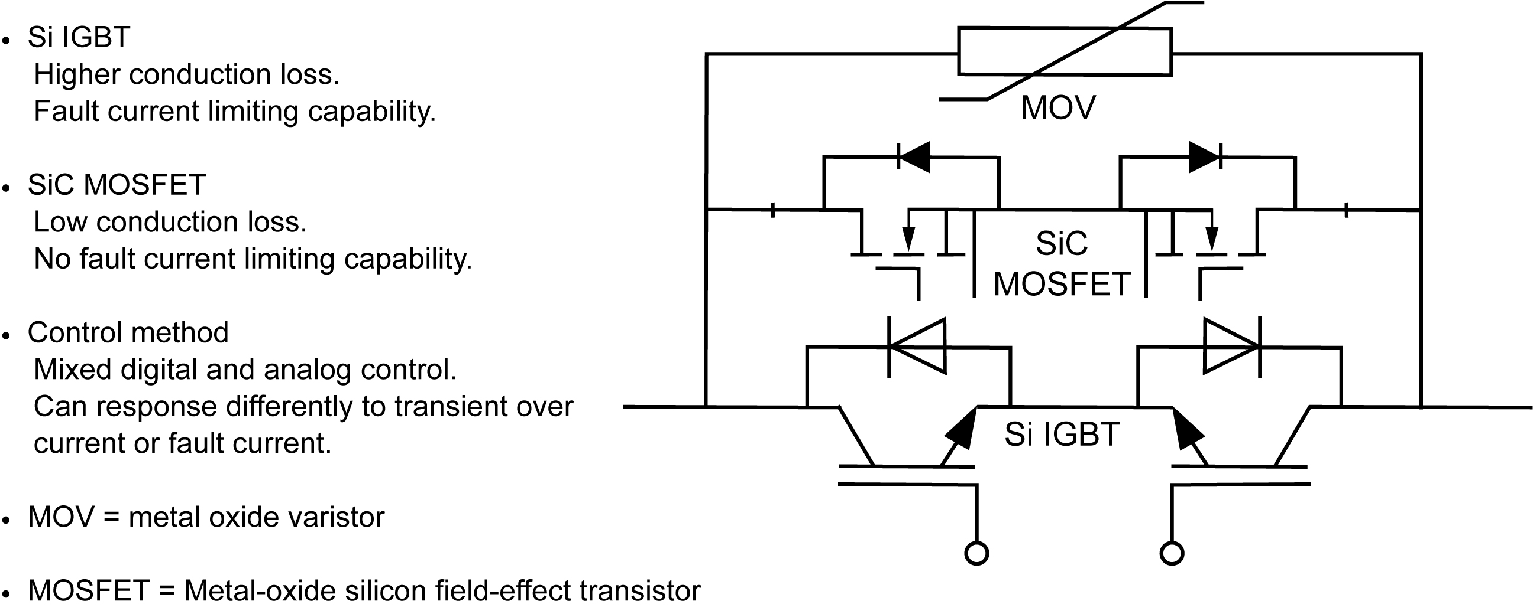
Caption: Figure 16.2. Very efficient, lightweight system requires dynamic thermal recycling system

Credit: NASA

Note in Figure 16.2 that this breaker system naturally provides both current and voltage limiting without requiring inductors and can operate at the time scales necessary for megawatt-scale aircraft. Despite the higher conduction losses compared to those of a hybrid breaker, an effective high drive efficiency shown in Figure 16.3 can still be maintained by recycling the waste heat with a distributed thermal management recycling system to be described.

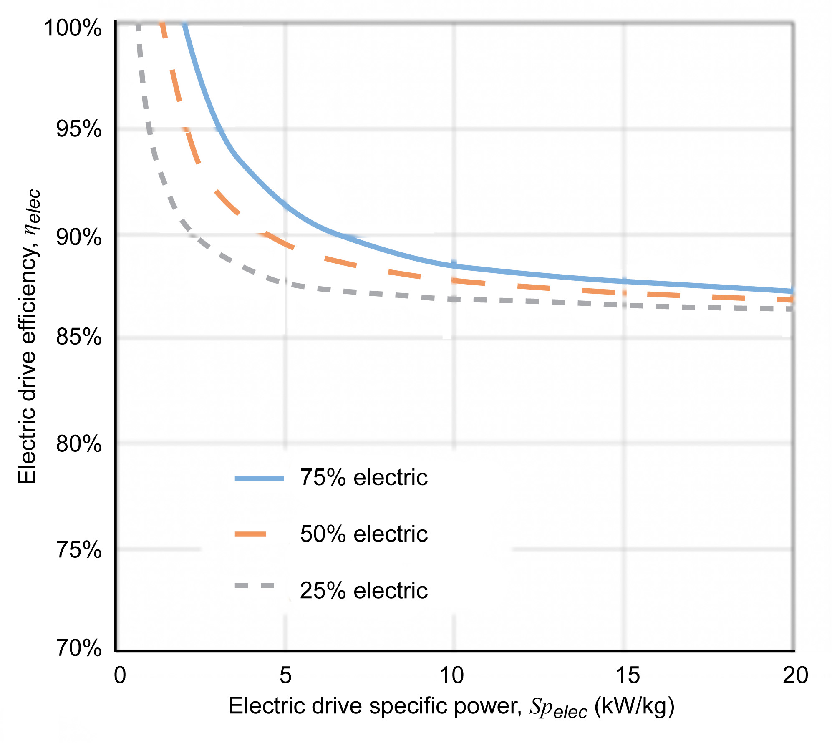
Caption: Figure 16.3. Example breakeven curves for electric aircraft propulsion: efficiency trades with specific power

Credit: NASA

Thermal Management Challenge
Electric aircraft have not only the challenge of managing the electrically related risks of high voltage, power, and current. It is also just as important to manage the significant new low-grade heat loads that are introduced each time an electrical component is added to the aircraft (Dooley, 2016); this was a primary consideration in the development of TREES.

The challenges with low-grade waste heat in aircraft is five-fold because it

- is not useful for work and difficult to reject
- adds system mass from large heat exchangers, plumbing, and fluids
- reduces net propulsive power from increased drag, compressor bleed, and turbine power extraction
- has a limited thermal capacity due to sink temperature or surface availability
- increases maintenance due to thermal management system complexity or structural integration challenges

Caption: Figure 16.4 Heat sources distributed throughout the aircraft. (a) High-exergy (>20 MW). (b) Low-exergy (<1 MW).

Credit: NASA

As shown in Figure 16.4, aircraft have a range of heat sources distributed throughout the aircraft. High-exergy waste heat is emitted from the turbofan core, and low-exergy waste heat is distributed nearly everywhere else on the aircraft. The current approaches for managing this heat (Dooley, 2016), along with its drawbacks, are listed in Table 16.2.

Table 16.2. Thermal Management Technology Options
Thermal management technology | Drawback
Ram air heat exchanger | Adds weight, aircraft drag, displaces fuel capacity
Convective skin cooling heat exchanger | Adds weight and drag, and requires liquid pumping losses
Sinking heat into fuel | Limited thermal capacity due to coking and volume
Sinking heat into lubricating oil | Limited thermal capacity; low ΔT adds heat exchanger mass
Active cooling | Reduces propulsive efficiency; adds weight and maintenance
Phase change cooling | Limited thermal capacity; adds weight
Heat pipe | Does not increase exergy, which impacts mass and efficiency

The heat pipe technology is shown as a drawback in Table 16.2 when used in isolation because it does not increase the exergy (Fleming A. L., 2016). It is a means for transporting heat energy relatively short distances and at constant temperature. However, when it is integrated with exergy-increasing components and dynamic heat pipes, it no longer has that drawback: its mass impacts are mitigated by reusing the waste heat, which serves to increase the effective powertrain efficiency. As shown in Figure 16.3, if the powertrain efficiency can be increased with exergy recycling, then the system can add system mass and still have a net benefit. Then if exergy recycling is not used as shown in Figure 16.5, large transport aircraft cannot be fully electrified because of inherent heat sink limits and system-level losses.

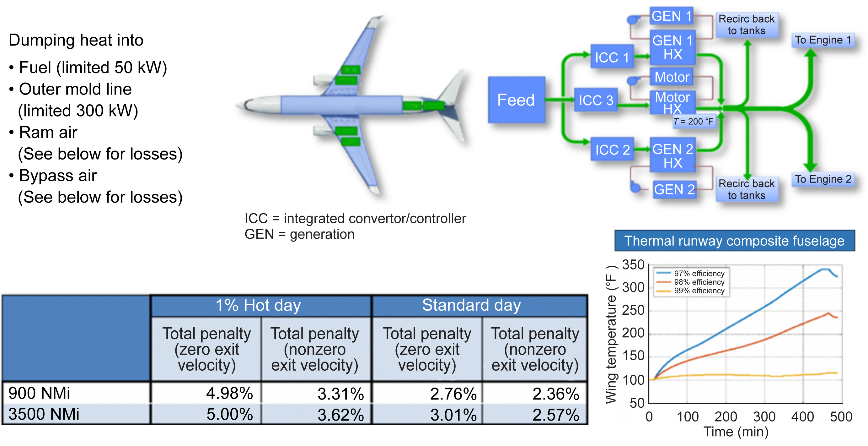
Caption: Figure 16.5. Electric aircraft propulsion thermal management technology impacts on performance and safety certification

Credit: NASA

Note that in the PC Krause study (Walters et al., 2010) shown in Figure 16.5, commonly suggested methods for rejecting low-grade waste heat has both intrinsic heat load Q limits and/or negative system-level drag losses on the scale of 3% total fuel burning. At this loss level, the projected benefits of transport-class electrification can be nullified. Moreover, even an ideally 99%-efficient component will often be required to operate outside its peak performance zone, and this can result in a thermal runaway scenario unless active thermal control features are available to mitigate this response. It is therefore critically important to integrate an active thermal control system, such as TREES, with all the systems on the aircraft.

Integrated Fault and Thermal Management
Future electric aircraft propulsion systems will be based on the variety of configurations shown in Figure 16.6. Still, they all have in common the need to protect against electrical faults with DC breakers (indicated by the yellow dots) and to manage the waste heat produced by everything shown.

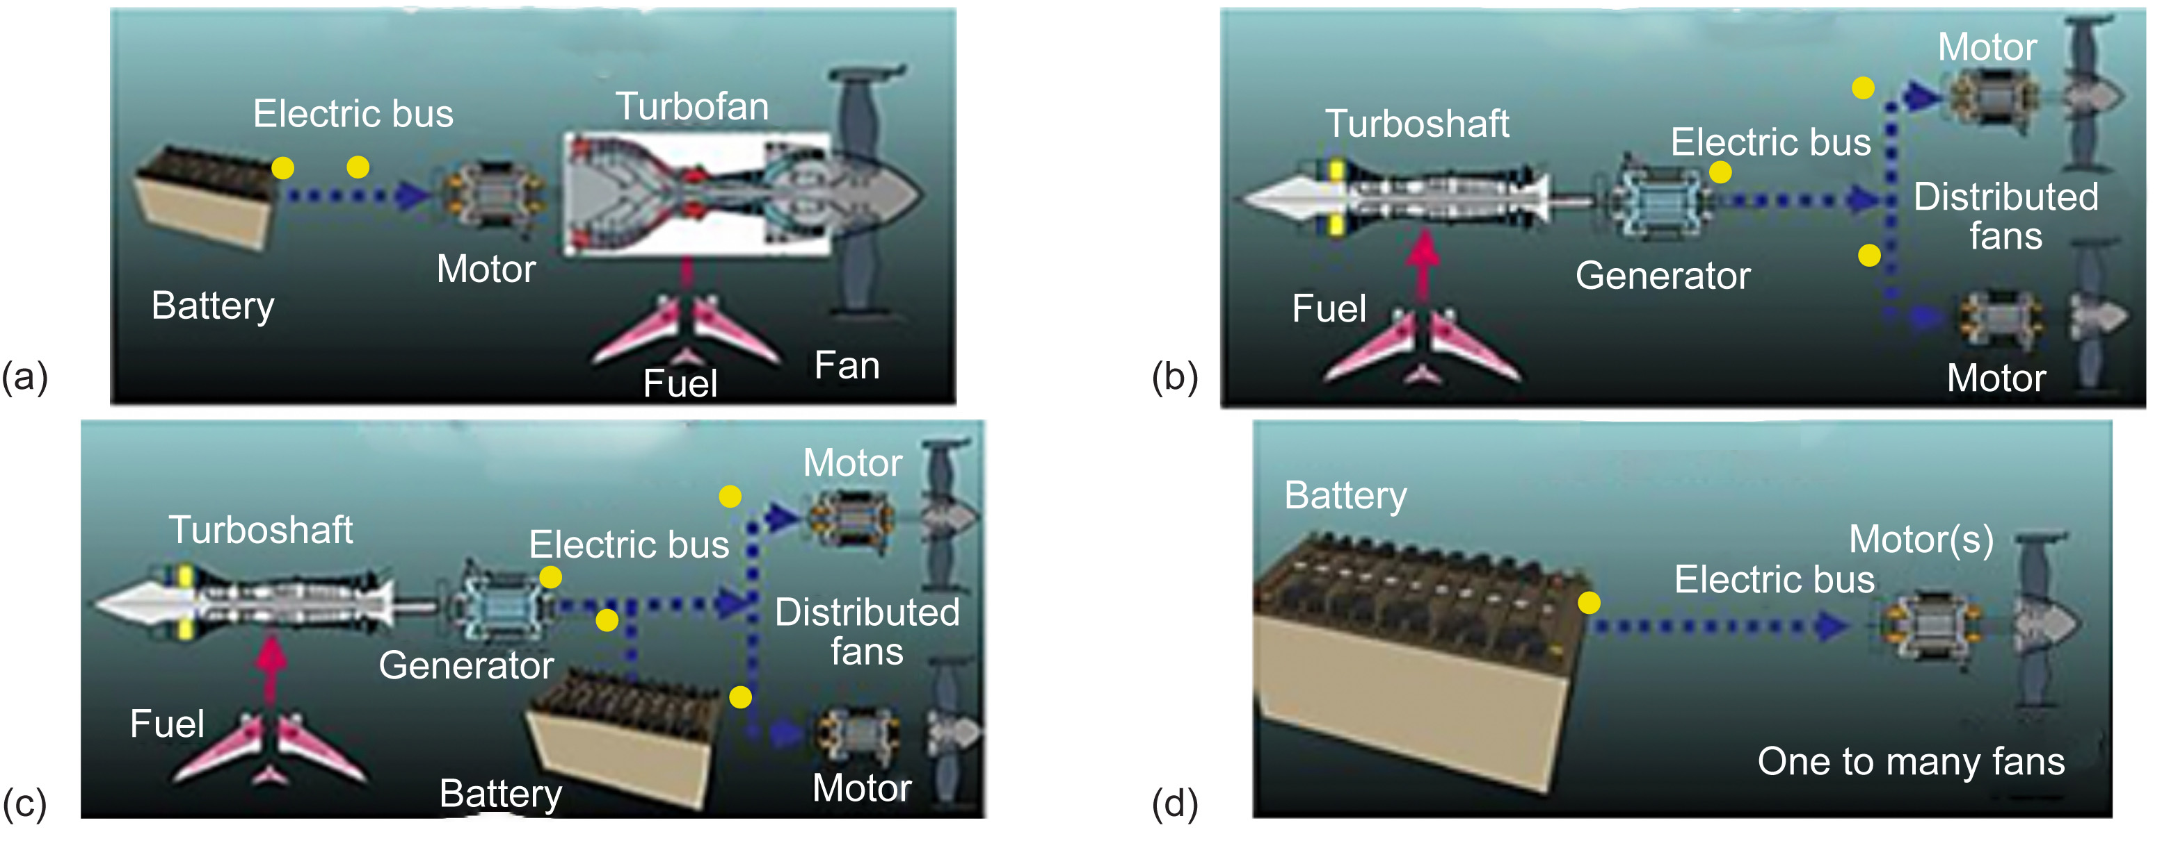
Caption: Figure 16.6. Powertrain configurations require both thermal and fault management protection (yellow dots). (a) Parallel hybrid. (b) Turboelectric. (c) Series hybrid. (d) All electric.

Credit: NASA

Figure 16.7 depicts the TREES thermal management system (Dyson, 2019) integrated with a fault management system and applied to a Boeing 737 flight vehicle with parallel hybrid propulsion. The basic approach here is to extract high-exergy waste heat from the turbofan core using low–mass, SiC-coated graphite heat exchangers to thermoacoustically generate a ducted acoustic wave that is used to deliver mechanical energy throughout the aircraft. This acoustic energy can then operate a thermoacoustic heat pump to actively refrigerate the powertrain components while collecting the low-exergy waste heat from the powertrain and convert it to high-exergy useful heat, through which dynamically switchable heat pipes can then deliver throughout the aircraft for the beneficial applications shown in Table 16.3.

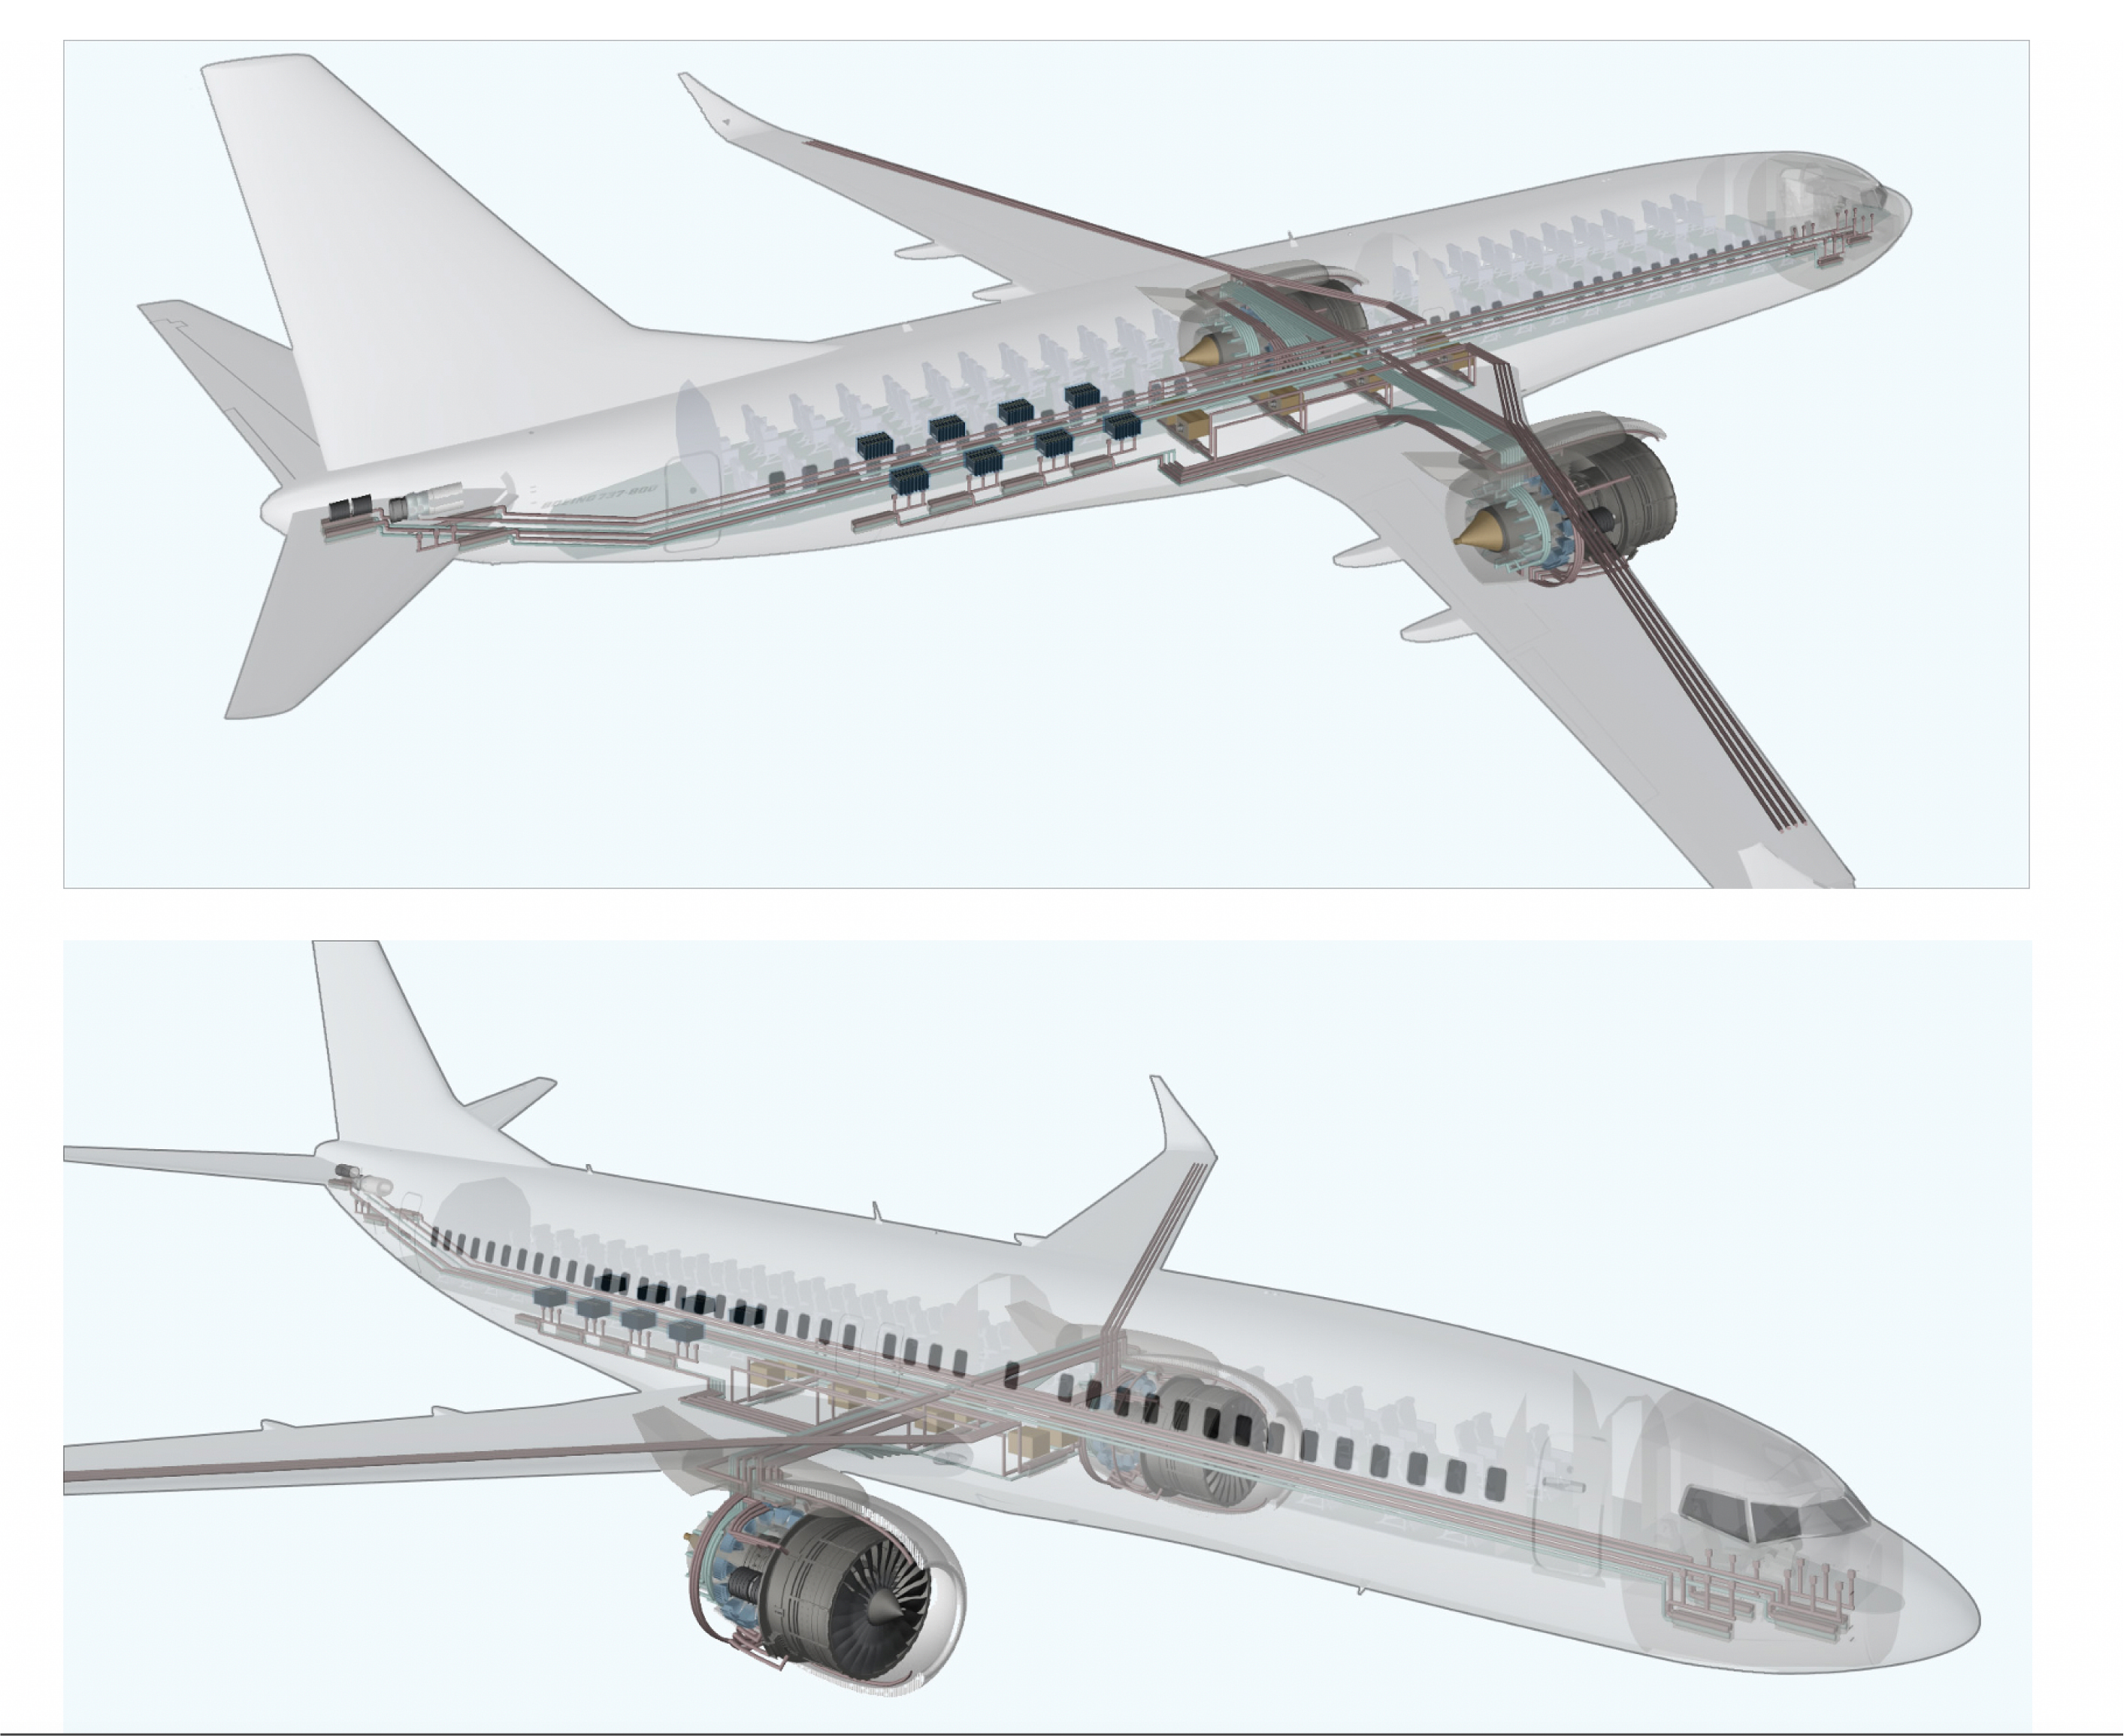
Caption: Figure 16.7. TREES uses thermoacoustic and dynamically redirectable heat pipe tubes embedded in the aircraft to recycle both the turbofan and powertrain waste heat

Credit: NASA

Table 16.3. Beneficial Applications of Higher Exergy Waste Heat from Powertrain
Sink location | Sink temperature  (°C) | Benefit
Engine core | 600 | Recuperates engine and powertrain heat for efficiency
Engine bypass | 100 | Increases thrust with P-51 effect
Outer mold line | 200 | Manages icing and boundary layer turbulence
Auxiliary power unit | 400 | Provides electrical power from waste heat
Cabin | 40 | Provides cabin heating without bleed air from turbine
Battery | 20 | Maintains batteries above freezing
Oil coolant loop | 100 | Requires smaller heat exchanger, as temperatures are higher
Ram air | 100 | Requires smaller heat exchanger, as temperatures are higher

High-Exergy-Heat Extraction
As shown in Figure 16.8, modern turbofan propulsion systems provide thrust using high-bypass-ratio architectures in which over 85% of the thrust is NOT from the core. As distributed electric propulsion systems are employed in the future, the amount of thrust due to the nozzle flow will continue to decrease. It is anticipated that eventually turbofans will be replaced with turboshaft generators that exclusively deliver electric power to electric motor propulsors (Felder, 2011); in this case, none of the thrust is produced in the Brayton cycle engine core.

It is also important to note that the bypass and combustion air paths can utilize a design similar to that of the heat exchanger for returning heat energy to those locations to achieve the benefits listed in Table 16.2.

Moreover, any source of high-exergy waste heat can be used for this system, such as solid oxide fuel cells, but in that case the heat exchanger would be a different design, since no high-speed air flow is required. Also, since the thermoacoustic heat engine only requires conducted heat into its system, it is possible to directly conduct heat from the fuel cell directly to the acoustic engine to avoid conjugate heat transfer altogether.

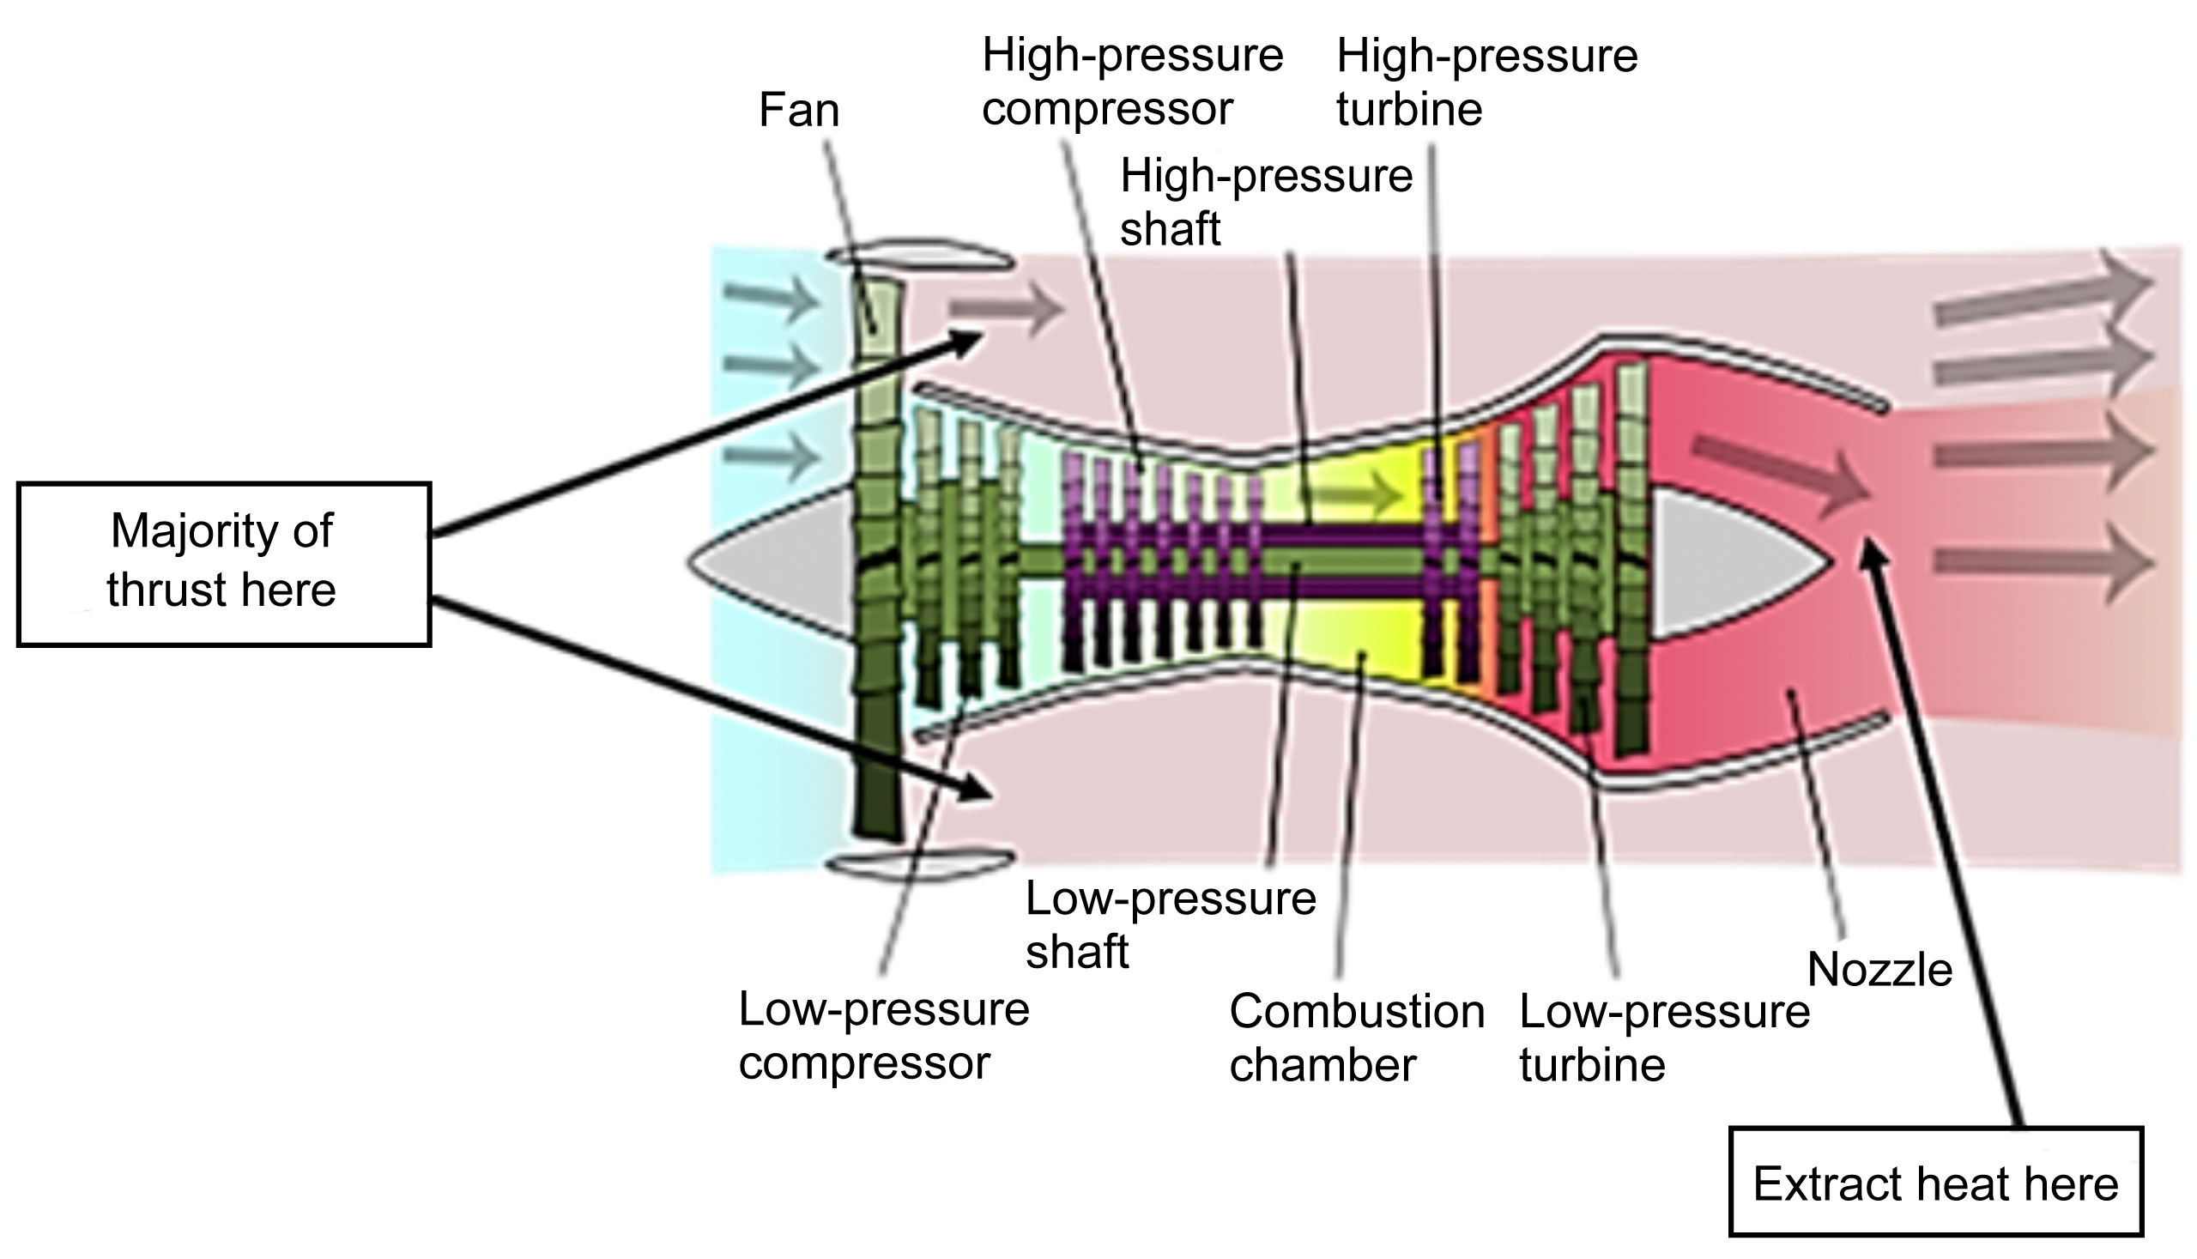
Caption: Figure 16.8. High-exergy flow extracted from turbofan core

Credit: NASA

If a low-pressure-drop heat exchanger is installed in the core, then some of this high-exergy waste heat can be extracted with minimal to zero impact to the overall vehicle thrust. Preliminary results from an integrated turbofan and heat exchanger model developed in the Sage modeling environment are shown in Table 16.4 and indicate such a heat exchanger is feasible for extracting at least 20% of the energy using 8000 channels (2.5 mm × 5 cm × 10 cm) in the nozzle. A detailed graphite-based heat exchanger development effort (see Fig. 16.9) is currently underway (Hendricks, 2017) that can collect core heat and reject heat to the bypass flow or ram air.

Table 16.4. Minimal Thrust Impact from Extracting Core Heat Energy at Nozzle Exit
Thrust  (kN) | Total engine core enthalpy  (MW) | Extracted energy  (% of core (kW))
49.6 | 17.7 | 1% (267)
49.5 | 17.7 | 10% (1700)
49.4 | 17.7 | 18% (3100)

As previously mentioned, as the bypass ratio increases to fully turboelectric levels none of the thrust is produced by the core, and the turboshaft generator exhaust gas ducting can be optimized for maximum exergy extraction.
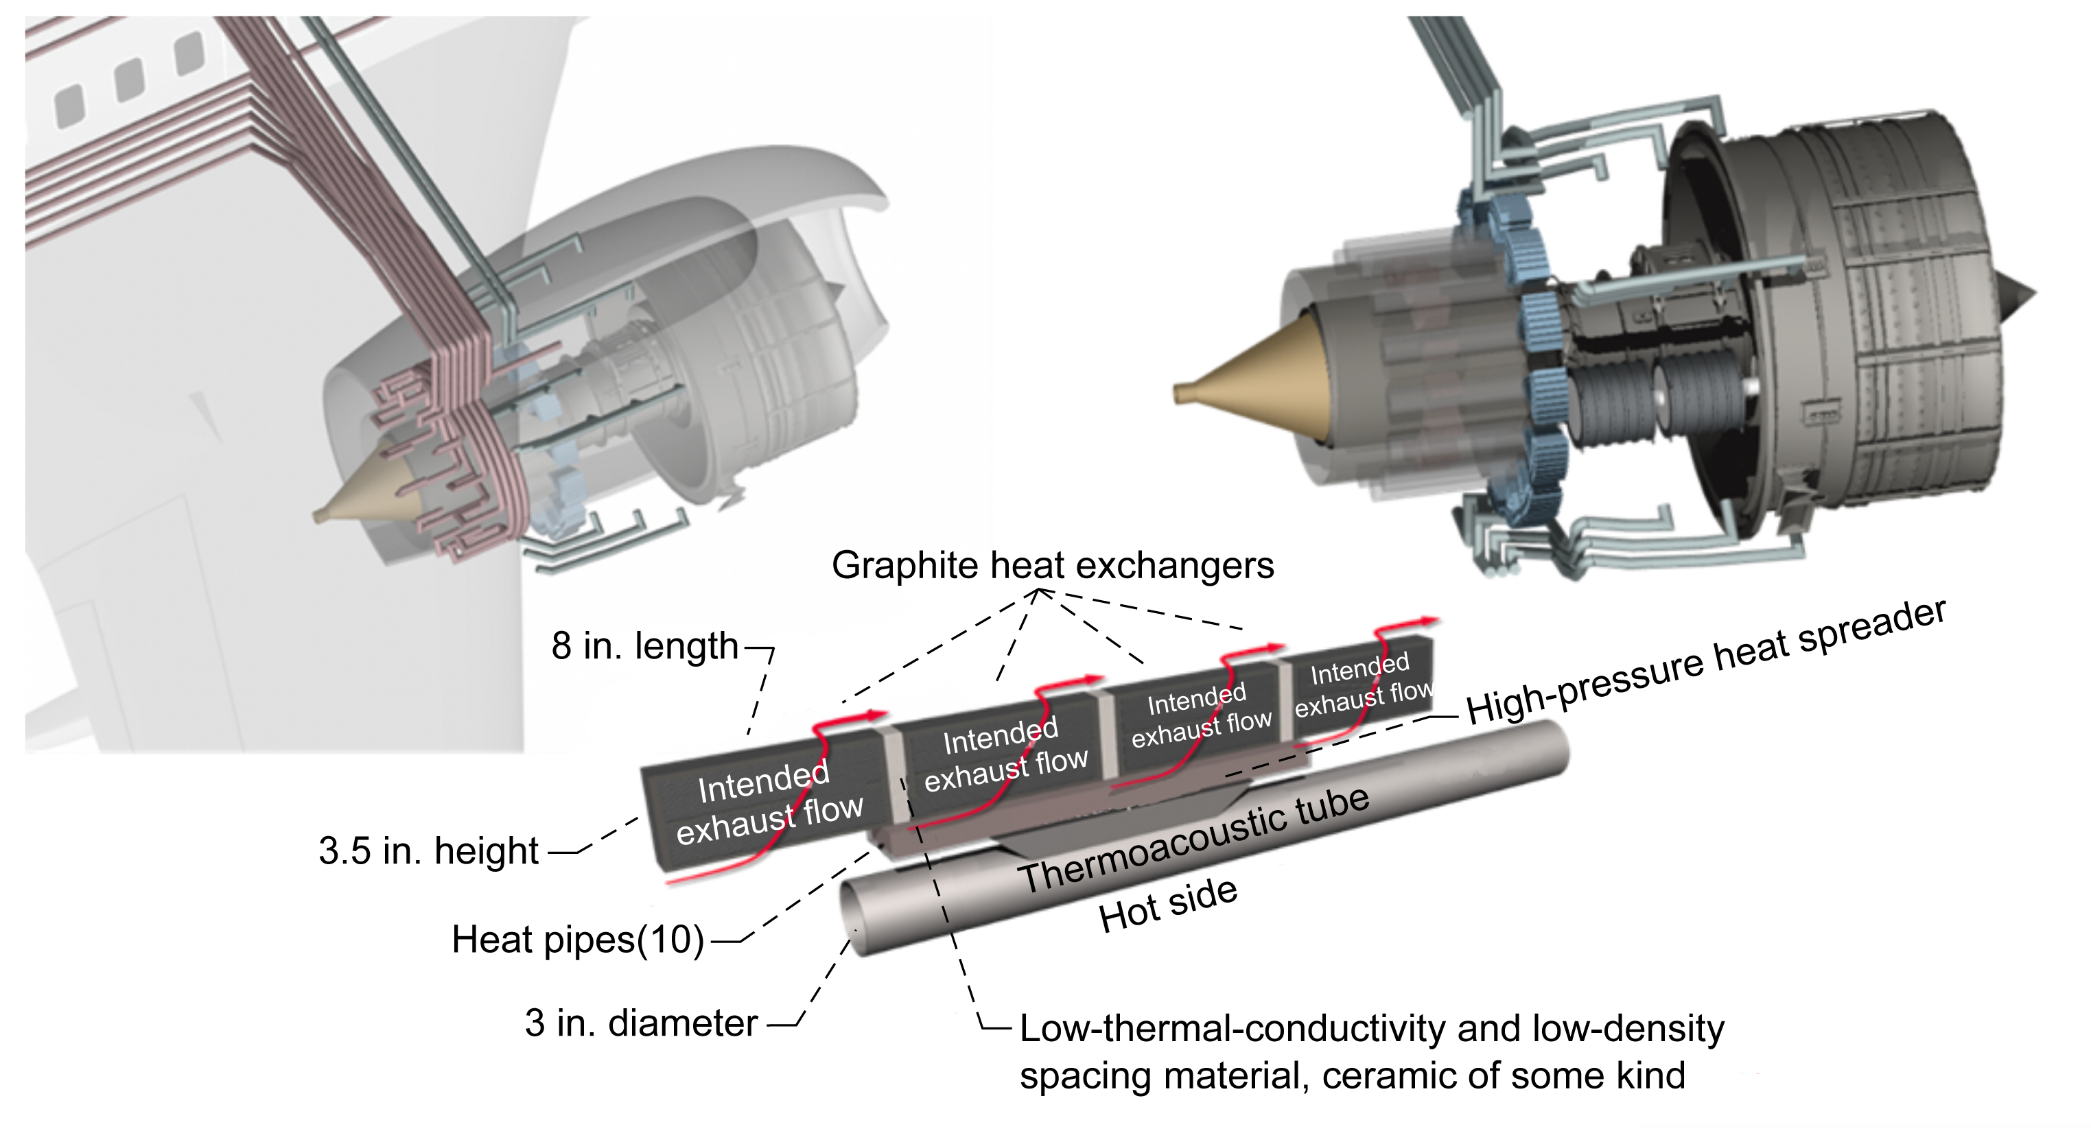
Caption: Figure 16.9. Turbofan heat exchanger integration

Credit: NASA

Acoustic Exergy Pumping Tubes
As shown in Figure 16.10, a forward and reverse thermoacoustic heat engine and heat pump can be combined into a duplex configuration with a long acoustic wave guide tube between them (Swift, 1999). The high-exergy heat from the turbofan core can be used to create an acoustic wave on the left side of the tube that travels the length of this tube and then operates the heat pump to increase the exergy of the waste heat from the powertrain. In Figure 16.10 it is assumed the incoming heat from the turbofan core is about 800 K and a portion of that energy (70%) is rejected into the bypass stream at 300 K. Based on the results in Table 16.4 the incoming heat would be about 3 MW, and the produced acoustic energy would be about 1 MW.

The amount of mechanical acoustic power traveling through the long wave-guide duct tubes is given by

The amount of sound amplification is a function of the temperature ratio, T_{h}/T_{c}. The efficiency is a function of both the temperature ratio and the phasing of the proper pressure and volume velocity, V, in the regenerator regions in order to achieve amplification and heat pumping, respectively. In addition, the system must be designed to resonate, achieving high acoustic gas-particle displacement while also matching the proper acoustic impedance, Z, with the boundaries and appropriate compliance, C, and inertance, L. The input wave can be created with a standing-wave thermoacoustic tube (no moving parts), piezoelectric actuator, turbine blade tip compressor, linear actuator, voice-coil, or solenoid that has acoustically matched impedance with the acoustic wave working fluid. Similarly, the receiving end (heat pump region), can use an inertance tube with reservoir or any of the same methods used for the input wave. The combination of the end effectors, tube geometry, heat exchanger, regenerator dimensions, operating frequency, and location of the heat engine and heat pump within the tube must all be accounted for in a proper design of the acoustic exergy pumping tubes.

Note that acoustic waves do not generate heat and do not require insulation along their lengths. Since most of the heat exchangers are very porous and the tube can be directly embedded into the airframe, the total mass of the system can then be kept to a minimum. Typical coefficient of performance values from thermoacoustic refrigerators at these temperatures can approach 40% of Carnot efficiency, and the heat engine can approach 50% of Carnot efficiency.
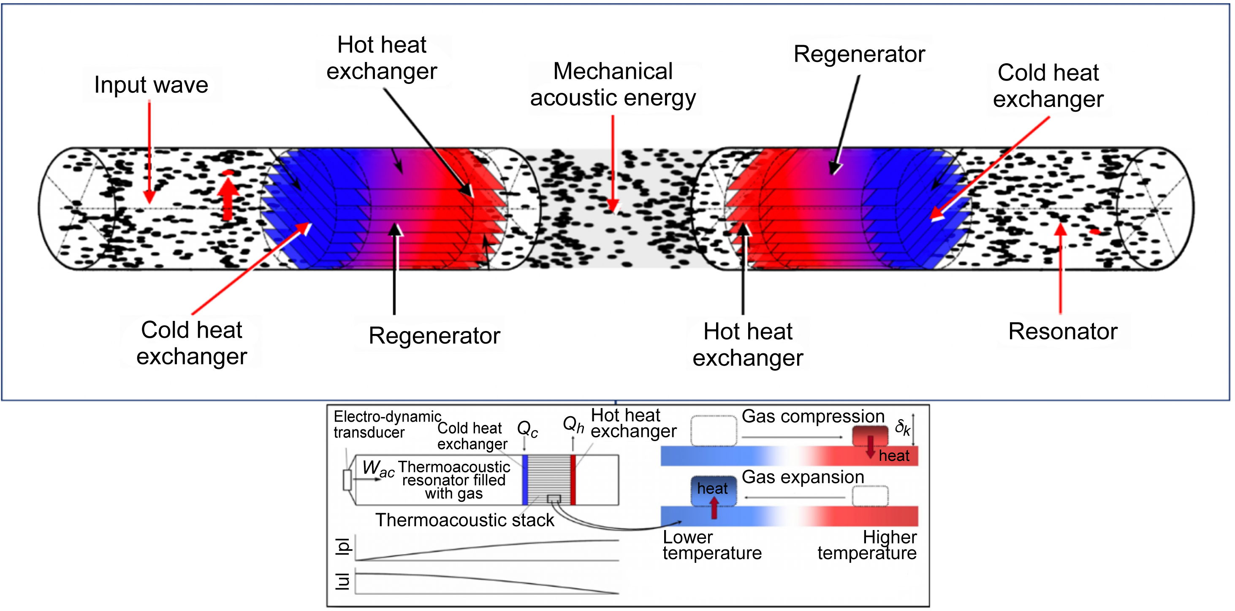
Caption: Figure 16.10. Acoustic exergy multiplication tube

Credit: NASA

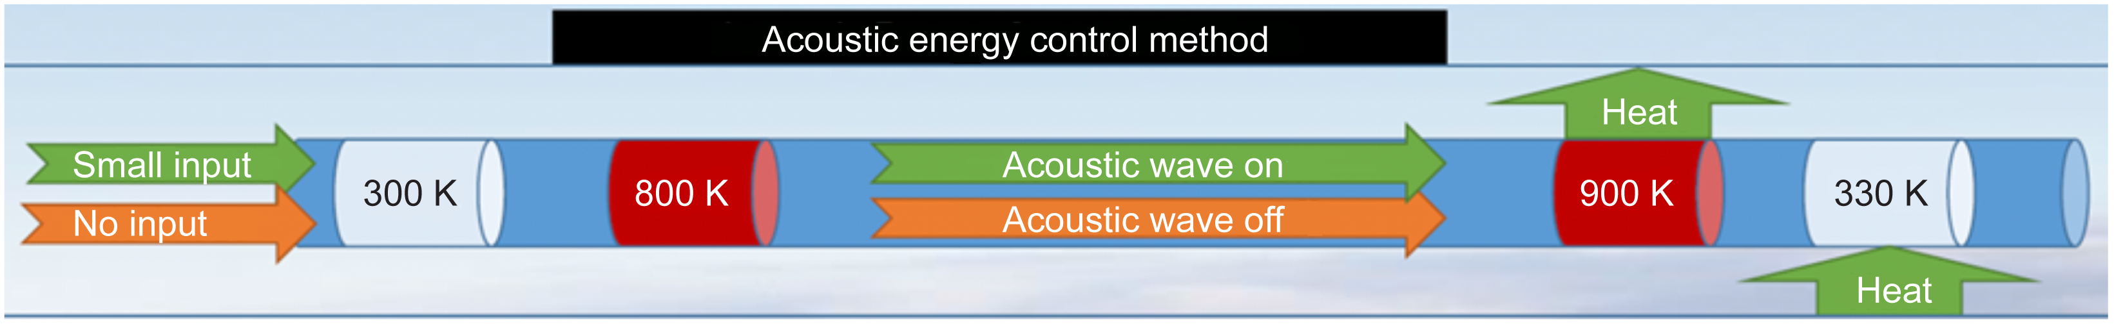
Caption: Figure 16.11. Acoustic energy can be switched on/off and delivered anywhere in the aircraft for heat pumping

Credit: NASA

During a full flight profile, the aircraft heat energy flows will change at both the turbofan and powertrain, and the available heat sinks can vary considerably as well depending on altitude, speed, and environmental temperatures. Thus, it is important to be able to actively change the amount of refrigeration and the destination of the waste heat while in flight. As shown in Figure 16.11, the amount of refrigeration can be modulated by adjusting the size of the incoming acoustic wave. If a standing-wave generator is used, then the adjustment is accomplished with small thermoelectric heat source changes. If an electric-wave generator is used, then the adjustment is accomplished electrically.

The amount of cooling that can be provided depends on the temperature ratio across the heat pump (Fig. 16.12). As an example, for a temperature ratio of 3 (900 K/300 K), for every 2 W of acoustic energy input into the heat pump W, 1 W of powertrain heat Q can be pumped, resulting in 3 W of high-exergy heat at 900 K being rejected to a heat pipe. Therefore, 1 MW of acoustic energy can lift 500 kW of low-grade 300 K electric powertrain heat, and then up to 1.5 MW of high-exergy heat is available for the beneficial purposes listed in Table 16.3.
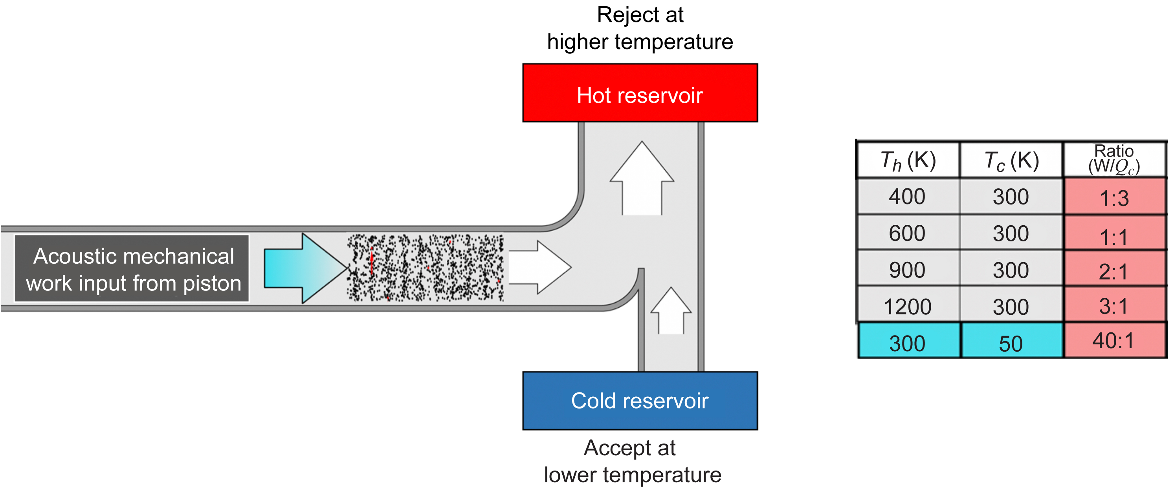
Caption: Figure 16.12. Ratio of input acoustic energy required for heat pumping

Credit: NASA

Thermally Redirectable Heat Pipes
As shown in Figure 16.13, solid-state variable-conductance heat pipes can be used to deliver the high-exergy heat produced by the acoustic heat pump. Moreover, by including a noncondensable gas inside the heat pipe, it is possible to thermally control the conductance of the heat pipe—in essence to control (switch on and off) the heat pipe with no moving parts (Fleming A., 2004). A detailed development effort is underway by Advanced Cooling Technologies, Inc., to build and test a series of low- and high-temperature variable-conductance heat pipes that can operate over long distances in a changing g-force and slope environment. By adding multiple noncondensable-gas condenser tubes (Fig. 16.14), it is possible to dynamically control where the heat goes with no moving parts and very fast response times. A successful test of this concept was recently completed and will be presented in more detail soon.
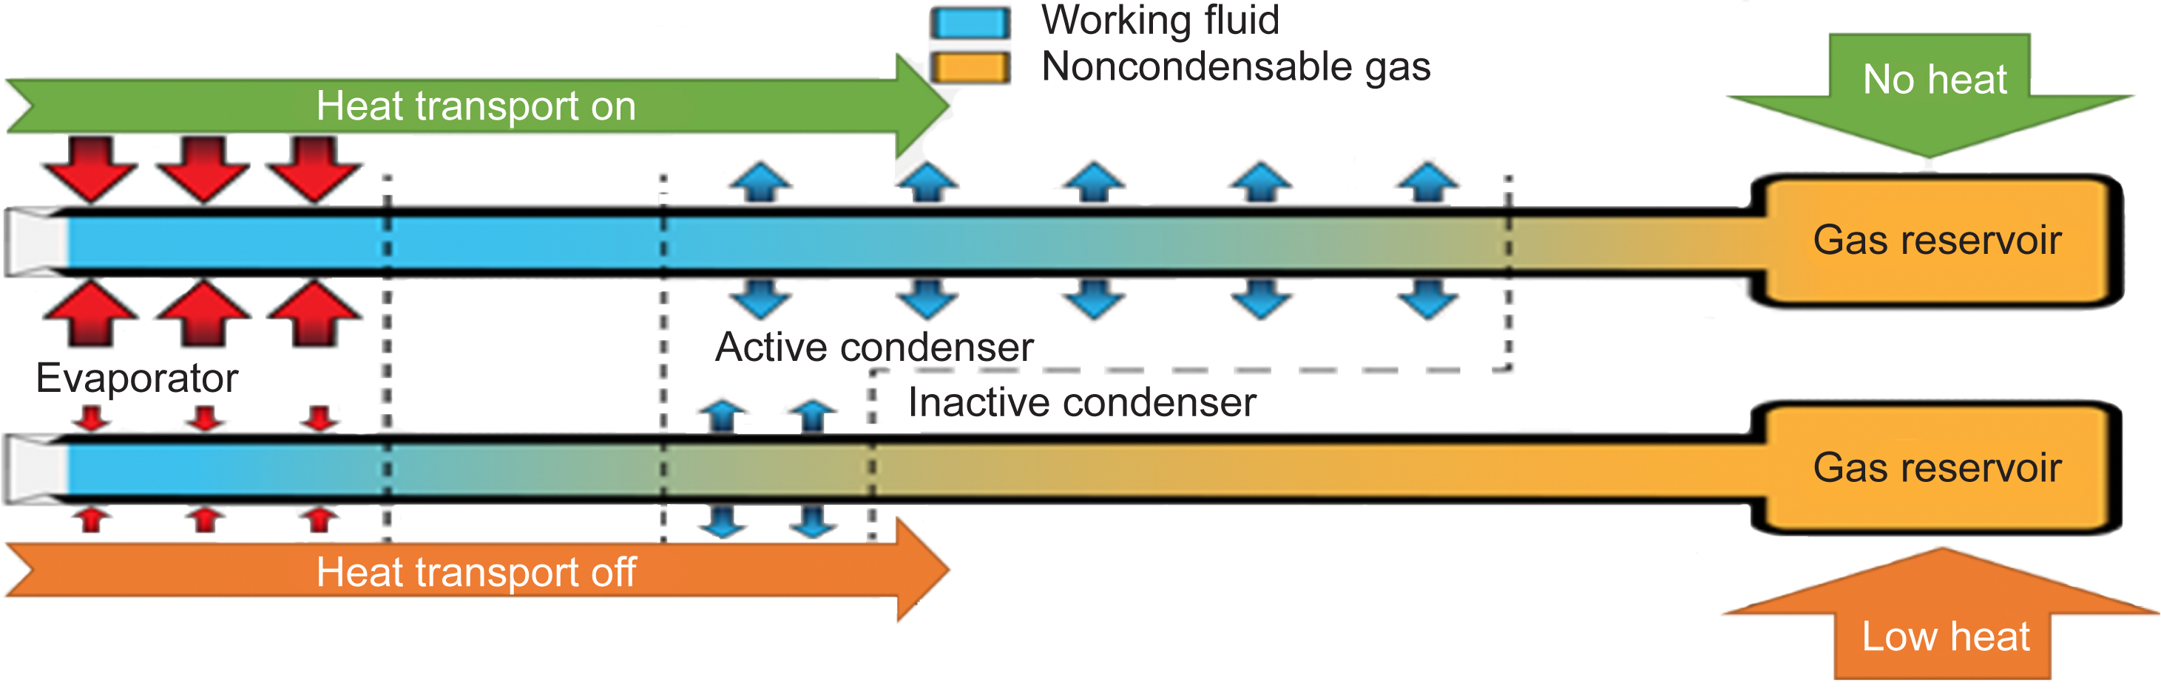
Caption: Figure 16.13. Solid-state switchable heat pipe technology can redistribute the high-temperature thermal energy

Credit: NASA
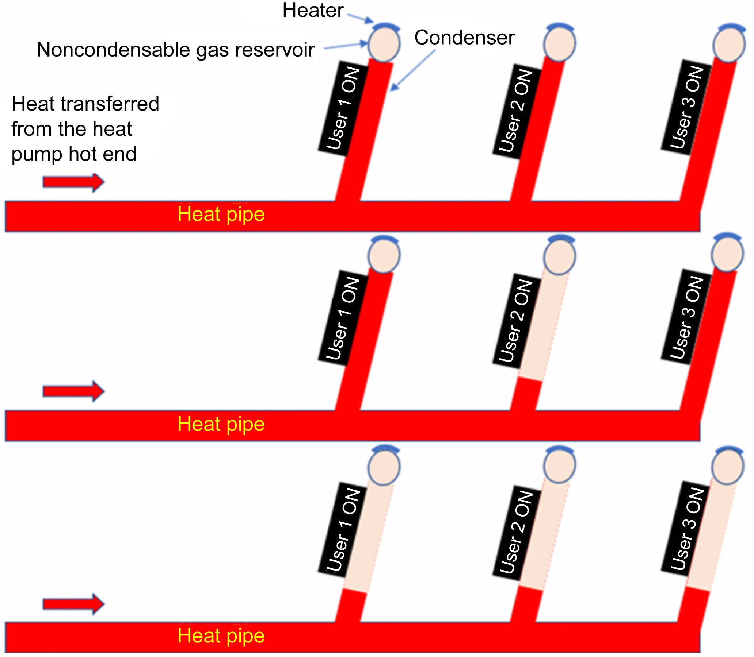
Caption: Figure 16.14. Solid-state thermal switching

Credit: NASA
This new capability enables an entirely new approach (shown in Fig. 16.15) to delivering different temperature heat to different locations at a user-adjusted rate while the aircraft is in flight. In this sense, it is a completely general solution that can support recuperation, de-icing, thrust augmentation, environmental control, or auxiliary power units.
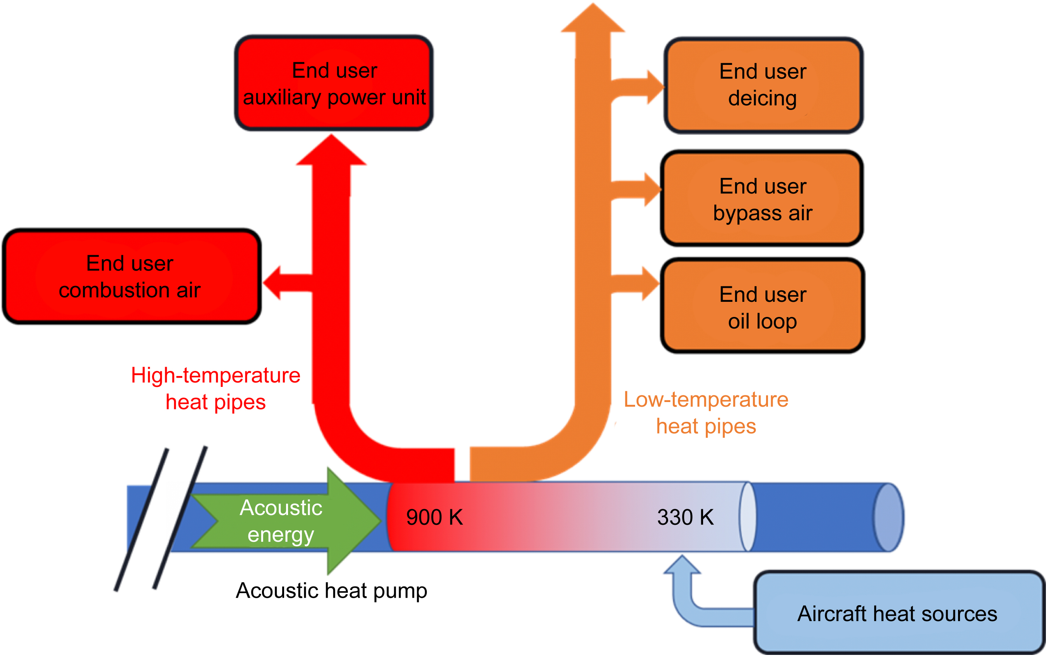
Caption: Figure 16.15. Prototype layout of acoustic heat pump combined with heat pipe: standing-wave ends, linear acoustic tube

Credit: NASA

Integrated TREES System Operation and Test Results Summary
Ideally, future aircraft thermal management systems can lift 500 kW or more of low-grade waste heat ranging in temperature from 50 to 300 K to a higher temperature greater than 400 K without adding excessive mass or system losses or being limited in total heat capacity. As mentioned, the key to making this technology lightweight and efficient is the generation of a ducted acoustic wave to deliver refrigeration energy to distal locations throughout the aircraft that would otherwise be expensive to cool, such as fault management and sensor technologies. This eliminates the need to transport energy with electrical, mechanical, or fluids—each of which adds system mass and complexity. For example,

- Electrical power distribution produces EMI, distributed heating, and requires heavy cables.
- Mechanical power distribution such as distributed torque shafts adds weight and requires lubrication.
- Pumping a coolant requires a large volume of fluid, pumping mechanisms, extensive insulation, and heavy heat exchangers to transfer heat energy.
- Passive solutions need to be over-designed to support a full flight profile, don’t protect against unforeseen failure modes, and have more limited thermal capacity

Instead, once the pressure wave is formed it is a simple matter to channel the wave in small tubes to anywhere in the aircraft. Compared to reverse Brayton or Rankine systems, the thermoacoustic engine pressure wave generator requires no lubrication and has no moving parts. Moreover, this technology is useful for aircraft because it does not require extra fuel to operate it, is lightweight, and essentially maintenance free. It could be used to provide cabin cooling, ambient and/or cryogenic cooling of converter, cables, and motors, and in addition it can be used to deliver power to remote locations on the aircraft without using wires.

A related thermoacoustic cooling technology was recently demonstrated in the Netherlands to lift 25 kW of heat for residential uses (Bloc, 2019), and it is shown in Figure 16.16. This success clearly suggests thermoacoustic cooling is an important new area to include in our suite of thermal management technologies for aircraft. Note that although this example uses a rotational configuration to maintain a traveling wave, it would be challenging to install in an aircraft.
Caption: Figure16.16. Example thermoacoustic cooling technology

Credit: NASA

Figure 16.17 presents the development of the TREES acoustic tube system. Rather than using a circular configuration, standing wave end-caps that enable a linear configuration are used for the acoustic exergy tubes. The initial acoustic tube prototype is being built and tested to confirm modeling predictions are accurate and to confirm the ability to deliver acoustic energy the entire length of an aircraft. The first phase of development is a simple pulse-tube-like configuration with an inertance tube and reservoir end-cap (i). This is followed by stretching the acoustic tube to aircraft-scale lengths (ii) and confirming the acoustic tube losses match the predictions shown in Figure 16.18. This is followed by removing the pulse-tube-like end tubes with an active impedance matching (iii) to provide better control options and to shorten the length of the end caps.
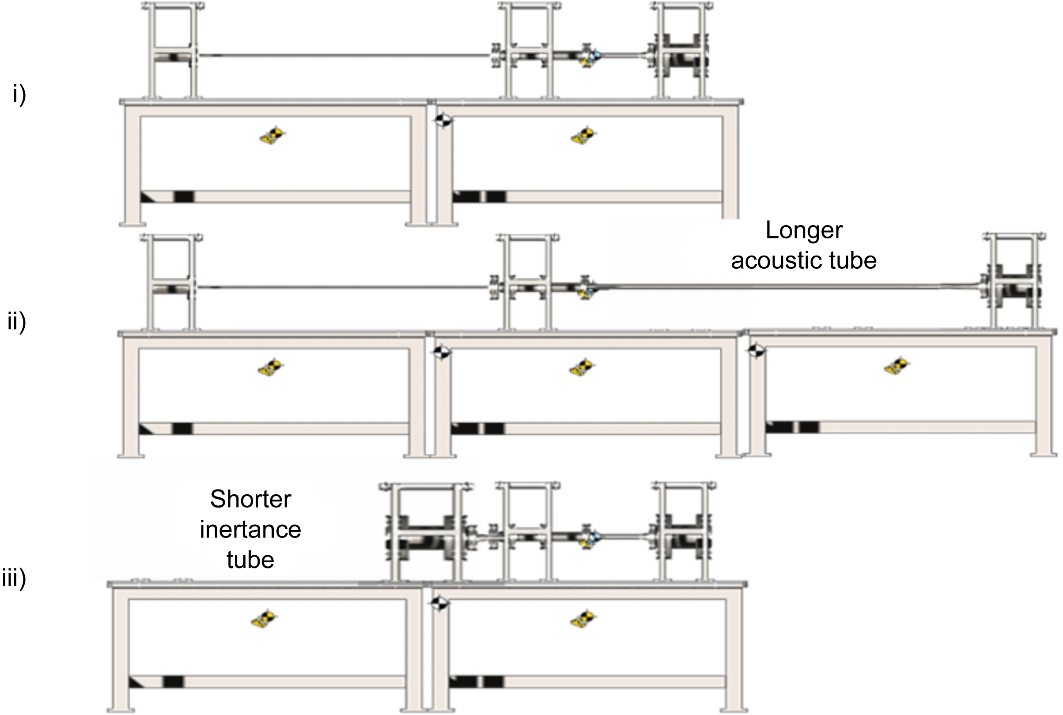
Caption: Figure 16.17. Acoustic tube system prototype testbed development steps

Credit: NASA

Subsequent steps include combining the acoustic exergy amplification tubes with the dynamic heat pipes into a system that actively manages the temperatures throughout an entire powertrain while dynamically optimizing the performance of the air vehicle during flight.
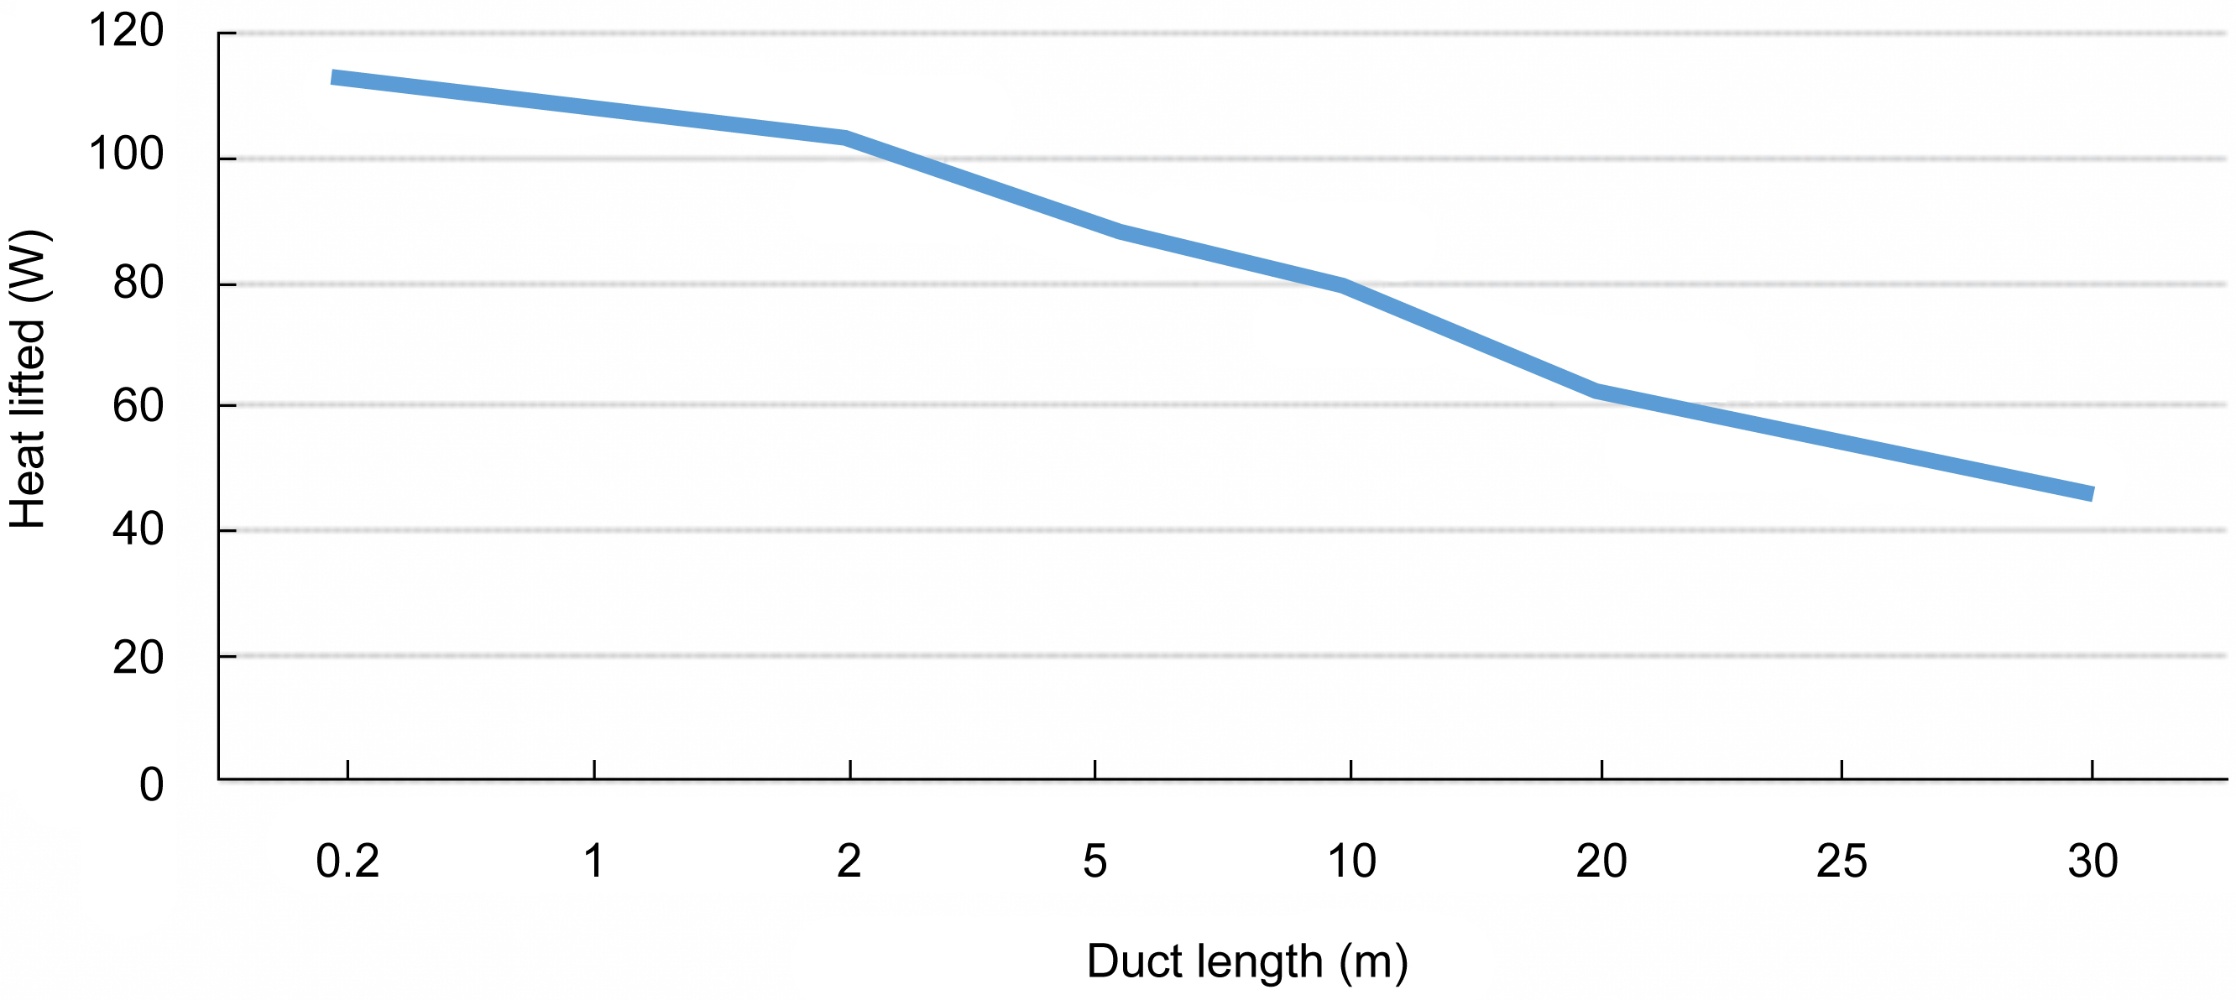
Caption: Figure 16.18. Traveling acoustic wave losses as duct length increases

Credit: NASA

It is also important to recognize that fully integrating the power, propulsion, thermal, fault protection, and airframe technologies requires the ability to optimize a very complex system to minimize mass, maximize efficiency, and maximize safety. In support of this objective, a new gradient-based powertrain optimizer specifically designed to select the best suite of thermal management technologies (Fig. 16.19) is also under development as a new open source optimization design tool called OpenConcept (Brelje, 2019).

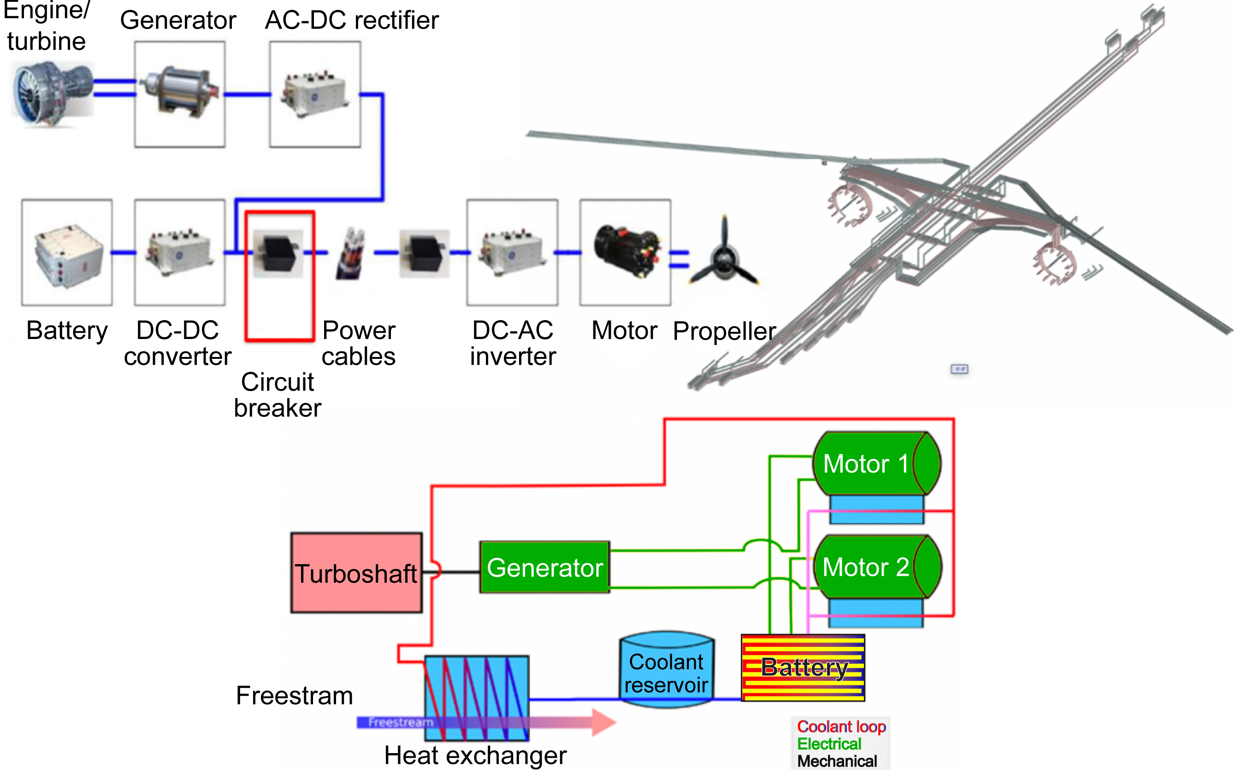
Caption: Figure 16.19. Optimized powertrain with integrated fault and thermal management system

Credit: NASA

Conclusion
As summarized in Table16.5, a combination of an advanced turbofan core and bypass heat exchanger, advanced dynamically redirectable heat pipes, an advanced hybrid electric powertrain optimization tool, and acoustic exergy amplification tubes, enables TREES to provide solid-state cooling and fault management for an entire transport-class electric aircraft. Moreover, this solid-state system (no moving parts) can increase the propulsive efficiency of the vehicle while enabling ultrafast response fault management. This increases the safety of the vehicle and protects personnel, aircraft, and sensitive power electronics and sensors.

Table 16.5. Technical Elements and Status
Subtask | Organization | Status | Deliverable
OpenConcept thermal system optimization | University of Michigan | In development | Open-source powertrain optimization tool
Turbofan heat exchanger | NASA Jet Propulsion Laboratory | Preliminary design | Core heat exchanger demonstration
Acoustic tube | NASA | Prototype ordered | Full aircraft exergy-efficient recycling system
Switchable long heat pipes | Advanced Cooling Technologies, Inc. | First prototype built and tested | Full aircraft heat transport solution
Fast switchgear | Naval Postgraduate School | System requirements completed | TRL 6 fault management system compatible with thermal management system

Overall, when fully integrated into the airframe of the aircraft these technologies can potentially provide fully integrated power, propulsion, thermal, fault protection, and airframe systems that enable significant fuel, emission, noise, safety, and mobility benefits. These developments are critical for achieving new transport class certification standards over the next decade.

Acknowledgments
The authors thanks the many people and organizations who are contributing to this project including Advanced Cooling Technologies, Inc., University of Michigan, the NASA Jet Propulsion Laboratory, and the Naval Postgraduate School. This work was sponsored by the Advanced Air Transportation Technologies project/Electric Aircraft Powertrain Technologies subproject.

Chapter 16 References
Armstrong, M. (2015). Architecture, voltage, and components for a turboelectric distributed propulsion electric grid. Cleveland, OH: NASA/CR—2015-218440.
Bloc, D. (2019). SoundEnergy. https://www.soundenergy.nl/
Brelje, B. (2019). OpenConcept—A conceptual design toolkit with efficient gradients implemented in the OpenMDAO framework. https://github.com/mdolab/openconcept
Dooley, M. L. (2016). Aircraft thermal management-heat sink challenge. In M. Ahlers, Aircraft thermal management systems architectures (p. 99). Warrendale, PA: SAE International.
Dyson, R., & Bruder, G. (2015). Alpha-stream convertor. U.S. Patent No. 9,163,581B2.
Dyson, R. (2019). Thermal management system. U.S. Patent No. 10,507,934.
Epstein, A. (2013). Aeropropulsion for commercial aviation in the 21st century and research directions needed. Presented at the AIAA Aerospace Sciences Meeting. Reston, VA: American Institute of Aeronautics and Astronautics.
Felder, J. B. (2011). Turboelectric Distributed Propulsion in a Hybrid Wing Body Aircraft. Sweden: International Society for Airbreathing Engines.
Fleming, A. (2004). Aircraft thermal management using loop heat pipes. Ph.D. Thesis. Wright, OH: Wright State University.
Fleming, A. L. (2016). Aircraft thermal management using loop heat pipes: Experimental simulation of high acceleration environments using the centrifuge table test bed. In M. Ahler, Aircraft Thermal Management (p. 99). Warrendale, PA: SAE International.
Hendricks, T. J., et al. (2017). Design and testing of high-performance mini-channel graphite heat exchangers in thermoelectric energy recovery systems. Tampa, FL: ASME International Mechanical Engineering Congress.
Jansen, R. (2019). NASA electrified propulsion efforts. Trondheim, Norway: NATO/AVT-RSY-323 Research Symposium.
Swift, G. (1999). Thermoacoustic engines and refrigerators: A short course. Berlin: Joint 137th Meeting of Acoustical Societies of America and Europe.
Walters, E. A., & Iden, S. (2010). INVENT modeling, simulation, analysis and optimization. Reston, VA: American Institute of Aeronautics and Astronautics: AIAA 2010–287.

