PACE Propulsion Subsystem Surge Analysis and Testing
Christopher Y. Mikhailovsky
Trident Vantage Systems LLC, Greenbelt, MD, 20771, United States
Jacob M. Stahl and Henry W. Mulkey
NASA Goddard Space Flight Center, Greenbelt, MD, 20771, United States
Propulsion subsystem surge analysis and testing was performed at NASA Goddard Space Flight Center (GSFC) in order to analytically and experimentally determine the potential for damaging dynamic pressure events in the Plankton Aerosol Cloud and ocean Ecosystem (PACE) propulsion subsystem. Surge pressures occur when propellant flow is initiated following the actuation of an isolation valve separating an upstream high pressure fluid from a downstream low pressure manifold. By design, the PACE propulsion subsystem mitigates surge pressures using an orifice, or a cavitating venturi, placed upstream of each thruster bank isolation latch valve. Venturi sizing is a balancing act due to the competing performance goals of staying within the margins of an acceptable pressure loss and maintaining surge pressures below the proof pressure rating of the subsystem components. Subsystem pressure loss is dependent upon the venturi throat diameter and is higher for smaller venturi sizes. A venturi with a smaller throat diameter incurs an increased pressure loss through the orifice resulting in a reduced thruster inlet pressure and diminished thruster performance. The PACE propulsion subsystem surge analysis and testing supports system optimization, i.e. pressure drop minimization, while still meeting the surge pressure requirements to maximize overall system performance. In this paper a new approach to surge pressure analytical gauging is discussed, as well as its accuracy when compared to traditional surge testing campaign.
- Nomenclature
GSFC = Goddard Space Flight Center
ID = Inside Diameter
LFD = Liquid Fill and Drain Valve
LV = Latch Valve
MEOP = Maximum Expected Operating Pressure
MMS = Magnetospheric MultiScale
NASA = National Aeronautics and Space Administration
OD = Outside Diameter
PACE = Plankton, Aerosols, Clouds and ocean Ecosystems
TD = Thermal Desktop

- Introduction
Analytically gauging surge pressure with the use of a computer simulation provides numerous benefits to current and future NASA missions. These include quantification of surge pressure magnitudes, allowing for cavitating orifice, or venturi, sizing to be accomplished without the need for developing and testing a propulsion feed subsystem flight physical model, saving on both cost and schedule. This analytical approach also proves helpful in reducing the uncertainty in a non 1:1 testing setup, where the so called “worst case” propulsion subsystem is empirically tested. In order to evaluate the analytically determined surge pressure magnitudes accuracy, initial software modeling must be compared against experimental data. In order to eliminate the greatest number of dissimilarities, the empirical testing must match the model, i.e. mimicking the spacecraft unique propulsion feed system. The testing and analysis being described in this paper is unique to the PACE propulsion subsystem, but is representative of typical testing performed by NASA GSFC Code 597 Propulsion [1, 2].
The PACE propulsion subsystem is a monopropellant blowdown hydrazine architecture. It uses a single diaphragm propellant tank and eight (8) x 22N (4.95 lbf) thrusters separated into two banks of four (4) primary and four (4) redundant, depicted in Fig. 1 below. The Maximum Expected Operating Pressure (MEOP) for the system is 400 psia (27.58 bar) at 50°C. Propulsion subsystem venturi sizing methodology, unique to spacecraft propulsion feed systems at GSFC, includes selecting a range of orifices based on past mission practices and sizing below allowable component peak surge pressures [3] followed by a testing campaign to characterize each venturi at flight like conditions in a laboratory environment. During this testing, dynamic pressure transducers are placed at fluid component locations and surge events are induced by creating a high pressure differential across an isolation valve. The location specific dynamic pressures repeatability to remain below component specific proof pressures throughout testing is weighed against peak surge pressure magnitudes allowable at component locations. The sampled surge pressure data coupled with the venturi pressure drop performance gives the criteria against which venturi selection is made. Venturi sizing and surge testing [1] begins with the Joukowsky equation [4], which can be used to calculate a single value surge pressure unique for the venturi, knowing the cavitation flow rate unique to the throat diameter. Using the Joukowsky equation, a preliminarily set of three (3) different venturi throat diameters were selected, each having the potential to be implemented in the PACE propulsion subsystem for surge mitigation. Each venturi geometry was flow tested to determine their corresponding pressure drop and cavitation flow rate and additionally tested in the PACE propulsion subsystem surge campaign. This approach to testing each of the selected venturi in an identical feed system was strategic in order to gather data to shape a criteria to evaluate the surge computational model.
The PACE propulsion subsystem design details, component specifications relevant to the surge flow model (i.e. pressure drops, valve opening times), and driving parameters were implemented in the computational model. Considerable effort was made to make both the analytical model and physical surge testing setup as analogous as possible to the flight system with the exception of the recreation of the redundant thruster bank, since each bank is identical. Recreating the flight configuration of the propulsion subsystem in the experiment as closely as possible provides results more analogous to those which will occur in the spacecraft operation on-orbit mission scenario. Figure 1 shows the PACE propulsion subsystem fluid schematic with the dashed line indicating the fluid sections relevant to the surge analysis and testing. The redundant thruster bank was isolated during testing and analysis in order to assess the surge pressure wave impacting the closed latching isolation valve. The subsystem components of primary interest for the surge analysis and testing are sensitive to pressure spikes and serve mission critical functions. If the proof pressure capability of the components are exceeded in flight, damage is possible, potentially leading to mission failure. The critical components in this scenario are: the thrusters, the closed redundant isolation latch valve, and the liquid fill and drain valve. Through this effort, the PACE propulsion subsystem was designed to protect these mission critical components through the use of a properly sized surge mitigation venturi. The upstream components, i.e. the gas fill and drain valve and the pressure transducers depicted in Figure 1, were not evaluated as they are protected from dynamic surge events by the large propellant liquid volume in the tank that acts as a dampener for reverberating pressure waves.

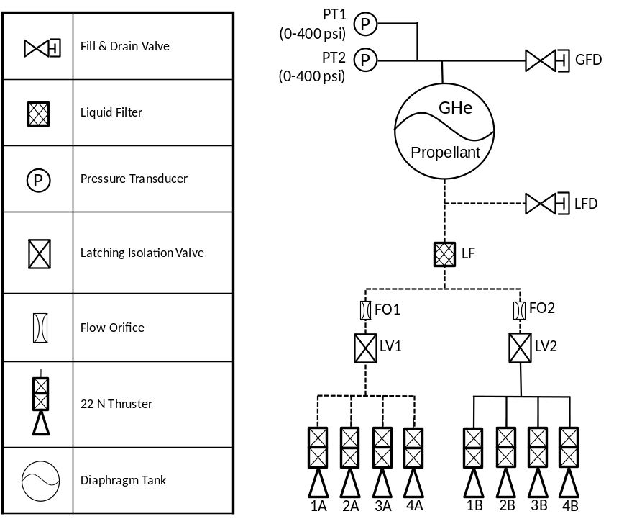
Fig. 1 PACE Propulsion Subsystem Schematic
- Subsystem Manifold Tubing
The PACE propulsion subsystem is composed of 304L stainless steel tubing with two different outer diameters (OD) of 0.25” (6.35 mm) and 0.375” (9.53 mm), each with 0.028” (0.71 mm) wall thickness. The feed lines running from the propellant tank outlet to both of the latching isolation valves and the liquid fill and drain valve are 0.375” (9.53 mm) OD. Immediately downstream of the isolation valve there is a 0.375” (9.53 mm) OD to 0.25” (6.35 mm) OD reducer, with the 0.25” (6.35 mm) tubing then running from the reducer to each of the thruster valve inlets. The propulsion surge testing used PACE flight-like tubing meeting spec AMS 5569, and corresponded almost identically to the PACE propulsion subsystem physical layout geometry. For the analytical model, the as-designed CAD model was employed to match the system geometry, paying attention to model each line length and tube bend accurately. The tube inner flow surface roughness in both the physical and analytical models was also matched to the tubing at 32 RMS.

- Conditions Evaluated
Two downstream pressure conditions between the thrusters and the isolation latch valves are germane to the subsystem surge mitigation: a padded pressure scenario and a vacuum case. In the flight system, during the final range propulsion functional test, 45 psia (3.10 bar) of gaseous helium will be left in the thruster manifold as padding to reduce the initial surge pressure event upon priming. Directly before launch, each latching isolation valve will be commanded open and the pressure differential between the tank pressure at MEOP and the downstream manifold at 45 psia (3.10 bar) will drive the hydrazine propellant into the downstream manifold, producing a pressure surge at the closed engine valves. This type of operation was implemented on the GSFC MMS mission, and PACE has adapted this system level approach. The helium padding significantly reduces the magnitude of the surge pressure event, resulting in a minimal pressure rise realized in the propulsion subsystem components. The second case has the downstream manifold at vacuum and represents an off-nominal on-orbit failure of a leaky thruster valve which causes the downstream pressure to fall to near vacuum over some finite timeframe. In this scenario, the thruster anomaly would result in the latching isolation valve being closed on-orbit, and as such the re-opening (at some point in the mission to perform a spacecraft maneuver) into the downstream vacuum condition causes substantially higher surge pressure peaks. Due to testing constraints, the vacuum limit attainable during experimental testing was 7.2 torr (0.14 psia). This vacuum limit was incorporated in the computational model for consistency. Table 1, below, shows the different analytical simulation cases evaluated.

Table 1 Simulation Cases
Venturi Throat ID (in) | Downstream Pressure (psia) | Upstream Pressure (psig) | System Temperature (F) | Fluid Medium
0.048 | 0.14 | 385 (400 psia) | 68 | Water
0.052
0.055
0.048 | 45 | 385 (400 psia) | 68 | Water
0.052
0.055

Each of the two scenarios being evaluated were applied to three (3) candidate cavitating venturis, each with unique throat diameters of: 0.048” (1.22 mm), 0.052” (1.32 mm), and 0.055” (1.40 mm). The tank pressure and upstream manifold were modeled at a MEOP pressure of 400 psia (27. 58 bar) for a conservative worst-case condition. For each of the simulation cases listed in Table 1, above, deionized water was used as the fluid medium in both lab tests and the computational model. A scaling factor [5] was then applied to the resulting water pressure surges to determine the corresponding hydrazine propellant surge pressure magnitudes. The padded pressure case was also simulated for completeness, although it showed minimal pressure rise.

- Propulsion Subsystem Proof Pressure Limitations
In the subsystem, the thrusters see the highest magnitude surge pressures as they are in the low blanket pressure or evacuated portion of the tubing (depending on the scenario). However, it is important to note that the initial induced pressure wave, resulting from the pressure differential across the primary latch valve seat, will reflect back upstream from the thrusters and impact the liquid fill and drain and redundant closed latching isolation valve. As mentioned previously, the components of concern for the PACE propulsion subsystem are the thrusters, the liquid fill and drain valve, and the redundant bank isolation valve. The specific proof pressure capabilities for each component are shown in Table 2, below.

Table 2 Component Specific Proof Pressures
Component | Thruster | Liquid Fill and Drain Valve | Isolation Latch Valve
Proof Pressure | 1650 psi | 975 psi | 825 psi

- Surge Analytical Modeling
A computational transient surge model was developed using C&R Technologies’ Thermal Desktop (TD) [6] program using the internal FloCAD [7] module to build, analyze, and evaluate resulting surge pressure magnitudes at the thrusters (1A-4A), the closed redundant latching isolation valve (LV2), and the liquid fill and drain valve (LFD). A Thermal Desktop visualization model was built in an AutoCAD environment using subsystem CAD geometry tubing centerline run dimensions to create a 1:1 representation of the PACE propulsion feed system. Each tube bend, elbow fitting, and tee fitting contained in the system was carefully constructed, to scale, to include the flow passages realized in the flight and test manifolds. The simulation cases defined above were driven by the propulsion subsystem flight operating conditions.
There were two discrete manifold sections in the feed system that needed to be defined; the first being the lower manifold, or the volume downstream of the latching isolation valve, and the second being the upper manifold, or volume upstream of the isolation latch valve. For all six simulation cases, the upper manifold was pressurized to MEOP, the lines were wetted, and were set to have a 0.0 void fraction, defining the manifold as being occupied by only liquid. The lower manifold has two sets of three cases (depending on which venturi is inline). One set has gaseous helium (GHe) with a 1.0 void fraction at a pressure of 45 psia, representing the padded case, and the other has the manifold at a pressure of 0.14 psia, or vacuum. The upper manifold includes the propellant tank, which is the fluid source in the subsystem, which was modeled as a supply in the analytical model. A transient solution is needed in order to capture the surge event, which is on the order of milliseconds, and the driving factor behind the surge is the actuation of the latching isolation valve, through which the lower manifold gets pressurized. In the analyses, the latch valve was discretely modeled, taking into account its convergent portion of tubing prior to the valve seat and its diverging portion of tubing following the valve seat.
After an outline of the subsystem fluid network was created in an AutoCAD environment, the initial components were modeled to include the location of the propellant tank, the location of the four primary thrusters, the six tee/elbow fittings, and the liquid fill and drain valve. Each of these components was given a nodal definition based on the component being either a source, divergence, or a sink relative to the rest of the flow network. The pressure and temperature conditions were driven by conservative worst-case conditions and defined at the tank boundary node with the use of a Thermal Desktop “lump”. A “lump” is a static point that can be assigned initial conditions such as void fraction, quality, pressure, and temperature. With a transient analysis, the unique lump location allows for an evaluation of the system at the nodal definition, making the lump the basic building block for any fluid subsystem in FloCAD [8, 9]. Additionally, a lump can be used to define the distinct characteristics of each of the evaluation points mentioned. For the tank, the lump was used to define a plenum boundary with an infinite volume, since the surge event is instantaneous, and the lower manifold which it affects has a small relative volume to that of the tank. The computational analysis modeled the thrusters via a lump nodal definition to set their location within the system. After the definition of the supply, the tubing was defined with the use of the software’s “pipe” feature. The “pipe” allows for the definition of a flow path with the selection of a tube’s centerline. The PACE propulsion subsystem geometry that was generated in the AutoCAD environment provided the centerline for each tube section of interest in the analysis and “pipes” were generated along each path. Each “pipe” was subdivided into a finite amount of “flow lumps” and “flow paths”, with the subdivisions being tuned as required to model the complexity of the tubing sectional bends. Pipes allow for a quick way to define sectional temperature and void fraction conditions, specifically allowing for the distinction between the lower and upper manifolds. Additional parameters that were defined in each pipe include geometry pertaining to the tube, i.e. wall thickness, outside diameter, and wall roughness which was set to match the flight tubing. The “flow lumps” generated provide location specific pressure, volume, and temperature information. Two “flow lumps” are connected using a “flow path”, which inherits the tube specific geometry from the “pipe” parameters and are assigned an initial flow rate. In order to highlight the dynamic event, stagnant conditions were defined at the start of the transient solution and each tube run flow rate was default set to zero.
The two inline venturi flow orifices (positioned just upstream of LV1 and LV2, see Figure 1) each feature a converging inlet and diverging outlet, which were modeled using a “reducer” and “expander” in series. The converging length was an input along with the upstream and downstream flow area. The upstream “reducer” area and the downstream “expander” area were inherited from the tubing geometry, and the “reducer” downstream area and “expander” upstream area were equal to the venturi throat area.
The latch valves were modeled using an “orifice” and were given parameters such as the maximum orifice area of the latch valve, the upstream and downstream tubing lengths, and the pressure lost across the seat, which was determined from vendor acceptance test data. A custom code was written to model the actuation, changing from a fully closed position to the maximum flow orifice area over the actuation response time of the latch valve. At the latch valve inlet portion, two converging sections were modeled to account for the reduced area at the valve seat and two diverging portions were similarly modeled at the outlet of the valve. The geometry for the divergence was taken from the component interface control document.
A total of six simulation models were generated to account for the six cases defined above in Table 1 (three venturis with two pressure scenarios, each). Two important assumptions that were made to the analytical model was that the working fluid is incompressible and that gravitational forces do not affect the transient solution. A view of the analytical model is shown below in Figure 2. In this illustration, both banks of thrusters are depicted, however only one is being analyzed. The isolation latch valve for the redundant bank of thrusters remains closed throughout the analysis run.

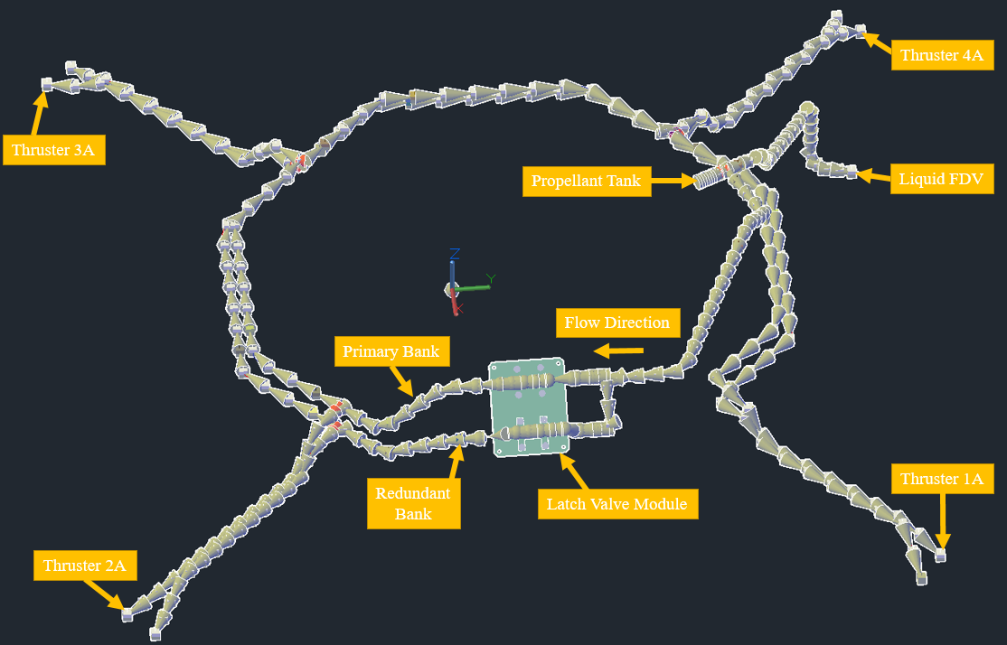
Fig. 2 Thermal Desktop Propulsion Model
A typical solution of the computational model for the vacuum downstream condition is provided below in Figure 3 and Figure 4 for the 0.048” (1.22 mm) venturi to illustrate the analytically determined dynamic event occurring. The dynamic pressure at thruster locations is shown in Figure 3, which demonstrates the peak surge pressure seen locally by each thruster which proceeds to dampen quickly. Figure 4 shows the dynamic pressures as caused by reflected waves at the fill and drain valve and the isolation valve for the redundant bank of thrusters.

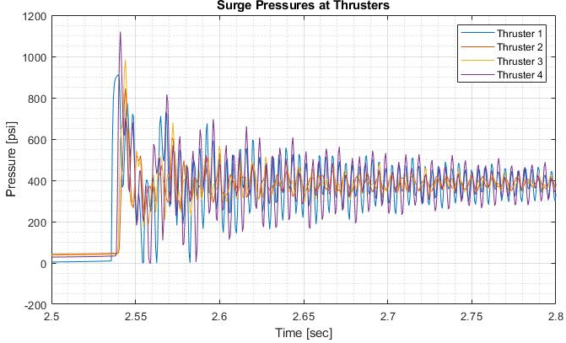
Fig. 3 Venturi Thruster Specific Surge Curves for Vacuum Condition 0.048” (1.22 mm)
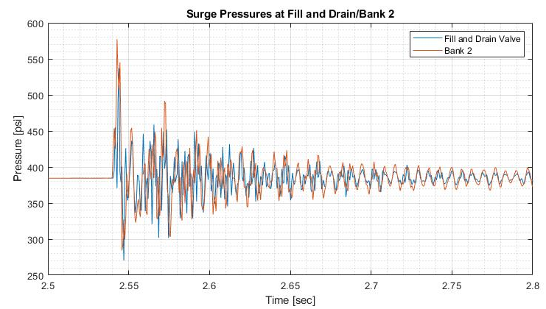
Fig. 4 Venturi Latching Isolation Valve and FDV Surge Curves for Vacuum Condition 0.048” (1.22 mm)

Figure 5, shown below, presents an ideal scenario of a 45 psi gHe padded downstream condition, unique to the 0.052” (1.32 mm) venturi, which incurs a smaller expected surge magnitude. As can be seen in the figure, the dampening effect of the gas pad prevents the surge pressures from rising to levels compared to the vacuum manifold condition. The padded condition will occur on the launch pad once the isolation latch valves are actuated open following final spacecraft testing just prior to launch.

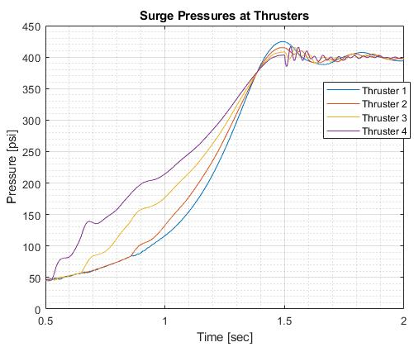
Fig. 5 Venturi Thruster Specific Surge Curves for 45 psi gHe Padded Condition 0.052” (1.32 mm)

Figure 6, shown below, displays the data for the vacuum downstream condition as evaluated by the computational model for the 0.052” (1.32 mm) venturi. Figure 6, when compared to Figure 5, provides a clear distinction between an evacuated (at vacuum) manifold and a padded manifold.

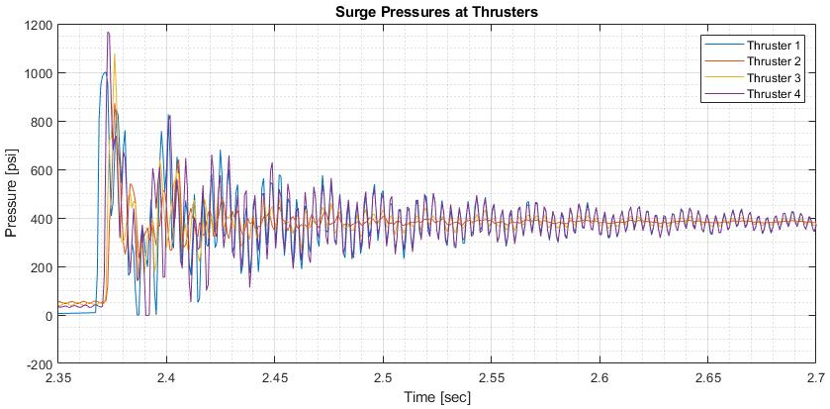
Fig. 6 Venturi Thruster Specific Surge Curves for Vacuum Condition 0.052” (1.32 mm)

- Surge Testing

The physical surge testing manifold was created to replicate the PACE flight configuration in order to ensure the results were as accurate as possible and to remove dissimilarities when compared to the surge computational model. This was accomplished by making the tube lengths and bends as close to identical as possible to the PACE primary propulsion manifold and minimizing the number of instrumentation test fittings in the design by welding the tubing sections together, as they would be in the flight system. With the primary and redundant manifolds being similar in their line lengths and bends, it was assumed that the results for the tested manifold will match closely with the untested redundant manifold.

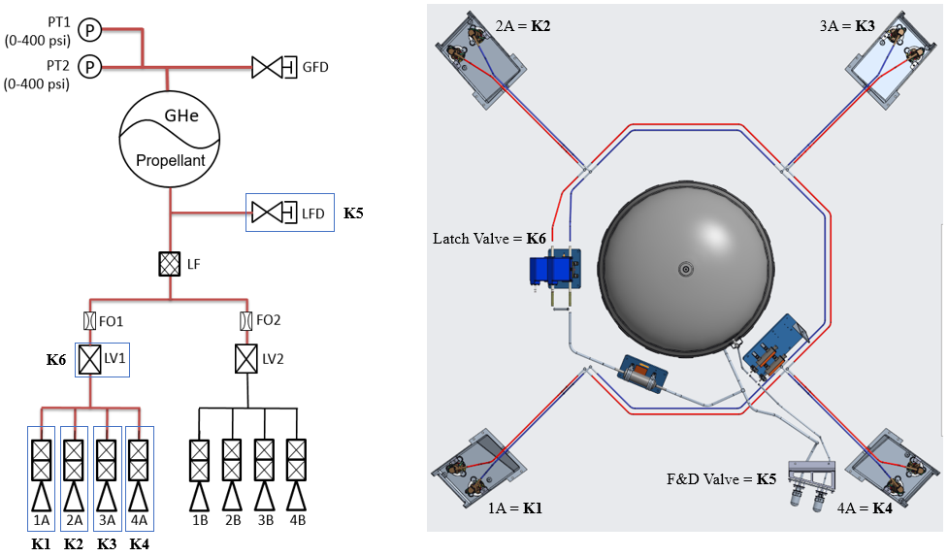
Fig. 7 Surge Testing Designations against Propulsion Subsystem Components

As discussed previously, the propulsion subsystem components subjected to propellant priming surge pressures are the thrusters in the manifold downstream of the latch valve (K1 - K4 in Figure 7), the liquid fill and drain valve (K5), and the inlet of the redundant latch valve (K6). The reference physical location of these components compared to the PACE propulsion system schematic can be seen in Figure 7, where K1 represents thruster 1A, K2 represents 2A, etc. To measure surge pressures, dynamic piezoelectric pressure sensors (manufactured by, and referred to as, Kistlers) are installed at the end of the respective tubing section where each component would be in the flight system. To represent worst-case conditions, tests were conducted at the propulsion subsystem Maximum Expected Operating Pressure (MEOP) of 400 psia (27.58 bar). An overview photograph of the experimental test setup is shown in Figure 8, highlighting the latching isolation valve, and three of the six Kistler locations.

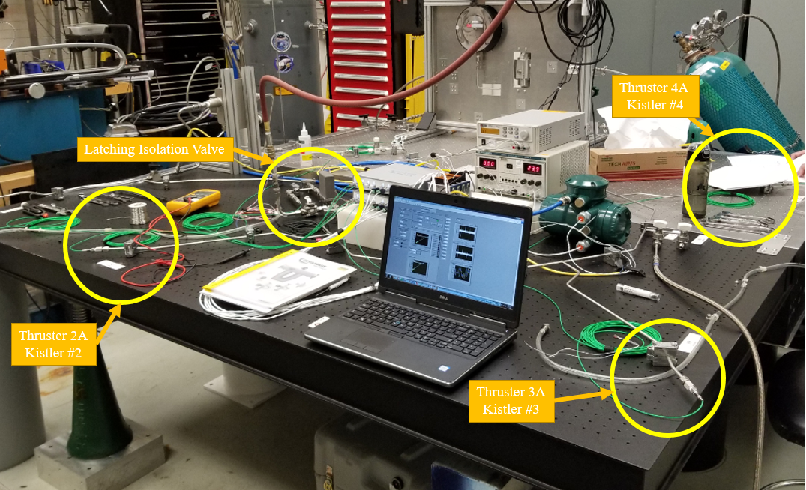
Fig. 8 Overview of Surge Testing at NASA GSFC Waterhammer Laboratory

The most critical system variable is the pressure downstream of the primary latching isolation valve. The worst-case pressure downstream of the latching isolation valve is when there is complete evacuation, i.e. vacuum. To replicate this potential on-orbit vacuum condition downstream of the latch valve, a vacuum pump was used to evacuate the downstream manifold to a test pressure of approximately 0.14 psia (7.24 torr). This vacuum test condition results in the worst-case surge pressures as there is no liquid or gas to resist the incoming liquid flow from the latching isolation valve opening. Numerous surge tests were conducted using 0.048” (1.22 mm), 0.052” (1.32 mm), and 0.055” (1.40 mm) cavitating venturis to gather a data set to determine a viable venturi size for the surge mitigation.
- Flow Testing
The propulsion subsystem surge mitigation flight venturi candidates underwent flow testing upon arriving at GSFC. The flow testing was performed in order to characterize the flow performance for each of the three different throat diameter orifice geometries. Of primary concern was the cavitation mass flow rate unique to each venturi, which can be used both as an upper limit on the flow rate in the surge computational model and as a verification value against the flow rates calculated internally by the Thermal Desktop computational model. In Figure 9, shown below, the mass flow rate for each of the three venturi sizes is shown plotted against the pressure loss across the orifice. The values shown in the figure were attained empirically, where with the use of a metering valve allowed the flow rate to be increased incrementally to sample instantaneous mass flow rates as well as the pressure upstream and downstream of the venturi device. The cavitating flow rates for each of the venturis are shown in Table 3, below. The results are unique to a feed pressure of the as-tested 400 psia upstream pressure condition.

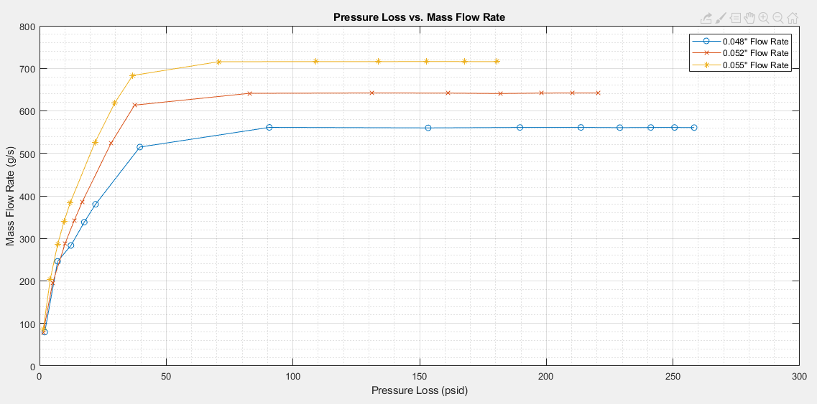
Fig. 9 Mass Flow Rates as a function of Pressure Loss for each Venturi Case

As a verification method, the Thermal Desktop computational model calculated the mass flow rate consistently within 5% of the empirical results, as shown in Table 3 below. The 5% divergence in the results could be caused by the expanding portion of the venturi not reaching the full ID of the tube and having a quick transition at the location shown in Figure 10 below. This is brought about by having a converging/diverging portion of a finite length venturi which meets a minimum inlet/outlet length criteria in order for ease of welding to adjacent tubing. It can be seen that the converging portion goes from the upstream tubing ID to the venturi specific throat area and the diverging portion goes from the throat diameter to the downstream tubing ID, as shown in Fig. 10. In reality, the diverging portion of the venturi does not fully reach the ID due to a constraint on the length of the venturi so there is a step that transitions to the ID of the downstream tube. In the data, it is seen that as the venturi throat diameter sizing is increased, the tested and analytically determined mass flow rate converge to within 1 gram/sec of each other.

Table 3 Cavitation Mass Flow Rates for Venturi
Venturi ID | 0.048” (1.22 mm) | 0.052” (1.32 mm) | 0.055” (1.40 mm)
Empirical Cavitation Flow Rate  lbm/hr | 560.3 (70.6 g/s) | 640.5 (80.7 g/s) | 709.5 (89.4 g/s)
Analytical Cavitation Flow Rate  lbm/hr | 580.2 (73.1 g/s) | 667.6 (84.1 g/s) | 706.2 (88.9 g/s)

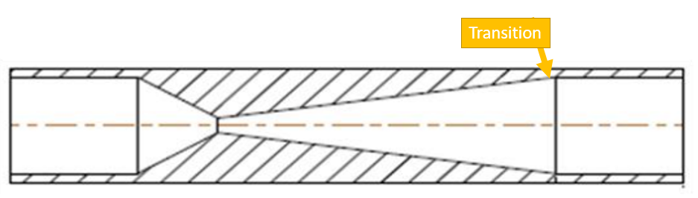
Figure 10: Transition in ID for Venturi

Joukowsky Equation
The cavitation mass flow rates determined by empirical testing can be used in the Joukowsky equation in order to find a single magnitude surge pressure based on fluid velocity, fluid density, and wave propagation velocity [4, 5]. The fluid velocity in the equation is computed from the cavitation mass flow rates and is unique to a given venturi size. A total of three values were obtained, and are discussed later in this paper.
- Comparison of Computational Model against Testing
Based on the surge analysis and follow-on testing, the 0.052” (1.321mm) venturi was baselined for the PACE propulsion subsystem. Figure 11, below, shows the 0.052” venturi sizing analytical versus empirical results. The Kistler # corresponds to the location of components throughout the system, as was depicted above in Figure 8. The data displayed shows the peak pressure during a surge event and includes the analysis results, the surge testing results, and the mean value from the surge testing. The analytical and test results match with a ~10.5% average variance between the mean testing surge pressure and the computational model calculated peak pressure.

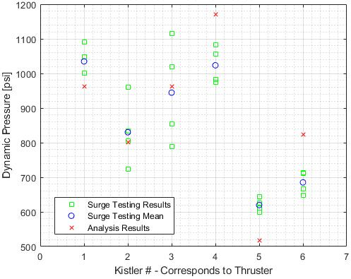
Fig. 11 0.052” (1.32 mm) Venturi Vacuum Condition Comparison – Analytical versus Empirical

As can be seen in Figure 12 in the empirical testing data summary, the redundant closed latching isolation valve peak pressures were higher than the latch valve proof pressure once a hydrazine scaling factor was applied, this phenomenon was seen by each of the three different venturis tested. The computational model also captured the same result, as can be seen in the computational vs. empirical comparison in Table 4 below. The propulsion subsystem has two fully redundant thruster banks in order to meet the safe system de-orbit reliability requirements and is single fault tolerant, meaning that all propulsion requirements can be accomplished using a single thruster bank (either the primary or secondary). The scenario for propulsion subsystem components to experience a peak surge pressure (worst case as tested in this campaign: MEOP driving pressure, vacuum downstream) requires a leak through a single (or multiple) redundant thruster valve seat in any thruster, i.e. two failures. This also requires both failures to occur early in mission life, when the propellant tank is at a higher propellant fill fraction, and closer to MEOP. Since the propulsion subsystem is a blowdown system, tank pressure decreases as propellant is consumed for maneuvers. The primary thruster bank will be used for all mission maneuvers, and the secondary thruster bank is a fully redundant backup. If, during the PACE mission, the situation presents where a thruster valve is leaking in the primary bank, the latching isolation valve associated with that bank will be closed to block off the propellant tank from the leaky thruster or thrusters in the primary bank. From this point forward, the secondary thruster bank will be utilized. If after this step, a leaky thruster valve presents in the secondary bank, the same procedure would be followed to isolate the secondary thruster bank latch valve from the propellant tank. At this point, both latching isolation valves are closed and the primary and secondary banks have leaky thruster valves. Going forward, when a thruster maneuver is required, one of the latch valves will be opened (either for the primary or secondary bank), and the hydrazine flow priming the manifold will surge to the thruster valves, producing another surge event. The reflecting pressure wave will impact the propellant fill and drain valve and the secondary (or primary depending) latching isolation valve. In this situation, it is possible that the latch valve could experience a higher surge pressure than the proof pressure. All this noted, the risk of damage occurring to the latch valve as a result of a surge pressure event in this scenario is low, acceptable, and beyond the requirement scope. For the PACE mission, the propulsion subsystem is required to be single fault tolerant, and for this worst case condition to be realized in flight requires two or more failures.

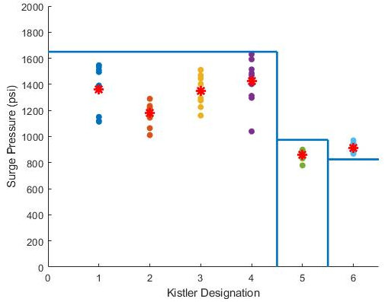
Fig. 12 0.052” (1.32 mm) Venturi Scaled Surge Pressures
There also exist two operational solutions which can minimize the risk of damaging the second latch valve if the worst case scenario were to occur. The first solution is to allow the tank temperature to drop prior to the opening of either latching isolation valve in order to minimize the surge pressure by lowering the tank pressure. The second operational solution is to open both latch valves before the manifold is allowed to prime. There is a 1.4 second period of time between the latch valve actuating and the surge event occurring. This is the time it takes for the downstream manifold to prime and for the pressure wave to travel back through the liquid and impact the propulsion subsystem component surfaces. If the second manifold is opened within this 1.4 second window of time, the reflecting pressure wave would pass through the open latch valve rather than impacting the closed valve seat. The PACE valve driver electronics have this capability should it be required.
The results outlined in Table 4, below, show that the computational model developed in TD predicts component specific surge pressure magnitudes within 4σ when compared against results attained during testing. The majority of the results are within 3σ, with the exception of two outliers for the 0.048” (1.22 mm) venturi at Thruster 3A and the F/D valve. Both outliers can be associated with an increased testing result spread at the testing condition. Dynamic peaks unique to a component are modeled accurately by the computational model, allowing for attention to be paid to vulnerable components when sizing a propulsion subsystem. This higher fidelity model, when compared to the single surge pressure value attained with the use of the Joukowsky Equation, provides more flexibility for early identification of more sensitive components and potential failures and provides increased time to look for viable solutions, rather than in the middle of a test campaign.

Table 4: Comparison Data between Computational model and Empirical Test Data
Boundary Condition |  | MEOP, Vacuum Downstream |  |  |  | Analysis Result Sigma | Joukowsky Solutions
Venturi Size and Evaluation Point |  | Analysis Results (psi) | Testing Results (psi) |  |  | Analysis Result Sigma | Joukowsky Solutions
 |  | Analysis Results (psi) | Average | Peak | Sigma | Analysis Result Sigma | Joukowsky Solutions
0.048” | Thruster 1A | 911 | 950.4 | 1055.0 | 67.4 | 0.58 σ | 758.2
0.048” | Thruster 2A | 845 | 1059.7 | 1155.1 | 84.5 | 2.54 σ | 758.2
0.048” | Thruster 3A | 985 | 810.4 | 926.3 | 45.7 | -3.82 σ | 758.2
0.048” | Thruster 4A | 1120 | 998.4 | 1100.8 | 70.5 | -1.72 σ | 758.2
0.048” | F/D Valve | 536 | 744.0 | 792.8 | 54.7 | 3.8 σ | 758.2
0.048” | Latch Valve | 709 | 664.7 | 699.4 | 34.3 | -1.29 σ | 758.2
0.052” | Thruster 1A | 1001 | 986.4 | 1120.5 | 113.3 | -0.13 σ | 867.8
0.052” | Thruster 2A | 872 | 857.2 | 934.3 | 55.8 | -0.26 σ | 867.8
0.052” | Thruster 3A | 1078 | 976.9 | 1095.1 | 73.0 | -1.38 σ | 867.8
0.052” | Thruster 4A | 1167 | 1031.7 | 1181.2 | 112.5 | -1.2 σ | 867.8
0.052” | F/D Valve | 554 | 623.4 | 652.1 | 23.6 | 2.94 σ | 867.8
0.052” | Latch Valve | 727 | 663.4 | 703.2 | 22.5 | -2.83 σ | 867.8
0.055” | Thruster 1A | 1062 | 1213.2 | 1744.5 | 54.8 | 2.76 σ | 968
0.055” | Thruster 2A | 928 | 959.5 | 1388.8 | 28.7 | 1.1 σ | 968
0.055” | Thruster 3A | 1134 | 1090 | 1573.2 | 61.8 | -0.71 σ | 968
0.055” | Thruster 4A | 1300 | 1113.2 | 1732.9 | 102.5 | -1.82 σ | 968
0.055” | F/D Valve | 586 | 589.5 | 946.9 | 56.9 | 0.06 σ | 968
0.055” | Latch Valve | 625 | 652.7 | 969.9 | 30.1 | 0.92 σ | 968

- Conclusion and Future Work
Surge analysis and testing was conducted for the PACE propulsion subsystem design to determine a venturi throat diameter to preclude surge damage to the components while minimizing operational pressure losses. The analytical model created using Thermal Desktop’s FloCAD module proved to be a useful tool in generating preliminary expected surge pressure magnitudes for a given feed system, allowing for candidate venturi sizing. The analytical surge modeling represents an enhanced capability for the NASA GSFC Propulsion Branch, and produced surge pressure magnitudes matching closely to experimentally obtained values. Going forward, this analytical modeling method can be anchored to historical surge testing and implemented for new propulsion feed systems, increasing the capability and fidelity of GSFC propulsion subsystem modeling, as well as providing flexibility of surge mitigation sizing.
The PACE Propulsion subsystem is straight forward in regards to the propellant feed line layout and overall configuration. A more complex system should be evaluated using the described analytical methodology in order to verify model accuracy and the ability to consistently estimate peak pressures at component locations within a ~10% margin. Feed system complexity can be driven by increased asymmetrical branches with unique line lengths or diameters, additional venturi arrays, and overall system size in terms of subsystem components. Additional testing of various system configurations can also provide a greater data set against which to evaluate the effectiveness of a TD computational model. Additionally, hydrazine can be used as the working fluid in the computational model and evaluated against empirical testing results with a scaling factor applied.
Depending on the future mission in which this computational model methodology is used, it is possible to preliminarily determine unexpected surge outcomes allowing for early recognition of noncompliance. With early detection, computational models can be iterated upon quickly to accommodate potentially sensitive components. This analysis also proves quite useful in driving a test campaign, as described herein, if required for the mission.

Acknowledgments
The authors wish to acknowledge the support provided by the NASA GSFC Propulsion Branch and the PACE Mission.

References
[1] Scroggins, A. R., “A Streamlined Approach to Venturi Sizing,” 48th AIAA Joint Propulsion Conference, Paper AIAA 2012-4028, AIAA, Reston, VA, 2012.
[2] Cardiff, E., Parker, K., Rao, A., and D. Ramspacher, “Propulsion System Design and Analysis for the Magnetospheric MultiScale (MMS) Mission” JANNAF 62nd JPM/ 10th MSS / 8th LPS / 7th SPS Joint Subcommittee Meeting, Nashville, TN, 1 - 5 June 2015.
[3] Scroggins, A. R., Fiebig, M. D., “Surge Pressure Mitigation in the Global Precipitation Measurement Mission Core Propulsion System,” 50th AIAA Joint Propulsion Conference, Paper AIAA 2014-3785, AIAA, Reston, VA, 2014.
[4] American Society of Mechanical Engineers, “Water-Hammer Head…or the Joukowsky Equation…is as Derived by Moody,” ASME-ASCE Symposium on Water Hammer, New York, 1933, pp.25-28.
[5] Prickett, R. P., Mayer, E., and Hermel, J., “Water Hammer in a Spacecraft Propellant Feed System.” 24th AIAA Joint Propulsion Conference, Paper AIAA-88-2920, AIAA, Reston, VA, 1988.
[6] Thermal Desktop®, PC/CAD-Based Thermal Model Builder, developed at Cullimore & Ring (C&R) Technologies.
[7] FloCAD®, PC/CAD-Based Thermal/Fluid Model Builder, developed at Cullimore & Ring (C&R) Technologies.
[8] Panczak, T.; Ring, S.; Welch, M.; Johnson, D.; Cullimore, B.; Bell, D.: Thermal Desktop User’s Manual, Version 5.7, C&R Technologies, 2014.
[9] Cullimore, B.; Ring, S.; Johnson, D.: SINDA/FLUINT User’s Manual, Version 5.8, C&R Technologies, 2015

Propulsion Engineer, NASA GSFC Propulsion Branch, Mail Stop 597.
Propulsion Engineer, NASA GSFC Propulsion Branch, Mail Stop 597, AIAA Member.
Propulsion Engineer, NASA GSFC Propulsion Branch, Mail Stop 597, AIAA Member.

