Researching the Effect of Parameter Changes on FUN3D Simulations and ROM Generation

Brianna L. Blocher
NASA Langley Research Center, Hampton, VA 23681
This paper discusses the preliminary background and resulting research conducted on the effect of plateau length on CFD results and ROM generation. Within this research, smaller studies were conducted to assess both CFD and ROM parameters for a determination of best practices. The results in this paper lead to a preliminary assessment of potential best practices for ROM generation moving forward.

Nomenclature

AEROM = Aeroelastic Reduced Order Model
CFD = Computational Fluid Dynamics
CRM = Common Research Model
ERA = Eigensystem Realization Algorithm
FUN3D = Fully Unstructured Navier-Stokes
q, Q = Flutter Dynamic Pressure
RANS = Reynolds-Averaged Navier-Stokes
ROM = Reduced Order Model
SOCIT = System Observer Controller Identification Toolbox

I. Introduction
The Aeroelasticity branch of NASA Langley Research Center (LaRC) is responsible for studying different phenomena that occur between fluid and structural interaction. Flutter is one of these phenomena that occurs with this interaction, budding an instability that leads to a growth in vibrational oscillations and eventual massive structural damage if not kept in check. Within the branch, a method for Reduced Order Model (ROM) generation is being studied to help more accurately predict the flutter dynamic pressure of a structure in a shorter time period than traditional Computational Fluid Dynamics (CFD) simulations with the eventual goal of creating ROMs for accurate real-use predictions.
FUN3D is an analysis code designed to solve the Reynolds-Averaged Navier-Stokes (RANS) equations and produce an accurate CFD simulation. It is a node-centered, finite-volume, unstructured solver that primarily uses the Spalart-Allmaras turbulence model to solve the RANS equations [1]. Because the flow becomes turbulent in its interaction with a structure, a turbulence model is used to mathematically embody that relationship. The Spalart-Allmaras model utilizes one equation, helping to characterize the resulting eddies and their resulting viscosity. The research that will be discussed initially used FUN3D version 13.6 but transitioned to version 13.2 to help minimize the software errors being experienced from 13.6.
This research uses NASA’s Common Research Model as its body of focus. It is like other transonic commercial aircraft, with a cruising Mach number of 0.85, a wing span of 58.7 meters, a mean chord of 7 meters, an aspect ratio of 9, a taper ratio of 0.275, and a sweep of 35 degrees. This design is used to help experimentally validate CFD results via wind-tunnel testing.
Reduced Order aeroelastic modeling generated about a converged static aeroelastic solution is created via training simulations from FUN3D. It is useful in capturing nonlinearities, and physically perturbs modes, leading to the possibility of picking up nonlinear influence while linearizing [1]. First, a converged steady flow solution with a rigid aircraft configuration is found. Its rigidity implies a very high structural damping to allow for very minimal/no structural movement. Next a static aeroelastic simulation is run from the converged points so that the control modes do not evolve, but the structural modes do until there is a static aeroelastic convergence. This will have a lower damping to allow for this movement. Finally, a new simulation is run using the static solution to prescribe desired motions in chosen modes [2].
In the Walsh input functions, there are distinct peaks and valleys containing flat plateaus. The length of these plateaus, though, can differ in the code and be scaled relative to the other modes. Because of the scaling that occurs, increasing or decreasing that length will proportionally increase or decrease the other lengths. These Walsh input functions act on specific modes from the structure. Structural modes characterize a specific vibration pattern caused at a determined frequency, and this study includes 25 structural modes. From previous research done, the modes of interest are 1, 2, 3 and 8 as they cover most of the wing’s movement. Mode 1 and 3 are bending modes, while Modes 2 and 8 are torsion mode. The figure below shows the resulting displacement patterns seen from these modes.
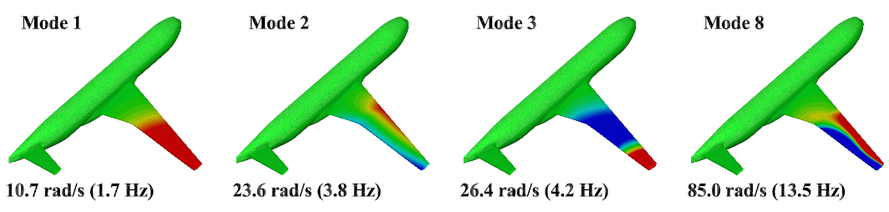
Figure 1. The CRM is shown with the displacement of each mode. Blue correlates to downwards movement while red correlates to an upwards movement.

II. Methods

A. FUN3D
Because of this, it was decided to run a study on the effect that change in length would have on the FUN3D results and resulting ROMs. On the smallest possible flat, four cases were run with lengths of 200 steps, 500 steps, 1000 steps, and 2000 steps. This resulted, then, in a total of 1300 steps, 2800 steps, 5300 steps, and 10300 steps, respectively, for the dynamic portion of the run. For the static aeroelastic case, an additional 600 steps were used to cover the static run convergence. Using an in-house Python script, desired cases for submission to FUN3D were created. For the static aeroelastic case, the steps per smallest plateau were set to 200, 500, 1000, and 2000, respectively. To allow for a proper start and finish, a pre-buffer of 300 steps and a post-buffer of 200/500/1000/2000 were added.

Looking at the generated Walsh inputs, mode 8 appeared to have the smallest plateau lengths, and was used as the scale for the other Walsh inputs. This is seen in the differences in plateau lengths in the graphs below.

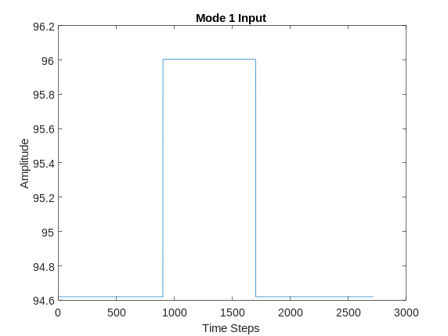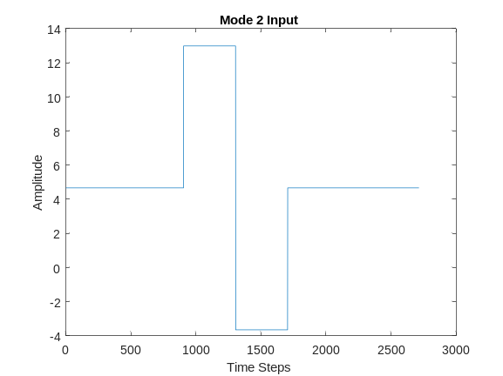
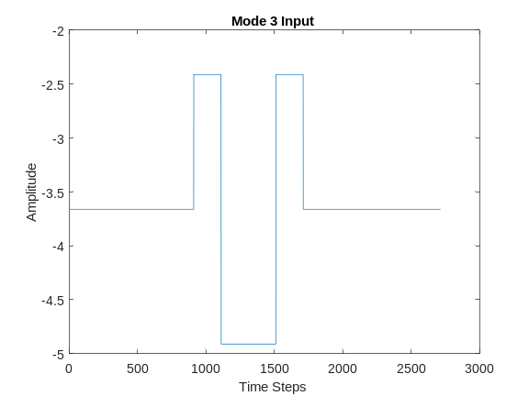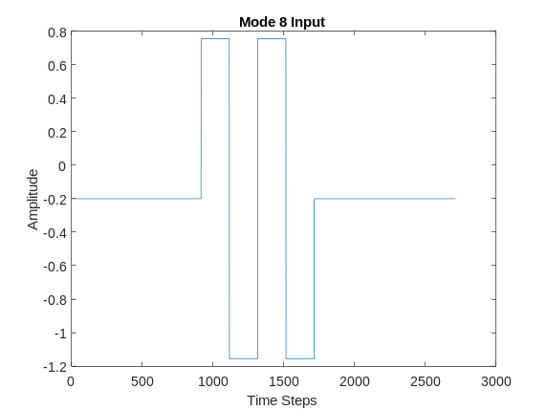
Figure 2. Walsh Inputs for Modes 1,2,3, and 8.

Looking at the above figures, there is also a difference in the amplitudes achieved by each mode. This is due to the scaling being set to be one percent of the tip chord, with each mode having a different value in reference to this condition. Because of this change in amplitudes, a small study was performed to see the limits of FUN3D with these input amplitudes. The cases, however, use a rigid restart rather than a steady convergence point to decrease the chance of the deformation becoming too much for FUN3D to process. With a rigid restart, initial values would begin at zero rather than have an initial displacement. Surprisingly, though, all but one case with a percent scaling greater than one crashed partway through its iterations. The case that did manage to complete its run will be discussed in later in the Results section.
Another small study was performed was on understanding the effect of gforce0 on the FUN3D output. Gforce0 is a parameter within the input file that was previously used to simulate weight for another configuration and remained in some input files. Understanding the effect on the resulting outputs was a way to determine if it was needed in all configurations.

B. AEROM/SOCIT
When generating a ROM, the outputted Generalized Aerodynamic Forces (GAFs) and the Walsh Inputs are read in and processed through PULSE. PULSE is a routine that takes these inputs and outputs and separates them into impulse responses. From there, the impulse responses are processed through ERA, converting them into state-space matrices, and the output is considered the unsteady aerodynamic ROM. Once this ROM is completed, the structural ROM is generated by creating a state-space model from the generalized mass, and modal damping information it reads in. Verifying with a root locus to ensure poles lie in their appropriate position, the ROM has been created, and a dynamic pressure and/or modal perturbance can be simulated to see if the ROM’s response lines up with that of the CFD results. Figure 3a shows the general structure of the entire ROM, containing both the aerodynamic ROM and the structural model created through the AEROM/SOCIT routine. For the models done in this study, note that there are no “Inputs” other than the prescribed modal movement. All other inputs, like gust or control surface movement, are not considered. Figure 3b details the steps taken before the aerodynamic ROM to generate it.
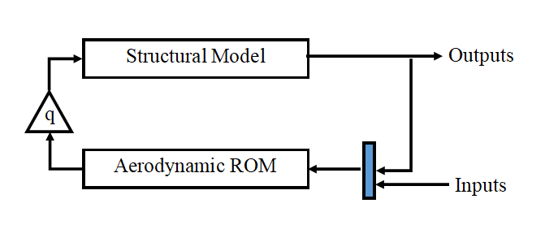
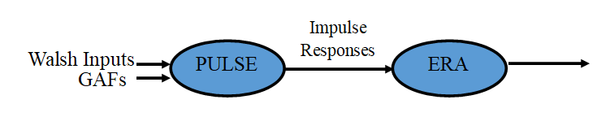
Figure 3. Block diagram of ROM generation

To test the newly generated ROMs, a test simulation was run in FUN3D with an initial velocity perturbation of 150 m/s on Mode 1. This information was inputted into the ROM as well, and a comparison was conducted.

III. Results
For the static aeroelastic case, the following time history plots were created from FUN3D. Note that only the forces for Mode 1, 2, 3, and 8 are shown, but all relevant figures are included below in Appendix B.

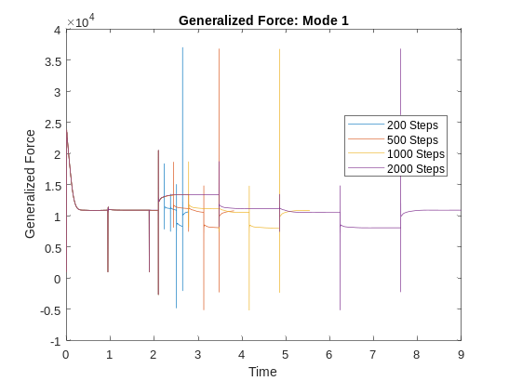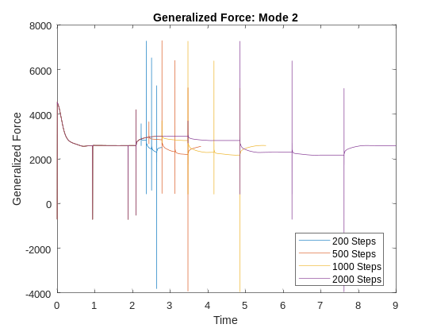
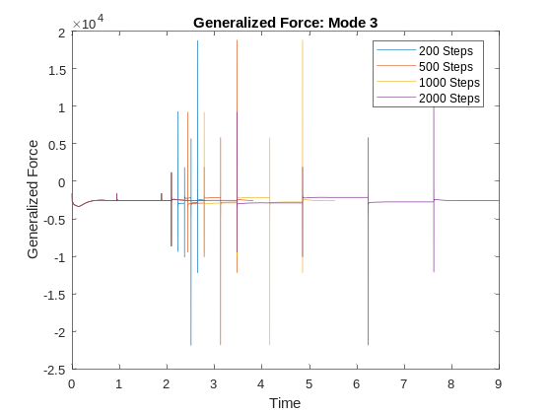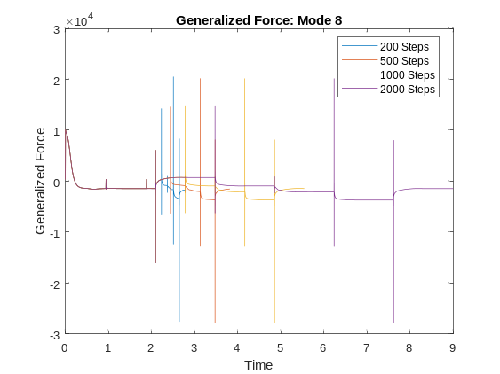
Figure 4. Generalized Aerodynamic Forces output from static aeroelastic run

Looking at the figures above, there does not appear to be any immediate issues with the FUN3D simulations as the force output is expected and helps to proceed with ROM generation. Immediately after a spike, a curve can be seen leading to a “flattening out” to a stable value before spiking again.
Because of the sensitivity of the ROM generation code, a small study was done on some of the values within. The tables below detail the results. The in-house MATLAB code synthesized by Josiah Waite has an internal system to determine the best possible ROM parameters that result in the smallest relative error when compared to a CFD solution for that ROM. Running this on the different cases, the following values were found. The variable “nm” is an input into the ERA routine to set the number of rows in the Hankel Matrix. The variables “pf” and “npulse” are inputs to PULSE, the former assigning the number of states to be kept within the impulse responses, and the latter defining the length of the impulse responses produced. The npulse value was changed between two previously used values by Waite and Silva to determine if there was a noticeable difference in the resulting values, but the change, however, did not seem to affect the nm and pf values obtained. The error is a relative value within the code, so any discussion on error must be done so in relation to the other cases’ values.

Table 1.
Steps | nm | pf | npulse | error | q
200 | 96 | 96 | 800 | 1*10^5 | 14285.7143
500 | 92 | 74 | 800 | 4.8*10^4 | 29591.8367
1000 | 92 | 72 | 800 | 2.6*10^4 | 33673.4694
2000 | 100 | 88 | 800 | 3.9*10^4 | 30612.2449
200 | 96 | 96 | 1500 | 1*10^5 | 12244.898
500 | 92 | 74 | 1500 | 4.8*10^4 | 29591.8367
1000 | 92 | 72 | 1500 | 2.6*10^4 | 33673.4694
2000 | 100 | 88 | 1500 | 3.9*10^4 | 30612.2449

From this, the cases were re-run with the given nm and pf values to determine the appropriate nm and pf value to use in the final ROM generation. For brevity, only one table and case are shown, and all relevant tables and figures are shown in Appendix B.

Table 2. nm = 96, pf = 96
Steps | npulse | error | q
200 | 800 | 1.0*10^5 | 14285.7143
500 | 800 | 5.1*10^5 | 29591.8367
1000 | 800 | 3*10^5 | 36734.6939
2000 | 800 | 1*10^5 | 160760.7608 (modified root locus)
200 | 1500 | 1*10^5 | 12244.898
500 | 1500 | 4.3*10^5 | 29591.8367
1000 | 1500 | 2.5*10^5 | 36734.6939
2000 | 1500 | 9.1*10^4 | 160960.961 (modified root locus)
Note that while this table shows that an increase in npulse reduces the relative error, other nm/pf value combinations show the opposite occur where an increase in npulse also leads to an increase in the relative error. Refer to Appendix B for all the tables.
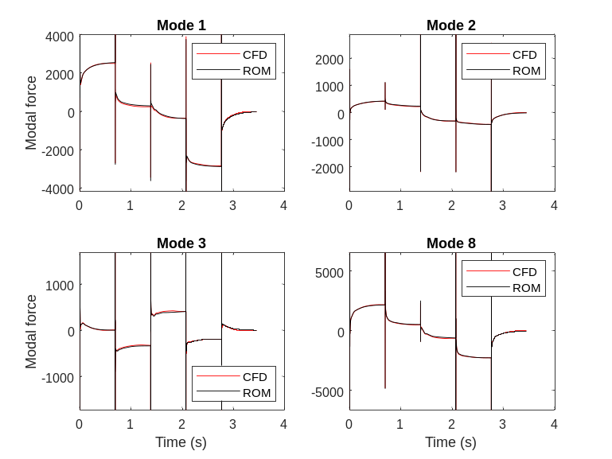
Figure 5. CFD vs ROM comparison for an outputted ROM

The ROM created for the 1000 steps with an nm and pf of 96 follows the CFD closely, as shown in Figure 5. Looking at the root locus created below, Mode 2 leads to an instability as we see its curve cross the 0-Real axis into positive real values.
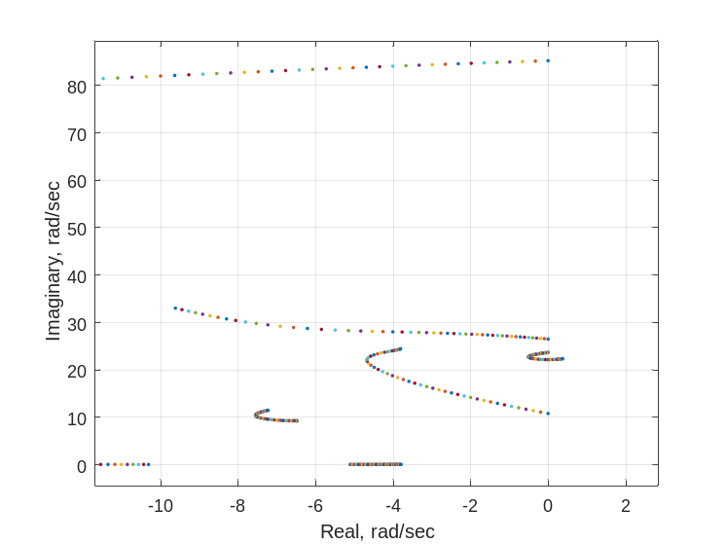
Figure 6. Root Locus Plot for 2000 Step Plateau Length

For the 2000 steps case, the root locus never had a point that crossed into unstable territory. Because of this, the max dynamic pressure was increased from 50 kPa to 200 kPa, and a flutter dynamic pressure was found. The modification has been noted in the table.
Using the training simulation from FUN3D for each plateau length as described in the Procedure section, the following comparisons were found. The graphs below are from an nm/pf combination of 25/100.
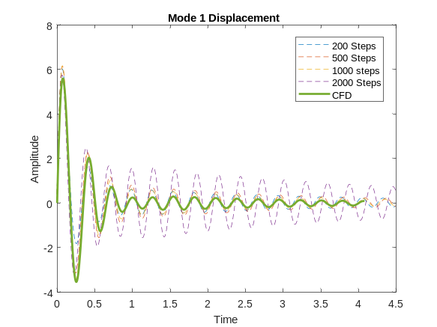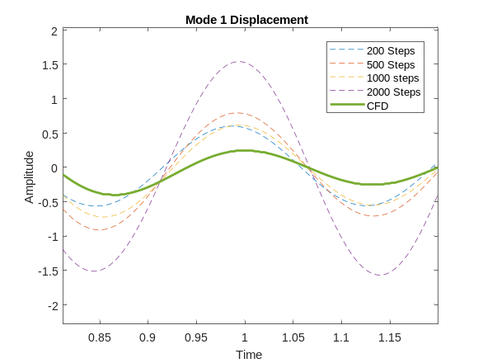
Figure 7. Comparison of ROM output with FUN3D simulation output at varying plateau lengths

Figure 7 shows a comparison of the Mode 1 displacements calculated by the different plateau length ROMs alongside the CFD result. Looking through all nm/pf combination comparisons, 1000 steps appeared to have the closest match to the CFD, so another comparison was made with all 1000 step ROMs at different nm/pf combinations. From the comparison below, 96/96 is seen to align the closest with the CFD result.
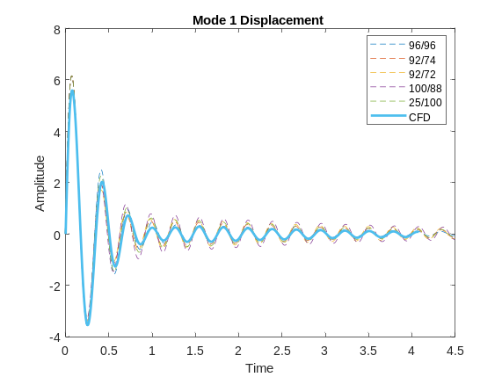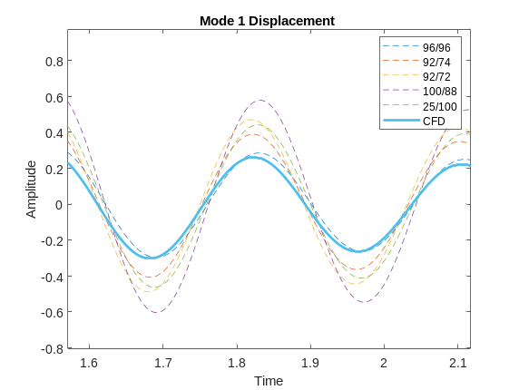
Figure 8. Comparison of ROM output with FUN3D simulation output at varying nm/pf combinations

When running a parameter study for the rigid restart cases, the same issue kept occurring. For all plateau lengths, the ROM would predict an immediate instability in one or more of the modes. One of the generated root locus plots is shown for reference.
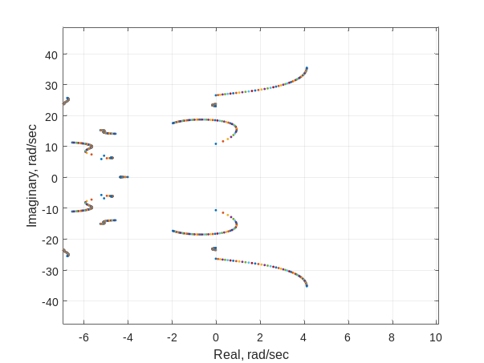
Figure 9. Rigid Restart Root Locus Plot
Because of this, an amplitude study was conducted increasing the percentage of the tip chord, but all attempts to increase could not be finished successfully by FUN3D. Only one case ran successfully with a 2% amplitude scale and an increased nondimensional timestep from 0.22 to 1.0.
The gforce0 study showed differences in the GAFs outputted by FUN3D, shown below. While the shape of the curves follows closely, the values are decreased noticeably with the inclusion of gforce0.

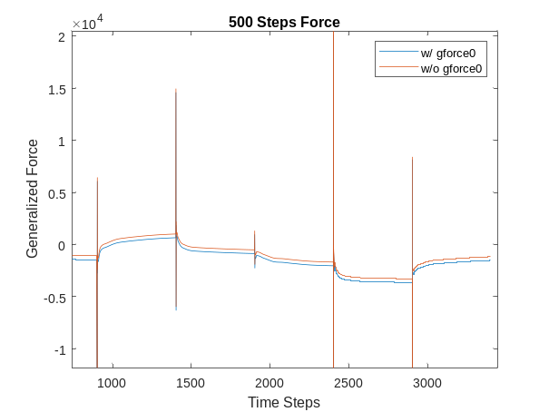
Figure 10. Comparison of gforce0 usage in FUN3D simulations

IV. Discussion and Conclusions
Comparing the data obtained for the static aeroelastic simulations, there is a difference that can be seen between the number of steps used. In most cases, the 200 steps case captured a much lower flutter dynamic pressure than the other three cases. Generating the ROMs, a similar issue occurs, as the error is highest in the 200 steps case than the others.
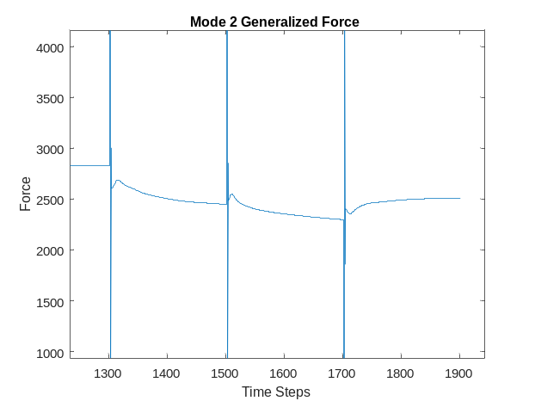
Figure 11. Force output for 200 step simulation

Figure 11 shows only the 200 steps case forces. Looking at the flats before the spikes, we see that the value is not fully stabilizing before spiking again. This could potentially be the reason for bad ROM generation by this case. There is also a similar issue in the 2000 steps cases. The ROM predicts a drastically higher flutter pressure than expected, despite the relative error typically being the smallest of the group. 1000 step plateau length proved to be the most accurate in predicting the CFD results and should continue being used for current best practices. A length of 500 steps, however, was also accurate with its results, showing that if a smaller computational time is needed, or an overall reduction in the number of timesteps is wanted, 500 steps is still a viable option.
Regarding the gforce0 parameter, there was a noticeable difference with and without it in the input file, leading to the conclusion that it should not be included in future configurations to not impact any potential results. Looking at the amplitude study, a dive into potential points of failure was conducted. Figure 12 shows the outputted generalized velocity graphs for two of the cases, and there seems to be a spike directly before FUN3D failed to continue. This could be the main cause, as the rapid change in velocity could have led to a mesh deformation that was too quick for FUN3D to work with.
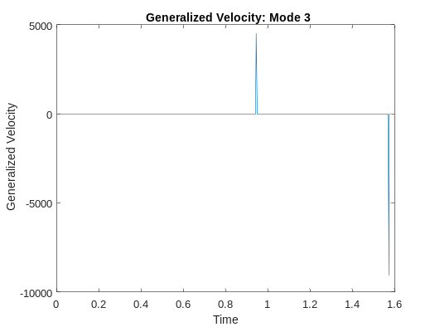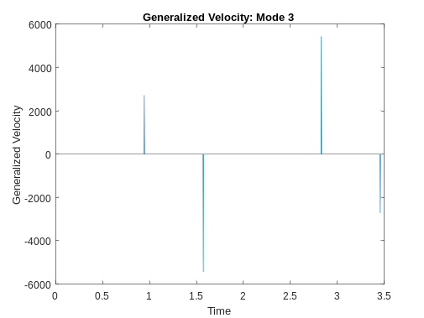
Figure 12. Generalized Velocity Outputs for Amplitude Study cases

With the parameter study, I found that ROMs are highly sensitive to any changes, and the penalty matrix used in determining the best nm/pf combination may not be the best method for finding them. This is seen by the 2000 step case having the lowest relative error to all other cases despite predicting a wildly high flutter dynamic pressure. This is also seen in how the nm/pf combination of 96/96 worked the best for 1000 steps with the CFD, despite 92/74 being the best combination for 1000 steps.
In the future, I would propose another small study into the gforce0 parameter to better understand its full effect and confirm that there is indeed a noticeable impact on the results. It would also be beneficial to improve the current penalty matrix or find some other method for determining the best nm/pf pair, as there were some discrepancies in what the matrix determined as the “best” versus what gave the actual accurate results. Finally, it would be good to look more into the rigid restart cases, as my work led to some dead ends and holes regarding them. Regarding the parameters, try to find the appropriate nm/pf/npulse values that create ROMs that are not immediately unstable. Regarding FUN3D and the amplitudes, try to adjust the input so that FUN3D is not overloaded, potentially leading to an error.

V. Acknowledgements
I would like to thank Josiah Waite and Walt Silva for their guidance through this project and unending patience at all questions I could throw their way. They made this experience interesting and very educational, inspiring me to pursue Aeroelasticity in my own career. I’d also like to thank Jonathan Davami for being a great partner to work with and bounce ideas off to help me learn the material that much more.

VI. Appendices

A. References

[1] Waite, J.M., Bartels, R.E., and Stanford, B.K. “Aeroelastic Model Development for the Integrated Adaptive Wing Technology Maturation Project Wind-Tunnel Test,” AIAA Aviation 2020 Forum, 2020

[2] Waite, J., Stanford, B., Bartels, R. E., and Silva, W. A., “Active Flutter Suppression Using Reduced Order Modeling for Transonic Aeroservoelastic Control Law Development,” AIAA Aviation 2019 Forum, 2019, p. 3025.

B. Tables and Figures
Static Aero Mode 1
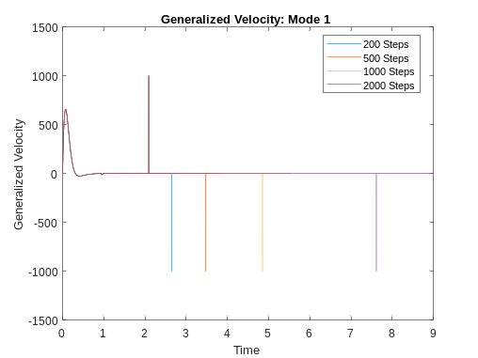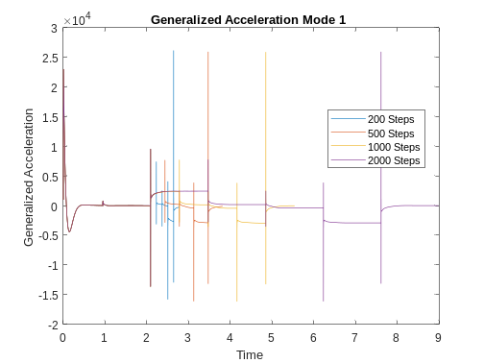
Static Aero Mode 2
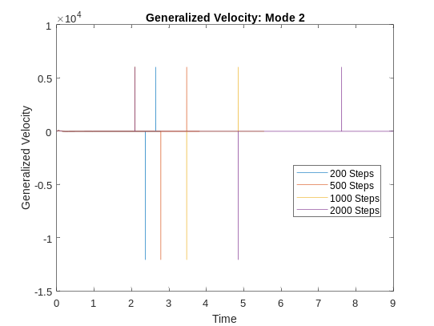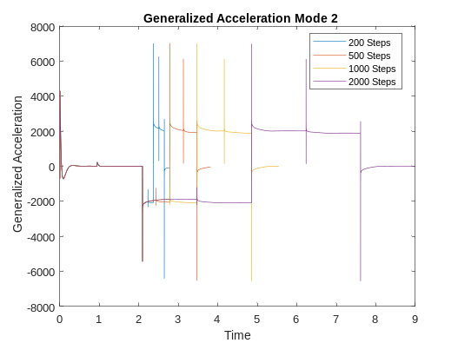
Static Aero Mode 3
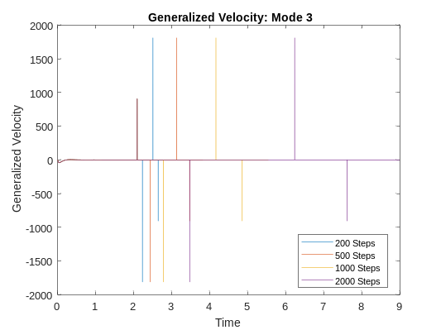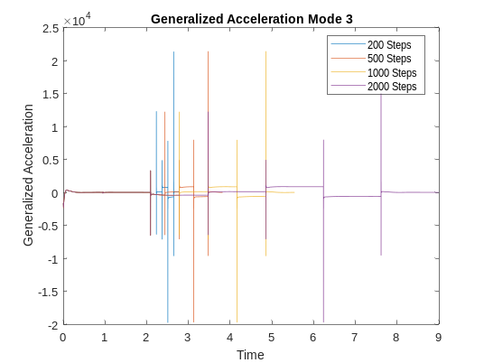

Static Aero Mode 8
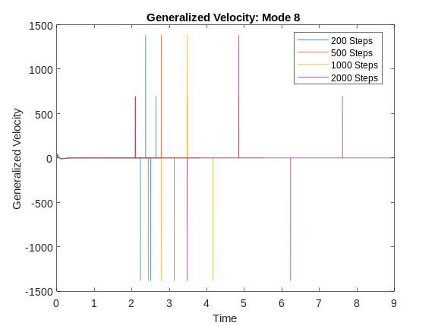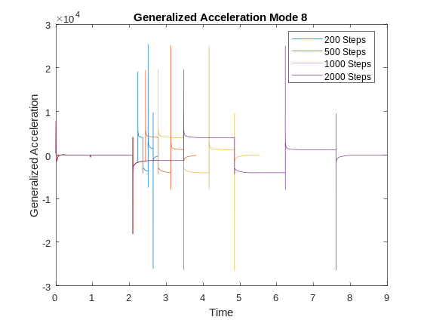

Rigid Mode 1
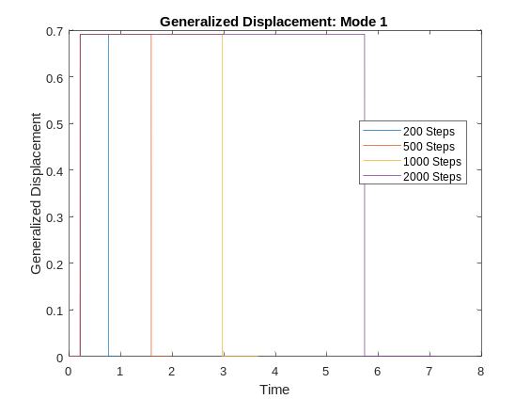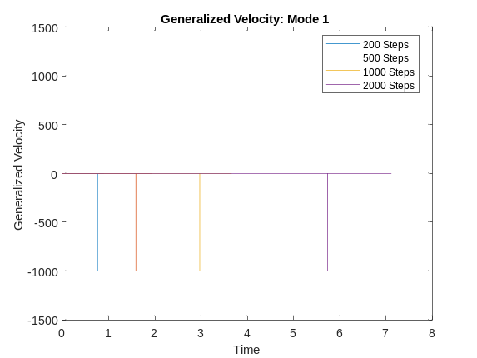
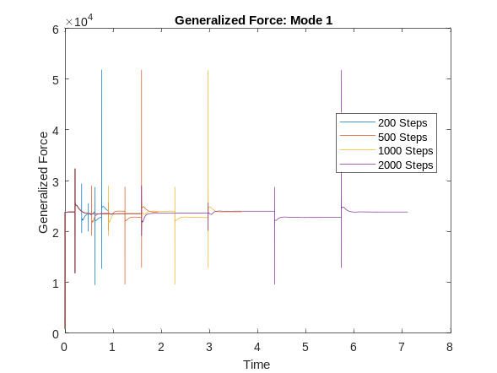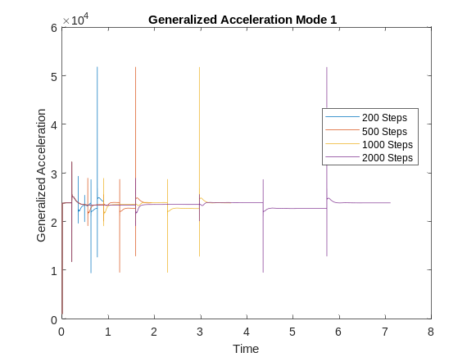

Rigid Mode 2
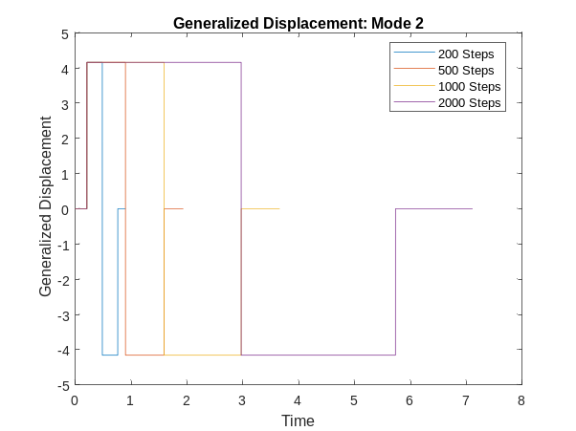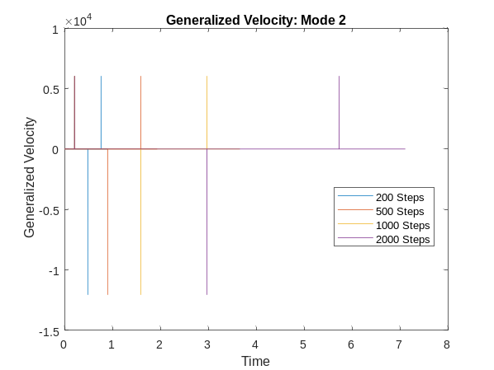
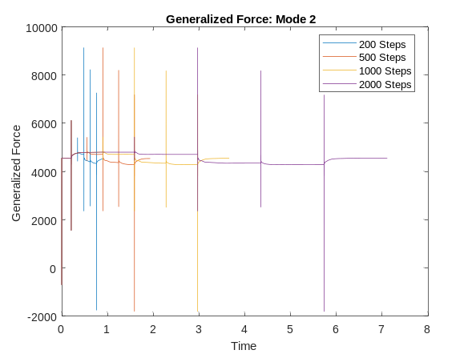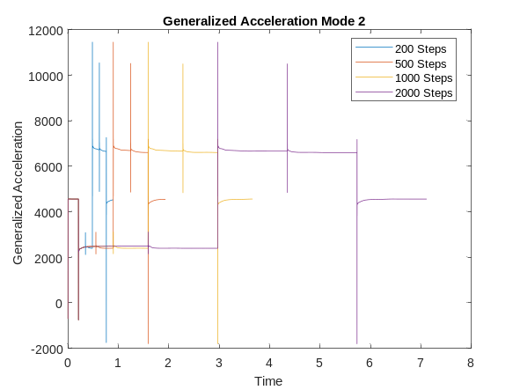
Rigid Mode 3
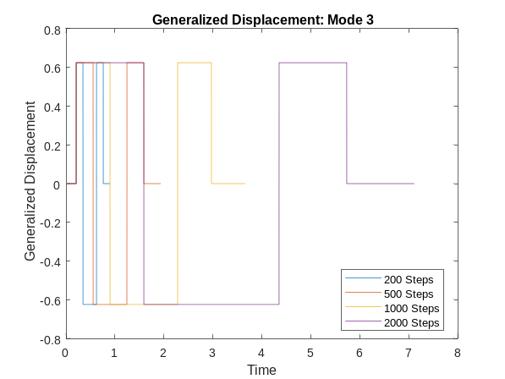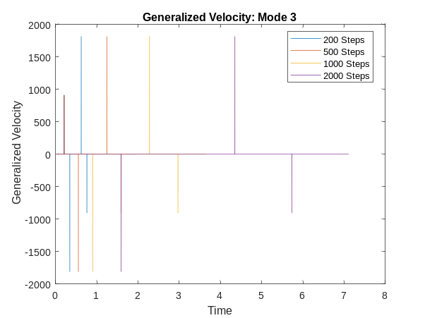
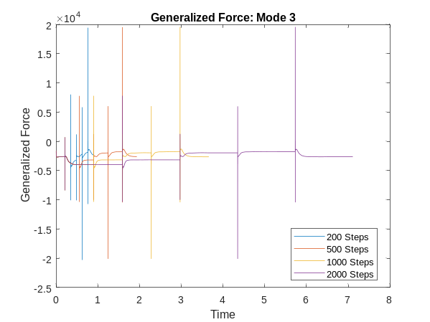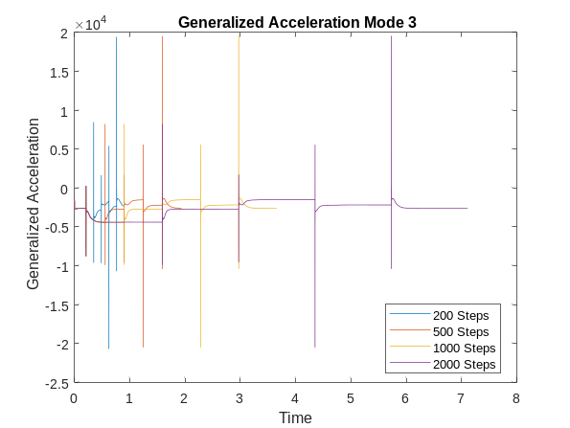
Rigid Mode 8
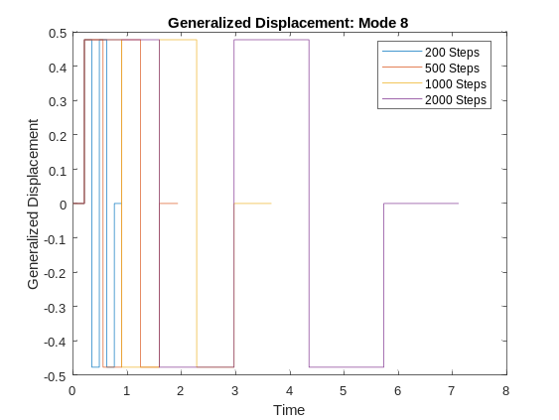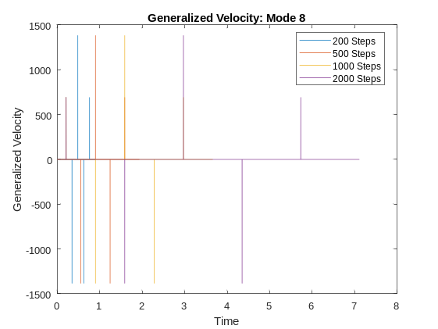
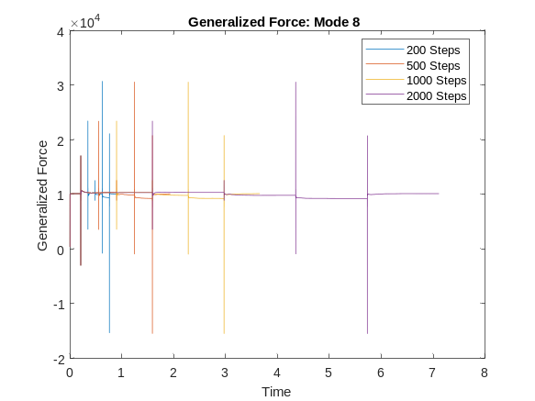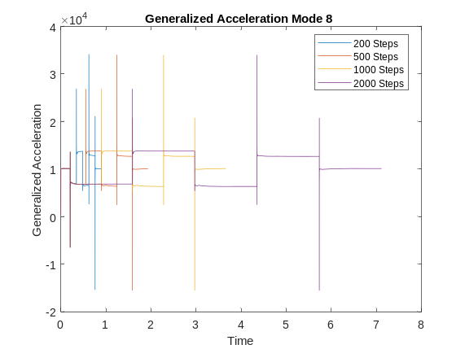
nm/pf/npulse Study
nm = 92, pf = 74
Steps | npulse | error | q
200 | 800 | 2.2*10^5 | 42857.1429
500 | 800 | 4.8*10^4 | 29591.8367
1000 | 800 | 2.9*10^4 | 32653.0612
2000 | 800 | 4.9*10^4 | 36734.6939
200 | 1500 | 2.2*10^5 | 42857.1429
500 | 1500 | 4.8*10^4 | 29591.8367
1000 | 1500 | 2.8*10^4 | 32653.0612
2000 | 1500 | 4.6*10^4 | 36734.6939
nm = 92, pf = 72
Steps | npulse | error | q
200 | 800 | 1.8*10^5 | 40816.3265
500 | 800 | 8.5*10^4 | 31632.6531
1000 | 800 | 2.6*10^4 | 33673.4694
2000 | 800 | 4.8*10^4 | 148748.7487 (modified root locus)
200 | 1500 | 1.8*10^5 | 40816.3265
500 | 1500 | 8.3*10^4 | 31632.6531
1000 | 1500 | 2.6*10^4 | 33673.4694
2000 | 1500 | 4.4*10^4 | 148748.7487 (modified root locus)
nm = 100, pf = 88
Steps | npulse | error | q
200 | 800 | 1.6*10^5 | 38775.5102
500 | 800 | 4*10^5 | 28571.4286
1000 | 800 | 5.9*10^4 | 31632.6531
2000 | 800 | 3.9*10^4 | 30612.2449
200 | 1500 | 1.6*10^5 | 38775.5102
500 | 1500 | 4.1*10^5 | 28571.4286
1000 | 1500 | 6.2*10^4 | 31632.6531
2000 | 1500 | 3.9*10^4 | 30612.2449

nm = 25, pf = 100
Steps | npulse | error | q
200 | 800 | 1.6*10^7 | 32653.0612
500 | 800 | 1.5*10^6 | 31632.6531
1000 | 800 | 2.2*10^6 | 32653.0612
2000 | 800 | 1.7*10^7 | 28571.4286
200 | 1500 | 2*10^7 | 32653.0612
500 | 1500 | 1.5*10^6 | 31632.6531
1000 | 1500 | 2.3*10^6 | 32653.0612
2000 | 1500 | 1.7*10^7 | 28571.4286

ROM Generation
200 Steps (96/96)
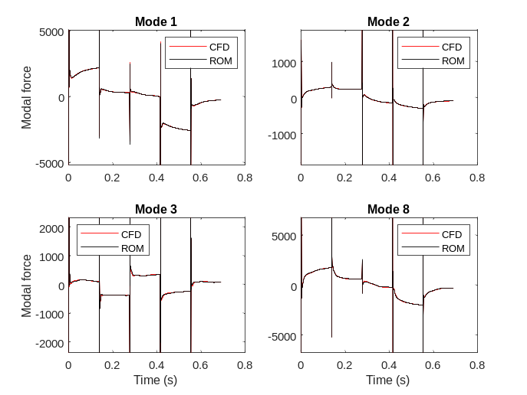
500 Steps (92/74)
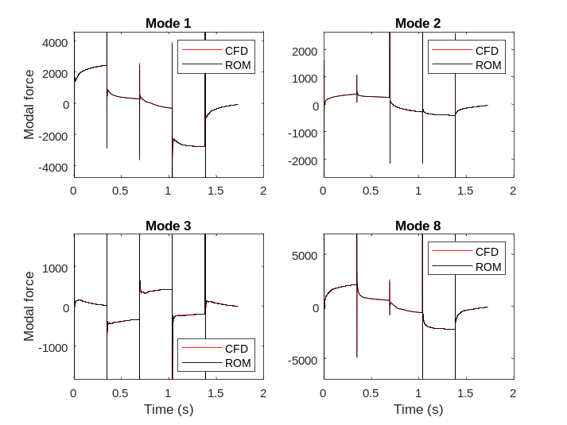
1000 Steps (92/72)
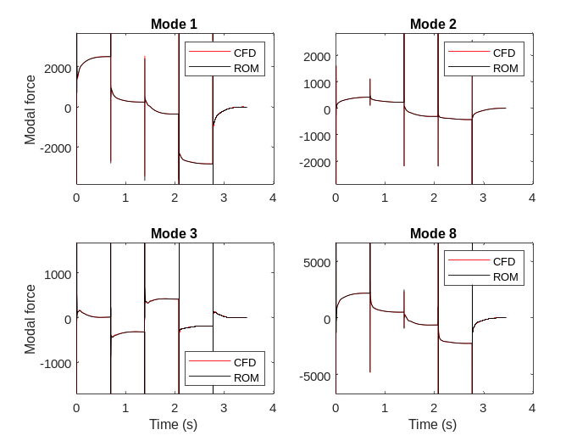
2000 Steps (100/88)
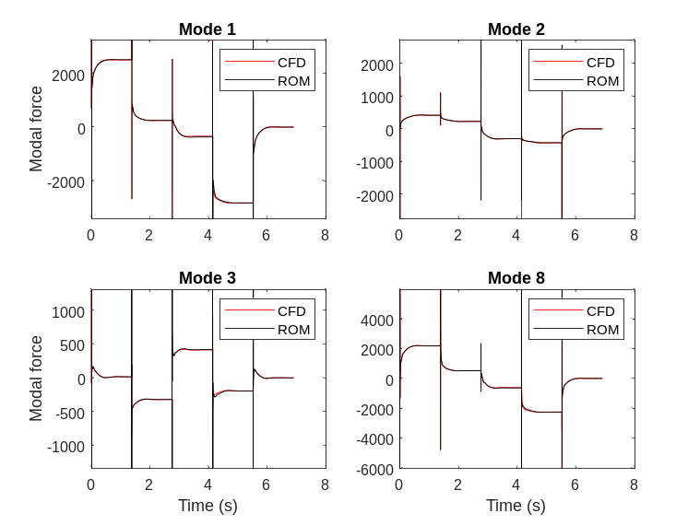

gforce0 Study

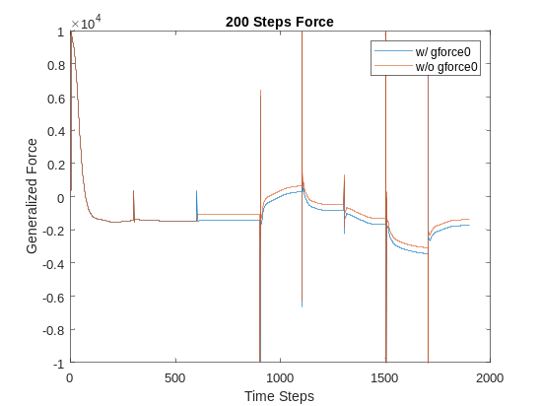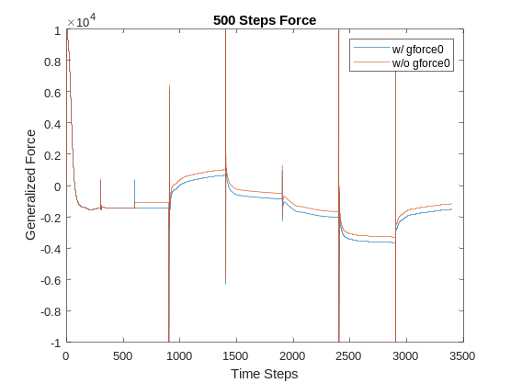
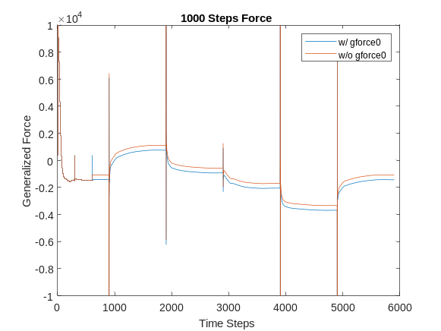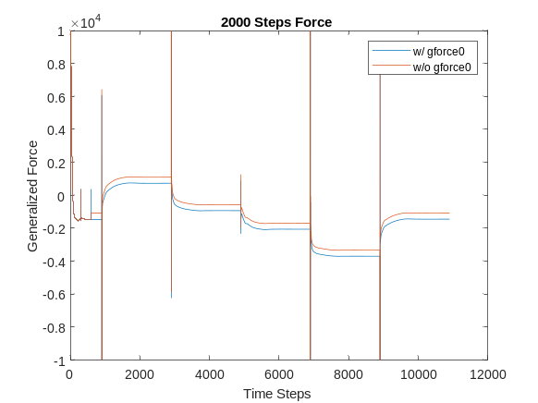

Aeroelasticity Intern, Aeroelasticity Branch D-308

