NASA Advanced Composites Project
The recently-completed NASA Advanced Composites Project (ACP) successfully developed several new technologies aimed at reducing the timeline to design and certify composite aircraft structures. Advancements in the areas of manufacturing simulation, nondestructive inspection and advanced structural design and analysis methodologies were completed in late 2019 under the Advanced Composites Consortium (ACC) public/private partnership as well as NRA-funded university contracts. In the area of Structures, the ACC made significant improvements in rapid design tools for preliminary sizing of structure, along with developing detailed static and fatigue strength prediction methods and methods for modeling high energy impact events in composite structures. These new methodologies and toolsets were validated against a range of representative test data using a comprehensive verification and validation approach which has been published and is now used extensively on other programs. Specific new tool improvements supported by ACC include NASA’s CompDam code and Floating Node Method code. CompDam is now available from NASA as open source code. The team also worked on improved impact modeling using LS-Dyna™ and improved delamination modeling using Abaqus™. Rapid design tool improvements are available through Hypersizer. The ACC team released well over 50 publications documenting these method improvements, and the ACP recently received the prestigious NASA Group Achievement Award for their work.

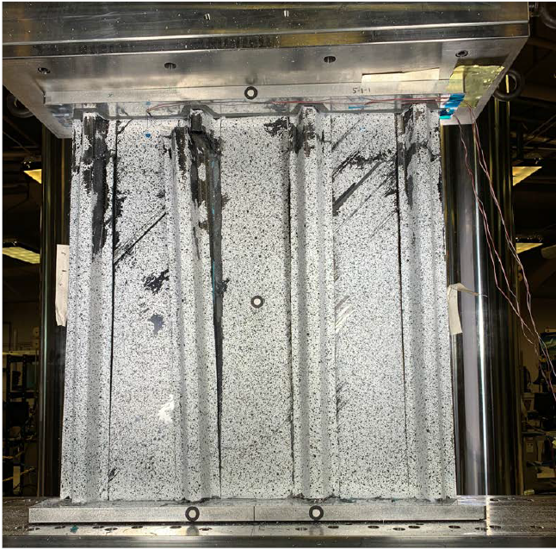
Typical Hat Stiffened Panel Test Article Used for Method Validation

