**Title**: **Hydrogen Abundance and Distribution on (101955) Bennu**

Authors: A. Praet1, M. A. Barucci1, B. E. Clark2, H. H. Kaplan3, A. A. Simon3, V. E. Hamilton4, J. P. Emery5,6, E. S. Howell7, L. F. Lim3, X.-D. Zou8, J.-Y. Li8, D.C. Reuter3, F. Merlin1, J. D. P. Deshapriya1, S. Fornasier1, P. H. Hasselmann1, G. Poggiali9,10, S. Ferrone2, J. R. Brucato9, D. Takir11, E. Cloutis12 , H. C. Connolly Jr13, M. Fulchignoni1, D. S. Lauretta7.

1LESIA, Observatoire de Paris, Université PSL, CNRS, Université de Paris, Sorbonne Université, 5 place Jules Janssen, 92195 Meudon, France ([alice.praet@obspm.fr](mailto:alice.praet@obspm.fr)),

2Department of Physics, Ithaca College, Ithaca, NY, USA,

3NASA Goddard Space Flight Center, Greenbelt, MD, USA,

4Southwest Research Institute, Boulder, CO, USA,

5University of Tennessee, Knoxville, TN, USA,

6Northern Arizona University, Flagstaff, AZ, USA,

7Lunar and Planetary Laboratory, University of Arizona, Tucson, AZ, USA,

8Planetary Science Institute, Tucson, AZ, USA,

9INAF–Arcetri Astrophysical Observatory, Florence, Italy,

10Department of Physics and Astronomy, University of Florence, Florence, Italy,

11JETS/ARES, NASA JSC, Houston, TX, USA,

12University of Winnipeg, Winnipeg, Manitoba, Canada R3B 2E9,

13Department of Geology, Rowan University, Glassboro, NJ, USA.

**Total = 3697 words (max: 3500 words)**

**ABSTRACT (143 words)**

**Asteroids are likely a major source of water and organics to early Earth (Chyba, 1990). The Origins, Spectral Interpretation, Resource Identification, and Security–Regolith Explorer (OSIRIS-REx) spacecraft will collect a sample from the asteroid (101955) Bennu, with the goal of better understanding this source material (Lauretta et al., 2017). Spectral measurements of the Bennu’s surface provide context for the returned sample (e.g., Reuter et al., 2018) and will be used to link global composition to the high-resolution laboratory studies. Spectral results from the OSIRIS-REx Visible and Infrared Spectrometer (OVIRS) reveal that Bennu is hydrated and carbon-bearing (Simon et al., 2020), confirming that the returned sample will be similar to the asteroids that delivered these materials to Earth. Here we estimate the hydrogen content of Bennu’s surface from visible – near-infrared (VNIR) spectra with implications Bennu’s global hydration and water in the early Solar System.**

**INTRODUCTION**: **760 words**

The OSIRIS-REx spacecraft collected VNIR spectra (0.4 to 4.3 μm) with OVIRS during multiple mission phases, including Approach to the asteroid (October 2018), and a global mapping campaign while orbiting the asteroid (April 2019). Early observations showed that Bennu’s strongest spectral feature is the absorption band at 2.74 ± 0.01 μm, associated with the presence of OH- or H2O bound in phyllosilicates and other “hydrated” minerals (Hamilton et al., 2019). The position and global distribution of Bennu’s 2.74µm feature indicates the global presence of Mg/Fe-phyllosilicate minerals that are the result of an advanced stage of hydrothermal alteration (Hamilton et al. 2019). Bennu is a rubble pile asteroid that reaccumulated from the fragments of a ~100 km parent asteroid that was broken apart by impacts (DellaGiustina and Emery et al., 2019; Jutzi and Michel, 2020; Barnouin et al., 2019) and this hydrothermal alteration most likely occurred early in solar system history on the parent body.

OVIRS obtained the global spectra with a spatial resolution of ~20 meters per spectrum (Simon et al. 2020). In parallel, the spacecraft acquired image data that revealed a very rough and rocky surface covered with boulders up to ~60 meters in size (DellaGiustina & Emery 2019; Walsh et al. 2019). There are two distinct populations of boulders, distinguished by their albedo and color properties (DellaGiustina et al., in revision, 2020). All of the largest boulders (> 12 m) are low reflectance (<4.9% normal albedo, DellaGiustina et al., in revision, 2020) and have a rough, hummocky texture; these boulders are concentrated in two diagonal traces in the southern hemisphere. Many of the smaller boulders are part of the high reflectance population (>4.9% normal albedo) and have smoother and more angular features; these occur ubiquitously on Bennu, often mixed with the darker materials. The distribution of the high and low reflectance boulders is correlated with some observed spectral variations at the OVIRS spatial scale (Simon et al., in revision, 2020), which may be due to differences in the degree of aqueous alteration (Kaplan et al., in revision, 2020).

Carbonaceous (C) chondrite meteorites are the closest analog to Bennu (Clark et al., 2011) and other carbonaceous asteroids (e.g., Clark et al., 2010, Fornasier et al., 1999). Previous studies reveal a continuum of mineralogical, petrological, and textural properties, resulting from mild to strong aqueous alteration, and the observed continuum can be used to constrain scenarios of geological evolution of small planetary bodies within the early solar system material (McSween et al. 2018). Laboratory VNIR reflectance spectra of these meteorites have been analyzed to understand the spectral properties of hydrated minerals associated with varying degrees of alteration (Garenne et al. 2016; Potin et al. 2020; Takir and Emery, 2015). In the first spectral analysis of the data from OSIRIS-REx show that Bennu is most consistent with either CM or CI type C chondrite meteorites, which are the most aqueously altered of the C chondrites (Hamilton et al., 2019).

Previous studies of CM/CI chondrite hydration indicate that these meteorites have a range of hydration (H wt.% in H2O, OH) that is correlated with the degree of alteration (Alexander et al., 2007; 2012; 2013). Most hydrated species are hosted in phyllosilicates, in particular Mg- and Fe-serpentines and saponite, and phyllosilicate composition will change from Fe-rich to Mg-rich with increasing alteration (Takir et al., 2013).

The ability to quantify hydration from the VNIR spectra of Bennu also relies on these previous laboratory studies of C chondrites. Milliken and Mustard (2007) developed an approach where the effective single-particle absorption thickness (ESPAT) as well as the normalized optical path length (NOPL) is calculated for the spectrum and can be linked directly to water content (Milliken et Mustard, 2005; Garenne et al., 2016). This approach has since been applied to global spectral datasets from Mars (e.g., Mustard et al., 2008) and the moon (e.g., Li and Milliken, 2017). A similar study using H wt.% and spectra of carbonaceous chondrites found that both ESPAT and band depth can be used to estimate hydration for these meteorites (Garenne et al, 2016). Other analyses of C chondrites showed that Gaussian modeling of the 2.7 µm feature could be directly related to H wt.% of the samples (Kaplan et al., 2019, Potin et al., 2020).

Our goal is to explore in detail how the hydrogen (H) content of the water and hydroxyl groups (H2O-OH-) of the hydrated phyllosilicates (hereafter **H2O-OH- H content**), and therefore the hydration of Bennu’s surface, spatially varies with the analysis of the 2.7-µm absorption band and consider what these variations tell us about the cosmochemical history and aqueous alteration of the Bennu’s parent body.

**Hydration Estimation: (1112 words)**

The spectra we analyzed of Bennu were acquired by the OVIRS instrument during Equatorial Station 3 (EQ3) of the Detailed Survey mission phase, on May 9, 2019, at 12:30 pm local solar time (Simon et al., in revision, 2020). The reflectance spectra have been calibrated and photometrically corrected to an incidence angle of 0°, emission angle of 30°, and phase angle of 30°, using a McEwen photometrical model (Zou et al., in revision, 2020). We used a global dataset of 7089 spectra that covers all of Bennu surface up to 80 degrees north and south latitudes. The average EQ3 Bennu spectrum with propagated uncertainties is shown in **Figure 1a**.

To estimate the hydration state of Bennu’s surface, we calculated the normalized optical path length (NOPL), the effective single particle absorption thickness (ESPAT) and computed gaussian modeling of the 2.7-µm absorption band (**See** **Supplement material - Methods**) for all of Bennu’s EQ3 reflectance spectra as well as for the absolute reflectance spectra of a set of well-measured meteorites (**Table 1** **SM**)

The NOPL parameter was calculated for the absolute reflectance spectra corresponding to each meteoritic analogue in our sample as well as for all of Bennu’s EQ3 reflectance spectra (Milliken and Mustard, 2005; Milliken et al. 2007; Garenne et al., 2016). A linear continuum is fitted from 2.6 to 3.3 μm. The mean wavelength of the hydration band minimum position for the EQ3 dataset corrected with McEwen model (**See** **Supplement material – Methods**) is 2.73 μm. The NOPL parameter is calculated at the latter wavelength.

The ESPAT parameter was calculated following the method described by Milliken and Mustard (2005) (see also Milliken et al., 2007; Garenne et al., 2016). Absolute reflectance spectra were first converted single scattering albedo (SSA) by inverting the Hapke Isotropic Multiple Scattering Approximation (IMSA) model (Hapke 1993, 2002). We use the roughness, opposition effect, and single-particle phase function parameters obtained by Zou et al. (in revision, 2020) leaving SSA as a free parameter at every channel. A linear continuum is then fit to the SSA spectrum from 2.6 to 3.3 μm and the ESPAT parameter is calculated at 2.73 μm. The ESPAT function is a useful method to estimate adsorbed water content in minerals and is linearly correlated with water content (Milliken and Mustard 2005).

We also modeled the absorption bands of Bennu and meteorites using five Gaussian curves (see **Figure 1b**), as a separate test of the values computed from ESPAT and NOPL. While these five Gaussian curves combine to create the composite absorption feature from 2.7 to 3.2 μm, each individual curve is associated with energy required by a slightly different hydrogen-rich functional group: hydroxyl (OH-), water (H2O), or both (Clark et al. 1999; Rivkin et al. 2015; DeSanctis et al. 2017). In our analysis, we use the area of the second Gaussian curve centered (on average) at 2.75 μm (hereafter the G2 area) that is associated with OH- (Kaplan et al., 2019). For example, in **Figure 1b** we show Gaussian modeling results for the average EQ3 Bennu spectrum. Of the three methods we have employed to assess hydration of Bennu, Gaussian modeling of the absorption band is the method with the highest number of free parameters and, as a result, the greatest uncertainty (see **Supplemental Material** for more details).

We compare NOPL, ESPAT and Gaussian modeling results from Bennu with the hydrogen content of H2O and OH– groups in hydrated phyllosilicates for the selected meteorites (Takir et al., 2013, 2019; Garenne et al., 2016; Potin et al., 2020) (See **Supplement Material** on Methods). This analysis allows us to estimate H2O-OH– H content of Bennu (**Figure 2**)

The maps obtained with the NOPL and ESPAT methods representing the spatial variations of each spectral parameter are shown overlain on Bennu’s a basemap comprised of PolyCam images (Bennett et al. 2020) in **Figure 2 (SM)**. The ESPAT and NOPL maps present a global pattern that is very similar to the hydration band depth map (Simon et al. 2020) shown in **Figure 1 (SM).** Because the gaussian modeling method presents a large number of free parameters, the non-singularity of its results enhance its noise levels, and therefore is not representative of spatial variations.

Spectral parameter variations are strongly associated with albedo and morphological features on Bennu’s surface. We find that Bennu’s boulder-rich areas (Walsh et al., 2019) are characterized by lower NOPL and lower ESPAT. The Equatorial band (-20° to 20° latitude) also shows lower NOPL and lower ESPAT. On the other hand, higher latitudes (low to intermediate boulder abundances) show higher values of NOPL and ESPAT.

We have performed the same analysis for a high quality set of absolute reflectance spectra of meteorites measured in the laboratory (Takir et al., 2013, 2019, Potin et al., 2020, Garenne et al., 2016; see **Supplementary Methods**). Drawing from these studies, we have assembled over 40 meteorites (**Table 1, Supplemental material**) for which bulk hydrogen values have been independently measured (Alexander et al., 2012, 2013; Garenne et al. 2016). In the case of the Orgueil and Tagish Lake meteorites, several samples were analyzed and several hydrogen content values were ultimately derived (Alexander et al., 2012, Gilmore et al. 2019), and our results and figures reflect the variability in the reported values.

We find a linear correlation (**Figure 2**) between each spectral parameter (ESPAT, **Figure 2A**; NOPL, **Figure 2B**; G2 band area, **Figure 2C**) calculated from meteorite spectra and their H2O-OH– H content. For each spectral parameter, we report in **Figure 2** the average value for Bennu as well as the relative minimum and maximum values obtained from the EQ3 station spectra as error bars.

Using these correlations, we estimate the H2O-OH– H content for Bennu’s average surface to be: **0.61 ± 0.09** wt.% using ESPAT, **0.58 ± 0.07** wt.% using NOPL and **0.53+ 0.36 - 0.21**wt.% using the area of the second Gaussian centered at ~2.75 μm. All H2O-OH- H content values we derived for Bennu’s average surface are summarized in **Table 1**. We find that the full range of possible values for the H2O-OH- H content of Bennu’s surface is **0.46 to 0.71 wt.%.** This range of values is consistent with the C2 Tagish Lake and heated CM meteorites, but is not consistent with the most heavily aqueously altered meteorites, the CIs (**Figure 2**).

The spatial variations of the average H2O-OH– H content are presented overlain on the base map of Bennu (Bennett et al., 2020) (**Figure 3).** An average H2O-OH– H content map of Bennu (**Figure 3**) is calculated with the combined values of the NOPL and ESPAT maps**.** Smaller H2O-OH– H contents are evident in boulder-rich areas (such as from 225 to 275 degrees longitude and 0 to -60 degrees latitude) as well as in the equatorial band (-20° to 20° latitude).

**DISCUSSION: (1825 words)**

We show the variation inhydrogen abundance in water and hydroxyl molecules in coordination with phyllosilicate minerals (H2O-OH– H content) on Bennu’s surface (**Figure 3**) and find the H2O-OH– H content of the surface to be **0.46 - 0.71 wt.%** (**Table 1**)**.** To the best of our knowledge, this is the first time such an estimate has been made for an asteroid from spacecraft observations, and variations in hydration are resolved across the surface (at the OVIRS resolution of ~20 m/footprint see supplementary materials for mapping details). Values obtained by measuring the NOPL parameter are consistent with values from ESPAT and the Gaussian band fits to Bennu’s 2.7-μm absorption band, which adds confidence to the result. The values obtained for Bennu are compared with similar measurements of laboratory reflectance spectra of carbonaceous chondrite meteorites, and we show that each method (ESPAT, NOPL, Gaussian area) is useful for estimating H2O-OH– hydrogen content by analogy with meteorite data.

A very similar global pattern of distribution across the surface of Bennu is evident for the NOPL and ESPAT estimates (**Figure 2 SM**). Furthermore, the band depth, surface temperature and albedo (Simon et al., 2020), are strongly correlated with the ESPAT and NOPL maps. This correlation does not appear to be the result of the thermal tail removal method and may be a function of surface properties (e.g., boulder thermal inertial, albedo, and composition) all varying together.

We note several areas of interest, including the boulders Benben Saxum (56 meters) and Roc Saxum (95 meters), and the Tlanuwa Regio, a region with a large number of big boulders (~50 meters). These surface features are characterized by shallow band depths, low NOPL, low ESPAT and low H2O-OH– hydrogen content (~**0.48 wt. %**), as compared to the average surface (**~0.57 wt. %**). These features are all characterized by larger than average boulders on the surface of Bennu. Boulders > 20 m were all inherited from this Bennu parent body and represent the oldest material on the asteroid’s surface (DellaGiustina and Emery et al., 2019).

We find a latitude band centered on the equator (from -20° to 20° latitude) that also displays smaller Gaussian band areas, lower ESPAT values, and lower NOPL values. In this equatorial band, the H2O-OH– hydrogen content is 9% lower than Bennu average. This equatorial region is characterized by craters filled with smaller rubble material as well as a few boulders. Other workers have described a similar equatorial band as having a higher thermal inertia than global average (Rozitis et al. 2020), a stronger red spectral slope than global average (Clark et al. 2019; Barucci et al. 2020, Li et al. 2020, Simon et al., 2020) and a higher 1064nm normal reflectance than global average. The causes of all of these differences along the equator is not determined yet, however several possible mechanisms are under investigation, such as space weathering, surface roughness variations due to mass movement (Ryan et al. 2020; Jawin et al. 2020, Barucci et al. 2020); and preferential particle fall back patterns (McMahon et al. 2020).

We also find areas that display deeper than average band depths, and higher than average ESPAT and NOPL values at high latitudes, higher than 20°N and -30°N. These areas show the most hydration - high H2O-OH- hydrogen content ~**0.71 wt. %** (see **Figure 3**, particularly at longitudes 0-100° and 275-360°). There are intermediate-size boulders (< x meters) in these regions, and the surface has a higher than average albedo at 0.55 μm and lower abundances of the organic carbon surface components (Simon et al. 2020). Interestingly, the primary sampling site Nightingale (56.0° N and 42.1° E) lies within this region of high hydrogen/high hydration values, suggesting that the spacecraft is very likely to return a sample of this high H2O-OH- H-abundance material.

**Interpretation of hydrogen spatial distribution**

The patterns of high and low hydration on Bennu’s surface likely reflect early processes on Bennu’s parent body, as well as ongoing modification on Bennu by space weathering, heating, and the as-yet-unknown driver of the particle ejection events seen by OSIRIS-REx (Lauretta and Hergenrother et al., 2019). Some of these processes remove hydration (e.g., impact induced heating can cause dehydration; Nakamura, 2006), and others may increase the H+ ions on the surface (e.g., solar wind implantation; Li and Milliken, 2017, Tucker et al., 2019).

The lowest hydration regions are the largest boulders and the equatorial region. Solar wind implantation of hydrogen, one form of space weather, has been shown to increase the 3µm signature diurnally on the moon with higher hydrogen content at higher latitudes (Li and Milliken, 2017). A similar spatial pattern of higher hydration at the poles is seen on Bennu, though it has not been noted on Ryugu (Kitazato et al., 2019). At this time, there is no evidence variation in surface H content with local time of day. However, there is a strong relationship between observed hydration and temperature, which is also the case for the implanted hydrogen on the moon (Li and Milliken, 2017). Solar wind implantation is a surface process, which means the spectroscopy results shown here may not be representative of unexposed Bennu. Further, micrometeorite bombardment could trigger a dehydration reaction (Bottke et al., 2020) and would preferentially affect the equatorial region; larger impacts in the equatorial region could also have dehydrated material in the past. Finally, boulders exposed for longer periods of time may also be more likely to experience a similar dehydration event.

The combination of dehydration from impact and solar wind implantation may explain the major distribution of Bennu’s 3µm signature. Another consideration is differences in hydration originally inherited from the Bennu parent body. Bennu hosts two distinct populations of boulders, high and low reflectance boulders, that shows distinct albedos (DellaGiustina et al., 2020), thermal inertias (Rozitis et al., 2020), and proposed compositions (Kaplan et al., 2020). These differences may have been inherited from the Bennu parent body, as a result of initial differences in composition (e.g., resulting from spatially varying alteration) (Kaplan et al., 2020) and subsequent different reaction to space weathering (DellaGiustina et al., 2020). We find that higher albedo regions on Bennu (Simon et al., 2020) generally have more hydrogen (**Figure 3**). In addition, the largest boulders on Bennu are dark (<4.9% albedo) and are also associated with lower hydration, which suggests that some of the hydration signature is inherent to the discrete boulder population and likely reflects a dichotomy on Bennu’s parent asteroid. At this time, it is not possible to separate the effects of space weather, impact dehydration, or original composition/alteration.

**Interpretation of hydrogen abundance**

Comparing the Bennu values with those obtained by Alexander et al. (2012), we find that Bennu has a similar H2O-OH- H content range to heated CM meteorites (0.46–1.36 wt%), Tagish Lake (0.50–0.69 wt.%), CR meteorites (0.30–1.20 wt.%) and CO meteorites (0.49–0.52 wt.%). Previous analyses of OVIRS and the OSIRIS-REx Thermal Emission Spectrometer (OTES) suggest that Bennu is most similar to the most aqueously altered CM and CI chondrites (Hamilton et al., 2019). It does not appear to be similar to the CR or CO meteorites (Hamilton et al. 2019), leaving heated CM chondrites and some lithologies of Tagish Lake as the best analogs resulting from this study.

Most heated CMs have experienced temperatures of >~400°C (e.g., Lee et al., 2016). The presence of a global 2.7-µm absorption band, as shown here, and the fact that olivine has not been detected on the surface by OVIRS or OTES both suggests that Bennu’s phyllosilicates have not been significantly dehydrated/decomposed, which occurs at ~700°C (Hamilton et al., 2019). The presence of organics in some locations on Bennu’s surface could imply that these regions have not experienced significant heating, perhaps as low as <15°C (Kaplan et al., 2020; Kebukawa et al., 2010), which could potentially rule out the heated CMs. However, most other evidence is consistent with low or moderate heating, likely not exceeding the lower end of heated CMs.

Tagish Lake has previously been suggested as an analog for Bennu, because of its carbonate-rich lithology, strong hydration feature, and low albedo (Kaplan et al., 2020, Merlin et al., 2020). The strong red spectral slope of Tagish Lake is not represented anywhere on Bennu, however, it is not a direct analog, but it suggests that Bennu may also be aqueously altered with CM and CI affinities.

**Conclusions**

These results represent the first spatially resolved hydration estimates for an asteroid surface, revealing the presence of small latitudinal differences in H2O-OH- H content as well as differences associated with geomorphology. Our results suggest that Bennu is moderately hydrated compared to other C chondrites with ~**0.57** wt% H2O-OH- H content. Long-lived processes, including solar wind implantation and impact dehydration may be responsible for the major spatial patterns we see on the surface and these processes are likely occurring in the present day. In addition, initial differences composition in Bennu’s parent body were inherited by Bennu and are still reflected in the distribution of hydration despite the ongoing modification by other processes, which matches results from other studies of Bennu.

Quantifying the H2O-OH- H content at the surface of Bennu helps us to understand the composition of the primitive asteroid populations, which may in turn reveal more about the asteroids that delivered water to early Earth. The H2O-OH- H content variation on Bennu is small compared to the overall range of the C chondrite meteorites, which could validate the use of future non-spatially-resolved investigations of asteroid 2.7 µm feature to understand hydration and/or relation to the C chondrites (e.g., with ground- or space-based telescopes). The study of H2O and OH- abundance on many primitive bodies can help constrain models of the formation and evolution of our solar system, as well as some of the key processes of the development of life on Earth itself (Brack 1993). However, unanswered questions remain as to how the Earth acquired so much water, having formed from a hot, dry part of the disk of gas and dust from which the solar system formed; hydrogen abundances and distributions for Bennu could help with future modeling of this problem.

Two of the key ingredients for life (water and complex organic molecules) may have been delivered to Earth after formation, by impacts with small bodies (Altwegg et al., 2019). OSIRIS-REx will sample Bennu’s surface in October 2020 and return a pristine sample to Earth in 2023 containing both of these ingredients. Our interpretations suggest that the H2O-OH- hydrogen content of the returned sample will be at least **0.58 wt%**, which will be tested through the analyses of returned samples from Bennu. These hydrogen abundances are similar to the heated CM meteorites and Tagish Lake, which share similarities in phyllosilicate mineralogy with the interpreted mineralogy of Bennu. Both the sample and the VNIR spectral data will reflect the surface of Bennu, which may be more heated or space weathered than material sourced from the interior.

**Figures**

**(A)**

**(B)**



Figure 1: A) Average EQ3 Bennu spectrum with propagated measurement uncertainties, B) Gaussian model result obtained for the average EQ3 spectrum (normalized to 1.0 @ 2.5μm), showing five separate Gaussian curves (dotted green lines), for which the composite spectrum (solid green curve), agrees quite well with the measured spectrum (blue dots).

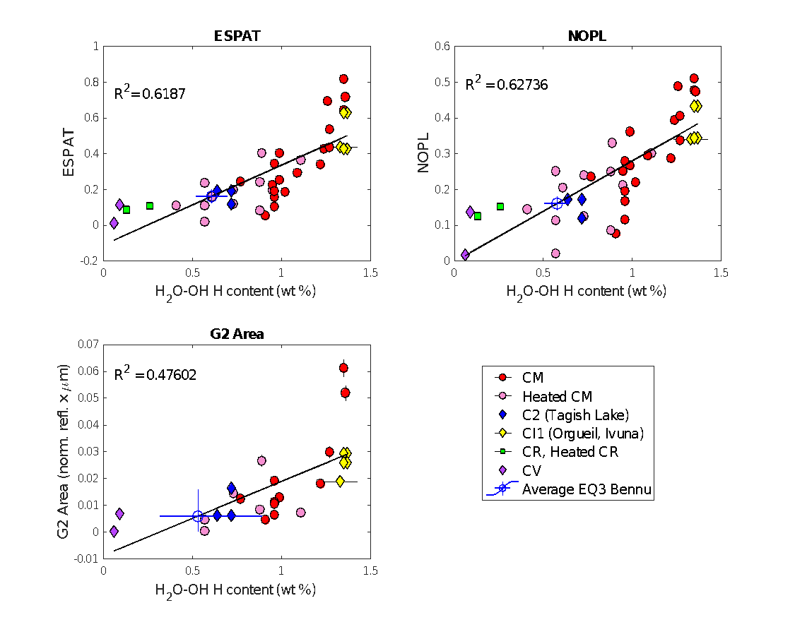

**(B)**

**(C)**

**(A)**

**Figure 2**: Correlation between the H2O-OH- H content and the ESPAT parameter (**A**), the NOPL parameter (**B**), and the G2 area (**C**). The different C chondrite meteorites types we measured are represented with different symbols and colors as explained in the legend.

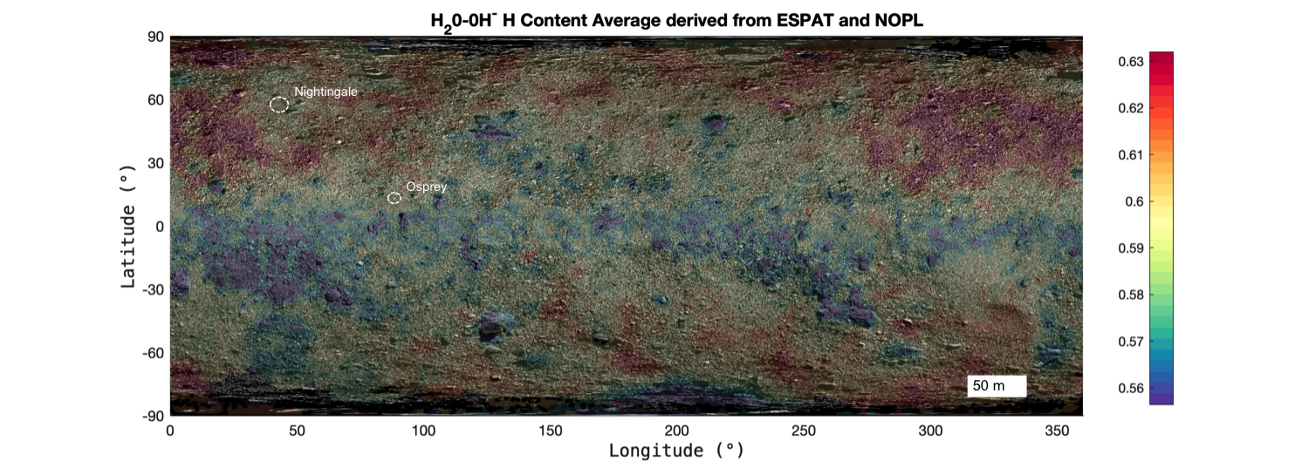

**Figure 3**: Average H2O-OH– H content map of Bennu, derived from the NOPL and ESPAT methods, with the two preselected sampling sites (Nightingale and Osprey).

|  |  |
| --- | --- |
| **Parameter** | **Estimated Bennu H2O-OH- H content** |
| NOPL | 0.58 ± 0.07 |
| ESPAT | 0.61 ± 0.09 |
| G2**1** | 0.53+ 0.36 - 0.21 |
| All (averaged) | 0.57 +0.14 -0.11 |

**Table 1:** H2O-OH- H content of Bennu's average surface derived from NOPL, ESPAT, Gaussian Modeling1

**Supplementary Material:**

**METHODS**

**Bennu data**

*OVIRS data calibration.*The OVIRS spectra are calibrated on a spot-by-spot basis using an automated pipeline that subtracts a nearby deep space background level, subtracts out-of-band signal (IR leakage in all filters < 2.95 microns), converts to absolute physical radiance units and screens for outlier pixels (Simon et al 2018, 2020). Each spectrum is then resampled onto a common wavelength axis with 2-nm sampling below 2.4 μm and 5-nm sampling above 2.4 μm. As part of the signal above 2.5 μm is from thermal radiance, a thermal tail is calculated and removed from each spectrum before dividing by a range-corrected solar spectrum to convert to reflectance (Simon 2020). There are two sources of uncertainty in the final spectra: channel-to-channel noise, which is calculated based on read noise and photon noise, and absolute radiance calibration. The absolute radiometric uncertainty affects the overall radiance across the full spectrum with no particular wavelength dependence. However, two terms do have a spectral dependence that may affect the hydration band. First, the out-of-band signal is calculated by summing the long wavelength radiance and multiplying by coefficients for each wavelength derived from perfect blackbody source data. Any spot that covers a mixed temperature scene may potentially have an error in this correction that increases with decreasing wavelength in each filter segment (i.e., it is larger at 1.7 μm than at 2.9 μm). The second uncertainty comes from the thermal tail correction which may remove too much, or not enough, radiance, if the thermal tail fit is incorrect. Both of these contribute a few percent of uncertainty to the absolute radiance.

*Bennu’s spectra***.** In April 2019, the OSIRIS-REx spacecraft acquired visible-infrared spectra, from 0.4 to 4.3 μm, of asteroid 101955 Bennu from a range of 5km. Global coverage was obtained at a solar phase angle of 8-10 degrees, with approximately 30% overlap from one spectrometer spot to the next (Simon et al. 2020). This data set allows both careful spectral analysis at a spectral resolution of lambda/delta-lambda >250 from 0.4 to 2.4 μm and >480 onwards, and global mapping at a spatial resolution of 20x30 meters per spectrum.

Bennu’s spectral data used were acquired during the Equatorial Station (EQ3) of the Detailed Survey phase, on May 9th 2019, at 12:30pm local solar time.Spectra acquired were then calibrated and resampled. Finally, the thermal tail of each spectrum is removed (DellaGiustina and Emery, 2019) and all spectra are divided by solar flux (Simon et al., 2020) and then photometrically corrected.

The spectral reflectance of OVIRS spectral reflectance of Bennu surface depends on the light scattering geometry. In order to make comparisons between different areas and quantitatively interpret the spectra based on laboratory measurements, the observations need to be photometrically corrected to the same geometry. We choose a common geometry often used in laboratory settings, REFF(i0, e0, α0) = (0°, 30°, 30°) as our default reference angles. A McEwen model is used to correct all the RADF values of each spectral band to the reference angle (Zou et al., in revision, 2020). Then, RADF data were converted into REFF values.

Generally, the model parameters were fitted independently for each channel. Before correction, a smoothing procedure is applied on the model parameters over the wavelengths ranging from 0.39 to 3.7 μm to reduce the noise of each band to reduce the noises in parameters caused by ignoring the fact that the bands are not actually independent.

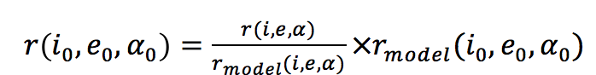 (1)

(i, e, α) is the scattering geometry of measured reflectance.

The details of the photometric process were explained in (Zou et al., in revision, 2020).

This dataset is characterized by a global coverage of Bennu, with a spatial resolution of about 20m x 30m. The spectra were filtered according to their viewing geometry with incidence and emergence angles both inferior or equal to 70°, to eliminate viewing geometry artifacts. Spectra were also filtered for spikes and saturation. Our data set after filtering is 7089 spectra for EQ3 station.

**Meteorites**

*Meteorite spectra.* All the selected meteorites (**Table1**) were powdered and spectra were measured under asteroid-like conditions (vacuum- and thermally-desiccated conditions).

Meteorite chips from Takir et al. 2013, 2019 were grounded into ~100- μm powder and no grain size distributions were measured due to the small amount of meteorite sample. While the meteorites from Potin et al. 2020 and Garenne et al. 2016 were powdered manually but not sieved to keep a large grain size distribution.

An additional spectrum was collected for Mighei (with grain size < 500 microns) at INAF-Astrophysical Observatory of Arcetri in Firenze, Italy (*Poggiali personal communication*).

*Meteorite H2O-OH- H content.*The meteorite H2O-OH- H contents used in this study are calculated using the method of Alexander et al. 2012, 2013. The authors have measured the bulk carbon content as well as bulk hydrogen content. Assuming all carbon is in the organic matter, they then deduced the organic hydrogen content using the typical Insoluble Organic Matter (IOM) hydrogen to carbon ratio of CR meteorites and CM meteorites. The organic hydrogen content is subtracted from the bulk hydrogen content to derive the bulk hydrogen content in water and hydroxyl, i.e.: H2O-OH- H content (**Table 1**).

**Table1**. The selected meteorites are reported with their spectral reference and their H2O-OH- H content calculated by Alexander et al., 2012, 2013 (*); Garenne et al., 2016 (**); Gilmore et al. 2019 (***). For each meteorite, the type and the subtype using Rubin, 2007 scale are reported, as well as the ones for which a gaussian centered originally at 2.75μm was modeled (**1**).

|  |  |  |  |  |  |  |
| --- | --- | --- | --- | --- | --- | --- |
| **Name** | **H2O-OH- H content** | **H2O-H- H error** | **Types** | **Subtypes** | **Spectrum Reference** | **H2O-OH- H Reference** |
| ALH83100 | 1,35 | 0,009 | CM1/2 | 2.1 | Garenne et al. 2016 | * |
| ALH83100**1** | 1,35 | 0,009 | CM1/2 | 2.1 | Potin et al. 2020 | * |
| ALH84029 | 1,26 | 0,009 | CM1/2 | 2.1 | Garenne et al. 2016 | * |
| ALH84033 | 0,61 | 0,018 | CM2 Heated |  | Garenne et al. 2016 | * |
| ALH84044 | 1,24 | 0,008 | CM2 | 2.1 | Garenne et al. 2016 | * |
| Allende**1** | 0,09 | 0,000 | CV3 | / | Takir et al. 2019 | * |
| Banten**1** | 0,91 | 0,010 | CM2 | 2.5 | Takir et al. 2019 | * |
| Cold Bokkeveld (*) **1** | 1,22 | 0,004 | CM2 | 2.2 | Takir et al. 2013 | * |
| DOM03183 | 0,95 | 0,001 | CM2 Heated | 2.3 | Garenne et al. 2016 | * |
| DOM08003**1** | 1,36 | 0,006 | CM2 | 2.2 | Potin et al. 2020 | * |
| EET83355 | 0,41 | 0,001 | CM2 Heated |  | Garenne et al. 2016 | * |
| EET96029 | 0,73 | 0,012 | CM2 Heated |  | Garenne et al. 2016 | * |
| EET96029**1** | 0,73 | 0,012 | CM2 Heated |  | Potin et al. 2020 | * |
| Essebi (*) **1** | 0,77 | 0,005 | CM2? |  | Takir et al. 2019 | * |
| GRA06100 | 0,13 | 0,003 | CR2 | / | Garenne et al. 2016 | * |
| Ivuna**1** | 1,33 | 0,094 | CI1 | / | Takir et al. 2013 | * |
| LAP02277**1** | 1,11 | 0,009 | CM1 Heated | 2.0 | Takir et al. 2013 | * |
| LAP02333 | 1,02 | 0,005 | CM2 | 2.6 | Garenne et al. 2016 | * |
| LAP02336 | 0,95 | 0,005 | CM2 | 2.6 | Garenne et al. 2016 | * |
| LEW87022 | 1,09 | 0,014 | CM2 | 2.3 | Garenne et al. 2016 | * |
| LEW90500 | 0,99 | 0,005 | CM2 | 2.3 | Garenne et al. 2016 | * |
| MAC88100**1** | 0,89 | 0,010 | CM2 Heated | 2.3 | Potin et al. 2020 | * |
| MET01070 | 1,27 | 0,000 | CM1 | 2.0 | Garenne et al. 2016 | * |
| MET01070**1** | 1,27 | 0,000 | CM1 | 2.0 | Potin et al. 2020 | * |
| Mighei (*) **1** | 0,99 | 0,003 | CM2 | 2.3 | Poggiali personal communication | * |
| MIL07700 | 0,57 | 0,016 | CM2 Heated |  | Garenne et al. 2016 | * |
| MIL07700**1** | 0,57 | 0,016 | CM2 Heated |  | Potin et al. 2020 | * |
| MIL07700**1** | 0,57 | 0,016 | CM2 Heated |  | Takir et al. 2013 | * |
| Murchison**1** | 0,96 | 0,002 | CM2 | 2.4 | Potin et al. 2020 | * |
| Murchison**1** | 0,96 | 0,002 | CM2 | 2.4 | Takir et al. 2019 | * |
| Orgueil BM**1** | 1,37 | 0,015 | CI1 | / | Potin et al. 2020 | * |
| Orgueil BM**1** | 1,37 | 0,015 | CI1 | / | Takir et al. 2019 | * |
| Orgueil Smith.**1** | 1,35 | 0,019 | CI1 | / | Potin et al. 2020 | * |
| Orgueil Smith.**1** | 1,35 | 0,019 | CI1 | / | Takir et al. 2019 | * |
| QUE97990**1** | 0,96 | 0,000 | CM2 | 2.5 | Potin et al. 2020 | * |
| QUE97990**1** | 0,96 | 0,000 | CM2 | 2.5 | Takir et al. 2013 | * |
| QUE99038**1** | 0,06 | 0,001 | CV | / | Takir et al. 2013 | * |
| RBT04133 | 0,26 | 0,001 | CR | / | Garenne et al. 2016 | * |
| Tagish Lake  lithology 4**1** | 0,72 | 0,000 | C2 | / | Potin et al. 2020 | *** |
| Tagish Lake**1** | 0,72 | 0,003 | C2 | / | Takir et al. 2019 | * |
| Tagish Lake**1** | 0,64 | 0,004 | C2 | / | Takir et al. 2019 | * |
| WIS91600 | 0,88 | 0,000 | CM2 Heated |  | Garenne et al. 2016 | ** |
| WIS91600**1** | 0,88 | 0,000 | CM2 Heated |  | Potin et al. 2020 | ** |
|  |  |  |  |  |  |  |
|  |  |  |  |  |  |  |

**METHOD: Spectral Parameters Calculation:**

**I/F spectrum conversion into SSA spectrum:**

*Bennu spectra.* We converted Bennu I/F spectra into single-scattering albedo (SSA) spectra using the five-parameter form of Hapke model (Li et al. (2009); Li et al. (2007a); Li et al. (2007b)) that consider a single-scattering albedo term (ω), a single-term Henyey-Greenstein (HG) function (p) with an asymmetry factor (g), a roughness parameter (θ) and finally a shadow hiding opposition effect term (SHOE) characterized by its width (h) and its height (B0). The two latter parameters are fixed to 0.11 and 2.06, respectively, as derived from the disk-integrated phase function based on the OCAMS images obtained during the approach to the asteroid in December 2018.

The Hapke modeling is then run on global-surface spectral data set in order to obtained the following global Hapke modeling parameters for the model best fit: ω, g, θ, geometric albedo and bond albedo and goodness-of-fit indicators root-mean-square (RMS), relative root-mean-square (RRMS). The best fit deduced from the smallest chi-square test (χ2) value when searching in parameter space (Li et al., 2020, in prep.). The same Hapke modeling was then re-run on global-surface I/F spectral data set (EQ3) using the previously obtained global Hapke modeling parameters, with the porosity term (K) calculated using Helfenstein and Shepard (2011).

*Meteorite spectra.* In the case of meteorite spectra measured in laboratory: we apply several simplifications on the Hapke model (Beck et al. 2010). The hypothesis (Garenne et al. (2016); Milliken and Mustard (2007)) are the absence of opposition effects (no SHOE, no CBOE), therefore the backscattering term is negligible (B(g) = 0), and the phase function is supposed isotropic (the scattering term is set to p(g) = 1). They are reasonable hypothesis for particulate sample which particles are in contact (powder) and larger in size than the wavelength (from 2.67 to 3.3 microns) (Milliken and Mustard (2007)).

**ESPAT parameter calculation:**

The Effective Single Particle Absorption Thickness parameter ($W(λ)$) (ESPAT) function is a quantity defined by Hapke (1993) related to the absorption coefficient, volume of particles and the single-scattering albedo (**Equation 2**).

Dealing with such quantity has proved to have some advantages: Hapke (1993) has shown that the ESPAT function is a quasi-linear proportional for a wide range of effective particle size determined by the value of internal scattered coefficient; and later on, Milliken & Mustard (2005) found that this function is also linearly proportional for a wide range of absolute water content (0-15 %wt H2O). ESPAT function is, therefore, most useful when the medium consists of particles that are sufficiently small (Hapke, 1993) or surface roughness equivalent to small particle size. It also indicates that the water content is quasi-linear in respect with the effective particle size.

When the extinction coefficient (QE(λ)) is assumed to be 1, then the scattering coefficient (QS(λ)) is equivalent to the volume-average single-scattering albedo (ω(λ)). Thus, the ESPAT parameter can be calculated using volume-average single-scattering albedo (ω) (**Equation** **2**), Milliken and Mustard (2007).

$W\left(λ\right)=\frac{1-ω(λ)}{ω(λ)}$ (**2**)

**Equation 2** shows that when there is no absorption (ω(λ) = 1), the ESPAT parameter is null (W(λ) = 0). However, for dark material: ω(λ) values are inferior to 1 in OVIRS wavelength range (0.4 to 4.3 microns), even when no absorption occurs. Therefore, following (Milliken and Mustard (2007)), we divide ω(λ) values by their continuum fits (using the maximum single scattering albedo value = ωmax(λ)) to isolate the absorption band studied, with the following equation (**Equation 3**):

$W\left(λ\right)= \frac{1-\frac{ω(λ)}{ω_{max}(λ)}}{\frac{ω(λ)}{ω_{max}(λ)}}$ (**3**)

Linear continuum is fitted using the reflectance average of three OVIRS channels as left and right anchor points.

*Table of Symbols:*

W: Espat function (effective single-particle absorption thickness)

λ: Wavelength

ϖ definition: “The ratio of the total amount of power scattered to the total power removed from the wave is the particle single-scattering albedo, ϖ”.

ω: Volume-average single-scattering albedo

QS: Scattering coefficient

QE: Extinction coefficient

**NOPL parameter calculation:**

The normalized optical path length (NOPL) is calculated on absolute reflectance spectra of Bennu’s surface and meteorites following the calculation of Milliken and Mustard (2007). The NOPL parameter at a defined wavelength (λ, here 2.73 μm) is calculated using the reflectance (R(λ)) as well as the reflectance of the linear continuum (Rc(λ)) fitted between 2.67 μm and 3.3 μm (**Equation 4**).

$NOPL\left(λ\right)=\frac{-ln⁡(R\left(λ\right)+1-R_{c}\left(λ\right))}{-ln⁡(1-R_{c}\left(λ\right))}$**(4)**

**Band Gaussian Modeling:**

The absorption band due to hydrated phyllosilicates in Bennu’s spectra as well as all meteorite spectra were modeled using several gaussians. The 2.7-μm region absorption band was modeled using gaussians from 2.6 to 3.3 μm for Bennu’s EQ3 average spectrum and using continuum anchor points adapted for each meteorite, using up to five gaussian curve fits and a linear continuum. Each gaussian is diagnostic of one or several different stretching modes of OH- and/or H2O, depending on their center wavelength (2.72, 2.75, 2.8, 2.9 and 3.1 microns). Examples of gaussian modeling on Bennu’s EQ3 average spectrum can be found in **figure 1B**.

This method contains a large number of free parameters and possible local solutions of its modeling results, which leads to noisier results, therefore we fund not relevant to show Gaussian area map as we cannot distinct the spatial resolution from the noise.

**METHOD: Mapping**

In this study, we use the 200,000-facet Palmer shape model v20 (Barnouin et al., 2019). For each facet, a weighted averaged value of the spectral parameter of all overlapping OVIRS spots is calculated using the percentage of overlap between OVIRS spot and the facet as weight.

As described before, each spectra thermal tail is removed and all spectra are photometrically corrected. All spectral parameter maps are, then, overlaid on the global mosaic (Bennett et al. 2020).

*Band Depth Map.*As reported by Simon et al., 2020, we independently computed the 2.74μm band depth distribution and reported it below (**Figure 1 (SM)**).

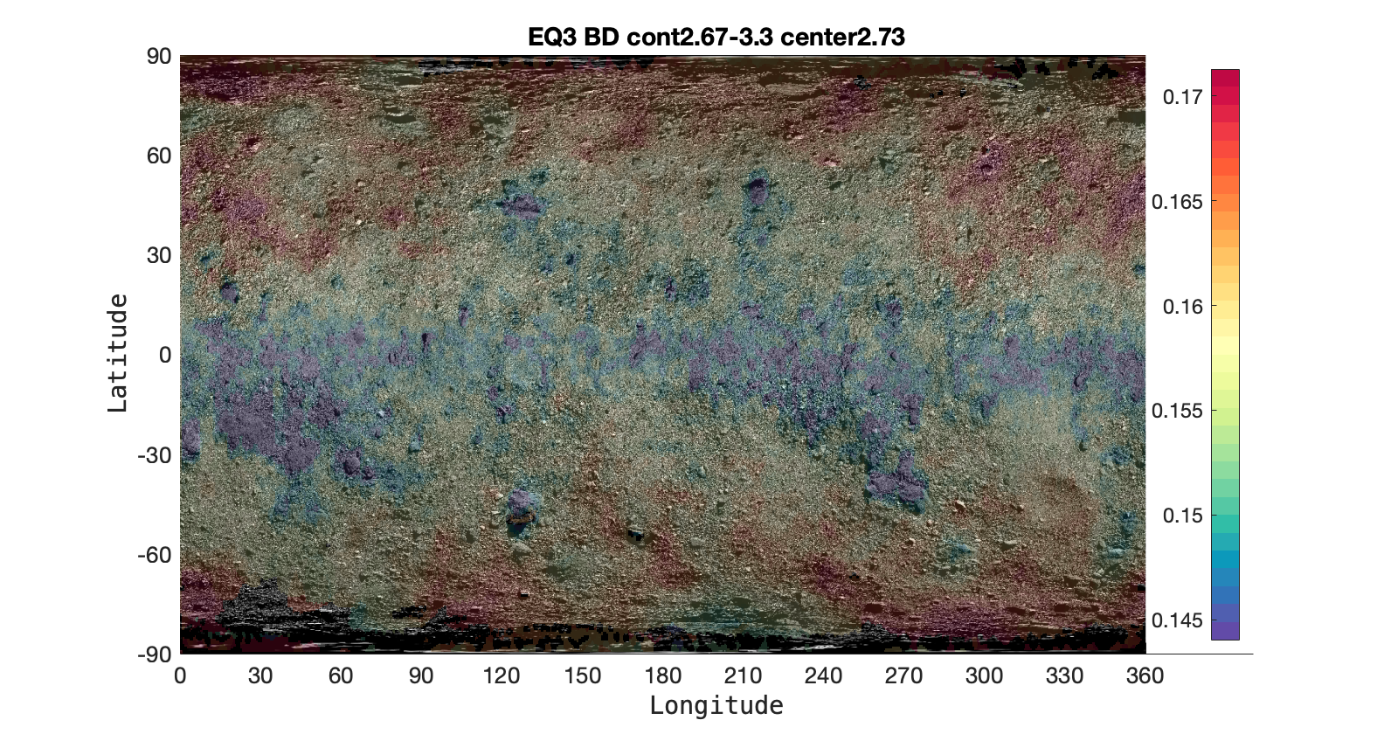

**Figure 1 (SM):** Band depth calculated from Bennu's EQ3 spectra, overlain on the Bennett et al. (2020) imaging basemap.

*Bennu individual map of NOPL, ESPAT and the H2O-OH- H content derived from each spectrum.*Using each linear correlation between each spectral parameter and H2O-OH- H content of meteorites shown in **figure 2**, we computed Bennu H2O-OH- H content map derived from each spectral parameter (NOPL and ESPAT) as well as each spectral parameter spatial variations simultaneously (**Figure 2 (SM)**).

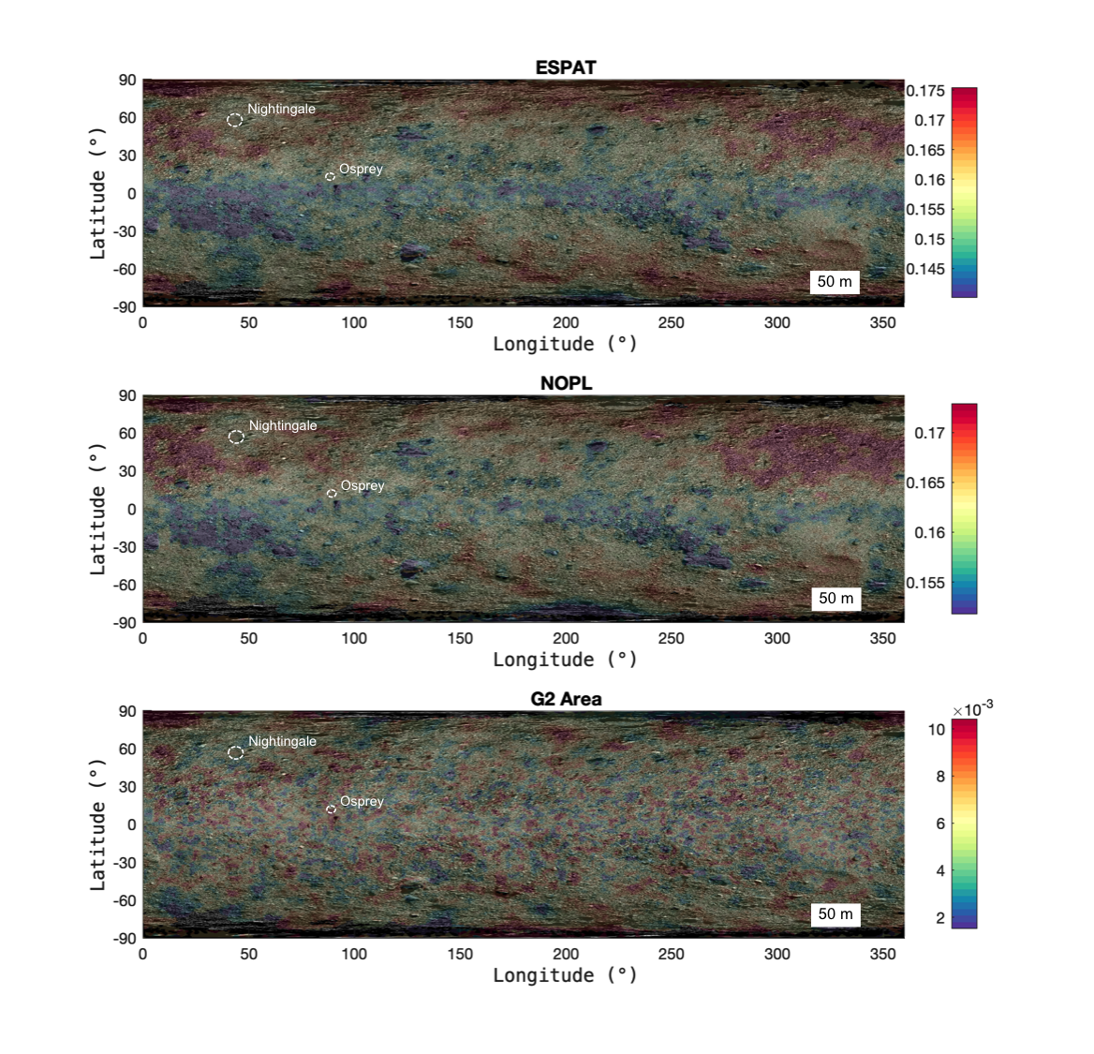



ESPAT

H2O-OH- H content

NOPL

H2O-OH- H content

**(B)**

**(A)**

**Figure 2 SM**: The ESPAT and NOPL parameters calculated on Bennu's EQ3 spectra are mapping on the global mosaic in (**A**) and (**B**) respectively as well as their relative derived H2O-OH- H content.

**REFERENCES:**

* Alexander C.M.O’D., Fogel M. L., Yabuta H., Cody G. D. (2007). The origin and evolution of chondrites recorded in the elemental and isotopic compositions of their macromolecular organic matter, Geochim. Cosmochim. Acta, 71(17), 4380-4403.
* Alexander C.M.O’D., Bowden R., Fogel M. L., Howard K. T., Herd C. D. K., Nittler L. R. (2012). The Provenances of Asteroids, and Their Contributions to the Volatile Inventories of the Terrestrial Planets**,** Science, 337, 721-723.
* Alexander C.M.O’D., Howard K. T., Bowden R., and Fogel M. L. (2013). The classification of CM and CR chondrites using bulk H, C and N abundances and isotopic compositions, Geochim. Cosmochim. Acta, 123, 244-260.
* Altwegg, K., Balsiger, H., & Fuselier, S. A. (2019). Cometary chemistry and the origin of icy solar system bodies: the view after Rosetta. Annual Review of Astronomy and Astrophysics, 57, 113-155.
* Barnouin, O. S., Daly, M. G., Palmer, E. E., Gaskell, R. W., Weirich, J. R., Johnson, C. L., ... & Daly, R. T. (2019). Shape of (101955) Bennu indicative of a rubble pile with internal stiffness. Nature Geoscience, 12(4), 247-252.
* Barucci M.A. et al. (2020). OSIRIS-REx spectral analysis of (101955) Bennu by multivariate Statistics, A&A, 637, L4.
* Beck, P., Quirico, E., Montes-Hernandez, G., Bonal, L., Bollard, J., Orthous-Daunay, F. R., ... & Wunder, B. (2010). Hydrous mineralogy of CM and CI chondrites from infrared spectroscopy and their relationship with low albedo asteroids. Geochim. Cosmochim. Acta, 74(16), 4881-4892.
* Bennett, C., DellaGiustina, D., Becker, K., Becker, T., Edmundson, K., Golish, D., Bennett, R., Burke, K., Cue, N., Clark, B. E., Contreras, J., Deshapriya, J. D. P., Drouet d'Aubigny, C., Jawin, E., Nolan, T., Porter, N., Riehl, M., Roper, H., Rizk, B., Tang, Y., Zeszut, Z., Gaskell, R., Palmer, E., Weirich, J., Al Asad, M., Philpott, L., Daly, M., Barnouin, O., Enos, H., Lauretta, D. (2020) A High-Resolution Global Basemap of (101995) Bennu. Icarus, 113690.
* Bottke, W. F., Moorhead, A., Connolly, H. C. Jr (2020), Meteoroid Impacts as a Source of Bennu’s Particle Ejection Events, JGR Planets, doi:10.1029/2019JE006282.
* Brack, A. (1993). Liquid water and the origin of life. Origins of Life and Evolution of the Biosphere, 23(1), 3-10.
* Campins, H. et al., 2010. Water ice and organics on the surface of the Asteroid 24 Themis. *Nature* 464, 1320-1321.
* Chyba, C. F. (1990). Impact delivery and erosion of planetary oceans in the early inner solar system. Nature, 343(6254), 129-133.
* Clark, R. N. (1999). Spectroscopy of rocks and minerals, and principles of spectroscopy. Manual of remote sensing, 3(3-58), 2-2.
* Clark, B. E., Ziffer, J., Nesvorny, D., Campins, H., Rivkin, A. S., Hiroi, T., ... & DeMeo, F. (2010). Spectroscopy of B‐type asteroids: Subgroups and meteorite analogs. Journal of Geophysical Research: Planets, 115(E6).
* Clark B.E., Binzel R.P.,Howell E., Cloutis E.A., Ockert-Bell M.E., Christensen P., Barucci M.A., DeMeo F., Lauretta D., Connolly H. C. Jr., Soderberg A., Hergenrother C., and Lim L., (2011) Asteroid (101955) 1999 RQ36: Spectroscopy from 0.4 to 2.5µm and Meteorite Analogs, *Icarus 216, 462-475*.
* DellaGiustina, D. N., Emery, J. P., Golish, D. R., Rozitis, B., Bennett, C. A., Burke, K. N., ... & Hamilton, V. E. (2019). Properties of rubble-pile asteroid (101955) Bennu from OSIRIS-REx imaging and thermal analysis. Nature Astronomy, 3(4), 341-351.
* DellaGiustina, D. N. et al., (2020). Diverse Color and Reflectance of Asteroid (101955) Bennu, Science, in revision.
* De Sanctis, M. C., Ammannito, E., McSween, H. Y., Raponi, A., Marchi, S., Capaccioni, F., ... & Formisano, M. (2017). Localized aliphatic organic material on the surface of Ceres. Science, 355(6326), 719-722.
* Fornasier, S., Lazzarin, M., Barbieri, C., & Barucci, M. A. (1999). Spectroscopic comparison of aqueous altered asteroids with CM2 carbonaceous chondrite meteorites. Astronomy and Astrophysics Supplement Series, 135(1), 65-73.
* Garenne, A., Beck, P., Montes-Hernandez G., Brissaud O., Schmitt B., Quirico E., Bonal L., Beck C., and Howard K.T. (2016). Bidirectional reflectance spectroscopy of carbonaceous chondrites: Implications for water quantification and primary composition, Icarus, 264, 172-183.
* Gilmour, C. M., Herd, C. D. K., Beck, P. (2019). Water abundance in the Tagish Lake meteorite from TGA and IR spectroscopy: Evaluation of aqueous alteration, Meteorit. Planet. Sci. 54, 1951–1972.
* Hamilton, V. E., Simon, A. A., Christensen, P. R., Reuter, D. C., Clark, B. E., Barucci, M. A., ... & Connolly, H. C. (2019). Evidence for widespread hydrated minerals on asteroid (101955) Bennu. Nature Astronomy, 3(4), 332-340.
* Hapke, B. (1993). Theory of Reflectance and Emittance Spectroscopy. Cambridge University Press, Cambridge, UK.
* Hapke, B. (2002). Bidirectional reflectance spectroscopy: 5. The coherent backscatter opposition effect and anisotropic scattering. Icarus, 157(2), 523-534.
* Helfenstein, P., & Shepard, M. K. (2011). Testing the Hapke photometric model: Improved inversion and the porosity correction. Icarus, 215(1), 83-100.
* Jawin, E. R. et al., (2020). Global patterns of recent mass movement on asteroid (101955) Bennu, JGR Planets.
* Jutzi, M., & Michel, P. (2020). Collisional heating and compaction of small bodies: constraints for their origin and evolution. Icarus, 113867.
* Kaplan, H. H., Milliken, R. E., Alexander, C. M. O. D., & Herd, C. D. (2019). Reflectance spectroscopy of insoluble organic matter (IOM) and carbonaceous meteorites. Meteorit. Planet. Sci., 54(5), 1051-1068.
* Kaplan, H. H., et al. (2020). Composition of Organics on Asteroid (101955) Bennu, Science, in revision.
* Kebukawa, Y., Nakashima, S. & Zolensky, M. E. (2010). Kinetics of organic matter degradation in the Murchison meteorite for the evaluation of parent-body temperature history: Kinetics of organic matter degradation in the Murchison meteorite. Meteorit. Planet. Sci. 45, 99–113.
* Kitazato, K., Milliken, R. E., Iwata, T., Abe, M., Ohtake, M., Matsuura, S., ... & Senshu, H. (2019). The surface composition of asteroid 162173 Ryugu from Hayabusa2 near-infrared spectroscopy. Science, 364(6437), 272-275.
* Lauretta, D. S., Balram-Knutson, S. S., Beshore, E., Boynton, W. V., d’Aubigny, C. D., DellaGiustina, D. N., ... & Bennett, C. A. (2017). OSIRIS-REx: sample return from asteroid (101955) Bennu. Space Science Reviews, 212(1-2), 925-984.
* Lee, M. R., Lindgren, P., King, A. J., Greenwood, R. C., Franchi, I. A., & Sparkes, R. (2016). Elephant Moraine 96029, a very mildly aqueously altered and heated CM carbonaceous chondrite: Implications for the drivers of parent body processing. Geochim. Cosmochim. Acta, 187, 237-259.
* Li, J. Y., A'Hearn, M. F., Belton, M. J., Crockett, C. J., Farnham, T. L., Lisse, C. M., ... & Veverka, J. (2007a). Deep Impact photometry of comet 9P/Tempel 1. Icarus, 187(1), 41-55.
* Li, J. Y., A'Hearn, M. F., McFadden, L. A., & Belton, M. J. (2007b). Photometric analysis and disk-resolved thermal modeling of Comet 19P/Borrelly from Deep Space 1 data. Icarus, 188(1), 195-211.
* Li, J. Y., A’Hearn, M. F., Farnham, T. L., & McFadden, L. A. (2009). Photometric analysis of the nucleus of Comet 81P/Wild 2 from Stardust images. Icarus, 204(1), 209-226.
* Li, J. Y., et al. (2020)
* Li, S., & Milliken, R. E. (2017). Water on the surface of the Moon as seen by the Moon Mineralogy Mapper: Distribution, abundance, and origins. Science Advances, 3(9), e1701471.
* McMahon, J. W., Scheeres, D. J., Chesley, S. R., French, A., Brack, D., Farnocchia, D., ... & Bierhaus, B. (2020). Dynamical Evolution of Simulated Particles Ejected from Asteroid Bennu. Journal of Geophysical Research: Planets, e2019JE006229.
* McSween Jr, H. Y., Emery, J. P., Rivkin, A. S., Toplis, M. J., C. Castillo‐Rogez, J., Prettyman, T. H., ... & Russell, C. T. (2018). Carbonaceous chondrites as analogs for the composition and alteration of Ceres. Meteorit. Planet. Sci., 53(9), 1793-1804.
* Merlin, F., et al., (2020). Constraining the physical and chemical properties of the surface of Bennu using spectral modeling, A&A, to be submitted.
* Milliken R. E. and Mustard J. F. (2005). Quantifying absolute water content of minerals using near-infrared reflectance spectroscopy, JGR, 110, E12001, doi:10.1029/2005JE002534, 2005
* Milliken, R. E., & Mustard, J. F. (2007). Estimating the water content of hydrated minerals using reflectance spectroscopy: II. Effects of particle size. Icarus, 189(2), 574-588.
* Milliken R. E., Mustard J. F., Poulet F.,Jouglet D., Bibring J.-P., Gondet B., Langevin Y.(2007). Hydration state of the Martian surface as seen by Mars Express OMEGA: 2. H2O content of the surface, JGR, 112, E08S07, doi:10.1029/2006JE002853
* Mustard, J. F., Murchie, S. L., Pelkey, S. M., Ehlmann, B. L., Milliken, R. E., Grant, J. A., ... & Roach, L. (2008). Hydrated silicate minerals on Mars observed by the Mars Reconnaissance Orbiter CRISM instrument. Nature, 454(7202), 305-309.
* Nakamura, T. Yamato (2006). 793321 CM chondrite: Dehydrated regolith material of a hydrous asteroid. *Earth and Planetary Science Letters* 242, 26–38.
* Potin S., Beck. P., Usui F., Bonal L., Vernazza P. and Schmitt B. (2020). Style and intensity of hydration among C-complex asteroids: a comparison to desiccated carbonaceous chondrites, Icarus, 348, 113826.
* Reuter, D. C., Simon, A. A., Hair, J., Lunsford, A., Manthripragada, S., Bly, V., ... & Dolch, Z. (2018). The OSIRIS-REx Visible and InfraRed Spectrometer (OVIRS): spectral maps of the asteroid Bennu. Space Science Reviews, 214(2), 54.
* Rivkin A.S., Campins H., Howell E., Emery J.P., Licandro J., Takir D., and Vilas F. (2015). Water and Hydroxyl on Asteroids. In Asteroids IV (P. Michel et al., eds), pp 65-87. Univ. of Arizona Press, Tucson.
* Rozitis, B., et al. (2020). Asteroid (101955) Bennu’s Weak Boulders and Thermally Anomalous Equator*.* Science, in press.
* Ryan, A., et al., (2020).
* Simon A. A. et al. (2020). Widespread distribution of carbon-bearing materials on near-Earth asteroid (101955) Bennu, Science, in revision.
* Takir, D., Emery, J. P., Mcsween Jr, H. Y., Hibbitts, C. A., Clark, R. N., Pearson, N., & Wang, A. (2013). Nature and degree of aqueous alteration in CM and CI carbonaceous chondrites. Meteoritics & Planetary Science, 48(9), 1618-1637.
* Takir, D., Emery, J. P., & McSween Jr, H. Y. (2015). Toward an understanding of phyllosilicate mineralogy in the outer main asteroid belt. Icarus, 257, 185-193.
* Takir D., Stockstill-Cahill K. R., Hibbitts C. A., Nakauchi Y. (2019). 3-μm reflectance spectroscopy of carbonaceous chondrites under asteroid-like conditions, Icarus 333, 243–251.
* Tucker, O. J., Farrell, W. M., Killen, R. M. & Hurley, D. M. (2019). Solar Wind Implantation Into the Lunar Regolith: Monte Carlo Simulations of H Retention in a Surface With Defects and the H2 Exosphere. *JGR Planets* 124, 278–293.
* Walsh, K. J., Jawin, E. R., Ballouz, R. L., Barnouin, O. S., Bierhaus, E. B., Connolly, H. C., ... & Pajola, M. (2019). Craters, boulders and regolith of (101955) Bennu indicative of an old and dynamic surface. Nature Geoscience, 12(4), 242-246.
* Zou, X.-D., et al. (2020). Photometry of asteroid (101955) Bennu with OVIRS on OSIRIS-REx, Icarus, in revision.