Development and Characterization of the Integrally Stiffened Cylinder (ISC) Process for Launch Vehicles and Aircraft Fuselage Structures

Wesley Tayon^{1*}, Marcia Domack¹, John Wagner¹, Karen Taminger¹, Eric Hoffman¹, Sydney Newman²

¹NASA Langley Research Center, Hampton, VA
²Virginia Polytechnic Institute and State University, Blacksburg, VA

Keywords: Integrally stiffened cylinders, Flow-forming, Aluminum alloys, Mechanical properties

Abstract

Over the past decade, NASA Langley has led development of the Integrally Stiffened Cylinder (ISC) Process, a near-net-shape, flow-forming technology. This innovative process is being evaluated for launch vehicle and commercial aircraft manufacturing. A thick-walled, cylindrical preform is flow-formed using a single operation into a thin-walled barrel with integral longitudinal stiffeners. The one-piece, stiffened barrels offer a direct replacement for conventional multi-piece, welded or riveted structures. A cost-benefit analysis for launch vehicle cryogenic propellant tanks estimated that the ISC process offers up to a 50% reduction in manufacturing costs and a 10% reduction in mass. NASA, the European Space Agency (ESA), and industry partners have teamed to manufacture 3-m (10-ft.) diameter aluminum ISCs. The intent is to demonstrate the commercial viability of the process at a scale relevant to the commercial launch and aircraft industries. Development activities will be presented, including process scale-up, formability assessment, and mechanical property testing.

Introduction
The current standard for launch vehicle structures is multi-piece construction, involving extensive machining and welding or riveting to produce the final assembly. This approach to manufacturing has been the production standard since the 1950’s. Over the past decade, NASA Langley Research Center (LaRC) has been developing a new manufacturing concept, known as the Integrally Stiffened Cylinder (ISC) Process. The method has been applied to the fabrication of future launch vehicle structures with an emphasis on cryogenic propellant (liquid oxygen and hydrogen) tanks.

Current tank construction is dependent on processes that have seen only modest development or improvement over time. Traditional methods have inefficiencies that adversely affect overall structural performance, manufacturing schedule, production costs, and many other factors relevant to the complexity of manufacturing these structures. Using the former Space Shuttle External Tank as an example, orthogrid-stiffened panels were produced by machining of thick plates, producing ~90% material scrap rate [1]. This translated to ~$8M of material waste (~230,000 kg./500,000 lbs. of machining chips) per tank. The barrel sections were fabricated by longitudinally welding multiple arc-shaped panels together to form barrel sections, followed by circumferential welding of multiple barrel sections together to complete the assembly. Each tank required over 0.8 km (0.5 miles) of welds, incurring extensive labor costs. The welds cause significant property knockdown, and increase the overall tank weight due to the thicker weld lands required. The ISC process offers the potential for more economical and structurally efficient tank manufacturing for future launch vehicles.

The ISC process is unique because the wall and stiffeners are formed concurrently to produce a single-piece, near-net-shape product. This approach reduces welding and machining requirements, which reduce production time. A cost-benefit analysis undertaken in 2015, which was led by NASA in consultation with US industry, concluded that applying ISC technology to cryogenic tank barrel sections reduced the structural mass, production time, and overall manufacturing costs [2]. Using a hypothetical tank size of 4.9 m (16 ft.) in diameter by 12.2 m (40 ft.) in length, the ISC process reduced manufacturing cost by 50% compared to conventional manufacturing processes as shown in Figure 1. The reduction in machining, welding, and inspection labor decreased the manufacturing time by 40%. The additional benefits of improved structural efficiency and reduced material property knockdown were also recognized. A 5-10% reduction in tank mass resulted from the elimination of longitudinal welds. A parallel study of a single-piece, stiffened cylinder machined from a thick-wall flow-forming demonstrated a 28% increase in buckling load over similar machined, welded structure [3].

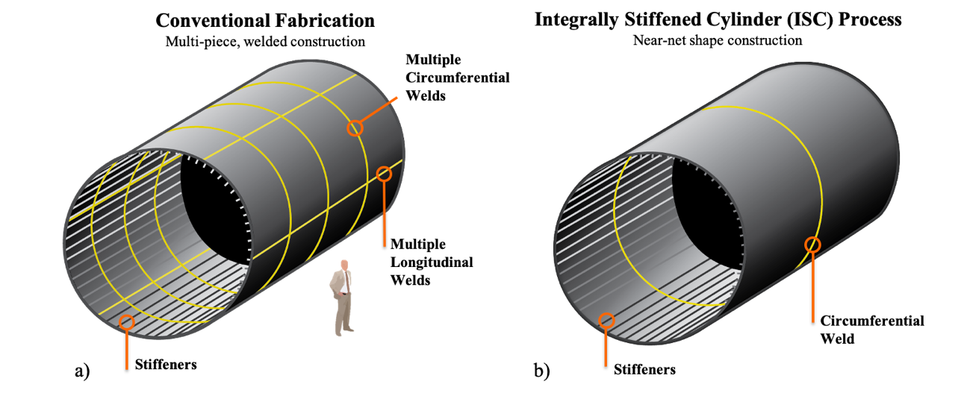
Figure 1. Comparison of welds required for cryogenic tank fabrication using a) conventional methods vs. b) ISC technology. Yellow lines indicate weld seams.

Cryogenic tank fabrication using the ISC process creates the barrel section and the integral longitudinal stiffeners on the inner surface in a single-step flow-forming operation. As depicted in Figure 2, the process begins with a thick-walled roll ring forging (also referred to as preform) that is formed over a hollow, cylindrical mandrel. Both the preform and the mandrel spin in unison. The mandrel has machined grooves on the outer surface corresponding to the desired stiffener spacing and geometry. Forming is conducted at room temperature, although friction results in some heating. Multiple pairs of interior and exterior rollers are located at fixed positions around the circumference during deformation. The internal rollers provide support to the mandrel and the external rollers exert force on the preform. As the material thins, the cylinder grows axially, material is forced into the grooves, and both the wall and longitudinal stiffeners are formed in unison.

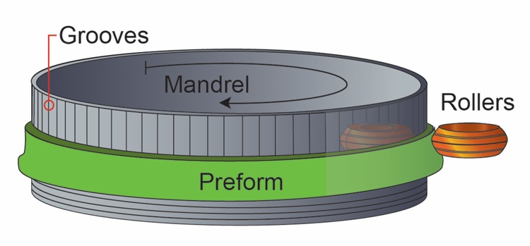
Figure 2. ISC manufacturing process schematic at 3-m (10-ft.) diameter scale depicting the mandrel (gray), the preform (green), and the rollers (orange). The arrow indicates clockwise mandrel rotation direction.

In the sections that follow, the history and the accomplishments associated with ISC process development will be detailed. This summary will include the materials used, scale-up progress toward commercialization, and testing performed to characterize the properties of fully-formed ISC products and evaluate several starting tempers which may have advantages for commercial manufacturing. Test results for ISCs formed using a variety of aluminum alloys and the effect of starting temper on formability are discussed. Also described is the progress made in maturation of the ISC process.

Materials, Methods, and Procedures

Materials
The most successful aluminum alloys for ISC production possess high malleability. All of the ISC preforms were formed in the O temper per AMS 2770 specifications [4], as this condition is known for high tensile ductility. Three alloys have been used in ISC forming campaigns: Al alloys 6061 and 2219, and Al-Li alloy 2050. Of these, Al 6061 is the only alloy that has been employed at all scales of ISC development.

Al 6061 is a general, all-purpose aluminum alloy used in countless industry applications. Customarily, it is not used in launch vehicle structures, such as cryogenic tanks, because it has higher density and lower strength than other more favorable alloys. The alloy was selected for forming during ISC process development because of cost, availability, and exceptional formability. There have also been more successful demonstrations using Al 6061 with the ISC process than other aluminum alloys. Consequently, it has essentially become a standard material for ISC process development activities.
Al 2219 is the thick-plate aluminum alloy that is the standard for launch vehicle structures, especially cryogenic propellant tanks. It was chosen early-on as a candidate for forming because initial ISC process development was primarily focused on cryogenic propellant tanks.

Alloy 2050 is an aluminum-lithium (Al-Li) alloy that is becoming more widely used in launch vehicle and crew capsule structures. It has a lower density than Al 2219 while exhibiting comparable tensile strength, enabling structural weight reduction.

Alternative Preform Heat Treatments
ISCs formed in the O temper require post-forming solution heat treatment (SHT) and aging to meet service property specifications. Distortion of the formed ISC during rapid quenching is an inherent risk and will need to be addressed either with internal bracing or through straightening operations. A solution might be to adjust the temper of the preform, such that post-forming thermal treatments can be simplified. Forming in the T4 (SHT + natural-age) condition is practical, if subsequent direct aging produces acceptable properties. Forming in the T6 (SHT + artificial age) condition is possible, if the strength and ductility levels are compatible with adequate formability.

ISC forming using starting blanks in the T4 or T6 temper condition has yet to be demonstrated. However, tensile testing to evaluate formability has been completed using sections of preform rings heat treated to O, T4, and T6 tempers. Coupon level test specimens were fabricated from preform material and heat treated to produce representative T4 and T6 temper staring conditions per AMS 2770 [4] for evaluation. This is further discussed in sections 2.4 and 4.2.

Post-Forming Heat Treatment
Aluminum alloys used for cryogenic tanks are typically used in the peak or near-peak aged T8 temper. The T8 temper requires cold stretching, usually in the range of 3-5% strain, prior to artificial aging to develop higher strength. Imparting such plastic deformation in a complex cross section like the ISC may not be practical. Therefore, the T6 condition will probably be the peak strength service temper for most ISC products. Al 6061 and Al 2219 are both offered commercially in a T6 temper. AMS 2770 [4] defines the appropriate heat treatment protocol for T6 product forms of these alloys, and was followed in this study.

Al-Li alloy products are not typically used in the T6 temper. Consequently, there are no established standard specifications for heat treatment to the T6 condition. Definition of an aging practice for a T6 temper in Al-Li 2050, to facilitate comparison with Al 2219 and Al 6061, involved a hardness study with remnant pieces from the Al-Li 2050 ISCs. The formed material was solution heat treated at 500°C (932°F) for 1 hour, water quenched, and then aged at 165°C (330°F) for various hold times ranging from 1 to 100 hours. Hardness measurements using the Rockwell B scale were obtained for each discrete aging times. The hardness of the Al-Li 2050 reached a plateau after 30 hours. Therefore, a 30-hour age was selected to achieve peak strength for the T6 condition.

Mechanical Testing
Tensile testing of coupons extracted from preforms and formed ISCs was performed using ASTM E8 standard subsize specimens [5]. The mechanical testing had two objectives: 1) provide tensile data in a relevant final product form – the T6 temper – for ISC material; and 2) examine differences in formability between the three alloys used in ISC fabrication and formability within several different starting tempers in Al 6061. In both cases, tensile yield strength (YS), ultimate tensile strength (UTS), and elongation were measured for comparison to other wrought products.

For assessing formability, two additional parameters were computed from tensile test data: uniform elongation and strain hardening exponent, n. Uniform elongation is the elongation value when the material reaches the point of instability in deformation, which is coincident with the UTS and onset of necking. The strain hardening exponent was calculated from Hollomon’s equation (Eq. 1),

σ = K ε^{n} (Eq. 1)

where σ is the true stress, ε is the true strain, n is the strain hardening exponent and K is the strength coefficient. Hollomon’s equation is a simple power-law fit to the true stress-strain curve in the plastic region per ASTM E646 [6].

ISC Process Development

Proof of Concept Demonstration and Development
The key stages of ISC process development by an international team led by NASA are highlighted in Figure 3. The technology began as an adaptation of an automotive process used to fabricate steel clutch housings. At this scale, the process utilized thin discs as the preforms for conversion into stiffened cylinders – one of these discs is shown in Figure 3(a). In 2012, forming of a 200-mm (8-inch) diameter cylinder with 5-mm (0.2-inch) tall stiffeners using Al-Li alloy 2195 successfully demonstrated the proof of concept for the ISC process for aluminum structures. Over the next few years, the team optimized the process to achieve stiffeners with height and spacing typical of launch vehicle tank structures, advancing the technology readiness level (TRL) from 1 to 3. These developments are shown in Figure 3(a).

Sounding Rocket Manufacturing Demonstration and Flight Test
In 2015, the process was scaled up to 432-mm (17-inch) in diameter, and three Al 6061 ISCs were produced at this scale. The ISCs had 6 longitudinal stiffeners that were 0.2 inches tall and a spacing of 9 inches. Two of the three sounding rocket scale ISCs can be seen in the center image in Figure 3(b). Forming blanks for these ISCs were fabricated from extruded bar. One of the three was flown on a sounding rocket in collaboration with Wallops Flight Facility. Two others were subjected to ground testing. Data collected from ground certification and during flight validated the ISC technology and advanced the TRL level to 6 for sounding rocket scale applications. Machines exist for commercial production at this scale and could easily be tailored to support sounding rocket production or various applications pertinent to the defense industry.

Commercial-Scale Demonstration and Manufacturing Development
In 2017, NASA LaRC and MT Aerospace conducted a forming campaign to demonstrate the technology at a scale commensurate with commercial launch vehicles. The forming campaign took place at MT Aerospace in Augsburg, Germany. NASA supplied three 3-m (10-ft.) diameter Al 2219 roll ring forgings (preforms) that were produced at Scot Forge in Spring Grove, IL. MT Aerospace separately provided two 3-m (10-ft.) diameter Al-Li 2050 preforms. Forming was conducted on a commercial flow-forming machine owned by the European Space Agency (ESA) and used for fabricating smooth-walled, steel booster segments for the Ariane 5 launcher.

NASA LaRC provided guidance on mandrel design for the 2017 forming campaign, which consisted of 48 equally-spaced grooves of two different shapes (symmetric vs asymmetric), three depths (15, 20 and 25 mm; 0.6, 0.8, and 1.0 inch), and two widths (6 and 8 mm; 0.24 and 0.32 inch). The stiffeners spacing was 203 mm (8 inches). This provided a total of 12 unique combinations repeated four times each around the circumference of the cylinder. The stiffeners on the formed ISC part take the shape of the groves on the mandrel. The most successfully formed stiffeners were those that were the shortest in height, 15mm (0.6 inches). Stiffener shape and width appeared to have a lesser impact on the stiffener forming.

The 2017 forming campaign resulted in a successful manufacturing demonstration at the commercial scale. However, cracking occurred in ISCs produced with both 2219 and 2050, primarily in the stiffeners and in some instances extended into the wall region. NASA, MT Aerospace, and Scot Forge provided independent assessments of the formed Al 2219 ISCs that exhibited poorer formability and more extensive cracking to gain a better understanding of the issues [7]. The increased tendency for cracking was attributed to three sources: 1) reduced formability due to large Al-Cu particles, 2) insufficient lubrication during forming as evidenced by stick-slip friction marks on the stiffener surface, and 3) differential material flow rates between the wall and stiffener leading to axial tensile stresses within the stiffener.

A second forming campaign at the 3-m (10-ft) diameter scale occurred in 2019, leveraging the success and lessons learned from the 2017 campaign. Modifications were implemented to improve the process and mitigate cracking issues to produce defect-free ISCs at the commercial scale. The process modifications included:
- redesigning the mandrel to reduce groove spacing and adopt a uniform stiffener shape to minimize the differential flow rate
- improving the preform fixturing method to the mandrel and adjusting lubrication to prevent slippage during forming
- switching from Al 2219 to Al 6061 for risk reduction due to its inherently good formability and heritage in ISC development.

Adoption of these changes resulted in the fabrication of six, defect-free 3-m (10-ft.) diameter ISCs, as shown in Figure 3(c). Successful ISCs were produced up to a length of 1.5 m (5 ft.) with 12.5 mm (0.5 inch) tall stiffeners, 58.3 mm (2.3 inch) stiffener spacing, and a final wall thickness of 3 mm (0.12 inches). A cylinder of this size was formed in roughly 1.5 hours. The successful production of multiple ISCs at this scale demonstrates the commercial viability of the ISC process to US industry for single-piece, stiffened aerospace structures. These demonstrations advanced the ISC process’s TRL level to 5 for commercial scale manufacturing.

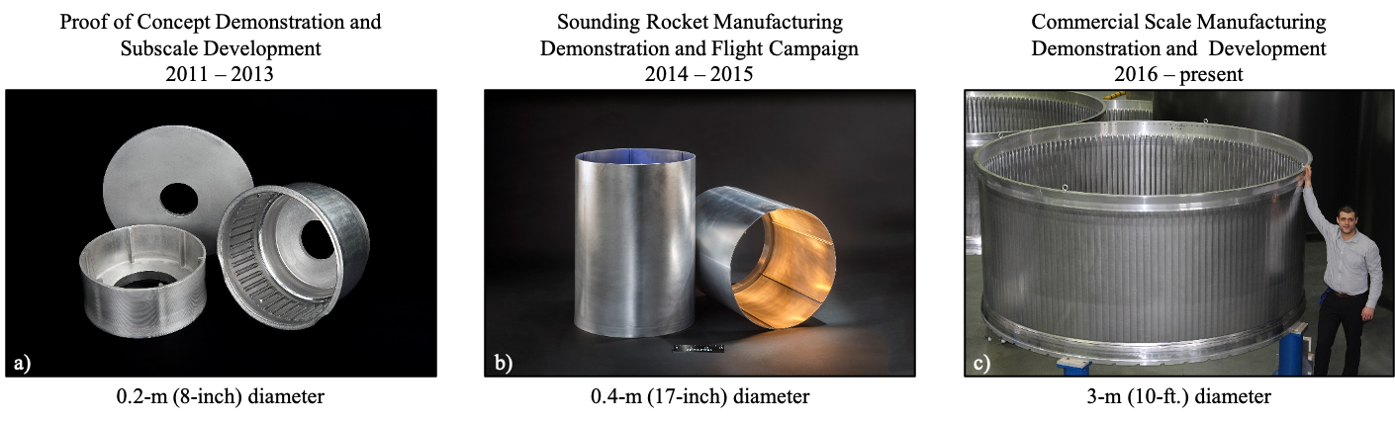
Figure 3. Historical progression of the ISC process by product and scale.

As a result of the two large-scale forming campaigns, stiffener height and spacing have emerged as an important design variable that impacts successful stiffener forming. Experiences reveal that shorter, closely-spaced stiffeners are easier to form than taller, widely-spaced stiffeners. This result is likely related to differential material flow rates within the wall and stiffeners. The shorter, more closely-spaced stiffeners minimize flow rate disparities between the wall and stiffener, while increasing the height and spacing of stiffeners creates a greater difference in flow rate between the wall and stiffener.

The ISC mandrel used in 2019 has a stiffener spacing of 58 mm (2.3 inches) and a uniform stiffener height of 12.5 mm (0.5 inches). In contrast, the mandrel used in 2017 has a stiffener spacing of 203 mm (8 inches) and 3 different heights – 15, 20, and 25 mm (0.6, 0.8, and 1.0 inch). The two mandrels are compared in Figure 4.

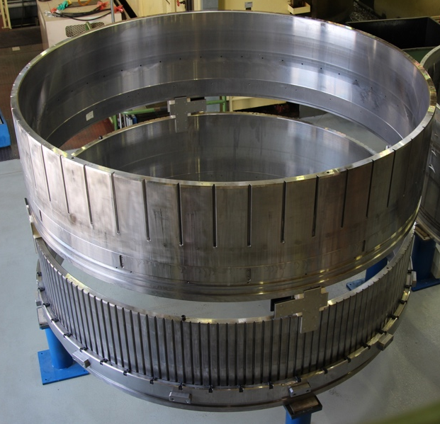
Figure 4. Two 3-m (10-ft.) diameter ISC forming mandrels with 48 stiffeners (top) from the 2017 campaign, and 164 stiffeners (bottom) from the 2019 campaign.

Recent Adaptation of the ISC Process to Fuselage Structures
The NASA Advanced Air Transport Technology (AATT) project is developing technologies for ultra-efficient commercial aircraft. One objective of the project is to reduce assembly time and cost through rapid net-shape forming of integrated structure and simultaneously reducing weight through elimination of fasteners. The AATT project is exploring the use of ISC technology to fabricate single-piece barrel sections for aircraft fuselages. This is in response to a US industry need for advanced concepts that reduce manufacturing time and cost relative to the traditional riveted assemblies. The cost and schedule benefits noted in the cost-benefit analysis for launch vehicles is motivating the application of ISC technology for fuselage construction. Although the ISC approach can produce the required skin and a longitudinally stiffened structure, additional secondary structures are required. These stiffening elements include circumferential ring frames, window belts, and door frames. Accordingly, the ISC process will be combined with complementary manufacturing processes that can join and / or build up secondary structures on the pre-formed ISC.
Currently, the AATT project is forming four 3-m (10-ft.) diameter by 2-m (6-ft.) long Al 6061 ISCs in collaboration with Scot Forge and MT Aerospace. These ISCs will be integrated into a 3-m (10-ft.) diameter by 6-m (20-ft.) long representative metallic fuselage structure to demonstrate high-rate manufacturing that also enables reductions in cost and weight. Initial structural design optimizations predict the use of ISCs can result in weight savings of more than 20% compared to incumbent single-aisle commercial aircraft.

Mechanical Test Results & Discussion
As a consequence of the successful forming campaigns at the sounding rocket and commercial launch vehicle scales, fundamental studies were conducted to characterize the mechanical properties of the ISCs, and study the effects of preform heat treatment on formability. The subsequent subsections will discuss these two areas of coupon level testing.

T6 Properties of Formed ISCs
Tensile properties of the 3-m (10-ft.) diameter ISCs after SHT and aging to the T6 temper are shown in Table 1 for both axial and circumferential orientations. Data is also shown for the 432-mm (17-inch) diameter sounding rocket ISC. Tensile yield strength (YS), ultimate tensile strength (UTS), and elongation are reported from the average of duplicate test specimens. Test specimens were extracted from both the wall and stiffener regions of the ISC. Axial wall specimens were machined such that the center of the gauge section aligned with the center of the wall between two adjacent stiffeners. Axial stiffener specimens were extracted from the center of the stiffener. Due to obvious material limitations within the stiffener, circumferential stiffener specimens were only extracted from the wall with the gauge section centered directly below the stiffener. Typical and minimum properties for Al 6061-T6 are provided in Table 2 for comparison with other wrought product forms.

Al 6061 has been used at every scale of ISC development. Consequently, tensile properties are available for the two diameters of most interest for commercializing the ISC process, i.e. at the sounding rocket and launch vehicle scales. The sounding rocket test data display some anisotropy in YS between the axial and circumferential directions, with the circumferential direction being 50-70 MPa (8-10 ksi) lower than the axial direction in both the stiffener and wall regions. The circumferential direction YS is below the minimum YS for Al 6061-T6 wrought product forms by 7-14 MPa (1-2 ksi). Meanwhile, the YS values for the axial direction meet or exceed both the minimum and typical properties for Al 6061-T6. In general, elongation values are close to the AMS specification minimum of 9% with slightly lower values in the circumferential direction.

In the 3-m (10-ft.) Al 6061 ISCs, yield and ultimate strengths exceed typical T6 properties by ~10%. Elongation values were higher than handbook minimums for each location and orientation with the exception of the circumferential wall specimens. In axial specimens from the stiffener, the average elongation of 30% was double the typical elongation for Al 6061-T6 materials.

The sounding rocket ISCs exhibited lower strength properties when comparing with the Al 6061-T6 3-m (10-ft. diameter) ISCs. Additionally, a greater degree of anisotropy was observed in the YS in the sounding rocket ISC. At the 3-m (10-ft.) diameter scale, there was noticeably more isotropy with YS properties only varying by 7 MPa (1 ksi) or less. The difference in YS properties and the degree of anisotropy between the two products may be related to the different starting material conditions. The sounding rocket preform was machined from extruded bar with the extrusion direction aligned with the axial direction of the ISC. In contrast, the 3-m (10-ft.) diameter ISC preform was a ring rolled forging where the axial direction was not the primary working direction. Generally, the level of tensile ductility was similar between the two scales with the exception of the high (30%) elongation reported in stiffener axial specimens for the 10-foot diameter ISC. Consistently higher elongation values were obtained in the axial direction than the circumferential direction for both scales.

Al-Li 2050 tensile data is only available from the wall regions, due to cracking in the stiffeners. The 3-m (10-ft.) Al-Li 2050 ISC material provided superior strength properties compared to Al 6061, as expected. There is no standard 2050-T6 data for comparison, since Al-Li 2050 is not used in the T6 temper commercially. Instead, a similar alloy Al-Li 2195 was used for comparison with the Al-Li 2050 ISC data. Although Al-Li 2195 is rarely used in the T6 temper, the Al-Li 2050 producer Constellium provided internal Al-Li 2195-T6 wrought product data [8]. Values for the 2050 material are comparable to the furnished Al-Li 2195-T6 properties ranges.

In summary, properties for Al 6061 and Al-Li 2050 in the T6 temper indicate no deleterious impacts on mechanical properties from the ISC process. At the 3-m (10-ft.) scale, properties generally meet or exceed typical properties for similar T6 wrought product forms.
Table 1. Tensile properties of the fully formed ISCs in T6 temper.
Alloy  Location | ISC Diameter | Orientation | UTS |  | YS |  | Elong.
Alloy  Location | ISC Diameter | Orientation | MPa | ksi | MPa | ksi | %
2050-T6  Wall | 3 m (10 ft.)  Commercial Scale | Circumferential | 434 | 62.9 | 364 | 52.8 | 15.2
2050-T6  Wall | 3 m (10 ft.)  Commercial Scale | Axial | 441 | 64.0 | 373 | 54.1 | 10.2
6061-T6  Wall | 3 m (10 ft.)  Commercial Scale | Circumferential | 335 | 48.6 | 312 | 45.3 | 6.4
6061-T6  Wall | 3 m (10 ft.)  Commercial Scale | Axial | 345 | 50.1 | 314 | 45.5 | 11.5
6061-T6  Stiffener | 3 m (10 ft.)  Commercial Scale | Circumferential | 346 | 50.2 | 317 | 46.0 | 9.9
6061-T6  Stiffener | 3 m (10 ft.)  Commercial Scale | Axial | 348 | 50.4 | 319 | 46.3 | 30.3
6061-T6  Wall | 432 mm (17 inch)  Sounding Rocket | Circumferential | 317 | 45.9 | 229 | 33.2 | 9.0
6061-T6  Wall | 432 mm (17 inch)  Sounding Rocket | Axial | 319 | 46.3 | 297 | 43.0 | 9.8
6061-T6  Stiffener | 432 mm (17 inch)  Sounding Rocket | Circumferential | 317 | 46.0 | 240 | 34.8 | 8.1
6061-T6  Stiffener | 432 mm (17 inch)  Sounding Rocket | Axial | 321 | 46.6 | 293 | 42.5 | 11.9

Table 2. Reference tensile properties of T6 products.
Reference Material | UTS |  | YS |  | Elong.
Reference Material | MPa | ksi | MPa | ksi | %
6061 Wrought (typical) [9] | 310 | 45 | 279 | 40 | 14.5
6061 Wrought (minimum) [10] | 290 | 42 | 241 | 35 | 9.0
2195 Wrought [8] | 455-490 | 66-71 | 351-400 | 51-58 | 13-22

Preform Formability Assessment
Formability of the three alloys was evaluated using the elongation and strain hardening data provided in Table 3. The strain hardening exponent, n, correlates with the true strain at which plastic instability (e.g., necking) occurs during tensile deformation, and evaluation of n is frequently included in metal formability studies. Higher n values are associated with higher uniform elongation values, indicating a higher degree of stable plastic deformation which is desirable for forming.

Al-Li 2050 and Al 2219 exhibit higher n values and greater uniform and total elongation in the circumferential orientation, an indicator of higher formability. Conversely, the axial orientation shows decreased n values and elongation, suggestive of lower formability. Uniform and total elongation and n values are notably higher for 6061, supporting the greater formability of 6061 observed during ISC processing. The enhanced formability of Al 6061 was confirmed during the 2019 forming campaign, which repeatedly produced Al 6061 ISCs without cracking.

The 2019 forming campaign demonstrated the ability of Al 6061 to form in the O temper state without any cracking or defects. However, if forming can be applied to material in a solution treated condition, this would benefit commercial production. Two additional conditions were assessed via tensile testing to study the effect of forming Al 6061 in T4 and T6 tempers.

By forming in the T4 condition, the solution heat treatment and water quench would have been performed before forming, eliminating the distortion risk associated with quenching a large ISC. In this case, only aging would need to be conducted post-fabrication. Additionally, the shear deformation associated with ISC forming may act as a replacement for the tensile stretch typically required to create the T8 temper. Potentially, direct aging after ISC forming may yield properties that are closer to T8 targets.

Table 3. Tensile strength and formability of Al alloys in the O temper.
Material  Condition | Specimen  Orientation | UTS |  | YS |  | Uniform  Elongation | Total  Elongation | n
Material  Condition | Specimen  Orientation | MPa | ksi | MPa | ksi | % | %
6061-O | Axial | 118 | 17.1 | 53 | 7.7 | 17.4 | 27.8 | 0.238
6061-O | Circumferential | 117 | 16.9 | 55 | 7.9 | 22.9 | 35.3 | 0.226
2219-O | Axial | 183 | 26.5 | 105 | 15.2 | 14.1 | 16.6 | 0.170
2219-O | Circumferential | 188 | 27.2 | 86 | 12.5 | 17.0 | 23.8 | 0.244
2050-O | Axial | 221 | 32.1 | 132 | 19.2 | 9.3 | 16.7 | 0.161
2050-O | Circumferential | 219 | 31.8 | 105 | 15.2 | 12.8 | 16.9 | 0.232

Table 4. Formability assessment of Al 6061 in various heat-treated conditions.

Material  Condition | Specimen  Orientation | UTS |  | YS |  | Uniform Elongation | Total Elongation | n
Material  Condition | Specimen  Orientation | MPa | ksi | MPa | ksi | % | %
6061-O | Axial | 118 | 17.1 | 53 | 7.7 | 17.4 | 27.8 | 0.238
6061-O | Circumferential | 117 | 16.9 | 55 | 7.9 | 22.9 | 35.3 | 0.226
6061-T4 | Axial | 238 | 34.5 | 117 | 16.9 | 16.9 | 19.9 | 0.243
6061-T4 | Circumferential | 247 | 35.8 | 120 | 17.4 | 22.2 | 32.5 | 0.247
6061-T6 | Axial | 297 | 43.0 | 268 | 38.9 | 7.4 | 10.1 | 0.051
6061-T6 | Circumferential | 295 | 42.8 | 265 | 38.5 | 16.7 | 25.8 | 0.054

In the event that forming can be conducted on material in the T6 temper, both solutionizing and aging treatments would be completed before fabrication. This would simplify post-forming procedures, eliminate the risk of distortion, and reduce the manufacturing time. Forming in the T6 condition would also reduce the furnace and quench tank capacity needed for production, as the ISC preform rings, while the same weight and diameter as the fully-formed cylinders, are significantly shorter in length. It is also likely that starting with a preform in the T6 temper would increase the strength of an ISC through work hardening during forming.

Tensile properties measured for Al 6061 roll ring forged preforms that were heat treated to produce representative O, T4, and T6 tempers are shown in Table 4. The values of elongation and n for Al 6061 in the T4 temper are comparable with the O temper, indicating that this condition may have similar formability. However, the higher strength values indicate that higher forming stresses will be required. The T6 elongation values are lower, particularly for the axial orientation, and the n values are significantly lower, indicating a decrease in formability, suggesting that forming in the T6 state may not be feasible. Forming campaigns have yet to employ preforms in either the T4 or T6 tempers. However, these preliminary results indicate that forming in a T4 temper is promising, which would have significant benefits for commercial production of ISCs.

Conclusions and Future Work
Over the last 10 years, collaborations between NASA LaRC and MT Aerospace have taken the ISC process from proof-of-concept to a commercially viable process. The recent 3-m (10-ft.) diameter demonstrator was very successful, despite the fact that the machine used was designed to form smooth wall, steel booster casings. The process seeks to revolutionize the construction of aerospace hardware by producing single-piece axisymmetric structures that are lighter, cheaper, safer, and offer increased structural performance compared to traditional manufacturing approaches. The advantages of the ISC process are the result of eliminating all longitudinal welds and greatly reducing machining and material waste. The ISC technology awaits infusion into aerospace markets by US industry. The technology has relevance for small-scale applications, such as sounding rockets or missiles, and large-scale applications, such as launch vehicles.

It has already been demonstrated that the mechanical properties of ISC hardware heat treated to the T6 temper meet or exceed those associated with other wrought products. Additionally, using preforms that have been solution heat treated prior to ISC forming may have benefits. Avoidance of post-forming treatments that include quenching eliminates the risk of distortion. Formability of starting blanks in the T4 temper condition has proved adequate based on preliminary assessments. This will be an area of focus for process development moving forward with commercialization in mind.

Although the primary focus of ISC development has been for space launch vehicles, NASA has recently invested in the ISC process to meet the demands for high-rate, low-cost fuselage production. Under the Advanced Air Transport Technology (AATT) Project, NASA LaRC is fabricating a 3-m (10-ft.) diameter by 6-m (20-ft.) long fuselage manufacturing demonstration article. Several ISCs will be joined and integrated with additional structural elements in collaboration with US industry to complete this manufacturing demonstrator. This demonstration article has direct relevance to reducing manufacturing time, cost, and improving structural performance for future single-aisle commercial jets, business jets, and cargo aircraft.

References
1. Zell, D, et al., (2019) Developments on Low Cost Manufacturing Methods for Cylindrical Launch Vehicle Structures. Paper presented at the 67th International Astronautical Congress, Washington, D.C.
2. Stoner, MC, et al., (2016) Cost-Benefit Analysis for the Advanced Near Net Shape Technology (ANNST) Method for Fabricating Stiffened Cylinders.
3. Rudd, MT, et al., (2018) Buckling response of a large-scale, seamless, orthogrid-stiffened metallic cylinder. Paper presented at the 2018 AIAA/ASCE/AHS/ASC Structures, Structural Dynamics, and Materials Conference,
4. Aerospace Material Specification 2770H: Heat Treatment of Wrought Alumunum Alloy Parts. (2010) SAE International, Warrendale, PA.
5. Annual Book of ASTM Standards Vol. 3.01. (2010) American Society for Testing and Materials, West Conshohocken, PA.
6. Annual Book of ASTM Standards Vol. 3.01. (2010) American Society for Testing and Materials, West Conshohocken, PA.
7. Tayon, W, et al., (2019) Characterization of 10-ft. Diameter, Aluminum Alloy 2219 Integrally Stiffened Cylinders. NASA Technical Memorandum, (NASA/TM-20190002739):
8. Personal Communication with Constellium Regarding Al-Li Alloy 2195-T6 Properties, (2018).
9. Al 6061-T6 Material Data Sheet (2020), Aerospace Specification Metals, Inc. http://asm.matweb.com/search/SpecificMaterial.asp?bassnum=MA6061T6
10. Aerospace Metals Specification AMS 4127 Rev. K: Aluminum Alloy, Forgings and Rolled or Forged Rings, (6061-T6) Solution and Precipitation Heat Treated. . (2019) SAE International, Warrendale, PA.

