SUPPLEMENTARY MATERIAL

A Sensitive Quantitative Analysis of Abiotically Synthesized Short Homopeptides using Ultraperformance Liquid Chromatography and Time-of-Flight Mass Spectrometry

Eric T. Parker ª, Megha Karki ^{b, 1}, Daniel P. Glavin ª, Jason P. Dworkin ^{a, **}, Ramanarayanan Krishnamurthy ^{b,*}

ªNASA Goddard Space Flight Center, Solar System Exploration Division, 8800 Greenbelt Road, Greenbelt, MD 20771, U.S.A.;
^{b}Department of Chemistry, Scripps Research, 10550 North Torrey Pines Road, La Jolla, CA 92037, U.S.A.
¹Present Address: Singular Genomics, 10931 North Torrey Pines Road Suite #100, La Jolla, CA 92037, U.S.A.

Corresponding Author:
*Ramanarayanan Krishnamurthy, Department of Chemistry, Scripps Research, 10550 North Torrey Pines Road, La Jolla, CA 92037, U.S.A.; phone: 1-858-784-8520; fax: 1-858-784- 9573; email: rkrishna@scripps.edu

Co-Corresponding Author:
**Jason P. Dworkin, NASA Goddard Space Flight Center, Solar System Exploration Division, 8800 Greenbelt Road, Greenbelt, MD 20771, U.S.A.; phone: 1-301-286-8631; fax: 1- 301-286-1683; email: jason.p.dworkin@nasa.gov

Supplementary Material

1. Materials and methods S2
1.1. Chemicals and reagents S2
1.2. Method development S3
1.3. Analytical figures of merit S3
2. Results and discussion S6
2.1. Method development S6
2.2. Analytical figures of merit S6
2.3. Room temperature/heating experiments S8
2.4. Simulated environmental wet-dry cycling experiments S11
References S12
Figures S13
Tables S23

1. Materials and methods
1.1. Chemicals and reagents
Four reagents were used to enable pre-column derivatization of samples and standards. These four reagents were: 1) AccQ·Tag Ultra borate buffer, 2) AccQ·Tag Ultra reagent powder, 3) AccQ·Tag Ultra reagent diluent, and 4) AccQ·Tag derivatization agent. Reagents 1) – 3) were purchased from Waters Corporation. Reagent 4) was prepared by mixing 1 mL of reagent 3) with reagent 2). Once formed, reagent 4) was then vortexed for 10 seconds and heated for 15 minutes on top of a heating block set at 55 °C, until the powder fully dissolved, at which point, reagent 4) was ready for use as the derivatization agent as detailed in §2.2 of the main text.
Four eluents were used during analysis by UPLC-FD/ToF-MS: A) AccQ·Tag A buffer, B) AccQ·Tag B buffer, C) strong wash, and D) weak wash. Eluent A) was prepared by mixing 100 mL of AccQ·Tag Eluent A Concentrate, which was purchased from Waters Corporation, with 900 mL of Millipore ultrapure water. Eluent B) was purchased directly from Waters Corporation. Eluent C) was prepared by mixing 700 mL of HPLC grade acetonitrile with 300 mL of ultrapure water. Eluent D) was prepared by mixing 900 mL of ultrapure water with 100 mL of HPLC grade acetonitrile. Eluents A) and B) were used to perform chromatography, while eluents C) and D) were used to clean the chromatography pump.
A 0.5 M aqueous solution of sodium formate was used for daily calibrations of the ToF-MS, and real-time lock mass corrections were executed using a 200 µg L⁻¹ solution of leucine enkephalin. Both the 0.5 M sodium formate solution and the 200 µg L⁻¹ leucine enkephalin solution were prepared as described elsewhere [S1].

1.2. Method development
Chromatographic separation of target analytes was preceded by pre-column derivatization using the AccQ·Tag derivatization agent. The primary amino group of an amino acid or peptide reacted with the ester carbonyl of the derivatization agent to form a new amide bond (Figure S1), and in doing so, the target analytes were converted into a derivative with fluorescent properties. Target analyte derivatives were subsequently detected by both the FD and the ToF-MS, as detailed in §2.2 of the main text.
1.3. Analytical figures of merit
Following the development of the new analytical technique, an analytical figures of merit experiment was performed for both the FD and the ToF-MS detectors. The purpose of the analytical figures of merit experiments was to assess the quantitative accuracy and precision of the newly developed analytical technique. The analytical figures of merit experiments were performed by constructing calibration curves, produced by performing triplicate analyses of a mixed standard composed of target amino acids and homopeptides. Ten serial dilutions were generated for this experiment to obtain calibration curves across a range of 10 different analyte concentrations: 1.5 nM, 5.0 nM, 15.0 nM, 50.0 nM, 150.0 nM, 500.0 nM, 1.5 μM, 5.0 μM, 15.0 μM, and 45.0 μM.
Analytical figures of merit were obtained by performing linear regression analyses, which were executed by plotting observed standard analyte peak areas vs. known standard analyte concentrations. When doing this, it was determined that the observed analyte peak area standard deviations increased proportionally to known analyte concentrations, demonstrating the heteroscedastic nature of the acquired calibration data. Consequently, a weighted linear regression analysis was implemented to account for heteroscedasticity in the calibration data [S3-S5]. To perform a weighted linear regression, weights ($w_{i}$) were applied:
 | $$w_{i}= \frac{s_{i}^{-2}}{\sum_{i}^{n}{s_{i}^{-2}/n}}$$ | (S1)

In equation (S1), $n$ is the number of standard concentrations that make up the calibration curve and $s_{i}$ is the standard deviation of the peak area triplicate measurements. After their application, the weights were used to determine weighted centroid coordinates (${\overline{x}}_{w},{\overline{y}}_{w})$:
 | $${\overline{x}}_{w}= \frac{\sum_{i}^{n}{w_{i}x_{i}}}{n}$$ | (S2)
 | $${\overline{y}}_{w}= \frac{\sum_{i}^{n}{w_{i}y_{i}}}{n}$$ | (S3)

In equation (S2), $x_{i}$ is the analyte concentration, and in equation (S3), $y_{i}$ is the observed peak area associated with $x_{i}$. Once obtained, weighted centroid coordinates were used to help calculate the weighted slope ($b_{w})$:
 | $$b_{w}= \frac{\sum_{i}^{n}{w_{i}x_{i}y_{i}}-n{\overline{x}}_{w}{\overline{y}}_{w}}{\sum_{i}^{n}{w_{i}x_{i}^{2}-n{\overline{x}}_{w}^{2}}}$$ | (S4)

and the weighted y-intercept ($a_{w})$:
 | $$a_{w}= {\overline{y}}_{w}-b_{w}{\overline{x}}_{w}$$ | (S5)

Using the algebraic form of the general equation of a weighted straight line:
 | $$y_{i}=a_{w}+b_{w}x_{i}$$ | (S6)

the ${\hat{y}}_{i}$ component of the y-residuals $(y_{i}- {\hat{y}}_{i})$ can be calculated using the following equation:
 | $${\hat{y}}_{i}= a_{w}+ b_{w}x_{i}$$ | (S7)

when using the analyte concentration ($x_{i}$), the weighted slope ($b_{w},$from equation (S4)), and the weighted y-intercept ($a_{w}$, from equation (S5)).
Next, the weighted, random error in the y-direction ($s_{\left(y/x\right)w}$) was obtained using:
 | $$s_{\left(y/x\right)w}= \sqrt{\frac{\sum_{i}^{n}{w_{i}{({y_{i}- \hat{y}}_{i})}^{2}}}{n-2}}$$ | (S8)

Finally, limit of detection (LOD) and limit of quantitation (LOQ) values for each analyte, using both detectors, were calculated as 3$s_{\left(y/x\right)w}$ and 10$s_{\left(y/x\right)w}$, respectively. The 3$s_{\left(y/x\right)w}$ and 10$s_{\left(y/x\right)w}$ values are an estimation of LOD and LOQ based on observed signal intensities. These LOD and LOQ values were then converted into their respective molar concentrations ($x_{i}$) by insertion into equation (S6) as $y_{i}$, along with inserting the calculated values for $b_{w}$ and $a_{w}$ into equation (S6).
The uncertainty estimates of the weighted slope are confidence intervals, which were calculated by executing a two-tailed t-test. First, the weighted standard deviations for the slope, $s_{b_{w}}$, were calculated as:
 | $$s_{b_{w}}={[\frac{n{\left[s_{\left(y/x\right)w}\right]}^{2}}{(n[\sum_{i}^{n}{w_{i}x_{i}^{2}]-{[\sum_{i}^{n}{w_{i}x_{i}]}}^{2})}}]}^{1/2}$$ | (S9)

After the value of $s_{b_{w}}$ was obtained, the confidence interval was calculated as the product of the tabulated t-value at a 95% confidence level (α= 0.05) with $n-2$ degrees of freedom and the value for $s_{b_{w}}$.

2. Results and discussion
2.1. Method development

The chromatographic approach developed in this study produced broad peaks that eluted first, followed by narrow, sharp peaks that eluted later. The reason for this observed difference in peak shape is due to the change in eluent composition during the course of the chromatographic run. When the first peaks eluted from the column, the eluent composition is <10% organic mobile phase. The Gly-based species that eluted from the column first eluted more slowly in such a strongly aqueous buffer composition, leading to relatively broad peaks (peaks 1 – 6, Figure 1). The later eluting peaks elute faster due to the greater organic eluent composition (~15%) near the end of the run, causing the sharper appearance of these later peaks.
During chromatographic optimization, an effort was made to increase the sharpness of the Gly-based peaks that eluted first. The organic composition of the eluent was increased at the time the first compounds eluted; however, it was observed that doing so caused later peaks to coelute, thereby compromising the chromatographic resolution of subsequent peaks. As a result, it was determined that the gradient described in §2.2 of the main text, which produced relatively broad peaks that eluted first and sharper peaks that eluted later (Figure 1) was acceptable because under this configuration, the chromatographic resolution of target analytes was largely preserved. A detailed accounting of resultant detection metrics is shown in Table S1.
2.2. Analytical figures of merit
The analytical figures of merit experiments resulted in the determination of the LOD, LOQ, sensitivity, and linear range values of each detector used in the newly developed method, with respect to each individual analyte targeted in this study. Table S2 displays the analytical figures of merit for the FD. The sensitivity of the FD to each analyte was relatively similar, approximately within a factor of 2. The FD coefficients of determination with respect to changes in analyte concentrations were > 0.999 for all target analytes, spanning a range from slightly less than 3 orders of magnitude at the minimum (Gly₂), to more than 3 orders of magnitude at the maximum (Ala₄). The FD LOD values for all analytes were below 100 nM, with the largest LOD being for Gly₂, at 86.50 nM, and the lowest LOD being for Ala₄, at 10.01 nM. The FD LOQ values for all analytes were below 500 nM, with the largest LOQ being associated with Glu, at 429.08 nM, and the lowest LOQ being associated with Ala₄, at 24.82 nM. Also included in Table S2, are the LOD and LOQ values converted from nM to femtomoles (fmol) on column, after taking into account the injection volume and dilution effects from the derivatization reaction. The FD LOD values, in terms of femtomoles on column, spanned a range of 2.00 fmol – 17.30 fmol. Similarly, the FD LOQ values, in terms of femtomoles on column, spanned a range of 4.96 fmol – 85.82 fmol.
Table S3 displays the analytical figures of merit for the ToF-MS. The sensitivity of the ToF-MS to each analyte was as low as 0.08 nM⁻¹ for Asp₄, and as high as 2.52 nM⁻¹ for Ala₅. The ToF-MS coefficients of determination with respect to changes in analyte concentrations were > 0.985 for all target analytes, spanning a range from just under 3 orders of magnitude at the minimum (Gly), to more than 4 orders of magnitude at the maximum (Ala₃). The ToF-MS LOD values for all analytes were below 50 nM, except for Gly (53.83 nM). The lowest ToF-MS LOD was for Ala₃, at 1.75 nM. The ToF-MS LOQ values for most analytes were below 100 nM, except for Gly (280.15 nM), Ala (161.95 nM), and Asp (140.12 nM). The lowest ToF-MS LOQ was for Ala₃, at 5.30 nM. Also included in Table S3, are the LOD and LOQ values converted from nM to femtomoles on column, as described above. The ToF-MS LOD, in terms of femtomoles on column, spanned a range of 0.35 fmol – 10.77 fmol. Similarly, the ToF-MS LOQ values, in terms of femtomoles on column, spanned a range of 1.06 fmol – 56.03 fmol.
The analytical figures of merit for the FD (Table S2) and the ToF-MS (Table S3) allow for a comparison between the two types of detectors used in the method developed here. It can be seen that the FD is consistently more sensitive than the ToF-MS. However, the LOD and LOQ values for the FD are both generally greater than that observed for the ToF-MS. To understand the reasoning for this, it is important to keep in mind that instrumental sensitivity is defined as the instrument response to a given analyte, per unit concentration of that analyte, whereas the LOD and LOQ values are functions of the backgrounds observed by the detector for a given analyte. The FD exhibited a greater response per unit concentration of each target analyte it was exposed to, yet the background observed by the FD was greater for most analytes, than that which was observed by the ToF-MS. Consequently, the ToF-MS demonstrated a greater overall ability to limit background noise associated with most analytes than was the FD. Therefore, the ToF-MS boasted a lower LOD for 15 of the target analytes and a lower LOQ for 16 of the target analytes, than did the FD. During the evaluation of the performance of the method developed here, it can be seen that this new technique is a sensitive analytical tool that provides low LOD and LOQ values for amino acids and respective homopeptides, while using multiple detectors to identify target analytes via 3 different analytical metrics, including accurate mass measurements.
2.3. Room temperature/heating experiments
Small quantities of Gly₃ were produced by the fourth collection time (t₄ = 24 days) for room temperature and mildly heated experimental reaction solutions. The signal intensities for this analyte in both the room temperature and mildly heated experimental reaction solutions reached a maximum at t_{f} = 106 days (Figure S2). Gly₃ abundances are not reported here because the analyte concentrations did not exceed the instrumental LOQ. Additionally, Gly-based homopeptides longer than trimers were not formed over the course of the 106-day experiment.
Accurate mass chromatograms demonstrate the detection of Ala₂ in the experimental reaction solutions, but the absence of Ala₂ in the experimental control solutions (Figure S3). The temporal Ala₂ formation under room temperature and mild heating conditions, is displayed in Figure S4 for both experimental control and reaction solutions. Experimental control solutions failed to generate detectable quantities of Ala₂. Experimental reaction solutions generated detectable quantities of Ala₂ by the first collection time (t₁ = 3 days) when exposed to mild heating (50 °C), but failed to generate detectable quantities of Ala₂ until after the third collection time (t₃ = 9 days) when left at room temperature. Given the disparate synthetic trends between room temperature and mild heating conditions at the onset of the experiment, it was surprising to observe that the room temperature experimental reaction solutions produced almost twice as much Ala₂ after 106 days than did the mildly heated experimental reaction solutions (Figure S4). The room temperature experimental reaction solutions produced ~77 μM of Ala₂, while the heated experimental reaction solutions produced ~40 μM of Ala₂ (Table 4). Small quantities of Ala₃ were produced in both the room temperature and heating experiments, where maximum concentrations were observed after 106 days (Figure S5) for both room temperature and mild heating conditions. Ala₃ abundances are not reported here because the analyte concentrations did not exceed the instrumental LOQ. Furthermore, Ala-based homopeptides longer than trimers were not observed over the course of the 106-day experiment.
Upon confirming that DAP successfully facilitated the oligomerization of simple amino acids, such as Gly and Ala, it was explored if DAP could facilitate amino acid oligomerization of more complex monomers, such as Asp and Glu. Under room temperature conditions, maximum Asp₂ formation was observed after 24 days, while maximum Asp₂ formation was observed after 9 days when mild heating was applied (Table 4). While the differences between these maximum Asp₂ abundances appeared to be significant when examining accurate mass LC-MS data (Figure S6), the quantitative synthetic trends of Asp₂ over the course of the 106-day experiment appeared to be surprisingly similar for both room temperature and mild heating conditions (Figure S7). As was the case with simple amino acids, such as Gly, experimental control solutions failed to produce Asp-based peptides, confirming the necessity of DAP to induce oligomerization. Experimental reaction solutions generated detectable quantities of Asp₂ by the first collection time (t₁ = 3 days) under both room temperature and mild heating (50 °C) conditions, demonstrating the facile nature by which Asp oligomerized in the presence of DAP. However, Asp-based homopeptides longer than dimers were not formed during the experiment.
Accurate mass chromatograms of Glu₂ formation at the respective time points of maximum signal intensities for both the room temperature and mild heating experimental reaction solutions indicate that the room temperature experiments generated a greater maximum quantity of Glu₂ over the course of the 106-day experiment than did the heating experiments (Figure S8). The temporal Glu₂ formation under room temperature and mild heating conditions is displayed in Figure S9 for both experimental control and reaction solutions. Experimental control solutions failed to produce Glu-based peptides, while experimental reaction solutions produced minimal quantities (~2 μM) of Glu₂ under room temperature conditions. Glu₂ abundances formed under mild heating conditions are not reported here because under these conditions, Glu₂ was detected just over the LOD, but did not exceed the instrumental LOQ. Experimental reaction solutions generated detectable quantities of Glu₂ by the fourth collection time (t₄ = 24 days) when exposed to both room temperature and mild heating (50 °C) conditions. Furthermore, Glu-based homopeptides longer than dimers could not be detected in either the room temperature experimental reaction solutions, or those exposed to mild heating at 50 °C. This result underscores that Glu does not oligomerize nearly as readily as the other three amino acids tested under the same experimental conditions.
2.4. Simulated environmental wet-dry cycling experiments
For the purpose of evaluating if DAP was capable of facilitating the oligomerization of peptides, in addition to amino acids, Gly₂ was used as an additional test starting reagent to determine if oligomers of Gly₂ were preferentially synthesized upon exposure to simulated environmental cycling. Under these conditions, it can be seen that in the absence of cycling (t_{i}), only Gly₂ is detectable (Figure S10A). However, after cycling is implemented, Gly₄ and Gly₆ are also detectable, indicating that Gly₂ was successfully oligomerized into its dimer and trimer (Figure S10B). It is worth noting that Gly₃ and Gly₅ were disproportionately not formed in this experiment; however, a small peak for Gly₃ was observed in the mass chromatogram (Figure S10B), likely due to the presence of trace amounts of Gly contaminant reacting with Gly₂ and DAP during the oligomerization reaction to form minute quantities of Gly₃. The formation of Gly₂ oligomers as a function of simulated environmental cycles is shown in Figure S10C where it can be seen that, as expected, Gly₄ was formed more prevalently than Gly₆, but that Gly₆ was still readily generated to appreciable quantities (~363 μM) after 4 cycles (Table 5). The higher abundances of Gly₄ than Gly₆ may be partially due to aqueous solubility limitations associated with Gly₆.

References

[S1] D.P. Glavin, J.E. Elsila, H.L. McLain, J.C. Aponte, E.T. Parker, J.P. Dworkin, D.H. Hill, H.C. Connolly Jr., D.S. Lauretta, Extraterrestrial amino acids and L-enantiomeric excesses in the CM2 carbonaceous chondrites Aguas Zarcas and Murchison, Meteorit. & Planet. Sci. (2020) https://doi.org/10.1111/maps.13451.

[S2] S.A. Cohen, D.P. Michaud, Synthesis of a Fluorescent Derivatizing Reagent, 6-Aminoquinolyl-N-Hydroxysuccinimidyl Carbamate, and Its Application for the Analysis of Hydrolysate Amino Acids via High-Performance Liquid Chromatography, Anal. Biochem. 211 (1993) 279-287.

[S3] K. Danzer, L.A. Currie, Guidelines for Calibration in Analytical Chemistry. Part 1. Fundamentals and Single Component Calibration, Pure and Appl. Chem. 70 (1998) 993-1014.

[S4] M.E Monge, J.J. Perez, P. Dwivedi, M. Zhou, N.A. McCarty, A.A. Stecenko, F.M. Fernández, Ion mobility and liquid chromatography/mass spectrometry strategies for exhaled breath condensate glucose quantitation in cystic fibrosis studies, Rapid Commun. in Mass Spectrom. 27 (2013) 2263-2271.

[S5] E.T. Parker, H.J. Cleaves II, J.L. Bada, F.M. Fernández, Quantitation of α-hydroxy acids in complex prebiotic mixtures via liquid chromatography/tandem mass spectrometry, Rapid Commun. in Mass Spectrom. 30 (2016) 2043-2051.

Figures

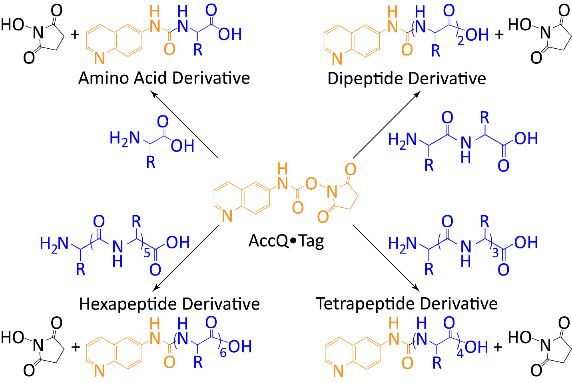
Figure S1. Schematic of AccQ·Tag derivatization reaction. This schematic gives general examples of how the AccQ·Tag derivatization agent reacts with amino acids and homopeptides to yield the derivatized target analyte that were subsequently detected and quantitated by UPLC-FD/ToF-MS. The schematic shown here is based on Cohen and Michaud [S2].
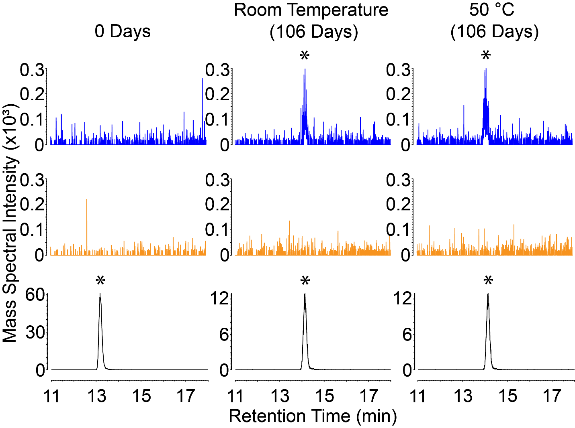
Figure S2. Gly₃ production under room temperature and mild heating conditions. Accurate mass chromatograms of a Gly₃ standard (bottom, black), reaction mixture of a solution of Gly + imidazole (middle, orange), and reaction mixture of a solution of Gly + imidazole + DAP (top, blue). Data are collected after 0 days (t_{i}) and 106 days (t_{f}) when maximum Gly₃ signal intensities were reached for both the room temperature and mild heating (50 °C) experimental reaction solutions. Accurate mass chromatograms were extracted from m/z 360.1308. Asterisks denote peaks that represent Gly₃. Here, min = minutes.

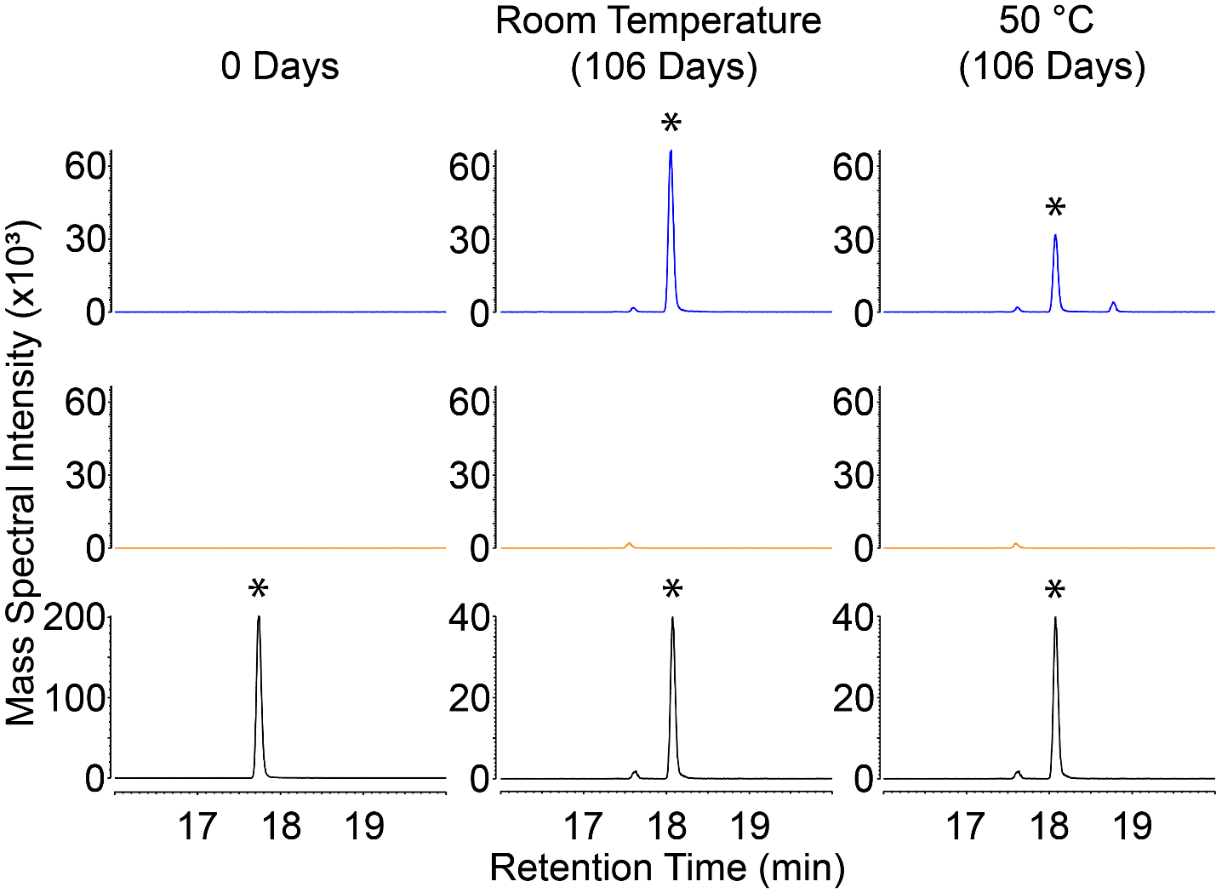
Figure S3. Ala₂ production under room temperature and mild heating conditions. Accurate mass chromatograms of an Ala₂ standard (bottom, black), reaction mixture of a solution of Ala + imidazole (middle, orange), and reaction mixture a solution of Ala + imidazole + DAP (top, blue). Data are collected after 0 days (t_{i}) and 106 days (t_{f}) when maximum Ala₂ concentrations were reached for both room temperature and mild heating (50 °C) experimental reaction solutions. Accurate mass chromatograms were extracted from m/z 331.1406. Asterisks denote peaks that represent Ala₂. Here, min = minutes.

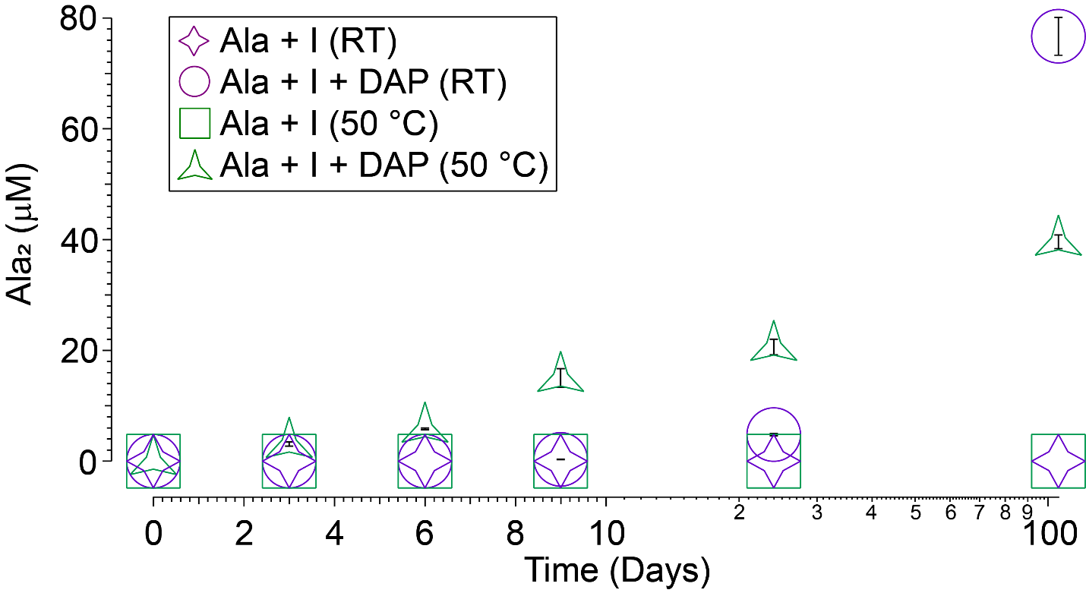
Figure S4. Temporal Ala₂ production under room temperature and mild heating conditions. Ala₂ is not synthesized in the absence of DAP, and Ala₂ synthesis was surprisingly enhanced at the end of the 106-day experiment, under room temperature conditions. Samples portrayed here were analyzed in triplicate. Uncertainties $(δ_{x}$) were determined as the standard error ($δ_{x}= σ_{x} · {(n)}^{{-1}/2}$), whereby the uncertainties were based on the standard deviation ($σ_{x})$of the average value of 3 separate measurements ($n=3$). In this figure, I = imidazole, and RT = room temperature.

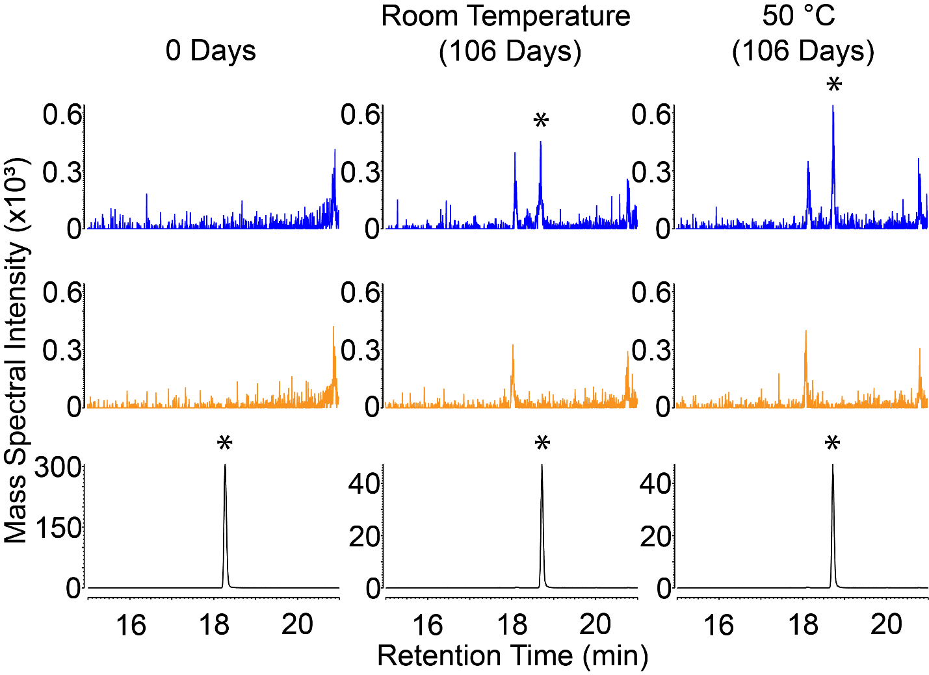
Figure S5. Ala₃ production under room temperature and mild heating conditions. Accurate mass chromatograms of an Ala₃ standard (bottom, black), reaction mixture of a solution of Ala + imidazole (middle, orange), and reaction mixture of a solution of Ala + imidazole + DAP (top, blue). Data are collected after 0 days (t_{i}) and 106 days (t_{f}) when maximum Ala₃ signal intensities were reached for both room temperature and mild heating (50 °C) experimental reaction solutions. Accurate mass chromatograms were extracted from m/z 402.1777. Asterisks denote peaks that represent Ala₃. Here, min = minutes.

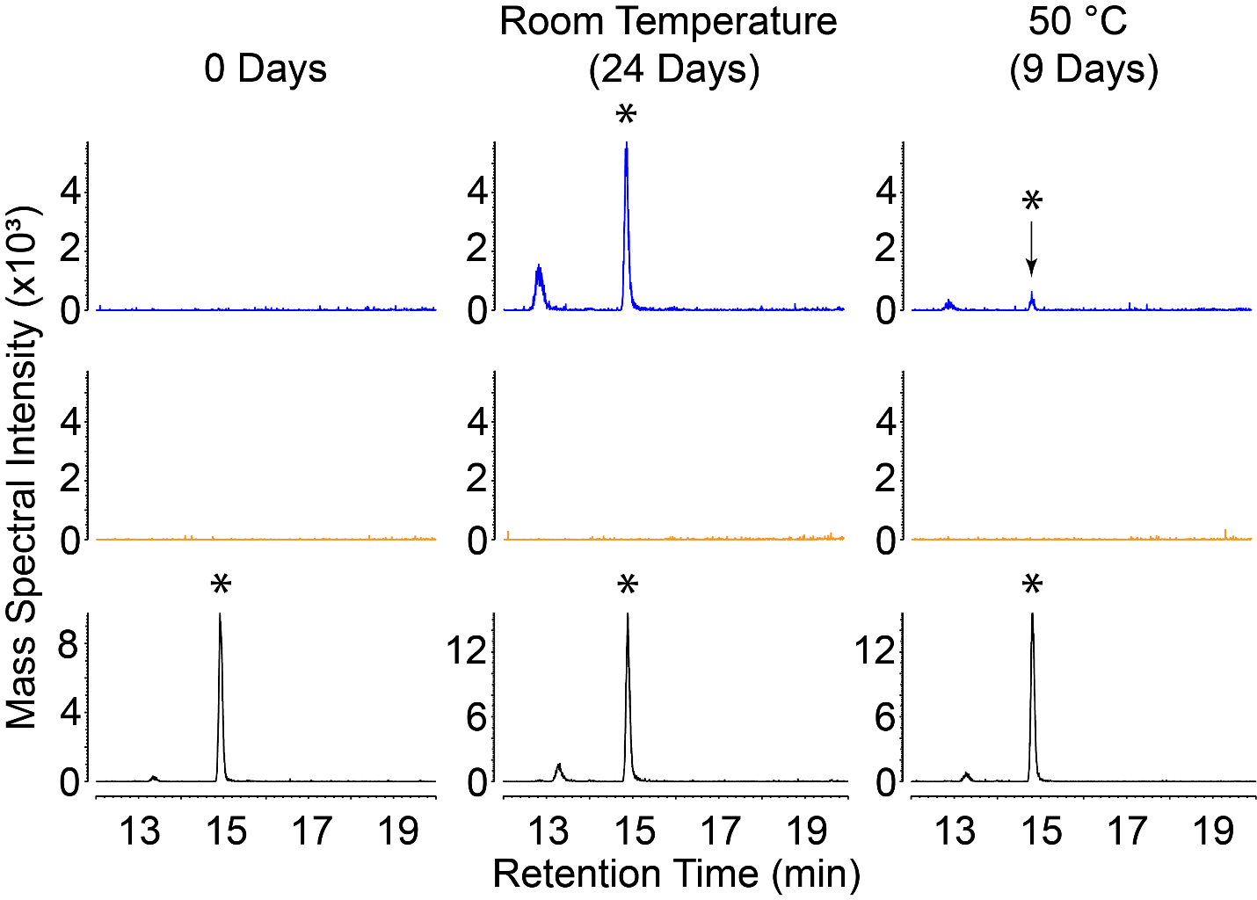
Figure S6. Asp₂ production under room temperature and mild heating conditions. Accurate mass chromatograms of an Asp₂ standard (bottom, black), reaction mixture of a solution of Asp + imidazole (middle, orange), and reaction mixture of a solution of Asp + imidazole + DAP (top, blue). Data are collected after 0 days (t_{i}), after 24 days (t₄) when maximum Asp₂ concentrations were reached for room temperature experimental reaction solutions, and after 9 days (t₃) when maximum Asp₂ concentrations were reached for mild heating (50 °C) experimental reaction solutions. Accurate mass chromatograms were extracted from m/z 419.1203. Asterisks denote peaks that represent Asp₂. Here, min = minutes.

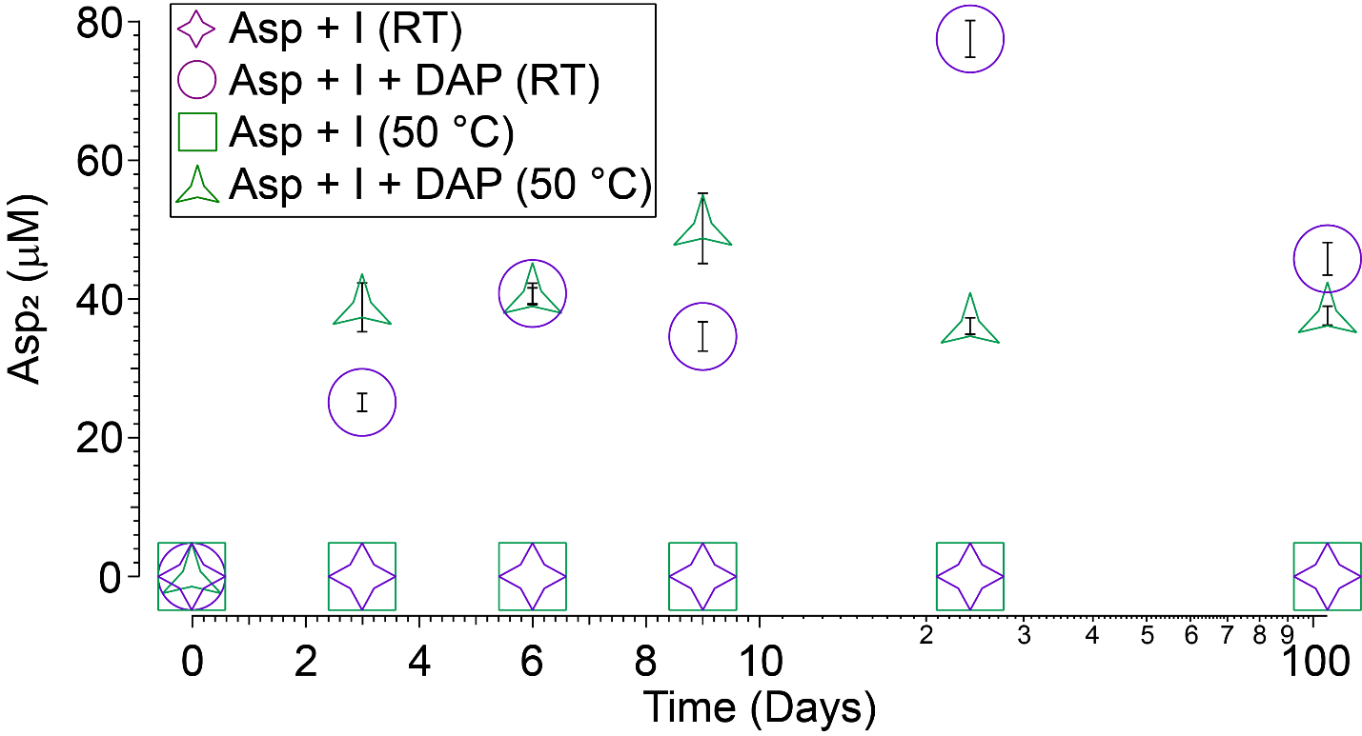
Figure S7. Temporal Asp₂ production under room temperature and mild heating conditions. Asp₂ is not synthesized in the absence of DAP, and Asp₂ synthesis is surprisingly similar between room temperature and mild heating conditions. Samples portrayed here were analyzed in triplicate. Uncertainties $(δ_{x}$) were determined as the standard error ($δ_{x}= σ_{x} · {(n)}^{{-1}/2}$), whereby the uncertainties were based on the standard deviation ($σ_{x})$of the average value of 3 separate measurements ($n=3$). In this figure, I = imidazole, and RT = room temperature.

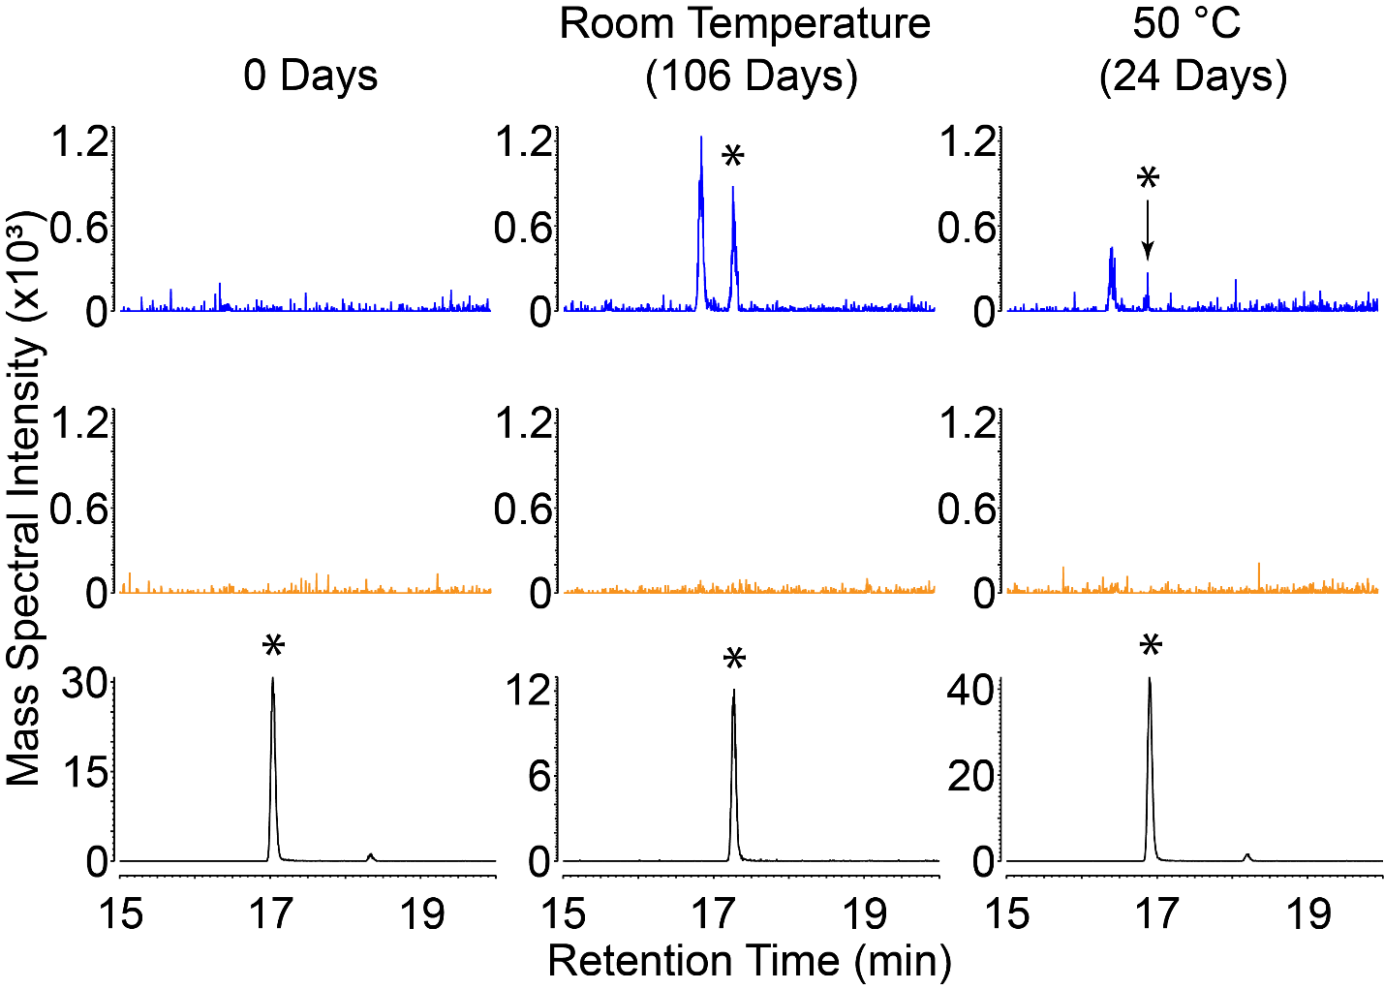
Figure S8. Glu₂ production under room temperature and mild heating conditions. Accurate mass chromatograms of a Glu₂ standard (bottom, black), reaction mixture of a solution of Glu + imidazole (middle, orange), and reaction mixture of a solution of Glu + imidazole + DAP (top, blue). Data are collected after 0 days (t_{i}), after 106 days (t_{f}) when maximum Glu₂ concentrations were reached for room temperature experimental reaction solutions, and after 24 days (t₄) when maximum Glu₂ signal intensities were reached for mild heating (50 °C) experimental reaction solutions. Accurate mass chromatograms were extracted from m/z 447.1516. Asterisks denote peaks that represent Glu₂. Here, min = minutes.

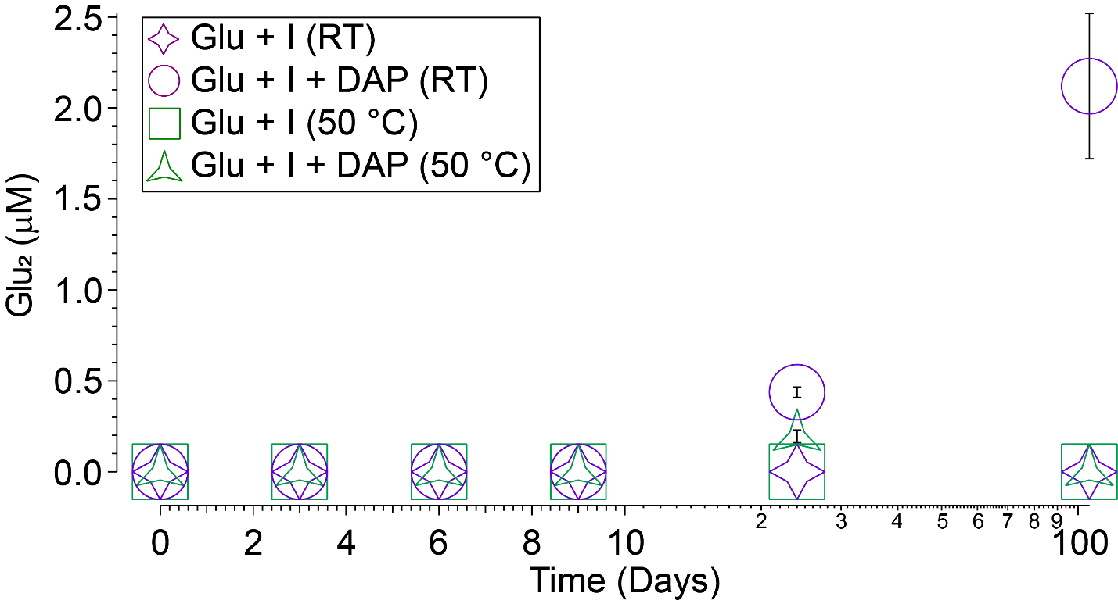
Figure S9. Temporal Glu₂ production under room temperature and mild heating conditions. Glu₂ is not synthesized in the absence of DAP. However, Glu₂ synthesis is relatively inefficient when in the presence of DAP and imidazole, possibly due to the complexity of the Glu structure compared to simpler amino acids like Gly and Ala. Measurements portrayed here were performed in triplicate, except for the t_{f} measurement for the Glu + imidazole + DAP room temperature experimental reaction solution, which was performed in duplicate, thus causing a larger uncertainty estimate for the corresponding measurement. Uncertainties $(δ_{x}$) were determined as the standard error ($δ_{x}= σ_{x} · {(n)}^{{-1}/2}$), whereby the uncertainties were based on the standard deviation ($σ_{x})$of the average value of 2 or 3 separate measurements ($n=2 or 3$). In this figure, I = imidazole, and RT = room temperature.

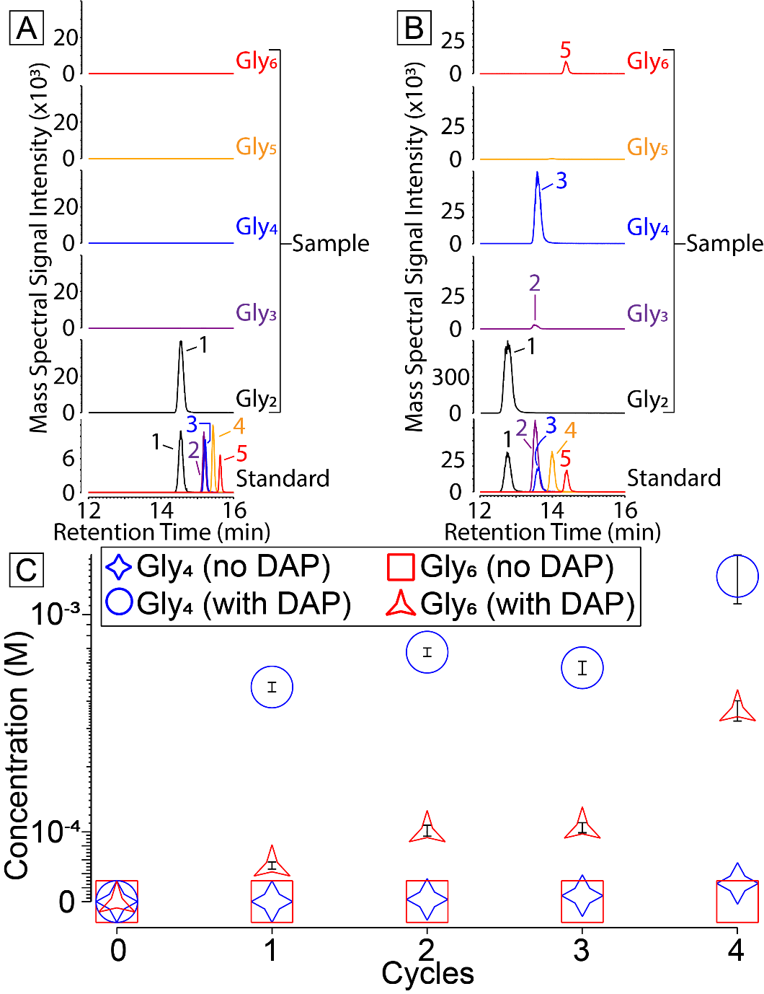
Figure S10. DAP is capable of inducing the oligomerization of peptides. A mixture of 10 mM Gly₂, 10 mM imidazole, and 10 mM DAP did not contain any oligomers of Gly₂ prior to cycling (A). However, upon cycling, it is readily observed that Gly₄ and Gly₆ were disproportionately synthesized (B). Upon completion of the cycling experiments, it can be seen that Gly₄ was consistently present at higher abundances than Gly₆ (C). Samples portrayed here were analyzed in triplicate. Uncertainties $(δ_{x}$) were determined as the standard error ($δ_{x}= σ_{x} · {(n)}^{{-1}/2}$), whereby the uncertainties were based on the standard deviation ($σ_{x})$of the average value of 3 separate measurements ($n=3$). The following m/z values were used to obtain the chromatograms shown in (A) and (B): Peak #1) Gly₂ = m/z 303.1093, Peak #2) Gly₃ = m/z 360.1308, Peak #3) Gly₄ = m/z 417.1523, Peak #4) Gly₅ = m/z 474.1737, and Peak #5) Gly₆ = m/z 531.1952. Standard chromatograms in (A) and (B) were composed by combining individual mass chromatograms of Gly-based oligomers in a mixed standard, which were run on the same days as the non-cycled sample (A) and the cycled sample (B). Here, min = minutes.
Tables

Table S1. The newly developed method provided accurate identification of target analytes. Detection metrics associated with the technique developed in this study, when exposed to a mixed standard of target amino acids and homopeptides. The data in this table was generated from the same standard run that produced the fluorescence chromatogram shown in Figure 1. Upon derivatization with AccQ·Tag, target analytes experienced a mass shift of 170 Da. Mass error was calculated as ${[({mass}_{theoretical}- {mass}_{experimental})}/{{mass}_{theoretical}}] x {10}^{6}$.

Peak Number | Analyte | LC RT (min) | MS RT (min) | [M+H]⁺ Chemical Formula | Theoretical m/z | Experimental m/z | Mass Error (ppm)
1 | Gly₂ | 12.22 | 12.29 | C₁₄H₁₅N₄O₄ | 303.1093 | 303.1077 | 5.2786
2 | Gly₃ | 13.23 | 13.25 | C₁₆H₁₈N₅O₅ | 360.1308 | 360.1296 | 3.3321
3 | Gly₄ | 13.23 | 13.34 | C₁₈H₂₁N₆O₆ | 417.1523 | 417.1512 | 2.6369
4 | Gly₅ | 13.73 | 13.84 | C₂₀H₂₄N₇O₇ | 474.1737 | 474.1730 | 1.4763
5 | Gly₆ | 14.17 | 14.26 | C₂₂H₂₇N₈O₈ | 531.1952 | 531.1937 | 2.8238
6 | Gly | 14.59 | 14.68 | C₁₂H₁₂N₃O₃ | 246.0879 | 246.0857 | 8.9399
7 | Asp₂ | 14.84 | 14.92 | C₁₈H₁₉N₄O₈ | 419.1203 | 419.1181 | 5.2491
8 | Asp₃ | 15.40 | 15.49 | C₂₂H₂₄N₅O₁₁ | 534.1472 | 534.1460 | 2.2466
9 | Asp | 15.83 | 15.93 | C₁₄H₁₄N₃O₅ | 304.0933 | 304.0927 | 1.9731
10 | Asp₄ | 16.21 | 16.30 | C₂₆H₂₉N₆O₁₄ | 649.1742 | 649.1753 | -1.6945
11 | Glu | 16.63 | 16.71 | C₁₅H₁₆N₃O₅ | 318.1090 | 318.1082 | 2.5149
12 | Glu₂ | 16.95 | 17.30 | C₂₀H₂₃N₄O₈ | 447.1516 | 447.1515 | 0.2236
13 | Glu₃ | 17.51 | 17.61 | C₂₅H₃₀N₅O₁₁ | 576.1942 | 576.1948 | -1.0413
14 | Ala₂ | 17.65 | 17.74 | C₁₆H₁₉N₄O₄ | 331.1406 | 331.1403 | 0.9060
15 | Ala | 17.95 | 18.04 | C₁₃H₁₄N₃O₃ | 260.1035 | 260.1024 | 4.2291
16 | Ala₃ | 18.25 | 18.34 | C₁₉H₂₄N₅O₅ | 402.1777 | 402.1773 | 0.9946
17 | Ala₄ | 19.17 | 19.26 | C₂₂H₂₉N₆O₆ | 473.2149 | 473.2146 | 0.5340
18 | Ala₅ | 19.51 | 19.60 | C₂₅H₃₄N₇O₇ | 544.2520 | 544.2522 | -0.3675

Table S2. Analytical figures of merit for the FD. This table reports the following analytical figures of merit for the FD: sensitivity, linear range, LOD, and LOQ.

Analyte | Regression Equation | R² | Linear Range (nM)ª | Sensitivity  (S, nM⁻¹)^{b} | LOD^{c}  (nM) | LOD  (fmol on column) | LOQ^{d}  (nM) | LOQ  (fmol on column)
Gly | y = 1.40x + 44.59 | 1.0000 | 37.65 - 45,000 | 1.40 ± 0.01 | 37.65 | 7.53 | 203.67 | 40.73
Gly₂ | y = 2.80x - 32.08 | 0.9997 | 86.50 - 45,000 | 2.80 ± 0.07 | 86.50 | 17.30 | 262.25 | 52.45
Gly₃ | y = 2.36x + 17.47 | 0.9997 | 73.82 - 45,000 | 2.36 ± 0.05 | 73.82 | 14.76 | 250.19 | 50.04
Gly₄ | y = 2.36x + 17.47 | 0.9997 | 73.82 - 45,000 | 2.36 ± 0.05 | 73.82 | 14.76 | 250.19 | 50.04
Gly₅ | y = 1.98x + 131.56 | 0.9998 | 81.62 - 45,000 | 1.98 ± 0.04 | 81.62 | 16.32 | 379.60 | 75.92
Gly₆ | y = 1.49x - 1.22 | 0.9992 | 27.93 - 45,000 | 1.49 ± 0.05 | 27.93 | 5.59 | 91.19 | 18.24
Ala | y = 1.39x - 6.94 | 1.0000 | 22.06 - 45,000 | 1.39 ± 0.01 | 22.06 | 4.41 | 79.87 | 15.97
Ala₂ | y = 2.41x + 34.44 | 0.9997 | 50.19 - 45,000 | 2.41 ± 0.06 | 50.19 | 10.04 | 194.70 | 38.94
Ala₃ | y = 2.54x + 27.50 | 0.9993 | 57.69 - 45,000 | 2.54 ± 0.03 | 57.69 | 11.54 | 184.90 | 36.98
Ala₄ | y = 1.67x - 6.13 | 1.0000 | 10.01 - 45,000 | 1.67 ± 0.004 | 10.01 | 2.00 | 24.82 | 4.96
Ala₅ | y = 3.03x + 1.45 | 1.0000 | 29.42 - 45,000 | 3.03 ± 0.01 | 29.42 | 5.88 | 99.16 | 19.83
Asp | y = 1.47x + 20.76 | 1.0000 | 42.47 - 45,000 | 1.47 ± 0.01 | 42.47 | 8.49 | 183.44 | 36.69
Asp₂ | y = 2.17x - 11.23 | 0.9999 | 32.67 - 45,000 | 2.17 ± 0.02 | 32.67 | 6.53 | 96.81 | 19.36
Asp₃ | y = 2.56x + 12.12 | 1.0000 | 83.69 - 45,000 | 2.56 ± 0.02 | 83.69 | 16.74 | 292.84 | 58.57
Asp₄ | y = 2.25x + 26.16 | 0.9999 | 54.71 - 45,000 | 2.25 ± 0.04 | 54.71 | 10.94 | 204.99 | 41.00
Glu | y = 1.47x + 196.47 | 0.9999 | 35.10 - 45,000 | 1.47 ± 0.02 | 35.10 | 7.02 | 429.08 | 85.82
Glu₂ | y = 2.39x + 61.64 | 0.9998 | 24.77 - 45,000 | 2.39 ± 0.03 | 24.77 | 4.95 | 142.83 | 28.57
Glu₃ | y = 2.10x + 11.69 | 1.0000 | 18.89 - 45,000 | 2.10 ± 0.02 | 18.89 | 3.78 | 64.20 | 12.84
ªWhen determining the linear range, analyte concentrations above 45,000 nM (45.0 μM) were not tested.
^{b}The sensitivity of the detector to a given analyte is determined by the slope of the weighted linear regression (averaged peak area vs analyte concentration).
^{c}The LOD is defined as 3 times the weighted, random error in the y-direction ( $s_{\left(y/x\right)w}$). See equation (S8) for details on how to obtain the weighted, random error in the y-direction.
^{d}The LOQ is defined as 10 times the weighted, random error in the y-direction ( $s_{\left(y/x\right)w}$). See equation (S8) for details.

Table S3. Analytical figures of merit for the ToF-MS. This table reports the following analytical figures of merit for the ToF-MS: sensitivity, linear range, LOD, and LOQ.

Analyte | Regression Equation | R² | Linear Range (nM)ª | Sensitivity  (S, nM⁻¹)^{b} | LOD^{c}  (nM) | LOD  (fmol on column) | LOQ^{d}  (nM) | LOQ  (fmol on column)
Gly | y = 0.65x + 25.09 | 0.9898 | 53.83 - 45,000 | 0.65 ± 0.09 | 53.83 | 10.77 | 280.15 | 56.03
Gly₂ | y = 0.80x – 2.72 | 0.9981 | 15.39 - 45,000 | 0.80 ± 0.06 | 15.39 | 3.08 | 51.51 | 10.30
Gly₃ | y = 0.63x – 4.39 | 0.9851 | 17.03 - 45,000 | 0.63 ± 0.09 | 17.03 | 3.41 | 40.46 | 8.09
Gly₄ | y = 0.56x + 0.20 | 0.9892 | 25.17 - 45,000 | 0.56 ± 0.07 | 25.17 | 5.03 | 82.15 | 16.43
Gly₅ | y = 0.51x – 0.02 | 0.9954 | 9.91 - 45,000 | 0.51 ± 0.03 | 9.91 | 1.98 | 32.91 | 6.58
Gly₆ | y = 0.29x – 0.64 | 0.9975 | 17.20 - 45,000 | 0.29 ± 0.02 | 17.20 | 3.44 | 52.21 | 10.44
Ala | y = 0.79x – 1.11 | 0.9950 | 48.99 - 45,000 | 0.79 ± 0.06 | 48.99 | 9.80 | 161.95 | 32.39
Ala₂ | y = 1.23x – 2.34 | 0.9932 | 7.12 - 45,000 | 1.23 ± 0.10 | 7.12 | 1.42 | 19.08 | 3.82
Ala₃ | y = 1.45x – 0.33 | 0.9923 | 1.75 - 45,000 | 1.45 ± 0.11 | 1.75 | 0.35 | 5.30 | 1.06
Ala₄ | y = 0.94x – 1.03 | 0.9931 | 4.56 - 45,000 | 0.94 ± 0.07 | 4.56 | 0.91 | 13.05 | 2.61
Ala₅ | y = 2.52x – 0.84 | 0.9910 | 3.14 - 45,000 | 2.52 ± 0.21 | 3.14 | 0.63 | 9.74 | 1.95
Asp | y = 0.26x + 3.36 | 0.9954 | 31.79 - 45,000 | 0.26 ± 0.02 | 31.79 | 6.36 | 140.12 | 28.02
Asp₂ | y = 0.14x + 0.24 | 0.9992 | 16.83 - 45,000 | 0.14 ± 0.004 | 16.83 | 3.37 | 60.29 | 12.06
Asp₃ | y = 0.12x – 2.20 | 0.9991 | 39.66 - 45,000 | 0.12 ± 0.004 | 39.66 | 7.93 | 88.31 | 17.66
Asp₄ | y = 0.08x – 1.66 | 0.9972 | 37.92 - 45,000 | 0.08 ± 0.01 | 37.92 | 7.58 | 77.94 | 15.59
Glu | y = 0.47x + 1.51 | 0.9940 | 10.65 - 45,000 | 0.47 ± 0.04 | 10.65 | 2.13 | 48.59 | 9.72
Glu₂ | y = 0.23x + 0.33 | 0.9968 | 18.44 - 45,000 | 0.23 ± 0.01 | 18.44 | 3.69 | 64.85 | 12.97
Glu₃ | y = 0.13x – 1.22 | 0.9983 | 22.99 - 45,000 | 0.13 ± 0.01 | 22.99 | 4.60 | 54.08 | 10.82
ªWhen determining the linear range, analyte concentrations above 45,000 nM (45.0 μM) were not tested.
^{b}The sensitivity of the detector to a given analyte is determined by the slope of the weighted linear regression (averaged peak area vs analyte concentration).
^{c}The LOD is defined as 3 times the weighted, random error in the y-direction $s_{\left(y/x\right)w}$. See equation (S8) for details.
^{d}The LOQ is defined as 10 times the weighted, random error in the y-direction $s_{\left(y/x\right)w}$. See equation (S8) for details.

