Supplementary Figures and Tables

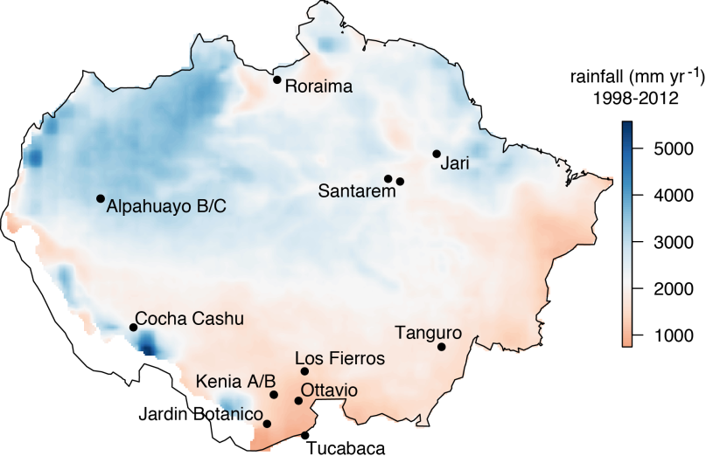

**Figure S1.** Mean annual rainfall and site locations and names across the Amazon.

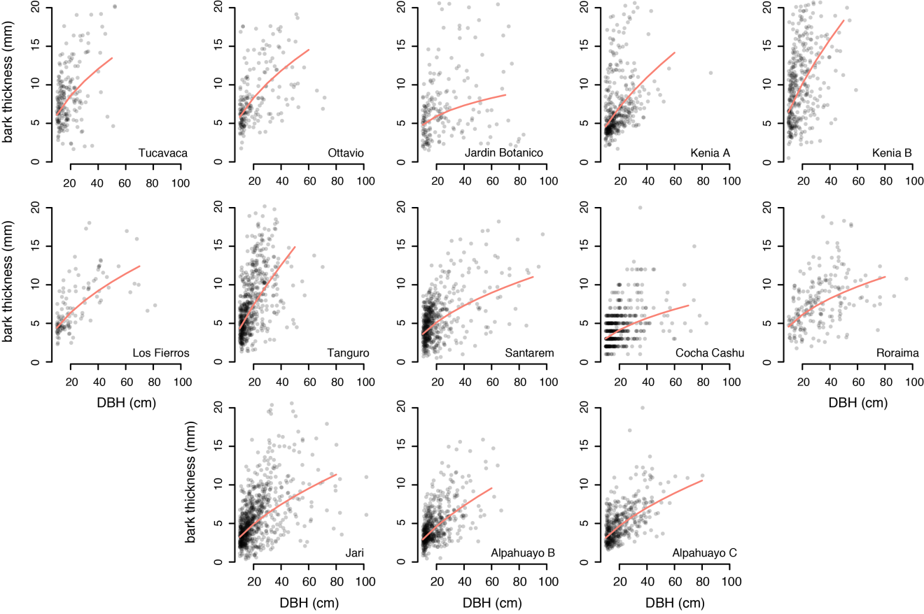

**Figure S2.** Bark allometries by site. Lines represent the best-fit relationship between diameter (DBH; cm) and bark thickness (mm) with a form given by $bark={DBH}^{α}$. Here, fits are shown to all trees at a site, but for formal analysis, allometric constants were calculated by species, and averaged weighted by species abundance at a site. Note that all plots have been truncated at 20 mm bark thickness and 100 cm DBH, focusing on the majority of data (89.4%) and avoiding sparse regions of morphological space.

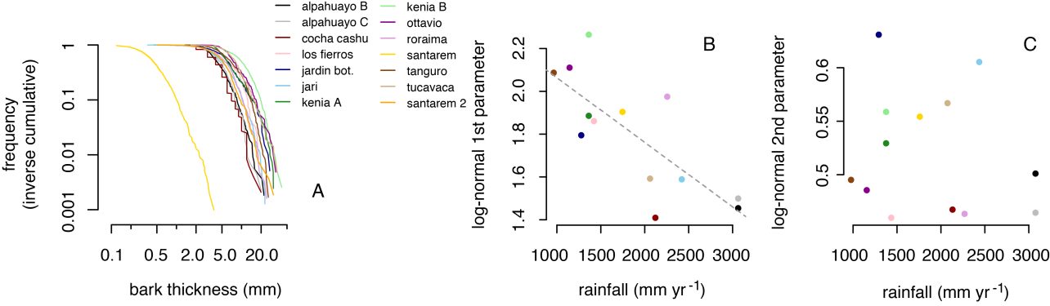

**Figure S3.** Inverse cumulative bark thickness distribution at each site (A), and response of the best-fit log-normal parameters at each site to rainfall (B-C). The first parameter of the log-normal distribution varied predictably with rainfall across sites (*R2* = 0.592, *df* = 11, *p* = 0.0021).

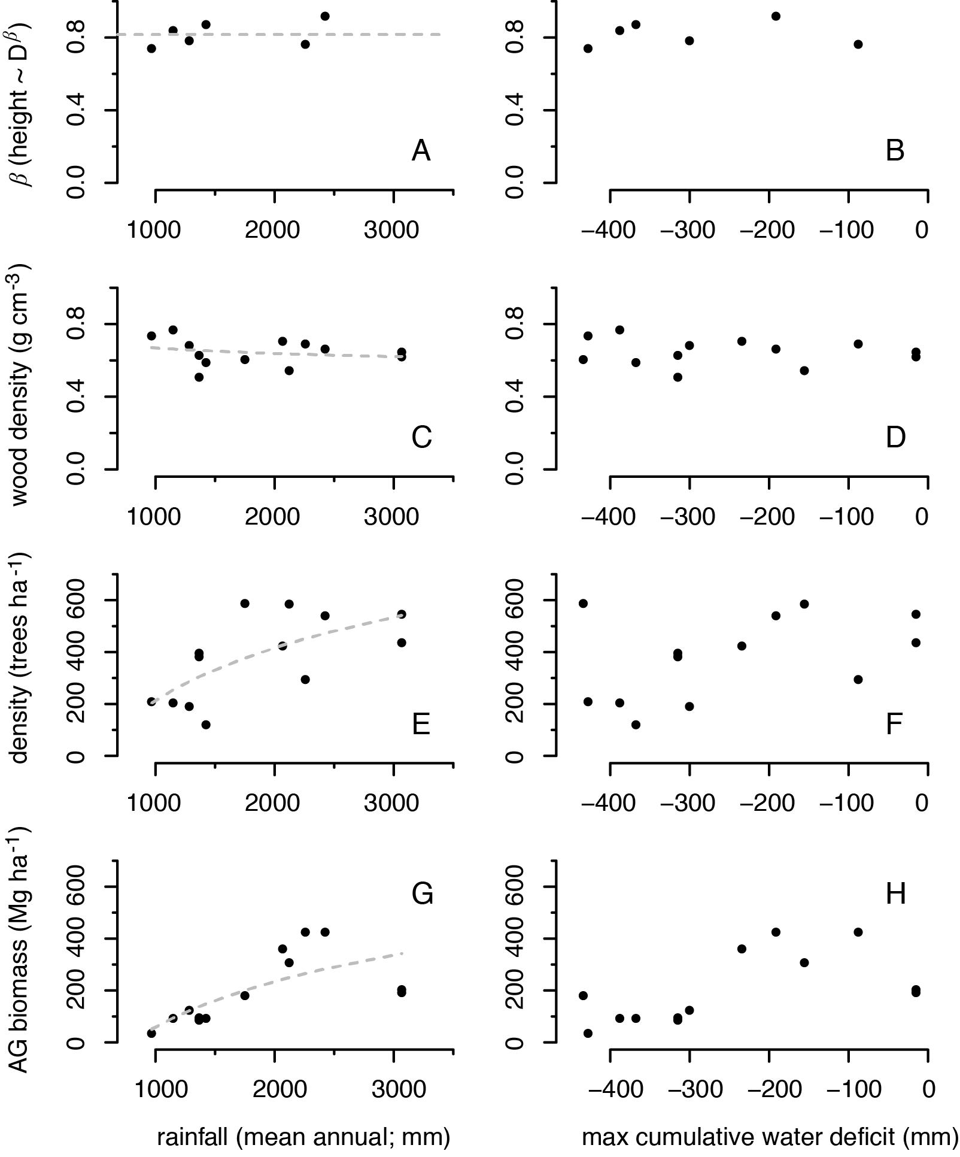

**Figure S4.** Response of height allometry (A-B), wood density (C-D), tree density (E-F), and above-ground biomass (G-H) at each site to rainfall and MCWD.

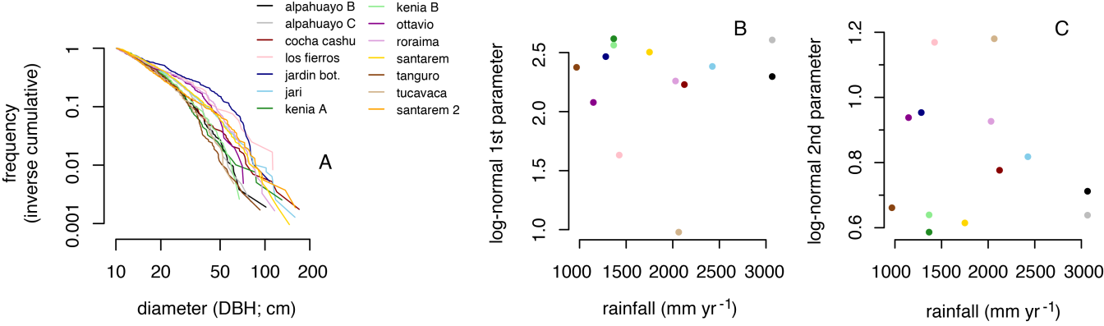

**Figure S5.** Inverse cumulative diameter distribution at each site (A), and response of the best-fit log-normal parameters at each site to rainfall (B-C).

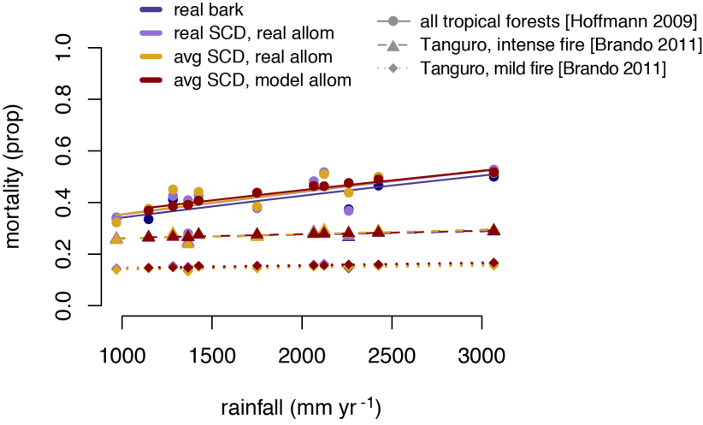

**Figure S6.** Fire-driven tree mortality response to rainfall, modeled using real bark measurements (blue),bark modeled on real diameter measurements and real bark allometric constants by site (purple), bark modeled on a stylized diameter distribution (see Figure S4) and real bark allometric constants by site (yellow), and bark modeled on a stylized diameter distribution and modelled bark allometric constants (see Figure 1) (red). Mortality was estimated using published relationships between bark and mortality from Tanguro (Brando *et al.* 2011) (triangle and diamonds for intense and mild fires, respectively) and from all tropical forests (Hoffmann *et al.* 2009) (circles).

**Table S1.** Sites and plot details.

|  |  |  |
| --- | --- | --- |
| Site | Plot dimensions | Total area sampled |
| Tucabaca | 100 m × 100 m | 1 ha |
| Ottavio | 100 m × 100 m | 1 ha |
| Jardin Botanico | 100 m × 100 m | 1 ha |
| Kenia A | 100 m × 100 m | 1 ha |
| Kenia B | 100 m × 100 m | 1 ha |
| Los Fierros | 500 m × 20 m | 1 ha |
| Tanguro | 50 m × 50 m × 4 | 1 ha |
| Santarem† | 50 m × 50 m × 5 | 1.25 ha |
| Cocha Cashu | 100 m × 100 m | 1 ha |
| Roraima | 50 m × 50 m × 3 | 0.75 ha |
| Jari | 10 m × 250 m × 6 | 1.5 ha |
| Alpahuayo B | 100 m × 100 m | 1 ha |
| Alpahuayo C | 100 m × 100 m | 1 ha |

† At Santarem, species were identified only to morphospecies, so site-specific biomass was calculated for another nearby site, where taxonomic information was available, for use in analyses.

**Table S2.** Akaike information criterion model selection for bark allometry (*α*: bark = DBH*α*), height (*β*: height = DBH*β*), and wood density (*ρ*) functional traits, and plot-level stem density (ha-1) and above ground biomass (Mg ha-1). The simplest model with ΔAIC < 2 was selected as the best, indicated in bold.

|  |  |  |  |  |  |
| --- | --- | --- | --- | --- | --- |
| predictors | ΔAIC | | | | |
| bark (*α*) | height (*β*) | wood (*ρ*) | stem density (ha-1) | AG biomass  (Mg ha-1) |
| ~ log (mar) * mcwd | 9.31 | > 10 | 11.05 | 6.21 | 4.78 |
| ~ log (mar) + mcwd | 3.92 | > 10 | 6.85 | 1.18 | 6.04 |
| ~ mar * mcwd | 9.11 | > 10 | 11.84 | 5.60 | 0 |
| ~ mar + mcwd | 4.39 | > 10 | 7.44 | 2.73 | 8.40 |
| ~ log (mar) | **\*0\*** | 8.65 | 2.83 | **\*0\*** | **\*1.81\*** |
| ~ mar | 0.37 | 8.81 | 3.13 | 1.22 | 4.15 |
| ~ mcwd | 1.83 | 9.96 | 3.26 | 5.14 | 4.92 |
| ~ 1 | 8.96 | **\*0\*** | **\*0\*** | 4.35 | 6.96 |

**Table S3.** Fire-driven carbon losses from Amazonian forests, calculated assuming constant bark thickness vs. variable bark. For constant bark calculations, we assume bark equivalent to our four driest sites, near the southern edge of the Amazon, where fires may have been historically frequent. This reveals the effects of extrapolating from comparatively fire-tolerant forests to the entire Amazon basin. Errors represent standard deviations.

|  |  |  |  |  |
| --- | --- | --- | --- | --- |
| fire extent estimate | mortality model | Total fire-driven biomass loss (GtC), constant bark | Total fire-driven biomass loss (GtC), variable bark | Percent change (%) |
| MODIS  Active Fires | All forests† | 0.16 ± 0.09 | 0.26 ± 0.14 | 57.6 ± 3.9 |
| Mild Tanguro‡ | 0 ± 0 | 0.11 ± 0.06 | ∞ |
| Intense Tanguro‡ | 0.097 ± 0.053 | 0.20 ± 0.11 | 1927.3 ± 14.3 |
| MODIS-derived ‘Morton’ | All forests† | 0.015 ± 0.017 | 0.024 ± 0.026 | 57.2 ± 0.047 |
| Mild Tanguro‡ | 0 ± 0 | 0.019 ± 0.021 | ∞ |
| Intense Tanguro‡ | 0.0010 ± 0.0011 | 0.010 ± 0.012 | 18.2 ± 0.16 |

ºMorton *et al.* 2013

† (Hoffmann *et al.* 2009)

‡ (Brando *et al.* 2011)