Measuring large amplitude surface figure error using coordinate metrology

Manal Khreishi,^{a,b,*} Raymond G. Ohl,ª Ryan Mcclelland,ª Ron Shiri,ª Tilak Hewagama,^{a,c} Shahid Aslam,ª Melville P. Ulmer,^{d} Edgar Canavan,ª Rongguang Liang^{b}
a NASA Goddard Space Flight Center, 8800 Greenbelt Road, Greenbelt, MD 20771, USA
b The University of Arizona, College of Optical Sciences, 1630 E University Blvd, Tucson, AZ 85721, USA
c University of Maryland at College Park, 7999 Regents Dr, College Park, MD 20742
d Northwestern University, 2145 Sheridan Road, Evanston, IL, 60208, USA
Abstract. Advances in optical testing are as important as advances in optical fabrication, because one can make only what one can measure, particularly for unconventional prescriptions, like aspheric and freeform optics. A new, high-precision metrology capability is utilized to close the gap between interferometric testing and lower precision, contact-probe-based coordinate measuring machines or laser tracker/radar metrology to accurately measure surfaces with large figure error. This nearly universal optical testing method employs an ultra-precision coordinate measuring machine equipped with a non-contact probe. It was developed to characterize a broad spectrum of optical surfaces including ones with high slopes, impossible to measure using traditional interferometric testing. Optical components, covering a wide range of prescriptions, such as large convex conics, high-sloped aspherics, grazing-incidence x-ray optics, and highly deformed flats, were successfully measured. The resulting data were reduced using custom-developed routines to determine the optic’s alignment, surface departure from design, and the as-built optical prescription. This information guided the fabrication and modeling of these optical components.
Keywords: optical metrology; optical shop testing; universal optical testing; large convex; grazing incidence; x-ray optics; adaptive optics; surface deformation; coordinate measuring machine; coordinate optical metrology; confocal probe.

* Address all correspondence to Manal Khreishi, E-mail: manal.a.khreishi@nasa.gov

Introduction
Researchers are always seeking new techniques to characterize optical surfaces to improve the quality and reduce the cost of fabrication, testing, and alignment. This paper focuses on a testing method which employs a precision coordinate measuring machine (CMM) equipped with a non-contact probe. The fundamental advantage of this nearly universal optical testing (UOT) method is the large dynamic range it offers. The UOT was shown to be capable of characterizing a wide range of optical surfaces including large convex conics, high-sloped aspherics, unusual freeform surfaces, and grazing-incidence X-ray mirrors.¹ The ability to measure large surface figure error stems from the simple fact that according to the UOT, the most arbitrarily deformed optical surface is just another 3D surface.
A key application of the UOT is guiding the fabrication of challenging optical elements and other components, mechanical or electronic, of optical quality. For such application, the surface departure can be potentially large during the intermediate stages of fabrication, which rules out, or at least limits, the use of other high-precision testing techniques, such as classical interferometry. This paper demonstrates how the CMM equipped with a non-contact probe can play a crucial role in optical fabrication by closing the gap between interferometry and other lower precision metrologies, and without requiring any ancillary optics. Another application that calls for the ability to measure large SFE is testing adaptive optics and evaluating actuators with large dynamic range, or designed with freeform or other challenging prescriptions.
Section 2 of this paper describes the fundamentals of the UOT method, highlighting the required hardware and software, and overviews the data collection and data reduction techniques.
Section 3 gives multiple examples on utilizing the UOT method to guide the fabrication of optical-like surfaces and various normal and grazing incidence optical components. It describes employing coordinate optical metrology to inspect high quality flat, electrically conducting components that are NASA mission critical. It also details the characterization of a large convex mandrel and three off-axis-parabolic (OAP) Carbon-Nano-Tube (CNT) mirrors, molded using the parent mandrel. In addition, Section 3 addresses the metrology of four grazing-incidence X-ray optics: a conical form silicon block, the grinding tool, and two finished mirror segments.
Section 4 presents two examples of testing optics with large surface deformation. The first is the characterization of silicon wafers before any treatment applied, and the second is measuring the electromagnetically induced optical surface deformation of silicon substrates coated with magnetic smart material (MSM).

Data collection and data reduction techniques
The CMM used for this work is the Leitz PMM-C 700, with a fixed bridge and a moving table, Fig. 1. This CMM is an ultra-high precision instrument with sub-micron accuracy. It was originally procured to guide the intermediate stages of fabrication of the James Webb Space Telescope (JWST) primary mirror segments (PMS), using tactile probes. This large machine is 2.4x1.6x0.7 m in dimension, with a maximum load capacity of 2000 Kg. The contact probing force is small, 0.1 to 1.2 N. Additional information is available in the PMM-C datasheet.² In this work, tactile probes are used to measure parts’ mechanical datum such as pins, holes, slots, and planes. This is inevitable when those features cannot be measured using the non-contact probe, driven by physical access constraints.
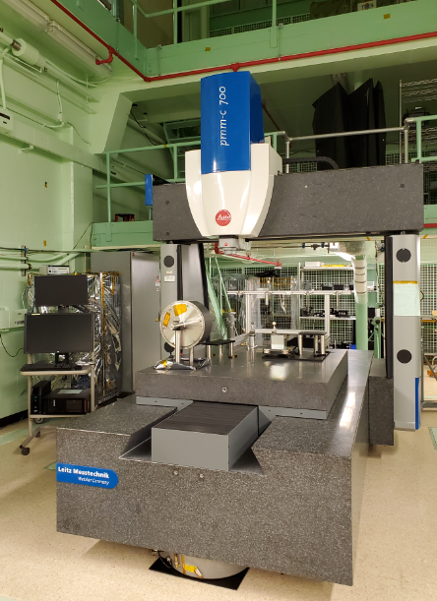
Fig. 1 PMM-C 700 CMM used for this work.
The non-contact, Precitec LR, optimized for high lateral resolution, is used to reduce the risk of optical surface damage. The probe used for this work is in the vertical direction, but other configurations, like horizontal layout with azimuth rotation degree of freedom, are available if needed. The 158 mm long probe, 30 mm in diameter, has a measurement range of 100 μm, with a resolution of 3 nm in the vertical, Z-axis. The measuring distance of 6.5 mm makes it possible to get in close proximity to the measurand at a reasonably lower risk, compared to other probes with shorter working distance. The measuring angle is up to ± 40° from the vertical. It is a good practice, however, to keep the surface slope below 30° relative to the probe for higher measurement fidelity. Additional information is available in the Precitec LR datasheet.³
The Precitec LR measures the surface position by employing chromatic confocal principle, Fig. 2. Light travels from a source to the optical probe via an optical fiber and is used to illuminate the surface at a focused spot that varies for different wavelengths. The spot distance is calibrated with respect to the focal depth of the spectrum. The probe has a high dynamic range allowing the measurement of a wide range of materials and surface properties.³ During this work, Many materials were measured including aluminum, stainless steel, copper, silicon nitride, silicon, kapton, ceramic, gold, glass, sapphire, fused silica, carbon-nano-tube, chromium, and plastic. One of the measured fused silica plates was coated with an anti-reflective coating. Surface finishes have ranged from matte and highly absorptive, including CNT, to highly specular.
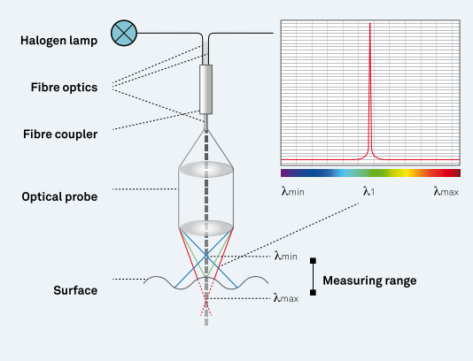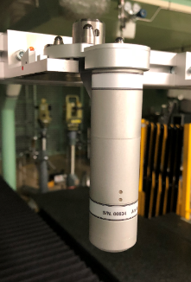
Fig. 2 Sketch illustrating the measurement principle of the Precitec LR sensor (courtesy Hexagon Metrology) ^{3,} left, and the Precitec probe used for this work in the probe holder bin.

Data collection
It is common to use multiple probes to measure various features of a part. Multiple tactile probes, and the non-contact probe, are available for use in the probe garage. Touch probes can be custom-configured as needed. The probes are qualified using a NIST-certified calibration sphere. A matt calibration sphere is recommended to calibrate the Precitec probe. Initial manual measurements are often needed to define the part local coordinate system (CS), before running an automated measurement script.¹
There are three measurement approaches, point probing and closed and open loop scanning. The latter two methods are ones mostly used by UOT method. In the closed loop scanning, illustrated in Fig. 3, the probe gets feedback from the surface. The path the probe follows is unknown, except for the starting and ending points and an approximate initial scanning direction. One can define an axis as the “nominal” path to scan a curve with large, millimeters, departure from the nominal axis. Most of the scans reported in this paper employed closed loop scanning, since it does not require detailed knowledge of the surface. Unfortunately, this scan only works for a well behaving surface with no significant discontinuities. If a surface defect or discontinuity is encountered, the scan will be aborted due to losing contact with the workpiece and all scan points in queue will be lost.
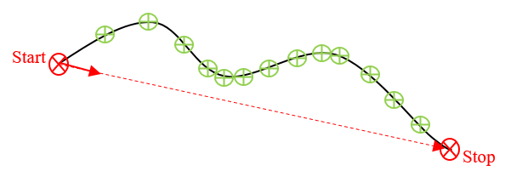
Fig. 3 Illustration of closed vs. open loop scanning: Closed loop “nominal” path defined as an axis, dashed red line between the start and stop points. The actual scanned path, shown as a black curve, can have a large departure from the “nominal” axis. The green points define the nominal path for the open loop scan.

In the open loop scan, the probe follows a well-defined nominal path. A disadvantage of this type of scan, it works as long as the actual surface is within the Precitec probe in-tolerance measuring range, < 100 µm. The parameters affecting the open loop scan can be set in the I⁺⁺ interface, the lower level server command environment. With the correct settings, one can suppress the error resulting from being out-of-tolerance, and force the scan to continue. Invalid, out-of-tolerance, data must be identified and discarded by the user, using a command that selects points based on their quality index. This approach is particularly useful for scanning fiducials or slits. Since this type of scan requires prior knowledge of the surface, it is not easy to implement for an unknown surface, or one with large surface figure error (SFE).
To distinguish mid spatial frequency (MSF) content from potential scan artifacts, it is highly recommended to scan the surface using at least two independent scans/approaches. Patterns that seem to change with scan direction/type are scan-related. The scan parameters such as the scan density, speed, and type must be optimized to obtain the largest number of samples possible over a reasonable time, with the highest scan quality possible. Scan speeds ranging from 1 to 5 mm/sec were usually used in this work, but speeds up to 15 mm/s were also used successfully in several measurements. The scan quality using the Precitec at higher speeds, however, was often found unsatisfactory.
Although data could be partially processed in Quindos, the CMM software, data was often exported from Quindos for processing using another program such as MATLAB. SpatialAnalyzer metrology software was occasionally used for improved graphics and for metrology planning purposes.

Data reduction
CMM surface scans are processed using custom codes developed in MATLAB. The data reduction includes fitting the scans to the ideal surface, determining the surface misalignment, described as 6 degrees of freedom (DoF), the actual prescription, and the residual error. Apart from the minor differences between processing the various types of surfaces, most of the codes follow a rather general course illustrated in Fig. 4. A single, raw data set is processed several times using different initial solutions and different subsampling, advancing the starting point of sampling in each trial, to yield unique subsets of the data and improve estimation of the uncertainty in the fit parameters.
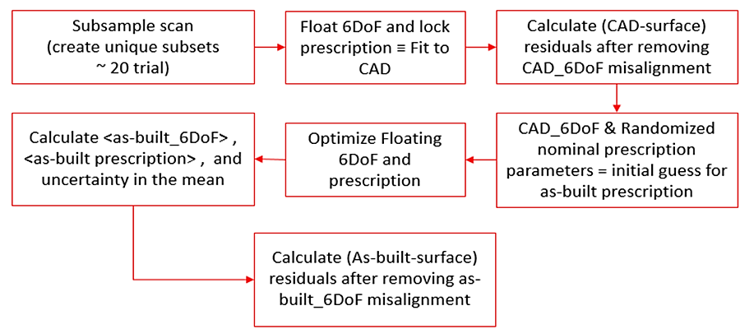
Fig. 4 Schematic of basic data reduction code.¹

Using optimization routines, the data is first fit to the nominal prescription to determine the nominal 6DoF corresponding to the transformation of the data from the working CS to the nominal optic’s vertex frame that would minimize the residual error. This initial alignment and the design prescription can then be floated to determine the true 6 DoF alignment, relative to the as-built vertex CS and the as-built prescription. The average as-built prescription and alignment, and their standard uncertainties, are estimated from all the trials.
A Graphical User Interface (GUI) was developed in MATLAB to offer a user-friendly environment to process the data. The Advanced Surface-Fitting Analysis (ASFA) tool serves as a powerful tool to fit a wide range of surface data, collected using any coordinate measuring instrument and not just the CMM, Fig. 5.
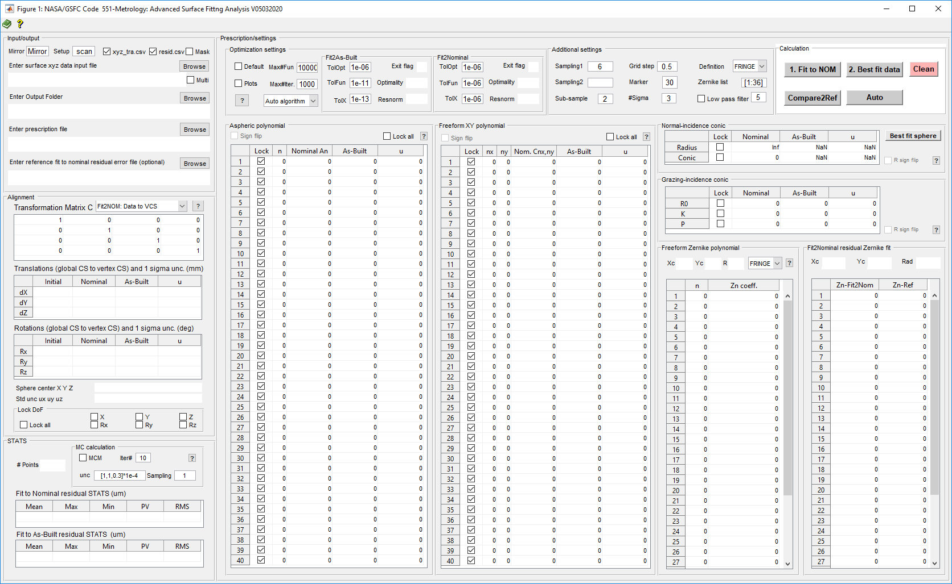
Fig. 5 Advanced Surface-Fitting Analysis (ASFA) GUI.
ASFA imports surface data in text format and reports the results in multiple formats. It generates actual and interpolated maps of surface data along with the SFE map before and after the removal of the specified Zernike terms. There is an option to process multiple sub-aperture data files, reported in approximately the same coordinate system. The residual is stitched by optimizing the alignment of each sub-aperture data set, minimizing the individual and collective residual RMS error. Processing a nearly cylindrical X-ray optic grinding tool, Section 3.3.2, is an example on this data reduction feature.
ASFA supports a wide range of prescriptions from flats and conics, normal- and grazing-incidence, to aspheric and freeform (FF) polynomials. Prescriptions are either imported or manually entered. “Fit to NOM” function, starts by checking the sign of the radius of curvature (RoC) and the polynomial coefficients and determines if a sign flip is needed. Upon fitting to nominal prescription, the unlocked DoF, relative to the design vertex CS, are calculate and residual error maps are generated, along with a map with Zernike terms removed. Additionally, the Zernike coefficients, the radius, and the X and Y center coordinates are reported. The optional “Compare2Ref” function generates a map of the difference between the Fit2NOM residuals and an imported reference residual data set.
The “Best fit data” function calculates the unlocked DoF relative to the actual vertex CS, while floating the unlocked prescription parameters. The initial guess for this DoF is based on the preceding “Fit2NOM” step. The average as-built prescription parameters along with an estimation of their uncertainties, and the corresponding statistics are calculated in addition to generating residual error maps. Other main features in ASFA GUI include advanced optimization algorithm settings, multiple data sampling options, Monte Carlo uncertainty propagation method, and a comprehensive MS Excel reporting capability.

Guiding the intermediate fabrication stages
This section presents multiple examples of utilizing the UOT method to provide feedback information that can be used to assess and guide the fabrication of a variety of optical and optical-like surfaces. Section 3.1 describes the metrology performed to inspect electrically conducting, flat components that were fabricated at NASA Goddard Space Flight Center (GSFC). Section 3.2 discusses the metrologies performed to characterize developmental CNT optics, the convex mandrel and three different OAP mirror segments, molded using the mandrel. Section 3.3 describes the metrologies of four R&D X-ray optics from different stages of fabrication, a silicon block, the grinding tool, and two finished mirror segments.

Inspection of optical-like components
The parts measured in this section are small, <8 mm in diameter, gold-plated copper bobbins. They serve as the electrical interface between the High Temperature Superconductor (HTS) lead assemblies and superconducting magnets. The purpose of the HTS lead assemblies⁵ for the Resolve instrument is quite simple: They must carry the current for the superconducting magnets that drive the Adiabatic Demagnetization Refrigerator that provides the 50 mK environment for the microcalorimeter array that is the heart of the instrument. The HTS lead assemblies run from a 28 K shell to a liquid helium tank at 1.2 K, and must carry up to 2 Amps for each of the 3 magnets. The entire heat budget for the tank is ~800 µW, so every microwatt matters.
The bobbin pairs tested are bolted together with high force. One bobbin in each pair is mounted to the HTS lead assembly, and the other is soldered to a superconducting wire from the magnet. The bobbins are the only non-superconducting, and thus dissipative, part of the circuit. The resistance of the copper itself is negligible, but the interface resistance is of order micro-Ohms. Note that a 1 µΩ resistance in each pair will produce 8 µW of dissipation in each circuit when at maximum current.⁵ In preliminary testing, it was discovered that GSFC in-house fabricated bobbins made of high purity copper, with a thick, pure gold plating gave higher resistance than commercially available bobbins of lower grade copper and lower grade gold plating. In addition, under microscope inspection, the in-house bobbins had a good surface finish, while the commercial bobbins had tool marks from a lathe.
CMM metrology of the mating surfaces, Fig. 6, revealed the reason for the superior performance of the commercial bobbins: In spite of the tool marks, the average flatness of the commercial bobbins was excellent, Fig. 7, whereas the in-house bobbins had a rounded surface, with the edges at inner and outer diameter several µm below the maximum height. Thus, contact was only being made at a small annular region between the inner and outer diameters. Two independent, open and closed loop, scans were performed on each bobbin for higher fidelity in results. Overall, the main features in both scans/ bobbin are consistent. The slight differences between the polar and spiral scans can be attributed to covering slightly different clear apertures, in addition to the possibility of one of the scans missing some surface defects/small features due to the finite nature of the scans.
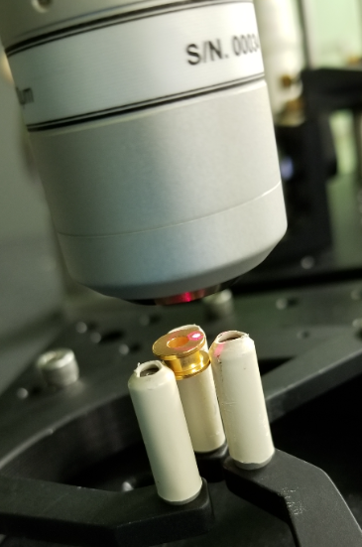
Fig. 6 Precitec LR scanning the gold-plated bobbin.
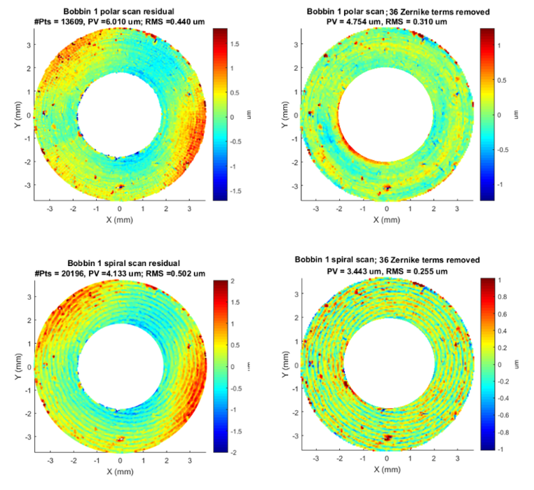
(a) (b)

(c) (d)

Fig. 7 Commercial bobbin optical metrology. Residual map of closed loop, polar scan with a meandering pattern, with nominal start and end-points on circles at inner and outer circles, before and after removing the Zernike terms (a, b). Residual map of open loop spiral scan before and after removing the Zernike terms (c, d).
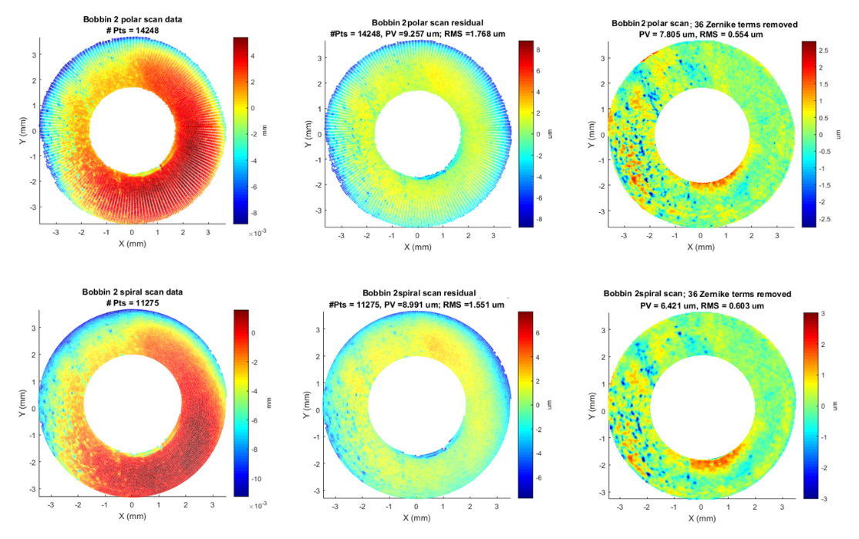
(a) (b) (c)

(d) (e) (f)
Fig. 8 In-house bobbin CMM-optical metrology. Surface scan and the corresponding residual maps of a closed loop polar scan before and after removing the Zernike terms (a, b, c). Surface scan and the corresponding residual maps of an open loop spiral scan before and after removing the Zernike terms (a, b, c).

Guiding CNT optics fabrication
The metrologies performed in this section were requested by the “Science Telescope for CubeSat Applications” IRAD at NASA-GSFC in collaboration with the University of Maryland. The objective of this research is to design a low-mass, compact telescope with fast, reflective optics and develop an interface to science instruments specifically designed for CubeSat science investigations spanning the near-UV, VIS, and NIR in support of planetary science investigations. It is a major advantage to develop a “standard” telescope/interface package that is easily adaptable to a variety of mini-instruments in a CubeSat configuration (including use of Commercial off the Shelf (COTS) spectrometers) capable of measurements over a 0.2 to 2.5 μm wavelength range. The developed package would enable compact, low mass, and low cost instrumentation, which could be reproduced for array or swarm CubeSat configurations for lunar, planetary, and Earth science and other investigations.^{6,7,8}

Mandrel Characterization
The mandrel used to mold the CNT primary mirrors, is a convex paraboloid with a nominal focal length of 100 mm and ~216 mm diameter, Fig. 9. A Hindle test, traditionally employed to characterize a large convex asphere, would have been challenging for such a fast optic, and hence only a Ronchi optical test was performed to characterize the mandrel, other than CMM metrology. The mirror was circularly scanned at 1 mm point spacing and 1 mm radial increment. Mechanical datum/fiducial needed for CS and alignment purposes were measured using contact probes. Using the ~120k point-surface scan, the as-built prescription was found to agree with the Ronchi test, Fig. 10, but at a much higher accuracy. The scan data was fit the conic sag equation (1), where c = 1/RoC is the base curvature at the vertex, r is the radius from the optical axis, and k is the conic constant.
$$z=\frac{cr^{2}}{1+\sqrt{{1-\left(1+k\right)c}^{2}r^{2}}}$$ | (1)
The calculated values of the focal length (FL) and conic constant, k, were 99.995 mm and -0.999424 respectively, Fig. 11.
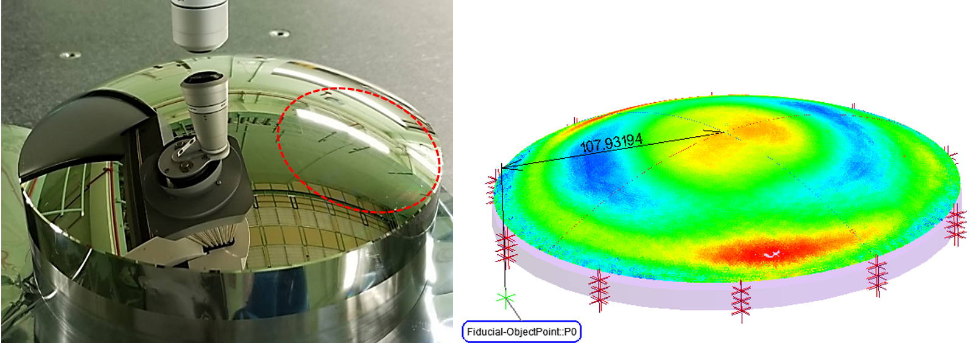
(a) (b)

Fig. 9 Mandrel used for CNT primary mirror fabrication being scanned with the Precitec LR probe. Note the diamond-turning tool marks (a), and the full metrology including the cross-shaped scan, the SFE, and the edge and the fiducial measurement using a contact probe (b).

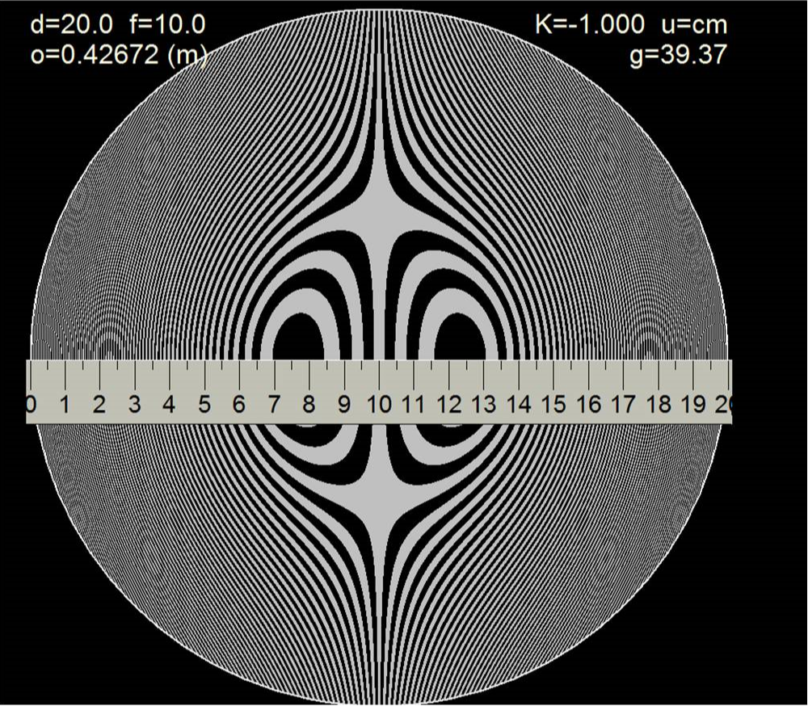
Fig. 10 Fringe pattern and results and the Ronchi test over the CA.

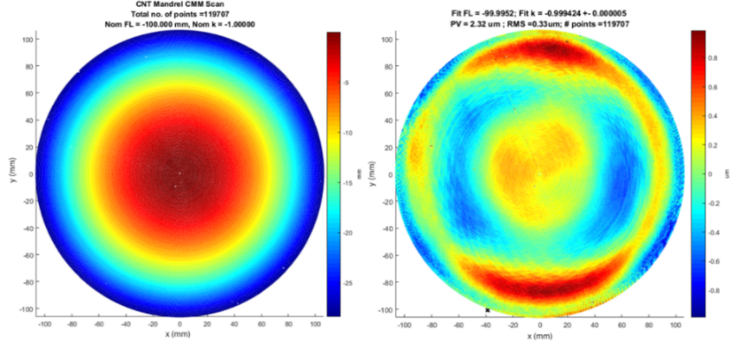
(a) (b)

Fig. 11 Mandrel surface scan (a), the resulting residual error map fitting to the as-built prescription (b), the resulting residual error map
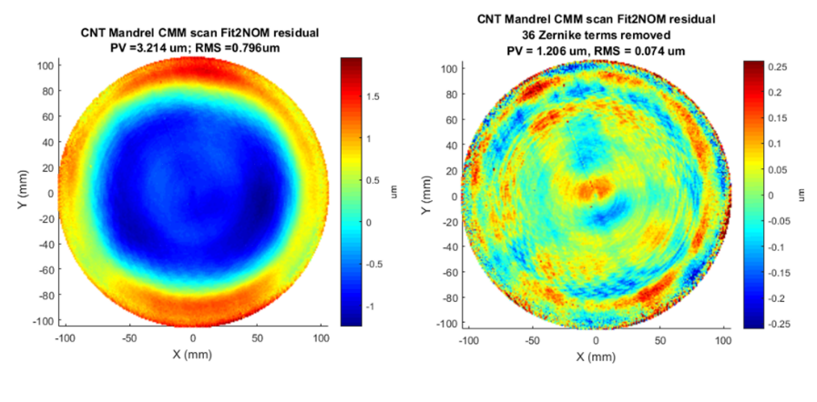
(a) (b)

Fig. 12 Mandrel residual error fitting to the nominal prescription (a) and the residual after removing 36 Zernike terms. Note the diamond turning tool rings seen in the mandrel scan, visible in in Fig. 9.
The randomized initial and fit FL, as well as the initial and fit k, as a function of fitting trial are shown in Fig. 13. Note, although the initial solutions of FL and k were randomized within relatively large ranges, the non-linear least square optimization algorithm results were incredibly stable and the resulting uncertainties were almost negligible. The as-built FL and k values are provided in Table 1.

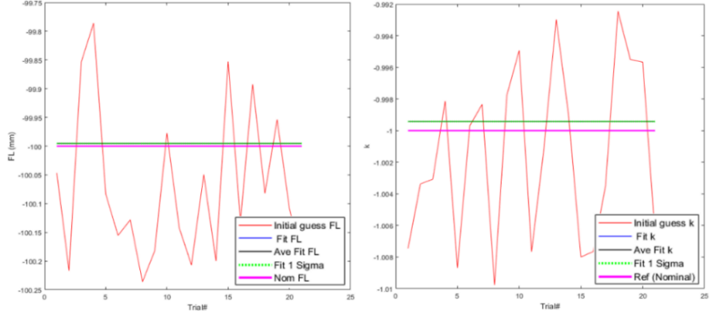
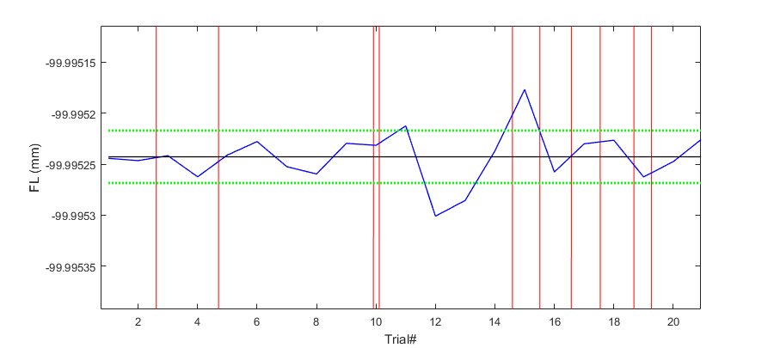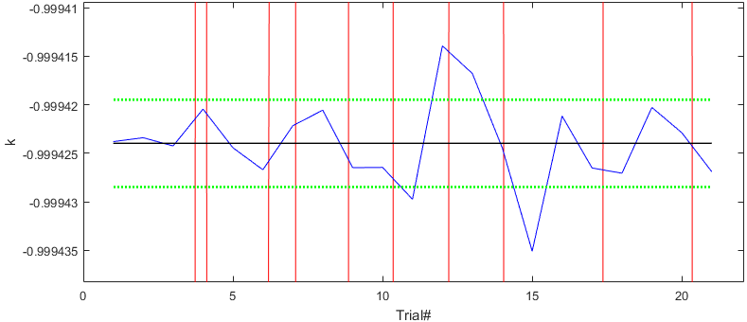
(a) (b)

Fig. 13 Randomized initial and fit FL for as a function of fitting trial (a), and the corresponding initial and fit conic constant, k (b). Both plots are shown with the corresponding zoomed-in view below the parent figure.
Table 1 CMM Mandrel as-built prescription results
 | Initial FL (mm) | Average Fit FL (mm) | Initial k | Average Fit k
Average | -100.071 | -99.99524 | -1.001 | -0.999424
Uncertainty | 0.135 | 0.00003 | 0.006 | 0.000005

The circular scan path was based on two polar scans, sampled at 1 mm point spacing and forming a cross on the mirror. A paraboloid fit to the ~ 450 point cross, Fig. 14, which took less than 2 minutes, provided the same FL value of 99.995 mm obtained from the full mirror scan, with an RMS error of 0.15 µm. This conceptually eliminates the need for the full scan to determine the FL. However, since no interferometric test was performed on the mandrel, the SFE and the prescription parameters were both required, and hence the need for the full scan.
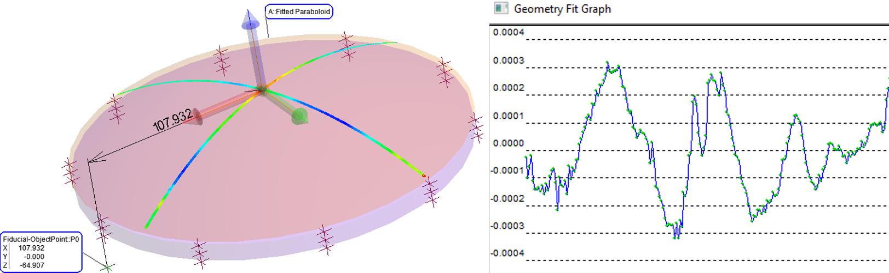
(a) (b)

Fig. 14 Polar scan residual error shown on the mandrel (a), and plotted in a geometry fit graph (b).

Coated CNT OAP testing
CNTs embedded in an epoxy matrix starting as a liquid is particularly powerful for fabricating segmented and very large mirrors.⁶ In an optical replication process, the OAP mirrors were molded by pouring the CNT polymer composite onto the mandrel using fabrication masks similar to ones shown in Fig. 15.⁷ The measured R&D OAP mirrors serve as the primary mirror in a Cassegrain type telescope, Fig. 16 (a). Three CNT mirrors were tested using the CMM non-contact metrology, one with a hole and two without.
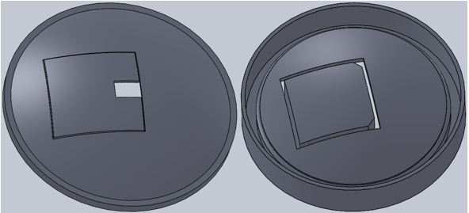
Fig. 15 Fabrication masks with and without a hole.⁸

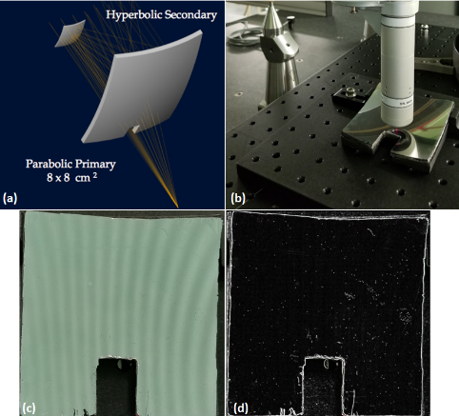
Fig. 16 A model of the CNT telescope⁸ (a), the CMM metrology of the OAP with hole (b), a closer look at the R&D mirror showing a straight fringe pattern reflection (c), and the image of the mirror processed with an edge finder to highlight the surface defects (d).
The silver-coated CNT OAP was scanned using the closed loop, unknown scan path approach, failed a few times due to the presence of surface defects, Fig. 16. The aborted scan lines correspond to the missing data in Fig. 17. On the other hand, an attempt to scan utilizing the known scan path, an open loop scanning approach, proved even more challenging due to large departure from the nominal surface. With an actual FL of 98.762 mm, instead of the nominal 100 mm, and a k value of -0.9654 instead of -1, attempts to employ an open loop scan completely failed. The scan obtained, with ~90k points, even with few missing lines, was still good enough to retrieve accurate surface parameters, including the FL, k, and the alignment 6 DoF, which provided the vertex location and the optical axis information.
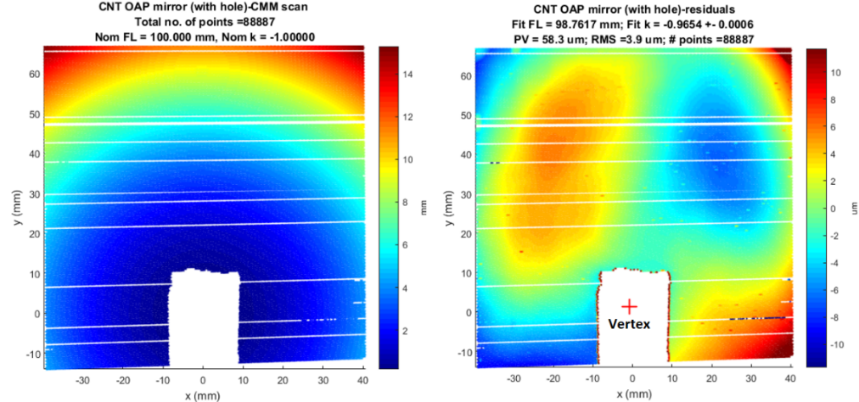
(a) (b)

Fig. 17 CMM scan of OAP with hole (left), and the resulting residual error (right).

An interesting feature the CMM metrology revealed, Fig. 17, was the mirror distortion at the corners, possibly caused by the technique of removing the mirror off the mandrel. The randomized values of the initial solution and fit FL, as well as the initial and fit conic constant, are shown in Fig. 18, and the as-built FL and k values are provided in Table 2. This is a good example were the non-contact CMM metrology can characterize an optic during the intermediate fabrication/ development stages, closing the gap between an interferometer and other metrology instruments such as LRs. This metrology provided critical feedback that guided the fabrication process of these new mirrors, particularly as attempts to test this mirror using an interferometer completely failed.
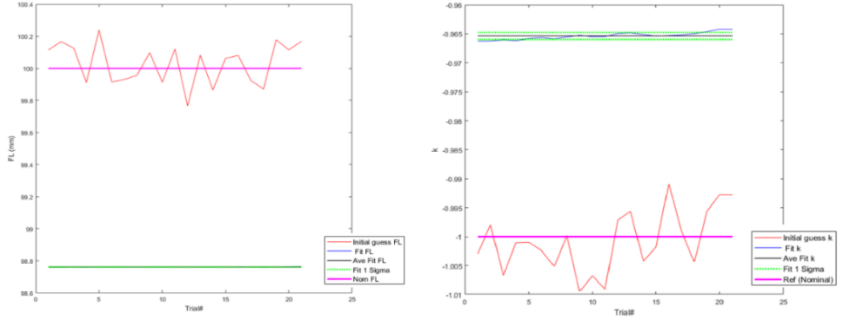
Fig. 18 Randomized initial and fit FL per trial, the scale is too large to show details in the FL fluctuations (left), and the initial and fit conic constant, k per trial (right).

Table 2 CNT OAP, with a hole, as-built prescription
 | Initial FL (mm) | Average Fit FL (mm) | Initial k | Average Fit k
Average | 100.029 | 98.762 | -1.001 | -0.9654
Uncertainty | 0.130 | 0.001 | 0.005 | 0.0006

Uncoated CNT OAP testing
As the researchers continued to improve their CNT mirror fabrication techniques, the more recent molded mirrors seemed to be getting closer to the nominal prescription. Two uncoated CNT OAPs, without holes, were tested using the CMM Precitec probe. Similar to the OAP with a hole, the mirrors were scanned via a closed loop scan. Only one line scan encountered an error big enough to abort, Fig. 19. The residual error maps for both samples show progress in comparison to the earlier mirror with a hole. The FL and k values of sample #9, 100.050 mm and 0.9991 respectively, indicate a remarkable improvement in the fabrication process. However, the lower left corners of both samples, #9 and #11, show significantly larger SFE suggesting the segment is peeled off the mandrel from those corners. Another observation made from the residual error maps, is the evident surface defects that might be originating from the mandrel, as some common features between both segments suggest. More defects might have been dropped by the outlier rejection in the fitting code.
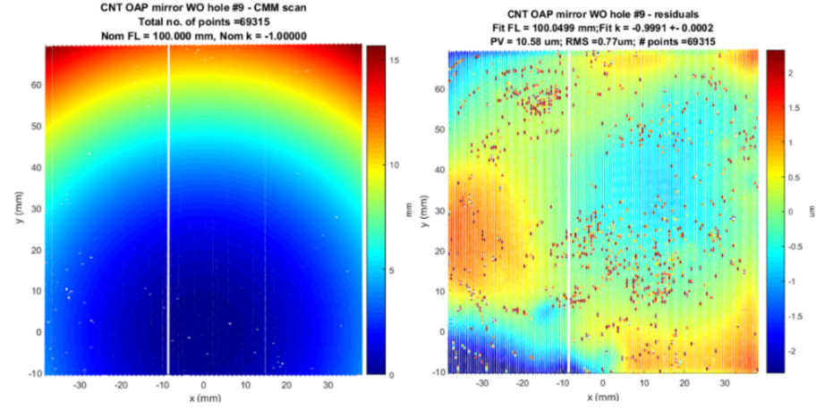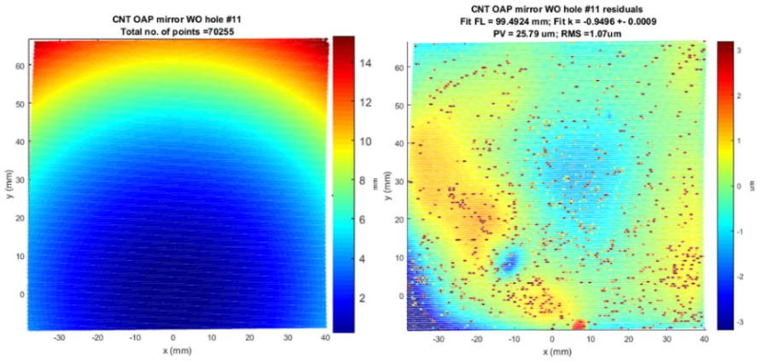
(c) (d)

(a) (b)

Fig. 19 Precitec closed loop scan, and residual error map, of CNT mirror sample #9 (a, b), and #11 (c, d).
The randomized initial and fit of the conic constant as a function of fitting trials, for both samples, are shown in Fig. 20, and the as-built FL and k values are provided in Table 3.
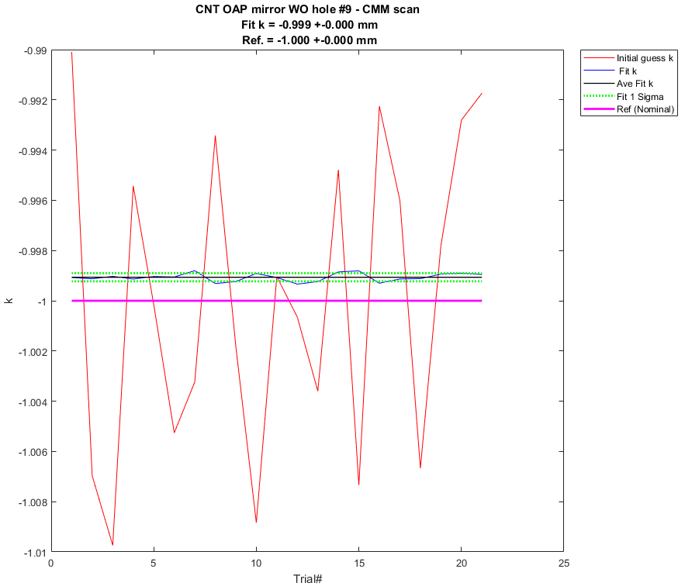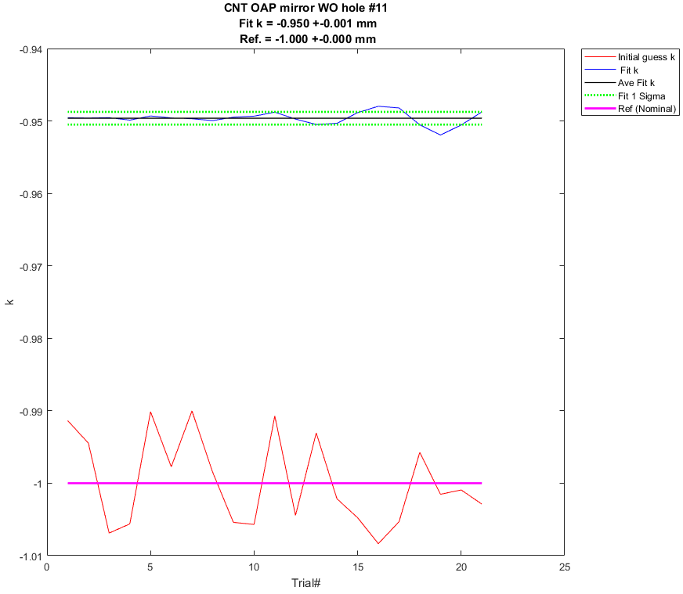
(a) (b)

Fig. 20 Randomized initial guess and the fitting results of the conic constant as a function of trial for sample #9 (a), and sample#11 (b).

Table 3 CNT OAPs, without holes, as-built prescription
 |  | Initial FL (mm) | Average Fit FL (mm) | Initial k | Average Fit k
SN#9 | Average | 100.042 | 100.0499 | -1.0010 | -0.9991
 | Uncertainty | 0.103 | 0.0003 | 0.0060 | 0.0002
SN#11 | Average | 99.463 | 99.4920 | -1.0000 | -0.9496
 | Uncertainty | 0.108 | 0.0008 | 0.0060 | 0.0009

Guiding X-ray segmented mirror fabrication
Next generation space-based x-ray telescopes are needed to advance high-energy astrophysics. These grazing-incidence-based telescopes require lightweight and high-resolution optics, due to the need for large mirror surface area, to achieve sufficient photon collecting area. The Next Generation X-Ray Optics (NGXO) group at NASA GSFC is developing high-resolution, lightweight-segmented silicon x-ray optics to support future missions. The fabrication of these grazing-incidence optics face two main challenges: fabrication of precision mirror segments that meet the required prescription, and precise integration of thousands of these mirrors. The fabrication process involves generating a 0.5 mm thick, 100 mm x 100 mm mirror segments from a block of single crystal silicon as shown in Fig. 21.
Although the mirror figure can be measured using a Null Lens and a Fizeau interferometer, the lower order terms of the prescription such as radius and cone angle cannot be measured as such and require another metrology solution. A high precision CMM equipped with an optical sensor was found to be the much-needed advanced metrology to verify and inform all aspects of the fabrication and integration process. This section describes the non-contact CMM measurement technique used to characterize key fabrication tools, as well as the intermediate and final optical products. The coordinate optical metrology presented in this paper holds great promise in measuring and aligning the mirror segments in the future.
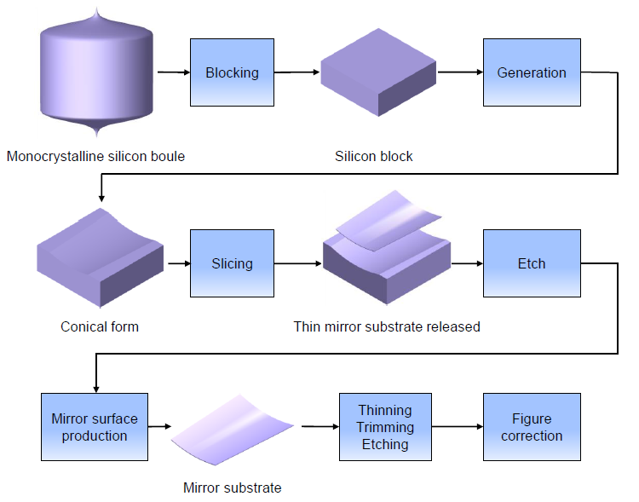
Fig. 21 Schematic of the NGXO fabrication procedure for X-ray optics.

Grinding tool
The grinding tool (GT) described in this section is a tool used in the early stages of fabrication of the R&D grazing-incidence PMS. The non-contact CMM Precitec probe, with an acceptance angle of ± 35° from vertical, can only measure about a sixth of the GT surface in a single setting. Six GT sub-aperture measurements are required to measure the full cylinder. For each measurement, the drum was rotated by ~ 60°. The six spatial metrologies are tied together by best fitting the side tooling balls (TBs), measured using a long T-shaped contact probe, Fig. 22 and Fig. 23 .
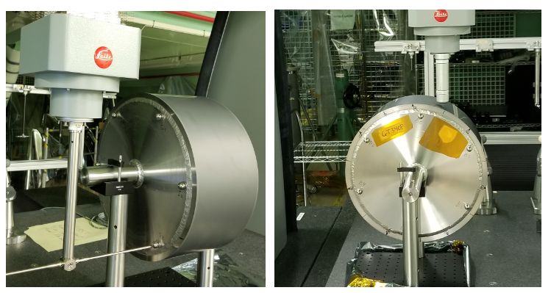
(a) (b)

Fig. 22 CMM tactile probe measuring the side metrology TBs, used to setup the local coordinate frame (a), and the Precitec non-contact probe measuring the grinding tool optical surface at ~ 30° from the vertical (b).
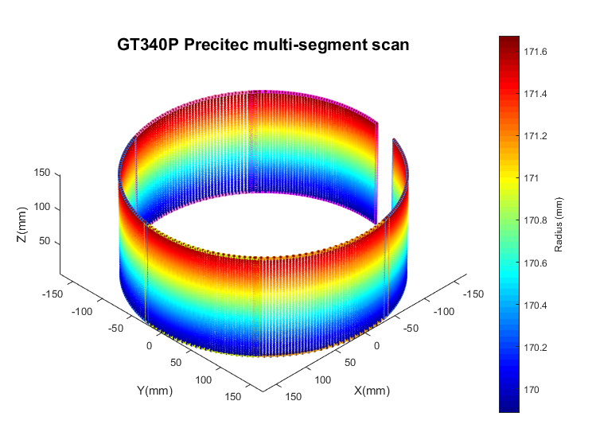
Fig. 23 Combined surface scans of the grinding tool, reported in the optic local CS, to within the tolerance of the TBs.
Prior to fine-tuning the alignment of the six sub-aperture scans, the collective cone residual RMS error was > 10 µm. Optimizing the alignment of the six scans and floating the prescription at the same time yields a dramatically reduced RMS error ~ 0.8 µm, Fig. 24. The GT conical sag is described by R-R₀ = tan (Ɵ/2)*z, where R is the radius from the optical axis z, R₀ is the radius at z = 0, and Ɵ is the cone angle. The multi-scan optimization resulted in as-built values of R₀ = 169.806 mm and Ɵ = 1.3854°. Cone fitting details, of individual and combined scans, are provided in Table 4. Profiling the residual map along the axial direction agreed, overall, with the corresponding laser scan result, Fig. 25. The differences between the two measurements might be attributed to profiling different parts of the surface.
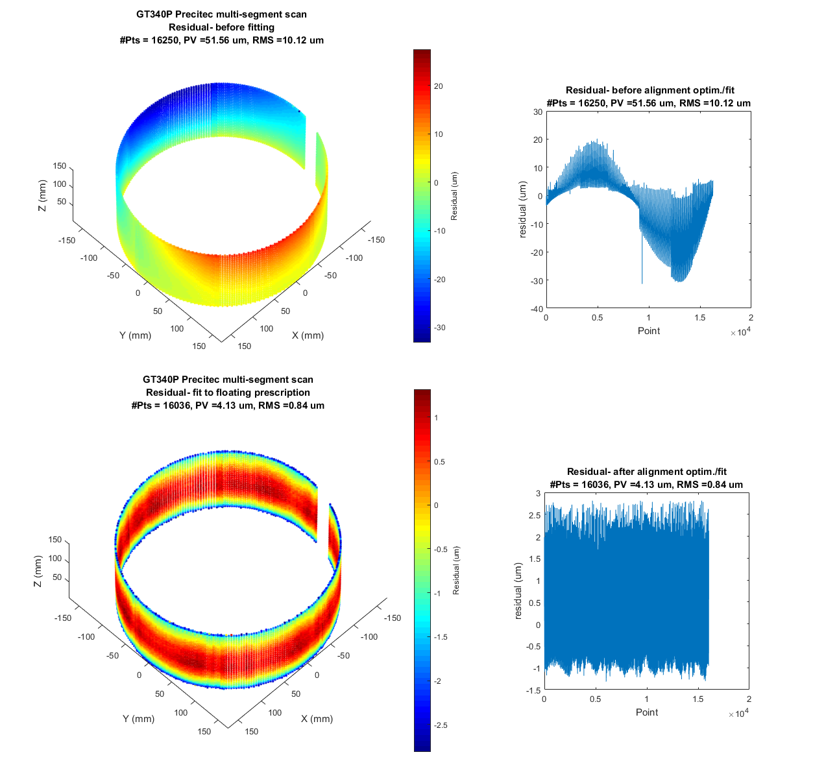
(c) (d)

(a) (b)

Fig. 24 Departure from the nominal cone, of all the scans, prior to micro-alignment of the scans and floating the cone parameters (a, b). Cone departure is dramatically reduced in the optimized sub-aperture stitching by floating the alignment of the six segments, and the as-built cone prescription of the combined scans (c, d).
Table 4 Individual and combined scan fitting results, cone parameters and fitting statistics.
Scan# | R₀ | Ɵ | Mean | Max | Min | RMS | PV
 | (mm) | (Deg) | (µm) | (µm) | (µm) | (µm) | (µm)
1 | 169.8128 | 1.38771 | 0.000 | 1.208 | -2.713 | 3.921 | 0.842
2 | 169.8010 | 1.38437 | 0.000 | 1.182 | -2.637 | 3.819 | 0.822
3 | 169.7945 | 1.38494 | 0.000 | 1.314 | -2.740 | 4.054 | 0.835
4 | 169.7980 | 1.38606 | 0.000 | 1.222 | -2.968 | 4.189 | 0.871
5 | 169.8023 | 1.38643 | 0.000 | 1.258 | -2.863 | 4.121 | 0.876
6 | 169.8191 | 1.38432 | 0.000 | 1.301 | -2.891 | 4.192 | 0.874
Average | 169.8046 | 1.38564 | 0.000 | 1.247 | -2.802 | 4.049 | 0.853
Uncertainty | 0.0038 | 0.00055 | 0.000 | 0.022 | 0.051 | 0.062 | 0.009
Combined | 169.8063 | 1.38544 | 0.000 | 1.317 | -2.812 | 4.129 | 0.845

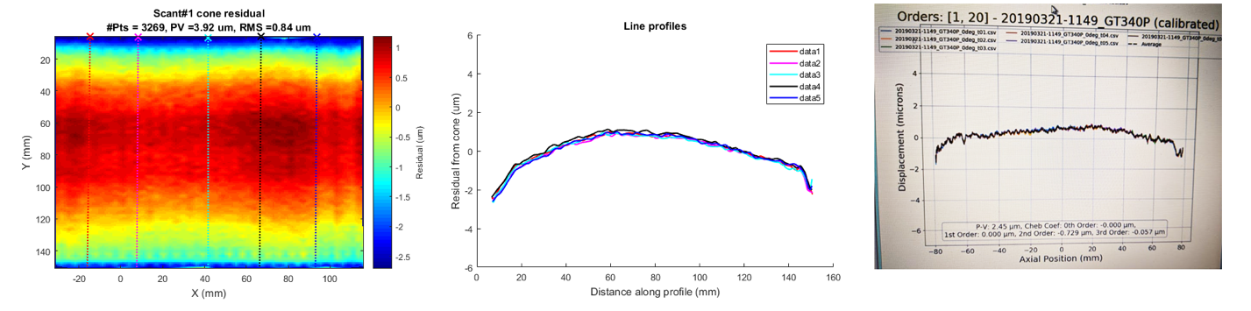
(a) (b) (c)

Fig. 25 Cone residual error map of a single GT metrology profiled along the dotted lines (a) and the corresponding profile plots (b). Laser scan of the GT is in an overall agreement with the coordinate optical metrology (c).

silicon block
The silicon block presented in this section was fabricated using the grinding tool described in the previous section. The optical surface of the block was scanned with the Precitec probe along the azimuth and the axial directions, Fig. 26, using closed loop scanning approach. The resulting best cone residual maps are shown in Fig. 27. A summary of the fitting R₀ and Ɵ results, along with the PV and RMS error is provided in Table 5. Comparing the silicon block to the grinding tool cone-fitting results yields a good agreement, Table 6, with 2 µm difference in R₀ and ~11 arc seconds in Ɵ.
.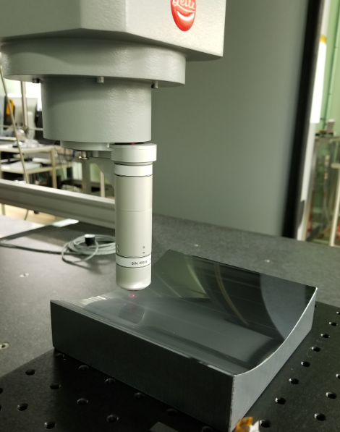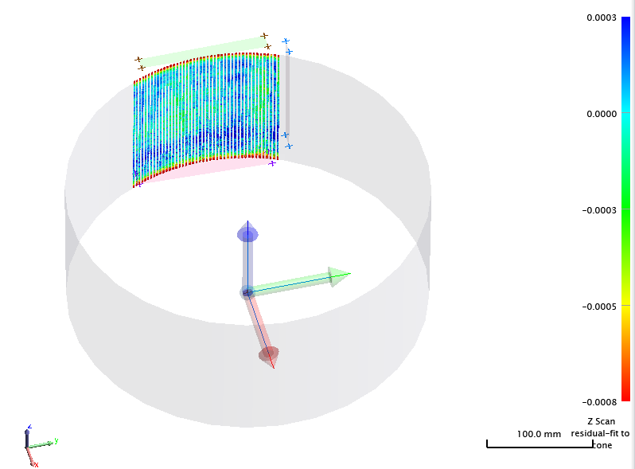
(a) (b)

Fig. 26 Precitec scanning the silicon block (a), and the cone residual error of the scan along the optical axis, with the corresponding best-fit cone, annular object, and the definition of the local CS (b)
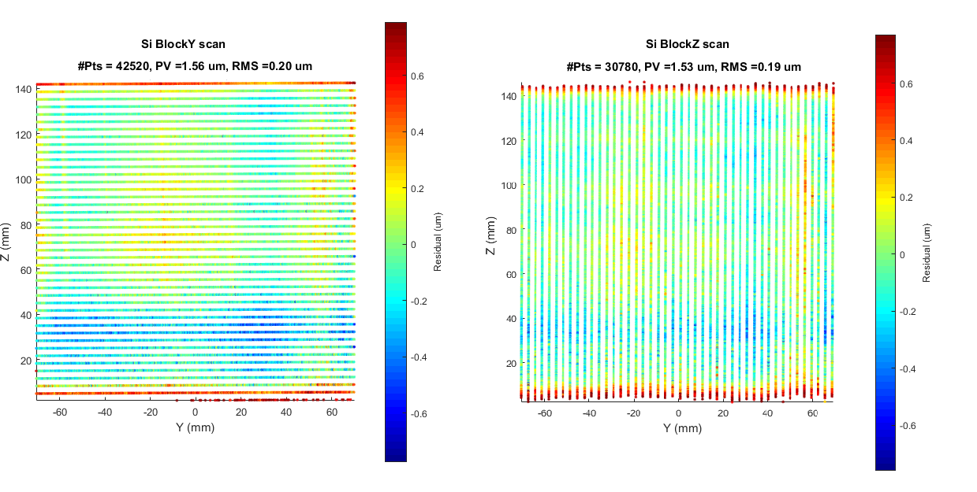
(a) (b)

Fig. 27 silicon block best-fit cone residual error map of the Precitec scan along the azimuth (a) and the axial directions (b).
Table 5 Block best-fit cone parameters and fitting statistics.
 | R₀  (mm) | Ɵ  (deg) | RMS  (µm) | PV  (µm)
Y-Scan | 169.815 | 1.3887 | 0.48 | 2.48
Z-Scan | 169.802 | 1.3885 | 0.44 | 2.22
Average | 169.808 | 1.3886 | 0.46 | 2.35

Table 6 Grinding tool vs. block cone parameters.
Scan# | R₀ | Ɵ
 | (mm) | (Deg)
Average GT individual scans | 169.805 | 1.3856
Uncertainty | 0.004 | 0.0006
Combined GT scans | 169.8063 | 1.3854
Si Block | 169.808 | 1.3886
Difference | -0.002 | -0.0032

Primary mirror segments
Two grazing incidence primary mirror segments (PMS) were characterized with the UOT method. The non-contact CMM metrology results, that were deemed vital to assessing the fabrication procedure, are presented in this section. During the metrology, the PMS was mounted on a kinematic mount, four points, for stability during the measurement, Fig. 28. The non-contact probe was used to scan the surface, along the azimuth, Y, and the axial, Z, axes, employing the closed loop scanning approach, Fig. 28. The data was aligned, by floating the DoF, and fit to a floating cone prescription. The resulting residuals of both scans are in a good agreement with the results obtained from the interferometric test and with each other, Fig. 29 and Fig. 30. The results for the cone fit are summarized in Table 7 and Table 8.
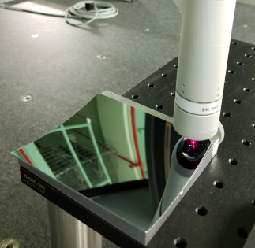
Fig. 28 CMM Precitec probe scanning grazing incidence PMS, mounted on a kinematic mount.
Table 7 PMSs as-built cone parameters.
 | Sample #0 |  | Sample #1
 | R₀  (mm) | Ɵ  (deg) | R₀  (mm) | Ɵ  (deg)
Y-Scan | 169.759 | 1.4473 | 169.758 | 1.4437
Z-Scan | 169.754 | 1.4478 | 169.758 | 1.4450
Average | 169.757 | 1.4476 | 169.758 | 1.4443

Table 8 PMS UOT and interferometric test comparison.
 | Sample #0 |  | Sample #1
 | RMS  (µm) | PV  (µm) | RMS  (µm) | PV  (µm)
Y-Scan | 0.48 | 2.48 | 0.35 | 1.68
Z-Scan | 0.44 | 2.22 | 0.31 | 1.58
Average | 0.46 | 2.35 | 0.33 | 1.53
Fizeau interferometer | 0.47 | 2.23 | 0.34 | 1.45
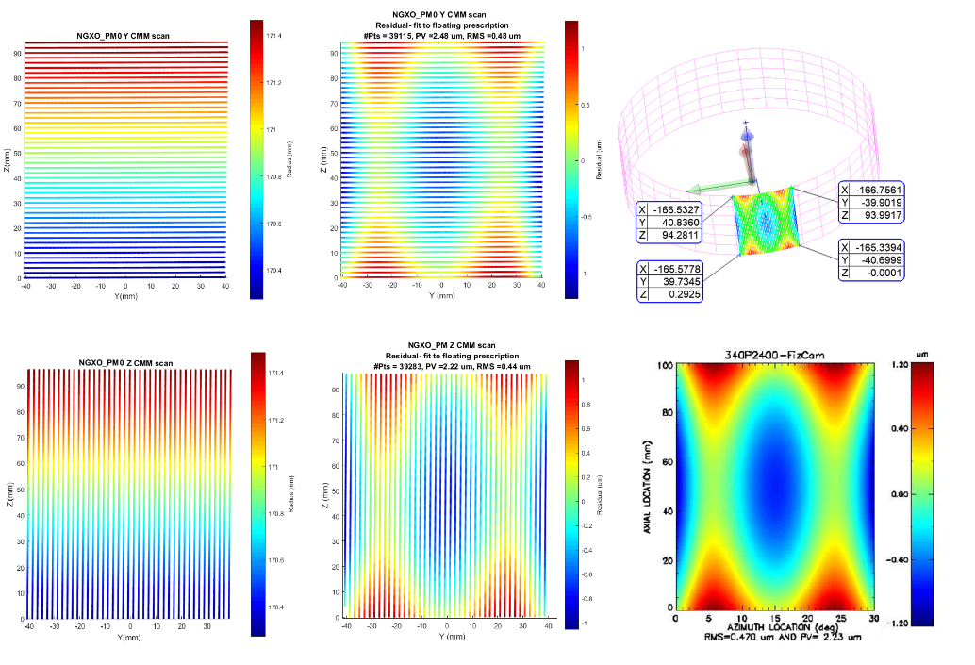
(a) (b) (c)

(d) (e) (f)

Fig. 29 Surface scans of the developmental grazing incidence PMS#0 along the Y and Z-axes (a, d), the corresponding SFE maps (b, e), the CS and PMS scan are illustrated relative to the parent annular mirror (c), and the interferometric test result obtained using a null corrector with clear agreement with the CMM metrology.
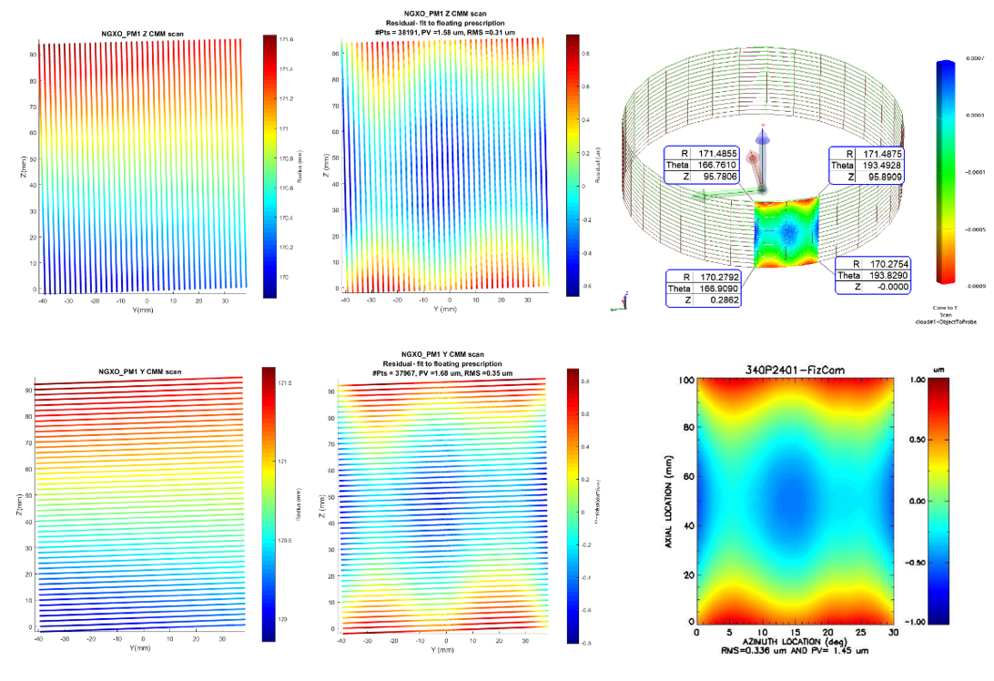
(a) (b) (c)

(d) (e) (f)

Fig. 30 Surface scans of PMS#1 along the Y and Z-axes (a, d), the corresponding SFE maps (b, e), the CS and PMS geometry are illustrated relative to the parent mirror (c), and the interferometric test result obtained using a null corrector (f).

Testing optics with large surface deformation
Employing Magnetic Smart Material (MSM) coating to control the figure of a membrane mirror was demonstrated for “A Precise Extremely large Reflective Telescope Using Re-configurable Elements” (APERTURE), next generation of UV-Vis space telescope.⁹ Future X-ray space telescopes, with increased sensitivity, can also benefit from magnetostriction as the active control method of thin X-ray adaptive optics.¹⁰ Section 4.1 discusses characterization of six silicon wafers pre-applying any MSM coating. Section 4.2 details measuring the electromagnetically induced deformation of two MSM coated samples utilizing the UOT method.

Characterizing silicon wafers with large SFE
Six silicon wafers were characterized prior to being coated with MSM, as flats, using the CMM Precitec Probe. Since the wafers were very delicate, but stable, they were simply placed on a plate for the coordinate metrology without being secured, Fig. 31, to avoid potential distortion. The local CS of the workpiece is initially established based on few manual measurements, such that the origin is approximately at the center of the wafer, and the Z-axis is normal to the surface. A perimeter circle scan is then performed with 0.5 mm point spacing, resulting in N points. A closed-loop line scan along the Y-direction, defined by two opposite perimeter points, is performed in a do-loop and results in N/2 lines, in a meandering pattern advancing along the X-direction, Fig. 31. Since the circle perimeter is sampled linearly and the lines are along the Y-axis, the line spacing is not uniform and follows a cosine function. The lines are much denser at both ends of the line scan. This approach was no longer used for flat scans performed later during this work. A naturally improved scan strategy reciprocates the part’s geometry; a circular aperture is best scanned in circles, while a rectangular aperture is best scanned in lines. However, this approach is still valid and can be used as an additional, independent crosscheck scan.
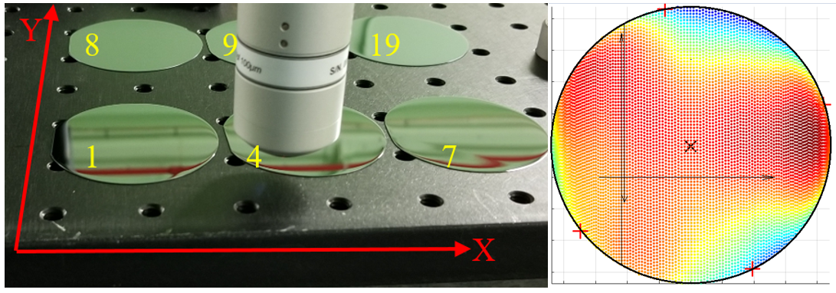
(a) (b)

Fig. 31 Characterizing Si wafers using the Precitec probe (a), and setting up the local CS includes four manual points to fit a circle perimeter, with CS origin at the center and Z-axis normal to circle. Line scans performed along the Y-axis in an alternating direction, advancing along the X-axis (b).
The residual error maps resulting from the Precitec measurement of wafers #1, 4, and 7 are qualitatively compared, side by side, to the corresponding 4D interferometer measurements, Fig. 32 and Fig. 33. For all 4D measurements, the maps should be flipped about the vertical axis, and clocked. The inability of the interferometer to measure the entire wafer surface was the researchers’ main motivation for seeking the non-contact CMM metrology as an alternative metrology.
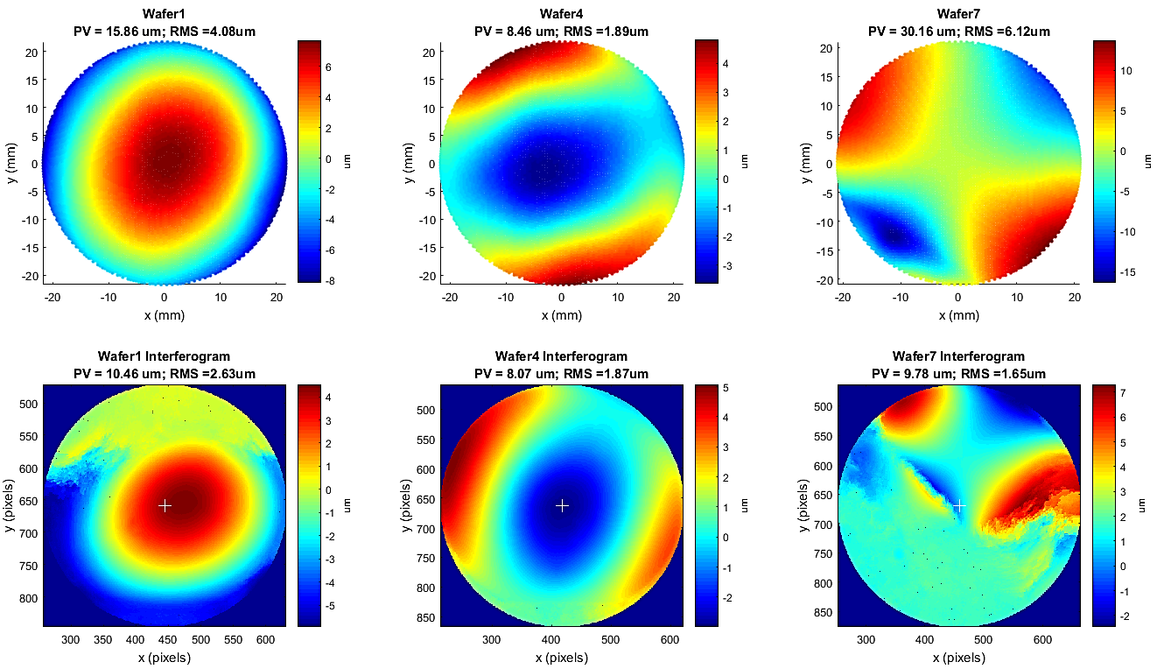
Fig. 32 Plane residual error maps of Precitec (top) and interferometer (bottom) measurements of wafers # 1, 4, and 7. Notice the severe loss of data on wafers # 7, causing the false large discrepancy between CMM and 4D map PV and RMS error.

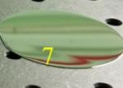
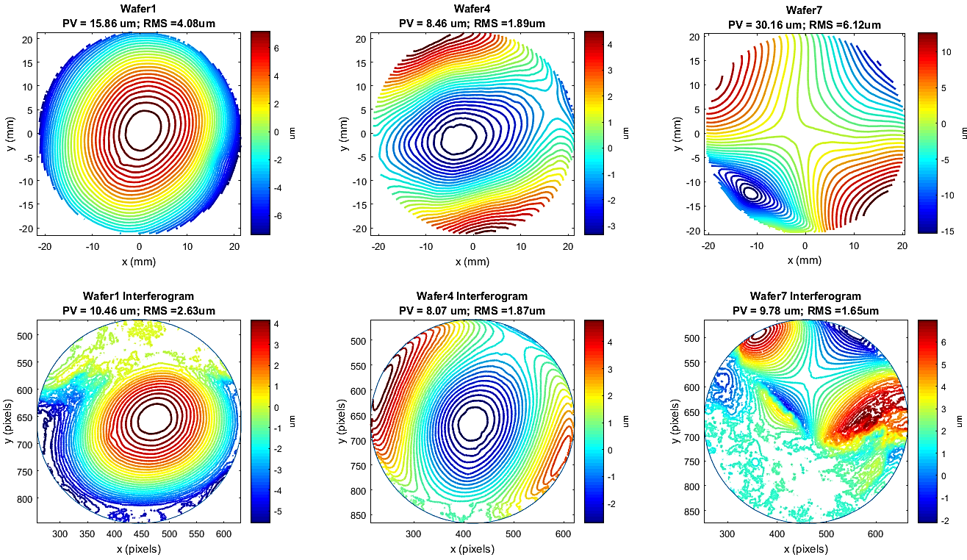
Fig. 33 Residual error contour maps corresponding to Precitec (top) and interferometer (bottom) measurements of wafers# 1, 4, and 7. Notice the loss of data near the steep edges of all the wafers, and particularly wafer #7. Wafer #4, with the most successful 4D measurement, compares well to the CMM scan in PV and RMS error values. Wafer #7 large SFE ~30 µm PV is visible in the aberrated image of the red pipe seen through the mirror.
Similarly, the residual error maps of wafers #8, 9, and 10 are shown in Fig. 34 and Fig. 35. Overall, the corresponding Precitec and 4D maps, after clocking, have similar high/low features, and the PV/RMS values are reasonably close. There are some differences between the two metrologies, possibly due to the wafer mounting, the details of which are not reported for the 4D measurement. A comparison of the PV and RMS error between the CMM and 4D interferometer is provided in Table 9.
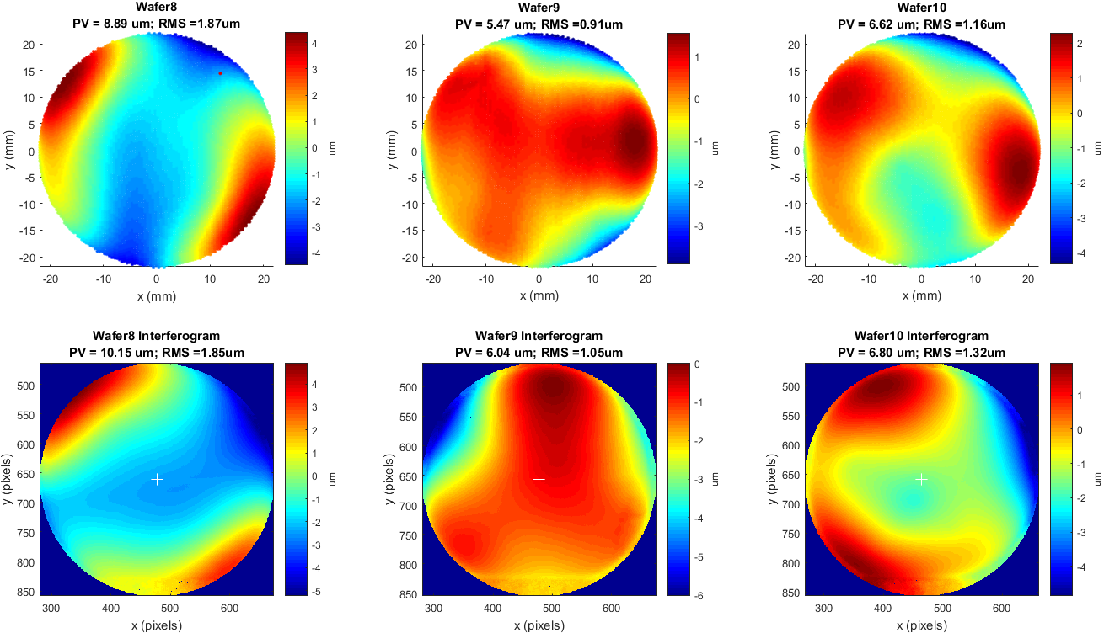
Fig. 34 Residual error maps of CMM (top) and 4D (bottom) measurements of wafers# 8, 9, and 10.
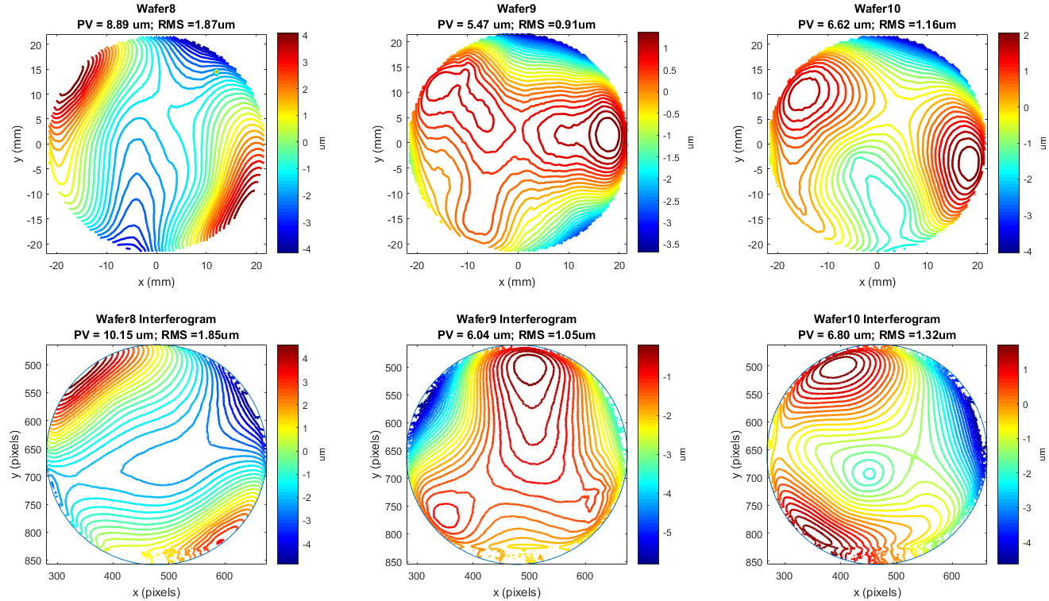
Fig. 35 Residual error contour maps of CMM (top) and 4D (bottom) measurements of wafers# 8, 9, and 10. Notice the 4D measurement quality is better than wafers# 1, 4, and 7, and the PV and RMS error of both metrologies are reasonably close.

Table 9 Comparison between CMM and 4D RMS and PV values of the Si wafers
 | Precitec |  | 4D |  | Perc. Diff. (100%)
Wafer | PV | RMS | PV | RMS | PV | RMS
# | (µm) | (µm) | (µm) | (µm) | (µm) | (µm)
1 | 15.86 | 4.08 | 10.46 | 2.63 | 34 | 36
4 | 8.46 | 1.89 | 8.07 | 1.87 | 5 | 1
7 | 30.16 | 6.12 | 9.78 | 1.65 | 68 | 73
8 | 8.89 | 1.87 | 10.15 | 1.85 | 14 | 1
9 | 5.47 | 0.91 | 6.04 | 1.05 | 10 | 15
10 | 6.62 | 1.16 | 6.8 | 1.32 | 3 | 14
For wafer #4, the Precitec and the 4D measurements were compared quantitatively, Fig. 36 and Fig. 37. Since registering both measurements is required before subtracting the residual error maps for a quantitative comparison, and since there were no fiducials, unique features in both maps were used to align the 4D map relative to Precitec metrology map. The lowest point, close to the center was used as the origin, the center of the saddle was used for clocking, and the distance ratio between the origin and clocking points was used for scaling. In addition, the 4D map was flipped about the vertical, as the need to flip is suggested by the circled features in Fig. 36. The alignment steps are detailed in Fig. 37. Although the difference was not completely nulled, the RMS error of the difference map was much less than that of the individual maps. The central part of the difference map indicates a reasonably good agreement between the two maps, given the 4D challenge measuring higher slopes at the edge.

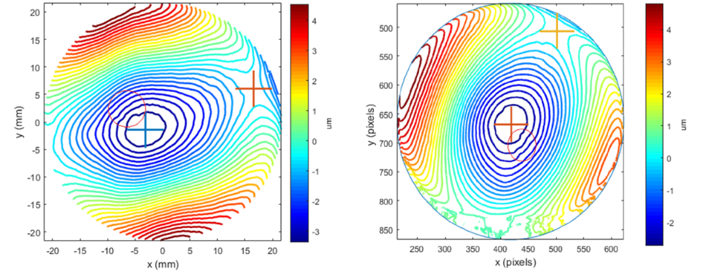
(a) (b)

Fig. 36 Using the contour map unique features to align the 4D map (right) to the corresponding Precitec map (left). The ratio of the arrow lengths, origin to clocking point, is the scale factor. The circled feature indicates the 4D image must be flipped about this axis.

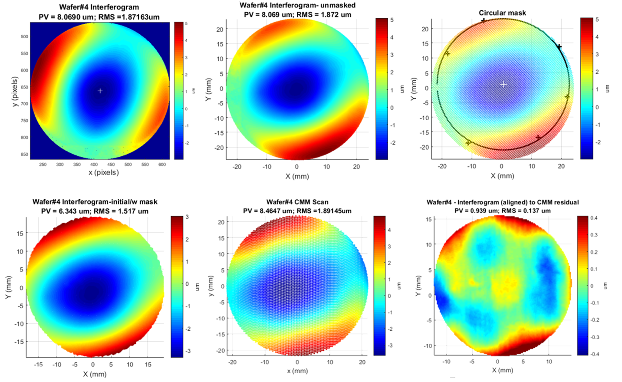
(a) (b) (c)

(d) (e) (f)

Fig. 37 Aligning 4D measurement of wafer #4. Raw 4D image (a), positioned, rotated, flipped, and scaled 4D map (b), masked map (c), 4D area of interest within CMM map limits (d), the corresponding CMM map (e), and the difference between the CMM and the aligned 4D residual error maps (f).

Measurement of magnetically induced surface deformation
In this section, the Precitec probe was used to characterize magnetically induced surface deformation of membrane mirrors. Each of the samples consisted of a 100µm thick silicon substrate, cut from a wafer, with three layers deposited: an adhesion layer (Cr), a magnetic smart material (Terfenol-D), and a magnetic hard material (NiCo).¹⁰ The sample was sandwiched between two strips of foam tape on both sides of the mount clamps, to reduce stress. An electromagnet was fastened to a two-axis translation stage beneath the sample, with poles facing the magnetic coating side, Fig. 38.
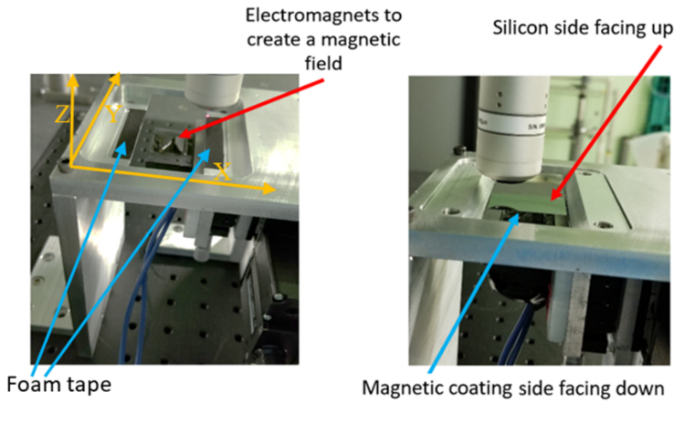
(a) (b)

Fig. 38 MSM surface deformation test setup. The aluminum sample/electromagnet holder before placing the sample on the foam tape (left), and the Si sample clamped to the sample holder with magnetically coated side facing the electromagnet (right).

Two samples were studied utilizing the same methodology. The samples were initially demagnetized using a Proton 1100 Degausser Wand. Baseline scans were performed on the samples prior to applying the magnetic field. A magnetic field was applied to the sample by running a 20A current through the electromagnet for ~10 sec, inducing a magnetic field ~2500 G. The electromagnet, set ~1.5 mm beneath the sample, was started at one position then was moved to another. At each location, the Precitec was used to scan the sample after applying the field, employing the closed loop scanning approach.
The uncoated side of each sample was scanned with a line spacing of 0.2 mm, point spacing of 0.1 mm, and at a speed of 15 mm/sec. Since the scans are not performed at fixed pixels on the surface, the CMM areal profiles, 3D point clouds, were interpolated at a square grid of 0.05 mm point spacing, for inter-test comparison, Fig. 39.
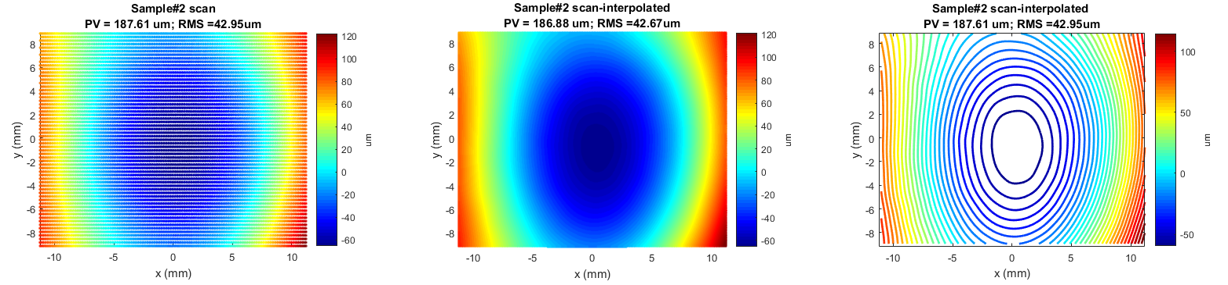
(a) (b) (c)

Fig. 39 Actual Precitec scan (a), the interpolated scan (b), and the contour map of the interpolated scan (c).
Fig. 40 shows Sample#1 MSM deformation test scans; initial baseline, post magnetization at position 1, and post magnetization after the electromagnet was moved to position 2. Fig. 42 shows the corresponding scans of Sample#2. The interpolated surface scans were subtracted to obtain the deformation maps. Fig. 41 shows the magnetically induced distortion of Sample#1, while Fig. 43 shows the corresponding deformation maps of Sample#2. In both figures, the initial degaussed scan is subtracted from the post magnetic induction measurement, at the respective positions. The effect of magnetization at a second induction location is evaluated by subtracting the post-induction measurement at position1 from that at position2. The resulting deflection RMS error were ~90 nm and ~250 nm for Sample#1 and Sample#2 respectively. The PV and RMS error for the full MSM test results are summarized in Table 10.
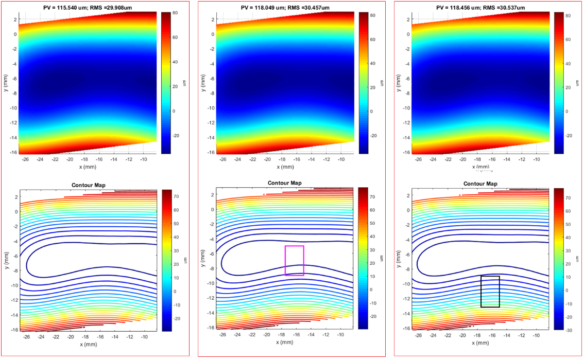
(a) (b) (c)

Fig. 40 Baseline scan of demagnetized Sample #1 (a), after applying the magnetic field at position 1, indicated by the magenta box (b), and after applying the magnetic field at position 2, indicated by the black box (c). Contour maps are shown below the corresponding surface scans.
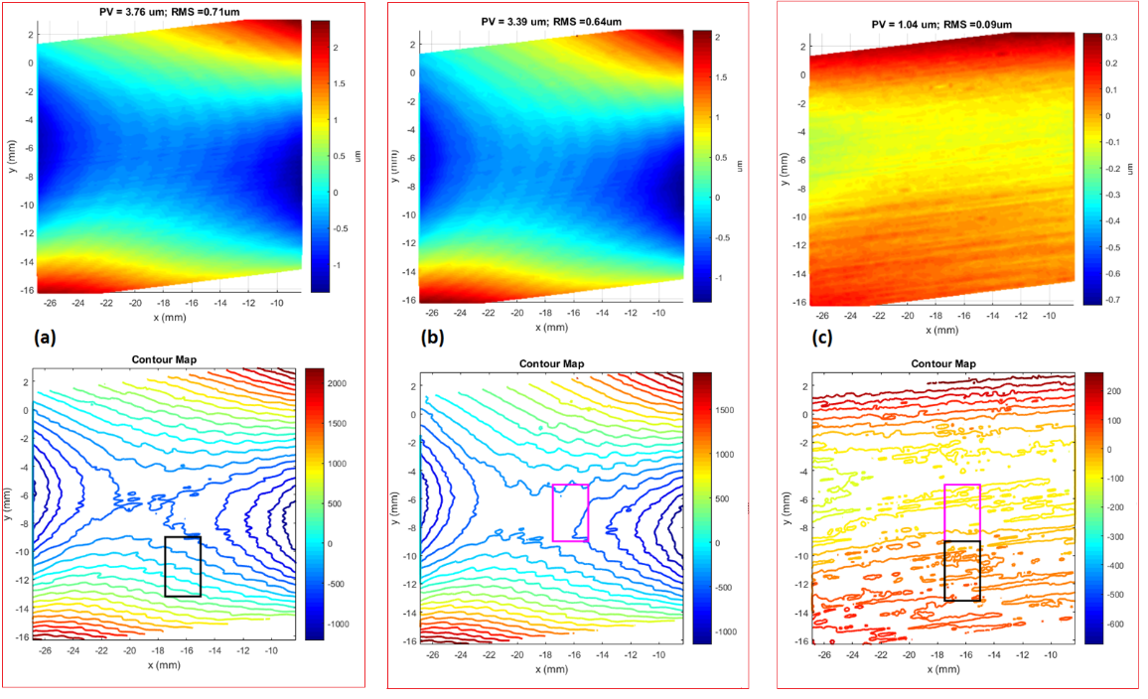
(a) (b) (c)

Fig. 41 Sample #1 MSM test surface deformation and contour maps: Post magnetization at position1 minus the degaussed baseline (a), post magnetization at position 2 minus the baseline (b), and post magnetization at position 2 minus post magnetization at position 1 (c).

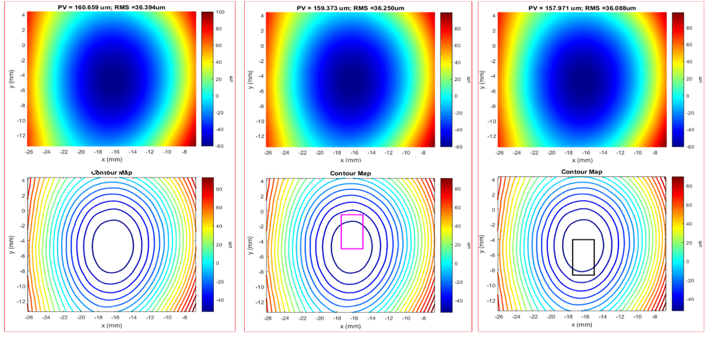
(a) (b) (c)

Fig. 42 Baseline scan of Sample #2 post demagnetization (a), after applying the magnetic field at position 1, indicated by the magenta box (b), and after applying the magnetic field at position 2, indicated by the black box (c). Contour maps are shown below the corresponding surface scan. Note the SFE is completely different from Sample#1.
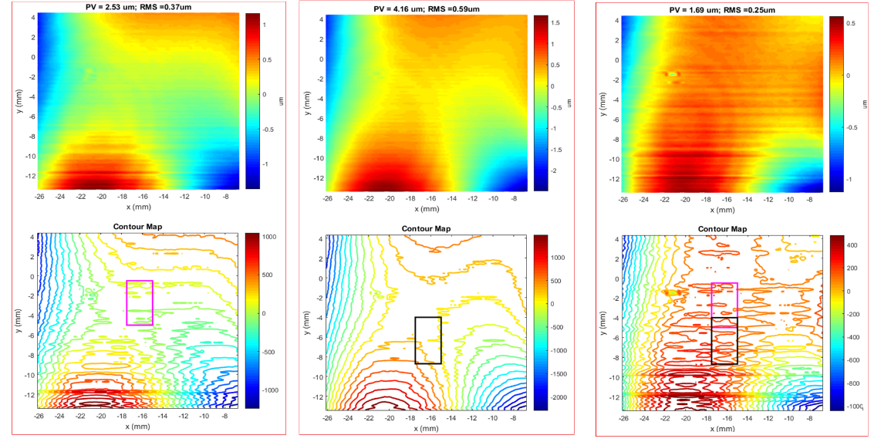
(a) (b) (c)

Fig. 43 Sample #2 deformation and contour maps: Post magnetization at position1 minus the baseline (a), post magnetization at position 2 minus the baseline (b), and magnetized at position 2 minus magnetized at position 1 (c).
Table 10 Summary of MSM test results
 | Sample #1 |  | Sample #2
 | PV | RMS | PV | RMS
 | (µm) | (µm) | (µm) | (µm)
Degaussed baseline (B) | 115.54 | 29.91 | 160.66 | 36.39
Magnetized @position1 (M1) | 118.05 | 30.46 | 159.37 | 36.25
Magnetized @position2 (M2) | 118.46 | 30.54 | 157.97 | 36.09
M1-B | 3.76 | 0.71 | 2.53 | 0.37
M2-B | 3.39 | 0.64 | 4.16 | 0.59
M2-M1 | 1.04 | 0.09 | 1.69 | 0.25

The first sixteen Zernike coefficients of the three surface scans, the baseline and post magnetization with the electromagnet at position 1 and then at position 2, were calculated for both samples. Table 11 lists the Zernike coefficients of the surface scans and the difference maps for Sample #1, while Table 12 lists those for Sample#2. The largest percentage differences of Sample #1 Zernike coefficients from the baseline to the post-magnetized cases were the vertical secondary coma, vertical trefoil, vertical tilt, and vertical astigmatism. However, the largest changes from the first position applying the magnetic field to the second position were the horizontal secondary coma, vertical astigmatism, horizontal secondary coma, and oblique trefoil. As for Sample #2, the Zernike coefficients from the baseline to post magnetization were the horizontal secondary coma, horizontal secondary coma, vertical astigmatism, and oblique trefoil. These were also the largest differences obtained by moving the electromagnet from the first to the second position. It is interesting that moving the electromagnet from one location to another, which is about the same for both samples, had a relatively similar effect on the Zernike coefficient’s percentage difference although the initial surfaces were entirely different.

Table 11 Sample#1 Zernike coefficients for the surface and difference maps
 | Degaussed | Post Position1 | Post Position2 | Position1-DeGaussed  (100%) | Position2-DeGaussed  (100%) | Position2-Position1  (100%)
Zern1 | 2.530 | 2.550 | 2.557 | 0.79 | 1.06 | 0.27
Zern2 | -0.326 | -0.307 | -0.316 | -6.00 | -3.12 | -10.66
Zern3 | -0.339 | -0.382 | -0.371 | 11.93 | 9.01 | -1.65
Zern4 | 22.649 | 22.982 | 23.042 | 1.46 | 1.72 | -0.50
Zern5 | -2.805 | -2.561 | -2.564 | -9.09 | -8.98 | -29.27
Zern6 | -23.627 | -24.100 | -24.167 | 1.98 | 2.26 | -2.41
Zern7 | 3.266 | 3.204 | 3.236 | -1.92 | -0.92 | -8.03
Zern8 | -0.991 | -0.922 | -0.936 | -7.21 | -5.71 | -0.32
Zern9 | 1.394 | 1.472 | 1.436 | 5.44 | 2.97 | -5.16
Zern10 | -1.048 | -1.078 | -1.062 | 2.82 | 1.33 | -18.54
Zern11 | -0.322 | -0.255 | -0.248 | -23.22 | -25.96 | 4.15
Zern12 | -0.264 | -0.261 | -0.264 | -1.14 | 0.00 | -0.90
Zern13 | 0.464 | 0.444 | 0.442 | -4.41 | -4.86 | -5.15
Zern14 | 1.531 | 1.456 | 1.455 | -5.02 | -5.09 | 51.44
Zern15 | 0.012 | 0.023 | 0.023 | 62.86 | 62.86 | 28.34
Zern16 | -0.058 | -0.061 | -0.061 | 5.04 | 5.04 | 11.65

Table 12 Sample#2 Zernike coefficients for the surface and difference maps
 | Degaussed | Post Position1 | Post Position2 | Position1-DeGaussed  (100%) | Position2-DeGaussed  (100%) | Position2-Position1  (100%)
Zern1 | -6.879 | -6.830 | -6.805 | -0.71 | -1.08 | -0.37
Zern2 | 0.733 | 0.711 | 0.662 | -3.05 | -10.18 | -7.14
Zern3 | 0.701 | 0.685 | 0.690 | -2.31 | -1.58 | 0.73
Zern4 | 31.812 | 31.779 | 31.653 | -0.10 | -0.50 | -0.40
Zern5 | -1.873 | -1.596 | -1.449 | -15.97 | -25.53 | -9.66
Zern6 | 12.095 | 11.888 | 11.810 | -1.73 | -2.38 | -0.66
Zern7 | -0.638 | -0.616 | -0.591 | -3.51 | -7.65 | -4.14
Zern8 | 1.925 | 1.920 | 1.919 | -0.26 | -0.31 | -0.05
Zern9 | -0.899 | -0.865 | -0.855 | -3.85 | -5.02 | -1.16
Zern10 | -1.421 | -1.302 | -1.199 | -8.74 | -16.95 | -8.24
Zern11 | -2.160 | -2.212 | -2.253 | 2.38 | 4.21 | 1.84
Zern12 | -0.198 | -0.197 | -0.196 | -0.51 | -1.02 | -0.51
Zern13 | 0.131 | 0.128 | 0.124 | -2.32 | -5.49 | -3.17
Zern14 | 0.054 | 0.086 | 0.112 | 45.71 | 69.88 | 26.26
Zern15 | -0.102 | -0.125 | -0.142 | 20.26 | 32.79 | 12.73
Zern16 | 0.110 | 0.120 | 0.125 | 8.70 | 12.77 | 4.08

Conclusion
The work presented in this paper closes the gap between commercial coordinate measuring techniques, and lower precision metrologies such as laser radar/tracker, and interferometry. For many applications, the coordinate optical metrology can replace interferometry as the primary means of feedback to optical fabrication and requirements verification. When equipped with an optical sensor, a precision coordinate measuring machine is a promising, non-contact and hence low risk, large dynamic range metrology tool for optical shop testing and alignment applications.
Coordinate optical metrology has a key capability of retrieving the as-build prescription (i.e., radius of curvature, conic constant, polynomial coefficients, and alignment). This unique advantage will speed the fabrication due to the greater dynamic range than current optical testing techniques, allowing it to be used deeper into the fabrication process. The nearly UOT method can be used from rough machining and grinding of blanks though the fine stages of optical polishing, before transitioning to an interferometric test, if needed, for the final stages of polishing and verification.
Optical surface fabrication requires feedback from a metrology tool to identify deviation from an ideal surface shape. In this paper, we demonstrated that a CMM equipped with a non-contact optical probe could guide the fabrication of a spectrum of optics from simple normal incidence optics such as OAPs, but with the challenge of large SFE, to more challenging grazing incidence X-ray optics and their fabrication tools.
Testing large surface deformation of adaptive optics is another application that calls for a metrology solution with a large dynamic range and high sensitivity. For the non-contact ultra-precision coordinate metrology presented in this paper, the most arbitrarily deformed optical surface is simply just another surface.

Disclosures
This paper is mostly based on the first author’s Doctor of Philosophy dissertation titled “Ultra-precision non-contact metrology for optical shop testing and alignment applications”, accepted on April 24, 2019, at the University of Arizona, College of Optical Sciences.

Acknowledgments
The authors gratefully acknowledge John Kolasinski, Theodor Kostiuk, Peter Chen, and Qian Gong for the unique R&D opportunity on carbon-nano-tube optics and for their assistance with CNT mirror components and metrology. The CNT mirror fabrication effort was funded by NASA Goddard Space Flight Center’s Internal Research and Development (IRAD) program.
Many thanks for Alan Crane and Brian Comber for their assistance with the metrology of the high conductance bobbins. This work was supported by NASA’s REOLVE project.
Thanks to William Zhang and the NGXO group at GSFC for supporting this effort. The development work of X-ray optics technology has been funded by NASA through the Astronomy & Physics Research and Analysis Program (APRA) and the Strategic Astrophysics Technology Program under the Research Opportunities in Space and Earth Sciences (ROSES) program.
The authors would like to thank Rocco Coppejans for facilitating the metrology of MSM, and acknowledge Kathryn Keely for her help performing the electromagnetically induced deformation experiment. The authors also thank Dr. Peter Takacs for advice and support. The MSM work was supported primarily by an adaptive X-ray optics NASA (Grant NNX16AL31G) plus support from a NASA Innovative Advanced Concepts (NIAC).

References
[1] M. Khreishi et al., “Enabling precision coordinate measuring machine for universal optical testing and alignment applications.” (submission in progress to Optical Engineering).
[2] Hexagon Metrology, “Leitz PMM-C Line Data Sheet 2016-6_EN.pdf.”
[3] Hexagon Metrology, “Leitz Precitec LR_brochure_en.pdf.” .
[4] S. Phillips, “Performance Evaluation,” in Coordinate Measuring Machines and Systems, R. H. and P. Pereira, Ed. 2010.
[5] E. R. Canavan, B. L. James, T. P. Hait, A. Oliver, and D. F. Sullivan, “The Astro-H high temperature superconductor lead assemblies,” Cryogenics, vol. 64, pp. 194–200, 2014.
[6] P. C. Chen and D. Rabin, “Carbon nanotube optical mirrors,” J. Astron. Telesc. Instruments, Syst., vol. 1, no. 1, p. 014005, 2014.
[7] P. C. Chen and D. Rabin, “Using carbon nanotubes to make smart telescope mirrors,” SPIE Newsroom, pp. 10–12, 2015.
[8] S. (NASA/GSFC) Aslam, “IRAD2018-poster-Aslam-Telescope-v2.” .
[9] M. P. Ulmer et al., “APERTURE : A precise extremely large reflective telescope using re-configurable elements,” Space Telescopes and Instrumentation 2016: Optical, Infrared, and Millimeter Wave. Vol. 9904 SPIE, 2016.
[10] M. P. Ulmer et al., “Magnetostrictively deforming the surface of a silicon wafer at two locations,” ADAPTIVE X-RAY OPTICS V. Conference on Adaptive X-Ray Optics V; AUG 21, 2018; San Diego, CA. 2018; p. 9.

Biographies
Manal Khreishi received her PhD from the College of Optical Sciences, at the University of Arizona (UA), in 2019. At UA, she worked on the development and implementation of “Software Configurable Optical Test System” for testing the first primary mirror segment of the Giant Magellan Telescope and other large mirrors. She has been working as an optical metrology engineer at GSFC since 2013. She currently supports Lucy/L’Ralph, PACE/OCI, and a number of IRADs.
Raymond Ohl is an optical engineer at NASA’s Goddard Space Flight Center. He received the PhD in astronomy from the University of Virginia (2000). He serves as the lead optical engineer for the science instruments aboard the James Webb Space Telescope. He served as the Alignment, Integration, and Test Group in the Optics Branch at GSFC, where he currently serves as the Branch Head. He is a senior member of SPIE.
Ryan Mcclelland is a Research Engineer in the Instrument Systems and Technology Division at NASA GSFC, currently developing X-ray optics for future astrophysics missions. His previous technology development experience includes work on aluminum foam core optical systems and non-linear effects of clearances in kinematic mechanisms. Ryan has also worked on flight missions with designs currently on orbit aboard the Hubble Space Telescope and International Space Station.
Ron Shiri is a Supervisory Physicist at the Goddard Space Flight Center Optics Branch. He has supported a number of flight missions and projects as an optical engineer. He studied the computational optics of nanoscale metamaterials and is currently investigating the modeling and development of cryogenic etching of black-silicon as an ultra-high absorber in the infrared regime. He received his doctoral degree in electrical engineering from the George Washington University.
Tilak Hewagama is a research scientist with the University of Maryland, College Park, working in the Planetary Systems Laboratory, NASA GSFC. Areas of scientific interest include composition, thermal structure, and atmospheric dynamics of solar system objects, solar physics, molecular spectroscopy, and exoplanets. He is also involved in developing UV/visible/IR/THz spectroscopy and radiometry instruments for remote sensing, and SmallSat/CubeSat spacecraft based missions for solar system exploration. He received a Ph.D. from the University of Maryland in 1991.
Shahid Aslam is currently employed as a Space Scientist in the Planetary Systems Laboratory, NASA GSFC. He received a D.Phil. in Planetary Physics from the University of Oxford, UK in 2006. He has significant experience in instrument hardware development with direct contributions to the following NASA flight programs: Pressure Modulated Infra-Red Radiometer on Mars Observer; Composite Infra-Red Spectrometer on Cassini; Gas and Aerosol Monitoring Sensor-craft; Stratospheric Aerosol and Gas Experiment III; and James Web Space Telescope.
Melville P. Ulmer is a Professor of Physics & Astronomy at Northwestern University. He is a Fellow of the APS and SPIE. He is a member of the AAS, APS, IAU, RAS, and SPIE. He obtained a B.A.in Physics from The Johns Hopkins University and his Ph.D. was in Physics and from The Univ. of Wisconsin-Madison. He published over 400 articles with over 4,000 citations in a combination of refereed journals and conference proceedings.
Edgar Canavan Dr. Edgar R. Canavan did his graduate work at the University of Wisconsin in cryogenics and superconductivity. He did postdoctoral work at the University of Maryland in superconducting gravitational instruments before coming to NASA. At the Goddard Space Flight Center, he has worked on numerous research and flight projects, many of which involved magnetic coolers for ultra-sensitive milli-Kelvin photon detectors.
Rongguang Liang is a Professor at James C. Wyant College of Optical Sciences, The University of Arizona. Before his move to academia in 2011, he was a Research Scientist at Carestream Health Inc and Eastman Kodak Co. His research in industry focused on optical technologies for digital and medical imaging applications. Dr. Liang’s current research focuses on imaging technologies, optical engineering, and biomedical imaging. Dr. Liang is an SPIE Fellow, OSA Fellow, and Associate Editor of Optica.

